Zecharia Sitchin's Errors:
An Overview
Coast to Coast listeners:
To go right to the papers discussed on the show,
click on the paper titles below or scroll down for abstracts
- The mythical 12th planet cylinder seal
- The real Nibiru in the Cuneiform Texts
This section of the website covers the brief studies in the points below, any of which may be viewed by clicking on the links. You'll eventually need the Adobe Acrobat 5.0 Reader, though. It's available free if you don't have it.
- An introduction to Zecharia Sitchin's flawed scholarship and why I feel it is important that these flaws be exposed.
In a nutshell, I'm a trained scholar in Hebrew Bible and ancient
Semitic languages and care about my field and its resources. That
means I have taken real classes in these languages and the ancient
texts from real professors in real universities. I am not stumbling
around in the dark. My knowledge isn't just based on the fact that I
can use a library. Getting a Ph.D. in this area really does matter. I know
many who come to this website are frustrated by "academese" and
a seeming unwillingness (it's more than imaginary) of academics to
consider alternative research on the ancient world. I would agree with
you that there is a "knowledge filter" in academia (I think of Cremo and
Thompson's amazing efforts in "Forbidden Archaeology" when I say that),
but that does not justify poor scholarship and fabrication of "data" to
prop up ideas. It is illegitimate to complain that academics should
look at alternate ideas and then turn around and refuse to look at
what the original sources say. Whether you want to accept it or not,
when you take Sitchin's interpretations of stories over the word meanings
the scribes themselves left us (they made dictionaries back then too!),
this justifies academics treating alternate material with disdain. This
situation should not be. We should look and be willing to slay academic
(and even theological) sacred cows; you should respect the results
of centuries of work in the field by people who do this for a living.
- An analysis of the cylinder seal (VA 243) that Sitchin uses to argue that the Sumerians knew there were 12 planets.
This analysis focuses on the demonstrable fact that the "sun" symbol
on this seal (which is essential to allegedly depicting the solar system)
is not the sun. The actual sun symbol used on literally hundreds of
seals, monuments, and other artwork from Sumer and Mesopotamia
is shown to the reader via photos and compared to the symbol on
this seal. It's not even close. I include examples where Sitchin's
symbol occurs side-by-side with the real sun symbol so there can be
no mistaking the fact that the Sumerians and Mesopotamians did in
fact distinguish these symbols. This analysis erodes the entire
foundation of Sitchin's 12 planet hypothesis.
- A study of the word "Nibiru" and an examination of the nature of Nibiru in cuneiform astronomical texts.
The goal here was to amass for readers every occurrence of the
word "nibiru" in ancient cuneiform texts. Fortunately, this is possible
because of the diligent work of the compilers of the well known
Chicago Assyrian Dictionary, which bases its entries on exhaustive
compilations of all cuneiform material know to the present day (there's
a reason its taken decades to compile!). The study shows - from the
texts themselves, not my opinion - that "Nibiru" is not a planet beyond
Pluto and that the Anunnaki gods are never associated with it. These
ideas are fabrications. Additionally, this study briefly details the
sources left to us by the Mesopotamian scribes that are of an
astronomical nature, and addresses Sitchin's "god to planet" matchups
that he uses to reconstruct the cosmology of earth and our solar
system. In other words, when Sitchin says "the god Marduk is the planet
Nibiru" and proceeds to read this equation (and others) into the
Sumero-Akkadian texts to interpret them, I compare such equations
to the actual lists in cuneiform where Mesopotamian astronomers
struck god = planet equations. Not surprisingly, they don't agree.
- Zecharia Sitchin's complete misunderstanding of the meaning of the word "elohim"
This study focuses on the fact that, though elohim is
morphologically plural (its "shape" or grammatical form is plural), the
meaning of the word is almost always singular (one god) in the
Hebrew Bible. This is the case over 2500 times. The same
phenomenon is also present in Sumerian and Akkadian. The reader
does not need to know Hebrew to follow the discussion, as I have
color-coded the grammatical features and examples illustrating the
truth of this well known (to those who know Hebrew anyway) feature
of biblical Hebrew. The section also contains a response to Erik
Parker's (Sitchin's webmaster) attempts to rebut the material.
Erik has never studied Hebrew or any ancient language, but he
nevertheless tried to respond. It isn't pretty.
- Zecharia Sitchin's misunderstanding of the word "nephilim"
This study details the impossibility of Sitchin's translations of
"nephilim" as "those who came down" or "people of the fiery rockets"
in light of Hebrew vocabulary and grammar. I know it sounds mind-
numbing, but again I have tried to illustrate the concepts and
problems. It also contains a scan of a page from one of Sitchin's books
where he could not tell the difference between Aramaic and Hebrew -
an amazing mistake if he's an expert.
- Alleged rocket ships in ancient Mesopotamia and the biblical Babel story
The point of this discussion is to show that Sitchin's translations
of certain Sumero-Akkadian words cannot be correct for the simple
reason that the ancient Mesopotamian dictionaries (yes, they kept
bilingual dictionaries and we have them today) translate the words
of their own language in ways that unanimously contradict Mr.
Sitchin. You either believe him or the ancient Sumerians /
Mesopotamians. Seems like an easy call.
- The notion that Adam was "the first test tube baby"
Covers more tortured linguistics from Mr. Sitchin. This time he takes
meanings from the etymologies of certain words and argues those
meanings are behind other words. He even makes up a word or two
in the ancient texts along the way. This one is sort of a favorite
of mine because I use the transliteration and translation of two
scholars whom Sitchin calls experts against Sitchin himself.
- An Open Letter to Zecharia Sitchin
My goal here is to set the record straight for all who care about
thinking and paying attention to facts (the original sources) in these
matters. I accept the sad truth that many disciples of Zecharia Sitchin
will not be swayed by any amount of data from the cuneiform texts.
They literally will believe Sitchin over the Sumerians and Mesopotamians
themselves. There isn't much I can do or say to such cultic
obsessions. On the other hand, there are those out there who
really do want to think, are willing to change their minds, and who
care about the primary sources. This letter is as much for you as
Mr. Sitchin. The facts are these:
  - I have had this letter online for two years and it has never been
answered. I haven't even seen some sort of resume or transcript proving Sitchin has ever even studied ancient languages. My CV is on this website.
  - I was asked if I was willing to debate Mr. Sitchin two years ago
by Art Bell on the air, and was asked again by Coast to Coast's
weekend host, Barbara Simpson the same question months
later. I accepted immediately; Mr. Sitchin has been silent;
  - The only person who has responded to anything on this website has been the intrepid but unprepared Erik Parker, Sitchin's webmaster. To date Erik has not answered the questions below. He has not produced a single text that says Nibiru is a planet beyond Pluto, or that associates the Anunnaki with Nibiru. He has not refuted (or even understood) the points of Hebrew grammar I have introduced regarding "nephilim" and "elohim". (And in fairness, he can't be expected to since he has no language training). He has not explained why the Sumero-Akkadian story of building the tower (Sitchin says rocket ship) has the object being built with bricks, or why such advanced ETs as the Anunnaki came here with internal combustion engines. Most importantly, he has not explained why there has been no effort to arrange any sort of debate. Instead, Erik has attacked my motives and tried to twist parts of my discussions into "agreeing" with Sitchin (which is why I reproduce all our exchanges in whole - so you know who is twisting what). Zero response. Zero substance.
Don't believe me? Have the courage to look through these studies yourself. I have nothing to hide, and always try to give the reader sources to check everything.
Introductory Comments:
The work of Zecharia Sitchin was brought to my attention just over a year ago, shortly after I completed my book, The Façade. As a trained scholar in ancient Semitic languages with a lifelong interest in UFOs and paranormal phenomena, I was naturally enthused about Mr. Sitchin's studies, particularly since I had also heard he was a Sumerian scholar. I thought I had found a kindred spirit, perhaps even a guide to navigating the possible intersection of my academic disciplines with ufology, a discipline unfairly ridiculed by the academic mainstream. Unfortunately, I was wrong.
What follows will no doubt trouble some readers. I have come to learn that Mr. Sitchin has an avid following, and so that is inevitable. Nevertheless, I feel it my responsibility as someone who has earned credentials in the languages, cultures, and history of antiquity to point out the errors in Mr. Sitchin's work. Indeed, this is the academic enterprise. I have yet to find anyone with credentials or demonstrable lay-expertise in Sumerian, Akkadian, or any of the other ancient Semitic languages who positively assesses Mr. Sitchin's academic work.
The reader must realize that the substance of my disagreement is not due to "translation philosophy," as though Mr. Sitchin and I merely disagree over possible translations of certain words. What is at stake is the integrity of the cuneiform tablets themselves, along with the legacy of Sumer and Mesopotamian scribes. Very simply, the ancient Mesopotamians compiled their own dictionaries, and the words Mr. Sitchin tells us refer to rocket ships have no such meanings according to the ancient Mesopotamians themselves. Likewise when Mr. Sitchin draws connections between Sumero-Mesopotamian gods and stories that simply do not exist in the literature (like insisting the Sumerians believed there were twelve planets and having the Anunnaki living on Nibiru, the supposed 12th planet), my argument with him is one that opposes such fabrications, not just one how words are translated. To persist in embracing Mr. Sitchin's views on this matter (and a host of others) amounts to rejecting the legacy of the ancient Sumerian and Akkadian scribes whose labors have come down to us from the ages. Put bluntly, is it more coherent to believe a Mesopotamian scribe's definition of a word, or Mr. Sitchin's?
I do believe that Mr. Sitchin has done some kind of work in the ancient languages (I have never seen academic credentials in the form of degrees or transcripts), but some of the mistakes he makes are at so basic a level of language knowledge that I am sincerely doubt he knows ANY of the ancient languages he says he does. I'm guessing that with Hebrew, for example, Mr. Sitchin (being Jewish) can sight-read the language but doesn't understand ancient Biblical Hebrew grammar (much like many English readers don't have a real grasp of the mechanics of English grammar). I have seen little that convinces me that Mr. Sitchin knows any ancient languages, much less demonstrating that he is a language "expert". I say this because of Mr. Sitchin's linguistic mistakes (see below), and because he rarely interacts with scholarly articles pertaining to any linguistic material in the texts he uses. Unfortunately, there are even points he just makes up.
The reader should also know that I believe that the strange phenomena people have experienced in antiquity through the present day with respect to "UFOs" and "aliens" are real. The Facade offers an alternative paradigm to these phenomena, one that, contrary to Mr. Sitchin's reconstruction, CAN be defended (if the connections be legitimate) through ancient texts.
Mr. Sitchin's Errors: The Specifics
1) An overview of Cylinder Seal VA 243
A few of the basic issues are covered at this link. A more thorough treatment is available as a PDF file (available through this link).
2) A Study of Nibiru
Again, a few of the basic issues are explained here with a more lengthy follow-up available in PDF form.
3) Mr. Sitchin insists that "Elohim" in Genesis 1:26-27 is plural, thereby "requiring" us to interpret that passage as supporting his idea that extraterrestrial "gods" (The Annunaki) created humankind. (See The 12th Planet, p. 337-338).
Sitchin's comments in this regard show either a refusal to consider the Hebrew grammar of this passage, or outright ignorance of that grammar (i.e., he just never looked). "Elohim" does NOT always mean "gods" (plural); the meaning of the term is to be determined by grammatical and contextual clues. GRAMMAR is IMPORTANT! Grammar is to language what your graphical internet browser is to the websites on the internet - it is the organizing vehicle that gives meaning to the data -bits of information; without it you'd have to create your own method of obtaining and understanding that information - it would be totally SELF STYLED. Grammar dictates the formation of words, the relationship of words to each other, and the meaning of those words with respect to that arrangement. Without attention to the rules of grammar that have governed the languages of ancient texts, you can make the texts say ANYTHING; grammar is a control against total subjectivity. Sitchin ignores grammar in his work on elohim in this passage (and others). The PDF files below illustrate (from the Hebrew) that "elohim" often refers to a "god" or "God" (proper name). Besides this evidence from the Hebrew Bible, I have also posted examples from ancient Mesopotamian texts (Akkadian) and the famous El-Amarna texts (also Akkadian) where the plural word for "gods" ('ilanu) refers to a single person or god - just as in the case of Hebrew elohim. Why is Sitchin (and others) unaware of this material? Someone trained in the ancient languages would know about this - and if he knows it, why doesn't he tell his readers!?
PDF file on Sitchin's erroneous teachings on the word "elohim". The overheads include examples of the Akkadian word for "gods" (plural ilanu) used to refer to SINGLE gods or individuals.
For an expanded treatment of the meaning of Elohim, click on the link below. Mr. Sitchin's webmaster, Erik Parker, attempted to respond to my criticism's of his mentor's work, with disastrous results. In case the reader thinks I am picking on Mr. Parker, it is fair to say the arguments he uses are Sitchin's, not his own (he knows Sitchin's work very well). To really see how poor Sitchin's scholarship is on the word Elohim (as well as those who parrot his work, like Laurence Gardner and William Henry), click here.
4) Mr. Sitchin contends that the word "Nephilim" means "those who came down from above" or "those who descended to earth" or "people of the fiery rockets" (see The Twelfth Planet, pp. vii, 128ff.).
These translations, of course, serve his purpose - to see the Nephilim as ancient astronauts. As such it is hard to over-estimate the importance of Sitchin's work here - if he's wrong about the meaning of "nephilim," much of his overall thesis falls.
Unfortunately for Sitchin, such translations are completely out of step with the Hebrew text and the word which is at the base of "Nephilim." Once again ignoring the grammar of the text (and actually making up his own word meaning in this case), Sitchin makes the following errors, addressed in the PDF files below.
Sitchin assumes "Nephilim" comes from the Hebrew word "naphal" (as opposed to ARAMAIC - see below) which usually means "to fall." He then forces the meaning "to come down" onto the word, creating his "to come down from above" translation. "Nephilim" - in the form we find it in the Hebrew Bible - COULD come from Hebrew "naphal," but it could ONLY mean be translated one way in light of the spelling - "those who are fallen" (i.e., either "fallen in battle" - which is out of the question given the context of Genesis 6 - or "spiritually fallen" / evil - which fits the context IF the sons of God are evil). That the sons of God in Genesis 6 were evil divine beings and this cohabitation was evil, one needs only to turn to either Jude 6-7 and II Peter 2:4-6, or the Book of Enoch.
How can I say "ONLY" above? The scholarly reasons for my assertion are demonstrated in the PDF file on the Nephilim. In short, if you care about the grammar of Hebrew, Sitchin's word meanings CAN'T be correct.
The above file also discusses Sitchin's confusion of the sons of God and the nephilim - and evidence from his own book, Stairway to Heaven, that he cannot distinguish between Hebrew and Aramaic! My suspicion behind this apparent blunder is that Sitchin wants to distance the Annunaki from the evil Watchers of ancient Jewish literature (Hebrew Bible, Enoch, and some Dead Sea Scrolls). The textual parallels linking the Annunaki and these evil divine beings are charted in this PDF file.
5) Mr. Sitchin argues that certain Sumerian terms (and the Akkadian equivalents) refer to flying craft.
Specifically, the terms used by Mr. Sitchin to argue for ancient rockets and space flight are Sumerian "MU" (Akkadian "shamu"; Hebrew "shem") and Sumerian "ME" (see The 12th Planet, pp. 130 ff.). Mr. Sitchin argues in turn that the Genesis account of the tower of Babel, where the people wanted to make for themselves a "shem," actually describes the construction of a flying craft/rocket.
There are a number of difficulties with Sitchin's arguments and his use of the languages here.
A. The Meaning of "MU", "shamu",, and "shem"
As noted above, the ancient Mesopotamian scribes created dictionaries. Lists of words are a common feature among the thousands of Sumerian and Akkadian cuneiform tablets which have been discovered by archaeologists. Many are just groupings of common words, while others represent an inventory of the word meanings of the languages used in Mesopotamia. These "lexical lists", as scholars call them, were indispensable to the 19th century scholars who deciphered the Sumerian and Akkadian texts, for they were used to compile modern dictionaries of these languages. Today all major lexical texts have been published in the multi-volume set, Materials for the Sumerian Lexicon, begun by Benno Landsberger in the 1930s. It is indeed a rare instance where ancient dictionaries of a dead language form the core of the modern dictionaries used by scholars of today. Such is the case for the ancient languages of Sumer and Akkad. Sadly, Mr. Sitchin neglects these resources.
The Meaning of Sumerian “MU”
On pages 140-143 of The 12th Planet, we read that Mr. Sitchin defines the Sumerian MU as "an oval-topped, conical object," and "that which rises straight." Mr. Sitchin cites no Sumerian dictionary for these meanings. A check of the dictionaries contained in Sumerian grammars and the online Sumerian dictionary reveal no such word meanings. But why trust modern scholars when we can check with the Mesopotamian scribes themselves?
In his technical but stimulating study of Sumerian and Mesopotamian terminology for the cosmos, Mesopotamian Cosmic Geography, Mesopotamian scholar W. Horowitz lays out the meaning of the Sumerian word “MU” directly as the Mesopotamian lexical lists have it. In discussing the meaning of the Akkadian word “shamu,” in his book, Horowitz gathered all the lexical list data for that word. What follows below is his layout. Note that the word “MU” in the left-hand (Sumerian) was among the cuneiform dictionary entries for “shamu.” A discussion of the meanings follows the entries. Briefly, “shamu” in Akkadian here means “heaven” (or part of the sky/heavens) or perhaps “rain.” According to the scribal tablets themselves, the meaning is not "that which rises straight,” or “conical object” (i.e., “rocket ship”). This is the verdict of the scribes themselves, not this writer. The red explanatory insertions are my own:
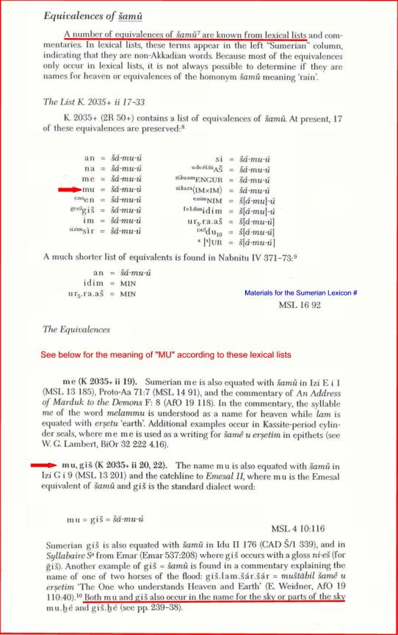
Mr. Sitchin goes on to claim (p. 143) that the Sumerian syllable MU was adopted into Semitic languages as "SHU-MU," which he translates as "that which is a MU" (by implication, “that which is a rocket ship”). Allegedly, "SHU-MU" then morphed into Akkadian shamu and Biblical Hebrew shem. We will consider the Akkadian word first, and then the Hebrew word.
The Meaning of Akkadian “shamu”
Does Akkadian shamu come from Sitchin’s "SHU-MU"? Does Sumerian even have a word that means "that which is a MU"? Contrary to Mr. Sitchin, Akkadian shamu does NOT derive from SHU-MU, nor does shamu mean "that which is a MU."
First, Mr. Sitchin's translation of shu-mu presupposes that "SHU-" is what's called in grammar a "relative pronoun" (the classification of pronouns in all languages that mean: “that which”). Mr. Sitchin is apparently unaware of Sumerian grammar at this point, because the Sumerian language does not have a class of pronouns that are relative pronouns! One need only consult a Sumerian grammar to find this out, such as John L. Hayes, A Manual of Sumerian Grammar (p.88).
Second, in light of the fact that there is no "SHU-MU" form in Sumerian (since Sitchin’s relative pronoun “SHU-” is concocted), it logically follows that Akkadian shamu did not derive from a Sumerian “SHU-MU.” Nevertheless, Akkadian does have a word shumu, but it does not come from Sumerian “SHU-MU” (since that combination never existed in light of Sumerian grammar’s lack of the assumed relative pronoun). In fact, the shumu of Akkadian undermines Sitchin’s entire argument when it comes to the Tower of Babel account (see below for more on Akkadian shumu).
Returning to shamu, the Akkadian word shamu can have multiple meanings, depending on its original root origin. The lexical lists above presuppose a shamu that comes from the Akkadian word shama'u or shamamu, both of which mean "heaven," as in a place or portion of the sky. Notice how similar shamu is to both shama'u and shamamu. Only the extra letter marks them as different, marked either by an apostrophe (shama'u) in English or an “m” (shamamu). It turns out that our word shamu in the lexical lists above is a contraction of either shama'u or shamamu (the word loses a letter just like in English "didn't" for "did not").
The Meaning of Biblical Hebrew “shem”
As noted above, there is an Akkadian word shumu. This word has its own meaning, a meaning that did in fact get absorbed into Biblical Hebrew, from whence Hebrew shem originated. Both this Akkadian shumu and Hebrew shem mean “name” or “renown,” the word meanings Mr. Sitchin ridicules in The 12th Planet on his way to fabricating rocket ships in Mesopotamia and the Biblical Tower of Babel story. Other than the concocted word origin (SHU.MU), how do we know that Mr. Sitchin’s word meanings are wrong? Here are the entries in the gold standard Akkadian dictionary, The Chicago Assyrian Dictionary painstakingly produced over several decades by scholars of the Oriental Institute of the University of Chicago:

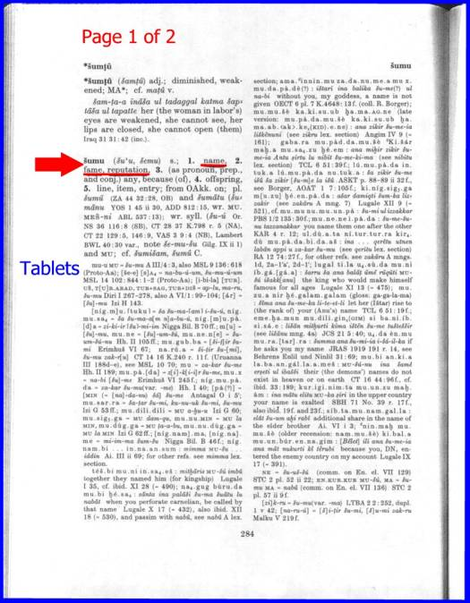

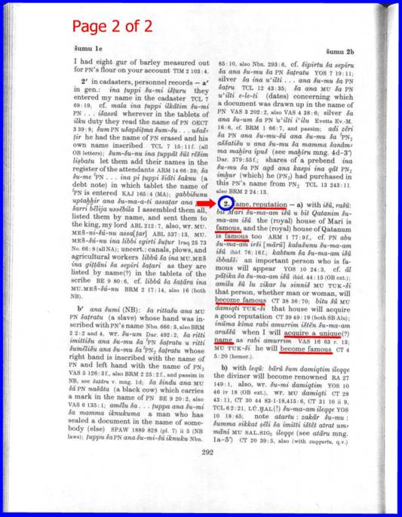

A Word on the Tower of Babel Accounts in both Sumerian and Biblical Literature – The Common Sense of Context
In the absence of any linguistic support for his rocket ships, Mr. Sitchin’s supporters might claim a linguistic cover-up. No, scholars aren’t hiding “rocket ship” meanings in the cuneiform tablets. In fact, the discerning reader of the Sumerian and biblical Babel accounts need not retreat to linguistics at all to know Mr. Sitchin’s theories are nonsensical. Consider first the biblical story of Genesis 11:1-9:
1 And the whole earth was of one language, and of one speech. 2 And it came to pass, as they journeyed from the east, that they found a plain in the land of Babylon; and they dwelt there. 3 And they said one to another, Go to, let us make brick, and burn them thoroughly. And they had brick for stone, and slime had they for mortar. 4 And they said, Go to, let us build us a city and a tower, whose top [may reach] unto heaven; and let us make us a name (shem) lest we be scattered abroad upon the face of the whole earth. 5 And the Lord came down to see the city and the tower, which the children of men built. 6 And the Lord said, Behold, the people are one, and they have all one language; and this they begin to do: and now nothing will be restrained from them, which they have imagined to do. 7 Let us go; let us go down, and there confound their language, that they may not understand one another's speech. 8 So the Lord scattered them abroad from thence upon the face of all the earth: and they stopped building the city. 9 Therefore is the name of it called Babel; because the Lord confounded the language of all the earth there: and from thence did the Lord scatter them abroad upon the face of all the earth.
The point here is brief. Note two obvious facts from the plain English:
(1) The people are not building the shem; they are building “a city and a tower” (verse 4). The Hebrew words here are not shem in either case, they are ‘ir (“city”; pronounced ghir) and migdal (“tower”). The word shem comes later in the verse, and is the purpose for building the city and tower – to make a great name for themselves, just what the Akkadian word shumu means!
(2) The tower is being built with brick and mortar (verse 3) – what rocket ships are made of bricks and mortar?
Again, Mr. Sitchin’s supporters could claim some sort of Christian or Jewish conspiracy to obscure the construction of a rocket ship. If so, then the Sumerians themselves started the cover-up (leaving only Mr. Sitchin correct). Here’s their version, from Enuma Elish (Tablet VI: lines 59-64):
The Anunnaki set to with hoes
(Unusual tools for rocket-building!)
One full year they made its bricks
(A rocket made of bricks! Sounds like a building to me)
They raised up Esagila, the counterpart to Apsu,
They built the high ziggurat of counterpart Apsu
(A ziggurat, not a shem or shumu)
For Anu-Enlil-Ea they founded his dwelling.
So, in the very story Mr. Sitchin uses to create a parallel between Sumer and the Old Testament, the Anunnaki are clearly constructing a tower made of bricks – not a spaceship.
B. The Meaning of "ME"
To begin his argument, Sitchin quotes the following lines from an unnamed text (p. 130; why doesn't he give sources?). The text is most likely from the Descent of Inanna:
She (Inanna) placed the SHU.GAR.RA on her her head.
She arranged the dark locks of hair across her forehead.
She tied the small lapis beads around her neck.
Let the double strand of beads fall to her breast,
And wrapped the royal robe (PALA) around her body.
Although the word "ME" is not in this text, Sitchin insists that the SHU.GAR.RA is a space helmet. The object is surely some type of headgear, as is evident from the statuary Sitchin reproduces in his book (p. 132). That it involves SPACE TRAVEL is a fabrication, based on some presumed connection between it and a passage he quotes on page 136, which describes the ME that Enlil fastens to Inanna's body, objects which Inanna wears for her journeys in the "Boat of Heaven" (and so, for Sitchin, space gear or a space suit). Enlil announces to her:
You have lifted the ME
You have tied the ME to your hands
You have gathered the ME
You have attached the ME to your breast
O Queen of all the ME, O radiant light
Who with her hands grasps the seven ME
Where's the space travel part? That comes with Sitchin's interpretation of the "Boat of Heaven" in which Inanna rides - the MU. Inanna TAKES the ME's with her on her trip in the MU. Naturally, Sitchin's interpretation of the above depends on whether the MU is a flying craft, which even the Mesopotamians would deny (see A. above).
The word ME in other Sumerian texts describing Inanna's journey wearing the SHU.GAR.RA is used dozens of times for objects that are NOT worn. Specifically, the famous text Inanna and Enki deals with Inanna's desire to "possess the ME" of Enki. In this work, ME can refer to: (a) abstract ideas, like rulership, godship, shepherdship, priestess-ship, the throne of kingship, dishonesty, kissing, extinguishing fire, etc.; (b) activities, such as love-making, prostitution, slander, plunder, writing, leather-working, arguing, mat-weaving, and washing; and (c) concrete objects, like a black dress, hair, a sheepfold, descendants, etc.
This data is what leads scholars to define "ME" as either "cultural norms (which can be stored like concrete objects) or banners that represent these objects or ideas" (see "Inanna and Enki," pp. 518ff. in The Context of Scripture, vol 1: Canonical Compositions from the Biblical World, ed. W. Hallo and K. L. Younger; Brill, 2000). What would love-making have to do with flying in a spaceship? Hair? Washing? Etc.! In all, there are 94 "ME's" in the above text, NONE of which have any clear connection to flight.
For more specific study of the word "ME", see:
Gertrud Farber, Der Mythos "Inanna und Enki" unter besonderer Berucksichtigung der Liste der ME, Studia Pohl 10 (Rome: Biblical Institute Press, 1973)
Gertrud Farber, "ME" in Real-lexikon der Assyriologie
Richard Averbeck, The Cylinders of Gudea, pp. 417-433 in The Context of Scripture, vol 2: Monumental Inscriptions from the Biblical World, ed. W. Hallo and K. L. Younger (Brill, 2000)
6) Mr. Sitchin argues that "Adam was the first test tube baby."
Mr. Sitchin believes the Sumerian - Akkadian vocabulary in the ancient Mesopotamian account of the creation of humankind evinces genetic engineering of a primitive hominid to create homo sapiens. He also argues that this idea is behind the story of the creation of Adam from Genesis 1 and 2. These views are without textual merit, as demonstrated in this PDF file on Adam.

An Open Letter to Mr. Sitchin
Dear Mr. Sitchin
While the contents of this letter may constitute a challenge to your academic scholarship, the intent of this letter is more in the interest of research than confrontation. I recognize and appreciate your efforts toward understanding the ancient texts of Mesopotamia and the Hebrew Bible in more than a sterile, unimaginative way than characterizes most scholarship in this area. However, I find many of your positions to be curiously lacking in precisely the area which you (or perhaps mainly your followers) have claimed expertise - the languages of the ancient near east. At this point I can only conclude (perhaps ignorantly) that either you do not know the grammar of these languages, did not do enough research into the languages and therefore missed the points I have raised above on this webpage, or (hopefully not) do not want your readers to know what's going on in these ancient texts with respect to the grammar and structure of the languages. Toward clarifying why your work has overlooked some obvious linguistic issues, I would ask that you respond to the following questions:
1. Can you please provide transcripts of your academic language work, or an address to which I could write to obtain proof of your training in this area? I would like to post this information on my website, and would gladly do so.
2. Can you explain why your work on Genesis 1:26-27 overlooks so many obvious grammatical indications that Elohim in that passage refers to a single deity (as demonstrated above)?
3. Can you explain why you did not include the comparative linguistic material from the Amarna texts that shows the Akkadian language also uses the plural word for "gods" to refer to a single deity (as demonstrated above)?
4. Can you explain how your interpretation of the word "nephilim" is at all viable in light of its morphological impossibility?
5. Can you explain why you were unaware that Sumerian has no relative pronouns, thereby making the alleged "SHU.MU" etymology for Hebrew "shem" a totally bogus argument (as demonstrated above)? Why did you fabricate this form in light of Sumerian grammar?
6. Can you produce a single text that says the Anunnaki come from the planet Nibiru - or that Nibiru is a planet beyond Pluto?
7. Can you explain why the alleged sun symbol on cylinder seal VA 243 is not the normal sun symbol or th esymbol for the sun god Shamash?
8. Can you explain why your god=planet equivalencies do not match the listings of such matching in cuneiform astronomical texts?
9. Can you explain how the Babylonians, if they knew the world was round by virtue of the Annunaki, made so many errors in the well-known Babylonian World Map?
10. Can you provide a coherent rationale in response to the logical problems presented by your understanding of the technology of the Annunaki:
How is it that the same gods who conquered deep space travel took several tries to genetically create humans? Couldn't they get it right the first time?
How is it that these gods, with their fantastic space travel technology, gods who gave mankind the technology to build the pyramids and other fantastic structures, didn't have a better mechanism than MANUAL LABOR for mining the earth's gold?
How is it that the deep space travel capability of the Annunaki CONSISTED OF COMBUSTION ENGINES (Sitchin's "fiery rockets")?
How is it that these deep space vehicles (rockets - !?) don't match the vehicles now seen by people in terms of their apparent propulsion systems - systems that many physicists believe (if genuine) COULD be capable of the kind of speeds necessary for true deep space travel?
How is it that these gods who had mastered the forces of physics and biology could not make a synthetic equivalent to gold?
Thank you for taking the time to respond. I will of course post any responses on this site.
Sincerely,
Michael S. Heiser
PhD candidate, Department of Hebrew and Semitic Studies, University of Wisconsin-Madison

