"Someone's Watching Over Us"

by

Maj. Donald E. Keyhoe, USMC (Ret.)
from
The TRUE Report on Flying Saucers, 1967

http://users.ev1.net/~seektress/key3.htm
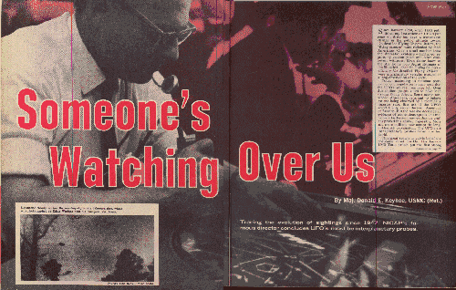
Since January 1950, when TRUE published my first article on UFO's (see page 6), there has been a tremendous change in the public attitude toward Unidentified Flying Objects. Before, the "flying saucers" were ridiculed by most Americans. Only a small number knew the dramatic evidence - confirmed reports by veteran pilots and other competent witnesses. Even fewer knew of the Air Force Top Secret Estimate of the Situation - that the Flying Saucers - officially Unidentified Flying Objects - were interplanetary vehicles engaged in a long observation of the earth.
Today, according to national polls, half of our population is convinced that the UFO's are real (see page 52). Over five million people claim to have seen strange flying objects. Some newly convinced Americans, reluctant to believe we are being observed by a technically superior race, first ask if the UFO's aren't highly secret devices - American or Russian. But the massive documented evidence of tremendous speeds and maneuvers far beyond any earthmade craft has proved this answer impossible. More and more millions now accept the long-hidden AF explanation: The UFO's are interplanetary probes from another world.
This great switch in public belief did not come about quickly. The January 1950 TRUE article put the first strong spotlight on UFO's, and hundreds of witnesses reported sightings they had withheld for fear of ridicule.
In 1952, a sudden outbreak of UFO sightings made front-page news, with hundreds of verified reports by military and airline pilots, control tower operators, expert radar trackers, and other reliable observers.
Early in 1953, one group of AF Intelligence officers connected with the UFO project planned to release their most baffling cases, also unexplained photographs of UFO's. No final conclusion was to be stated, though the released evidence would strongly point to the interplanetary answer. But at the last moment, fears of high-level officials caused the plan to be killed. Withholding of UFO reports and "explanations" to prevent public excitement steadily increased.
Despite this, many military reports leaked out because the pilots and others involved opposed this cover-up as a bad policy. In addition to UFO operations over the United States, thousands of similar reports came to light in foreign countries.
In November 1957, another outbreak of sightings further strained official withholding efforts, as a number of "touchdown" landings occurred in this country and abroad.
That same year, investigations were begun by NICAP - the National Investigations Committee On Aerial Phenomena - a private fact-finding group with headquarters in Washington D.C. As Director of NICAP, I have seen it grow to a powerful organization, recognized as the largest scientific UFO research group in the world, with over 12,000 members. NICAP has nearly 300 scientific and technical advisers and special consultants on space operations, astronomy, communications, and other fields bearing on UFO investigations.
Because of its serious and thorough evaluations, and its determined efforts to expose the numerous frauds, opportunists, and deluded persons spreading wild tales about UFO's, NICAP is now accepted as the highest private UFO authority in the world. Our documented reports to Congress and the press have played a major part in making hidden facts public.
After the "marsh gas" fiasco in the spring of 1966, millions of citizens began to reject the AF UFO explanations. High officials, still honestly believing that explaining away the sightings was the safest policy for the country, were caught in an unenviable spot.
The result was a decision to have an independent scientific investigation made - with officials agreeing to a "hands off" policy. The University of Colorado was selected, and a number of recent sightings has already had on-the-scene investigations by one or more scientists from the Colorado project.
Even before the project began operations, NICAP played a vital part, at the request of Dr. Edward Condon, the project head, and his scientific colleagues. In addition to advice on field investigations and evaluations, NICAP has made available several hundred verified reports, including many duplications of cases in AF files.
As a result, the Colorado Project has added to NICAP hopes for a fair and impartial report to the public. Although this is not due until late spring of 1968 - and more time may be requested - public pressure for all possible answers is rapidly increasing.
With at least half the country now strongly interested, it is now more important than ever to re-examine the strongest earlier cases, to search for possibly overlooked clues. It is also extremely important that witnesses to sightings put their reports on record, to help complete the picture and also to help the already lessening ridicule. I urge everyone with factual UFO sighting information to report the details to me at NICAP, 1536 Connecticut Avenue, Washington, D.C. 20036. If you wish, we shall keep your name confidential.
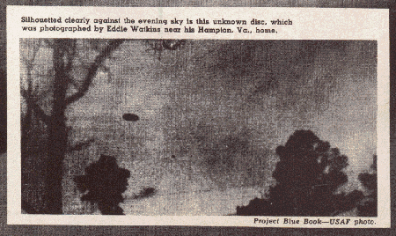

Silouetted clearly against the evening sky is this unknown disc,
which was photographed by Eddie Watkins near his Hampton, Va., home.
Project Blue Book - USAF photo.

Please visit today's

N.I.C.A.P.

The TRUE Report On Flying Saucers, 1967

"What radar tells about flying saucers."

by Maj. Donald Keyhoe
December 1952 issue of True (The Man's Magazine)

"I Know the Secret of the Flying Saucers"

by Maj. Donald Keyhoe
January 1966 issue of TRUE (The Man's Magazine)

