Donald E. Keyhoe Archives

The Donald E. Keyhoe Archives comprises 40 years of correspondence, documents, books, and audiovisual materials related to investigation and research of unidentified flying objects (UFOs). It was established to honor the memory of Richard Hall's mentor and friend, Major Keyhoe, and is made available to scholars, newspaper and TV reporters, and documentary film producers by appointment only. Users so far include the Turner Network (TNT), and the Discovery Channel.
A secondary collection relates to Major Keyhoe's background in Marine Corps and private aviation, and his association with Charles A. Lindbergh as a personal aide during Lindbergh's post-flight tour. It includes the writings of Charles and Ann Morrow Lindbergh, Major Keyhoe's writings on numerous other topics, books and articles about the Lindberghs, aviation history books, photographs, and memorabilia.
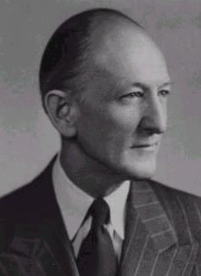 | 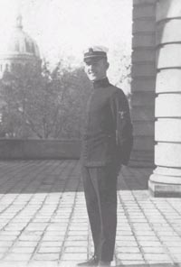  Donald Keyhoe in Naval Academy uniform,  circa 1918
DONALD EDWARD KEYHOE
(1897-1988)
http://www.hallrichard.com/keyhoe.htm
BIOGRAPHY
Donald E. Keyhoe was born in Ottumwa, Iowa, on June 20, 1897, at the dawn of human flight. He graduated from the U.S. Naval Academy in Annapolis, Maryland, in the Class of 1920, with a B.S. degree and the commission of a 2nd Lieutenant in the Marine Corps. During his senior year at the Academy, Robert Goddard published his theoretical paper, "A Method of Reaching Extreme Altitudes" (i.e., rockets), and two years later Hermann Oberth, the famous German space pioneer, wrote "The Rocket Into Interplanetary Space."
The Wright Brothers had flown at Kitty Hawk, N.C., when Keyhoe was a young child. Balloon flights were also much in the news. The young Lieutenant became a Naval aviator, piloting both balloons and airplanes in the period between the World Wars. In the years leading to World War II, Lieutenant Keyhoe commanded a flight of Naval seaplanes being ferried from the U.S. to Guam, and served on that island. After a night crash at Guam, he retired from active duty and began freelance writing.
Joining Government service, he became editor of the Coast and Geodetic Survey publications, then he was appointed Chief of Information for the Aeronautics Branch of the U.S. Department of Commerce. (This agency later evolved into the Federal Aviation Administration.) After Floyd Bennett flew over the North Pole on May 9, 1926, in a historic flight, Keyhoe was assigned to manage his nationwide tour in the "Josephine Ford" North Pole plane. Then when Colonel Charles A. Lindbergh about a year later successfully hopped the Atlantic in the "Spirit of St. Louis" and became a national and international hero, Keyhoe was assigned as his aide, accompanying the flier on his triumphant 48-State tour. Later he wrote the charming and popular book Flying With Lindbergh (New York: Putnams, 1928).
During the 1930s and early 1940s Keyhoe wrote fictional aviation adventure stories for then popular pulp magazines, inventing the heroic fliers "Phil Strange" and "Dick Knight," among other heroes and villains. He also contributed numerous factual articles to major magazines of the day on a wide range of topics, many popularizing aviation. The magazines included Saturday Evening Post, Cosmopolitan, American, Redbook, and True. Other articles and features appeared in the Sunday newspaper supplements This Week and American Weekly.
As war loomed in Europe, Keyhoe published M-Day: If War Comes, What Your Government Plans for You (New York: Dutton, 1940) dealing with U.S. mobilization for warfare. During World War II he was recalled to active duty with the rank of Major and served in the Pentagon in the Naval Aviation Training Division.
After the war he again retired to private life and resumed his writing career.

POST-WORLD WAR II
During the late 1940s and early 1950s, Keyhoe personally test-flew a wide variety of aircraft and evaluated their performance and features for True Magazine. When the first "flying saucer" sightings were reported in June of 1947, Keyhoe, as an experienced aviator was skeptical. But when True asked him to investigate in 1949 and he interviewed numerous fliers as well as military officers in the Pentagon, he discovered that expert observers had seen the unexplained discs, many at close range.
The more he investigated, the more he became convinced that the UFOs were nothing from this planet, apparently coming from outer space. He concluded that the Air Force had to know this and were covering up the truth.
His article "Flying Saucers Are Real" in the January 1950 issue of True became one of the most widely read and discussed articles in publishing history, and caused a sensation. The article was expanded into a paperback book The Flying Saucers Are Real (New York: Fawcett, 1950) and reached an even wider audience. This was followed by the major hardcover books Flying Saucers From Outer Space (1953), Flying Saucer Conspiracy (1955), and Flying Saucers: Top Secret (1960). In January 1957 Keyhoe had become Director of the newly formed National Investigations Committee on Aerial Phenomena (NICAP) in Washington, D.C., which under his leadership gave serious publicity to the UFO mystery through the 1960s and encouraged Congressional hearings.
His last book Aliens From Space was published in 1973. By this time Keyhoe had become convinced that the Central Intelligence Agency was the principal agency behind the cover-up. He spent his later retirement years at "Bluemont" in the beautiful Shenandoah Valley outside of Luray, Virginia, with his wife Helen Gardner Keyhoe, a native of Page County, Virginia. Mrs. Keyhoe was a member of the Daughters of the American Revolution and a prize-winning rose grower.

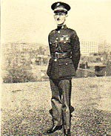
Donald E. Keyhoe photo from a brochure of the School Assembly Association, Chicago, Illinois, announcing speakers for the 1928-29 season. "Keyhoe is a noted flyer--a Marine Corps officer, retired--a recognized aviation authority. His talk is on the "Spirit of Aviation."
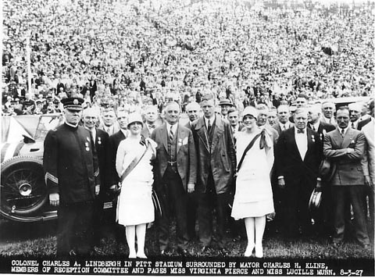
Above and R: photos from the Carnegie Library of Pittsburgh.  Above: Charles A. Lindbergh (center) and party being welcomed to Pittsburgh, PA, August 3, 1927, by Mayor Charles H. Kline and members of the reception committee during the national tour. Don Keyhoe is on the right, arms folded.  R: Enlargement of August 3, 1927 photo showing Charles A. Lindbergh (left) and Don Keyhoe (R), during national tour | 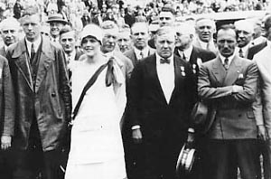
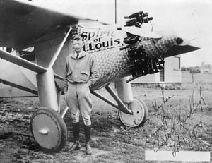 | Lindbergh standing in front of the "Spirit of St. Louis," photo inscribed to Don Keyhoe, October 1, 1927
Donald Keyhoe surrounded by students at Evans Junior High School in Ottumwa, Iowa (his home town). Photo from Ottumwa Daily Courier, April 6, 1958. | 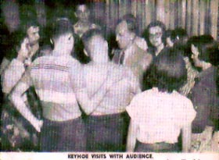
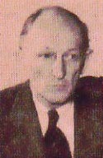 | Donald Keyhoe during a visit to Ottumwa, Iowa circa 1953 following publication of Flying Saucers from Outer Space. Photo from Ottumwa Daily Courier.
Dr. James E. McDonald, professor of atmospheric physics and meteorology, University of Arizona. McDonald's writings about UFOs are available from the Fund for UFO Research, P.O. Box 277, Mt. Rainier, MD 20722. www.fufor.com (Credit: Betsy McDonald and Ann Druffel) | 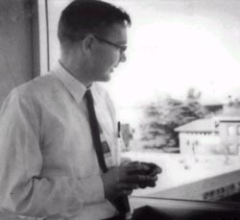
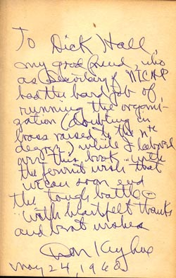 | Inscription to Richard Hall from Donald Keyhoe, 1960
A true love story. Donald and Helen Keyhoe in retirement years at "Bluemont," Luray, Virginia. | 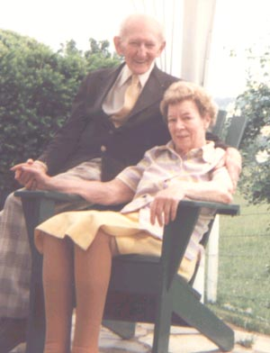

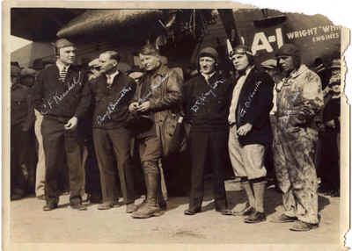
Donald E. Keyhoe with other aviation pioneers, 1927
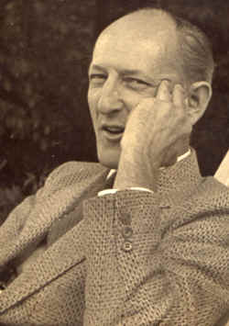 | Major Keyhoe in a light moment.

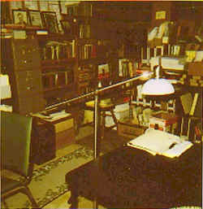
DEK Archives
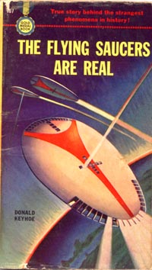 | 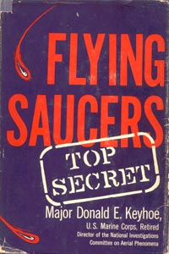
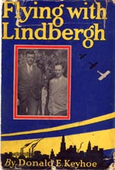

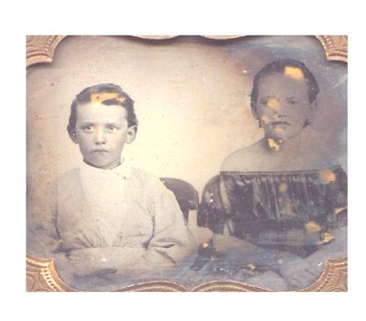 | Glass plate photograph in ornate gilt frame (approx. 3 x 3-1/2 inches) inherited from Helen G. Keyhoe, possibly showing family ancestors. The clothing might supply some clues as to its date. Note that the young woman on the right is wearing a low-cut blouse. Comments invited from photo and costume historians.

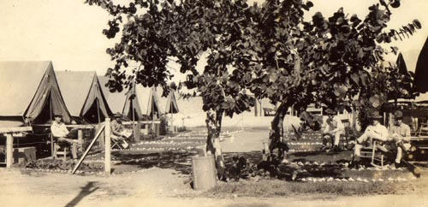
Major Keyhoe's Marine Corps camp on Guam, 1921

Major Donald Keyhoe

http://ourworld.compuserve.com/homepages/AndyPage/keyhoe.htm
No single individual has done as much as Keyhoe to pierce the veil of secrecy that imposed by the US military. As a former US Marine fighter pilot Keyhoe earned the respect of military personnel, especially pilots, who would often be willing to confide in him rather than the typical amateur UFO investigator.
Keyhoe established the most objective investigating organisation outside government circles. It is no accident NICAP was targeted for infiltration by the intelligence community. Since its demise no successor has emerged to effectively challenge them. Donald Keyhoe died in 1988.
Books:
Aliens from Outer Space: The Real Story of Unidentified Flying Objects - 1973
Flying Saucers: Top Secret - Putnam - 1960
Flying Saucers From Outer Space - 1953
Strange Effects For UFOs - 1969
The Flying Saucer Conspiracy - Henry Holt - 1955
The Flying Saucers are Real - 1950

http://www.qtm.net/~geibdan/piri_asc.html
Taken from KeelyNet BBS (214) 324-3501
Sponsored by Vangard Sciences
PO BOX 1031
Mesquite, TX 75150
January 29, 1992
- I have been reading a book by Major Donald Keyhoe titled 'Flying Saucers - Top Secret'. This book was copyrighted (C) 1960 by Donald Keyhoe. As you may know, Maj. Keyhoe was the Director of NICAP (National Investigations Committee on Aerial Phenomenon) back in the late 50's and 60's. I ran across a very interesting chapter, Chapter 16, which deals with the Navy investigation of a map which was discovered which caused them a great deal of concern. I am reprinting part of that chapter here for information. I am also interested in knowing if anyone might have further information on this map for discussion.
Major Keyhoe is in a meeting with Captain John Brent and Commander Larsen. Captain Brent was one of Major Keyhoe's classmates at the Naval Academy. Keyhoe has arranged the meeting to ask about reports that there had been UFOs 'observing rocket launchings at Cape Canaveral. And another report, from a missile technician at a different base, said they'd had to hold up launchings several times because of UFO interference.' During the discussion, the story comes out about the map....
"Why do you think UFOs are watching us?" I asked. "They may be afraid we'll cause trouble out in space," said Larsen. "And they'd have reason to worry, if they were dealing with Soviet space fleets."
"Have you ever thought," Captain Brent asked me quietly, "that the earth might be a colony started by another world?" I looked at him, startled. "I've heard it suggested, but--do you actually believe it?"
"I'm certain of this much," replied Brent. "A race far more technically advanced than we are today was on earth thousands of years ago." He swung around to a cabinet, took out a folder.
Page 1
"The Hydrographic Office of the Navy has verified an ancient chart--it's called the Piri Reis map--that goes back more than 5,000 years. It's so accurate only one thing could explain it-- a worldwide aerial survey." "That's almost incredible!" I said.
"The Hydrographic Office experts couldn't believe it, either, at first. But they no only proved the map genuine, it's been used to correct errors in some present day maps."
Commander Larsen leaned forward. "Tell him about the seismic soundings."
"All right." The captain turned back to me. "The Director of Weston Observatory of Boston College is a top seismologist - Reverend Daniel Linehan, Society of Jesuits. He's so good that the Navy got him to help in the Antarctic, to find where there was land under the ice.
The coast lines they found were identical with those on the Piri Reis map. So the map surveys would have to have been made centuries ago, before the land was buried by that deep ice.
"Father Linehan revealed this on a Georgetown University Forum, as proof that this map is genuine. The forum transcript also contains statements by the Hydrographic Office engineer in charge of the evaluation of the map -- Mr. M.I. Walters. Other significant points were made by A.H. Mallery, a retired sea captain--he's the man who persuaded the Navy to examine the Piri Reis map, after he realized how important the old chart was."
So far, Captain Brent told me, only part of the complete Piri Reis map had been found, a section covering the coasts of South America, Africa and a portion of Antarctica. He showed me a copy of the ancient chart, then read the main points of the transcript.
Early in the sixteenth century, Admiral Piri Reis, Turkish Navy, had acquired a map used by Columbus. Combining it with Greek maps dating back to Alexander the Great, he compiled a world chart in 1513.
In 1953, a Turkish naval officer sent the Piri Reis map to the Chief Engineer of the United States Navy Hydrographic Office. To evaluate it, the Chief Engineer asked the aid of Captain Mallery, an authority on old maps, who had previously worked with him.
Afte r a long study, Mallery discovered the projection method used. Confirming this and other technical points, the Navy cartographers came to these conclusions:
1. Columbus had a map, on his historic voyage to America, which showed the coasts of Yucatan, Guatemala, South America to the Straits of Magellan and a large part of the Antarctic coast.
2. The original maps went back at least 5,000 years, and some data shown went back even farther. Part of the land areas shown had been buried under ice for twenty centuries or
Page 2
more.
3. Only highly trained survey teams and cartographers could have produced charts of such "amazing accuracy." Their operations must have covered the entire earth.
"We don't know how they could do it so accurately without the airplane," Captain Mallery summed it up. Captain Brent put down the transcript.
"Mallery was right. They couldn't have done it without some type of flying machine. And there are other indications of a highly advanced technology thousands of years before Christ."
"But couldn't there have been an advanced earth race?" I inquired.
"Archaeologists have found evidence of other lost civilizations."
"Yes, but no trace of factories, laboratories or fuel plants. It would have taken a huge industry to build and maintain such an air fleet. But spaceships from another world wouldn't require any of that--they'd bring what they needed, just as we intend to do in our own space explorations.
"For the first stages, our men will live aboard their ships, after landing on the moon and Mars. This unknown space race could have done the same thing, and from that point we've worked out several possible developments."
Using the Piri Reis map evaluations, Captain Brent and Larsen had assumed spaceship landings at least 10,000 years ago. Before deciding on a colony, said Brent, the unknown explorers undoubtedly would have tested our atmosphere, gravity and other living conditions, to make sure their race could adjust to life on earth.
If overpopulation on their own planet had led them to plan a large scale migration, they would plan a civilization like their own, as far as possible. Technically trained groups would be brought in first, then basic equipment, just as we plan for our own space colonies. Following this, emigrants from their own world would be ferried to earth in huge spaceships.
"That's simple logic," said Captain Brent. "Our own planners expect giant spaceships, for this same purpose, within a century or two."
"Yes," I said, "but if this had happened there'd surely be signs of advanced construction--different and better than anything we have today."
Captain Brent agreed. "That's why we think something must have stopped them during the early stages. Possibly it was disaster on their own planet--accidental nuclear explosions, or an epidemic, or interplanetary war.
Even if their world survived, the earth colony might be almost forgotten as they rebuilt. It could be centuries before their descendants got around to checking up."
Meantime, Captain Brent continued, descendants of the first colony on earth would have developed on entirely different lines. When the
Page 3
spaceships failed to return, the colony members would be concerned mainly with survival.
Lacking machines and other technical equipment, they would be forced into a primitive life, their advanced civilization but an unhappy memory. To later generations, struggling for existence, the link with another world would seem only a myth--if thought of at all.
"And the net result," concluded Brent, "would be the same if the first group was deliberately abandoned here."
"Abandoned?" I said. "But why should they be?"
"To get rid of undesirables."
"That's an ugly thought."
"I don't mean criminals necessarily," replied the captain. "Though turning a planet into a Devil's Island isn't impossible."
Commander Larsen grimaced. "Being banished like that - most people would prefer a death sentence."
Further....
As I went out to the parking lot, I thought of another angle to the colony theory. What effect would this have upon religion?
At first, it appeared to deny the Biblical story of man's creation. But the landing of spaceships on an already inhabited world would pose no such problem, and the space race still could have played a vital part in our civilization. Ten thousand years ago, spaceships could have landed with no opposition. The primitive tribes then on earth would have been awed, probably frightened into hiding. ....
...More and more, I realized the difficulties of preparing the public. The most peaceful contact, even with beings like ourselves, would have a tremendous impact, raising a hundred questions.
Why wasn't the CIA, or whatever agency was in control, already at work on a program of prepartion?
Perhaps they were working on preparation. Recently, Don Ecker uploaded a file (USAFTXT.FIL) which contains the chapter removed from USAF training manuals dealing with the subject of UFOs. In this manual, there is discussion of possible involvement with UFOs going back as far as 50,000 years.
This material was being widely taught to cadets in prepartion for their military careers until publicity after the Condon Committee's recommendation to disband Project Bluebook brought unfavorable criticism to the Air Force for teaching this despite the findings that UFOs are not real.
The main point here is that apparently there was enough concern and curiousity on the part of the military to study the Piri Reis maps and conclude that they were authentic and the other conclusions that were derived from that study to indicate that they were sufficiently concerned about the UFO phenomenon to connect them with the maps.
Another interesting note in this material is the conclusions that the military was drawing out of it in regards to the ancient civilizations.

http://keyholepublishing.com/Summary.htm

The UFO problem reached its climax and resolution between 1966 and 1969. What had begun as a situation where anything seemed possible, in which flying saucer reports deluged the globe, ended with the sound of a door slamming shut. The Air Force, at the nadir of its credibility on the UFO issue in 1966, rode tall with the sanction of official science in 1969. The University of Colorado study on UFOs was riddled with dissension, and saddled with bad publicity; it produced a report that, for all its bulk, was remarkably skimpy where it mattered. Its conclusion did not coincide, even remotely, with its own data. But none of that mattered – a telling statement on the state of mainstream science, and a lesson in how to ride that capricious horse, known as the public. It also surely helped that UFO reports dropped, as if off a table.
The Air Force and the CIA had finally gotten what they had wanted for so long. Whatever UFOs represented to them, they could work on the situation henceforth in relative isolation from the prying eyes of the public. For, contrary to what Bollender claimed, UFOs were much more than an administrative burden. They continued to represent, and be, a real burden. The mere publication of a weakly supported scientific refutation could hardly be expected to change the judgments of those within the intelligence community such as Lambrose Callimahos of the NSA, the strike team members at Minot AFB who saw a hovering UFO over their launch facility, or famous scientists such as Paul Santorini. The explanations passed off to the public were not congruent with the situation the classified world continued to deal with.
Winners need losers, and by 1969 NICAP had lost in a big way. For all of Donald Keyhoe's faults, he had been NICAP's driving force, the Major who led the charge. His ouster loosened the organization from its mooring, and it soon crashed into the rocks. It may be that there was little Keyhoe could have done to save NICAP had he continued at its helm. The future looked bleak from any vantage point. But, old man that he was, Keyhoe remained its best hope. Without him, instead of going down fighting, NICAP committed suicide. Perhaps, with the CIA in mind, we should say, assisted suicide.
Did the public lose, as well? The answer depends on whether one believes truth to be of greater value than social stability. In 1968, Richard Nixon was elected President on a platform of Law and Order, amid a society with a disintegrating social consensus. Not everyone cared about Truth At All Cost; many just wanted to keep the machinery moving. At the front of the line – as it is in all places and all eras – was the national security apparatus, which saw the maintenance of stability and the status quo as its preeminent goal. Viewed from this perspective, at once paternalistic and self-serving, one might say the public interest was served. With the issue of UFOs at rest, the country, and perhaps the world, could move on to other pressing items.
There remains the small matter of truth, however. The problem with truth is that it ever remains the uninvited guest who crashes the party. Even in disgrace, truth is hard to get rid of. With the wrong conclusion coming from the Colorado University project – and it was the wrong conclusion – a new era of deception about UFOs had begun, one with the sanction of science. Inevitably, truth would pop up again, never without a challenge, of course, but there all the same. Within such a context, in the face of official denials about UFOs, truth could only erode the public's confidence in its leaders. It may be hard for later generations to appreciate the faith placed by those of an earlier time in their government, in their country. The death, long ago, of this faith testifies to the dangerous power of truth, not simply in relation to UFOs, of course, but to all activities of the national security state, including UFOs.

http://www.virtuallystrange.net/ufo/updates/1997/may/m24-013.shtml

From: Gary <galevy@pipeline.com>
Date: Sat, 24 May 1997 00:49:49 -0400
Fwd Date: Sat, 24 May 1997 15:51:52 -0400
Subject: UFOSEARCH #2 - Donald Keyhoe's Role In The UFO

This is the second of the series of essays I will be posting to UFO
UpDates.

Several of these essays were posted in the past in the
alt.paranet.ufo USENET newsgroup. There are approximately
25 essays in all.

I am posting these with the permission of the author. Unfortunately
the author is not presently available on the Internet. However, if you
would like to correspond with the author I have arranged a temporary
internet email address that I will use for forwarding the
correspondence to him. This is not a permanent email address.
The address is:

ufosearch@pipeline.com

I hope you find these essays as interesting and thought provoking
as I did.

Commentary:

If you would like to learn a bit more about Major Donald E. Keyhoe and
the origins of modern ufology, what serious student of the field would
not, then let me suggest two additional readings. These are instructive
in a number of ways. One will expose you through its treatment of the
subject matter to what some consider debunkery and the other will expose
you to what some consider the scholarly approach.

You will also discover that there is a refereed journal in this field
despite some people's assertions that they don't exist, in fact there is
even another one.

These readings are an interesting contrast in the treatment of Donald
Keyhoe and his role in the UFO phenomenon. Does debunkery exist? Was
Keyhoe a "hack" writer, concerned citizen or intelligence operative?
Read and judge for yourself...

UFO: The Government Files
Peter Brooksmith
Barnes and Noble, Inc.
1996
ISBN 0-7607-0218-7
$14.98

The indexed discussions of Donald Keyhoe in this book are on pages
29-30, 33, 35, 44-6, 57, 71, 47.

Donald E. Keyhoe and the Pentagon: The Rise of Interest in the UFO
Phenomenon and What the Government Really Knew
Micheal Swords
Journal of UFO Studies
New Series, Vol. 6 1995/1996
$21.00 single copy

The article is on pages 195-201.

The Journal of UFO Studies is published by:
The J. Allen Hynek Center For UFO Studies
CUFOS
2457 W, Peterson Ave
Chicago, IL 60659

Gary Alevy

And on to essay #2...

**********************************************************************

Donald Keyhoe's Role In The UFO Arena
(was: Who is Major Donald E. Keyhoe?)

UFOSearch
Val Germann
Columbia, Missouri

I want to thank Steve Meaders for his reply to my recent message
concerning the Major -- I could well be wrong about him. And
even though I think he was in some ways playing both sides of the
street, I still admire him greatly. He was in an awkward
position, still in the reserves and with many, many friends high
in the armed forces. I think if you closely study his role in
the Betty & Barney Hill affair you may find something there that
might illuminate his role a bit. The world of the "UFO" is very,
very complex, as is the "human" side of the thing. Below begins
a look at Keyhoe's 1953 book: Flying Saucers From Outer Space.
My comments appear inside (( double paren )).

Premonitions Of The Future, Part III
Flying Saucers From Outer Space; 1953
Major Donald Keyhoe, U.S.M.C., Ret.

Major Keyhoe died in the fall of 1988, about the same time
as the Lorenzens and Allen Hynek. He was all of 91 years old and had
been a friend of both Admiral Byrd AND Charles Lindberg! He was
a free-lance writer on military affairs throughout the 1930s and
1940s and put his career on the line as a promoter of the UFO as
interplanetary vehicle. His connections within the military were
and are unique and he was allowed to see "cleared" UFO reports
during the early 1950s. It was a different world then. The
"intelligence boys" had yet not taken over, or so it seemed.
Flying Saucers From Outer Space, now over three decades old,
remains amazing, especially in light of the Lear Letters,
Communion and Raymond Fowler's The Watchers.. Was Keyhoe
working for ???? in the early and middle-1950s when his influence
was the greatest? Was his job to float trial balloons up and see
who shot at them? Well, something strange and unusual was going
on as you will soon see.

The fantastic quote below begins on page 231 of FSFOS and is
contained in a chapter called `Exodus From Space.' The time is
early in 1953, more than 40 years ago! "Al" is Al Chop, then
Keyhoe's main liason between the press and the Air Force. His
office was in the Pentagon, if that helps any. A "PIO" is a
Public Information Officer. The "Utah film" is one of the most
amazing ever made, one that was never shown in its entirety to
the public. This film clearly showed a group of UFOs "maneuver"
and was made by a military photographer. "Riordan" is a fighter
pilot friend of the Major's and we begin with Keyhoe speaking.

"It was two days before I heard from the Pentagon. Then one
morning an Air Force PIO called me.

"Al told me to give you a message--he had to rush off to a
meeting. He said to ask you to come at about 2 pm. He's got
something to show you."

When I saw Al, I noticed he had a worried look. "What's
happened?" I said.

"There's been a spurt in sightings. Only a few have gotten into
the papers, but we've had 42 military reports alone, the first 17
days of February. I've got a few here for you." He was silent
for a moment, tapping has fingers on the desk. "It's not good,
Don. If it keeps on, there may be a lot of public reports. We
might have the July trouble all over again."

(( The "July trouble" refers to July, 1952, when UFOs overflew
the White House and Capitol, causing a nation-wide flap! This
flap has now, in 1995, dropped from the view of many in today's
`Ufology.' Notice how Keyhoe verges on being a co-conspirator,
almost a de-facto employee of the Air Force. ))

"I can guess the rest," I said, "They're backing down on the Utah
film showing." (( See Ruppelt's book for the inside view of how
the Robertson Committee killed the film for the public. ))

"Nobody's backing down," Al retorted. "Anyway, not the ones who
think it should be made public. But it wasn't the Utah business I
wanted to see you about."

Reaching into a desk drawer, he brought out a manila folder. As
he opened it, I saw several typed pages. "This script," he said
carefully, "has been approved for publication--on one condition.
I'll tell you what it is after you read it."

He handed me the pages and I looked at the title:

"Planet Earth--Host To Extraterrestial Life

"I stared at Al, then read the beginning. The key paragraph
repeated a statement which several scientists had made: In some
far-off future, when the earth cools or our sun expands, Man's
only chance for survival will be escape to another planet. This
situation, the script went on, can be expected on any inhabited
planet. Then one line seemed to leap from the page:

"Granted that superintelligents in another solar system are
looking for a suitable planet for a second home, why would earth
be singled out?"

(( You see, I really do like Keyhoe, in many respects he liked to
get to the heart of the matter. But. But. He never took the
train all the way to the station. I fault him for this because
he really did have a sophisticated understanding of the true
issues involved, quite sophisticated. We all should know that
every investigator in this field has ten times as much info held
back as they have ever published. Me, too. ))

"I looked at Al in amazement. "This is dynamite. You mean the
Air Force wants this made public?"

"It's not an official statement," he said quickly.

"Then what is it?"

"It's one person's opinion--a man named W.C. Odell."

"Not Colonel Odell, in Intelligence""

"Well--yes. But his Air Force connection can't be used on the
by-line."

"You'll never keep it secret, if this gets into print. The boys
in the press will dig it up. When that hits the wires, it'll
raise holy hell."

"The Air Force would say it was simply one man's opinion."

(( Unofficial info can always be denied! Here we see, in my
opinion, one use for Keyhoe, as the unofficial source for, as
Vallee's Major Murphy said, "Any rumor they want spread." Now it
is not as simple as that because I think Keyhoe was working for
one of several factions within "government" looking into the UFO
situation. A leak can have many purposes, many of them quite
legitimate and useful to the public at large. And Keyhoe might
have been quite willing to have been used, for the inside dope it
occasionally got him. In spite of some of the things I have said
about Keyhoe I actually admire him greatly -- he was walking a
very high and very tight tightrope indeed. ))

"But an Intelligence colonel!" Why take the risk--now at all
times!" (( Keyhoe takes up the cudgel of secrecy? ))

"Odell has the right to express a personal opinion, if it doesn't
violate security."

"For heaven's sake, Al! You know what this means. If this
invasion idea gets out after you show the Utah film--"

"It won't be published then, no magazine could get it on the
stands that quick."

"You think they'd sit on it that long? The minute the Utah story
breaks out, they'd resell it to a wire service, with joint
credit."

Al was silent.

"You want me to show this to True--is that it?"

"Yes, or any other magazine you write for. But make sure it is
clear that Odell's AirForce rank can't be used."

(( The question, of course, is WHY? Why do they want THIS out?
And, of course, Keyhoe knows this is the question. ))

"Look, Al, I've got to know what's back of this. Does the Air
Force want it out as one of the possible answers?"

Al shook his head. "I told you it was just one man's idea.
Security Review passed it. That's all I know."

(( And today, in 1995, that's all anyone knows! Except that we
do know now that the `Air Force' investigation was a front for
the real one. The article was never published. No-one Keyhoe
showed it to had the nerve to run it, or something -- Keyhoe
never really tells us. ))

"He put the script in an envelope, along with the February cases
he'd cleared. "Show it to your editors, and let me know their
reactions as soon as you can."

"I went out, still astonished. Even if Al were telling the
truth, it was incredible that Colonel Odell's suggestion should
be made public now. On the face of it, the Air Force was
throwing caution to the winds. But knowing the fight against
even the film showing, I couldn't believe it. There must be some
other answer."

(( Read the last several paragraphs again. This is how the
system still works except on a more sophisticated level. ))

(( Is what you will read below the fact, or at least what was
accepted as fact by insiders? Is this what the OTHERS had told
some of those inside and thus was in fact what they were then
believing? You decide. ))

Stopping under a corridor light, I read over the entire script.
It was quietly written, the invasion suggestions sandwiched
between discussions of space travel and astronomy. There was no
hint of a violent occupation of the earth. But nothing could
reduce the impact of Odell's suggestion. If he were right,
unknown beings from a dying planet were considering the earth as
a possible haven--a new home in which to perpetuate their race.
Possibly, as Odell said, the long survey would prove our world
was not suitable. Otherwise, Planet Earth might become --
willingly or no -- a "host to extraterrestrial life."

(( Now, notice the crucial concept here. These OTHERS are the
ones in trouble, not US, and this was perfectly acceptable in the
middle 1950s, before hardly anyone realized how we were tearing
up the Earth and its life forms. But today we know that WE are
in trouble, too, and WE may be the ones needing help! This is
the operative paragraph. If true, it explains so much of what
has been going on for so many years. How could such information
have been garnered? Well, nowhere except from THEM, of course.
But how did our insiders *KNOW* that what they were told was in
fact the truth? Answer: they DIDN'T. But the story was one they
could live with, it posed an old, failing alien race interacting
with a young, virile humanity (the Captain Kirk syndrome). But
was all of this only a cover story, a deadly one? I think so. ))

"On the way to the airport, I thought over Odell's suggestion.
The mass migration idea wasn't new--it had been used in dozens of
stories and plays. But I'd never taken it seriously; moving any
large number of people from a distant planet seemed impossible.

(( And IS impossible. But we now know there are OTHER ways!! ))

"Of course, it could be done gradually, over a period of time.
Even then, the problems seemed enormous, though they might not be
barriers to a race which had long ago mastered space travel.
How would Man, in some far-distant age, go about migrating to
another planet? In that far-distant time, Man would certainly
have mastered interstellar flight. Long before the earth becomes
unbearably hot or cold, our descendants would begin to look for a
new home in the universe.

"Since no solar system planet has a climate like earth's, the
nearest star systems would be explored first. Perhaps a twin to
the Earth will be found; if not, the explorers would search
farther and farther. During a long exploration more than one
earth "twin" might be found. If the nearest one were inhabited,
our descendants might choose a more distant planet, especially if
the planet race were strong enough to resist invasion.

"Once an Earth II was selected, bases would be set up and an
occupation force gradually brought in."

(( To secret bases in New Mexico, as per Lear and Cooper, for
instance? And you thought all of that was NEW! ))

"On a planet similiar to this, evolution probably would have
produced fish and fowl, also animals which the colonists could
domesticate. If not, small numbers could be brought in to start
such life."

(( Or, as we know today, genetically created, the way it would
have to be done! The lynch pin to the whole deal would be
whether or not the "others" could be modified enough genetically
to live on the Earth without a lot of hardware. How long would
it take to discover this? Years. . .decades. . .centuries --
longer? Such a situation would explain a great deal concerning
the "UFO," would it not? ))

(( It was right after this `explanation' was `leaked' by the `Air
Force' that "Project Aquarius" was said to be formed. The UFO
was taken away from project Grudge and given to "Aquarius," i.e.,
put under an airtight intelligence umbrella where it has remained
ever since. ))

"Even with giant space ships, moving most of the earth's
population would be impossible. At first, probably, migration
would be limited to technicians, builders, defense forces and
their families. It might take hundreds of years for Earth II to
be fully occupied. Migration might be voluntary, but probably it
would be restricted to younger age groups--except for key
scientists and various experts."

(( Or, you might create your people "in situ" on the new planet
through genetic engineering, using local resources and even
assistance! Now there is speculation!! ))

"But if the planet were inhabited, a different plan would be
used. The choice of such a planet might be forced on the
Earthlings; it might be the only one on which they might survive.
Or it could be a cynically deliberate choice--the homes,
industries, farms and mineral supplies of the planet race might be
short cuts to colonization."

(( Or more importantly, to use the lifeforms that already exist
there, their resources, their genetic material! ))

"Either way, the fate of the planet's inhabitants would depend on
the character of future man. By then, a wiser human race may
have outlawed war, or they may have degenerated into scientific
barbarians."

(( The question of the century, already answered. ))

"If our descendants were peaceful, they could suggest a friendly
coexistence to the planet race: the earth's scientific
advancement might be held out as an inducement.

(( Here, of course, is the Lear scenario, suggested 35 years
before the first Lear Letter was written. Is some kind of
"genetic coexistance" being proposed by these "others" and this
is the reason behind the abductions and genetic experiments? And
think about this--could it be that it is not these "others" who
are in trouble but humanity? That is, could they be here because
we are about to do ourselves in and they are trying to save what
they can--and inherit the Earth later? Such is possible. ))

"But if future Man is a cruel materialist, he would take one of
two steps: 1) Destroy the inhabitants and take over their world.
2) Conquer them and use the captive race as forced labor.
Even if the earthlings desire peaceful occupation, it might not
succeed. A race too weak to resist would be no problem but an
advanced race might fight. If the planet were the only possible
choice for Earth II, our descendants would probably have to use
force if reason failed. Once in control, they might persuade the
inhabitants to cooperate.

(( The Lear Letters, of course, suggest one of the scenarios
above is in fact taking place now. They suggest our elites may
be trading living space or support for other programs for
scientific advances--or at least they're trying. But the
"advances" turn out to be MAJIC beans, according to some. ))

Way-Cool, huh?!

Major Keyhoe's Role In The UFO Arena -- Part Two

Val Germann
Columbia, Missouri

We continue quoting and commenting on Keyhoe's Flying Saucers
From Outer Space. Keyhoe is just finishing reading a script
given to him by Al Chop, a public information officer assigned by
the Air Force to Project Blue Book. Chop would later go to NASA
and climb high in that organization, his association with "Flying
Saucers" not hurting him one bit. "Riordan" is an Air Force
pilot friend of Keyhoe. My comments on this material are inside
(( double paren )) --

"It is possible that the earthlings would discover a highly
superior race, forcing them to renew their search for a second
home. If none were found they might, in desperation, stage a
sudden attack with their most deadly weapons, hoping surprise
would overcome the inhabitants defenses. Should this fail,
undergound life on earth would be Man's last hope.

"When I went into the airport terminal, there was no sign of
Riordan. He came in a few minutes later, as I was leaving the
American Airlines counter. We went up to the deserted mezzanine
section and I told him about Colonel Odell's migration answer.

"Good Lord!" Riordan said. "Does the Air Force really
believe that?"

"I don't think so, but I'm puzzled at their letting Odell
say it."

(( Exactly the proper response and a question that Keyhoe does
not really answer to my satisfaction. Was he simply the last cog
in a transport mechanism that the "Air Force" was using to
disinform the American people? This is what many would say. ))

"Riordan skipped throught the typescript, pausing at the key
points.

"It's fantastic," he muttered, "If an Intelligence colonel
hadn't written it--" he stopped. "There's one thing for sure, if
any other race tried to muscle in here, there'd be one hell of a
fight."

(( Americans are absolutely obsessed with "race" as a biological
concept, most revealing in its own way. Notice the concern with
the idea of others "muscling in" the same way we in the Western
World have been muscling in around our globe. ))

"It would depend on their weapons-- "

(( A most interesting concept, he at first seems to be saying,
"Well, if their weapons are really overpowering there wouldn't be
much of a fight." Or, think of this, Keyhoe could have meant
something like "We might not even RECOGNIZE their weapons." ))

"We'd fight anyway," Riordan said. "I can't see Americans--
or the rest of the world, either--letting themselves be pushed
off onto reservations like the Indians. They'd have to finish us
off before they could settle here."

(( Spoken like a true imperialist. But never mind. Here we see
the primary reason this kind of thing would never be made public,
never. Well, at least not until it was too late. Like now? ))

"I still think one of the other answers is more likely. But
even if it's true, it doesn't mean they've definitely decided on
the Earth. They may be considering some other planet. They
might have trouble with our atmosphere; if they find they can't
adjust they might give up. There could be a dozen reasons why
they'd have touble settling here."

"Even if they did select the earth, it could take them years
to be able to start migration. And if they tried it on a small
scale, we could handle them. Also, we might have space ships by
then, maybe new weapons to hit them with. Of course, if the
earth was their only choice, they might rush things."

(( Here, too, are fertile ideas for Lear Letter speculation. Is
the `survey' still ongoing or have they made up their minds! Is
that the reason for all the leaks of late--many on the inside see
an actual invasion shaping up and are trying to force the issue
into the public realm! This is possible. ))

Riordan made a face, "Damn it, I still say it's fantastic, intelligence
colonel or not!"

(( I would have said, "Well, intelligence colonel, it's GOT to be
fantastic!" ))

"The thing that bothers me," I said, "Is the Air Force
clearing this thing."

Riordan gave me a crooked grin, "Even though I don't believe it,
I wish I hadn't heard it."

(( This was exactly my response to the Lear Letters. But, again,
no answer from Keyhoe as to `why' this stuff is to be allowed
out. The reason that Keyhoe can't answer the question is because
the answer would involve discussion of what the `Air Force' was
using him for! That was something he would not talk about! ))

"As my airliner droned over Baltimore, I looked down over the
sprawling city. Would this and other American cities be coveted
by unknown space races? Would they offer the homes, industries
and food that these mysterious beings required? Or would their
needs be totally different? Even if they closely resembled us in
form, they might have developed a civilization so strange that
ours would be totally useless to them. . .

(( Very important. Only a small part of our biosphere is
probably of any use to them. And they might wish to sort of,
well, clear the air a little before they really start getting
down to serious business. Thus, a little mass extinction. ))

"For two days after my return from New York, I heard nothing from
the Pentagon. Finally I called Chop, but a PIO told me he was in
a conference.

"I left word for him to call, and a little later the phone rang.
But instead of Al, it was Henry Brennard, the man who had tipped
me off to the Utah pictures.

"Did you hear about yesterday's blow-up over the saucers?"

"No," I said, "What happened?"

"There's been a rush of new sightings."

"I know that. Chop told me."

"Well, most of them have been kept quiet. . .then on top of
that an Intelligence colonel got an article cleared."

"You mean the Odell piece? They let me see it."

"That set off another row. . .it's another argument for
slamming down the lid tight."

"You mean they've done that?"

"No, but the Central Intelligence Agency recommended it,"
Brennard said. "At least that's what I heard."

(( Here we see the ripples spreading out from the Robertson
Committee, still a Top Secret as Keyhoe wrote this book. ))

"How did the CIA get into this?"

"The Air Force gave some of their top men a secret briefing.

The CIA people told them to put out a new report, debunking the
saucers the way they did in '49--tell the people the project was
ended, and then carry it on underground. It'd probably be top
secret."

(( The Robertson Committee, part of what I call the Second
Crackdown -- see Chronology. Hynek was a full participant in
this and since he kept his job for a couple of decades beyond it
he MUST have signed off on it. Thus "Aquarius," or something
very much like it, was by then in full control. ))

"They'd never get away with it--not with all they've let out
now!"

"I don't think they'll even try. Some of the boys are mad
at the CIA for even suggesting it. . . "

(( `Some of the boys' got quiet real quick as you'll see! ))

"I had barely had time to put down the phone when it rang again.
This time it was Al.

"I've resigned," he said bluntly. "You'd better come on in
and meet my relief."

"Look, I heard there's been a big row over the Utah film."

"I don't want to talk about that now. Come on over to my
place tonight and I'll tell you what I can."

"When I saw Al that night he told me that there were two groups
deadlocked over the secret film. . .one group wants to say the
objects might have been reflections."

"But the analysis!" I said. "Those speeds and maneuvers
proved the things couldn't be birds or balloons--or even jets.
Both ATIC and the Navy agreed on that."

"It's not my suggestion--don't get mad at me. . .they
honestly think they're right--that it's better to keep the thing
quiet and not stir up the people."

(( Keyhoe, through Chop, presents the justification for denying
to the American people the story of the millenium. "Aquarius" or
"MJ-12" (or whatever) clamps down the lid. And note that the
information Keyhoe is getting is correct, as far as it goes. ))

"It's a dangerous gamble, Al. What if something happens and
the public isn't prepared--"

(( At this point Keyhoe thinks "invasion" might be imminent and
wants to guard against panic! Chop doesn't blink an eye! ))

"I know, but it isn't settled. We may yet win."

(( But, of course, we know by now that they didn't win! ))

"I believe four steps should be taken as quickly as possible:

"1) The secret Intelligence analysis should be made public, with
all the evidence which led to the final conclusion.

"2) The Utah film should be released, with the detailed
statements by Air Technical Intelligence and Navy Photo-Interpre-
tation.

"3) Project Bluebook should be expanded, given the fulltime
services of top-level scientists, and coordinated with foreign
investigations. An integrated, world-wide investigation will
probably reveal new facts, especially clues to the motives of the
unknown space race.

(( As yes, those motives, you know, they may have come all this
way just to admire Niagra Falls! ))

"4) A plan for communication and eventual contact should be
drawn up and made world-wide if possible. Such a plan should
include standard radio and visual signals for all aircraft, ships
and ground stations. Detailed steps should be worked out to
cover every possible development, from the first message to the
saucer landings.

(( The last two of these things were even then being done, of
course, under "Aquarius" or whatever, and in deepest secrecy.
That is why there has not been a `real' scientific investigation.
One hasn't been needed since 1953! ))

"If there is any proof that attack or invasion is planned--we
should be told at once. The American people have risen to
supreme heights before. They would undoubtedly meet this danger,
after the first hysteria, as bravely as they have faced all of
our great crises.

(( Well, this is a nice thought. . . ))

"All of us--every nation--should be told the truth and be made
ready for the saucer landings. Even if we are fully prepared,
there will be tense moments. We must accept the possibility that
the saucer creatures will differ from us in form. Even if they
are utterly friendly, their strange appearance could cause panic.
But there may be no such problem.

(( Does he really think our top dogs want to tell the hoi-polloi
that there are other, even topper dogs, on the Earth today? To
ask the question is to answer it! ))

"These beings from another world may resemble us closely, in form
if not in size. Regardless of their appearance, we must be ready
to match the friendliness of any strangers from space. Those
first dramatic moments may decide the fate of our world."

(( I think that the scenario that Keyhoe lays out here has some
small possiblity of being true! This "deal" that our betters
made with these aliens could be much the one that Keyhoe
describes--they traded "advances" for alien "living space."
There is evidence that extreme pressure was put on some of our
top people in the 1947-48 period, again in 1951-52, yet again in
1965-66 and once more in 1973-75. If a "deal" was made it was
completed in the 1973 time frame, in my opinion. But someone
always leaks. Depend on it. All do not like the policy.
That is, is the above possibility what is bothering those who
leak documents to independent researchers? Is this what is going
on? I think it could be the fact, in some cases. But how will
anyone on the outside ever find out for sure--when the "saucers
land?" If so, it will be way, way too late by then, won't it! ))

