Historical Artwork and Photos of UFOs Before 1947
by Matthew Hurley

http://homepage.ntlworld.com/m.hurley/index.html

For a number of years I have been intrigued by old artwork that appears to depict UFOs. The artwork in my collection consists of frescos, tapestries, illustrations, oil paintings and early photographs. Although some of the artwork represents actual sightings, others feature UFOs in a religious context. One can only guess at why these artists chose to insert UFOs into their artwork. Did they have UFO sightings in their day and decide to add them in ? Perhaps they had an inner urge to insert them. Maybe they had some arcane knowledge about the relationship between UFOs and certain religious events. Whatever the truth is, there are UFOs in these pieces of artwork and one can ponder and reflect on this truth.

UFO artwork B.C.

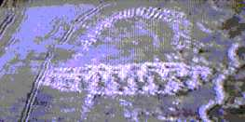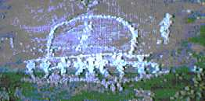
These petroglyphs were created thousands of years ago by ancient Indians in the American Southwest. According to Indian folklore, two objects collided high in the sky and one crash-landed in the region of Death Valley. Some men arrived (presumably in another ship) and spent some time repairing the damaged Craft and were observed by the local Indians. The two images below may possibly depict the ship (left) used by the men who came to repair the damaged craft. In comparing the two images, the one on the right seems to depict structural damage around the edges and the bottom. Could it be the one that allegedly crashed? The images are stills taken from an old TV series entitled "In search of..." hosted by Leonard Nimoy.

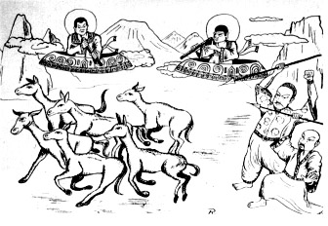
This is an artistic reproduction of a relief found in a labyrinth on the island Jotuo in the Toengt'ing lake. An expedition took place in 1957 (two years before an earthquake in that region). The expedition was led by professor Tsj'i Pen-Lai. They found various reliefs showing "humans" in strange clothes which looked like astronaut suits (hose like objects attached to the clothes). They also found a painting which apparently resembled the solar system. The third and fourth circle (planet) were connected with a line. Also there were ten planets (excluding the sun as planet). This connects easily to the theories about Nibiru, planet X, etc.

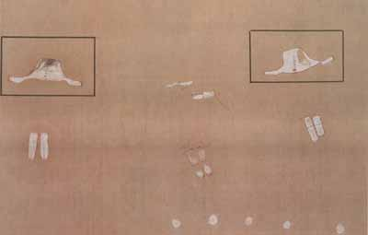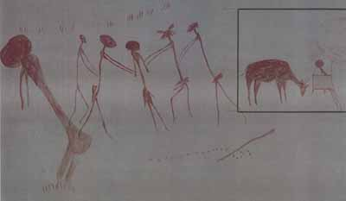
These are two cave paintings from Tanzania. Both are estimated to be up to 29,000 years old. The one on the left is located in Itolo and depicts several disc shaped objects. The other painting is from Kolo shows four entities surrounding a women.

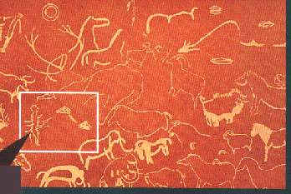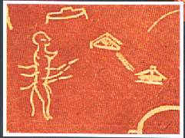
This two images are from France, the cave of "Pech Merle" near "Le Cabrerets" c.17,000 - 15,000 BC. The scene depicts a landscape full of wildlife together with a number of saucer shaped objects. The objects seem totally out of context. Notice also the bipedal figure has a tail.

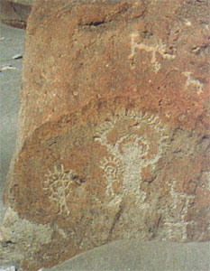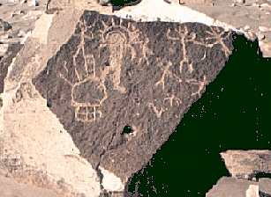
These two examples of rock art are from Toro Muerto,Peru 12-14,000 years old. Notice the beings have some sort of halo or covering over their heads (compare with the Val Camonica photo below). Also, in the right hand picture there is some sort of object left of the main being. Possibly a UFO ?

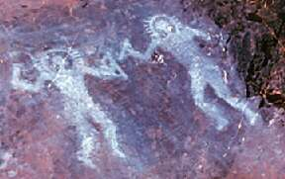
This cave painting is c.10,000 BC and is from Val Camonica, Italy. It appears to depict two beings in protective suits holding strange implements.

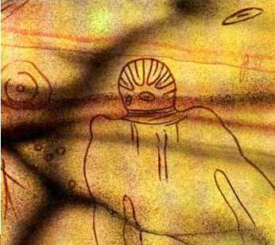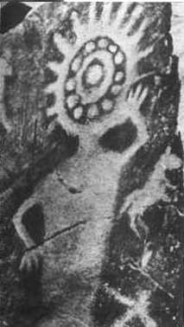
Two images c.6000 BC from Tassili, Sahara Desert, North Africa. They do not look human do they ? Also notice the disk in the sky in left hand picture.

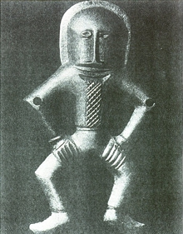
This strange suited figure was found in Kiev and I believe its dated to 4,000 BC.

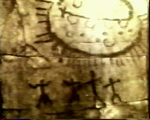
This is a 7000 year petroglyph discovered in the province of Querato, Mexico in 1966. You can see 4 figures with their arms outstretched below a large oval object radiating what appear to be beams of light.

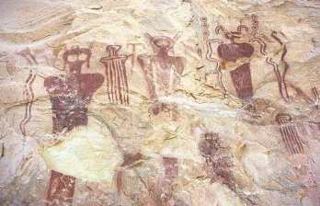
More strange looking figures this time from Sego Canyon , Utah. Estimated up to 5,500 BC.

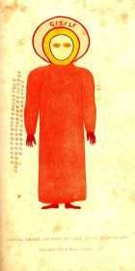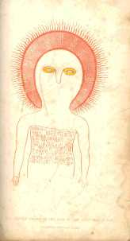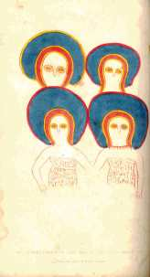
These are illustrations from a book by Lt. Grey. "Journals of Two Expeditions of Discovery in North-West and Western Australia 1837, 1838, & 1839". He led an expedition in the 19th century to some caves near the Glenelg River region of Kimberley, Northern Australia where he came across a series of cave paintings. The beings are called the Wandjina by the Aboriginies who painted them.

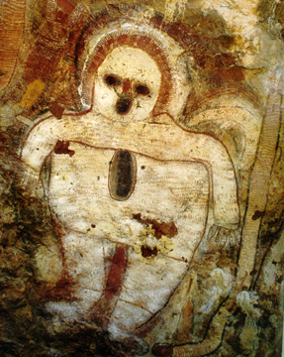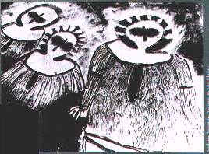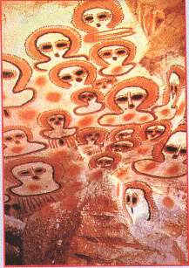
More examples of Wandjina. These a images from Kimberley, Australia. Possibly 5,000 years old. Some people believe they may represent ET beings. Here is a link giving you more info on Aboriginal beliefs

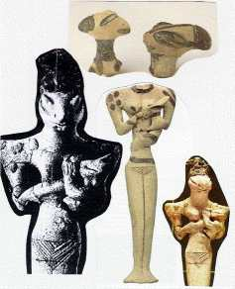<>
The above photo is of a number of reptilian entities found in Iraq. They are dated at 5000-4500 BC. They are housed in the british museum

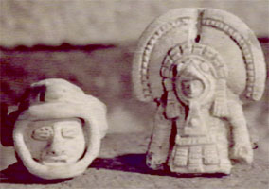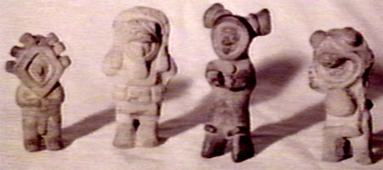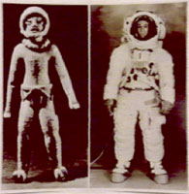
These photos depict figures found in Equador. Notice they appear to be wearing space suits. You can see a comparison photo with an Apollo astronaut.

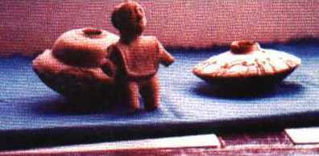
Some ceramic Incan artifacts showing discs and a suited figure

UFO artwork A.D.

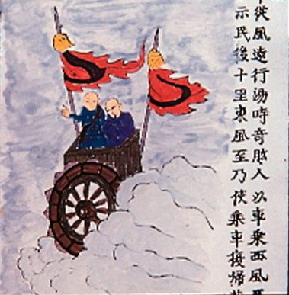
This is an old Chinese illustration from a fictional book entitled "Illustrated Survey of Weird Countries" (c.1400 A.D.) and had the following original caption: "Ji Gung Land: The people could make flying cars that travelled far with a suitable wind. In Tarng's day (c.1700 B.C.), Ji Gung people flying a car on a westerley reached Yew Jo. Tarng dismantled their car so it could not be demonstrated to the people ... Later an east wind came on which he had them fly the car back to their own country [5,000 km] west pf our gateway."


This artwork is alledgedly from the buddhist Dharamsala temple in Himachal Pradesh, India. This is where the Dalai Lama lives in exile. You can just make out six silvery saucer shaped objects.

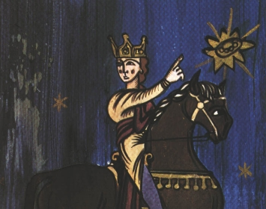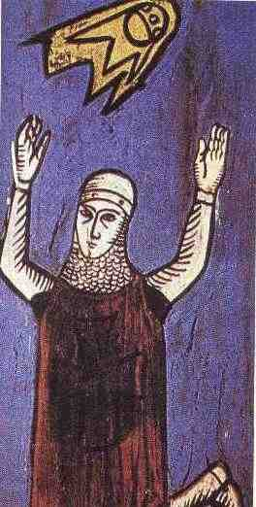
These images of two crusaders date from a 12th century manuscript " Annales Laurissenses" (volumes/books about historical and religion events)and refer to a UFO sighting in the year 776, during the siege on Sigiburg castle, France. The Saxons besieged and surrounded the French people. They both were fighting when suddenly a group of discs (flaming shields) appeared hovering over the top of the church. It appeared to the Saxons that the French were protected by these objects and the Saxons fled.

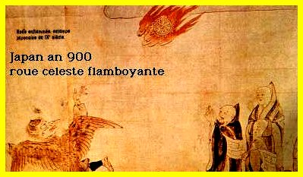
This is an illustration depicting a sighting of a burning wheel in the year 900 over Japan.

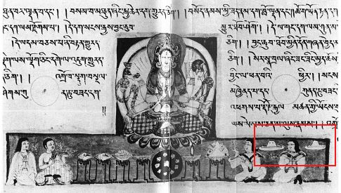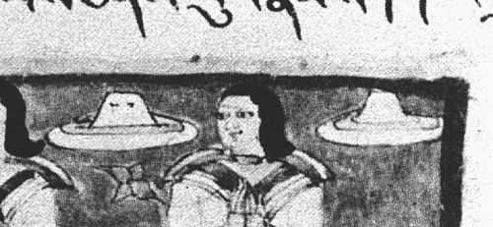<>
The above image comes from the 10th Century Tibetan translation of the Sanskrit text "Prajnaparamita Sutra", held at a Japanese museum. In the enlargement you can see two objects that look like hats, but why are they floating in mid air ? also one of them appears to have port holes on it. Indian Vedic texts are full of descriptions of Vimanas. The Ramayana describes Vimanas as a double decked, circular or cylindrical aircraft with portholes and a dome. It flew with "the speed of the wind" and gave forth a "melodious sound".

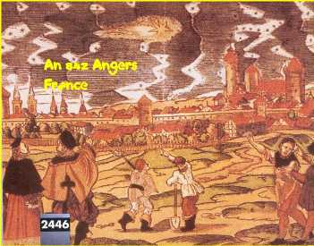
This is an illustration of a sighting that occured in the french town of Angers in the year 842. I'm not sure when this illustration was done or who it was by however.

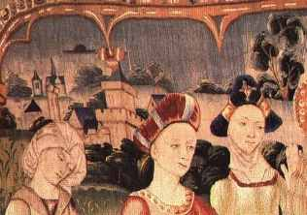
These two tapestries were created in the 15th century. Both depict the life of Mary. Hat shaped objects can be clearly seen in both tapestries.The one on the right is entitled "The Magnificat". Both are located at the french basillica Notre-Dame in Beaune, Burgandy.

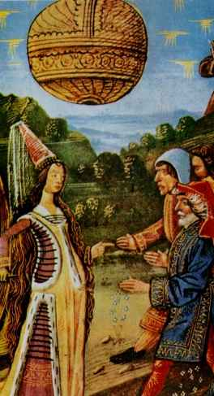
This image cames from the french book "Le Livre Des Bonnes Moeurs" by Jacques Legrand. You can find this book in Chantilly Condé's Museum ref 1338 ,297 part 15 B 8. Some people say that the sphere is a Montgolfiere ( french name for baloon) but there was no baloon in france in 1338 ...

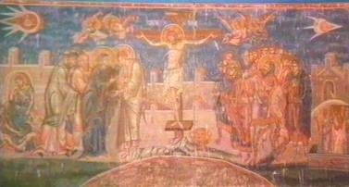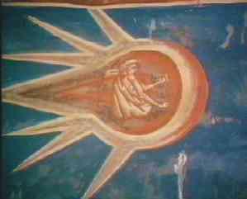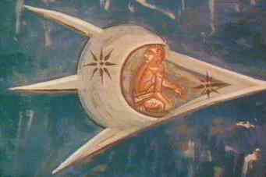
The first picture shows a fresco entitled "The Crucifixion" and was painted in 1350. Two objects with figures inside can be seen in the top left and top right of the fresco. Two enlargements of these objects are shown above. The fresco is located above the altar at the Visoki Decani Monestary in Kosovo, Yugoslavia

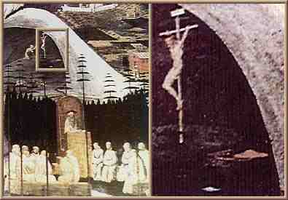
The above painting is by Paolo Uccello (1396-1475) and is entitled "La Tebaide" (painted c.1460-1465). The blown up picture on the right shows a red saucer shaped UFO seen near Jesus. It hangs in the Academy of Florence.

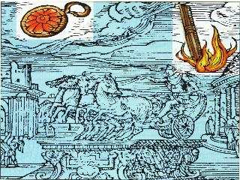
This is a renaissance illustration of a UFO sighting in Rome detailed in a book "Prodigiorum liber" by Roman historian Julio Obsequens - "Something like a sort of weapon, or missile, rose with a great noise from the earth and soared into the sky".

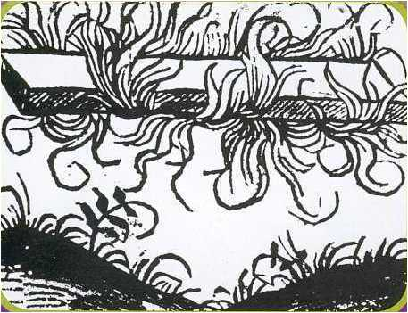
February 1465. The above illustration is from Notabilia Temporum by Angelo de Tummulillis. It describes a flaming girder seen in the sky during the reign of Enrico IV. , looks similar to the object in the Obsequens picture above.

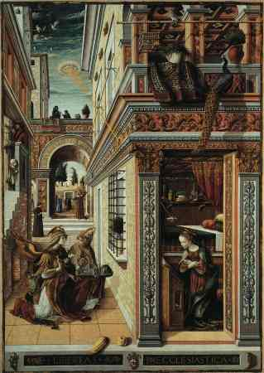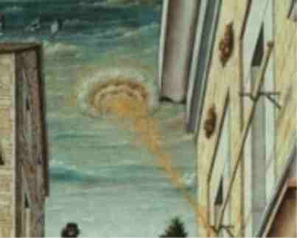
The above painting is by Carlo Crivelli (1430-1495) and is called "The Annunciation" (1486) and hangs in the National Gallery, London. A disk shaped object is shining a pencil beam of light down onto the crown of Mary's head. A Blow up of the object is next to the painting.

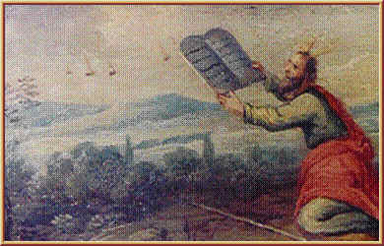
The above is a painting on wood drawer from furniture kept at the Earls D’Oltremond, Belgium. Moses is receiving the tablets and several objects in the sky are seen near by. Date and artist unknown

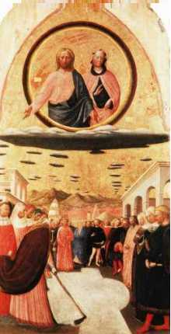<>
The above picture depicts Jesus and Mary on what appear to be lenticular clouds. The painting is entitled "The Miracle of the Snow" and was painted by Masolino Da Panicale (1383-1440) and hangs at the church of Santa Maria Maggiore, Florence, Italy.

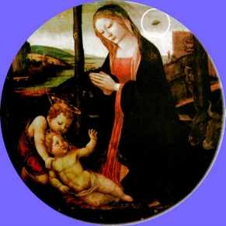
This painting is called "The Madonna with Saint Giovannino". It was painted in the 15th century. The Palazzo Vecchio lists the artist as unknown although attributed to the Lippi school.Above Mary's right shoulder is a disk shaped object. Below is a blow up of this section and a man and his dog can clearly be seen looking up at the object.
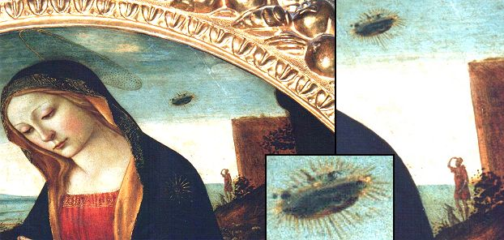<>

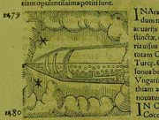
The above picture is from a book entitled Prodigiorum Ac Ostentorum Chronicon by Conrad Lycosthenes (1518-1561). Basel: Henricpteri, 1557. It depicts a UFO sighting in Arabia in 1479. The book is held at the Australian Museum Research Library.

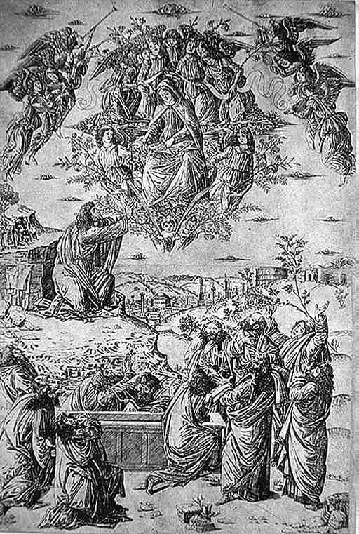
The above image is entitled "The Assumption of the Virgin" by ANON. Painted c.1490. Once again notice the discoidal clouds.

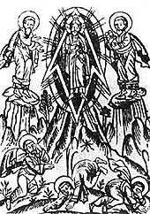
This is a 15th century fresco from Kiev. Seems to show Jesus in a rocket type device

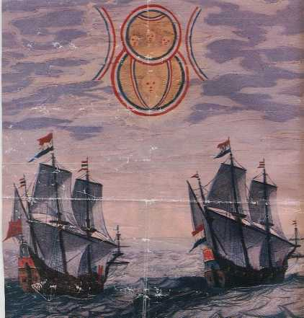
1660. The illustration depicts a sighting by two Dutch ships in the North Sea of an object moving slowly in the sky. It appeared to be made by two disks of different size. The source for this account is one of the books entitled :"Theatrum Orbis Terrarum" by Admiral Blaeu. These books were compilations of articles by different authors and consisted of detailed accounts of long engagements at sea, cartography information etc.

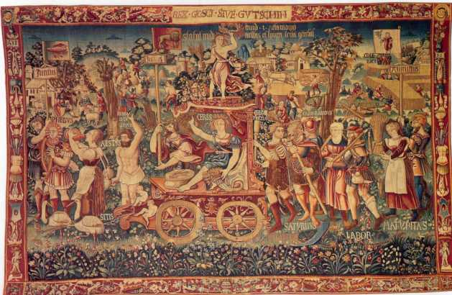<>
This is a tapestry called Summer's triumph and was created in Bruges in 1538. It now resides at the Bayerisches National Museum. You can clearly see several disc shaped objects in the top of the tapestry. Someone has speculated that they are islands, if so, then these islands are floating in the sky !


The above image is of an actual sighting that occurred in Nuremburg on the 14th April 1561. It appeared in a local broadsheet and was a woodcut by Hans Glasser. The globes, crosses and tubes began to fight one another, and this went on for an hour. Then they all fell to earth, as if on fire, and faded slowly away producing a lot of steam. Afterwards a black spear-like object was seen, and the whole event was taken to be a divine warning. Held at the Wickiana Collection, Zurich Central Library.

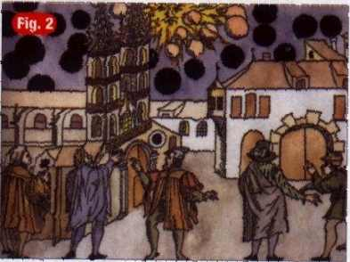
This broadsheet picture by Samuel Coccius illustrates a UFO sighting over Basel, Switzerland in 1566. 'Large black Globes' appeared in the skies. It is held at the Wickiana Collection, Zurich Central Library

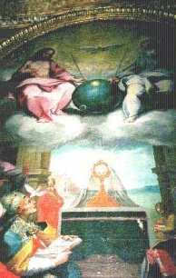
The above painting is by Bonaventura Salimbeni entitled "Glorification of the Eucharist", painted in 1600. Notice the Sputnik satellite device. It hangs in the church of San Lorenzo in San Pietro. It is considered by some to be a stylised representation of the Earth but I have included it here as it still looks interesting. More info.

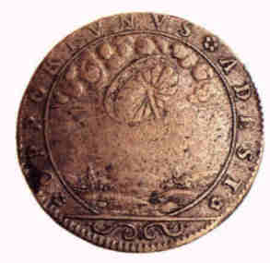
This is a French medal apparently commemorating a UFO sighting of a wheel like object in 1680. Artist/location unknown.

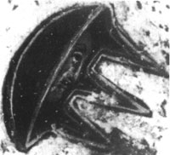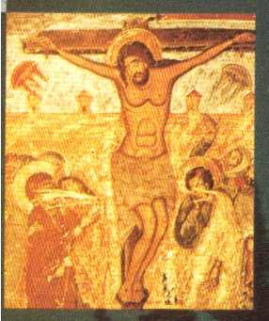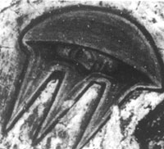
This is a 17th century fresco and is located in the Svetishoveli Cathedral in Mtskheta, Georgia. Notice the two saucer shaped objects either side of Christ. In the two blow ups you can see they contain faces.

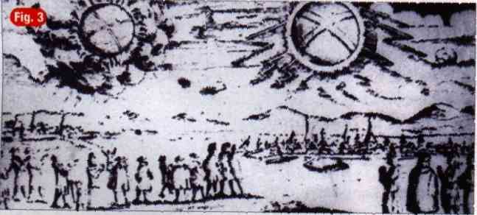
More wheels ! This picture shows a UFO sighting over Hamburg, Germany 4 November 1697. The objects were described as "two glowing wheels"

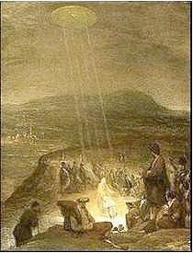
This image is by flemish artist Aert De Gelder and is entitled "The Baptism of Christ" It was painted in 1710 and hangs in the Fitzwilliam Musuem, Cambridge. A disk shaped object is shining beams of light down on John the Baptist and Jesus.

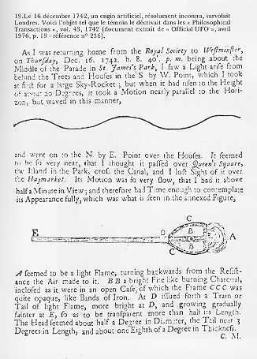
This is a scan from vol. 42 of the Philosophical Transactions 1742 describing a sighting that occured on the 16th December 1742. Alongside is a contemporary reconstruction depicting the object with the colours described.

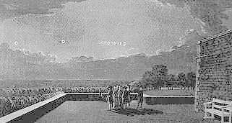
The above illustration depicts a sighting that occurred at 9.45pm on the evening of 18th August 1783 when four witnesses on the terrace of Windsor Castle observed a luminous object in the skies of the Home Counties of England. The sighting was recorded the following year in the Philosophical Transactions of the Royal Society. According to this report, witnesses observed an oblong cloud moving more or less parallel to the horizon. Under this cloud could be seen a luminous object which soon became spherical, brilliantly lit, which came to a halt; This strange sphere seemed at first to be pale blue in colour but then its luminosity increased and soon it set off again towards the east. Then the object changed direction and moved parallel to the horizon before disappearing to the south-east ; the light it gave out was prodigious; it lit us everything on the ground.; The image was captured in this by Thomas Sandby (a founder of the Royal Academy) and his brother Paul, both of whom witnessed the event.

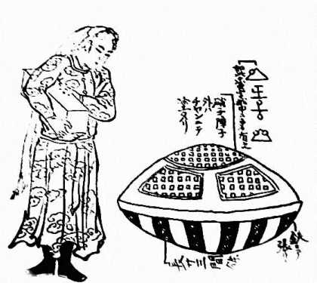
This is an illustration from a book "Ume No Chiri (Dust of Apricot)" published in 1803. A foreign ship and crew witnessed at Haratonohama (Haratono Seashore) in Hitachi no Kuni (Ibaragi Prefecture), Japan this strange object. According to the explanation in the drawing, the outershell was made of iron and glass, and strange letters shown in this drawing were seen inside the ship.

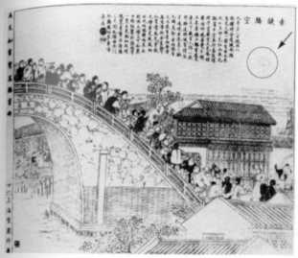
The above illustration is of a sighting of a red fireball above Nankin in China 28 sept 1890 . It was drawn by Wu You-run, a painter and witness himself to this ufo sighting. There were a 100+ witnesses. It was described as looking like an egg but not shining. It moved slowly to the east. The image depicts witnesses on the Shu Que bridge looking at the object. An old man said "when the ball appeared I heard and very loud sound like running man ..." I know the image is faint but hopefully I'll have a clearer version sometime.

I have set this page up consisting of images for which I require further information.

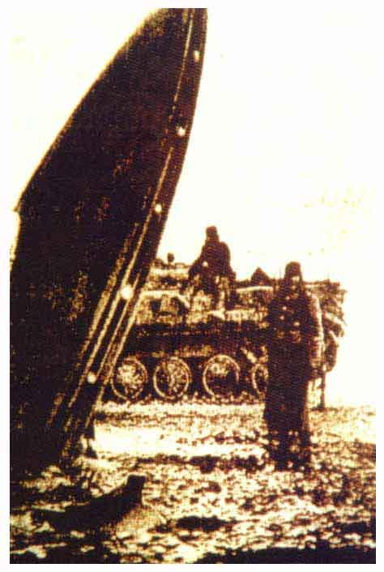
Russian photo. In the background is a 60's BMP personnel carrier.

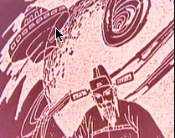
The article below appeared on the net a few months ago together with the artwork above : HONG KONG, China (CNN) http://fyi.cnn.com/2002/fyi/news/05/15/ufology.china/ -- UFO research is the stuff of sci-fi buffs and conspiracy freaks, but in China it's treated seriously. Joseph Wong, a lab manager at Hong Kong's City University, is a man of science. His job is to assess the structural performance of buildings. But familiar as he is with hard data, Wong is also a fan of the unexplained. "If something flies over, there's a very good reason for trying to understand why they're here, why they come to us, what is their relationship between us and them," he says. Wong is the Chairman of Hong Kong's thriving UFO club -- exploring "unidentified flying objects" or, to the uninitiated, "flying saucers." The club meets once a month to explore otherworldly topics like "E.T. Civilization" and "Alien Kung Fu." Members occasionally meet at a cyber cafe called UFO Station in Hong Kong's Tsim Sha Tsui district. The spot is home to Hong Kong's own version of the X-files. The dark monitor-lit cafe has UFO books, newsletters, and old news clippings of close encounters -- material that UFO club members take very seriously. A masters in UFOlogy? "In order to understand UFO phenomena, we need to have a broad understanding of different disciplines," says Albert So, university professor and Hong Kong UFO club member, "including mathematics, physics, history, philosophy, even some sort of paranormal activities and all that." Hong Kong's UFO enthusiasts, like So, are not dreamy stargazers, but researchers who see their passion as a science. So much so that they're lobbying for a university degree program in "UFOlogy." "The graduates of this program will grasp at least all the major knowledge in order to understand UFO phenomena, and also other technologies and any skills related to UFOs," So says. "After students or friends finish this degree, they may have their own understanding about this universe," Wong says. "Maybe they will be able to come up with a new universe model, new way of life, or whatever." It sounds like a tough sell, but it may not be hard to pitch in mainland China, where there is little taboo about discs that glow in the night or theories on visitors from out there. Flying boats in China China's state-run media reports on UFO sightings. Even the government's Ministry of Science and Technology treats the topic with respect. "It seems that people in the East are more open to discuss issues related to UFOs," So says. "Perhaps that is something to do with the culture of the races. In particular, Chinese. Chinese is a kind of race who easily believes in something supernatural." This ancient drawing of an emporer meeting a flying boat is proof that interest in UFOs in China is not new. And they may have been believing for a long time. UFO researchers point to an ancient drawing of the 100-year story of an emperor meeting a flying boat a compelling artifact in support of UFO study, but not the only one. "For me, it's not very important whether there is really a UFO that can fly or not," Wong says. "It's when we are investigating this, I think it's the process that actually helps us to understand more about ourselves or our planet." For club chairman Joseph Wong, the truth may be out there, but the payoff is personal studying aliens helps to satiate a very healthy, and very human, curiosity.

Historical UFO photographs - Pre 1947
Copyright 2002

I have now decided to collate old photographs of UFOs. I have decided on 1946 as a cut off. I purposely selected this as it pre-dates Kenneth Arnold's sighting and the Roswell incident. Both famous cases that have given Ufology a starting point.
If you have any information on the images below or photographs that are pre 1947, please contact me.

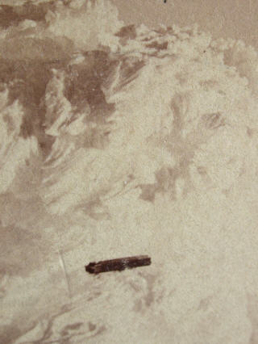
This photograph depicts a cloud formation over the summit of Mt. Washington in the Winter of 1870 - 1871 - along with an added surprise! One can see a cigar shaped object. This could possibly be the earliest photograph of a UFO. The image is part of an antique stereoview. The description reads "SUMMIT Mt. Washington WINTER 1870-1871 Entered according to Act of Congress in the year 1871, by CLOGH & KIMBALL, in the Office of the Librarian of Congress, at Washington." Further information, http://www.virtuallystrange.net/ufo/updates/2002/mar/m06-023.shtml

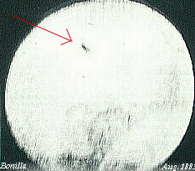
This early UFO photo was taken on the 12th August 1883. Astronomer Jose Bonilla, at Zacatecas Observatory, Mexico, photographed formations of 15 to 20 disc-shaped objects crossing the face of the sun.

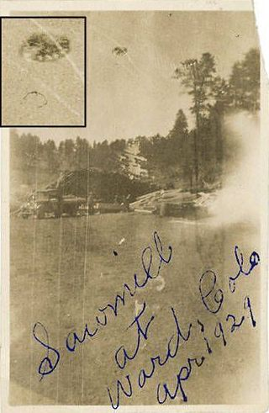
Ward Sawmill, SlideWard, Colorado. April, 1929. This incident is re-told by the photographers daughter : This photo was taken by my father Edward Pline at the sawmill in Ward where we lived at the time, I think it was 1929. I was about six years old then. My father was there to photograph the sawmill for some reason or another, and as he was taking the photo, he described a "terrible thunderous bellow," and a large round thing as big as a very large boulder that moved through the air above them. You can see it in the picture. None of the sawmill workers saw the thing in the photo, but they all heard the sound and felt the ground shudder. Later in my life I tried researching the incident at the County Historical Society, but I did not find any references to it. My father passed on a few years after the incident, and I have not found any surving sawmill workers from that time. Hetty Pline

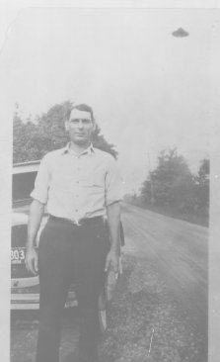
The description for this one reads The unidentified flying object in the picture could not have been a street lamp, simply because there were no street lamps there at the time. There are no power poles or power lines visible anywhere in this picture. Summer 1932, Mid-day, St. Paris, Ohio. This picture of George Sutton of St. Paris, Ohio, taken near mid-day (as may be seen from the shadows on the ground) shows a vintage automobile with a 1932 license plate on the front bumper. The owner of the photo album says there were no electric street lights along this road in those days. Nobody has been able to account for the dark object seen over Sutton's left shoulder in this photograph.

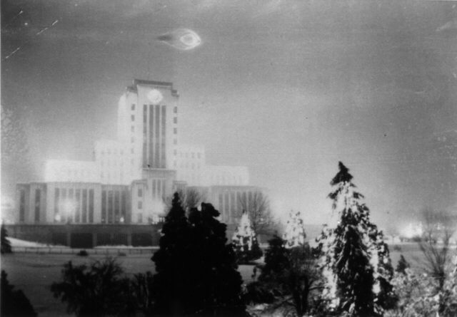
Leonard Lamoureux, age 21 was on leave from the Army when he visited Vancouver City Hall to view and photograph the Christmas light display. Along with him was his brother Wilfred. The two were suddenly astounded to see a "bright bright blue light" drop straight down from the sky. It became larger as it did so and they were able to observe the source of the light as an object that Leonard described as "two saucers" open ends facing each other, glowing bright blue. The object then moved "dead straight" horizontally across the sky. When it just appeared to clear the flagpole on the roof of the City Hall it came to an almost dead stop and Leonard clicked the shutter on the camera. The object then shot straight back up into the sky. "They never seen anything fly so fast!" This scared them to death and they ran from the scene. The object made no sound.
Leonard's daughter, Debra DeCamillis who still lives in the Vancouver Lower Mainland area related this account to us. She remarked how vivid and excited her father sounded each time he described the sighting. Leonard Lamoureux passed away in 1992 and his brother Wilfred in 1955. Misfortune has it that the negative is no longer around as some UFO researchers have suggested that this image is nothing but a watermark defect that appeared during the development of the print. Debra has this to add regarding this assertion: "I know for fact there was no bubbles on the film, or watermarks because I was facinated by negatives as a child and saw that negative many many times. On the rest of the pictures there was nothing but pictures of lights, so I know it had no bubbles or watermarks on it."
Deborah provided the following additional details: "The camera was on a tri-pod of sorts because Dad was trying to take sequential shots of the courthouse to capture all the lights. But he was not using a timed exposure, his camera was not sophisticated enough. He did say that he could actually see the bubble or tail as he called it that the object was encapsulated in." Thanks to Martin Jasek of www.ufobc.ca for this information.

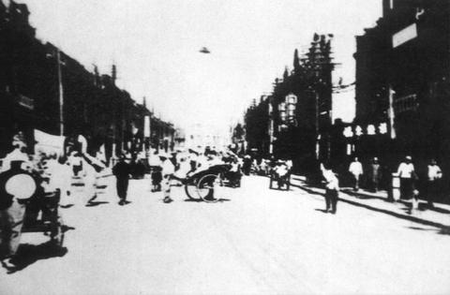
There seems to be some confusion over this photo. One site states it was taken in the city of Tienjin, China in 1911 by a Japanese journalist. http://www.taipeitimes.com/News/archives/2001/06/03/0000088538 . Another site says it was taken in Tiensten, Hopeh Province, China in 1942 http://www.fenomeno.trix.net/fenomeno_ufologia_1_galeria-16.htm
I recently received this information from Alain Stauffer, Geneva : Chinese ufologist Shi Bo: "La Chine et les extraterrestres" (in French, since Shi Bo lives in Paris). He states in his book (my translation): "In 1942, an American man on duty was walking in the street of a town [not specified] in the north of China. He suddenly saw a black hat silently flying above the street. He immediately grabed his camera and took this first picture of a UFO in China. This American citizen wished to visit China very soon in order to trace the witnesses of this event." (This commentary has been written in 1982 - the book was published in January 1983). Additional information comes from Wendelle Steven's "UFOs over Modern China" UFO Photo Archives. Young Japanese student Masujiro Kiryu, going through his fathers scrapbook of photographs fron the China Campaign, just before World War II, discovered a strange cone-shaped object in the sky above a Tsientsien Street. A number of people in the street are looking up and two are pointing up at the object. A sidewalk photographer snappped a picutre of the strange machine and his father bought it from the street vendor for a souvenir of the place.

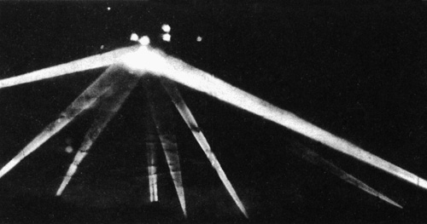
This UFO was photographed on the 25th February 1942 and was featured in the Los Angeles Times. A strange aerial intruder hovered over the Culver City area of Los Angeles during that morning. It was described by one eyewitness as "enormous" and "pale orange" in colour. The blobs of light are not UFOs but bursts of anti aircraft shells being fired at the object. Nearly 2000 rounds of ammunition were discharged before the object disappeared from view. The beams of light are earth based search lights focussing on the object which can just be made out. Source

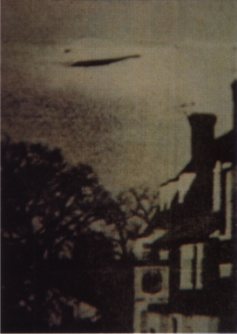
This UFO was photographed over England in 1944. Source : "The X Factor" magazine issue 53 (Marshall Cavendish publications).

Numerous UFOs photographed during WW2. They received the nickname "Foo Fighters" from a maxim used by a cartoon comic character Smokey Stover. This comic was a favourite among US forces during WW2. More information required on these images, there are others in existence as well. Picture source : UFO Magazine UK Jan/Feb 2000. Here is an informative article on Foo fighters :
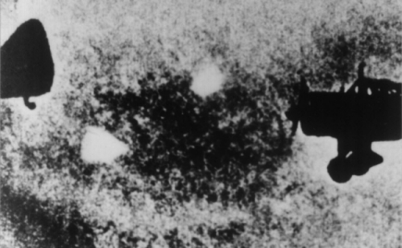
Above: These luminous objects were sighted and photographed in the middle of a formation of Tahikawa Ki 36 reconnaissance planes in 1942.
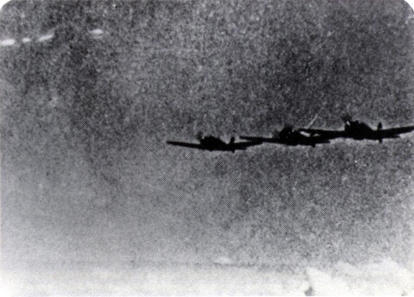
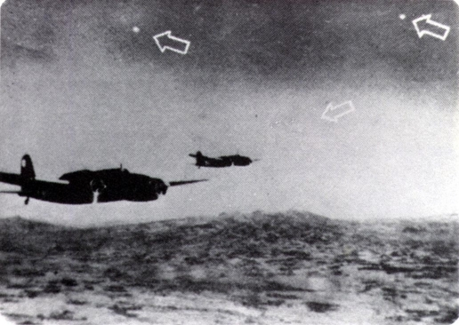
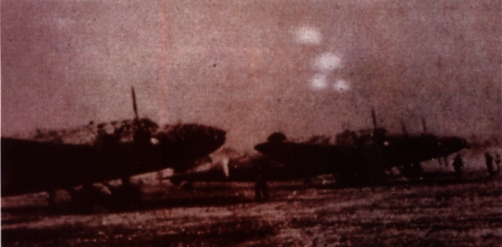
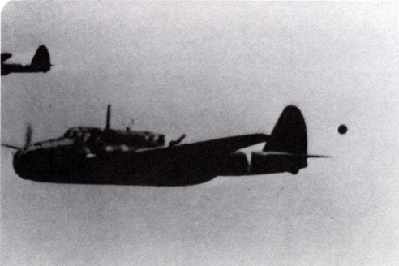
Above : A Japanese Sally Bomber flies over the Japanese Sea in 1943, followed by a dark sphere.
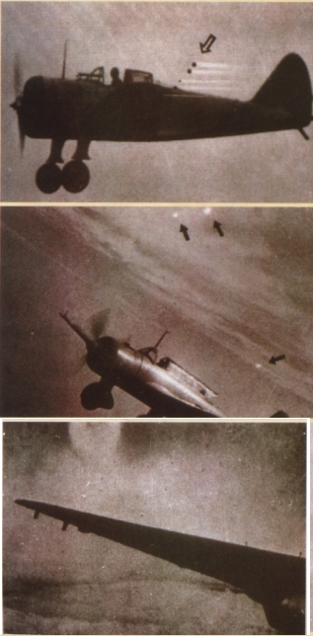

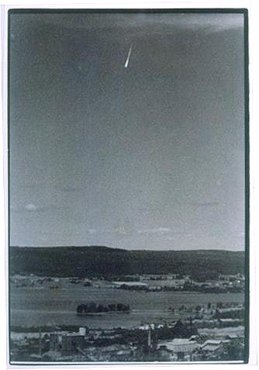
This UFO was photographed by Erik Reuterswärd at 2.30 PM on July 9th, 1946. As it was a sunny summer day there were many witnessess. Reuterswärd happened to snap the picture by chance from an air watch tower close to Guldsmedshyttan in mid-Sweden. Throughout the year, numerous "ghost rockets" were reported flying over Norway and Sweden, and even crashing. This is one of the few known photographs of the phenomenon. http://www.forteantimes.com/gallery/ghostrocket.shtml .Thanks to Anders Liljegren Archives for UFO Research (AFU) Sweden for this information.
Ufologist Tim Good in his 1987 book "Above Top Secret", commented on the Ghost Rockets : In 1946 the Scandanavian countries reported over 2,000 unidentified flying objects over their airspace. These objects usually looked like rockets with fiery exhausts, and they sometimes performed unusual maneuvers as they passed overhead. At first they were thought to be captured German V-2 missiles that were being tested by the Russians, but British radar experts said they did not come from the U.S.S.R. Experts said that 80% of the reports were due to natural phenomena such as meteors, but they had no explanation for the other 20%. Oddly, the objects appeared over some of the southern European countries also, such as Greece, where an official investigation was conducted in 1947. The leader of that investigation, Professor Paul Santorini, revealed in 1967 that their investigation showed that the objects were not missiles. He also said that before they could proceed any further, the army ordered the investigation stopped. Even today, fifty years later, official files on the ghost rockets are still classified documents.

END

