

**CHARADE; Black Ops, Black Budgets & UFOs - Darrel Gusner and Robert Morningstar June 10th, 2023**

***“We now have the technology to take ET back home”***

<https://robertmorningstar.substack.com/p/charade-black-budgets-and-ufos>

[[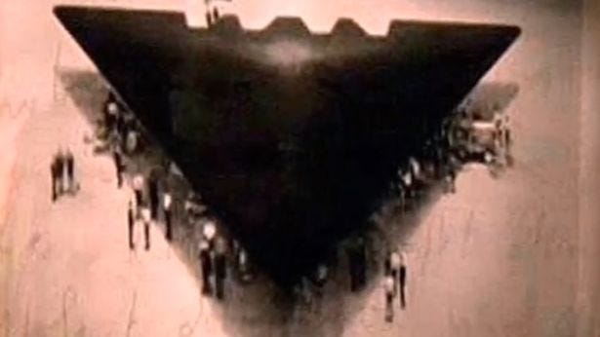](https://substackcdn.com/image/fetch/f_auto,q_auto:good,fl_progressive:steep/https%3A%2F%2Fsubstack-post-media.s3.amazonaws.com%2Fpublic%2Fimages%2F5462c6ef-9179-4725-9dd0-587e158c37fd_615x346.jpeg)](https://substackcdn.com/image/fetch/f_auto,q_auto:good,fl_progressive:steep/https%3A%2F%2Fsubstack-post-media.s3.amazonaws.com%2Fpublic%2Fimages%2F5462c6ef-9179-4725-9dd0-587e158c37fd_615x346.jpeg" \t "_blank)

The following brief research article is predicated upon the author's personal observations and deductions made over more than seventy years.

With sharp clarity, he still remembers the emotional shock of hearing on December 7, 1941, the radio news broadcasts declaring that the Empire of Japan had just bombed Pearl Harbor.

Similarly, it is with clear memories that the author remembers the extraordinary events of June and July 1947 and the startling and novel reports of the initial sightings around the world of a new exciting wonder, flying saucers. The following article is the product of the author's own decades of independent study, thoughts, deductions, and reasoned conclusions about an important, but often dark and troubling subject:

[[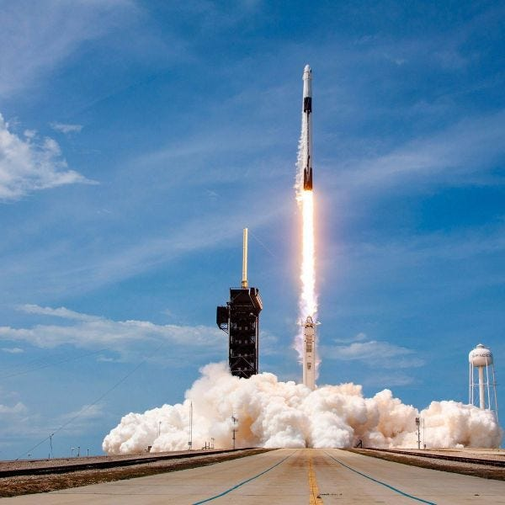](https://substackcdn.com/image/fetch/f_auto,q_auto:good,fl_progressive:steep/https%3A%2F%2Fsubstack-post-media.s3.amazonaws.com%2Fpublic%2Fimages%2F92c93c80-ea6a-4c17-9d96-50a8b92e6b7e_600x600.jpeg)](https://substackcdn.com/image/fetch/f_auto,q_auto:good,fl_progressive:steep/https%3A%2F%2Fsubstack-post-media.s3.amazonaws.com%2Fpublic%2Fimages%2F92c93c80-ea6a-4c17-9d96-50a8b92e6b7e_600x600.jpeg" \t "_blank)

**Cape Canaveral, Florida – SpaceX image**

**Saturday, May 30, 2020:**

Containing tons of deep cryogenic "densified" liquid oxygen and kerosene, the towering fuel tanks stood poised ready to provide the ravenous demands of a precisely controlled burn.

At 3:22 P.M. Eastern Time, SpaceX’s Crew Dragon spacecraft lifted off on a Falcon 9 rocket from the historic Cape Canaveral Launch "Complex 39 A."

It was 94 years after the first ever successful liquid fuel powered rocket flight. That first flight was launched by Robert Goddard at Auburn, Mass, and reached an estimated height of 96 feet. By comparison, the Falcon 9, lifting off with about 694 tons of sea level thrust, a few minutes thereafter reached a Low-Earth Orbit. The precision SpaceX Falcon 9 rocket launch was broadly acclaimed to represent a new and historical beginning of manned space flight.

**January 17, 1961:**

**During his farewell address, President Eisenhower purposefully warned:**

**“We should take nothing for granted only an alert and knowledgeable citizenry can compel the proper meshing of huge industrial and military machinery of defense with our peaceful methods and goals, so that security and liberty may prosper together.”**

In spite of being cautioned, has the citizenry failed in its responsibility to remain alert or else altogether taken too much for granted?

click the link below to hear President Eisenhower’s entire Farewell Address.

[**President Eisenhower's Farewell Address - The Full Speech**](https://www.c-span.org/video/?15026-1/president-dwight-eisenhower-farewell-address)

In his farewell address, President Eisenhower also said:

**“Akin to, and largely responsible for the sweeping changes in our industrial-military posture, has been the technological revolution during recent decades. In this revolution, research has become central; it also becomes more formalized, complex, and costly. A steadily increasing share is conducted for, by, or at the direction of, the Federal government.”**

In his speech, President Eisenhower also provided a shocking, but seldom quoted fact:

**“We annually spend on military security more than the net income of all United States corporations.”**

The U.S. Constitution is the Supreme Law of the United States, and it plainly declares:

**“No Money shall be drawn from the Treasury, but in Consequence of Appropriations made by Law; and a regular Statement and Account of the Receipts and Expenditures of all public Money shall be published from time to time.”**

In spite of ***The Supreme Law of the United States***, no **"regular Statement and Account"** of the trillions of taxpayers' dollars spent on research has ever been publicly published, let alone audited.

**Ask,** ***how much of the vast expenditure was on*** **Area 51** **and "Black-Ops" Research & Development (R&D)?**

What were the formal written goals for justification of that enormous research expenditure?

Precisely who has benefited and grown wealthy from the fruits of the taxpayers' funded research breakthroughs? What hidden scientific breakthroughs remain concealed from the public?

One of the most outrageous facts is that the Government seems to expect the taxpayers to believe that after 94 years of continuing rocket developments, including the German V2 rockets program of WW II, and 73 years of additional budget breaking R&D expenditures, the latest and greatest technology now available in humanity boldly reaching for the stars is a big can of kerosene and a flask of liquid oxygen.

If this were true, then the 30 May 2020 SpaceX Falcon 9 launch must represent the culmination of trillions of dollars expended since 1947 for Black-Ops research and development. If so, then those R&D expenditures represent an Earth-shaking colossal boondoggle, and the taxpayers seem entitled to a whopping refund. It is far past time for the citizenry, as President Eisenhower warned, to stop taking things for granted and look carefully at a chain of related facts that stretch back to 1945.

[[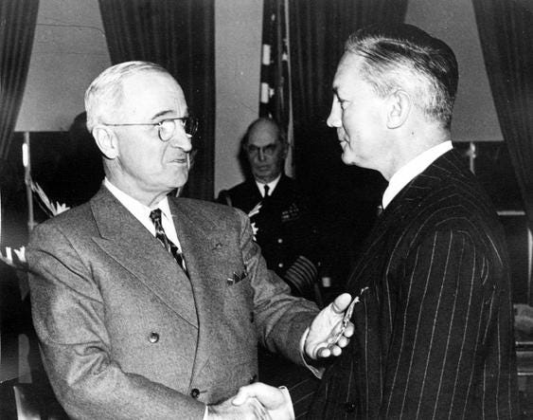](https://substackcdn.com/image/fetch/f_auto,q_auto:good,fl_progressive:steep/https%3A%2F%2Fsubstack-post-media.s3.amazonaws.com%2Fpublic%2Fimages%2F300a0801-a7c7-411d-a405-6bbf9422d037_563x443.jpeg)](https://substackcdn.com/image/fetch/f_auto,q_auto:good,fl_progressive:steep/https%3A%2F%2Fsubstack-post-media.s3.amazonaws.com%2Fpublic%2Fimages%2F300a0801-a7c7-411d-a405-6bbf9422d037_563x443.jpeg" \t "_blank)

President Truman Confers Medal on James Forestall a Year Before his “Suicide”

Three formal signing ceremonies May 8, May 9, and September 2, 1945, represented the end of a terrible worldwide war, WW II, wherein perhaps ***one-hundred and fifty million people perished***!

At the end of the death and destruction, with the transformative detonation of two atomic bombs, the geopolitical structure and balance of power among the nations of our world was forever altered. Moreover, the global peace that followed was at best troubled.

**September 20, 1945:**

With "Victory," the prevailing mood within the United States Congress was demobilization. Nearly everyone expected downsizing the Government to its smaller peacetime role would be quickly accomplished. Part of that demobilization included **Executive Order 9621**, **"Termination of the Office of Strategic Services (OSS) and Disposition of Its Functions,"** which was prepared by the Budget Bureau and its **Director Harold Smith** and signed by **President Truman.**

[[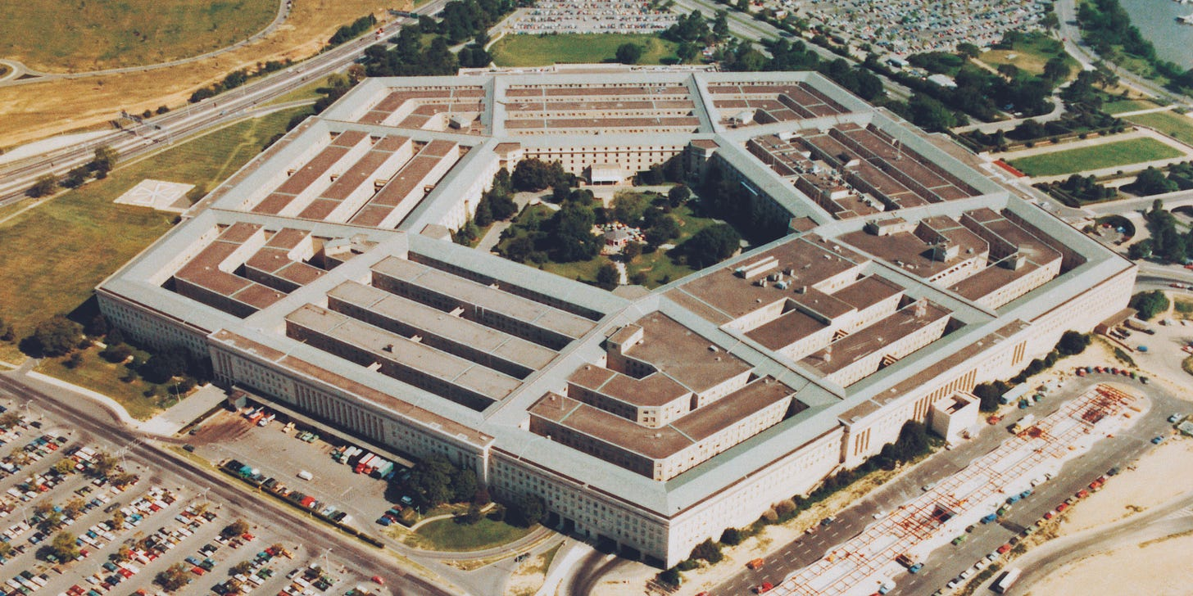](https://substackcdn.com/image/fetch/f_auto,q_auto:good,fl_progressive:steep/https%3A%2F%2Fsubstack-post-media.s3.amazonaws.com%2Fpublic%2Fimages%2F94e866dc-d165-4040-9040-8022d0b1da63_2000x1000.jpeg)](https://substackcdn.com/image/fetch/f_auto,q_auto:good,fl_progressive:steep/https%3A%2F%2Fsubstack-post-media.s3.amazonaws.com%2Fpublic%2Fimages%2F94e866dc-d165-4040-9040-8022d0b1da63_2000x1000.jpeg" \t "_blank)

**Complying with the President's Executive Order, by a sleight of hand, the "institution" of the OSS and its assets were not "demobilized," but rather streamlined and preserved.**

The War Department first isolated The OSS Research and Analysis and Presentation Branch from its associated ***Secret*** wartime clandestine counter-intelligence and Espionage Branch.

The Research and Analysis and Presentation Branch was then transferred intact to the Department of State, while the Department of War absorbed intact the OSS clandestine intelligence and Counter-Espionage Branch, thereby preserving the wide flung OSS wartime Espionage-Intelligence capability (including the OSS propaganda, economic warfare, political subversion, and psychological warfare components).

**The War Department renamed its newly acquired counter-Intelligence and espionage capability *"The Strategic Services Unit" (SSU*).**

**January 1946:**

Following a reorganization plan developed by the **Joint Chiefs of Staff**, and modified by the Budget Bureau, President Truman created a new **Central Intelligence Group (CIG)**.

The previously preserved **SSU clandestine-Intelligence warfare assets** were then, in mid-1946, transferred to the newly created CIG and there *rebranded* **The Office of Special Operations (OSO**). This shell-game feat of reorganizing and preserving clandestine assets would soon have far reaching consequences.

[[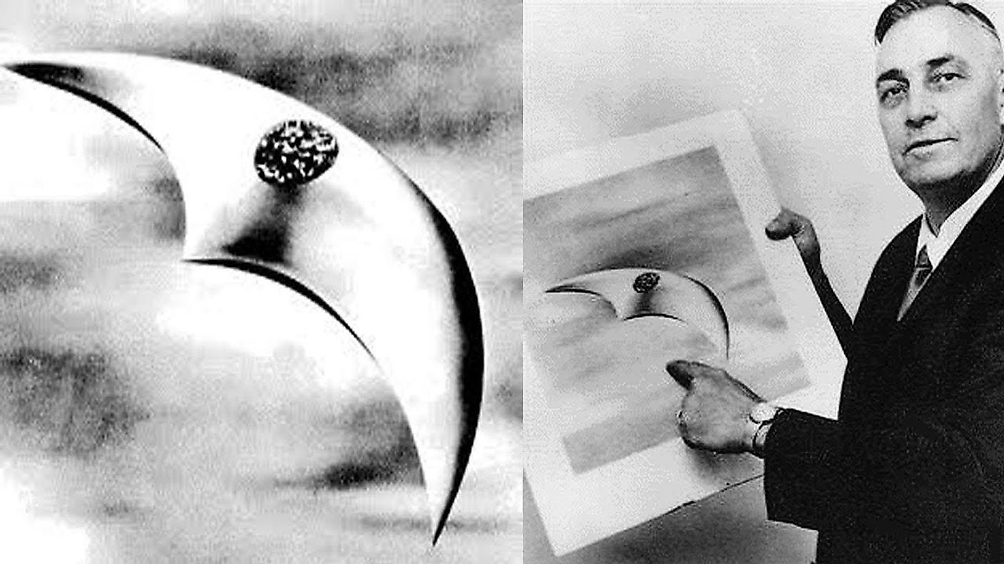](https://substackcdn.com/image/fetch/f_auto,q_auto:good,fl_progressive:steep/https%3A%2F%2Fsubstack-post-media.s3.amazonaws.com%2Fpublic%2Fimages%2F18d68499-c579-4d8b-ba12-9b4822f7f9a0_1408x792.jpeg)](https://substackcdn.com/image/fetch/f_auto,q_auto:good,fl_progressive:steep/https%3A%2F%2Fsubstack-post-media.s3.amazonaws.com%2Fpublic%2Fimages%2F18d68499-c579-4d8b-ba12-9b4822f7f9a0_1408x792.jpeg" \t "_blank)

**June 26, 1947:**

**The Chicago Sun** reported a startling and novel event. A private pilot, Kenneth Arnold, testified he had observed a string of nine shiny unidentified objects flying past Mount Rainier. He estimated their speed at a minimum of 1,200 miles an hour.

This post-War sighting of unidentified flying objects (UFOs) is credited as being the first of numerous similar reported sightings around the world. Like everyone else, the world governments had no grasp on where the sighted UFOs were coming from.

Nevertheless, the Government remembered Orson Welles's recent (Oct 30, 1938) radio broadcast, ***"War of the Worlds,"*** which stunned its audiences by dramatizing purported news describing an "alien invasion" happening in New Jersey.

[[](https://substackcdn.com/image/fetch/f_auto,q_auto:good,fl_progressive:steep/https%3A%2F%2Fsubstack-post-media.s3.amazonaws.com%2Fpublic%2Fimages%2Fdbbc9239-95bb-4f17-b9da-cefa160e5b78_1500x1500.jpeg)](https://substackcdn.com/image/fetch/f_auto,q_auto:good,fl_progressive:steep/https%3A%2F%2Fsubstack-post-media.s3.amazonaws.com%2Fpublic%2Fimages%2Fdbbc9239-95bb-4f17-b9da-cefa160e5b78_1500x1500.jpeg" \t "_blank)

Unquestionably, in June of 1947, high on the U.S. Government’s and The War Department's list of priorities was maintaining control of the unfolding public UFO narrative and preventing another panic. In accomplishing this manipulative propaganda feat, the U.S. Government and its War Department undoubtedly found the fine-honed wartime (SSU) Bureau of Clandestine-Intelligence and Espionage propaganda capability of its newly absorbed and streamlined Office of Special Operations (OSS) to be of immense value.

**July 3, 1947:**

A week following Kenneth Arnold's sighting of UFOs, during the night, an intense thunderstorm swept menacingly across New Mexico. Within the depth of that howling storm unanticipated catastrophic events unfolded that changed the future of the entire world.

On the morning following the storm, a New Mexico rancher, **Max Brazel**, went outside and found to his displeasure that one of his sheep pastures was broadly littered with debris, including a metallic material, a shiny foil exhibiting a bizarre quality.

[[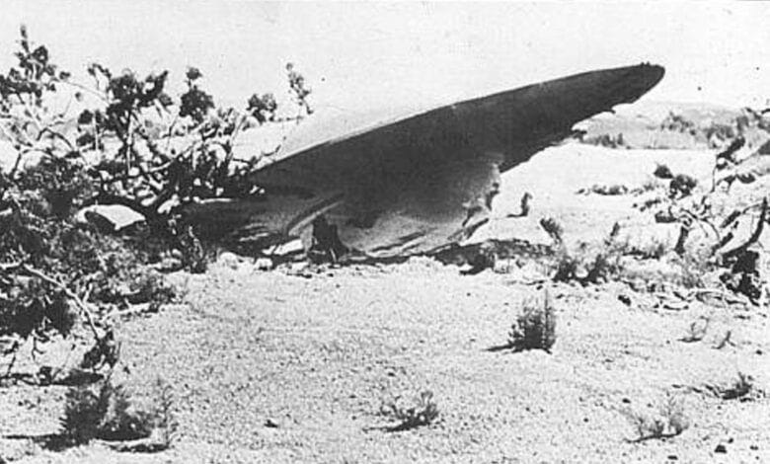](https://substackcdn.com/image/fetch/f_auto,q_auto:good,fl_progressive:steep/https%3A%2F%2Fsubstack-post-media.s3.amazonaws.com%2Fpublic%2Fimages%2F7743e69f-b2ba-4df3-9982-0a6b9c01dc71_780x470.jpeg)](https://substackcdn.com/image/fetch/f_auto,q_auto:good,fl_progressive:steep/https%3A%2F%2Fsubstack-post-media.s3.amazonaws.com%2Fpublic%2Fimages%2F7743e69f-b2ba-4df3-9982-0a6b9c01dc71_780x470.jpeg" \t "_blank)

When the foil was crumpled and then released, it promptly resumed its initial shape. This signature memory characteristic is commonly exhibited by a metallic material later named **Nitinol**, a ***Nickel Titanium alloy***.

The singular problem presented here is that **Nitinol was discovered in 1959** by **William J. Buehler and Frederick Wang** at the **Naval Ordnance Laboratory, 12 years** ***after*** Max Brazel had found shiny memory foil in his pasture.

In 1947 Nitinol was not a product manufactured *anywhere* on our bountiful Earth.

Irately gathering together some of the wide spread debris from his pasture, Max Brazel put it into his pickup truck, then drove his truck to the nearby U.S.. Army Air Force base. Upon arrival, he loudly demanded that the Army clean up their debris from his pasture.

[[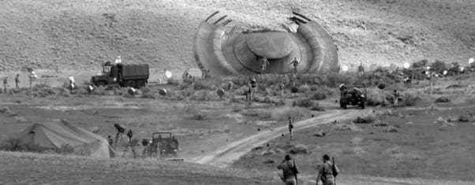](https://substackcdn.com/image/fetch/f_auto,q_auto:good,fl_progressive:steep/https%3A%2F%2Fsubstack-post-media.s3.amazonaws.com%2Fpublic%2Fimages%2F438e9767-b093-416e-a139-268f7a47848b_602x235.png)](https://substackcdn.com/image/fetch/f_auto,q_auto:good,fl_progressive:steep/https%3A%2F%2Fsubstack-post-media.s3.amazonaws.com%2Fpublic%2Fimages%2F438e9767-b093-416e-a139-268f7a47848b_602x235.png" \t "_blank)

**Photo facsimile (above) of the 2nd UFO Disk Crash Recovered at Corona, NM**

At the end of WW II, only one nation on Earth possessed both atomic bombs and the means to deliver those weapons. A stockpile of atomic bombs, a fleet of **B-29** “Super Fortress” bombers and their elite crews (the **509th Bombardment Group**), were then stationed at the U.S. Army Air Field located at **Roswell, New Mexico**, which was a scant few miles distant from where Max Brazel had found his pasture littered with copious samples of off-world debris.

Thanks to Max Brazel and his dusty pickup truck load of strange wreckage he had gathered from his pasture, the U.S. Government was presented physical evidence of ***an alien off-world technology***.

Soon thereafter, the Roswell Army Air Base itself issued a press release, saying the military had recovered the remains of a "flying disc." This news release was quickly retracted on the orders of **General Roger Ramey.**

[[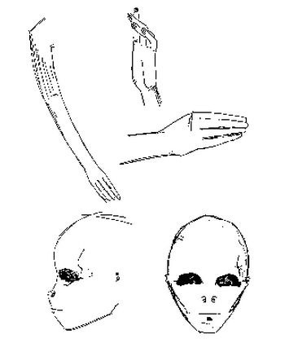](https://substackcdn.com/image/fetch/f_auto,q_auto:good,fl_progressive:steep/https%3A%2F%2Fsubstack-post-media.s3.amazonaws.com%2Fpublic%2Fimages%2Ffe89298c-a4dc-4927-8d39-bacc24144c89_350x432.jpeg)](https://substackcdn.com/image/fetch/f_auto,q_auto:good,fl_progressive:steep/https%3A%2F%2Fsubstack-post-media.s3.amazonaws.com%2Fpublic%2Fimages%2Ffe89298c-a4dc-4927-8d39-bacc24144c89_350x432.jpeg" \t "_blank)

Once alerted to the existence of strange wreckage close to a stockpile of the country's atomic bombs, the alarmed government officials in Washington, D.C. immediately activated its preserved and proficient wartime gaslighting and clandestine-intelligence propaganda capabilities.

The US military clamped down hard on its own press release and the entire UFO story, especially including the story dealing with the "capture" of a UFO, which had emerged in the local Roswell newspaper on 7 July, 1947.

To achieve the Government's inflexible goal of complete control of the public UFO narrative, both media and witnesses alike were unabashedly suppressed.

The U.S. Government's ceaseless suppression of the truth about what happened at Roswell began about **July 8,1947**. It is noteworthy that almost 50 years later **(June 24, 1997)** the U.S. Air Force released a new 231-page report about a weather balloon that crashed in 1947 near Roswell, once again dismissing the long-standing claims of an alien spacecraft crash.

Seventy-years after the UFO crash, the Government is *still* attempting to control the public UFO narrative:

**“Honest folks, there's nothing here to see, it's just an old weather balloon, move-on, move-on.”**

Given the multiple newspaper reports coming from around the world, and the available physical wreckage, the government fully understood that ***an alien agency***, one ***not of our world***, had sent spacecraft to Earth, and they had penetrated the airspace of multiple nations.

Alarmingly, the *intentions* of that off-world agency were unknown! But what was definitely known, and most alarming to the United States Government, was one of multiple observed advanced alien spacecrafts had crashed just a few miles from a well-guarded stockpile of its atomic bombs.

[[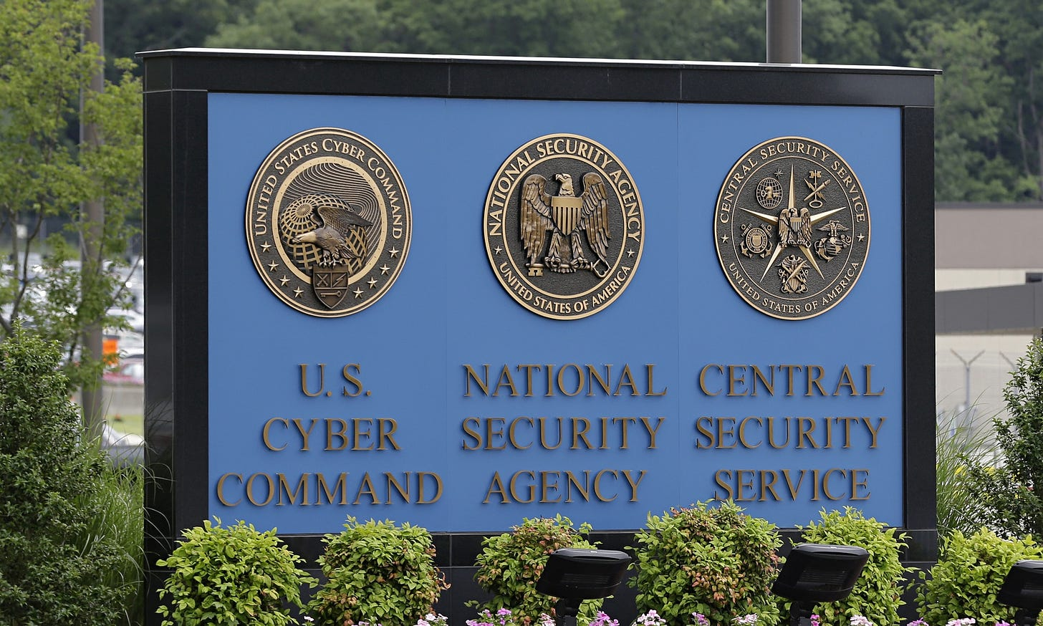](https://substackcdn.com/image/fetch/f_auto,q_auto:good,fl_progressive:steep/https%3A%2F%2Fsubstack-post-media.s3.amazonaws.com%2Fpublic%2Fimages%2Fc0c245ab-2f41-43b5-b798-197ff344fd86_2060x1236.jpeg)](https://substackcdn.com/image/fetch/f_auto,q_auto:good,fl_progressive:steep/https%3A%2F%2Fsubstack-post-media.s3.amazonaws.com%2Fpublic%2Fimages%2Fc0c245ab-2f41-43b5-b798-197ff344fd86_2060x1236.jpeg" \t "_blank)

In spite of the many material misrepresentations and cover stories that it created, strategically, The United States Government and its War Department were unequivocally compelled to acknowledge the existence of an alien force having a vastly superior technology. The alarm bells in Washington DC were stridently ringing, and its *Duty* obliged the Government to acknowledge the possibility of an imminent invasion.

**July 1947:**

The scope of the problems facing the Government planners was immense. The potential enemy was not of this world; therefore, it posed an incalculable level of military threat. What was then undeniable, and definitely understood, was that the potential enemy was far beyond the limited strike range of a B-29. Unyielding, the factor of time exerted its own intense pressure; an invasion might occur at any time. Therefore, all viable military efforts, by necessity, must be directed toward building a viable Defense.

Responding to the potentially imminent threat, informed government officials, and the War Department, justifiably shifted from demobilization to a covert and high gear preparation for a previously inconceivable star-war.

The planners' initial goals were likely twofold. First, they absolutely must:

(a) control the public narrative;

(b), they must also achieve "a viable Defense."

These two goals mandated the Government use every available tool of propaganda and psychological warfare to control the narrative, while using secrecy and whatsoever pressure was needed to acquire the enormous funding demanded for initial reverse engineering and the follow-on massive open-ended research and defense effort.

Working under extreme pressure, the choices then being made by the planners were crucial, and they have, for better or for worse since then, shaped the U.S. Government.

Overcoming bitter and enduring internal political skirmishing involving a military consolidation bill, the Government proved itself to be both capable and *ruthless.*

Within 23 days from the storm-filled night that brought alien UFO spacecraft(s) down over Roswell on 3 July, 1947, **Public Law 235 of July 26, 1947** ( also known as **The National Security Act of 1947**) was expediently adopted.

The **National Security Act** reorganized the entire United States military, creating a new **"Department of Defense."**

**The NSA of 1947 was an Act to "promote the national security by providing for a Secretary of Defense; for a National Military Establishment; for a Department of the Army, a Department of the Navy, a Department of the Air Force; and for the coordination of the activities of the National Military Establishment with other departments and agencies of the Government concerned with the National Security."**

The majority of the provisions of the new Defense Act took effect on **September 18, 1947**, one day after the U.S. Senate confirmed **James Forrestal** as the *first* **Secretary of Defense.**

Noteworthy, given its deep-roots of OSS wartime black-ops and counter-intelligence operations, including sanctioned assassinations (where the wartime desired ends justified the means), selecting the OSO (The Office of strategic Operations) for the key function of **"coordination of the activities of the Department of Defense"** and **"other departments and agencies of the Government concerned with the national security,"** plausibly created a potential risk of inappropriate use of latent wartime OSS methods of clandestine political actions and the abuse of Counter-Intelligence methods.

In 1949 a top-secret report entitled: "**INTELLIGENCE REPORT TO THE NATIONAL SECURITY COUNCIL - Allen W. Dulles 1 January 1949,"** provided the scope of what "coordination" involved.

[[](https://substackcdn.com/image/fetch/f_auto,q_auto:good,fl_progressive:steep/https%3A%2F%2Fsubstack-post-media.s3.amazonaws.com%2Fpublic%2Fimages%2Fa4335f5e-0f6c-4cfb-b694-20228d936099_640x480.jpeg)](https://substackcdn.com/image/fetch/f_auto,q_auto:good,fl_progressive:steep/https%3A%2F%2Fsubstack-post-media.s3.amazonaws.com%2Fpublic%2Fimages%2Fa4335f5e-0f6c-4cfb-b694-20228d936099_640x480.jpeg" \t "_blank)

**The 1947 National Defense Act** and subsequent ***top-secret*** **1949 INTELLIGENCE REPORT** produced far-reaching domestic and international consequences, including a significant redistribution of raw political power within the U.S. Government, where over the decades **OSO** ***morphed*** into the **CIA** of today.

**July 8, 1947:**

From the outset, those within the Government who were closely involved with the Roswell UFO recovery fully understood that the crashed alien spaceship had no identifiable propellers and no discernable fuel tanks or jet engines. It was absolutely certain that the observed alien space ships were not being fueled from big tanks of kerosene and flasks of liquid oxygen. Therefore, the first and obvious research challenge then posed was to figure out what made the darn things go and what kept them in the air.

From 1947 the unrelenting demands on research for "Defense" has consisted of catching up with and then hopefully surpassing the observed alien technology; that of course being if time and resources permit.

Given the external pressures, from the outset Government planners were confronted with grim and competing demands involving secrecy, funding, and the troublesome restraints of the U.S. Constitution and its Rule of Law.

World War II was just over, and the war weary population of the United States had only just begun to rebuild and enjoy the hard-earned fruits of victory, including enjoying their brand-new global peacetime.

Indeed, the planners' challenge was *difficult*: **How could they possibly *gaslight* everyone, conceal the new alien threat, and also require Americans to sacrifice their new well-earned prosperity?**

The stakes could not have been be higher, they reasoned, ***the whole world was at risk.*** But, in 1947 was the world actually at risk of an imminent alien invasion?

If true, then is it still at risk?

More than seventy (70+) years of unfolding history, like steady erosion washing away topsoil, has exposed much of the underlying and troubling truth. Nevertheless, there are many dark reasons why the hard choices made by the planners remain concealed and will likely continue to be shrouded in secrecy.

Today the operating presumption still seems that given ***the whole world is at risk***, the end justifies the means.

As can be understood, at the beginning, in 1947, there undoubtedly were major differing viewpoints on what far ranging policies should be implemented, including critical issues regarding transparency and accountability or else the adoption of provisions for creation of a secret "black budget."

[[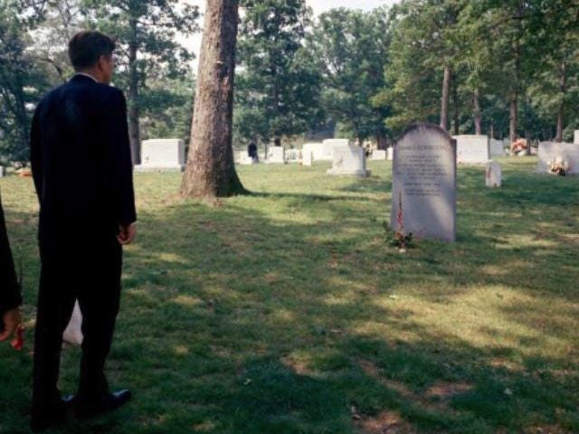](https://substackcdn.com/image/fetch/f_auto,q_auto:good,fl_progressive:steep/https%3A%2F%2Fsubstack-post-media.s3.amazonaws.com%2Fpublic%2Fimages%2F8e508165-2e12-4766-8ff1-a2f440f0fd52_640x480.jpeg)](https://substackcdn.com/image/fetch/f_auto,q_auto:good,fl_progressive:steep/https%3A%2F%2Fsubstack-post-media.s3.amazonaws.com%2Fpublic%2Fimages%2F8e508165-2e12-4766-8ff1-a2f440f0fd52_640x480.jpeg" \t "_blank)

**President Kennedy Visits Grave of James Forrestal – Memorial Day (May 30, 1963)**

To meet the perceived demands imposed by an imminent alien invasion, the planners, for better or worse, chose to evoke the dire and perilous articles and methods of clandestine warfare (including propaganda, material misrepresentations, callous acts of terrorism, honey-traps, blackmail, sanctioned killings, assassination, extorsion, and coercion).

[[](https://substackcdn.com/image/fetch/f_auto,q_auto:good,fl_progressive:steep/https%3A%2F%2Fsubstack-post-media.s3.amazonaws.com%2Fpublic%2Fimages%2F8396f00e-5c2e-41e4-b680-d8928805aade_543x285.jpeg)](https://substackcdn.com/image/fetch/f_auto,q_auto:good,fl_progressive:steep/https%3A%2F%2Fsubstack-post-media.s3.amazonaws.com%2Fpublic%2Fimages%2F8396f00e-5c2e-41e4-b680-d8928805aade_543x285.jpeg" \t "_blank)

In 1949, the first **Secretary of Defense, James Forrestal**, is thought to be among those who opposed creation of a covert secret "black budget." The official cover-up, a consensus about Secretary Forrestal's "no-fault" suicide, combined with the glaring hallmark of discordant "loose-ends," flag his untimely death in 1949 as very likely being an officially sanctioned murder.

**The Reckoning**

Even in 1949, the planners must then have realized that eventually their hard choices and methods would produce a harsh rupture, the unavoidable and dreaded day of a social and economic ***reckoning.***

The money required for star-wars research, which President Eisenhower referred to in 1961, was in part made possible by a series of "heightened International crises.”

These International conflicts typically involved clandestine operations (such as the **1947 to 1949,** 3-year long, counterinsurgency campaign in Greece; the **1946-1949** involvement in China (where about 100,000 US troops fought, trained and advised local combatants); the **17 April 1961 (failed) Bay of Pigs invasion**; the **3 August 1964** **Gulf of Tonkin incident** and the **Vietnam War** that followed; the **15 April 1986 bombing of Libya**; and the **2 August 1990 Gulf War**).

The continuing crises and related pressures of "Defense" provided the essential justification for ever increasing "Defense" budgets, which were generally not heralded as being political in nature.

Over the lengthening decades the chain of unending international crises and regional wars involving clandestine operations (from 1947 through 1991) are euphemistically identified as the "Cold War." Notably, when in late 1991 the Soviet Union fragmented into multiple republics, and “The Cold War ended," the continuing United States' international crises did not end, they simply shifted gears.

Although it was in 1947 that the U.S. Government initiated its costly reverse engineering of off-world technology, it had already imported (August 1946) Wernher von Braun and about 700 German rocket engineers and technicians (known as **Operation Paperclip**) to the United States.

As reverse engineering was secretly ramping up, the continuing development of the **German V2** rocket program moved center front and into public view, reaching its zenith with the **Apollo Program** and the landing on the Moon.

[[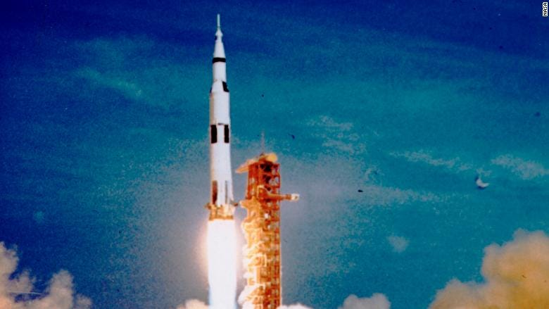](https://substackcdn.com/image/fetch/f_auto,q_auto:good,fl_progressive:steep/https%3A%2F%2Fsubstack-post-media.s3.amazonaws.com%2Fpublic%2Fimages%2Fbe4de38d-195a-43d9-9d41-9f1ee16b9ca7_780x439.jpeg)](https://substackcdn.com/image/fetch/f_auto,q_auto:good,fl_progressive:steep/https%3A%2F%2Fsubstack-post-media.s3.amazonaws.com%2Fpublic%2Fimages%2Fbe4de38d-195a-43d9-9d41-9f1ee16b9ca7_780x439.jpeg" \t "_blank)

After the Apollo lunar landings, the super heavy-lift Saturn V rocket was proposed as the prime launch vehicle for multiple programs, including the shuttle, the nuclear rocket stage RIFT test, and the later NERVA project. These programs were then all canceled, with cost being the major declared contributing factor (maximum cost being in 1966 with $1.2 billion (equivalent to $7.24 billion in 2018).

By 1969, the Apollo funding cuts had eliminated the procurement of more Apollo hardware. Nonetheless, the cancellation of all United States heavy lift rockets glaringly left the United States without a super heavy-lift launch vehicle. This rather obvious void in the US space program was not addressed until SpaceX took up the fallen (or dropped) gauntlet, with development of its own commercial space program.

Other than bankruptcy, a likely reason for shutting down all super heavy-lift rocket projects and "next generation" aircraft research was that the decades of secret reverse engineering had succeeded.

The "new physics" derived from the research likely included renewable energy and related ***"gravimetrics,"*** which made chemically fueled rockets and advanced "nominal state-of-art" aircraft as obsolete as a *horse-drawn* buggy.

This speculative probability is supported by occasional sightings of **Area 51** experimental aircraft and a few comments by people familiar with the research, such as **Ben R. Rich**, an aeronautical engineer most noted for designing ***stealth aircraft*** and as the second director of **Lockheed Martin’s top-secret Skunk Works Program**. Born in 1925, Mr. Rich passed away in 1995.

**March 1993:**

[[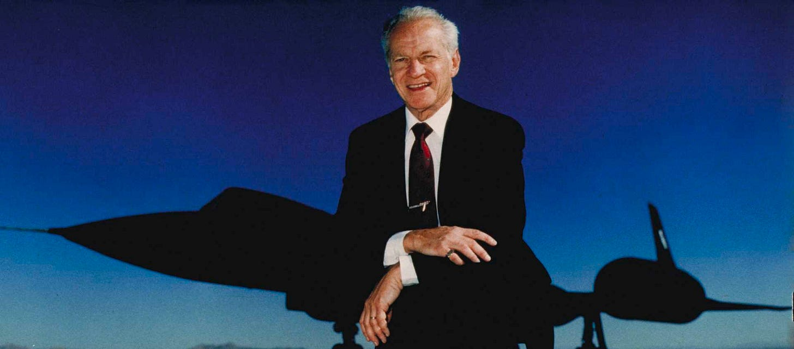](https://substackcdn.com/image/fetch/f_auto,q_auto:good,fl_progressive:steep/https%3A%2F%2Fsubstack-post-media.s3.amazonaws.com%2Fpublic%2Fimages%2F4e9c06b9-0a91-415c-9d5a-a8fa9a2c8305_1920x846.jpeg)](https://substackcdn.com/image/fetch/f_auto,q_auto:good,fl_progressive:steep/https%3A%2F%2Fsubstack-post-media.s3.amazonaws.com%2Fpublic%2Fimages%2F4e9c06b9-0a91-415c-9d5a-a8fa9a2c8305_1920x846.jpeg" \t "_blank)

As noted above, one man, who was well-informed about emerging new **Black-Ops** technologies, was **Ben R. Rich.** There are many comments attributed to Mr. Rich that are echoed about, and can with a simple search be found on the Internet.

A few of such comments are:

**"There are many in the intelligence community who would like to see this stay in the black, and not see the light of day"** (Source: UCLA School of Engineering Alumni speech 3/23/93);

**"The Air Force has just given us a contract to take ET back home"** (Source: 1993 Wright-Patterson Air Force Base slide presentation);

**"We already have the means to travel among the stars, but these technologies are locked up in black projects and it would take an act of GOD to ever get them out to benefit humanity"** (Source: statement made after UCLA presentation to three "Disclosure Project" witnesses);

**"We now have the technology to take ET back home"** (Source: UCLA School of Engineering Alumni speech 3/23/93);

**"There is an error in the equations, and we have figured it out, and now know how to travel to the stars, and it won’t take a lifetime to do it"** (Source: UCLA School of Engineering Alumni speech 3/23/93);

**"Jim, we have things out in the desert that are fifty (50) years beyond what you could possibly comprehend. If you have seen it on Star Wars or Star Trek, we’ve been there done that, or decided it was not worth the effort"** (Source: telephone call on January 5th 1995, direct comments by Ben Rich to Jim Goodall at USC medical center, approximately one week before Mr. Rich passed away).

In fully evaluating the U.S. Government's deceptive behavior, it becomes essential that the appalling consequences of that behavior are acknowledged. Ethically predictable, over the decades the enormity of the accruing clandestine abuses of Truth and Constitutional Rule of Law, justified or not, **has** ***metastasized***, **deforming the Republic and bringing it to the brink of economic and social chaos**.

[[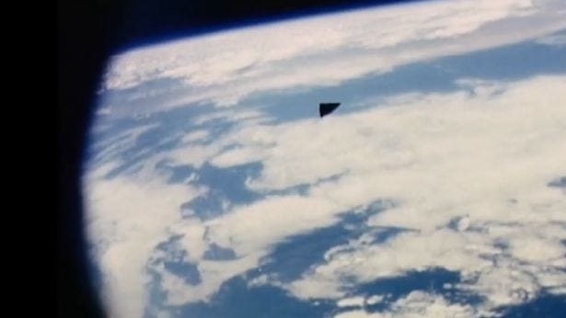](https://substackcdn.com/image/fetch/f_auto,q_auto:good,fl_progressive:steep/https%3A%2F%2Fsubstack-post-media.s3.amazonaws.com%2Fpublic%2Fimages%2F52488055-9a88-4e99-8296-2cc56fafac93_615x346.jpeg)](https://substackcdn.com/image/fetch/f_auto,q_auto:good,fl_progressive:steep/https%3A%2F%2Fsubstack-post-media.s3.amazonaws.com%2Fpublic%2Fimages%2F52488055-9a88-4e99-8296-2cc56fafac93_615x346.jpeg" \t "_blank)

The powerful covert “Shadow Government,” given its secrecy and unchecked funding, appears to be acting outside the lawful constraints of the Rule of Constitutional Law and “of the People.”

By its nature, the present-day tangled web of Black-Ops groups still demand secrecy and increasing funding. Pragmatically, the widening gulf between the advanced black-ops technology and its stifled civilian counterpart must at some point be reconciled. However, given the economic consequences of that reconciliation, the problem of equitably distributing the bounty of the accrued benefits of advanced technology among ***The People*** has become prodigious.

While SpaceX’s Crew Dragon spacecraft, fueled by its big can of kerosene and a flask of liquid oxygen, successfully lifted off from Florida on 30 May 2020, Americans must now demand of their elected officials that the Government come clean, that it disclose what has been done and reveal what has emerged from the more than seventy years of Area 51 and related Black-Ops research. Hopefully part of that truth may have already been subtly announced.

[[](https://substackcdn.com/image/fetch/f_auto,q_auto:good,fl_progressive:steep/https%3A%2F%2Fsubstack-post-media.s3.amazonaws.com%2Fpublic%2Fimages%2Fd5a5f93f-7efe-44f6-967c-40cab97372a8_720x720.jpeg)](https://substackcdn.com/image/fetch/f_auto,q_auto:good,fl_progressive:steep/https%3A%2F%2Fsubstack-post-media.s3.amazonaws.com%2Fpublic%2Fimages%2Fd5a5f93f-7efe-44f6-967c-40cab97372a8_720x720.jpeg" \t "_blank)

**April 27, 2020**

After **President Donald Trump** declared the formation of a new **"Space Force,"** the Pentagon has declassified 3 Navy videos purportedly showing "UFOs," now popularly designated **“Tic-Tacs.”** These encouraging Navy videos were extracted from reports previously leaked during recent years.

Taken together, the physical dynamics of the tracked and photographed UFOs may well reveal tangible evidence of the fruits of costly Black-Ops R & D; namely, a quantum advancement in general physics and space technology.

This reasoned deduction presumes some of the UFOs being photographed are coming from Area 51 or similar American bases, rather than from a distant star. This presumption is rationally predicated upon recent sightings of what military pilots have nicknamed **“Tic-Tacs”** and especially upon images of a fast moving object that looks remarkably like a “Tic-Tac,” which appears in seven magnified frames (0.23 seconds) of an intriguing video.

Magnified, and studied frame by frame, the video recorded on September 1, 2016, shows an Unidentified Aerial Phenomenon (aka UAP) approaching a SpaceX rocket being prepared for launch at Cape Canaveral. As the object approaches and passes over the rocket, the rocket explodes. Boldly casting synchronicity aside, the "unseen" aerial phenomenon remains officially non-existent, and more significant, remains officially unacknowledged.

While in September 2016, sharp international tensions did exist between Washington D.C. and Israel, no reports are known of similar sharp political tensions existing between Israel and distant stars, like Tau Ceti or nearer Sirius. While not being absolute, this telling political factor does suggest a likely correlation between the object and the explosion that destroyed the **Amos 6** satellite.

When viewing the images on the seven frames, reminiscent of 1947 and Roswell, one expert in video technology dryly quipped:

***"It sure enough looks like a weather balloon to me!"***

**April 2021**

The parallel existence of a secret advanced technology, monopolized by the "Defense Department," poses an enormous challenge for integration of that technology into global commerce.

With the advantage of a long familiarity, Ben Rich plainly stated:

**"It is time to end all secrecy on this, as it no longer poses a national security threat, and make the technology available for use in the private sector"** (Source: UCLA School of Engineering Alumni speech 3/23/93).

About two thousand years ago a wise man taught, "You shall know The Truth and the Truth shall set you free."

Enough is enough. For the sake of essential and long-overdue healing of the nations and of people all around the world, “The Supreme Law of the Land,” namely, **The U.S. Constitution**, declares, **"and a regular Statement and Account of the Receipts and Expenditures of all public Money shall be published from time to time."**

**It is past time for that account to be audited and published and the Truth be told.**

**Written By Darrel Gusner**

**Edited & illustrated by Robert D. Morningstar**

\*\*\*\*\*\*\*

Please support *The Morningstar Report*​ **by making a pledge or upgrading** to ***paid subscriber***through ​

**RobertMorningstar.​Substack.com.**

To help keep us broadcasting and publishing, please contribute a *tax-deductible donation* through ***Global Peace Media*by clicking the link below**

***Click this link to donate:***[***Global Peace Media***](http://yhttps/www.paypal.com/donate/?hosted_button_id=6PVTRV8GQKMCY)

[[](https://substackcdn.com/image/fetch/f_auto,q_auto:good,fl_progressive:steep/https%3A%2F%2Fsubstack-post-media.s3.amazonaws.com%2Fpublic%2Fimages%2F6b8f0750-6eff-4dc8-b6b4-c448057416dd_300x300.png)](https://substackcdn.com/image/fetch/f_auto,q_auto:good,fl_progressive:steep/https%3A%2F%2Fsubstack-post-media.s3.amazonaws.com%2Fpublic%2Fimages%2F6b8f0750-6eff-4dc8-b6b4-c448057416dd_300x300.png" \t "_blank)

***​*Be sure to tune in to our radio programs The Morningstar Report on Sundays at 3 pm. Eastern and Mondays at 10 p.m. Eastern.**

**You can tune in to our Sunday show at 3 p.m Eastern by going to Studio A**

Or on **Monday to Studio B** at **10 p.m. Eastern**

**https://Revolution.Radio**

**Or by clicking one of these links: →** [**Studio A Voscast**](http://station.voscast.com/4f9a30abca0bc/) **or** [**Studio A ZenoFm**](https://zeno.fm/freedomslips/)

**You can also tune in to our show on Mondays at 10 p.m. Eastern by clicking one of these links below:**

[**Studio B Voscast**](http://station.voscast.com/51159480a11a1/) **or** [**Studio B ZenoFm**](https://zeno.fm/freedomslips-studio-b/)

**Thank you for your support.**

**Robert D. Morningstar**

[[🐬](https://substackcdn.com/image/fetch/f_auto,q_auto:good,fl_progressive:steep/https%3A%2F%2Fsubstack-post-media.s3.amazonaws.com%2Fpublic%2Fimages%2Fb47742f6-ab63-46ef-905a-41d4f9a42f06_32x32.png)](https://substackcdn.com/image/fetch/f_auto,q_auto:good,fl_progressive:steep/https%3A%2F%2Fsubstack-post-media.s3.amazonaws.com%2Fpublic%2Fimages%2Fb47742f6-ab63-46ef-905a-41d4f9a42f06_32x32.png" \t "_blank)

**Subscribe to The Morningstar Report Newsletter**

========================================================================================================================================