COLIN ANDREWS

Best known for his research into the crop circle & UFO subjects since 1983. He provides the only
continuity between the past crop circle research era and the present, along with his friend and colleague,
Busty Taylor. His long view of both the genuine phenomenon and the human-made phenomenon provides
unique insight into the subject. His research results indicate the intelligence behind the phenomenon is
interacting with both crop circle researchers and many of the people who make the hoaxes.
He has publicly stated since the late 1980’s that the phenomenon indicates a future period of human chaos.
The period indicated, supported by current trends, can be changed with human awareness and he believes
there are serious eco-political implications and that the future direction of the planet is at the center of the
phenomenon. In the final analysis Andrews believes the phenomenon is challenging people to a higher
level of consciousness. Some native elders agree with Colin’s assessment which is supported by the
2012 Mayan Prophecy, which his latest book, along with his wife, speaks: 'The Complete Idiots
Guide to 2012'. Colin’s twenty-eight year investigation continues with growing urgency for openness
and honesty in government and private research, respect for divergent opinions and co-operation
between investigators in all areas.

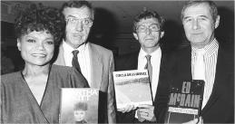

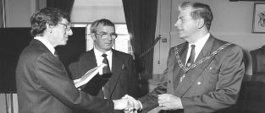

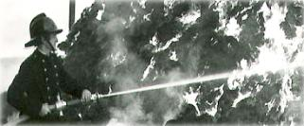

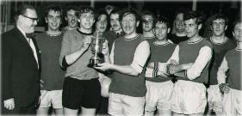

He is an accomplished photographer, who has been invited to show his photographs in art galleries
across the United States, including the Philadelphia Art Museum and the Cortland Jessup Art Gallery
in Provincetown, Cape Cod. One spectacular photograph of Princess Diana and Prince Charles
on their honeymoon was presented to the Queen and to this day also hangs in the Mayors Parlour at
Romsey, England - the home town of Prince Charles uncle, Lord Louis Mountbatten of Burma.
Colin Andrews, electrical engineer by profession, is the man who coined the term ‘Crop Circle’.
Among his many accomplishments: he started the first research organization, Circles Phenomenon
Research (CPR); designed high-tech surveillance operations attempting to film a circle being made;
and advised Prime Minister Margaret Thatcher’s cabinet and Queen Elizabeth on the mysterious
phenomenon. He compiled the largest data base in the world on the subject. Colin has written
numerous books including the classic Circular Evidence (1989) with co-author Pat Delgado, chosen
by the Queen for her prestigious Summer Reading List. He is frequently highlighted in documentaries
on the subject and was a consultant with the Mel Gibson movie Signs. His most recent books include
The Complete Idiots Guide to 2012 and The Complete Idiots Guide to the Akashic Record
written with his wife, Dr. Synthia Andrews. He is currently making his archives available to the public
in books such as Government Circles, The Andrews Catalogue and The Assessment.
Presentations
He has spent 29 years making presentations at universities, schools and public venues as well as
participate in government meetings and brainstorming sessions. He has been a consultant to
international institutes in many countries.

For fifteen years Colin was a retained (volunteer) fireman in the
Hampshire Fire and Rescue Service in his home town of Andover,
England.
He played soccer and represented Hampshire County in
several cup finals and continued to play for several teams
over a number of years. He lost just one fight as a light
heavy-weight boxer in the Army Cadet Force.

Colin was engaged by Test Valley Borough Council in 1974,
initially as head of their Electrical operations. He went through
a series of rapid promotions into middle management, ending his
career with government service as a senior officer. Seen here
saying goodbye to the Mayor of the authority just before he
resigned to take up his research full-time in 1991.

Publications and cinema
Circular Evidence, 1989. Co-authored with Pat Delgado, this was the first book ever written on the
subject. It became an international best seller. It was also chosen by Queen Elizabeth for her
prestigious "Summer Reading List", the first time a book of this kind has ever been selected.
Crop Circles: The Latest Evidence , 1990, was also co-authored with Pat Delgado, this was the
popular update to Circular Evidence and sold over 100,000 copies in Europe alone.
Crop Circles – Signs of Contact, 2003, co-written with New York Times best selling author,
Steve Spignesi covering new aspects of the research. The book includes a full catalogue of crop
patterns recorded by Colin between 1983 and 2003, which has also been self published separately
and called The Andrews Catalogue. May 2009 his book Government Circles was published by
Archive Publishing. Undeniable Evidence- 1990, the first crop circle video ever produced, which
showed stunning aerial footage of the phenomenon, and links the mystery to eco-political changes.
The Truth About Crop Circles – 1995, the live presentation made at Madison Square Garden, New
York. Andrews was consultant for Mel Gibson’s Disney block buster movie Signs; and Marcus
Thompson’s British movie A Place to Stay which was shown at the Cannes Film Festival in 2002.
Circular Evidence the Movie: Renegade Pictures. This movie is under contract and tells a story based
on the deeply moving experiences Colin has had while researching the mystery. His research has
profoundly affected all aspects of his personal life and career, as well as deeply impacting member’s of
his family. Colin and his wife Dr. Synthia Andrews, co-authored the new book 'The Complete Idiots
Guide to 2012 for Alpha books. It was published in various countries in October 2008. A second
book in the famous series is due out in July 2010 called The Complete Idiots Guide to The Akashic
Record.
Media
Andrews has appeared on numerous well known television and radio programs around the world
including 60 Minutes, 20-20 with Barbara Walters, Good Morning America, Sightings, Unsolved
Mysteries with Robert Stack, Coast To Coast with Art Bell, Histories Mysteries, The Shirley
Maclaine Show, Dan Aykroyd’s Out There, The Sally Jessy Raphael Show, BBC's Daytime Live,
The Ray Martin Show, National Geographic, Nippon TV’s Thursday Special, The Gloria Hunniford
Show, History v Hollywood, American Movie Classics with Mel Gibson and M. Night Shyamalan,
CNN Live Today, The Learning Channel's Looking for a Sign, Discovery one hour special, CBS
Gateway to the Unknown and many more. He has lectured extensively throughout the world to a
wide range of audiences including the special interest group 'U.N.S.R.C..' at the United Nations, and
The Hakui Museum Project in Japan.
"The Toby Award" from New Heaven New Earth for his 'honesty and perseverance’ in the face of
character assassination during his research of the Oliver's Castle video,. The video showed a crop
circle being made by UFO’s and was claimed by many to be genuine. Colin’s investigation revealed
it to be an elaborate hoax, intended to undermine the genuine crop circle mystery.
'EBE Film Award' for the movie "UFOs, Crop Formations and the Paranormal: The Secrets
Unfold as Time Runs Out at the IUFOC Film Awards in 1995: Producer, Reg Presley, featuring
Colin Andrews, Reg Presley and Busty Taylor.
September, 2002 The Maverick Award from the Bay Area UFO Congress for pioneering scientific
research into the Crop Circles.
The 2009 Paradigm Research Group 'Lifetime Achievement Award' - Hall of Fame Inductee,
presented in Washington D.C.
February 2012 at Scottsdale, Arizona, ' The Lifetime Achievement Award' by Open Minds TV at
the International UFO Congress, one of the largest of its kind in the world.
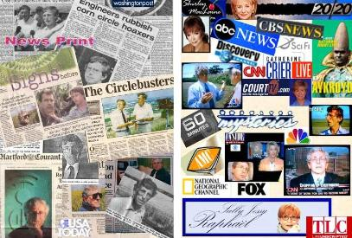

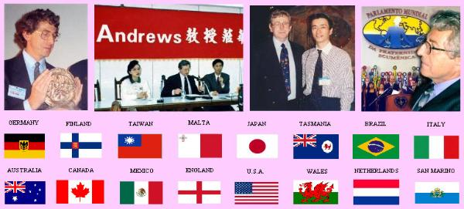

Colin and Synthia have been invited to work with The World Genesis Foundation in corporation with
The United Nations Educational, Scientific and Cultural Organization - To Support UNESCO Youth
Project in Romania.
Colin is writing two new books, one of which is a novel and has taken part in several recent
television interviews, both of which will be transmitted on International networks - details soon.
Colin is also a professional photographer, having shown in art galleries across the United States. His
photographs have appeared in numerous television programs, magazines, newspapers, etc. He uses
his photography to highlight the importance of nature and the dire need for preservation and
conservation on our planet.
Synthia his wife, has just completed writing another book which she and many others, including Colin
are very excited about. Called The Path of Energy encompasses much of her life's work and has
arrived at a unique time in history when science is now able to relate and support it. The book will
be published in June 2011 and has received powerful endorsements by well known and highly
respected pioneers such as Astronaut Dr. Edgar Mitchell, Dr. James Hurtak, Dr. Desiree Hurtak,
Gregg Braden and Dannion Brinkley. The forward is written by Barbara Marciniak.
Colin and his wife Synthia reside on a small farm in rural Connecticut.
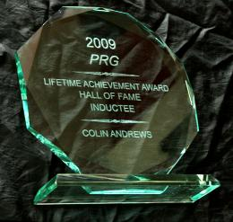

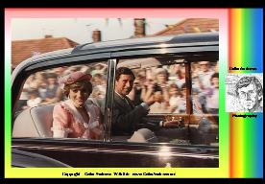
Photographer
One of Colin's favourite photographs, taken of Princess
Diana and Prince Charles arriving on their honeymoon in
Romsey, Hampshire, England.

Media Appearances
Presentations throughout the world
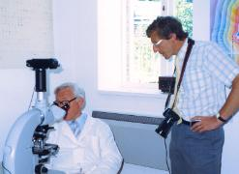
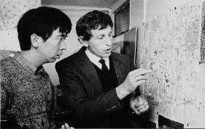
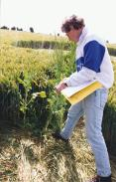

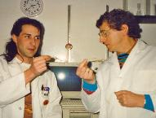

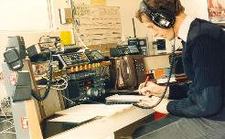

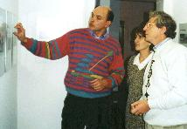

Principal Websites and Bloggs
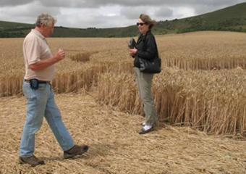

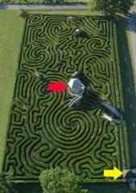

Without prior knowledge of why he had been invited to Longleat Adventure Park in
England, he was lead to the center (red arrow) of the worlds longest maze which is one
and three quarters mile long, handed his copper dowsing rods and asked to dowse his
way to the exit (yellow arrow). Without a single error his rods took him directly via
many twists and turns to the exit. With just one bend to go, he was told he was in the
wrong place to test his confidence which he ignored and continued directly as the rods
lead him to the exit. Colin worked with elders in the Australian outback and impressed
them with his ability to confirm traditional routes taken by the Aborigine peoples
hundreds of years ago. He has also successfully dowsed human involvement in crop
circles.
One of many highly successful results of his
remote viewing skills was when he identified a
murderer in Washington DC before the police
knew who they were looking for.
The murderer became known as the Beltway
sniper, who randomly killed ten people over a
period of three weeks during October 2002,
creating near panic along the I95 near the city.
Apart from those he shot and killed he also
critically injured three. On the night of October
14th, 2002 while watching reports on TV of
another shooting, Colin Remotely Viewed a
young black man, 17years old, and sketched
him near the edge of a parking lot, some
distant from the victim. When the police
finally got their man, Colin's Sketch closely
resembled that of the young 17 year old black
man, Lee Boyd Malvo. The incident Colin
accessed was in the parking lot of Home
Depot, in Fairfax County, Virginia where FBI
intelligence analyst was shot dead as she left
the store - killed by Lee Boyd Malvo (watch
video above). Colin has interacted with many of
the best known Remote Viewers in the world,
and was invited to participate in programs at
the famous Monroe Institute in the United
States.
Experienced Dowser
Remote Viewer

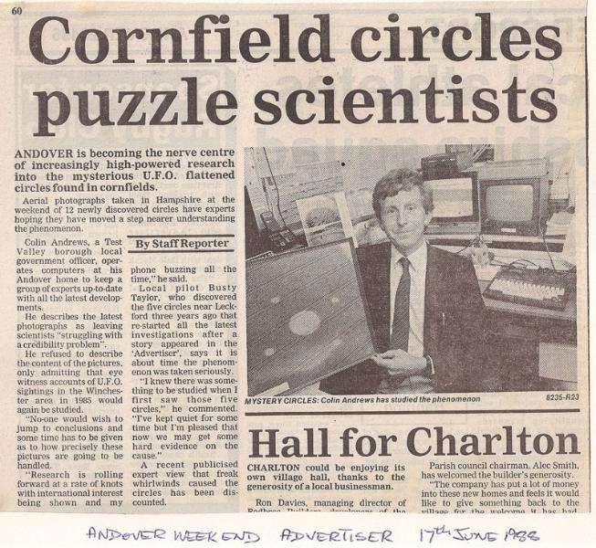
Life Changing Experience
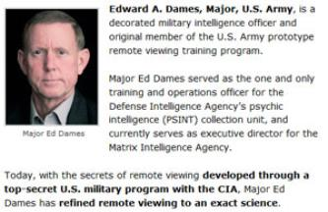
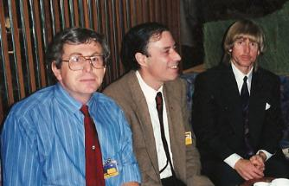
Left: Colin Andrews, Antonio Huneeus and Edward Dames in
Dusseldorf, Germany where they spoke at an International Conference

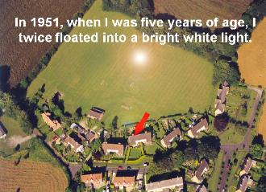

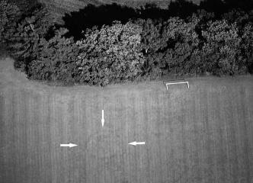

I was Five Years Old When A Bright White Light Appeared in the Field Behind my
House and Following a Strange Experience Blisters Appeared Over My Body. The
First Circle To Appear in my life Is Still There in the Field Today - HERE
..........................................................
PERSONAL MISSION
To expose truths in Politics,
Government and Business /
Promote Environmental Awareness
and Education / Illuminate the
Crop Circle & UFO Phenomenon./
Investigate Consciousness as an
energy field / Increase awareness
about the mistreatment of Animals
and to
Give our Children Hope.
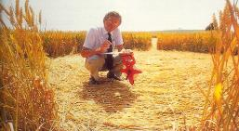

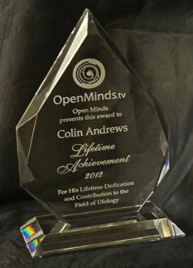

The award ceremony
Lifetime Achievement
Award
2012
Presented to
COLIN ANDREWS
By Open Minds
Lifetime Dedication and
Contribution to the Field
of Ufology
World's Largest UFO
Congress, Scottsdale,
Arizona, USA

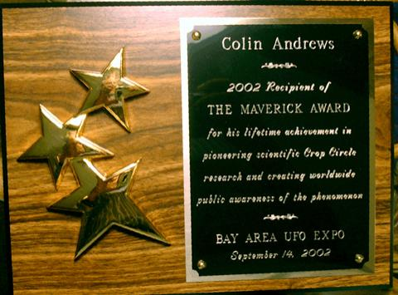

COLIN ANDREWS
2002 Recipient of
THE MAVERICK
AWARD
for his liftetime
achievement
in pioneering scientific
Crop Circle research
and creating worldwide
public awareness of the
phenomenon.
- - -
BAY AREA UFO
EXPO
September 14, 2002
Lifetime Achievement Award
Presented following the short movie above

SIDE NOTE
The two incidence that Colin
experienced when he was five
years old, and referred to in
this film can be seen HERE
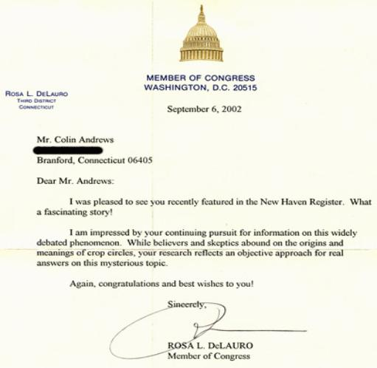
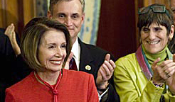

Nancy Pelosi and Rosa L. DeLauro - Congress 2009.
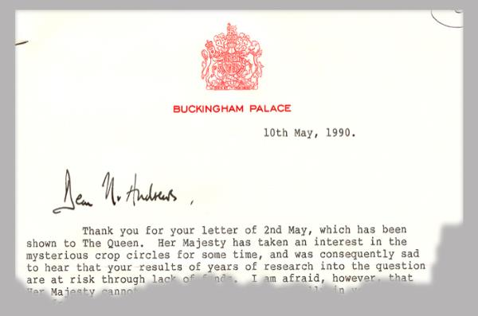

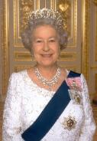
Her Majesty Queen Elizabeth.
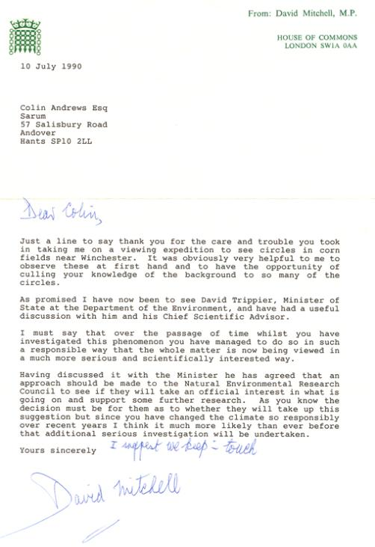
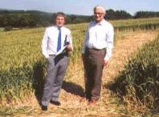
Colin Andrews with Sir David Mitchell
M.P.(member of the British Government) in a
crop circle.

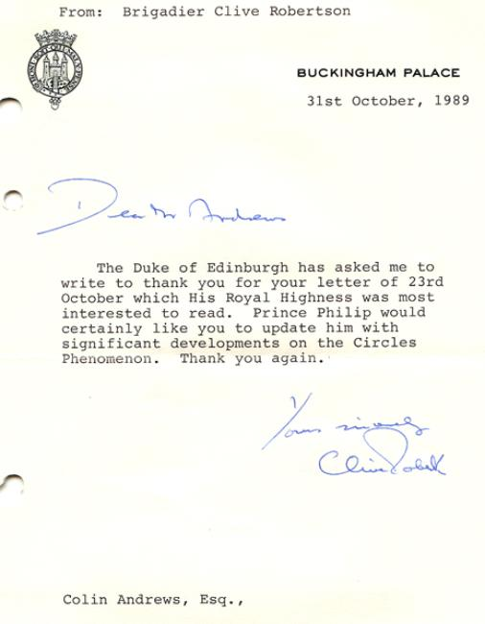
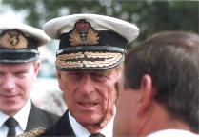
Duke of Edinburgh: Fascinated with the crop circles.

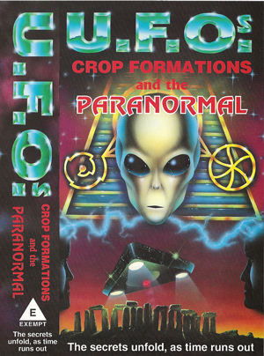

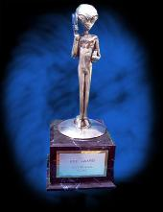

EBE Film Award - 1995
EBE Film Award 1995 - Reg Presley, Colin Andrews and Busty Taylor

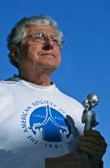

==========================================================================================
END

