A Brief History Of The Planet Nibiru

By Robertino Solàrion ©1996

http://www.apollonius.net/nibiru.html

After the discovery of the Planet Pluto in 1930 CE, astronomers soon noted that earlier theories regarding the hypothetical influences of such a planet on the orbits of Planets Uranus and Neptune were not validated by the existence of only Pluto. So eventually in the 1970s after computers were becoming commonplace, a computer-generated model of this "Planet X", as it was called, was created. It was determined that Planet X would have to be at least five times bigger than the Planet Earth. They also calculated the length and shape of its orbit around the Sun as well as the number of years necessary to complete such an orbit.
In 1983 with NASA's cooperation a group of astronomers began a comprehensive survey of the sky with the Infrared Astronomical Satellite (IRAS). In the fall of that year the IRAS discovered several moving objects in the vicinity of this solar system, including 5 previously unknown comets, a few "lost" comets, 4 new asteroids and "an enigmatic comet-like object". Headlines read "Giant Object Mystifies Astronomers" and "Mystery Body Found in Space". In The Washington Post was the headline and story "At Solar System's Edge Giant Object is a Mystery -- A heavenly body possibly as large as the giant planet Jupiter and possibly so close to Earth that it would be part of this solar system has been found in the direction of the Constellation Orion by an orbiting telescope called the IRAS. So mysterious is the object that astronomers do not know if it is a planet, a giant comet, a 'protostar' that never got hot enough to become a star, a distant galaxy so young that it is still in the process of forming its first stars, or a galaxy so shrouded in dust that none of the light cast by its stars ever gets through. 'All I can tell you is that we don't know what it is,' said Gerry Neugebauer, chief IRAS scientist."
The United States Government squashed the story immediately! For some arcane top-secret reason the government doesn't want to alarm or panic the general public by disclosure of this discovery. Why? Because a race of reptilian super-beings inhabits that planet, and common knowledge of this fact would have people screaming in the streets. Listen to this story.
Long, long ago, approximately 500,000 years back into the past, our Planet Earth/Tiamat was a quite different place than it is today. To clarify a point, this planet's original name is Tiamat. The nickname "Earth", from the Greek "Gaia", is only a recent innovation. Herein, this planet will be referred to as Planet Tiamat.
A half a million years ago, Tiamat was not located in Space where it is today. It orbited farther out from the Sun, in between the orbits of Mars and Jupiter. Mars was orbiting at a distance much closer to the Sun than now and was quite habitable, with a temperate climate and liquid water. This fact has been verified numerous times by NASA and other scientific groups. What those groups do not acknowledge is the fact that Mars had a different orbital pattern than today. Establishment groups do not accept a cataclysmic evolution of this solar system, at least not publicly.
Then, too, Tiamat's system was closer to the Star Sirius (or Sothis, as the ancient Egyptians called it). This solar system and the Sirian planetary system are part of a unit. The two systems are gravitationally connected to one another, a new fact that is now beginning to gain widespread consensus from the scientific community. Our "Sirian Regional System" as a unit revolves around the Central Sun Alcyone in the Pleiades Cluster, which might be termed "the Pleiades Quadrant". This greater sector revolves around the Galactic Center, in the direction of the Stars of Sagittarius, once every 200,000,000 years or so. What is so significant about our present-day epoch is that certain great cycles relating to orbital alignments within the Pleiades Quadrant and between this Quadrant and the Galactic Center are starting to repeat themselves, and there's nothing that we can do about it. It's happening, folks! Prepare for the unexpected! This Great Cycle should be in full swing by 21 December 2012 CE. Mark your calendars!
But returning to the history of Nibiru and Tiamat, our planet had a much colder environment than today. The humanoid population, which our paleontologists and the like call "Neanderthals", were hardier and hairier than we are. They lived in caves to take advantage of the natural internal warmth of Tiamat. These early Tiamatians were directly descended from ancestors in the Pleiades, a fact that can be amply verified by the history and mythology of the Mayans and the Polynesians, to name a couple. However, the Pleiadian origins of Tiamat in the first place will not be discussed in this brief history. That is for another time and space.
This solar system was internally stable 500,000 years ago. But an unanticipated, strange event occurred. One of the larger planets from the Sirian System had strayed off course eons before and had drifted our way. This planet had been unwittingly captured by our Sun and thrown into an extremely elongated comet-like orbit, lasting 3,600 of our current years, with its aphelion at the Oort Cloud, the very boundary of the Sun's gravitational field. It is approximately the size of our Planet Neptune. It is populated with a reptilian super-race governed by an elite aristocracy known as "the Nefilim". The general population is known as "Anunnaki" (Sumerian) or "Anakim" (Old Testament). At the time of this event, the Planet Nibiru was being ruled by Emperor Alalu and Empress Lilitu.
After its capture by our Sun, the Planet Nibiru slowly began to suffer atmospheric deterioration. The governing "Council of Twelve" headed by Emperor Alalu met in emergency session and concluded that in order for their planet to survive, a heat-shield of gold dust would have to be constructed to protect their atmosphere and prevent a cooling off of the planet, which would have been disastrous for a reptilian-based existence constantly dependent upon external heat sources for bodily warmth. They began an immediate exploration of their new solar system. A fleet of spacecraft was dispatched to Tiamat and other planets in an attempt to search for gold.

CURRENT MEMBERS
OF THE COUNCIL OF TWELVE

*
Emperor Anu & Empress Antu
Crown-Prince Enlil & Crown-Princess Ninlil
Prince Enki & Princess Ninki
Prince Nannar & Princess Ningal
Prince Utu & Princess-Royal Inanna
Prince Ishkur & Queen Ninkhursag

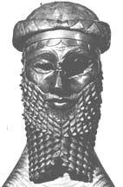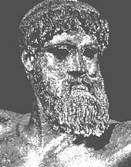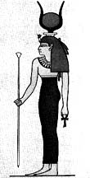
Left-Right : Emperor Anu, Prince Enki, Princess-Royal Inanna
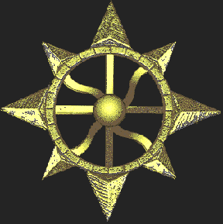
The above graphic, obtained from a website, is supposed to be the insignia of
Nibiruan Crown-Prince Enlil, Yahweh, Zeus, Osiris, Thor.
Probably it represents the central core of the Winged Disk.
The following are images from the Internet of depictions of the Winged Disk. If you are interested further, you can contact me or search at Google or elsewhere for additional information. Some of these Internet images are corrupted.
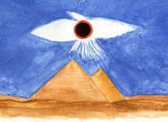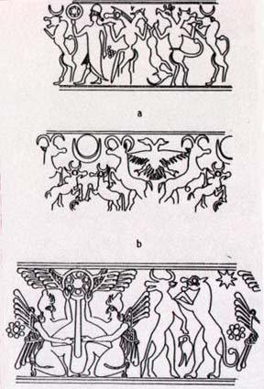

Commander and Crown-Prince Anu, along with his two sons Enki and Enlil and daughter Ninkhursag, landed in what is now the Persian Gulf and first went ashore in what is now modern-day Kuwait. Eventually they established a spaceport in Mesopotamia at a place known in our mythology and religion as E-din or Eden. Guided by those early Tiamatians, they found abundant sources of gold on Tiamat and successfully created their Nibiruan heat-shield. They soon found out, however, that this heat-shield required periodic maintenance, in turn forcing them to always have a contingent of Anunnaki gold-miners stationed here on Tiamat, constantly shipping more gold home to Planet Nibiru.
After the passage of several Nibiruan orbits around their new Sun, perhaps 26,000 Tiamatian Years, as their planet's orbit stabilized, Nibiru passed perilously close to Tiamat. One of its host of moons and moonlets crashed into Tiamat in what is now the Pacific Ocean, blowing the lost continent of Lemuria to smithereens, leaving its remnants floating about in Space in what we now so casually refer to as the "Asteroid Belt", and knocking Tiamat out of it old orbit and into a newer one closer to the Sun. In the process, Tiamat captured one of Nibiru's moons named "Kingu", which is the correct term for our present Moon. Tiamat and Kingu finally settled down into their current positions, and in all of this chaos the Planet Mars got displaced to a new orbit farther out from the Sun, eventually causing that planet's surface to freeze and die. On the up-side of all of this was the fact that this cosmic catastrophe made Nibiru's orbit finally stabilize, so that no more events of this awful magnitude have subsequently occurred.
In connection with this upheaval, Crown-Prince Anu and his consort Crown-Princess Antu became distressed with Emperor Alalu's actions and decisions, so the next time Emperor Alalu and Empress Lilitu visited Tiamat to check for gold-mine damage that might have resulted from the collision, they staged a coup d'état and proclaimed themselves Emperor Anu and Empress Antu. They banished deposed Emperor Alalu and Empress Lilitu to Tiamat and forbade them from ever returning to Nibiru. Alalu and Lilitu, believe it or not, may still be alive and living in a palatial underground spaceport in the Grand Teton Mountains near Yellowstone National Park, surrounded by massive hordes of gold and precious gems, and operating an enormous transmitter device (the source of the Taos Hum?) that allows them to stay in communication with Nibiru and its space patrols. It should be emphasized now that the Nibiruans are not the typical big-eyed "Greys" that we hear about so often in the media. See The Gods Of Eden by William Bramley for additional details.
To digress for a moment at this point, the reptilian inhabitants of the Planet Nibiru are anywhere from 10-20 feet (3-6 meters) tall. They have elaborate cranial hair, often multi-colored, but very little, if any, body hair, although some of the males do have mustaches and beards. Many of the males have goat-like horns on their heads, and many of the females are winged. They do not sweat and have no body odors, which was one reason they didn't let the Tiamatians do their gold-mining for them. They thought the hairy Tiamatian mammals stank, and they didn't like to be around them. They stayed to themselves. They can have up to seven pupils in each eye, seven fingers on each hand, and seven toes on each foot. They regularly wear clothing made of pure goldleaf, and their diet mainly consists of liquids which provide them with their necessary nutrients without their having to consume many solid foods. They seeded Tiamat with many of our current fruits and vegetables, however, and they deserve credit for that. See the companion essay Nibiruan Physiology.
Time passed. The Anunnaki gold-miners got restless, despising their drudgery in the mines, which were primarily located in what is now South Africa, under the command of Nefilim Duke Nergal and Duchess Ereshkigal. Eventually they revolted and refused to do anymore mining. Alarmed, Emperor Anu summoned Queen Ninkhursag to the throne room. Queen Ninkhursag is Nibiru's Chief Medical Officer and Geneticist. Emperor Anu implored Queen Ninkhursag to come up with a cloned hybrid Nibiruan-Tiamatian to act as a slave gold-miner. She accepted the challenge and eventually created a hybrid male from the egg of Tiamatian female and the sperm of her brother Prince Enki. She referred to this hybrid as the "Adamu". At first, only males were produced, cloned one just like the other. A group of Nibiruan females was ordered to serve as incubation vessels for the Adamu clones. These female Anunnaki were known as the "Birth Goddesses".
Life went merrily along. Nibiru had its gold, the Anunnaki males were freed from the mines, the Adamu clones went into fullscale production and became excellent gold-mining slaves. But as always happens both here and on Nibiru, a hitch developed. The Birth Goddesses got fed up with sitting around pregnant all the time with little Adamu clones, so they revolted and refused to continue with the incubation process. Emperor Anu immediately had Queen Ninkhursag brought back to the throne room and this time ordered her to create a "female Adamu" that could mate with the males and produce their own clones. By now, for Queen Ninkhursag, this was a piece of cake. She created the female "Eva" prototype along with an absolutely perfect Adamu clone. These two were allowed to romp around naked on the palace grounds at Eden, in hopes that they would produce a child, a little-bitty-baby-slave gold-miner, the PERFECT ROBOT!
But alas -- they were infertile. Just as two mules cannot produce another mule, requiring instead that a horse mate with a donkey, these two hybrid clones could not reproduce. At this point Emperor Anu was beside himself. He had to have gold! So he ordered Queen Ninkhursag to undo the hybridization! She had her brother Prince Enki travel to the Eden Palace to do the job for her. Prince Enki had the hybrid Adamu and Eva ingest a chemical substance of some sort that caused them to revert back to more of a Tiamatian than a Nibiruan creation. They immediately shed their reptilian outer-skins and began to mate. Realizing that he'd been dealt a major blow, in that as a result of the dehybridization he'd lost power over these new creatures, Emperor Anu banished the Adamu and Eva from forever re-entering the Eden Palace grounds.
Cro-Magnon Man was born. It was approximately 20,000 years ago. Neanderthal Man was slowly but inexorably going extinct as a result of Tiamat's closer proximity to the Sun and its warmer climate. By 10,000 BCE, they really no longer existed, leaving Cro-Magnon Man to dominate Tiamat.
In his book The Rainbow Conspiracy, Brad Steiger writes in connection with the Philadelphia Experiment that U.S. President Franklin Delano Roosevelt met with some "nearly human aliens" in the 1930s. These aliens had a greenish tint to their skin. In order to mingle unnoticed here on Tiamat, they use a bleaching solution to lighten their skin-tone. And then there are all those old drawings of "gods" from India, nearly human-looking "gods" who have a bluish skin-tone. Did you ever look closely at the skin color and quality of anole lizards (faux chameleons)? Their skin is so, so smooth and silky! And green! According to a report on TV in August 1996, medical researchers, looking into better ways to develop medicine-delivery skin-patches for sick people, have discovered that snakeskin is extremely similar to human skin. They are developing new medicine-delivery skin-patches from plain old snakeskin! Why is this important? Well, R.A. Boulay in his book Flying Serpents And Dragons writes in connection with our Nibiruan ancestors that the snake was a correlative creation that occurred during the dehybridization process of the Adamu and Eva! What unnecessary or useless reptilian characteristics that had to be "shed" during dehybridization rematerialized as a "serpent". Thus, one might contemplate the following: if an anole or a chameleon can change colors, can a Nibiruan do the same?
What happened next is our recorded history. Nibiru once again came too close to Tiamat, unleashing a worldwide catastrophe of floods and earthquakes. This time the Eden Palace and Spaceport themselves were inundated and destroyed. Nefilim Prince Utu was ordered to rebuild the Spaceport in what is now the Sinai Peninsula. Life on Tiamat eventually got back to normal, but then the "Pyramid Wars" broke out.
One of Emperor Anu's favorites was a Princess-Royal Inanna, whom he appointed as ruler of what is now known as India and Nepal. Her Hindi/Sanskrit title was Lakshmi. She is still worshipped there today. Her lover and consort was the most handsome man on Nibiru, the Duke Dumuzi. Duke Dumuzi became involved in a quarrel with Baron Marduk, resulting in the outbreak of the "Pyramid Wars". Princess-Royal Inanna and Duke Dumuzi began a protracted power struggle with Baron Marduk and Baroness Sarpanit. In the process Duke Dumuzi was murdered by Baron Marduk; and Prince Utu in cahoots with Princess-Royal Inanna blew up the Sinai Spaceport along with the satellite R&R cities of Sodom and Gomorrah. The South African goldmines fell into disarray when Duke Nergal and Duchess Ereshkigal allied themselves with Baron Marduk and Baroness Sarpanit. Once again there was chaos among the Nefilim Ruling Council

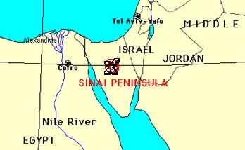
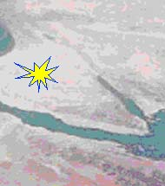

Emperor Anu was forced to rebuild the Nibiruan Spaceport, this time putting it under the command of his son Prince Enki. Prince Enki and his consort Princess Ninki were sent to what is now the area around Lake Titicaca, Peru, where they rebuilt the complex on the Nazca Plain. Massive new sources of gold were found in the surrounding Andes Mountains, so the South African mining operation was moved to Lake Titicaca.

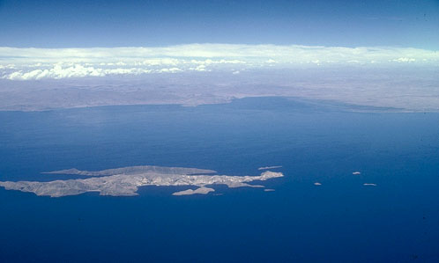
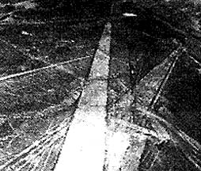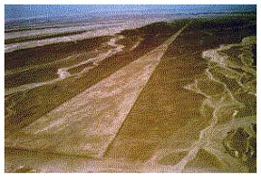
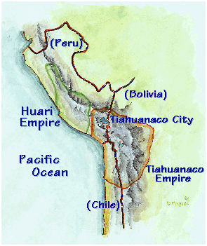
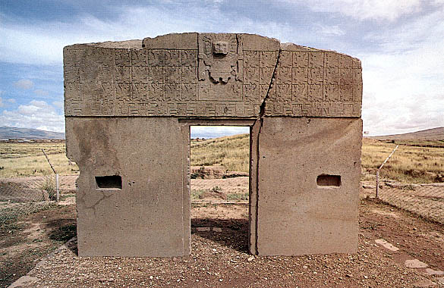

And that brings us up to about 3,600 years ago. At that point it seems that the Nibiruans began to abandon Tiamat. Perhaps their atmospheric heat-shield had "crystallized" by then, and they no longer had need of so much gold from Tiamat. This is unclear. The last time their planet passed by Tiamat was in 687BCE when they once again headed out for their long winter hibernation at the Oort Cloud. But they have always continued to maintain some sort of presence here. In addition to the underground installation in the Grand Teton Mountains, they have other underground facilities in South America, in the Saudi Arabian Empty Quarter and in the Himalaya Mountains, to name a few. There's another underground chamber just southwest of the Great Pyramid of Egypt, which the Nefilim built in connection with the Sinai Spaceport; but there is a debate of sorts about which extraterrestrial race controls access to that most sacred, ancient chamber. The answer to that question, as well as many others, will undoubtedly be forthcoming in the very near future.
Where is Planet Nibiru today? Well, it's still out there. Occasionally some astronomer will spot it and name it some enigmatic cosmic object, like an "Object Kowal" or a "mini-galaxy". Our governments definitely suspect that it's there but may be keeping this knowledge under wraps from the general population. Ancient skywatchers in the Middle East and Mayan Mexico are said to have looked for Nibiru's grand arrival in the Constellation of Sagittarius. When it periodically returns to this part of the solar system, it apparently sort of appears out of nowhere. Suddenly it's just up there, like a golden miniature sun with a long and fearsome cometary tail trailing along behind it and its host of satellites, hovering, dangling like a jewel over the Tiamatian North Pole for a "millennium of the gods." The Cosmic Tree. The World Mountain. Mount Olympus. Mount Meru. Hyperborea, the North Country, the nation beyond the land where the North Wind rises, the land of eternal springtime, the nation beyond the mountains of the God of the North Wind! Hyperborea!
The material presented here in only the tip of the iceberg of our available knowledge of the Planet Nibiru and her stormy interaction with Planet Tiamat. If you would wish to obtain additional information, you are referred to the following books, including all of the Sitchin material in eight volumes consisting of more than 2,800 pages total.

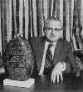
Genesis Revisited by Zecharia Sitchin
Divine Encounters by Zecharia Sitchin
The Earth Chronicles by Zecharia Sitchin
1 -- The Twelfth Planet
2 -- The Stairway To Heaven
3 -- The Wars Of Gods And Men
4 -- The Lost Realms
5 -- When Time Began
6 -- The Cosmic Code

The Gods Of Eden by William Bramley
Gods Of The New Millennium by Alan F. Alford
Matrix IV: The Equivideum by Val Valerian, Drunvalo Melchizedek & Michael Topper
The Secret Science by John Baines
The Stellar Man by John Baines
The Rainbow Conspiracy by Brad Steiger
The Hidden History Of The Human Race by Michael A. Cremo & Richard L. Thompson

END

