THEY LIVE
By John Carpenter 1988

http://www.toptown.com/dorms/creedstonegate/they/they.htm

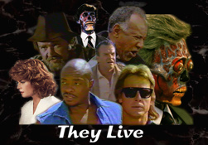

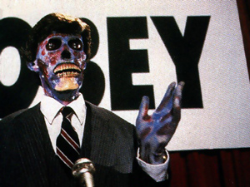 | 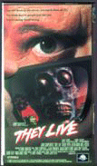  Greetings, this page is just one section of many that make this site. Once you're done here, be sure to check out the other sections, they're linked at the bottom of the page. I'm Creed, the author of the whole site, thanks for stopping by. If you have any comments on this or any other section of this site, please feel free to drop me a line at Creed@bigfoot.com, or post your thoughts on the Message Board.  This section of the site is about the greatest movie I've ever seen, director John Carpenter's masterpiece They Live. The movie stars Roddy Piper as John Nada, a normal guy who stumbles upon the existence of a hidden race of extradimensional beings. These "aliens" cloak their existence by using subliminal transmissions. They also use these transmissions to get the humans of earth to obey their every command. He joins the cause of a small band of rebels who are armed with the knowledge of what's going on, and special glasses called Hoffman lenses that allow them to see beyond the subliminal signals.  I won't give any more away, but like I said, this movie is the best I've ever seen! I've been fortunate enough to get some screen captures from the movie done. Most images here were scanned or digitized by me. If you'd like to use some of them for your own site, I don't mind at all, just let me know. I'd also appreciate it if you mentioned where you got the images, and supplied a link to this page. There is a lot here, so just scroll down to see the various attractions that I've set up here. Thanks for stopping by.

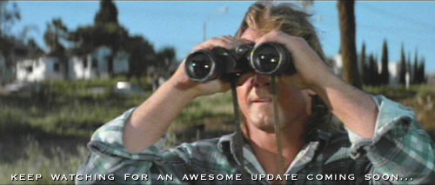

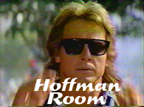 | This seems to be one of the best liked sections of the entire site. I get more comments on it than most other sections. It's an example of the subliminal messages that are found in They Live. I've used javascript to make you a pair of virtual Hoffman Lenses. Just enter the Hoffman Room by clicking on the picture on the left. Then roll your mouse over the pictures there to see the subliminal messages! It's that easy. Let me know what you think!

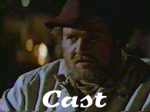 | A full list of everyone in and involved in They Live. There are even pictures and links to some of them. I'm still working on this section, check out what I've done so far. If you have any info that's not listed here, please pass it along to me. Thanks.
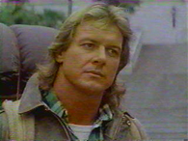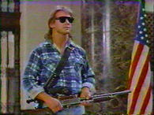 | Roddy Piper as Nada  More famous for being a wrestler than an actor (though the two are related), Roddy Piper proves he's a great actor in this movie. His real name is Roderick Toombs, and he's a canuck like myself. According to some sources, he was born 17 April 1951, Winnipeg, Manitoba, Canada. Other sources say that he was born in Glasgow, Scotland. I believe that he currently wrestles for WCW Wrestling.  • If you're a fan of the Hot Rod like myself, The Piper's Pit is a MUST SEE SITE!!! Check it out!!!  • The list of films that he has been in ...IMDB  • Check out this Spotlight on Roddy Piper.  • Check out these great sounds of Piper from wrestling.

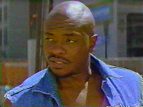 | Keith David as Frank  Keith David is probably best known as the voice of Goliath on the cartoon show Gargoyles. Well, he proves to be as tough as his cartoon alter ego in this movie, in the famous fight scene in They Live.  • The list of films that he has been in ...IMDB

 | Meg Foster as Holly Thompson  Meg Foster is one of those actresses who's name probably isn't as well known as her face. She seems to get a small part in almost everything at one time or another. One thing's for sure, you won't forget those unique icy eyes. I only got to do some screen captures from the first bit of the movie, and had no picture of Meg Foster as Holly. The one you see is from A Tribute to John Carpenter, a really great site with lots of great images. You really should check it out!  • The list of films that she has been in ...IMDB

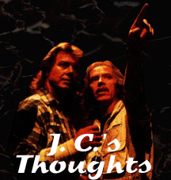 | Here is a collection of quotes from interviews with John Carpenter. They all have to do with They Live, and I found them (or links to them) on Marc Bright's John Carpenter page. It's probably the most comprehensive John Carpenter site you'll find.
Here is a short clip about They Livefrom a John Carpenter interview:
KOOLKING: Were you proud of They Live?
Carpenter: I love 'They Live'. It is one of my favorites of my own movies.
...and from another interview:
AOLiveMC11: From EBerns697:
Question: What is your favorite movie that you have directed?
JCarpentr: I love each one of my movies as you might love a child. I make them, they grow up to be 18, I kick
them out of the house and into the theaters, and tell them to get a job. I do have, however, a few particular
favorites, including "The Thing" and "They Live."
AOLiveMC11: From HuckHound:
Question: Hi, John. I had an impression of Nada from "They Live" as being a somewhat Christ-like figure. I also get the same impression from Travis Bickle. Nothing concrete to back this up, but I was wondering if this is completely insane or not.
JCarpentr: John Nada was meant to be an everyman/working class character. I'm not so sure about the Christ-like stuff.
AOLiveMC11: From BDuke25:
Question: Despite his surprisingly good performance (for a wrestler), what was the impulse or story behind the casting of Roddy Piper in "They Live?"
JCarpentr: I thought Roddy had a lot of charisma and ability, and I wanted to give him a chance. I think he did a great job.
More wisdom by Carpenter:
"You have an opportunity in a lot of films to really tell a story,” says Carpenter. “They Live is a good example of a traditional story turned inside out. The aliens have taken over, they’re definitely horrible, ugly aliens, but what they stand for is unrestrained capitalism and what it’s doing."
Another quote about They Live from Carpenter:
Carpenter : "This is one of my favourite movies. It's a comment on unrestrained capitalism and features the greatest fight scene in history. I saw The Quiet Man and thought, 'I can do it better.' We rehearsed it for two months - and shot it in four days."
Why he made the movie:
"I wanted to return to low budget movies that would turn a profit for the studio cos it cost shit to make. I wanted to say something about a lot of the things what were going wrong in the country at the time. There was this trend to unrestrained capitalism, it was absolute total stupidity some if it. All the problems I thought had been solved were back: censorship, racism. But I didn’t want to preach. So I took a short story and adapted it. And I also wanted to make the longest fight scene in film history..."

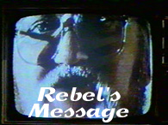 | In the movie, the aliens are using subliminal messages to control the earth. The group of rebels who make the Hoffman lenses also hack their tv signals. Check out the rebel's message that they try to get out to the people. This page also has the only gif animation you'll find on the whole site. I really hate looping animations, and wouldn't use an animation unless I thought it was appropriate. This one is appropriate, and it only loops 5 times.
...our impulses are being redirected. We are living in an artificially induced state of consciousness that resembles sleep..
...the movement was begun eight months ago by a small group of scientists who discovered, quite by accident, these signals being sent through tele...
...the poor and the underclass are growing. Racial justice and human rights are nonexistent. They have created a repressive society and we are their unwitting accomplices...
...their intention to rule rests with the annhialation of consciousness. We have been lulled into a trance. They have made us indifferent, to ourselves, to others, we are
focused only on our own gain. We ha...
...please understand, they are safe as long as they are not discovered. That is their primary method of survival. Keep us asleep, keep us selfish, keep us sedated...
...they are dismantling the sleeping middle class. More and more people are becoming poor. We are their cattle. We are being bred for slavery. The revolu...
...we cannot break their signal, our transmitter is not powerful enough. The signal must be shut off at the source. We have...
Well, this message is transmitted from a church by the rebels in the movie. They also make and distribute Hoffman Lenses from that church. Gilbert seems to be the leader of the group which includes the street preacher, and the man in the transmissions. As they say, their signal isn't strong enough to break the alien's signal for long, so the message keeps breaking up. People who see the message get a headache as their brainwashing is interrupted. They say that the revolution is only eight months old, I wish they would've shown something of the scientists who discovered the whole thing. I also wonder if there were any other rebel groups in any other parts of the world. There are a lot of interesting stories here, that are left unexplored. I have seen the movie well over 100 times, and I'm playing around with a story. If I ever finish it, I'll post it here for fans of the movie to evaluate.
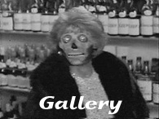 | Here is a gallery of screen captures I've done from the movie. I've only captured from the first part, but there are some great pictures here. Just click on a thumbnail to see the large version of the pictures from They Live! The thumbnails are here, but the actual pictures are on another server to conserve space, so it's conceivable that the links to the larger images might not work. This is unlikely to happen, but if it does, that's why. Just come back later and try again. Also, there are quite a few images here, so it'll take a bit to load.
Here are the stills that I've captured, with the exception of the picture of Meg Foster as Holly, which I got from A Tribute to John Carpenter. I only got to capture these from the first part of the film, and I don't have access to the equipment any more. You can use any of my images, just drop me a line at Creed@bigfoot.com and tell me that you're using them. I'd also like you to mention where they came from, and supply a link to the main They Live page. Even the greatest website can't do this amazing movie justice, so make sure that you go out and rent or buy the movie. You'll be glad you did! Also, be sure to check out the other sections of my site. They're linked at the bottom of the page.
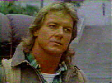 | 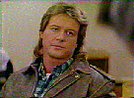 | 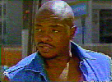 |  | 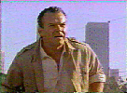
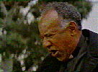 | 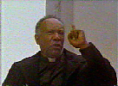 | 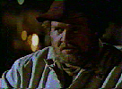 |  | 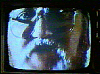
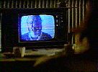 |  |  |  | 
 |  |  |  | 
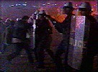 | 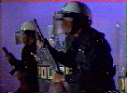 | 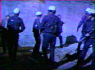 | 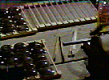 | 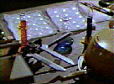
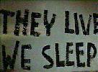 |  | 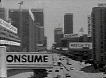 | 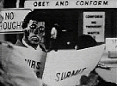 | 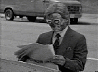

 | 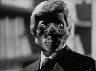 | 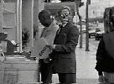 | 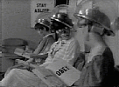 | 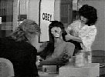
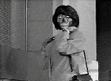 |  | 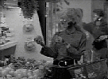 | 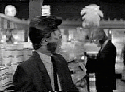 | 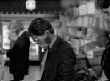
 | 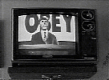 | 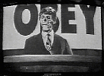 |  | 
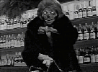 | 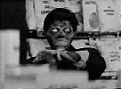 | 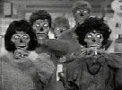 | 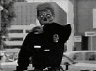 | 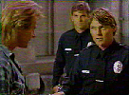
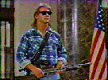 | 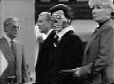 | 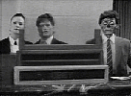 | 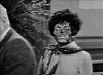 | 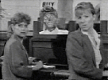
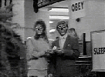 | 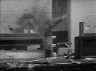 | 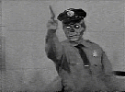 | 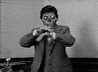

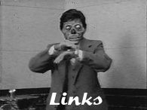 | I'll modestly say right now that this is the best They Live site, but there are some others that are really good. I've linked to them here. Check out their links sections for even more related links.

Well, you're at the best site about They Live, but there are others that are great too. Most of them are about John Carpenter in general. Anyone who likes the movie must be cool, and the site authors who have sites listed below are definitely cool. Check out these links, you'll be glad you did!



This site didn't really have any They Live content for a while there, but now it rules. The They Live section has really great design, some great pictures and sounds! This should definitely be your first stop after this site! And be sure to check out the whole Assault on Website 13 site!
This is definitely the most comprehensive John Carpenter site online. It's the first one I found when I came online a few years ago. The image above links to the They Live section of the site. Here is a link to the Main Page.
Well, if you're looking for multimedia from the film, this is a great place to look. There are sounds, pictures, and even a Realvideo version of the awesome trailer!!! This place is a must see for any fan of the movie. Here is a link to the Main Page.
Those are the main links I wanted to put up. Eventually, I want to list every site with a mention of the movie, but that'll wait for later. If you have a site with some content about They Live, and you'd like to be here, just drop me a line at Creed@bigfoot.com. Also, be sure to check out the other sections of the site, they're linked at the bottom of the page.
Here are some other places that mention They Live. I'm only putting these here to eventually list every site I can find. A lot of these are just reviews by lame people who don't see the greatness of the movie. Anyway, here are the other links I've found...
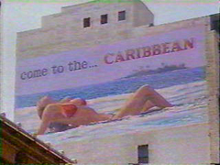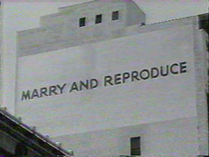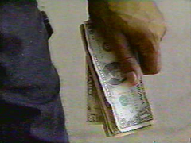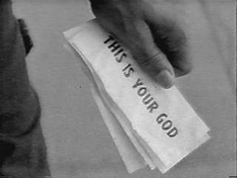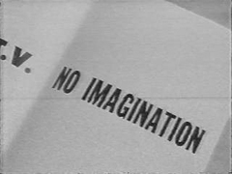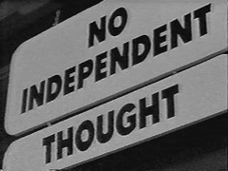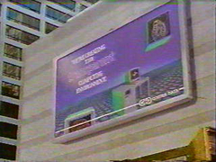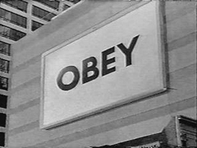



http://www.geocities.com/avenger00soul/pics9.html
WE SLEEP
Summary: A down on his luck construction worker moves to L.A. and makes the startling discovery that the world has been taken over by an alien race now posing as the upper classes of society and who are now using humanity as a slave race, using mind control techniques to keep them pacified.
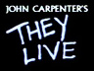
The Heroes:
"Rowdy" Roddy Piper &
Keith David
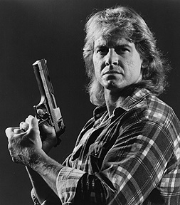
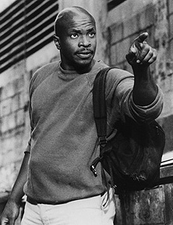
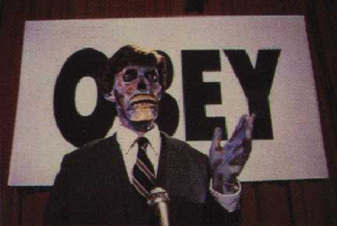
Review: Did you ever think that you would see "Rowdy" Roddy Piper in an extremely intelligent movie? If you said no, then I guess you've never seen They Live. John Carpenter's They Live depicts the world overrun by aliens who control everything, our money, our economy, and even our thought patterns. They run the whole show. And no one knows. The story begins with an unusual but great,
straight-to-the-point, graffiti intro. And then the drifter (Piper) appears. His character name (which is never given) says it all: Nada--nothing, zero, the underclass and the poor. Meanwhile, with the promise of money, the rich are under alien control and the middle class are following. Shows the power of the dollar bill right? Carpenter doesn't focus too long on America's greed but one scene sums it up: A
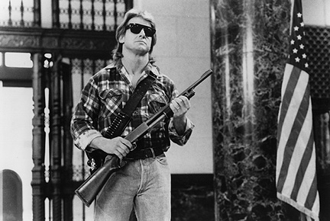
dollar bill is shown reading "This is your God." Horror, sci-fi, action, and intelligence have never been blended so well. Carpenter's score also taps into the feeling of the film. It's gritty and very western at times, it fits the film well. The actors are great too. Piper and Keith David make an awesome duo. They stage the best fight scene ever filmed. And seeing Buck Flower is always a plus ("Some sort of epidemic of violence is what they been sayin'."). They Live is Carpenter at his best and a must-see in my book. Watch this movie (OBEY).
"I have come here to do two things: chew bubble gum and kick ass."

They Live (1988)

http://www.geocities.com/j_nada/carp/tlive.html
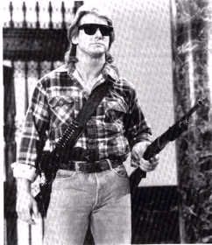
' I Have Come Here....'
They Live is one of Carpenters most interesting and satisfying films. Opening shots of Roddy Piper, walking through heavily run-down industrial zones, inform us that we are in a world of economic hardship for the masses. Piper is a drifter, looking for any sort of work just to buy food. He hooks up with Keith David and manages to get a job on a building site and a place to stay.
The place to stay is a cardboard city. While at the city Piper notices people creeping in and out of the church across the road at unsociable hours. These people get especially edgy when the police helicopters are making one of their increasingly frequent sweeps across the area.
Strange things are happening throughout the city. A preacher spouting doom gets arrested by the police, a weird group of scientists are tapping into TV broadcasts and saying strange things about invaders. These broadcasts urge people to wake up, shake off their apathy and take a look at what is really happening in the world.
Events come to a head when the cardboard city is cleared by the police, using excessive violence. Piper manages to escape and finds his way back to the church. In the church he finds a strange laboratory and a box of sunglasses. When he puts on the glasses he has a huge surprise.
The alien invasion has already happened, they have been living amongst us for years. The glasses enable Piper to see the subliminal messages and the aliens real faces, damn ugly. The aliens are treating Earth as just another developing zone, prime real estate space. This is where Carpenter really hits us with his anti-authoritarian satire. Money is labelled with This Is Your God, everywhere there are signs telling us to eat more, sleep more, consume more. Piper goes off on a mad rampage that ends with the apparent death of loads of innocent civilians. He later tries to get his friend David to wear the sunglasses but David has heard of Pipers killing spree and thinks he has gone nuts. There then follows one of the most hilarious and certainly one of the longest fight scenes in movie history. Carpenter apparently just pointed the camera and said GO to the two actors, they just start to knock lumps out of each other.
Armed with a set of glasses and his partner David, Piper sets out to find out what is going on and ultimately to unmask the aliens.
They Live is very reminiscent of the typical 50's sci-fi movies where something has infiltrated and is subverting our way of life. They Live replaces the 50's paranoia of Communism with JCs distrust of the capitalist money making machine. The whole thing is done slightly tongue in cheek with plenty of humour spread throughout the movie. Thats not to say the usual Carpenter suspense isn't there as well. Piper is excellent as the wisecracking hero, shooting first and asking questions later.
It is based on a short story called 6 O’clock In The Morning, it is also very similar to the Stephen King short The Eleven O’clock People. They Live is a brilliant sci-fi actioner that is one of the highlights of Carpenters directorial output.
Courtesy Of The Infinite Coolness Website a transcript of the alien message in the film:-
...our impulses are being redirected. We are living in an artificially induced state of consciousness that resembles sleep.. ...the movement was begun eight months ago by a small group of scientists who discovered, quite by accident, these signals being sent through tele... ...the poor and the underclass are growing. Racial justice and human rights are nonexistent. They have created a repressive society and we are their unwitting accomplices... ...their intention to rule rests with the annhialation of consciousness. We have been lulled into a trance. They have made us indifferent, to ourselves, to others, we are focused only on our own gain. We ha... ...please understand, they are safe as long as they are not discovered. That is their primary method of survival. Keep us asleep, keep us selfish, keep us sedated... ...they are dismantling the sleeping middle class. More and more people are becoming poor. We are their cattle. We are being bred for slavery. The revolu... ...we cannot break their signal, our transmitter is not powerful enough. The signal must be shut off at the source. We have...
Cast overview, first billed only:
Roddy Piper | .... | Nada
Keith David (I) | .... | Frank
Meg Foster | .... | Holly
George 'Buck' Flower | .... | Drifter
Peter Jason | .... | Gilbert
Raymond St. Jacques | .... | Street Preacher
Jason Robards III | .... | Family Man
John Lawrence (I) | .... | Bearded Man
Susan Barnes | .... | Brown Haired Woman
Sy Richardson | .... | Black Revolutionary
Wendy Brainard | .... | Family Man's Daughter
Lucille Meredith | .... | Female Interviewer
Susan Blanchard (I) | .... | Ingenue
Norman Alden | .... | Foreman
Dana Bratton | .... | Black Junkie
(more)

Also Known As:
John Carpenter's They Live (1988) (USA: complete title)
They Live! (1988) (USA: poster title)
Runtime: 93
Country: USA
Language: English
Color: Color (DeLuxe)
Sound Mix: Dolby
Certification: Australia:M / UK:18 / USA:R / West Germany:18 (nf)

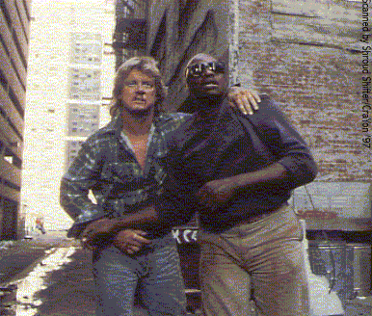
Roddy Piper and Keith David
http://www.geocities.com/j_nada/carp/tltriv.html

During a scene in a bar, one of the aliens watches two critics raging against violence in the movies. The main director they criticise is John Carpenter.
The films star, Roddy Piper is a WWF star.
Writer Frank Armitage is actually director John Carpenter.
The fight between Nada (Roddy Piper) and Frank (Keith David) was only supposed to last 20 seconds, but Piper and David decided to fight it out for real, only faking the punches to the face. Carpenter was so impressed he kept the scene intact. - More recent info actually disputes this but it makes a nice enough legend. The actual fight was meticulously choreographed and rehearsed for weeks before filming. It was a direct intent by JC to get the longest fight scene onto film.

http://uk.imdb.com/M/title-exact?title=They%20Live%20(1988)
M. A. Rogers (docrog@sprynet.com)
New York City
Date: 28 November 2000
Summary: Underrated Sleeper
Rating: 9 out of 10; What the rating means in my system: "A must see for everyone who is a fan of the genre. Anyone seriously or casually interested in film should enjoy it or at least find something interesting about it."
Horror auteur John Carpenter's foray into full-fledged science fiction, They Live, may not be as successful as some of his masterpieces such as Halloween, Christine and Vampires, but it's awfully close.
It's not the first time director/writer/composer Carpenter has ventured into other arenas, including sci-fi. In fact, if you closely analyze his films, you'll discover that most of them contain elements from all the fantasy genres--horror, sci-fi, action (actioners are a more complicated case, but most of them qualify), and fantasy proper--and Carpenter just chooses to emphasize one over the others in each film. They Live suggests a turn back to the classic sci-fi films of the 1950's, while introducing a tinge of Orwellianism and incorporating action and horror elements.
Of course it doesn't begin that way. It begins, curiously enough, but sticking your nose in its `subtext' and rubbing it in. We meet Nada (Spanish for `nothing,' and if I recall correctly, I don't think we're ever told his name in the film), who is roaming Los Angeles looking for a job. They Live is set in an almost paranoid exaggeration of the Reagan 80's, where the wealth is ending up in the hands of an increasing minority, and everyone else is under threat of homelessness and despair. Nada finally finds work, but since he hasn't enough money to afford a place to stay before his first paycheck arrives, he camps in a makeshift `village' of homeless people.
This opening section has an unusual atmosphere and relatively slow pacing. It's not flawed, in my opinion, just very different. For at least 15 - 20 minutes, Carpenter seems to trying his hand at a vanilla, if somewhat preachy-from-the-left drama, told with subtly unusual cinematography, lighting, editing, etc. Former WWF and current WCW wrestling sensation `Rowdy' Roddy Piper plays Nada, and his enchanting performance lends to the unusual mood. Piper has a knack for seeming incredibly easy-going and mellow while still retaining an intensity and focus at the same time. Although he's been in quite a few films since They Live, I'm surprised that he's not a bigger star--his abilities are on a par with Harrison Ford or Bruce Willis, plus he's got the background to enable incredible fight scenes.
While relaxing in the shantytown after work, Nada glances at the old, static-laden television that some of the residents have acquired (just how they got electricity remains a mystery, but it's not that important). In the midst of press-on nail and other fashion-oriented commercials, a pirate broadcast suddenly interrupts. We see a gruff, grayed, bearded man ranting what sounds like a conspiracy theory. Nada is mildly amused, especially since the ranting has parallel tones to the leftist, conspiracy-leaning comments that a fellow construction worker, Frank (Keith David), made earlier.
But when Nada notices some odd activity centered on a Presbyterian church across the street from his humble abode, he begins to suspect that there may be some merit to the conspiracy ideas. The crux of They Live is Nada's unwilling descent into a world that he never dreamed existed--one much more frightening than anyone had imagined.
The story of They Live is excellent, and the script relays it well. While we could draw various parallels to other science fiction stories and films, Carpenter's tale, and the way he instantiates common science fiction themes, is highly original. Many plot devices might be silly or unintentionally campy in lesser hands, but here they remain intriguing, thrilling, eerie and suspenseful.
As a testament to Carpenter's ingenious directorial abilities, They Live looks and plays like a mega-budget blockbuster-on a level with the costliest Arnold Schwarzenegger films--despite the fact that the budget was actually quite low. Carpenter gets maximum mileage out of all his sets, and is able to turn plain concrete corridors, a hotel convention room and a minor, blue-screened special effect into an alien world.
Characteristically, he also seamlessly melds his varied approaches here, and we move from drama to science fiction to action without a hitch. As I mentioned earlier, Piper's background can be a benefit to filmmakers, and Carpenter utilizes it to produce one of the most brutal, realistic fight scenes yet committed to celluloid. The fight scene alone makes They Live a must see for genre fans.
Like many of his films, Carpenter also scored They Live. While the music isn't nearly as effective as Halloween (one of the best scores, ever, in my opinion) or Vampires, it serves its purpose well. Whether due to a lack of technical facility or an abundance of ingenuity, or a bit of both, Carpenter's musical style tends toward simple, recurring themes. Whatever the reason for the technique, it works beautifully, and I'm surprised more composers haven't tried to mimic the style.
Unfortunately, They Live is one of the lesser known works by this masterful filmmaker. Combining pithy ideas, an unusual narrative and a surplus of genres, yet managing to maintain coherency and economy of artistic conception, plus the fine technical aspects and performances, not to mention being simply entertaining, They Live deserves much wider recognition. Check it out if you haven't seen it yet, and give it a second chance if you have and prematurely dismissed it.

http://www.coldfusionvideo.com/t/theylive.html They Live (1988)
Directed by John Carpenter
Written by "Frank Armitage" (John Carpenter), based on the short story "Eight O'Clock in the Morning" by Ray Nelson
Starring
Roddy Piper
Keith David
Meg Foster

Every movie needs one great scene, something that sticks in your mind and never lets go. They Live has such a scene, and it's what everyone remembers. Unfortunately, it happens well before the halfway mark, and things go downhill from there.
Roddy Piper stars as, well, a guy. He's never mentioned by name (the closing credits list him as "Nada"), just as the protagonist in the original short story is never named. I'm gonna go ahead and call him Roddy. He's down on his luck, having just hitchhiked to LA from Colorado where he was out of work, but things aren't much better around here. The Job Service lady is brusque and disinterested, the police are spending their time rousting blind street preachers, and all the while TV commercials taunt with depictions of "the good life" -- luxury and disposable goods.
His luck turns when he finds a construction site that can use someone bringing his own tools and --
WOW! Sorry, Roddy just took off his shirt, and guess what -- he's got body hair! Sure, it's not much, but compared the the baby-smooth torso he's displayed in most of his movies, it took me by surprise. Sorry.
Anyway. Roddy falls in with Frank (Keith David), a young black man who leads him to kind of a homeless commune, an empty lot where squatters have set up their own neighborhood, complete with a food-kitchen line. It's not a terrible life -- if it weren't for the television (using pirated electricity, no doubt), which still insists on contrasting their life with the ideal.
Then late at night the TV shows something else -- a brek-in signal of a bearded man, explaining fervently but academically about "their signal" which engenders "an artificially induced state of consciousness." It's a bad signal, and it breaks up frequently, but it's enough to interest Roddy -- especially when the blind preacher he saw in the park (Raymond St. Jacques) is standing at the bus stop in front of the small church opposite the shantytown, quoting the text of the discourse word-for-word.
So next day, Roddy investigates the church and discovers a small chemical lab, some lenses, and a hidden panel containing tape-up boxes. Alas, he gets no further in his investigations then -- and it seems he won't, as about a bazillion cops in riot gear then descend upon the place, not to mention the squatter community as well, literally bulldozing it to the ground.
It's during the cleanup next day that Roddy gets ahold of one of the secreted boxes and takes it to an alleyway to stash it, but it turns out to be -- sunglasses. Puzzled, he hies the box, walks out of the alley, absently puts on the sunglasses...
...Ready? Here's the good scene.
The world seen through the sunglasses is black and white. And every single damned sign on the street, be it a business logo or a vacation billboard, says something other than what it "normally" does. Big black letters: OBEY. CONSUME. MARRY AND REPRODUCE. STAY ASLEEP.
He wanders by a magazine rack, stunned to see magazine after magazine which is nothing but these subliminal messages -- and finds his second big shock: A distinguished-looking man with silvered executive hair is actually, when seen through the glasses, a hideous corpse-like thing with bulging eyes.
That scene is incredibly cool. Adding to what I've just described, Carpenter wisely decided to let the whole scene go without any musical score whatsoever. It's stark, it's disquieting, and it is, in fact, the high point to which I referred earlier. Unfortunately, we're what, thirty minutes into the film? Forty? (I didn't note the time. Sue me.) And we've just seen the high water mark.
See, Roddy then stumbles around some more, watching the Uglies, (the closing credits calls them "ghouls") mixed in with normal people, always seeming well-to-do. And then, he picks a fight with one of them, insulting what, to everyone else, is a well-off matriarch. And they all start speaking into their wristwatches: "I've got one that can see."
Now, the question is, why did he do that? I know it seems strange to complain that an act is "out of character" for a character with no name and no history, but Roddy has to this point acted out of cautious curiosity, not thoughtless impetuosity that can bring the weight of the Uglies down on him. It's a clear case of "It's In The Script," and it will be echoed throughout the remainder of the running time.
Ugly cops come after him, and thanks to his fighting prowess, he ends up with a goodly stock of firearms. He then (Out of Character Moment #2) ventures into a bank and gives the movie's most quoted line: "I have come here to chew bubble gum and kick ass -- and I'm all out of bubble gum." And then it's open season on Uglies.
His eventual escape comes when he takes Holly (Meg Foster) hostage. A digression: If there's anyone in the world I wouldn't trust as my hostage, or even to hold the door for me while my hands were full, it'd be Meg Foster. Call me easily spooked, but those damned Geordi eyes of hers creep me right out. Best role I ever saw her in was as the android deputy in Oblivion -- it took absolutely no makeup to convince viewers that, yup, she's an android. So when she manages to knock him out a window and down a hill, my only reaction is, "Serves you right, Roddy, for taking the first hostage that comes along."
At this point, you may be hoping that the movie will regain that high water mark and continue at that level. It's right about here that those hopes can be dashed. Roddy finds Frank at the construction site, and despite the fact that Roddy has reportedly killed half a dozen "people," he gives him some money to tide him over, but wants to be rid of him. Roddy, though, insists that Frank try on the sunglasses. Frank doesn't want to. And so, to make him, Roddy starts fighting him. And fighting. And fighting. And fighting. For five whole minutes. I timed it. (Yeah, I couldn't be bothered to keep track of the time for the one good scene, but I timed this one.) Now, you may have seen long action sequences before, but they invariably have some variety to them -- the combatants, the weapons, the settings. This is just Roddy and Frank having a mutual asskicking party in a back alley for five straight minutes. Finally, having bludgeoned Frank into complacency (and thanks to the last five minutes, we all know how that feels), Roddy slaps the glasses on him, and suddenly Frank's a convert.
From here, it's almost as if Carpenter got bored and hit the "AutoFiller" command on his screenwriting software. Roddy and Frank run into and join the resistance movement (you know, those guys who were hanging out in the church with the sunglasses in the first place), they elude a raid on their meeting and gain entrance to the Uglies' base by the most tenuous of circumstances, are instantly mistaken for human collaborators by another collaborator from the shantytown, and pretty much manage to save the world. Of course, that only comes about because the Uglies are so stupid that their entire brain-dominating transmission center is run from a single location, with a single satellite dish -- no backups or redundant systems here. And it quickly becomes apparent why the Uglies keep humans around for grunt work, especially in policing them; the Uglies, despite their protuberant eyes, can't shoot worth a damn.
Now. In documenting where this movie went south, let's go back to that scene. The good one. I mentioned what a showstopper it is, playing on all of our prerational fears. That's great, but you ever get up in the middle of the night to go to the bathroom, and suddenly you see what you swear is a person lurking in your entryway? That, too, is a showstopper (and a heartstopper), playing on your prerational fears. Half a second later, your cerebrum catches up to your medulla oblongata and informs your heart to stop racing -- it's only the coatrack. In a similar fashion, that scene -- and with it, the entire premise -- works well for a short period of time, before our brains catch up to our paranoid impulses. And unfortunately, there plenty of time left in the movie from that point out for your brain to do that catching up.
To wit:
These Uglies are intimated to be an extra-dimensional version of capitalism, treating Earth like we treat the Third World. Odd, I don't remember our exploitation of the Third World involving native disguises. And if they're slowly terraforming our environment into theirs with pollution, isn't that something they could accomplish more quickly with other means? What do they need us to do that for? Hell, wipe out humans, set some designer microbes to work, and they'll have exactly the world they want in a couple of years. And how have they managed to stay hidden for so long, when two construction workers can bring down their entire organization in a matter of days? Why do they bother taking on these leisurely societal roles -- why don't they just run things at a distance, Charlie's Angels-style? I mean, is it really part of their master plan that they have to run out to newsstands for magazines and convenience stores for liquor?
Also troubling is how all of the insightful subtext stops short after that one great scene. Before, Carpenter's well on his way to making statements on how deeply we allow our economic selves to define our real selves, and how much we've "bought into" consumer culture. If you think about the messages on the magazines, it's not that surprising, since those "BUY -- CONFORM -- CONSUME" messages are all over the contents, even without using special glasses. Frank is an especially potent symbol of "economic identity"; he's in LA working to support a wife and children in Detroit that he hasn't seen in six months, and until forced to see the "real" world, he uses his economic responsibility there are justification not to get involved or see anything he's not meant to see. (The fact that it's specifically an economic responsibility is demonstrated by the fact that he thinks he's doing the right thing to be an absentee parent and spouse in order to provide money.) And yet his family completely disappears as soon as Roddy shows him "the truth." There's not even an off-handed mention of how he doesn't want his kids growing up in a world dominated by the Uglies (which would have been simple -- all it would take is a single line of dialogue). Nope, he goes from dutiful provider to unattached revolutionary between camera cuts.
there's also a message in there about the continuum between capitalism and fascism, and how they're really not different beasts. All of that poofs away as soon as Roddy and Frank do their little two-fisted dance.
What could have been a nifty statement on collaboration -- that anyone who endorses the capitalist structure and chases the capitalist dream is an effective quisling -- dissolves as soon as we concentrate on the "official" collaborators, those who knowingly side with the Uglies for monetary reward. And while the Uglies' grand design could have been shown as "nature red in tooth and claw," instead we get the speech given at the collaborators' ball, which Roddy and Frank crash -- a speech that's only a hair away from the knowing satire of Bad Taste.
What finally defeats the movie, though, is the fact that it's central premise is actually a guilt-negating fairy tale. Oh, we humans would never be so cruel and inhumane to our fellow man -- it's the aliens that have been making us this way! Carpenter here provides a nefarious enemy that's also a scapegoat for the foibles that have always been with human society. (Or is he positing that the Uglies have been among us since the Stone Age -- on an extremely long-range plan? Is that how they please the stockholders in parallel dimensions?) It's the ultimate victimhood defense -- everything I have or don't have, everything I've done or haven't done, can be blamed on the Uglies; I'm not responsible for human evil, not even my share of it. we are thereby absolved of solving any of our real problems, by pointing out the "true" sources of evil lurking in our midst. Comparisons to Nazi Germany may be excessive, but certainly not unimaginable.
It's a great scene. That's undeniable. And it may not carry the rest of the movie -- but I suppose if a "dumb" movie can prompt so much thought, even to disagree with its premise, then it's time well spent watching "bad" movies.
(And the final impertinent comment: Yes, I understand the symbolism of being "screwed" by the Uglies in the final shot -- but what director in his right mind saves the sole gratuitous breast shot for the final four seconds of a movie?)
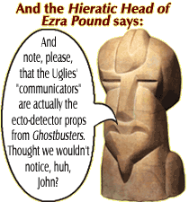
Some Notable Totables:
- body count: 41
- breasts: 2
- explosions: 5
- ominous thunderstorms: 0
- actors who've appeared on Star Trek:
  - Meg Foster (Holly) played "Onaya" in the DS9 episode "The Muse"
  - Thelma Lee (the rich matriarch) played "Kahlest" in the TNG episode "Sins of the Father"
  - Greg Barnett (security guard #1) was Leonard Nimoy's stunt double in Star Trek 5
  - Jimmy Nickerson (security guard #2) did stuntwork in Star Trek: First Contact
  - Jeff Imada ("male ghoul") did stuntwork in Star Trek 6 (are we sensing a trend?)
Nathan Shumate
4/18/01

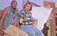 |  |  |  |  |  |  |  |  |  |  |  |  |  | 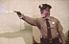
 |  |  |  |  |  |  |  |  |  |  |  | 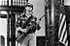
 |  |  |  |  |  |  |  |  |  | 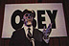
 |  |  |  | 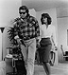 |  |  |  |  |  |  |  |  |  |  | 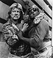
 |  |  |  |  |  |  |  |  |  |  | 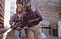
 |  |  |  |  |  |  |  |  |  | 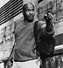
 |  |  |  |  | 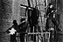 |  |  |  |  |  |  |  | 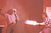
 |  |  |  |  |  |  |  |  |  | 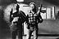
http://www.theofficialjohncarpenter.com/pages/themovies/tl/tlstills.html

http://www.mortystwistedworld.com/stuff/movie_reviews/they-live.html

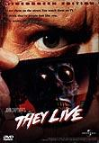
Movie Title: They Live
Producer: Image Entertainment
Director: John Carpenter
Year: 1988
Time: 95 minutes
Rating: R
Genre: Sci-Fi & Fantasy
Featuring: Meg Foster, Roddy Piper
Format: DVD
Rental: NetFlix
Overall Opinion
For being made back in 1988, it was good. I enjoyed laughing at the "one liners" the main star was spilling out when ever he was getting pissed or had a big scene with guns in his hands. I liked the story, and I liked the order of the different scenes and the way the various events tied together. Bad acting, but they get a happy face sticker by their name for their effort.
Quick Overview
There is a small group of people that have discovered that aliens have slowly taken over our world and our broadcasting out signals across TVs, radios, anything with a speaker, street signals, you name it, they are broadcasting. With this "broadcast" their alien faces are cloaked and they look exactly like we do. This small group of people have put together special eye wear, sunglasses in the first half of the movie, that block out the broadcast and you can see the aliens as their true, ugly selves. Also all the hidden messages in advertising and books, and signs, and road signs, are perfectly clear. All being words of brainwashing us. The lead character comes across some of these sunglasses and goes on a killing spree. Killing as many aliens as he can.
To wind it up, Roddy Pipper finds his way into the broadcasting station, locates the antenna on the top of the local news station roof, and destroys it, thus removing the cloaking of all these aliens. The scene after that, the end of the movie, they leave us in suspense by just showing different clips of these aliens in their ugly self sitting around or being publicly displayed infront of humans. Not knowing that there cover is blown. And the last 5 seconds of the movie they show a clip of a hot blonde with her breasts dancing around as she is thrusting her self up and down on her boyfriend. She suddenly makes a horrified facial expression as the camera rolls down to the boyfriends face. He leans up saying "What's wrong baby?" with his disgusting alien face.
Movie Company's Synopsis
They influence our decisions without us knowing it. They numb our senses without us feeling it. They control our lives without us realizing it. They Live. Horror master John Carpenter (Halloween, The Thing) directs this action-packed sci-fi thriller about one man's battle against aliens who are systematically gaining control of the earth. Rugged Roddy Piper stars as the loner who stumbles upon a terrifying discovery: ghoulish creatures are masquerading as humans while they lull the public into submission through subliminal advertising messages. Only specially made sunglasses make the deadly thruth visible. Suspenseful science-fiction and heart-pounding action highlight this masterfully ironic and startling tale co-starring Keith David and Meg Foster.
My View
Well, it was lame. Yet I liked it. Discovered where the makers of the game Duke Nukem came up with one of Duke's favorite lines. "Its time to kick ass and chew bubble gum. And I'm all out of bubble gum." I loved that line in the game, yet hearing Roddy Piper say it in this movie was stupid. I laughed because it was so corny, along with a lot of other one liners. Such as when he told someone to scram, he told them to "Beat their feet!" Miriah thought that line was just plain dumb. Which it was, but you gotta laugh at the stupidity behind it.
For being a movie with a WWF wrestler as the main charachter, it was good. Not great. Not something you should be "waiting all week to watch" sorta movie, but it was good.
Only part that I felt they skimped on was one of the characters at the end of the movie was a homeless guy that was in several scenes earlier in the movie. But the aliens had talked him into working with them and he was now all cleaned up, his hair done real nice and he was wearing a tuxedo. If you weren't watching closely earlier in the movie, you would of never known who the hell he was because they didn't put any effort into explaining it.
Recommend it?
Yes. It is a fun little movie. Using the NetFlix service, I'd rent it.

