**The crop circle in California is a BIG ALERT for the critical situation in Fukushima**

http://cropcirclestzolkin.wordpress.com/2014/01/03/the-crop-circle-in-california-is-a-big-alert-for-the-critical-situation-in-fukushima/

A new giant crop circle has appeared in California on December 30, 2013. It has a size of about 1 acre, this is nearly 4000 m2.

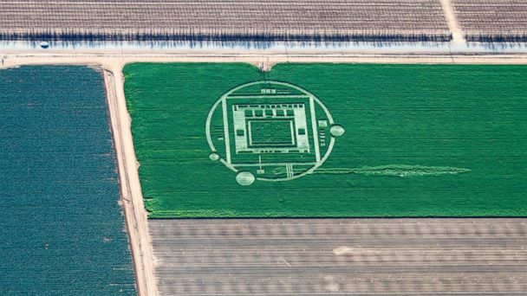

On December 31, 2013, Angela Greenlief wrote in the Facebook group “Crop Circles-UFO’s-Ancient Mysteries-Scientific Speculations” about a connection between this crop circle and the alerting situation in the Nuclear plant Fukushima in Japan. Also in my opinion there are several arguments for such connection.

I think, this crop circle is a BIG ALERT for the critical situation in the Nuclear plant in Fukushima and about the great danger for the people on the west coast of North America and in the whole North semisphere !!

Here you can see several pictures from the Nuclear plant Fukushima:

<https://www.facebook.com/media/set/?set=oa.528871980553372&type=1>

There are several similarities between the pictogram of the crop circle and the pictures of the Nuclear plant.

We can say, that the row of 5 small squares depicts the 5 reactors of the plant.

The Nuclear plant Fukushima-1 and Fukushima-2 has in total 6 reactors, but during the earthquake they were partially destroyed. On this picture we see that two of the reactors are very damaged. The first reactor from left to right is almost totally destroyed. This could be an explanation why on the pictogram of the crop circle we see only 5 reactors.

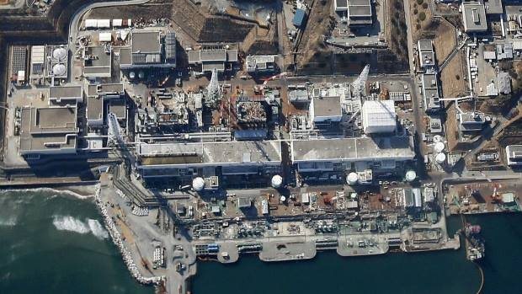

On this picture of the Fukushima Nuclear plant we see an arrow pointing the North. When we match this picture of the Fukushima plant with the picture of the crop circle, using the reactors (the 5 squares) as referent points, we could say, that the biggest of the 3 circles on the outer big circumference is the Sun, which is in the East.

Japan is known as the “Land of the Rising Sun”. So on the pictogram we see the Rising Sun on the East position compared with the geographic disposition of the Nuclear plant.

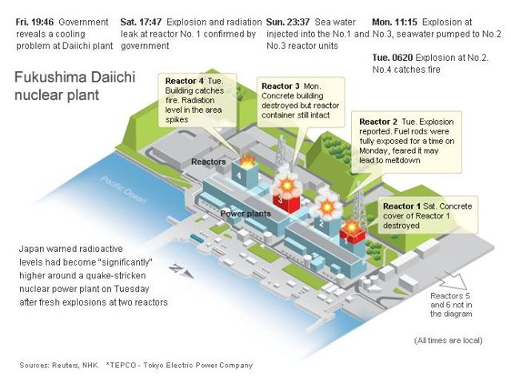

According to the Braille Alphabet in the square in the centre of the crop circle we have 3 lines, in the first and in the third line we have in total 4 times “#192″.

In a lot of posts in the Facebook group “Crop Circles-UFO’s-Ancient Mysteries-Scientific Speculations” there are several explanations for this number: Iridium is #192 in the table of elements, 192.com is a site for searching of people, business and places in UK….

A Google search for “Fukushima, 192” gives following link:

<http://www.fmu.ac.jp/univ/dbook-e/pageindices/index192.html>

FUKUSHIMA Lives on the Line   
192 / 306 1881Department of Emergency and Critical Care Medicine,   
Fukushima Medical University School of Medicine…

**There are a lot of indications that the situation in the Nuclear plant Fukushima has become more and more critical in the last weeks of 2013.**

**Following article from December 30, 2013 is very alerting:**

**TEPCO Quietly Admits Reactor 3 Could Be Melting Down NOW**

<http://www.occupycorporatism.com/tepco-quietly-admits-reactor-3-melting-now/>

Here some main points from this article:

Turner Radio Network (TRN) has [issued a report](http://www.turnerradionetwork.com/news/146-mjt) regarding Fukushima Nuclear Plant that is expected to affect the entire Northern Hemisphere.

According to the report: “Persons residing on the west coast of North America should IMMEDIATELY begin preparing for another possible onslaught of dangerous atmospheric radiation from the Fukushima nuclear disaster site in Japan”…

TEPCO are reporting that “radioactive steam has suddenly begun emanating from previously exploded nuclear reactor building #3 at the Fukuishima disaster site in Japan”…

Summations from experts conclude that this may “be the beginning of a ‘spent fuel pool criticality (meltdown)’ involving up to 89 TONS of nuclear fuel burning up into the atmosphere and heading to North America…”

The accord is that “pellets of radioactive fuel, ejected when the reactor exploded, went into the spent fuel pool located above the reactor and have begun melting down so seriously they are boiling off the water in the spent fuel pool.”

Should this be the case “the situation could escalate rapidly out of control.”

TRN is warning of preparatory measures that should be taken by those living on the West Coast of America because after the “releasing 89 tons of deadly radioactive fuel directly into the air”, it would be a matter or 2 to 3 days before the deadly material would fry North America “by [the] levels of airborne radiation and ‘hot particles’ which could kill.”

Another alerting article with very detailed instructions for the people how to prepare for the possible danger, the article is from December 30, 2013:

[**\*\* NEWS FLASH — URGENT ** STEAM SUDDENLY EMANATING FROM FUKUSHIMA REACTOR # 3**](http://www.thelibertybeacon.com/2013/12/30/news-flash-urgent-steam-suddenly-emanating-from-fukushima-reactor-3/)

**WEST COAST OF NORTH AMERICA SHOULD BEGIN PREPARATIONS FOR POSSIBLE RADIATION CLOUD WITHIN 3 TO 5 DAYS**

<http://www.thelibertybeacon.com/2013/12/30/news-flash-urgent-steam-suddenly-emanating-from-fukushima-reactor-3/>

An article from December 16, 2013:

**Tepco Plans to Dump ALL the Fukushima Radiation Into the Ocean**

<http://www.globalresearch.ca/tepco-plans-to-dump-all-the-fukushima-radiation-into-the-ocean/5361714>

Here some videos which also confirms the raising radiation on the West coast of North America:

ALERT! Fukushima Radiation Hits San Francisco! Dec 2013

<http://www.youtube.com/watch?v=Fytpcs6oRig>

Radioactive Reality (17 December 2013) Fukushima fuel melted “on unprecedented scale”:

<http://www.youtube.com/watch?v=3uaEmn5Kr18>

West Coast Warning: Video Proof Fukushima Radiation Hits California – video from December 28, 2013:

<http://www.youtube.com/watch?v=ru102DBNW0s>