<http://www.projectcamelot.org/interviews.html>

**Project Camelot's goals**

We were asked this excellent question on 24 January, 2007:

You have done a lot of good work in expanding the awareness of truthseekers. To avoid the sophisticated harassments that others have suffered, discernment is useful. You seem to be begging for harassment with some of your releases. Are your goals well defined?

We replied:

Your question about our goals is a good one and we have a clear answer, although as with all aspects of experiential learning while engaged in ongoing projects, it is not static, but rather grows in a multitude of ways and transforms. Over the New Year we refined our goals considerably for ourselves.  
  
In regard to harassment, part of Camelot’s mission is to stand up straight and say things without being intimidated, and therefore to encourage others to come forward. And, you’re quite right about the need for discernment. Needless to say, we do discern, and there are a number of potential interviewees we are NOT pursuing because we think the claims made are just too dubious. However, it’s important to note that we’re not professing belief or even outright agreement with everything our interviewees say regardless. We’re firm believers in allowing the public to make up their own minds about what is true and what is not.  
  
All those interviewees we’ve published are with those people who we are either convinced are telling the truth, or have such an important (if true) story to tell that to decline to publish because the data are unbelievable or inconvenient would actually be a dereliction of journalistic duty. One only has to examine the mainstream press to see what stories [don’t] get published because the editorial minds are already made up – or they themselves are afraid of ridicule. We are not – it’s a matter of integrity, in that particular sense.  
  
We think the stories we present need to be examined carefully and without prior judgment. The reason we do video interviews at all (rather than written ones, or on audio – both of which are far easier!) is to present you (the viewer) with the best possible substitute for meeting with the person yourself. This is important to understand, and is certainly not understood by (e.g.) those who trash Dan Burisch’s claims wholesale... without ever having met the man. We’ve met him several times (as, I imagine, have you), and we’re convinced of his integrity. We’re also aware he’s been working for and with Majestic for years and as such may not yet be revealing absolutely everything he knows.    
  
Another one of our interviews is with Duncan O’Finioan, a less well-known figure but one whose story is hugely important if true, as we believe it is, at least in its principal claims. (And if he has some false recall as part of a mind-controlled implanted false reality, that in itself proves the point!)  
  
To our goals. Our focus now is on the future. We believe our planet is currently undergoing a marked transition that includes the likelihood of significant earth changes in the near future – these being connected with a significant behind-the-scenes complexity which involves various alien agendas some of which we can only guess at. Our intention is to follow those important threads to wherever the testimony leads, and to present the evidence we come across in documentary form.   
  
We’re also very interested in using the power of the feature film to reveal greater truths through the use of fiction, or fiction based on fact. Kerry has been working with James and Mark of the WingMakers ([www.wingmakers.com](http://wingmakers.com)) to bring that story to the screen, for example. We also have several other projects we’re pursuing in addition to this one.  
  
The common thread here is to make as much information as possible available in an eye-catching format, which holds the attention and is entertaining in a non-trivial way.   
  
In the meantime, we’ll continue to present interesting and important individual stories as they reach us and as we have the opportunity to cover them. We have a number of unpublished interviews that we intend to release in the near future. We’re aware that our interviews are participating in a growing conversation that, as it expands, is leading toward greater awareness in all of us as to what’s really going on and where we’re all headed together.   
  
With all best wishes,  
  
Bill and Kerry  
  
**Project Camelot**

Benjamin Fulford

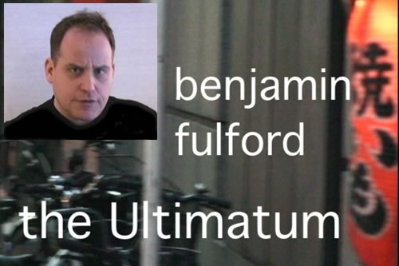

***If you need a bodyguard, it's too late. You have to make them not want to shoot you.***  
Benjamin Fulford  
  
The son of a Canadian diplomat, Benjamin Fulford rebelled against his upbringing and at the age of 17 made his way by boat into the heart of the Amazon to live with a tribe of former cannibals. Continuing to seek answers and better understand Western society, he spent time in a self-sufficient community in Argentina before heading to attend university in Japan.  
  
Principled, brave, and still a diehard idealist after all these years, he resigned as Asia-Pacific Bureau Chief of Forbes Magazine after investigating a scandal which the editor refused to report. As he researched global affairs further in his own time, he uncovered for himself the complex web which is global financial control at the hands of the Rockefellers and the Rothschilds - and also the existence of racially targeted bioweapons such as SARS.  
  
It was these plans for global depopulation that upset some important and powerful factions in Japan, Taiwan and China. After being approached by a real-life, present-day Ninja, matters came to a head in 2007 when Benjamin became the first Westerner for 500 years to be admitted into the ranks of the Eastern Secret Societies, a vast group with six million members. Acting as their spokesman, he stepped up to the plate to deliver a simple message to the Illuminati:  
  
Recognize that your time is over, step down without a fight, and allow the world to thrive as it should - or face the consequences from up to 100,000 professional assassins for whom no love is lost towards the self-styled ruling elite of the planet.  
  
This was first communicated through Dr Henry Makow and Jeff Rense in July 2007. Project Camelot has now traveled to Japan to meet with Benjamin Fulford personally. Our comprehensive interview presents the far-reaching and literally incredible background story - and will also enable the Illuminati, who we have every confidence watch our videos carefully, to be reminded that the ultimatum is real, serious, and still in force.  
  
Armed also with a contagiously optimistic vision of the future, Benjamin is fully prepared to be the next Finance Minister for Japan. His plans for how he would spend Japan's $5 trillion of foreign reserves to eliminate global poverty are plausible and inspiring as practical steps, way beyond rhetoric, to repair the generations of damage done by a ruthless ruling elite. This is a man with a deep understanding of both East and West, a global economic historian who thinks way outside of the box, a lover of peace who is unafraid to speak warrior words.  
  
In this comprehensive three part video, Parts 1 and 2 focus on global financial history and Benjamin's most interesting personal story leading up to his approach by the Ninja. Part 3 contains the details of The Ultimatum itself.  
  
[*Click here*](http://www.projectcamelot.org/benjamin_fulford_interview_transcript_1.html) ***for a transcript of Part 1 of the video***  
[*Click here*](http://www.projectcamelot.org/benjamin_fulford_interview_transcript_2.html) ***for a transcript of Part 2 of the video***  
[*Click here*](http://www.projectcamelot.org/benjamin_fulford_interview_transcript_3.html) ***for a transcript of Part 3 of the video***

Bill Hamilton

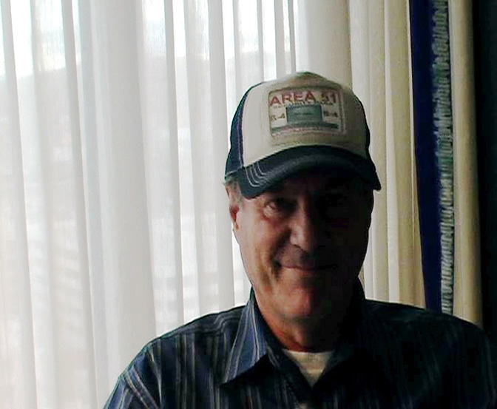

Calling Down the Craft: Adventures with the MindA video interview with Bill Hamilton  
Laughlin, Nevada, March 2006

Bill Hamilton is a fascinating personality. I have seen him around the UFO/exopolitics arena, at conferences and online, for the past two years that I've been actively involved in the field. I was curious about his past and as it turns out, his past is something of a chronicle of the UFO field coming of age. When I ran into him at the Laughlin conference this year, I got a chance to talk with him at length. This interview is the result. In it, he reveals his own encounters with alien beings who walk among us, a phenomenal ability to 'call down their craft' and the meandering pathways of his own investigations into the unknown and the personalities of this intangible field we now call exopolitics.  
  
According to Bill Hamilton, Dan Burisch has been given until the end of 2006 to get his message out to the public. In this must-see interview, Bill reveals crucial background information about Dan Burisch and the background of his statements.  
  
[*Click here*](http://www.projectcamelot.org/bill_hamilton_interview_transcript.html) ***for a transcript of the video interview.***

Bill Holden

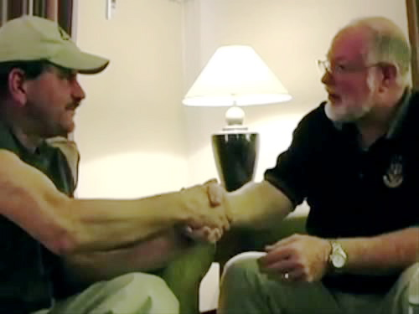

Jim Sparks and Bill Holden :  
Making the Connection  
  
Las Vegas, Nevada  
April 2008

When we were in Las Vegas to interview [John Lear](http://www.projectcamelot.org/john_lear.html), we called both Bill Holden and Jim Sparks to see if they'd like to meet with us again. We also suggested that they might like to take the opportunity to meet one another for the first time, in our presence.  
  
We were privileged to capture on camera, with their permission, the most interesting conversation which ensued. We hope you enjoy it as much as we did.

Bob Dean

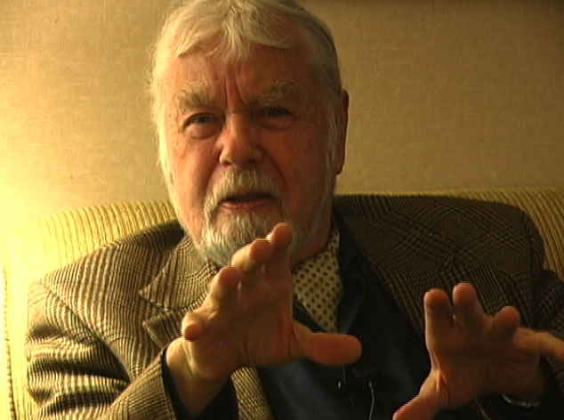

We have met many remarkable people in the course of our work for Project Camelot, but meeting Bob Dean was one of our greatest privileges. As an elder statesman he is charming, eloquent and dashing, and we are proud to present this as what may be one of our most memorable interviews.  
  
In Part One, Bob shares with us his knowledge of the UFO phenomenon and what he encountered while working at SHAPE in Europe in the 1960s: an inch and a half thick detailed official report on the extraterrestrial 'problem' called at that time simply "The Assessment". Having the clearance to have free access to the document, he read it and re-read it many times, and he tells us how that changed his life. Later, after retiring from the military, he made the courageous decision to defy his Oath of Secrecy and began to speak publicly about what he had learned.  
  
In Part Two of the interview, Bob tells us that this is probably his last interview... and having done so, he pauses, takes a deep breath, and reveals on record for the first time that he has been contacted, and has been on board the craft.  
  
Do not miss this... and we invite you to join us in applauding the courage, integrity, dignity and commitment to truth of this very special man. We would like to think that this interview is an appropriate and fitting tribute to everything that he has stood for and wishes for the world.  
  
  
[*Click here*](http://www.projectcamelot.org/bob_dean_interview_transcript_1.html) ***for a transcript of the video - Part 1***[*Click here*](http://www.projectcamelot.org/bob_dean_interview_transcript_2.html) ***for a transcript of the video - Part 2***[*Click here*](http://www.projectcamelot.org/bob_dean_interview_transcript_3.html) ***for a transcript of the video - Part 3***

Boriska

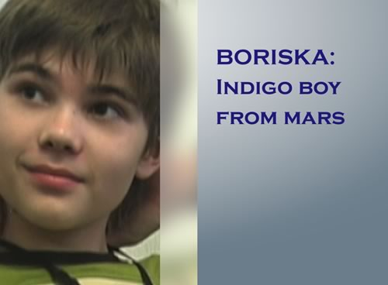

Boriska : Indigo Boy from Mars   
  
Moscow, Russia   
October 2007 Boris Kipriyanovich is an Indigo Child, probably the most famous in Russia. Boriska, or 'little Boris', was featured in Pravda [here](http://english.pravda.ru/science/19/94/377/12257_Martian.html) and [here](http://english.pravda.ru/science/19/94/378/16387_Boriska.html), after Gennady Belimov, a university professor in the Volgograd region of Russia, witnessed Boriska, then aged just seven, astound an adult audience during a camping trip in which he held them spellbound for an hour and a half as he recounted tales of past lives on Mars and Lemuria, and warned of catastrophes due to affect the Earth in 2009 and 2013. Belimov had the presence of mind to record Boriska's monologue, and within a short time word was spreading within Russia about what this diminutive prophet had to say, especially once the story was picked by Moscow's premier newspaper.  
  
Word gradually filtered to the west via a Pravda article that made it on to the internet. Meanwhile, there had been a short piece about him in Nexus Magazine which had stirred up a huge amount of interest.

On the trail of our documentary project on 2012, Project Camelot decided to travel to Russia to find Boriska and capture his testimony on camera. It seems we were the first westerners to have made the journey. On 8 October, we were privileged to interview him with his mother, Nadya, near Moscow where Nadya had brought him to attend a special school for gifted children. They live in a small one-roomed apartment. The father is absent. -- Bill Ryan  
**_____________________________**  
  
We headed to pick up Boriska and his mother from Moscow... with the traffic it took over an hour. When we finally rolled up outside the high rise older apartment building where Boriska is staying they were nowhere in sight. We spent a few minutes in the parking lot when we noticed a gangly youngster peeking around the corners of the building at us... and ducking away when he saw me looking.

He wore a backwards red baseball cap and an impish expression I could see even at a distance. After a moment I realized this must indeed be Boriska... and when his mother appeared she waved us over to meet him. He had run behind the partition and was apparently experiencing a bout of shyness... I quickly went around the corner and stuck my hand out with a smile... telling him in English everything would be ok. He took my hand and smiled sweetly. I knew we would be friends.Later, during the interview, Boriska exhibited all the signs of a young boy becoming a teenager, reluctant to express more than was absolutely necessary... waving away the details as things he spoke about in his youth, now his mind was on other things. This life had taken a firm hold and no more did his eyes shine with the memories of his past life on Mars or even Lemuria.

In spite of this, his charm and impish personality shone through as he patiently waded through our pragmatic adult questions. His eyes roamed and his imagination searched for more stimulation than provided by this small room with little furniture, crammed with adults and cameras... He squirmed to escape to his video game where he played an Avatar, part cat and part superman... scaling walls and outwitting enemies at every turn.

He was bored with us!! But earnest and polite to a fault.. unusual for a boy of 11. He spoke about the wars that caused the end of the Martian civilization, how they tried to turn Jupiter into a 2nd sun... with what purpose is unclear. He was surprised in the most humble way, to learn that his professor friend, Vladislav Lugovenko, remembered well an incident where Boris tapped into a dangerous event that happened on his way home in the subway. When he arrived home, Boris asked him about the thugs who had approached and threatened him... when the professor had said nothing. "You are a telepath", I told him. "Not yet"... he modestly replied... with a small smile, wise beyond his years, careful and delicate.When asked what he thought of the humans on this planet he sighed quietly then said he "did not like to speak bad about people".

The understatement said it all. What must he really be seeing through those wonderfully clear eyes? This is not so much an interview as an exploration of the place and time that this 11 year old boy finds himself in, with some surprise. He talks of the future waters coming to inundate Moscow, in 2009, matter-of-factly... Will he survive? Will his mother? He shrugs... survival is not so important, he seems to be saying. Life is what matters. Living in the moment... fully and completely awake.. this is what matters when you are an eternal being. -- Kerry Lynn Cassidy

[*Click here*](http://english.pravda.ru/science/19/94/377/12257_Martian.html) ***and*** [*here*](http://english.pravda.ru/science/19/94/378/16387_Boriska.html) ***for the two original Pravda articles about Boriska.***[*Click here*](http://www.projectcamelot.org/indigo_boy_from_mars.html) ***for Gennady Belimov's marvelous article 'Indigo Boy from Mars', in English for the first time.***[*Click here*](http://www.projectcamelot.org/boriska_astrological_chart.html) ***for Boriska's astrological chart, prepared by*** [Michael St Clair](http://passage11.com).[*Click here*](http://www.projectcamelot.org/lugovenko.html) ***for Dr Vladislav Lugovenko's article 'The Breathing of the Earth'.***

Dan Burisch

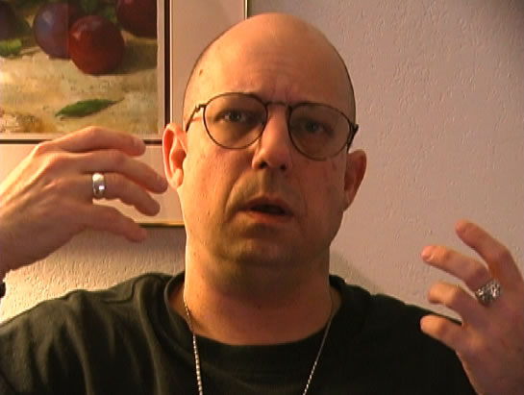

We were delighted to have the chance to interview Dan again almost a year after our first meeting -- for details of which please see below. In this second in-depth interview, which arose from our having presented him with a long list of questions of our own, Dan goes into great detail about both the technology and the politics of the [Stargates and the Looking Glass](http://www.projectcamelot.org/project_looking_glass.html). He also discusses the 'Cube', which may or may not be the same device as the fabled 'Yellow Book', or the 'Black Box' reported by our important witness [Henry Deacon](http://www.projectcamelot.org/livermore_physicist_2.html).

In this fascinating interview we found Dan once more to be outspoken, challenging, informed, values-driven, mischievous, human and likeable.

We also want to take this opportunity to publish an announcement, as supplied by Marci McDowell, who works closely with Dan. Marci asked us to make the following formal statement on Dan's behalf:

|  |
| --- |
| Dr. Dan Burisch is on a necessary hiatus from official public contact until later this year.  Unfortunately, there is very little that I am allowed to say, regarding what Dan is doing.  We have informed the public that he is NOT working for Majestic.  Majestic no longer exists.  Dan retired from that group in September, 2006.  Majestic sat formally adjourned in October, 2005.  I can say that Dan's present activities are so important, pressing and secret that those in the new group, the group which took over from Majestic at the end of 2006, the group for whom he has agreed to make himself available, sought him out for this assignment and insisted that he is limited to no public contact until after December 14, 2007.  This will provide the time for him to complete his activities with them, and be debriefed from the assignment.  His present assignment is National Security related.  Due to the nature of the assignment, Dan has accepted and been sworn to a National Security Oath.  Following his activities for the new group, Dan and I will be publishing our new book, 'Emanation of the Solfeggio', which will detail cutting edge discoveries in the area of acoustics.  Next year, he and I will be speaking publicly (in person) about Project Lotus - the groundbreaking investigation into a strange silicate-associated phenomenon which may be altering the genomes of every living organism on planet earth.  We are presently scheduled for an academic venue and planning a general audience presentation. (Introductory video trailers are already on Google.)  A new edition of our work on Mars and Earth anomalies is also underway. |

At the time of the interview Dan was unaware of this new development, and so this was not mentioned or discussed when we spoke. We have no further inside information, but can surmise that at least some of the issues raised in the interview are likely to be connected. This new interview is itself in two parts.  
  
[*Click here*](http://www.projectcamelot.org/dan_burisch_stargate_secrets_interview_transcript_1.html) ***for a transcript of Part 1 of the video.***  
[*Click here*](http://www.projectcamelot.org/dan_burisch_stargate_secrets_interview_transcript_2.html) ***for a transcript of Part 2 of the video.***

Dan Sherman

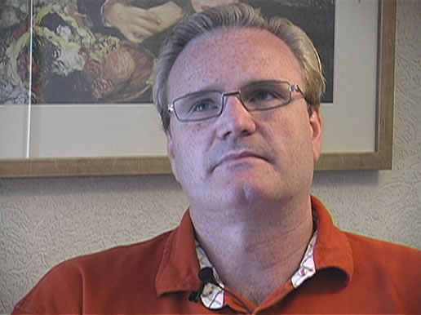

Dan Sherman: Way Above Black   
A video interview with Dan Sherman   
Portland, Oregon, June 2007

Dan Sherman was trained by the US Air Force as an "Intuitive Communicator" - a high-tech telepath - and found himself in daily communication with two extraterrestrials as part of the US military's preparation "for a future time in which all electronic communications would be rendered useless".

In this fascinating interview, Dan states: "If I were to make up a story, it would be a lot more elaborate than this. I want to stick to what happened to me, and let everyone else conjecture upon that. If I start conjecturing, then it sullies my credibility. I need to stick to the facts."

So Dan tells it like it is, and refrains from speculation. His low-key, matter-of-fact presentation has great power in a field where sometimes stories can be dramatized and embellished. His book, Above Black, available [here](http://aboveblack.com), is a straightforward narrative in which further details of the story can be found. It presents a concise, clear statement of one man's extraordinary experience.

This is one of the cornerstones of Project Camelot's current focus on 2012 and the events that may surround it. We have heard from several independent and credible sources that a time will come soon when the electromagnetic grid will go down. There is overwhelming evidence that the US military were somehow well aware of this over twenty years ago... and that plans are now well advanced to deal with a serious situation about which the public are still being kept totally in the dark.

[*Click here*](http://www.projectcamelot.org/dan_sherman_interview_transcript.html) ***for a transcript of the video.*** [*Click here*](http://aboveblack.com) ***for Dan Sherman's website, where his book ABOVE BLACK is available.***

David Wilcock



Another after-dinner conversation with David Wilcock, Bill Ryan and Kerry Cassidy... this time on the topic of how conscious awareness and intention can affect future outcomes.

Jumproom to Mars :  
A Conversation with David Wilcock  
  
Los Angeles, California  
December 2007This video captures an informal and spirited 45-minute conversation between David Wilcock and ourselves at a restaurant where we met up for dinner in early December. We were exchanging information and comparing the testimonies from Project Camelot's [Henry Deacon](http://www.projectcamelot.org/livermore_physicist.html) (for a detailed new statement from him, please [click here](http://www.projectcamelot.org/livermore_physicist_4.html)) and David's Montauk source [Daniel](http://divinecosmos.com/index.php?option=com_content&task=view&id=331&Itemid=70), and had found some very important corroborations.  
  
Captured live on camera with editing only to switch between the two cameras, David gives his unrehearsed response to new information Project Camelot has learned about the colony on Mars, the secret space program, the Apollo missions, and more.  
  
This interview contains significant new information which we believe to be fully credible. Did we really make it to the moon in 1969? Do we really have a base on Mars? Why is the secret space program so important? What is the relationship with Montauk? What truths may be concealed in Arthur C. Clarke's seminal film, 2001? Join us at the restaurant table and find out in this interview - you may enjoy the ride. The Road to Ascension : David Wilcock  
  
Los Angeles, California  
May/June 2007

Our interview with David Wilcock is part of the redirection of Camelot’s energies toward the future of our planet in the years leading up to 2012. As the self-professed reincarnation of Edgar Cayce, he is a good person to start with. In some ways, we have approached David less in the traditional interview mode and more with the stance that all we at Camelot had to do was to place the camera at the opportune time and place and the rest would take care of itself. And so it happened. David is extremely well-read, eloquent and dynamic and in our conversation was able to hit the ground running. He tells us about his own spiritual journey, how he came to terms with his very probable prior life as Edgar Cayce, his meetings with members of the Black Ops community and encounters with the world of the Illuminati, his understanding of the Law of One and the ‘Ra material’, and his in-depth scientific investigations.  
  
Wrapping his own considerable channeling abilities into a vast and lucid review of the scientific basis for the coming changes approaching 2012, this interview will raise many questions and provoke a great deal of thought. To his credit, in this lifetime David has duly recognized the areas where his prior self needed to grow and has set to work rectifying these things with a frank self-appraisal in the spirit of truth. He’s not lost his former channeling ability, but in this lifetime has complimented that skill with a solid grounding in science to augment both his knowledge and intuition and gain greater leverage into the social and mental thought framework of today's world. David is currently working with Richard Hoagland on an investigation into the planetary changes surrounding 2012, and is the co-author of the extremely important and well-researched article to be found on Hoagland's website entitled [*The Interplanetary Day After Tomorrow*](http://www.enterprisemission.com/_articles/05-14-2004_Interplanetary_Part_1/Interplanetary_1.htm). This is recommended reading for all.  
  
In presenting this material, we at Project Camelot recognize that some of what David states is contentious, and we encourage everyone to consider David's conclusions in the spirit of open inquiry and as part of an ongoing investigation into the mystery surrounding 2012. This interview is in four parts.

Duncan O'Finioan



Ultimate Warrior: Robert Duncan O'Finioan  
A video interview with Duncan O'Finioan  
Kentucky, November 2006

Duncan O’Finioan was the Ultimate Warrior... brainwashed, conditioned and controlled as part of a highly classified MKULTRA program called PROJECT TALENT. From a thousand others trained as child warriors in 1966, he is now, he believes, only one of 20 left alive to tell the story.  
  
In his powerful and compelling testimony for the camera – one of the most extraordinary we have ever heard – Duncan describes:

– His mission to “terminate” the very drunk, future President of the United States... George W Bush;  
– His dizzying enhanced physical and psychic abilities... including the abilities to hurl someone across the room with his mind, and walk through a solid wall;  
– How he and 11 other children were flown to Cambodia to deliver a targeted death blow to all the surrounding Khmer Rouge troops... using only the combined power of their minds;  
– How his right arm is “hardwired” and is capable of astonishing speed and strength;  
– His struggle to regain his memory, aided by a car accident which led to the discovery of a cranial implant uncovered by an MRI machine... deactivating the implant and causing the MRI machine to catch fire;  
– His role as a programmed assassin, targeting Americans under the command of an undisclosed agency;  
– The selection, torture, and brutal training process that he endured... and which children are undergoing to this day;  
– And more…

Twenty years later, Duncan (who is of mixed Cherokee and Irish blood) comes forward to tell the truth about the Ultimate Warrior project: how he was chosen, groomed and tortured into becoming the perfect fighting machine, combining physical superiority with the extraordinary mental abilities of a psychic spy.Fearless, principled, and determined to regain control over his life, Duncan O’Finioan tells his story in detail. Do not miss this interview.

An Unconventional Friendship: Duncan O'Finioan and David Corso   
A video interview with Duncan O'Finioan and David Corso   
Pahrump, Nevada, January 2007

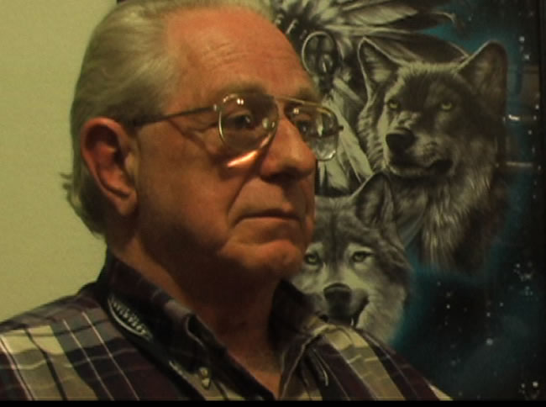

We interviewed Dave Corso at his home in Pahrump, Nevada, together with Duncan O'Finioan. Both were part of PROJECT TALENT, an unacknowledged MK-ULTRA military program. These unconventional friends have a strikingly similar background involving Vietnam, a mysterious military base on an island off St Thomas, and frequent symptoms of PTSD (post-traumatic stress disorder). Both have been known to draw the blinds and sit in the dark with a loaded gun, armed against some hidden threat just on the other side of the front door...  
  
Corso's substantiation of important parts of Duncan's story is significant. Their joint testimony strongly suggests that the US military has a program of super soldiers, not only those like Duncan – with psychic abilities and uncommon strength – but also those in command, who were trained to spot military talent and were skilled in psychotronics, that is: mind control.  
  
Controller and soldier? Who rescued who in the middle of that Cambodian jungle? Their relationship is unclear. But somewhere in the murky waters of the past, two men, from vastly different backgrounds, have come together as friends only to discover that what brings them together may be far more mysterious and sinister than either is prepared to remember.

Gary McKinnon



I caught up with Gary McKinnon in North London on my way back from safari in Kenya. The interview was shot using a hand-held camcorder and uploaded at 4 am UK time, making use of a wireless connection outside of an office building in downtown Birmingham. This is what is known as guerilla filmmaking...  
  
We sat in the back of his local pub, in a garden in the late afternoon. Gary is lucid, eloquent and extremely intelligent. He made it clear that the real reason the Americans want to extradite him is not for any damage he has done, for in fact there wasn't any. They are pursuing him is because of what he might have seen. Specifically, documents revealing a list of "Non-terrestrial officers" and off-world cargo operations somewhere out in space, hinting at the real possibility of military activities taking place in relation to other planets.

Such a possibility has got to be mind-blowing to the average person who barely grasps that there might actually be aliens from other worlds interacting with earth and governments in the vicinity of our solar system. Key to the whole extradition matter is the issue that there were NO passwords required in order to access this material... and that a relatively unprofessional hacker, self-taught albeit brilliant, would be able, using a dial-up modem, to gain top secret access to NASA files and places as sacrosanct as the Pentagon.[*Click here*](http://www.projectcamelot.org/gary_mckinnon_interview_transcript.html) ***for a transcript of the video.***  
[*Click here*](http://www.freegary.org.uk) ***for Gary McKinnon's website.***[*Click here*](http://www.projectcamelot.org/delphi_newsletter_112.pdf) ***for Gary McKinnon in the Delphi Associates newsletter, December 2005.***

George Green : Messages for the Ground Crew  
  
Spokane, Washington  
April 2008

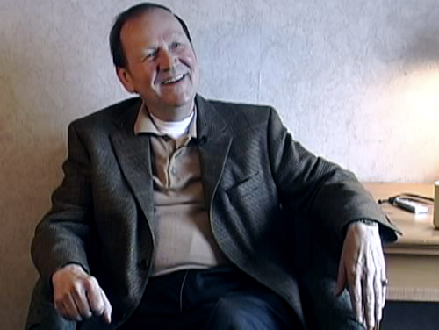

George Green's career extends from military service in the USAF (where he encountered alien disk craft in a remote hangar at Edwards AFB), through "playing monopoly" in corporate banking and large-scale construction, to working closely with the Pleiadians and other benevolent intelligences to "wake people up" in preparation for coming changes. Very few people we have talked to have a span of personal experience - and contacts - which is this broad.  
  
As George describes, he "used to run around with the big boys". He was asked to build an enemy prisoner-of-war camp in downtown Las Vegas - he refused - and was asked to be Finance Chairman for the Carter campaign, but declined after it became clear to him that the ethics of many of the senior players were heavily compromised. Shortly after he turned down the offer, his loans were called in and he lost many millions of dollars as finance was removed from dozens of major construction projects. Undeterred, George rebuilt his world and is in direct contact with Pleiadian intelligences and other beings. He has devoted his life to spreading the word that all is not as it seems. His very important free e-book, [*Handbook for the New Paradigm*](http://www.nomorehoaxes.com/index.php?option=com_content&task=view&id=22&Itemid=60), has been read by millions all over the world.  
  
George is a delight to listen to: relaxed, friendly and humorous. He has an extremely serious message: there is very little time left in which to prepare. Telling us that his "sources" are informing him that too few people are "waking up" and that it is almost too late, his own bags are packed and he is about to relocate to Ecuador where he says that many "insiders" have bought real estate and have already left the United States.  
  
When asked when we might expect major changes to occur, his response is to look at his watch. "The moment we launch a strike against Iran is the moment no longer to be in the US," George says. "Pretty soon we'll be waking up one Monday morning to find that the world is no longer the same."  
  
[*Click here*](http://nomorehoaxes.com) ***for George Green's website.***  
[*Click here*](http://www.projectcamelot.org/george_green_interview_transcript_1.html) ***for a transcript of Part 1 of the video.***  
[*Click here*](http://www.projectcamelot.org/george_green_interview_transcript_2.html) ***for a transcript of Part 2 of the video.***

Gordon Novel

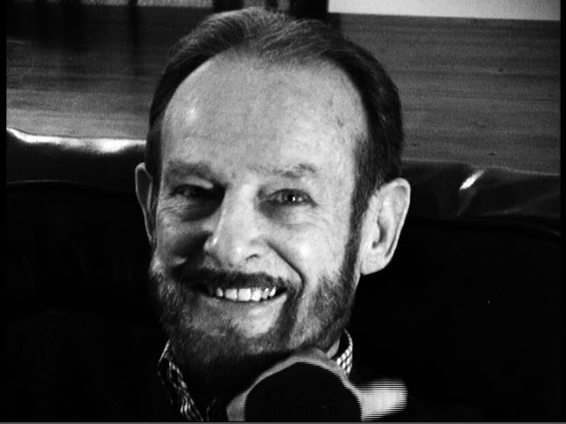

Renegade: Gordon Novel on Camera  
A video interview with Gordon Novel  
Los Angeles, December 2006

Gordon Novel is a fascinating man. Carried along on the train of history, Gordon Novel has had a front seat to many of the most controversial chapters in U.S. history. From the Kennedy assassination to Watergate, Waco and beyond, Gordon has really seen it all. In his first interview for over a decade, he gives us a glimpse of his role and perspective on a multitude of subjects including; the Vietnam war, Saddam Hussein and his trial, Majestic and the CIA, UFOs, the 'Extraterrestrial Revolution' and much more.  
     
He is charming, bold, uncompromising in his vision and determined to change the world. We are given a special look at Gordon's new quest to bring free energy to the world, along with news of his proposed motion picture in development, KINGDOMS COME, in a deal being brokered with some of the biggest names in Hollywood. With the support of the CIA, he believes his vision of a world set free from the confines of oil and gas will become a reality. A big picture thinker with a strong will and an indomitable spirit, he is forging ahead against all odds. His fierce dedication is something to behold and we wish him every success in his quest.  
  
[*Click here*](http://www.projectcamelot.org/gordon_novel_interview_transcript.html) ***for a transcript of the video interview.***[*Click here*](http://www.projectcamelot.org/gordon_novel.pdf) ***for a fully illustrated, high quality PDF of the video interview transcript.***

Jim Sparks

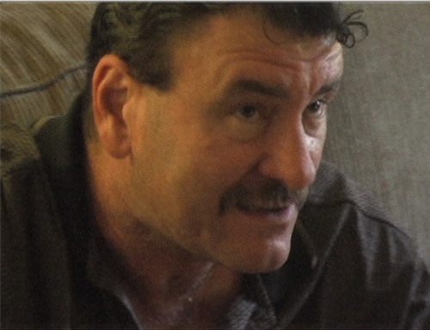

Jim Sparks and The Keepers  
  
Las Vegas, Nevada   
June 2007

Jim Sparks has become well-known as one of the few multiple abductees who has, in his own words, 95% recall of all his experiences. Having been abducted many hundreds of times, at first he rebelled and totally refused to co-operate with the aliens who would repeatedly take him to their craft at night. He attributes his very complete memories of his experiences to his rage, and outrage, about the continued violations.

As the years passed, and Jim and his captors battled with one another, Jim gradually seemed to become trusted by the aliens - who he calls The Keepers - to assist them in increasingly significant ways. In turn, Jim feels he understands better now what their agenda and modus operandi might be. The story he tells on camera is spellbinding... and culminates in a message which we might ignore at our peril: that the Earth is in danger, and that while there may be a new dawn ahead of the human race, there might be some difficult times ahead before we get there.

[*Click here*](http://www.projectcamelot.org/jim_sparks_interview_transcript.html) ***for a transcript of the video.***  
[*Click here*](http://jim-sparks.com) ***for Jim Sparks' personal website (where his book 'The Keepers' is available).***

John Lear

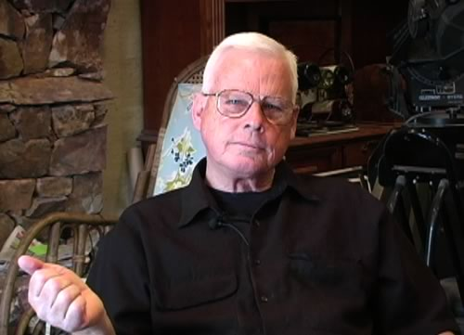

John Lear Tells All  
  
Las Vegas, Nevada   
April 2008

**...now some of you may be asking why so many airlines collapsed that I worked for and why I got fired so many times. My excuse is simple. I am not the brightest crayon in the box, I am extremely lazy, I have a smart mouth and a real poor f**king attitude.**John Lear  
  
Yes, he's incorrigible and fun loving, with a great sense of humor that has served him well over these many years. Our 2006 interview with John Lear (see below) remains one of our favorites.  
  
When we met again with him recently, with considerably more time at our disposal than we had two years ago, John piled his studio table high with books, diagrams and research papers and sat down to tell us "everything he knew".  
  
With special emphasis on the Bob Lazar saga - as only John can tell it - we cover the inconsistencies in the 911 theories and why as a world renowned pilot he is uniquely qualified to judge just what kind of planes, if any, hit the World Trade Center (answer, none: John explains why they were holograms); why the moon's gravity may be as much as 64% that of the Earth's, and could retain a very thin atmosphere; how Ben Rich, the former Director of the Lockheed Skunk Works, was a Mossad agent; the location of the "new Area 51", called Sandia, deep within the Nevada desert; what really happened at Above Top Secret, an internet forum where he was attacked and which he has subsequently left... and much more.  
  
There's nothing here about 2012 or 'Planet X' - both of which John dismisses - but we think you will be entertained and fascinated by the reported detailed experiences and opinions of someone who deserves to be respected and admired for his courage, character, and maverick commitment to revealing what he believes is the truth.   
  
[*Click here*](http://www.pilotsfor911truth.org) ***for the website of 'Pilots for 911 Truth'.*** [*Click here*](http://www.thelivingmoon.com) ***for Ron Schmidt's Pegasus Research ('The Living Moon') website, which represents John Lear's opinions, ideas and research.***

**__________________________**

Flying into the sun with John Lear  
  
Las Vegas, Nevada   
August 2006

John Lear is a well known, even legendary figure in the UFO community. We were privileged recently to interview him at his home in Las Vegas. We turned up early one morning and were ushered into his amazing study by his lovely wife. John launched into the interview with few preliminaries; to our surprise, he had mountaineering on his mind, and we soon learned that he’d been the youngest American to climb the Matterhorn, and shares with Bill Ryan – a fellow climber – a fascination with the history of Everest exploration.  
  
We had no time to carefully prepare the lights or audio as John began to talk. Luckily, however, the lighting in his study was perfect; the Las Vegas morning sun streamed in through a side window framing the man and his world in high relief.  
  
Enigmatic, outspoken and challenging, he is the quintessential man of the world. Framed by close-up photographs of Area 51, detailed un-airbrushed moonscapes showing artificial structures, NASA astronauts, advanced airplanes, and every other kind of aerospace memorabilia, he launched straight away into the untold story of the 4th astronaut, never acknowledged by NASA, who died in the tragic Apollo 1 fire along with Grissom, Chaffee and White back in January 1967.  
  
In this cutting edge interview, John tells it like it is with no holds barred. He's a man who can tell a great story, keeping you on the edge of your seat the entire time. Under his gruff exterior we found ourselves enjoying the company of a truly charming guy who's seen it all and has never lost his joie de vivre under the weight of significant knowledge.  
  
[*Click here*](http://www.projectcamelot.org/john_lear_interview_transcript.html) ***for a transcript of the video interview.***

Leo Zagami

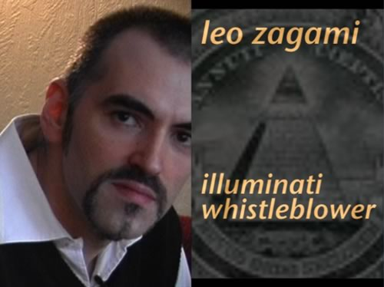

Illuminati Whistleblower : Leo Zagami  
  
Oslo, Norway  
February 2008

***The weapons business is the big business to make cash. I was a rich man when I was in that kind of business. Now I'm a poor man. The difference is that now I'm an honest man. Before I was a crook.***  
Leo Zagami  
  
Leo Lyon Zagami, ex-member of the Comitato Esecutivo Massonico - the Masonic Executive Committee - of Monte Carlo, was, until recently, a high level member of the Italian Illuminati. He is a 33rd degree Freemason, and a senior member of the infamous P2 Lodge. He was the 'Prince': prepared to take over after the older Illuminati 'King', Licio Gelli. He was born of a Scottish-Sicilian Illuminati aristocratic bloodline, and so has been involved in the Illuminati Order since childhood.  
  
Disgusted with satanic black magic rituals, and with the true intentions of those who regard themselves as the elite controllers of the planet, he has now made the commitment to tell the real story of those who seek to rule us all without our consent.  
  
Quick, intelligent, likeable, passionate, and with a huge amount of information at his fingertips about the inside workings of the Powers that Be, Leo welcomed us into his house in Oslo, Norway, where he lives in what might be called exile.  
  
In our two hour interview we were barely able to scratch the surface of everything he knows, and what we present is a summary for those unfamiliar with the labyrinthine details of one of the most important stories of our time.  
  
However, he seems to have paid a price for talking to us on camera. Days after our interview, his wife Fatma Süslü, of Turkish descent but an aspiring Norwegian politician, left him - accusing us at Project Camelot, in the process, of being agents. Shortly after her departure he was temporarily imprisoned and his cellphone and computers were confiscated by the police. He intends to leave Norway for safer shores as soon as he can make the arrangements.  
  
For more details on what has recently occurred, Leo copied us these letters he wrote to [Greg Szymanski](http://www.projectcamelot.org/zagami_szymanski.html) and [Henry Makow](http://www.projectcamelot.org/zagami_makow.html) on 8 and 13 March respectively.

Leo is a brave man, and we wish him well. We spoke with him for 45 minutes a short time ago and he is determined and resilient. The information he presents is extraordinary and detailed, and much more will be found on his own [Illuminati Confessions](http://www.illuminaticonfessions.webfriend.it) website.  
  
[*Click here*](http://www.projectcamelot.org/svali.html) **for our tribute to Svali, Illuminati whistleblower**

**Here's a short extract from our 18 March 2007 phone conversation with Leo confirming the identity of the** [Norwegian Politician](http://www.projectcamelot.org/norway.html) **(who had contacted us about the existence of extensive underground bases and Norway's detailed plans for 2012) and relating details of their own recent conversation.**

|  |
| --- |
|  |
| [[*Launch in external player*](http://projectcamelot.org/leo_zagami_cellphone_short.mp3)] |

*For the entire 30 minute phone conversation,* [*click here*](http://www.projectcamelot.org/leo_zagami_cellphone_long.mp3)  
[*[*](http://projectcamelot.org/leo_zagami_cellphone_short.mp3)To download, option-click (Mac) or Right-click and Save As (PC)]

Luca Scantamburlo

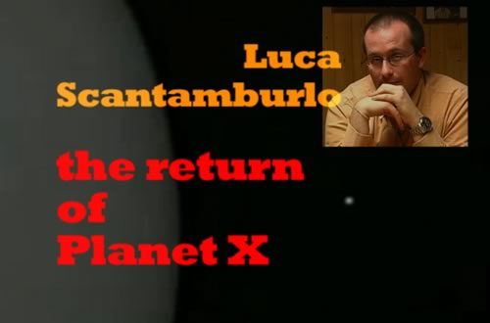

Luca Scantamburlo : The Return of Planet X   
  
Italy, February 2008

Luca Scantamburlo, an Italian journalist of tremendous heart and intelligence, is a courageous and independent UFO researcher who took it upon himself to publicize the events surrounding a fellow-Italian, Cristoforo Barbato, a few years ago.  
  
We are also in touch with Barbato, but he speaks no English and was not in a position to meet with us. So it fell upon Luca, who had investigated Barbato's story and interviewed him at length, to present to Project Camelot the story of what Barbato had learned about the return of Planet X.  
  
The story, at its simplest, is this: Barbato had written an important article about the Secrets of Fatima, focusing on the mystery of the untold Third Secret. Following this, he was contacted by someone who told him he was a Jesuit priest, working for the Vatican Intelligence Service (SIV), and who had important information to reveal. At first Barbato was skeptical, but the Jesuit was persistent; and eventually Barbato was able to substantiate all his claimed personal details. The Jesuit was exactly who he said he was.  
  
At Barbato's insistence, they finally met in a public place in Rome. At that point the Jesuit gave Barbato a significant amount of information about the return of Planet X, which was being carefully tracked by the Vatican and others; and handed Barbato a two-minute videotape - never publicly released, although [this short clip](http://www.disclose.tv/action/viewvideo/691/NSD42_secret_video___unknown_planet/) (which we incorporated in our video) appears very similar - which the Jesuit said was Planet X filmed at close range from a classified Vatican-controlled space probe called Siloe.  
  
This, and the complex web of detail and controversy that surrounds it, was the subject of our interview. Luca is the foremost English-speaking authority on this subject, which is why we approached him. We were charmed with his friendship, courtesy, intelligence, and the depth of his own research and analysis, and are pleased to present it all here in a comprehensive and important two-part interview.  
  
[*Click here*](http://www.projectcamelot.org/luca_scantamburlo_message.html) **for an important personal message from Luca Scantamburlo, containing further research data**[*Click here*](http://www.projectcamelot.org/luca_scantamburlo_interview_transcript_1.html) ***for a transcript of Part 1 of the video***  
[*Click here*](http://www.projectcamelot.org/luca_scantamburlo_interview_transcript_2.html) ***for a transcript of Part 2 of the video***  
[*Click here*](http://www.angelismarriti.it) **for Luca Scantamburlo's website**[*Click here*](http://www.ufodigest.com/news/1106/jesuitfootage.html) **for Luca Scantamburlo's interview with Cristoforo Barbato**[*Click here*](http://www.ufodigest.com/news/1206/omegasecret.html) **for Cristoforo Barbato's interview with his Jesuit contact from the Vatican**

Michael St Clair

Futuretalk II: A Second Conversation  
with Michael St Clair  
Montreux, Switzerland  
May 2008

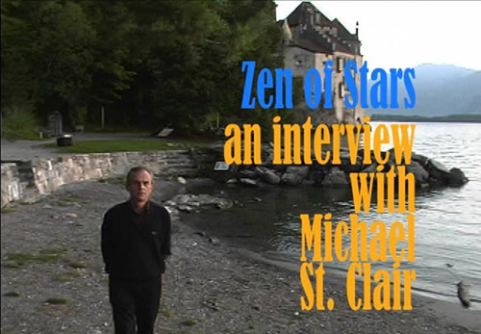

After the initial success of our Futuretalk with David Wilcock, we decided to continue our Futuretalks as a series of conversations - not interviews - with people who have something important to say. This format encourages a more free-flowing interchange with our guest while at the same time allowing us to engage in a discussion that includes many of the questions and concerns of those who write to us every day.

A Futuretalk with Michael St.Clair seemed to be an excellent next step. Michael, as those of you will know who are already familiar with our first interview with him at Chillion Castle in Switzerland, is a fascinating futurist and metaphysician as well as an acclaimed astrologer. He's been thinking about the future in a multitude of ways for many years, has written three important and well-received books, and recently has re-entered the world of banking to advise private clients with an eye to the coming changes in world economies and ways of doing business.

We cover the whole range from safe spaces (which Michael prefers to call radiant zones), to what might be happening and what one should consider preparing for in the future, coming bank failures, possible geopolitical events that could change our lives, and other concerns. Michael has spent several years viewing the scenarios - both positive and negative - that one might need to consider in the years ahead. He shares his thoughts and his own personal vision, as well as some key points that everyone should keep in mind in the coming days.

[*Click here*](http://Passage11.com/LS/index.html) ***for Michael St Clair's website.***  
[*Click here*](http://wingmakers.com) ***for the WingMakers website, referenced by Michael in Part 1.***[*Click here*](http://www.projectcamelot.org/henry_deacon.html) ***for more on Henry Deacon, referenced by Michael in Part 2.***

**__________________________**

Zen of Stars:  
Michael St Clair, Futurist and Visionary  
  
Montreux, Switzerland  
September 2006

Project Camelot had the great pleasure of interviewing Michael St Clair, a renowned futurist and visionary, at the magical Chateau de Chillon in Montreux. St Clair has written a book called [Zen of Stars](http://216.198.243.200/Zenofstars/) that addresses the transformations and earth changes which are coming in the next few years.  
  
As he says: "We are psychic beings inhabiting a physical reality." St Clair is a synthesist who covers areas as diverse as astrology, astronomy, cosmology and the evolution of the human soul. Inspired by the work of Krishnamurti, he talks about the future of the planet Earth and our growing awareness that is launching us into an enlightened view of the merging of realities.  
  
His work centers around the notion of the growth of small communities and safe places – where those who wish to ride out the coming years can live true to their ideals while maintaining the calm necessary to be ports of shelter to those around us.[*Click here*](http://www.projectcamelot.org/michael_st_clair_interview_transcript.html) ***for a transcript of the video interview.***[*Click here*](http://Passage11.com/LS/index.html) ***for Michael St Clair's website.***

'Mr. X', a former UFO archivist

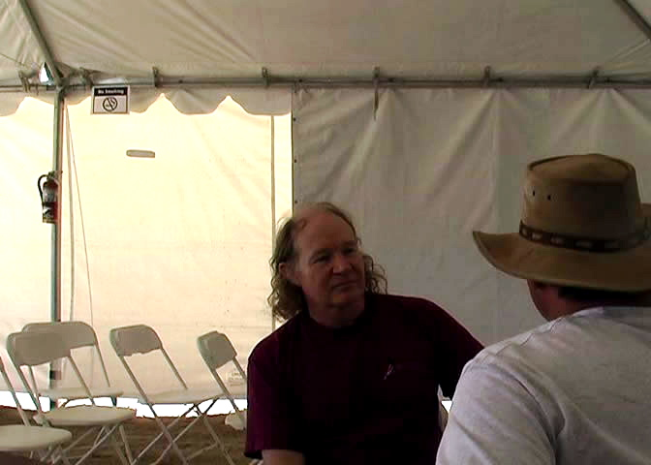

Secret – Eyes Only  
A video interview with "Mr X", a former UFO archivist  
Landers, California, May 2006

"Mr X", as he has come to be known, came forward quite unexpectedly in December 2005, posting a message to Bill Ryan on the Serpo website contact page. His story was unusual and important. He claimed that, back in the 1980s, he was employed by a Californian defense contractor as an archivist. Working long hours in a locked vault, he opened large mail bags full of photos, videotapes, alien artifacts, and volumes of top secret eyes-only documents that told the story behind Roswell, alien visitation and the government's careful handling of what was documented evidence of reverse engineering of alien craft.  
  
Softly spoken, polite and truthful to a fault in all appearances, Mr X was hard to ignore and impossible to disregard as anything but what he seemed to be: a hard working believer in the ET presence and courageous crusader on behalf of disclosure. He has chosen to put himself and his family on the line in coming forward. We salute him and applaud his valor.  
  
[*Click here*](http://www.projectcamelot.org/mr_x_interview_transcript.html) ***for a transcript of the video interview.***   
  
[*Click here*](http://www.projectcamelot.org/mr_x_interview.html) ***for a 6,400 word written interview with Mr X.***[*Click here*](http://www.projectcamelot.org/nexus_magazine_mr_x.pdf) ***for the Nexus Magazine publication of this interview.***

Ralph Ring

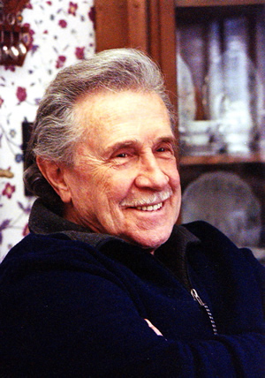

Aquamarine Dreams: Ralph Ring and Otis T Carr  
A video interview with Ralph Ring  
Las Vegas, August 2006

Ralph Ring is a brilliant innovative technician who as a young man in the late 1950s and early 1960s worked closely with Otis T. Carr. With the aid of his small team, Carr, who was himself a protegé of the great inventor Nikola Tesla, built a number of flying disks, which worked.... prior to their experimentation being forcibly terminated by government agents.  
  
In a dramatic experiment, Ring co-piloted a 45 foot disk a distance of ten miles, arriving at their destination instantaneously. Ring, now aged 71, tells his story to Project Camelot – the first time it has been reported.

*"You must always work with Mother Nature. Force is never necessary. The laws of the physical universe are really very simple."*

*Ralph Ring, interviewed by Kerry Cassidy, August 2006*

*"You are assuming that ET crafts are made with our technology... Many years ago, we made that same mistake and it took us several years to correct the mistake and start fresh from the drawing board. Their technology is nothing similar to ours... We started from scratch and learned their principles of dynamics, physics, etc... The ET craft was manufactured using ET technology. This craft was built many years before we developed flight. They used a different physics principle that we still don't fully understand... I've worked on this project for 12 years and I sometimes call myself dumb because I try to compare the craft with our technology. Doing that is dumb, as all who have worked on the craft over the years have come to understand."*

*Los Alamos National Laboratories physicist, quoted in* **Exempt from Disclosure***, by Robert Collins*

*"The pilots... knew they were going very fast, but it was so fast that they saw things stand still in time... At first our pilots could not interface with the craft. The Alien Life Form corrected the problem with three fingers on the globe panel. Then the wave formed and the craft began to cooperate and generate lift..."*

*James Jesus Angleton (CIA), quoted in* **Exempt from Disclosure***, by Robert Collins*

*"The vehicle was simply an extension of their own bodies because it was tied into their neurological systems…"*

*Col. Philip J. Corso,* **The Day After Roswell**

*"My flying machine will have neither wings nor propellers. You might see it on the ground and you would never guess that it was a flying machine. Yet it will be able to move at will through the air in any direction with perfect safety."*

*Nikola Tesla, interviewed in* **The New York Herald Tribune**, *October 15, 1911*

**_____________________________**

Project Camelot is privileged to have been introduced to Ralph Ring, a gifted intuitive technician who in the late 1950s and early 1960s worked closely with Otis T. Carr, a protegé of the great inventor Nikola Tesla. Prior to meeting Carr, Ralph had helped the famous French oceanographer Jacques Cousteau develop the aqualung, and had then spent a period working with a government-funded research organization called Advanced Kinetics.

Project Camelot's Bill Ryan talked with Ralph for over twelve hours on their first meeting, in March 2006. He was genial, charismatic, gentle, compelling, and sprightly for his 71 years. The story he told was captivating.

In essence, the account is as follows. Carr and a small group of engineers and technicians, one of whom was Ralph, built a flying disk, powered by rotating electromagnets in conjunction with a number of small, ingenious capacitor-like devices called "Utrons". A number of prototypes were built, ranging in size from experimental models a few feet across to a passenger-carrying craft which was fully 45 feet in diameter. The smaller disks flew successfully – one even disappeared completely and was permanently lost – and Ralph himself testifies to having co-piloted, with two others, the large craft a distance of some ten miles, traversing this distance instantaneously.

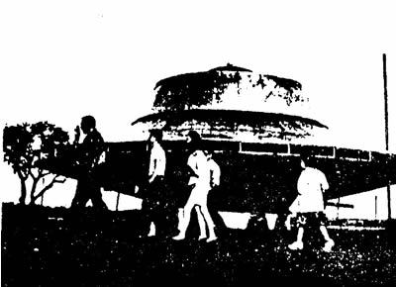 

Carr was seriously intent on taking his craft to the moon. However, two weeks after Ralph's dramatic experience, their laboratory was forcibly shut down by government agents and all files and documentation were confiscated. The group was forced to disband, and the project was never completed. Dismayed and frustrated, Ralph later bought some land in Arizona where he built a futuristic disk-shaped home which he said was astonishingly energy-efficient and, he later realized, decades ahead of its time. Carr's work has been recorded in several places, but the details are relatively scant. One highly respected physicist, researching alternative energy systems with the backing of a substantial organization, told Bill Ryan that he "had never investigated Otis Carr because his claims just seemed too outlandish." But few researchers are aware that one of the team of Carr's engineers is still alive. Project Camelot is proud to tell Ralph Ring's story, and will be releasing a video interview with him within the next few weeks.

When recalling the heady events of the late 1950s working day and night with Carr, Ring again and again stressed that the key was working with nature. "Resonance", he would emphasize repeatedly. "You have to work with nature, not against her." He described how when the model disks were powered up and reached a particular rotational speed, "...the metal turned to Jell-o. You could push your finger right into it. It ceased to be solid. It turned into another form of matter, which was as if it was not entirely here in this reality. That's the only way I can attempt to describe it. It was uncanny, one of the weirdest sensations I've ever felt."

What was it like working with Carr? "He was an unquestioned genius. Tesla had recognized his quality immediately and had taught him everything he knew. He was inspired, and – like Tesla – seemed to know exactly what to do to get something to work. He was a private man and was also very metaphysical in his thinking. I think the fact that he was not formally trained in physics helped him. He was not constrained by any preconceived ideas. As crazy as it sounds now, he was determined to fly to the moon and really believed it could be done. I believed it. We all did." Did the craft fly? "Fly is not the right word. It traversed distance. It seemed to take no time. I was with two other engineers when we piloted the 45' craft about ten miles. I thought it hadn't moved – I thought it had failed. I was completely astonished when we realized that we had returned with samples of rocks and plants from our destination. It was a dramatic success. It was more like a kind of teleportation.  
  
"What's more, time was distorted somehow. We felt we were in the craft about fifteen or twenty minutes. We were told afterwards that we'd been carefully timed as having been in the craft no longer than three or four minutes. I still have no complete idea how it worked. We just built it exactly according to Carr's instructions. Everything had to be perfect... it all had to be just so, or it he said it would not work: a kind of symbiotic state between man and machine.  
  
"The Utron was the key to it all. Carr said it accumulated energy because of its shape, and focused it, and also responded to our conscious intentions. When we operated the machine, we didn't work any controls. We went into a kind of meditative state and all three of us focused our intentions on the effect we wanted to achieve. It sounds ridiculous, I know. But that's what we did, and that's what worked. Carr had tapped into some principle which is not understood, in which consciousness melds with engineering to create an effect. You can't write that into equations. I have no idea how he knew it would work. But it did.

"I've lost count of the number of people who have refused to believe what happened. I no longer talk about it. It's no fun being laughed at and ridiculed. But I've described it exactly as it occurred. One day someone will build the disk just as we did and they'll have the same experience. All his blueprints still exist. Nowadays, it would all be done with digital and solid state circuitry - no moving parts would be necessary.  
  
"I've heard that the aliens use the same principle to operate their craft. Their physics seems to work in harness with their consciousness. The craft amplifies the power of their minds. Their craft won't operate without the pilots. I've heard that's why we can't operate their craft – or, at any rate, we can't operate them the way they do. We're just not adept enough mentally and spiritually. So there are two secrets to making the saucers work. One is the advanced engineering, and the other is the mental and spiritual ability. We may have duplicated some of the first, but we may be a long way from the second yet."

Bill Ryan left Ralph having promised to get the information into the hands of someone who could understand and then duplicate the dramatic experiments conducted by Carr and his team. Ralph and Bill Ryan had agreed to work together to see the project through to its reality. Shortly afterwards, Ralph went into hospital for a routine knee replacement operation. He accidentally received the wrong treatment, and nearly died three times. At the time of writing (July 2006) he has just recently emerged, very frail, from intensive care - but is determined to tell his story. Prior to that he had enjoyed perfect health for 71 years.  
  
This is exactly what Project Camelot is for. SEE for MUCH more <http://www.projectcamelot.org/ralph_ring.html>

Richard Hoagland

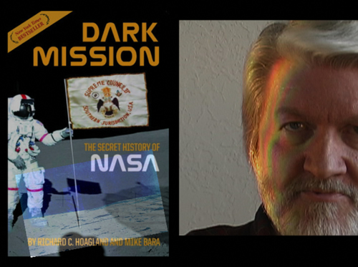

Dark Mission : Richard Hoagland  
  
Albuquerque, New Mexico  
December 2007

The name of Richard Hoagland - a bearded Viking warrior, still standing after all these years - is inevitably etched in the minds of all those who have contemplated the possibility that all may not be the way we are led to believe on the Moon and Mars. Informed and opinionated, and proud to have been a steady thorn in NASA's side for over twenty years, Richard makes regular appearances as the Science Adviser on Coast to Coast AM - and has written two books, the most recent of which, [Dark Mission](http://www.amazon.com/Dark-Mission-Secret-History-NASA/dp/1932595260), has climbed to near the top of the New York Times best seller list.  
  
We visited Richard at his Albuquerque home on two occasions. The first, in December 2006, generated the kind of spirited and wide-ranging restaurant conversation that really should have been captured on video. The second time, a year later, we channeled all our conversation on camera - three hours' worth - and then celebrated with the restaurant conversation afterwards. The three of us were delighted with what we had captured.  
  
This interview, in three comprehensive parts, first chronicles Richard's personal journey; then detailed photographic analysis evidencing NASA's deception of the public for decades; and finally his personal views and conclusions about 2012.  
  
Richard - articulate, outspoken and controversial as always - packs a huge amount of information into the nearly three hours of edited interview. Whatever your personal views about NASA, the Apollo missions, or the possible real history of our solar system and its exploration past and present, you will find material here that will educate, inform and stimulate, and which cannot be ignored.  
  
[*Click here*](http://www.projectcamelot.org/richard_hoagland_interview_transcript_1.html) ***for a transcript of Part 1 of the video.***   
[*Click here*](http://www.projectcamelot.org/richard_hoagland_interview_transcript_2.html) ***for a transcript of Part 2 of the video.***   
[*Click here*](http://www.projectcamelot.org/richard_hoagland_interview_transcript_3.html) ***for a transcript of Part 3 of the video.***  
[*Click here*](http://www.amazon.com/review/R1799GZ3ASYXLR/ref=cm_cr_rdp_perm) ***for the comprehensive Amazon review by a former NASA Manned Spaceflight Controller, supporting much of the Dark Mission testimony, which Richard recounts at the very end of Part 3 of the interview.***[*Click here*](http://www.enterprisemission.com) ***for Richard Hoagland's 'Enterprise Mission' website.***[*Click here*](http://darkmission.net) ***for the website of Richard's 'Dark Mission' book.***[*Click here*](http://www.filmbaby.com/films/422) ***for the Enterprise Mission National Press Club NASA Briefing, 30 October 2007.***

END