THE MARSHALL REPORT

THE CORPORATION OF THE UNITED STATES GETS NEW CEO

https://themarshallreport.wordpress.com/

AND

https://themarshallreport.wordpress.com/author/spearofdestiny1/

January 20, 2021 The Marshall Report98 Comments

The first Day of the Biden Corporation is off to a very busy start. Many executive orders needed to be over ridden and the CEO was ready with pen in hand. Rescinding, rescinding….and then of course 1776 Report canceled from the White House web site along with anything Trump and We The People, replaced with WE THE PEOPLE CORPORATE RULINGS.
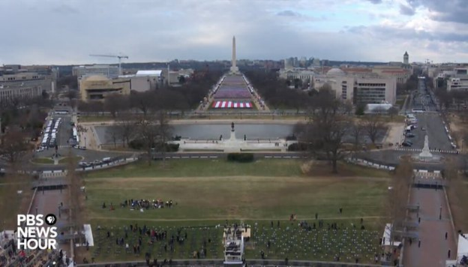The surreal event just didn’t seem all that patriot, nor did it have any pomp and grandeur. At least that was my take. The gaslighters on fake news said it was the bla, bla, bla and best they ever saw.
What the press failed to report was the message from France praising President Trump and railed in a professional manner about the coup to steal the election. Well, Biden’s off on the wrong foot there…and I’m sure the whole world is watching with popcorn to see just how far he will be able to go on his corporate leash?
After all, it is now common knowledge that one of the sister corporations, the one that funds the stuff also known as the Vatican has had their coffers all but emptied and so has the Italian government. The entire nation is running in circles and the government heads have resigned. So far including the Italian mafia over 300 in Italy have been arrested….leaving Italy in a financial shambles that looked dire until yesterday it righted itself a bit leaving Conte in power, but, with a tighter rein. We’ll have to wait and see where this goes for it’s still broke. Italy’s Conte survives no-confidence vote to stave off government collapse – The Washington Post . Where ever the gold in the vaults have gone is anyones guess, and then there are other issues within its secrets. Vatican risks going broke slowly, former treasurer Cardinal Pell says | Catholic News in Asia | LiCAS.news | Licas News ; Vatican risks going broke slowly, former treasurer Cardinal Pell says | Catholic News in Asia | LiCAS.news | Licas News
Biden is ready to write checks and send big bucks to governors, nations, and rev up a war while he halts oil production at home and gets us back into the middle east energy wars. He has rolled up his sleeves ready for the games to begin. I think they are called the Hunger games. At least his entertainment today gave that impression.
The Biden Corporation had a bit of the hunger games and super bowl half time as Lady Gaga presented her version of something…dressed right out of the movie and singing the national anthem. By the way she sang the song beautifully and her voice was lovely. That’s true.
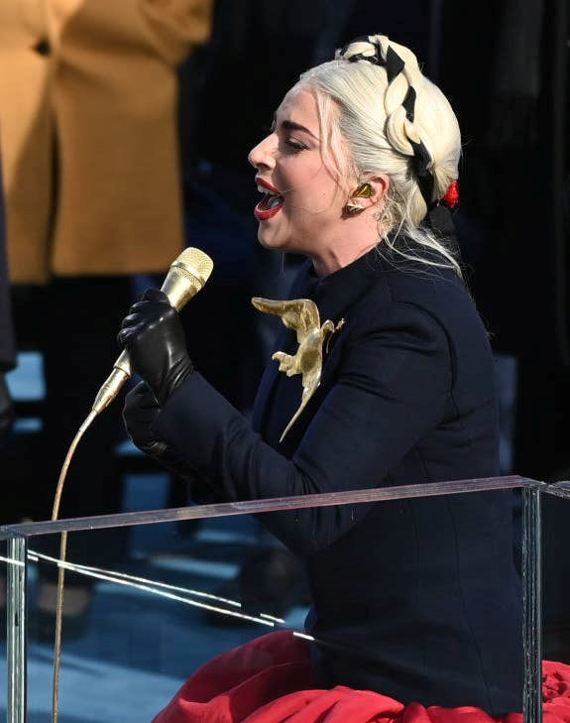
When she was preparing, Mike Pence was there to assist, handing he the microphone. How sweet.
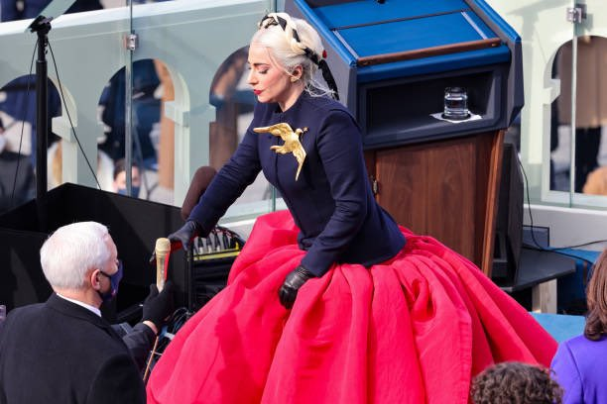

Don’t even ask me to explain the photo above, for although I liked the movie, I’m not sure I want to live it. My answer would be strikingly shocking for most ears to hear. But we seem to have Lady Gaga and the hunger games stars saluting their new CORPORATE OVERLORD in the land of something? Certainly not under God. It wasn’t your typical coronation, that’s for sure. Perhaps they were just getting ready to see who would be sent out in this years games. You know, who gets to eat and who doesn’t sorta thing.
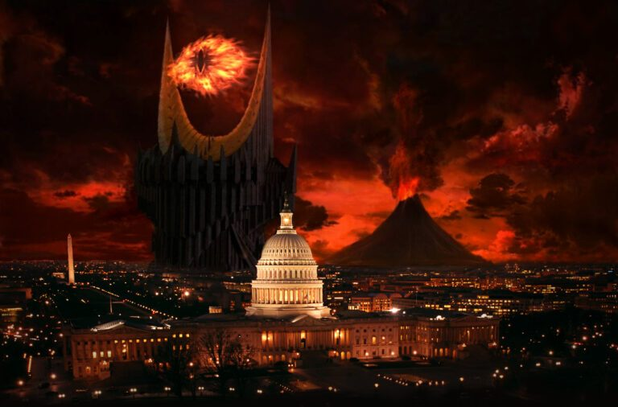
But, hey…I really have no clue as to what this meant or the meaning they intended to send. It’s like the innocent spirit cooking thing…I have no idea what they mean or don’t mean by eating food that looks like human body parts and babies. It’s one of those elite upper class things that they do for fun and people who question it all are crazy conspiracy nuts.
The CEO also held his first press conference today. It looks a bit high tech but hey, he’s on the cutting edge and enjoys censorship. He can unplug any questions he wants. It’s fool proof for the new corporation.
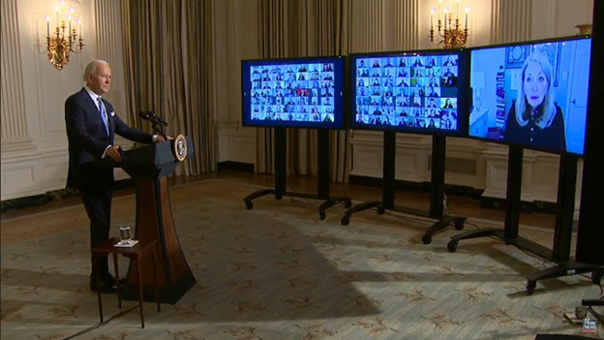
Why didn’t Trump think of this?
Meanwhile, President Trump sent his letter to the new CEO as is custom. Now, I am told this was the letter, so before anyone fact checks me and starts to hollar…I make no claim as to the authenticity of this letter, I merely present it for you to see and consider.
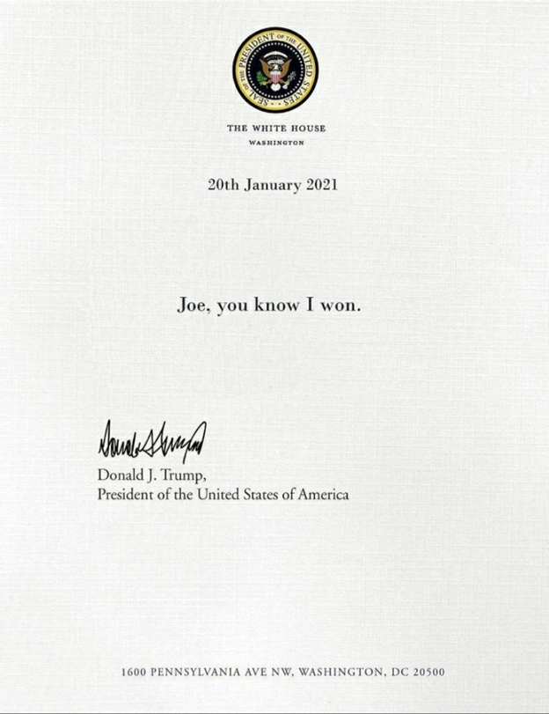
Meanwhile in cities outside of the corporate grounds the protestors that Biden called a myth, and fake news called peaceful, were conducting their own form of support. I was told that once there was a new CEO over the corporation and now because of that, all the protests would stop. Well, this is just the first day…so I’ll give it a little longer before I make any real judgement.
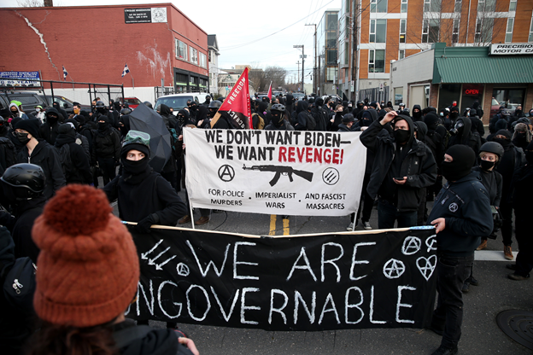
While all the excitement of the peaceful protests took place, there were people who gathered to hear the departing speech by the President Trump. Quite a different crowd.
Later in the day when President Trump was escorted to his home in Mara Largo there were some mobs of patriots there to do some very dangerous waving. (sarcasm)
The streets were lined with people cheering and waving as he passed in his motorcade.
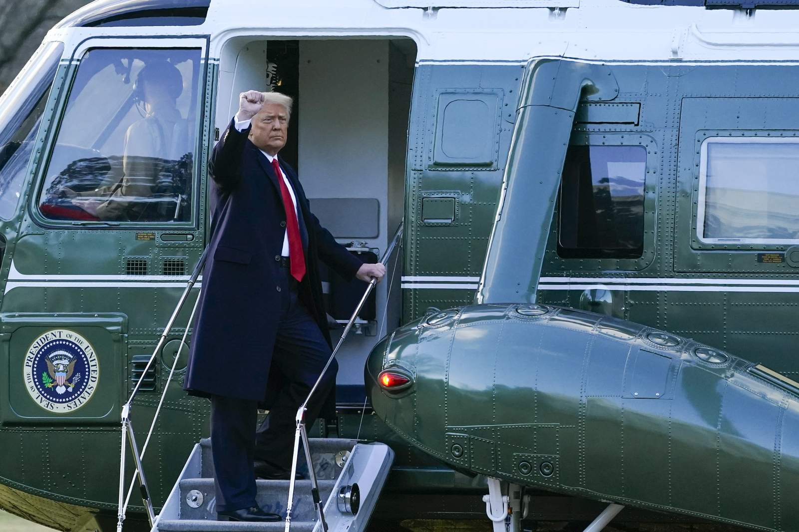
Earlier in the day, President Trump departed the Whitehouse on which looks like Marine One with the presidential seal on the front. Which is the BIGGEST CLUE OF ALL!
“After a presidential inauguration resulting in a change in office, the outgoing president is provided transport on a VC-25 aircraft to their home destination. The aircraft for this flight does not use the Air Force One call sign because it is not carrying the president in office. Whether the call sign was on or off, I do not know, however, shouldn’t Marine One have been reserved for the CEO of the Corporation? Trump leaves White House, says ‘It’s been a great honor’ (click2houston.com)
So have fun with that one, and again…I make no disclaimer as to whether it was or was not proper to leave with the CEO’s plane…I am merely pointing out what happened today. The article in the link calls it MARINE ONE and the only time you call it MARINE ONE is when a seated president is on board.
So, that’s the run down on a part of today’s behind the scenes events the news doesn’t show you. We’ll bring you more updates as time ticks away.
Pray for one another and stay safe!
Dianne Marshall

TRUMP ODE TO THE CORPORATION!
January 20, 2021 The Marshall Report877 Comments
D.C. is fenced off and the President is never going back to the White House. But not for reasons you may be thinking.
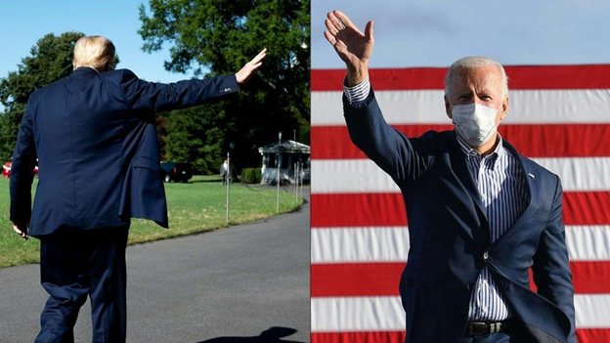
Fear not, there will be a new capitol built and an end to income taxes paid to the tax collectors of the Corporation that is now in the hands of a new administration. They went to all the trouble to steal a corporation whose assetts are in the process of being seized. Most did not see this coming for they did not even know their nation was a Corporation. But, it is indeed but now, no more are the states subject to it. Please read on to understand the nature of the battle we are in.
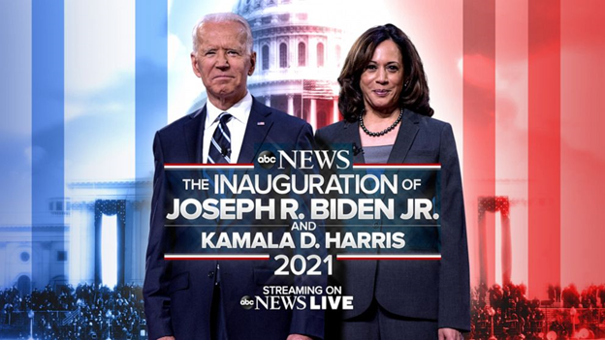Meet the thieves in the light of day. So proudly they claim what is not theirs to take…or is it?
In 1871 a sedious act was performed by the Government. A coup was made to rewrite the constitution and put WE THE PEOPLE in all capitals, under a new corporate contract transferring the United States of America into the new Corporation of the United States of America which transferred the power of We The People and the constitution over to the new corporation. When they did that, it placed the citizens in the United States as property of the Corporation which was centered in Washington D.C.. This action made Washington D.C. a FOREIGN ENTITY on American soil of sovereign states. It was established through a loan from the Vatican when D.C. was transferred into a city-state, and this corporate entity then ruled over the people. Citizens rights were taken from them in this process. No one realized this.
When they did the broker deal to get the loan from the Vatican, they did so via the Bank of London. At that time, they transferred all the property in D.C. Columbia over to the Corporate entity of D.C. a foreign corporation. (See BACK STORY below in this article).
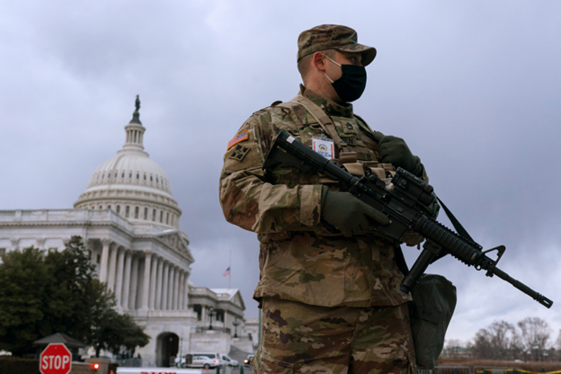
The forming of this corporation in D.C. is of major importance to understand, for when President Trump signed an executive order in 2018 on Election Interference/Fraud for entities both foreign and domestic, it outlined how assetts would be seized. The President and the people knew and had the proof that a coup transpired out of the Corporation of the United States of America along with other foreign nations and was ignored by the Corporation in D.C.. They continued with their illegal steal, and the military is now in the process of seizing the assets of this foreign country known as THE CORPORATION OF THE UNITED STATES OF AMERICA. It appears that President Trump’s executive order was actually directed at the Washington D.C. corporate swamp/cabal all along. D.C. is now walled in and filled with military guard.
President Donald J. Trump has moved out permanently for he cannot be president over a Sovereign Nation in a Foreign land, which is what the White House and Capitol are. President Trump was voted in by We The People. Not the Corporation.
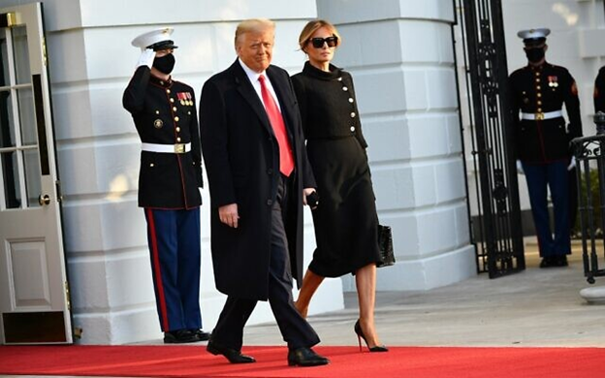
After Donald J. Trump exits the White House, D.C. will be locked down because it will not be possible for a foreign ruler to rule over a sovereign country, therefore, the foreign ruler must be locked out. In this case, that would be this new administration.

Now you see what is meant by Lin Wood’s shouts that we are in the second revolution.
We are literally watching the reclaiming of the United States of America. What this means for We The People is many things. One of them is no more IRS. Watch and see how this plays out. It is a genius move. God is in charge of this nation and is now leading his elect to restore this great nation called by his name.
BACK STORY:
The City of London (that is the square mile within Greater London) is not technically part of Greater London or England, just as Vatican City is not part of Rome or Italy. Likewise, Washington DC is not part of the United States that it controls. These three entities have one goal and that is to do away with the old world order of sovereign nations and usher in a new global world order under one government rule under the iron fist of the cabal.
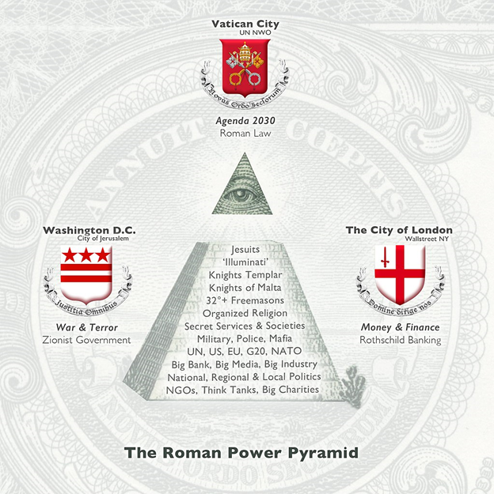
These sovereign, corporate entities have their own laws and their own identities.They also have their own flags. Seen below is the flag of Washington DC. Note the three stars, representing the trinity of these three city-states, also known as the Empire of the City. (There is also high esoteric significance to the number 3.)
The government of the United States, Canada and Britain are all subsidiaries of the crown, as is the Federal Reserve in the U.S.. The ruling Monarch in England is also subordinate to the Crown. The global financial and legal system is controlled from the City of London by the Crown.
The square mile making up the center of Greater London is the global seat of power, at least at the visible level.
Washington DC was established as a city-state in 1871 with the passage of the Act of 1871, which officially established the United States as a corporation under the rule of Washington, which itself is subservient to the City of London.
Corporations are run by presidents, which is why we call the person perceived to hold the highest seat of power in the land “the president.”
The fact is the president is nothing more than a figurehead for the central bankers and transnational corporations (both of which themselves are controlled by High Ecclesiastic Freemasonry) that really control this country and ultimately call the shots.
Washington DC operates under a system of Roman Law and outside of the limitations established by the U.S. Constitution.The Unholy Trinity of Globalist Control: The Vatican, The City of London & Washington D.C. – (awakeandaware.ca)
Washington D.C. Flag
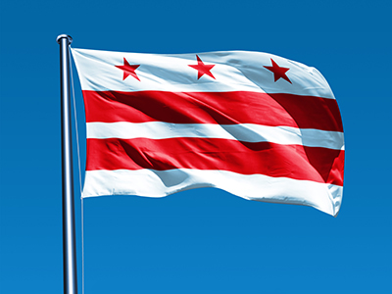
Vatican Flag
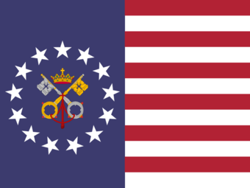
The Papal States are the territories on the East Coast of the former United States under the sovereign direct rule of the pope, from the fall of the United States around the turn of the twentieth century to the present. The Papal States are one of the regional powers of the Chesapeake Bay, controlling the city of Washington, as well as much of the surrounding area. Several towns, baronies, and other holdings outside Washington are also held by the pope, creating an intricate network of holdings which pay tribute directly to the pope.
The Papal States were born out of the former United States, viewed by the modern world as an ancient empire and continent spawning government. Following a violent coup in Washington, the Papal States were established by Chester Hale Fitzgerald, built on the beliefs of a new religion, which would later become Unionism. The Pope claims however that his power originates from the American Empire, which supposedly granted the first pope complete power over the empire via the Donation of Lincoln, a forged American imperial decree. The document has since been used in support of claims of political authority by the papacy. Know your history…read more here: https://althistory.fandom.com/wiki/Papal_States_(Days_After_Chaos)
Flag of the City of London
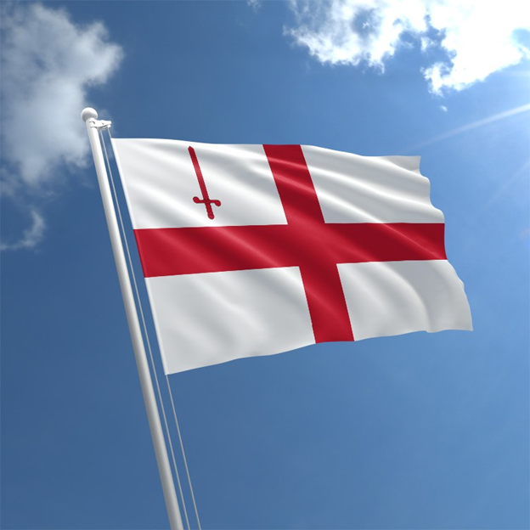
So how are these three cities ultimately connected? We must first go back to the Knights Templar and their initial 200-year reign of power. You see this in the flag of the City of London. Read about the flags of all Foreign entities here: https://awakeandaware.ca/the-unholy-trinity-of-globalist-control-the-vatican-the-city-of-london-washington-d-c/
In Conclusion: The Corporation called Washington D.C. is now a foreign entity on American soil of sovereign states. It was established through a loan from the Vatican when D.C. was transferred into a city state and this corporate entity. It is now under seige for interferring with the elections of We The People of the United States along with the Vatican and the other foreign nations who interfered, such as Germany, Italy, China, et al. They are now an enemy of the state and their assets shall be seized. Our miltary has already been taking down the giant as we have witnessed while all eyes were set on the voter fraud.
The word is in a shake down….
Italian Government has resigned: https://www.businesslive.co.za/bd/world/europe/2021-01-13-italys-government-in-crisis-after-matteo-renzis-party-quits/
Poland Government has resigned: https://www.dw.com/en/poland-jacek-czaputowicz-resignation/a-54633895
Russian Government resigned except Putin: https://www.bbc.com/news/world-europe-51120166
300 Italian politicians and police charged along with Italian mafia: https://www.theguardian.com/world/2019/dec/19/italian-politicians-and-police-among-300-held-in-historic-mafia-bust
The entire Kuwait Government has resigned: https://news.yahoo.com/kuwaits-government-quits-deepening-political-161447092.html
Dutch government of the Netherlands resigns: https://www.cnn.com/2021/01/15/europe/netherlands-government-resigns-scandal-intl/index.html
German Chancellor Angela Merkel steps down: https://www.wionews.com/world/end-of-an-era-german-chancellor-angela-merkel-prepares-to-step-down-after-15-years-357816
Malaysian Government steps down: https://www.bbc.com/news/world-asia-51716474
Baron Benjamin de Rothschild died at 57: https://heavy.com/news/baron-benjamin-de-rothschild-dead-billionaire-dies-suddenly-of-heart-attack/
Estonian Prime ministers fired: https://www.sandiegouniontribune.com/news/nation-world/story/2021-01-13/estonias-pm-resigns-over-corruption-scandal-in-his-party
Obamagate documents declassed – fully loaded with incriminating facts: https://www.publishedreporter.com/2021/01/14/solomon-president-has-delivered-in-a-big-way-with-declassification-major-obamagate-documents-may-be-released-as-early-as-friday/
25,000+ National Guard and Military in DC and 10 state capitols guarded and locked down: https://abcnews.go.com/Politics/inside-25000-national-guardsmen-arriving-washington-dc/story?id=75299202
Washington DC in lockdown and panic: https://www.cbsnews.com/live-updates/joe-biden-inauguration-washington-dc-lockdown/
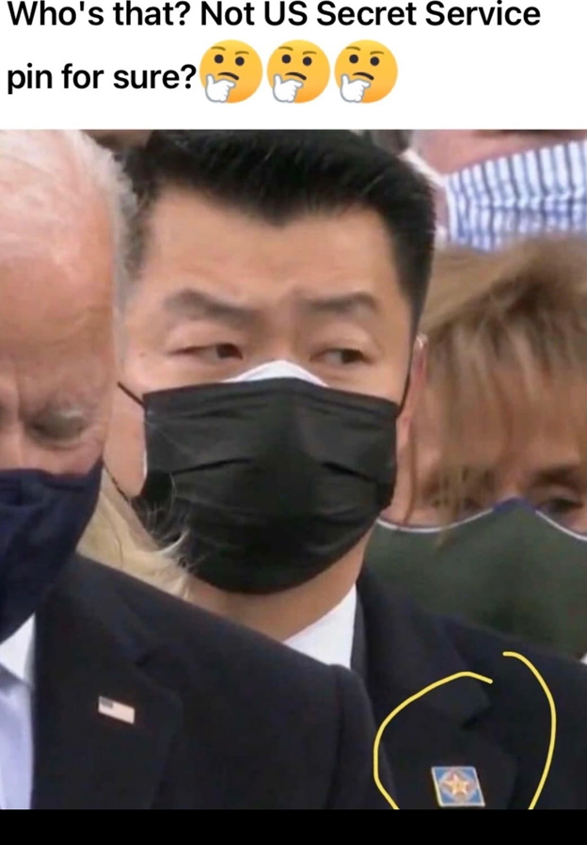Who is this attending the inauguration at the Corporation of the United States of No States?
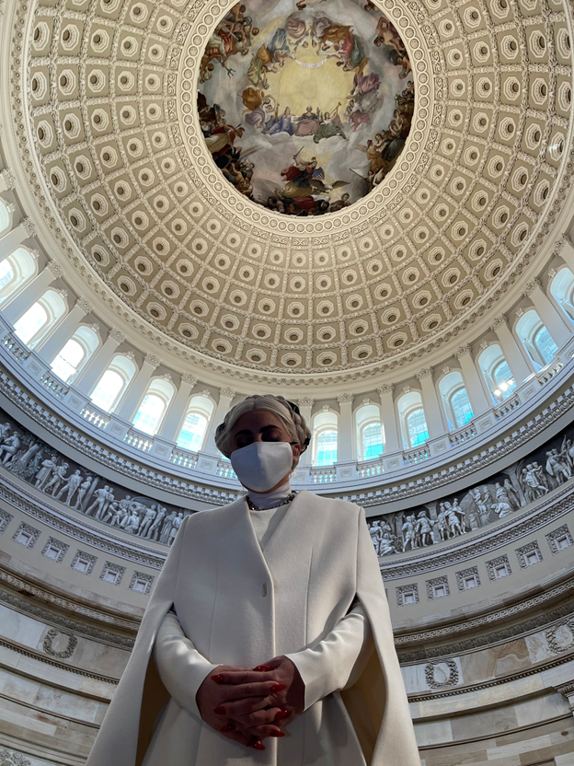And look at Gaga inside the Apotheosis (raising to the ranks of a God) Capitol Dome. Do you really believe the founding fathers would have authorized the Greek and Roman gods to be painted on the dome of the rotunda? Do you believe they would have Artemis’s goddess of freedom on its’ dome? Do you think George Washington would have wanted a statue of him posing as Baphomet in the capitol dome raising him to the ranks of a god? ALL ANSWERS ARE NO!
The entire corporate capitol grounds have been laid out by secret societies in the shape of a pentagram that honors the god they follow, that of Baal sacrifices of children. Sad, but so very true. All that is hidden shall be revealed.
THE DUTY TO SECURE AMERICA FIRST NEVER ENDS POMPEO

So be patient and remember what Trump has said, THE BEST IS YET TO COME!
And for those who think this is a bunch of bull crap, to you I quote the famous line from the epic film, Gone With The Wind….. “Frankly my dear, I don’t give a damn!”
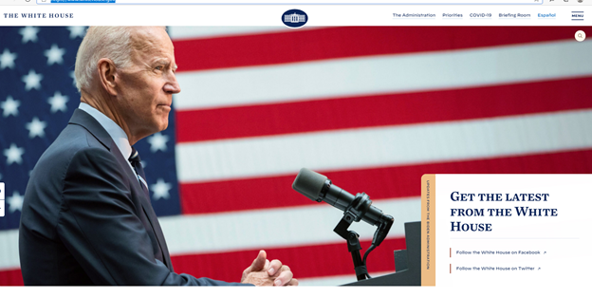
Why don’t the naysayers google antifa.com…..and see the corporations new website! It takes you to it.
May God speed be with each one of you as this storm blows through, and may each be kept safe in Father God’s mighty hands as he performs his work, a marvelous work!
Dianne Marshall

THE REAL TRUMP SEND OFF…
January 20, 2021 The Marshall Report84 Comments
While mainstream fake news wants you to believe all is bottomed out for the Commander in Chief….it has not been as they have said.
It has been as President Trump has said…THE BEST IS YET TO COME!
The Lord is watching all things.
Numbers 6:22
22And the Lord spoke to Moses, saying: 23“Speak to Aaron and his sons, saying, ‘This is the way you shall bless the children of Israel. Say to them:
24“The Lord bless you and keep you;
25The Lord make His face shine upon you,
And be gracious to you;
26The Lord lift up His countenance upon you,
And give you peace.” ’
27“So they shall put My name on the children of Israel, and I will bless them.”
Amen
Dianne Marshall

NEVER GIVE UP FOR THE BEST IS YET TO COME!
January 19, 2021 The Marshall Report31 Comments
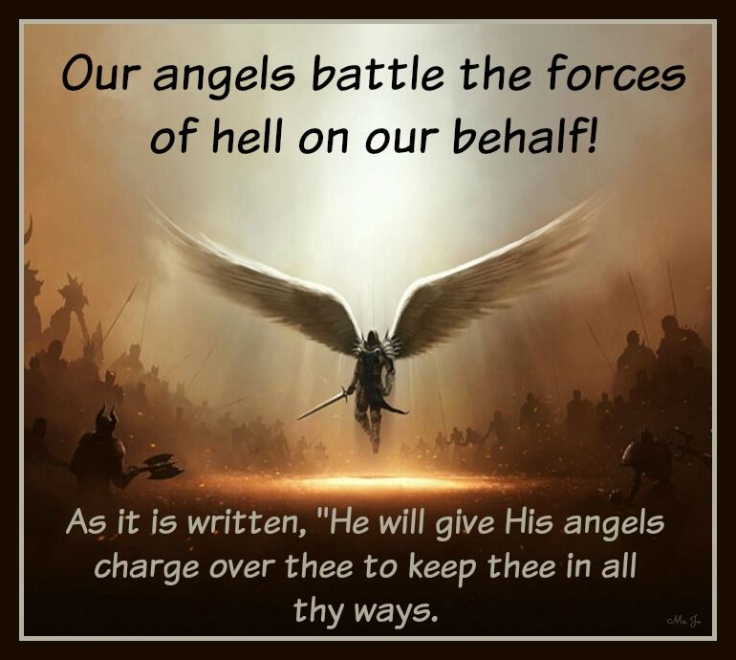
These are days of vengence, destruction, weeping, pain, and sorrow. These are also days of repentence, mercy, redemption, joy, and triumph. Who are we to battle between one another like the children of Israel in the wilderness yelling at Moses (America’s Trump) and blaming him for not saving all of us from our misery that was brought upon us by our own complacency. It is surprising how many have given up on our Moses, the one Kim Clement called God’s David and prophecied all of this would take place, and so far it has to a “T”.
The moans of those who have thrown Trump under the bus like the RINOs have. The scoffing jeers (although less harsh) resounding like the left against good people. Perhaps he is hidden from your demands the same as God’s plans for you are hidden? Perhaps in his hiding, God is doing a bit of testing to see who has faith in him, and who deserves a leader such as his David? I say repent, hold the faith, and find yourselves worthy of the gift that is about to appear after the storm.
It is way past the time for those down hearted to turn to God for redemption and to strengthen their faith. For it is God almighty that will perform the miracle. This nation belongs to him. We belong to him. What are we doing to be deserving of mercy and grace? What are we doing to prepare for the day of the Lord to do his miracle? I have heard whispers and some shouts that NOW WE ARE ALL DOOMED BECAUSE TRUMP DID NOTHING TO SAVE US! These are the words of the devilish minions who enter into human minds when they are gripped with fear and lacking faith during times of testing and peril.
Seek the Lord and he will comfort you and stand still and behold the salvation of the Lord. Again remember that when the people were chased by the armies of Egypt and the sea was before them…many lamented and beat their chests shouting false accusations at Moses – for they believed he took them out of Egypt and foolishly led them to the sea to die.
EXODUS 14:13-14
AND MOSES SAID UNTO THE PEOPLE –
Fear ye not, stand still, and see the salvation of the Lord, which he will shew to you to day: for the Egyptians whom ye have seen to day, ye shall see them again no more for ever.
¹⁴ The Lord shall fight for you, and ye shall hold your peace.
I say to all that are having a doubting moment and railing against what we do not know nor understand. Quarreling amongst one another gains nothing. Rather, instead read the Bible – it will reknew your heart and give you strength to mount up with wings like eagles.
Remember miracles happen only when there appears to be no other way out…
THE BEST IS YET TO COME!

Dr. Gina Will Discuss Her Private Talk With Trump On 1-19-2021!
January 19, 2021 The Marshall Report35 Comments
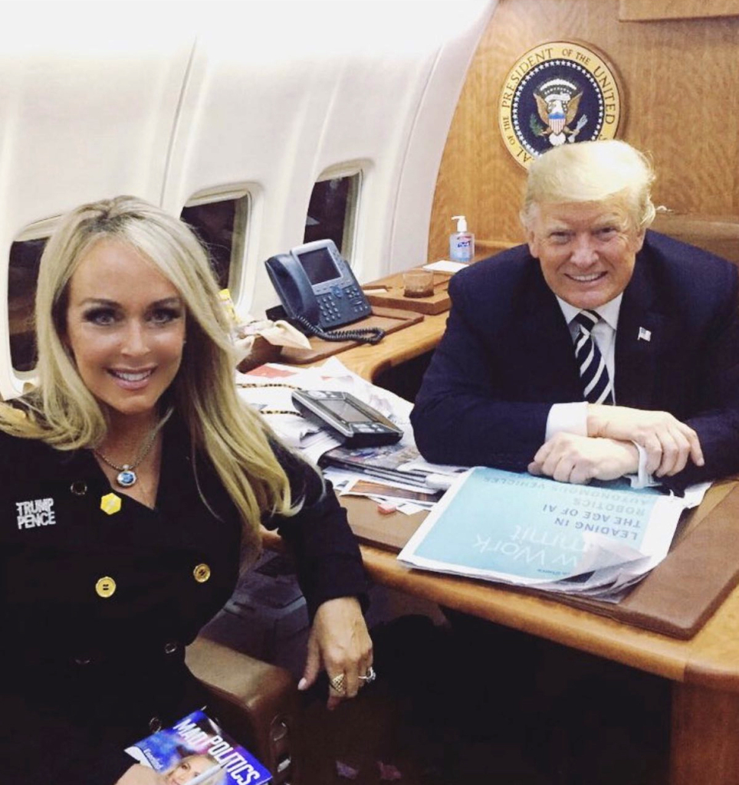
Dr. Gina RAV @RealAmVoice stated on January 18. 2021 at 7:17 PM, “Just hung up the phone with the President. I’ll talk about it a little more on my show tomorrow night. This country will wake up to realize a devastating loss on Wednesday. He is the best thing that ever happened to this country!”
Does anyone have a clue what she may be getting ready to talk about? I do!
Gina Loudon, MA., MA., Ph.D. is the President of Programming and Senior Anchor at Real America’s Voice (RAV-TV).
Dr. Gina was selected as a Woman of Influence in Media by the Miami Israeli Consulate, and traveled to Israel studying business, economics, social policy, and faith issues.
She was selected by Lara Trump as national co-chair of Women for Trump, serves on the Trump 2020 Media Advisory board, as well as co-chair of Florida Trump Victory. She currently serves on the board of directors at Chula Vista Christian University.; and is a bestselling author and her latest book is Mad Politics: Keeping Your Sanity in a World Gone Crazy.
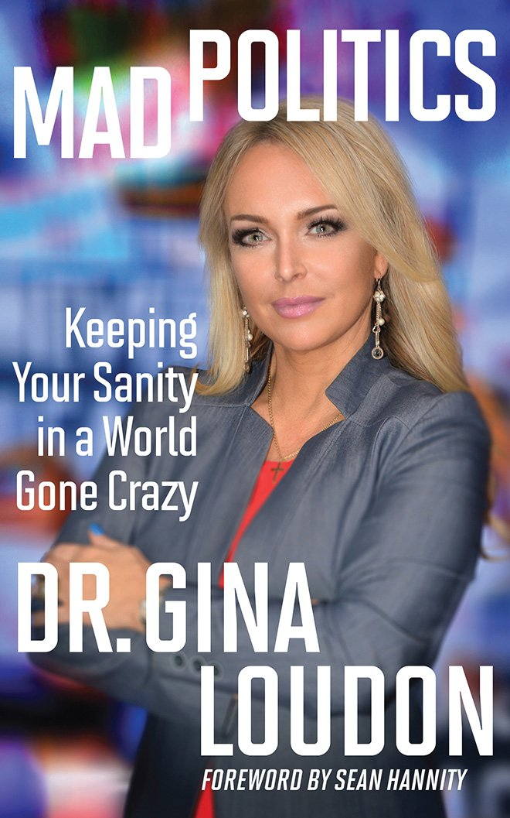
You can hear what she has to say about her talk with President Trump on http://Real America’s Voice (RAV-TV).
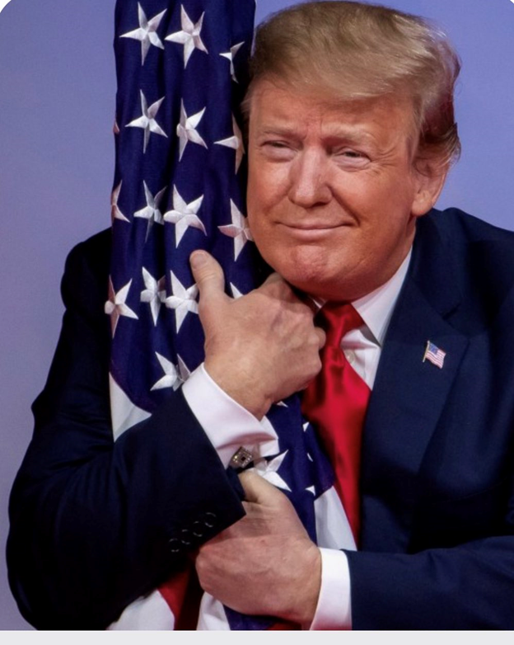
Pray for America and pray for the innocent.
Dianne Marshall

President Trump’s Farewell Speech
January 19, 2021 The Marshall Report39 Comments
President Trump’s farewell speech to America is live now.

Laptop Letter…
January 19, 2021 The Marshall Report75 Comments
There was a laptop confiscated in the Capitol Building. Many of them on January 6, 2021. There were a lot of revealing things found. Here is one of them.
Did they really think people were that stupid? It appears the one who wrote the letter did. Now I ask you, do you really believe President Trump who knows EVERYTHING is going to do nothing when he has everything still at his disposal?
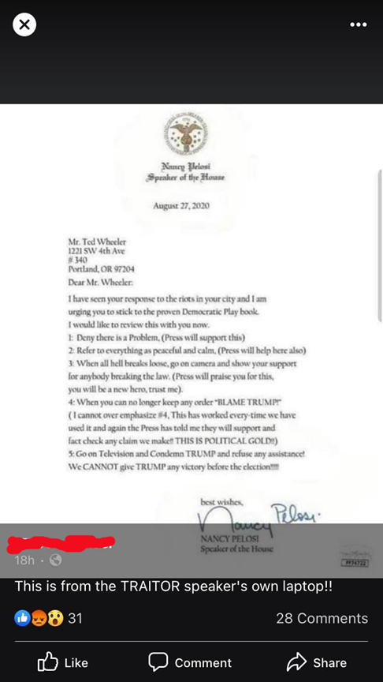
Remember Portland …what is she planning in D.C.?
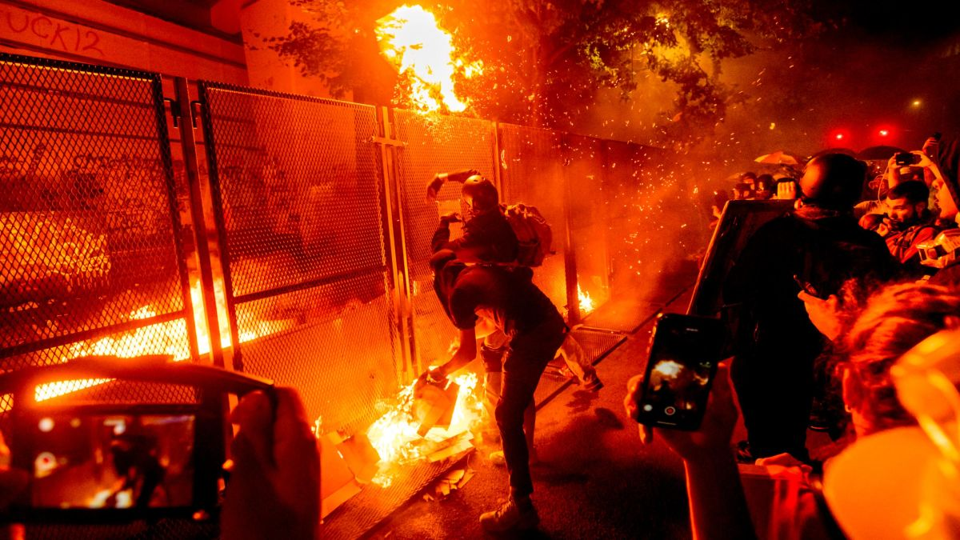
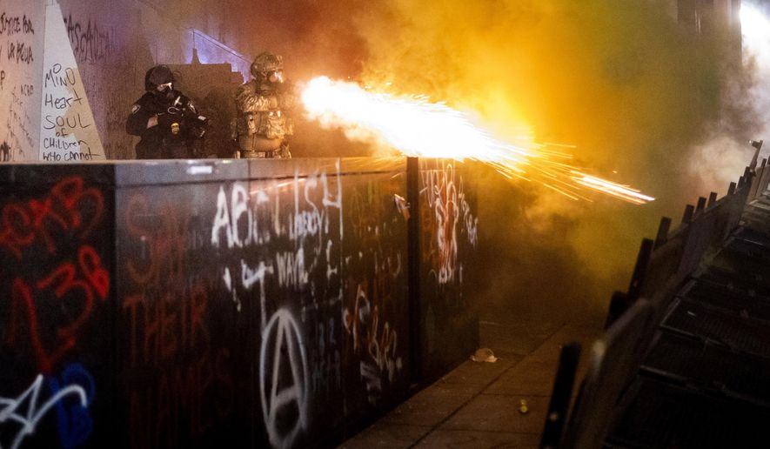
Dianne Marshall

WHITE HOUSE ANNOUNCES NEW 1776 REPORT! LIN WOOD REPUBLIC UPDATE -THE BEST IS YET TO COME!
January 19, 2021 The Marshall Report16 Comments
On November 2, 2020 President Trump signed an executive order executive order to establish a 1776 Commission to advise the president on how America’s founding story should be taught in schools, an effort that was criticized by some historians and educators when he first addressed it in a speech responding to the 1619 Project and other efforts to change how American history is taught. The executive order established a 20-person 1776 Commission under the Department of Education to help the president promote “patriotic education.”
The following excerpts from the Executive order addresses key issues of the day that have been ignored and festered into an undermining of the Constitution, Bill of Rights and the governing rights of WE THE PEOPLE:
“Against this history, in recent years, a series of polemics grounded in poor scholarship has vilified our Founders and our founding. Despite the virtues and accomplishments of this Nation, many students are now taught in school to hate their own country, and to believe that the men and women who built it were not heroes, but rather villains. This radicalized view of American history lacks perspective, obscures virtues, twists motives, ignores or distorts facts, and magnifies flaws, resulting in the truth being concealed and history disfigured. Failing to identify, challenge, and correct this distorted perspective could fray and ultimately erase the bonds that knit our country and culture together.”
“The recent attacks on our founding have highlighted America’s history related to race. These one-sided and divisive accounts too often ignore or fail to properly honor and recollect the great legacy of the American national experience -- our country’s valiant and successful effort to shake off the curse of slavery and to use the lessons of that struggle to guide our work toward equal rights for all citizens in the present. Viewing America as an irredeemably and systemically racist country cannot account for the extraordinary role of the great heroes of the American movement against slavery and for civil rights — a great moral endeavor that, from Abraham Lincoln to Martin Luther King, Jr., was marked by religious fellowship, good will, generosity of heart, an emphasis on our shared principles, and an inclusive vision for the future.”
The commission delivered a report about the main principles of America’s founding story and supporting the government’s plans to celebrate the 250th anniversary of the signing of the Declaration of Independence.
The President’s Advisory 1776 Commission January 2021 – is now available on the White House Website.
It sure looks as though the government is now in the process of going back into the hands of WE THE PEOPLE!
The President’s Advisory 1776 Commission is a very moving account based on defending the fundamental truths of human liberty proclaimed on July 4, 1776.
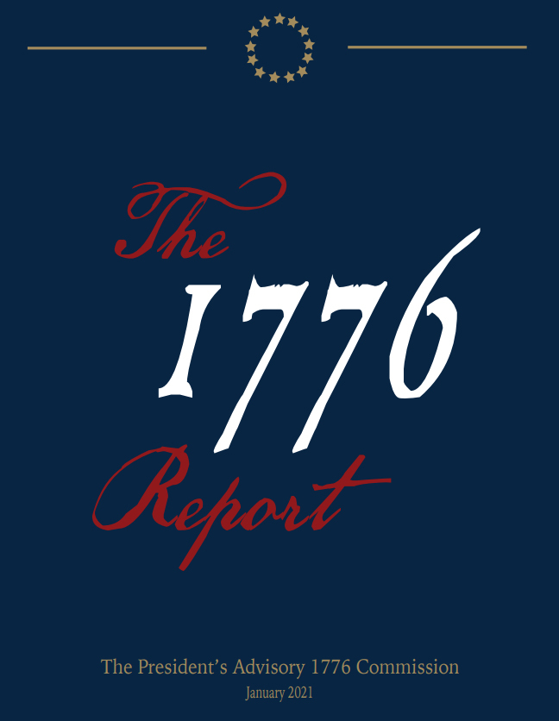
The following is the Table of Contents and a few pages of the Report. The entire report can be viewed by clicking here: The-Presidents-Advisory-1776-Commission-Final-Report.pdf (whitehouse.gov)
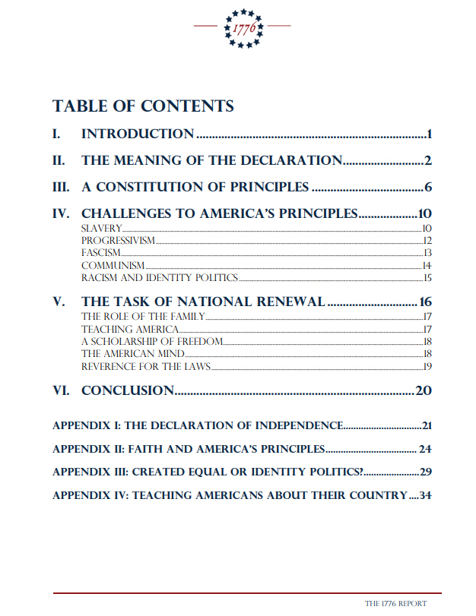
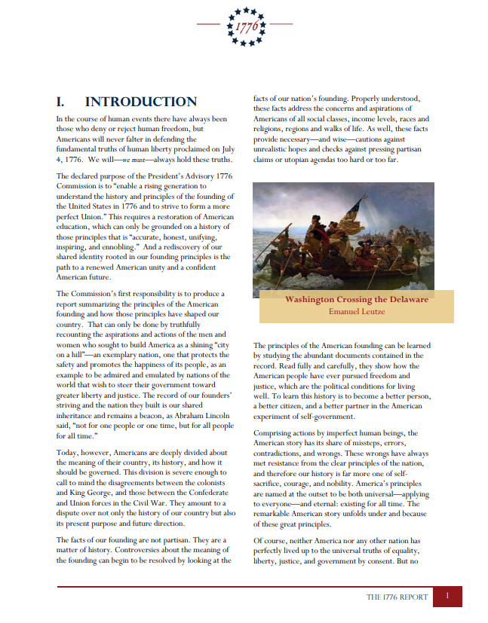
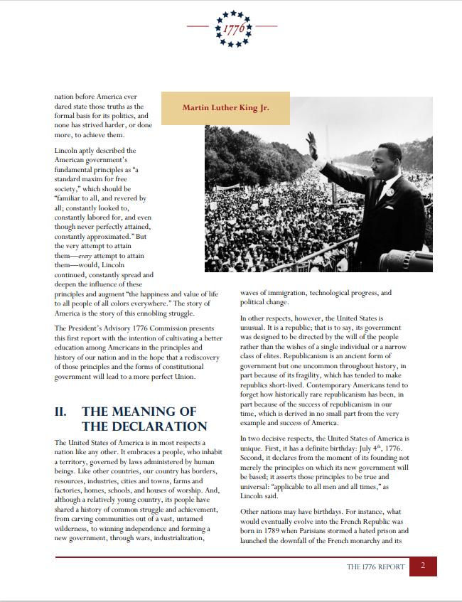
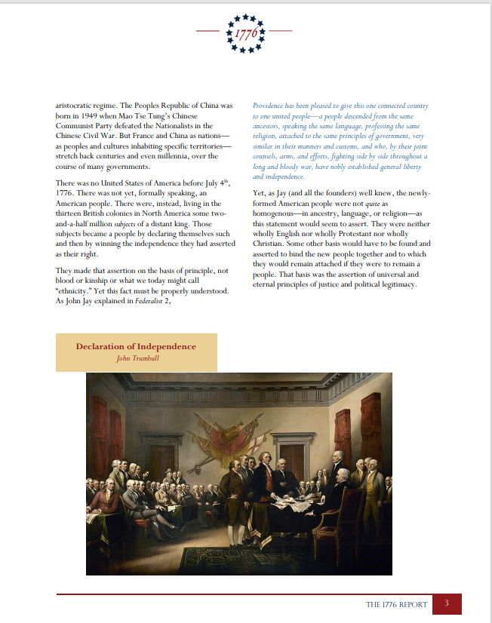
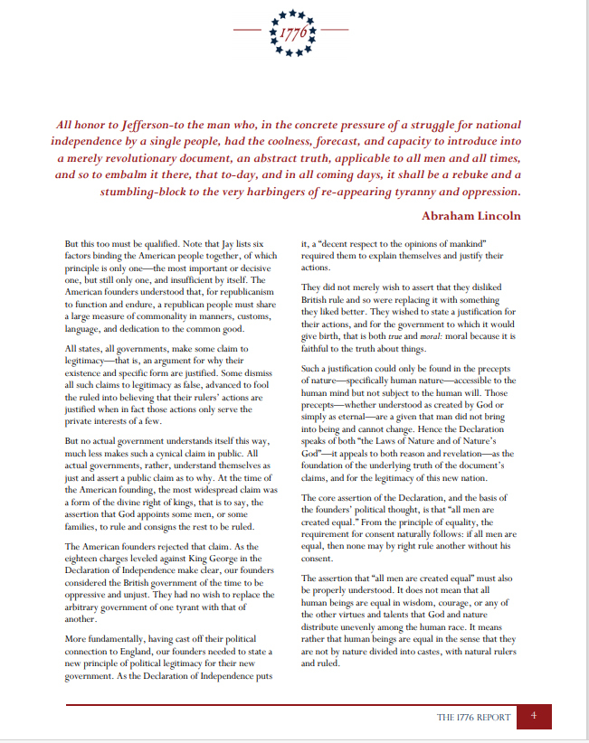
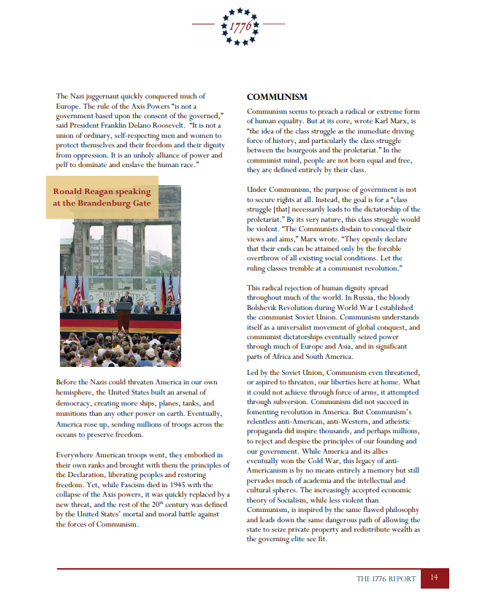
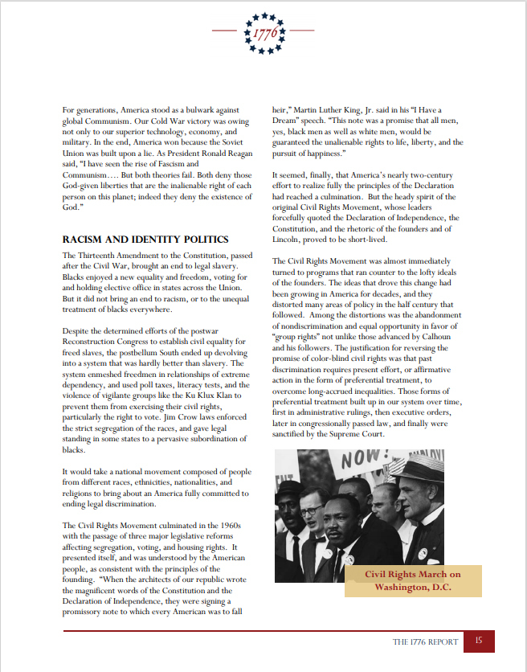
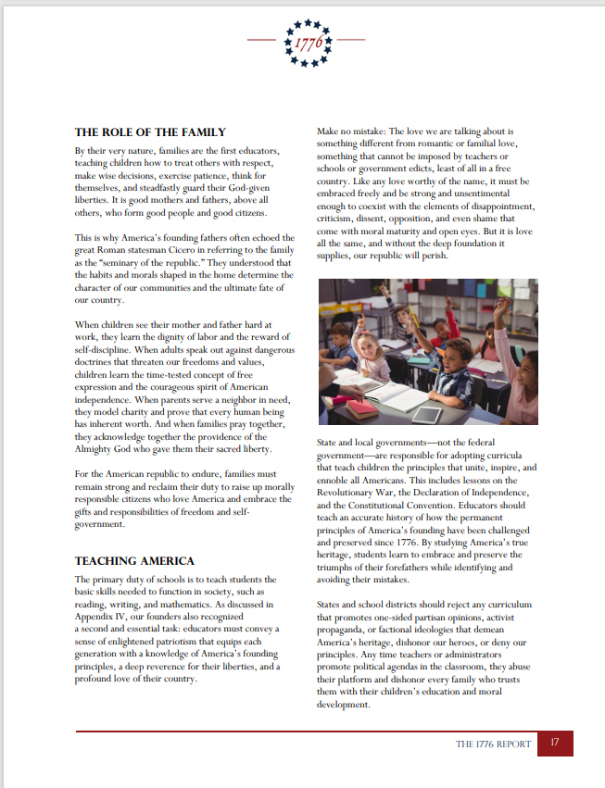
REPUBLIC UPDATE
America and the world has been watching a full blown display of a stolen election like a third world country, but it started before this election. We have all been watching lawlessness for the decades. Because We The People watched in shock and awe, and disbelief, then sighed and went about business as usual, we are now watching in real time what the result of complacency looks like. We have a full socialistic, communism in our face overthrow of the constitution, the will of the people, and those that will not lay down and roll over to the tyranny are threatened with having no employment, re-education camps, arrests, banned from airlines, even threats of taking away peoples college degrees!
The Biden elect administration along with congress and the senate on both sides of the aisle have lied, bore false witness, and all with all but starting mass arrests. It’s as if they don’t know what to do first – arrest everyone who doesn’t agree with communism or have a the inauguration. They have lost not only their moral compass, they have lost their minds believing they have all the power and they will rule the world. It’s like a very sick Sci-Fi where the takeover has to wall itself in to keep the good people out until they can authorize their Chinese deployment via their United Nations call for help to arrest good innocent people. Then they will make the children wards of the state beyond that of their education, they will decide how they are raised and who and where they are raised once they are weaned. Hillary is getting her village under the Biden deal.
But, I have faith that this nightmare on Pennsylvania street and inside their tunnels will come to and end fast.
L. LIN WOOD

Meanwhile in the midst of the chaos, LIN WOOD IS REASSURING AMERICA THAT PRESIDENT TRUMP WILL SERVE FOUR MORE YEARS FOR THIS WAS A STOLEN ELECTION with both domestic and foreign interference. The insane lawlessness is coming to an end. But it will be a rough winter.
Wood tells us there will be no stolen election and there will be no communism and tyrannical government on Capitol Hill. There will be no FEMA CAMPS and arrests for Trump Supporters and Patriots. We will remain a free nation, under God, with liberty and Justice for all. But, in the process of freedom there will be some fireworks.
Lin Wood explains the process and cautions the people to stay calm, be safe, and let the military do their job.
Pray for our military and President Trump. God bless America THE LAND OF THE FREE!
Dianne Marshall
Update…they have stripped the White House Web site…you can read the 1776 report here: Copy and paste. file:///C:/Users/Dianne/Downloads/888e233f-1b81-4250-b02c-5832e9dc5932%20(1).pdf

DON TRUMP JR. SAYS – GET YOUR TICKETS TO “THE STORM”!
January 18, 2021 The Marshall Report25 Comments
Donald Trump Jr. showed his ticket to “The Storm” today and asked if you are going. It looks like a World Premier Grand Showing. Not sure if they will roll out the red carpet, but there are a few interesting things about it.
You can make of it what you want. I find the Adult Standard interesting as in the Standard Hotel. WWG1WGA Cinema Presents is interesting….along with the hash tags. He said to share it to support his father, President Trump. Just click on this and copy image and repaste somewhere you post!

If you were lucky enough to get a cell phone ticket and you clicked on the barcode….you will hear this song!
WE’RE NOT GONNA TAKE IT ANYMORE!
Did you know January 19th is National Popcorn Day?

President Trump also signed another Executive Order Today….

Executive Order on Ensuring Democratic Accountability in Agency Rulemaking
LAW & JUSTICE
Issued on: January 18, 2021
By the authority vested in me as President by the Constitution and the laws of the United States of America, it is hereby ordered as follows:
Section 1. Purpose. American democracy operates on the principle of the consent of the governed. Regular elections for the Congress and the President and Vice President of the United States are designed to ensure that the officials responsible for making and executing the law are held accountable to the American people. The President chooses Federal agency heads who exercise executive authority and implement his regulatory agenda. The American people, in electing the President, thereby have a role in choosing the individuals who govern them.
However, some agencies have chosen to blur these lines of democratic accountability by allowing career officials to authorize, approve, and serve as the final word on regulations. This practice transfers the power to set rules governing Americans’ daily lives from the President, acting through his executive subordinates, to officials insulated from the accountability that national elections bring. This practice undermines the power of the American people to choose who governs them and I am directing steps to end it.
Read all of it here: Executive Order on Ensuring Democratic Accountability in Agency Rulemaking | The White House
I love Sec.4 !!!!!
Sec. 4. Review of Existing Rules. (a) Within 90 days of the date of this order, the head of each agency shall review all significant rules the agency has issued over the last 12 years, and any other rules identified by the Administrator, to determine whether the rule was issued by a senior appointee. For good cause shown, the Administrator may authorize an extension of the period within which an agency shall conduct such review.
Dianne Marshall
To those who said Don Jr. didn’t put this out…he did. He also put out a video. I only have a screen shot of it. Here it is.
You need to get the ap!!!!! 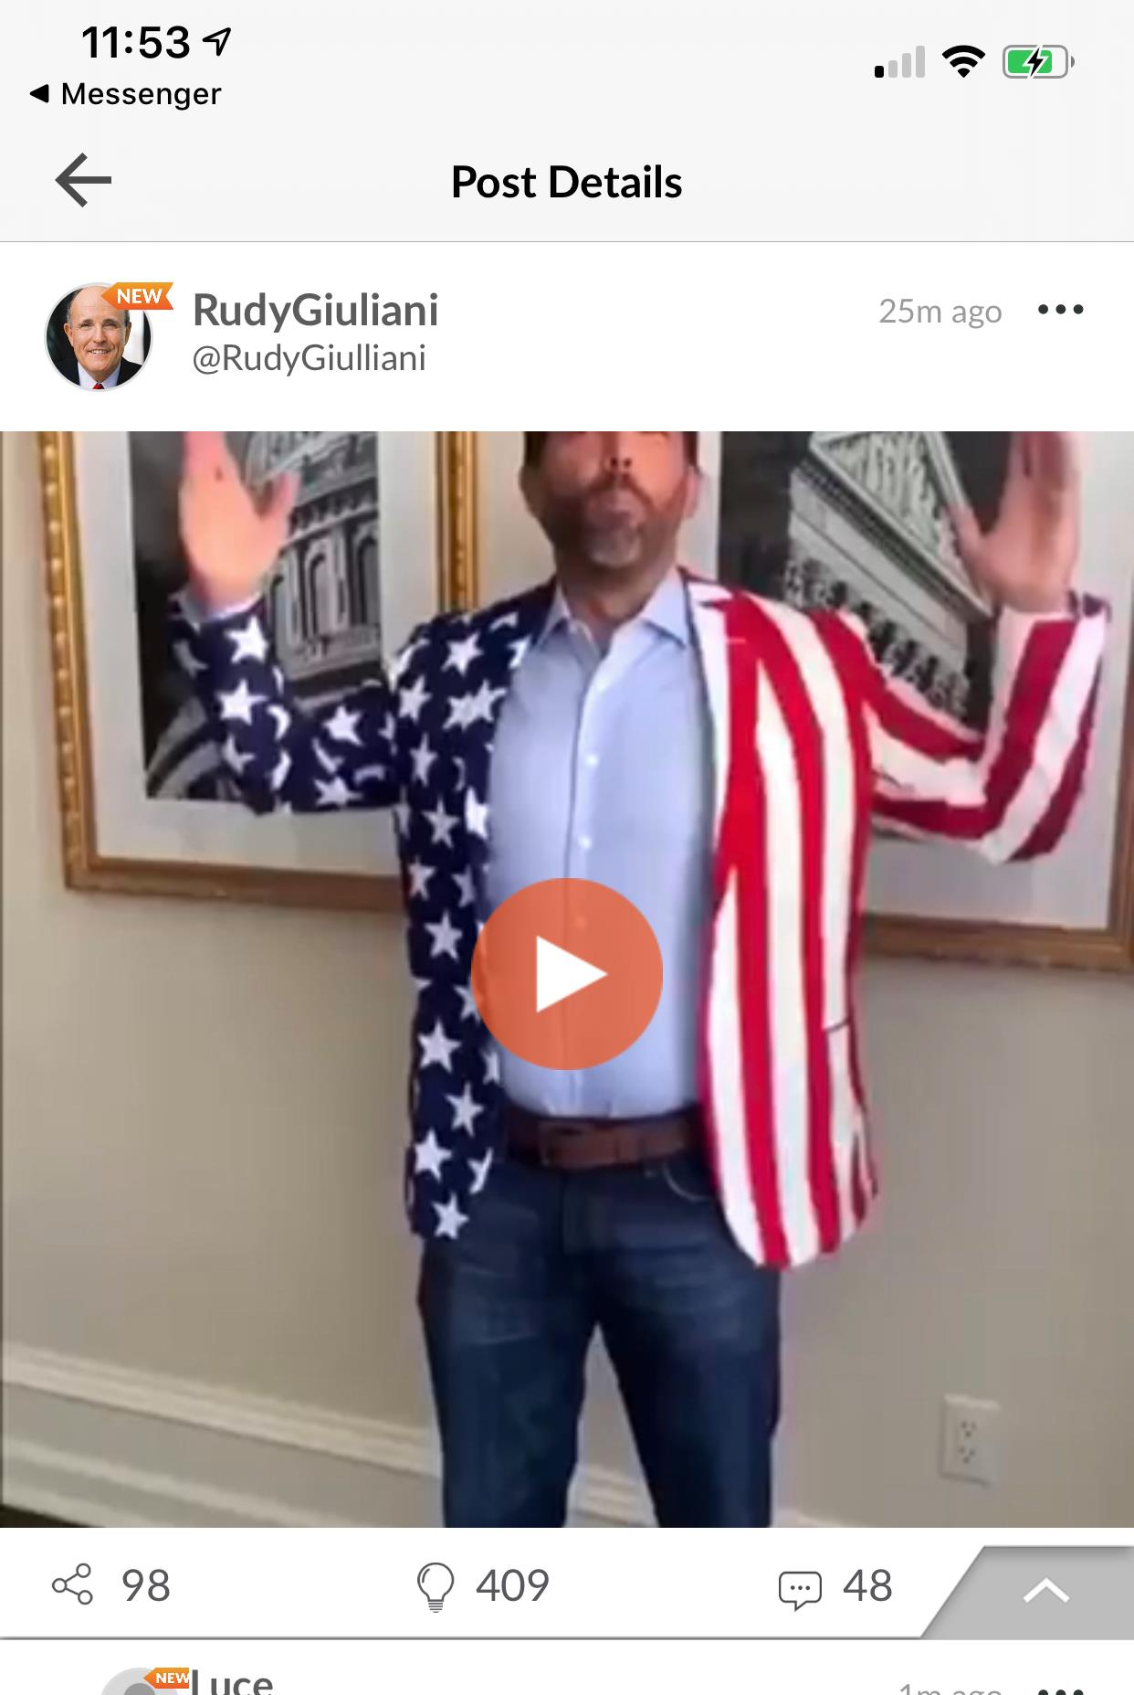FIND DON JR., TRUMP, WOOD, ON CloutHUB! 

IF WE KNEW THEN WHAT WE DON’T KNOW NOW, WOULD IT HAVE MADE ANY DIFFERENCE?
January 18, 2021 The Marshall Report21 Comments
In the age of high technology and interdependence on a cashless society, we have been conditioned to rely on electronic communications whether we wanted to or not. Unless you were among those such as the Amish, who refused to adapt, we have all been herded into an electronic web and captured. So as the censoring started and we all were left with pieces of a puzzle putting the truth pieces together. We formed the corners and began finding the pieces that interlocked inside it. There are still many pieces to the puzzle missing in order to see the entire big picture clearly. But we have enough pieces to see that it is a picture of a great battle.
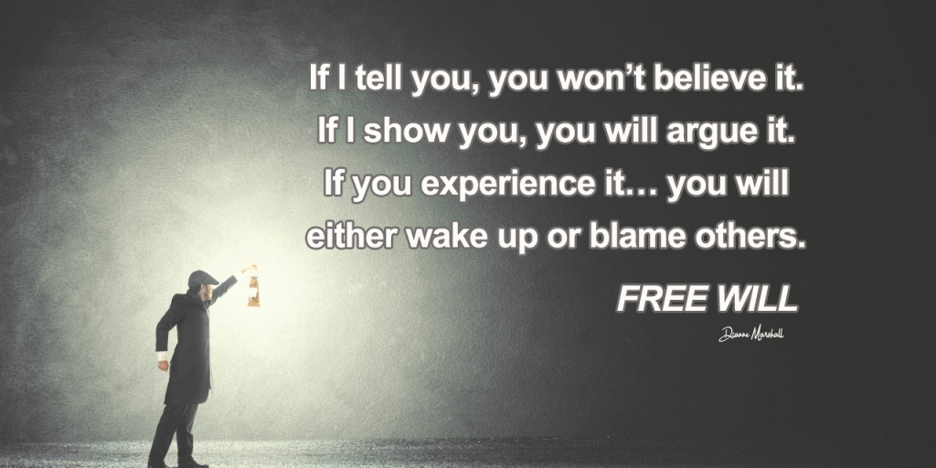
We cannot make a piece fit if it clearly does not fit. So the entire journey to discover the truth is one of frustration and patience. Yet the greatest truth is the only one who can save us from peril and destruction is the Lord God Almighty. That is the one truth that shall never fail and the truth we are to hold tight to as we are coming out of this chaos.
Yet, in our curious human form we are left to wonder and ask questions. God has the answers and in him seek. We are also to watch what is taking place for ourselves and we now see President Trump made another huge move, making a very large amendment to his Executive Order 13959. He has sent Nancy Pelosi a letter about it!
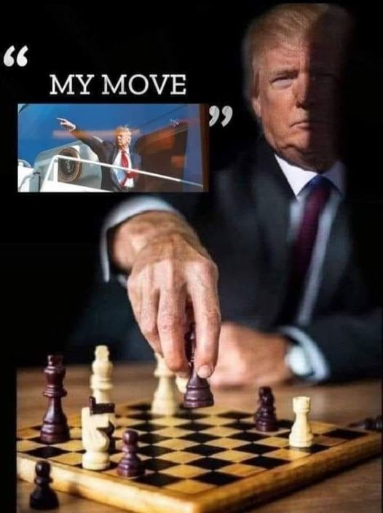
Read the Amendment and then ask yourself, if he’s leaving office in 7 days why does he keep making all these moves?
Appointing people to new positions, signing new Executive Orders….it doesn’t really make sense.
The answer of course, is I don’t think he’s going anywhere.
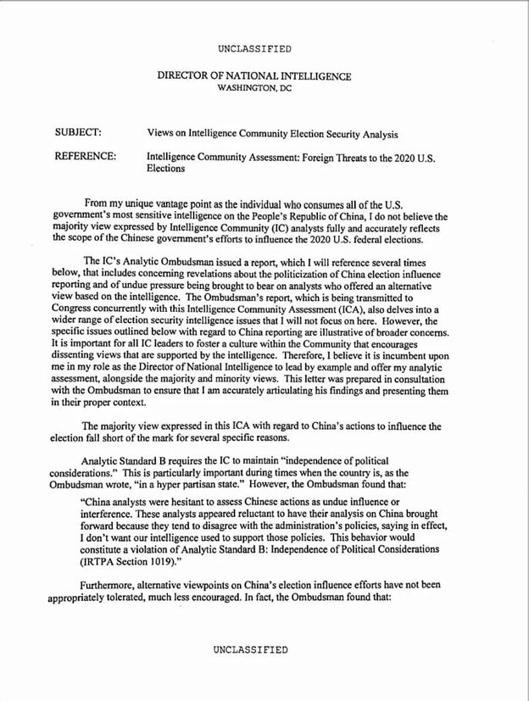
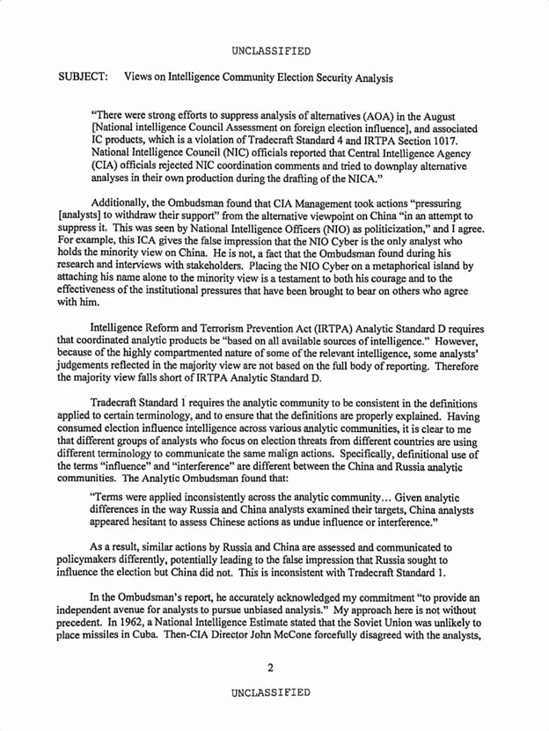
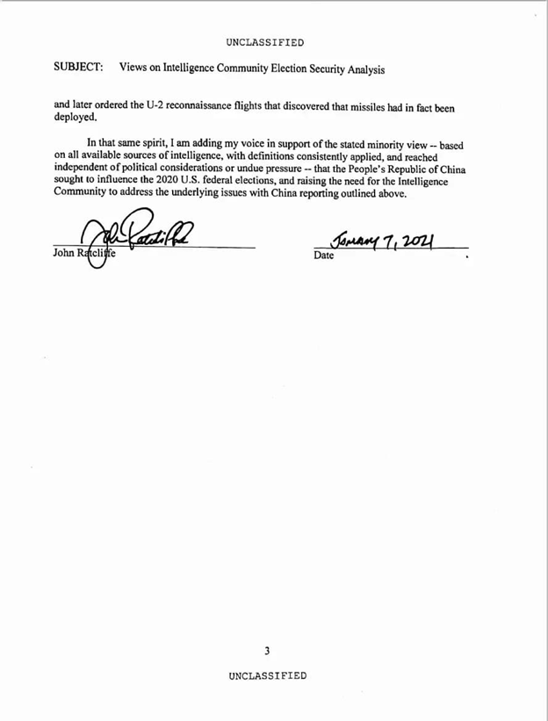
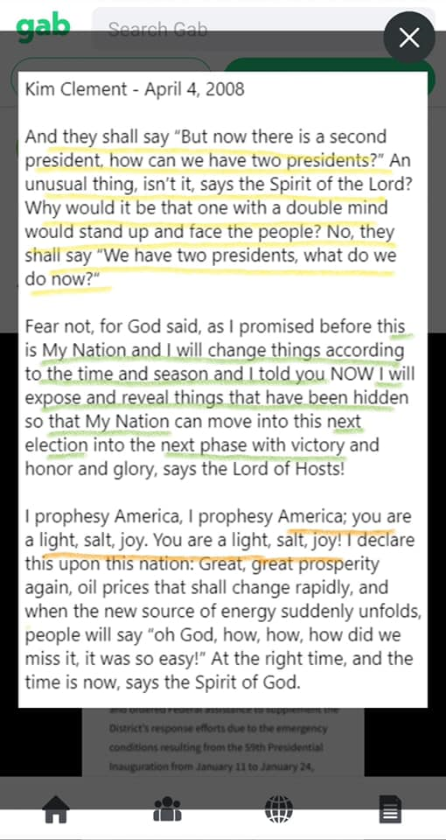
There has been a lot of disinformation and a lot of truth hidden inbetween. There are many who appear to be knowledgeable who are not. There are many that appear to not be knowledgeable who are. This is a different type of war, one we have never seen. This war pushes God’s people to press fast to him for it is a separation of the wheat and the tares.
As we move forward in this pressing of nations remember that the Lord Yeshua told us all the Kingdom of God does not come with observation, you cannot say lo here it is or there. The kingdom of God is within you.
“The kingdom of God does not come with observation; nor will they say, ‘See here!’ or ‘See there!’ For indeed, the kingdom of God is within you ” (Luke 17:20-21).
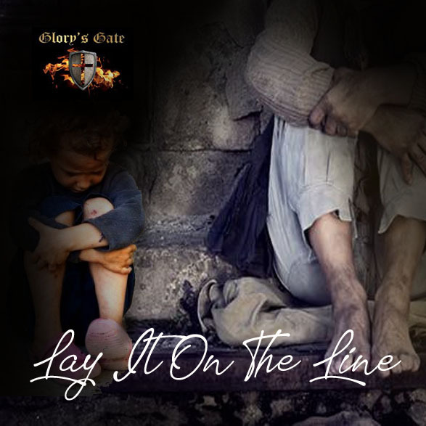
He also told us how we ought to pray, he gave us the Lord’s prayer and in it he said to pray, “Thy Kingdom Come, Thy will be done on earth as it is in heaven.” In Luke 16:16 that from the time the kingdom of God is proclaimed, that everyone forces his way into it. King James Bible, “The law and the prophets were until John: since that time the kingdom of God is preached, and every man presseth into it.”
This is where we are and the truth in the entire matter is God’s Kingdom is within each one of us, and every man is pressing into it that is called by his name.
So no matter what the events and battles on the ground and in the news will forecast, keep your eyes on the Lord and know that he has sent us a good man to lead us out of bondage. God always sends a warrior to stand in the gap for a repenting people. The purpose of chastisement is of repentance and a great awakening.
Pray today and everyday unceasing for the Lord hears our prayers and he is doing a great and marvelous work. Amen.
Dianne Marshall

