Antony C. Sutton 1925 -2002
http://en.wikipedia.org/wiki/Antony_C._Sutton
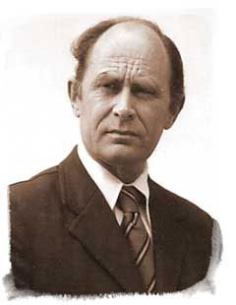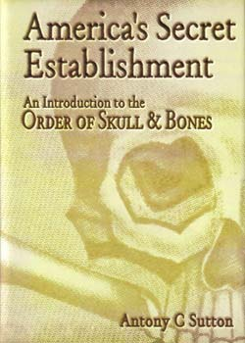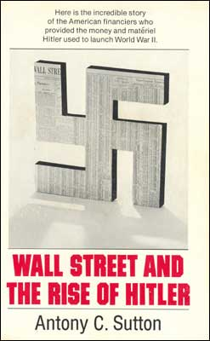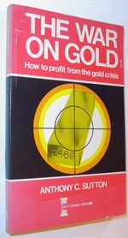

Antony C. Sutton (January 17, 1925 - June 17 2002) was a British-born economist, historian, and writer. He was educated at the universities of London, Göttingen, and California. He was a research fellow at Stanford University's Hoover Institute from 1968 to 1973.
Sutton published many books, including Wall Street and the Rise of Hitler, Western Technology and Soviet Economic Development (in three volumes), and The Best Enemy Money Can Buy.
In the early 1980s, Sutton received documents from an anonymous source revealing the historical membership of Yale's Skull and Bones society, which dates from 1832. Using these membership lists, Sutton was able to discern political and economic relationships underlying significant historical events, and to draw some conclusions regarding the purpose of these relationships. He published these findings as America's Secret Establishment: An Introduction to the Order of Skull and Bones, which he considered to be his most important work.

[] In his own words
Antony C. Sutton, 74, has been persecuted but never prosecuted for his research and subsequent publishing of his findings. His mainstream career was shattered by his devotion towards uncovering the truth. In 1968, his Western Technology and Soviet Economic Development was published by The Hoover Institute at Stanford University. Sutton showed how the Soviet state's technological and manufacturing base, which was then engaged in supplying the North Vietnamese the armaments and supplies to kill and wound American soldiers, was built by US firms and mostly paid for by the US taxpayers. From their largest steel and iron plant, to automobile manufacturing equipment, to precision ball-bearings and computers, basically the majority of the Soviet's large industrial enterprises had been built with the United States help or technical assistance.
Professor Richard Pipes, of Harvard, said in his book, Survival Is Not Enough: Soviet Realities and America's Future (Simon & Schuster;1984): "In his three-volume detailed account of Soviet Purchases of Western Equipment and Technology . . . [Antony] Sutton comes to conclusions that are uncomfortable for many businessmen and economists. For this reason his work tends to be either dismissed out of hand as 'extreme' or, more often, simply ignored."
The report was too much and Sutton's career as a well-paid member of the academic establishment was under attack and he was told that he "would not survive".
His work led him to more questions than answers. "Why had the US built up its enemy? Why did the US build-up the Soviet Union, while we also transferred technology to Hitler's Germany? Why does Washington want to conceal these facts?"
Sutton, following his leads, proceeded to research and write his three outstanding books on Wall Street: and FDR; and the Rise of Hitler; and The Bolshevik Revolution. Then, someone sent Antony a membership list of Skull and Bones and--"a picture jumped out". And what a picture! A multigenerational foreign-based secret society with fingers in all kinds of pies and roots going back to 'Illuminati' influences in 1830's Germany.

[] External links
- The Best Enemy Money Can Buy
- Wall Street and the Bolshevik Revolution
- Wall Street and the Rise of Hitler
- Wall Street and FDR
- Trilaterals over America
- America's Secret Establishment: An Introduction to the Order of Skull and Bones
- An Interview with Antony Sutton
- Wall Street and the Rise of Hitler: Stan Monteith interviews Anthony Sutton video
==============================================================================================================================
END

