**Retired MI5 Agent Confesses On Deathbed: ‘I Killed Princess Diana’**

<http://yournewswire.com/mi5-agent-killed-princess-diana/>

[June 19, 2017](http://yournewswire.com/2017/06/) [Baxter Dmitry](http://yournewswire.com/author/baxter/) [Conspiracies](http://yournewswire.com/category/conspiracies/) [260](http://yournewswire.com/mi5-agent-killed-princess-diana/#mh-comments)

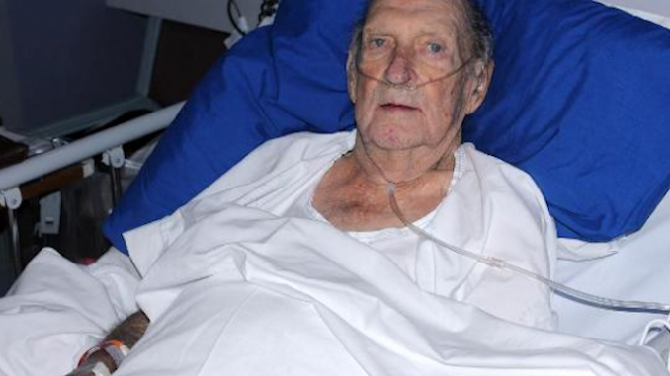

**An 80-year-old retired MI5 agent, John Hopkins, has made a series of astonishing confessions since he was released from hospital in London on Wednesday and told he has weeks to live. Hopkins claims to have been involved in 23 assassinations for the British intelligence agency between 1973 and 1999, including Princess Diana.**

Mr. Hopkins, who worked for M15 for 38 years as an operative, claims he was often used as an hitman by the agency, to discreetly assassinate individuals considered a threat to the domestic security of the United Kingdom.

Trained as both a mechanical engineer and munitions expert, Mr. Hopkins claims he also has extensive experience of less conventional methods of inflicting death and destruction, including chemicals and poisons.

The 80-year-old British man claims he was involved with MI5 assassinations between June 1973 and December 1999, during a period he says “*the MI5 operated with less external oversight*.” Hopkins says he was part of a cell of seven operatives who were trusted to carry out political assassinations across the UK. Most victims were politicians, activists, journalists and union leaders.

Mr. Hopkins says Princess Diana is unique among his victims, as she is the only female he ever assassinated, as well as the only Royal. She is also the only victim that the Royal Family themselves ordered to be taken out.

*[*[*Banned Worldwide: Princess Diana Documentary ‘Unlawful Killing’. Must See.*](http://yournewswire.com/banned-in-the-uk-princess-diana-documentary-unlawful-killing-must-see/)*]*

He claims to feel “ambivalent” about Princess Diana’s death. On the one hand, Diana was “a beautiful, kind-hearted woman” who did not deserve to have her life cut short. But according to Mr. Hopkins, she was also placing the British Crown at risk:

“*She knew too many Royal secrets. She had a huge grudge and she was going to go public with all sorts of* [*wild claims*](http://yournewswire.com/video-is-this-the-reason-why-princess-diana-was-assassinated/)*. My boss told me she had to die – he’d received orders directly from* [*Prince Philip*](http://yournewswire.com/royal-family-face-nazi-expose-on-tv/) *– and we had to make it look like an accident. I’d never killed a woman before, much less a princess, but I obeyed orders. I did it for Queen and country.”*

The next stage of the high-level conspiracy involved the media, under tight Palace control, talking to each other to *“square their stories, make sure everybody was on the same page. It was a well run operation*.”

“*British journalists all answer to editors who answer to oligarchs who all want knighthoods from the crime family at Buckingham Palace. There is no free press in Britain,”* said Mr. Hopkins*.*

*“We got away with murder.”*

The 80-year-old, spending his final weeks at home, said he expects to be taken into custody following his admissions, but says “*I can’t say that I care an awful lot*.” Hopkins explained that any investigation into the affair would “*take forever*” and be “*very complicated*” because there are few written records around secret MI5 activities and “*most of my colleagues are already dead*“.

The most important witness in the case, Mr. Hopkin’s boss, died of a heart attack in “*the early 2000s*” and the alleged ringleader, Prince Philip, “*will never be charged with anything, of course*“

*[*[*Queen Elizabeth Ordered Princess Diana Murder Says Diana’s Best Friend*](http://yournewswire.com/queen-elizabeth-ordered-princess-diana-murder-says-dianas-best-friend/)*]*

“*If Prince Philip ever let himself be analyzed by a psychiatrist I’m sure he’d be diagnosed a psychopath. He has all the dark triad traits*.”

Asked why he didn’t refuse the job, or expose the plot at the time, he explained “*MI5 agents* [*swear allegiance to the Crown*](https://en.wikipedia.org/wiki/Oath_of_Allegiance_%28United_Kingdom%29)*, we can’t be impartial when it comes to the Royal family. At best I would have been done for treason, at worst Philip would have designed a grisly fate for me.*”

# Retired MI5 Agent Confesses on Deathbed: ‘I Killed Princess Diana’?

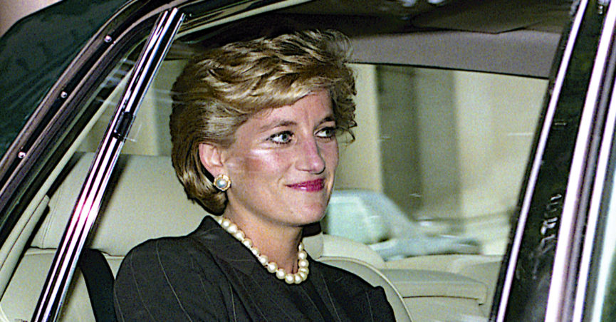

On 19 June 2017, the [YourNewsWire](http://www.snopes.com/tag/yournewswire-com/) web site published the [implausible](http://static.snopes.com/app/uploads/2017/06/Retired_MI5_Agent_Confesses_On_Deathbed___I_Killed_Princess_Diana_.jpg) [claim](http://static.snopes.com/app/uploads/2017/06/Retired_MI5_Agent_Confesses_On_Deathbed___I_Killed_Princess_Diana_2.jpg) that a former MI5 agent named John Hopkins had confessed to assassinating Princess Diana in 1997:

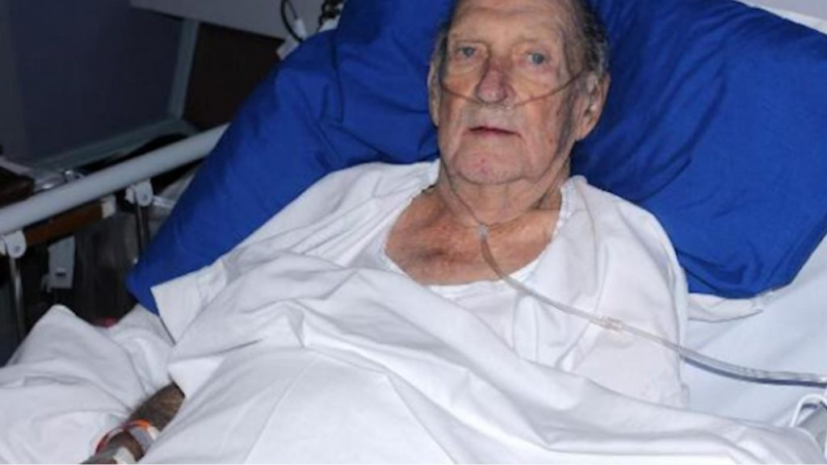

An 80-year-old retired MI5 agent, John Hopkins, has made a series of astonishing confessions since he was released from hospital in London on Wednesday and told he has weeks to live. Hopkins claims to have been involved in 23 assassinations for the British intelligence agency between 1973 and 1999, including Princess Diana.

The 80-year-old British man claims he was involved with MI5 assassinations between June 1973 and December 1999, during a period he says “the MI5 operated with less external oversight.” Hopkins says he was part of a cell of seven operatives who were trusted to carry out political assassinations across the UK. Most victims were politicians, activists, journalists and union leaders.

Mr. Hopkins says Princess Diana is unique among his victims, as she is the only female he ever assassinated, as well as the only Royal. She is also the only victim that the Royal Family themselves ordered to be taken out … He claims to feel “ambivalent” about Princess Diana’s death. On the one hand, Diana was “a beautiful, kind-hearted woman” who did not deserve to have her life cut short. But according to Mr. Hopkins, she was also placing the British Crown at risk:

There was no truth to the story, which originated with YourNewsWire, a [fake news](http://www.thedrum.com/news/2017/01/29/man-behind-one-the-biggest-sites-accused-fake-news-former-bbc-worker) site. As is often the case with fake news, the article lacked critical details such as when and where the confession occurred or how the purported assassination took place, and no other credible news outlet (or even tabloid) reported the story.

The MI5 agent deathbed confession story was not the first of its type proffered by YourNewsWire, a site known for promoting [baseless](http://rationalwiki.org/wiki/YourNewsWire) [conspiracy](http://www.thedrum.com/news/2017/01/29/man-behind-one-the-biggest-sites-accused-fake-news-former-bbc-worker) theories.