Murrah Federal Office Building (April 19, 1995)
Andres R. Perez, BAE/MAE, Penn State, 2009

On April 19, 1995, a rental truck filled with a highly explosive substance was detonated about 10 feet away from the Alfred P. Murrah Federal Office Building in Oklahoma City, Oklahoma killing 167 people and injuring 782 (Hinman, 1997, p. xi). The resulting explosion caused the disproportionate (progressive) collapse of about half of the nine-story, reinforced concrete structures. As a result, a majority of the fatalities were due to crushing caused by the manner of the failure (Rens, 1997, p. 44). Before any investigation of the collapse could take place, structural engineers were called up on by the Federal Emergency Management Agency (FEMA) to aid in the Urban Search and Recovery Program (US&R). Bracing had to be added throughout the process in order to support the remaining structure.
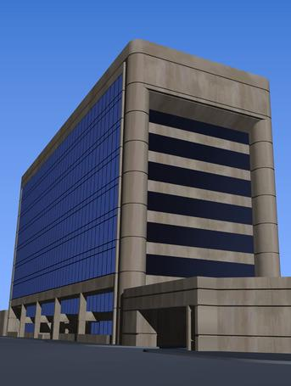
Figure 1: Murrah Federal Building, courtesy Dr. John D. Osteraas
After the rescue and recovery was completed, FEMA deployed a Building Performance Analysis Team (BPAT) comprised of engineers from ASCE and several government agencies. The report issued by the BPAT (FEMA 277) provides a general description of the building’s response to the explosion and the resulting damage. However, articles and papers authored by members of the US&R have issued alternative collapse mechanisms to the BPAT report. Also due to the extent of the resulting damage, skepticism has brought about alternative theories stating that the collapse resulted from bombs detonated within the Murrah Federal Building. Nevertheless, the findings in this case eventually led to a new design approach for reinforced concrete structures. The BPAT recommended that reinforced concrete structures subjected to explosions and/or similar threats should be designed using Special Moment Frames, Dual Systems with Special Moment Frames, or compartmentalized design, all of which originally were only found in areas of high seismic activity (Corely, 1996, p. 6-1).

Building Description

The Alfred P. Murrah Federal Building was designed for the GSA Public Buildings Service in the early 1970s. The construction for the project occurred over a 20 month span and was completed in early 1976. Overall, the project consisted of a nine-story office building, two one-story ancillary wings, and a multilevel parking garage. The project site was surrounded by North Harvey Avenue to the west, N.W. Fifth Street to the north, North Roberson Avenue to the east, and N.W. Forth Street to the south. The nine-story office structure was located on the north side of the site facing N.W. Fifth Street. On the east and west sides of the of the nine-story portion were the two ancillary wings. To the south of the nine-story office building, across a landscaped plaza stood the parking structure.
The structural system for the nine-story portion of the Murrah Building was an ordinary concrete moment frame. The framing plan for the structure, as seen in Figure 2, consisted of two 35 ft bays in north-south direction and ten 20 ft bays in the east-west direction. Typical floor-to-floor height for the building was 13 feet for floors three through eight and 14 feet for the ninth. The lateral system of the building was made up of cast-in-place concrete core/shear walls which were exposed to the exterior on the south face.
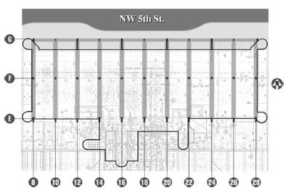
Figure 2: Plan of Murrah Building, courtesy of Dr. John D. Osteraas
In addition to the exposed shear walls, the south face of the nine story building comprised of precast concrete spandrels and glass curtain wall system. The east and west faces of the structure also contained the precast spandrels, but 3 inch granite stone paneling replaced the glass curtain wall. The north façade was made up of a glass curtain wall system. A transfer girder at the third floor level is also a notable aspect to the north building face (Column Line G). This girder allowed for the intermediate columns above to be terminated at level three which permitted the column spacing for the first two levels to be increased to 40 feet (Corley, 1998, p. 102-103).

Collapse and Failure Investigation

Blast Loading

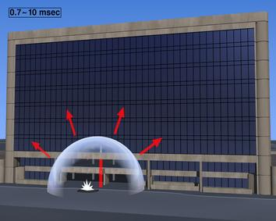
Figure 3: Blast Location, courtesy of Dr. John D. Osteraas
Other than with speculative theories which are not supported by the majority of the engineering community (see Partin Report), it has been widely accepted that the trigger to the collapse of the Murrah Federal Building was the detonation of a homemade bomb contained in a rental truck which was parked in front of the nine-story office building on N.W. Fifth Street. The resulting crater from the blast was approximately 28 feet in diameter and 7 feet deep. This crater was measured to be only about 10 feet away from Column G20 of the Murrah Building. After conducting analysis, the BPAT found that the required energy which would result in a crater of equal magnitude would be equivalent to that of the detonation of approximately 4,000 lbs of trinitrotoluene (TNT) (Mlakar, 1998, p. 113). After additional investigation, it was determined that the rental truck had been loaded with an estimated 4,800 lbs of ammonium nitrate and fuel oil explosive, also known as ANFO (Delatte, 2009, p.157). The detonation of bomb of this magnitude produces a radially propagating air-blast wave. The BPAT calculated that resulting pressures on the nine-story portion of the Murrah Building due to this air-blast wave were a maximum of 10,000 psi at the area closest to the detonation and a minimum of 9 psi at the upper west corner of the structure
(Mlakar, 1998, p. 113-114).

Failure Mechanisms
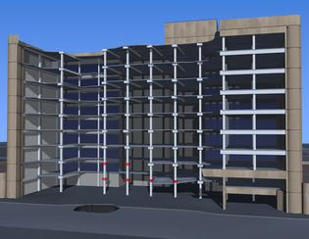
Figure 4: Illustration of Murrah Building after Collapse, courtesy of Dr. John D. Osteraas
Several reports, articles and papers have been written to discuss the failure mechanism of the Murrah Federal Building. Most agree that the collapse was the result of the loss of only four columns on the north side of the structure. But, there are inconsistencies as to the failure of these columns being a direct result of the blast (Osteraas, 2006, p. 330). Nevertheless, a substantial failure did occur resulting in the loss of life and the collapse of almost half of the Murrah Federal Building, please refer to model in Figure 4.

BPAT Report
The FEMA Building Performance Investigation Team (BPAT) reported that three columns, G16, G20, and G24, where directly effected by the blast from the truck bomb. The BPAT stated that Column G20, the closest to the detonation location, was likely removed by brisance which is the complete shattering of concrete. Columns G16 and G24 were found to not be in close enough proximity to the detonation point to suffer from brisant effects. However, lateral loadings due to blast were applied to weak axis of these columns (the east-west direction). The abrupt pressure caused the shear at the supports, Ground and Third Levels, to exceed the allowable shear resulting in a brittle failure (Mlakar, 1998, p. 116-117). The destruction of these columns resulted in the transfer girder at Level 3 to be unsupported and a progressive collapse of the floors above was initiated (Corley, 1998, p. 104).
The BPAT found that the floor slabs in the proximity of the detonation were loaded by the blast as well. Because the glazing of the curtain wall provided no resistance to the blast wave, resulting pressures filled the Murrah Building. These filling pressures were greater below the floor slabs than above due to the nature of the propagating blast wave. As a result, upward loading was applied to the floor slabs. Because reinforcement was only near the bottom of the slabs, acceptable for design in 1970s, there was little resistance to the upward response likely resulting in the failure and collapse of the slabs from Level 5 and below. According to the BPAT, slabs above Level 5 were believed to act elastically and would not collapse as a result of the differential blast loading (Mlakar, 1998, p. 117-119). The failure of the slabs above Level 5 was merely a result of the disproportionate collapse.

US&R Reports
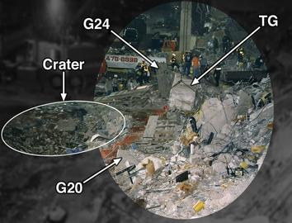
Figure 5: View looking east along Column Line G showing crater, transfer girder (TG), Columns G24 &G20; courtesy Dr. John D. Osteraas
After the collapse of the Murrah Building on April 19, 1995, FEMA deployed the Urban Search and Recovery Program (US&R) in order to conduct the rescue and recovery operations. Because they were exposed to the site immediately after the collapse, the structural engineers on this team witnessed firsthand the final result as well as the debris removal. The members of the BPAT, on the other hand, were on site three weeks after the event and did not have access to findings during the removal of the debris.
The main differences in the findings by the members of the US&R were that some lower portions of Column G20 were not completely disintegrated and remained intact, please refer to Figure 5. Also Columns G16 and G24 were reported to not have failed in shear as a direct result of the propagating blast wave. These columns are believed to fail by buckling likely caused by falling debris from the floor above.
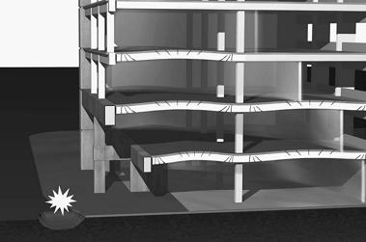
Figure 6: Illustration of slab responce due to blast pressure; courtesy of Dr. John D. Osteraas
The main blast response which initiated progressive collapse as reported by the US&R members was the upward force applied to the slabs in the blast proximity. This floor uplift resulted in the reverse flexural and shear cracking of the slabs as pictured in Figure 6. After the uplift load by the blast terminated, gravity took over resulting in a catenary action of the floor slab, see Figure 7. This action caused the slabs to fail in punching shear at the columns on Column Line F. Also because of the fact that the Level 3 transfer girder was cast monolithically with the slab, the catenary action also caused the girder to rotate and be pulled inward. This was confirmed after finding the transfer girder lying in the debris rotated at 90 degrees. As with the BPAT report, the report stated that loss of the transfer girder resulted in the progressive collapse to the rest of the Murrah Building (Osteraas, 2006, p 330-333).

Alternative Theories (The Partin Report)
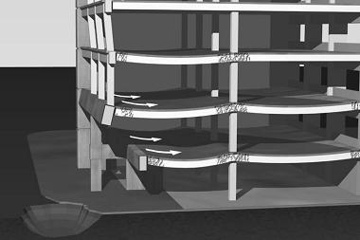
Figure 7: Illustration of cantenay action of floor slabs; courtesy of Dr. John D. Osteraas
Due to extent of the damage/collapse of the Murrah Building, other theories, which are not supported by the majority of the engineering community, arose. One report in particular was submitted to Congress by Brigadier General Benton R. Partin USAF (ret.) in July of 1995 in response to media reporting that the trigger in the failure was the detonation of a truck bomb. Partin stated that the yield from the 4,800 lbs of ANFOwould be far less than would be required for a concrete failure. Partin concluded that several columns had demolition charges attached to them which when detonated, caused the resulting collapse of the Murrah Federal Building (Partin, 1995).

Lessons Learned

The collapse of the Murrah Federal Building has greatly influenced the way present day structural engineer accounts for the loading due to blast. After analyzing the structural design of the Murrah Building, the BPAT found that structure complied with all the codes and provisions at the time for the design and construction of an ordinary reinforced concrete frame structure (Corley, 1998, p.109). With this in mind, it was evident that a change in structural design philosophy was needed in order to account for blast loadings and progressive collapse. In 1997, Hinman and Hammond issued recommendations for the design if reinforced concrete structures.
Several of their suggestions were as follows:
- Two-way floor slabs designed with alternate load paths
- Confinement of the entire length of columns and beams provided through the use of ties
- Upward loads on slabs accounted for through the use of continuous top reinforcement
- Seismic detailing at connections
- Floor systems designed to develop full strength of reinforcement
- Continuous bottom reinforcement in slabs along column lines
- All columns in public areas to be designed for unbraced lengths of a minimum of two stories
- Outer bays redundantly designed to account for the loss of a ground floor column (Hinman, 1997, p. 34)

Sources

Corley, W. G., Sozen, M. A., Thorton, C. H., and Mlakar, P. F. (1996). “The Oklahoma City Bombing: Improving Building Performance through Multi-hazard Mitigation.” FEMA Bulletin 277, Federal Emergency Management Agency. Washington D.C.
Corley, W. G., Mlakar, P. F., Sozen, M. A., Thorton, C. H. (1998). “The Oklahoma City Bombing: Summary and Recommendations for Multi-hazard Mitigation,” J. Perf. of Constr. Fac., ASCE, 12(3), 100-112.
Delatte, N. J. (2009). Beyond Failure: Forensic Cases Studies for Civil Engineers, ASCE Press., Reston, Va, pp. 155-162.
Hinman, E. E., and Hammond, D. J. (1997). Lessons from the Oklahoma City Bombing, Defensive Design Techniques, ASCE Press, New York.
Mlakar, P. F., Corley, W. G., Sozen, M. A., and Thorton, C. H. (1998). “The Oklahoma City Bombing: Analysis of Blast Damage to the Murrah Building,” J. Perf. of Constr. Fac., ASCE, 12(3), 113-119.
Osteraas, J. D. (2006). “Murrah Building Bombing Revisited: A Qualitative Assessment of Blast Damage and Collapse Patterns,” J. Perf. of Constr. Fac., ASCE, 20(4), 330-335.
Partin, B. K. (1995). “Oklahoma City Bomb Report,” < http://whatreallyhappened.com/RANCHO/POLITICS/OK/PARTIN/okm.htm > (October 12, 2009).
Rens, K. L., ed. (1997). Forensic Engineering, Proceedings of the First Congress, October 5-8, ASCE, Reston, Va, pp. 22-44.
Sozen, M. A., Thorton, C. H., Corley, W. G., and Mlakar, P. F. (1998). “The Oklahoma City Bombing: Structure and Mechanisms of the Murrah Building,” J. Perf. of Constr. Fac., ASCE, 12(3), 120-136.



3D Nonlinear Dynamic Analysis of AP Murrah
sscoba May 10, 2017
Our company performed 3D Nonlinear Dynamic Analysis of AP Murrah Building. Her is a link to some of the results: https://youtu.be/bnLnLDjm1wU

