 | 

 | Oklahoma City Bombing Cover-Up  A Preponderance of Evidence  by Michael Rivero  Veritas News Service -- Exclusive, June 6, 2001 -- Let's get one thing straight. There has been a cover-up in the Oklahoma Bombing. The moment the FBI admitted that it had withheld evidence in the case from the lawyers, the Grand Jury, and the public, evidence the FBI admits it should have turned over long ago, then we had, by any definition of the word, a cover-up. The cover-up is not an accident, but deliberate, both because according to CNN and the Los Angles Times, all of the evidence on McVeigh's accomplices are in the withheld materials, but the FBI lied about when it knew about the withheld evidence, first claiming only recent awareness, then admitting they had known about the withheld evidence last year.  Over the past weeks, we have seen a large number of government huggers posting to the internet, attempting to isolate each new piece of evidence and attack its credibility, failing that, attack the source of the evidence, and failing that, accusing the source of dubious motives. You know the type. They are the ones screaming "tin foil", "disgruntled ex agents", "the bomb squad are all idiots who can't identify a practice bomb", and the most infamous smear attempt, that those who doubt the official story are "in cahoots" with the commies!  The main tactic used by the government huggers is to isolate each new piece of evidence and debate it as if in a vacuum. This "divide and conquer" tactic is designed to focus disinfo effort on a single piece of the evidence at a time, claim that the evidence has been refuted (often erroneously) and then expand this questionable refutation into an attempted refutation of the entire subject under discussion. This too is an old government disinfo trick (old enough to be shaving it's grand kids). When Jim Garrison brought suit against CIA agent Clay Shaw, the government planted one witness, the "fingerprint man", on Jim in a successful effort to wreck his case against Shaw. Later, when the House Select Committee on Assassinations met to discuss the JFK assassination, a story about a dart gun in the open umbrella was planted with the HSCA so that once the umbrella was proven to be just an umbrella, the government huggers on the HSCA could smile indulgently about what fools and idiots anyone who doubted the lone assassin story were. More recently, a public hearing in Congress intended as a forum for the concerns of the patriot movement had a planted witness as well. In a hearing in which the patriot group members had dress appropriately for the Capitol Building and were discussing issues related to the Bill of Rights, this plant strode into the hearing room in camo fatigues and started making statements about secret government machines that made tornadoes, thereby providing the servile media a means to ridicule the patriot movement as a whole.  One need only read the history of COINTELPRO to understand the tactics the FBI (and by extension the entire government) is willing to use to silence its critics.  During COINTELPRO, the US Congress, forced to investigate due to public outcry, found that the FBI routinely lied, cheated, stole, forged documents, engaged in smear campaigns, and ran networks of informants and agents provocateurs across the land.  The forged Black Panther Coloring Book, the planted phony story about Jean Seberg, the planted fake letters (on FBI stationary no less) falsely identifying Raymond Hewit as an FBI informant in the hopes that he would be killed, letters written by the FBI and sent anonymously to political leaders they wanted to intimidate, all were documented by the US Congress as having happened.  The goal of all of these operations was to make sure that individuals who had information embarassing to the government could not get that information to the public.  And, we have been seeing a lot of the same here during the discussions into the OK City Bombing cover-up.  The problem for the FBI is that there isn't just one or two pieces of evidence, but a preponderance of evidence which taken together builds a compelling case that We The People have not been told the truth about the Oklahoma City Bombing.  The evidence for a cover-up isn't just that the bomb squads found additional bombs in the Murrah Building. The government huggers like to pretend that this is an isolated piece of information, refuted by claiming that the trained members of the bomb squad are to stupid to recognize practice bombs and novelty clocks. But when coupled with additional evidence, such as the use of trained explosives sniffing dogs, it becomes harder to refute and dismiss the reports of additional bombs in the Murrah Building. When you add in the affidavits by eye witnesses (one of whom was contacted by another researcher and who verified the authenticity and content of the affidavit), it becomes even harder to refute.  As long as the pieces of evidence are treated as separate and isolated, the government huggers have an easier time to try to discredit the facts. If one points only to the bomb squad reports of the additional bombs, the government huggers can just say "The bomb squad are too stupid to know a real bomb from a fake". But, if one deals with all of the evidence of the additional bombs as a single unit, the bob squads, the trained dogs, and the other eye witnesses, then it becomes harder for the government huggers to claim that all those varying parties have to be in error about what they saw (or smelled).  Another example is the famous photo of the Ryder truck in the secret camp. When presented by itself, the government huggers attacked it by making up their own fake versions and then claiming that since they were willing to be liars and cheats and forgers that this somehow disproved the authenticity of the original photo. But when the photo is presented with a Washington Post article that describes the photo in unmistakable and quotes the Oklahoma National Guard as authenticating the photo's contents, efforts to claim it is a fake are far less effective.  Still another tactic for the government huggers is the "it could have happened this way" argument, in which the huggers, who were not even in Oklahoma City, just know that the Murrah Building was deficient and "could have been" blown down by the 1600, no wait, it was 2000, no, 4000, wait, 6000 pounds of ANFO in the Ryder truck, and that this "proves" there were no additional bombs in the building. This is a classic case of the huggers "divide and conquer" tactics, because this debate regarding the additional bombs is intentionally kept isolated from the devices found by the trained bomb squad members and the trained bomb sniffing dogs.  That there is a cover-up is irrefutable act. And the key to finding out what lies under that cover-up is to refuse to play the game the way the government huggers do. Don't let them break up the evidence into tiny, easily attacked, pieces. Keep the evidence together. Keep it whole. Present multiple pieces of evidence together and force the government huggers (who for the most part weren't even in Oklahoma City at the time) to stand here going down the entire line of facts screaming, "It's a fake", "they're liars", "those guys are idiots", "they're in cahoots with the commies", until it becomes obvious to all just who the huggers are and what they are really up to.  So, it's time to stop playing the game the way the government huggers. It's time to collect all the hard facts about Oklahoma City, to demonstrate the preponderance of evidence of the now-admitted cover-up.  Here are some examples.  Official documents reporting additional unexploded bombs in the Murrah Building  Tiffany Bible affidavit  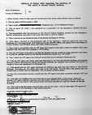  Click for full size document.  Tiffany Bible was a paramedic called to the Murrah Building following the bombing. This affidavit reports three important facts.  1. The ATF were not in the building.  2. That the ATF was already putting out a story that the Murrah Building was bombed "because of Waco" only a few hours after the actual blast and before Tim McVeigh was even arrested.  3. That an unexploded bomb was found attached to a gas line inside the building.  Arlene Blanchard Press Release  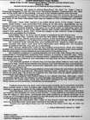  Click for full size document.  Arlene was a survivor of the bombing. In this press release, issued at the time of her grand jury appearance, she reveals that she was ordered to keep silent about what she knew of the bombing by the Army under threat of court martial.  DoD Atlantic Command Memo  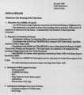  Clickfor full size document.  This memo, issued 24 hours after the bombing, reports at least two additional bombs were found in the Murrah Building.  FEMA Situation Report  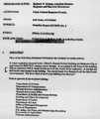  Click for full size document.  This FEMA memo also reports at least two additional bombs were found in the Murrah Building.  U.S. Forces Command Daily Log  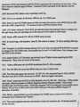  Click for full size document.  Again, confirmation of at least two additional bombs which were found in the Murrah Building.  Joe Harp affidavit  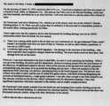  Click for full size document.  Joe Harp, based on his military explosives experience, refutes the ANFO claim and identifies the additional bombs he sees removed from the building as being military in nature.  Jane Graham Statement  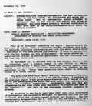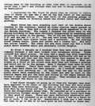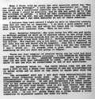  Click for full size documents.  This statement by a survivor tells of three men he saw in the Murrah Building Garage the week prior to the bombing, and the FBI's obvious disinterest in the matter.  Oklahoma Highway Patrol Radio Logs  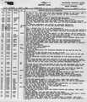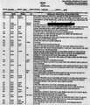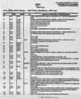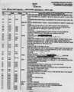  Click for full size documents.  These four pages are the radio log of the Oklahoma Highway Patrol.  Note that the reports of additional bombs are confirmed by the fire department. The suggestion that the bombs found in the Murrah Building were just practice bombs requires that the trained experts of the police and fire department bomb squads be too stupid to know real explosives from fake.  But it gets better. The trained experts of the police and fire department bomb squads used trained explosives sniffing dogs to locate those additional bombs, so not only did the devices found in the Murrah Building have to look enough like real bombs to fool the bomb squad, they had to SMELL LIKE REAL EXPLOSIVES TO THE BOMB SNIFFING DOGS!  Virgil Steele Affidavit  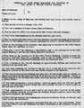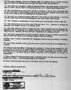  Click for full size document.  Virgil Steele is the elevator inspector who discovered that the story told by a senior BATF agent about being trapped in a plummeting elevator was a lie. The elevators were in working order except for being without power, and nobody had been trapped in them. Virgil also sees two additional bombs being removed from the building.  None of the above documents have been demonstrated to be fakes. One researcher who knows Joe Harp authenticated that affidavit and its contents.  CNN Broadcasts  CNN audio feed clips from the local news in Oklahoma City the morning just after the bomb went off.  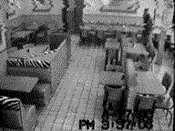  Video of Tim McVeigh from a security camera at McDonald's in Junction City, cited as proof that McVeigh did not rent the Ryder Truck.  "McVeigh had been filmed by a security camera at a nearby McDonald's 24 minutes before the time stamped on the rental agreement, wearing clothes that did not match either of the men seen at Elliott's. There is also no plausible explanation of how he traveled the mile and a quarter from McDonald's to the rental agency, carless and alone as he claims, without getting soaked in the rain. The three people interviewed agreed John Does 1 and 2 were dry.  According to Stephen Jones, who has seen the interview transcripts, it took 44 days for the FBI to convince the car rental agency owner that John Doe 1 was Timothy McVeigh. And in the end they did not dare put him on the witness stand, for fear of what might happen under cross-examination."  This might explain why the initial description of John Doe I circulated by the FBI referred to a man with "pock-marked skin, fairly stocky" who stood about 5'10", whereas McVeigh is about 6' 3" tall, thin as a rail (160 lbs) and has a smooth complexion."  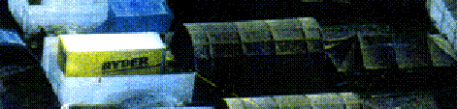  Click for information on the second Ryder truck in the secret base halfway from Elohim City to Oklahoma City.  The photos of the Ryder Tuck in the camp were authenticated as being what they appear to be, a Ryder truck in the secret camp, by the Oklahoma National Guard in an article appearing in the Washington Post, June 14th 1997. In the same article, the OKNG and Post attempted to distance the photos from the Murrah Bombing by claiming that the photos had not been taken in the spring of 1995 but the preceding autumn, a claim exposed as an obvious lie by close examination of the foliage.  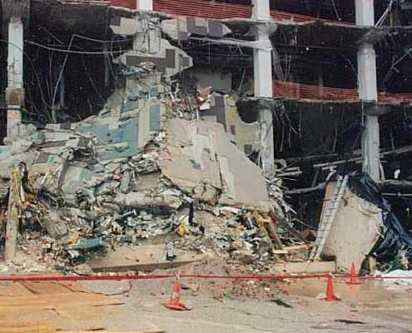  The photo above documents reports by several witnesses of the aftermath of the Murrah Bombing that portions of the building debris were wrapped in plastic to conceal them from view. A section of building beam, roughly 20 feet long to judge from the ladder near it, can be seen wrapped in new sheet plastic at the right edge of the photo.  Then you have all the recent articles and the "60 Minutes II" interviews with ex-agents admitting that the FBI was less than forthright with the evidence in the case. Plus the whistle blown by Frederick Whitehurst that the FBI's lab was playing fast and loose with the rules as well.  The important point is not to let the government huggers split up all the facts into tiny pieces that can be endlessly debated. It's easier for the huggers to win if they can argue about a single piece of information without having to deal with other facts that support it And the goal of the huggers is to tire you all out in endless arguments, to wear you down, to crush your spirit and blunt your anger.  Don't play the game their way. Gather together ALL the facts, the photos, the documents, the interviews, all of it, in one place, indeed in one notebook that you can show to your non-internet friends (and with Charles Key's report due out this week, any groundwork you lay now will be very effective in swaying public opinion). Keep all the evidence together in one informational "battering ram", with which to pound on the FBI's "Bastille gates". Emphasize that there is a preponderance of evidence in this affair that begs a full exposure of the inner secrets of the FBI.
  
  
  
  
  Money Making and
  Asset Protection

Home | The HOTT Shop | Hour of the Time | Advertising | Contact Us | Privacy Statement
© 1999-2001, Excel Studios Corporation S.A. All rights reserved.

