**The Medusa File II: The Politics of Terror and the Oklahoma City Bombing**

[July 24, 2019](https://jamesfetzer.org/2019/07/ralph-cinque-review-of-craig-roberts-the-medusa-file-ii-the-politics-of-terror-and-the-oklahoma-city-bombing/) [James Fetzer](https://jamesfetzer.org/author/reginald/)[blog](https://jamesfetzer.org/blog/)

[**Ralph Cinque**](http://oswaldinthedoorway.blogspot.com/2019/07/the-medusa-file-ii-politics-of-terror.html)

Medusa was a female monster from Greek mythology, and in his first Medusa book, Craig Roberts revealed crimes and cover-ups of the U.S. government, starting at 1940. I haven’t read it yet, but I’m glad he started at 1940 because there were plenty of U.S. crimes committed during World War II,  such as the nuclear bombing of two civilian population centers in Japan AFTER Japan had already agreed, in principle, to surrender.

I have read one other book on the OK City bombing, The Secret Life of Bill Clinton, by Ambrose Evans-Pritchard, about a third of which is devoted to OK City. And that book, like this one, points the blame, ultimately, to then President Bill Clinton.

It’s amazing how Craig got involved in the OK City investigation, and I mean that he was directly and officially involved.  He was sought by the FBI to investigate. At the time, he was a Tulsa police officer, a member of their SWAT team (after having been a Marine sharpshooter in Vietnam), and he was also a police helicopter pilot. But, the FBI official who called him actually cited his work in *Kill Zone (*one of Criag’s books on the JFK assassination) as the reason they wanted his investigative services.

But, that doesn’t make sense to me because any book that exonerates Oswald and establishes him as a framed patsy, as Craig’s book does, can’t be a friend to the FBI. So, I find it very strange that the FBI would go to Craig and work out a deal with his employer the Tulsa PD for him to spend part of his time investigating the OK City bombing. So, why did they do that?

To answer that, I have to sidetrack. You know that I maintain that Jack Ruby was innocent, that he did not shoot Oswald, that he showed up at the police garage much earlier than reported, that he was jumped and swifted up to the 5th floor jail where he was told that he shot Oswald. He didn’t know it before that. But, he believed them because he was enamored with the Dallas Police, and to an extreme degree. It is bizarre how adoring he was of them. It’s like he was programmed as in *The Manchurian Candidate.*Ruby had no memory of shooting Oswald and no intention or consciousness of doing it. Ever. IT’S BECAUSE HE DIDN’T DO IT. Jack Ruby was drugged, and I mean heavily drugged on November 24,  including with scopalmine, the “zombie drug”, and he looks like a zombie.  How could someone look like this after not only shooting somebody but completely destroying his own life? Look at his weird stare. That was pharmaceutically induced.

[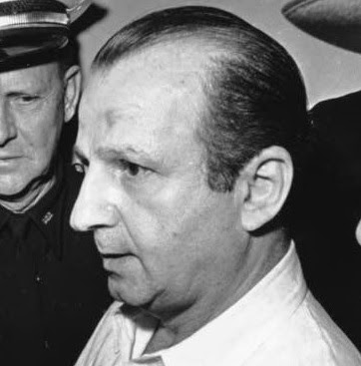](https://1.bp.blogspot.com/-Uc0RaU0P00Q/XTiM8EeLtrI/AAAAAAABJZ4/_We8v1GGk6w_Qm9cFErSJsvIfpPSuzC5ACLcBGAs/s1600/Ruby%2Bbust.jpg)

Jack Ruby was MK-ULTRA. He was tricked into going to the garage, first with the Karen Carlin ruse, which got him to the WU office. And then, all it took was the slightest urging, in the drug-induced, mentally-compliant state that he was in, for him to walk down to the police ramp and then down the ramp (no doubt nudged further by the Ops who were there) to the awaiting ambush, and that was about 10:15. And hour later came the televised spectacle, which was all an act, with FBI Agent James Bookhout playing the role of Jack Ruby. The Dallas Police and FBI killed Oswald afterwards, but exactly where and how I don’t know. But, Oswald did die on the operating table at Parkland Hospital.

But, they knew ahead of time that some people were not going to accept the official story of another lone-nut assassin. And, they wanted to make sure those people didn’t get anywhere near the truth of Ruby’s innocence. So, they wrote their own backstory for Ruby,  claiming that he was a Mafioso, a hit man, a gun runner, a pimp, a guy who loved to throw people down stairs and did it often, etc. etc.

There is a whole narrative for Jack Ruby that is complete, total, utter bull shit, and he said so himself. And remember that he accepted that he shot Oswald and was heading for the electric chair for it . So, why would he lie about having been a gunrunner, a Mafioso, an undercover agent for Richard Nixon, or any of the other wild claims that are made about him?  He wouldn’t. He couldn’t. He didn’t. It’s all a smokescreen.

Well, the same thing happened in OK City. They wanted to establish Timothy McVeigh and Terry Nichols as the two lone nuts, three if you count Michael Fortiere, but the plan was to keep the conspiracy crowd busy dwelling on militia groups, particularly the one in Elohim City, Oklahoma, to which McVeigh supposedly had ties.  But, as Craig said himself, those militia people would have been more likely to defend the Murrah Building than blow it up. I think the FBI sought Craig because he was a noteable truthdigger who happened to be a police officer, and they pointed him to the Elohim City enclave as a diversion.

It was noise. But, Craig is a very bright guy, and he quickly figured it out. Do you remember in *Butch Cassidy and the Sundance Kid*, when they ditched one of their horses to make it look like they split up, and the elite lawmen following them were briefly fooled by it but quickly saw through it? Well, that’s what happened here, and the elite lawman in this case was Craig Roberts, and he found no ties for McVeigh to militia groups other than him having gone to a  rally uninvited.

So, what did Craig find? He found that many witnesses were being ignored, including those who saw two men get out of the Ryder truck; witnesses who reported seeing suspicious men who looked Middle Eastern at the scene, for instance, a witness reported seeing McVeigh with a Middle Eastern man with a tattoo on his arm of Saddam Hussein’s Republican Guard, later identified as Husseini al Hussein; a total of 5 witnesses saw McVeigh in the Ryder truck with a Middle Eastern man with black curly hair; witnesses who said that the bombing smelled of sulfur rather than ammonium, as a fertilizer bomb would smell. No one reported smelling ammonium.

There were a lot of cut columns and cut rebar. How could an oil-soaked fertilizer bomb do that?- Craig asked. And it was apparent that the building was blown outward, not inward. And did you know that the building was designed to be bomb-proof from outside explosives?

The bottom line was that there were bombs in the building. Oil-soaked fertilizer in the back of a Ryder truck could not do this:

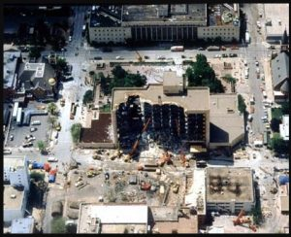

Craig cited the numerous reports of multiple and sequential bombs going off, and of course that is similar to 9/11 where victims and firefighters reported a sequence of explosions prior to collapse.

Then, there was the weird action of hustling files and records out of the building before they would allow rescue workers in. They actually delayed getting aid to victims in order to get records out. This was when lives were at stake. One has to wonder if some of the dead could have been saved if not for this delay. Just to be clear: rescue workers had to sit on their hands waiting for files to be removed from the building before they could go in and search for wounded, trapped people.

Two seismic events were reported by the Oklahoma Seismic Center, and Craig says that the tape, which he saw, actually showed 3.  Did you know that, initially, it was said to be a standard Ryder  truck, but later it became a larger box-truck for a growing quantity of fertilizer?   Craig pointed out that the ammonium that people didn’t smell would have been a serious and potentially fatal choking hazard.

Craig made a list of incongruities, including: Ryder truck full of fertilizer could not have caused the damage; the crater was too small, only 8 to 12 feet across; damage to the building and cut columns and rebar means there were shaped charges or plastic explosives on the columns; the building was quickly demolished, hauled off, and buried; all video tapes immediately seized and rendered classified; police and firefighters reported that they saw federal agents removing “unexploded devices” from the building;  Bomb expert General Benton Partin said that the asymmetrical damage could not have resulted from a truck bomb, that explosives had to be placed on columns at 4 critical junctions, was barred from the investigation; Jane  Graham who saw two government workers puttying something to the columns in the parking garage two days before not allowed to testify.

Even Governor Frank Keating first said that other devices were found in the building, until that story became inoperative.

Then,  there  were the strange, untimely deaths, and the list is about as long as with JFK, and realize that Craig wrote a book on the suspicious deaths in that case.  Sergeant Terrance Yeakey of the OK City PD was one of the first officers on the scene, and he said the official story was bull shit. He was found dead a year later with 11 lacerations and a small gunshot  wound to the right temple from a silenced weapon, and it was ruled a suicide. He had a young family. He was devoted to them. He never would have killed himself. The man was traumatized, battered, with damage to his face and head.  And I’ll point out that he was African-American.

I won’t go into them individually; you’ll have to read the book; but here are some other dead Murrah bombing witnesses: Mike Loudenslager, Dr. Don Chamley, Glenn Wilburn, Ted Richardson, Alan G. Whicher, Gary Webb, Joey Gladden, Mark Anthony  Finnigin, and Michael Abbot.

Craig has a whole chapter on why it’s likely that McVeigh was a “Manchurian Candidate” and it is fascinating.  Do you know who they sent to treat McVeigh? It was Dr. Louis Joylan West! The same efffin’ CIA doctor, the “Maestro of Mind Control” whom they sent to treat Jack Ruby!

You are going to have to read the book to find out all that Craig uncovered about this, but I will tell you that I suspected as much before I read the book, and it was from McVeigh’s interview with Ed Bradley. I could tell immediately that McVeigh was not of right mind, that he was not in touch with reality, that he was delusional.

So, what’s the bottom line? Where does the buck stop in this case? Craig says it goes to and stops on William Jefferson Clinton. And those records and files being swifted out of the building? Craig says they were related to the CIA Mena, Arkansas drug running operation, which reportedly done with the knowledge of and involvement of then Arkansas Governor Bill Clinton. Those files were moved to the Murrah Building in Oklahoma, and that’s why that building was chosen to be the target, says Craig.

So, it looks like Timothy McVeigh was another in a long line of Manchurian Candidate pseudo-assassins, including Jack Ruby, Sirhan Sirhan, James Earl Ray, Mark David Chapman, John Hinckley, but do you who know who was not a Manchurian Candidate? Lee Harvey Oswald. Oswald was of sound mind, and he did a lot of damage while in custody those last two days of his life. Shit yes.

The book, *The Medusa File II, The Politics of Terror and The Oklahoma City Bombing* (2017) by Craig Roberts is great. It is thorough, well reasoned, and also very well written. And it will scare the shit out of you about what went down. God damn it, are they going to come after me next? For the record, I would never, ever, ever, ever, ever, ever, ever commit suicide.

Craig is an amazing guy, and he should write his life story before he passes from this world because he has lived an amazing life. This book is illuminating, and it is important for our time. That things like this can happen in our world is frightening.

Here is [the link to the book on Amazon](https://www.amazon.com/Medusa-File-II-Politics-Oklahoma/dp/1547027843/ref=sr_1_2?keywords=The+Medusa+Files+II+Craig+Roberts&qid=1563991358&s=gateway&sr=8-2):

[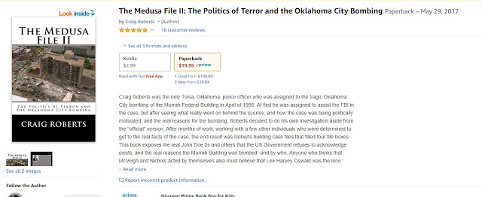](https://1.bp.blogspot.com/-MD3B5SDFt4s/XTidySsImLI/AAAAAAABJaE/qLntOiUA8gcScLRo5ij6kdR0qS0TatwMgCLcBGAs/s1600/MFII.jpg)