Michael Francis Moore 1954-
http://en.wikipedia.org/wiki/Michael_Moore
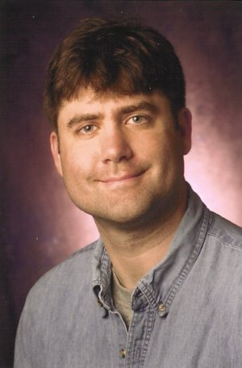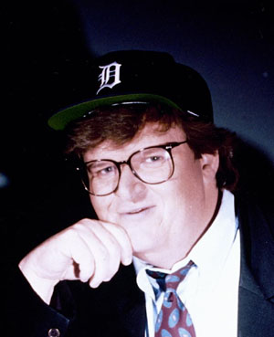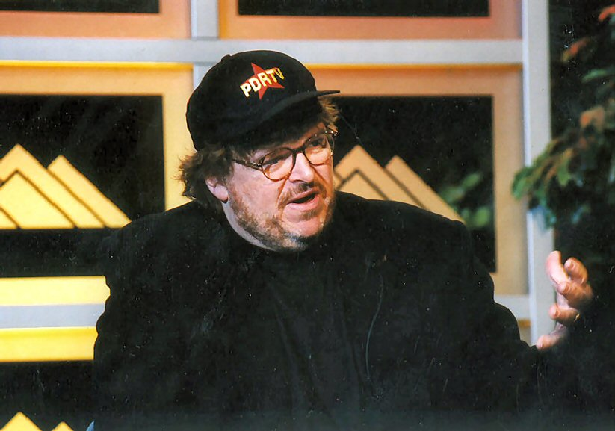

Michael Francis Moore (born April 23, 1954) is an American film director, author and political activist known for his outspoken, critical views on globalization, large corporations, gun violence, the Iraq War, the United States, and President George W. Bush.

Contents
[hide]
- 1 Early life
- 2 Directing
  - 2.1 Films and awards
  - 2.2 Television shows
  - 2.3 Music videos
  - 2.4 Appearances in other documentaries
- 3 Writings and political views
- 4 Controversy and criticism
- 5 His published work
  - 5.1 List of books
  - 5.2 List of films
  - 5.3 List of TV series
- 6 References
- 7 External links
  - 7.1 Current events (unofficial sites)
  - 7.2 General criticism & responses
  - 7.3 Other
  - 7.4 News features

Early life
Born in Flint, Michigan, Michael Moore grew up in the city of Davison. At the time the neighboring city of Flint was home to many General Motors factories, where his mother was a secretary, and both his father and grandfather were auto workers. His uncle was one of the founders of the United Automobile Workers labor union and participated in the famous Flint Sit-Down Strike.
Moore, an Irish American, was brought up Roman Catholic and attended a Diocesan seminary at age 14. He then attended Davison High School, where he was active in both drama and debate,^{[1]} graduating in 1972. That same year, he ran for and won a seat on the Davison school board on a platform based on firing the high school's principal, John B McKenna, and vice principal, Kanje Cohen. By the end of his term both had resigned.
Moore is also an Eagle Scout, the highest rank awarded by the Boy Scouts of America, and an achievement of which he is still very proud. For his Eagle Project, he filmed a documentary pointing out various safety hazards in his community.
After dropping out of the University of Michigan-Flint (where he wrote for the student newspaper The Michigan Times) and working for a day at the General Motors plant,^{[2]} at 22 he founded the alternative weekly magazine The Flint Voice, which soon changed its name to The Michigan Voice. In 1986, when Moore became the editor of Mother Jones, a liberal political magazine, he moved to California and The Michigan Voice was shut down. In 2003, the Star-Ledger printed an opinion piece by Paul Mulshine, where he quoted Paul Berman, who stated that Moore had been fired following a series of clashes with people on the magazine's staff, including a dispute over Moore's refusal to publish an article by Berman that was critical of the Sandinistas' human rights record. Before Moore's arrival, the magazine had commissioned the article.^{[3]} Moore later sued for wrongful dismissal, seeking $2 million. He finally accepted a settlement of $58,000 — the amount of anticipated trial costs — from the magazine's insurance company. Some of this money provided partial funding for his first film project, Roger and Me.
Moore has been married to producer Kathleen Glynn (born April 10, 1958 in Flint) since 1990. They now live in New York City. Natalie (born 1981) is Michael's stepdaughter. He has no other children.
He has also dabbled in acting, following a 2000 supporting role in Lucky Numbers as the cousin of Lisa Kudrow's character, who agrees to be part of the scheme concocted by John Travolta's character.
Currently Moore leads Michigan's annual Traverse City Film Fest, which is also the location of the State Theater, a classic venue that Moore (as of 2006) has been attempting to purchase.

Directing

Films and awards
- Roger & Me: Moore first became famous for his controversial 1989 film, Roger & Me, a documentary about what happened to Flint, Michigan after General Motors closed its factories and opened new ones in Mexico, where the workers were paid much less. Since then Moore has been known as a critic of the neoliberal view of globalization. "Roger" is Roger B. Smith, former CEO and president of General Motors. Moore was largely taught the craft of film making by his cinematographer Kevin Rafferty, who is ironically also a first cousin of President George W. Bush. The influence of Rafferty, who co-directed the 1982 cult classic documentary film The Atomic Café, can be seen in Moore's satirical use of archival footage taken from vintage B-movies, television commercials, and newsreels that has since become a hallmark of his documentaries.
- Canadian Bacon: In 1995, Moore released a satirical film, Canadian Bacon, which features a fictional US president (played by Alan Alda) engineering a fake war with Canada in order to boost his popularity. It is noted for containing a number of Canadian and American stereotypes, and for being Moore's only non-documentary film. The film is also the last featuring Canadian-born actor John Candy, and also features a number of cameos by other Canadian actors. It should be mentioned that in the film several potential enemies for America's next great campaign are discussed by the president and his cabinet (the scene was strongly influenced by the Kubrick film, Dr. Strangelove). His military adviser (played by Rip Torn) quickly rebuffs this idea, saying that no one would care about "...a bunch of guys driving around blowing up rent-a-cars".
- The Big One: In 1997, Moore directed The Big One, which documents the tour publicizing his book Downsize This! Random Threats from an Unarmed American, where he criticizes mass layoffs despite record corporate profits. Among others, he targets Nike for outsourcing shoe production to Indonesia.
- Bowling for Columbine: Moore's 2002 film, Bowling for Columbine, probes the culture of guns and violence in the United States, taking as a starting point the Columbine High School massacre of 1999. Bowling for Columbine won the Anniversary Prize at the Cannes Film Festival and France's Cesar Award as the Best Foreign Film. In the United States, it won the 2002 Academy Award for Documentary Feature. It also enjoyed great commercial and critical success for a film of its type and became, at the time, the highest-grossing mainstream-released documentary (a record later held by Moore's Fahrenheit 9/11). It was praised by some for illuminating a subject slighted by the mainstream media, but it was attacked by others who claim it is inaccurate and misleading in its presentations and suggested interpretations of events.
- Fahrenheit 9/11: Fahrenheit 9/11 examines America in the aftermath of the September 11, 2001 attacks, particularly the record of the Bush administration and alleged links between the families of George W. Bush and Osama bin Laden. Fahrenheit was awarded the Palme d'Or, the top honor at the Cannes Film Festival; it was the first documentary film to win the prize since 1956. Moore later announced that Fahrenheit 9/11 would not be in consideration for the 2005 Academy Award for Documentary Feature, but instead for the Academy Award for Best Picture. He stated he wanted the movie to be seen by a few million more people, preferably on television, by election day. Since November 2 was less than nine months after the film's release, it would be disqualified for the Documentary Oscar. Moore also said he wanted to be supportive of his "teammates in non-fiction film." However, Fahrenheit received no Oscar nomination for Best Picture. The title of the film alludes to the classic book Fahrenheit 451 about a future totalitarian state in which books are banned; according to the book, paper begins to burn at 451 degrees Fahrenheit. The pre-release subtitle of the film confirms the allusion: "The temperature at which freedom burns." At the box office, Fahrenheit 9/11 remains the highest-grossing documentary of all time, taking in close to $200 million worldwide, including United States box office revenue of $120 million.
- Sicko (filming): Moore is currently working on a film about the American health care system from the viewpoint of mental health care, focusing particularly on the managed-care and pharmaceutical industries, under the working title Sicko. At least four major pharmaceutical companies, Pfizer, Eli Lilly and Company, AstraZeneca and GlaxoSmithKline, have ordered their employees not to grant any interviews to Moore.^{[4][5][6]} According to Moore on a letter at his website, "roads that often surprise us and lead us to new ideas -- and challenge us to reconsider the ones we began with" have caused some minor delays, and the film is set to be released sometime in 2007.^{[7]}
- Fahrenheit 9/11½ (pre-production): On November 11, 2004 Moore told the Hollywood trade publication Daily Variety that he is also planning a sequel to Fahrenheit 9/11. He said, "Fifty-one percent of the American people lacked information in this election, and we want to educate and enlighten them. They weren't told the truth. We're communicators, and it's up to us to start doing it now."^{[8]} The sequel, like the original, will concern the war in Iraq and terrorism. Moore expects to complete Fahrenheit 9/11½ in 2007 or 2008.

Television shows
Between 1994 and 1995, he directed and hosted the television series TV Nation, which followed the format of news magazine shows but covered topics they avoid. The series was aired on NBC in 1994 for 9 episodes and again for 8 episodes on FOX in 1995.
His other major series was The Awful Truth, which satirized actions by big corporations and politicians. It aired on Channel 4 in the UK, and the Bravo network in the US, in 1999 and 2000.
Another 1999 series, Michael Moore Live, was aired in the UK only on Channel 4, though it was broadcast from New York. This show had a similar format to The Awful Truth, but also incorporated phone-ins and a live stunt each week. The show was performed around midday local time, which due to the time difference made it a late-night show in the UK.
In 1999 Moore won the Hugh M. Hefner First Amendment Award in Arts and Entertainment, for being the executive producer and host of The Awful Truth, where he was also described as "muckraker, author and documentary filmmaker."

Music videos
Moore has directed several music videos, including two for Rage Against the Machine for songs from "The Battle of Los Angeles": "Sleep Now in the Fire" and "Testify". He was threatened with arrest during the shooting of "Sleep Now in the Fire", which was filmed on Wall Street; the city of New York had denied the band permission to play there, although the band and Moore had secured a federal permit to perform.^{[9]}
He also directed the music videos for System of a Down's "Boom!" and "All the Way to Reno (You're Gonna Be a Star)" by R.E.M..

Appearances in other documentaries
- Moore appeared as an interviewer in 1991's Blood in the Face, a documentary about white supremacy groups. The film centers around a neo-Nazis gathering in Michigan.
- Michael Moore's brief appearance in Alex Jones's Martial Law: 9/11 Rise of the Police State, Alex Jones prompts Michael Moore for an answer as to why he did not mention any of the real issues about the September 11, 2001 attacks in his film Fahrenheit 9/11. Specifically, why Michael Moore did not mention why NORAD stood down. Michael Moore's reply was simply, "Because it would be Un-American."
- Moore appeared in the documentary The Yes Men, a documentary about two men who pose as the World Trade Organization. He appears during a segment concerning working conditions in Mexico and Latin America.
- Moore was also interviewed for the 2004 documentary, The Corporation. One of his highlighted quotes was, "The problem is the profit motive: for corporations, there's no such thing as 'enough'."^{[10]}
- Moore appeared in the 2006 documentary I'm Going to Tell You a Secret, which chronicles Madonna during her 2004 Re-Invention World Tour. Moore attended her show in New York City at Madison Square Garden.

Writings and political views
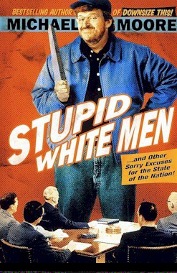
Michael Moore, pictured on the cover of one of his three best-selling books, Stupid White Men.

Moore has authored three best-selling books:
- Downsize This! (1996), about politics and corporate crime in the United States,
- Stupid White Men (2001), ostensibly a critique of American domestic and foreign policy but, by Moore's own admission, "a book of political humor,"^{[11]} and
- Dude, Where's My Country? (2003), an examination of the Bush family's relationships with Saudi royalty, the Bin Laden family, and the energy industry, and a call-to-action for progressives in the 2004 election.
After Moore's departure from Mother Jones, he became an employee of Ralph Nader. He left Nader's employment on bad terms, but Moore vociferously supported Nader's campaign for the United States presidency in 2000.
In exchange for jumping in the shows "traveling mosh pit," Republican Alan Keyes won the endorsement of Moore's television series The Awful Truth in 2000, although Moore does not endorse Keyes' views.
Moore became a lifetime member of the National Rifle Association upon winning an NRA tournament as a youth.^{[citation needed]}
In the 2004 election, Moore urged Nader not to run, despite having supported him in 2000, so as not to split the progressive vote. (Moore joined Bill Maher on the latter's television show in kneeling before Nader to plead with him to stay out of the race.) In June 2004, Moore claimed he is not a member of the Democratic party (although he registered as a Democrat in 1992 [1]). Although Moore endorsed General Wesley Clark for the Democratic nomination on January 14, Clark withdrew from the primary race on February 11. Moore drew attention when charging publicly that Bush was AWOL during his service in the National Guard (see George W. Bush military service controversy). Also, during an October 27 stop in Portland, OR, Moore called the private phone number of radio host Lars Larson, given to him by a member of the audience.
Moore was a high-profile guest at the 2004 Democratic National Convention, prominently seated in a box with former President Jimmy Carter and his wife. Moore also attended the 2004 Republican National Convention, (for a daily column chronicling his impressions of the convention in USA Today), where he was criticized in a speech by Republican Senator John McCain as "a disingenuous film-maker". Moore smiled and waved as people in the audience jeered at him after this comment but there was no bad behavior from either side.
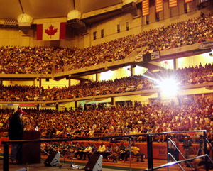
Michael Moore speaks in the Carrier Dome at Syracuse University

During September and October 2004, Moore spoke at universities and colleges in swing states during his "Slacker Uprising Tour". The tour gave away ramen and underwear to young people who promised to vote. This provoked public denunciations from the Michigan Republican Party and attempts to convince the government that Moore should be arrested for buying votes, but since Moore did not tell the 'slackers' involved for whom to vote, just to vote, district attorneys refused to get involved. The "Underwear" tour was a popular success. Large numbers of young adults registered to vote, and by a strong percentage voted for John Kerry (Kerry 54%, Bush 44%). Nonetheless, the generally increased turnout in the election ensured that the percentage of youth voting was little different than in 2000, albeit at a higher numerical level. John Kerry eventually won the state of Michigan by 3%.
Quite possibly the most controversial stop during the tour was Utah Valley State College in Orem, Utah. A fight for his right to speak ensued and resulted in massive public debates and a media blitz. Death threats, bribes and lawsuits followed. The event was chronicled in the documentary film This Divided State.^{[12]}
With the 2004 election over, Moore continues to collect information on the war in Iraq and the Bush administration in addition to his film projects. In 2006, Moore has also been involved in a email campaign regarding the 2006 United States midterm elections to draft up support for the Democrats.

Controversy and criticism
Moore has been the subject of some controversy and criticism. See Michael Moore controversies.

His published work

List of books
- Moore, Michael (1996). Downsize This! Random Threats from an Unarmed American. Perennial (Harper Edition). ISBN 0-06-097733-7.
- Moore, Michael; & Glynn, Kathleen (1998). Adventures In A TV Nation. Perennial. ISBN 0-06-098809-6.
- Moore, Michael (2002). Stupid White Men ...and Other Sorry Excuses for the State of the Nation!. Regan Books. ISBN 0-06-039245-2.
- Moore, Michael (2003). Dude, Where's My Country?. Warner Books. ISBN 0-446-53223-1.
- Moore, Michael (2004). Will They Ever Trust Us Again?. Simon & Schuster. ISBN 0-7432-7152-1.
- Moore, Michael (2004). The Official Fahrenheit 9/11 Reader. Simon & Schuster. ISBN 0-7432-7292-7.

List of films
- Roger & Me (1989)
- Pets or Meat: The Return to Flint (1992) (TV)
- Canadian Bacon (1995)
- The Big One (1997)
- And Justice for All (1998)
- Lucky Numbers (2000)
- Bowling for Columbine (2002)
- Fahrenheit 9/11 (2004) "Palme d'Or" in Cannes
- Sicko (projected for June 2007)
- Fahrenheit 9/11½ (projected for 2008)

List of TV series
- TV Nation (1994)
- The Awful Truth (1999)
- Michael Moore Live (1999)

References
- ^ Gary Strauss (June 20, 2004). The truth about Michael Moore. USA Today. Retrieved on July 8, 2006.
- ^ Ron Sheldon (September 23, 1995). Exclusive Interview with Michael Moore of TV Nation. People's Weekly World.
- ^ Paul Mulshine (March 30, 2003). A stupid white man and a smart one. The Star-Ledger.
- ^ The Philadelphia Inquirer: Inqlings | Michael Moore takes on Glaxo. Michael Klein, 30 September 2005. Archive accessed 9 July 2006.
- ^ Common Dreams News Center: Drug Firms are on the Defense as Filmmaker Michael Moore Plans to Dissect Their Industry. Original Article - Elaine Dutka, L.A. Times, December 22, 2004. Archive accessed August 09, 2006
- ^ Chicago Tribune: Michael Moore turns camera onto health care industry. Bruce Japsen, 3 October 2004. Archive accessed 9 July 2006.
- ^ MichaelMoore.com: An Update from Michael Moore (and an invitation to his film festival). Michael Moore, 7 July 2006. URL accessed 9 July 2006.
- ^ Variety: Get ready for more Moore. Army Archerd, 10 November 2004. URL accessed 9 July 2006.
- ^ Green Left Weekly: Rage against Wall Street. Michael Moore, via MichaelMoore.com, date unspecified. URL accessed 9 July 2006.
- ^ Who's Who. The Corporation Film.
- ^ Opinion Journal from the Wall Street Journal: Unmoored from Reality. John Fund's Political Diary, 21 March 2003. URL accessed 29 August 2006.
- ^ This Divided State official website. Accessed 9 July 2006.

External links
- Michael Moore Official site, includes mailing list and news
- Fahrenheit 9/11 Official site, with links to reviews, trailers and library resources
- Michael Moore at the Internet Movie Database
- Michael Moore Biography at Greater Talent Network (Speakers Bureau)

Current events (unofficial sites)
- Michael Moore Online A fan site with news, video and discussion forum

General criticism & responses
- One Man, Two Registrations by The Smoking Gun
- Critics seize upon faulty report of Moore's supposed dual voter registrations by Media Matters
- Sometimes Moore Is Less by Tim Blair
- Michael Moore, Humbug by Kay Hymowitz
- Hey Michael, Where’s Your Past? by Ralph Nader
- I'm With Stupid by Marco Roth
- Michael Moore Hates America movie site

Other
- Michael Moore on the corporate media Google video

News features
- "Moore Wins Bowling Round" in E! News, February 21, 2007
- "U.S. soldier loses Fahrenheit 9/11 film claim" in BBC News, December 22, 2006
- "Michael Moore previews new film 'Sicko'" in New Zealand Herald, September 27, 2006
- "Michael Moore dissects health-care system" in Courier-Journal., September 17, 2006
- "Michael Moore to Borat's rescue" in The Globe and Mail, September 9, 2006

===============================================================================================================================
END

