Brian Tracy 1944-
http://en.wikipedia.org/wiki/Brian_Tracy
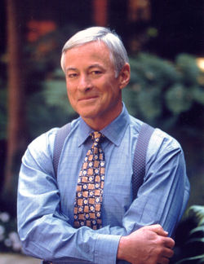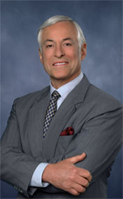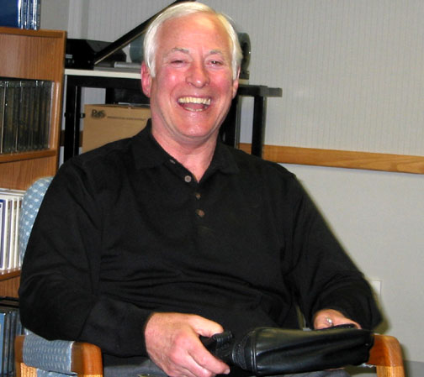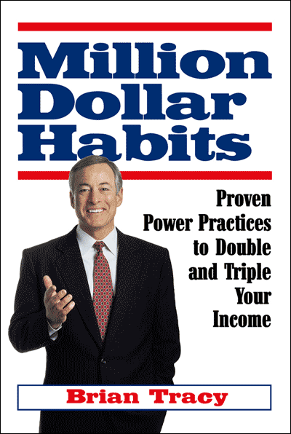

Brian Tracy (born in Canada in 1944) is a self-help author who has recorded many of his works as audio books. His talks and seminar topics include leadership, sales, managerial effectiveness, and business strategy.
Tracy has a B.Comm., M.A. and is the Chairman of Brian Tracy International, a human resource company based in San Diego, California, with affiliates throughout the United States, and in thirty-one other countries.
The Brian Tracy College of Management and Entrepreneurship at Andrew Jackson University is named after him.

Contents
- 1 Quotes
- 2 See also
- 3 Books
- 4 External links

Quotes
"Perhaps one of the greatest discoveries in history is this simple truth: you become that which you think about most of the time. No one is smarter than you, no one is better than you, no one has more inborn talent than you. But successful people, at one point or another, set their minds on becoming that which they have now become."
"The sad fact is that people are poor because they have not yet decided to be rich. People are overweight and unfit because they have not yet decided to be thin and fit. People are inefficient time wasters because they haven't yet decided to be highly productive in everything they do."
"The solution to the problems of marriage and parenting is simple. Spend more time with the people you care about the most"

See also
- time management

Books
- Focal Point (2001) American Management Association ISBN 0-8144-7278-8
- Time Power: A Proven System for Getting More Done in Less Time Than You Ever Thought Possible (2004) American Management Association ISBN 0-8144-7247-8
- Something for Nothing : The All-Consuming Desire that Turns the American Dream into a Social Nightmare (2005) ISBN 1-59555-038-0
- The Power of Charm: How to Win Anyone over in Any Situation (2006) American Management Association ISBN 0-8144-7357-1
- Eat that Frog: 21 Ways to stop Procrastination and get More Done in Less Time (2001) ISBN 1-58376-202-7
- Get Paid More and Promoted Faster (2001) ISBN 1-58376-207-8
- Victory!: Applying the Proven Principles of Military Strategy to Achieve Success in Your Business and Personal Life(2002) ISBN 0-8144-0750-1
- Turbostrategy: 21 Powerful Ways to Transform your Business and Boost Your Profits Quickly (2003) ISBN 0-8144-7193-5
- Getting Rich Your Own Way: Achieve All Your Financial Goals Faster Than You Ever Thought Possible (2004) ISBN 0-471-65264-4
- Create Your Own Future: How to Master the 12 Critical Factors of Unlimited Success (2002) ISBN 0-471-25107-0
- Be a Sales Superstar: 21 Great Ways to Sell More, Faster, Easier in Tough Markets (2002) ISBN 1-57675-175-9
- Advanced Selling Strategies: The Proven System of Sales Ideas, Methods, and Techniques Used by Top Salespeople Everywhere (1995) ISBN 0-684-82474-4
- The 100 Absolutely Unbreakable Laws of Business Success (2000) ISBN 1-57675-126-0
- The 21 Success Secrets of Self-Made Millionaires: How to Achieve Financial Independence Faster and Easier Than You Ever Thought Possible (2001) ISBN 1-58376-205-1
- Maximum Achievement: Strategies and Skills That Will Unlock Your Hidden Powers to Succeed (1993) ISBN 0-671-86518-8

External links
- Official site
Retrieved from "http://en.wikipedia.org/wiki/Brian_Tracy"
Categories: 1944 births | American non-fiction writers | Canadian non-fiction writers | Self-help writers | Living people
=======================================================================================================================================
END

