THE ALHAMBRA DECREE 31 MARCH 1492
ROYAL EDICT OF THE KING AND QUEEN OF SPAIN
EXPELLING THE JEWS FROM SPAIN
http://www.jrbooksonline.com/ALHAMBRA_DECREE.htm

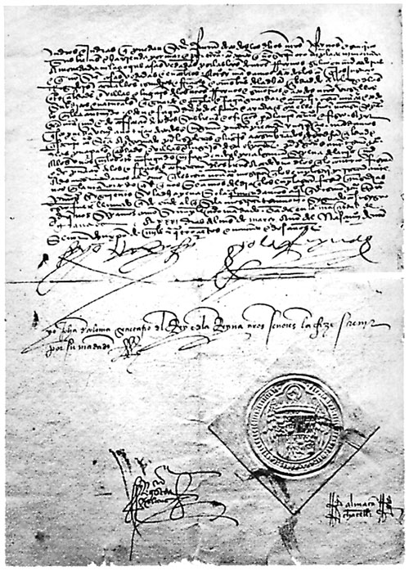
King Ferdinand and Queen Isabella, by the grace of God, King and Queen of Castile, Leon, Aragon and other dominions of the crown — to the prince Juan, to dukes, marquees, counts, the holy orders, priors, knight commanders, lords of the castles, cavaliers, and to all Jews, men and women of whatever age, and to anyone else this letter may concern — health and grace unto you.
You well know that in our dominion, there are certain bad Christians that judaised and committed apostasy against our Holy Catholic faith, much of it in the course of communications between Jews and Christians. Therefore, in the year 1480, we ordered that the Jews be separated from the cities and towns of our domains and that they be given separate quarters, hoping that by such separation the situation would be remedied. And we ordered that an Inquisition be established in such domains; and in the twelve years it has functioned, the Inquisition has found many guilty persons.
Furthermore, we are informed by the Inquisition and others that the great harm done to the Christians persists, and it continues because of the conversations and communications that they have with the Jews, such Jews trying by whatever manner to subvert our Holy Catholic faith and trying to draw faithful Christians away from their beliefs.
These Jews instruct these Christians in the ceremonies and observances of their Law, circumcising their children, and giving them books with which to pray, and declaring unto them the days of fasting, and meeting with them to teach them the histories of their Law, notifying them when to expect Passover and how to observe it, giving them the unleavened bread and ceremonially prepared meats, and instructing them in things from which they should abstain, both with regard to food items and other things requiring observances of their Law of Moses, making them understand that there is no other law or truth besides it.
All of which then is clear that, on the basis of confessions from such Jews as well as those perverted by them, that it has resulted in great damage and detriment of our Holy Catholic faith. And because we knew that the true remedy of such damages and difficulties lay in the severing of all communications between the said Jews with the Christians and in sending them forth from all our reigns, we sought to content ourselves with ordering the said Jews from all the cities and villages and places of Andalusia where it appeared that they had done major damage, believing that this would suffice so that those from other cities and villages and places in our reigns and holdings would cease to commit the aforesaid. And because we have been informed that neither this, nor the justices done for some of the said Jews found very culpable in the said crimes and transgressions against our Holy Catholic faith, has been a complete remedy to obviate and to correct such opprobrium and offense to the Christian faith and religion; because every day it appears that the said Jews increase in continuing their evil and harmful purposes wherever they reside and converse; and because there is no place left whereby to more offend our holy faith, as much as those which God has protected to this day as in those already affected, it is left for this Holy Mother Church to mend and reduce the matter to its previous state inasmuch as, because of our frailty of humanity, it could occur that we could succumb to the diabolical temptation that continually wars against us so easily if its principal cause were not removed, which would be to expel the said Jews from the kingdom. Because whenever a grave and detestable crime is committed by some members of a given group, it is reasonable that the group be dissolved or annihilated, the minors for the majors being punished one for the other; and that those who pervert the good and honest living on the cities and villages and who by their contagion could harm others, be expelled from the midst of the people, still yet for other minor causes, that would be of harm to the Republic, and all the more so for the major of these crimes, dangerous and contagious as it is.
Therefore, with the council and advice of the eminent men and cavaliers of our reign, and of other persons of knowledge and conscience of our Supreme Council, after much deliberation, it is agreed and resolved that all Jews and Jewesses be ordered to leave our kingdoms, and that they never be allowed to return.
And we further order in this edict that all Jews and Jewesses of whatever age that reside in our domain and territories, that they leave with their sons and daughters, their servants and relatives, large and small, of whatever age, by the end of July of this year, and that they dare not return to our lands, not so much as to take a step on them nor trespass upon them in any other manner whatsoever. Any Jew who does not comply with this edict and is to be found in our kingdom and domains, or who returns to the kingdom in any manner, will incur punishment by death and confiscation of all their belongings.
We further order that no person in our kingdom of whatever station or noble status hide or keep or defend any Jew or Jewess, either publicly or secretly, from the end of July onwards, in their homes or elsewhere in our reign, upon punishment of loss of their belongings, vassals, fortresses, and hereditary privileges. So that the said Jews may dispose of their household and belongings in the given time period, for the present we provide our assurance of royal protection and security so that, until the end of the month of July, they may sell and exchange their belongings and furniture and other items, and to dispose of them freely as they wish; and that during said time, no one is to do them harm or injury or injustice to their persons or to their goods, which is contrary to justice, and which shall incur the punishment that befalls those who violate our royal security.
Thus we grant permission to the said Jews and Jewesses to take their goods and belongings out of our reigns, either by sea or by land, with the condition that they not take out either gold or silver or minted money or any other items prohibited by the laws of the kingdom.
Therefore, we order all councilors, justices, magistrates, cavaliers, shield-bearers, officials, good men of the city of Burgos and of other cities and villages of our reigns and dominions, and all our vassals and subjects, that they observe and comply with this letter and all that is contained in it, and that they give all the help and favor that is necessary for its execution, subject to punishment by our sovereign grace and by confiscation of all their goods and offices for our royal state house.
And so that this may come to the notice of all, and so that no one may pretend ignorance, we order that this edict be proclaimed in all the plazas and usual meeting places of any given city; and that in the major cities and villages of the diocese, that it be done by the town crier in the presence of the public scribe, and that neither one nor the other should do the contrary of what was desired, subject to the punishment by our sovereign grace and deprivation of their offices and by confiscation of their goods to whosoever does the contrary.
And we further order that evidence be provided to the court, in the manner of signed testimony, regarding the manner in which the edict is being carried out.
Given in this city of Granada on the thirty-first day of March in the year of our Lord Jesus Christ — 1492. Signed, I, the King, I, the Queen, Juan de Coloma, Secretary of the King and Queen, which I have written by order of our Majesties.

