
Birth to 1990's
http://www.zundelsite.org/english/zundel_life_in_pics/index.html

Contact the Zundelsite
3152 Parkway #13, PMB109,
Pigeon Forge, TN,
37863, USA.
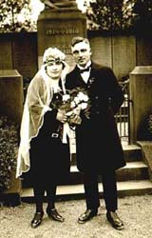  Ernst parents on their wedding day | 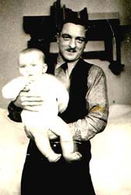  Ernst in the arms of his proud father - 1939
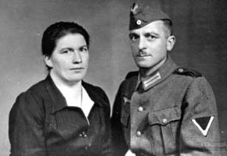  Zundel parents in 1944 | 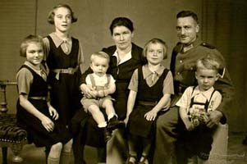  Zundel family - 1944
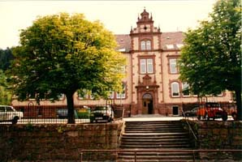  The schoolhouse where Ernst learned the three R's | 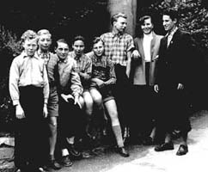  Ernst Zundel attending trade school age 14
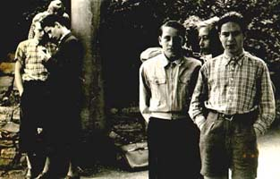  Zundel in trade school - 1954 | 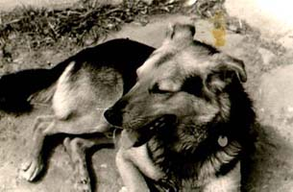  Zundel's dog "Ato" his boyhood friend
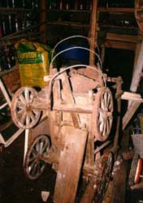  The Leiterwagen used in Ernst's childhood, to pick up wood and food from the distant village | 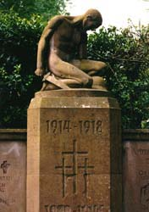  This is the Warriors Monument in Ernst Zundel's village
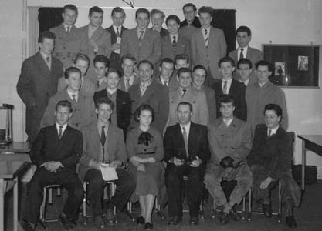
Ernst Zundel graduates from graphics arts trade school - 1956
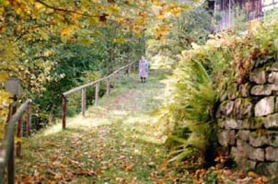  The path Ernst took up the mountain for 17 years in his youth | 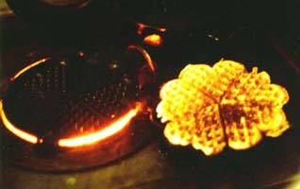  Ernst makes waffles taught to him by mother Z on an ancient wood burning stove
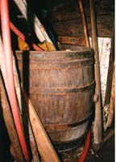  Apple cider barrels in the cellar | 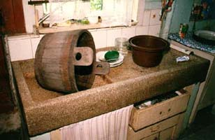  Ernst Zundel's childhood memories of medieval utensils, pot made from wood
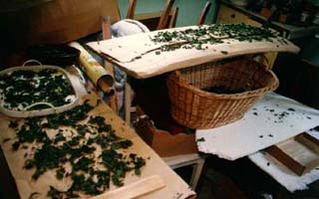  Herbal Teas drying collected from the meadows | 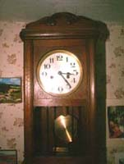  The Regulator clock that ruled Ernst's schooldays
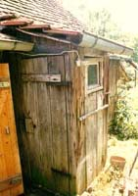  The modernized outhouse in the 400 year old Zundel house | 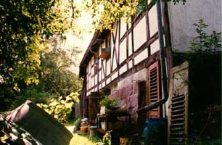  Ernst Zundel grew up in this idyllic place
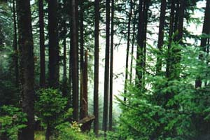  The Black Forest, Ernst Zundel's native land | 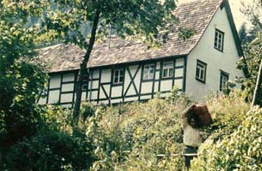  The Zundel homestead newly renovated by Ernst's younger brother, in foreground right
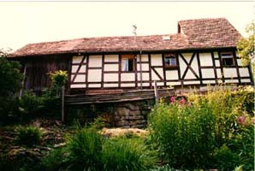  The Zundel house renovated as it is today | 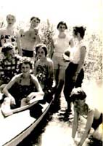  Zundel 1957 - Germany

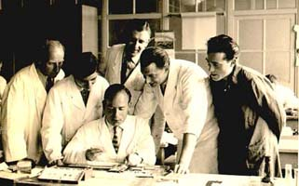  Zundel the commercial artist - 1958 Germany | 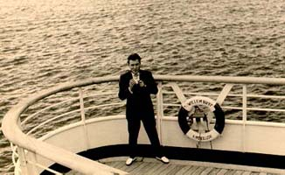  Leaving Germany - August 21, 1958
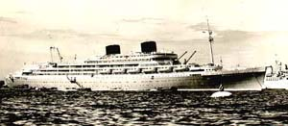  The "William Ruys" with Zundel on board heading for Canada - Aug, 1958 | 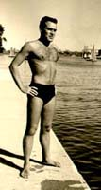  October 1958 after arriving in Toronto
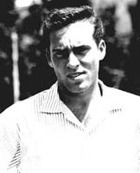  Ernst Zundel 1958 | 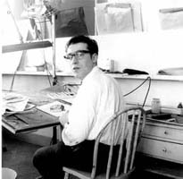  Zundel at work in first job in Canada - 1958
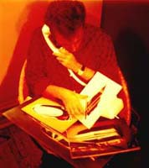  Zundel with some of his graphic artwork | 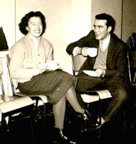  Ernst Zundel during break in night school learning English 1958
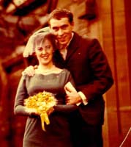  Ernst Zundel first marriage - 1959 | 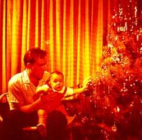  Zundel and his new born Son - 1960

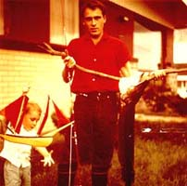  Family - father Ernst with Pierre | 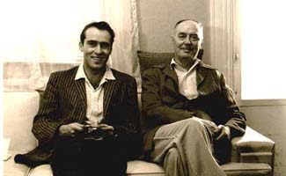  Zundel with Adrien Arcand 1963 - his Political Mentor, prior to leaving on a 3 1/2 month tour of Europe to meet and interview famous writers, politicians and former soldiers

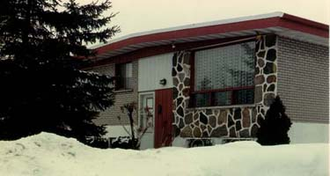  First house Zundel built in 1963, in Montreal suburb | 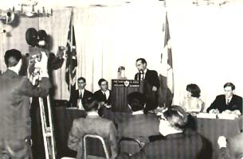  Zundel declaring his candidacy for Prime Minister of Canada, Spring, 1968
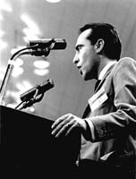  Zundel appeals to 25,000 in Ottawa 1968 | 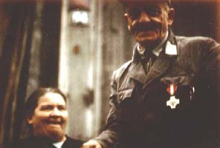  Zundel's mother and father in the Black forest
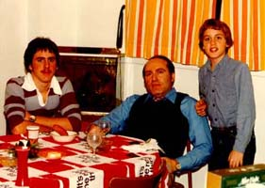  The boys are growing up | 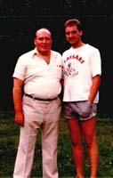  The boys are growing up
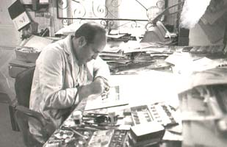  Ernst Zundel as commercial artist in 1973 | 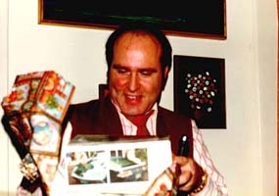  Opening a Christmas present - Early 1970's
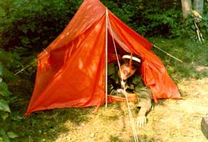  Ernst camping with the boys - Canada 1975 | 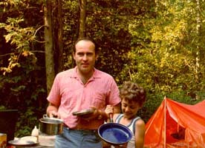  Ernst camping with the boys - Canada 1975

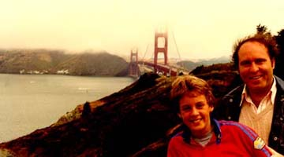  With son Hans in 1976 - San Francisco | 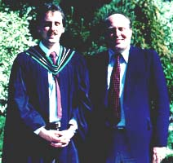  Pierre graduates from University
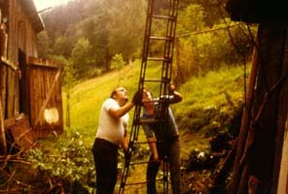  Ernst & Son Pierre fixing his mothers roof, during a visit to the old homested in 1977 | 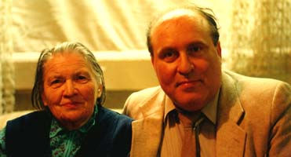  Ernst Zundel with mother in 1977
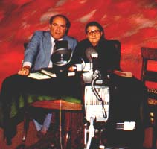  Ernst Zundel filming his mothers life history, 1978 | 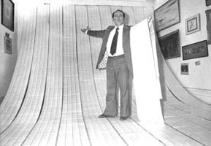  Address labels - tens of thousands of addresses from all over the world, soon to receive Zundel material
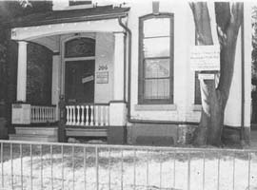  Ernst Zundel buys nice Victorian house in peaceful downtown neighborhood in Toronto, Canada. Things were soon to change | 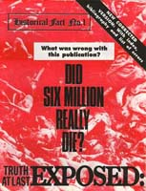  Publishes "Did Six Million Really Die?" and life changes
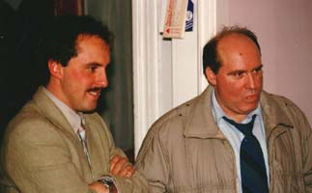  Ernst Zundel with oldest son Pierre | 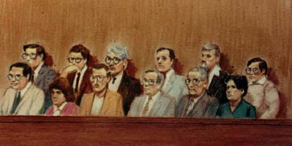  The Zundel jury in Trial I - 1985
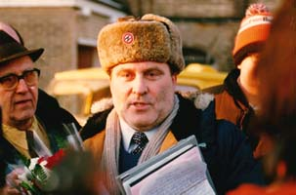  Zundel leaving jail in 1985 | 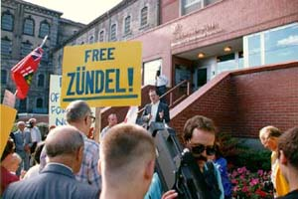  Friends demonstrate for Zundel release in 1985

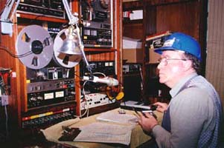  Zundel doing Another Voice of Freedom Radio Shows |  | 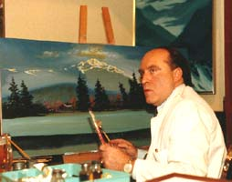  Zundel, still the artist - 1986
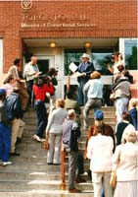  Meeting reporters leaving Toronto Jail - 1987 | 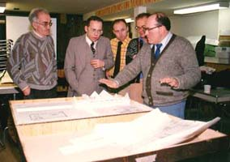  Solving the 6 million riddle with Fred Leuchter, Dr. Faurisson, Ditlieb Felderer, - 1988
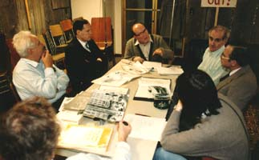  Zundel during 1988 trial | 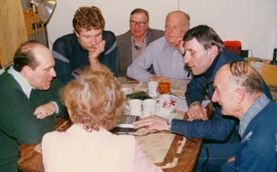  Zundel with friends during trial
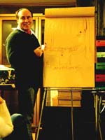  Explaining trial strategy to his friends | 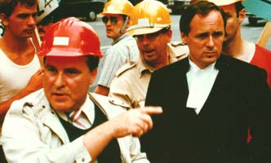  Ernst Zundel with Canadian Lawyer, Doug Christie
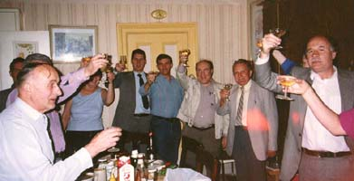  Victory party after 1988 trial | 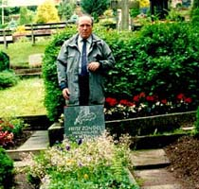  Ernst at his fathers grave - 1991
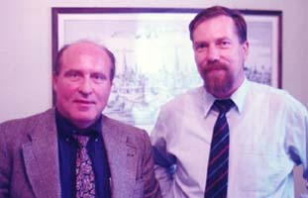  Ernst Zundel with German Lawyer, Jurgen Rieger | 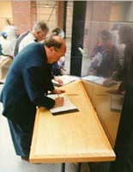  Ernst Zundel signing guest book after a visit of the U.S. Holocaust Memorial Museum in Washington D.C

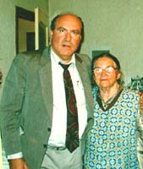  Mother Zundel and her eldest son - 1991, the last time they saw one another in Germany | 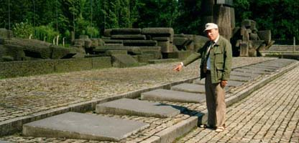  Victory in Auschwitz - Removal of plaques dedicated to the lie of the "4 million victims"
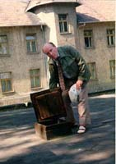  Checking out the crematory in Auschwitz | 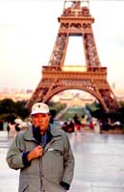  Ernst Zundel in Paris doing T.V. show
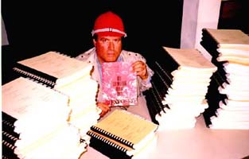  Ernst Zundel buried behind trial transcripts, all over the book he is holding asking "Did Six Million Really Die?" | 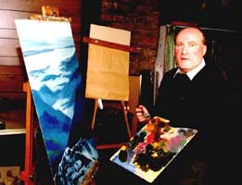  Ernst Zundel 1993
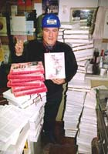  Truth must be told - Shipping Revisionist books to the world after Supreme Court Victory - 1993 | 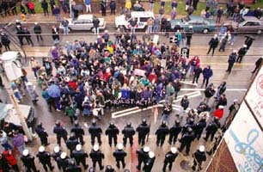  Demonstration outside Zundel's home - 1994
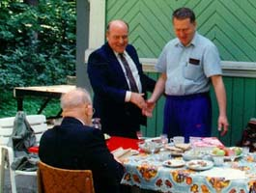  Zundel meets Zhirinovsky in Moscow - 1994 | 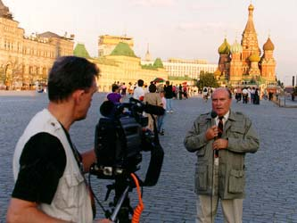  Zundel doing one of his T.V. shows in Moscow - 1994

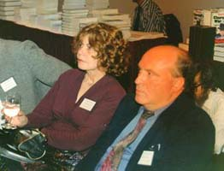  Meeting Dr. Ingrid Rimland - 1994 | 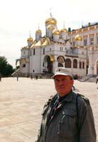  Inside the Kremlin walls
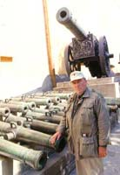  Napoleons Captured guns inside the Kremlin | 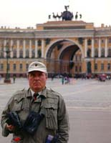  The Hermitage in Leningrad
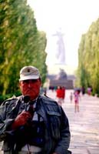  In Stalingrad | 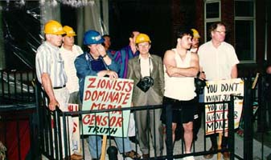  Zundel's friends helping him to protect his house before a demonstration, by a motley collection of his political enemies
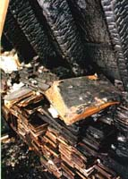  Zundel-haus - book burning 1995 style | 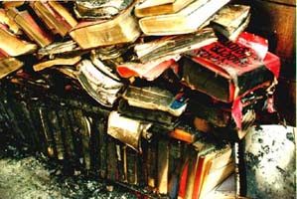  Burning books Canadian style
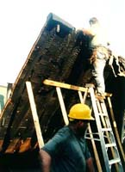  Tearing down what's left of the roof | 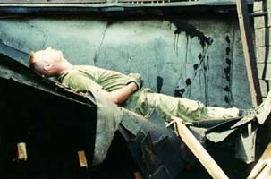  Zundel friends helping out, dirty, tired and worn out
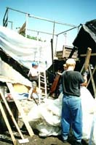  Tearing down the rest of the roof | 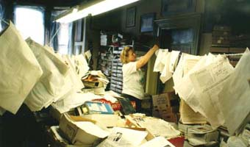  Drying documents after 1995 arson
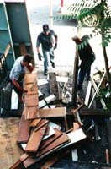  Rebuilding | 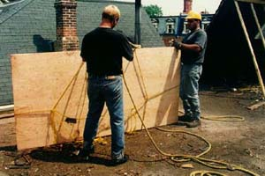  Rebuilding the house
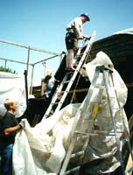  Rebuilding the roof | 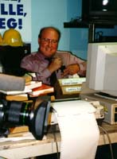  Interviews chase interviews
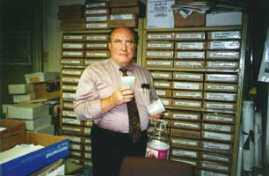  Files, files, files | 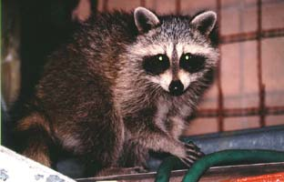  Zundel's "pet" racoons are back, after the house is repaired - life returns to "normal"

