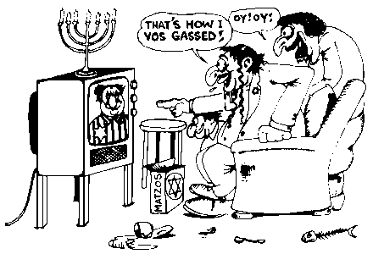 | Excerpts from THE TRUTH AT LAST newspaper, Issues 380 and 407  http://www.heretical.org/miscella/holocult.html

The First ‘Eye Witness’ Accounts of the Holocaust at Auschwitz

On January 27, 1945 Soviet forces occupied Auschwitz and released some 6,000 prisoners. Except for the sick, most appeared in good health, even better than the German soldiers.
On February 2, 1945 the official Communist newspaper Pravda in Moscow carried an article on Auschwitz. This was the first inkling that the holocaust story was being developed. It stated in part:
‘City of Auschwitz - an impartial committee will investigate the accurate number of people killed or tortured to death. The Germans levelled the burial mounds and destroyed all traces of the electric conveyor system where hundreds of people at a time were electrocuted. The bodies fell onto a slow-moving transport belt, taking them to a blast furnace. There they were burnt completely, the bones ground in a roller mill and the remains spread on the fields as fertilizer. The special mobile devices to kill children were relocated to the back fields.
‘It is still possible to assemble traces of the murder of millions based on descriptions by prisoners liberated by the Red Army. This huge death mill was equipped with the latest-style technology which only the German brutes are able to invent.’
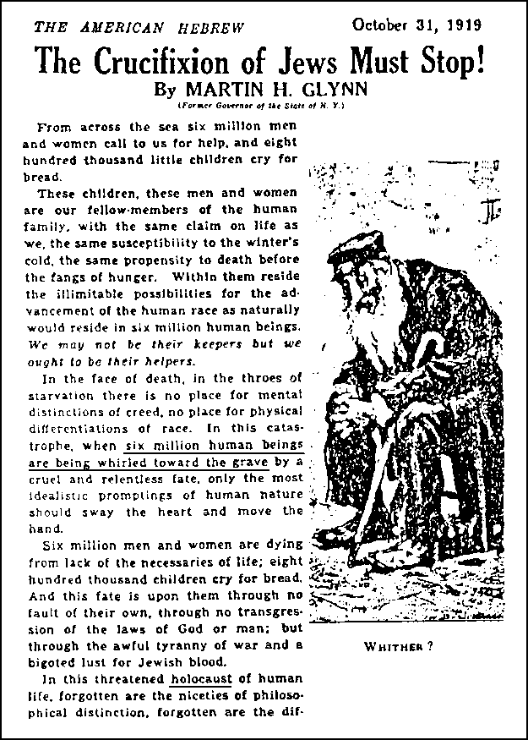

Now in our time, Rabbi Jonathan Rosenblum of the Jerusalem Post

Holocaust More Important Than God

‘When otherwise sane and intelligent people affirm nonsense, it behooves us to inquire into the reason. Falling into that category is the recent finding by the American Jewish Committee that American Jews believe anti-Semitism is a greater threat than intermarriage by a margin of 57 percent to 38 percent.
‘The professed fear of resurgent anti-Semitism goes hand-in-hand with the elevation of the Holocaust to the defining element in Jewish self-identity. All surveys of American Jewry place the Holocaust way ahead of any other factor in Jewish self-identity. Between 75 percent and 85 percent of American Jews rate the Holocaust as a very important factor in their sense of themselves as Jews, far higher than belief in God, Torah or Israel.
‘We focus on the Holocaust as the defining event in Jewish history...’

