Jewish Soap

Mark Weber

www.zundelsite.org/english/advanced_articles/incorrect.007.html

One of the most lurid and slanderous Holocaust claims is the story that the Germans manufactured soap from the bodies of their victims. Although a similar charge during the First World War was exposed as a hoax almost immediately afterwards, it was nevertheless revived and widely believed during the Second. More important, this accusation was "proved" at the main Nuremberg trial of 1945-1946, and has been authoritatively endorsed by numerous historians in the decades since. In recent years, though, as part of a broad retreat from the most obviously untenable aspects of the "orthodox" extermination story, Holocaust historians have grudgingly conceded that the human soap tale is a wartime propaganda lie. In their retreat, though, these historians have tried to dismiss the soap story as a mere wartime "rumor," neglecting to mention that international Jewish organizations and then Allied governments endorsed and sanctioned this libelous canard.
Wartime rumors that the Germans were manufacturing soap from the corpses of slaughtered Jews were based in part on the fact that soap bars distributed by German authorities in Jewish ghettos and camps bore the impressed initials "RIF," which many took to stand for "Rein juedisches Fett" or "Pure Jewish Fat." (It did not seem to matter that the letters were "RIF" and not "RJF.") These rumors spread so widely in 1941 and 1942 that by late 1942 German authorities in Poland and Slovakia were expressing official concern about their impact.
According to a Polish source quoted in a secret wartime U.S. Army military intelligence report, for example, the Germans were operating a "human soap factory" in 1941 at Turek, Poland. "The Germans had brought thousands of Polish teachers, priests and Jews there and after extracting the blood serum from their bodies, had thrown them on large pots and melted off grease to make soap," the intelligence report added.
Macabre "Jewish soap" jokes became popular in the ghettos and camps, and many non-Jews on the outside came to believe the story. When trains loaded with Jewish deportees stopped temporarily at rail stations, Poles reportedly would gleefully shout at them: "Jews to soap!" Even British prisoners of war interned at Auschwitz in 1944 testified later about the wartime rumors that corpses of gassing victims were being turned into soap there.
In spite of its inherently incredible character, the soap story became an important feature of Jewish and Allied war propaganda. Rabbi Stephen S. Wise, wartime head of both the World Jewish Congress and the American Jewish Congress, publicly charged in November 1942 that Jewish corpses were being "processed into such war-vital commodities as soap, fats and fertilizer" by the Germans. He further announced that the Germans were "even exhuming the dead for the value of the corpses," and were paying fifty marks for each body.
In late 1942, the Congress Weekly, published by the American Jewish Congress, editorialized that the Germans were turning Jews "by scientific methods of dissolution into fertilizer, soap and glue." An article in the same issue reported that Jewish deportees from France and Holland were being processed into "soap, glue and train oil" in at least two special factories in Germany. Typical of many other American periodicals, the influential New Republic reported in early 1943 that the Germans were "using the bodies of their Jewish victims to make soap and fertilizer in a factory at Siedlce."
During June and July 1943, two prominent representatives of the Moscow-based "Jewish Anti-Fascist Committee" toured the United States and raised more than two million dollars for the Soviet war effort at a series of mass meetings. At each of these rallies, Soviet Jewish leader Solomon Mikhoels showed the crowd a bar of soap that he said was made from Jewish corpses.
After the war the soap story was given important legitimacy at the main Nuremberg trial. L. N. Smirnov, Chief Counsellor of Justice for the USSR, declared to the Tribunal:
... The same base, rationalized SS technical minds which created gas chambers and murder vans, began devising such methods of complete annihilation of human bodies, which would not only conceal the traces of their crimes, but also to serve in the manufacturing of certain products. In the Danzig Anatomical Institute, semi-industrial experiments in the production of soap from human bodies and the tanning of human skin for industrial purposes were carried out.
Smirnov quoted at length from an affidavit by Sigmund Mazur, an Institute employee, which was accepted as Nuremberg exhibit USSR-197. It alleged that Dr. Rudolf Spanner, the head of the Danzig Institute, had ordered the production of soap from corpses in 1943. According to Mazur's affidavit, Dr. Spanner's operation was of interest to high-ranking German officials. Education Minister Bernhard Rust and Health Leader Dr. Leonardo Conti, as well as professors from other medical institutes, came to witness Spanner's efforts. Mazur also claimed to have used the "human soap" to wash himself and his laundry.
A human soap "recipe," allegedly prepared by Dr. Spanner (Nuremberg document USSR-196), was also presented. Finally, a sample of what was supposed to be a piece of "human soap" was submitted to the Nuremberg Tribunal as exhibit USSR-393.
In his closing address to the Tribunal, chief British prosecutor Sir Hartley Shawcross echoed his Soviet colleague: "On occasion, even the bodies of their victims were used to make good the wartime shortage of soap." And in their final judgment, the Nuremberg Tribunal judges found that "attempts were made to utilize the fat from the bodies of the victims in the commercial manufacture of soap."
It is worth emphasizing here that the "evidence" presented at the Nuremberg Tribunal for the bogus soap story was no less substantial than the "evidence" presented for the claims of mass extermination in "gas chambers." At least in the former case, an actual sample of soap supposedly made from corpses was submitted in evidence.
After the war, supposed Holocaust victims were solemnly buried, in the form of soap bars, in Jewish cemeteries. In 1948, for example, four such bars wrapped in a funeral shroud were ceremoniously buried according to Jewish religious ritual at the Haifa cemetery in Israel. Other bars of "Jewish soap" have been displayed as grim Holocaust relics at the Jewish Historical Institute in Warsaw, the Stutthof Museum near Gdansk (Danzig), the Yivo Institute in New York, the Holocaust Museum in Philadelphia, the Jewish Holocaust Centre in Melbourne (Australia), and at various locations in Israel.
Numerous Jews who lived in German ghettos and camps during the war helped keep the soap story alive many years later. Ben Edelbaum, for example, wrote in his 1980 memoir Growing Up in the Holocaust:
Often with our rations in the ghettos, the Germans had included a bar of soap branded with initials R.J.F. which came to be known as "RIF" soap. It wasn't until the war had ended that we learned the horrible truth about the bar of soap. Had we known in the ghetto, every bar of "RIF" soap would have been accorded a sacred Jewish funeral in the cemetery at Marysin. As it was, we were completely oblivious to its origin and used the bones and flesh of our murdered loved ones to wash our bodies.
Nesse Godin was transferred from a ghetto in Lithuania to the Stutthof concentration camp in the spring of 1944. In a 1983 interview, she recalled her arrival there:
That day they gave us a shower and a piece of soap. After the war we found out the soap was made out of pure Jew fat, Rein Juden Fett, marked in the initials on the soap that I washed with. For all I know sometimes maybe there was a little bit of my father's fat in that soap that I washed with. How do you think I feel when I think about that?
Mel Mermelstein, the former Auschwitz inmate who was featured in the sensationalized April 1991 cable television movie "Never Forget" (and who sued the Institute for Historical Review and three other defendants for $11 million), declared in a 1981 sworn deposition that he and other camp inmates used soap bars made from human fat. It was an "established fact," he insisted, that the soap he washed with was made from Jewish bodies.
Renowned "Nazi hunter" Simon Wiesenthal repeated the soap tale in a series of articles published in 1946 in the Austrian Jewish community paper Der Neue Weg. In the first of these he wrote:
During the last weeks of March the Romanian press reported an unusual piece of news: In the small Romanian city of Folticeni twenty boxes of soap were buried in the Jewish cemetery with full ceremony and complete funeral rites. This soap had been found recently in a former German army depot. On the boxes were the initials RIF, "Pure Jewish Fat." These boxes were destined for the Waffen-SS. The wrapping paper revealed with completely cynical objectivity that this soap was manufactured from Jewish bodies. Surprisingly, the thorough Germans forgot to describe whether the soap was produced from children, girls, men or elderly persons.
Wiesenthal went on:
After 1942 people in the General Government [Poland] knew quite well what the RIF soap meant. The civilized world may not believe the joy with which the Nazis and their women in the General Government thought of this soap. In each piece of soap they saw a Jew who had been magically put there, and had thus been prevented from growing into a second Freud, Ehrlich or Einstein.
In another article he observed: "The production of soap from human fat is so unbelievable that even some who were in concentration camps find it difficult to comprehend."
Over the years, numerous supposedly reputable historians have promoted the durable soap story. Journalist-historian William L. Shirer, for example, repeated it in his best-selling work, The Rise and Fall of the Third Reich.
Leading Soviet war propagandist Ilya Ehrenburg wrote in his postwar memoir: "I have held in my hand a cake of soap stamped with the legend 'pure Jewish soap', prepared from the corpses of people who had been destroyed. But there is no need to speak of these things: thousands of books have been written about them."
A standard history studies textbook used in Canadian secondary schools, Canada: The Twentieth Century, told students that the Germans "boiled" the corpses of their Jewish victims "to make soap." The Anatomy of Nazism, a booklet published and distributed by the Zionist "Anti-Defamation League" of B'nai B'rith, stated: "The process of brutalization did not end with the mass murders themselves. Large quantities of soap were manufactured from the corpses of those murdered."
A detailed 1981 work, Hitler's Death Camps, repeated the soap story in lurid detail. While noting that "some historians claim that the Nazi manufacture of soap from human fat is just a grim rumor," author Konnilyn Feig nevertheless accepted the story because "most East European camp scholars ... validate the soap stories, and other kinds of bars made from humans are displayed in Eastern Europe -- I have seen many over the years."
New York Rabbi Arthur Schneier repeated the tale at the opening ceremony of the largest Holocaust meeting in history. In his invocation to the "American Gathering of Jewish Holocaust Survivors," held in Washington in April 1983, the Rabbi solemnly declared: "We remember the bars of soap with the initials RJF -- Rein jüdisches Fett, Pure Jewish Fat -- made from the bodies of our loved ones."
In spite of all the apparently impressive evidence, the charge that the Germans manufactured soap from human beings is a falsehood, as Holocaust historians are now belatedly acknowledging. The "RIF" soap bar initials that supposedly stood for "Pure Jewish Fat" actually indicated nothing more sinister than "Reich Center for Industrial Fat Provisioning" ("Reichsstelle für Industrielle Fettversorgung"), a German agency responsible for wartime production and distribution of soap and washing products. RIF soap was a poor quality substitute that contained no fat at all, human or otherwise.
Shortly after the war the public prosecutor's office of Flensburg, Germany, began legal proceedings against Dr. Rudolf Spanner for his alleged role in producing human soap at the Danzig Institute. But after an investigation the charge was quietly dropped. In a January 1968 letter, the office stated that its inquiry had determined that no soap from human corpses was made at the Danzig Institute during the war.
More recently, Jewish historian Walter Laqueur "denied established history" by acknowledging in his 1980 book, The Terrible Secret, that the human soap story has no basis in reality. Gitta Sereny, another Jewish historian, noted in her book Into That Darkness: "The universally accepted story that the corpses were used to make soap and fertilizer is finally refuted by the generally very reliable Ludwigsburg Central Authority for Investigation into Nazi Crimes."
Deborah Lipstadt, a professor of modern Jewish history, similarly "rewrote history" when she confirmed in 1981: "The fact is that the Nazis never used the bodies of Jews, or for that matter anyone else, for the production of soap."
In April 1990, professor Yehuda Bauer of Israel's Hebrew University, regarded as a leading Holocaust historian, as well as Shmuel Krakowski, archives director of Israel's Yad Vashem Holocaust center, confirmed that the human soap story is not true. Camp inmates "were prepared to believe any horror stories about their persecutors," Bauer said. At the same time, though, he had the chutzpah to blame the legend on "the Nazis."
In fact, blame for the soap story lies rather with individuals such as Simon Wiesenthal and Stephen Wise, organizations like the World Jewish Congress, and the victorious Allied powers, none of whom has ever apologized for promoting this vile falsehood.
Why did Bauer and Krakowski decide that this was the appropriate time to officially abandon the soap story? Krakowski himself hints that a large part of the motivation for this "tactical retreat" has been to save what's left of the sinking Holocaust ship by throwing overboard the most obvious falsehoods. In the face of the growing Revisionist challenge, easily demonstrable falsehoods like the soap story have become dangerous embarrassments because they raise doubts about the entire Holocaust legend. As Krakowski put it: "Historians have concluded that soap was not made from human fat. When so many people deny the Holocaust ever happened, why give them something to use against the truth?"
The bad faith of those making this calculated and belated concession to truth is shown by their failure to note that the soap myth was authoritatively "confirmed" at Nuremberg, and by their unwillingness to deal with the implications of that confirmation for the credibility of the Tribunal and other supposedly trustworthy authorities in establishing other, more fundamental aspects of the Holocaust story.
The striking contrast between the prompt postwar disavowal by the British government of the infamous "human soap" lie of the First World War, and the way in which a similarly baseless propaganda story from the Second World War was officially endorsed by the victorious Allied powers and then authoritatively maintained for so many years not only points up the dispiriting lack of integrity on the part of so many Western historians, but underscores the general decline in Western ethical standards during this century.
The "human soap" story demonstrates anew the tremendous impact that a wartime rumor, no matter how fantastic, can have once it has taken hold, particularly when it is disseminated as a propaganda lie by influential individuals and powerful organizations. That so many intelligent and otherwise thoughtful people could ever have seriously believed that the Germans distributed bars of soap brazenly labeled with letters indicating that they were manufactured from Jewish corpses shows how readily even the most absurd Holocaust fables can be -- and are -- accepted as fact.

ABOUT THE AUTHOR
Mark Weber is editor of The Journal of Historical Review, published six times yearly by the Institute for Historical Review. He studied history at the University of Illinois (Chicago), the University of Munich, Portland State University, and Indiana University (M.A., 1977). For five days in March 1988, he testified as a recognized expert witness on the "final solution" and the Holocaust issue in a Toronto District Court case. He is the author of many published articles, reviews and essays on various aspects of modern European history. Weber has appeared as a guest on numerous radio talk shows, and on the nationally-syndicated "Montel Williams" television show.

We wish to acknowledge that the above article was made available courtesy of the Institute for Historical Review.
Copyright restrictions:
The copyright holders (Greg Raven and/or the Institute for Historical Review) hereby grant to anyone the right to reproduce electronically or magnetically the BBS versions of these files. We do not grant reprint rights to any words-on-paper versions of these files except for extracts up to 500 words in book reviews or citations in other books. You are allowed to print out one copy of these files for your own personal use. You are not allowed to sell a print-out.
For a current catalog, with a complete listing of books and audio and video tapes, send one dollar to:
Institute For Historical Review
Post Office Box 2739
Newport Beach, California 92659

===================================================================================================================================
www.zundelsite.org\english\antiprop\jewish_soap

"Jewish soap" and "lampshade" lies

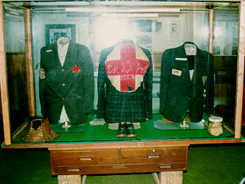

In Nitro, West Virgina, the "Jewish soap" and "lampshade" rackets are still prospering
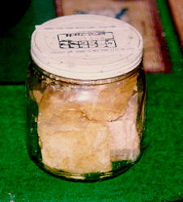..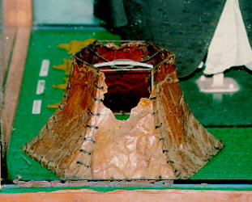

In France, they still have not heard that the soap story is a lie
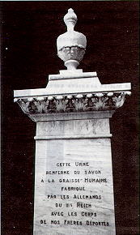

Adult books also make money off the soap lie.
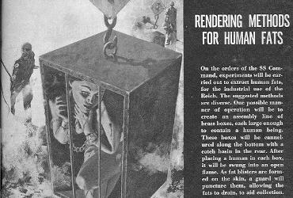

Have none of these people read the news?
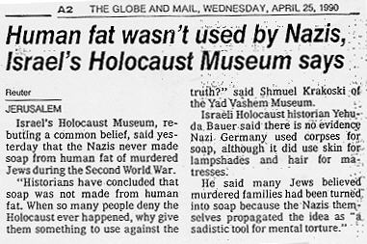..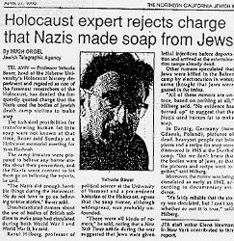
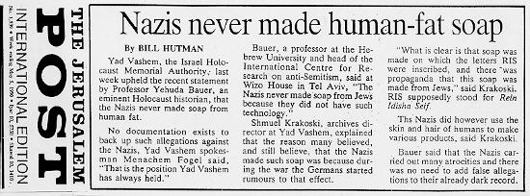

Even Holocaust promoter Deborah Lipstadt admits the soap story is a lie!
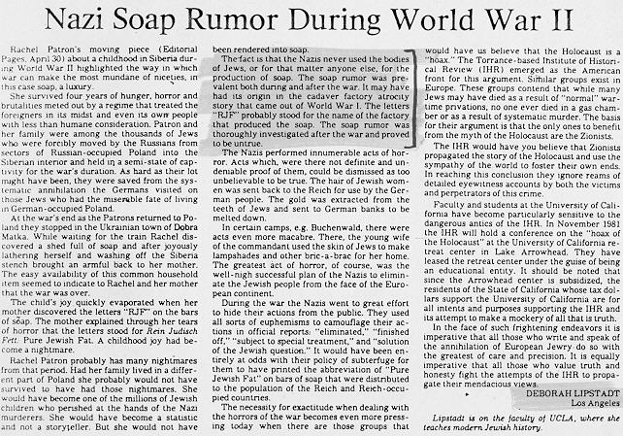

Even after the truth is out there, newspapers still carry the lie and report as truth peoples fantasies about "Jewish soap".
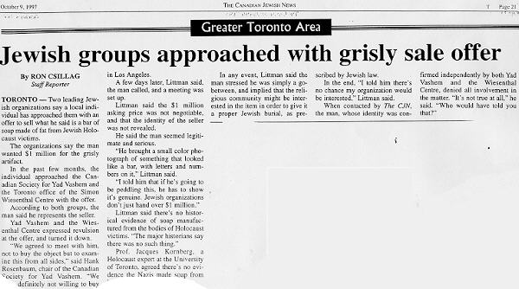

In Canada, a man tries to pon off a "bar of Jewish soap" for a cool million bucks
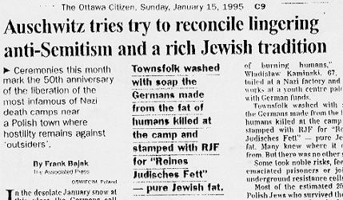..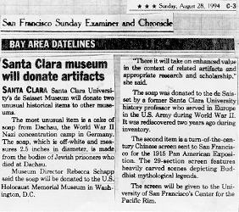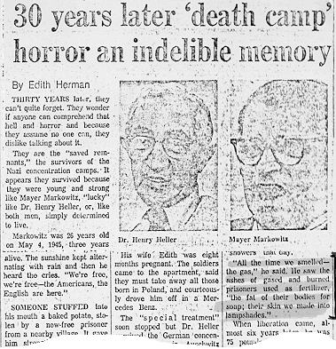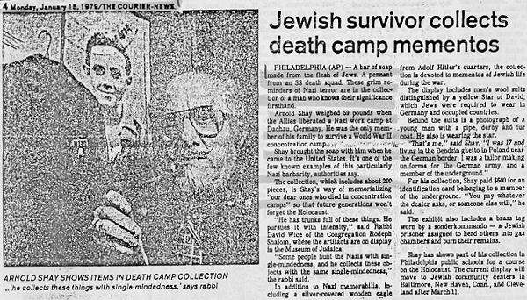

The soap lie has also been published in many books

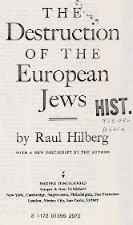
..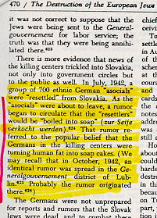..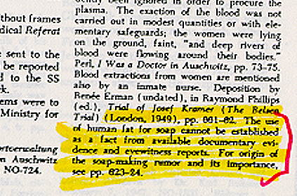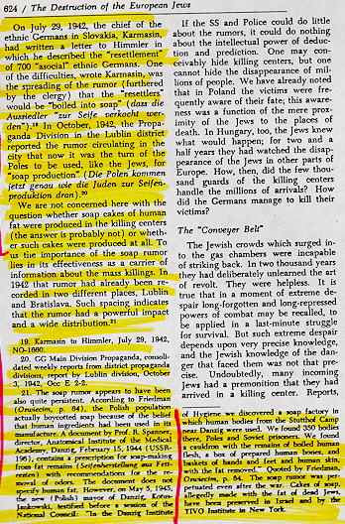....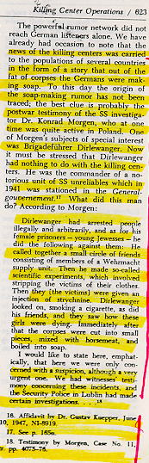

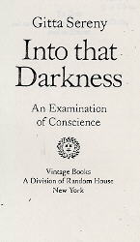....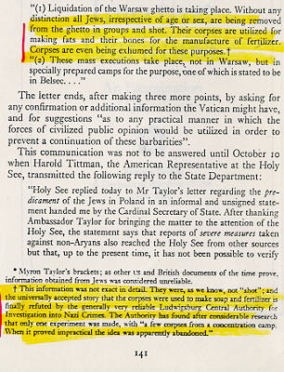

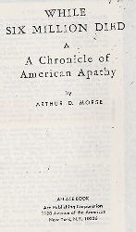....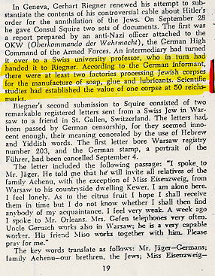

How the Lie started!

International Military Tribunal at Nüremburg transcripts.

February 19, 1946 - (IMT Vol. 7 Blue Series) Russian Prosecutor: Rudenko
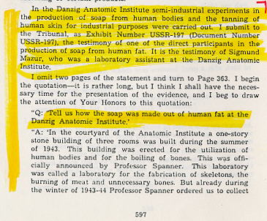
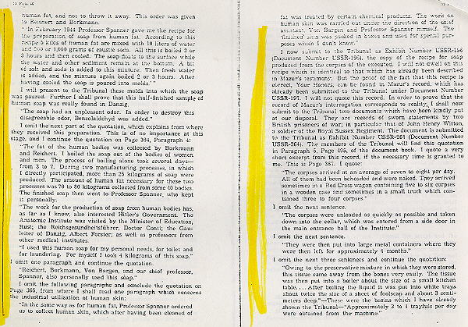
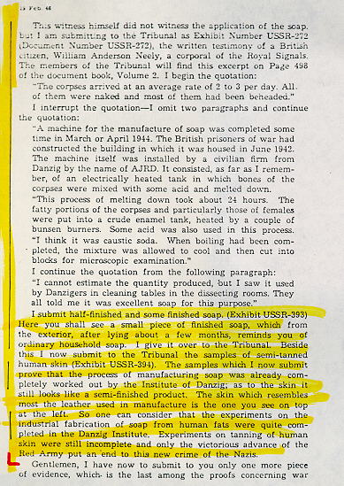

Nuremberg exhibit - USSR-393
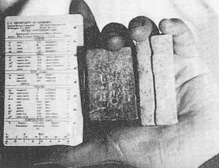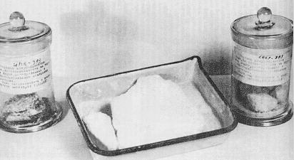
Document 196 - USSR
International Military Tribunal, Vol 39 Page 463 & 464
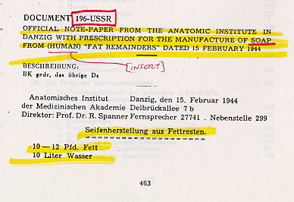
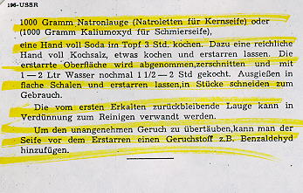

More Lies from the Nüremberg IMT witch-hunts
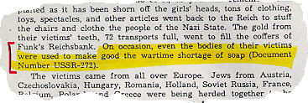
British Prosecutor Sir Hartley Shawcross
July 27, 1946 - IMT Vol 19, (Blue Series)

Nuremberg soap lie becomes "true" by mere repetition
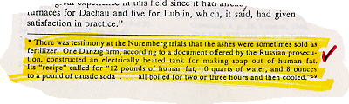

Shirer - Rise and Fall of the Third Reich - Page 971

END

