The ‘Six Million’ Myth
September 27, 2015 renegade 11 Comments
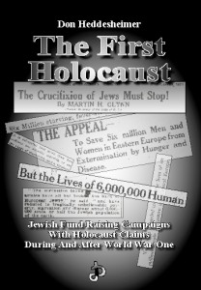Must read book by Don Heddesheimer, The First Holocaust.

by Zander C. Fuerza (ZCF) aka Zion Crime Factory
Author Don Heddesheimer’s book, The First Holocaust: Jewish Fundraising Campaigns With Holocaust Claims During and After World War One, is an important piece of the revisionist puzzle. Heddesheimer cogently documents the slew of previous attempts by Jews to disseminate deceitful and untrue atrocity propaganda before, during and after World War I. The First Holocaust features an amazing collection of press clippings and propaganda articles dating back to the late 19th century that make claims of the suffering and imminent extermination of European Jewry. Among such articles we find that Jews have, dozens of times before WWII, invoked the cabalisitc “6,000,000″ number as the amount of Jews on the verge of death and destruction during various periods of turmoil and conflict in Europe and Russia. Undoubtedly, this book exposes the deliberate fraudulence of these sinister Zionist campaigns and media blitzes — long before Hitler became Chancellor of Germany in 1933 — designed to elicit public sympathy and financial support for Jewish political ambitions, principally the establishment of the State of Israel.
The obsessive invocation of the cabalistic fable of “6,000,000 dead or dying Jews” dating back at least four decades prior to the events of WWII directly undermines and betrays the notion that 6,000,000 Jews perished in Europe between 1939-1945, as Jews have claimed. It was a lie the first time, and it is a lie today!
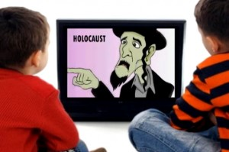Young White children are taught to hate their own kind over something that never even happened!
The Gentile populations of the West have, for decades, been inundated and inoculated with an endless onslaught of holocaust-themed Hollywood movies, television shows, “docudramas”, books and memoirs; in conjunction with mandatory “holocaust education” in schools across North America and Europe. The primary function of this insidious global propaganda campaign is to — quite simply — brainwash non-Jews into a state of abject fear and paralysis while we are ideologically, economically and physically enslaved by the Jewish tribe. It is also designed to delegitimize all criticism of Jews and the State of Israel and to ensnare non-Jews into adopting a pro-Jewish, pro-Zionist worldview. With their hateful holocaust lies, Zionist myth-makers are teaching masses of young school children to hate Germans, and European mankind in general. These kids, not knowing any better and unable to think for themselves, blindly believe these tall tales and never question what they’ve been told when they become adults. The indoctrination of our little ones with Zionist ‘holocaust’ fiction is permanently damaging the minds of young people. Force-feeding young children, as well as teenagers, distortions and outright falsehoods about World War II so that they sympathize with Jewish people and treacherous Jewish causes — such as Zionism and Communism — is immoral, destructive, harmful and criminal. It must be stopped!
A question that you might ask is: “what is the significance of the ‘Six Million’ figure and where did it originate?”
The mythical “Six Million” figure has intriguing origins indeed. Jews have staunchly emphasized the 6,000,000 figure in atrocity propaganda from the years 1890 through 1945. World War II ended in 1945, and since that time the cabalistic 6,000,000 figure has now reached sacrosanct status. This was achieved through a sleazy and deceptive campaign of repetitive HoloHoax swindlespeak in the news and entertainment media, centered in Jewish Hollywood. As the Jewish-Communist mass murderer, Vladimir Lenin, once said: “a lie told often enough becomes the truth.” This campaign of Jewish deceit has steadily intensified over the years. When Jews sense an increase in awareness of their treachery and global crimes against humanity amongst the Gentile public (a natural reaction of which is resentment and hostility), the louder they begin to wail about their invented holocaust in the octopus of media organs they control. That’s why they are always gauging the pulse of public opinion.
World leaders, Presidents, Prime Ministers, ceremonial Kings and Queens, Popes, Priests and Holy Men of all faiths, genuflect in groveling reverence of the mythical “6,000,000 Jews” who didn’t perish in “Nazi gas chambers”, as such chambers did not exist and were impossible. (See: VHO, IHR, CODOH, WSMOT, Zundelsite, Nazi Gassings Never Happened) Research shows that the reason for this bizarre Jewish fixation on the number 6,000,000 primarily stems from an ancient religious prophecy in the Torah. According to some sources, the prophecy envisioned that before the Jewish people could reclaim and reconquer Palestine to establish a Jewish homeland called “Israel”, 6,000,000 Jews would first have to perish in a fiery burnt offering (i.e. “Holocaust”), as a sacrifice to their bloodthirsty tribal deity, YHWH. (See: Weintraub, Ben. The Holocaust Dogma of Judaism: Keystone of the New World Order. Washington, D.C.: Cosmo Pub., 1995.) Jewish author, Benjamen Blech, confirmed this reality in his book “The Secrets of Hebrew Words” (J Aronson Inc., 1991, p. 241), stating,
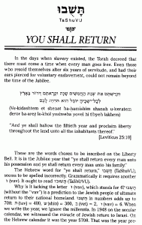“You shall return minus 6,000,000″; Jewish scripture relates a prophecy that 6,000,000 Jews must vanish before they can reclaim Palestine as their ancient ancestral homeland.
“The Hebrew word for ‘ye shall return’(TaShuVU), seems to have been spelled incorrectly. Grammatically it requires another (vav). It ought to read (TaShUVU). Why is it lacking the letter (vav) which stands for six?. [TaShuVU] without the vav is a prediction to the Jewish people of ultimate return to their national homeland. TaShuVU in numbers adds up to 708: tav=400, shin=300, vei=2, vey=6. When we write the year, we ignore the millennia. In 1948 on the secular calendar, we witnessed the miracle of Jewish return to Israel. On the Hebrew calendar it was the year 5708. That was the year predicted by the incomplete word (TaShuVu), you shall return. We did return, lacking 6 – an all important 6 million of our people who perished in the holocaust. Yet the fulfillment of the prediction of return in precisely that year implied by the gematria of TaShuVU gives us firm hope that the words of the prophets for Final Redemption will come true as well.”
Here are two additional commentaries on the origins of the “Six Million” from History & Scriptural Origins of the Six Million Number:
[Quote 1] Jewish prophecies in the Torah require that 6 million Jews must “vanish” before the state of Israel can be formed. “You shall return minus 6 million.” That’s why Tom Segev, an Israeli historian, declared that the “6 million” is an attempt to transform the Holocaust story into state religion. Those six million, according to prophecy, had to disappear in “burning ovens”, which the judicial version of the Holocaust now authenticates. As a matter of fact, Robert B. Goldmann writes: “. . . without the Holocaust, there would be no Jewish State.” A simple consequence: Given six million Jews gassed at Auschwitz who ended up in the “burning ovens” (the Greek word holocaust means burned offerings), therefore, the prophecies have now been “fulfilled” and Israel can become a “legitimate state”. –Unknown
[Quote 2] Regarding the ‘six million’ number you should know the following: In the Hebrew text of the Torah prophesies, one can read “you shall return”. In the text the letter “V” or “VAU” is absent, as Hebrew does not have any numbers; the letter V stands for the number 6. Ben Weintraub, a religious scientist, learned from rabbis that the meaning of the missing letter means the number is ’6 million’. The prophesy then reads: You will return, but with 6 million less. See Ben Weintraub: “The Holocaust Dogma of Judaism”, Cosmo Publishing, Washington 1995, page 3. The missing 6 million must be so before the Jews can return to the Promised Land. Jahweh sees this as a cleaning of the souls of the sinful people. The Jews must, on the return to the Promised Land, be clean — the cleaning shall be done in burning stokes. — A Correspondent
Is it just coincidental that the flimsy and farcical story of “6,000,000 Jews” being murdered in “gas chambers” and burned up in “ovens” in concentration camps during WWII gave the Jews the impetus and PR ammunition they needed to make their “gallant return” to the “promised land” at the war’s end — occupying and ethnically cleansing much of Palestine through terrorism and force of arms — establishing a racist/apartheid “Jewish state” called “Israel” in 1948? And this all just happens to fit the previously cited ancient Torah prophecy to the letter? I hardly think so!
Today, the holocaust™ tall tale has taken the form of a bizarre cult-like State-enforced and protected religious dogma of the West (i.e. Holocaustianity), as it is illegal to question, dispute or deny in over a dozen European countries, under punishment of heavy fines and imprisonment! This farfetched Zionist-trumpeted conspiracy theory is being utilized by Jewish hucksters and scam artists as a money-making enterprise — a larcenous con of near-planetary proportions which Jewish professor Norman Finkelstein dubbed “The Holocaust Industry”. (The Holocaust Industry: Reflection on the Exploitation of Jewish Suffering. London: VERSO, 2000.) On top of that, this myth has been wielded by Jewish zealots as an ideological sledgehammer to club Gentiles over the head with any time non-Jews dare criticize or oppose the global banditry and menacing influence of the self-professed “Chosen People”.
Below are reproductions of many press clippings and articles featuring the cabalistic 6,000,000 number, dating back to the year 1900. Note the ceaseless references to “6,000,000 Jews”, the continuous begging for money and land (Palestine), and the term “holocaust” used well before the events of the 1940s. It is also noteworthy that the authors of the vast majority of these propaganda articles were the richest of Wall Street’s Jewish bankers as well as leaders of Zionist pressure groups — Schiffs and Warburgs among them. (More examples can be found here, here and here; credit also goes to this blogger for unearthing many of these article clippings).
1900-
American Zionist leader, Rabbi Stephen S. Wise, let slip the Zionist agenda behind the Holocaust Hoax: to promote public sympathy for Zionism (Jewish takeover of Palestine).
“There are 6,000,000 living, bleeding, suffering arguments in favor of Zionism.”
(“ZIONISTS’ MASS MEETING: Rabbi Wise’s Address.” New York Times. June 11, 1900.)
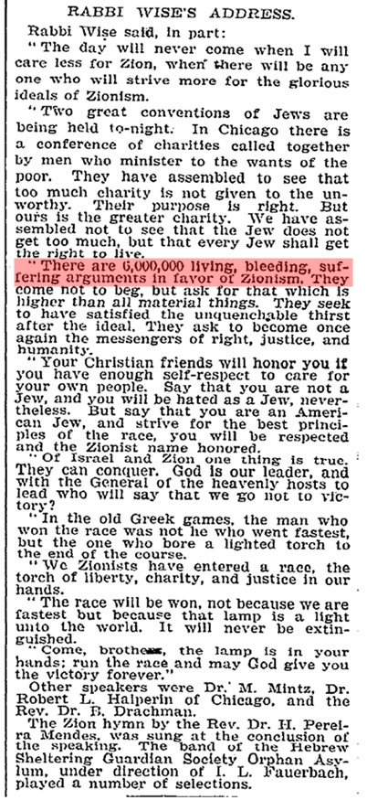The Zionist pronouncement that kick-started the hoax of the twentieth century.
1902-
Under its entry on “anti-Semitism”, the tenth edition of the Encyclopedia Britannica references “Six Million Jews” of Rumania and Russia being “systematically degraded.”
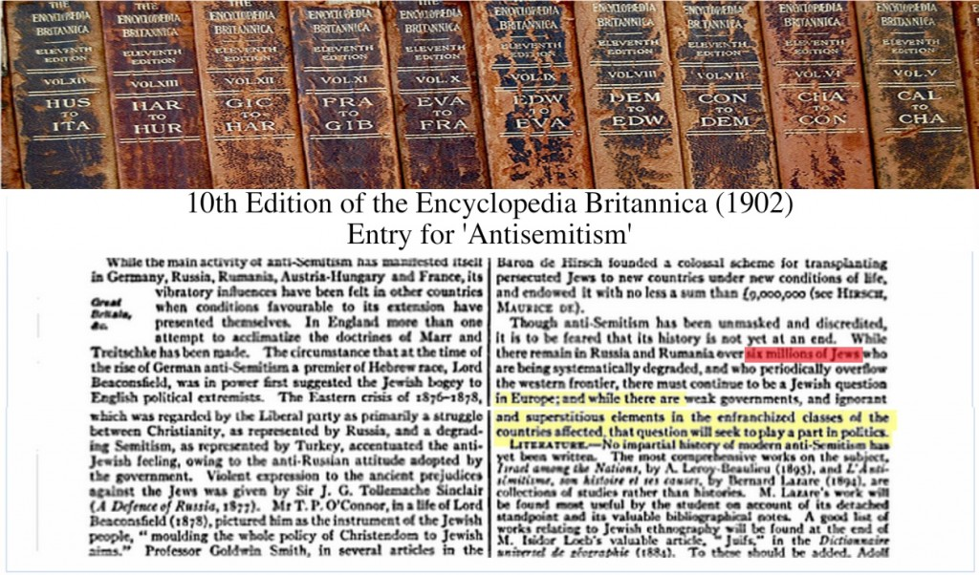
1905-
A Jewish preacher declares that if the (Jewish-led) Communist uprising in Russia succeeds in its long-time goal of overthrowing the Tsarist government, Zionism would be obsolete. “6,000,000 Jews” is mentioned.
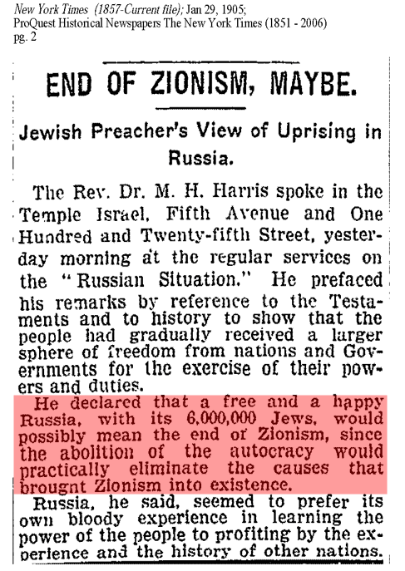
The New York Times reports: “From 1890 to 1902 he caused 6,000,000 Jewish families to be expelled from Russia.”
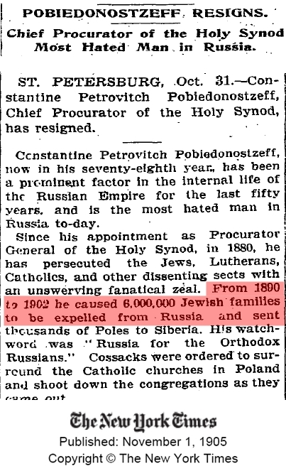
1906-
A Jewish publicist addresses an audience in Germany where he claimed that the Russian Government had a “solution of the Jewish Question” and that this solution entailed the “murderous extermination” of “6,000,000 Jews.” Of course, the Russians never had any such plans but the fictional story was resurrected during WWII with the Germans being on the receiving end of these slanderous accusations this time around.
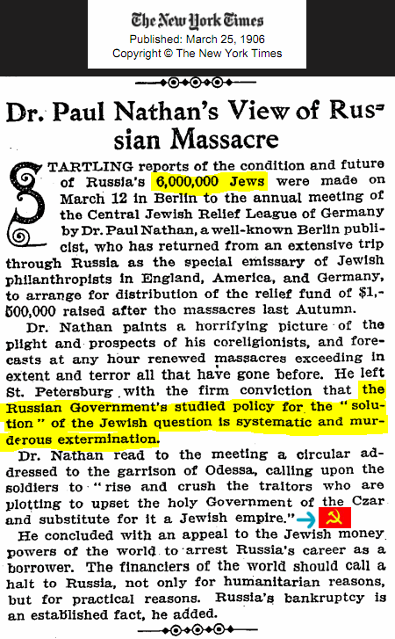As a side note: 1906 was the year after the first Jewish-led Communist uprising in Russia had failed. This lame sob story was nothing more than a ploy to distract public attention from the fact that the Communist-led upheaval that took place in Russia a year earlier was the handiwork of his fellow Jews who perpetrated widespread atrocities against Russian patriots (anti-Communists).
1908-
Donmeh Jews organize a coup d’etat in the Ottoman Empire and seize power from the Sultan.
1910-
In the American Jewish Committee’s annual report it is claimed that since 1890 Russia has had a policy to “expel or exterminate” Six Million Jews. (Source: American Jewish Yearbook pg. 15)
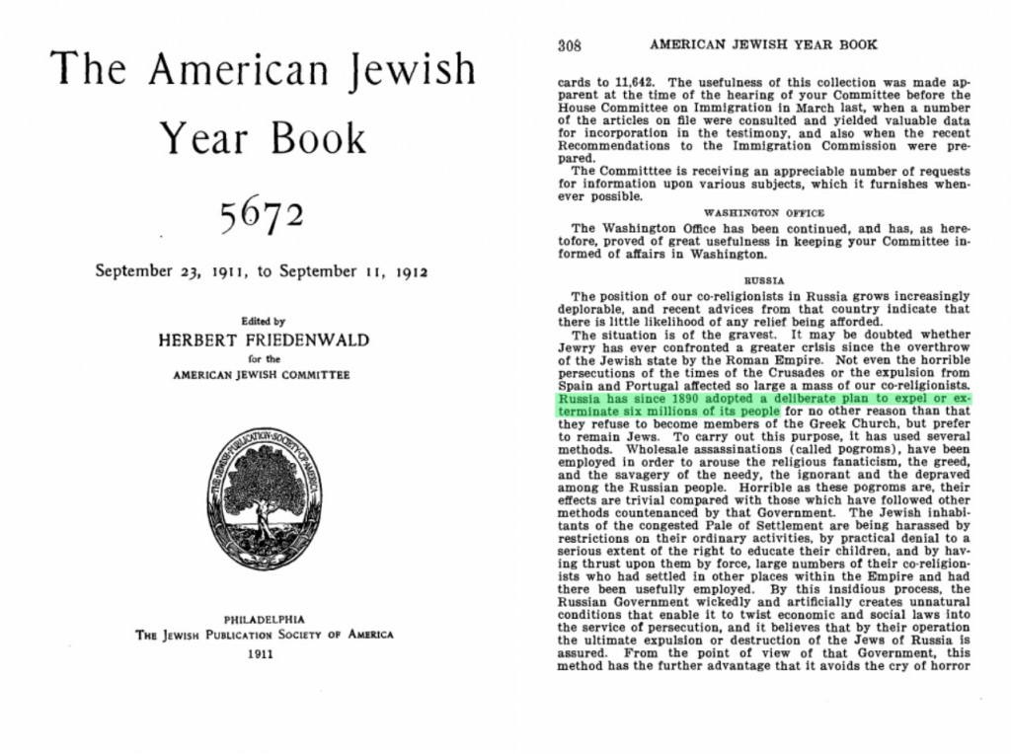
1911-
Max Nordau, co-founder of the World Zionist Organization together with Theodore Herzl, made an astonishing pronouncement at the tenth Zionist Congress in Basle, Switzerland. He claimed that 6,000,000 Jews would be annihilated. This was twenty-two years before Hitler came to power and three years before World War I started.
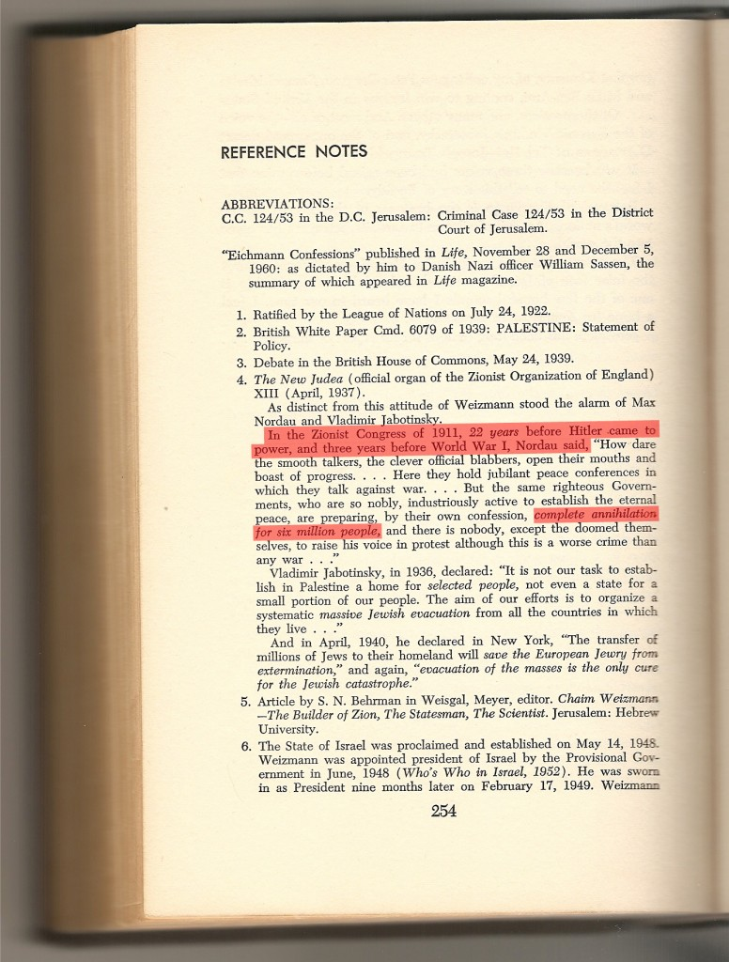Quoted in Ben Hecht’s book, Perfidy. Hecht, a Zionist Jew himself, would go on to make the very same claim in 1943.
1914-
The bloodbath of World War I kicks off and the Jews are already whining that “6,000,000 Jews” are in danger.
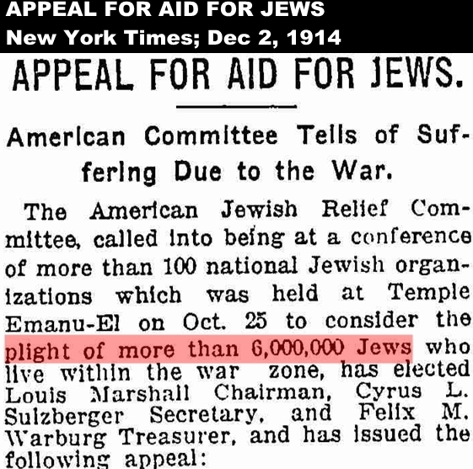
1915-
Jewish leader Louis Marshall proclaims: “In the world today there are about 13,000,000 Jews, of whom more than 6,000,000 are in the heart of the war zone: Jews whose lives are at stake and who today are subjected to every manner of suffering and sorrow…”
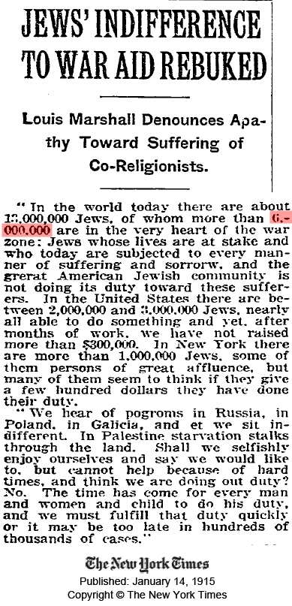
The crypto-Jewish “Young Turks” orchestrate a mass murder of 1.5 million Armenian Christians, as well as 250,000 Greek and Assyrian Christians.
1917-
Jewish lobbyists convince the British government to support the Zionist project of making Palestine the national homeland for the Jews. British official James Arthur Balfour decrees the “Balfour Declaration.” The letter is addressed to Zionist big-wig Lord Rothschild.
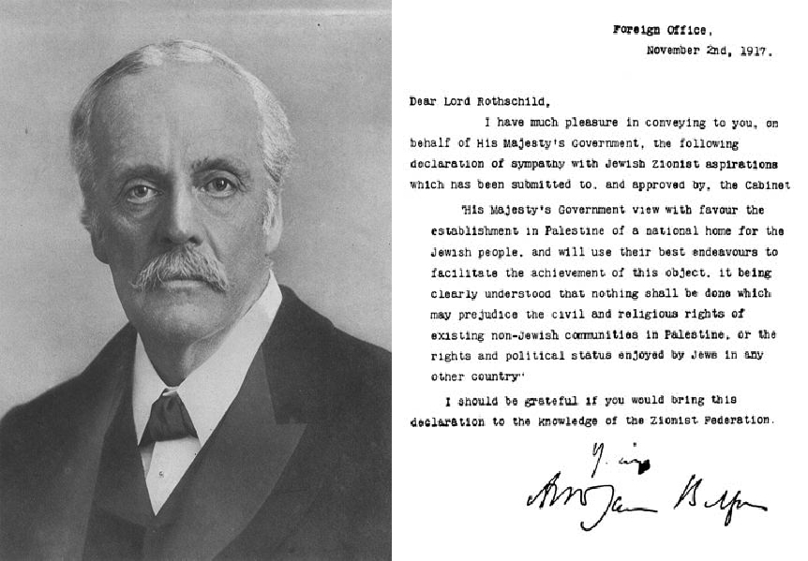Britain becomes a deadly pawn of Zionism.
This very same year radical Jewish Marxists take control of Russia in the Bolshevik Revolution establishing the first Zionist state, the “Soviet Union.” Czar Nicholas II, along with his wife and children, are kidnapped by Jews, then shot and bayoneted. The “revolution” was led by the Jews’ Leon Trotsky, Lazar Kaganovich, Lev Kamanev, Grigory Zinoviev, Jacob Sverdlov, Moisei Uritsky, Alexander Parvus, Karl Radek, and the philosemitic part-Jew Vladimir Lenin, who all received financing from capitalist Jewish international bankers: Jacob Schiff, Max Warburg and ultimately the Rothschild’s. The Communist Jews and their pawns would go on a six decade long reign of terror. Some 40 million Russian and Eastern European Gentiles would perish in Gulags, death camps, mass executions and via man-made famines under Jewish Communist ruler-ship.
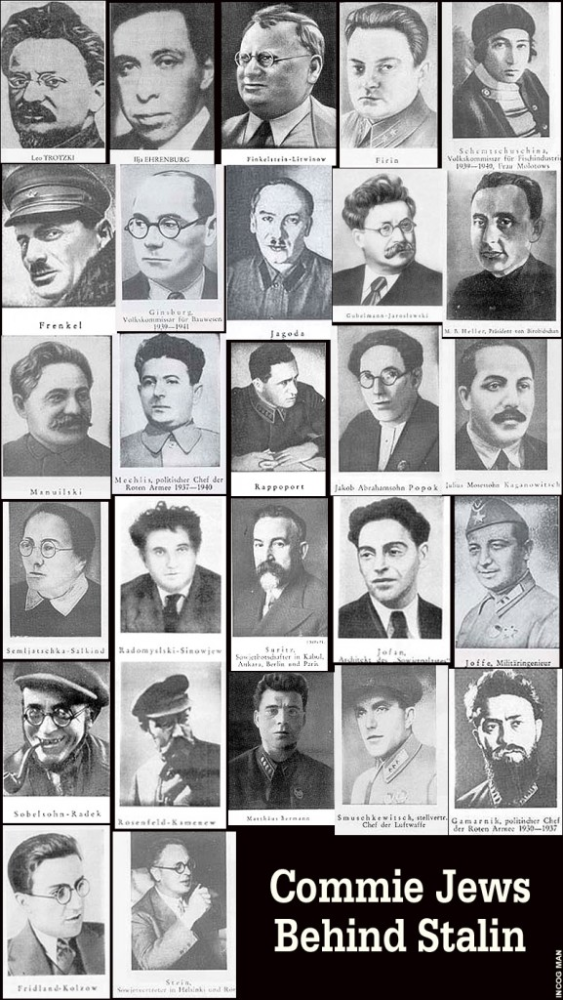
1918-
“Six million souls” need a billion dollars.
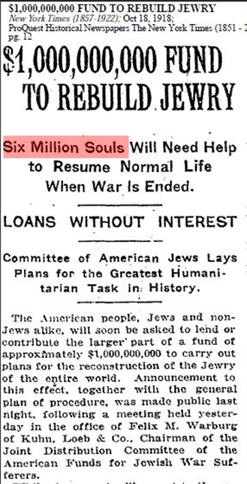
The British take control of Palestine, and occupy the country militarily. Eventually the British Mandate for Palestine is administered, against the will of the Arabs living there.
This same year Jewish Communist leader Grigory Zinoviev announces plans for the annihilation of 10,000,000 Russians.
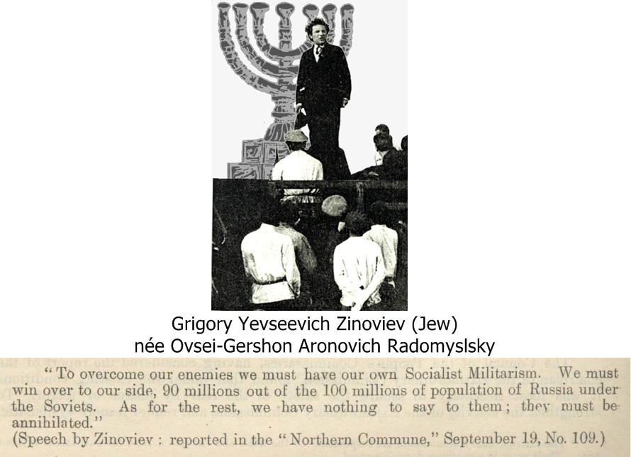Jewish Communists plot genocide of Russians. They put out stories of Jewish persecution at this same time to hide their blood-curdling atrocities in Russia.
1919-
Shortly after the end of World War I hostilities, Zionists claim a “Holocaust” of “Six Million Jews” is imminent in Europe in a deceitful campaign to raise money for Jewish charities and also to distract public attention from the Jewish origins of Communism, the Bolshevik atrocities in Russia and the Armenian Genocide.
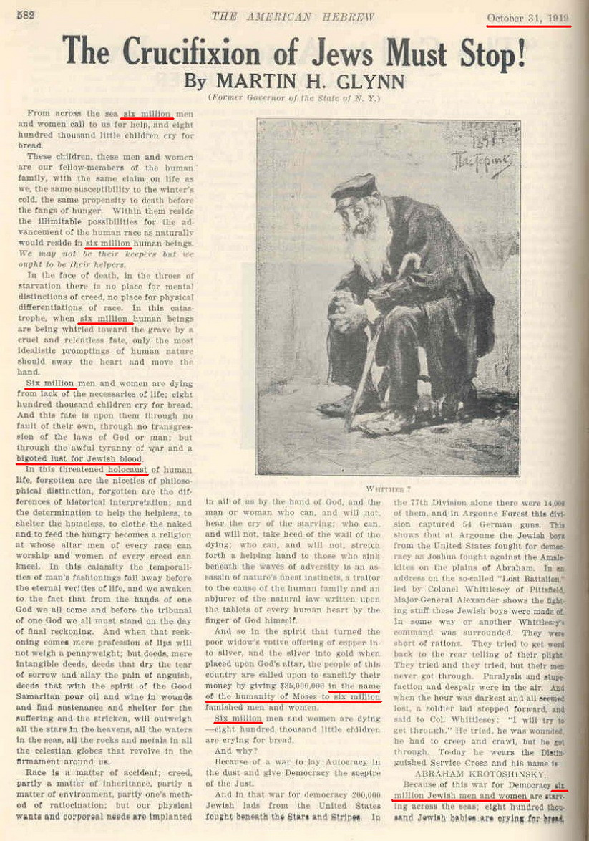The first reported “Holocaust” of “Six Million Jews.” Nothing more than Zionist propaganda.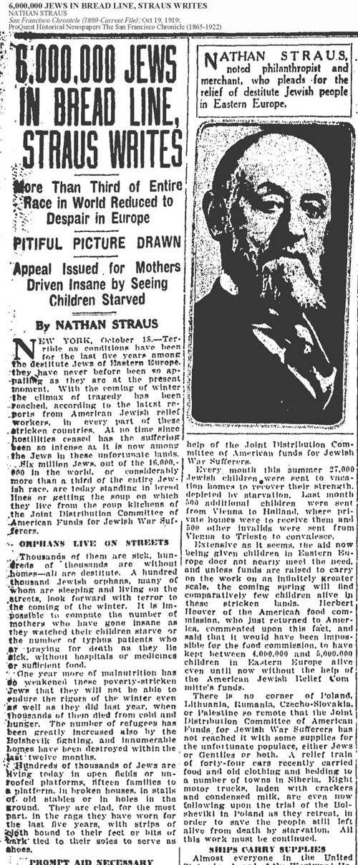Elder of Zion Nathan Straus published this article in the San Fransico Chronicle claiming 6,000,000 Jews were in peril.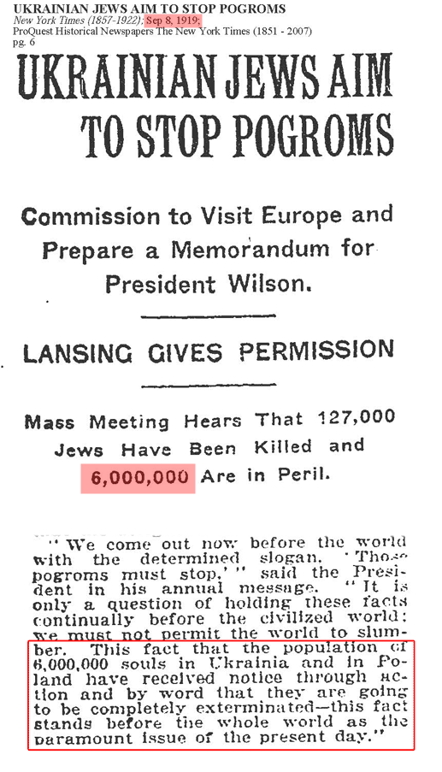More persecution propaganda in the same year. Again “6,000,000 Jews” as victims, of course.
Full article of above clipping
1920-
A Jewish relief campaign advertisement states: “Today 6,000,000 Jews are facing the darkest days ever known in the history of the race.”
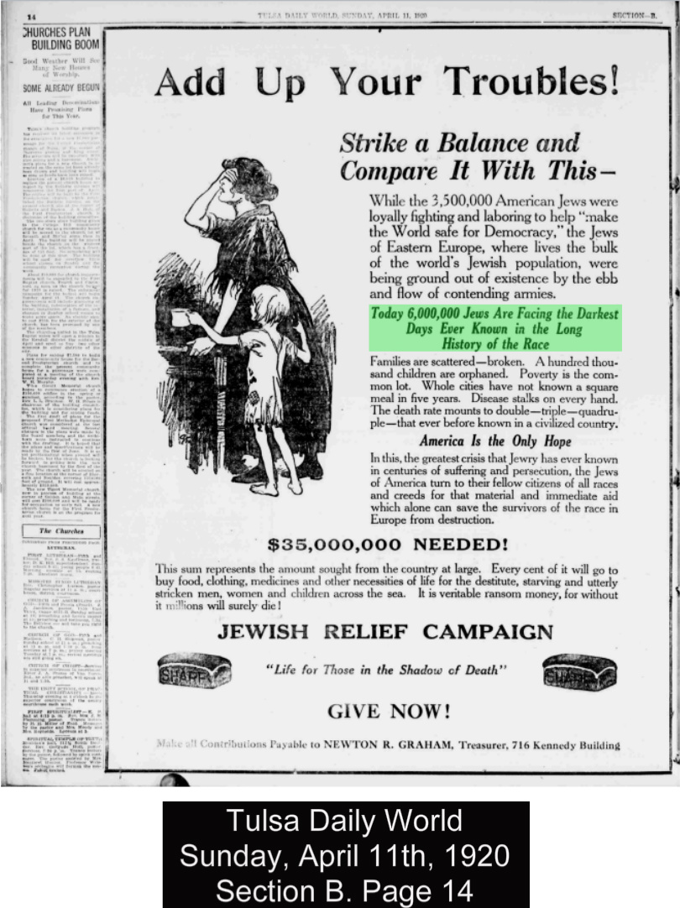
1921-
Russian patriots gain ground on the Jewish Bolshevik usurpers of their nation. In a vein attempt to hide their heavy involvement in the brutal Bolshevist atrocities being committed in Russia, Jews reel out the “six million” myth once again.
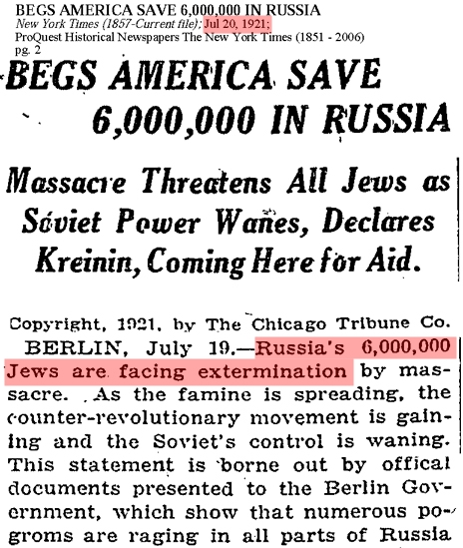
1922-
Zionist leader, Nahum Sokolow, boasts about Organized Jewry’s globalist ambitions when, at a Zionist conference in Carlsbad, California, he proclaimed: “The League of Nations is a Jewish idea, and Jerusalem some day will become the capital of the world’s peace.”
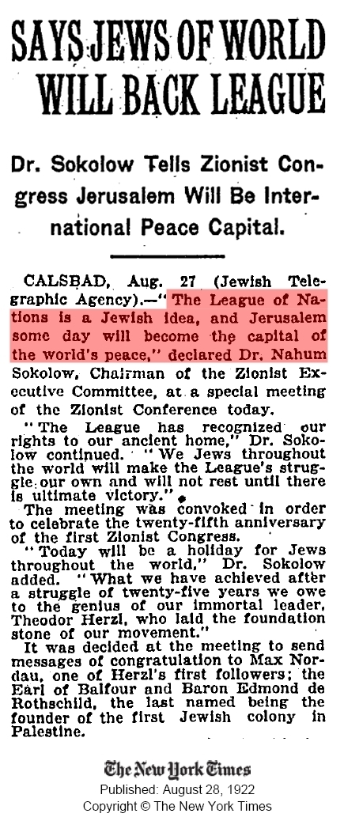
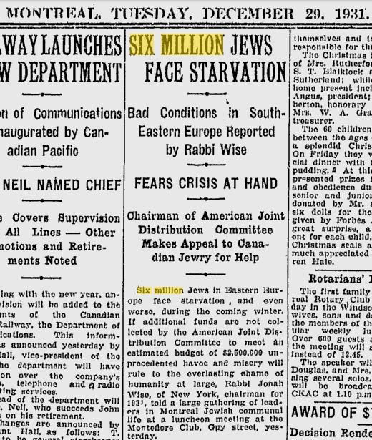Six Million again. Jews demand that Gentiles hand over their food to the poor, innocent Jews while they murder millions, and ship millions more off to Gulag slave camps in Communist Jew-controlled Russia.
1932-
Jews commit a deliberate genocide. To put down nationalist resistance to a Communist takeover, Soviet Dictator Josef Stalin orders the Jewish-dominated Soviet Secret Police (NKVD) to orchestrate a man-made famine in the Ukraine. Stalin’s Jewish deputies and secret police chiefs (Kaganovich, Beria, Yagoda, etc) ruthlessly implement the murderous starvation policy. Between six and seven million Ukrainian men, women and children, are annihilated in this genuine Holocaust. It is now known as the “Holodomor.”
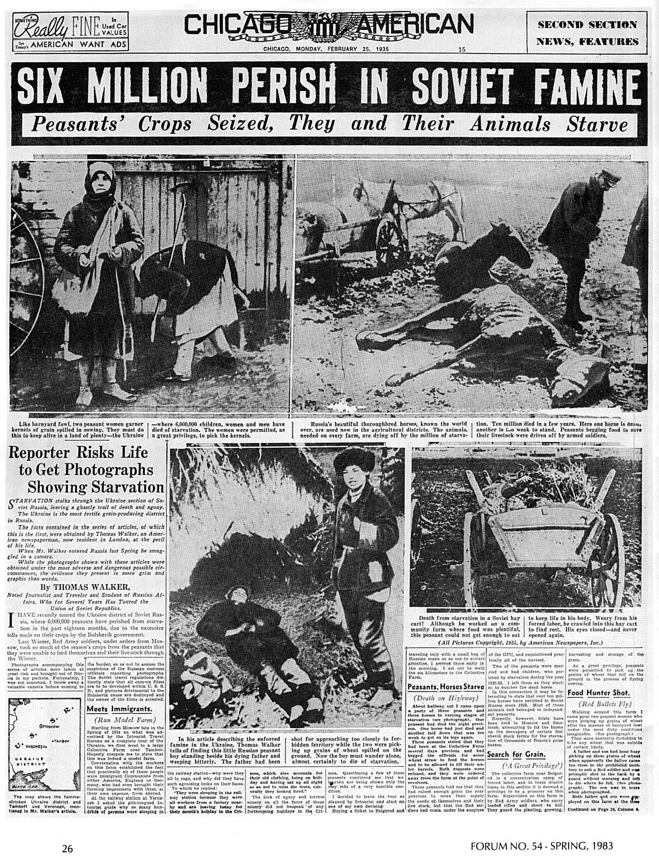
1933-
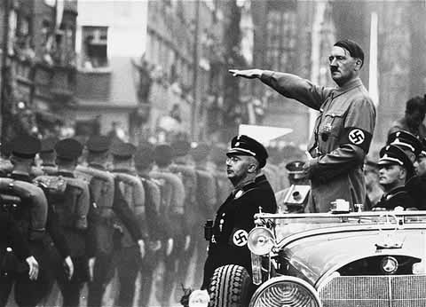Adolf Hitler becomes Chancellor of Germany in 1933. Jews immediately seek his complete destruction.
Hitler comes to power in Germany. Antithetical to Jewish banking interests which thrives off of usury (the lending of money at interest making debt-slaves out of countries), Hitler immediately begins printing his own state-controlled, labor-backed currency and thus breaking the death-grip of the monolithic Jewish banking establishment of Europe, led by the Rothschild’s and the Warburg’s. Hitler also removed Jews from all positions in government, media, education and banks, which they had been dominating up until that point.
Because of this World Jewry declares war on Germany in 1933. Jews around the world launched a global economic boycott of German goods in an effort to economically strangle Germany to death and topple Hitler’s new government.
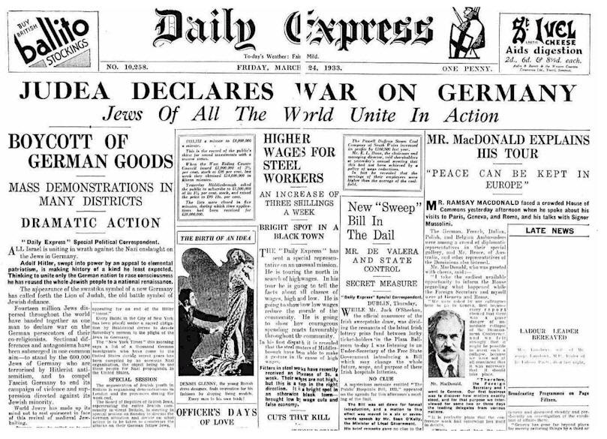Jews don’t like it when Gentiles revolt against their tyranny and control. Their motto is: be our slave or be dead.
This act of treachery leads to widespread dislike of Jews in Germany and foments tension between Jews and German Gentiles. For this act, and for the Jews’ well-known support for Communism and substantial involvement in the bloody Bolshevik Revolution, the Nazis declare Jews “enemies of the state” eventually interning them in concentration camps and labor camps during the Second World War. Almost the same thing happened to Japanese-Americans after Pearl Harbor. Although, unlike the Jews, Japanese people never waged an economic war on America, they were interned in American concentration camps simply for their ethnicity.
1936-
As early as 1936, Zionists who originally coined the phrase Final Solution of The Jewish Question, somehow knew exactly 6,000,000 Jews had “neither hope nor future.”
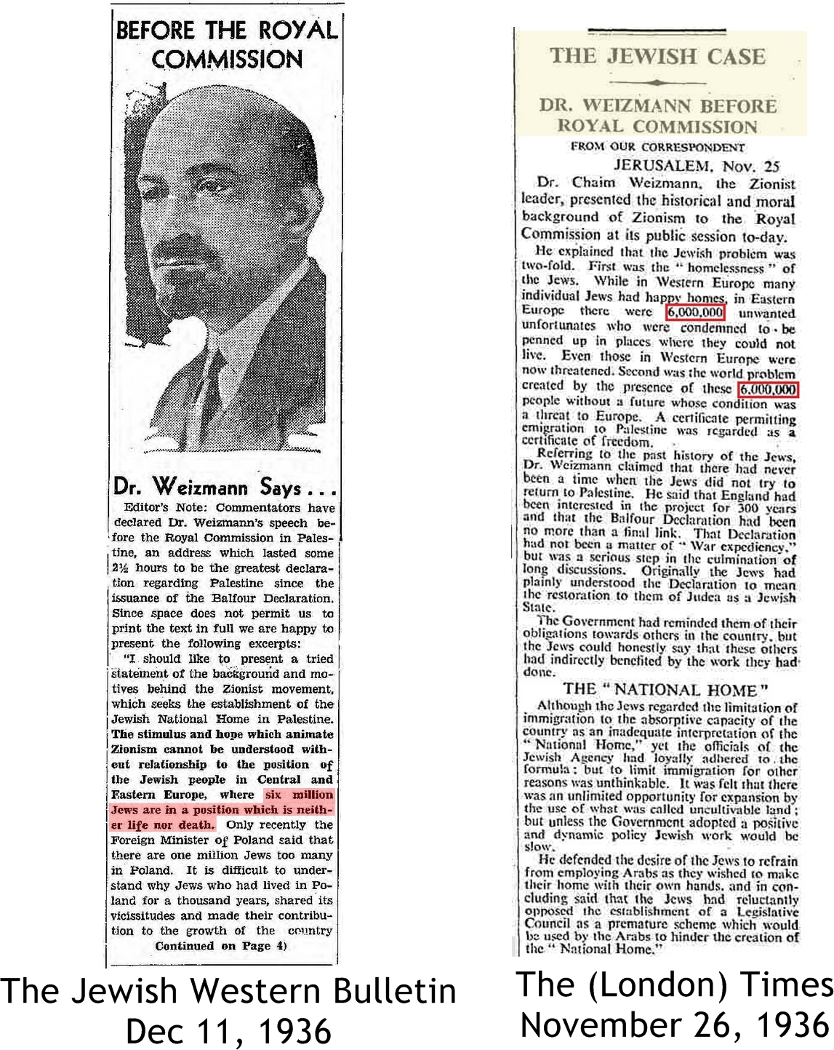Appearing before the Peel Commission, World Zionist Organization chairman, and first Israeli president, Chaim Weizmann, declares that “6,000,000 Jews are destined to be imprisoned,” (in Europe) “where they are unwanted.”
Jews continue to agitate for Palestine. The New York Times reported that Zionist groups were desperately lobbying American Christian leaders, Christian organizations, and the British government, demanding assistance in the creation of a “Jewish nation in Palestine” to save the Jews from “the European Holocaust.” These strikingly prophetic statements were made years before the creation of ghettos or concentration camps and over three years before the German invasion of Poland.
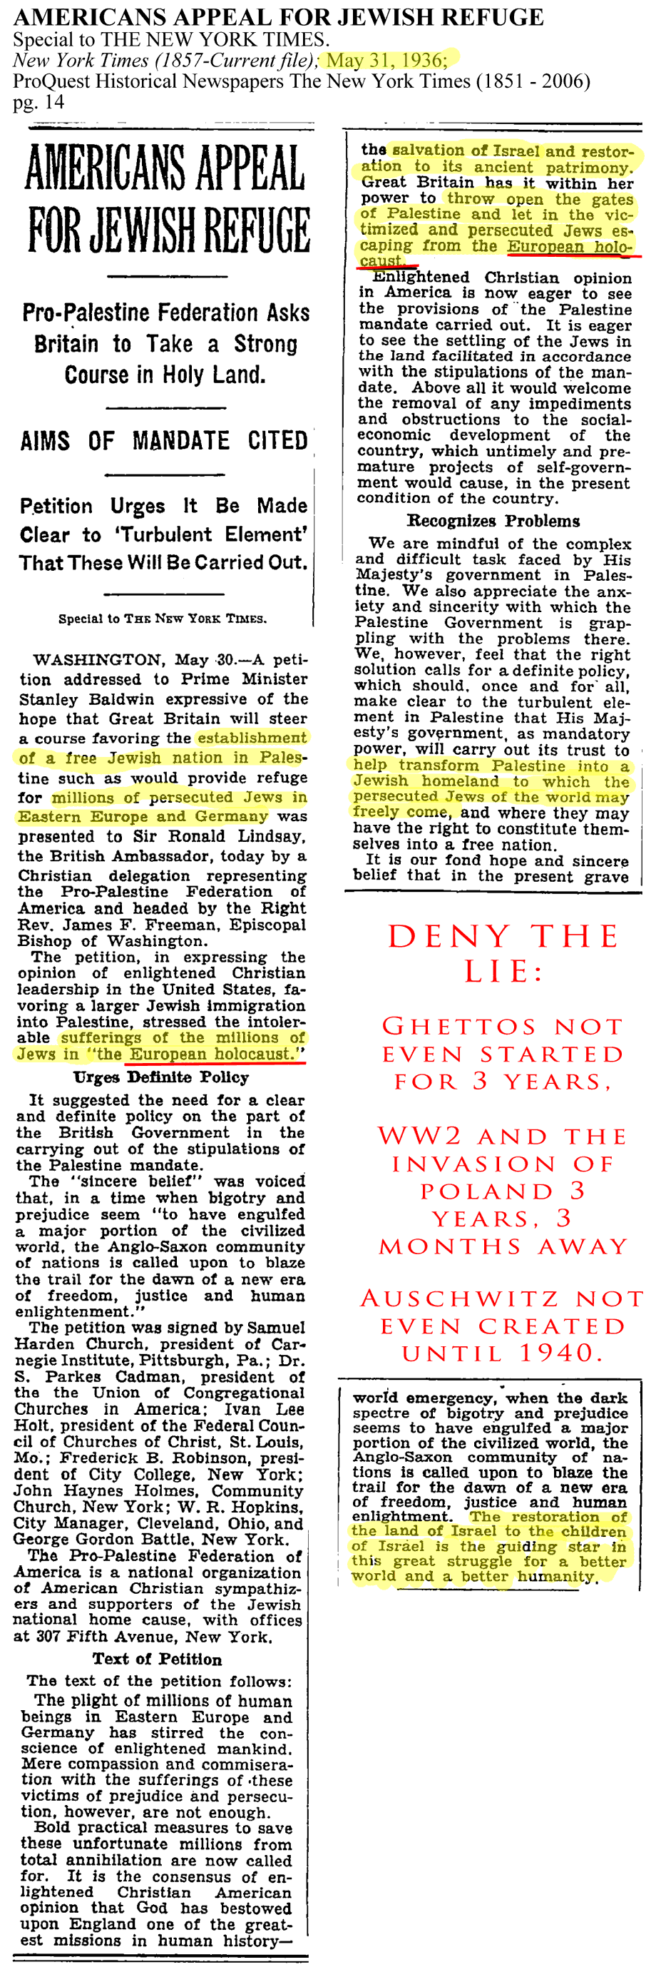
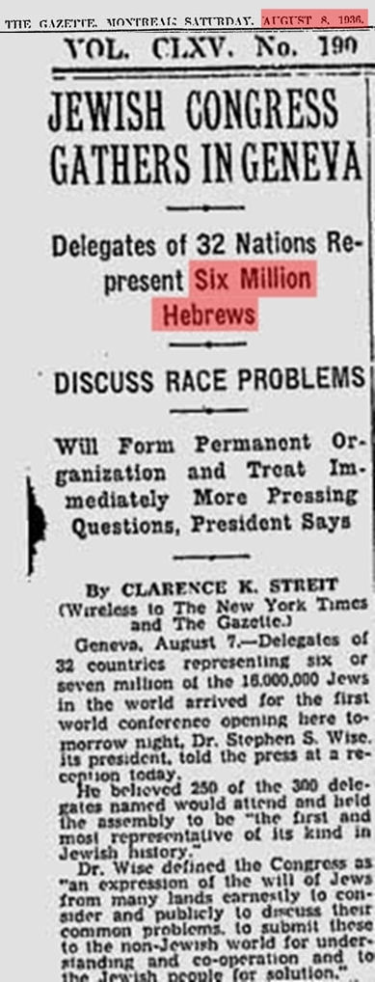Jewish leaders meet to discuss their schemes, swindles and sinister conspiracies. “Six Million Hebrews” is mentioned in the article title.
View full spread
1938-
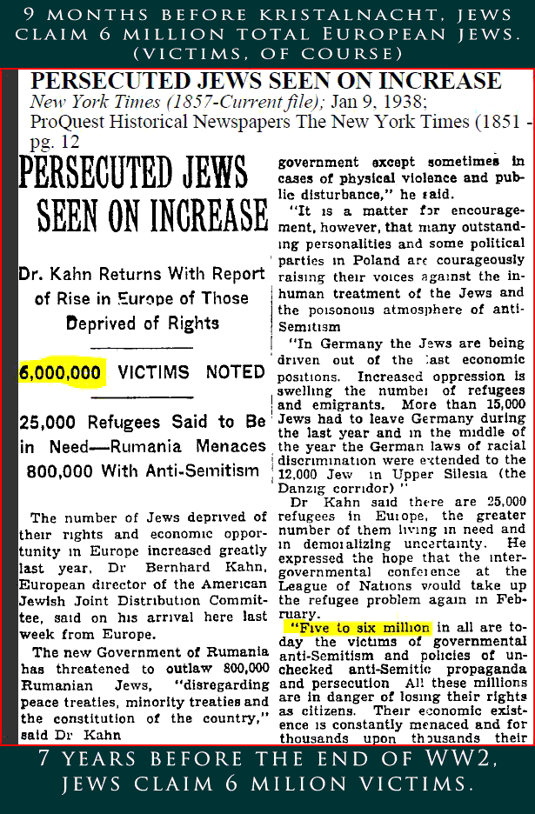Jew propagandists amp up the “Six Million” b.s. as World War II draws closer.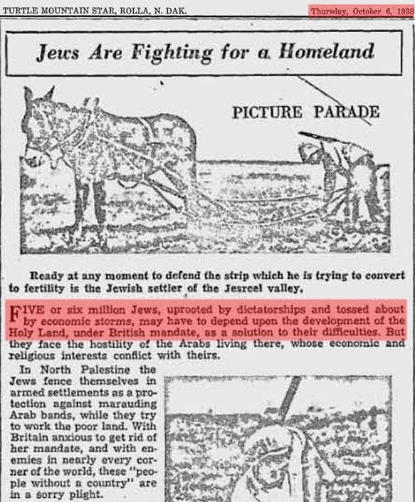This article references “five or six million Jews uprooted by dictatorships” and calls for them to be settled in the “Holy Land” (Palestine).
View full spread
1939-
Poland, under British influence, refuses to concede to Hitler any of his relatively modest territorial demands. Hitler sought to recover the territory stripped away from Germany and given to Poland at the end of WWI; specifically the formerly German city of Danzig. Hitler also demanded an autobahn in the Danzig corridor connecting the German mainland to East Prussia. Poland categorically refused all of Hitler’s somewhat reasonable demands.
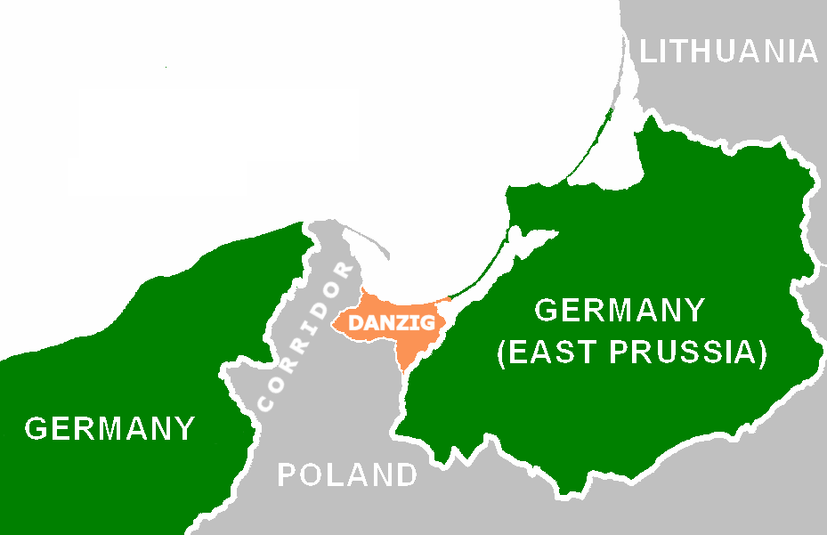Hitler wanted back the German city of Danzig and an autobahn through the Danzig corridor connecting the German mainland to East Prussia. Poland, under British/Jewish direction, refused to acquiesce to Hitler’s modest demands.
In September Poland is invaded from the west by Germany and from the east by the Soviet Union. Britain and France immediately declare war on Germany, supposedly because of Hitler’s invasion of Poland. However, Britain and France didnot declare war on the Soviet Union who also had invaded Poland and then attacked Finland a few months later.
The reason the Allies only found fault with Germany for invading Poland, and not the Soviets, was because the USSR was under Jewish rule, and had been since 1917. The purpose of WWII all along was not to free Poland but to destroy Germany, who had broken loose from the grip of the Jews. The Allies, who originally claimed to be concerned for Poland’s sovereignty, dumped Poland, along with the rest of Eastern Europe, off to the Soviet-Communist butchers at the end of the war! This Allied betrayal proves that the Allies never cared about Poland at all. Poland was nothing more than a pawn used by the Allied warmongers to sucker the Third Reich into a war.
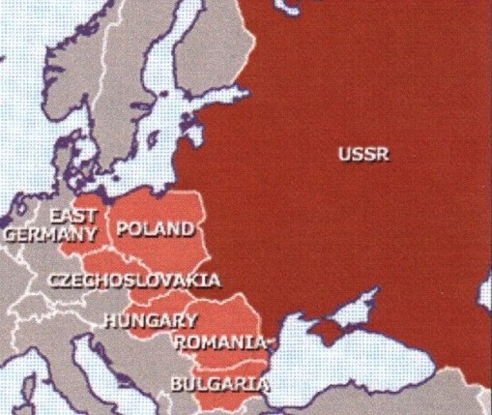The Allies, who waged war on Germany in 1939 using as a justification the excuse that Germany breached Polish sovereignty by invading, DUMPED Poland off to Stalin and the Communist butchers who had murdered 22,000 Poles in the Katyn Forest in 1940!
Meanwhile Jews were whining about “Six Million” helpless victims in February, seven months before the war even started.
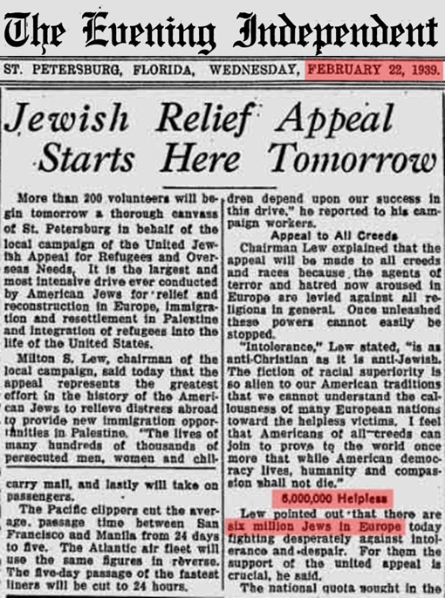Over half a year before the war began Jews were already squawking about “6,000,000 helpless victims of persecution.”
View full spread
Chaim Weizmann turns up again and proclaims: “The fate of six million people was in the balance”
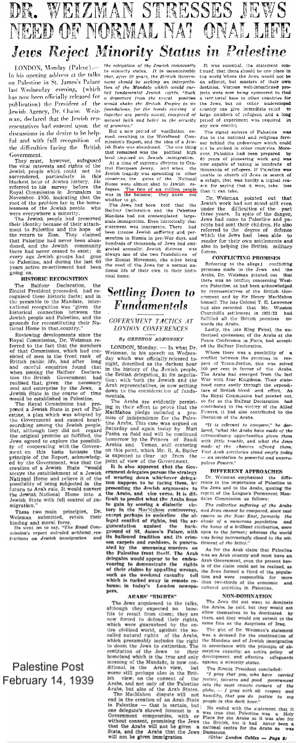
A Jewish newspaper, The Jewish Criterion, predicts that “the coming world war would be the annihilation of six million Jews in East and Central Europe.”
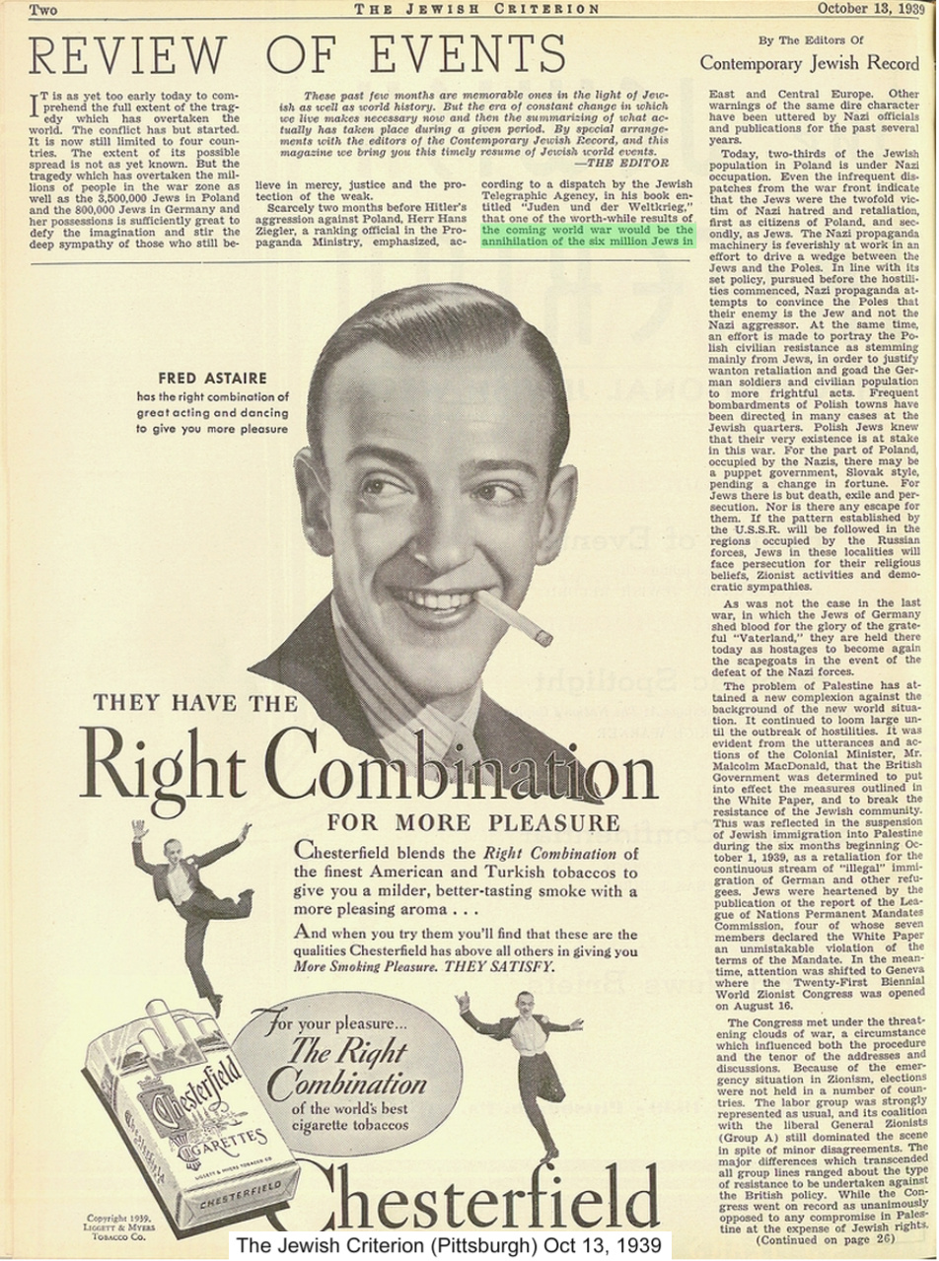More “six million” references from this paper.
1940-
Jewish leader Nahum Goldmann predicts “Six Million” Jewish victims before Nazi concentration camps have even fully completed construction.
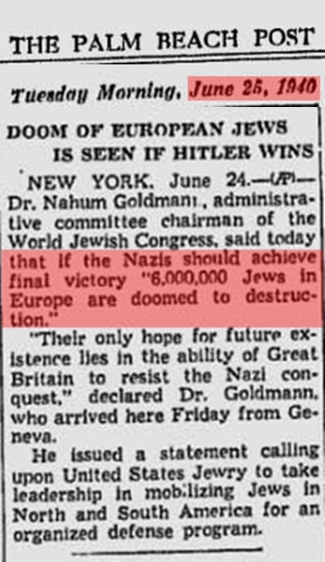
1941-
An American Jew named Theodore Newman Kaufman devises a plan for the extermination of all Germans through forced sterilization. He publishes his evil aspiration to annihilate the German people in a book called “Germany Must Perish!” This Jewish “Final Solution” to Germans is praised by Jewish-owned publications in America.
1942-
British Jew, Victor Gollancz, predicts 6,000,000 Jewish deaths.
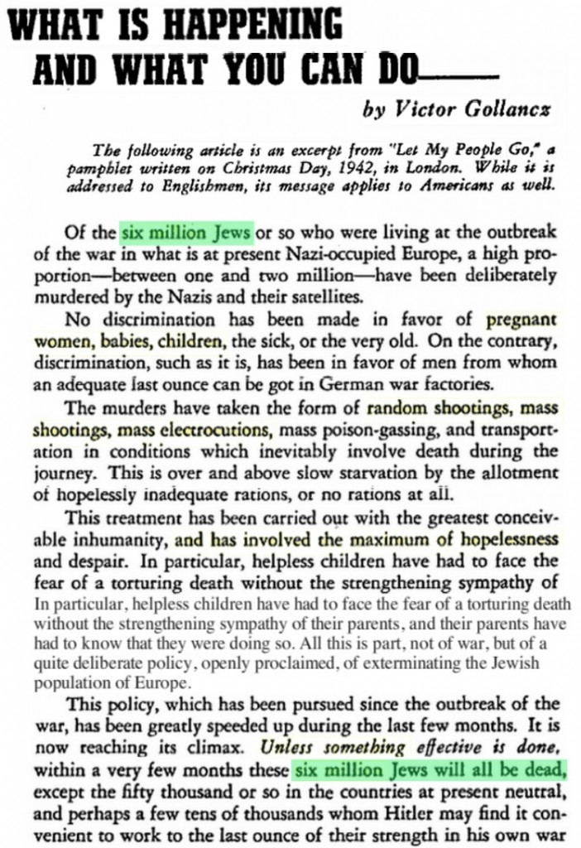
1943-
A Zionist organization, The American Jewish Committee, claims the Nazis had set in motion a plan to kill 6,000,000 Jews.
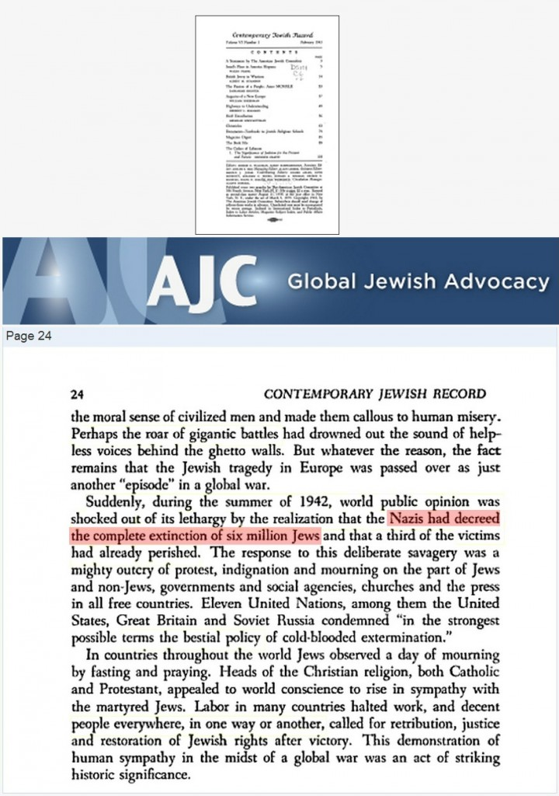Zionist propaganda build up nearing the end of the war.
Ben Hecht, a Hollywood screenwriter and Zionist Jew, floats out the “Six Million” lie in Reader’s Digest Magazine. He would later go on to support the Zionist terrorist group Irgun in Palestine “by writing propaganda and fund-raising.”
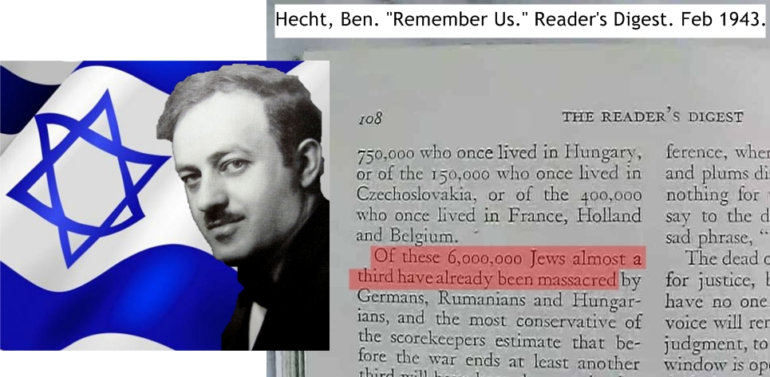
During the Nazi offensive on the eastern front, German soldiers discover the mass graves of some of the 22,000 Polish military officers and intelligentsia who were murdered and then buried in mass graves in the Katyn Forest by the Soviets in 1940. The insidious Allies knew their “gallant Soviet ally” was a mass murderer but kept quiet about it. When it could no longer be kept hidden from the public they then tried to blame the atrocity on the Germans!
1944-
In September of 1944, eight months before the end of WWII, U.S. Communist (Jewish) Union leaders prematurely proclaim that nearly Six Million Jews have been killed, long before that could have been known or calculated.
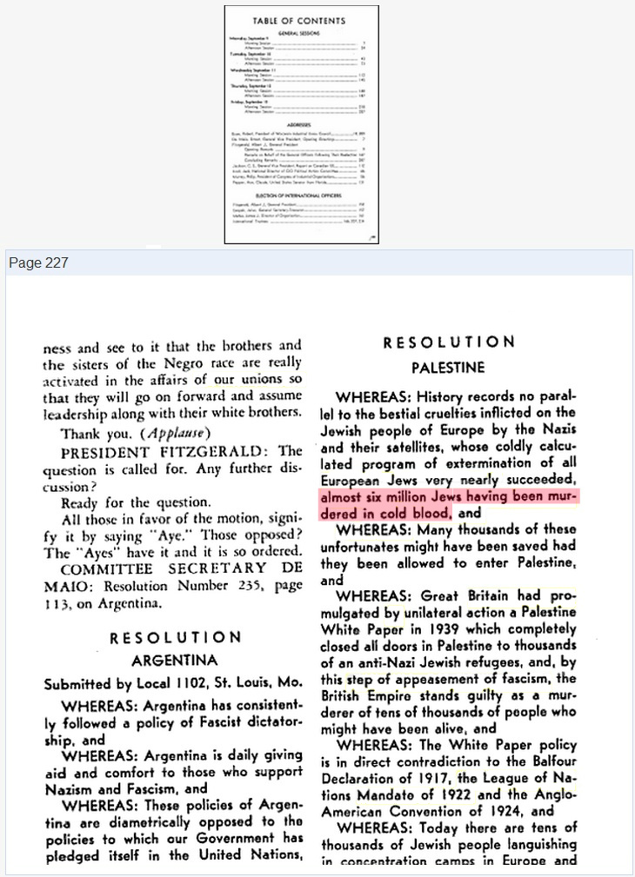
In late 1944, half a year before the official end of the war, at least three newspapers printed stories informing us of the mythical deaths of “six million Jews.” All of these propaganda articles were based on the lies of Ilya Ehrenburg, a Jewish propagandist in the USSR.
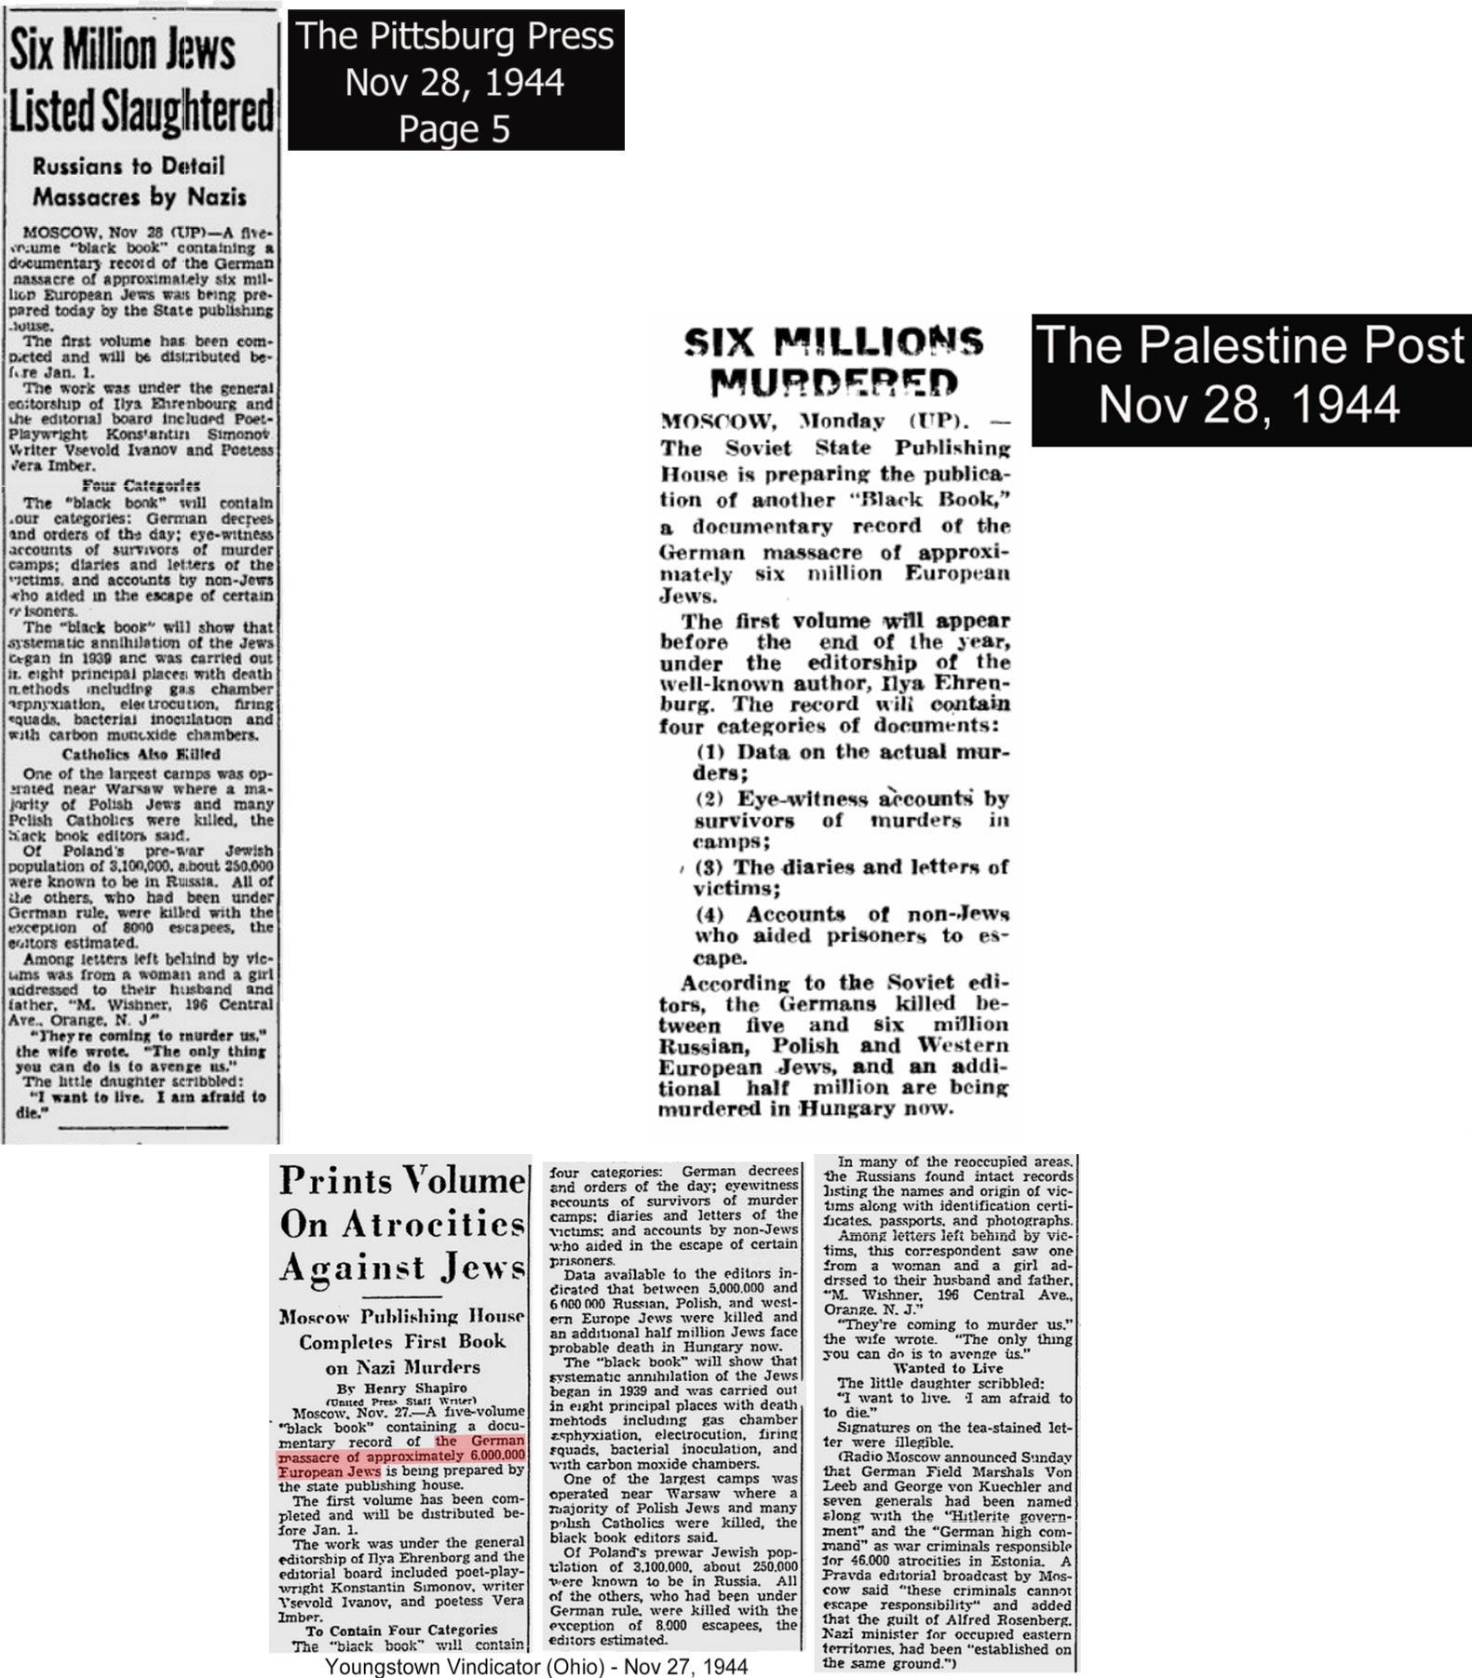
The New York Times reports that Jewish groups were urging the governments of Britain and America to launch gas attacks against the Nazis.
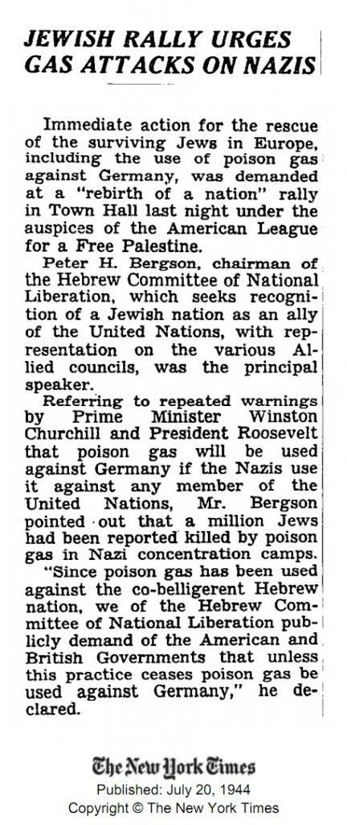
1945-
In January, still many months prior to the end of the war, before any official body count for any group could have reasonably been calculated or ascertained, Zionists proclaim exactly “Six Million Jews” had died. (more premature ’6,000,000 Jews have died’ pronouncements)
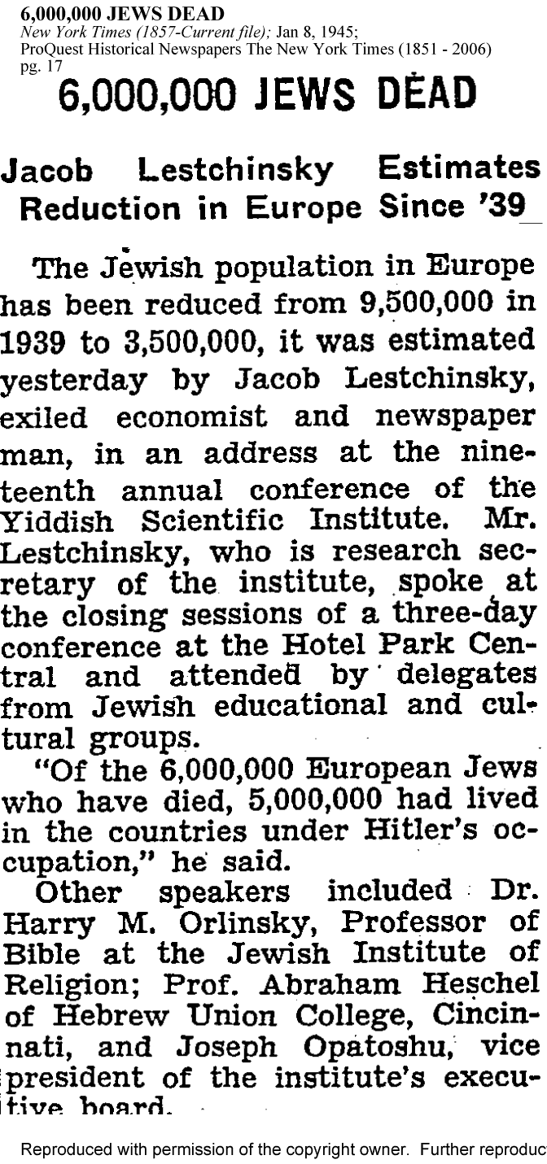
Ilya Ehrenburg, a notorious Jewish Propagandist in the USSR who agitated for genocide against Germans and incited the mass rape of German women by the Red Army, prematurely proclaimed that “the world now knows that Germany has killed Six Million Jews” before anyone could have known that was the number.
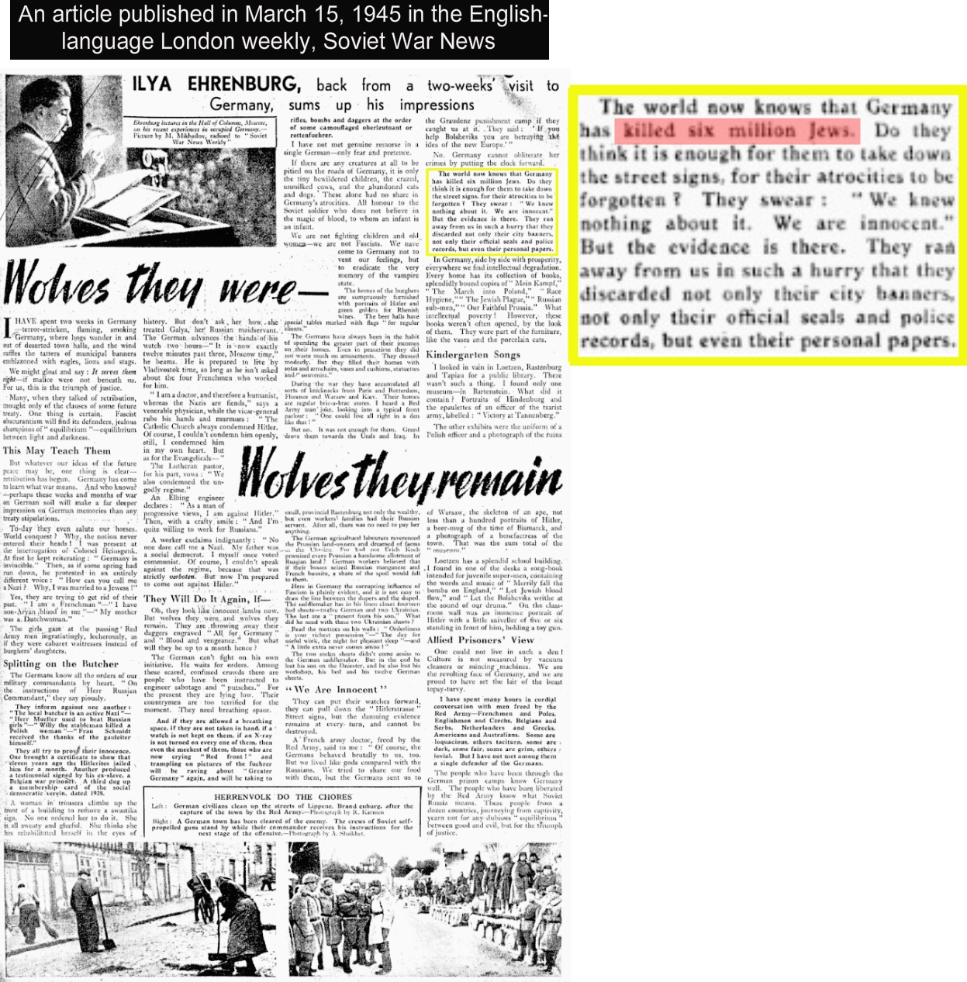Jewish Communist devil, Ilya Ehrenburg, prematurely announces 6,000,000 Jews killed, thus exposing himself as a fraud and the holocaust as a premeditated hoax.
Ehrenburg, along with another Communist Jew propagandist Vasily Grossman, are considered by many revisionists to be the brains behind the Holocaust Hoax. Together they penned “The Black Book,” a work of pure fiction inundated with unconscionable anti-German hate propaganda horror stories that are physically impossible, and have since been thoroughly discredited.
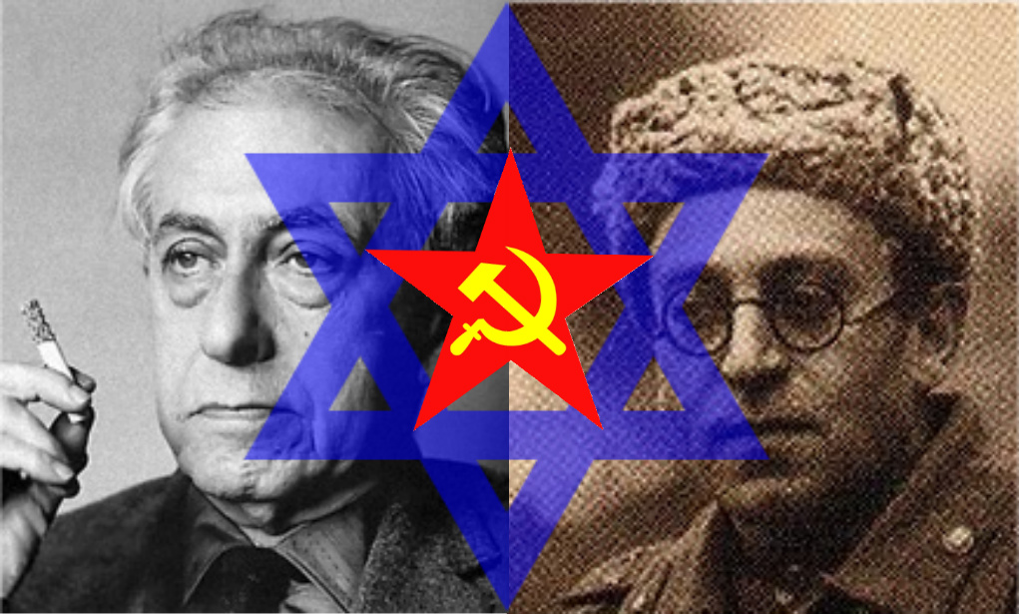Communist Jew demons, Ilya Ehrenburg and Vassily Grossman.
At a March 1945 Congressional Hearing, Joseph Thon, representing The National Organization of Polish Jews in America, stated to the committee:
“The German people murdered, in cold blood, in excess of 6,000,000 European Jews … I accuse the whole German people that in the years 1939 to 1945 they slaughtered upward of 15,000,000 men, among which there were 6,000,000 Jews.”
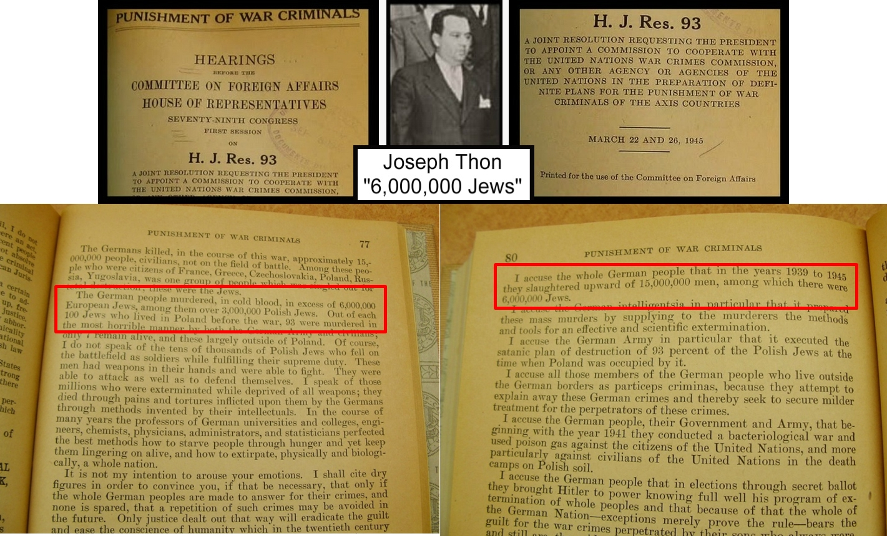Zionist liar, Joseph Thon, let slip the “6,000,000 Jews have died” hoax a bit too early. These Jews just can’t help themselves can they?
More newspaper clippings from 1945 telling us exactly 6,000,000 Jews had been killed, before any official body count could have been accurately ascertained.
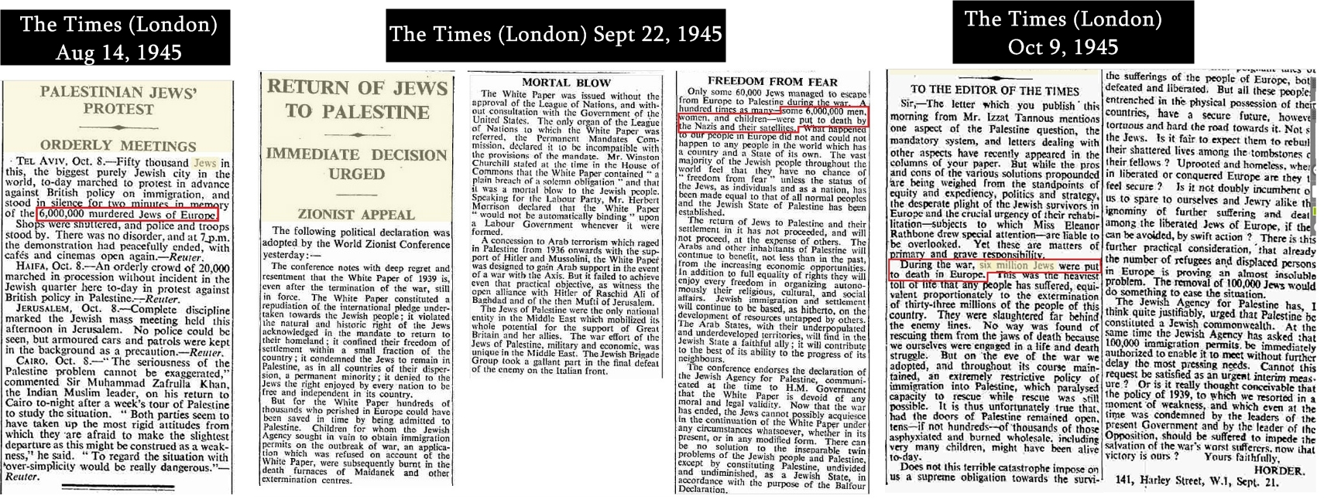
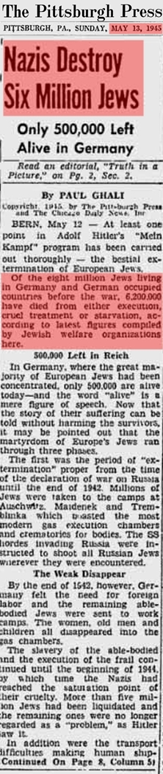
In May of 1945 the New York Times reported that “more than 6,000,000 people” had been “liberated” from Nazi concentration camps.
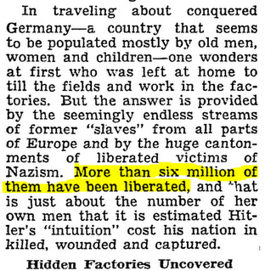The New York Times reports 6,000,000 had been liberated, not killed. OOPS!
Read full article
1946-
A year after the war Jews are already spouting the “six million” myth as fact.
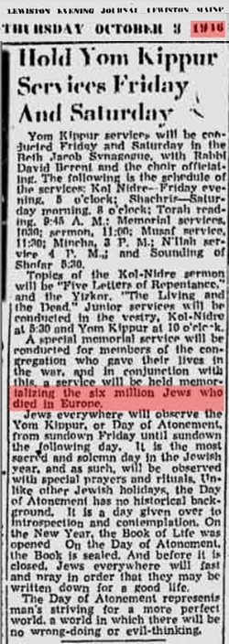
Meanwhile, as the Jews whine about a phony Holocaust in Europe, Zionist terrorist groups wreak havoc in Palestine slaughtering Arab men, women and children, at will, like the massacre at Deir Yassin.
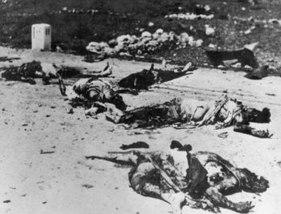Inhuman Jewish terror agents of the Irgun ruthlessly slaughtered Arab women and babies, then mutilated their corpses in the Palestinian village of Deir Yassin.
In 1946, Jewish Terror agents from the cutthroat Irgun terrorist network in Palestine, led by the mass murderer Menachem Begin (who would later become the Prime Minister of Israel), blow up the King David Hotel, disguised as Arabs. 91 people are killed, 28 of the victims were British officials. The British were the real target of the bombing as the hotel was the headquarters for the British military command.
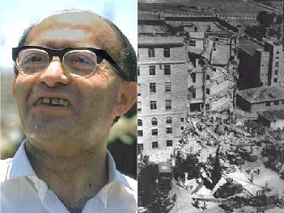Begin the beast; terrorist leader of the Irgun; mastermind of the King David Hotel bombing in 1946 and other atrocities; Prime Minister of Israel. A complete animal.
1947-1949
Over the course of two years Zionist Jews obliterate 419 Arab villages and build Jewish settlements in their place. This process of ethnic cleansing of Palestinians from their own homeland by Jews continues to this very day.
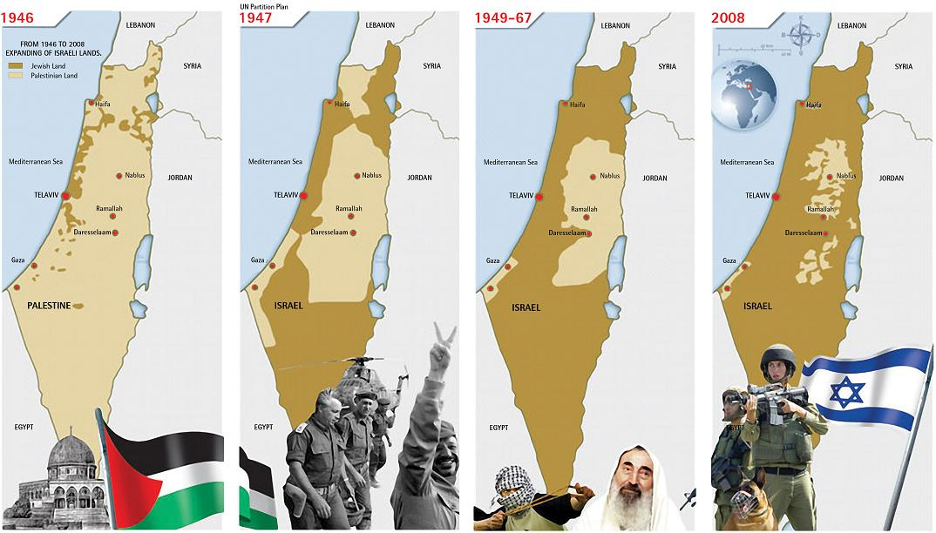The Zionist colonization and ethnic cleansing of Palestine — a crime against humanity that goes unpunished and is, in fact, supported by many Western governments.
1963-
The Encyclopedia Britannica prints its 1963 edition, within which it states that 2,000,000 people, mostly Jews, were exterminated by the Nazis in Mauthausen, a concentration camp in Austria. This absurd figure has been officially revised quite a lot. Now it is claimed that only 95,000 people died in Mauthausen, of which only 14,000 were Jews. An exaggeration of 1,905,000! (more info) This camp is no longer considered by official sources who support the holocaust legend as an “extermination camp,” nor is it still claimed that any camps on German soil were either.
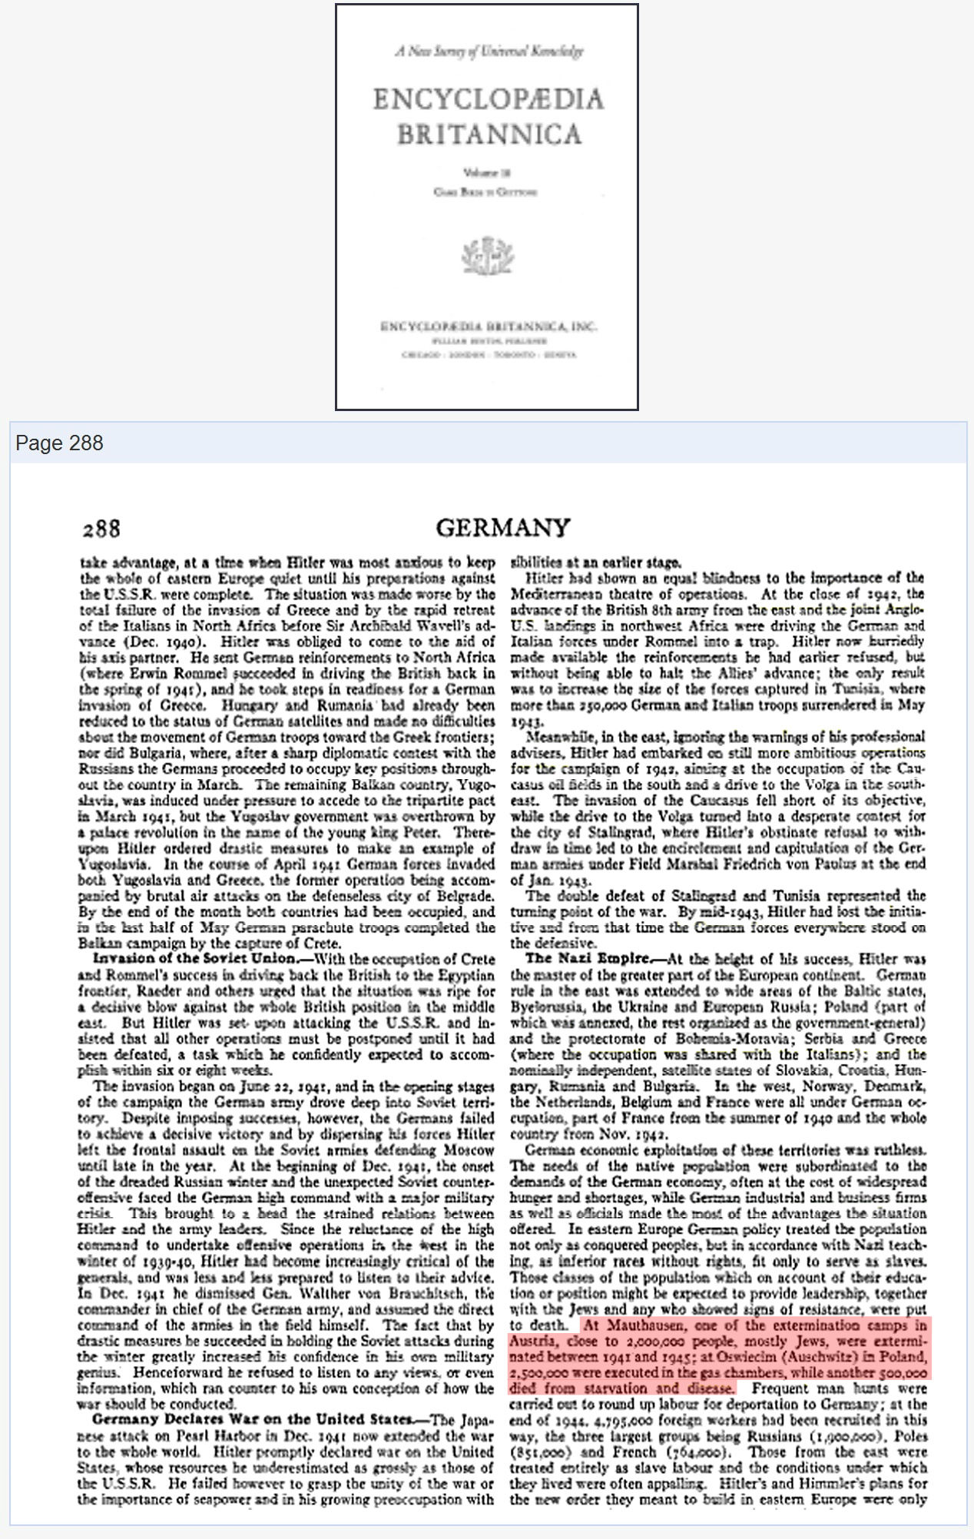
1976-
The influential Zionist leader Nahum Goldmann, co-founder and long-time head of the World Jewish Congress, publishes a book about Jews, The Jewish Paradox. In the book Goldmann candidly admits on pages 122 and 123 that years before the end of the second World War two influential co-conspiring Jews conceived the idea of a post-war Nuremberg show-tribunal and “German reparations” to be paid out to the Jews. Goldmann describes how he, and his fellow conniving Zionists at the World Jewish Congress, intended the reparations swindle to finance Jewish settlement in Palestine after the war.
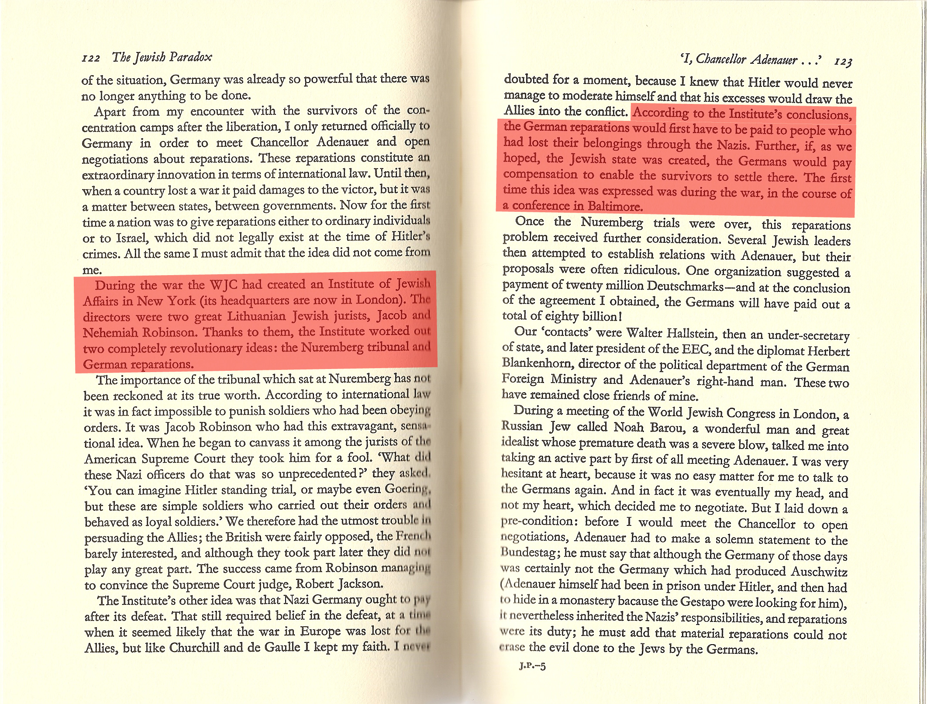Goldmann admits the swindle.
1990-
The Allied Nuremberg Trial indictment charged the Nazis with murdering 4,000,000 people at Auschwitz. This figure was printed on the plaques displayed to tourists visiting Auschwitz, and the figure was repeated as “fact” by governments, historians, journalists, politicians, and all authority figures, for 45 years. In 1990 it was all exposed as a big lie when the Auschwitz State Museum officially revised the death toll from 4,000,000 down to 1.1 million, of which 960,000 are claimed to be Jews. (source)
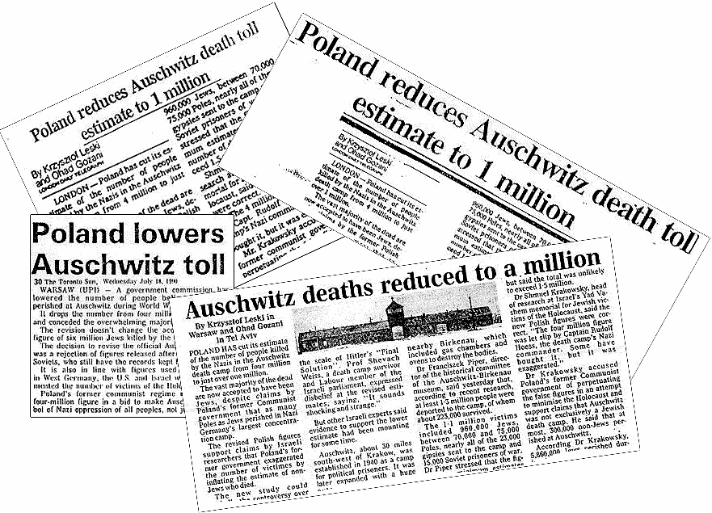Auschwitz death toll reduced to a million, yet sacred “Six Million” figure remains unchanged and is still repeated by Jews.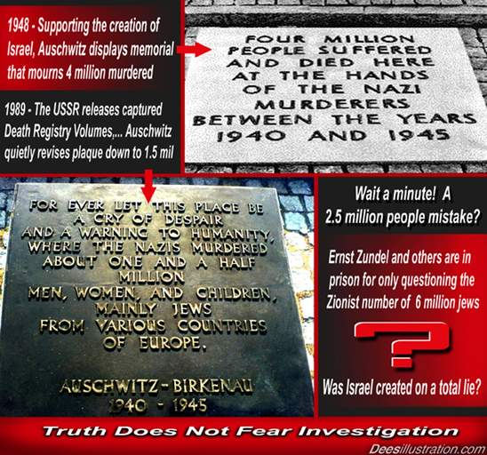The original plaques were removed and replaced with new ones sporting the “new” fake figure of 1.5 million. That’s at least 2.5 million people erased from the official death toll overnight. They can’t even make up their mind about what the new figure should be. This should tell you right away that they are just making it up as they go along.
The Nuremberg Trial indictment charged the Nazis with killing 1,500,000 people at Majdanek, a camp in Poland. This ridiculous figure was conjured by Saul Hayes, a Canadian journalist in the pay of a Canadian Zionist organization, the Canadian Jewish Congress. It is now claimed that only 79,000 people died in this camp, officially. An exaggeration of 1,421,000!
Despite substantial reductions in the official death toll’s of Mauthausen, Auschwitz and Majdanek, the mythical and obviously false “Six Million” figure is never revised and continues to be peddled by Zionist Jews everywhere. That’s because it has religious significance to Jews and fulfills their delusional ancient Torah prophecies. The Holocaust™ is nothing more than a religion to inoculate the “Goyim”.
Also in 1990, another Holocaust myth was vanquished; that being the preposterous lie that the Nazis used the skin of Jews to make “lampshades” and their fat to make “human soap.” Jewish groups in Israel have confessed that this widespread rumor was a myth.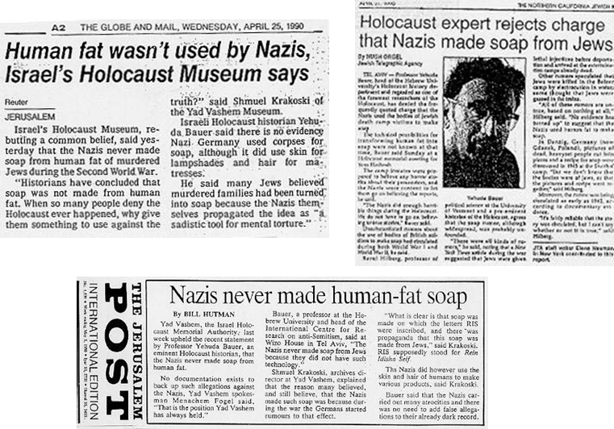
Despite this admission, there are still Jews today going around claiming that this actually occurred.
Two Zionist Holocaust promoters, Deborah Lipstadt and Professor Peter Novick, both have stated in their books that Simon Wiesenthal, the infamous “Nazi hunter” and pathological liar, outright invented the “five million non-Jewish deaths” that supposedly happened in the Holocaust as a marketing ploy to garner interest of Non-Jews in the Holocaust religion, also known as “Holocaustianity.”
The revisionists estimate that the combined death toll in all German concentration camps was somewhere between 300,000 to 500,000. Of that amount about half the victims were Jews. Unlike the comical and discredited “6,000,000″, this figure is based on solid documentation, including the reports released by the International Red Cross who inspected the camps, the Auschwitz death registries released to the Soviet archives in 1990 (which recorded only 69,000 deaths in Auschwitz), and other evidence. The main cause of death was the typhus epidemic and starvation.
After decades of careful forensic investigation, scientific analysis, and intense study, scholarly revisionists have allocated the “gas chambers,” “steam chambers,” “electrocution conveyor belts,” “suffocation rooms,” “pedal-driven-brain-bashing-devices,” “Jew bone powder used for construction,” and other absurdities to the realm of science fiction. (See: Vho.org, Codoh.com, holocaustdenialvideos.com, Winston Smith Ministry of Truth)
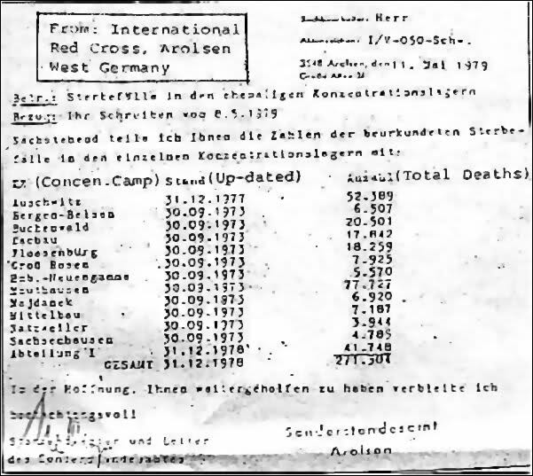A report from the International Red Cross Tracing Service that tallied a total of just under 300,000 German concentration camp victims. Main cause of death: Typhus.
1991-
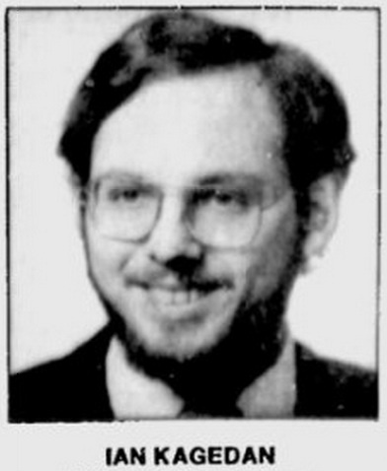
In 1991, a leading Jewish Freemason let slip the agenda behind the Holocaust religion. Ian J. Kagedan, an official for the Canadian branch of B’nai B’rith (a secretive organization founded in New York City in 1843 by Jewish Freemasons), told us:
“Memory of the Holocaust is central to the new world order. …Achieving our quest of a “new world order” depends on our learning the Holocaust’s lessons.”
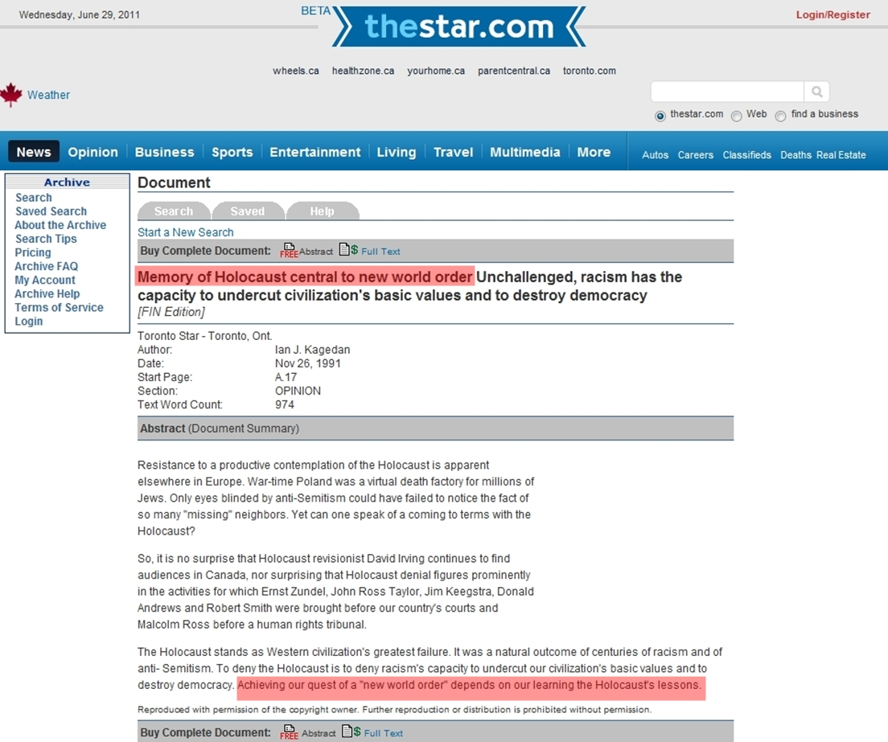Jewish Freemason admits Holocaust story a vehicle for Jewish World Domination.
Fund Raising Fliers-
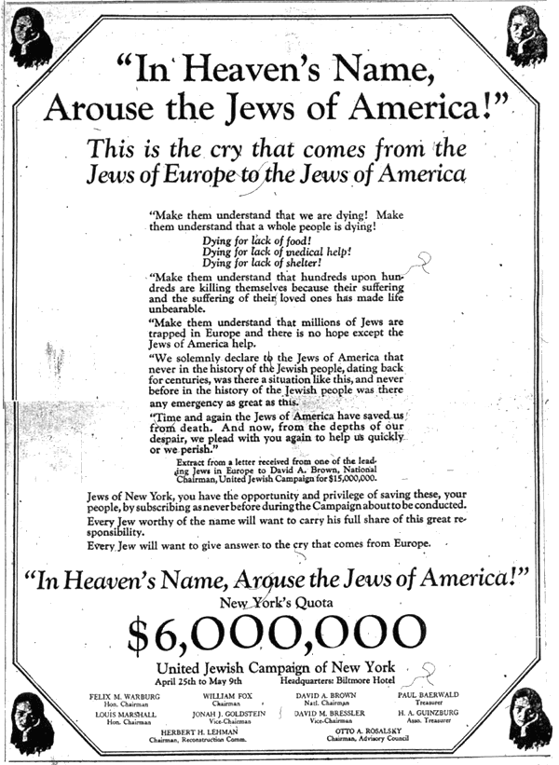
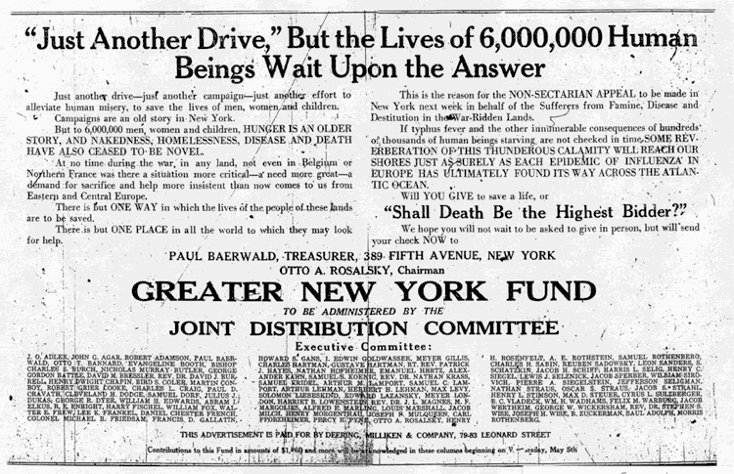
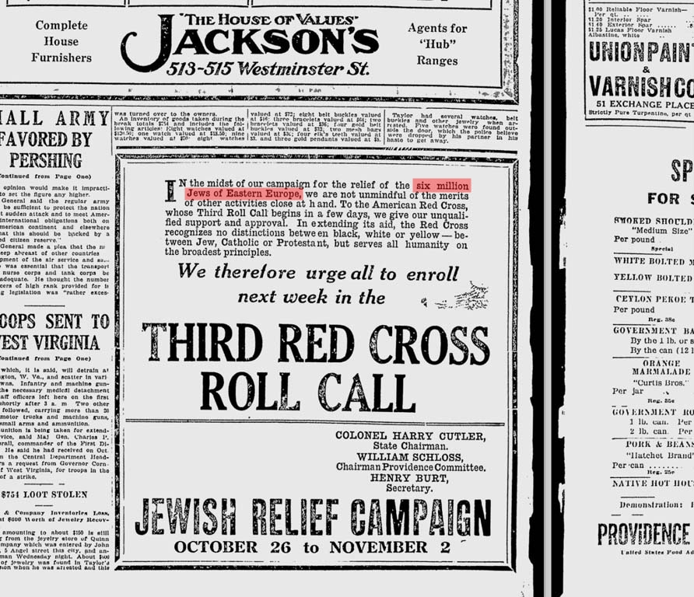
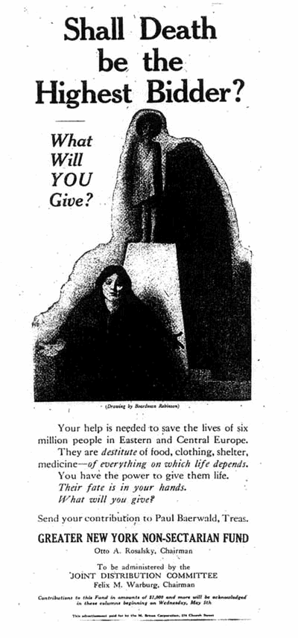
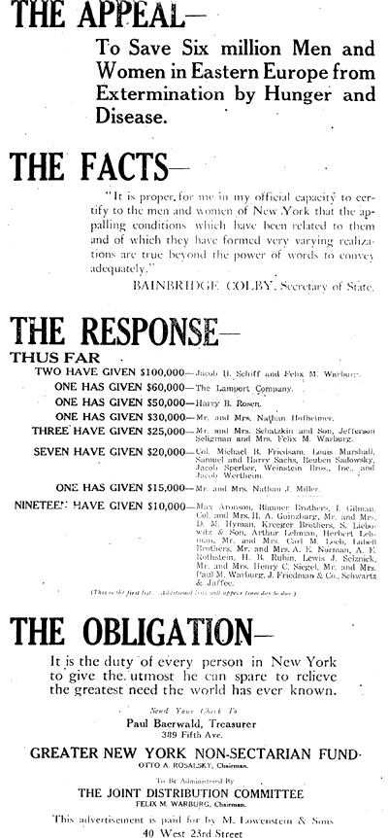
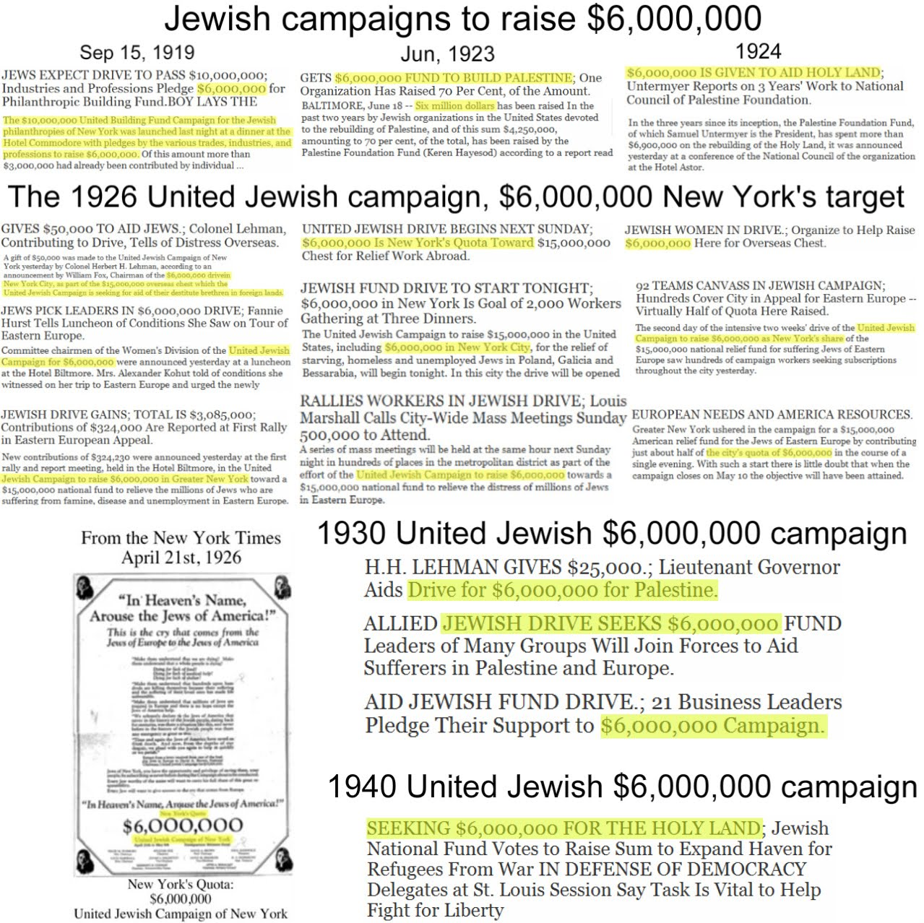Compendium of Jewish fund raising campaigns; 6,000,000 galore. Click to enlarge
New York Times “6,000,000″ References (1869-1945)-
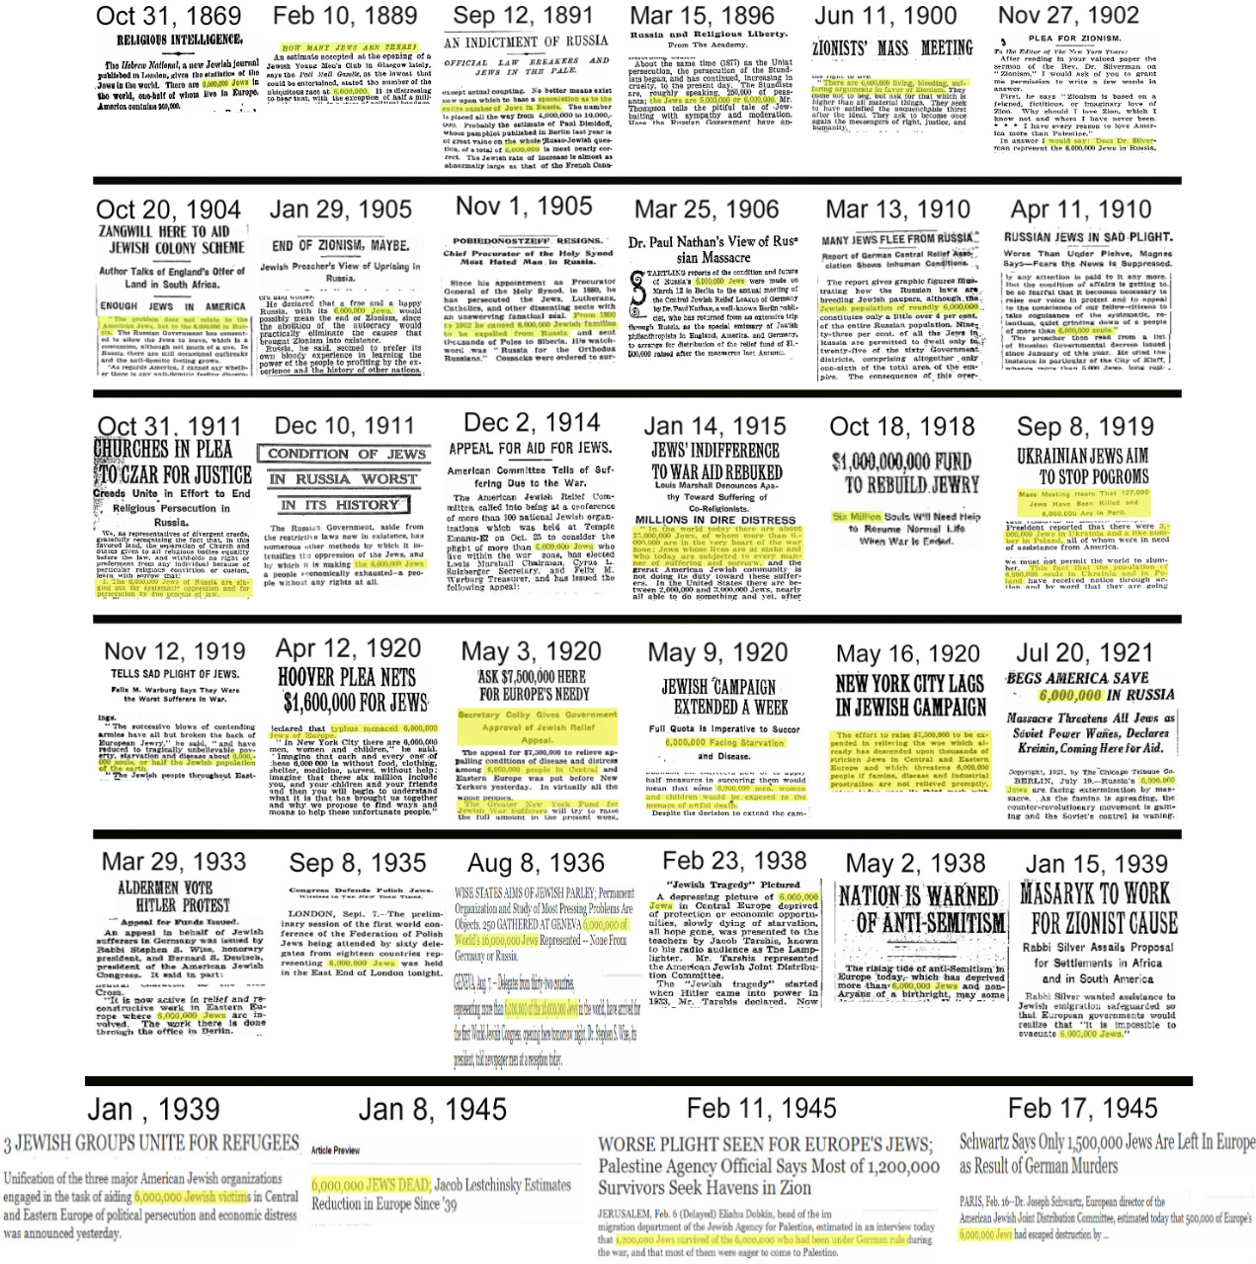34 appearances of the Kabbalistic 6,000,000 figure of Jews in the New York Times from 1869 – 1945 (months before the end of WWII). Click to enlarge.
Five early Jewish “holocausts” in the New York Times-
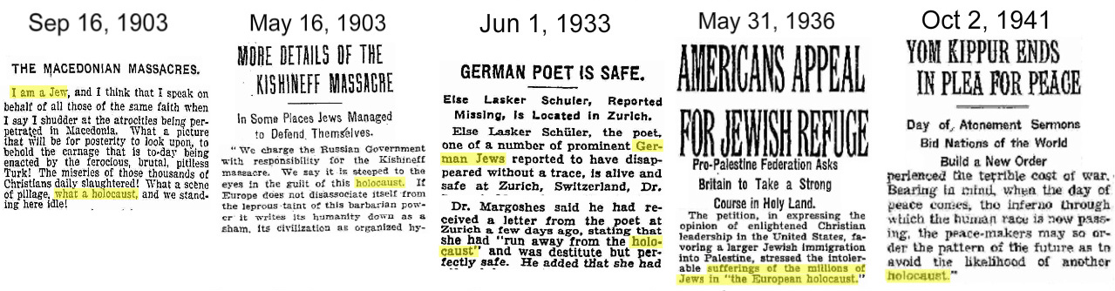Five early Jew holohoaxes. Click to enlarge.
More pre-WWII 6,000,000 References-
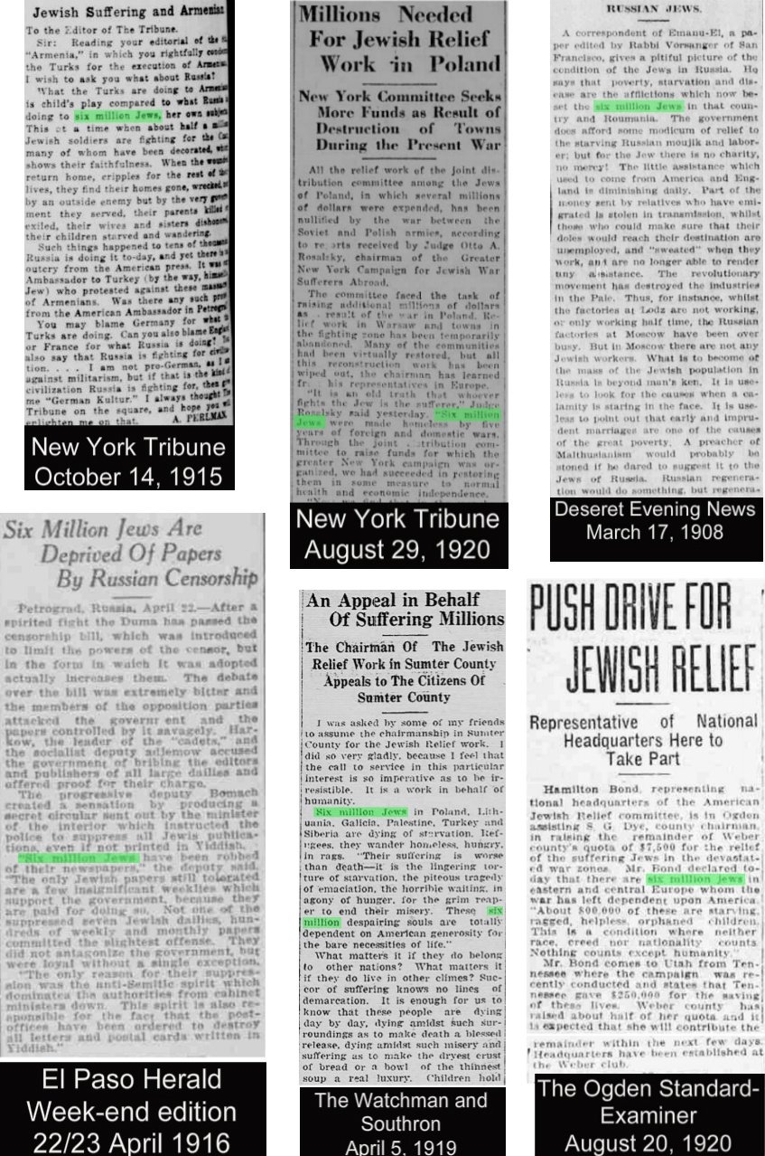
More early hoaxocausts-
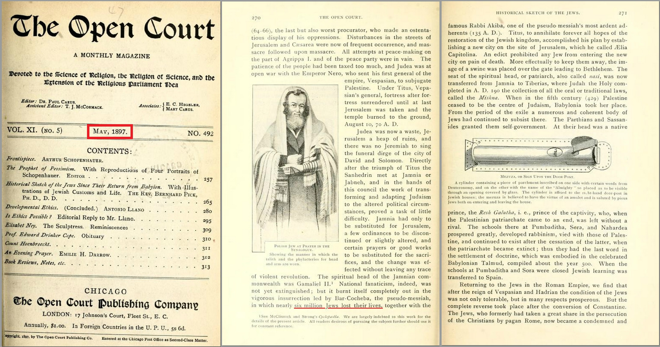This 1897 “Science of Religion” American magazine, claims nearly six million Jews were killed in the Bar Kokhba revolt 132-136AD. What a laugh! Click to enlarge.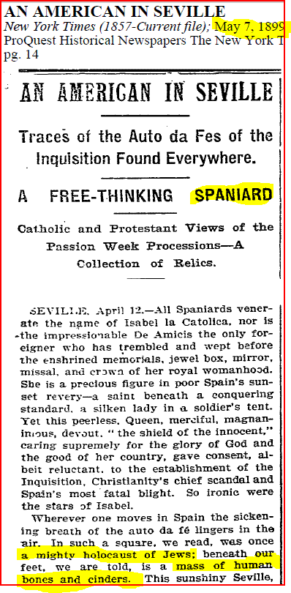1899: New York Times speaks of a “mighty holocaust of jews”. Click to enlarge.
Holocaust Debunking Videos-
One Third of the Holocaust
Judea Declares War on Germany (by Fredrick Toben)
A Holocaust Inquiry (by David Duke)
Truth in History – The Holocaust Lie Exposed (by David Irving)
The Persecution of Revisionists: The Holocaust Unveiled
A Holocaust Debate (Michael Shermer vs Mark Weber)
The Truth Behind the Gates of Auschwitz (by David Cole)
The “Holocaust” Debunked – Ernst Zundel
The Last Days of the Big Lie (by Eric Hunt)
242
SHARES
FacebookTwitterSubscribe
- ← The Life and Times of Leonardo Da Vinci
- Pornography as a Secret Weapon →


renegade
Thanks for being a reader of this site. Your contributions make this all possible. You can send support to: Kyle Hunt, PO Box 1052, Sorrento FL 32776. Bitcoin address: 1AfppjYZddJzc2C15PXKMsnyBPjPJQezwA

You May Also Like
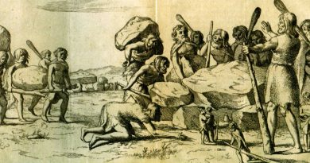

Did Aryan Giants Build the European Megaliths?
February 24, 2018 3


How Russia Stole the Truth Movement
April 23, 2018 10


Henry John Yeend King’s Paintings of Rustic English Farms and Young Women in the Countryside
July 19, 2018 7

11

Leave a Reply
CONNECT WITH:




9

2

1

10


Subscribe
newestoldestmost voted
Guest
Koolz
Not only is six million Jews suffering in Europe a Myth but the whole Jewish Holocaust is a Myth and so is the Stories behind WWI and WWII.
The News Articles that were propaganda for those wars were owned by the very same people who were behind creating the Wars!!
The story of Hitler is also a lie.
The Evil Side won in WWII.
4 Reply
3 years ago
Guest
odinsvengeance
If the Torah prophesy is true, that six million Jews had to be sacrificed as an offering to YHWH before Israel could become a nation, then everyone who believes the Holyhoax to be true– especially Jews and fundamentalist Zionist Christians – should be PRAISING the National Socialist Germans for helping to FULFILL THAT PROPHESY!
3 Reply
3 years ago

Member
Blut und Boden
The Holo[$]hoax and the Phony Six Million
1 Reply
3 years ago

Guest
30.06
A most excellent presentation ! It is so time consuming to compile and layout so much evidence , and to do it so well , a most well deserved Thank You for this work bringing truth to the surface , for those that have not yet been noticing . The Lies Will Not Always Hide The Truth ! https://notimeforsilence.wordpress.com/the-big-lie-holocash/
1 Reply
3 years ago
Member
mothman777
Sterling report, most thorough, many thanks for collating all these facts and presenting them so well. The war for Jewish control of the world is picking up speed now very rapidly, and internet censoring and deleting of articles, videos and comments is rife, reaching overwhelming levels. This indicates that they are getting ready now for a really big push, most likely to coincide with the imminently expected incarnation of their messiah, when it is predicted that a period of world chaos will occur much worse than any ever seen before, which will be WWIII, and this is… Read more »
1 Reply
3 years ago

Member
Digger for Truth
Great article.
What’s happened to ZCF?
Did he not backtrack in the end and say Hitler was ‘an agent’ for the zionists. I think living in Canada, he may have been threatened??
Here’s my thoughts on these Holohoax deniers:
https://diggerfortruth.wordpress.com/2014/04/13/spudheads/
https://diggerfortruth.wordpress.com/2014/04/09/holohoax-deniers/
0 Reply
3 years ago

Author
renegade
He became Brandon Martinez of Non-Aligned Media.
0 Reply
3 years ago

Guest
ElRey
A new interview with the long lost, presumed dead, Fred Leuchter. He discusses his experiences of being persecuted for testifying in Canada at Ernst Zuendel’s trial that the gas chamber story was impossible https://www.youtube.com/watch?v=G_EMnWi38JA
0 Reply
3 years ago
Guest
shash
WHEN DID THE 6 MILLION HOLOCAUST EMERGE?
https://www.youtube.com/watch?v=jJ2X8UWHOjY
0 Reply
3 years ago
Guest
Cecil The Lyin
Well, how much did die then? And I would still rather live under a Jew controlled state than a Muslim one. How about you?
-2 Reply
3 years ago
Member
Blut und Boden
No jews were gassed in gas chambers. Zero. The answer to the second question is that both are undesirable.

