**BLACKFACE HISTORY IS JEWISH HISTORY**

**FEBRUARY 7, 2019**[**NOI RESEARCH**](https://noirg.org/author/noiresearch/)[**ARTICLES**](https://noirg.org/category/articles/)**,**[**BLACKS AND JEWS**](https://noirg.org/category/history-2/blacks-and-jews/)**,**[**HISTORY**](https://noirg.org/category/history-2/)**,**[**JIM CROW**](https://noirg.org/category/history-2/jim-crow/)**,**[**POLITICS**](https://noirg.org/category/politics/)**,**[**RACE RELATIONS**](https://noirg.org/category/race-relations/)**,**[**SLAVE TRADE**](https://noirg.org/category/history-2/slave-trade/)**,**[**SLAVERY**](https://noirg.org/category/history-2/slavery/)**0**

*[](https://noirg.org/articles/blackface-history-is-jewish-history/attachment/blackfaceisjewishhistory-2/)*

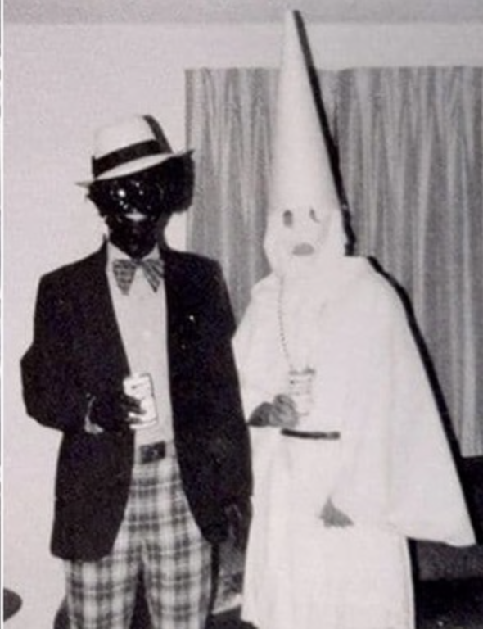The recent spate of blackface outings seems to have started with the Megyn Kelly debacle a few months ago. She didn’t actually wear blackface—she just wasn’t sufficiently disgusted by it; and though she apologized for the gaff, the harsh reaction quickly unemployed her. Now Virginia’s Governor Ralph Northam and Attorney General Mark Herring have been caught up in blackface scandals: many years ago Herring blacked up to mock rapper Kurtis Blow, and Northam tarred up for his yearbook page, teaming with a classmate who donned the hood-&-robe regalia of American terrorism—a photo that school authorities apparently thought appropriate.

Whether or not one accepts the rounds of sorrowful apologies*,*it is essential to note that the Christian offenders—Kelly, Northam, and Herring—**are apologizing for a *Jewish*crime**.

Blackface, as a form of American “entertainment,” started out in the early 1800s, most notably through a highly popular minstrel show performer by the name of Thomas “Daddy” Rice, a white entertainer who blackened his face with burnt cork to ridicule Blacks and their culture. White minstrel shows lampooned Black people, presenting them as dim-witted, lazy, buffoonish, superstitious, criminal, but nonetheless prodigiously musical. Rice’s popular blackface character was named *Jim Crow—*a name that came to describe the racially repressive era after the Civil War in which white society was determined to violently force Blacks back into plantation slavery. Blackface died a well-earned death, but was revived when Jews became perversely connected with this racist “art form” as performers and as fans, filling auditoriums to watch blackface stage shows in Jewish neighborhoods all over America.

***Jewish History of Blackface Hate***

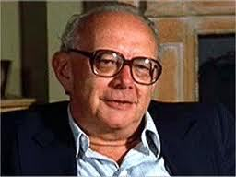

**Dr. Irving Howe**

From the time of the earliest American colonies [*Jews had always been a formidable presence in the slave-based economy*](https://noirg.org/wp-content/uploads/2018/11/HKP.37pgs.2018.final_.pdf), where they became important slave traders and international marketers of slavery’s products, especially sugar, cotton, and tobacco. But after the Civil War Jewish immigration to America increased dramatically. Their history in Europe with Gentiles over many centuries was one of conflict and violence, and so in America they saw distinct advantages in helping to create a society that made but one distinction based entirely on skin color. **Brandeis’s Irving Howe**, author of the most popular book on American Jewish history, *World of Our Fathers*, is one of [*many Jewish scholars*](https://noirg.org/articles/the-scapegoating-of-blacks-is-an-old-very-old-jewish-trick/) that admitted that Blacks were scapegoats for Jews:

“For decades American blacks had served…as a kind of buffer for American Jews. So long as native hatreds were taken out primarily on blacks, they were less likely to be taken out on Jews.”

So, **for Jews, anti-Black racism *was a benefit* and a valuable asset to their own goals of gaining power and influence**. Jews saw blackface minstrelsy as a vehicle to claim their whiteness and to ensure that racism—*and not religious ethnicism*—would become the American way. It was this *conscious*Jewish need to use Blacks as scapegoats that drove their involvement in that atrocious “art form” known as **blackface minstrelsy**. Jewish film scholar **Lester D. Friedman**is even more direct in his book *Hollywood’s Image of the Jew*:

“In actuality, many Jewish performers gained early and continued success using [blackface]….Indeed, it is too easy to ignore the derogatory aspects of such activities, the unconscious racism accepted and nourished by such cruel parodies, by citing historical contexts. The undisguised elements of ridicule in such blackface portrayals by **Jews mimicking the outlandish stereotypes of blacks now looks suspiciously like one group’s desperate need to assert its own superiority by mimicking another**.”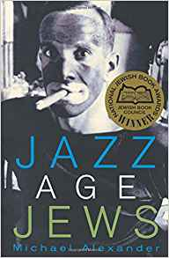

University of California religious studies professor **Dr. Michael Alexander** received a National Jewish Book Award for his bookin which he asserts that minstrelsy—the public ridicule and mockery of the Black race—became identified with Jewish entertainers: “**Jews performed this kind of minstrelsy in the 1910s and 1920s better and more often than any other group in America. Jewish faces covered in cork were ubiquitous**.”

In fact, blackface and a singing style pioneered by Jews known as “**coon shouting**” were mainstays of Jewish entertainment, with their most popular performers, like **Eddie Cantor, Sophie Tucker, Al Jolson, Irving Berlin, George Burns**, and **Florenz Ziegfeld**, using Black-race mockery as a dominant theme. Jewish historian Dr. **Jeffrey Melnick** says that Jews played “a major role in the manufacture of the racial stereotypes on which American popular culture depended.”

**Al Jolson Sings “Mammy” in blackface**

But blackface Jews had an even more devious design. According to Melnick,

“Both Cantor and Jolson cultivated what Cantor called ‘**the cultured, pansy-like negro’**; Cantor also made an early blackface appearance in drag. The **production of effeminacy**—which is, in this context, another way of saying **homosexuality**—as **a major modality**for these Jewish men in blackface was also tied up with their display as children…”



**Dr. Jeffrey Melnick**

What blackface represents, then, is not simply Jewish ridicule of Blacks, but a purposefully malicious destruction ***and redefinition*** of the Black character fronting as entertainment. And it is a formula that has permeated the film output of Jewish Hollywood for generations. This treachery was not limited to the Jewish actors on stage and screen. B’nai B’rith is seen as the most prestigious of Jewish organizations, and it is the parent of the [*notorious den of spies and racists*](https://noirg.org/articles/tamika-mallory-the-adl-the-hypocrisy-of-the-anti-black-zionists/), the **Anti-Defamation League**. In the 1920s their monthly magazine printed meticulously crafted examples of what they considered “jokes.” Here is a B’nai B’rith “joke” the Jewish editors titled **DARKTOWN**:

**Rastus**: Whuffo’ yo’ ‘jeculate yoself to me in dat onery manner?

**Cicero**: Whoffo’? Nigguh, who do yo’ calkerate yo’ is?

**Rastus**: Yo’ nigguh! mah family am quality folks an’ ahm a pusson of rank.

**Cicero**: Huh! ah’ll have yo’ triflin’, Rastus, to know that ah’m ranker than you is.

And this *B’nai B’rith Magazine*“joke” is titled “**Good Enough**”:

**Mose**: Dat’s a purty shirt you has on, Rastus, How many yards does it take for one ob dem shirts?

**Rastus**: What you all talking about, Nigger? I done got three like them in one yard last night.

In the age of Black leaders and thinkers of such intelligence and prestige as **W.E.B. Du Bois, Marcus Garvey, Booker T. Washington, Nannie Burroughs, William Monroe Trotter, Ida B. Wells-Barnett**, and **Noble Drew Ali**, among many, many others, the Jewish leadership preferred to invent “nigguhs” they named “Rastus,” “Cicero,” and “Mose.”

B’nai B’rith’s blackface depictions occurred in the 1920s, more than a decade after that same organization set up the Anti-Defamation League to counter what it saw as the prevalent public ridicule of Jews! According to the ADL’s 1913 charter: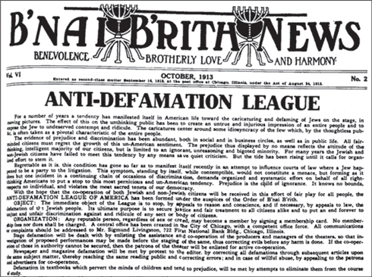

“For a number of years a tendency has manifested itself in American life toward **the caricaturing and defaming of Jews on the stage, in moving pictures**. The effect of this on the unthinking public has been to create an **untrue and injurious impression of an entire people**and to expose the Jew to **undeserved contempt, and ridicule**. The caricatures center around some idiosyncrasy of the few which, by the thoughtless public, is often taken as a pivotal characteristic of the entire people…”

So the highest levels of the American Jewish leadership were keenly aware of the negative power of these blackface images, and even forced their own Hollywood brethren to cleanse the Jewish image, while these same Jews ran the image and reputation of Blacks into the gutter. Jews smeared black shoe polish on their faces and assaulted the consciousness of the entire world with anti-Black racism in its purest and most concentrated form.

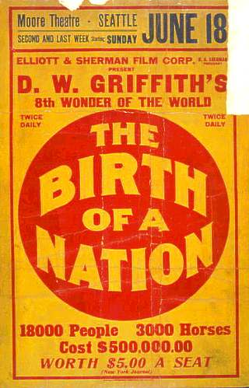

**It gets worse**.

At the same moment the ADL began, a number of **Jewish businessmen from the Boston area** were plotting to finance the most degrading and hateful blackface movie ever made—***The Birth of a Nation***. The silent movie epic released in 1915 was the first movie blockbuster, smashing all box office records. It rewrote the history of the Civil War to make the Ku Klux Klan terrorists the heroes and saviors of a grateful white nation. It depicted all Blacks as notorious criminals, uncontrollable rapists of white women, and intellectual, social, and spiritual inferiors who had no useful or rightful function in America except as slaves. So racially hateful were its blackface portrayals of the Black man that the Ku Klux Klan used this Jewish production as its recruitment film! How many of the thousands of American lynchings this Jewish-financed film was responsible for may never be known. For the many white immigrants pouring in to America by the millions at the time, it was the first “black” image they would see and it depicted an *American*racial system they could believe in.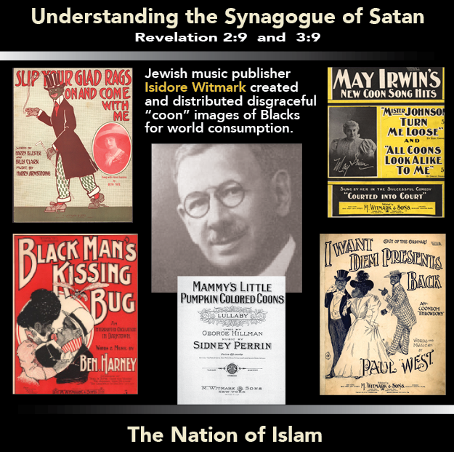

The NAACP condemned***The Birth of a Nation***in the harshest words, whilst Jewish reviewers trumpeted the virtues of the film, Jewish-owned movie theaters premiered it, and Jewish distributors spread the debased Black stereotypes to theaters around the world. **Louis B. Mayer** made so much money distributing this blackface hatefest that he started **Metro-Goldwyn-Mayer (MGM)**, the “greatest” of the Jewish movie studios, where he continued to make movies that trafficked in the ugliest stereotypes of Native Americans, Asians, Blacks, Latinos, and Arabs.

Jewish music publisher **Isidore Witmark** created and distributed disgraceful “coon” images of Blacks for world consumption. Witmark, along with his Hollywood brethren, were leaders in institutionalizing anti-Black racism.

The Jewish-dominated media takes a hard line with whites who have been blackface-outed, but they are careful to conceal the Jewish role in the history of this truly American hate phenomenon. Kelly, Herring, and Northam were certainly racially naïve, but the treacherous blackface Jews had something far more diabolical in mind.

*[](https://noirg.org/store-orig/#!/The-Secret-Relationship-Series/c/19266035/offset=0&sort=normal)*

**Share this:**