# First American Jewish Families

<https://www.americanjewisharchives.org/aja-publications/first-american-families/>

When it first appeared in 1960, Malcolm Stern's Americans of Jewish Descent marked a milestone in the study of American Jewish genealogy.  The Jacob Rader Marcus Center of the American Jewish Archives is proud to make the latest edition of this classic text available online.

Researchers now have access to the complete text of Rabbi Stern's monumental volume that was published in 1991 as the updated and revised 3rd edition titled: First American Jewish Families: 600 Genealogies, 1654-1988.  This publication is an historical document in its own right, and it is not our intention to alter it in any way.  Students of American Jewish genealogy are encouraged to use this text as a basis for their research.

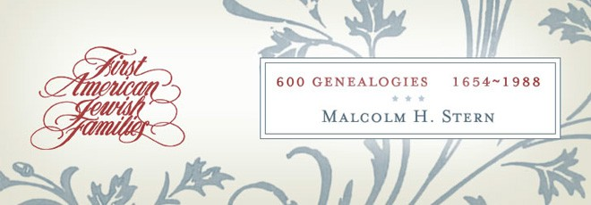

===================

Americans of Jewish Descent - Rabbi & genealogist Malcolm H. Stern '1960

[**Americans of Jewish Descent; a Compendium of Genealogy [1/550]**](https://www.abebooks.com/servlet/BookDetailsPL?bi=31259551040&searchurl=kn%3Dmalcolm%2Bstern%2Bamericans%2Bof%2Bjewish%2Bdescent%26sortby%3D17&cm_sp=snippet-_-srp1-_-title3)

[**Stern, Malcolm H. (compiler)**](https://www.abebooks.com/book-search/author/stern-malcolm)

https://www.abebooks.com/book-search/kw/malcolm-stern-americans-of-jewish-descent/

500.00\USD used3

Hardcover. Condition: g+ to vg-. First edition. Oblong folio (11-1/4" x 17-1/2"). (22), 307, (1)pp. Index. Light green cloth, spine lettered in gilt. Endpaper maps. Edition limited to 550 numbered copies (this is #301). Some light soiling. Extremities starting to fray but binding is still sound. Rubber stamp of "Temple B'nai Abraham of Newark, N. J." on several preliminary leaves. "In a modest way the American Jewish Archives has set out to fashion the basic research instruments necessary to further the science of American Jewish history. In the historian's tool chest, there are few utensils more helpful than genealogist tables. These tables will help illuminate almost every document of early American Jewry, for they reveal relationships never before suspected and shed light on obscure references that up to now have baffled the most skillful of researchers. The rise of communities will be documented here; the interplay of intramarriage between Jewish natives and Jewish newcomers will be visible on every page. Here, most graphically, one can trace the assimilatory influence of intermarriage, and notice, not without irony, the unbroken line that leads from a Polish Jewish immigrant peddler to an American ambassador to one of the Great Powers". Publications of the American Jewish Archives - Number V.

=============

https://www.abebooks.com/book-search/kw/malcolm-stern-americans-of-jewish-descent/

600.00 USD used

Hardcover. Condition: Good+ to very good condition. Dust Jacket Condition: good. Revised edition. Signed "Malcolm H. Stern, January, 1979" on half-title. Oblong quarto. 8 leaves, (1) 419pp. Blue cloth with gold lettering on spine in original illustrated dust jacket. Illustrated endpapers. Comprehensive work with family trees charts of every family of Jewish origin known to have been established in America prior to 1840 traced where possible up until the 1970s. Lists places and dates of birth and death, marriage, dates of individuals' arrivals in America, significant occupations and titles, military service, etc. Includes non-Jewish descendants. Index contains over 40,000 names. Bookplate of Sisterhood of Congregation B'nai B'rith and donation plate of the Landsberger family on verso of front endpaper. Some light wear along edges of binding. Minor staining on spine. Some light creasing, chipping and few closed tears to parts of dustjacket. Dust jacket and binding in good+, interior in very good condition.

======================================================================