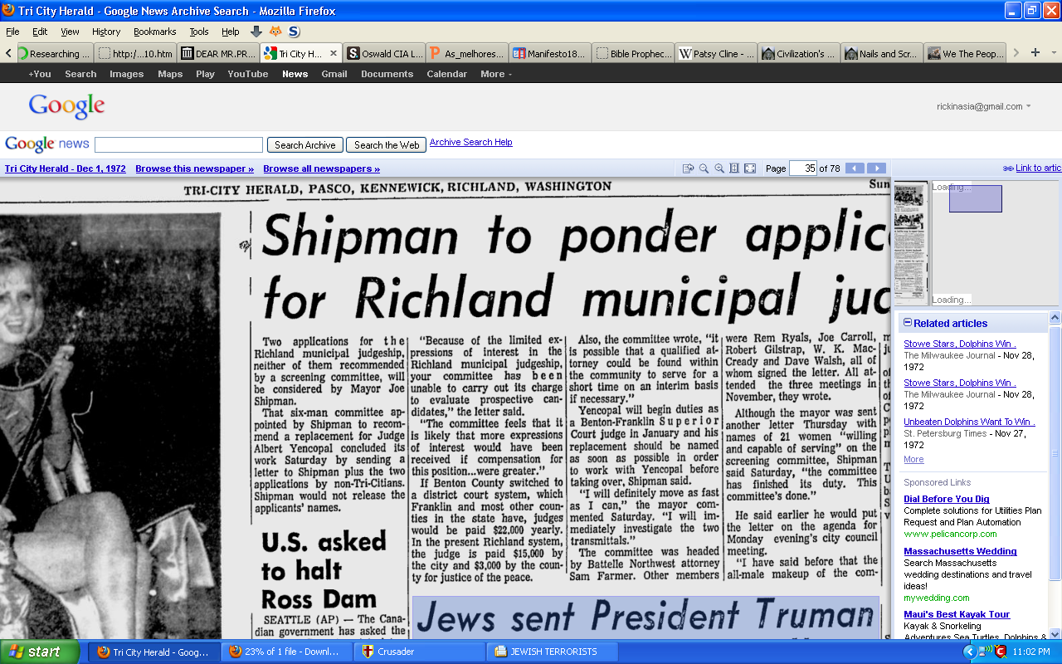

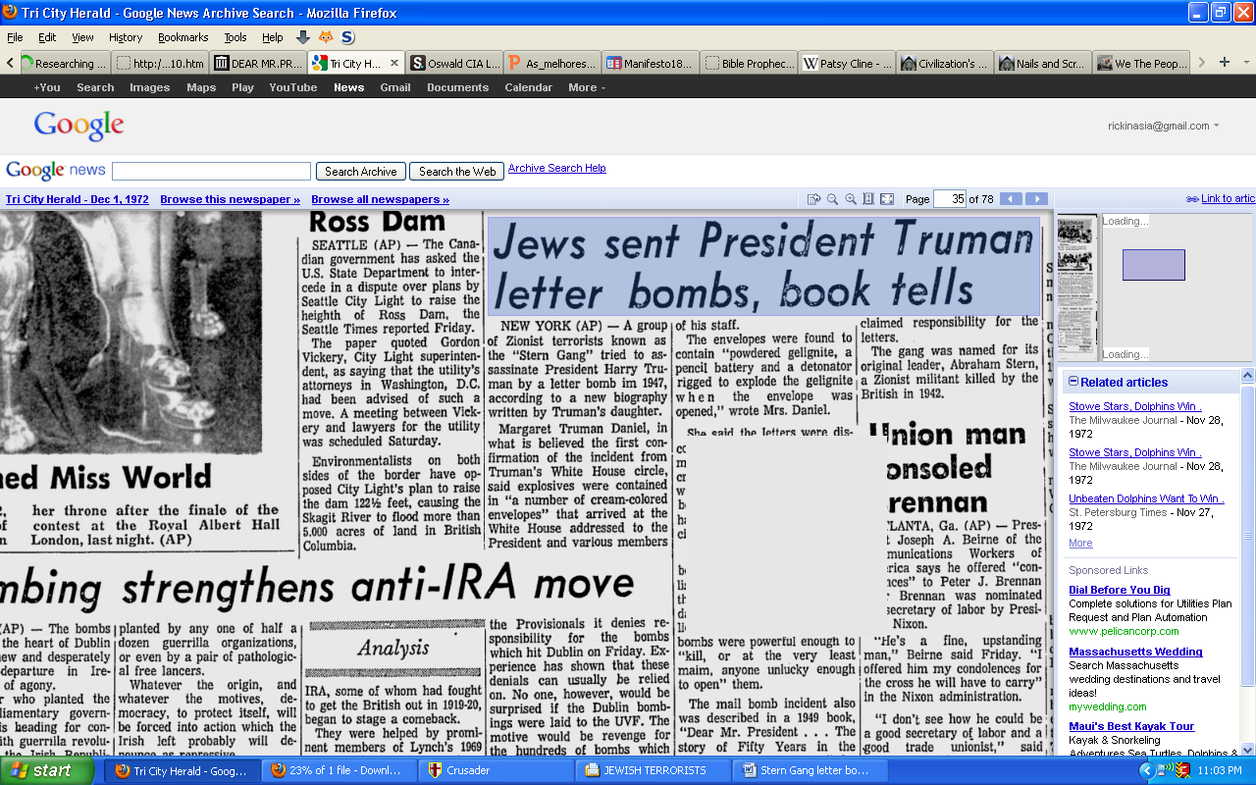

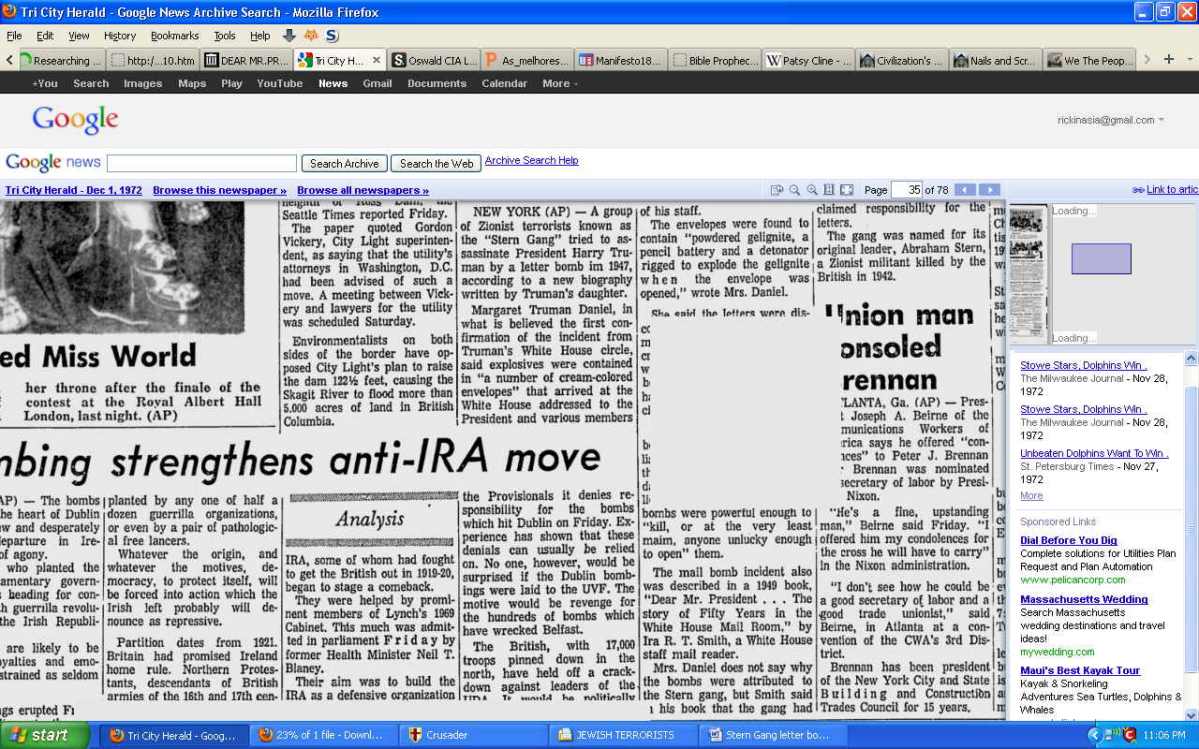

----- http://news.google.com/newspapers?nid=1951&dat=19721201&id=s00xAAAAIBAJ&sjid=AeIFAAAAIBAJ&pg=2264,343939

