THE TORTURE AND DEATH OF SAINT SIMON OF TRENT

The small Simon, a little boy from Trent, was slayed on the 21st March, 1475 A.D., on Maundy-Thursday during Holy Week. The Jews of this town wanted to celebrate their Passover in their own way; so they secretly abducted the small boy and carried him to the house of the Jew Samuel. During Holy Week on Maundy-Thursday, the day before Good Friday, "and" on the day before the outlawed "Perfidious Passover", about three hours after supper, the little boy, like children do, was sitting in front of his parents’ house. Neither his father nor mother were home at the time as they were at Church. It was at this time that the Jew Tobias approached the child, who was not quite 30 months old, and while speaking kindly and offering the boy a piece of money, picked him up and carried him at once to the house of the Jew Samuel.  When night fell, the twin brothers Saligman and Samuel, with Tobias, Vitalis (Veitel), Moses, Israel and Mayr, undressed the little boy and unmercifully butchered him. While Moses strangled him with a handkerchief as he lay across Samuel’s knee, pieces of flesh from his neck were cut with a knife and the blood collected in a bowl. At the same time, they punctured the naked offering with needles and murmured Hebrew curses. They then cut pieces of flesh from the boy’s arm and legs and collected the blood in pots.  Finally the torturers mitated the crucifixion by holding the twitching body upside down and the arms outstretched and during this horrible act they spoke the following:  Take this, crucified Jesus. Just as our forefathers did once, so may all Christians by land and sea perish. | 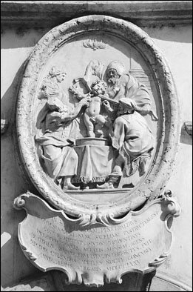  Relief Commemorating the Horrific Death of St. Simon of Trent 1475 A.D., Child Martyr & Canonized Saint, at the Hands of Perfidious Jews
They then rushed to their meal. When the child had died they threw his body in the river which flowed by their house. After this, they joyously celebrated Passover. The case was prosecuted by Bishop Hinderbach, and the Jews were sentenced to death. Immediately, all Jews of the area protested the sentence and succeeded in gaining a new trial for the accused. It was tried before Giudici of Ventimiglia, and he confirmed the sentence. Again because of Jewish protests, the case came before the court of Pope Sixtus IV. He commissioned the greatest and most famous professor of law at that time, Panvino, to serve as Chief Justice. Assisted by six cardinals, he too confirmed the sentence.
*The court officially stated:  The Hebrews killed the little boy Simon, in order to obey a rabbinical religious law; their motive being to serve a most wicked piety and devotion by obtaining Christian blood for the celebration of Passover.  The *records of this trial were originally kept in the secret archive of the Citadel of St. Angelo and were then transferred to the Vatican, where they are now available for examination. They were disclosed by Pope Benedict XIV. Also Pope Clement XIV as legal counsellor for the Holy Office, before he became Pope, verified the murders of both St. Simon of Trent and St. Andreas of Rinn (remember St. Dominguito del Val, Mártir) as cases of ritual murder almost 300 years later, in 1770. The boy [Simon] who was tortured to death at Trent was officially canonized by Pope Sixtus V. The Holy Infant Martyr, St. Simon of Trent's feast day is always celebrated on March 24th. | 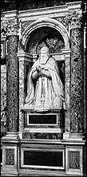  Pope Sixtus V Canonized St. Simon of Trent

Excerpt from: www. St.SimonofTrent.com

