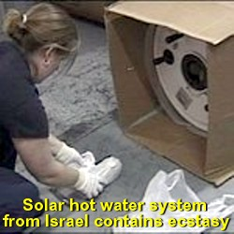
An Israeli national, 46-year-old Benjamin Rosenfeld, has today faced court over the matter of the seizure of ecstasy worth an estimated $37 million by the Australian Federal Police in Sydney, Australia.
The MDMA powder was detected at Port Botany late last month, in a container from Israel.
Customs spokeswoman Gail Batman says it was concealed in solar hot water systems.
"There were six in total, and three of them had drugs hidden within them," she said.
Federal Police say the shipment was placed under surveillance until the drugs were recovered yesterday.
AFP spokesman David Stewart says he believes an international syndicate was responsible.

Israeli national, 46-year-old Benjamin Rosenfeld, the alleged organiser, has been charged with importing a commercial quantity of the drug.
He has been remanded in custody and is due to face a Sydney court early in July.
ABC News online Monday, April 23, 2007. 6:03pm (AEST)

Zeev Rosenstein, 52, a notorious Israeli criminal described by U.S. authorities as one of the world's biggest drug traffickers returned to Israel on Wednesday to serve his 12-year prison term for his conviction on drug charges in South Florida.

A U.S. District judge in January sentenced Zeev Rosenstein, for conspiring to distribute more than 850,000 Ecstasy pills. As part of the plea bargain, Rosenstein will serve the time in Israel, from where he had been extradited in March 2006.

Zeev Rosenstein is married to a Jewish ultra-Orthodox woman who passionately maintains his innocence in interviews.

By LAURIE COPANS, Associated Press, Posted March 28 2007, 11:50 AM EDT

