"It was all a prank" say two Zionists
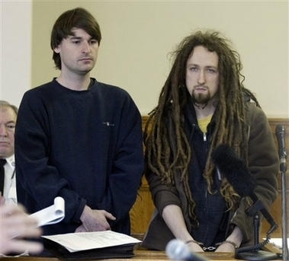
It cost the City of Boston over a million dollars
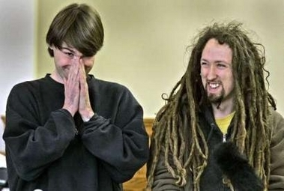
Boston at standstill
The city of Boston shut down roads, rail services and river transport to investigate a possible terrorist attack. Boston police arrested suspects, Peter Berdovsky, 27, of Arlington and Sean Stevens, 28,. The two Jewish men put electrical devices resembling bombs on Boston subways, under bridges, and on highways, and Boston shut down.
The two giggled and laughed out loud as assistant Attorney General John Grossman, chief of high technology and computer crimes, described for Judge Paul K. Leary the light-emitting diodes fashioned to resemble a bomb.
Mickey Rich is the attorney
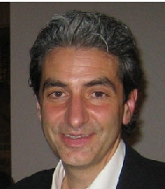
Berdovsky, a Belarus immigrant who reportedly has political asylum, came to court in long dreadlocks, red sox and sandals. Attorney Michael Rich, the de facto foster father with whom he has lived, represented both men, who appeared in shackles.
Stevens claims to be a self-employed computer consultant and Berdovsky, a freelance artist.
“Only someone with a nefarious intent would place the bombs like they did. There’s a big difference between putting one on a rolled-down gate at Newbury Comics and putting one under the Longfellow Bridge.”
Mayor Thomas M. Menino was still smarting over the prank this morning, but expressed some empathy for Berdovsky and Stevens. But Menino doubted how anyone could view citywide bomb scares as a joke when the devices were placed under bridges and near major highways.
Commentary
If a white gentile did this, he would be sitting in jail, and looking at years behind bars. The fact these two are Jewish takes it from a terror threat to a 'Prank'.

Arrest Made In Boston's Hoax Device Incident
"Devices" Were Part Of A Marketing Campaign
(WBZ) BOSTON Boston police say they have made in arrest in connection to the suspicious device scare that turned out to be a marketing ploy for a television cartoon. The Peter Berdvosky was arrested in Arlington Wednesday night and charged under a recently enacted statute making it a crime to place a hoax device that results in panic.
The scare forced bomb units to scramble across Boston all day. The "devices" were actually magnetic lights which resemble a character on the show "Aqua Teen Hunger Force", on Turner Broadcasting's Cartoon Network...
(full story)

