Illustration 4: Sobibor, May 30, 1944
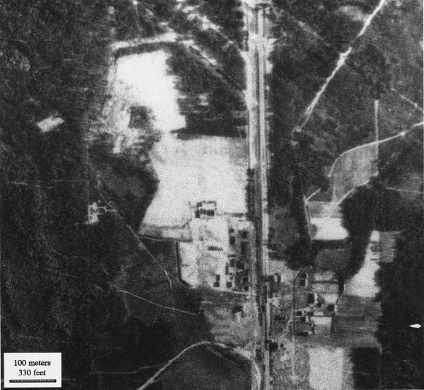
It is claimed that in Sobibor 100,000 of the total 150,000 victims were buried before being exhumed later and being cremated along with the rest of the victims. The air photo from 1944,(12) also taken after the camp was dismantled, shows this camp as having covered an area of roughly 50,000m2 (12.4 acres). Some 10,000m2 (107,600 sq.ft.) - fully 1/5 of the total camp area - would have been needed to bury the victims. However, the air photo shows that the ground in the camp area was not disturbed. There are no signs of former building foundations, large-scale movements of earth, or cremation sites.
---- Air Photo Evidence Contradicts Concentration-Camp Mass Graves - John Clive Ball

