JEWISH HATE PROPAGANDA
Responsible for largest ever mass-killing at Dachau.
"Sometimes truth is stranger than fiction."
The German soldiers/guards at the Dachau, Buchenwald and Mauthausen camps were simply massacred after the camps were taken by the Americans in the final weeks of the war. The massacre at Dachau was filmed and numerous still photographs have survived. Some of these photos are included below.
Of the 560 German soldiers massacred at Dachau, 200 of them from the Waffen-SS Division Wiking, who were in Dachau resting from fighting the Red Army on the Eastern Front. The rest wore the Edelweiss insignia of the elite Alpine army troops. Most were dressed in battle-stained camouflage clothing. Their commander, Obersturmf Chrer (1st. Lieutenant) Heinrich Skodzensky, had negotiated a surrender to the Americans that morning with the help of the Swiss Red Cross official Victor Maurer.
The normal force of 1,473 SS guards at Dachau had left earlier.
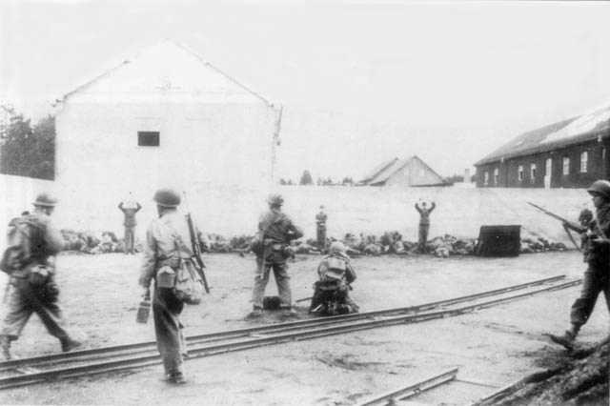
The photo above shows about 60 dead or wounded German soldiers lying at the base of a long wall. Only about one fourth of the total length of the wall is visible. A machine gunner crouches over a model 1919A4 machine gun, center foreground. The four German soldiers still standing and three or four of their fallen comrades at left who are still alive were shot only seconds after this photo was taken. (Photo by Arland B. Musser, US Signal Corps. Courtesy National Archives, Washington D.C.)
The murder of 560 guards at Dachau is confirmed by two eyewitnesses to the atrocity and U.S. Army records.
The first eyewitness report was by U.S. Army Colonel Howard Buechner, who described the killings in detail in his 1986 book,
Dachau: The Hour of the Avenger.
The second eyewitness report was by the Turkish inmate Nerin Gun, who describes the atrocity in his memoir,
The Day of the Americans.
In case you are interested, here is some information concerning the above books:
Call#(S)JFE97-4673
Author--Buechner,HowardA.,1919-
Title--Dachau:TheHourOfTheAvenger:(AnEyewitnessAccount).
Imprint Metairie, La., U.S.A. : Thunderbird Press, c1986.
Call#D-168084
Author--Gun,NerinE.
Title--TheDayOfTheAmericans.
Imprint New York, Fleet Pub. Corp, 1966.
The U.S. Army records were declassified in 1991. They detail several other incidents that day: a U.S. lieutenant ordered four German soldiers into an empty boxcar and personally shot each of them. Another American soldier clubbed and shot those still moaning. Several GIs turned their backs on two inmates beating a German guard to death with a shovel.
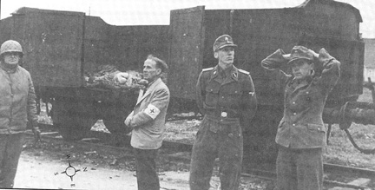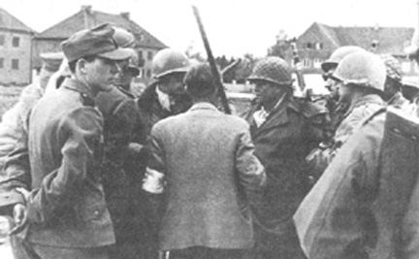
Photos of the German surrender to the Americans, negotiated by Red Cross representative Victor Maurer.

Photo of Germans massacred at Dachau.
Read the following book review of Howard A. Buechner's book: Dachau: The Hour of the Avenger (by J. B. Campbell).
http://www.thirdworldplanet.com/jubel/dachau.htm
Above is Buechner's tally of those executed/murdered.
So why did these massacres occur?
At best, they occurred because the American soldiers believed the lies published in American newspapers concerning the wholesale massacre of Jews at Dachau and other concentration camps, and they took the law into their own hands, in doing so becoming as evil as those they believed massacred Jews.
At worst, the massacres at Dachau, Buchenwald and Mauthausen were ordered by senior US Army personnel so that there would be no voices able to tell the truth about what happened at these camps. So that there would be no voices to contradict the myth of the Jewish holocaust.
Of course, it is now known (and accepted) that contrary to much propaganda, there were never any mass-killings of Jews at these camps. In fact, it is now known (but not universally accepted) that there were never any mass-killings of Jews at any of the German concentration camps.

----------------

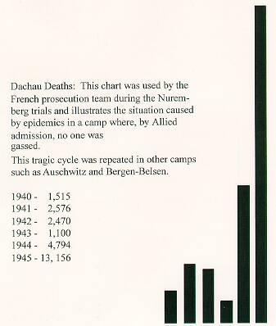
Dachau chart:

