This Is The Best Evidence David Icke Is Right About Reptilians
http://www.collective-evolution.com/2017/12/02/this-is-the-best-evidence-david-icke-is-right-about-reptilians/

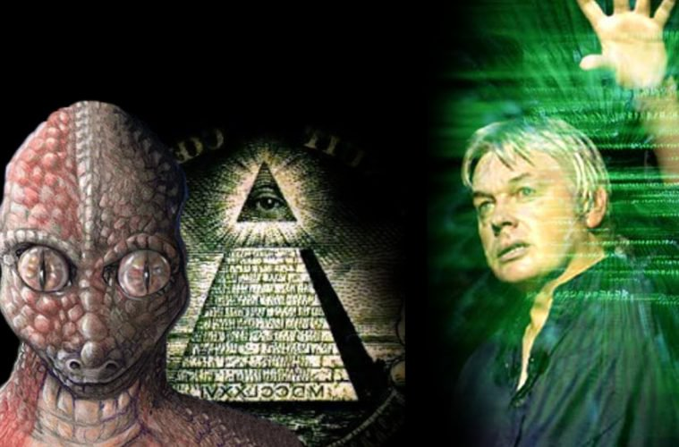

We're creating viewer supported news. Become a member!
I'm in!
Probably one of the most challenging conspiracy theories of the past 30 years for people to digest is that of David Icke’s theory that reptilian ET’s are mixed in with the elite of our planet and have influence over how it is run. To be fair, this theory doesn’t belong to David but was simply popularized by him.
I challenge you to continue reading this with an open mind, you will be surprised as to how deep this actually goes. For the record, no I’m not going to be talking about silly YouTube videos or photoshopped images showing reptile eyes belonging to the elite. We’re only going to look at very real evidence anyone can verify.
When I first realized the true magnitude of what the Pope’s Audience Hall design reveals, I was shocked. Despite 10 years of research into the elite, occult, Illuminati, consciousness, and more, this stuck out as something I just HAD to write about.
Have you heard of the Pope’s Audience Hall? Also known as the Paul VI Audience Hall or the Hall of the Pontifical Audiences, it lies partially in Vatican City and partially in Rome, Italy. Named after Pope Paul VI and built in 1971 by Italian architect Pier Luigi Nervi, it seats 6,300 and contains a bronze statue called La Resurrezione, designed by Pericle Fazzini, within.
This all sounds pretty straightforward so far, but let’s dive into what makes this building so strange. We’ll start with the less weird, and get progressively weirder as we go.

Building Method and Design
The building was designed with reinforced concrete by well-known architect Pier Luigi Nervi. Nervi is known for simple yet practical designs that are strong and made to last.
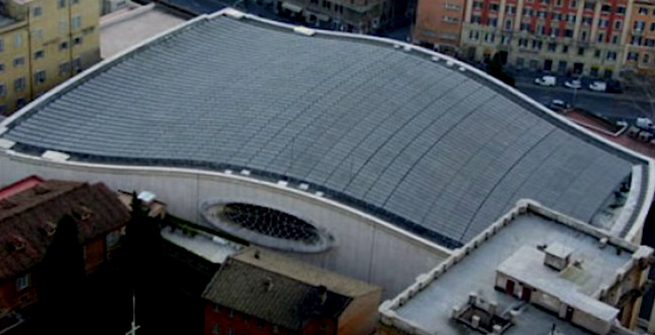
The simple curvature of the building might seem unassuming from the outside, but this is part one of what we will begin to explore about this building, and I promise you, by the time we get to the end, you will see what I’m getting at.
Have a look at the image below and compare its shape to the image of a snake beside it. Note the overall shape — wide back, narrow, rounded front, eyes in the middle, nostril at the front, and curved top.
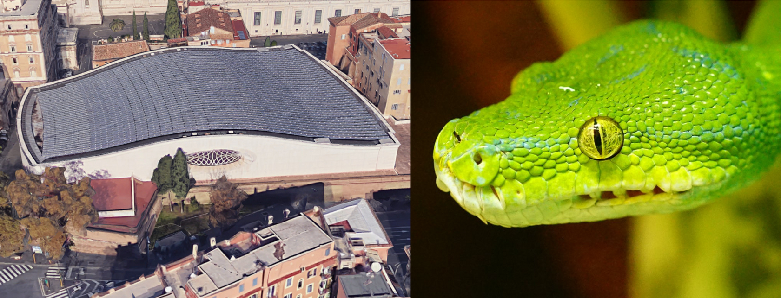

Windows
As you can already begin to see in the image above, there are two windows on either side of the building that resemble eyes. They are made of stained glass and sit about halfway through the building’s length on either side.
In the centre of the eye shape, you begin to see a slit that could resemble a reptile eye. If you’re not convinced yet, which is understandable, keep reading.


Keep Evolving Your Consciousness

Inspiration and all our best content, straight to your inbox.
Top of Form
Bottom of Form
Top of Form
Bottom of Form
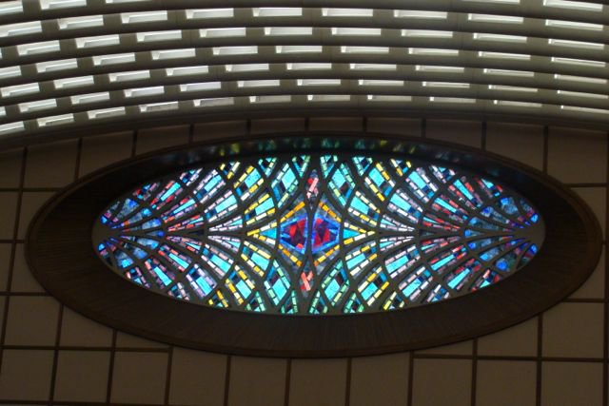
Maybe looking at one window on its own isn’t the most clear, so let’s have a look at both of them together now.
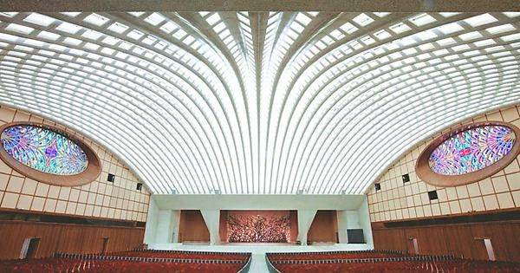
All of a sudden we begin to see things taking shape here — two reptilian eyes, staring at you as you observe the stage.

Scales and Fangs
Have a look again at the image above — what do you notice down the centre? There stands what looks to be a statue in the middle and then on either side, two sharp, pointed fangs. The building’s roof and sides also resemble scales.
Here are two more images to give you a sense of the scales.
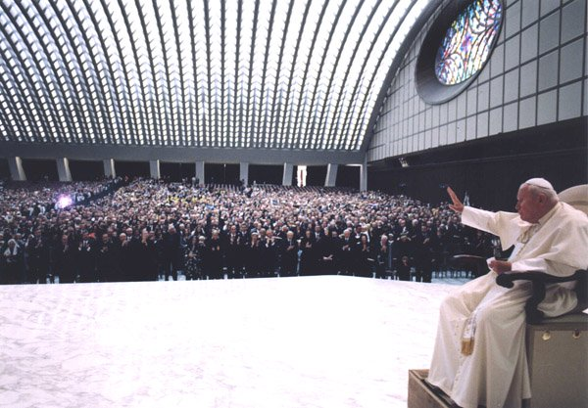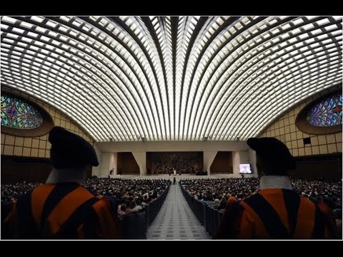

Now let’s pull it together a bit more so we can really see what we are looking at. In the image below, really pay attention to the whole building and stage layout next to the image of a snake. The eyes, the shape, the scales, the fangs, the look and feel of the reptile… it’s all there.
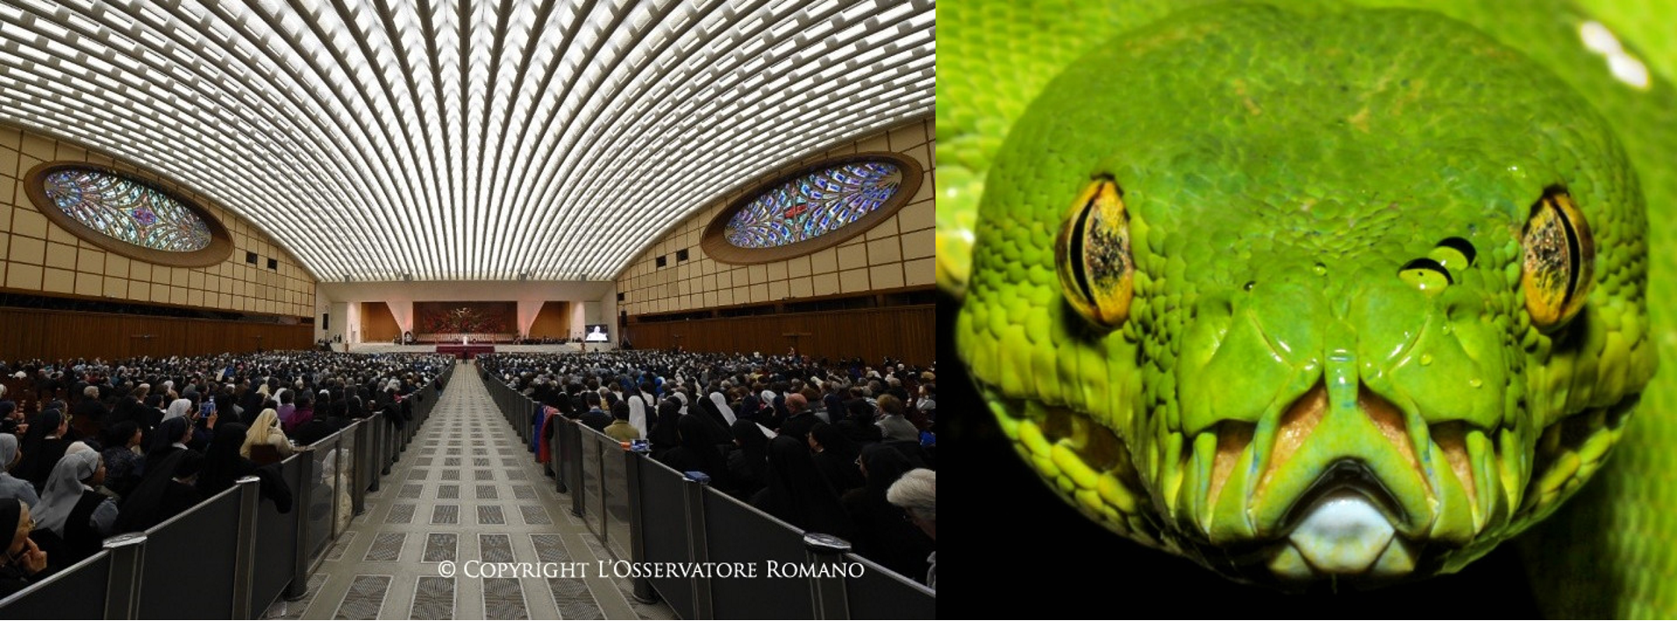

The La Resurrezione Statue
In the middle of the stage sits a statue of Christ rising from an atomic apocalypse. It was designed by Pericle Fazzini and put in place by 1977. Have a look at it below. Do you notice anything about Jesus’ head?
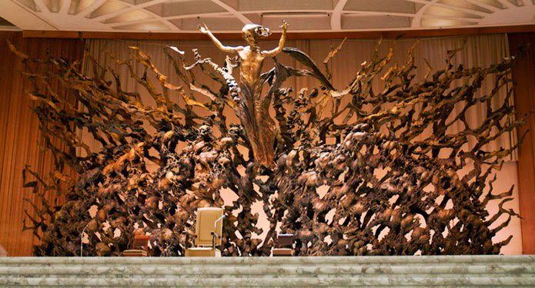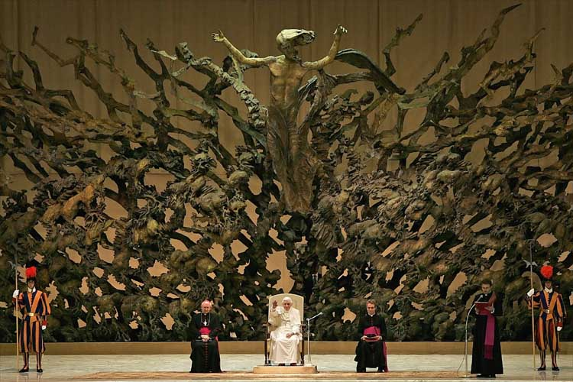

Front
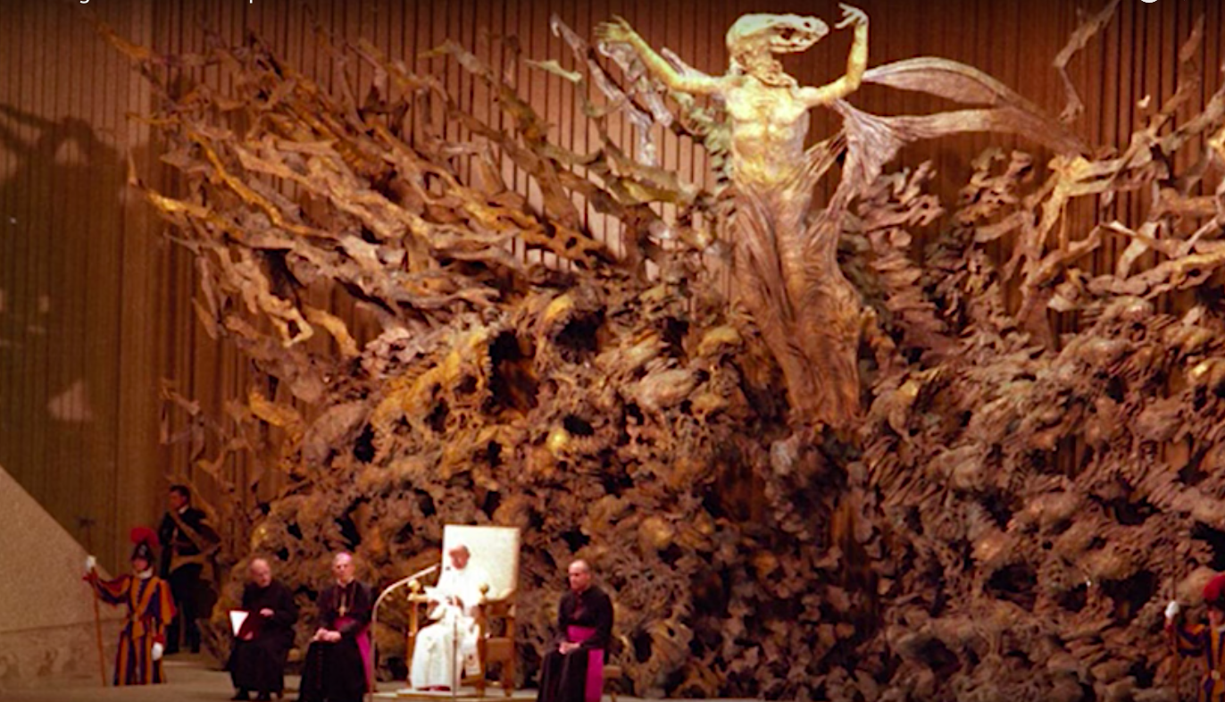
Right side
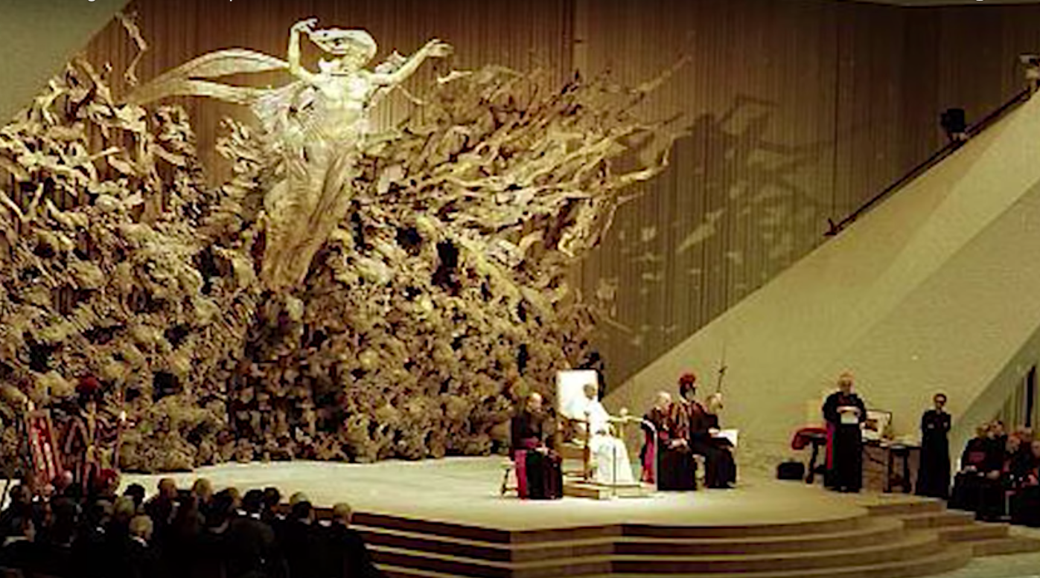
Left side
It’s difficult to see from the front, but when you view the statue from the sides, where patrons would sit, it becomes strikingly clear from both sides that the head of Jesus is meant to look like that of a snake.
Think about it for a moment: If just one side of the statue gave the impression of a snake’s head, we could brush this off as coincidence, but when it looks this way from all angles, and the entire building resembles a snake as well, it becomes much more difficult to ignore. One must begin to realize that this was purposefully designed to appear this way. The thought and planning that went into this would have to have been immense.
The reality is, there is an obvious reason for this imagery.

The Big Question
You may be asking what that reason is; why was this building built in such a way that the Pope appears to be speaking from the mouth of a reptile? If you aren’t asking that question, you’re simply turning a blind eye. It’s not that the evidence isn’t present, it’s that you are choosing not to see it. There are seven separate pieces that comprise the snake or reptile symbol. If it were one or two I would understand your skepticism — even three. But when seven pieces come together so beautifully, so perfectly, you know beyond any shadow of a doubt that it was intentional.
Regardless, I know what I’m saying may be difficult to accept, but all tough truths go through phases — laughter and ridicule, partial acceptance, and then, eventually, they appear self-evident to the population. I believe we are getting closer to the third stage when it comes to understanding who truly runs and has influence over our world, which is why this snake symbolism exists here.
Research demonstrates there is a Deep State that largely governs our world — a group of people that aren’t American, European, Russian, Canadian, etc., but beyond national identity, and they control our entire world. It has been said for a long time that there is an extraterrestrial influence there as well. Not from all races of ETs, but from one in particular, the reptilians. Not all reptilians are defectors of the heart, but a group, just like a group of humans, that has worked to influence this planet.
I understand this sounds ‘out there,’ but really think about it. There is more evidence for the reality of ETs than anyone could possibly imagine. There is a ton of evidence for a Deep State controlling things. Is it at all possible that these two realities are linked? Again, I’m not saying all ETs or even all reptilians are ‘bad,’ but rather that perhaps a few are, and they are working with our governments.
Even our own government officials have stated they are well aware of ETs but simply haven’t told the public. As revealed by former Defense Minister of Canada Paul Hellyer: “So they decided to do an investigation, and they investigated for three years, and they decided that, with absolute certainty, that four species, four different species, at least, have been visiting this planet for thousands of years.”
The knowledge governments have of ETs is immense, and whistleblowers have revealed this many times, with plenty of documentation behind them. You can watch the film Unacknowledged on Netflix to learn more about this.
The reptilian influence over the Deep State theory is not new, and can be found in many traditions and cultures. But it has been popularized by the work of David Icke who, understandably, has received a lot of ridicule for it. Regardless of that, millions follow and believe in his work. I highly suggest reading more about this theory here.

Why This Symbolism Is Used
While at an event in California called Contact In The Desert, we interviewed David Wilcock, a longtime occult researcher. During the interview, he mentioned that the Elite/Illuminati believe they must convey their intentions to humanity in order to, in essence, get permission from us to enact them. This manifests as rituals during mass sports events and symbolism found around society and in various popular industries like film and music.
When you begin to consider what the Pope’s Audience Hall is truly saying, it becomes clear he is speaking from the mouth of the snake. He stands in front of the mouth and speaks the words of the Elite to all those listening. The Elite are telling humanity via symbolism that this is what’s happening.
You can watch the full interview with David Wilcock here.
It has been said and proposed by many researchers that Christianity, among most other religions, is used to control the masses. While religious stories may hold some truth and convey helpful messages, their overall purpose is to lead people into a relationship with spirit that is disempowering. The guilt, judgement, and wrath that exist within religions are designed to control us, to take away our power. We must also realize that these religions are impure and that we have been turning a blind eye to this for some time. Look what happened with the coverup of Vatican child sex abuse scandals, for example.
In the end, I’m not asking you to believe everything being said here, but I’m also not suggesting you laugh it off. There are facts here that can be explored, but one has to go through the research. There is clearly something very intentional going on here and one doesn’t spend many millions to design and build a very obvious snake within Vatican-owned buildings for no reason. Do your own research on the topic of reptilians, the Elite bloodlines, and what symbolism like this means. See how it feels for you. Allow your mind to be open to connect the dots as opposed to being closed and dismissive on something that doesn’t sound like ‘everyday life.’

- 

Ex Chief Adviser For The UN’s Child Labour Program Arrested For Pedophilia
Arjun WaliaApril 21, 2018

