John Holdren, Obama's Science Czar, says: Forced abortions and mass sterilization needed to save the planet

http://zombietime.com/john_holdren/

Book he authored in 1977 advocates for extreme totalitarian measures to control the population

Ecoscience - Population, Resources, Environment - Paul R. Ehrlich, John P. Holdren, Anne H. Ehrlich 1977

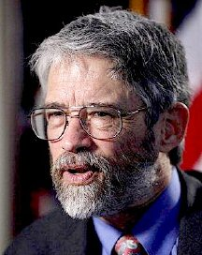

Forced abortions. Mass sterilization. A "Planetary Regime" with the power of life and death over American citizens.
The tyrannical fantasies of a madman? Or merely the opinions of the person now in control of science policy in the United States? Or both?
These ideas (among many other equally horrifying recommendations) were put forth by John Holdren, whom Barack Obama has recently appointed Director of the White House Office of Science and Technology Policy, Assistant to the President for Science and Technology, and Co-Chair of the President's Council of Advisors on Science and Technology -- informally known as the United States' Science Czar. In a book Holdren co-authored in 1977, the man now firmly in control of science policy in this country wrote that:
• Women could be forced to abort their pregnancies, whether they wanted to or not;
• The population at large could be sterilized by infertility drugs intentionally put into the nation's drinking water or in food;
• Single mothers and teen mothers should have their babies seized from them against their will and given away to other couples to raise;
• People who "contribute to social deterioration" (i.e. undesirables) "can be required by law to exercise reproductive responsibility" -- in other words, be compelled to have abortions or be sterilized.
• A transnational "Planetary Regime" should assume control of the global economy and also dictate the most intimate details of Americans' lives -- using an armed international police force.
Impossible, you say? That must be an exaggeration or a hoax. No one in their right mind would say such things.
Well, I hate to break the news to you, but it is no hoax, no exaggeration. John Holdren really did say those things, and this report contains the proof. Below you will find photographs, scans, and transcriptions of pages in the book Ecoscience, co-authored in 1977 by John Holdren and his close colleagues Paul Ehrlich and Anne Ehrlich. The scans and photos are provided to supply conclusive evidence that the words attributed to Holdren are unaltered and accurately transcribed.
[UPDATE: Make sure to read the new statements issued by the White House and by John Holdren's office in response to the controversy raised by this essay -- you can see them below following the Ecoscience excerpts, or you can jump directly to the statements by clicking here.]
This report was originally inspired by this article in FrontPage magazine, which covers some of the same information given here. But that article, although it contained many shocking quotes from John Holdren, failed to make much of an impact on public opinion. Why not? Because, as I discovered when discussing the article with various friends, there was no proof that the quotes were accurate -- so most folks (even those opposed to Obama's policies) doubted their veracity, because the statements seemed too inflammatory to be true. In the modern era, it seems, journalists have lost all credibility, and so are presumed to be lying or exaggerating unless solid evidence is offered to back up the claims. Well, this report contains that evidence.
Of course, Holdren wrote these things in the framework of a book he co-authored about what he imagined at the time (late 1970s) was an apocalyptic crisis facing mankind: overpopulation. He felt extreme measures would be required to combat an extreme problem. Whether or not you think this provides him a valid "excuse" for having descended into a totalitarian fantasy is up to you: personally, I don't think it's a valid excuse at all, since the crisis he was in a panic over was mostly in his imagination. Totalitarian regimes and unhinged people almost always have what seems internally like a reasonable justification for actions which to the outside world seem incomprehensible.
Direct quotes from John Holdren's Ecoscience
Below you will find a series of ten short passages from Ecoscience. On the left in each case is a scanned image taken directly from the pages of the book itself; on the right is an exact transcription of each passage, with noteworthy sections highlighted. Below each quote is a short analysis by me.
Following these short quotes, I take a "step back" and provide the full extended passages from which each of the shorter quotes were excerpted, to provide the full context.
And at the bottom of this report, I provide untouched scans (and photos) of the full pages from which all of these passages were taken, to quash any doubts anyone might have that these are absolutely real, and to forestall any claims that the quotes were taken "out of context."
Ready? Brace yourself. And prepare to be shocked.

Page 837: Compulsory abortions would be legal
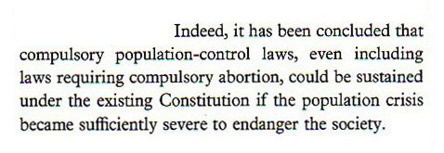 | Indeed, it has been concluded that compulsory population-control laws, even including laws requiring compulsory abortion, could be sustained under the existing Constitution if the population crisis became sufficiently severe to endanger the society.
As noted in the FrontPage article cited above, Holdren "hides behind the passive voice" in this passage, by saying "it has been concluded." Really? By whom? By the authors of the book, that's whom. What Holdren's really saying here is, "I have determined that there's nothing unconstitutional about laws which would force women to abort their babies." And as we will see later, although Holdren bemoans the fact that most people think there's no need for such laws, he and his co-authors believe that the population crisis is so severe that the time has indeed come for "compulsory population-control laws." In fact, they spend the entire book arguing that "the population crisis" has already become "sufficiently severe to endanger the society."

Page 786: Single mothers should have their babies taken away by the government; or they could be forced to have abortions
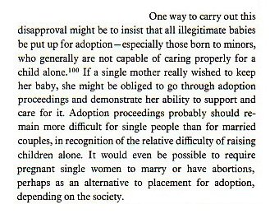 | One way to carry out this disapproval might be to insist that all illegitimate babies be put up for adoption—especially those born to minors, who generally are not capable of caring properly for a child alone. If a single mother really wished to keep her baby, she might be obliged to go through adoption proceedings and demonstrate her ability to support and care for it. Adoption proceedings probably should remain more difficult for single people than for married couples, in recognition of the relative difficulty of raising children alone. It would even be possible to require pregnant single women to marry or have abortions, perhaps as an alternative to placement for adoption, depending on the society.
Holdren and his co-authors once again speculate about unbelievably draconian solutions to what they feel is an overpopulation crisis. But what's especially disturbing is not that Holdren has merely made these proposals -- wrenching babies from their mothers' arms and giving them away; compelling single mothers to prove in court that they would be good parents; and forcing women to have abortions, whether they wanted to or not -- but that he does so in such a dispassionate, bureaucratic way. Don't be fooled by the innocuous and "level-headed" tone he takes: the proposals are nightmarish, however euphemistically they are expressed.
Holdren seems to have no grasp of the emotional bond between mother and child, and the soul-crushing trauma many women have felt throughout history when their babies were taken away from them involuntarily.
This kind of clinical, almost robotic discussion of laws that would affect millions of people at the most personal possible level is deeply unsettling, and the kind of attitude that gives scientists a bad name. I'm reminded of the phrase "banality of evil."
Not that it matters, but I myself am "pro-choice" -- i.e. I think that abortion should not be illegal. But that doesn't mean I'm pro-abortion -- I don't particularly like abortions, but I do believe women should be allowed the choice to have them. But John Holdren here proposes to take away that choice -- to force women to have abortions. One doesn't need to be a "pro-life" activist to see the horror of this proposal -- people on all sides of the political spectrum should be outraged. My objection to forced abortion is not so much to protect the embryo, but rather to protect the mother from undergoing a medical procedure against her will. And not just any medical procedure, but one which she herself (regardless of my views) may find particularly immoral or traumatic.
There's a bumper sticker that's popular in liberal areas which says: "Against abortion? Then don't have one." Well, John Holdren wants to MAKE you have one, whether you're against it or not.

Page 787-8: Mass sterilization of humans though drugs in the water supply is OK as long as it doesn't harm livestock
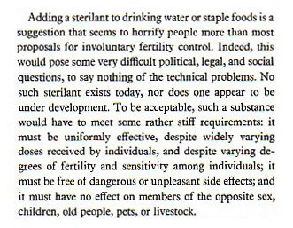 | Adding a sterilant to drinking water or staple foods is a suggestion that seems to horrify people more than most proposals for involuntary fertility control. Indeed, this would pose some very difficult political, legal, and social questions, to say nothing of the technical problems. No such sterilant exists today, nor does one appear to be under development. To be acceptable, such a substance would have to meet some rather stiff requirements: it must be uniformly effective, despite widely varying doses received by individuals, and despite varying degrees of fertility and sensitivity among individuals; it must be free of dangerous or unpleasant side effects; and it must have no effect on members of the opposite sex, children, old people, pets, or livestock.
OK, John, now you're really starting to scare me. Putting sterilants in the water supply? While you correctly surmise that this suggestion "seems to horrify people more than most proposals," you apparently are not among those people it horrifies. Because in your extensive list of problems with this possible scheme, there is no mention whatsoever of any ethical concerns or moral issues. In your view, the only impediment to involuntary mass sterlization of the population is that it ought to affect everyone equally and not have any unintended side effects or hurt animals. But hey, if we could sterilize all the humans safely without hurting the livestock, that'd be peachy! The fact that Holdren has no moral qualms about such a deeply invasive and unethical scheme (aside from the fact that it would be difficult to implement) is extremely unsettling and in a sane world all by itself would disqualify him from holding a position of power in the government.

Page 786-7: The government could control women's reproduction by either sterilizing them or implanting mandatory long-term birth control
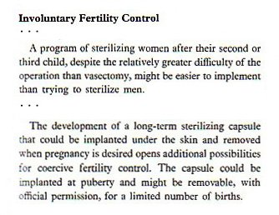 | Involuntary fertility control  ...  A program of sterilizing women after their second or third child, despite the relatively greater difficulty of the operation than vasectomy, might be easier to implement than trying to sterilize men.  ...  The development of a long-term sterilizing capsule that could be implanted under the skin and removed when pregnancy is desired opens additional possibilities for coercive fertility control. The capsule could be implanted at puberty and might be removable, with official permission, for a limited number of births.
Note well the phrase "with official permission" in the above quote. Johh Holdren envisions a society in which the government implants a long-term sterilization capsule in all girls as soon as they reach puberty, who then must apply for official permission to temporarily remove the capsule and be allowed to get pregnant at some later date. Alternately, he wants a society that sterilizes all women once they have two children. Do you want to live in such a society? Because I sure as hell don't.

Page 838: The kind of people who cause "social deterioration" can be compelled to not have children
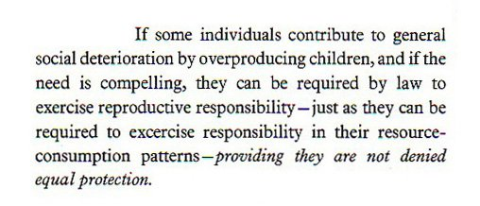 | If some individuals contribute to general social deterioration by overproducing children, and if the need is compelling, they can be required by law to exercise reproductive responsibility—just as they can be required to exercise responsibility in their resource-consumption patterns—providing they are not denied equal protection.
To me, this is in some ways the most horrifying sentence in the entire book -- and it had a lot of competition. Because here Holdren reveals that moral judgments would be involved in determining who gets sterilized or is forced to abort their babies. Proper, decent people will be left alone -- but those who "contribute to social deterioration" could be "forced to exercise reproductive responsibility" which could only mean one thing -- compulsory abortion or involuntary sterilization. What other alternative would there be to "force" people to not have children? Will government monitors be stationed in irresponsible people's bedrooms to ensure they use condoms? Will we bring back the chastity belt? No -- the only way to "force" people to not become or remain pregnant is to sterilize them or make them have abortions.
But what manner of insanity is this? "Social deterioration"? Is Holdren seriously suggesting that "some" people contribute to social deterioriation more than others, and thus should be sterilized or forced to have abortions, to prevent them from propagating their kind? Isn't that eugenics, plain and simple? And isn't eugenics universally condemned as a grotesquely evil practice?
We've already been down this road before. In one of the most shameful episodes in the history of U.S. jurisprudence, the Supreme Court ruled in the infamous 1927 Buck v. Bell case that the State of Virginia had had the right to sterilize a woman named Carrie Buck against her will, based solely on the (spurious) criteria that she was "feeble-minded" and promiscuous, with Justice Oliver Wendell Holmes concluding, "Three generations of imbeciles are enough." Nowadays, of course, we look back on that ruling in horror, as eugenics as a concept has been forever discredited. In fact, the United Nations now regards forced sterilization as a crime against humanity.
The italicized phrase at the end ("providing they are not denied equal protection"), which Holdren seems to think gets him off the eugenics hook, refers to the 14th Amendment (as you will see in the more complete version of this passage quoted below), meaning that the eugenics program wouldn't be racially based or discriminatory -- merely based on the whim and assessments of government bureaucrats deciding who and who is not an undesirable. If some civil servant in Holdren's America determines that you are "contributing to social deterioration" by being promiscuous or pregnant or both, will government agents break down your door and and haul you off kicking and screaming to the abortion clinic? In fact, the Supreme Court case Skinner v. Oklahoma already determined that the Equal Protection Clause of the 14th Amendment distinctly prohibits state-sanctioned sterilization being applied unequally to only certain types of people.
No no, you say, Holdren isn't claiming that some kind of people contribute to social deterioration more than others; rather, he's stating that anyone who overproduces children thereby contributes to social deterioration and needs to be stopped from having more. If so -- how is that more palatable? It seems Holdren and his co-authors have not really thought this through, because what they are suggesting is a nightmarish totalitarian society. What does he envision: All women who commit the crime of having more than two children be dragged away by police to the government-run sterilization centers? Or -- most disturbingly of all -- perhaps Holdren has thought it through, and is perfectly OK with the kind of dystopian society he envisions in this book.
Sure, I could imagine a bunch of drunken guys sitting around shooting the breeze, expressing these kinds of forbidden thoughts; who among us hasn't looked in exasperation at a harried mother buying candy bars and soda for her immense brood of unruly children and thought: Lady, why don't you just get your tubes tied already? But it's a different matter when the Science Czar of the United States suggests the very same thing officially in print. It ceases being a harmless fantasy, and suddenly the possibility looms that it could become government policy. And then it's not so funny anymore.

Page 838: Nothing is wrong or illegal about the government dictating family size
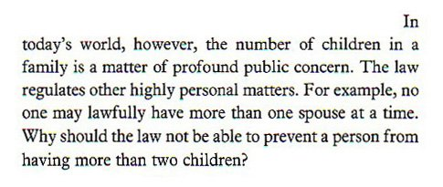 | In today's world, however, the number of children in a family is a matter of profound public concern. The law regulates other highly personal matters. For example, no one may lawfully have more than one spouse at a time. Why should the law not be able to prevent a person from having more than two children?
Why should the law not be able to prevent a person from having more than two children?
Why?
I'll tell you why, John. Because the the principle of habeas corpus upon which our nation rests automatically renders any compulsory abortion scheme to be unconstitutional, since it guarantees the freedom of each individual's body from detention or interference, until that person has been convicted of a crime. Or are you seriously suggesting that, should bureaucrats decide that the country is overpopulated, the mere act of pregnancy be made a crime?
I am no legal scholar, but it seems that John Holgren is even less of a legal scholar than I am. Many of the bizarre schemes suggested in Ecoscience rely on seriously flawed legal reasoning. The book is not so much about science, but instead is about reinterpreting the Constitution to allow totalitarian population-control measures.

Page 942-3: A "Planetary Regime" should control the global economy and dictate by force the number of children allowed to be born
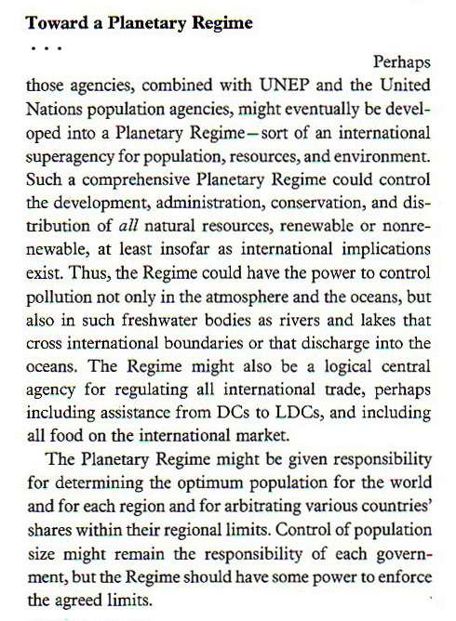 | Toward a Planetary Regime  ...  Perhaps those agencies, combined with UNEP and the United Nations population agencies, might eventually be developed into a Planetary Regime—sort of an international superagency for population, resources, and environment. Such a comprehensive Planetary Regime could control the development, administration, conservation, and distribution of all natural resources, renewable or nonrenewable, at least insofar as international implications exist. Thus the Regime could have the power to control pollution not only in the atmosphere and oceans, but also in such freshwater bodies as rivers and lakes that cross international boundaries or that discharge into the oceans. The Regime might also be a logical central agency for regulating all international trade, perhaps including assistance from DCs to LDCs, and including all food on the international market.  The Planetary Regime might be given responsibility for determining the optimum population for the world and for each region and for arbitrating various countries' shares within their regional limits. Control of population size might remain the responsibility of each government, but the Regime would have some power to enforce the agreed limits.
In case you were wondering exactly who would enforce these forced abortion and mass sterilization laws: Why, it'll be the "Planetary Regime"! Of course! I should have seen that one coming.
The rest of this passage speaks for itself. Once you add up all the things the Planetary Regime (which has a nice science-fiction ring to it, doesn't it?) will control, it becomes quite clear that it will have total power over the global economy, since according to Holdren this Planetary Regime will control "all natural resources, renewable or nonrenewable" (which basically means all goods) as well as all food, and commerce on the oceans and any rivers "that discharge into the oceans" (i.e. 99% of all navigable rivers). What's left? Not much.

Page 917: We will need to surrender national sovereignty to an armed international police force
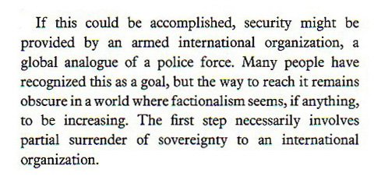 | If this could be accomplished, security might be provided by an armed international organization, a global analogue of a police force. Many people have recognized this as a goal, but the way to reach it remains obscure in a world where factionalism seems, if anything, to be increasing. The first step necessarily involves partial surrender of sovereignty to an international organization.
The other shoe drops. So: We are expected to voluntarily surrender national sovereignty to an international organization (the "Planetary Regime," presumably), which will be armed and have the ability to act as a police force. And we saw in the previous quote exactly which rules this armed international police force will be enforcing: compulsory birth control, and all economic activity.
It would be laughable if Holdren weren't so deadly serious. Do you want this man to be in charge of science and technology in the United States? Because he already is in charge.

Page 749: Pro-family and pro-birth attitudes are caused by ethnic chauvinism
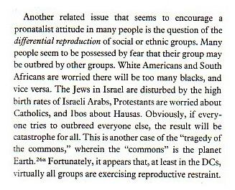 | Another related issue that seems to encourage a pronatalist attitude in many people is the question of the differential reproduction of social or ethnic groups. Many people seem to be possessed by fear that their group may be outbred by other groups. White Americans and South Africans are worried there will be too many blacks, and vice versa. The Jews in Israel are disturbed by the high birth rates of Israeli Arabs, Protestants are worried about Catholics, and lbos about Hausas. Obviously, if everyone tries to outbreed everyone else, the result will be catastrophe for all. This is another case of the "tragedy of the commons," wherein the "commons" is the planet Earth. Fortunately, it appears that, at least in the DCs, virtually all groups are exercising reproductive restraint.
This passage is not particularly noteworthy except for the inclusion of the odd phrase "pronatalist attitude," which Holdren spends much of the book trying to undermine. And what exactly is a "pronatalist attitude"? Basically it means the urge to have children, and to like babies. If only we could suppress people's natural urge to want children and start families, we could solve all our problems!
What's disturbing to me is the incredibly patronizing and culturally imperialist attitude he displays here, basically acting like he has the right to tell every ethnic group in the world that they should allow themselves to go extinct or at least not increase their populations any more. How would we feel if Andaman Islanders showed up on the steps of the Capitol in Washington D.C. and announced that there were simply too many Americans, and we therefore are commanded to stop breeding immediately? One imagines that the attitude of every ethnic group in the world to John Holdren's proposal would be: Cram it, John. Stop telling us what to do.

Page 944: As of 1977, we are facing a global overpopulation catastrophe that must be resolved at all costs by the year 2000
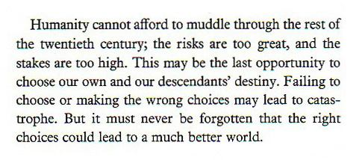 | Humanity cannot afford to muddle through the rest of the twentieth century; the risks are too great, and the stakes are too high. This may be the last opportunity to choose our own and our descendants' destiny. Failing to choose or making the wrong choices may lead to catastrophe. But it must never be forgotten that the right choices could lead to a much better world.
This is the final paragraph of the book, which I include here only to show how embarrassingly inaccurate his "scientific" projections were. In 1977, Holdren thought we were teetering on the brink of global catastrophe, and he proposed implementing fascistic rules and laws to stave off the impending disaster. Luckily, we ignored his warnings, yet the world managed to survive anyway without the need to punish ourselves with the oppressive society which Holdren proposed. Yes, there still is overpopulation, but the problems it causes are not as morally repugnant as the "solutions" which John Holdren wanted us to adopt.

I actually don't disagree with everything Holdren says. I agree with him that overpopulation is a problem, and that much of the environmental degradation that has happened is due in large part to overpopulation (mostly in the developing world). Where we disagree is in the solution. While Holdren does occasionally advocate for milder solutions elsewhere in the book, his basic premise is that the population explosion has gotten so out of control that only the most oppressive and totalitarian measures can possibly stop humanity from stripping the planet bare and causing a catastrophe beyond our imagining. Holdren has (apparently) no problem saying we should force people to not have children, by any means necessary. And that is where we part ways. I draw the line at even the hint of compulsory compliance to draconian laws about pregnancy and abortion; Holdren does not hesitate to cross that line without a second thought.
My solution would be to adopt social policies that are known to lead to voluntary and non-coercive trends toward a lower birth rate: increased education for girls in poor countries, better access to (voluntarily adopted) birth control, higher standards of living. In fact, population trends since 1977 have started to level off in the crisis areas of Asia and Latin America, primarily due to better standards of living and better education, which are known to decrease population growth. These non-oppressive policies appear to be sufficient to control the population -- and Holdren's decades-long panic attack seems to be unfounded.
Now, consider all the recommendations by Holdren given above, and then note that at his Senate confirmation hearing he said he would "keep policy free from politics" if confirmed. In fact Holdren has repeatedly said that science should not be be tainted by politics, telling the BBC just a few days ago that "he wanted to take the politics out of scientific advice." But have you ever seen more politicized science-policy recommendations than those given in Ecoscience?

For the doubters and the naysayers...
There are five possible counter-claims which you might make against this report:
1. I'm lying, Holdren wrote no such thing, and this whole page is one big hoax.
2. He may have said those things, but I'm taking them out of context.
3. He was just the co-author -- he probably didn't write these particular passages, nor did he agree with them.
4. What he said really isn't that egregious: in fact, it seems pretty reasonable.
5. He wrote all this a long time ago -- he's probably changed his views by now.
I'll address each in turn:
1. I'm lying, Holdren wrote no such thing, and this whole page is one big hoax.
Scroll to the bottom of this page, and look at the photos of the book -- especially the last two photos, showing the book opened to pages quoted in this report. Then look at the full-page scans directly above those photos, showing each page mentioned here in full, unaltered. What more proof do you need? If you're still not convinced, go to any large library and check out the book yourself, and you'll see: everything I claim here is true.
If you don't have the patience to go to a library, you can always view the actual contents of the book online for free for a brief trial period.
2. He may have said those things, but I'm taking them out of context.
Some have argued that the FrontPage article "takes quotes out of context," which is the very reason why I went and investigated the original book itself. Turns out that not only are the quotes not out of context, but the additional paragraphs on either side of each passage only serve to make Holdren's ideas appear even more sinister. You want context? Be careful what you ask for, because the context makes things worse.
But yes, to satisfy the curious and the doubters, the "extended passages" and full-page scans given below provide more than sufficient context for the quotes.
In truth, I weary of the "context game" in which every controversial statement is always claimed to be "out of context," and no matter how much context is then given, it's never enough, until one must present every single word someone has ever written -- at which point the reader becomes overwhelmed and loses interest. Which is the whole point of the context game to begin with.
3. He was just the co-author -- he probably didn't write these particular passages, nor did he agree with them.
First of all: If you are a co-author of a book, you are signing your name to it, and you must take responsibility for everything that is in that book. This is true for John Holdren and every other author.
But there's plenty more evidence than that. Most significantly, Holdren has held similar views for years and frequently wrote about them under his own name. It's not like these quotes are unexpected and came out of the blue -- they fit into a pattern of other Holdren writings and viewpoints.
Lastly, below I present full-page scans of the "Acknowledgments" pages in Ecoscience, and in those Acknowledgments pages are dozens of thank-yous to people at U.C. Berkeley -- where Holdren was a professor at the time. In fact, there are more acknowledgments involving Berkeley than anywhere else, and since Holdren was the only one of the three authors with a connection to Berkeley, they must be his thank-yous -- indicating that he wrote a substantial portion of the book. Even his wife is thanked.
I have no way of knowing if Holdren himself typed the exact words quoted on this page, but he certainly at a minimum edited them and gave them his stamp of approval.
4. What he said really isn't that egregious: in fact, it seems pretty reasonable.
Well, if you believe that, then I guess this page holds no interest for you, and you are thereby free to ignore it. But I have a suspicion that the vast majority of Americans find the views expressed by Holdren to be alarming and abhorrent.
5. He wrote all this a long time ago -- he's probably changed his views by now.
You might argue that this book was written in a different era, during which time a certain clique of radical scientists (including Holdren) were in a frenzy over what they thought was a crisis so severe it threatened the whole planet: overpopulation. But, you could say, all that is in the past, an embarrassing episode which Holdren might wish everyone would now forget. I mean, people change their opinions all the time. Senator Robert Byrd was once in the KKK, after all, but by now he has renounced those views. Perhaps in a similar vein John Holdren no longer believes any of the things he wrote in Ecoscience, so we can't hold them against him any more.
.
The White House gets involved: Recent statements by Holdren and the Ehrlichs in response to this controversy
When I originally wrote and published this essay on July 10, I said:
"Unfortunately, as far as I've been able to discover, Holdren has never disavowed the views he held in the 1970s and spelled out in Ecoscience and other books."
However, that is no longer entirely true. On July 15, both the White House and John Holdren's office issued statements on this controversy after prodding from reporters at both the Washington Times and the Catholic News Agency.
According to this article by Amanda Carpenter in the Washington Times, Holdren and his co-authors have now distanced themselves from the words published in Ecoscience 32 years ago. From the article:
When asked whether Mr. Holdren's thoughts on population control have changed over the years, his staff gave The Washington Times a statement that said, "This material is from a three-decade-old, three-author college textbook. Dr. Holdren addressed this issue during his confirmation when he said he does not believe that determining optimal population is a proper role of government. Dr. Holdren is not and never has been an advocate for policies of forced sterilization."
...
The White House also passed along a statement from the Ehrlichs that said, in part, "anybody who actually wants to know what we and/or Professor Holdren believe and recommend about these matters would presumably read some of the dozens of publications that we and he separately have produced in more recent times, rather than going back a third of a century to find some formulations in an encyclopedic textbook where description can be misrepresented as endorsement."
(The second quote above is from page 2 of the article.)
The Catholic News Agency also reported on July 15,
In Tuesday e-mails to CNA, Rick Weiss, the Office of Science and Technology Policy's Director of Strategic Communications, said the material at issue was from "a three-decade-old, three-author textbook used in colleges to teach energy policy."
He could "easily dismiss" fears that Dr. Holdren favors government control over population growth.
"He made that quite clear in his confirmation hearing," Weiss said.
He then quoted a section of the confirmation transcript in which Sen. David Vitter (R-LA) asked Holdren whether he thinks "determining optimal population is a proper role of government."
"No, Senator, I do not," was Holdren's reply, according to Weiss and a transcript of the proceedings.
In other remarks at the confirmation hearing, not cited by Weiss, Holdren told Sen. Vitter he no longer thinks it is "productive" to focus on the "optimum population" for the United States. "I don't think any of us know what the right answer is."
According to Weiss, Holdren "made clear that he did not believe in coercive means of population control" and is not an advocate for measures expressed in the book "and they are certainly not endorsed by this administration in any way."
Weiss also provided CNA with a statement from the book's other two authors, Paul and Anne Ehrlich.
The Ehrlichs said they had been "shocked" at what they called the "serious misrepresentation" of their and Holdren's views.
"We were not then, never have been, and are not now 'advocates' of the Draconian measures for population limitation described -- but not recommended -- in the book's 60-plus small-type pages cataloging the full spectrum of population policies that, at the time, had either been tried in some country or analyzed by some commentator."
Describing "Ecoscience" as a "textbook," they said its descriptions can be "misrepresented as endorsement."
In my original report, I challenged Holdren "to publicly renounce and disavow the opinions and recommendations he made in the book Ecoscience."
I ask my readers: Do you think these two articles count as the renunciation and disavowal I requested?
I'm not so sure. First of all, the disavowals were made by a spokesman and by his co-authors -- as of this writing, Holdren himself has never renounced and disavowed the contents of Ecoscience. Unless you want to count the one-sentence answer he gave during the confirmation hearing.
Under questioning from Senator David Vitter, Holdren did backpedal a bit concerning a different statement he made in the '70s about government-controlled population levels. Does this single sentence count as an across-the-board disavowal of every single specific recommendation he made in Ecoscience as well as in many other books and articles? My opinion is Not really, but as usual I'll provide the full evidence and the full context and I'll let you decide for yourself. You can view the video of the confirmation hearings here (introductory page here), but be warned that it is an extremely long streaming video that doesn't work in all browsers, and the answer in question doesn't come until the 120th minute.
Because most people won't or can't view the entire video, here's a transcript of the relevant part, and you can decide for yourself whether his statement counts as a disavowal of his quotes cited in this report:
[Starting at 120:30]
Senator David Vitter: In 1973, you encouraged "a decline in fertility well below replacement" in the United States because "280 million in 2040 is likely to be too many." What would your number for the right population in the US be today?
John Holdren: I no longer think it's productive, Senator, to focus on the optimum population of the United States. I don't think any of us know what the right answer is. When I wrote those lines in 1973, uh, I was preoccupied with the fact that many problems the United States faced appeared to be being made more difficult by the greater population growth that then prevailed. I think everyone who studies these matters understands that population growth brings some benefits and some liabilities; it's a tough question to determine which will prevail in a given time period.
Vitter then asked, "You think determining optimal population is a proper role of government?" To which Holdren replied, "No, Senator, I do not."
(If you want the full context of this exchange between Vitter and Holdren, a complete transcript of their entire question-and-answer session can be found posted here.)
I'm not sure just how seriously we should take a statement made by someone during what is essentially a job interview. A few words spent reassuring the interviewer that you don't really believe all those things you spent thirty years elaborating in detail -- what else should we expect? That Holdren would say, Yes, I think the government should lower the U.S. population down to 280 million? Of course he wouldn't say that during the interview, despite what he may or may not really believe internally.
But let's spend a moment looking at these answers more closely. Both of them referred to determining a specific number of people that should be allowed as the population of the United States. First he said it was "no longer productive" to set a hard-and-fast exact number for the population of the U.S., and then said he doesn't think we should "determine the optimal population." But that still leaves the door open for the notion that the population should be lowered by whatever means in general without a specific numerical goal in mind. Holdren still did not say that he's against population control as a concept -- only that he thinks we shouldn't set specific numeric targets.
And more importantly in the context of this essay, he did not disavow any of the specific proposals quoted here -- forced abortion, "Planetary Regime," etc.
Rather than a fairly vague blanket disavowal given in response to a question on a slightly different topic during the confirmation hearings, and rather than a statement given by someone in his office, and rather than a statement issued by his co-authors, I still would like to see a specific disavowal by Holdren himself. And so I repeat,
I challenge John Holdren himself to publicly renounce and disavow the opinions and specific recommendations he made in the book Ecoscience; and until he does so, I will hold him responsible for those statements.
Columnist David Harsanyi, who received a similar semi-disavowal from Holdren's office, dismantles it quite effectively in an excellent piece he published on July 15 in the Denver Post, Reason Online and elsewhere.
And who wants to take up the challenge from the Ehrlichs issued by the White House to look into "some of the dozens of publications that we and he separately have produced in more recent times" to uncover "what we and/or Professor Holdren believe"? Seems like territory ripe for exploration. Post any research you uncover either here in the comments section at zomblog, or on your own blog. Anything that John Holdren or the Ehrlichs have written since 1977 is fair game -- according to the Ehrlichs themselves.

Before you read any further...
If you accept the self-evident veracity of these quotations, and are outraged enough already, then you can stop reading here. Very little new information is presented below.
(And if you'd like to comment on this report, you can do so HERE at zomblog.)
But if you still harbor doubts that the United States Science Czar could possibly harbor such views, and want more proof, then read on for longer and fuller citations, and full-page scans of the pages in the book, as well as photographs of the book itself. And if by chance you are a Holdren or Obama supporter, and want to falsely claim that I have taken Holdren's statements out of context, then you'd better stop reading here too, because if you go any further then you'll see that I have given full context for the quotes and conclusive evidence that they're Holdren's -- removing any basis by which you could have questioned this report.

More Context: Complete extended passages from which the quotes above were taken
For most of these, I will present the following extended passages without further commentary -- judge for yourself if you think the context mitigates Holdren's intent, or only worsens the impression that he's completely serious about all this.

Page 837 full-length extended quote:
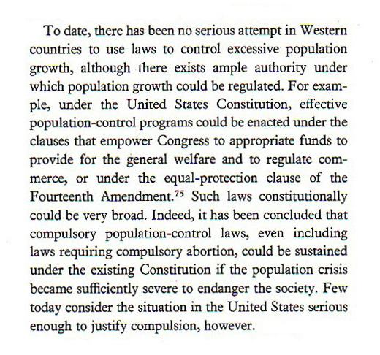 | To date, there has been no serious attempt in Western countries to use laws to control excessive population growth, although there exists ample authority under which population growth could be regulated. For example, under the United States Constitution, effective population-control programs could be enacted under the clauses that empower Congress to appropriate funds to provide for the general welfare and to regulate commerce, or under the equal-protection clause of the Fourteenth Amendment. Such laws constitutionally could be very broad. Indeed, it has been concluded that compulsory population-control laws, even including laws requiring compulsory abortion, could be sustained under the existing Constitution if the population crisis became sufficiently severe to endanger the society. Few today consider the situation in the United States serious enough to justify compulsion, however.
Let it be noted that John Holdren himself is among the few who "consider the situation in the United States serious enough to justify compulsion" -- in fact, that's the entire thrust of Ecoscience, to convince everyone that overpopulation is a catastrophic crisis which requires immediate and extreme solutions. So although the final sentence of the extended passage seems at first to mollify the extreme nature of his speculation, in reality Holdren is only speaking of all the unaware masses who don't see things his way.

Page 786 full-length extended quote:
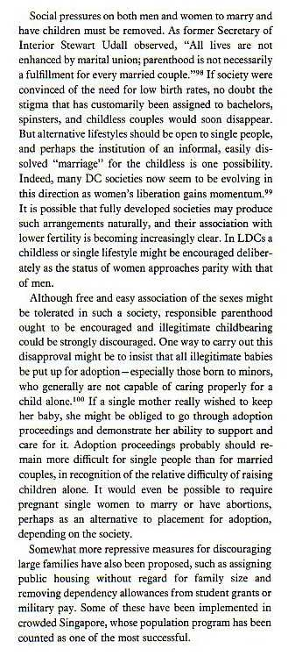 | Social pressures on both men and women to marry and have children must be removed. As former Secretary of Interior Stewart Udall observed, "All lives are not enhanced by marital union; parenthood is not necessarily a fulfillment for every married couple." If society were convinced of the need for low birth rates, no doubt the stigma that has customarily been assigned to bachelors, spinsters, and childless couples would soon disappear. But alternative lifestyles should be open to single people, and perhaps the institution of an informal, easily dissolved "marriage" for the childless is one possibility. Indeed, many DC societies now seem to be evolving in this direction as women's liberation gains momentum. It is possible that fully developed societies may produce such arrangements naturally, and their association with lower fertility is becoming increasingly clear. In LDCs a childless or single lifestyle might be encouraged deliberately as the status of women approaches parity with that of men.  Although free and easy association of the sexes might be tolerated in such a society, responsible parenthood ought to be encouraged and illegitimate childbearing could be strongly discouraged. One way to carry out this disapproval might be to insist that all illegitimate babies be put up for adoption—especially those born to minors, who generally are not capable of caring properly for a child alone. If a single mother really wished to keep her baby, she might be obliged to go through adoption proceedings and demonstrate her ability to support and care for it. Adoption proceedings probably should remain more difficult for single people than for married couples, in recognition of the relative difficulty of raising children alone. It would even he possible to require pregnant single women to marry or have abortions, perhaps as an alternative to placement for adoption, depending on the society.  Somewhat more repressive measures for discouraging large families have also been proposed, such as assigning public housing without regard for family size and removing dependency allowances from student grants or military pay. Some of these have been implemented in crowded Singapore, whose population program has been counted as one of the most successful.
In the final sentence of this passage, Holdren speaks approvingly of Singapore's infamous totalitarian micromanaging of people's daily lives.
But to me, the most bizarre and disturbing aspect of the quote given here is that Holgren seems to think that economic disincentives to have large families are more repressive and extreme than taking away basic bodily rights. To Holdren, "removing dependency allowances from student grants" is more repressive than compelling women to have abortions against their will. A very peculiar and twisted view of the world, I must say.

Page 787-8 full-length extended quote:
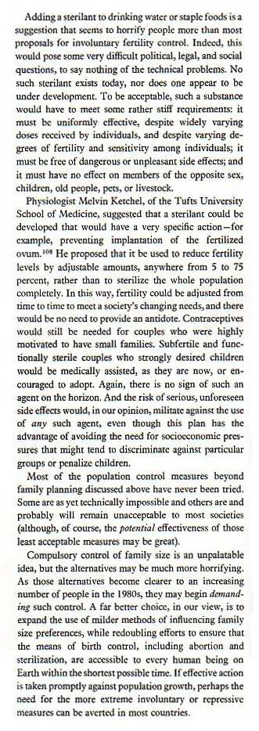 | Adding a sterilant to drinking water or staple foods is a suggestion that seems to horrify people more than most proposals for involuntary fertility control. Indeed, this would pose some very difficult political, legal, and social questions, to say nothing of the technical problems. No such sterilant exists today, nor does one appear to be under development. To be acceptable, such a substance would have to meet some rather stiff requirements: it must be uniformly effective, despite widely varying doses received by individuals, and despite varying degrees of fertility and sensitivity among individuals; it must be free of dangerous or unpleasant side effects; and it must have no effect on members of the opposite sex, children, old people, pets, or livestock.  Physiologist Melvin Ketchel, of the Tufts University School of Medicine, suggested that a sterilant could be developed that had a very specific action—for example, preventing implantation of the fertilized ovum. He proposed that it be used to reduce fertility levels by adjustable amounts, anywhere from five to 75 percent, rather than to sterilize the whole population completely. In this way, fertility could be adjusted from time to time to meet a society's changing needs, and there would be no need to provide an antidote. Contraceptives would still be needed for couples who were highly motivated to have small families. Subfertile and functionally sterile couples who strongly desired children would be medically assisted, as they are now, or encouraged to adopt. Again, there is no sign of such an agent on the horizon. And the risk of serious, unforeseen side effects would, in our opinion, militate against the use of any such agent, even though this plan has the advantage of avoiding the need for socioeconomic pressures that might tend to discriminate against particular groups or penalize children.  Most of the population control measures beyond family planning discussed above have never been tried. Some are as yet technically impossible and others are and probably will remain unacceptable to most societies (although, of course, the potential effectiveness of those least acceptable measures may be great).  Compulsory control of family size is an unpalatable idea, but the alternatives may be much more horrifying. As those alternatives become clearer to an increasing number of people in the 1980s, they may begin demanding such control. A far better choice, in our view, is to expand the use of milder methods of influencing family size preferences while redoubling efforts to ensure that the means of birth control, including abortion and sterilization, are accessible to every human being on Earth within the shortest possible time. If effective action is taken promptly against population growth, perhaps the need for the more extreme involuntary or repressive measures can be averted in most countries.

Page 786-7 full-length extended quote:
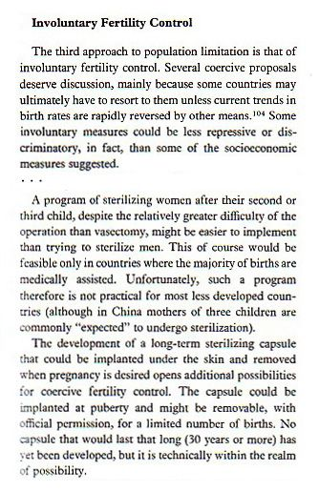 | Involuntary fertility control  The third approach to population limitation is that of involuntary fertility control. Several coercive proposals deserve discussion, mainly because some countries may ultimately have to resort to them unless current trends in birthrates are rapidly reversed by other means. Some involuntary measures could be less repressive or discriminatory, in fact, than some of the socioeconomic measure suggested.  ...  A program of sterilizing women after their second or third child, despite the relatively greater difficulty of the operation than vasectomy, might be easier to implement than trying to sterilize men. This of course would be feasible only in countries where the majority of births are medically assisted. Unfortunately, such a program therefore is not practical for most less developed countries (although in China, mothers of three children are commonly "expected" to undergo sterilization).  The development of a long-term sterilizing capsule that could be implanted under the skin and removed when pregnancy is desired opens additional possibilities for coercive fertility control. The capsule could be implanted at puberty and might be removable, with official permission, for a limited number of births. No capsule that would last that long (30 years or more) has yet been developed, but it is technically within the realm of possibility.

Page 838 full-length extended quote:
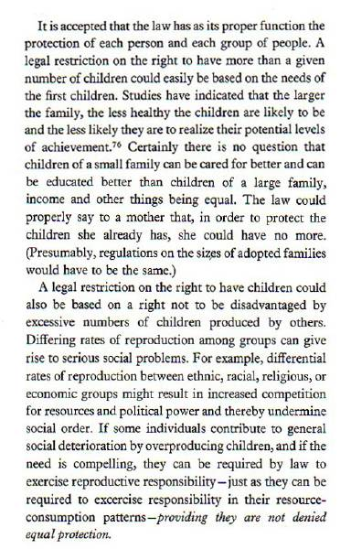 | It is accepted that the law has as its proper function the protection of each person and each group of people. A legal restriction on the right to have more than a given number of children could easily be based on the needs of the first children. Studies have indicated that the larger the family, the less healthy the children are likely to be and the less likely they are to realize their potential levels of achievement. Certainly there is no question that children of a small family can be cared for better and can be educated better than children of a large family, income and other things being equal. The law could properly say to a mother that, in order to protect the children she already has, she could have no more. (Presumably, regulations on the sizes of adopted families would have to be the same.)  A legal restriction on the right to have children could also be based on the right not to be disadvantaged by excessive numbers of children produced by others. Differing rates of reproduction among groups can give rise to serious social problems. For example, differential rates of reproduction between ethnic, racial, religious, or economic groups might result in increased competition for resources and political power and thereby undermine social order. If some individuals contribute to general social deterioration by overproducing children, and if the need is compelling, they can be required by law to exercise reproductive responsibility—just as they can be required to exercise responsibility in their resource-consumption patterns—providing they are not denied equal protection.
Study this whole extended passage carefully for an extremely unsettling view into the legal brain of John Holdren. Some of the sentiments he expresses here are beyond the pale, and his legal reasoning boggles the mind.

Page 838 full-length extended quote:
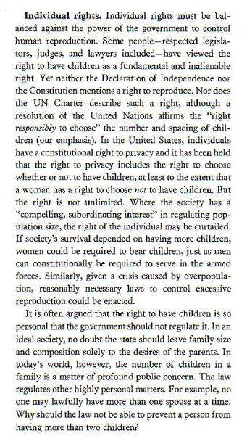 | Individual rights. Individual rights must be balanced against the power of the government to control human reproduction. Some people—respected legislators, judges, and lawyers included—have viewed the right to have children as a fundamental and inalienable right. Yet neither the Declaration of Independence nor the Constitution mentions a right to reproduce. Nor does the UN Charter describe such a right, although a resolution of the United Nations affirms the "right responsibly to choose" the number and spacing of children (our emphasis). In the United States, individuals have a constitutional right to privacy and it has been held that the right to privacy includes the right to choose whether or not to have children, at least to the extent that a woman has a right to choose not to have children. But the right is not unlimited. Where the society has a "compelling, subordinating interest" in regulating population size, the right of the individual may be curtailed. If society's survival depended on having more children, women could he required to bear children, just as men can constitutionally be required to serve in the armed forces. Similarly, given a crisis caused by overpopulation, reasonably necessary laws to control excessive reproduction could be enacted.  It is often argued that the right to have children is so personal that the government should not regulate it. In an ideal society, no doubt the state should leave family size and composition solely to the desires of the parents. In today's world, however, the number of children in a family is a matter of profound public concern. The law regulates other highly personal matters. For example, no one may lawfully have more than one spouse at a time. Why should the law not be able to prevent a person from having more than two children?
This extended passage is a perfect example of how the "full context" of a short quote only makes it worse; once you see Holdren's complete elaboration on the idea, you realize it's not some flippant notion he tossed off, but something he feels deeply about.

Page 942-3 full-length extended quote:
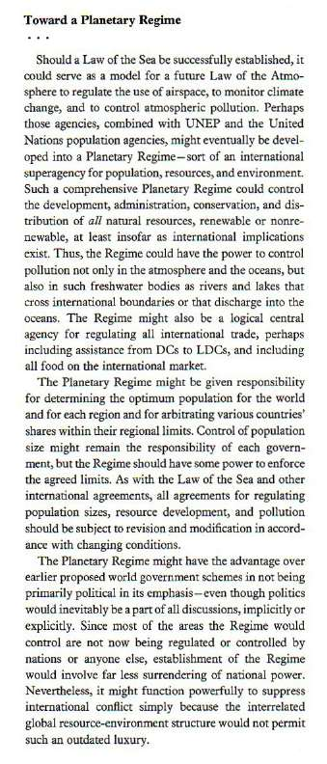 | Toward a Planetary Regime  ...  Should a Law of the Sea be successfully established, it could serve as a model for a future Law of the Atmosphere to regulate the use of airspace, to monitor climate change, and to control atmospheric pollution. Perhaps those agencies, combined with UNEP and the United Nations population agencies, might eventually be developed into a Planetary Regime—sort of an international superagency for population, resources, and environment. Such a comprehensive Planetary Regime could control the development, administration, conservation, and distribution of all natural resources, renewable or nonrenewable, at least insofar as international implications exist. Thus, the Regime could have the power to control pollution not only in the atmosphere and the oceans but also in such freshwater bodies as rivers and lakes that cross international boundaries or that discharge into the oceans. The Regime might also be a logical central agency for regulating all international trade, perhaps including assistance from DCs to LDCs, and including all food on the international market.  The Planetary Regime might be given responsibility for determining the optimum population for the world and for each region and for arbitrating various countries' shares within their regional limits. Control of population size might remain the responsibility of each government, but the Regime should have some power to enforce the agreed limits. As with the Law of the Sea an other international agreements, all agreements for regulating population sizes, resource development, and pollution should be subject to revision and modification in accordance with changing conditions.  The Planetary Regime might have the advantage over earlier proposed world government schemes in not being primarily political in its emphasis—even though politics would inevitably be a part of all discussions, implicitly or explicitly. Since most of the areas the Regime would control are not now being regulated or controlled by nations or anyone else, establishment of the Regime would involve far less surrendering of national power. Nevertheless it might function powerfully to suppress international conflict simply because the interrelated global resource-environment structure would not permit such an outdated luxury.

Page 917 full-length extended quote:
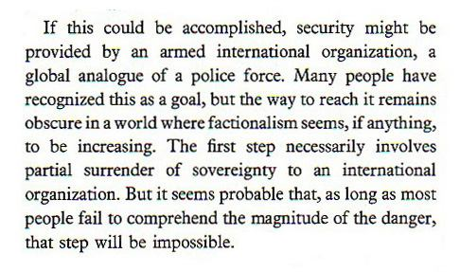 | If this could be accomplished, security might be provided by an armed international organization, a global analogue of a police force. Many people have recognized this as a goal, but the way to reach it remains obscure in a world where factionalism seems, if anything, to be increasing. The first step necessarily involves partial surrender of sovereignty to an international organization. But it seems probable that, as long as most people fail to comprehend the magnitude of the danger, that step will be impossible.

END

