**Deagel Population Forecast of Nearly 70 Percent Fewer Americans by 2025 Is Prophetic -** [Leo Hohmann](https://leohohmann.com/about/) April 21, 2023

<https://lionessofjudah.substack.com/p/deagel-population-forecast-of-nearly?utm_medium=email>

All of the globalist policies over the last three years are driving toward one thing, mass depopulation. Yes, they want to kill us. Until you understand that, you will never understand what’s going on. You will never make sense of it.

I know it’s a hard pill to swallow, but reject it at your own risk. Those who live in denial will get duped, again. Many of those duped the first time lost their lives, or ended up with life-long health issues. Some even offered their children to the military-biomedical-security complex.

I like to revert back to the analysis done by Deagel Corp. in 2014, forecasting massive global population declines out to the year 2025, especially in Western countries.

Deagel’s founder was a military contractor who had sources well positioned in the deep state. The Deagel Corporation is an offshoot of US military intelligence which collects data for high-level decision-makers and prepares confidential briefing documents for agencies like the National Security Agency, the United Nations and the World Bank.

According to the **[Deagel forecast](https://nobulart.com/wordpress/wp-content/uploads/2021/08/Deagel-2025-Forecast-by-Country.pdf)**, America’s population would plummet from just over 310 million in 2017 down to just 99 million by the end of 2025. Western European nations, especially the U.K. and Germany, were forecast to see similarly drastic decreases in population, as were Canada and Australia.

If the Deagel calculations turn out to be even close to accurate, the most unsafe places to live over the next three years will be the United States, Canada and the U.K., followed by Germany, Australia and the rest of the E.U. nations. This population forecast was so controversial, showing population reductions of 68.5 percent in the United States (from 2017 levels) and between 25 and 70 percent for almost every Western European country, that the study mysteriously disappeared from Deagel’s website in March 2021.

But not all areas of the world will continue to decline. Some will actually have larger populations by 2025, according to the Deagel forecast. The safest places to be living would appear to be Central and South America, China and Africa. Interestingly, Russia came in as neutral, not gaining or losing population.

*Is this Deagel forecast map a prediction of who will win World War III?*

[[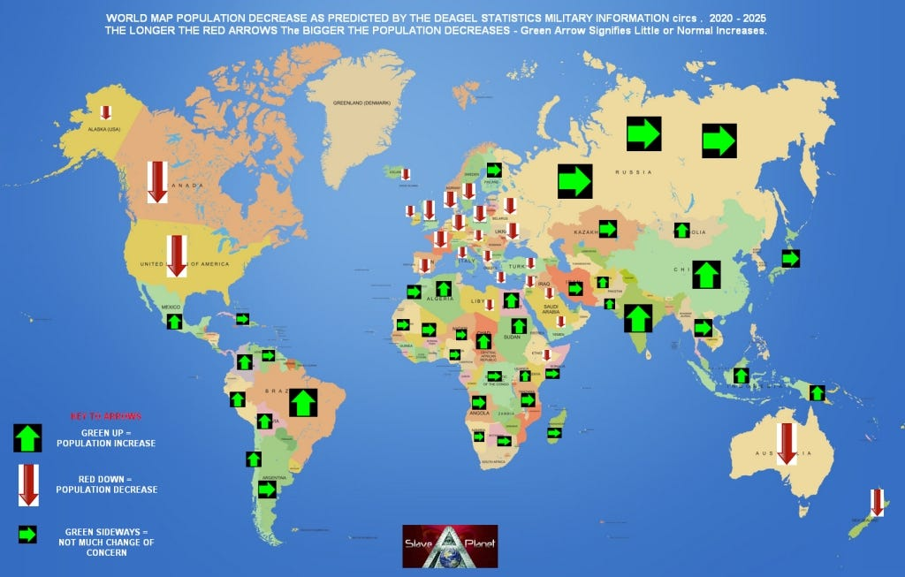](https://substackcdn.com/image/fetch/f_auto,q_auto:good,fl_progressive:steep/https%3A%2F%2Fsubstack-post-media.s3.amazonaws.com%2Fpublic%2Fimages%2F673eeb13-8fbc-4727-8df1-5e1a85aa328b_1024x653.jpeg)](https://substackcdn.com/image/fetch/f_auto,q_auto:good,fl_progressive:steep/https%3A%2F%2Fsubstack-post-media.s3.amazonaws.com%2Fpublic%2Fimages%2F673eeb13-8fbc-4727-8df1-5e1a85aa328b_1024x653.jpeg" \t "_blank)

Until the impact of the Covid “pandemic” and resulting mass vaccination campaign, many researchers were scratching their heads as they reviewed the Deagel calculations. But now it’s beginning to make sense.

Add in the rising potential for another manufactured pandemic, a manufactured global famine under the guise of fighting “climate change,” and the race toward World War III, and suddenly Deagel’s forecast becomes even more plausible.

Deagel’s predictions seemed so far-fetched in 2014 that some folks accused Deagel of engaging in a psy op. But maybe Deagel had good sources to back up its analysis. After all, the eugenics-loving Rockefeller Foundation had published its “Lockstep” analysis in 2010, all but guaranteeing that major pandemics would wipe out tens of millions of people, and Bill Gates, the world’s richest man, was well into his vaccine phase by 2014 as well, having shifted his focus a few years earlier away from computers and into the more profitable injections.

We also had the Georgia Guidestones to serve as a continuous reminder of the elites’ plan to drastically reduce the global population, to *cull the herd*, as they say.

The first “guideline” etched in the [**Georgia Guidestones monument**](https://leohohmann.com/2017/12/23/bible-belt-mystery-divine-or-from-the-devil/) stated “Maintain humanity under 500,000,000 in perpetual balance with nature,” representing a reduction of more than 90 percent of the earth’s people in typical Malthusian manner. That’s a goal that seemed outrageous until the full scope of the poison death shots and then the prospect of global famine and World War III started coming into view just beyond the horizon of the daily news headlines.

Then, the Guidestones were mysteriously bombed in the early morning hours of July 6, 2022. Just hours later, at around 6 p.m. on July 6, the Georgia Bureau of Investigation [**completely destroyed the damaged monument**](https://leohohmann.com/2022/07/06/explosion-reported-at-georgia-guidestones-monument-to-the-devil-has-now-been-completely-demolished/). This was an astonishing turn of events executed with lightning speed and then the state’s bizarre action quickly fell off the news cycle. Nobody was ever arrested and we hear nothing about any continuing investigation. Did it become necessary to get rid of the granite monument that stood as a testimony to the elites’ plan for mass depopulation of the world?

In fact, their plan may already be far enough down the road that it’s impossible to reverse. Humanity is being culled, whether we like it or not.

The globalists need to kill us off in order to fully enslave those who remain. Why? Because they have two basic disadvantages in their war against humanity. First, they are vastly outnumbered and, second, many of us still have the ability to think critically and independently of what we hear or see on their totally owned and controlled media outlets.

Sun Tzu, the brilliant Chinese military strategist on the Art of War, said that the smart warrior attacks his enemy’s strengths at his weakest point.

If the globalists are following the wisdom of Sun Tzu, they would cull the population and reduce the level at which they are outnumbered, and they would poison those of us who remain so that we are weakened and unable to think critically and independently, at least not to the level that we could organize any meaningful resistance.

[**The Covid Blog**](https://thecovidblog.com/2023/04/20/5-reasons-to-believe-the-global-population-is-already-one-billion-people-less-than-it-was-in-january-2020/) has put forth an interesting analysis on the global population after more than three years of the bioweapon that came out of Wuhan and more than two years of the related bioweapon that has been injected into people’s arms.

There were approximately [**7.84 billion people on Earth in January 2020**](https://www.macrotrends.net/countries/WLD/world/population)when all this started. The United Nations reported that the global population [**eclipsed the 8 billion mark in November 2022**](https://www.un.org/en/global-issues/population).

But here’s where it gets interesting. The Covid Blog’s article points out that there have been 40 million births and 20 million deaths, for a net population growth of 20 million thus far in 2023. But the sources of this information are the same ones who tell us to believe that men can give birth, gas stoves can kill us, and vaccines are safe and effective.

As of March 2023, there are [two jobs available in the U.S. for every one unemployed worker](https://numbernomics.com/unemployment-vs-job-openings-2/). The blog continues, adding:

“You don’t even need the [ADP Workforce Vitality Reports](https://workforcereport.adp.com/) to know that wages [have been at all-time highs since Q4 2021](https://www.myjournalcourier.com/news/article/U-S-wage-growth-hit-an-all-time-high-according-16809008.php). Just look around your local area, and you’ll see McDonald’s, Kum and Go, Circle K, Walmart, and all those former minimum wage jobs hiring at $15 per hour and up. They are forced to offer higher wages (or hire illegal immigrants) to entice what’s left of the U.S. workforce.”

The U.S. Chamber of Commerce [acknowledged the ongoing labor shortage earlier this month](https://www.uschamber.com/workforce/understanding-americas-labor-shortage). The corporate mainstream media have for two years blamed *anything but the vaccines* for the sudden deaths of young, healthy adults, even super-fit athletes and teenagers.

The bottom line is that millions of Americans have died or been severely maimed from the lethal mRNA and DNA injections. They can physically no longer work.

U.S. birth rates, meanwhile, are in free fall, as are global birth rates. In 2021, birth rates were the [lowest since World War I](https://apnews.com/article/birth-rates-science-coronavirus-pandemic-health-d51571bda4aa02eafdd42265912f1202) in the U.S., with Russia, China, and all the European countries similarly reporting a dearth of new babies being born. Sperm counts in men have fallen to the lowest level since such things started being measured. You cannot find a straight answer anywhere as to why this is happening.

So, the COVID Blog estimates that the global population has dropped from 7.8 billion in January 2020 to approximately 6.8 billion today – about a 13% drop in 28 months.

“The powers-that-be will never report the truth on this, and will do everything to conceal, manipulate and distort the real numbers. So all we can do is crunch everything we know to determine the progress of their goal – [500 million humans left on Earth by 2030](https://thecovidblog.com/2022/07/08/friday-update-rip-dr-zelenko-dr-carrie-madej-update-flccc-hope-for-vaxx-injured-georgia-guidestones-and-12-more-sudden-and-unexpected-deaths/). Former Malaysia Prime Minister Mahathir Mohamad fearlessly [**blew the whistle**](https://rumble.com/embed/vrlb7f/?pub=rze3r) on the depopulation agenda in 2015.”

[[](https://rumble.com/embed/vrlb7f/?pub=rze3r)](https://rumble.com/embed/vrlb7f/?pub=rze3r" \t "_blank)

The Covid Blog put forth five trends to back up its theory that the world’s population is already in free fall, according to the stated plans of the elites. Here are the first three:

**1. Governments across the world reported record increases in excess deaths in 2021 and 2022, and/or reported historically low birth rates.** “In other words, a lot of people are dying and few are being born.”

**2. There’s no way of knowing exactly what’s happening in the world’s two most populous countries, India and especially China**. “We know that China is dystopian hell. What we don’t know is how many people are being killed by the government and dying from the injections.”

India started injecting its population in January 2021, mostly with the Covishield/AstraZeneca viral vector DNA injections. As of March 2023, 95% of Indians age 12-plus [have received at least one shot.](https://dashboard.cowin.gov.in/)

Covid Blog reports: “By April 2021, truckloads of dead bodies being transported to morgues were so full that bodies were falling from the trucks on the roads. In Delhi, someone died every five minutes that month, [according to one report](https://archive.is/DtciE). The mass cremation videos from India in 2021 are very disturbing.”

The corporate mainstream media predictably blamed “COVID.” The only reason the deaths slowed after May 2021 was because India started [adopting Ivermectin and hydroxychloroquine protocols](https://thecovidblog.com/2021/05/16/india-turns-to-ivermectin-and-hydroxychloroquine-covid-cases-drop-significantly/).

Neither India nor China are particularly good about recording and reporting deaths, leading the Covid blog to conclude that “based on the foregoing, our educated guess is at least 350 million excess deaths in China and India from January 2020 to publishing today.”

**3. The kids die anonymously**. Deceived parents allow their children to be injected multiple times and/or they feed their babies vaxxed breast milk. The child dies. Most of these delusional parents play along with the mainstream narrative and blame anything but the vax, while only a tiny number of parents do the right thing and warn others not to get their children injected.

And of course the other big factor to weigh in is sterility caused by the vax. As people die, they’re not being replaced at normal rates.

Never comply. Never submit. Prepare mentally, physically and spiritually as we head into uncharted waters.

Source: [leohohmann.com](https://leohohmann.com/2023/04/21/deagel-population-forecast-of-nearly-70-percent-fewer-americans-by-2025-is-starting-to-look-prophetic/#more-13649)

[Share](https://lionessofjudah.substack.com/p/deagel-population-forecast-of-nearly?utm_source=substack&utm_medium=email&utm_content=share&action=share)

Top of Form

Bottom of Form

Top of Form

Bottom of Form

[Give a gift subscription](https://lionessofjudah.substack.com/subscribe?&gift=true)

**Related articles:**

[**SATANIC Mass Sacrifice: DESPITE Known Harms CDC Adds COVID-19 Vaccine to Routine Immunization Schedule for Children and Adolescents. Are you AWAKE yet? Our battle is SPIRITUAL**](https://lionessofjudah.substack.com/p/satanic-mass-sacrifice-despite-known)

[**How the Medical Establishment Is Working With the Cabal To Facilitate Global Genocide. National Security Study Memorandum NSSM 200 and the Global Depopulation Agenda**](https://lionessofjudah.substack.com/p/how-the-medical-establishment-is)

[**Pfizer and the New World Order Depopulation Agenda: Anti-Sperm Antibody Is One of the "Adverse Events of Special Interest" Found in the Secret Pfizer Document**](https://lionessofjudah.substack.com/p/pfizer-and-the-new-world-order-depopulation)

[**The Inventor of the Polio Vaccine Wanted To Depopulate the World**](https://lionessofjudah.substack.com/p/the-inventor-of-the-polio-vaccine)

[**The Depopulation Industrial Complex: FDA Licensed Vaccines Are Not Evaluated for Carcinogenesis, Mutagenesis, Impairment of Fertility**](https://lionessofjudah.substack.com/p/the-depopulation-industrial-complex)

[**PREMEDITATED MASS MURDER: Alarming Data From Canada and Vaccines Batch Scandal**](https://lionessofjudah.substack.com/p/premeditated-mass-murder-alarming)

[**A Sinister Force Behind Historical Conflicts, Global Agendas, Revolutions and World Wars. Is the same sinister force currently working behind The Corona Operation?**](https://lionessofjudah.substack.com/p/a-sinister-force-behind-historical)