
www.lanzarotecaliente.com (press control & click here)

This may be the document that got William Cooper killed. This is the document that fearless alternate media people like Alex Jones, Chris Gerner, Tom Valentine, Rick Wiles, Charles Gordon, and David J. Smith have been talking about since November 11, 2001(Quickly page down to Make Sure you see BOTH Cartoons and understand the MOTIVE, MOTIVE, MOTIVE)
There is a HARD, Bottom Line, Truth to all of this. TRUTH is often hard and offensive. Yet Jesus taught us in John 8:32 And ye shall know the truth, and the truth shall make you free. The Apostle Paul taught 2 Th 2:11-12 And for this cause God shall send them strong delusion, that they should believe a lie:That they all might be damned who believed not the truth, but had pleasure in unrighteousness. Is Bush a God sent, strong delusion?
It is confirmed by many phone calls to the FBI and Phoenix local law enforcement that such publications were being given, by the FBI, to local law enforcement. It was not intended for the general public to know such FBI domestic terrorist definitions. It is no wonder that the "used to be Protect & Serve" police have recently become legalized thugs who are untouchable, and now believe they have a license to steal, kill, and destroy anyone with

impunity. 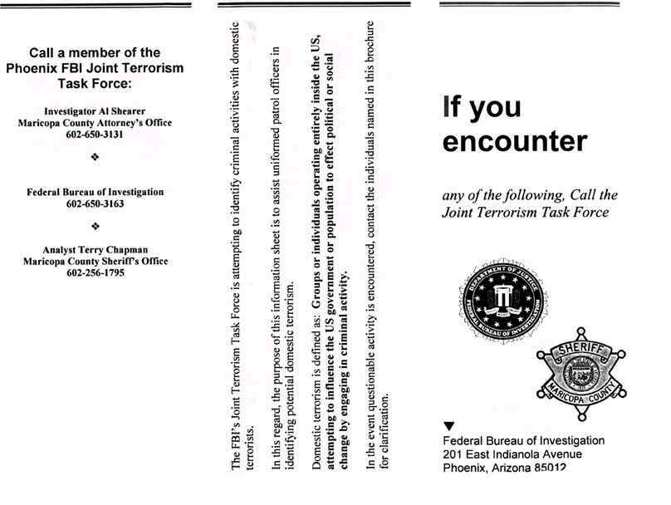

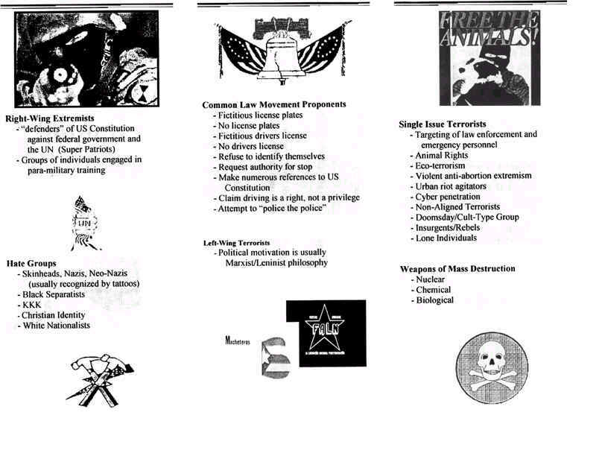

The Phoenix Federal Bureau of Investigation created a flyer about two years ago, during Clinton's Presidency, asking the recipients to help them fight domestic terrorism. I received one of these flyers this past weekend. The Maricopa County Sheriff's Office (Greater Phoenix, Arizona) and the Maricopa County Attorney were placed on the flyer, as well -- before they saw the actual wording of the flyer -- in an effort by the FBI to "work jointly with local law enforcement."
Called the Joint Terrorism Task Force, the program was created, presumably, to help preserve the American way of life. This flyer was created -- by the feds -- to disseminate information about who the bad guys might be. However, it's wording made it look like a disinformation campaign to paint at least a few groups of Real Americans as domestic terrorists.
THIS IS WHAT NEEDS TO BE UNDERSTOOD. THE DOMESTIC TERRORIST IMPLICATIONS IN THIS PUBLICATION HAVE BEEN MADE THE LAW OF THE LAND WITH BUSH'S "PATRIOT LAW" OR ANTI-TERRORISM LAW. THIS IS NOT JUST THE LAW OF THE LAND NOW IN AMERICA, BUT THIS SAME TYPE OF ANTICHRIST LEGISLATION WAS PASSED AT THE SAME TIME BY THE OTHER USED TO BE FREE NATIONS. IT WAS PASSED THE SAME WAY. THE LAW MAKERS IN THE VARIOUS GOVERNMENTS OF EUROPE, AUSTRAILIA, AND NEW ZEALAND WERE TOLD THEY WERE NOT ALLOWED TO READ IT. THE LAW MAKERS WERE TOLD THEY MUST VOTE TO PASS THE LEGISLATION WITHOUT READING OR DEBATE.
iF YOU BELIEVE IN THE BIBLE AND GOD GIVEN RIGHTS YOU ARE A DOMESTIC TERRORIST.
Among other things, the FBI was asking people:
"If you encounter any of the following, Call the Joint Terrorism Task Force":
"defenders of the US Constitution against federal government and the UN"
[That describes many civil liberties groups and most gun rights and American Sovereignty groups in existence -- and, by extension, their members.]
"Groups of individuals engaging in para-military training"
[Such as, perhaps, shooting your semi-automatic "assault weapon" with some friends out in the desert?"]
Also being sought are "Common Law Movement Proponents" who
"Request authority for a stop"
[That's illegal now?]
"Make numerous references to the US Constitution"
[That's illegal now?]
"Attempt to 'police the police'"
[That's illegal now?]
And let's not forget the other potential "domestic terrorists" being sought. We really need to watch out for these people:
"Lone Individuals"
[Do you meet that description?]
"Rebels"
[Almost all Americans have such ancestry from the Revolutionary and Civil Wars?]
Be sure and notice the following two things on the flyer, as well:
1) There is NOT ONE MENTION of "Islamic Fundamentalists" anywhere.
2) Defenders of the US Constitution and the common law from which it grew are being classified on the same level as the bottom-feeding Skinheads, Nazis and the KKK.
READ THE FLYER FOR YOURSELF
The flyer is a tri-fold, so you'll have to turn your head sideways to read one of the sections.
NOTE: The far right side of the above "Front Page" is the actual front of the tri-fold flyer. The far left side of the above "Back Page" -- the part that mentions the 'defenders of the US Constitution' -- is the inside flap... the first thing you see when you open the flyer.
HISTORY OF THE FLYER
According to Terry Chapman of the Maricopa County Sheriff's Office -- whose name is on the flyer as the MCSO contact -- the FBI created the flyer and printed with the MCSO and Attorney's Office logo and personnel and phone numbers before the text was approved. He said it was created as a full color brochure to hand out to officers, not for the general public -- and that as soon as he saw it, he urged them not to use it, knowing it had some problems.
"The flyer never got off the ground," said Officer Chapman, "but it did manage to make it's way out -- and maybe it's right that it did." He genuinely didn't like this piece of junk, and he showed true concern about my issues with the flyer, too. "We were not happy with it. It was formulated, I think, for legitimate purposes, but it fell on stony ground because of the way it was worded -- the unfortunate profiles that were put in there outraged a number of people who received it."
"It's dead in the water as far as I know," said Chapman. "I just can't imagine the FBI putting it out there again. It wasn't for the public. The fact that it's circulating again has gotta be by unofficial sources."
Mr. Chapman couldn't name the FBI agent who created the flyer, saying the individual who created it was no longer with the FBI's Phoenix branch, which he described as having "revolving doors." Sheriff's officers didn't like the flyer, either. Said Chapman, "I had a Lieutenant from our own office call me and ask 'Am I on your list?' Am I a threat?' for supporting the constitution?'" Chapman was embarrassed by the seeming targeting of "decent, honorable segments of the community" by the flyer -- he hoped it would never be handed out or go anywhere at all.
According to Chapman, the FBI approached the Sheriff's Office saying they wanted to put a flyer together to help local law enforcement raise officer awareness about who to watch out for. They asked for a local contact name and number for use of a flyer they wanted to produce, and because Terry Chapman heads up MCSO Intelligence, he was the likely candidate. Possible lesson for Chapman: don't let yourself get used by misguided federal agents again.
The big question: Why does the FBI have someone running around promoting that Defenders of the Constitution (and the common law from which the Constitution was born) are domestic terrorists?
One of the first calls to the FBI on this issue, the response was, "It's on the net? Awwwe God!" The FBI has not returned many subsequent phone calls on this matter. But suffice it to say, that there is proof, not theory, FACT, 2 YEARS PRIOR, that least one unAmerican weasel was running around with the US government definition of "Domestic Terrorism" found in HR3162, passed and signed into law October 26, 2001, WITHOUT THE LAWMAKERS BEING ALLOWED TO READ THE BILL. There is proof in fact, not theory, that the FBI was urging local police to turn against We The American People. Did the directive for such "HELP" come directly from Janet "the butcher of Waco"? Are "so called" Christian Bush & Ashcroft continuing to further this Clinton & Reno Luciferian Antichrist agenda? So far Bush has greatly out Clintoned Clinon. Clinton may indeed have been more honest when he only claimed to be a marginal Christian. If you track down more such FBI published "helps" to the local police, please let us know. This goes a long way in explaining how many "used to be Protect & Serve" police have become Luciferian Antichrist Thugs, who seem to believe they have a license to steal, kill, and destroy ANYONE with total impunity and immunity.
Let us never tolerate outrageous conspiracy theories concerning the attacks of September the 11th; malicious lies that attempt to shift the blame away from the terrorists, themselves, away from the guilty."
George Bush at the United Nations 11-11-2001
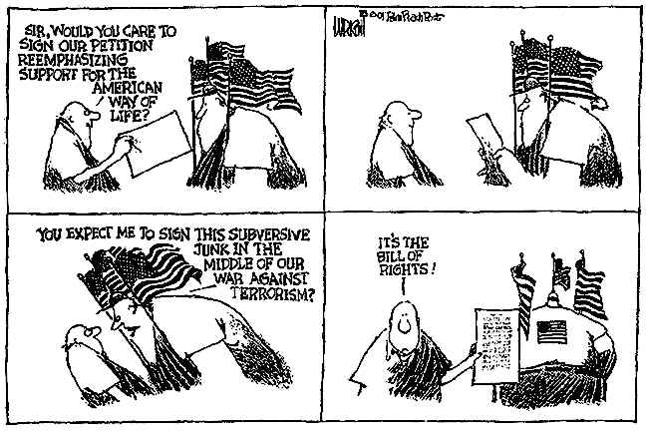
Let us never tolerate outrageous conspiracy theories concerning the attacks of September the 11th; malicious lies that attempt to shift the blame away from the terrorists, themselves, away from the guilty."
George Bush at the United Nations 11-11-2001

THOUGHT POLICE - 11/12/01
Dear Editor,
I was wondering when we would get to this, but it's here. President Bush said before the United Nations (an illegal band of usurping violators of the laws of nations) that:
• • "We must speak the truth about terror. Let us never tolerate outrageous conspiracy theories concerning the attacks of September the 11th; malicious lies that attempt to shift the blame away from the terrorists, themselves, away from the guilty. To inflame ethnic hatred is to advance the cause of terror."
This statement has many seeds of tyranny and violation of the laws of liberty planted within it. The first seed is the conversion of a theory into a malicious lie! Theories are not lies or truth. Theories may one day turn out to be true or false but a theory is just that, until proven otherwise. Theories are the result of free thought and the right of free speech. Bush should not be allowed to turn free thought and expression thereof into automatic lies that cannot be tolerated. Is this the firm compassion I voted for in November 2000 -- Theories out Intolerance in?
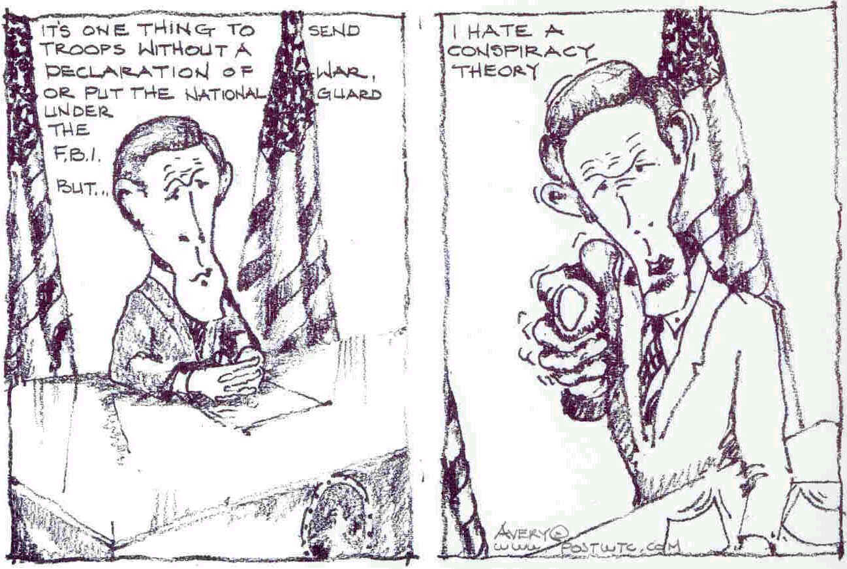
The second seed is to suggest that the automatic motive of thinking and expression is to inflame ethnic hatred. What in a theory of a potential conspiracy would automatically have to do with ethnic hatred? Is Bush now saying that only those who hate Jews or Arabs could think that some of them or a totally different group could act in concert to harm Americans? So now thinkers hate ethnic groups! Are we really this scared of terrorism? Are we going to institute the thought police at home to fight terrorism?
The third and most damaging seed is the alliance President Bush is making with those that think about any possibility or conspiracy with those that inflict death and destruction upon the innocent. This seed will permit the shallow citizen to justify the imprisonment and punishment of those who think deeply and fully. Thinkers are terrorists now? We cannot permit Bush to ally free thought with terrorism.
Is President Bush trying to tell me that Jews and Arabs don't whip-up tons of programming, theories, speculations and justifications to advance their respective causes in America? I get it, foreigners and ethnic groups can plot and scheme but Americans can't even think about them doing it, much less do it ourselves! Can we really safely assume that all conversation about the potential of conspiracy in the world of politics and government is made to advance the cause of terror? If anything it is the reverse! It is to alert all citizens to think deeply about everything that happens in their lives. This right the forefathers knew was critical to the protection of the liberties of the people of the United States. It is listed as amendment number one in the U.S. Constitution:
• • "Congress shall make no law respecting an establishment of religion, or prohibiting the free exercise thereof; or abridging the freedom of speech, or the press ; or the right of the people peaceably to assemble, and to petition the Government for a redress of grievances."
President Bush is suggesting that the whole world, including America, should abridge the freedom of speech? You can now exercise freedom of speech, but just don't say certain things? You newspaper people better get on the stick about this! This is serious stuff! Now this, my friends is our PATRIOTIC DUTY if I have ever seen it in my lifetime, to resist the encroachment upon thought and the expression of it. All veterans better be thinking about what their service meant to our elected servants.
Sincerely Yours,
Ronald F. Avery

MOTIVE - MOTIVE - MOTIVE - Does anyone gain from such a tragedy as WTC 9-11??
Antichrist Totalitarian World Government GAINS. Antichrist Luciferians can get Laws PASSED removing freedom and God Given rights. Antichrist World government despots can get such laws PASSED WITHOUT the Laws being READ or Debated. If someone voted to pass a law that they DID NOT READ, would that not be a BLATANT violation of a SWORN oath to protect and defend the Constitution?

HERE IS THE LEGAL DECISION THAT HAS BEEN HIDDEN FROM US! THEY CANNOT ABOLISH THE 4th amendment, or any of the first 10 amendments - for any reason, at any time! Forward this to everyone on your list. DEMAND repeal of the "Patriot Act!"--Now!
Below you will find word for word, the exact judicial decision of Robert H Jackson, Supreme Court Justice!
"The very purpose of a Bill of Rights was to withdraw certain subjects from the vicissitudes of political controversy, to place them beyond the reach of majorities and officials and to establish them as legal principles to be applied by the courts. One's right to life, liberty, and property, to free speech, free press, freedom of worship & assembly, and other fundamental rights may not be submitted to vote; they depend on the outcome of no elections."
Jackson, J., West Virginia State board of Education v Barnette 1943
319 US 624,638 87L ed 1628, 1638, 63 S Ct 1178, 147 ALR 674
The first ten amendments to the United States Constitution are called the Bill of Rights. The first ten amendments to the United States Constitution are different than the 11th to the 26th amendments. The first ten are NOT repealable. The 11th to 26th are. The Bill of Rights is not only an amendment to the United States Constitution, it is also a document of its own self. It is the American Magna Carta. (By the way, England is in the process of trying to abolish the Magna Carta!)
The laws in the Bill of Rights are laws that are higher than the rest of the Constitution to which they are attached. The reason for this is that the Bill of Rights contains natural rights--the laws endowed to man by God. Even IF a person so desired, he/she could NOT DIVEST themselves of their natural rights! No one can deny himself of them because we can not deny posterity these rights! It is incumbent upon us to preserve and to pass these rights on to them.
ALL PUBLIC officials and majorities are REQUIRED to abide by the position that the Bill of Rights is a special document itself, which protects the sacred rights of the people!
The Bill of rights was drawn up to prohibit even the discussion of elimination of these rights!
This decision rejects any recognition or acceptance of popular opinions or whims of public officials and majorities, and affirms that the rights contained in the Bill of rights are completely outside of the capricious presumptions of either group. In other words if every person in the U.S. EXCEPT YOU, votes to take away your rights--they cannot do it!
This decision states that these rights have already been debated, and clearly established by those who drafted the document and are not subject to interpretation, and it is therefore mandatory that their Constitutional intent is to be applied by the courts.
This decision states that the rights within the Bill of Rights are not dependent upon the outcome of any election and that they may not even be submitted for vote! This also prohibits state and federal courts and Supreme courts from even inferring that they have the right to "interpret" the meaning of any of the first 10 amendments!
On the contrary, this decision extends protection to any other fundamental right of the people, not necessarily listed in the Bill of Rights.
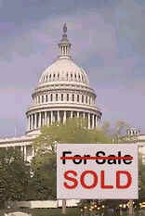
Not many, if any, on the GJiGT group watch TV. The following quotes may be useful to help someone permanently turn off their TV. The quotes are also handy when you hear someone spouting the Nightly News line of BALONEY.
Maybe some can yet become awakened. Maybe someone will even open their KJV bible and read some PURE TRUTH, that will not change, or ever pass away. Faith is what we all need NOW, and faith cometh by hearing and hearing by the word of God. Jesus warned us these days would have pulpits filled with false teachers. We do NOW fully understand why one of Satan's names is the "prince of the power of the air." Perhaps someone has their mind stirred when you give them a "Sheeple Tract." Such Holy Spirit stirring via the "Sheeple Tract" even recently caused a UN 3 star general to recieve the gospel. http://www.dccsa.com/greatjoy/666anti2.htm
Hammer on the FACT that the "Patriot Laws," or "Anti-Terrorist Laws," were PASSED WITHOUT READING. Try to make people aware that the SAME LAWS were PASSED at the SAME TIME, WITHOUT READING, Without Debate, in the OTHER 15 "Used to be" Free Nations of Europe, Plus Australia, and New Zealand.
Here are the QUOTES:
David Rockefeller, At the Bilderbergers meeting 1991:
"We are grateful to the Washington Post, the New York Times, Time Magazine and other great publications whose directors have attended our meetings and respected their promises of discretion for almost forty years."
Richard Salant, Former President of CBS news said:
"Our job is to give people not what they want, but what we decide they ought to have."
"If newsmen do not tell the truth as they see it because it might make waves, or if their bosses decide something should or should not be broadcast because of Washington or Main Street consequences, we have dishonored ourselves and we have lost the First Amendment by default."
John Swinton, Chief of Staff, New York Times, New York Press Club in 1953
"There is no such thing at this date of the world's history, in America, as an independent press. You know it and I know it. There is not one of you that dares to write his honest opinions, and if you did, you know beforehand that it would never appear in print. I am paid weekly for keeping my opinions out of the paper I am connected with. Others of you are paid similar salaries for similar things, and any of you who would be so foolish as to write honest opinions would be out on the streets looking for another job. If I allowed my honest opinions to appear in one issue of my paper, before twenty-four hours my occupation would be gone. The business of journalists is to destroy truth; to pervert; to vilify; to fawn at the feet of mammon, and to sell his country and his race for his daily bread. You know it and I know it and what folly is this toasting an independent press? We are tools and vassals for rich men behind the scenes. We are the jumping jacks, they pull the strings and we dance. Our talents, our possibilities and our lives are all the property of other men. We are intellectual prostitutes."
Dr. Carroll Quigley, Professor of International Relations, Georgetown University, and Bill Clinton mentor -
"The CFR is the American Branch of a society which originated in England and believes national directives should be obliterated and one-world rule established. I know of the operations of this network because I have studied it for twenty years, and was permitted in the early 1960's to examine its papers and secret records...".
James Paul Warburg, Chairman of the CFR, 1921 - 1932, before the U.S. Senate, February 17, 1950 -
"We shall have world government whether or not we like it. The only question is whether World government will be achieved by conquest or consent".
Brock Chisolm, former Director of the World Health Organization -
"To achieve world government, it is necessary to remove from the minds of men, their individualism, loyalty to family traditions, national patriotism and religious dogmas".
Rowan Gaither, former president of the Ford Foundation, in a 1954 statement in Congressional investigations - "We operate here under directives from the White House.. [to] use our grant making power to alter life in the US. so that we can comfortably be merged with the Soviet Union".
Senator George Malone of Nevada, speaking before Congress in 1957 -
"I believe that if the people of this nation fully understood what Congress has done to them over past forty-nine years, they would move on Washington. It adds up to a preconceived plan to destroy the economic and social independence of the United States".
John Danforth, Republican Senator from Missouri, on April 22, 1992 -
"I have never seen more Senators express discontent with their jobs ... we have been accomplices to doing something terrible and unforgivable to this wonderful country... we have given our children a legacy of bankruptcy. We have defrauded our country to get ourselves elected."
Mikhial Gorbachev -
"Gentlemen, Comrades, do not be concerned about all you hear about glasnost and perestroika and democracy in the coming years. These are primarily for outward consumption. There will be no significant internal change within the Soviet Union, other than for cosmetic purposes. Our purpose is to disarm the Americans and let them fall asleep".
Joseph Stalin, former dictator of the Soviet Union -
"America is like a healthy body and its resistance is threefold: its patriotism, its morality, and its spiritual life. If we can undermine these three areas, America will collapse from within".
=======================================================================================================

