**Milton William "Bill" Cooper 1943-2001**

https://en.wikipedia.org/wiki/Milton\_William\_Cooper

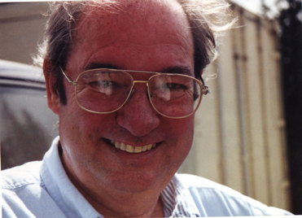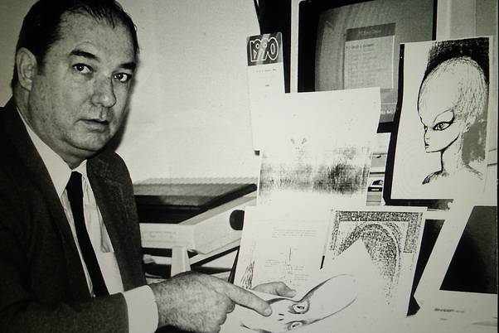 [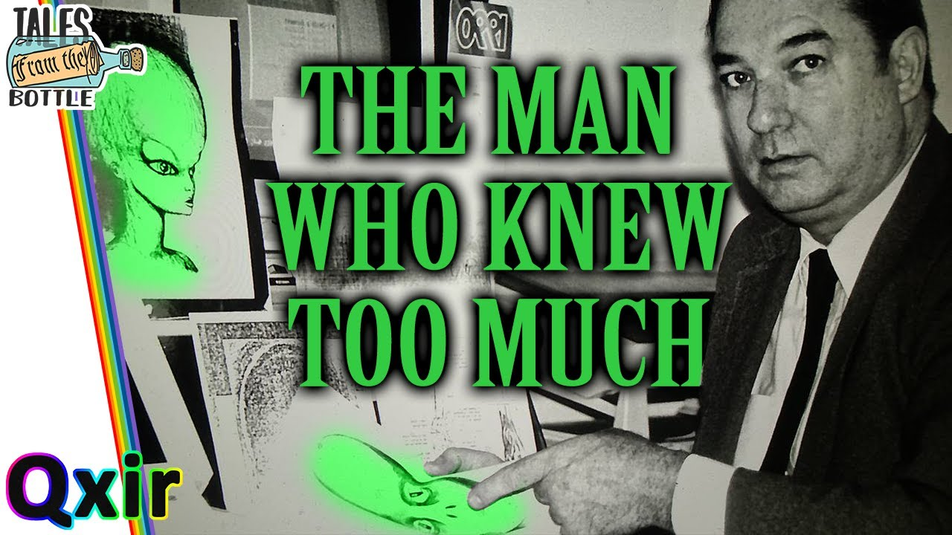](https://www.google.com/url?sa=i&url=https://www.youtube.com/watch?v=eLyyaT2w4pc&psig=AOvVaw0xF8Ju5l5UBd6-fW5gcP6B&ust=1683350682282000&source=images&cd=vfe&ved=0CA0QjRxqFwoTCLD2pKi53f4CFQAAAAAdAAAAABAD) 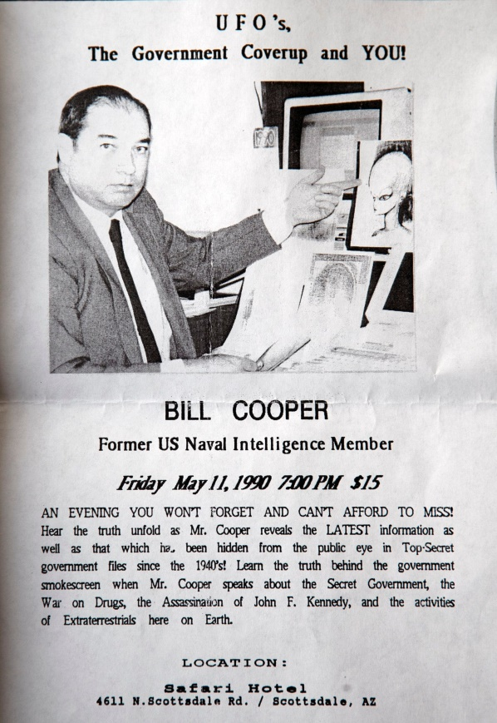

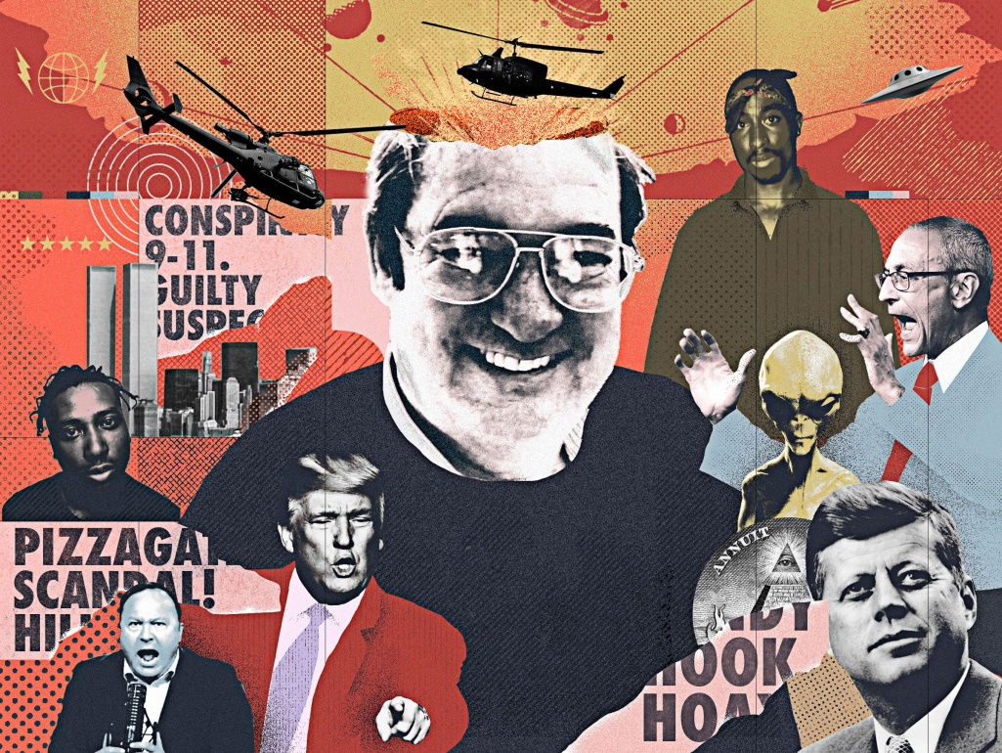 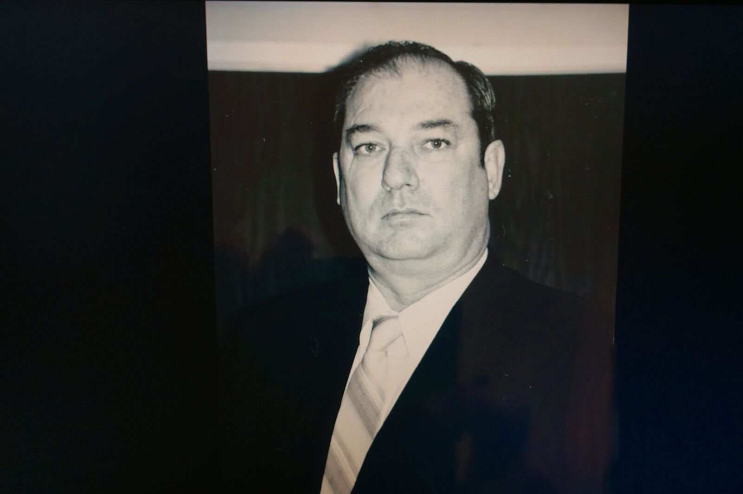 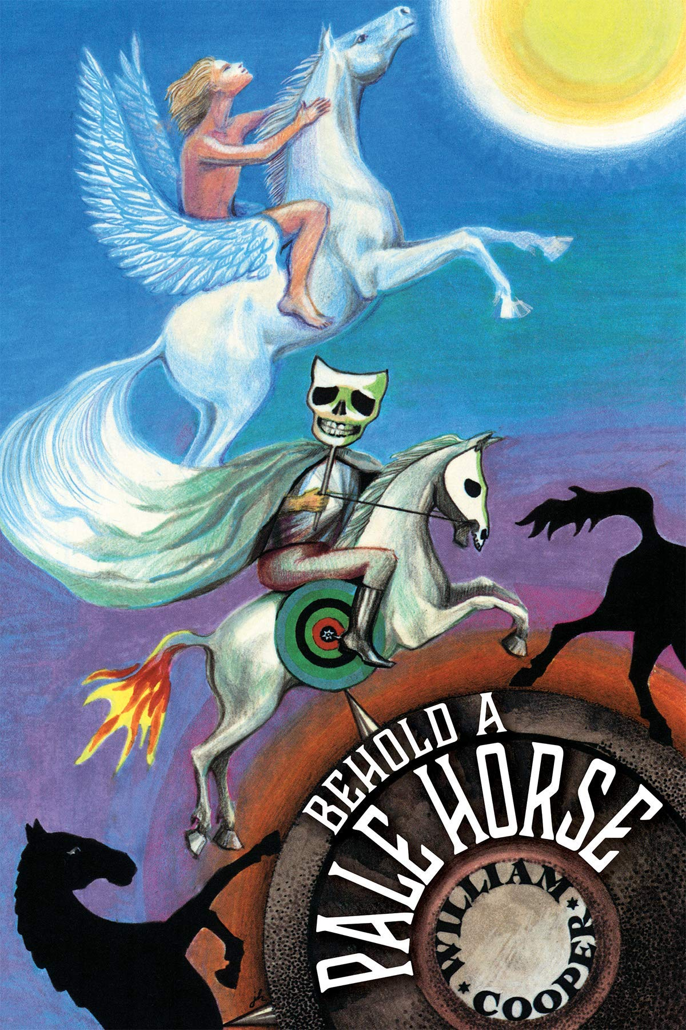 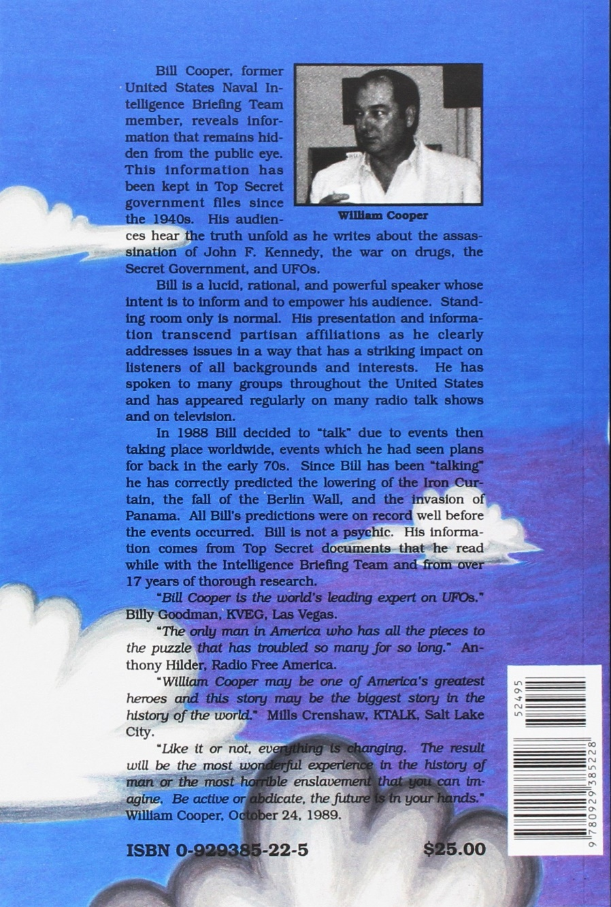

|  |  |
| --- | --- |
| **Milton William Cooper** | |
| [Milton William Cooper.png](https://en.wikipedia.org/wiki/File:Milton_William_Cooper.png) | |
| **Born** | May 6, 1943  [Long Beach, California](https://en.wikipedia.org/wiki/Long_Beach,_California), U.S. |
| **Died** | November 5, 2001 (aged 58)  [Eagar, Arizona](https://en.wikipedia.org/wiki/Eagar,_Arizona), U.S. |
| **Cause of death** | [Gunshot](https://en.wikipedia.org/wiki/Ballistic_trauma) |
| **Resting place** | Springerville Cemetery [Springerville, Arizona](https://en.wikipedia.org/wiki/Springerville,_Arizona) |
| **Other names** | Bill Cooper |
| **Occupation(s)** | Conspiracy theorist, radio broadcaster, author |

**Milton William "Bill" Cooper** (May 6, 1943 – November 5, 2001) was an American [conspiracy theorist](https://en.wikipedia.org/wiki/Conspiracy_theory), radio broadcaster, and author known for his 1991 book *Behold a Pale Horse*, in which he warned of multiple global conspiracies, some involving [extraterrestrial life](https://en.wikipedia.org/wiki/Extraterrestrial_life).[[1]](https://en.wikipedia.org/wiki/Milton_William_Cooper#cite_note-LATimes_death-1)[[2]](https://en.wikipedia.org/wiki/Milton_William_Cooper#cite_note-Landes2011-2)[[3]](https://en.wikipedia.org/wiki/Milton_William_Cooper#cite_note-Goldwag2009-3) Cooper also described [HIV/AIDS](https://en.wikipedia.org/wiki/HIV/AIDS) as a man-made disease used to target blacks, [Hispanics](https://en.wikipedia.org/wiki/Hispanic), and [homosexuals](https://en.wikipedia.org/wiki/Homosexuality), and that a cure was made before it was implemented.[[4]](https://en.wikipedia.org/wiki/Milton_William_Cooper#cite_note-Bill_Cooper_interview_CNN_Uncut_original-4) He has been described as a "militia theoretician".[[5]](https://en.wikipedia.org/wiki/Milton_William_Cooper#cite_note-Gilroy-5) Cooper was killed in 2001 by sheriff's deputies after he shot at them during an attempted arrest.[[1]](https://en.wikipedia.org/wiki/Milton_William_Cooper#cite_note-LATimes_death-1)

**Career**

Little is known about Cooper's background and education, beyond the information supplied in his own accounts. He claimed to have served in the [United States Navy](https://en.wikipedia.org/wiki/United_States_Navy), the [United States Air Force](https://en.wikipedia.org/wiki/United_States_Air_Force), and [Naval Intelligence](https://en.wikipedia.org/wiki/Office_of_Naval_Intelligence) until his discharge in 1975;[[6]](https://en.wikipedia.org/wiki/Milton_William_Cooper#cite_note-Barkun2006-6) however, public records only indicate a period of service in the Navy with a ratings code of E-5/Sergeant ([Petty officer second class](https://en.wikipedia.org/wiki/Petty_officer_second_class) in the Navy), including a tour of duty in [Vietnam](https://en.wikipedia.org/wiki/Vietnam) with two service medals.[[7]](https://en.wikipedia.org/wiki/Milton_William_Cooper#cite_note-7) At the end of the war, while working in naval intelligence, Cooper served on a briefing team for Admiral Bernard A. Clarey.[[8]](https://en.wikipedia.org/wiki/Milton_William_Cooper#cite_note-8) He then attended a junior college in California, and worked for several technical and vocational schools before making his conspiracy theories known, beginning in 1988. Cooper expanded the speculations of earlier conspiracists by incorporating government involvement with extraterrestrials as a central theme.[[9]](https://en.wikipedia.org/wiki/Milton_William_Cooper#cite_note-Carroll-9)

**Early involvement in UFO lore**

n the Summer of 1988, Cooper made his first public comments on the ParaNet [Bulletin Board System](https://en.wikipedia.org/wiki/Bulletin_Board_System), an early UFO message board. According to Cooper's first post, in 1966 he was serving aboard the [*USS Tiru*](https://en.wikipedia.org/wiki/USS_Tiru) when he and fellow Navy personnel witnessed a metal craft "larger than a football field" repeatedly enter and exit the water.[[10]](https://en.wikipedia.org/wiki/Milton_William_Cooper#cite_note-Rider-10) Cooper claimed he was instructed by superiors to never speak about the incident.[[10]](https://en.wikipedia.org/wiki/Milton_William_Cooper#cite_note-Rider-10) Biographer Mark Jacobson argues "the Tiru incident itself would not have done much to make Cooper's name in ufology. That opportunity came only a few days later" when he was contacted by fellow ParaNet poster [John Lear](https://en.wikipedia.org/wiki/John_Olsen_Lear). Lear, the son of Learjet founder [Bill Lear](https://en.wikipedia.org/wiki/Bill_Lear), identified as a pilot who had flown missions for the CIA.[[10]](https://en.wikipedia.org/wiki/Milton_William_Cooper#cite_note-Rider-10) Lear was the author of a post titled "The UFO Coverup" which incorporated [elements of mythos](https://en.wikipedia.org/wiki/Dulce_Base) from [Paul Bennewitz](https://en.wikipedia.org/wiki/Paul_Bennewitz), a [ufologist](https://en.wikipedia.org/wiki/Ufologist) who was later revealed to have been fed disinformation by American counter-intelligence agent [Richard Doty](https://en.wikipedia.org/wiki/Richard_Doty).[[10]](https://en.wikipedia.org/wiki/Milton_William_Cooper#cite_note-Rider-10)[[11]](https://en.wikipedia.org/wiki/Milton_William_Cooper#cite_note-11) Cooper soon visited Lear, and the two spent much time together from 1988 to 1990.[[10]](https://en.wikipedia.org/wiki/Milton_William_Cooper#cite_note-Rider-10)

Cooper's views were heavily influenced by Lear and his story of alien collusion with secret governmental forces.[[12]](https://en.wikipedia.org/wiki/Milton_William_Cooper#cite_note-Pioneer-12) In 1989, the two released an "indictment" against the US Government for "aiding and abetting and concealing this Alien Nation which exists in our borders".[[12]](https://en.wikipedia.org/wiki/Milton_William_Cooper#cite_note-Pioneer-12) In 2018, columnist [Colin Dickey](https://en.wikipedia.org/wiki/Colin_Dickey) noted the pair's influence, writing "in the early years [UFO writers] did not, by and large, embrace strong political positions. They were the tip of a spear asserting that the number one thing we had to fear was not little green men, but the government that colluded with them, appropriating their technology against us."[[12]](https://en.wikipedia.org/wiki/Milton_William_Cooper#cite_note-Pioneer-12)

Cooper and Lear's collaboration lasted for a few years, after which Cooper accused Lear of being a CIA plant.[[12]](https://en.wikipedia.org/wiki/Milton_William_Cooper#cite_note-Pioneer-12)

## *Behold a Pale Horse*

In 1991, Cooper wrote and published *Behold a Pale Horse*.[[5]](https://en.wikipedia.org/wiki/Milton_William_Cooper#cite_note-Gilroy-5) The book has been influential among "UFO and militia circles".[[13]](https://en.wikipedia.org/wiki/Milton_William_Cooper#cite_note-Nattrass-13) Just prior to the trial of [Terry Nichols](https://en.wikipedia.org/wiki/Terry_Nichols) in 1997, [*The Guardian*](https://en.wikipedia.org/wiki/The_Guardian) described it as "the manifesto of the [militia movement](https://en.wikipedia.org/wiki/Militia_organizations_in_the_United_States)".[[14]](https://en.wikipedia.org/wiki/Milton_William_Cooper#cite_note-Vulliamy-14)

According to sociologist [Paul Gilroy](https://en.wikipedia.org/wiki/Paul_Gilroy), Cooper claimed "an elaborate conspiracy theory that encompasses the Kennedy assassination, the doings of the secret world government, the coming ice age, and a variety of other covert activities associated with the [Illuminati](https://en.wikipedia.org/wiki/Illuminati)'s declaration of war upon the people of America".[[5]](https://en.wikipedia.org/wiki/Milton_William_Cooper#cite_note-Gilroy-5) [Political scientist](https://en.wikipedia.org/wiki/Political_science) [Michael Barkun](https://en.wikipedia.org/wiki/Michael_Barkun) characterized it as "among the most complex superconspiracy theories", and also among the most influential due to its popularity in militia circles as well as mainstream bookstores.[[6]](https://en.wikipedia.org/wiki/Milton_William_Cooper#cite_note-Barkun2006-6) Historian [Nicholas Goodrick-Clarke](https://en.wikipedia.org/wiki/Nicholas_Goodrick-Clarke) described the book as a "chaotic [farrago](https://en.wiktionary.org/wiki/farrago) of conspiracy myths interspersed with reprints of executive laws, official papers, reports and other extraneous materials designed to show the looming prospect of a world government imposed on the American people against their wishes and in flagrant contempt of the Constitution."[[15]](https://en.wikipedia.org/wiki/Milton_William_Cooper#cite_note-Goodrick-Clarke-15)

### UFOs, aliens and the Illuminati

Cooper gained attention in [Ufology](https://en.wikipedia.org/wiki/Ufology) circles in 1988 when he claimed to have seen secret documents while in the Navy describing governmental dealings with extraterrestrials, a topic on which he expounded in *Behold a Pale Horse.*[[6]](https://en.wikipedia.org/wiki/Milton_William_Cooper#cite_note-Barkun2006-6) (By one account he served as a "low level clerk" in the Navy, and as such would not have had the security clearance needed to access classified documents.)[[16]](https://en.wikipedia.org/wiki/Milton_William_Cooper#cite_note-Kirk_2-16) UFOlogists later asserted that some of the material Cooper claimed to have seen in Naval Intelligence documents was actually plagiarized by Cooper from their own research, including several items that the UFOlogists had fabricated as pranks.[[17]](https://en.wikipedia.org/wiki/Milton_William_Cooper#cite_note-17) Don Ecker of [*UFO Magazine*](https://en.wikipedia.org/wiki/UFO_Magazine) ran a series of exposés on Cooper in 1990.[[18]](https://en.wikipedia.org/wiki/Milton_William_Cooper#cite_note-18)

Cooper linked the Illuminati with his beliefs that extraterrestrials were secretly involved with the United States government, but later retracted these claims. He accused President [Dwight D. Eisenhower](https://en.wikipedia.org/wiki/Dwight_D._Eisenhower) of negotiating a treaty with extraterrestrials in 1954, which supposedly allowed the aliens to [abduct humans](https://en.wikipedia.org/wiki/Alien_abduction) in exchange for technological assistance.[[19]](https://en.wikipedia.org/wiki/Milton_William_Cooper#cite_note-19) Cooper then claimed that Eisenhower had established an inner circle of Illuminati to manage relations with the aliens and keep their presence a secret from the general public. Cooper believed that aliens "manipulated and/or ruled the human race through various secret societies, religions, magic, witchcraft, and the occult", and that even the Illuminati were unknowingly being manipulated by them.[[6]](https://en.wikipedia.org/wiki/Milton_William_Cooper#cite_note-Barkun2006-6)

Cooper described the Illuminati as a secret international organization, controlled by the [Bilderberg Group](https://en.wikipedia.org/wiki/Bilderberg_Group), that conspired with the [Knights of Columbus](https://en.wikipedia.org/wiki/Knights_of_Columbus), [Masons](https://en.wikipedia.org/wiki/Freemasonry), [Skull and Bones](https://en.wikipedia.org/wiki/Skull_and_Bones), and other organizations. Its ultimate goal, he said, was the establishment of a [New World Order](https://en.wikipedia.org/wiki/New_World_Order_(conspiracy_theory)). According to Cooper, the Illuminati conspirators not only invented alien threats for their own gain, but actively conspired with extraterrestrials to take over the world.[[6]](https://en.wikipedia.org/wiki/Milton_William_Cooper#cite_note-Barkun2006-6) Cooper believed that [James Forrestal](https://en.wikipedia.org/wiki/James_Forrestal)'s fatal fall from a window on the sixteenth floor of [Bethesda Hospital](https://en.wikipedia.org/wiki/Walter_Reed_National_Military_Medical_Center) was connected to the alleged secret committee [Majestic 12](https://en.wikipedia.org/wiki/Majestic_12), and that [JASON advisory group](https://en.wikipedia.org/wiki/JASON_(advisory_group)) scientists reported to an elite group of [Trilateral Commission](https://en.wikipedia.org/wiki/Trilateral_Commission) and [Council on Foreign Relations](https://en.wikipedia.org/wiki/Council_on_Foreign_Relations) executive committee members who were high-ranking members of the Illuminati.[[2]](https://en.wikipedia.org/wiki/Milton_William_Cooper#cite_note-Landes2011-2)[[3]](https://en.wikipedia.org/wiki/Milton_William_Cooper#cite_note-Goldwag2009-3)

Cooper also claimed that the [antisemitic](https://en.wikipedia.org/wiki/Antisemitism) conspiracy theory forgery [*The Protocols of the Elders of Zion*](https://en.wikipedia.org/wiki/The_Protocols_of_the_Elders_of_Zion) was actually an Illuminati work, and instructed readers to substitute "[Sion](https://en.wikipedia.org/wiki/Priory_of_Sion" \o "Priory of Sion)" for "Zion", "Illuminati" for "Jews", and "cattle" for "[Goyim](https://en.wikipedia.org/wiki/Goy)".[[3]](https://en.wikipedia.org/wiki/Milton_William_Cooper#cite_note-Goldwag2009-3)[[20]](https://en.wikipedia.org/wiki/Milton_William_Cooper#cite_note-Cooper1991-20)[[21]](https://en.wikipedia.org/wiki/Milton_William_Cooper#cite_note-Chang2005-21) The publisher removed the chapter that was a reproduction of The Protocols of the Elders of Zion document from later printings of *Behold a Pale Horse*.[[22]](https://en.wikipedia.org/wiki/Milton_William_Cooper#cite_note-azcentral2020-22)

### Kennedy assassination

In *Behold a Pale Horse*, Cooper asserts that President [John F. Kennedy](https://en.wikipedia.org/wiki/John_F._Kennedy) was [assassinated](https://en.wikipedia.org/wiki/Assassination_of_John_F._Kennedy) because he was about to reveal that extraterrestrials were in the process of taking over the Earth. According to a "top secret" video of the assassination that Cooper claimed to have discovered, the driver of the [presidential limousine](https://en.wikipedia.org/wiki/SS-100-X), [William Greer](https://en.wikipedia.org/wiki/William_Greer), used "a gas pressure device developed by aliens from the Trilateral Commission" to shoot the president from the driver's seat.[[16]](https://en.wikipedia.org/wiki/Milton_William_Cooper#cite_note-Kirk_2-16) The [Zapruder film](https://en.wikipedia.org/wiki/Zapruder_film) shows Greer twice turning to look into the back seat of the car; Cooper theorized that Greer first turned to assess Kennedy's status after the external attack, and then to fire the fatal shot. Conspiracy theories implicating Greer reportedly "snowballed" after publication of *Behold a Pale Horse*.[[23]](https://en.wikipedia.org/wiki/Milton_William_Cooper#cite_note-Tyrone_Times-23) Cooper's video purporting to prove his theory was analyzed by several television stations, according to one source, and was found to be "... a poor-quality fake using chunks of the... Zapruder film."[[16]](https://en.wikipedia.org/wiki/Milton_William_Cooper" \l "cite_note-Kirk_2-16)

### HIV/AIDS

In *Behold a Pale Horse* Cooper proposed that [AIDS](https://en.wikipedia.org/wiki/HIV/AIDS) was the result of a conspiracy to decrease the populations of [blacks](https://en.wikipedia.org/wiki/Black_people), [Hispanics](https://en.wikipedia.org/wiki/Hispanic), and [homosexuals](https://en.wikipedia.org/wiki/Homosexuality).[[9]](https://en.wikipedia.org/wiki/Milton_William_Cooper#cite_note-Carroll-9) In 2000 [South Africa's Minister of Health](https://en.wikipedia.org/wiki/Department_of_Health_(South_Africa)) [Manto Tshabalala-Msimang](https://en.wikipedia.org/wiki/Manto_Tshabalala-Msimang) received criticism for distributing the chapter discussing this theory to senior South African government officials.[[24]](https://en.wikipedia.org/wiki/Milton_William_Cooper#cite_note-BBC_News-24)

## Radio show

From 1992 until his death in November 2001, Cooper originated his radio show, *The Hour of the Time* from a studio in his house at the top of a hill in the small [White Mountains](https://en.wikipedia.org/wiki/White_Mountains_(Arizona)) town of [Eagar, Arizona](https://en.wikipedia.org/wiki/Eagar,_Arizona), 15 miles from the New Mexico border.[[25]](https://en.wikipedia.org/wiki/Milton_William_Cooper#cite_note-Worthington-25)[[26]](https://en.wikipedia.org/wiki/Milton_William_Cooper#cite_note-26) Cooper sent his show via [audio cassette](https://en.wikipedia.org/wiki/Audio_cassette), satellite patch, or direct telephone link to [WWCR](https://en.wikipedia.org/wiki/WWCR) in Nashville where it was broadcast by the station's 100,000-watt shortwave transmitter.[[25]](https://en.wikipedia.org/wiki/Milton_William_Cooper#cite_note-Worthington-25)[[27]](https://en.wikipedia.org/wiki/Milton_William_Cooper#cite_note-Griff-27) [Mark Potok](https://en.wikipedia.org/wiki/Mark_Potok), spokesman for the [Southern Poverty Law Center](https://en.wikipedia.org/wiki/Southern_Poverty_Law_Center), said Cooper was well known within the militia movement for his anti-government [shortwave radio](https://en.wikipedia.org/wiki/Shortwave_radio) program. Oklahoma City bomber [Timothy McVeigh](https://en.wikipedia.org/wiki/Timothy_McVeigh) was reportedly a fan.[[28]](https://en.wikipedia.org/wiki/Milton_William_Cooper#cite_note-Bergmann2018-28)[[1]](https://en.wikipedia.org/wiki/Milton_William_Cooper#cite_note-LATimes_death-1)[[29]](https://en.wikipedia.org/wiki/Milton_William_Cooper#cite_note-Barkun2013-29) McVeigh was reported by [*The Daily Beast*](https://en.wikipedia.org/wiki/The_Daily_Beast) to have ordered from Cooper a cassette, *Waco, The Big Lie*, which the radio host marketed. Cooper broadcast conspiracy theories on the [Waco siege](https://en.wikipedia.org/wiki/Waco_siege) in early 1993, which he believed had been the opening battle in a new Civil War. Cooper participated in the early radio shows of [Alex Jones](https://en.wikipedia.org/wiki/Alex_Jones), an admirer of his broadcasts.[[30]](https://en.wikipedia.org/wiki/Milton_William_Cooper#cite_note-30)

On June 28, 2001, commenting on a televised interview of [Osama bin Laden](https://en.wikipedia.org/wiki/Osama_bin_Laden) at his hideout in Afghanistan, Cooper claimed that bin Laden would soon be "blamed" for a 'major attack' on a large U.S. city, "but don't you believe it". Immediately after the attacks on [September 11, 2001](https://en.wikipedia.org/wiki/September_11_attacks), he predicted the U.S. would soon be at war in 'two or maybe three countries'.[[31]](https://en.wikipedia.org/wiki/Milton_William_Cooper#cite_note-31)[[32]](https://en.wikipedia.org/wiki/Milton_William_Cooper#cite_note-32)

## Death

As Cooper moved away from the Ufology community and toward the militia and anti-government subculture in the late 1990s, he became convinced that he was being personally targeted by President [Bill Clinton](https://en.wikipedia.org/wiki/Bill_Clinton) and the [Internal Revenue Service](https://en.wikipedia.org/wiki/Internal_Revenue_Service). In July 1998, he was charged with [tax evasion](https://en.wikipedia.org/wiki/Tax_evasion_in_the_United_States); an arrest warrant was issued, but Cooper eluded repeated attempts to serve it. In 2000, he was named a "major fugitive" by the [United States Marshals Service](https://en.wikipedia.org/wiki/United_States_Marshals_Service).[[6]](https://en.wikipedia.org/wiki/Milton_William_Cooper#cite_note-Barkun2006-6)

On November 5, 2001, [Apache County](https://en.wikipedia.org/wiki/Apache_County,_Arizona) [sheriff's deputies](https://en.wikipedia.org/wiki/Sheriffs_in_the_United_States) attempted to arrest Cooper at his [Eagar, Arizona](https://en.wikipedia.org/wiki/Eagar,_Arizona) home on charges of aggravated assault with a deadly weapon and endangerment stemming from disputes with local residents. After an exchange of gunfire during which Cooper shot one of the deputies in the head, Cooper was fatally shot. Federal authorities reported that Cooper had spent years evading execution of the 1998 arrest warrant, and according to a spokesman for the Marshals Service, he vowed that "he would not be taken alive".[[1]](https://en.wikipedia.org/wiki/Milton_William_Cooper#cite_note-LATimes_death-1)

## In popular culture

* Cooper's writing holds enduring popularity in hip hop, being referenced by artists including [Public Enemy](https://en.wikipedia.org/wiki/Public_Enemy_(band)), [Tupac Shakur](https://en.wikipedia.org/wiki/Tupac_Shakur), and [Jay-Z](https://en.wikipedia.org/wiki/Jay-Z).[[33]](https://en.wikipedia.org/wiki/Milton_William_Cooper#cite_note-Vulture-33)
* The rapper [William Cooper](https://en.wikipedia.org/wiki/Black_Market_Militia) took his stage name from Milton William Cooper.[[33]](https://en.wikipedia.org/wiki/Milton_William_Cooper#cite_note-Vulture-33)
* [*The X-Files*](https://en.wikipedia.org/wiki/The_X-Files) incorporated numerous elements of Cooper's mythos of a secret government in collusion with alien beings. In one of the most famous episodes, "[Musings of a Cigarette Smoking Man](https://en.wikipedia.org/wiki/Musings_of_a_Cigarette_Smoking_Man)", John F. Kennedy is assassinated to prevent him from revealing the existence of aliens.[[10]](https://en.wikipedia.org/wiki/Milton_William_Cooper#cite_note-Rider-10) The [1998 *X-Files* film](https://en.wikipedia.org/wiki/The_X-Files_(film)) uses phrasing from Cooper (e.g. "Silent Weapons for Quiet Wars") and features the name Cooper in apparent homage.[[10]](https://en.wikipedia.org/wiki/Milton_William_Cooper#cite_note-Rider-10)
* In 1997, hip hop group [Killarmy](https://en.wikipedia.org/wiki/Killarmy) released their debut album, [Silent Weapons for Quiet Wars](https://en.wikipedia.org/wiki/Silent_Weapons_for_Quiet_Wars), a title drawn from Cooper's work.

### Books

* Cooper, Milton William (1991). Behold a Pale Horse. Light Technology Publications. [*ISBN*](https://en.wikipedia.org/wiki/ISBN_(identifier)) [*0-929385-22-5*](https://en.wikipedia.org/wiki/Special:BookSources/0-929385-22-5).

## Lectures

*Truth vs Deception* (Undated, audio only), 1h 14m

*Sedona Speech* (September 24, 1989), 3h 26m

*The Secret Government: Origin, Identity and Purpose of the Real MJ-12* (1989), 1h 28m

*UFOs, Aliens and the Black Government* (1990), 2h 2m

*Behold a Pale Horse* (1991), 4h 40m

*UFO Alien Agenda Conference* (September 9, 1991), 3h 37m

*The Little Ale'Inn* (July 9, 1993), 1h

*Wembley Speech* (January 9, 1993), 2h 45m

*Lansing, Michigan* (1996), 1h

*The Porterville Presentation* (1997), 11h

## Self-Produced Videos, as "Shining Star Productions"

*Project Redlight* (1991), 2h 2m

*Project Redlight II* (1992), 1h 38m

*JFK: Assassin Unmasked* (1993), 45m

*Kennedy, The Sacrificed King* (1993), 1h 14m

*Luxor* (1994), 54m

## Media Appearances

Interview with Ellie Crystal (Undated)

*UFO Investigations-The Cover Up* (1989)

On the Kennedy Assassination, KUTV (May 15, 1991)

*Dimensions in Parapsychology* (1991)

Shane Eden's *The UFO Connection* (1991)

NYC Public Access Interview (April 24, 1992)

The CNN Interview (May 3, 1992)

*Reichstag '95* (1995)

*The Land of the Lost Story* (1999), dir. Anna Zetchus Smith

*The Hour of Our Time: The Legacy of William Cooper* (2006), dir. Jim Jankiewicz

## References

• *["Arizona Militia Figure Is Shot to Death"](https://www.latimes.com/archives/la-xpm-2001-nov-07-mn-1182-story.html)*. [*Los Angeles Times*](https://en.wikipedia.org/wiki/Los_Angeles_Times). November 7, 2001. p. A24*. Retrieved January 1, 2022*.

• • Richard Allen Landes (2011). [*Heaven on Earth: The Varieties of the Millennial Experience*](https://books.google.com/books?id=9TulaFe5FTYC&pg=PA418). [*Oxford University Press*](https://en.wikipedia.org/wiki/Oxford_University_Press). p. 418. [*ISBN*](https://en.wikipedia.org/wiki/ISBN_(identifier)) [*978-0-19-975359-8*](https://en.wikipedia.org/wiki/Special:BookSources/978-0-19-975359-8)*. Retrieved January 4, 2012*.

• • Arthur Goldwag (2009). [*Cults, Conspiracies, and Secret Societies: The Straight Scoop on Freemasons, the Illuminati, Skull and Bones, Black Helicopters, the New World Order, and Many, Many More*](https://books.google.com/books?id=DDbM5GeMgXIC). Random House Digital, Inc. [*ISBN*](https://en.wikipedia.org/wiki/ISBN_(identifier)) [*978-0-307-39067-7*](https://en.wikipedia.org/wiki/Special:BookSources/978-0-307-39067-7)*. Retrieved January 4, 2012*.

• • [*"Bill Cooper interview CNN Uncut original"*](https://www.youtube.com/watch?v=gOlybRtTnpM). Event occurs at 39:00*. Retrieved June 13, 2015*.

• • [*Gilroy, Paul*](https://en.wikipedia.org/wiki/Paul_Gilroy) (2000). [*"Planetary Humanism"*](https://books.google.com/books?id=wWpt-Js7JPEC&pg=PA352). [*Against Race: Imagining Political Culture Beyond the Color Line*](https://books.google.com/books?id=wWpt-Js7JPEC). Cambridge, MA: [*Harvard University Press*](https://en.wikipedia.org/wiki/Harvard_University_Press). pp. 352–353. [*ISBN*](https://en.wikipedia.org/wiki/ISBN_(identifier)) [*978-0674000964*](https://en.wikipedia.org/wiki/Special:BookSources/978-0674000964)*. Retrieved January 17, 2013*.

• • Michael Barkun (2006). [*A Culture of Conspiracy: Apocalyptic Visions in Contemporary America*](https://books.google.com/books?id=LiwjVsNBw-cC&pg=PA60). [*University of California Press*](https://en.wikipedia.org/wiki/University_of_California_Press). p. 60. [*ISBN*](https://en.wikipedia.org/wiki/ISBN_(identifier)) [*978-0-520-24812-0*](https://en.wikipedia.org/wiki/Special:BookSources/978-0-520-24812-0)*. Retrieved January 5, 2012*.

• • Milton William Cooper. [aad.archives.gov](https://aad.archives.gov/aad/display-partial-records.jsp?f=4254&mtch=2&q=milton+william+cooper&cat=all&dt=1784&tf=F). Retrieved November 24, 2014.

• • Colin Dickey (August 28, 2018). [*"A Pioneer of Paranoia"*](https://newrepublic.com/article/150922/pioneer-paranoia). The New Republic.

• • [*Carroll, Robert Todd*](https://en.wikipedia.org/wiki/Robert_Todd_Carroll) (2003). [*"Illuminati"*](https://books.google.com/books?id=6FPqDFx40vYC&pg=PA175). [*The Skeptic's Dictionary: A Collection of Strange Beliefs, Amusing Deceptions, and Dangerous Delusions*](https://books.google.com/books?id=6FPqDFx40vYC). Hoboken, NJ: [*John Wiley & Sons, Inc.*](https://en.wikipedia.org/wiki/John_Wiley_%26_Sons,_Inc.) p. 175. [*ISBN*](https://en.wikipedia.org/wiki/ISBN_(identifier)) [*978-1118045633*](https://en.wikipedia.org/wiki/Special:BookSources/978-1118045633)*. Retrieved January 17, 2013*.

• • Jacobson, Mark (2018). Pale Horse Rider: William Cooper, the Rise of Conspiracy, and the Fall of Trust in America. Blue Rider Press. [*ISBN*](https://en.wikipedia.org/wiki/ISBN_(identifier)) [*978-0399169953*](https://en.wikipedia.org/wiki/Special:BookSources/978-0399169953).

• • Pilkington, Mark (2010). [*Mirage Men: A Journey into Disinformation, Paranoia and UFOs*](https://books.google.com/books?id=TQ3BBAAAQBAJ). [*ISBN*](https://en.wikipedia.org/wiki/ISBN_(identifier)) [*978-1849012409*](https://en.wikipedia.org/wiki/Special:BookSources/978-1849012409).

• • Dickey, Colin (August 28, 2018). [*"A Pioneer of Paranoia"*](https://newrepublic.com/article/150922/pioneer-paranoia). The New Republic.

• • [*Nattrass, Nicoli*](https://en.wikipedia.org/wiki/Nicoli_Nattrass) (2012). [*The AIDS Conspiracy: Science Fights Back*](https://archive.org/details/aidsconspiracysc0000natt). New York: [*Columbia University Press*](https://en.wikipedia.org/wiki/Columbia_University_Press). pp. [*4*](https://archive.org/details/aidsconspiracysc0000natt/page/4), 23–27. [*ISBN*](https://en.wikipedia.org/wiki/ISBN_(identifier)) [*978-0231149129*](https://en.wikipedia.org/wiki/Special:BookSources/978-0231149129)*. Retrieved January 17, 2013*.

• • Vulliamy, Ed; Dirks, Bruce (November 3, 1997). [*"New trial may solve riddle of Oklahoma bombing"*](https://www.theguardian.com/world/1997/nov/03/mcveigh.usa). [*The Guardian*](https://en.wikipedia.org/wiki/The_Guardian). London*. Retrieved January 17, 2013*.

• • [*Goodrick-Clarke, Nicholas*](https://en.wikipedia.org/wiki/Nicholas_Goodrick-Clarke) (2002). "Conspiracy Beliefs and the New World Order". [*Black Sun: Aryan Cults, Esoteric Nazism, and the Politics of Identity*](https://books.google.com/books?id=xaiaM77s6N4C). New York: [*New York University Press*](https://en.wikipedia.org/wiki/New_York_University_Press). pp. 284–285. [*ISBN*](https://en.wikipedia.org/wiki/ISBN_(identifier)) [*978-0814731550*](https://en.wikipedia.org/wiki/Special:BookSources/978-0814731550)*. Retrieved January 17, 2013*.

• • Kirk, Paul (September 8, 2000). [*"Govt Aids nut linked to Ku Klux Klan"*](http://www.mg.co.za/article/2000-09-08-govt-aids-nut-linked-to-ku-klux-klan). [*Mail & Guardian*](https://en.wikipedia.org/wiki/Mail_%26_Guardian). Johannesburg*. Retrieved January 17, 2013*.

• • Doherty, Brian (December 7, 2001). Death Wish: How rebels punch their own ticket. [Reason.com archive](http://reason.com/archives/2001/12/07/death-wish). Retrieved February 5, 2013

• • Ecker, Don. *Bill Cooper*. [Skeptic Tank archive](http://www.skeptictank.org/files/ufo2/cooperex.htm) [Archived](https://web.archive.org/web/20180419231144/http:/www.skeptictank.org/files/ufo2/cooperex.htm) April 19, 2018, at the [Wayback Machine](https://en.wikipedia.org/wiki/Wayback_Machine). Retrieved February 5, 2013

• • [Al Franken](https://en.wikipedia.org/wiki/Al_Franken), [Rush Limbaugh is a Big Fat Idiot and Other Observations](https://en.wikipedia.org/wiki/Rush_Limbaugh_is_a_Big_Fat_Idiot_and_Other_Observations), [Bantam Books](https://en.wikipedia.org/wiki/Bantam_Books) 1996 p.122.

• • Milton William Cooper (1991). [*Behold a pale horse*](https://archive.org/details/beholdpalehorse0000coop). Light Technology Publishing. p. [*267*](https://archive.org/details/beholdpalehorse0000coop/page/267). [*ISBN*](https://en.wikipedia.org/wiki/ISBN_(identifier)) [*978-0-929385-22-8*](https://en.wikipedia.org/wiki/Special:BookSources/978-0-929385-22-8)*. Retrieved January 5, 2012*.

• • Jeff Chang (2005). [*Can't stop, won't stop: a history of the hip-hop generation*](https://books.google.com/books?id=4aofRcBRvMgC&pg=PA438). Macmillan. p. 438. [*ISBN*](https://en.wikipedia.org/wiki/ISBN_(identifier)) [*978-0-312-30143-9*](https://en.wikipedia.org/wiki/Special:BookSources/978-0-312-30143-9)*. Retrieved January 5, 2012*.

• • Richard Ruelas; Rob O'Dell (October 1, 2020). [*"How William Cooper and his book 'Behold a Pale Horse' planted seeds of QAnon conspiracy theory"*](https://www.azcentral.com/in-depth/news/local/arizona-investigations/2020/10/01/behold-pale-horse-how-william-cooper-planted-seeds-qanon-theory/3488115001/). Arizona Republic*. Retrieved January 13, 2020*.

• • [*"Did Stewartstown native kill JFK?"*](https://web.archive.org/web/20120729173942/http:/www.tyronetimes.co.uk/news/local/did-stewartstown-native-kill-jfk-1-1747006). Tyrone Times. Dungannon, Northern Ireland. July 17, 2008. Archived from [*the original*](http://www.tyronetimes.co.uk/news/local/did-stewartstown-native-kill-jfk-1-1747006) on July 29, 2012*. Retrieved January 17, 2013*.

• • [*"SA Government steps into Aids row"*](http://news.bbc.co.uk/2/hi/africa/924927.stm). [*BBC News*](https://en.wikipedia.org/wiki/BBC_News). September 14, 2000*. Retrieved January 17, 2013*.

• • Worthington, Rogers. [*"Far—Right Info Web: Rumors, Untruths"*](https://webcache.googleusercontent.com/search?q=cache:7WE7X28FnHEJ:https://www.chicagotribune.com/news/ct-xpm-1995-04-26-9504260072-story.html+&cd=6&hl=en&ct=clnk&gl=us). chicagotribune.com. [*The Chicago Tribune*](https://en.wikipedia.org/wiki/The_Chicago_Tribune). Archived from [*the original*](https://www.chicagotribune.com/news/ct-xpm-1995-04-26-9504260072-story.html) on May 24, 2021*. Retrieved June 8, 2021*.

• • Jacobson, Mark (August 22, 2018). [*"The Granddaddy of American Conspiracy Theorists"*](https://www.rollingstone.com/politics/politics-features/william-cooper-conspiracy-theory-711469/). Rolling Stone*. Retrieved August 6, 2019*.

• • Palmer, Griff (April 30, 1995). [*"Conspiracy Theories Flourish on Radical Shortwave Radio"*](https://www.oklahoman.com/article/2500802/conspiracy-theories-flourish-on-radical-shortwave-radio). oklahoman.com. [*The Oklahoman*](https://en.wikipedia.org/wiki/The_Oklahoman)*. Retrieved June 8, 2021*.

• • Eirikur Bergmann (2018). [*Conspiracy & Populism: The Politics of Misinformation*](https://books.google.com/books?id=pF5qDwAAQBAJ&pg=PA72). Springer International Publishing. pp. 72–. [*ISBN*](https://en.wikipedia.org/wiki/ISBN_(identifier)) [*978-3-319-90359-0*](https://en.wikipedia.org/wiki/Special:BookSources/978-3-319-90359-0).

• • Michael Barkun (2013). [*A Culture of Conspiracy: Apocalyptic Visions in Contemporary America*](https://books.google.com/books?id=Rn213R48e2YC&pg=PR11). University of California Press. pp. 11–. [*ISBN*](https://en.wikipedia.org/wiki/ISBN_(identifier)) [*978-0-520-95652-0*](https://en.wikipedia.org/wiki/Special:BookSources/978-0-520-95652-0).

• • Ling, Justin (November 29, 2021). [*"How a Crazy Plan to Rebuild Waco Compound Gave Us Alex Jones"*](https://www.thedailybeast.com/how-a-crazy-plan-to-rebuild-waco-compound-gave-us-alex-jones). The Daily Beast*. Retrieved April 19, 2022*.

• • Mark Jacobson (August 22, 2018). [*"The Granddaddy of American Conspiracy Theorists"*](https://www.rollingstone.com/politics/politics-features/william-cooper-conspiracy-theory-711469/). Rolling Stone.

• • Colin Dickey (August 28, 2018). [*"A Pioneer of Paranoia"*](https://newrepublic.com/article/150922/pioneer-paranoia). The New Republic.

1. • Jacobson, Mark (August 22, 2018). [*"The Conspiracist Manual That Influenced a Generation of Rappers"*](https://www.vulture.com/2018/08/how-behold-a-pale-horse-influenced-hip-hop.html). vulture.com. Vox Media*. Retrieved December 11, 2021*.

## Further reading

* Barkun, Michael (2003). A Culture of Conspiracy: Apocalyptic Visions in Contemporary America. University of California Press. [*ISBN*](https://en.wikipedia.org/wiki/ISBN_(identifier)) [*0-520-23805-2*](https://en.wikipedia.org/wiki/Special:BookSources/0-520-23805-2).
* Jacobson, Mark (2018). Pale Horse Rider: William Cooper, the Rise of Conspiracy, and the Fall of Trust in America. Blue Rider Press. [*ISBN*](https://en.wikipedia.org/wiki/ISBN_(identifier)) [*9780399169953*](https://en.wikipedia.org/wiki/Special:BookSources/9780399169953).

## External links

* [www.hourofthetime.com](https://web.archive.org/web/20191010104056/http:/hourofthetime.com/)—official site
* [Milton William Cooper](https://www.findagrave.com/memorial/32578338) at [Find a Grave](https://en.wikipedia.org/wiki/Find_a_Grave)
* [A collection of lectures at the Internet Archive](https://archive.org/download/MiltonWilliamCooper-Presentations)
* [A collection of self-produced documentaries at the Internet Archive](https://archive.org/download/MiltonWilliamCooper-Documentaries)
* [A collection of media appearances at the Internet Archive](https://archive.org/download/MiltonWilliamCooper-Interviews)
* [Complete catalog of the Hour of the Time radio program](https://archive.org/details/BillCooperComplete)

|  |
| --- |
|  |
| [**Authority control**](https://en.wikipedia.org/wiki/Help:Authority_control) **[Edit this at Wikidata](https://www.wikidata.org/wiki/Q961961#identifiers)** | | |
| **International** | | * [FAST](http://id.worldcat.org/fast/339068/) * [ISNI](https://isni.org/isni/0000000074042546)   + [2](https://isni.org/isni/0000000078788759) * [VIAF](https://viaf.org/viaf/3408150085877515060009) * [WorldCat](https://www.worldcat.org/identities/lccn-no94014492/) |
| **National** | | * [Germany](https://d-nb.info/gnd/133403637) * [United States](https://id.loc.gov/authorities/no94014492) |
| **People** | | * [Trove](https://trove.nla.gov.au/people/1075078) |
| **Other** | | * [SNAC](https://snaccooperative.org/ark:/99166/w6v145b0) |

[Categories](https://en.wikipedia.org/wiki/Help:Category):

* [1943 births](https://en.wikipedia.org/wiki/Category:1943_births)
* [2001 deaths](https://en.wikipedia.org/wiki/Category:2001_deaths)
* [American conspiracy theorists](https://en.wikipedia.org/wiki/Category:American_conspiracy_theorists)
* [American male non-fiction writers](https://en.wikipedia.org/wiki/Category:American_male_non-fiction_writers)
* [American political writers](https://en.wikipedia.org/wiki/Category:American_political_writers)
* [American radio personalities](https://en.wikipedia.org/wiki/Category:American_radio_personalities)
* [American UFO writers](https://en.wikipedia.org/wiki/Category:American_UFO_writers)
* [Burials in Arizona](https://en.wikipedia.org/wiki/Category:Burials_in_Arizona)
* [Deaths by firearm in Arizona](https://en.wikipedia.org/wiki/Category:Deaths_by_firearm_in_Arizona)
* [John F. Kennedy conspiracy theorists](https://en.wikipedia.org/wiki/Category:John_F._Kennedy_conspiracy_theorists)
* [JFK-UFO conspiracy theories](https://en.wikipedia.org/wiki/Category:JFK-UFO_conspiracy_theories)
* [People shot dead by law enforcement officers in the United States](https://en.wikipedia.org/wiki/Category:People_shot_dead_by_law_enforcement_officers_in_the_United_States)
* [UFO conspiracy theorists](https://en.wikipedia.org/wiki/Category:UFO_conspiracy_theorists)
* [Writers from Long Beach, California](https://en.wikipedia.org/wiki/Category:Writers_from_Long_Beach,_California)
* [United States Navy personnel of the Vietnam War](https://en.wikipedia.org/wiki/Category:United_States_Navy_personnel_of_the_Vietnam_War)
* [United States Navy sailors](https://en.wikipedia.org/wiki/Category:United_States_Navy_sailors)

**===================================================================================**