Updated: Wednesday, November 7th, 2001, 7:00 PM

In
Loving
Memory

With a deep sense of loss and mourning we announce the passing of William Cooper.
It appears at this time to be totally unrelated to the disputes he had with the federal government. All we know at this time is that he was shot and killed by an Apache County Sheriff around 12:15 AM this morning while serving of an arrest warrant on a local issue. A sheriff was also wounded.
Remain Calm! This is in no way a cause for action, but all patriots should be on high alert at this time.
Do NOT listen to or spread undocumented and unconfirmed RUMORS! If it is not here it is not confirmed as fact. Updates will be posted here as they become available.
We MUST all remember his love of freedom, America, the Constitution and the values it is founded on.

Here is the police report with the actual details of the incident that we have confirmed to be accurate. ALL OTHER REPORTS ARE FALSE and should be called on as such. Also BEWARE of other sites and radio shows that say they are quoting williamcooper.com. We have discovered that many of them are saying whatever they want and calling it a quote from our site. This is the ONLY place where you will find OUR findings.
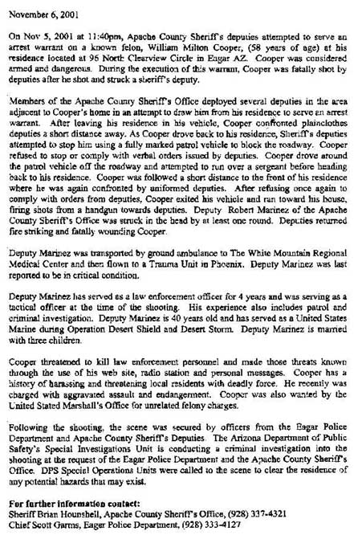

Updated: Wednesday, November 6th 2002, 2:15 PM
Milton William Cooper  Born: May 6, 1943  Died: November 6, 2001  Loving Father  Loving Husband  Loving Friend  True Patriot  God Bless You Bill.  You are Greatly Missed. | 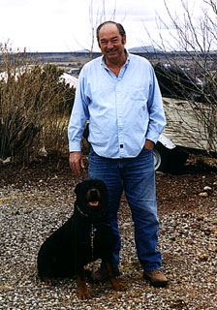  Bill & Crusher - Oct. 2001
We MUST all remember his love of freedom, America, the Constitution and the values it is founded on.

http://216.239.33.100/search?q=cache:YgRbu6iVBGkC:www.williamcooper.com/+%22William+Cooper%22&hl=en&ie=UTF-8

