**Canadian government publishes bid request for “Programmable Hydraulic Guillotines” needed “in support of Canada’s response to COVID-19”**

Sunday, November 15, 2020 by: [Mike Adams](https://www.naturalnews.com/author/healthranger)

<https://www.naturalnews.com/2020-11-15-canadian-government-publishes-bid-request-for-programmable-hydraulic-guillotines-covid-19.html>



([Natural News](https://www.naturalnews.com)) The Canadian government, on its official acquisition website (Buyandsell.gc.ca) is requesting bids for “Programmable Hydraulic Guillotines” as part of, “products and services in support of Canada’s response to COVID-19.”

The listing number is 45045-190091/A, and it is found at this link:  
<https://buyandsell.gc.ca/procurement-data/tender-notice/PW-PD-005-78707>

Additional details on the bid include:

Reference number: PW-$$PD-005-78707  
Solicitation number: 45045-190091/A  
Region of delivery: National Capital Region  
Notice type: Notice of Proposed Procurement (NPP)  
GSIN: N7520: Office Devices and Accessories  
Procurement entity: Public Works and Government Services Canada



The “Programmable Hydraulic Guillotines” listing on the Canadian government’s website is explained on the site as “products and services in support of Canada’s response to COVID-19.”

“Guillotine” is a term that describes a mechanical device with a powerful chopping blade that can slice things apart. Although there are industrial uses for cutting devices — such as in the book publishing industry — the term “guillotine” specifically refers to a device intended to execute human beings.

[As the Cambridge online dictionary explains](https://dictionary.cambridge.org/dictionary/english/guillotine), “guillotine” is a device that’s used to kill people by cutting off their heads:

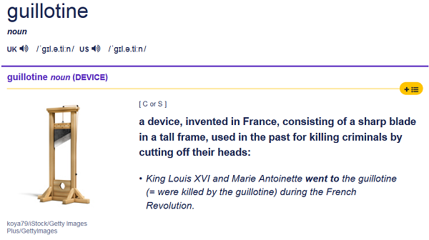

Here’s an image of a paper cutting machine, which is more commonly called a “shear” or cutting machine. This is not a guillotine, even though paper cutting companies might be used as a front for acquiring actual guillotines:

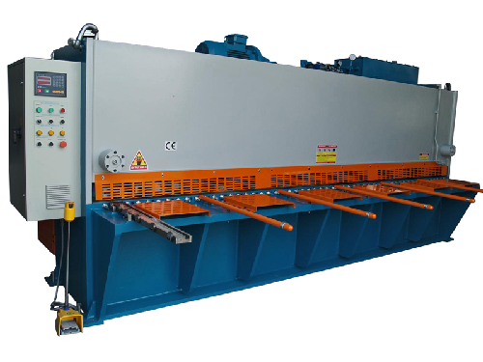

Antifa and left-wing BLM terrorists have recently displayed mock-up guillotines on the streets of America as part of their protest actions, demanding that the people with whom they disagree be executed via guillotine. Guillotines were also used in the French Revolution to execute political dissidents who opposed the incoming socialist regime

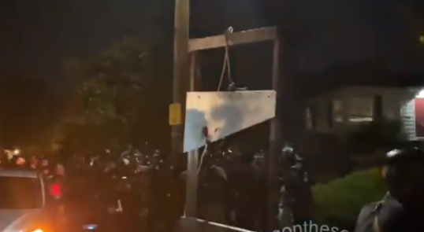





## Canadian official asks why covid camps are being constructed in Canada, gets silenced

It is difficult to imagine how guillotines would be needed to respond to COVID-19 unless Canada was building covid death camps to “process” people who refuse to submit to mass vaccinations. As it turns out, this may be exactly what Canada is doing. See this article: [Canadian government erecting a network of covid detainment camps and “isolation” sites to incarcerate those who don’t cooperate with medical tyranny](https://www.naturalnews.com/2020-10-14-canadian-government-erecting-detainment-camps-medical-tyranny.html). As that article explains:

Justin Trudeau and the Canadian government are creating Nazi Germany-like infrastructure to detain human beings en masse, and for years to come. A brave Ontario politician named Randy Hillier spoke out about the government’s nefarious detainment plan in a provincial question period in front of the government of Ontario. His microphone was cut off as soon as he started asking the tough questions.

Randy Hillier, Independent Ontario MPP for Lanark, Frontenac and Kingston, stood up and questioned the government, asking how many people will be detained and how many concentration camps are scheduled for construction. He expressed concern about their current use — to control the spread of covid-19 — and pointed out in documentation that these sites could be used for “other requirements” in the future.

“So your government must be in negotiations and aware of these plans to potentially detain and isolate citizens and residents of our country and our province,” Hillier began. “So speaker, to the Premier, where will these camps be built, how many people will be detained, and for what reason, for what reasons can people be kept in these isolation camps, and I’d like to have the Premier assure the people of Ontario…,” Hillier’s microphone was cut off before he could finish.

See the video here, which has been banned from YouTube:

## Additional details on the hydraulic guillotines request from the Canadian government

Solicitation document #ABES.PROD.PW__PD.B005.E78707.EBSU000 reveals additional details about the bid request



[The bid document](https://buyandsell.gc.ca/cds/public/2020/05/06/8a0d71f28177c86a47cda8667b8d7676/ABES.PROD.PW__PD.B005.E78707.EBSU000.PDF) lists technical requirements for the guillotines, under a heading called “Guillotines Mandatory Requirements:”

* The Guillotine’s cutting and clamping systems must be fully hydraulic;
* The Guillotine’s automatic blade and clamp must return from every position to its original  
  starting position;
* The Guillotine’s blade depth adjustment(s) must be achievable from outside of the  
  Guillotine;
* The Guillotine’s measurement readout must be in imperial measurement;
* The Guillotine’s blade changing tool, wrenches/screwdrivers and cutting block must be  
  provided for each Guillotine;

The document also calls for a “1 year parts and labour warranty” to make sure the guillotine continues running smoothly so that the chopping isn’t interrupted.

## Is this bid for industrial use, or something more sinister?

A skeptic might look at this government bid and conclude it must be a bid for cutting equipment to be used in cutting books, stacks of papers or posters. One of the companies involved in the bid appears to be a printing company, for example. But wouldn’t that also be **the perfect cover story** for acquiring actual guillotines intended for a more sinister purpose?

Given that Canada is already in the process of constructing covid “concentration camps” — while touting this guillotine bid as part of “Canada’s response to COVID-19,” many people will have serious questions about the intended use of these devices as well as the language used to describe them.

If these were merely industrial cutting machines, wouldn’t the listing just say, “Cutting Machine” instead of “Guillotines?”

And given the history of guillotines being used during radical left-wing revolutions in France, many people are wondering whether China’s corruption of modern-day Canada — including its French-speaking regions — means that China is planning to round up and execute anyone resisting communist influences in Canada. With Justin Trudeau now appearing to be a political puppet of China — [much like Joe Biden](http://joebiden.news) — and with Chinese troops already staged in Western Canada, these are no longer idle questions.

See this important story: [Western Canada has already fallen to Communist China – America may have a chance, but only if it stands united](https://www.naturalnews.com/2020-11-09-chinese-troops-western-canada.html).

[Dave Hodges of The Commonsense Show recently published an article](https://thecommonsenseshow.com/conspiracy-martial-law-united-nations/american-resisters-face-nato-gun-confiscation-and-deportations-canadian-based-concentration) describing plans to round up Americans and incarcerate them in Canadian concentration camps run by communist Chinese. That article explains:

Steve Quayle and myself have been investigating a three-nation deal involving Communist China, Canada and  the United States. The deal has now expanded to NATO forces, living in American bases that were closed during the Bush Sr., era. The CSS has also learned that their is some UN involvement as well. The agreements have to do with ridding America’s new Harris-Biden administration of any and all. Unfortunately, the interview that is presented below on this topic is a work in progress. The implications of this interview is frightening as it promises an international, state-sponsored genocidal program against “deplorables” who will oppose the real new world order.

As all this is happening, Trudeau is accelerating Canada’s gun control and gun confiscation efforts to make sure that Canadian citizens have no ability to fight back when the government comes to their homes and kidnaps them, depositing them in Canada’s COVID concentration camps.

Americans, on the other hand, will never give up their guns. Count on it.

**Is This The END**