Mescaline: The Chemistry and Pharmacology of its Analogs
Alexander T. Shulgin
1183 Shulgin Road, Lafayette, California
This was presented April 24, 1972 at the Symposium on Peyote, Houstan Texas
Abstract. - Although mescaline (3.4.5-trimethoxyphenethylamine the principal
alkaloid of the Peyote plant Lophophora williamsii) has been extensively explored
in man as a hallucinogenic intoxicant. only a few of the natural alkaloids that accom-
pany it in nature have been evaluated as chemical individuals. It appears that these
congeners do not contribute to the reported action of the intact plant. Synthetic
modifications of the structure of mescaline have been more rewarding in the search
for relationships between the details of chemical structure and of biological activity.
The most thoroughly investigated analogs are the substituted phenylisopro-
pylamines. These carry the carbon skeleton of amphetamine, as is found in natural
bases such at ephedrine. Ring substitution arrangements that imitate the peyote
alkaloids and the phenylpropenes from the essential oils, have led to a number of hal-
lucinogens generally more potent than mescaline. These all reflect some botanical
precedent.
Other analogs are based largely on changes in the length of the carbon chain. or in
the nature of the substituent in the 4-position (para to the aliphatic chain). The
shortening of the chain always decreases the observed potency, but any lengthening
invariably changes the pharmacological action from hallucinogenesis to relaxants or
to psychic energizers. The para-substitution changes involving alkyl groups, halides,
or cyclic ethers have led to a retention of mescaline-like activity, but with a consistent
increase in potency.
The preceding three papers of this symposium have reviewed much of our
current knowledge concerning Peyote. Dr. McLaughlin has introduced the
plant with a geographic and botanical definition, and with some mention of its
native usage. Dr. Kapadia has presented an up-to-date picture of the dozens of.
organic compounds isolated from, or identified in it. Dr. Paul has discussed the
possible pathways employed in their biosynthesis. I should like to round out
this picture with a brief review of the pharmacological effects of the plant, its
components, and a number of closely allied analogs, as have been reported in
clinical studies in humans.
From the botanical point of view, I shall restrict this review to the single
plant Lophophara williamsii (Lemaire) Coulter although note must be taken
of a small residual justification for keeping the name Anhalonium lewinii
alive. Although the alkaloid, mescaline, has been observed in a number of
unrelated cacti, to pursue these and consequently other congeners, would lead
too far away from the symposium topic, peyote.
From the chemical point of view, I intend to center this entire discussion on
the parent structure of mescaline (1). Although it is of comparatively low
potency, it is nonetheless one of the most dramatic drugs known from the stand
point of sensory synthesis. Mescaline is probably the principle active component
of the plant peyote and is certainly the best studied. This component is an
easily defined and easily reproduced tool in both sociological and clinical studies.
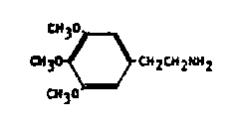
Chemically it displays a deceptively simple structure against which the structures of
the more recently studied analogs can be easily compared.
From the pharmacological side, I shall limit this review to those compounds
that are of known activity in man. In the large area of substituted phene-
thylamines related to mescaline there are literally hundreds of thousands of
compounds which have been isolated from nature, or synthesized in the lab-
oratory and described in the chemical literature. Many thousands of these
have been put into one animal or another, therefore providing the raw data that
have contributed to countless technical papers in the pharmaceutical and
pharmacological literature. However, less than a hundred of these compounds
are of known activity in man, and I shall restrict my discussion to these alone.
Clinical studies in this area can be best divided into three epochs of research,
Frier to the turn of the century, reports stemmed from the initial observations
of Lewin both in plant description and in anthropological detail. This period
also produced the earliest chemical descriptions of Heffter, and the first writings
of human activity. A second period of interest flourished in the 1920's with the
reports of Rouhier and Beringer describing the action of the entire plant and its
principle components in man. The work of Gordon Alles, that of Hoffer and
Smythies, and much of my own work has appeared over the last decade, and has
concentrated to a large measure on homologs and analogs of the parent mescaline
structure.
This body of pharmacological detail can be organized into three divisions:
the first deals with the natural material itself and the components isolated from
it which might contribute to the total effect of the intact plant; the second is a
discussion of chemicals which are biosynthetically reasonable although of syn-
thetic origin; and the third is an extension of this group to include compounds
without natural precedent, but which seem to duplicate much of the physical
and psychological action of mescaline.
PANPEYOTE
The first group defined above includes those materials actually found in the
peyote plant. One must not only consider the entire plant, but also the ex-
tracts of the plant and the pharmacological properties which have been ascribed
to the "active" components of the plant. The term panpeyote has frequently
been employed for preparations in which there have been no attempts to frac-
tionate the components of the cactus. Most of the early studies of either the
peyote buttons themselves, or of the panpeyote isolates, have been reported by
sociologists, anthropologists, and chemists. The medical literature is sparse
and, by modern standards, unsophisticated.
The first medical report of the effects, in human subjects, of the intact peyote
buttons appear to be that of Ptentiss and Morgan (1). This study employed
dosages of several buttons (from three to seven per experiment) but variability
of button size and potency, and of individual sensitivity to the plant, make com-
parisons difficult. Lewin describes the normal Indian usage of twice this num-
ber, yet recounts a thorough intoxication produced by a fraction of a single
button (2). Both infusions (3) and extractions (4) of the whole plant have
been evaluated. The Tincture of Peyote is an extraction of the pulverized
dry plant with 70% ethanol and appears to contain all active components.
This style of preparation has been employed in a number of studies (5, 6). In
fact, a tincture was the form employed in the first recorded non-Indian report
of medical utility (1886) (7).
Another form that has been evaluated in man is called Basic Panpeyote.
This is the residue that is obtained by the evaporation of a chloroform extract
of the pulverized plant. This residue contains over 30% alkaloidal material
(6) and satisfactorily duplicates the human pharmacology of the intact plant (5).
From such studies it was apparent that biological activity was associated with .
the plant's alkaloid components, and a study of this fraction would circumvent
many of the problems arising from variability of plant material. The term Soluble
Peyote is a reference to an aqueous solution that results from the hack-extraction
into dilute hydrochloric acid of a chloroform solution of the residue of an am-
moniacal alcohol extract of the plant. This solution is also referred to as In-
jectable Peyote.
By the turn of the century a number of reports had appeared using one or
another of these preparations, and there was a generally expressed satisfaction
that both the nature and the chronology of the induced intoxication seemed to
parallel that seen with the use of the plant itself. Unfortunately, most of these
were concerned more with the details of the intoxication than with the composi-
tion of the intoxicant. In those reports that do concern themselves with the
quantitative aspects of clinical study, it seems that when the tincture of peyote
is employed, about 800 mg of alkaloidal material is required to produce full
effects. With basic panpeyote, about 600 mg of alkaloids are required. All
early work with both intact peyote and the various panpeyote preparations has
been reviewed by Rouhier (6).
MESCALINE
With the isolation of mescaline (1) as the alkaloid principally responsible
for the intoxicative action of the cactus (8) and its correct structural assignment
and successful synthesis by Spath in 1919 19), the emphasis of pharmacological
study shifted from the inconsistent plant to the readily synthesized compound.
The pure chemical appears to duplicate most of the reported effects of the total
plant in dosages compatible with its weight contribution either in the plant or
in panpeyote.
At a nominally active dosage level of 350 mg, there is a generally predictable
chronology of events. The first signs of change are largely physical. At about
a half hour following ingestion there is an onset of nausea, often accompanied
with active vomiting. There is occasionally the development of diarrhea. A mild
tachycardia and slight rise in blood pressure is often seen during this initial
phase, but this may be associated with anxiety and apprehension. The initial
indication of sensory change is noted in about one hour. The development of
central effects ends the "physical distress" phase of the intoxication, and this
"sensory" phase continues to develop to a plateau of intensity during the next.
two to three hours The physical changes noted during this period are minor.
There is a cardiovascular quieting with the pulse rate and blood pressure drop-
ping below their initial base levels, and a constant, extensive, but reactive,
mydriasis. A gradual diminution of the central intoxication over the following
few hours leads to a complete recovery generally within twelve hours. There
is consistently an excellent recall of the impressions and events that occurred
during the experiment.
Whereas this time pattern and sequence of events is quite predictable from
one person to another and from one occasion to another, the content and direc-
tion taken by the subject's imagination as directed by his interpretive capacities
are completely unpredictable and are unique to each experience.
Some sensory changes are regularly noted and can be expected to contribute
to the overall impact of the drug's effects. There is a shimmering and intensi-
fication of the visual field, far more intense than one might expect from the
mydriasis-induced photophobia. There is an intensification of color perception,
an extreme amplification of minor differences in both color and texture. Fre-
quently observed is the generation of patterned imagery, sometimes in a grid
structure, sometimes with undulating shapes, but usually with some color
contribution There is a benign empathy shown to both inanimate and living
things, especially to small things.
Many reviews, theses, and books have been based on the content of individual
mescaline responses, and such unique anecdotal material lies outside the scope
of this symposium. Reference to Beringer's studies (10) will show the
range of observed responses, and Huxley (1l) has explored in depth a single
experiment. This review will be restricted to general pharmacological pro-
perties, principally quantitative in nature, of the several compounds structurally
related to mescaline.
An important question has as yet no satisfactory answer: To what extent does
mescaline account for all of the alleged activity of peyote itself? I know of no
experiment in which the two substances, the pure chemical and the total plant,
have been directly compared. The pure chemical is usually assayed with a
single administered dose. The plant is generally consumed over an extended
period of time. The chemical is almost always investigated in a single, often
isolated, subject. On the other hand the sacramental use of peyote is a group
experience invoking the added variable of social interaction. The setting of a
mescaline experiment is often clinical and frequently tainted with some moral
reservations, whereas the peyote ceremony is an accepted ritual. Some of these
factors may contribute to differences in the detail of the intoxicated state.
MESCALINE CONGENERS
Some of the suspected pharmacological differences between the pure corn-
pound mescaline and the total plant substance, may be due to any of several
congeners known to be present in quantities potentially adequate to modify the
intoxication syndrome. Four of the tetrahydroisoquinoline alkaloids known
to be present have been evaluated in human subjects. Two of these are phenols
and two are methylenedioxy ethers.
Peyotline a phenolic tetrahydroisoquinoline methylated at both the
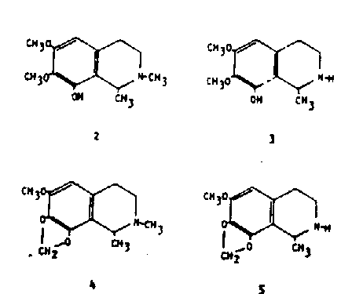

1- and 2-positions. This compound has played an interesting role in the early
research history of peyote. Heffter originally made reference to two species of
peyote (13). One he called Anhalonium lewinii and although he reported
the presence of mescaline and other alkaloids in it, he was unable to detect the
presence of any peyotline. This variant he called "mescalinica" A second
species called Anhalonium williamsii in his writing, appeared to contain
only peyotline. This he referred to as "peyotlinica". The generic name of
the latter variant has been modified and it has subsequently been referred to as
Lophophora williamsii. This has led understandably to some confusion. It
is now proper to use a single binomial for peyote (see p. 4, this issue) yet these
two mutually exclusive analyses must be rationalized. A disturbing note is
that while these two "variants" were morphologically indistinguishable, still
they were separated into their definitional classes.
The pharmacological action of peyotline in human subjects is one of calming
or sedation. rather than that of a hallucinogen. Jolly 14) has reported the
production of an uneventful sleep in patients with a dosage of 50 mg. At levels
of as much as 2~0 mg (total dosage) there are no indications of sensory distor-
dons (5). There is a dizziness and a generalized tiredness that undergoes a
gentle transition into sleep. This latter quantity of drug is greater than that
which would be encountered in a single dosage unit of peyote. It is certainly
possible that peyotline could contribute to the pharmacological picture asso-
ciated with peyote as this sedative action is noted at levels that might well be
encountered in the total cactus. At low levels in man i15-30 mg) there has
been described a calming effect, without overt hypnosis (14).
Anhalonidine (3) is the homologue of peyotline in which the N-methyl group
is absent. In man it appears to act in a manner parallel to peyotline (leading
to a heavy-headedness and sedation) but with only about one-fourth the potency.
At oral levels of between 100 and 250 mg there was a marked sedation, but no
sensory changes whatsoever (5). It is unlikely that this compound contributes
to the reported action of panpevote.
The two remaining tetrahydroisoquinoline principles of peyote are methvl-
enedioxy ethers rather than phenols. The first of these is lophophorine
the methylenedioxy analog of peyotline. This alkaloid has been considered the
most toxic of the natural components of peyote, but this claim is based solely
on animal studies. In man (5) oral dosages of 20 mg led to a distinct vasodiIa-
tion accompanied by an immediate headache and a warm flushed feeling. These
responses are lost within the hour. The level of lophophorine found in peyote
varies over a wide range and no estimate can be made concerning its contribu-
tion to the action of the entire plant,
Anhalonine (5) is the rnethylenedioxy ether analog of anhalonidine and the
N-demethyl homolog of lophophorine. This alkaloid appears to show pharma-
cological properties similar both quantitatively and qualitatively to its phenolic
counterpart anhalonidine. A single reported experiment with 100 mg orally
(5) led to an uneventful tiredness without any noticed central effects of a sen-
sory nature.
The term "amorphous anhalonine" is occasionally encountered in the early
literature on peyote. This has been shown not to be a single substance but a
mixture of peyotline and lophophorine.
Five additional compounds warrant mention here, for although they are all
either tract components in peyote or arguable as being possibly present on bio-
synthetic grounds, they have been explored in man pharmacologically.
N-acetylmescaline (6) has been isolated as a trace component in the peyote
plant (15) and has been identified as a metabolite of mescaline in man (16). It
has been explored in acute trials in human subjects at levels between 300 and
750 mg total dosage. Only at the highest levels were any effects noticed, and
they were summed up as being merely a mild degree of drowsiness (16).
N-methylmescaline (7) similarly is a trace component of peyote (17). Hu-
man studies have shown no effects either peripheral or central at levels of 25
mg (18) but even this level represents many times that which would be en-
countered in a nominal dose of peyote.
The homologous N,-Ndimethylmescaline (trichocerine, 8) has never been
observed in peyote, although it has been observed in a number of closely related
cacti. It has been included in this report because of its close relationship to the
well-documented presence of the mono-methyl homolog, and the known presence
of methylating enzymes in the peyote plant. The compound has been found
devoid of any central activity in humans even following parentetaly admin-
istered dosages of more than 500 mg (19).
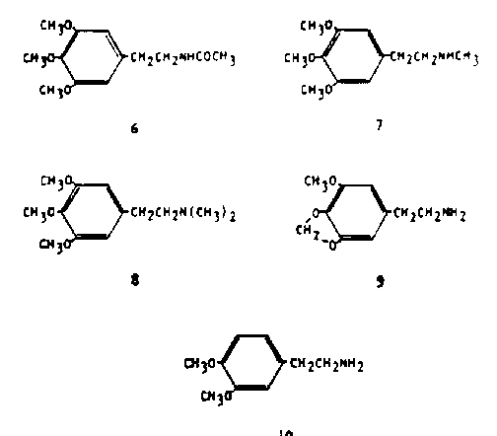
A fourth compound is homomyristicylamine (lophophine, 9) which also has
never been observed in the peyote plant, but which presents an obvious theoretical
potential as a biosynthetic precursor of the tetrahydroisoquinoline alkaloids
such as lophophorine and anhalonine. This compound is active in man at dosage
levels of 150 to 200 mg, about twice the potency of mescaline (18). The quali-
tative description of its action is quite similar to that of mescaline, in that there
is a peaceful elevation of mood, the generation of an euphoric state, and the
enhancement of visual perception especially in the color sense. There are dis-
similarities, particularly in that there is little if any nausea and there is no
visual distortion. These latter differences disappear at dosages of 300 mg and
there is the generation of eyes-closed imagery similar to that observed with
mescaline.
Some comment is in order concerning these responses to mescaline, to
homomyristicylamine, and to a number of materials to be described below.
This response has been given many names. It has been called hallucinogenesis,
a concept that insists that there is the generation of hallucinations. The defini-
tion of a hallucination is certainly controversial, and there are very few drugs
that are generally accepted as being able to produce them. 'It has been called
psychotomimesis and the drugs producing it, psychotomimetics. This term
suggests that the response resembles the psychotic state, and there is scant
medical support for such a stand. The term psychedelic has come to imply
social virtue and sanction in the use of these drugs. Each of these terms, as
with others such as psychodysleptic, is clearly biased and incomplete.
A compound, 3,4-dimethoxyphenethyiamine (DMPEA. 10), has received
wide attention due to its association with urine analysis of patients diagnosed
as schizophrenic (20). This compound has recently been reported as a trace
component of peyote (21) although it is a well established component in a
number of closely related cactus species. Investigation of this chemical in
humans, at levels of a full gram, failed to produce any observable disturbances
(22, 23).
It thus appeals that there is a structural requirement necessary for the
production in human subjects of the pharmacological properties characteristic of
mescaline. This is the 3,4,5- trisubstituted phenethylanine system, as illus-
trated by mescaline (of natural sources) and by lophophine (unnatural, but bio-
synthetically logical), both active at about 5 mg, kg in man. There are many
chemicals however, compounds with structures related to mescaline through
botanical analogy, that show this same psychopharmacological response but with
greatly increased potency. Three classifications of these "quasi-natural" com-
pounds may be made, based simply upon the nature of the chemical structural
variation. Included are those homologs that result from an extension of the
aliphatic chain, the isomers that can result from the variation of the position
and the number of the methoxyl groups present. and finally those analogs that
result from the substitution of a methylenedioxyheterocyclic ring for two ad-
jacent methoxyl groups.
MESCALINE: HOMOLOGS
The aliphatic chain that lies between the aromatic ring system, and the
basic nitrogen, for almost all alkaloids in the plant kingdom, is two carbons long.
The phenethylamine or indolethylamine (Tryptamine) system is a foundation of
nearly all known pharmaceutical agents that are based upon alkaloids. The
monomethylene or trimethylene homologs that have been prepared have to a
large measure proved to be uninteresting pharmacologically. The most re-
warding studies have come from chain lengthenings that have involved homol-
ogous families in which the basic nitrogen atom (the amine group) has been
maintained in the beta-position (two carbon atoms removed from the aromatic
ring). These are the so-called alpha-alkyl homologs such as the phenyliso-
ptopylamines and the phenylsec-butylamines.
The simplest of these homologs, the alphamethylphenethylamines, are
stimulants of both natural and man-made origins. The compound ephedrine
(11) is a component of the plant material that, and is a principle alkaloid in
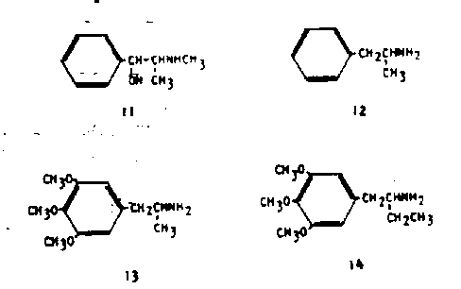
several of the species of Ephedra. Further, this simple molecular configuration
has led to the study of the completely unsubstituted analog, phenylisopropyl-
amine (amphetamine, 12). This latter compound appears to produce a simple
sympathomimetic stimulation at least at low dosages, and if there ate any
"psychotomimetic" developments they are to be found only at high usage
levels which can be achieved only through the development of a tolerance to
the normally expected debilitating effects.
The actions of a compound that results from the combination of the fea-
tures of mescaline and of amphetamine have been described (24). This com-
pound is 3,4,5-trimethoxyamphetamine (3,4,5-trimethoxyphenylisopropylamine,
TMA, 13) and it has been established as being an effective sensory distorting
agent at levels of about 175 mg (25). It is thus about twice as potent as mes-
caline.3 An extension of this chain to the 4-carbon homolog (alpha-ethyl-
mescaline, 14) produces a compound that lacks all central and peripheral activity
in human subjects at acute levels as high as 220 mg (27).
These several chemicals have laid the groundwork for all of the substances
to be discussed below, namely that the three carbon chain, the phenyiisopropyl-
amine or amphetamine structure, has proved to be optimum for the generation ·
of these sensory distortion effects. A decrease of the chain length to two car-
[ The carbon skeleton end positional location of the ether oxygen atom in 13 (end in
MMDA. 25. below) are identical to that found in elemicin end myristicin. components
of the spice nutmeg. These Latter nitrogen-free essential cils have recently been
shown capable of being converted into the above mentioned amphetamine
analogs under biological conditions (26).]
-bons (the loss of the alpha-methyl group) usually retains the nature of activity
but with some decrease in potency. A lengthening of the chain to four carbons
(the substitution of an alpha-ethyl group) changes the qualitative nature of the
pharmacological response.
MESCALINE ANALOGS
Variations of the substitution pattern of the methoxyl groups within this
generalization of a three-carbon chain optimum, have led to extensive changes
in potency. Using 13 as a parent structure, there are five possible positional
isomers. These have been synthesized (28) and clinically evaluated in man (29).
The first of these positional isomers (2,4,5-trimethoxyphenylisopropylamine,
TMA-2, 15) is also related to a series of essential oils, the unconjugated 2,4,5-
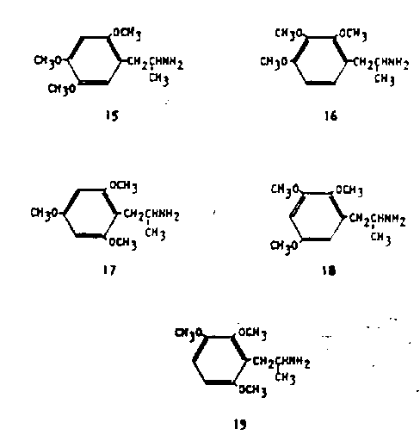

trimethoxy- l-allylbenzene found in Caesulia axillaries (30) and the conjugated
counterpart in a number of species of Asarum and Acorus (31). The isomer
has proven to be the most potent of all six, with an effective dosage level of 20
mg, about a twentieth that required for effective mescaline intoxication. The
vicinal analog (2,3,4-tiimethoxyphenylisopropylamine, TMA-3, 16) has neither
natural counterparts nor central activity.
The symmetrical isomer (2,4,6-trimethoxyphenylisopropylamine, TMA-6,
17) is without known analogy in the essential oils, but this ring substitution
pattern is extremely common throughout the many plant products related to
the chromones and the flavonoids. The styles of central activity of 15 and If
ate similar to one another in that at threshold levels there is noted only an en-
joyable light-headedness coupled with distinct euphoria and a minimum of
perceptive distortion. At effective dosages there again is the nausea reminiscent
of that seen with mescaline, and the visual distortions can become quite extensive.
The sensory disturbances and syntheses so often found to be entertaining or
instructive in the case of mescaline intoxication, are found to be disturbing with
these latter drugs. TMA-6, If, is about half as potent as 15, thus having some
ten times the effectiveness of mescaline.
The two remaining possible isomers are known, have been titrated clinically
to determine their relative potencies, but have not been explored to an extent
adequate for generalizations concerning the qualitative nature of their actions.
2,3,5-Trimethoxyphenyiisopropylamine (TMA-4, 18) is an effective central
intoxicant at a 90 mg dosage, and 2,3,6 -trimethoxyphenyli sopropylamine
(TMA-5, 19) has similar activity at 30 mg. Both ate thus clearly more potent
than mescaline,
A number of isomers of 13 have been studied wherein the variation is with the
number of methoxy groups rather than with their position. A single tetra-
methoxy analog is known, 2,3,4,5- tetramethoxyphenylisopropylamine (20). As
with others of the active phenylisopropylamines, there is a corresponding es-
sential oil in nature. This exact carbon skeleton is found in 2,3,4,5-tetra-
methoxy-l-allyl benzene, one of the major constituents of the seed oil of Apium
spp. (32). Compound 20 is effective in man at a dosage of 60 mg, i.e., six times
as potent as mescaline (29).
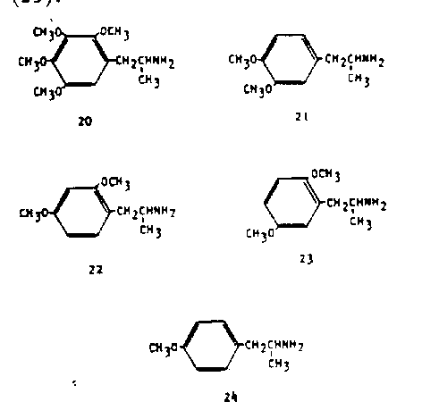

Three of the six possible dimethoxyphenylisopropylamines have been ex-
plored pharmacologically. The compound most closely allied with both botan-
ical and mammalian biochemistry is 3,4-dimethoxyphenylisopropylamine (DMA,
21). The plant correlation is to methyleugenol and methylisoeugenol, common
essential oils found in a host of plants. In animal chemistry, 3,4-dihydroxy-
phenethylamine (dopamine) is an intermediate in the synthesis of the trans-
mitter norepinephrine, and- 21 is its trimethyl homolog. The role and action of
the two-carbon analog 10 have been discussed above. Compound 21 is slightly
less potent than mescaline (33) in that levels of about 700 mg were required
parenterally to produce the color syntheses and other sensory distortions ascribed
to mescaline. The other two dimethoxy isomers that have been studied, 2,4-
dimethoxyphenylisopropylamine (22) and 2,5-dimethoxyphenylisopropylamine
(23), are considerably more potent, being active at 70 mg and 45 mg orally, resp.
(29).
Only one monomethoxy analog has been explored clinically. In animal
studies, this compound (4-methoxyphenylisopropylamine, PMA, 24) is reported
to have an hallucinogenic potential parallel to LSD (34).. In man, however,
some 75 mg is required (orally) for effective central activity, thus being closer
to mescaline than LSD in potency. Arguments that this compound might be
an active metabolite of amphetamine in cases of amphetamine-induced psychoses,
have been answered by the reported failure to observe this compound in human
urine samples following heavy amphetamine administration. It could only be
found as an excretory product following its own administration to human
subjects (35).
Bases that contain a methylenedioxy ring in place of two adjacent methoxyl
groups constitute a large family of compounds that parallel most of the above-
mentioned polymethoxylated phenylisopropylamines . In nature, this form of
biosynthetic relationship is frequently seen. It occurs within the tetrahydroiso-
quinoiine alkaloids of peyote itself. A generalized qualitative comment can be
made concerning the methylenedioxyphenylisoptopylamines itemized here. In
almost every case in which a specific comparison is available between a methyl
enedioxy compound and its dimethoxy counterpart, the methylenedioxy com
pound shows less potential for visual distortion, it is generally more controllable
in its extremes of central activity and, as a rule, it is more potent. Of this
family only two compounds, 25 and 33, have been sufficiently studied to warrant
extended discussion of qualitative subtleties.
Just as there are six possible trimethoxy-substitution isomers of amphetamine,
so there are six possible methoxymethylenedioxy isomers. Five of these six
have been described chemically and pharmacologically. Their trivial names
relate the position of the oxygen substituents directly to the trimethoxy counter
part; i.e., MMDA-5 and TMA-5 are both 2,3,6-substitution products.
The isomer that is the direct relative of mescaline (1) and the theoretical
lophophine (9) is 3-methoxy-4,5-methyienedioxyphenyiisopro (MMDAI
25). The carbon skeleton in this instance is that of myristicin and isomyristicin,
essential oils found throughout the plant kingdom. This compound was syn-
thesized and evaluated independently in two separate laboratories (36, 37).
The compound is active in man at 130 mg, and so has nearly three times the
potency of mescaline. Unlike mescaline, however, its actions are largely free of
perceptual distortions, and seem not to inflexibly command the complete atten-
tion of the subject. There is an element of choice in the degree of compliance
to the intoxication, and there seems to be some valid access to memory material.
These properties have been discussed in a recent monograph (38). The com-
pound analogous to TMA-2 (15) is 2-methoxy-4,5-methylenedioxyphenyliso-
propylamine (MMDA-2, 26). An essential oil (carpacin) with this substitu-
tion pattern has been isolated from Cinnamomumspp. (39). The base 26
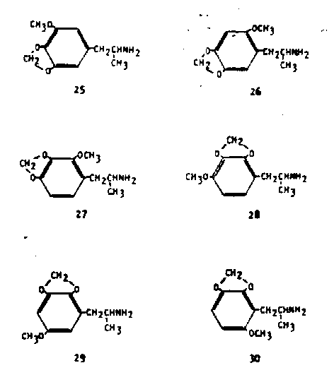

is only slightly less active in human triais (30 mg) than the trimethoxy counter-
part. Two possible 2,3,4- trisubstituted compounds can exist that correspond
to 16. These are 2-methoxy-3,4-methylenedioxyphenylisopro (MMDA-
39, 21) and 4-methoxy-2,3 -methylenedioxyphenyiisopropylamine (MMDA-3b,
28). The first of these has a natural counterpart in the ether croweacin iso-
lated from Eriostemon crowei (40); the second has no known analogy in
nature. Although the trimethoxy compound with this vicinal substitution
pattern was not active, both of these compounds have been shown to be effective
intoxicants, the first at a 35 mg dose (41) and the second at 120 mg (29). The
fifth of these methoxy methylenedioxy isomers is 6-mtthoxy-2,3-methylent-
dioxyphenylisopropylamine (MMDA-5, 30) which corresponds exactly to
TMA-5 (19) both in substitution pattern and in potency (42). No successful
synthesis yet exists for 5-methoxy-2.3-methylenedioxvphenylisopro
(MMDA-4, 29). The analog to TMA-6 (lit) cannot of course exist.
Only three methylenedioxy compounds that are not trisubstituted have beer
studied in man. Two of these are the tetrasubstituted analogs of apiole and
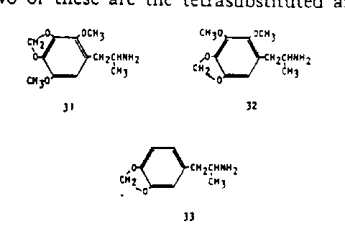

dill-apiole, both well explored essential oils from a number of spices. These
are 2,5 -dimethoxy-3,4-methylenedioxyphenyiisopr (31) and 2,3-di-
methoxy-4 ,S-methylenedioxyphenyiisopropylamine (.32). They are active at
30 mg and 70 mg resp. (43) corresponding to twelve times, and five times the
potency of mescaline. The -remaining compound is 3,4-methylenedioxyphenyl
isopropylamine (MDA, 33) which, along with MMDA (25) is the only material
sufficiently well studied to warrant generalizations concerning comparative quali-
tative properties (44). Although this compound is not particularly potent
(typical dosage, some 120 mg or about three times the activity of mescaline)
its easy availability and apparent consistency of action have led to its study in
a number of laboratories. The 2,3-isomer is unknown.
The last group to be discussed consists of compounds that are quite re-
moved from nature. They have evolved quite logically however from the im-
portance that is clearly assignable to the 4-position of the aromatic substitution
pattern. An example is that, of all the several possible ethoxy homologs of the
maximally potent trimethoxy-compound 15, it is only the 4-ethoxy compound
(2,5 -dimethoxy-4-ethoxyphenylisopropylamine, MEM, 3r) that maintains com-
plete central activity at the same potency (45). An argument can be extended
that this positional sensitivity might be associated with a theoretical ease of
metabolic attack at this position. Consistent with this approach, one could
expect that the replacement of an easily attackable group (alkoxy) with one
less amenable to removal (aikyl) might radically affect the pharmacological
properties of the corresponding amine. The simplest such example, 2,5-di-
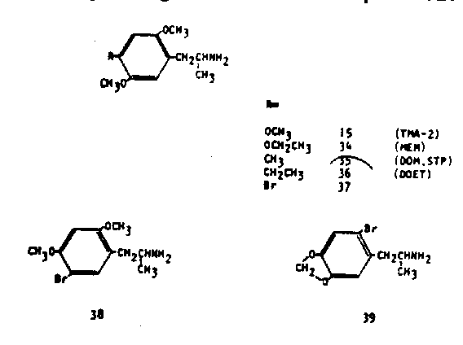

methoxy-4-mcthylphenylisoptopylamine (DOM, STP, 35) proved to be several
times more potent than 15 as a centrally active psychotomimetic. With an
effective, not threshold, level of activity of 3 mg total dosage, it has over one
hundred times the potency of mescaline. Further, the nature and chronology
of the intoxication is quite changed from that common to most of these chemicals
discussed. Most noteworthy is the unexpected lengthening of the time course
by a factor of three or more. Several clinical studies have appeared in the
medical literature concerning this drug (46, 47). The 4-ethyl homolog (2,5-di-
methoxy-4-ethyiphenylisopropylamine, DOET, 36) appears to be fully as potent
as DOM (35) although at lower clinical levels the psychological changes noted
seem to be somewhat more controllable and thus more constructive (118).
Recently yet another analog of this system has been described. In this, the
4-methyl group has been replaced with a bromo substituent to produce 2,5-
dimethoxy-4-bromophenylisopropylamine (37) (49, 50). This compound has in
man an effective response level of between 0.5 and 1.0 mg, thus it is several
hundred times mote potent than mescaline. Yet in the qualitative sense it
presents more of the clinical picture that has been associated with MDA (33)
(49). A positional isomer has been described (2,4-dimethoxy-5-bromophenyliso-
propylamine, 38) which is much less potent than 37 (100 mg for an effective in-
toxication) but which maintains the MDA-like response is1>. The 2-bromo-
analog of MMDA-2 (2-bromo-4,5-methylenedioxy·phenylisopropolymine) is
less active than mescaline (>350 mg in man) and seems to produce an ampheta-
mine-like response.
A final comment is in order concerning the frequent use of the term "ampheta-
mines" to describe these compounds. With the exception of some of the peyote
components, all of the centrally active substances that have been discussed here
contain the carbon skeleton of the amphetamine molecule. Yet almost none of
them display the sympathomimetic stimulation that is the reputation of am-
phetamine. The popular use of the term "amphetamines" has come to embrace
a large number of currently used drugs that are stimulants, and which call upon
these effects for their effectiveness. Examples of this are amphetamine itself
(and its dextrorotatory isomer, dexedrine), methamphetamine, methylphenidate
(Ritalin), phenmetrazine (Preludin) and mephenteramine (Wyamine). An
excellent demonstration of the separation of these pharmacological areas may be
se,., from the fact that the active isomer of DOM (35) is the R (-) form.
The S (+) form shows only stimulant properties, and this is the same absolute
configuration as that seen in the stimulatively active isomer of amphetamine
itself, S-(+) -dextroamphetamine (52).
This has been an up-to-date presentation of our knowledge of the structural
requirements for hallucinogenesis (or whatever this form of central stimulation
and sensory modification might be called). At this state of chemical evolution,
the structure of the parent compound mescaline might well look quite foreign.
However, its role has been evident as a starting point in this rapidly evolving
area of psychopharmacology.
HTML'd by GluckSpilz HTTP://www.cnw.com/~neuro/gaz/

