The “Deep State”?

**TOPICS:**[Catherine Frompovich](https://www.activistpost.com/tag/catherine-frompovich)[Constitution](https://www.activistpost.com/tag/constitution)[Deep State](https://www.activistpost.com/tag/deep-state)[Government](https://www.activistpost.com/tag/government)

NOVEMBER 26, 2018

**[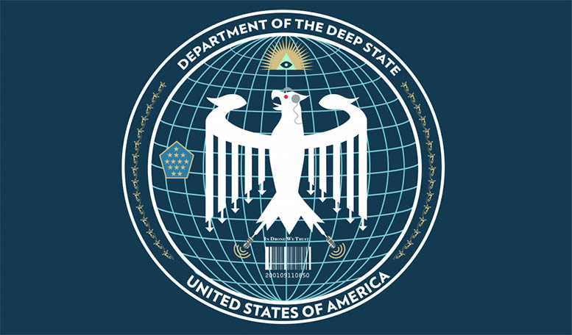](https://www.activistpost.com/wp-content/uploads/2017/09/DeepState-e1398185022722-1024x6011.jpg)**By [**Catherine J. Frompovich**](https://www.activistpost.com/product/1532840705/US/permacultucom-20/?cart=y)

For many years, especially since the infamous and diabolical decimation of the NYC World Trade Towers and Building No.7, *which no plane hit,* there’s been much talk about the “Deep State” and/or the “Shadow Government” being the *very real government running the USA.*  Most folks really don’t give a damn, *or so it seems.*  However, there are three sets of ‘actors’ who U.S. citizens seemingly can’t equate with manipulating the strings of governance, especially those folks who propose ‘socialism’.

Most folks think it’s the President and the political party they vote for and elect who run the country.  *Think again!*  Would you accept the President is not permitted to know the devious plans of the Deep State and Shadow Government; how about the machinations of the Federal Reserve and its cadre of *fiatmoney economy* manipulators; and what’s euphemistically referred to as the New World Order under the auspices of the United Nations!  See the UN’s Agenda 21 and 2030, if you don’t believe that.  Those are the defining actors, or “string pullers,” running the U.S., *and most of the world,* since they were able to get away with assassinating President John F. Kennedy, in my opinion.  I remember that day like it was yesterday!

So, who or what make up the Deep State or Shadow Government?  Basically, it’s a conglomerate of *military-influenced* and/or run *alphabet agencies* within the U.S. federal government.  Here’s a list and don’t gasp:

* CIA       Central Intelligence Agency
* IRS        Internal Revenue Service
* FBI        Federal Bureau of Investigation
* DoD      Department of Defense
* DHS      Department of Homeland Security
* DoS       Department of State
* EPA       Environmental Protection Agency
* NOAA   National Ocean and Atmospheric Agency
* NWS     National Weather Service
* NSA      National Security Agency
* DOJ       Department of Justice

We can accept the above because they were named by former CIA agent Kevin Shipp on August 5, 2016 before an audience gathered to hear about weather geoengineering.

**Download Your First Issue Free!**

Do You Want to Learn How to Become Financially Independent, Make a Living Without a Traditional Job & Finally Live Free?   
  
***Download Your Free Copy of Counter Markets***

Top of Form

**Issue:** Trends & Strategies for Maximum Freedom





Bottom of Form

According to Mr. Shipp, ***who had his legal run in with the CIA and won****,* these agencies are operating outside the U.S. Constitution in what‘s being called a “***Post Constitutional Government*** (PCG)”.  It’s illegal and we, the citizens, have allowed them to get away with it!  According to Shipp, even Congress doesn’t know the extent of the alphabet agencies involvement in post constitutional government, which is pretty sad.  *Where’s congressional oversight?*  Is that a ‘flagrant’ clue to what Mr. Shipp says about PCG?

Shipp talks about the CIA-NSA-connected newspapers.  He talks about how government agencies work with [***In-Q-Tel,***](https://www.iqt.org/) and that ***Google*** is working under In-Q-Tel to monitor the Internet.  However, according to Shipp, it’s all part of the military complex agenda.

At 27:42 on the timeline, Shipp ventures off into vaccines and the Autism heartbreak, which may prove interesting to parents.  He states we live in the ***“Age of Cowardice.”*** OMG!  How has it come down to that?

***CIA Whistleblower Speaks Out About Climate Engineering, Vaccination Dangers, and 911***  
41:22 minutes

[**https://youtu.be/Nl5NW9KcMt0?t=2110**](https://youtu.be/Nl5NW9KcMt0?t=2110)

***“The United States Constitution is the supreme law of the land.”***  
The government rules by fear.

Free ebook [***How To Survive the Job Automation Apocalypse***](https://www.activistpost.com/survive-job-automation-apocalypse)

Free ebook [***How To Get Started with Bitcoin: Quick and Easy Beginner’s Guide***](https://www.activistpost.com/bitcoin)