ARGUMENTS WITH THE THOUGHT POLICE
by john bart gerald drawings by julie maas
http://www.nightslantern.ca/book/1.htm

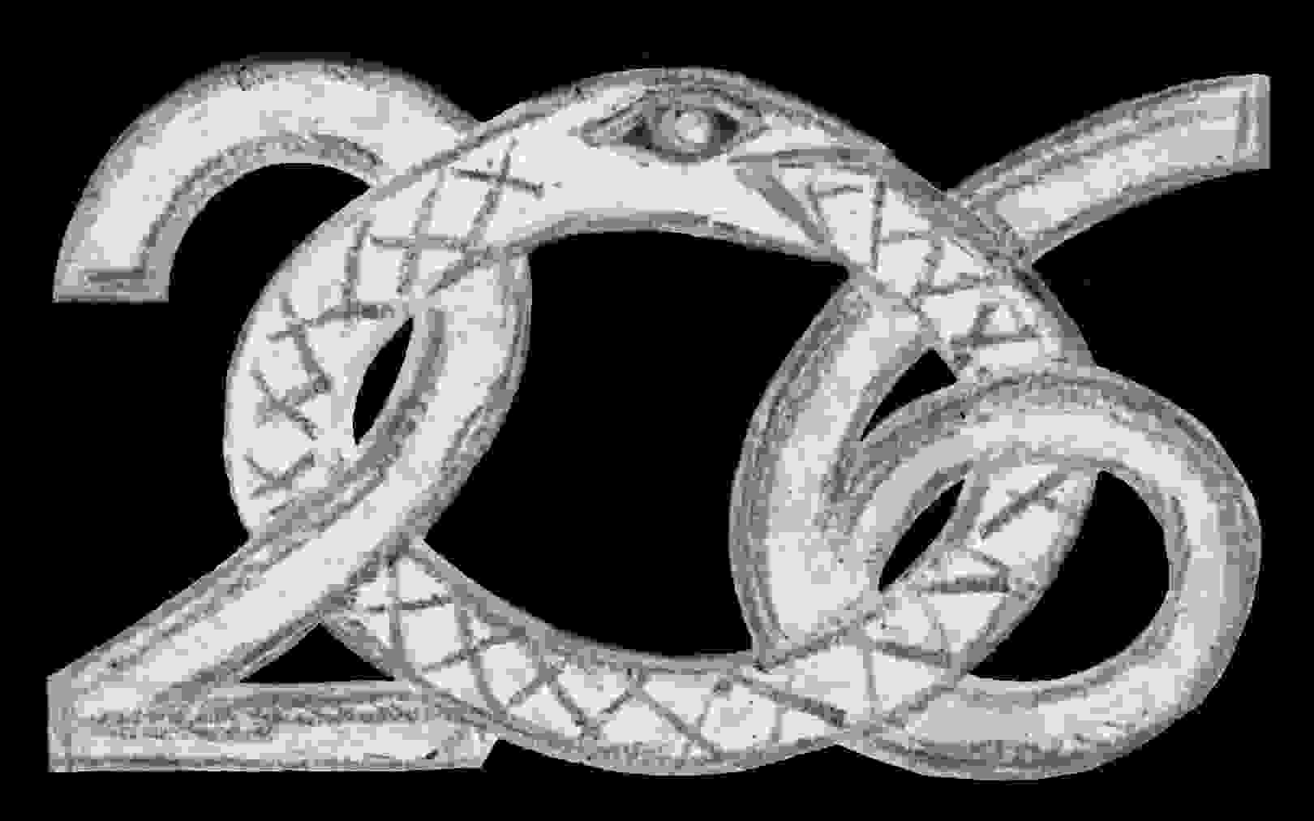

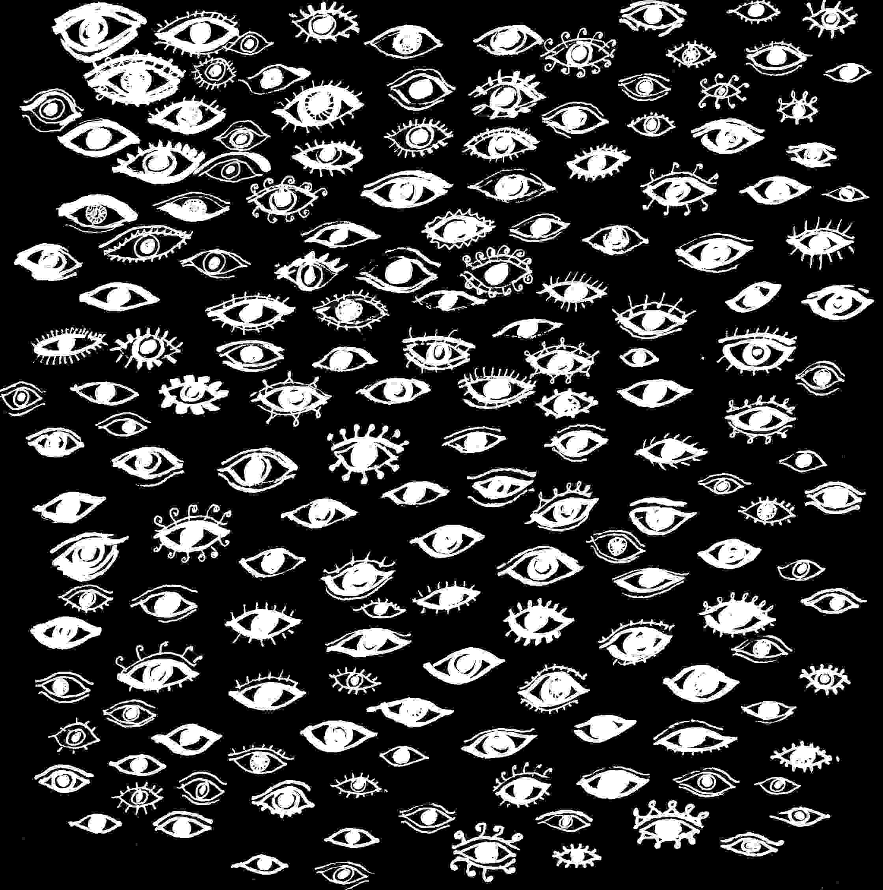
arguments with the thought police
TABLE OF CONTENTS
ESSAYS
Toward Nonviolence
On Neruda's Winter Garden
Windmills
An Essay against Genocide
An Open Letter
The Silence of Writers
The Silence of Mothers
Crimes of Power
Suppression of the Convention on Genocide
Essay on State Terrorism
DRAWINGS
first essay
title page
publication data
gerald and maas night's lantern
arguments with the thought police
copyright © 2002 john bart gerald
drawings copyright © 2002 julie maas

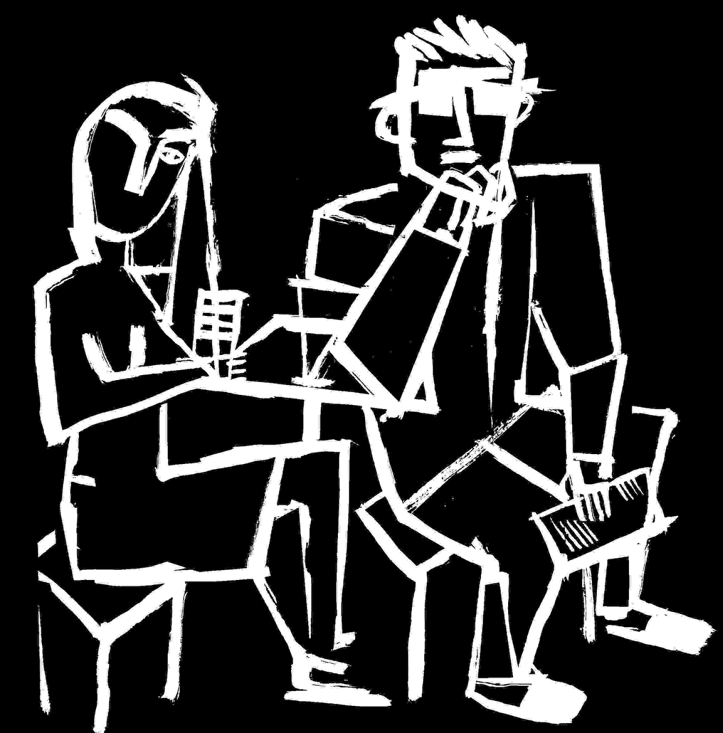
Toward Nonviolence ⁽¹⁾
Preface
Franz Fanon, a psychiatrist in Algeria during its liberation from French colonial rule, made a strong case for the use of violence as a necessary mechanism of Independence. He considered nonviolence a ploy of the middle and upper classes to ease the conscience of the uncommitted: when ruthlessly oppressed, a people fights violence with violence until the oppressors leave, cede power or die. Algeria lost thousands of her own in that bloody and partially successful struggle to free her people from an oppression that is always both physical and psychological. Fanon also realized that in the African Independences from colonial rule, there were often no fundamental changes for the people. The revolutions occurred within elite circles of urban populations, simply replacing the elite of one colour or religion or political persuasion, with the elite of another.
Both Albert Schweitzer and Martin Luther King Jr., provided alternatives based on Christian faith, at a time when western civilization had no proper answer to its colonial greed except increasing its repressive violence. Both Schweitzer and King served humanity beyond their own people. Both were used as models for holding actions when holding actions were needed to affirm political structures which continued to serve the elite. But neither preferred a political system to people. Schweitzer was incarcerated by the French during World War I and doctored in a prison camp. King, arrested some thirty times for his essential innocence, used the system against itself. Amid political struggles which both men were immersed in, and by simply not playing the terrible games of violence and death both found ways to win out over those who oppress everyone. Both lived within an ethic that leads to a nonviolent society by serving its people, by serving the poor, by practising nonviolence both physically and psychologically, by separating oneself as much as each of us can from violent institutions, by understanding the structures of violence we live within, by economic equalization, by refusing arms, by refusing to compromise our humanity. Each of them refused to honour abstractions before the value of each person, which I think is the basis of respect for human life and nonviolence. As a young man I was drawn to work for, understand in some way, each of them, and without conclusion, I offer here short accounts of what I learned.
An African Lesson in Nonviolence
As a peaceable kingdom, the remote enclave of European doctors, nurses and staff, met Gabon's Independence from European oppression without any protection at all. At Schweitzer's Hospital in 1960, the code was, no armed force. No guns. One or two whites had handguns, but it was as if they didn't know any better, an embarrassment to the others. My own service both to Schweitzer and survival was within a context of absolute nonviolence where it counts, of being entirely vulnerable to human nature at a moment when there were historical debts to settle.
Nonviolence is usually the way of missionaries and missionary doctors whose protection becomes the people they serve. The Hospital was a traditional missionary's answer to human suffering, and with the French teaching missions which also educated the native peoples' ruling class, both were part of the French colonial package. But without missionaries and the sacrifice of their own lives to their work, many people would have died from disease or had no recourse to an education which eventually gave the people tools to counter their oppressors. The French, having done the worst they could in Algeria, were careful of Gabon's Independence and withdrew their military advantage. Pre-Independence, there was no law in the jungle or much need for it, though there was a scattered stumbling bureaucracy of departing administrators. Schweitzer's insistence on the sanctity of life and his service to the people, was partly responsible for the entire country's escaping the massacres in neighbouring countries during Gabon's transition to independence. But it was more than coincidence that his philosophy grew and became articulate among a native people who were its source as strongly as any evidence of European civilization. Gabon's peaceful transition saved the lives of so many of her people, while Algeria's lost so many Algerians and French. Politically, nonviolence despite the losses of its martyrs, is a way of saving lives and I've never considered it a tactic, but a natural extension of respect for human life.
On the other hand this is hindsight. Before Independence in Gabon, no one could be sure the transition would be peaceful, or if the kind of independence which the French offered, would be enough.
When I left college and went to work for Schweitzer at his hospital in 1960, it was my response to the Sharpesville massacre, to racial slaughter in South Africa of unarmed blacks by white police. As many African countries prepared for Independence I found work at Schweitzer's Hospital as a labourer and foreman amid a construction crew of lepers, but much like any white colonialist. So I asked the good Doctor if I might be more helpful in serving humanity by working for the French Protestant missions which he had served on arriving in Africa years before. He found me a place at a missions post in the far bush on a European made border where three countries came together: one engaged in a civil war and two about to be independent of French rule. I knew nothing of African independence. I knew nothing of politics or race relations.
I learned in the bush that the good Doctor and his staff were only some of those whose lives were given to caring for the sick and education of a native people. The Missions included native peoples as ministers, teachers, carpenters, while Schweitzer's Hospital was European-staffed. I met as well a French military doctor alone at his station as Independence approached, and also two European Mission nurses who worked at a leprosarium amid a thousand square miles on an endless two rut road through a stretch of jungle considered unsafe for Europeans, where I took them medical supplies. The Doctor paid my flight over the area to the mission post, and from there with missionary and jeep I reached their village of patients. The world at large knew nothing of them, yet in their way the nurses were also part of the Doctor's instruction in the meaning of service to humanity, caring for the lepers with their own chances for lives, but without recognition or the world's understanding. I met a white Catholic priest amid his flock. There were several European Protestant missionaries with their wives and children so light amid deep dark people at other isolated posts. The French merchants were leaving or gone. The white police were gone. There was no trace of the French Army except that lonely doctor who would not leave his post.
A country away, the former Belgian Congo which was becoming Zaire began to host the slaughter of missionaries, doctors, nurses, teachers, nuns, whites left in the field while upper level administrators were pulled back to Europe. Those who stayed through the popular election of Patrice Lumumba and were allowed to function under a people's government became scapegoats for the corporate inspired rebellions which plunged the former Belgian Congo into blood. My once classmate at Milton Academy, Mark Higgens, who had helped me find work at Schweitzer's and introduced me and made a space for me in his room with an extra cot, was among those killed on the Congo River by rebelling troops. And to the north of Gabon, a strolling distance from the mission where I taught geography and English, was Cameroon where the ninety isolated Europeans of the region with their families were slaughtered - according to the newspapers in Douala Cameroon at my landing in Africa on the way to Schweitzer's. I learned all this as a young traveller, working for no government or salary. My entry permit to Gabon was never stamped in the partial breakdown of bureaucracy preceding Independence. I carried only my passport and letters from the good Doctor and from his aide Mathilde in the event I was turned in to the authorities when European law left.
After several months I returned to Schweitzer's Hospital, a haven of familiar calmness it seemed to me after high fevers and turmoil of malaria with complications that left me helpless. Gabon was about to sign Independence from France, and everywhere the people were celebrating with regional elections. At the Mission a native friend gave me a knife to protect myself. I refused yet he left it. He explained he could not be there to look after me if there was trouble. I told him my protection was having no protection. In those days of recovering at hospital, I was drawn to the few amid the staff who seemed to have some inkling of what Independence meant. The good Doctor left for Europe on a speaking tour. Dr. Friedman, a staff doctor told me to recover with the Missions until I could return to Europe and regain my health. For what was considered an incurable amoebic dysentery he gave me a several month dosage of arsenic compound which eventually worked but made me weaker. After several days at the hospital I was pronounced fit by a visiting American doctor with a sense of humour, and sent back north with the missionaries. Driving alone in the jeep middle of the night, I misjudged a river crossing. The jeep wheels slipped off two felled trees which served as a bridge, and I sat there in the dark of the solid mat of great trees and little trees entwined with vines under the night sky, listening to the waters in the ravine, exhausted and left until finally I saw the lights of the missionaries in the landrover returning for me. I wasn't strong enough to drive the long roads, and I was told to appear at the gendarmerie to explain exactly what I was doing there.
What was I to tell the native people ? And what was the truth ? That with faith I wanted to help people? That I too wanted to be free ? That Doctor Schweitzer and the Missions had set me up there to teach school ? Without conscious intention I was sitting on a triple border crossing and if Gabon's Independence became violent and if the slaughters started there as well, if the airport at Lambar'n' were closed at Independence, I could probably take white staff from Schweitzer's overland out of the country ? The missionaries might have but each had a family and flock to care for. The native teachers couldn't drive. Was it coincidence I was befriended by the country's opposition leader exiled in the region until his freedom came with Independence ? Or that I was locked in a hut with the daughter of the most powerful family on all sides of those European made borders until we made a peace of lovers, and then both would return without the locks ? Or that I was to be a father ? I said nothing. The native police looked very hard at me and my papers and let me go.
Should I have insisted on my presence in a world where whiteness meant oppression from the past ? I trusted her. I knew she was a nurse. Her father was the first native medical doctor in that country, and I knew nothing else about her until much later, except that she was my age and cared about me not whom I could save or how I could help humanity. Yet when I was sick the missionary and his wife came to my hut to care for me until I was strong enough to travel to the Hospital, while nearby she cared for her own people in the native infirmary.
Some fifteen years later, I met my African daughter's older sister in New York, an international lawyer passing through, and learned her mother was married when we met and later divorced. Her mother's father was head of the tribe. My friend the opposition leader was not a subject to be talked about. Before I left Gabon he brought me as his guest and the people's since he was elected to represent his region, to the country's chamber of deputies to witness the signing of Gabonese Independence, which included his freedom from house arrest. Twenty-five years later when I learned he was in prison for politics against the new regime, I urged his freedom since the other grandfather of grandchildren was the country's President, and my friend was freed, too old to cause much trouble, imprisoned for armed rebellion.
To think about what all this means: it goes beyond race, hatreds, politics or scores to settle. Possibly I was tolerated because I served people, because I worked with lepers when in those days the doctors neither knew how the disease was transferred nor how to heal it. Medicines could only arrest it, and frequently by then the scars and deformities were as frightening as the threat of isolation from others. But when I left their country it was one of the heavy planes from the former Belgian Congo that flew me out of Africa, with one empty seat among the families of Belgians, one empty seat when of course there were no empty seats in plane load after plane load flying low overhead from the Belgian Congo, day after day jammed with fleeing survivors, and I thought why is there an empty seat for me when it was impossible to find passage out except I knew I was taking the place of someone else who was not going to get out of the former Congo Belge. I learned later my friend from school had died. How could one survive that mix of experience without seeing the craziness of a racism which inevitably harms the innocent to the profit of corporations ? People fight back with a capacity for love.
In Europe I found my way to Switzerland and to a house by the lake where a friend took me in until I was well enough to travel to the States. Then I went back to college. My daughter's mother and I stopped writing each other shortly after my return. Neither of us wanted entanglements with the law or agencies. If whites were unpopular there, the treatment of blacks in the States was not so different from the treatment of Africans under colonialism. Northern racial sensibilities were awful in the early Sixties. The commonplace prejudices were stunning and because of my child and her mother and the black people who had protected me, I was aware of prejudice as cruelty and it hurt me. My parents thought I had changed. My father's family was southern, starting before the States. My mother's family was northern so there were kin on both sides of the Civil War. But for a long time there seemed no room in their worlds for anything I had learned.
In the Seventies, married with two children, I would send a portion of my Harvard lecturer's salary for my Gabonese daughter's education. For twenty years our family income almost never reached the minimum of poverty level. They were mostly thankless years of being too poor, without rights which others took for granted, years oppressed by all who should have helped, simply for understanding too closely the racism within my own society and because I resisted injustice as I became aware of it.
My Gabonese daughter visited summers ago, she wondering at the strangeness of a father she knew as a child only in my rare letters to her mother, the bits of money to help with education, and I knowing that she paid as well within her own society for me, for her lightness, knowing her mother paid in the raising of a partly white child, as I paid by trying to be true to them as a human being since I could not be to her as a father.
I think there are two ethics among peoples. One gives over to hatred and violence, the other to love and commits oneself to helping life-with-meaning as one can. That was what I brought home from Gabon's Independence in the equatorial jungle, and I was never sure whether the lesson of "reverence for life" was part of Albert Schweitzer's or their own people's instruction in the service of humanity.
Martin Luther King, Jr. on the March to Montgomery
It may help to remember what we've learned since, that in the early Sixties in Vietnam, the CIA's Operation Phoenix took village leaders and shot them for suspected sympathy with the Viet-Cong. CIA supported and US trained forces in South and Central America would destroy segments of civilian populations to establish cooperative rule. In multiple assassinations of the Sixties, the people's leaders in the States were also shot, in supposedly random acts of violence. I looked to four leaders: two Kennedys, King, Malcolm X. I met both JFK and Reverend King. The death of each terrorized everyone. The psychological impact of the deaths did not end with the loss of each leader. Who killed Kennedy ? Who killed King ? Was the mystery intended to provide a control by fear ? On the Lower Eastside of New York people didn't accept the official version of events. True leaders were at risk. Much of Martin Luther King Jr.'s heroism took place under the warning shadow of JFK's assassination, and I doubt there was anyone that cared who wasn't afraid King would be shot.
I had no early connections to the Civil Rights Movement. And I was also a USAF reserve medic, enlisting in a medical unit to beat the draft. Living and working in New York I transferred from Boston to a Jersey unit and one weekend a month took the subway to Newark and its City Hospital Emergency room.
When I met Dr. King the Atlantic City broadwalk was almost bare, except for several of us without proper press credentials who thought we'd go to the Democratic National Convention. Shut out, we were mid empty space except for scattered people in the distance and a couple with wicker stroller wheeling down the broadwalk, he sitting, a plaid blanket over his legs, a powerful man with a short neck, pushed by a woman who seemed delicate in comparison. They stopped for us, and one of my friends introduced me to Reverend King and his wife. They were laughing as though we had surprised them in a joke. He surprised me because he didn't peg me by my colour, as though he understood my feelings. He wasn't looking at race. He was entirely there, very real, quick-thinking, deep, jovial and assessing. I was no one important. He made me feel of value.
In 1965 when he put out the call for people to join him on the march from Selma to Montgomery, I went. So did my neighbour from New York. We found ourselves walking that road while groups of whites jeered along the roadside and a National Guard helicopter flew low over the trees ahead checking for snipers.
I wanted to write an article about the march but as a freelancer was refused press credentials. I kept a journal of my thoughts with observations and people and some addresses, as I had when working for Schweitzer and the Missions. Several pages of the notebook had been used for native vocabulary, the drawing of a missionary, and of a portion of the ceiling of Christ's Cathedral in England. But in Alabama it was a mistake to keep a journal because after the march I was arrested by Alabama police and they took the journal and sent a copy to the FBI. After that I learned when not to write. I saved the returned journal for years until living as a builder in New England, I burned it. A stranger had chosen to beat me in front of a crowd treated to my unwilling demonstration of nonviolent defence tactics. Shortly after, another stranger walked up to me and said they 'didn't like blacks.' And how would some stranger in a small town in Maine know to say that to me ? I had mailed a Christmas present to Africa. Without any protection I burned addresses and journals that might be misused.
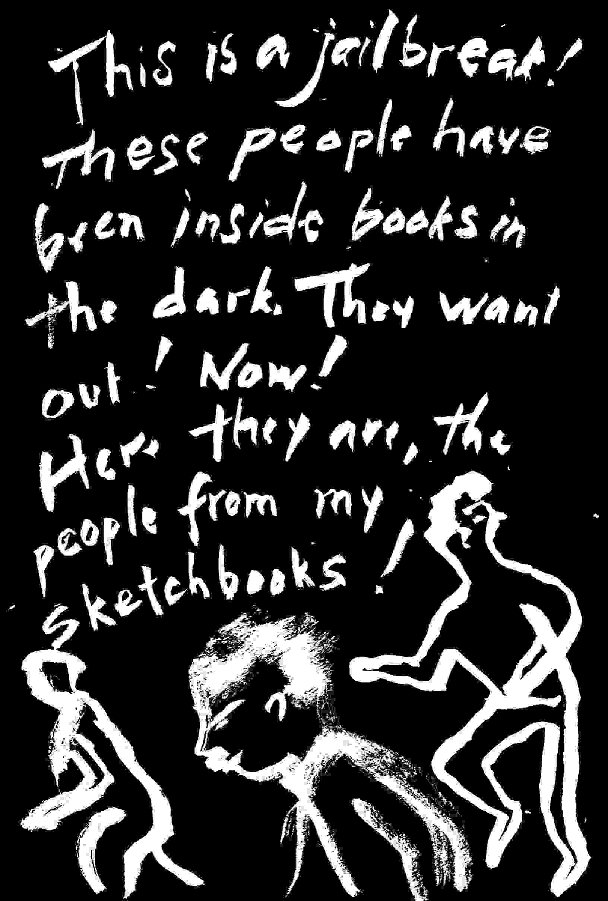
In Montgomery my neighbour from New York and I found our way to the congregating point in Montgomery for people who would march. A black high school kid made friends and helped us find our way around, found us a family to stay with that night. They fed us. They didn't have any money, with parents and two children all sleeping in one room and place made for several of us in the corner. When we went walking around with them after dinner a white man came out of his house with a baseball bat and chased us. During the day we were trained in nonviolent defence by some of the young men from the Southern Christian Leadership Conference and Student Nonviolent Coordinating Committee. They were the backbone of the Movement and March. They knew how to handle the problems, how to find help, how to ease the marchers into lodgings, how to see where the trouble might come. There was some turnover of those going to jail in various nonviolent protest actions, and returning after release. Later we found a ride to Selma. I realized that a swamp road connected that highway to Gunter Air Force Base where I took my medical training.
There was a family in Selma of everyone who was there for the march. At the congregating point, the church, there was a volunteer list for march marshals, people who would help with organizing. I wrote in the space for my reason to volunteer that I had worked with Schweitzer and believed in peace. I was selected. Once the march started we were to take the risks if there was trouble, and so walked between the line of marchers and groups of angry whites, and tried to cool things down. I was good enough at that. With southern ancestry I didn't feel entirely like a stranger, but the local whites scared me because to them, at that time, I doubted they considered me in their human family. That confused me and scared me more than the risk of being physically hurt. In Africa my fear was of being hurt simply because I was white. In Alabama I, and I think all the marchers only felt safe among the blacks.
If racists decided to attack us there was not much we could do. SCLC people had taught us how to hunch down and protect our heads with our arms if beaten. March marshals were given armbands and iridescent orange jackets - the joke was that we'd be more visible targets out on the road. Alabama National Guard troops were called up; they stayed in groups back from the marchers. There were a very few Justice Department people who were certainly there at the campgrounds, and they were in touch with the National Guard. They knew who we were and we could call on them if we had to.
Out in the countryside whites would stand along the road taunting us. There were so many marchers and relatively small groups of rural whites, at least until we reached the outskirts of Montgomery some days later. There was plenty of time to talk with the other march people: the leadership had other commitments and couldn't always be found at lead position mile after mile. The press would whisk them off for interviews in Montgomery, or hold them aside for the cameras. Media people and reporters were dressed for the office. The marchers slept in their clothes. I remember being thirsty, being tired. It was a long walk. The nights were a damp cold. The people from Selma would drive out at night and take some of the marchers back home and then back to the march for breakfast in the morning. When I wasn't at the campground gate pulling security duty at night - we worked in shifts organized on the principle of well you guys for a few hours then us, my neighbour and I would ride into Selma for a bed but it was risky because cars driven by whites buzzed up and down the road shining lights into cars as they passed, with black people driving under the speed limit so you could tell whether friend or trouble was driving a car by how fast it was going. Any car that passed from behind was trouble. There were inevitably a couple of attempts to run us off the road and thrown beer cans and yells, so that blacks kept any whites in their car hunkered down in the back seat sometimes under a blanket so trouble would not know the car was carrying marchers. It was safer to stay at the campground where there was our own security, Justice Department, and the Guard, and after a few days of march we just slept on the ground in the tents.
I think all the marchers were afraid of being shot, particularly in the empty stretches of the countryside. No one talked about it. Nine months earlier three Civil Rights workers in Mississippi were murdered. Later we learned they were murdered by law enforcement in a textbook example of civilian population control by fear. Eventually a marcher was murdered, a mother of four named Viola Liuzzo, shot by local racists with an FBI operative among them, but in a car instead of walking down that road. When we came into Montgomery, at the foot of that avenue leading up to the State Capitol there was a throng of hostile white people, men. A few of us march marshals and marchers formed a tight ring around Reverend King, locking arms as body shields against the anger. The crowd's anger was frightening and real, and growing out of control. Their hatred seemed directed against all of us. A group of local police nearby did nothing. The crowd was pushing us and for an instant it was serious and because I was walking sideways through that group helpless with my arms locked I was looking into Dr. King's face. He was accustomed to their hatred, but his fear was no different from mine, his eyes quick over the crowd around us, his chin down and head back a little, seeing also that I was looking to him, until his eyes rested up ahead where we were going. If the angry people had wanted to kill any or all of us they could have easily. "Justice" as we called the Federal Marshals, if there at all couldn't help, and the National Guard wasn't there, only the local policemen who stayed apart - then we were through the roughness and everything was semi-normal again though I understood what I didn't want to understand, that he knew what that kind of hatred meant, knew what might happen but would not happen right then, was afraid like the rest of us but past a point it didn't help to fear.
My neighbour from New York found us a ride back north with three northern white students. After stopping for breakfast at a diner and buying a newspaper that headlined the slaying of Mrs. Liuzzo, all five of us were arrested in a car heading north, just outside Montgomery. We were all five accused of stealing one newspaper, taken down a back road handcuffed and confronted with a line of twelve to fifteen uniformed white police. A white man in a business suit walked up and down in front of them, pointed at us and told them to shoot to kill any of us they saw in his county again. Then police expressing the most twisted racist verbal abuse I've ever encountered, took us into Montgomery and put us in Montgomery jail. The next day we were taken to the countryside and the court was held in a post office. The judge said the charge was ridiculous and without proof so he'd have to let us go. I asked him if that meant we were found innocent ? He said oh you're innocent alright, and then we were re-arrested on more charges, this time attached to supposed contents of the car we were riding in. We stayed in jail for five days. Our first SCLC lawyer was stabbed on the street and the second Movement lawyer advised us not to post bail. When the prisoners beat us we remained nonviolent. Before going into court our new lawyer told me that because of my journal of the march there was a warrant drawn up against me for criminal anarchy against the State of Alabama, a charge carrying twenty years, but no one had signed it. Four of us were released and the Justice Department escorted us to the airport. The car's driver remained for another trial.
False charges are frightening because you don't know at what point the charges will stop. By them, law enforcement claims absolute power. As a tactic it was used against civil rights workers throughout the South. It happened to me in New York City again, an overtly false charge for obstructing traffic when I was covering a peace rally, and years later again after countering government policy at a writers committee meeting, a false arrest in the subways for supposedly not paying my fare (NYC turnstiles do not give receipts). It is also psychological warfare, and it happens by surprise no matter how carefully law-abiding you are, and if you are alone without a witness it can be impossible to prove your innocence. As a writer with an unconventional novel about Africa published by Viking in 1964, I was tagged fairly early as a target for distinctively un-literary racists within law enforcement and without. Thirty years later the FBI still keeps the Alabama petty larceny charge next to my name without its disposition noted on the record. I would never have learned of it despite multiple requests under the Freedom of Information Act, if I hadn't applied to move to Canada in 1994. The FBI kept me and my family sitting in Maine for six months, waiting for a confirmation of "no conviction" to clear through the Alabama police departments which never rescinded their death threats.
I've thought about that moment reaching Montgomery, as though there must have been some lesson there for me, before Dr. King continued his way into history. I've tried to rationalize the white crowd's behaviour, the epithets, the attempts to break through our locked arms, as their way to warn Dr. King that there wasn't any real protection except people. The unwritten history of the Civil Rights movement and Peace movement, is of all the ordinary people who cared deeply for racial harmony and peace, and so became targets, and no one learned what happened to them.
Nonviolent Resistance to the War in Vietnam
The lessons of Vietnam linger. My Air Force duffle bag, gift of the Reserves, embarrassed the darkest corner of several attics. My medical whites were returned, my fatigues used up in house building, my duffle coat salvation armied, and light blues simply burned after cutting off the buttons which I can find with my dog tags in a little basket just to the left of my socks: shiny little moments of pain, my first lesson in the limits of American freedom, where under the Sixties draft they could take my body and put it in a war zone or prison. Conscientious objector status required an expensive lawyer: no one wanted to be drafted. So I enlisted in an Air Force Hospital Reserve unit to be trained as a medical specialist. It was 1962. JFK was President. In Vietnam there were advisors. If there ever was a war I wouldn't have to kill.
When the war came I stayed out of prison as a reserve medic, but for six years of monthly meetings the moral tension was extreme. I thought the war was criminal. Neither combatant nor deserter, I became a witness to disaster: my heroes were jailed or deserted and my brothers by the thousand served and some passed through the wards on stretchers during summer training, or arrived in the V.A. hospitals.
The hardest challenge of the Sixties was how to resist major crimes by government. It was more important than job, future, family. Leaving the country saved oneself, and it was hard to do without economic backing or good friends elsewhere. The alternative for those who stayed was war resistance, ignorance, or playing ball. Knowing about war wounded turns people against war, and in the early Sixties there was almost no press coverage of the US wounded. The casualties were in their realness, also a metaphor for what was happening to all Americans. So I wrote stories about the wounded and what the war was doing to people's lives, and some stories were managed into print. My political views fed into my teaching. I demonstrated, rallied, marched. I wrote engaged journalism. My attempts to cover peace rallies freelance for The Village Voice were interrupted by giving first aid to protestors hurt by police. After an article about police brutality, I was arbitrarily arrested at the next demonstration, and effectively silenced for two years until I went into the V.A. hospitals for Harper's to write about severely wounded veterans. My outlets became fewer and fewer. Out of the service in 1968, continually hassled, I moved to the countryside. Some twenty years later the New York City Police Department secret anti-war files were released by court order. The file on me was twenty some pages to note my presence at one peace rally I covered. The peaceful hero Abbie Hoffman whom I had interviewed since he was vaguely in charge was not mentioned, nor was some of the ugliest undercover military or plainclothes police unit brutality of the war. I saw a young woman struck and her limp body dumped in a police van and driven away alone. I was afraid they killed her. Fifteen minutes later I was arrested for obstructing traffic and would have been found guilty if I were not with witness. The report simply placed me in a crowd of five hundred made up of a lot of anti-war groups supposedly bent on violence, as well as supposed Communist Party fronts, and Viet-Cong banners which I certainly don't remember. In fact the ralliers were nonviolent and peaceful, planning to march without a permit in an act of civil disobedience. Some were hurt badly. The file was "secret" because I knew too much, or because I could have proved myself innocent of its implications in court.
The irony of being a medic within a system designed to kill people lent some insight into the problem of all those committed to nonviolence. The system insists on teaching us that violence "works," as former President Bush tried to teach the world in Iraq. Violence is almost always the result of controls or pressure by an elite, manipulating the people. Anti-war resistance on the other hand was chaotic. The mild anarchy of uncoordinated resistance was very close to a free society, until it intersected the machinery of government in demonstrations, at rallies, with civil disobedience, draft card burnings, flag burnings, draft resistance, refusals to serve, long term AWOLs, tax resistance, and as a result the inevitable punishments which stopped nothing. Resistance was the message of alternative society, with collectives, communes, cooperatives, and anti-establishment lifestyles, making peace with the increasingly large numbers within the establishment who protested the war. There were days devoted to strikes, and there were teach-ins, building takeovers, sit-ins, picketing, petitioning, along with street theatre and art and poetry and satire and festivals, and a free press in the underground and people's news services. It was real and not very safe because non-elite anti-war resistance was increasingly hassled in the late Sixties, infiltrated, and broken up. Some were made too unbalanced for effective political action. Some were silenced. Others left. A very few were broken into violence. Ultimately the government could not stop the movement for peace. Nonviolence won out because resistance that wasn't nonviolent either cooled out or was lost, murdered, caught, imprisoned, or burned its ghettoes apart from the peace movement's purpose of ending the war.
For me, respect for life led naturally into nonviolence, which meant refusing to use or accept violence, initially physical violence but with time, psychological violence and oppression. Within a violent nation, nonviolence usually requires religious faith, a moral code, ethics, just to be able to survive. It requires at least a knowledge of history: in the past , despite the number of martyrs, the cost in human life of nonviolent change is much less.
Since nonviolent resistance includes civil disobedience and in some instances requires opposition to the law and authorities, it relies on higher principle. There are higher principles, codes, ethnic and religious laws, which do not agree with each other. Because effective nonviolent resistance requires large numbers of people, higher principle usually affirms those points of humanity which groups hold in common. Resistance rises from that point where each of us says no, I will not accept this, so massive resistance is a response to some injustice which would in the objective court of human experience be called a crime. The essential purpose of nonviolent resistance is the affirmation of a human code, better than what society offers through the use of force.
Nonviolent resistance is more supple and unpredictable, more like the human heart than machinery of war. And there are as many ways to resist as there are people. But of two ways to counter what is criminal in one's own political system, the most common is taken for granted. The democratic process is based on nonviolence, and a criminal policy can be changed by electing new policy makers. When national policies remain criminal the obvious recourse is to counter them with laws created to protect the people and the nation from serious wrongs. So when policies are intentionally criminal the laws are subverted, or those who administer them serve the interests of an elite rather than justice. Most resistance actions occur when a just legal recourse is not available.
Despite civil liberties organizations which offer some protection against excesses of government power, Americans have almost no recourse to International Law, to applying within the US standards of human rights which internationally the law affirms for all humanity. Direct action resistance groups in the Seventies and Eighties, attempting to challenge the first strike capabilities of US nuclear armaments, were (with a few exceptions) not allowed the Nuremberg defence in US courts. This means for example, that defences against the crime of genocide if committed by our own government, are made purposefully weak, hidden, unrecognized. Without legal recourse by the people, the power and opportunity for government to commit genocide increase.
Confronted with a choice between complicity in punishable genocide, and nonviolent resistance, what free person would choose complicity ? The choice becomes not to recognize the genocide as genocide, or to choose resistance. We know that nonviolent resistance works, and in anti-war resistance to Vietnam it achieved its immediate goal. It took ten years. And for many it took too long with too much lost. Within a democracy, pressure from the people as a whole can turn the government to the people's will, even in long stretches between elections.
The German Nazi government of the 1940's provides a comfortably distant example of intolerable government policies. A generation of Americans was asked, what would you do if ? Many Americans believe that Germans who did not resist Hitler's policies, were morally deficient. We expected them to do anything/everything they could to retain the human value of resisting the unacceptable. But within the context of our own laws many of the possible actions would have been criminal. Through the Vietnam war, amid assas-sinations of American leaders and with government and military policies at points unacceptable to humanity, most Americans avoided resistance which directly confronted the law.
Yet there was a point where the nonviolence of American society could not be broken, and it was touched in the Sixties and Seventies by anti-war sentiment and the near impeachment and forced resignation of President Nixon. In both instances government was made to respond to the people's will, and not by popular elections or popular referendum, but by the people's consensus which could not (and yes there were exceptions) find just representation. The war in Vietnam was finally stopped by pressure from the people. It suggests that the American people have the power to stop war machinery, economic machinery, social and political machinery, nonviolently. It relies on a possibility that ordinary people acting in concert within their professions can without violence make the system inoperable. A structurally violent system relies on each of its parts. In the event of genocide the people have the capacity to shut the system down and keep it shut down until the crime is stopped. This is and always was a power of the people in agreement. But the question is always with a free people: at what point does the crime of a society become so great that its people collectively draw the line. That point exists whether it is ever reached, or not. It remains an obvious alternative to crimes by government, and affirms the nonviolence of the democratic process.

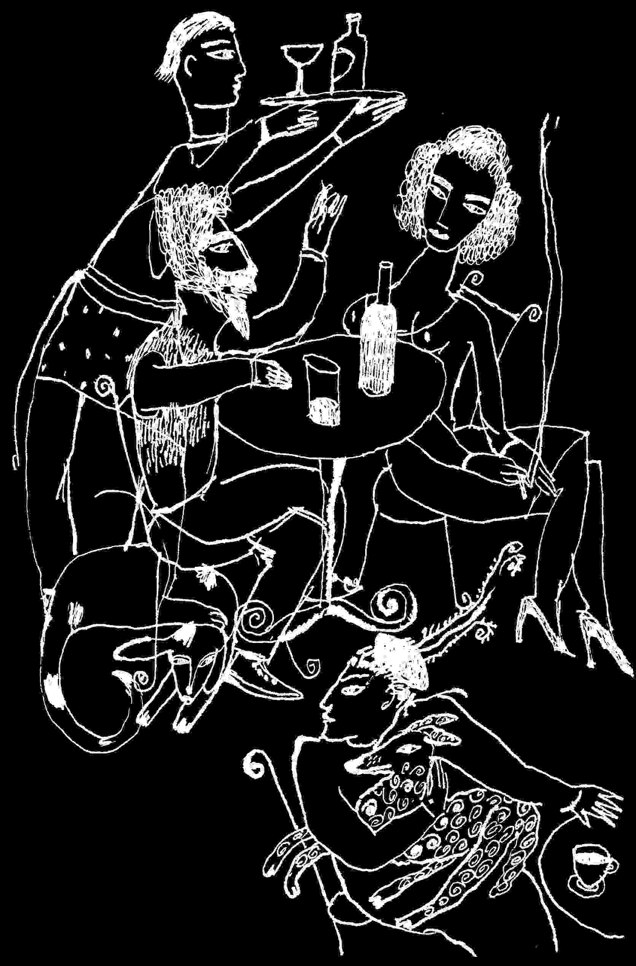
On Neruda's Winter Garden
July 20, 1990: a book review of Pablo Neruda's Winter Garden, translated by William O'Daly, Copper Canyon Press, 1986. (* See subsequent notes, 1)
This is a modest even humble book, one of the manuscripts remaining on the desk of Pablo Neruda at his death, not long after Chile's President Allende was murdered.
The CIA backed overthrow is still yielding the mass graves of those who disappeared under General Pinochet's rule. The killings remain a crime against humanity. Under the horrifying title of "Many Thanks," Neruda writes of arriving late at that amphitheatre, "When they closed the doors / and the world disappeared..." His poems remain to speak for the thousands who disappeared, for the lost humanity of Chile , and he writes calmly in Winter Garden of the names of god, of perception and wisdom in age, and of despair when he can look only to the sea for his freedom.
Loyal to people rather than power, the poetry is consistently deep, passionate, wise, insisting on life, crying in the American wilderness. US intelligence disapproval has had to confine itself to a character assassination of Neruda the man. The New York Times Book Review (Jan 24,'88) offered a feature article, "Intellectuals and Assassins - annals of Stalin's Killerati," with Neruda's picture , and that of the Mexican muralist Siqueiros, among others, while citing Defence Intelligence Agency research to intimate links between both and a KGB death squad. (* See subsequent notes 2)
Since Neruda isn't around to defend himself, it's worth noting that Hayden Herrera's Frida, a Biography of Frida Kahlo, finds him amid the lives of Diego Rivera, Kahlo and their guest, Trotsky, in Mexico, as a Chilean diplomat providing Siqueiros with a visa, when Siqueiros was in police custody for riding by Trotsky's lodgings and shooting at the shutters. Neruda was in 1971 Chile's ambassador to France. US Poet and statesman, Archibald MacLeish helped save Ezra Pound's life, yet no one implicates MacLeish in Nazi war crimes. And it was MacLeish who introduced me to Neruda, in a mid-Sixties lunch at the Algonquin in New York City. Neruda gave me and signed in huge green scrawl a copy of his Collected Poems. Through twenty-five years of political changes the ethic of the poems remains flexible and true to people. The actions by both men value life above politics.
Whatever is done to Neruda's reputation (* See subsequent notes 3) - (MacLeish in his Deerfield retirement also had to turn to small presses to publish his work), his poetry has already survived the worst a military system can do to its people. In the final days of Winter Garden, as the Pinochet regime closes his life's experience, Neruda writes with honesty poems which are a trial of his soul. As always, he is inclusive of the reader in his life's won knowledge, and without arrogance. And without evading the repercussions of his people's attempt at freedom, he foresees the consequences in a winter garden where life moves slowly , surely enough to assert its inevitable return. In "Guatama Christ," he chides the future for fingering and spending the names of God with good and evil. His fury at lasting injustice remains - "...golden brown victims who blazed with napalm / while Nixon with the hands / of Cain blessed those he had condemned to death...," but amidst an awe and commitment to the spiritual "iridescent footprint still shimmering in the light," - that sense in Neruda's best poems that the miraculous has just happened. His moments of pagan wholeness are at peace with his understanding a christ who walked for a while in Chile as the common man.
If you are accustomed to Ben Belitt's translations of early work, which retain the fever in the sinew of the line but are a little fancy, you'll find William O'Daly's: simple, direct, responsible and respectful. He doesn't interfere and he uses the craft of his poetry with restraint, yet naturally, and the translations like Spender's of Lorca, lead one again to the music of the Spanish line.
*
Subsequent notes, February 13,2000:
1. This review was accepted for publication by Harvard Book Review, ten years ago in the States, but when the issue appeared the review was missing. I was assured it wasn't "censored," but "replaced."
2. I tried to challenge The New York Times Book Review article, with a letter to the editor. I noted that the military sources who brought us the Vietnam war were now destroying a poet for a propaganda advantage. My letter (Jan. 25, 1988) wasn't printed, and I know of no other challenge by American writers, allowed in print.
3. Frances Stoner Saunder's book, Who Paid the Piper: the CIA and the Cultural Cold War (London: Granta Books, 1999) reveals a CIA covert operation of 1963, which decided to deprive Neruda of a Nobel Prize because he was a Communist. Operatives pressured Ren' Tavernier, a French poet and Resistance editor under the Nazi occupation, to co-author a tract accusing Neruda of pro-Stalinist political propaganda. Tavernier who survived one military occupation or another, is said to have complied, but with the result that the Nobel went to fellow Frenchman, Sartre who refused it (excellent !), while Neruda was simply awarded a Nobel the next time.
Without knowing this sophisticated story, I met Tavernier when he was President of French PEN, in 1983, and an eloquent spokesman for freedom of expression. After considerable harassment in the States I was looking for support to continue writing freely. American PEN took care of Soviet dissidents and its own elite. Tavernier wouldn't help me find work, but offered his poems to publish. They were anti-fascist and very good. In one, Pinochet was included in a gallery of monsters, though we disagreed about Castro, whom I favoured. I thought his own work was being suppressed because of his ties to Communists in the French Resistance, so I gathered and translated a small book. Back in Moody Maine with printing costs out of pocket, our small family press brought out the bilingual edition in 1984, Poèmes 34 Poems, his first book of poems since 1940. Subsequently a book of his poems appeared in France. He wrote that he sent me copies, three times, but they never arrived. He won the French Academy's Grand Prize for Poetry - for all his poetry, and became President of International PEN.

Windmills
A number of these letters were written to the Freedom to Write Committee of American PEN (the international writers' organization), which often looked after writers in prison or in extreme duress. Most of these writers were in other countries, and because the fortunes of many did not seem so much more terrible than the lot of some writers in the States I began attempting to encourage the Committee to care for our own as well. This is a small sampling of letters to PEN and several other organizations. My concern throughout is freedom of expression.
May 19, 1984
Dear Freedom to Write Committee:
Having recently received from Dial Press, Marek Nowakowski's The Canary, and promotional material on the book and author, it seems that Nowakowski was arrested on March 8th in Poland. The editor's letter does not state the specific charge in the arrest, and whether it is specifically for writings, or whether the charges are spurious, as is done here. In any event another dissident writer is in jail and the editor requests help on the author's behalf, and are we able to help him in any way ? I suggest we try.
It certainly is helpful of the authorities in Poland to arrest one of their authors just as his book is about to appear in the US. Such Soviet-American cooperation at a level of capitalist business and publicity! The poor author.
In any FTWC attempts to help the author, we might at least see that he is being paid, particularly if his book does well with Doubleday, as a result of his imprisonment. The possible difficulty of paying dissident writers in iron curtain countries, though it has made them popular with American publishers and propaganda, should finally be confronted directly by FTWC, because some form of payment is certainly in the interest of the writer. Does Doubleday, for instance, contribute its proceeds from the book to the Polish State ? This, for example, might ease the system's persecution of the dissident writer. Does the American publisher set up a trust fund for the author's widow or family, in the event his use by our propaganda systems, proves fatal?
Is there any way which FTWC can help iron curtain country dissident writers, without directly and purposefully serving US propaganda interests in the area ? Would the case be handled more appropriately, by a PEN organization of a more neutral country ? Since FTWC itself has, against my own vote, decided to publish yet another dissident writer along a propaganda perspective useful to the US, our moral weight and effectiveness as a Committee, is diminished.
Therefore I urge reconsideration of the Committee's nearsighted decision, as good as that poet may be....
May I also urge FTWC to take more care in how it is used. My own repeated efforts to bring attention to the instances of direct oppression of our own writers, have come to nothing, and are usually brushed off as the murmurings of a madman, or pre-empted by more abstract considerations of our conditions. The fact is that the freedoms of American writers are super if one plays ball, and in very bad shape if one does not play ball. And FTWC which ought to provide recourse to writers who for example offend some government policy, does not, and seems to be more useful as a tool of government propaganda, than as an organization seeking justice for writers and freedom of expression, in America as well. As offensive as it is to consider the takeover of Polish PEN by the government, how does that differ from the use of PEN American Center, by our own intelligence systems ?
It is then, in a spirit of brotherhood, that I return to the plight of Marek Nowakowski, in a Polish prison for in one way or another kicking against the pricks. My own inclination is to support any letter by the Committee, to assert our own kinship as writers, with this among other unfortunate Poles. And we might praise at least our own system for publishing them because to the best of my knowledge the Soviets lack the imagination to publish our own dissidents.

February 24, 1985
Dear Freedom to Write Committee:
In response to FTWC's request for Christmas cards to writers in prison, J.B.Gerald & J.Maas sent out a number of cards. Recently I received the following information:
Maina wa Kinyatti, Kamiti Prison, Kenya, imprisoned in 1982 for 6 years. Due to the political nature of the imprisonment, no likelihood of remission, amnesty, parole. Claims love for justice and democracy and humanity. Is going blind. Cyst in left eye which continues to eat out his iris. Disease has spread to his right eye and threatens him with total blindness.
Needs help. Also has developed stomach ulcers and serious heartburn due to dietary irregularities.
Prisoners are only allowed to write letters to relatives.
I think the request for medical help is authentic and requires immediate attention. Is there any way FTWC or PEN can ask the government of Kenya for immediate medical treatment to save the prisoner's sight, and provide treatment for ulcers ? Due to difficulties of any communications from prisoners, please find an appropriate way to cover your information source.

April 4, 1985
Dear Freedom to Write Committee:
Concerning the FTWC Bulletin handling of information about Kinyatti: my letter of February 24th makes no mention of a letter from the prisoner, warns of restrictions on letters from that prison, and specifically requests the information source be covered. Where confidence of source is advised, the Bulletin might want to say, "According to our sources...." Please be more careful of such things, and you might want to mention this to the Committee.

September 10, 1986
Dear Freedom to Write Committee:
It's not so easy to get down to New York City, find a place to stay, and attend FTWC meetings. From this safe distance, may I suggest some improvements.
There is a tradition in the States that persecutes, forces out, ruins, preys on, or ignores, those writers who don't play ball easily with government networks and publishing/literary fashions. I'm against that tradition. For some years I hoped FTWC would be able to do the unexpected and help out unpopular American writers. Our popular writers, whose names fill the lists of American PEN's Board, are so well loved and needed by the people, even here in the boondocks, that they have less need for Committee support.
Several years ago at an FTWC meeting, a non-white Committee member appeared to be in terrible trouble. When she was evicted in the City, and without funds, or by her account payments due from publishers, and with a child just out of the hospital, it seems no one would take her in. Though I had met her that once, they came here. Her fare out of town was contributed by another FTWC. member, I and my family took in the writer and her child, but we really did not have any choice about it. They were without money, even to return to New York. ...... When I called FTWC Staff for assistance, the Staff said it was not an FTWC problem, My wife and I were without work and without enough money to get through the winter. I and we certainly did not owe the writer and her child anything but normal human compassion. For two weeks we did nothing but care for them and paid their way back to the City, considerably healthier than when they came. FTWC did not share the expense or repay me and my family, in kindness or concern.
The visit did suggest that I was correct in my attempts to make provision at FTWC for American writers to find protection and means of recourse, when persecuted as a result of their writings. As far as I know, FTWC remains reluctant to deal with American realities.
I admire and support the Committee's efforts on behalf of writers suffering in other countries.I trust that its sensitivity to non-government information has improved. When I sent FTWC information concerning an African writer in prison, I requested that the information source be kept confidential because the letter was smuggled out of prison there, and might endanger the prisoner or his means of communication, FTWC did not cover the information source, and printed my name as well.
If FTWC and American Center do not take better care of their members and those who turn to them for help, the only survivors will be hacks, hypocrites and racists.

December 13, 1988
President Gustav Husak
President of the CSSR
11908 Praha--Hrad
Czechoslovakia
No doubt you have received many other letters urging the release from Valdice Prison of Jiri Wolf. As a writer who can barely survive in my own country, I humbly add my plea to theirs, and not because it is fashionable to express outrage at the treatment of writers in Communist countries, but because many of us feel a sense of brotherhood or sisterhood with those working in the same fields of endeavour in other countries.
Simply there is enough suffering and humbling in the lives of truly creative people, and much of it brought on by ourselves; that is only increased when we become the target of anger from officials. Yet each of us knows that the reason for our work, even when it appears to be subversive to the interests of one state or another, is love for our people. Otherwise there would be no desire to communicate. Or to take the risks of freedom which in many political systems lead to unjust punishment.
I respect Jiri Wolf for caring for his people and country, and urge you to persuade those in charge of your policies toward writers and artists, to relent, to recognize the true intention of all freedom of expression, whatever its political effect.

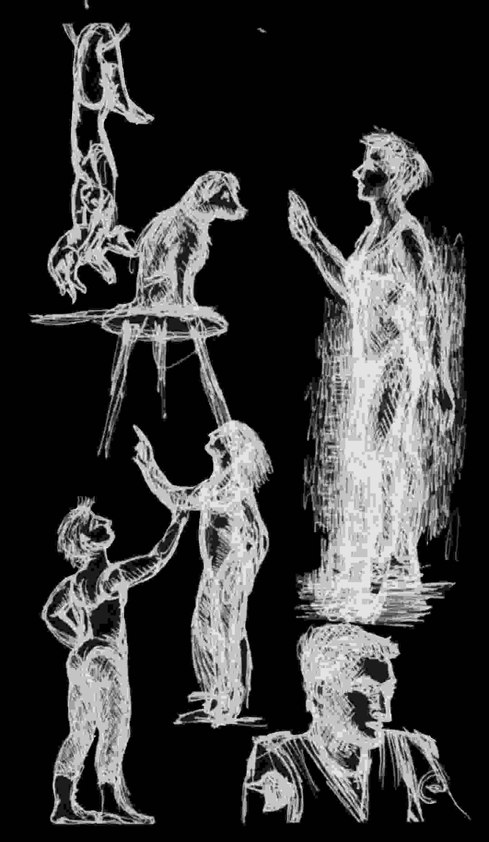
Selections from...
June 24, 1991
Freedom to Write Committee
Dear FTWC:
Re. Mumia Abu-Jamal: I'm enclosing a copy of my letter (5/25/90) to Governor Casey. The Philadelphia Police Department has made mistakes before in dealing with dissident journalism (ie. See Rips, Un-American Activities, p. 108). There is documentation that black dissidents were targeted by COINTELPRO in Philadelphia and that arrests were used as a tactical weapon rather than in response to crimes (See War at Home, by Brian Glick, p. 78). Nationally, framing of civil rights workers was an established tactic (for example, Ben Chavis: see War at Home, p. 24). I think most dissident writers would agree that if Jamal were found anywhere near the scene of a crime, he'd be charged with it.
My own experience is that illegal police and undercover retaliation was/remains a real threat to freedom of expression (See Dissident Accounts, by me, pp 54-60. This account of police retaliation and false arrest, as a result of reporting NY police brutality, was partly substantiated with the release under the Handschu decision of my NYPD secret police file from one day of peace activities during Vietnam: 27 pages in an attempt to implicate me in actions I was covering as a journalist).
In The Nation article of April 23,1990, a number of points raise reasonable doubt about Jamal's arrest, trial, conviction, and sentence, and I urge a very strong letter from FTWC to Governor Casey asking for clemency, in line with [staff's] "Recommendation for Action."
Black American journalists show exceptional faith in law enforcement, by going on record with dissident view, when America's most articulate Blacks have been murdered, imprisoned, forced from the country, etc.. Any journalism shares information with the police as well as the rest of the community. The fatal shooting of an officer was apparently both unintended and unpremeditated. Would these points give the Governor additional grounds for clemency ? Could the Legal Defence Fund present a case to the Human Rights Commission of the UN, or try to apply the Genocide Convention within our own court system?
When less than famous American writers are severely damaged, FTWC has provided no firm and aggressive back-up. It should. Jamal's case should have been an active concern of the Committee since 1981. The Committee has not had the resources for back-up and support, inquiry and follow up, for hundreds of possible cases. And FTWC is not going to be informed or be a recourse for most American writers, if it doesn't expand its resources. I've suggested this for over ten years.
Since I often criticize our society's treatment of its writers, I thought to include some positive examples of freedom of expression here in the US, and so enclose samples of Editions Gerald & Maas press posters/leaflets from Maine during the Gulf crisis as well as letters to the Writers Union newsletter and local newspaper (serving Kennebunkport as well). On the other hand my most recently published short story appears in Paris.

le 15 fevrier, 1992
PEN Club francais, Paris, France
Chers Amis
Considerons: dans Informations je ne trouve pas, meme sous "Rapport du Comite des ecrivains en Prison," un nom, un mot, des ecrivains de la France, l'Angleterre, l'Irlande, les États-Unis ou Canada, en detresse a cause de leurs ecrits et passion pour liberte. Est-ce-que Îa veut dire que tels ecrivains n'existent plus ? Ou est-ce que notres gouvernements sont tout a coup, justes et les vraies democraties ? Les peuples d'Iraq, est-ce qu'ils les trouvent justes? Est-ce que leures femmes et leurs enfants continuent . suivre les soldats prisonniers . une silence impos' d'abord par 141,921 tonnes des bombes nordicistes et par les niveleuses ? Est-ce qu'il n'y a personne parmi les 'crivains bienconnus, qui peut protester le crime de Génocide quand tant de gouvernements l'ont effectue? Sur deux cotes de l'Atlantique, l'epee, a-t-il coupe la plume ?
Comme membre de PEN American Center et membre associe du P.E.N. Club francais, je paye tous les deux, et c'est trop, surtout si on ne trouve pas des differences. A l'avenir, pourriez-vous regler ma cotisation ?
April 11, 1992
An Open Letter to the *** College Association (distributed to the Faculty)⁽²⁾
My own experience at other colleges is that faculty members interested in tenure are not entirely free to speak with conscience without encouraging their own replacement by someone more oppressed and so less vocal. In this way the academic community teaches silence. So the freedom of being a recent temporary part-time faculty member, carries some responsibility to note the obvious.
I was able to attend a portion of our meeting April 8th. The racial composition of attenders was by appearance, fifty white faculty members and only one faculty member from a minority group (black, brown, Asian, American Indian). If this reflects the racial balance of the *** Faculty as a whole, I am ashamed, because it isn't fair. I question any organization devoted to education, that invites us to accede to such an obvious imbalance of races and cultural perspectives. The representation in numbers of woman faculty members is much better than the norm, so one can say that at ***, there is apparently equal opportunity for women if they are white.
It might be to my self-interest, as a white anglo-saxon protestant male, to say nothing. I stake no exclusive claim on morality. I am not challenging the intellectual integrity of individual faculty. But I am questioning the common decency of the group, and in this instance an urban college faculty which is apparently almost entirely white. Because it suggests that in practice, the faculty seems to have defined itself racially, as almost exclusively white, and so is partaking in racial and cultural warfare at odds with the purposes of education.
No matter how diverse the views of white faculty members are, the views become a privilege, and a privilege acquired by the exclusion of in this instance, darker peoples. When diverse views become the privilege of a racially defined group, they are no longer an inherent right of the people. With an all white faculty, even when gentled by tokenism, education gradually becomes white cultural programming. The most serious challenges to the dominant culture become muted or are never made. Without serious intellectual challenges, the quality of education deteriorates to become training and propaganda, which conditions trainees to accept the unacceptable, whether it is the slaughter on the road to Basra, or another criminal war against third world peoples, the hypocrisy of doctors who charge exorbitant fees to attend to suffering, the endless list of injustices in American society.
Hiring by racially defined quotas does not really solve the problem, since other academic criteria can be applied to hiring which demand accession to white supremacist education. And by demanding that each person define self racially, even the census asks us to see ourselves not by what binds us together but by what differentiates us racially and to political advantage. Racial balance speaks for the justice inherent in each faculty, and remains a measure of each college's commitment to humanity. How much shame will *** teachers accept ? Possibly minority group part-time faculty members will be hired, guarding the power among tenured white faculty members. As temporary as my moment here is, I urge the *** Faculty Association to consider the following as *** reshapes its future:
1. Strengthen *** as an international American college, with course offerings, programs, departments, that will have an international appeal, particularly to third world countries.
2. Encourage the presence of visiting faculty from any nation that might be bombed into the stone age by the US or the new world order.
3.Individually, insist on the hiring of Black, Asian and Hispanic Americans, as part-time and tenure line faculty.
4. Since these might be initially represented among part-time faculty, allow part-time faculty equal voting powers in hiring procedures.
5. Encourage the employment of diverse writers, artists, and political leaders who most directly challenge the white cultural norms.
6. Provide programs in and certification for midwives, physicians' assistants, and other job classifications needed in "underdeveloped" countries and areas of poverty within our own, if these are not already available in your nursing programs.
7. Take the *** Faculty Association into the strongest union that will accept it.
8. Insist on full representation of minority groups in the college administration.
9. Increase the number of faculty who teach from successful experience in their fields. This will open the college to perspectives not offered within the closed circuit of white university education and employment.
10. Offer and integrate into existing curriculums, courses which specifically address the Holocaust, genocide, white supremacy, racial purity, nordicism, nazism, fascism, the arrogance of power, and crimes against humanity, drugs as a means of political control, etc..
11. Provide inexpensive continuing group medical insurance to all faculty members, even when they are no longer employed by ***, in order to draw the best part-time faculty ....

July 23, 1993
Letter to the Maine Public Utilities Commission:
I think both the Public Utilities Commission and Central Maine Power Company understand that safe electricity means lower rates in the long run.
With increasing scientific focus on possible effects of Electric Magnetic Fields, as studies expand, more evidence is suggesting a possible cancer causative risk of prolonged low level EMF. If and when the evidence becomes conclusive, it may place a terrible economic burden on the power companies, in correcting present facilities, and in health-related claims. The expenses would probably be passed along to the consumer as rate increases.
Recognizing possible health hazards, some enlightened power companies are already seeking new technology to lower EMF. But since the focus of scientific attention on this area is relatively recent, it stands to reason that the longer one waits to implement Maine's electrical grid, the more safe and less expensive it will be.
I am enclosing for your library the copies of two recent Swedish studies sent to me, which may help your consideration of Electric Magnetic Field risks to the people of Maine. As I understand, you have the 1990 workshop review draft evaluating EMF, that is available for comment from the EPA [US Environmental Protection Agency].
The first Swedish study brought out by their National Institute of Occupational Health, 1992, Occupational exposure to electromagnetic fields in relation to leukaemia and brain tumours, a case-control study, raises concern for electrical workers. This is surely a concern to CMP. Concern for workers naturally extends to residences in proximity to the lines where exposure is prolonged.
The second Swedish study, Magnetic fields and cancer in people residing near Swedish high voltage power lines (Institutet for miljomedicin report of June 1992), produced under contract for the Swedish electrical power industry and government, suggests a causative relationship between EMF and leukaemia in children. The study correlates people living within 300 metres of 220 kV and 400 kV lines in Sweden with all cases of cancer in Sweden from 1960-85.
These are simply two among hundreds of studies of possible effects of EMF on incidence of leukaemia, brain tumours and other cancers, as well as on cellular life itself. Correlation between EMF and many other types of illnesses have yet to be studied but I think precedent is established that there may be a causal link between EMF exposure as measured from the rate of 2 milligauss up, and cancer (particularly leukaemia in children). I urge you to consider carefully both studies, for their impact on both electrical workers and abutters of proposed transmission and distribution lines, and for possible consequences that would affect consumer price rates. As a York County abutter to a CMP right of way, I am particularly concerned that in my area, Moody-Wells, a right of way runs through and alongside medium density residential areas: York County: Moody-Wells; CMP option for 115 kV line on 100 foot wide right of ways between Captain Thomas Road (in Ogunquit) and Edgewood Road, according to the York County Coast Star, 6/16/93, "CMP power line routed the 21 mile distance."
Population density of this area has increased dramatically since the right of ways were obtained. Proximity to beaches suggests this area will be increasingly used for residences, rentals, tourism: people. It is accessible to Town sewage and water, through natural extensions of present Town services.
The State of Maine and Central Maine Power are in a fortunate position, in that the option may still exist in Maine to provide a reasonably safe electrical environment. Maine does not have the degree of established population densities of more industrially developed or thickly settled States,

where the electrical grids were laid out before contemporary findings were available.
With any substantive chance of EMF causing cancer, new high voltage lines through or alongside residential areas might be reconsidered. I think information on possible hazards should be made known to utility workers and all the people. Electric development might be delayed until new technologies can assure minimal or no EMF in line cable design and configuration, until provable need can pay for the expense of developing a surely safe technology and until present lines and substations have been considered in light of emerging data on cancer causative risk due to relatively low EMF fields from power lines, stations, equipment, techniques of repair, and office and household equipment. New transmission lines through and alongside residential areas might simply increase current EMF exposure. How can there be any "acceptable risk", when the risk is one of terminal illness, when it involves children, and when there is a choice?

A Letter to PEN listserv, March 2, 1997 13:02 PM
"Some Thoughts on Freedom of Expression"
"This old anvil laughs at many hammers..." Carl Sandburg
As a US writer for thirty years and american for enough generations to feel at home in the States, I see freedom of expression existing only within clearly defined parameters. Currently, I write in Ottawa.
I'd like to share some thought on the freedom of expression our American Center champions so well at points or at least so famously. I joined in 1977, not for the parties but because I was being beaten up at random in New England by para-military goons, despite my nonviolence. After I joined PEN the beatings stopped. I now pay dues to PEN organizations in three countries: the US, Canada, and France.
In the Eighties, American Center's limitations as a recourse for US writers in distress were clear. I put in four or five years working actively with the Freedom to Write Committee ('78-'83). I tried to encourage mechanisms of recourse but was not very effective. PEN's management, very successful writers, and sources of the organization's funding, seemed psychologically un-equipped to deal with the degree of oppression beyond inner circles of privilege. Attempts to extend American style freedom of expression to foreign countries relied on a coincidence with State Department policies and the covert machinery that still keeps what appears in print so consistently one-note.
The controlling ethic of what is "suitable" for publication, and what the public is allowed to understand, hasn't changed for thirty to forty years. Electronic communications are liberating, not only for information but the personal and human truths which mass-think tries to eradicate. For instance on this listserv posting I can consider what "freedom of expression" I have rather than what is allowed.
My early writing probably grew out of areas I couldn't talk about. Many years ago, in 1960, and partly in response to the Sharpesville massacre, I quit Harvard and went to work at Dr. Schweitzer's Hospital, where I learned Gabon was about to win Independence and the French military and law was going and gone. Through Schweitzer's good concern I moved from working with the lepers to delivering leprosy medications to an area where Europeans weren't usually allowed ("unrest") and then to teaching school at an isolated Missions post by the borders. In the country across the border ninety Europeans had recently been killed. On my side of the border there were no other Americans and a few European missionaries. The mother of my first child and the local independence leader among other native people looked after me until malaria knocked me out and I went back to Harvard. I wrote fiction about a world I couldn't share the facts of since African friends continued to protect those left which included European staff at Schweitzer's. Currently, the other grandfather of grandchildren there is the country's President and the country sits on a large oil reserve.
As a writer my experience includes about a hundred publications, some recognition as a short story writer, four false arrests, death threats by police, an NYPD secret police surveillance file, surveillance, denial of employment, hard labour to feed my family, stretches at City College, Harvard, and Bennington, an FBI record hidden from me until I tried to move to Canada, surprise assaults, mail problems, and when I come in contact with US intelligence services, a "Move to the back of the bus." It's easy for me to pinpoint when my freedom of expression began to be overtly suppressed rather than "guided" as it was through prep school and Harvard. In 1965 I went to Alabama as a recently published Viking novelist (a novel set in Africa), to freelance an article on the Selma to Montgomery march. Denied press credentials by Alabama police, I was selected by Dr. King's people as a movement march marshal/body shield. I did that well. I was also a reserve medic, not on duty which was a weekend a month usually at the Newark City Hospital emergency room. After the march five of us were falsely charged with stealing a newspaper, driven around the countryside in handcuffs, made to listen to the orders given state and county police officers to shoot to kill any of us seen in that county again, imprisoned for five days, beaten, etc.. I was threatened with twenty years imprisonment for my writings - "Anarchy against the State" or some police-imagined weirdness, and the FBI got all my notes for the article. Freedom of expression ? No. I wrote what the prison stay was like for The New York Review of Books. What was strange though was there was no cause for the threat. There was no cause for any hassle except as retribution for being there. The FBI laughed off our reports of death threats. There was never redress. There was never opportunity for redress. Alabama never withdrew its death threat and never apologized. It was later proved that Mississippi police were guilty of violating civil rights by murder of Schwerner Goodman and Cheney nine months before, and that an FBI operative participated in the murder of Viola Liuzzo.
Aware early that police are often made the tools of politics, I reported police brutality at an anti-war rally, in The Village Voice. At the next rally I tried to cover, police brutality was criminal. Afterward I was falsely arrested for "obstructing traffic" while walking down the sidewalk with a friend, and placed briefly in "The Tombs." I couldn't write the article for years. I did tell a D.A.. No there wasn't any redress. My lawyer said if we sued the City they would slap drugs on me and put me away. No I didn't have a press card which required clearance through the police, which is one reason more successful journalists didn't report police brutality. A lawyer friend at Louis Nizer's said sorry they were representing the Patrolmen's Benevolent Association. The arrest is not mentioned in a NYPD secret police surveillance report mailed to me some twenty years later thanks to the Handschu decision. It did not mention Abbie Hoffman whom I knew a bit and interviewed at the rally, but me amid group after group I never heard of, supposedly Communist organizations bent on violence.There was no way to answer twenty years later. Freedom of expression?
Not really.
Then to skip about thirty years in 1994 I was about to move to Canada with my family. Currently, this requires FBI clearance. My wife and kids were cleared to leave. I wasn't. After years of FOIA requests and responses denying they had any information, the FBI came up with an arrest record: a single petty larceny charge from 1965 in Montgomery Alabama, no disposition noted. This kept us sitting for six months, unemployed in Maine, while I was turned in to Alabama police, before the FBI admitted to the Canadian government that I hadn't been convicted as a petty thief and let me leave. Freedom of movement? Well yes, if no one wants to settle old scores.
While this is documentable material, it's a scratch on the surface of the kind of hassles which occur once one is targeted. Careful of laws, I found that government infrastructure and those who have to please it, get even with those who assert their rights. My experience is that if one insists on writing about what are in fact human rights violations in the US, one is shut out or made to pay.
Sensing a need for it in the late Eighties I found "The Convention on the Prevention and Punishment of the Crime of Genocide" out of print at the UN, and with permission published the Convention and related treaties with our small press in Maine. It was 1989, shortly before the Gulf War and the work was received badly; our ads in several papers were blanked out; our small press very nearly went out of business. The UN eventually re-published its edition of the Convention.
With research I learned that the US ratified the Convention in 1988 after a forty year delay but with specific "reservations" which allowed the Convention to be applied to the US only as the US government chooses. The Netherlands for example considers the US outside the treaty. This was news not covered in the press, and for several years my efforts to publish relevant articles were ignored.
I was able to bring out the Genocide Convention with other UN treaties, as well as any reservations by North American countries, here in Ottawa where Canadians have their own difficulties not only with Francophone Separatism but the rights of First Peoples. For those of you with web access I recommend the work as necessary information, and available to read without charge at [currently] http://www.nightslantern.ca/community.htm, under Common Rights and Expectations.
Of particular relevance to writers:
Article 19 of the "Universal Declaration of Human Rights," states:
"Everyone has the right of freedom of opinion and expression; this right includes freedom to hold opinions without interference and to seek, receive and impart information and ideas through any media and regardless of frontiers."
"The International Covenant on Civil and Political Rights" which became effective in 1976, signed by the US in 1977, and ratified by the US with reservations in 1992, states in Article 19:
"1. Everyone shall have the right to hold opinions without interference.
"2. Everyone shall have the right to freedom of expression; this right shall include freedom to seek, receive and impart information and ideas of all kinds, regardless of frontiers, either orally, in writing or in print, in the form of art, or through any other media of his choice.
"3. The exercise of the rights provided for in paragraph 2 of this article carries with it special duties and responsibilities. It may therefore be subject to certain restrictions, but these shall only be such as are provided for by law and are necessary:
a. For respect of the rights and reputations of others;
b. For protection of national security or of public order ("ordre public"), or of public health or morals."
It states in Article 20:
"1. Any propaganda for war shall be prohibited by law.
"2. Any advocacy of national, racial or religious hatred that constitutes incitement to discrimination, hostility or violence shall be prohibited by law."
Though reminiscent of principles stated in the US Constitution and PEN's International Charter, the Covenant extends any domestic protections to freedom of expression, through Article 5:
"1. Nothing in the Present Covenant may be interpreted as implying for any State, group or person any right to engage in any activity or perform any act aimed at the destruction of any of the rights and freedoms recognized herein or at their limitation to a greater extent than is provided for in the present Covenant.
"2. There shall be no restrictions upon or derogation from any of the fundamental human rights recognized or existing in any State Party to the present Covenant pursuant to law, conventions, regulations or custom on the pretext that the present Covenant does not recognize such rights or that it recognizes them to a lesser extent."
Among other things to note here: within the context of international law, American Center's changes in by-laws which deprive general membership the freedom to change PEN by direct vote, are unwise. PEN may want to assure general membership a strong participatory voice, among other evidence of the organization's care for rights, unless it will be only a force of suppression.

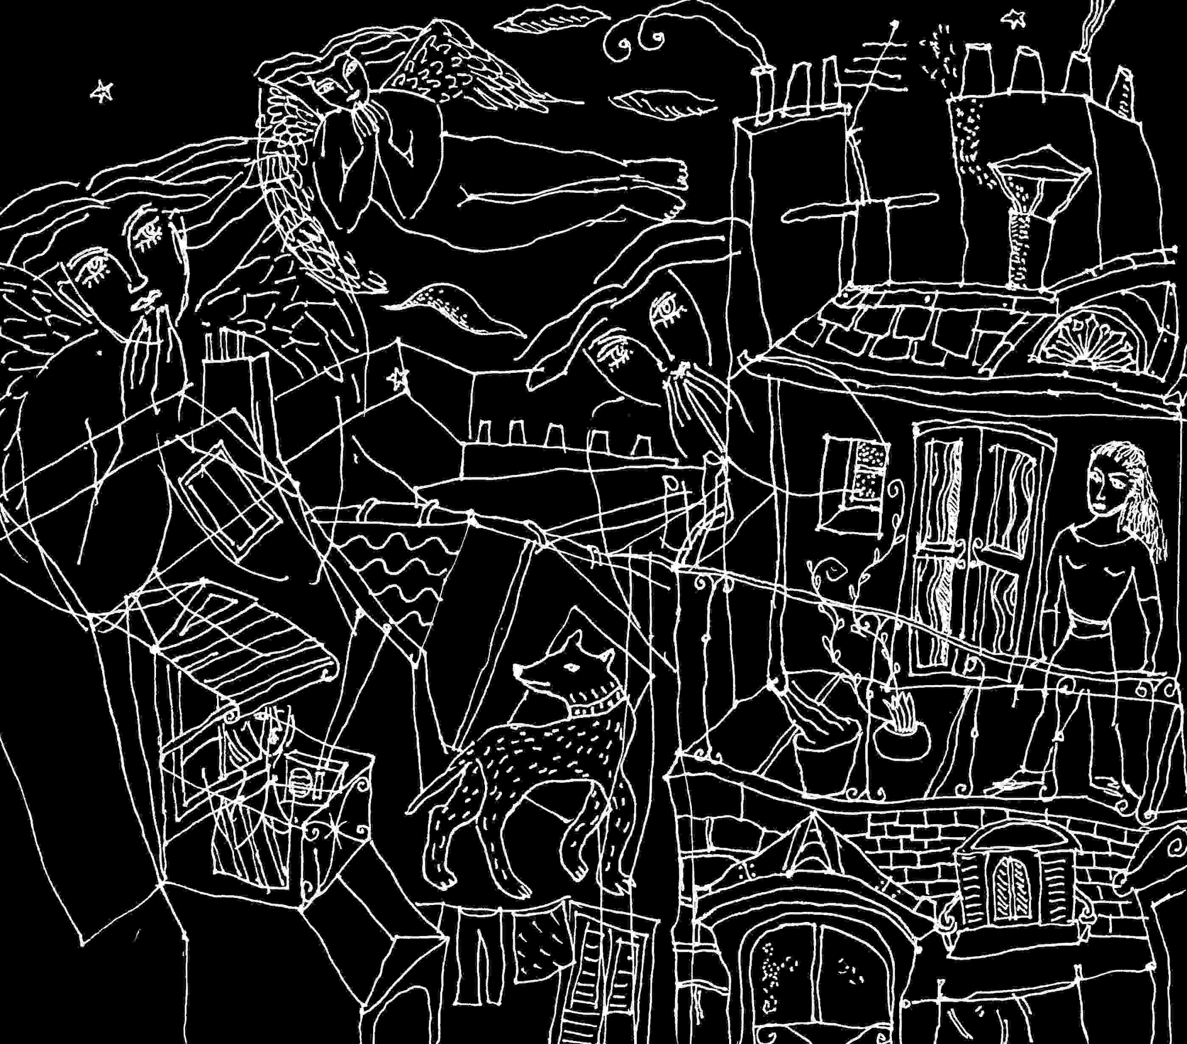
An Essay against Genocide,
or Why the Convention on Genocide Hasn't Worked
The Convention on Genocide⁽³⁾
To prevent the worst crimes, a set of principles was made law, to restrain leaders and those that serve them, and each of the people, from the worst crime by the stronger against the weaker. The Convention on the Prevention and Punishment of the Crime of Genocide, was adopted unanimously by the General Assembly of the United Nations on December 9, 1948, signed by the United States November 12, 1948, and ratified by the United States on November 23, 1988. With the Convention theoretically applicable in US Courts, Americans become liable to "complicity" under international law, although US "Reservations" and "Understandings" at ratification make it as difficult as possible to apply the Convention to the US government.
The "Convention on Genocide" clearly states that genocide is "a crime under international law," and that the signing nations will prevent and punish it (Article I).
Article II defines genocide as "any of the following acts committed with intent to destroy, in whole or in part, a national, ethnical (sic.), racial or religious group, as such: a: Killing members of the group; b. Causing serious bodily or mental harm to members of the group; c. Deliberately inflicting on the group conditions of life calculated to bring about its physical destruction in whole or in part; d. Imposing measures intended to prevent births within the group; e. Forcibly transferring children of the group to another group."
Article III lists acts which are punishable: "a. Genocide; b. Conspiracy to commit genocide; c. Direct and public incitement to commit genocide; d. Attempt to commit genocide; e. Complicity in genocide."
Article IV specifies: "Persons committing genocide or any of the other acts enumerated in Article 3 shall be punished whether they are constitutionally responsible rulers, public officials or private individuals."
Articles V requires each signing nation to put the Convention into effect within its own legal system. Article VI states the crime will be tried where it was committed or by an international tribunal acceded to by nations party to the Convention, who accept its jurisdiction.
Reservations and Understandings⁽⁴⁾
Of the specific "Reservations" and "Understandings" which the United States made when ratifying the Convention, each accommodates the US refusal (except where it wishes) to cede authority to the International Court of Justice, despite the fact that the International Court of Justice is the legal court of the United Nations.
The first US reservation states that any case "to which the United States is a party," cannot be submitted to the International Court without specific US consent. The second reservation insists: "Nothing in the Convention requires or authorizes legislation or other action by the United States of America prohibited by the Constitution of the United States as interpreted by the United States." The United States reserves the right to decide whether, when and how, the "Convention on Genocide" can be applied to itself. ⁽⁵⁾
The difficulty with a country placing itself beyond or above international law is that eventually a community of nations asserts a more valid sense of justice, economically, militarily, and eventually through law. When the US breaks international law (ie. the mining of Nicaraguan harbours) subsequent submission to the International Court of Justice becomes more difficult. Until the US with all other nations accepts the International Court of Justice or its successors, as a judicial power beyond its own self interest as a nation, there will be little chance for a just world peace.
When the US government claims to be beyond the reach of a world court, this directly affects the "Convention on Genocide" and other covenants of human rights law where the US position makes specific reservations to allow for the death penalty within the US, or to allow the incapacitation of prisoners, which international human rights treaties forbid⁽⁶⁾ . US government reservations to the "Convention on Genocide" similarly suggest that someone has thought very carefully about how the Convention might limit foreign policy options. The "Reservations" provide loopholes which seem made for actions like the Gulf War.
A number of other governments have also made reservations which limit the Convention's applicability to themselves, while recognizing that international law seems to fall to the interpretation of European-US interests. A number of US allies (ie. Australia, Belgium, Brazil) have concurred with US reservations but not with those of possible adversaries, and in a sense the Convention becomes an international political football. However Denmark, Finland, Greece protest the US reservation #2 as invalid under precepts of international law. Greece also cannot accept the first US reservation. Ireland will not accept the second. Italy accepts neither. Mexico accepts neither. Because of the US reservations the Netherlands states that it doesn't consider the US a party to the Convention.
Norway finds the second reservation contrary to principles of international law. Spain expects the US government to maintain the original provisions of the Convention, anyway. Sweden objects to the US second reservation. The United Kingdom does not accept the first US reservation and objects to the second. In short, the reservations are considered by many nations as abrogations of the US commitment to the Convention.
Although one nation might make abrogations to a treaty, a court of humanity might not find them legally acceptable. In signing the Genocide Convention, the US cannot be both the signee and ultimate judge of the law's applicability.
Common sense would suggest that the objection by the Netherlands is correct. The Statute of the Permanent Court of Justice (1945) claims within its jurisdiction "all matters specially provided for in the Charter of the United Nations or in treaties or Conventions in force" (Article 36.1.). Article 36.6 states: "In the event of a dispute as to whether the Court has jurisdiction, the matter shall be settled by the decision of the Court." There simply is no other world court to decide except possibly victors' courts set up by the US as it extends attempts at world domination. The other objecting nations are simply affirming the right and necessity of the International Court of Justice as the interpreter of international treaties. By refusing to submit to the International Court of Justice's possible interpretation of the "Convention on Genocide" the United States is in effect, denying its own participation.
So a tension is created, where the US government must rely ultimately on force, its military advantage within a world entirely concerned with economic advantage, while any just world peace is only possible if the United States as well submits to a higher court.
People's Law
Principles of communism tried to show humankind that all the workers' interests are essentially the same. An elite cannot control a united people, and it was the controllers job to divide and set people against each other, to make history as it has always shown itself to be - the cycle of victor and vanquished. Most historical injustices are mechanisms of dividing peoples so the rulers can control them. Opposing leaders have more in common with each other than either has with the people.
For the liberation of humankind from cycles of victor/victim which cause continual suffering, a people's ethic has evolved where portions of humankind place some limits on themselves. Yet most laws and their application are made and enforced to establish or maintain the power of a ruling elite. Under capitalism, laws protecting the people's interests become limited by economic interests of those with power.
Beyond the uses of the laws by the political system there are still laws, deep and sure in each person, each parent, child, worker, soldier, and prisoner as well. All have codes of what is acceptable and not. Some human behaviour is unwise in any instance, and so there become human laws which are stronger than legal systems because they represent the shared experience of humanity rather than laws protecting property or privilege. Beyond legal systems, class, race, and the demands of faith, there remain tenets of common decency. The body of laws which most accurately represents the needs of people are human rights laws. But the application of any civil or human rights law remains a political issue, often enforced as a control only when convenient.
After the glut of bloodshed at the end of World War II, with the founding of the United Nations and need for world peace, the Convention against Genocide became the primary human rights prohibition, not an affirmation as "the Universal Declaration of Human Rights" is, but a treaty with provision of recourse and judgement of punishment for any transgressor. Because the treaty should protect the vulnerable against the powerful, and placed limits on what the powerful could do with any group of the people, it became a threat to kinds of pragmatism which power contemplates and the people realize late. By the rejection of Nazi Germany's liquidations of peoples, by recognizing that all laws of human decency were broken, the political and legal recognition of genocide as criminality was a victory for all peoples, affirming human rights as opposed to any government's or ruling power's.
Preventive Law
The strongest resistance to genocide may in fact be the matrix of a true democracy, and within it compassionate cultures with literary and artistic traditions that question everything yet insist on humanity. But political stability alone risks the effect of genocide by economic deprivation of minorities.
Countering genocidal policies is difficult within "controlled democracies. "There is no guarantee that the majority of people within a semi-democracy won't agree to commit genocide, or countenance it by the uses of their military. This is one reason the Convention against Genocide is necessary as a preventive and applicable law.
The most effective political resistance to genocide is preventive, providing a strong code which precedes and supersedes all other laws, and policies. ie. primary law, which the Convention against Genocide is. Once recognized and established as primary law, then all other laws and treaties would occur within its perspective.
The Convention against Genocide does supersede the legal systems of all countries because the legal systems may function whether a genocide occurs or not. With the rise of Nazism in Germany the legal system prepared for genocide by enforcing new laws which specifically deprived Jews of property, ability to function in partnerships with Aryans, etc.. Even in "democracies" laws risk being selectively applied. When the legal system goes awry, as US law has in allowing the death penalty, it is finally answerable to humanity at large.
Despite the rather isolated US "Reservations" with their "Understandings" at ratification which limit its applicability within the US, internationally the Convention applies to individual citizens regardless of position or empowerment. The US government cannot under the treaty, legally prevent the prosecution abroad of any US citizen for the crime of genocide, while US "Reservations" abrogate the Convention by giving grounds for legal defence within the US to those engaged in genocidal policies.
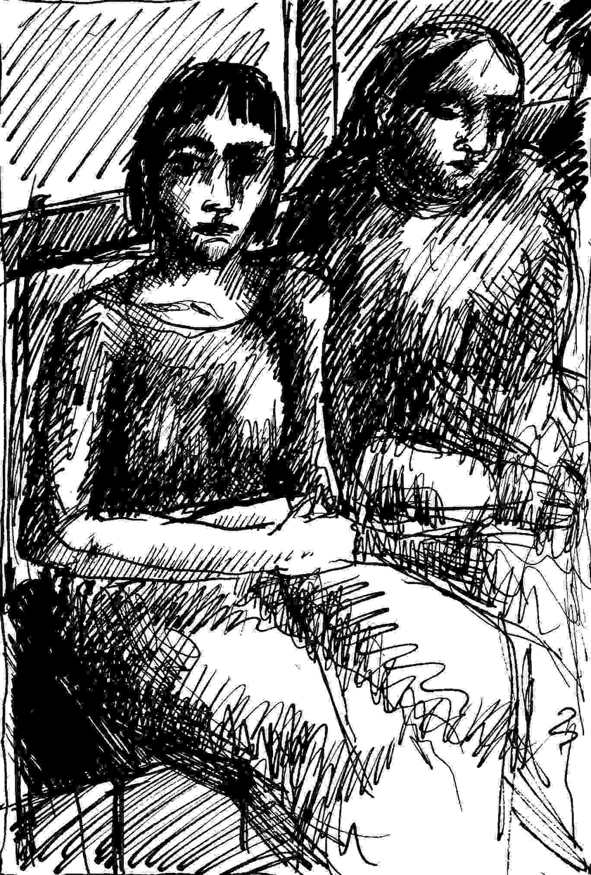
In other words, within the US citizens are discouraged from concern yet under international law are liable. Domestically individuals are denied any way to affect this issue in international court. The Convention against Genocide is a treaty between governments. So the citizen is vulnerable to paying for his/her government's policies beyond US domains of power and influence. Genocidal policies by government put future generations of Americans at risk of retribution. If the US does not maintain its controls internationally which apparently require oppression, then US citizens can be made accountable. In this way crimes by government perpetuate a cycle of injustice implicating every citizen. Still the Convention's prohibition of complicity provides moral and political support and possibly legal grounds to insist on what our consciences know.
Like other human rights laws which are heavily violated, the Convention may fall in and out of international judicial favour. And whether it is applicable or not within any judicial system, by applying to the individual's responsibility, it has both legal and prohibitive effect. If transgressed, it is one of the few laws that can bring down an administration or a government simply through assertion of the people's rights.
World Court
If the world court truly represented all nations, all peoples, and economic classes, the US and other super powers would have to submit to it. In as much as a world power commits what humanity considers crimes, that power will have to control the world court or refuse its jurisdiction, denying all peoples justice. There is the choice of two futures for the world court. Either there will be representative justice, impartially applied, or international law and institutions of "the new world order" will shield the enslavement and controls of the powerless and poor.
At present, the world court offers little defence against genocides, because these have taken place with the cooperation of the most powerful countries who established the Convention and control application of the law. Examples: US acquiescence and military support to Indonesia's takeover of East Timor involving the eradication of as many as 200,000 people by 1994; the Gulf War, involving the tactical destruction of Iraq's civilian infra-structure by the US and Coalition, and their invasion of and massive bombing of a sovereign nation which had an arguable case under international law.
Structural Impediments to Recognizing Genocide
Nations weren't forced to sign the Convention against Genocide, or to ratify it. Most have, because the treaty affirms the intention of a government to work within principles of law that protect entire groups of humanity at their moments of vulnerability. By applying to everyone it extends a legal responsibility for this concern to the individual.
The individual's human responsibility, is to try to counter genocide when it occurs, and in all instances the individual is legally bound to not cooperate. But for most Americans in 1994 the primary difficulty in opposing genocide is not the military or police controls of dissidence, but the recognition of a situation as genocidal.
One of the difficulties in raising consciousness about current forms of genocide, is that crimes by government are protected by the establishment of elites who become bonded by their risk of eventual prosecution.
In the 1960's, the assassinations of two Kennedys, King and Malcolm X, allowed genocidal policies to occur or continue. Because the assassinated leaders were messengers of inclusion, as opposed to the exclusions from human rights which lead to genocides, American defences against genocide were damaged. Assassination of leaders whose promises innately countered genocide, suggest there was and remains in the US policy management which doesn't mind genocide at all. Ratification of the Convention itself took forty years. Even at Ratification, US "Reservations" and "Understandings" allow continuation of genocides as tactical foreign and covert policy. During World War II, Roosevelt made clear to the American Jewish community that saving European Jewry was not a primary war aim. Following World War II acceptance within US intelligence, military and scientific communities, of former Nazis and collaborators, the access to upper levels of NATO by former Nazis, the political usefulness of the Nazis' hatred for communism, helped shift the US and European perspective of what is acceptable thinking to acceptance of genocidal policies within defence, nuclear, and scientific communities (and so within universities and research and business communities). So that the awareness of genocide as an aspect of any domestic or foreign policy was left to others.
Examples of genocide within US history are common enough not to be considered remarkable or even genocide. Among historic crimes which are not commonly called genocide: the destruction of North American Indian peoples, the liquidation of six million Brazilian Indians through the policies of multi-national corporations, effects of US economic and military policies on the poor throughout the Americas, the Euro-American slave trade and subsequent treatment of black Americans, and the fate of the American poor. An argument can be put forward that President Truman's decision to use the atomic bomb twice on Japan, or the effect of defoliation on Vietnam was genocidal.
Another difficulty: genocide is usually committed against poor people and those without legal representation, or against a minority group which becomes the object of the majority's attacks. In this sense democracy fails if it defaults on international laws. The will of the majority within a region is not always right, or legal, which is one reason for the necessity of an effective law to prevent genocide. Civil rights laws provide some protection domestically but do not extend to foreign policy consideration of non-Americans.
Another difficulty is that US foreign policy seems based on the perpetuation of genocide. The elders of each generation guilty of genocide, involve the next generation in genocide so that those still unscarred by war and horror, will not become sudden moralists and put their elders in jail. This may be why wars recur every twenty years. Former Nazis in the physics lab would not have been as easily tolerated by the postwar generation of Americans were it not for Vietnam, a war that escaped its own genocidal aspect only in the daily press. Policy makers of the Vietnam war, with their policies mired in deceits such as the Gulf Of Tonkin Resolution, may have been inclined to approve a criminal war, to cover their decisions with fresh blood in the Gulf. This may be a tacit fulcrum of contemporary military thinking.
The first obstacle to raising the issue of genocide within the United States is that the Congress, though it ratified the Genocide Convention in 1988, has not set up the means to effect it judicially within the United States, as provided for by Article V of the Convention. When the Nuremberg defence has been raised by radical pacifists such as the Plowshares groups in the United States, judges have usually refused to allow any appeal to conscience which touches on the issue of preventing greater crimes.
Whenever the word "genocide" becomes a public issue, it is co-opted by the government to apply to the policies of a current "enemy", deflecting its intention. Unpursued claims of genocide against Iraqi leaders helped cover the damage to civilian populations by the devastating effects of US/Coalition bombing, and failed rebellions encouraged by the US President.
In summary, one reason for the lack of application of the Convention is that so many nations have historically participated in genocide, and continue to, calling it by other names, or looking the other way. It isn't likely that the Convention can be enforceable except against militarily or economically weak nations, and essentially those without protection from mightier governments, unless a number of nations can reach a consensus to allow at least action at the World Court. For now, hope for the Convention and its affirmation is in its principle, which can be insisted on until the various nations of the world bring their militaries and foreign policies within its perspective. The Convention's essential modern problem is that it provides no legal way for ordinary citizens or groups to bring their own governments to account at World Court. When the Convention against Genocide is applicable, when governments rule within its perspective and limitations, then there may be world peace with justice.
Contemporary Genocides
While principles of communism supported economic equalization, those of capitalism support economic warfare. Under capitalism, foreign policy supports the interests of the nation's dominant economic class.
Our economic system thrives on genocide. Corporate capitalism may simply be legitimized genocide by economic means. Because multi-national corporations often are the world economy, it is hard for governments seeking to be viable in the world market, to raise the issue of genocide at international law. How can one protest the destruction of entire cultures by economic imperialism when that was exactly the point of the colonialism which built Europe's wealth, and of the pax americana intended to sustain America's own. Those without ethics no longer sell beads to the Indians, but rockets and missiles to "underdeveloped countries," where the arms kill off as many poor people as possible.
Capitalism frequently involves the imposition of capital (the power of an elite) to "develop" which has meant to control and subjugate, the resources of less technologically advanced countries. What resulting indigenous poverty means and leads to is gradual eradication and loss of peoples.
There is little evidence that capitalism itself can present any resistance to genocide. If the Convention against Genocide were active as a criminal procedure it would for example, attack the denial of the right to do business, which is a people's right to survive economically, of countries in political or religious opposition. In 1994 consider US policies toward Libya and Cuba, as well as NAFTA's effects on the poor within the Americas. The concept of Western hegemony which does not claim to have the intention of genocide, has genocide as its effect. Whenever a policy expressing the will of the powerful with a racial and cultural bias, is enforced, its result is at least partly genocidal.
If US foreign policy were considered within the context and per-spective of the Convention against Genocide, if people were sensitized to the Convention, then genocides could be avoided. Certainly US policy makers are aware of the Convention since they have already parried its intent with the "Reservations", tactical manoeuvres to sustain policy while protecting themselves.
In order to have some idea as to their representation of the people's will and their legality, each foreign policy decision should be subjected to the Convention's prohibitions as if the US were not the most terrifyingly armed nation in the world, a status that may change.
Within the perspective of the Convention against Genocide, the US policy against Iraq and US/Coalition actions of the Gulf War were a continuing nightmare. An air war against a people with no appropriate air defences, and against troops who did not fight back ? The legality of the US position relied on its "Reservations" to the Convention, collusion, threatening and bribing other nations of the UN, and a familiar arrogance of power.
The military strategy of the war against Iraq involved a purposeful attempt to destroy the country's life support systems and the economy. Its goal was said to be "post-war leverage" and an attempt to make life so intolerable for the people that they would overthrow their leadership⁽⁷⁾.
Trying to destroy leadership by destroying a civilian population is genocide. If half a million to a million Iraqis die(d) directly, indirectly or from "Sanctions," as a result of the Gulf crisis, to possibly 125 deaths within American forces, then that was not warfare but a policy of extermination.
Simply, terrible amounts of weaponry were used against a people which could not defend itself. The US and its Coalition foresaw this having supplied Iraq with most of its armaments. As a crime it differs from previous genocides in that it is the first committed since the Convention against Genocide was ratified and genocide was accepted by the United States as a punishable crime at home.
Who would destroy a people and portions of an ancient civilization as punishment for a crime committed by their ruler ? The "civilized" world's ethic of how humanity must treat humanity was broken so severely that the normal fabric of resistance to unjust war was disassociated in both Europe and the United States. The language of peace became the language of violence, the LA riots, the "ethnic cleansings" in what was once Yugoslavia, the ambivalent forced feeding of Somalia crippled by cold war policies. After the Gulf War a Haiti became comprehensible, a Rwanda. The difficulty with historical crimes is that they are no longer "political" or even strictly legal issues. The subsequent rationalization of the Gulf war due to Iraq's chance for nuclear capabilities could be applied to almost any country in the world which challenges US and European economic policies. So the Gulf War was in a tactical sense, an international act of terrorism, helping to impose a psychological control on all countries. It was also a terrorization of the American people.
The departure from the norm in what happened in Iraq, is that genocide was apparently used as a conscious military tactic, was accomplished primarily and directly by the US, was/is of substantial proportions, and was engineered to make effective domestic and international legal protest impossible.
The American civilian population was so thoroughly messed up by the brutality of its leaders that the crimes of the war were entirely suppressed by the media. Because the Convention against Genocide was not even discussed as applicable to the US and Coalition's attempted destruction of a third world country, and because genocide is never an isolated act but rather a symptom of direction, there is no assurance that it won't happen again. In a US dominated "new world order" opposition to the crime of genocide committed by US government policy, relies increasingly on the people's ability to resist the unacceptable.
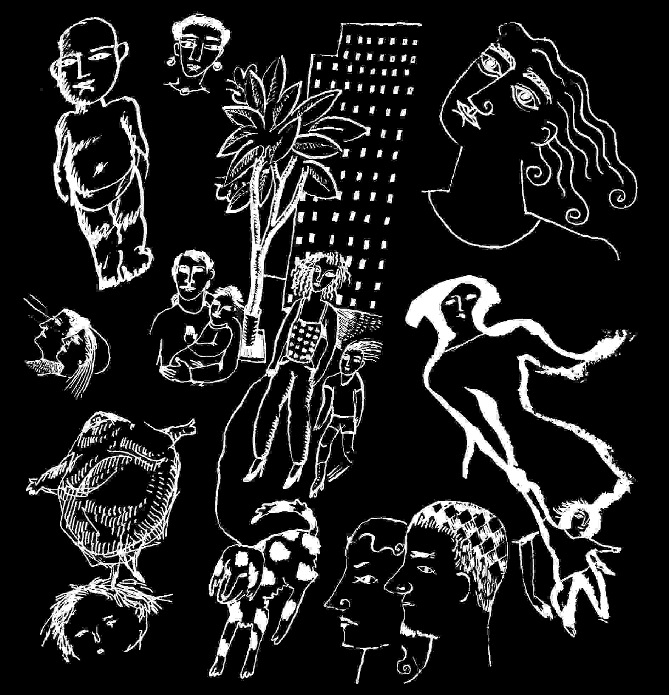
Strengthening the Convention
It would help to clarify, update, and strengthen the "Convention on Genocide" in four respects:
1. The Convention's definition of genocide might need expansion to include all groups specifically targeted by policies which lead to the destruction of any delineation of humanity. Groups formed by common gender, sexual preference, profession, political convictions, economic class, or sect within religions might be specifically included.
2. The Convention's applicability could extend more clearly to the economic policies of companies and nations, particularly when the effect of policy is to destroy existing cultures, to make them reliant on foreign products, or require military takeovers or incursions. Where profit motives with projected risk can be equated with the "intent to destroy" a people (Article 1), when governments or corporations with products such as nuclear energy endanger the people at large, they should be held accountable to the Convention.
3. Chemical, biological, or radiological warfares might be specifically included as innately genocidal. Each denies humanity by its inability to discern innocent from combatant, yet has the potential for destroying entire groups. In particular nuclear or radiological warfare involves the possible destruction of entire peoples, and the future. Without a strong Convention against Genocide a primary legal restraint to nuclear war is removed and the unacceptable becomes a tactical possibility.
4. Provisions might be made for the people to apply the Convention directly to their own leadership and policy makers.
Or possibly as it stands, the Convention encompasses these.

An Open Letter
This case is so filled with injustice that Mumia Abu Jamal has become victim, and to such psychological cruelty it terrorizes those who would attempt freedom of speech by writing their understanding of truth.
Portions of this letter were published in The PEN Newsletter #86, 1995, in "Reprieve Sought in Pennsylvania for Black Journalist Mumia Abu." My full letter appears here, with its faults, and includes portions of my own experiences with journalism because these provide some context for understanding the difficulties honest writers face when writing to the people about areas which embarrass law enforcement or government policy.
*
I'm against any imposition of a death penalty, as I am against killing, as I am against war, against death threats, against violence and the threat of violence and abuse and psychological abuse. I think it's abusive to American writers when the literary establishment champions Salmon Rushdie's offense to Islamic Law and ignores Mumia Abu-Jamal's death sentence under our own. It's likely that Abu-Jamal's death sentence as well, is the result of his words, though America doesn't always ban dissidents so overtly who die penniless on the streets of New York like Julia de Burgos, get shot in prison like George Jackson, are found with head blown off like Richard Brautigan, are said to commit suicide in Pennsylvania like Abbie Hoffman, join up with the system or are charged with murder like Mumia Abu-Jamal. I urge all our favorite authors, poets and editors, to extend the defense of Salmon Rushdie to American writers, specifically to Mumia Abu Jamal, and to encourage US lawmakers to reject the death penalty entirely. All it does is kill people.
Believing that Allah is compassionate but less so when funded by the CIA, I haven't been as worried about Salmon Rushdie as many of you. Though maybe you know something I don't. I surely affirm his freedom of expression and right to personal safety. But I think our writers and booksellers were poorly used when Viking/Penguin decided to flood the world market with Satanic Verses, despite Islamic law's predictable reaction. Resulting contempt for Islamic law and Islam harmed Islamic peoples in America, was partly responsible for the public's acceptance of the Gulf War, bombing of Muslim civilian populations and lethal continuing sanctions. Iraq didn't really fight the Gulf War, and to varying degrees the UN's Convention on Genocide was broken by the US and allies, or as Chomsky indicates of East Timor: a genocide, if the responsibility were anyone else's.
If our concern is freedom of expression rather than its propaganda value in faulting Islamic Law, why isn't Mumia Abu-Jamal a constant concern? The African-American journalist waits on death row in Pennsylvania.
The circumstances of his arrest and conviction (as presented by The Nation, 4/23/90) intimidate freedom of expression here in the US: a journalist who favored defendants on trial in the shooting death of a policeman, is subsequently almost killed, accused and convicted of shooting a policeman. The attempted murder of Abu-Jamal by police at his arrest was then covered over by charges against him. His trial, legal representation, the prosecution's tactics and evidence, raise obvious legal and ethical doubts. These doubts don't justify the killing of a policeman. They do deny the right of society to take a possibly innocent man's life in revenge. And if you've ever tried to write about crimes by law enforcement, you'll know that illegal retribution by police is a much deeper threat to freedom of expression than the usual silencing of a journalist through loss of his job.
I know the police have been used to silence dissidence. As a young freelance journalist / march marshall from Selma to Montgomery in times of intense police brutality against the civil rights movement, I was falsely arrested, under death threat from police, and threatened with a twenty year prison term for the contents of my journal. During early Vietnam I thought I could report police violence because I had a Harvard B.A., a novel published, had worked with Schweitzer, was a medical reservist one weekend a month in Jersey, and was teaching at City College. My first article reporting NYPD police brutality in The Village Voice, was followed by a false arrest at the next peace rally I tried to cover and a secret police file (I received a version in 1989 of 27 pages with only one reference to me). I was totally stopped from writing of a very ugly police-undercover-violent-action against peacefully assembled people. Without legal recourse, I forfeited my tenure year at City College and left town.
Of four false and arbitrary arrests I experienced, each 1. tried to silence me; 2. each got me back for trying to affirm human rights law; 3. each was an arbitrary false charge; 4. each invoked the threat of a more severe arbitrary charge; 5. each charge was ultimately dismissed in court; 6. in each, police used force for an unresisting (I believe in nonviolence) arrest, handcuffs, prison or detention; 7. each took away my freedom without compensation. So with my experiences as an American writer it would be wrong of me not to say obvious things about the case of Mumia Abu-Jamal.
In the police bombing of MOVE (with the resulting burning down of a low rent district), in the sentencing of MOVE members, in issues of police brutality against the community, the injustice and disregard for human rights scared everyone. Mumia Abu Jamal became a threat to authorities because he wasn't terrorized into silence. And he was reporting actions that thinking people consider crimes, both under American law, and under international laws which the government, the legal system and the media, usually suppress. ( * See subsequent note 1)
International laws are ignored by the national press when they counter government policies, until the politically expedient human damage is done. It is because of a very real oppression that human rights violations which the government is responsible for don't become known to the public for years. Five arbitrary (1994) examples: Robert Redford's "Incident at Oglala" (1991), gives testimony of death squads operating with government consent and support, on the Pine Ridge Reservation in the early and mid Seventies. US complicity in the El Mezote massacre (1981) El Salvador, became public knowledge after release of the UN Truth Commission Report in the 90's; repatriation of Haitian refugees breaks Article 33:1 of the UN Convention Relating to the Status of Refugees, yet the Convention remains ignored by the press; the press remains afraid to explore the issue of depleted uranium armor and shells in US tanks, which are a health hazard to American troops and technically weapons of "radiological warfare" (used in Iraq); in exchange for government funding, medical studies by the university/medical community in Boston/ Cambridge, without appropriate informed consent gave pregnant women, retarded children, and veterans radioactive materials internally. The news was not released for twenty to forty years.
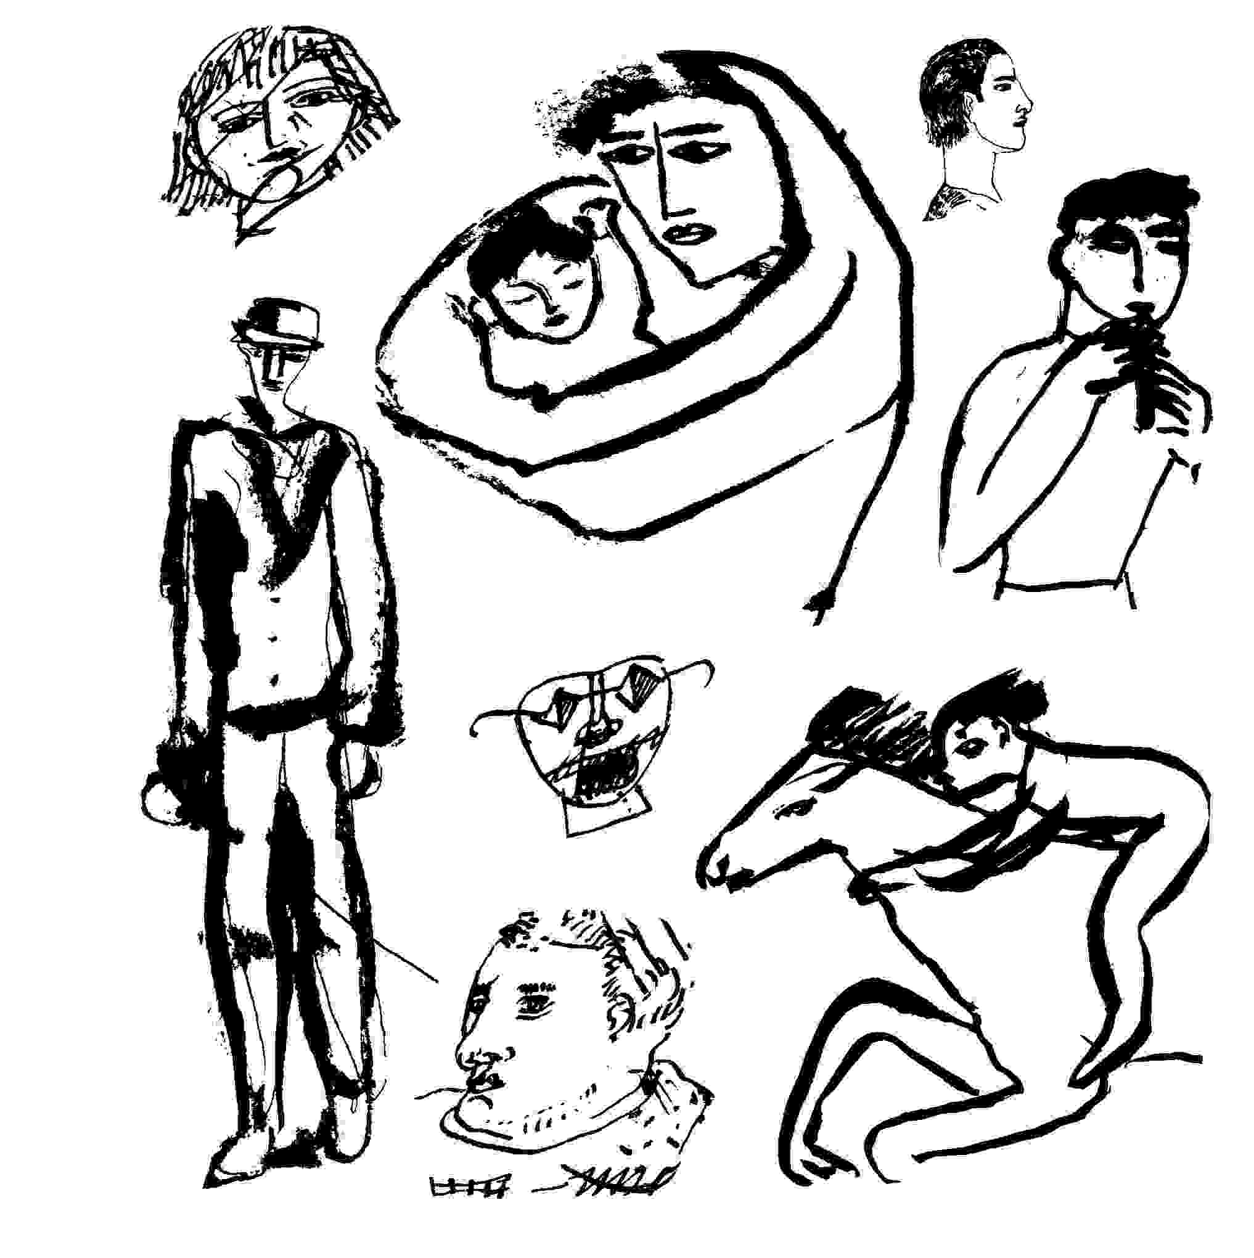
When news is suppressed or badly slanted by the establishment, the news comes from those close to it; from those who care not because they are paid to care, or paid not to care. Although journalists like Mumia Abu-Jamal are continually trying to make a free press, we rarely have one. Ben Bagdikian (The Media Monopoly) faults advertisers. Chomsky (passim) points to government policies. Both avoid dealing with how strictly the controls are enforced, and by whom. The American literary establishment rushes to defend an English writer from Islamic Law, yet can't effectively defend our own.
The retribution of police "framing" takes a journalist out of business, intimidates other journalists, helps discredit legal testimony of the victim journalist, and satisfies vengeance. In some countries this mechanism of retribution escalated to death squad activity. In Pennsylvania, the possibility of an innocent being sentenced to death as retribution for advocacy journalism, is a step in the wrong direction.
Given the precedent in treatment of African American writers, and given Mumia Abu-Jamal's message, it was simply a question of how he would be taken out. No journalist good enough to be the "voice of the voiceless" as he was called by Philadelphia Inquirer, would be spared targeting by the authorities, or be able to survive any involvement with the death of a policeman. He had no previous record. Strong evidence of his innocence was not allowed at his trial. What if it was exactly his affirmation of press freedoms that brought the terrifying retribution of his arrest, trial, and sentencing ?
Mumia Abu-Jamal is a political prisoner in a country that can not admit it makes political prisoners. He presents us all with a warning that is supposed to cost him his life, and I urge your concern for him.
*
1. If you consider the police bombing of MOVE (which may be where Mumia Abu-Jamal's reporting caused him to be targeted) as a microcosm for subsequent destructions, the bombing of Iraq, of Yugoslavia, then the obvious injustices in his arrest, trials and sentencing seem intended to offer an example to dissidence, and help explain lack of alternatives in the media to any journalism which doesn't parrot official press releases. I know of no one who has examined his case within the perspective of a psychological warfare operation against the free press.

The Silence of Writers
When writers are manipulated, silenced, or forced to write only what is acceptable to government policy or popular concerns, the people lose a first line of defence against terrible wrongs which are beyond our power as individuals to stop. Every nation is capable of mistakes, and of crimes against humanity, or warring to the point of genocide: this seems to be the lesson of Rwanda, former Yugoslavia, the Russians in Chechnya, the histories of settling North America. We know the faults of our native land most intimately. Both US policy in Vietnam and the US Coalition's war against Iraq initially presented as just causes, became warfare against civilians.
The more awful the crime against humanity the more profound the silence of the medias, as though it is "disloyal" to point out the war crimes of one's own country but acceptable to point out the war crimes of another. That places writers in particular within the perspective of military or tactical usefulness, rather than letting us be voices of conscience.
The silence lets further crimes occur. If our cultures and civilization present any impediment to the excesses of humanity stunned by its own capacity to create terror, where are the voices of Euro-Canadian-American writers protesting the slaughter of innocents ? As the Gulf War began, US Congressman Gonzalez of Texas protested commitments to make war in the Gulf by attempting to impeach President Bush. Few of the world's writers were able to effectively protest the Gulf war, and few have publicly declared common humanity with the victims of the Nineties sacrificed to military planners and strategic interests of the most powerful.
As a US writer during "Vietnam", I found that when a criminal military policy is in progress, all aspects of the media are controlled either by law, by covert pressure, or by economic self-interest. Although writers who take the point lead against a military policy may in the US retain their rights, severe covert repercussions are inevitable. The first obstacle is getting the work into print. Writers with strong government backing have the best chance of being heard if they speak out, but selective silence is often the price of government approval. Respect and good reputation are rarely accorded dissidents which limits their access to the media. "Straw men" dissidents are set up if their voices can be controlled in a clinch. Occasionally media responds to honest voices but at the risk of the good editors.
Many of the lessons from the US war against Vietnam, remain unwritten history of continuing relevance. The US writing community was against the Vietnam war. The tactical response was to identify protesting writers with Communism, or to buy them off with jobs in universities. Still, the people's dislike of oppression could be addressed by metaphor. There was effective literary protest reaching mass media markets, which became increasingly controlled during the war. Because Presidents Johnson and Nixon found the people's opposition the essential impediment to prosecuting a war, freedom of speech became a military political problem and tactically controlled.
Canadian writers were in an enviable position. They were not held accountable for American policy as American citizens were, and so were under less moral pressure to alter criminal policies. If they chose to write honestly about the Vietnam war, the border presented some buffer to retribution. The rising popularity in the States of Canadian writers relies partly on their lack of political commitment or responsibility for US policies.
A positive side to writing in the US during Vietnam was that literary protest was possible at all. The price was acceptable to some and not to others. I was falsely arrested several times, and without recourse for redress. As a mechanism of control false arrest is psychologically debilitating and knocks out the message by knocking out the messenger. However it showed that the press itself was open to printing dissident material. Through strong editors I was at rare points allowed to publish anti-war material in national media. I was able to write anti-war stories which could not have been published if I had worked the same material as fact. When anti-war stories no longer appeared, anywhere, I was still allowed to publish occasional book reviews.
Part of what military planners gained from the Vietnam war were mechanisms for controlling freedom of expression without overtly controlling the media. Censorship became a fallback mechanism, as it was used in the war against Iraq where journalists' access to military operations was limited. A much better indication of how silence was gained and maintained was apparent in the US media's treatment of the Kennedy assassinations which with unanimity found a single assassin guilty immediately. During the Vietnam war lists of people to be detained in event of a national emergency, grew from dissident writers to include presidents of universities, professors and possibly anyone with access to speak honestly to the American people. Anti-war organizations were used to train CIA operatives (it remains illegal to prove this). And long after the war ended the surveillance and persecution of dissidents remained but the reasons changed. The nonconformists who rely on the Constitutional protection of freedom of speech, once suspected of communism became suspected of drugs became suspected of terrorism.
The ad hoc peace movement lost political power at the Vietnam war's end, and the left wing and dissidents became increasingly vulnerable to the right wing which could operate in a clear field. Many peace organizations became non-government organizations with the United Nations which provided a measure of protection but may have limited their effectiveness in questioning wars of "the new world order." Within this perspective it became difficult for writers concerned with peace to find a literary political base and outlet for their understanding.
Until the internet became widely accessible it was impossible to share information beyond select circles, about international law, the environment, peace activism, etc.. Pacifist direct action groups working through the Seventies and Eighties were ignored by the US national press. Freedom of speech became a closed circuit apart from the news media.
With the advent of former President Bush's 'new world order" a fairly rigorous code of silence hit the US media hard. The Bush administration's handling of the Gulf War prefigured both questioning and protest. As a result of their experience with Vietnam, US planners factored the dissent of writers into their military equation. Military preparation and the massive transport of troops overseas happened so quickly that there was almost no public discussion. The people's protest to the war, huge at its initial stages when compared to Vietnam, was minimally reported. As international threats moved to speedy conclusion by force of arms, journalists were forced farther from the news. Access to military actions was parcelled out to a controlled press. In a sense the US and Coalition war was waged in a manner that could obviate protest.
The silence was unusual behaviour for American writers. Writers organizations were strong (though selective) defenders of freedom of speech. Yet the entire US writing community was essentially silenced by a simple mechanism of fear. Prosecution of the Gulf War was so rapid, ruthless, and objectively criminal that the American people were terrorized. Among others writers did not know how far the crime would go once the line of acceptability was crossed.
Two other factors capped any protest by US writers. The US writing community is essentially pro-Israel. In the States there are only recently, any well known Palestinian writers and few known Arab-American writers, as in another era there were no known Communist writers. To notice the absence is unsociable. Since the US Gulf War policy placed Israel in danger, literary ranks closed in its defence and few in the literary and intellectual communities championed reasonable diplomacy. Precedence for the American media's absolute denial of common humanity to the Iraqi people was established in the media's previously enforced silence about the humanity of Palestinians.
Secondly, the entire Euro-Canadian-American literary establishment, the entire machinery of NATO's press, writers, publishers, booksellers, media, championed Salman Rushdie's freedom of speech and right to stay alive despite the death threat from Islam, and so found themselves in an anti-Islamic camp about to drop five Hiroshimas worth of conventional weaponry on an Islamic nation. Before the Rushdie case arose American writers as a group were entirely unconcerned with Islam; the ethic of a free marketplace was always more interesting than a re-run of the Crusades. The fact that Rushdie's Satanic Verses, became an international best seller without yielding to simple subject verb object sentences is in itself remarkable. That his book was so purposefully and widely marketed once it was found offensive to Islam, suggests that the work was used strategically with no real concern for its author's safety other than his usefulness to essentially military policies. The efforts on Rushdie's behalf in all the NATO countries who formed the Gulf War Coalition, point to a fairly sophisticated example of a contemporary agit-prop campaign. The West's writers were tactically manipulated and therefore controlled. To be a writer in our countries one had to belong to a religious/political camp eager enough to do battle.
The Rushdie affair remained a kind of muzzle on Western writers. Of course one supported Rushdie's freedom to write without retribution, as one supports the rights of all serious writers even when their works are found "criminal" by governments owing their existence to the covert actions of Western countries. But to defend equally the rights of Islamic peoples became within the West a "disloyalty." With some experience in helping writers in duress, I thought the US response to threats against Rushdie was a state-of-the-art Anglo-American intelligence operation.
Beginning with the Gulf War, the US, and it appears to be true in Canada as well, entered a new era of silence. After the bombing of Iraq with the purposeful destruction of its civilian infra-structure, the intended ongoing suffering of civilians was an inhumanity of genocidal proportions. The damage was compounded by applying post-war Sanctions. This instigated a new order of silence, beyond the silences applied to Palestine, and East Timor, and aspects of US intervention in Grenada and Panama, as well as DIA and CIA connected death squads throughout Central and South America.
The best protection against democratic majorities going awry with policies such as ethnic cleansing, is respect for difference. Affirmation of differences is partly the value of dissidence. Without dissent, the media becomes a function of corporate interest and government. But the people cannot affect policy in a democracy if relevant news is suppressed.
Consider US declarations and understandings at ratification in 1988 of the UN's Convention on the Prevention and Punishment of the Crime of Genocide, which the US signed initially in 1948. In effect these declare the US the sole arbiter of the Convention's applicability to the US. In response the position of the Netherlands for example, was that the US is no longer party to the Convention. US understandings of the Convention also require a "specific intention" to commit genocide in war rather than say, genocide by collateral damage, for the crime to be subject to the Convention. It is as if the reservations were written with situations like the Gulf War in mind. My experience as a writer is that this area of discussion and information was and remains banned from the US press.
On paper, Canada's position on the Convention against Genocide is much more supportive than that of its neighbour to the South, and carries no reservations at all. Yet domestically, it is an unmentioned topic, despite particular relevance to the issue of Quebec Separatism and the historical reasons for it. The sense of tact within the Canadian press, at what is gradually proving
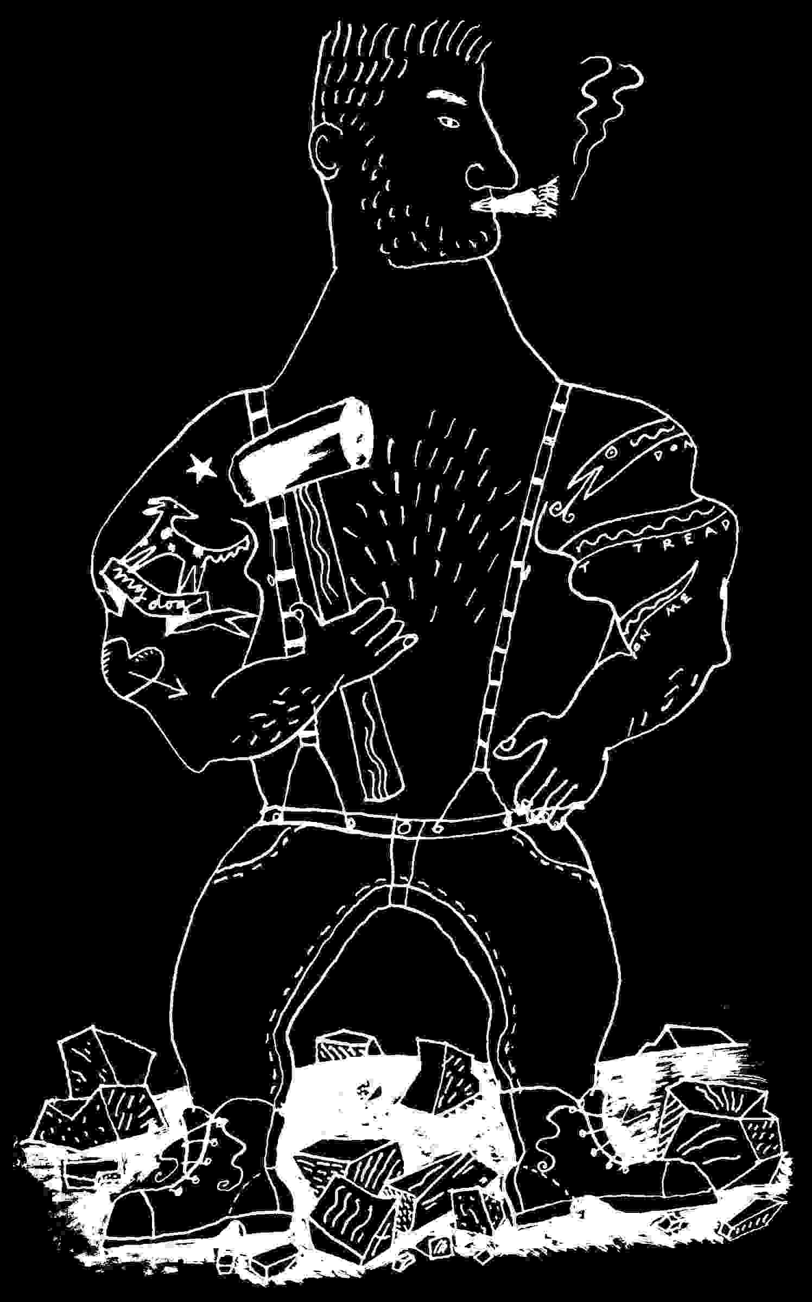
to be a nonviolent ethnic cleansing of Anglophones from Montreal, is remarkable.
When government policies of a democracy touch on issues of genocide, and writers prove silent, then silence is being enforced about issues which require public discussion. No national discussion of the genocidal aspects of US foreign policy has appeared since the Gulf War. Former US Attorney General Ramsey Clark's books War Crimes and The Fire This Time, present evidence of US and Coalition war crimes during the Gulf war, while carefully avoiding the word "genocide" (his subsequent work does find the use of Sanctions against Iraq, genocidal). The works and the information Clark's writings contain were and continue to be ignored by the US press. Books glorifying Gulf War military leaders were well covered and promoted. Subsequent actions by Voices in the Wilderness Campaign, where participants have risked prison terms, large fines, and the possibility of US bombing raids, by going to Iraq with emergency medical supplies, consistently receives little or no coverage in the US or international press.
Complicity in silence began to become the price of admission to publication. The silence remains enforced by codes of corporate and government loyalty which have nothing to do with morals, ethics, or the people's need to know. Policies which put entire civilian populations at risk have to be publicly discussed. And particularly when we are not supposed to, writers must raise issues of decency. Political leadership is accountable, as are the people to covenants and conventions which were made international law to spare all of us.
How can there be valid literature in English if our cultures require major crimes against humanity which aren't allowed to be publicly questioned? As the Gulf War slips into the exclusive domain of well-paid historians, the mass graves of soldiers who never fought back, the ruined temples of a civilization older than Europe's, the Iraqi children still dying from the effects of bombing, still dying from lack of nourishment and necessary medical supplies, all become submerged in a tradition of silence which creates chaos to sell armaments, which would destroy entire peoples in the name of peace.
What claim can silence make but as the grave marker of a terrible wrong ? Because in order to partake in the literary marketplace, we are supposed to forget the crimes at the heart of our cultures, the silence of North American writers is being enforced, as though the spoils of victory in those lucrative massacres called wars claim our rights to write our visions honestly. The silence of Canadian writers presents no contradiction to shared policies which supposedly serve US-Canadian mutual interests, but which risk literature's claims to anything greater than the self-serving claims of propaganda. In Canada particularly, our English language cannot escape some political accountability. By recognizing the silence we have a chance to question it. At the least I here pay respect to the more profound silence of those who become victims through what is left unsaid.

The Silence of Mothers
Amid my manuscripts, I notice the approach of a new millennium.
The previous time a thousand years slipped by, Greenland's Lief Ericcson went to Denmark for an education, and returned home converted to Christianity. He successfully converted his mother with the result that a. she built a church, and b. never spoke to him again.
This thousand years later, sitting at my desk in midwinter Ottawa, I remember my own mother, an American. After the shock of her childhood poverty she was a fairly wealthy American, which confused my love for her. My choice of career and natural inclinations left me penniless as soon as I turned the corner to adulthood, so she was in several ways important to me. When she stopped speaking to me it wasn't because I introduced her to Christianity, but simply tried to instill in her a love for the poor, among which I was a serious contender. She was a challenge to please, though easier than my father whose worldly success puzzled me. My father worked for the very wealthy, the famous, the powerful, all who paid him highly to deal with the home space they lived in, and it's hard for me to say anything just about my father's work. As soon as college was over I entered the world on my own.
My parents believed that people in authority were always correct, so during my vulnerable years, they kept voting to send anyone my age off to fight in Vietnam. I escaped through some cleverness and an early devotion to pacifism.
I became intrigued by politics. After thirty-odd years of suffering most of the short ends of sticks invented by the wealthy to control the underclasses, with wife and children I escaped to Canada. Which is how I finds myself in a new country, contemplating a new millennium.
The challenge of a new millennium is like the challenge of migration from one place to another, except through time. What does one do with all the problems of "back there"? How could so much that happened in the past thousand years suddenly be brought to justice? How could all the outdated thoughts and contraptions, the unworkable theories, the over-reaching hopes and unutterable cruelties all slip mindlessly into oblivion simply to accommodate Christian civilization's odd notion that time is divisible into measurable units? Some say civilization as we know it and all the amenities it provides a portion of humanity, might abruptly cease when the digits must mark the new year with a full two thousand. The possibility of a pure moment of chaos when all the mechanisms of electronic controls and the services these support, cease, calms me. A pure moment of anything is hard to find.
Chaos is an old acquaintance, a nod away, the daily challenge of a blank piece of paper awaiting words, or the suffering which precedes any realization, when nothing seems right, when my usual approaches to understanding are insufficient, when tradition and my own experience threaten to bind me in a satchel for storage, when to free myself into insight I slip gradually into questioning everything I ever took for granted point by point until I realize I know nothing, and about to lose myself in a sea of what others do and say and think and feel, I make a desperate lunge to construct something essential from self yet of value to others, until a story like this slowly forms with its own laws and integrities unlike anything else. The sea itself, the sea of humanity, its randomness, its hugeness, its un-encompassability is chaos, and a friend.
My peer, the great Canadian novelist, Franz Boergy⁽⁸⁾ who is a professor of Linguistics, is one of the few people I have occasion to speak with in this new land, because I'm continually looking for teaching work. Boergy finds my syntax too American. Boergy conceives of language as innate to humans, a genetically imbedded computer chip, with American grammatical differentiations an expensive impediment to the development of a universal grammar.
He refuses to offer me a job, sensing a degree of rebelliousness which historically one might expect from an American. "You see," Boergy says after I present my perspective on chaos as a friendly force, "you confuse the human nature of others with your own. Without controls what is to protect us from the lawless? From anarchy? Rebellion? From mob rule and soldiers entering our houses ?" I shift uncomfortably in my chair.
"Anarchy," Boergy continues, "is like a playing field with no rules except for those made by any well knit team with an objective. In chaos, the natural balance of society apparently doesn't function, due to individual self-concern, so the majority falls prey to the interests of a few."
"But," I say, "it's because the majority is often wrong, that a lack of controls offers anything to fear. What you fear in anarchy is simply justice, and its periods of inconvenience."
Boergy laughs happily. "Justice is the business of courts, law and the police. Those are relatively evolved institutions, while as people, we are as often as not, primitives."
My secret fear at the arrival of the new millennium is that with any food shortages or possibility of "civil unrest" all the emergency powers acts in North America will be applied and the rights of humankind will go down the rabbit hole. Emergency Powers acts inevitably allow the detention of anyone who might not agree with current authorities, and manage to round up mild-mannered intellectuals and free-thinkers if only to break our glasses. Since for thirty years I've lived on the wrong side of the political coin in my birth country, subjected to those hassles which attend the dispossessed, I am never entirely free from a fear of sudden arbitrary arrest for no reason other than my concern for fellow human beings.
While others prepare for the year 2000 by stocking emergency food supplies, water filters, an extra stick of wood or two for the fireplace or stove, I realize the irony of preparing my family to survive an emergency which might have other plans for me. I have anxiety dreams of an army of the poets who have won no prizes, teaching assistants who have taught the truth, minor officials who have spoken too frankly, innocent husbands with attractive wives, all in greatcoats, feet bound with rags, crouched around fires by tents in the local stadium while department heads and bureau chiefs, the masters of a tradition of literature that asks no questions, all deal with chaos in the most civilized manner by dropping by the homes of the less fortunate to see that their wives are managing.
"Well," I say, "I can't see the chance of anarchy if we all stick together."
"Mmmm," Boergy says. "Have you thought of applying to teach in Japan ? - No, no, just kidding."
Humourless, I am remembering Lief's Mother, her thousand years of silence, as if all she left unsaid, could not say to her son, is what's troubling my own awareness a millennium later. A huge wheel of years carrying a grain of her sand had made its evolution to mesh the gears of a giant watchmaker god, with his "now." What had she been forced to sacrifice? Or was it that in accepting Christianity, she lost everything she ever held sacred or had hoped her son would bear into the future ? Was her silence saying that suddenly without the history which mothers bear, she had nothing to say to him, no sustenance to give him from the traditions of her family, the life she once knew which brought generation after generation of sons into the world. In replacing the old traditions did christianity mean her death?
Or did she cease to speak, knowing she couldn't reason with this new religion that claimed to love but found god in a male, and ruthlessly erased all traces of religions it supplanted, re-forming all knowledge so that time itself began with the birth of Christ ? And as a reward for this betrayal of the past, were her people then allowed knowledge of the New World, so that the grey mountains and uncharted shores in the mist Lief found as he neared Greenland on the voyage home, might offer them all the lumber they didn't have? So at that millennium, for her people, all the bounty that the next one thousand years would bring, the riches of the new world beyond their own harvesting, seemed bought at the high expense of their gods, their ancestors, their heritage, their totems, their household gods, the magic inherent in their knowledge of nature, the seas, of magic itself ?
What I am thinking is that Lief's mom was like my own. It was a long way from poverty to affluence, from fear to not worrying, and how could I guess as a child the cost of her compromise, the loneliness of the rich which she entered defenceless, the degree of pain she felt in saying no to people, the uselessness to her of expensive things she gathered to her as blankets against the cold, so that one day I might not feel the cold so deeply ?
If it is in the silence of mothers that answers are found, now as the year 2000 approaches, I look for the silences and what they hide. I don't want to betray all that brought me into the world, in hopes of a new salvation buying my soul with promises of a new world order.
If technology takes power from the people and places it in the hands of an increasingly small elite, what defence does humanity have ? By breathing into computers an innate confusion about time at the arrival of the millennium,
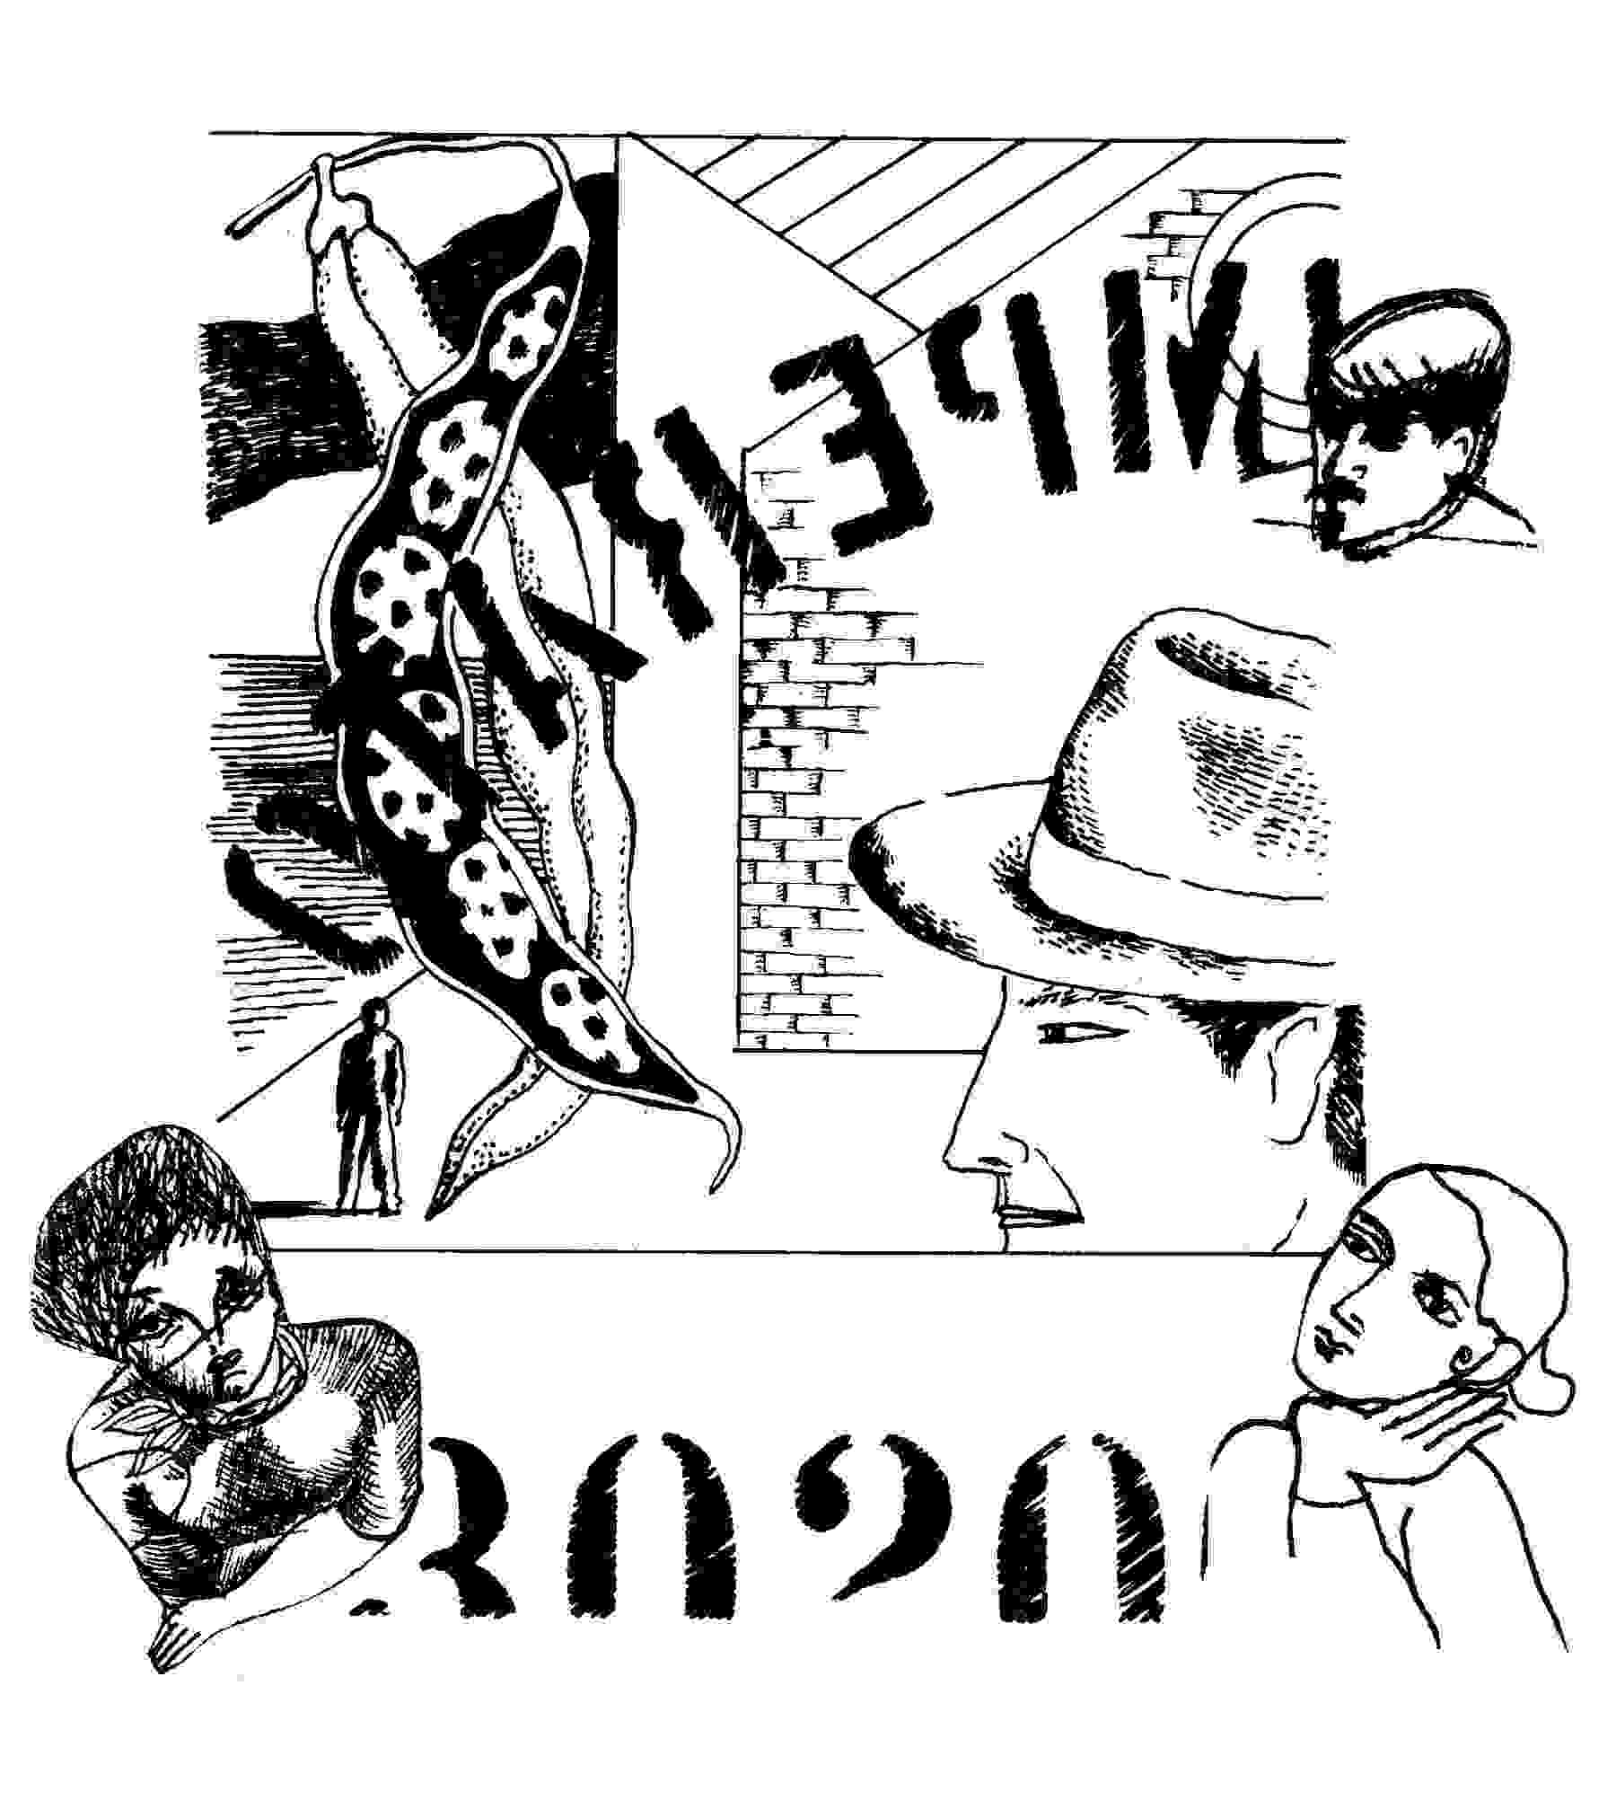
the earliest computer programmers must have been trying to breathe compassion into the machinery we rely on, to return each of us to ourselves, presenting all societies with the possibility of failure in geometric progression of inter-reliant systems.
I keep asking the mother of all silences -"Will we continue as we have before?" But her silence says, "You'll find the answer in your own heart."
The moment of midnight, the first instant of the year two thousand, will find me listening for the small voice in this north american wilderness of ourselves.

On Crimes of Power: the Bombing of Yugoslavia,1999⁽⁹⁾
I reluctantly start with these observations. Under Communism, Yugoslavia was held together peacefully, though its economy was not available to control by corporate capitalism. After the breakup of the Soviet Union Western governments continued cold war policies until the International Monetary Fund assured the destruction of Yugoslavia's economy⁽¹⁰⁾ . Despite instances of solidarity in the Unions, impoverishment increased ethnic tensions aided by German and American covert Operations⁽¹¹⁾ . Less covertly, in 1991 George Bush's "Foreign Operations Appropriations Bill," funded Yugoslavia's Provinces to declare independence from their central government⁽¹²⁾ . Croatia now flies the Ustashe flag. In a nation previously formed by the Third Reich, Croatia's Ustashe launched a policy of extermination against anti-fascists and specifically Serbs, Jews, and Siniti-Romans⁽¹³⁾ . With Hitler's defeat, the Ustashe treasury was used to buy safety for its war criminals from what are now NATO countries⁽¹⁴⁾ . Once part of Yugoslavia, under NATO, Bosnia is now divided and prepared to serve NATO, with rule and banking firmly under NATO control⁽¹⁵⁾ .
The Federal Republic of Yugoslavia proved more resistant. When think-tank policy reached the lives of the people, for two and half months day and night NATO forces bombed a small country's defences, bridges, factories, communications, storage facilities, hospitals, railways, roads, factories, schools, public housing, playgrounds and people. Yugoslavia had not attacked NATO but was attempting to settle an internal war with a history of atrocities on both sides. NATO's action caused the exodus of close to a million people from their homeland. It continued to erase the culture and existence of a national group, where Yugoslavia's fragile community of peoples was initially destabilized by cold war economic policies and covert assistance.
NATO bombing stopped no slaughters and may have initiated atrocities. It saved no people. International laws which attempt to protect peoples from aggression, dislocation, and war crimes of the most powerful nations, were ignored by a war of aggression without combat, without legal amenities even in NATO's charter, and without approval of the United Nations. It did not reflect the will of NATO's peoples. It was imposed from the top down by US leadership and economic game plans conceived of in such areas as the US Carnegie Endowment for International Peace, which helped prepare participants for a role in the Clinton administration⁽¹⁶⁾ . For massive military action against a sovereign State, NATO required a pretext.
NATO's Humanitarian Concern
NATO's "humanitarian" prerogative for military action followed standard procedure for initiating illegal aggressive wars. Hitler went into Poland to "save" its Germans⁽¹⁷⁾ . The US and Coalition went into Iraq to "save" Kuwait. The US and NATO went into Yugoslavia to "save" the Kosovars. In Kosovo, escalation of ethnic violence was first attributed to Kosovar Albanians in the late Eighties⁽¹⁸⁾. Whether the Kosovo Liberation Army drew its resources from the drug trade, covert NATO operations, Croatia, or Islamic fundamentalists, it was the protagonist of a war against Yugoslavia's central government. To note resulting Serbian atrocities, as evidence appears, Serbian forces and paramilitaries responded more moderately than the CIA programs in Guatemala, or in the South Vietnam under operation "Phoenix," or in Chile, or than graduates of the US School of the Americas throughout the Americas. That does not excuse them. It does suggest that any pretext of humanitarian intervention should be judged in light of its effect.
There was no attempt by the US to prevent the massacres, or the conditions which led to them. To the contrary, the history of US and NATO interference in Yugoslavia suggests the opposite. People's expectations are that if/when massacres occur, you try to save the people. You do not provoke their destruction, or obliterate their homeland. You try to ease the conditions that have pushed a human group into acting savagely. It is at least a moral crime to profit from their misery. You negotiate and submit to impartial arbitration. NATO cracked a foundation stone of peace when it proceeded to bomb without United Nations approval. One crime doesn't solve another.
The answer to the persecution of one group by another in Kosovo, lay only in prevention, which would have cost NATO countries a fraction of their military enterprise, but without profit to defence industries.
The ruthlessness of NATO's aggression and illegal bombardment was a public lesson, not covered with shame, but boasted of in press briefings. It's frightening because under the pretence of humanitarian concern, NATO's action placed so little value on human life, or the codes people insist on to make life bearable.
NATO found the people of the Federal Republic of Yugoslavia, expendable, when it began to kill them. It claimed civilian casualties were "mistakes" through ten weeks of bombs and missiles, and an air operation including more than a thousand planes⁽¹⁹⁾ . When NATO destroyed factories it destroyed jobs. When it destroyed bridges it destroyed freedom of movement and the transport of food. When it destroyed people, it destroyed people as a punishment, without trial, without choice, without direct provocation, without understanding. NATO bombed a prison. It bombed a zoo. By depriving all the peoples of Kosovo and Serbia of an economy, its reserves, its fuel, health of food supplies grown in contaminated fields, its water supplies, very specifically its entire electric grid, its medical supplies, its playgrounds, it deprived a country of the means of healing itself. NATO has prepared Yugoslavia for civilian casualties through death by exposure, disease, effects of cluster bombs, effects of depleted uranium, lack of medicines, lack of electricity for hospitals, lack of food, lack of psychological balance, and these casualties will continue to grow. NATO's targets increasingly included by intention, the peoples' means to survive.
Since the exodus of Albanian Kosovars was foreseeable, NATO considered these expendable as well. Since NATO with its occupation couldn't protect the Serbian Kosovars, they too were considered expendable. NATO considered Serbian soldiers immediately expendable because it targeted them, and what is a soldier, willing or not, but a prisoner in uniform ? What of our own militaries ? NATO made its own forces expendable by committing them to a war of aggression when war crimes have no statute of limitation.
Respecting international law against aggression, Russia defected from NATO's madness. But with its standing army in disarray, Russia's military protection rested with the threat of nuclear missiles aimed at NATO's capitol cities. NATO's bombing, as it continued destroying Yugoslavia threatened us all with the obliteration any nuclear exchange would cause, and the reminder that we are all expendable.
In Iraq a million young children have died so far from the effects of bombing and Sanctions. Although NATO's bombing officially caused the death of 5,000 of Serbia's soldiers and 10,000 troop casualties⁽²⁰⁾ (all ethnic groups were eligible for draft), the full extent of civilian casualties won't be known for a generation. The intention of massive destruction renders questions of whether the destruction of a people was actually intended or not, absurd, despite the calculated insistence on how specific the targets were. While questions of "intent" were argued by NATO country lawyers at the International Court of Justice, so that the bombing might continue, victim peoples continued very clearly to die, and will continue to die from the effect of the bombing.
As part of a national group, civilians are through time, the target of all destruction of countries. Within its own borders, an army defending its people, is part of that national group and its casualties contribute to any summation of casualties within the national group.
The lack of choice about NATO policy, accorded civilians of NATO countries was mirrored by NATO soldiers: mis-informed, mis-trained, told to effect policies presented to them as necessary and "humanitarian." They are also human beings, but purposefully deprived of individual choice to the benefit of a command structure. Living within a closed societal circuit of approval, they are often not aware of any "wrong" in what they are doing. Wealth has much the same function with North American ruling elites who aren't told what they don't already know.
The International Court of Justice
After World War II, the people's response to arrogance of power was to bind the powerful to laws and institutions which show some respect for our lives. National leaders at the service of corporate interests subvert these for political survival, A. by denying international courts their jurisdiction, B. by denying international courts any means to effect judgements, C. by appointing judges to represent national interest rather than justice, D. all of the above. Yet amid such mechanisms of control, there are people, and as people each of us is capable of resistance to obvious injustice.
On April 29th, the Federal Republic of Yugoslavia appealed to the International Court of Justice to make NATO stop bombing, on the grounds of aggression and genocide as stated in its case on "The Legality of the Use of Force," which contained a request for provisional measures to stop the bombing. The FRY's case was straightforward, and charged individual NATO countries separately. The NATO countries' responses relied on legal technicalities to have the charges dropped. Most responses tried to deny the FRY a right to bring charges, or pled that the charged country was not bound and responsible to the court in this instance.
Although the FRY's request for provisional measures was dismissed, the case was not, at least against countries, including Canada, which subscribe to this Court's jurisdiction. The Court's Order, of June 2nd, did not find at that moment, adequate evidence that a genocide against the FRY was intended, but it kept the case open pending further considerations of jurisdiction and evidence. The possibility that the charged countries in fact committed aggression and genocide, remains.⁽²¹⁾
Cases against Spain and the US were dismissed, since these have not allowed themselves to be bound to the Court's authority. Yet this judgement made the Court avoid its primary responsibility for peaceful settlement of disputes. Since cases it cannot judge are referred to the UN Security Council, a US veto in the Security Council would deny the FRY's case any consideration. The crimes charged have no statute of limitations and in this instance, the US forfeits protection of international law. Accused of aggression and genocide, US policy makers indicate their choice to proceed, overtly or covertly, outside the law.
By bombing a nation it wasn't at war with, and by denying the victim recourse to law, US policy makers created a victim national group. The US has done the same with Iraq. Sanctions were applied to both national groups, purposefully depriving the civilian populations of a means to recover. This suggests their total destruction could be intended.
We protect ourselves from realizing this by attributing such suffering to inevitable hardships of war. But neither military operation was a "war." There wasn't an armed conflict. It isn't war to massively bomb a country that has no adequate defences. When all the casualties are on one side, and American forces which were largely responsible for the bombings didn't lose a single person in combat, then we call it massacre. Once targeted, the victim country risks being destroyed as a national group so it won't have recourse to justice. Triggering ethnic warfare, calling for rebellion against leadership, funding of opposition groups within the victim State, all counter any chance for legal recourse as a national group.
The International Court of Justice reaffirmed all countries' responsibility to humanitarian law, whether charges against them by The Federal Republic of Yugoslavia could be applied in this case or not.
Crimes of Mass Destruction
Formed by an understanding of horror as the Holocaust in World War II, and the nuclear bombing of Hiroshima and Nagasaki, people in NATO countries are shy of the word "genocide," partly because as Noam Chomsky has
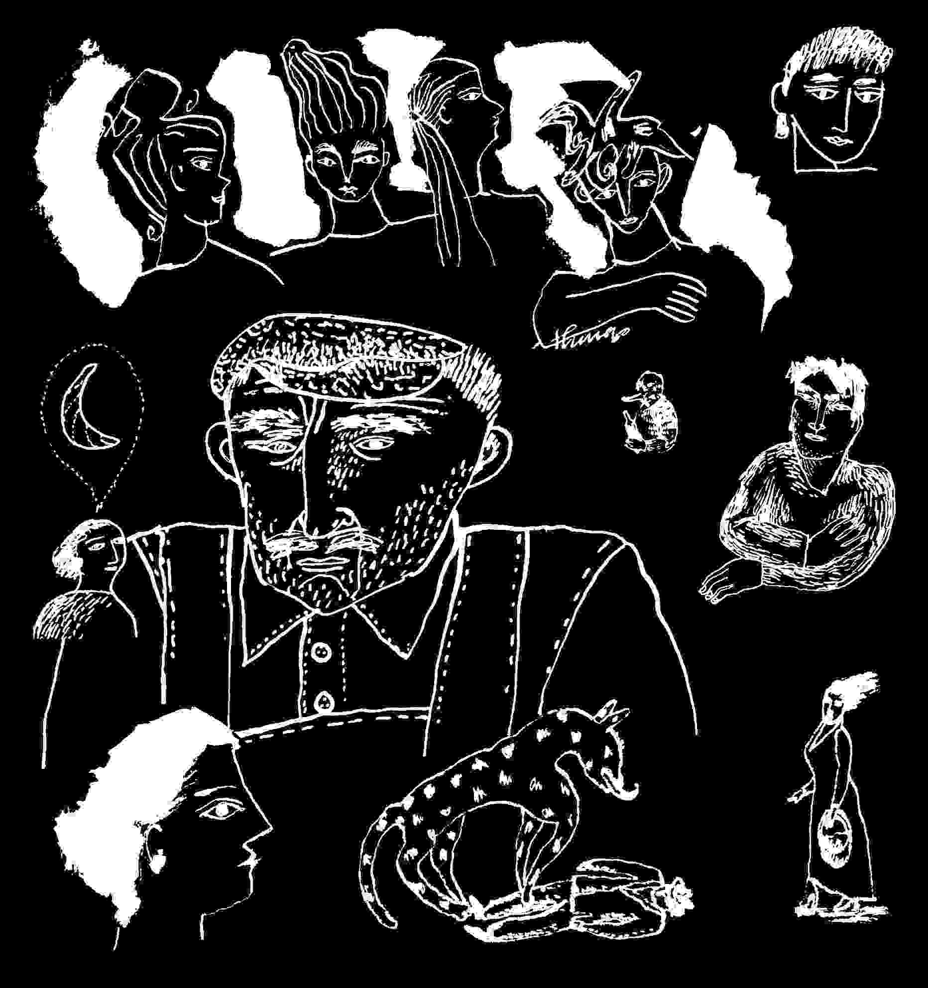
pointed out it's an affront to previous victims⁽²²⁾ and partly because it's a crime of power. When we have to, we apply the term to attempts on racial, ethnic, religious groups, because our own societies force us into recognition of these categorical differences. That shields us from understanding a crime which attempts to destroy entire groups defined by nationality, encompassing several groups. Yet the Convention on Genocide specifically includes a "national" group as a classification, before the others.
Furthermore, the cold war's "balance of power" relied on unpleasant facts of technology: beyond threat, actual projected use of the cold war's nuclear arsenals, was to devastate other national groups, and because the major powers were and remain nuclear powers, people are taught not to link the word "genocide" to the destruction of an opposing nation. In fact the victim group becomes the human race and humanity's future, an escalation of the concept of genocide, to wordlessness. Although massive bombings spare humanity ultimate weaponry, a portion of humanity is sacrificed within a targeted locale. Over five Hiroshimas of ordinance were expended on Iraq. Yugoslavia was bombed for over seventy days and nights. It was clear what the bombings' effects on people and the region would be. Yugoslavia's "Request" of April 28th, presented to the International Court of Justice, gives clear evidence of NATO targeting which could only lead to destruction of the civilian populations.⁽²³⁾ Yet the evidence was not sufficient...
The Court's argument in decisions again and again point to the need for proving intention, as did Canada's defence, where "intent and destruction" are necessary to its lawyers' definition for applicability of law and jurisdiction. To argue that there was no "intent" to destroy these portions of humanity, is to argue that the victim of a firing squad is not really supposed to die. The arguments followed a defence the US made at its Ratification of the Convention on Genocide in 1988, specifically requiring the element of "intent" as decided by itself.
Calculated manoeuvres implanted into treaties and relations to the Court, specifically protect US policies from the charge of genocide, rather than protect people from the crime, or even its allies from being charged for the results of US policy. Such protections within US policy were recognized by the Court's dismissal of charges against it, June 2nd, and in themselves suggest "intent" in policy planning.
If the effect is destruction of the national group, and the effect is foreseeable, how can anyone prove an absence of intention?
Within national courts of individual NATO nations, only the Greek government allowed its people the opportunity to challenge NATO policy under law. When the case was presented in a Greek Court NATO was found guilty.
The International Tribunal for Yugoslavia Indictment of Milosevic et al.
On May 24, with effect on May 27th, the International Court Tribunal for Yugoslavia, under a Chief Prosecutor appointed by the United Nations⁽²⁴⁾ , indicted Milosevic and his chief aids for crimes arising from their authority over Serbian actions in Kosovo. The Tribunal's President was American.
The indictment bravely held leadership accountable for crimes of policy, and claimed evidence of specific atrocities committed by Serbs. No doubt this will be substantiated by evidence gathered with NATO military assistance. The indictment also blamed the exodus of Albanian Kosovars, on Milosevic and his chiefs, despite the sequence of events reporting that exodus and foreseeable reprisals began predictably, in response to NATO's bombing.⁽²⁵⁾
Forced deportation is a crime but it isn't of itself, liquidation or enslavement⁽²⁶⁾ , nor does it destroy and contaminate with chemicals and radiation one's homeland or victimize residents with wars of extermination. With a different tactical objective, NATO might have overlooked Milosevic's policy as an attempt to evacuate a people under his responsibility, from an expanding war zone.
But if Milosevic were guilty of all charges, why did NATO commit a greater crime in the destruction of country and peoples ?
Neither Kosovo nor the Kosovar Albanians nor the Kosovar Serbs, nor the peoples of Serbia, benefited from the bombing, which killed civilians as well as military within their own country. US Defence contractors benefited most immediately. But if we can't apply international law to NATO's targeting of a civilian infra-structure which reasonably suggests the destruction of a national group, what national group is safe from a US elite's commands ?
The Tribunal's indictment lacked the balance of indicting NATO as well for the crime of bombing and risked the court to the service of NATO rather than the United Nations. It shifts blame for the humanitarian disaster the bombs and missiles caused while saving no one, while assuring a massive exodus, while triggering atrocities in reprisal, to a handful of indictable small-country leaders. Its indictment was presented at a point when the International Court of Justice held under consideration Yugoslavia's own case against NATO countries, presenting adequate evidence of this humanitarian disaster.
A Sense of Common Humanity
Both NATO's economic agenda and its military actions damaged the people of NATO countries, brutalizing us into accepting what we know is unacceptable. We feel powerless to do anything about it but question it, in spite of propaganda, misinformation and "briefings," the sale of the war to the public, the spin doctors, news management, all which try to distract us from three facts: thousands of people were intentionally killed; a nation was destroyed and its people might not survive; the destruction was an illegal act of aggression.
In the US war on Iraq, the civilian infra-structure was massively and purposefully bombed as a supposed tactic to force the civilian population to force their leader's compliance or ouster. Who would question the innocence of the children or that they as well had souls, hope, hunger, needs while they lived? The deaths exceed political justification.
As the children of Yugoslavia and Kosovo suffer their first casualties of displacement or that military euphemism of foreseen "collateral damage," the hatreds of retaliation and atrocity war nourishes, the effects of depleted uranium weapons⁽²⁷⁾ , the unexploded cluster bombs, the survival rate within a bombed out society, who can heal the children ? Who can heal the adults ? And who can find the perpetrators innocent of crimes against humanity ?
The subliminal messages to NATO's people are: that we should deny humanity to those outside our group, that our expectations of normal lives are at the mercy of government, that we risk extermination when we do not obey US orders, that there is no impartial justice for people. Will this message one day be brought home to North Americans ? We feel powerless because the overwhelming message of any war is that people are of no value. War kills people. Negotiations do not. When the powerful would rather kill than negotiate, then what value does human life have ?
We were not born without value, at least to our selves and families, yet we are made so, until we have no faith in our human rights, or voice to insist on them.
A lack of value is enforced by propaganda, which through manipu- lations, lies and omissions, relies on our stupidity. If we are not already stupid it tries to make us so. So we are not only voiceless but stupid. Most powerfully our worthlessness, and stupidity, are compounded by the moral wrongs imposed by devastating crimes against other peoples whatever their nation, colour, religion, language, peoples who are remarkably like us.
Having devalued humanity to the point of claiming to represent our peoples by obliterating a little country, NATO then exceeds itself with civilian casualties as minor, statistically negligible mistakes resulting in death of someone else's parent, child, lover, partner, as though these are not a concern when compared with the arsenals of slaughter at NATO's disposal.
What we learn as peoples is that because injustice itself is a weapon - to harm us, to identify resistance, to terrorize us, to nullify the concept of justice, to make us forget laws that protect us all, to perception manage us into wondering if right is wrong and wrong is right, to destroy our vision with pain, to tire us, what we learn is that an injustice against any one of us is an injustice against us all.
So when the people of Iraq are bombed into the stone age in some way they stood for us and stand in common humanity for our daily lives and expectations as well. When the Yugoslav people find their lives bombed away because their leader would not take orders from a country that places its crimes above the law, they have at least stood for humanity.

Footnotes
1. The first two sections of this were published under this title by Confrontation magazine: Thirtieth anniversary Issue, No.66/67 (New York, Long Island University, 1998).
2. Hired when a professor died of AIDS, mid-term. I withhold the name of this Eastern college because its policies presented no exception to a prevailing academic norm. The college requested Faculty input during its restructuring. I was never asked to teach again.
3. For the complete United Nations Text, see the Convention on the Prevention and Punishment of the Crime of Genocide, United Nations, December 1991 (DPI/1055), or at Common Rights & Expectations, http://www.nightslantern.ca/community.htm .
4. According to Multilateral Treaties deposited with the Secretary-General. Status as at 31 December 1992. United Nations, New York.
5. The "Understandings" are:
1.That the term 'intent to destroy, in whole or in part, a national, ethnical, racial, or religious group as such' appearing in article II means, the specific intent to destroy, in whole or in substantial part, a national, ethnical, racial or religious group as such by the acts specified in article II.
2. That the term 'mental harm' in article II(b) means permanent impairment of mental faculties through drugs, torture, or similar techniques.
3. That the pledge to grant extradition in accordance with a state's laws and treaties in force found in article VII extends only to acts which are criminal under the laws both of the requesting and the requested state and nothing in article VI affects the right of any state to bring to trial before its own tribunals any of its nationals for acts committed outside a state.
4. That acts in the course of armed conflicts committed without the specific intent required by article II are not sufficient to constitute genocide as defined by this Convention.
5. That with regard to the reference to an international penal tribunal in article VI or the Convention, the United States declares that it reserves the right to effect its participation in any such tribunal only by a treaty entered into specifically for that purpose with the advice and consent of the Senate. Ibid..
6. International Covenant on Civil and Political Rights. United States "Reservations" at ratification on 8 June 1992, to Article 6 and Article 10, among numerous others.
7. The Boston Globe, "The real Iraqi targets," June 6, 1991.
8. This is a fictional construct. There is no Franz Boergy, who presents a human truth from my own lessons in life and human nature.
9. Initially author published at http://www.achilles.net/~jbgerald, July 13,1999, this appeared August 1, 1999, on Serendipity in Switzerland.
10. See: Michel Chossudovsky, "NATO's War of Aggression against Yugoslavia: an Overview," Michel Chossudovsky, June 1999.
11. See: NewsMax (ref. a John Whitley quote in The Global Watch Bulletin (April 2, 1999); and "KLA Croatian Connection Resurfaces," 2357 (April 2, 1999); GMT,990503, Stratfor.Com, 1998.
12. See: Michael Parenti,"The Destruction of Yugoslavia," Michael Parenti Political Archives, 1996.
13. This point noted by a number of journalists, as well as the inception of various NAT0 countries' involvement with Croatia, was definitively explored in "The Fate of the Wartime Ustasha Treasury," US and Allied Wartime and Postwar Relations and negotiations With Argentina, Portugal, Spain, Sweden and Turkey on Looted Gold and German External Assets and US Concerns About the Fate of the Wartime Ustasha Treasury, USIA online site, or US Government Printing Office, #044-000-02494-2.
14. ibid..
15. Michael Chossudovsky, "Dismantling Yugoslavia; Colonizing Bosnia," Covert Action Quarterly, No.56, Spring 1996.
16. John B. Roberts II, "Roots of Allied Farce," The American Spectator, 6/4/99.
17. Richard Poe, "The Big Lie about Kosovo." NewsMax, April 14, 1999.
18. Binder, New York Times, Late City Final edition, Nov. 1, 1987.
19. Projected figure. "Cohen: U.S. Casualties Could Be High," Laura Myers. AP-NY 04/15/99. The Federal Republic of Yugoslavia's "Request for the Indication of Provisional Measures," of April 28th, about half way through the bombardment, states: "From the onset of the bombing of the Federal Republic of Yugoslavia, over 10000 attacks were made against the territory of the Federal Republic of Yugoslavia. In air strikes were used: 806 warplanes (of which over 530 combat planes) and 206 helicopters stationed in 30 air-bases (situated in 5 states) and aboard 6 warships in the Adriatic Sea. More than 2,500 cruise missiles were launched and over 7,000 tons of explosives were dropped."
20. Daniel Williams, "After Sanctions and War, Yugoslavia Is in Pieces" The Washington Post Foreign Service, June 5, 1999.
21. Canada's public response to this is negligible. On June 2nd in Parliament, the Secretary of Foreign Affairs, Lloyd Axworthy was asked to report on the International court's proceedings of this day. Mr. Axworthy stated that the Commons would be glad to hear the case was dismissed; any qualification of this he made, was unclear. Press discussion of the ICJ decision was minimal, and any mention of the open status of the case was accompanied by the implication that its resolution would take a long long time.
22. "Chomsky Replies Re. Kosovo from the ZNet Forum System," ZNet, June 1999.
23. The Federal Republic of Yugoslavia's "Request for the Indication of Provisional Measures," of April 28th, about half way through NATO's air campaign protests a thousand civilian casualties, listing many by name as well as location of targeted civilian facilities, the jobs of 500,000 workers through targeted industry, a million citizens short of water, two million citizens without means of sustenance, specific roads and bus stations, railways stations, track and line, 32 bridges destroyed or damaged and all with specific name and location. Similarly airports, housing blocks, fifty specific industrial factories ("Over 250 commercial and crafts shops in Djakovica were destroyed"); 18 refineries and warehouses were destroyed "causing large contamination of soil and the air;" fertile land and forests, 17 hospitals and health care facilities; over 200 schools from day care centres to elementary schools to secondary schools, to universities: "public and housing facilities" - refugee camps, theatres; infrastructure - power plants and lines, water plants; telecommunications, 18 monasteries and churches, 9 historical monuments and museums, each specifically noted. A partial listing.
24. Judge Louise Arbour of Canada, was then appointed to Canada's Supreme Court. Canada's leadership remained accused of war crimes at the International Court of Justice.
25. Aside from the sequence of Associated Press releases in March 1999: "Internal Documents from German's Foreign Office Regarding Pre-Bombardment Genocide in Kosovo," International Lawyers Against Nuclear Arms," junge welt, April 24, 1999. Trans. Canepa, Brecht Forum.
26. David McReynolds points this out in "Reflections on the Indictment of Milosevic," The Nonviolence Web, May 28th, 1999.
27. News management has tried to remove this area of concern from the public's attention. Use of Depleted Uranium weapons in air attacks is confirmed by Alex Kirby, BBC Online and Radio 4 Environment Correspondent, "Depleted Uranium: the Lingering Poison," BBC Online, June 6, 1999. It is specifically referred to in the Federal Republic of Yugoslavia's "Request for the Indication of Provisional Measures," of April 28th, 1999, presented to the International Court of Justice.
28. This is substantiated by the work of Peter Dale Scott,"Using Atrocities: U.S. Responsibility for the Slaughters in Indonesia and East Timor." 1998. <http://www.copi.com/deepbook.html> (June 2001), who states: "By the time of the 1965 coup, over 4000 Indonesian officers had been trained in the United States; and almost half of the officer corps had received some kind of training from the Americans." Citing footnote #52. Peter Dale Scott, "The United States and the Overthrow of Sukarno, 1965-1967," Pacific Affairs, 58 (Summer 1985), 248.
29. According to an article of May 19, 1990, Spartanburg South Carolina Herald-Journal reprinted May 20, 1990, San Francisco Examiner, and May 21, 1990, Washington Post, and May 23, 1990, Boston Globe.
30. To note here then, exceptional people in uniform: helicopter pilot Hugh Thompson,with Larry Colburn and Glenn Andreotta, who landed to stop Lt. Calley's massacre of villagers at My Lai (Nat Hentoff "The Americans Who Stopped My Lai," Village Voice, posting of May 25, 2001, citing CBS Sixty Minutes, Mike Wallace, May 6, 2001 rebroadcast of March 1998). Also, worthy of note,"The Dellums Committee Hearings on War Crimes in Vietnam, April 25-29, 1971, and the veterans and few Congressmen who appeared during the course of the hearings: Capt Fred Laughlin, Dr.Gordon Livingston, Captain Robert B. Johnson, Capt Greg Hayward, Capt Ron Bartek, Capt. Michael O'Mera, Daniel Barnes, Gary Battles, Daniel Notley, John Beitzel, Guadalupe G Villarreal, Kenneth Campbell, Thomas Cole, Randy Floyd, Charles Locke, Elliot L Meyrowitz, Terry Mullen, Steve Padoris, William Toffling, a non-veteran writer-John Sack, Congressman Reuss, Congressman Donald W.Riegle from Michigan, Congressman Don Edwards from California, Congressman Herman Badillo from New York, Congressman Frank Ryan of New York; Congresswoman Bella S.Abzug of New York, Congressman Parren Mitchell from Baltimore, Congressman John Conyers, Jr. from Michigan, Congressman Seiberling from Ohio, Congresswoman Mink from Hawaii, Congressman Ed Koch of New York, Congressman James Abourezk, Congressman Phillip Burton, Jr, Congressman Benjamin S. Rosenthal. Congressman Jonathan B. Bingham from NY, Congresswoman Shirley Chisholm, Congressman Robert W. Kastenmeier of Wisconsin, Congressman Abner J.Mikva, Congresman Don Edwards, Congressman Ronald V. Dellums, ( "Vietnam War History files, AOL "http://members.aol.com/warlibrary/vwch1.htm June 2001).
31. Scott. Ibid. and ref. Footnote #131, noting the role of the American Embassy, Jakarta, officials during the massacres, supplying lists of Communist party members marked for death.
32. Peter Dale Scott's essay (ibid.) points out that the CIA's Lansdale instituted a "Civic Action" program in 1955 in Vietnam, to provide cover for Special Forces black operations, citing endnote #145 Valentine, The Phoenix Program, 27.
33. Date: 19 Feb 1996 11:58:48 -0500, "CIA and Operation Phoenix in Vietnam," Ralph McGehee. 34. Ref. Edwin Black. IBM and the Holocaust. (Crown, 2001). passim., notes the transfer of Dehomag, a CTR licensee in Germany, to the American company CTR in 1922. German interests retained only 10%..CTR became IBM in 1924, and Dehomag was its German subsidiary. It became the tool of German statisticians serving the Nazis. Pp.43-44.
35. Jim Huck, "FBI Book 3 Chapter 10" <http://www.angelfire.com/ca3/jphuck/BOOK3Ch10.html.> As of June, 2001, this material has been reformulated to "Book 3 Chapter 14" at <http://www.angelfire.com/ca3/jphuck/rightframe.html>
36. Ibid..
37. Edwin Black. IBM and the Holocaust. Crown, 2001. Ibid.. 38. Date: 19 Feb 1996 11:58:48 -0500, "CIA and Operation Phoenix in Vietnam" Ralph McGehee's bibliography noting " Toohey, B., & Pinwill, W. (1990). Oyster: The Story of the Australian Secret Intelligence Service 87-88."
39. Recent evidence in French court suggests the role of French military officers in the training of Argentine Army and officials in torture and psywar operations. Susan Bell, "French Taught Torture to Argentines." TheScotsman.co.ukm June 15,2001.
40. "Did Science Create a Genetic Genocide Machine ?" New Dawn Magazine. <http://aidsbiowar.com/printpage.htm.> Noting in particular the DOD Appropriations Hearings for 1969, Dr. MacArthur's request for development of a virus to destroy the human immune system, Dr. Campbell's report on Africa, considerable other updated evidence on AIDS as an engineered biological warfare disease.
41. "Africa Panel Probes Science Horrors," by Paul Harris, AP-NY-06-11-98 1553EDT.
42. Leonard G. Horowitz, Capitol Mall, Washington D.C., Labor Day Weekend, 1996, "Kissinger and Rockefeller Connections to American Central Intelligence and the Origins of AIDS and Ebola." Available through <http://www.tetrahedron.org,/> in 1998.
43. US PATENT 4,877,027--HEARING SYSTEM. See Rense.com, "Actual Patents Of Mind Control And Behavior Modification Technology," Compiled by Theresa de Veto, SURFING THE APOCALYPSE, at "http://www.surfingtheapocalypse.com" and "http://www.surfingtheapocalypse .com/intelligence2.html#patentscontrol," 8-25-00.
44. De Veto, ibid.. ie. US PATENT 4,858,612 - HEARING DEVICE.
45. "The Depraved Spies and Moguls of the CIA's Operation MOCKINGBIRD," by Alex Constantine. Constantine was on this early and well. An internet classic this work remains currently available through most search engines. (June 2001).
46. J.B.Gerald, Dissident Accounts, New York, author published, 1980, "The Dove" p.7.
47. See C.D.Stelzer's, "Reasonable Doubt." Riverfront Times, April 2, 1997; http://home.stlnet.com/~cdstelzer/mlk6.html
48. According to Huck in "FBI Book 3 Chapter 10," ASA teams were used illegally and extensively to monitor civilian radio waves during Dr. King's "Poor People's Crusade" and "Resurrection City" actions in Washington, of May, 1968.
49. Huck, "FBI Book 3 Chapter 19".
50. One of the best early descriptions of this process is "Population Control, Nazis, and the UN!"-- by Anton Chaitkin, in "The Omega File." The Omega file, carries a heavy cover of extravagant UFO information which may impede some researchers' consideration. On checking, facts of Chaitkin's observations are continually verified by other sources. Or try current search engine information on "Operation Paperclip."
51. Chaitkin, ibid..
52. Webster G. Tarpley & Anton Chaitkin, George Bush: The Unauthorized Biography. "Chapter III - Race Hygiene: Three Bush Family Alliances."
53. Edwin Black, IBM and the Holocaust. Ibid. The thesis succinctly presented on page 22, is established with authority in subsequent pages.
54. Edwin Black. Ibid.
55. Anton Chaitkin, ibid.. Many of his works remain online.
56. Edwin Black. Ibid. p.47. "The government of our Fuhrer and Reichschancellor Adolph Hitler is statistics-friendly," Friedrich Zahn, President, Bavarian Statistical Office, 1939.
57. F.S. Saunders. Who Paid the Piper, London, Granta, 1999. Pp 62-63. ("Indeed for the CIA, the strategy of promoting the Non-Communist Left was to become 'the theoretical foundation of the Agency's political operations against Communism over the next two decades.'" c. 1948. Saunders footnotes Michael Warner, "Origins of the Congress for Cultural Freedom," Studies in Intelligence vol.38/5, Summer, 1995.)
58. Spartanburg, ibid; others.
59. Edwin Black. Ibid. p.423-425 notes IBM's reclaiming of inventory and the New York HQ's eventual reclamation of its German affiliate.
60. Mae Brussell, "How Nixon Actually Got Into Power, The Realist, August, 1972.
61. "Dellums Committee Hearings on War Crimes in Vietnam." April 25-29, 1971 Caucus Room, Cannon House Office Bdlg, http://members.aol.com/warlibrary/vwch1.htm; passim.
62. Warsaw Poland, Associated Press. "Mass Polish Grave Probe Continues," by Monika Scislowska,AP-NY-06-04-01 1549EDT.
63. CBS News "Sixty Minutes." May 1, 2001.
64. "Results of the Hearings on CIA misdeeds, 1973 Church Committee." NCOIC. (http://pw2.netcom.com/~ncoic/cia_info.htm).
65. See complete and online version 5 August 2000: http://cryptome.org/garden-plot.htm; Frank Morales, "US Military Civil Disturbance Planning: the War at Home." Covert Action Quarterly #68, Spring/Summer 2000.
66. For example, "The International Covenant on Civil and Political Rights," Part III, Article 12, #3 : "The above-mentioned rights shall not be subject to any restrictions except those which are provided by law, are necessary to protect national security, public order (ordre public), public health or morals or the rights and freedoms of others, and are consistent with the other rights recognized in the present Covenant." United Nations Texts: Common Rights and Expectations (Ottawa: Gerald and Maas, 1996). Currently available online at www.nightslantern.ca/01.htm.
67. "The Proxmire Act of 1987." US Code, Title 18, Part 1, Chapter 50A, Section 1091.
68. Department of Justice. Canada - Criminal Code 318 & 319
69. David Ransom, "Ford Country: Building an Elite for Indonesia." Steve Weissman, ed.,w. Pacific Studies Center and the North American Congress on Latin America, The Trojan Horse: A Radical Look at Foreign Aid. Palo Alto, Ramparts Press, 1975, rev.). Pp. 93-116 (http://www.cia-on-campus.org)
70. Ransom, Ibid. With footnote to Michael Max Ehrmann, The Indonesian Military in the Politics of Guided Democracy, 1957-1965, unpublished Masters thesis (Cornell University,Ithaca, New York, September 1967), p. 296, citing Col. George Benson (US Army), US military attache‚ in Indonesia 1956-1960.

Essay on State Terrorism: continuing reflections on Operation Phoenix
At my desk late one night in 1996 I was running a search engine through the internet for "Operation Phoenix." Born American I will always be interested in the Kennedy assassinations and was pursuing the notion that the JFK as well as Dr. Martin Luther King Jr. murders were accomplished by teams of military professionals operating in much the same way and within the same mindset as the people who initiated "Operation Phoenix" during Vietnam.
My understanding was that Operation Phoenix was an ongoing program, involving CIA led and trained teams who went into Vietnamese villages and murdered civilian village chiefs because of their politics, on the premise they might be Viet-Cong or had been designated as such.
The purpose seems to have been twofold, 1. to obliterate the Vietcong ie. communist infra-structure of the country, 2. to terrorize everyone else into accepting US authority.
What happened in that late night foray into my extended mourning for America's murdered leaders was that I found what seemed at first to be a humdrum file in courier regular typeface - the typewriter's bridge to computer fonts, on "Operation Phoenix," which gave me more information than I could deal with. It was a long listing of I think Vietnamese names and Western or other European names with dates and as I remember now - short phrase descriptions of the manner of death of each Vietnamese. The European or Western names appeared to be the person responsible for each death.
The file carried no identification. My understanding of this unlikely file, without military or government heading, logos, or seal, was that it was either misinformation, or a leaked checklist file the CIA might have used to confirm its kills, or an accounting whose score had yet to be settled. Without

source or avenues for verification it was of little use, a random piece of posted email bobbing about on the seas of the internet. I saved it, thinking it might prove useful as a source of leads and cross reference as information became available in time, and so tucked it away and continued my searching.
Several years later I found myself preparing for the millennium. I never rule out a possibility that my writings might cause me some difficulty under applications of the emergency management act (currently "Operation Garden Plot" in the US, empowered to relocate to concentration camps or prisons anyone it chooses), so I was and remain careful of my research data. My care increases in proportion to the harm it might cause innocent people. What could cause too much harm and couldn't be reasonably protected from access by others, I deleted.
I've had to do this at various points in life, essentially because I found myself without legal protections - access to a lawyer who could assure my rights as a journalist. In this instance I was fairly sure I could retrieve such a file again through internet searches. Then recently I was talking with a teacher about human rights and we ventured into a discussion of "Operation Phoenix", and then my theory of its effect on the Kennedy's and King assassinations. "Operation Phoenix" still seemed the only established American institution that provided any precedent for the assassinations. For some reason I was fairly sure that Operation Phoenix began back about 1962, even before the Vietnam conflict actively involved the United States. The teacher mused, oh no, Operation Phoenix was much later and didn't even start until '67 or '68. That was four or five years after JFK's death.
So I returned to the Internet search engines to look it up. I found statements affirming Phoenix's inception in 1967, 1968, and after some exhaustive searching found several files to back up my impression that it started earlier, but I couldn't find the particular file I had seen. It was in a sense as though the subject had been sanitized for history's consumption. This interested me.
Operation Phoenix was simply the portion that surfaced officially about 1967 or 68, when it was officially approved by the South Vietnamese government. It had been at work in Asia throughout the Sixties and Seventies under a variety of names. It seemed a logical forerunner of direct involvement and military action and an extension of CIA Asian policies from 1962 on, which sought to identify initially, Communist cadres in Indonesia and throughout South East Asia, all as thoughtfully expressed by the CIA station chief, years later when he became boss of the agency. Colby, in providing some background on the murders of half a million communist Indonesian leaders, by their own Army - a large portion of that army was trained in the United States,⁽²⁸⁾ stated the CIA operation to collect the names and turn the "shooting lists" over to the Army was basically the same as the Operation Phoenix he set up in Vietnam.⁽²⁹⁾ The same source refers to the detention camps the Indonesian Army set up as holding centres for those to be murdered later.
What I may have had in my possession was a list of persons chargeable eventually for specific war crimes in the illegal deaths of Vietnamese civilians. Since the list was available to the public on the internet, no doubt it will reappear some day with its appropriate source, in evidence against those who put it into effect.
Reigns of Terror
In a discussion of atrocities we have to remember that atrocities don't have to be. They are ordered by very sick minds, to instil fear. They can be stopped. War itself is an atrocity, and even within that there is a code of decency. Within war the human code asserts itself, eventually leading us to peace.⁽³⁰⁾ When Colby, the former CIA director as station chief for South East Asia, spoke of Operation Phoenix in Vietnam, he compared the early intelligence gathering to census taking. But to repeat, the purpose of his intelligence gathering as early as 1962, was to identify the Communist cadres and leaders, and these lists were turned over to the military. That is how the country's left wing was rounded up and murdered.⁽³¹⁾ Since 1962⁽³²⁾ throughout South East Asia the names of Communist cadres and leaders were gathered. Before Operation Phoenix in Vietnam there was ICEX where Navy Seals squads went into villages to kill the appointed civilians.⁽³³⁾ These and other "Black Operations" were hidden from the US public.
Operation Phoenix occurred in the gap between what the powerful knew and what the US people knew. It required the enforced ignorance of the people and families who gave up their sons to war. How inevitable was the result of identifying and listing South East Asia Communist cadre ? The result was inevitable under the Third Reich in the early thirties when the IBM prototypes of computers sorted Germany's population to specifically note the Jewish people by placement of a punched hole in a card.⁽³⁴⁾ But even the US census requests specific ethnic identification.
The difficulty of data collecting by racial, ethnic, religious or political classification is that historically, it risks creating a target group for persecution or eradication.
What such categorization meant to Germany was the murder of six million Jews. In Croatia the murder of 200,000 Serbs. Throughout Europe the termination of those who might resist or separate themselves from the majority group. Under US intelligence operations in South East Asia - these were entirely intentional political genocides - the excuse given was the Cold War, the nature of Communism. The particularly criminal aspect rises from the fact that the victims were innocent of any crime, but were singled out to be murdered because of what they thought - how they voted, how they hoped to live and raise their families. And this was instigated by a political system championing "Freedom of Expression," while committing genocide against people whose only crime apparently was faith in Communism, their political ideology.
What internet search engines begin to do is group events about certain keywords, juxtaposing histories which provide perspective and insights into patterns of human behaviour, into history as a sum of human experience, which we might be ignorant of. For instance if you consider the US FBI policies concerning surveillance of suspected Communists as early as 1948, with a list of 80,000⁽³⁵⁾ (this grew to six million known Communists, supporters, sym-pathizers by 1962 within the States),⁽³⁶⁾ you will find parallels to policies of US intelligence agency data collecting in South East Asia where Colby stated the intention was to identify Communists. So Colby's practices in South East Asia were extensions of FBI domestic US policy. Search engines won't note the more obvious parallels to computer identification of the Jews in Germany of the 1930's⁽³⁷⁾, until the relevant articles and essays make the parallel available by including the words "Operation Phoenix".
In 2001 you can still find references to "Operation Phoenix" in Vietnam (which is referred to as an amalgam of previous CIA and military policies which were mostly covert), operating as early as 1962 through Australian implementation⁽³⁸⁾. History may declare Operation Phoenix existed between 1968 and 1971. Its operating procedures were probably applied and in effect in Vietnam from 1962 (or earlier) until 1975, with additional prior application by the French.
What this meant to the States domestically was that Americans were not entirely safe. It was within the power groups' consideration to murder large groups of human beings because of their political beliefs, innocent or guilty, and whether they were unfriendly to the US or not. This did not require a declared war to accomplish. It did not require military action by the United States, which had trained portions of the Indonesian military. In Indonesia all that was required was the collection of data, lists, and turning over of these lists to the Indonesian military, to effect such thorough mass murders of suspected Communists. It was a program repeated again and again throughout the late Sixties and Seventies, and subsequently - not only in Indonesia, but by Operation Phoenix in Vietnam, within Cambodia of those suspected of cooperation with the Viet Cong, within Chile of all suspected of Communism or supporters of the democratically elected President Allende. The same thing happened under Operation Condor in surrounding countries. Brazil had its disappeared, Argentina,⁽³⁹⁾ Bolivia, El Salvador - with each, the institutionaliza- tion of mass murder, extra-judicial killings, of those on the left.
This is not to mention Guatemala where the genocide of the left and the indigenous Maya was prepared for by the CIA's overthrow of the democratically elected leader in 1952, and continued in synchronic complement to mass murders throughout South and Central America. The one common element to all these crimes against humanity was the commonality of each offending government's policy and military with policies of the CIA that included training portions of the offending militaries at the US School of the Americas. Each of these reigns of terror was the result of specific Central Intelligence Agency policies and directives.
Genocide as a weapon of terrorism
Consider then if this is still going on. After World War II could the US have initiated an international genocide, with victims specifically those who were not anti-communist ? Foreign policy was entirely anti-communist, but did this CIA/military policy proceed by non-military means as well ?
Cogent arguments have been presented which claim AIDS was developed specifically as a biological weapon with intention to destroy African peoples.⁽⁴⁰⁾ South African medical warfare experts as revealed by South Africa's Truth Commission were known to have attempted development of racially selective biological warfare weapons for use against native black Africans.⁽⁴¹⁾ The exposure of the program is at points accompanied by additional phrasing "...continuing biological warfare programs found in the States." There was specific funding of DIA/CIA doctors and laboratories to attempt biological warfare weapons with effects similar to AIDS.⁽⁴²⁾
The general pattern of these global actions is that each area affected gradually yields to a semblance of peace under corporate rule and service , but this is to say rule relying on and furthering the eradication of entire peoples, and forming survivors with minds that have been partially destroyed. The allowable human awareness is purposefully and unnaturally forced toward the right wing, extinguishing the portion of humanity which supports sharing our human assets. So this becomes a forcing toward extinction of an entire portion of humanity and human nature. I think the only way to understand the criminality of it is within the perspective of laws against genocide.
Fear as a mechanism of control
To understand the Western World since the end of World War II, it helps to understand the programs of mind control, funded by the CIA and military. A study of post World War II mind control programs funded by the CIA or the US military yields primarily projects which further the control of individuals for their uses to covert agency or military tactics. Material on mind control available to the uninitiated, by 2001 suggests a sure potential of either agency to take over individuals and use the individual even against his/her will, for tactical purposes. In the individual's favour, is that such efforts are expensive and apparently hard to keep secret. Even deeply planted hypnotically programmed agents, assassins, "slaves," have increasingly offered the public information about their training.
Very little information is available about group controls. For instance a study might say that sodium fluoride , available in City water supplies, can cause increased susceptibility to orders if ingested over periods of time, - it makes people more pliant, less resistant to authority. Alpha rhythms sometimes started by the flickering of a television set , may increase a person's openness to suggestion, to suggestion masked commands. There are established techniques of subliminal programming in music, movies, television. But these can be "found out" and proven. Considered illegal or at least a break in the code of good faith, they are less likely to be used where the market is legal. There could be public outcry, suits and damages. Extra-legal entertainment such as hard core pornography, or pirated music, would be more likely carriers of subliminal messages.
Population group controls are likely and possibly applied currently. These would include radio wave signals,⁽⁴³⁾ electromagnetic wave signals, light carried messages which, some evidence suggests, can be "heard" subliminally,
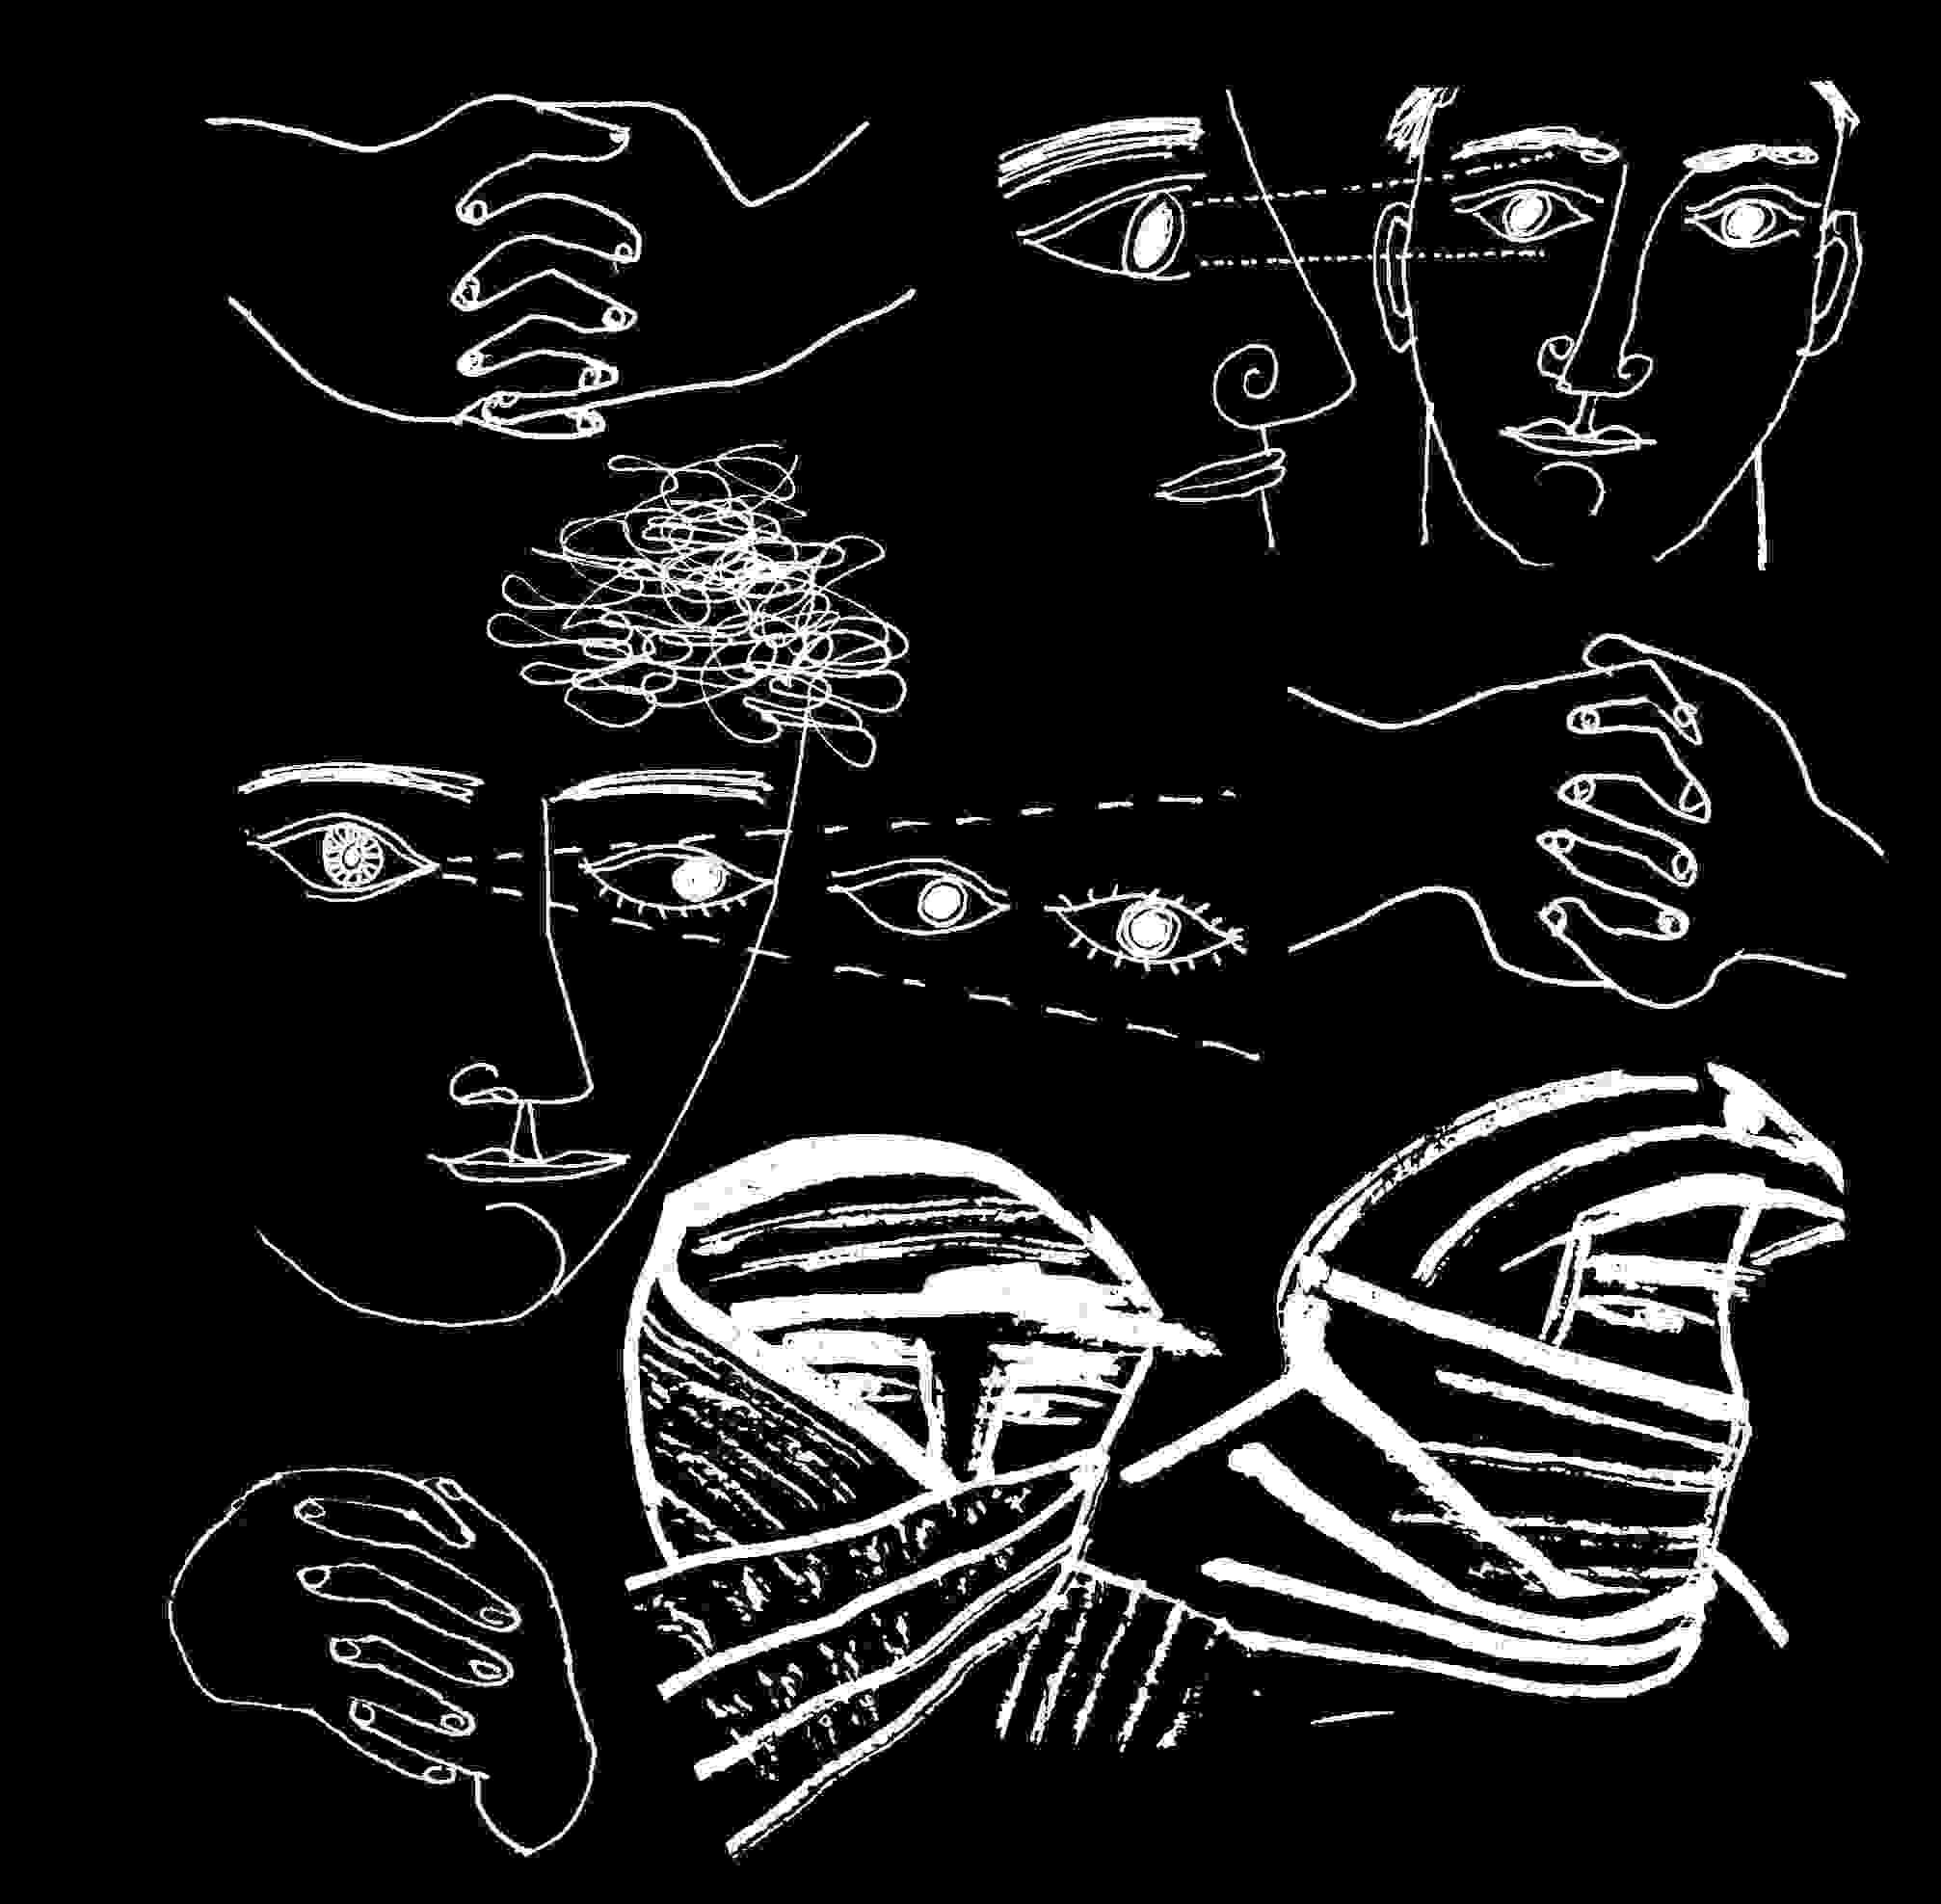
interpreted by the brain and acted upon ⁽⁴⁴⁾. There is as well the host of influences and directions present the minute one enters any commercial environment. Entire societies seem to require "blind spots" or areas of misperception, in order to function, and at least to give power to the initiated or priest class within. In capitalism, the powerful are the rich and within our own cultural examples who would deny that the rich have their own blind spots ? Such areas of ignorance are necessary to any unequal application of power. In capitalist society, these are commercial environments.
In a sense Americans are born into a large department store. One's usefulness to society is determined by how one contributes to the store and ultimately, sales. This explains anomalies such as a population electing a leader who cuts back the people's social services, medical protection, etc.. It is only to the best interest of the people to vote to increase social services, and for representatives who will further such benefits. People vote for the interests of big business for three reasons. 1. Fear; they are threatened with "enemies". 2. They are tricked through mind control mechanisms and deceit to vote against their own best interests. 3. They are, within a perspective of being born into a department store, voting for the corporate best interests of "sales," feeling that if the society does well economically, they will.
In western civilization policies of mind control all seem to employ some threat. Fear is the emotional pivot of capitalism, keeping each of us in touch with the primordial within, instead of welcoming us to the mutual sustenance and care of civilization. We are taught by all social institutions not to share, though Christianity stresses treating one's neighbour as oneself. Conservatism, by refusing to relinquish the primitive sense of me-first isolated survival, was so terrified by communism's loyalty to group survival - that it proceeded to destroy the group at every opportunity.
Of individual mind controls there is some evidence that both Kennedy assassinations involved programmed mind controlled assassins and decoy "assassins" who were either entirely innocent or unwitting; the controls were I think, available to the CIA and military agencies. But controls on individuals require a massive coverup of information and withholding of facts and technical data about mind control and what the governments had done in the past and could do. The Kennedy assassinations required a media and communications conspiracy of silence and misinformation, and cooperation from the entire field of psychology. Those trained in mind manipulation, were more likely to recognize it.
Understanding the King assassination
Information on "Operation Mockingbird" online, is increasingly extensive and challenges the myth of freedom of expression in the United States, with claims of five hundred bought journalists as well as half the country's academics, loyal first to the CIA.⁽⁴⁵⁾ This speaks of directly purchased people. What of those who were simply trying to please and succeed ? What chance did honest minds have ? And what of the naturally good intentions of everyone raised in a department store? And what of all those forced to government support by immigration policies, blackmail, a wish to survive ?
A study of the Dr. Martin Luther King Jr. assassination provides for me the break-through in understanding the assassinations of the Sixties - a subject I've personally worked through and confronted quietly since the assassinations occurred. I had met John F. Kennedy before he became President. I had met Dr. King and later was a march marshal for the people in his and our march from Selma to Montgomery. I was part of the ring of people arms locked about him to serve as a body shield to the anger of a white crowd on entering Montgomery.
In the Seventies and then in the Eighties I sat down to write out the answer to the assassination mysteries - and I was in each case defeated through not understanding deeply enough, the answer. So I read more and researched more. I knew and had written back in the Sixties⁽⁴⁶⁾ that the perpetrators of all four assassinations were at the service of a right wing conspiracy well entrenched in law enforcement bureaus and agencies but I couldn't proceed with anything more direct.
In Dr. King's assassination, for years so much misinformation was presented that understanding could be bent from the obvious. James Earl Ray died in jail, without the trial that might prove his innocence. The man that had initially set him up as the guilty person was identified⁽⁴⁷⁾ as a former Army Security Agency man.⁽⁴⁸⁾ Researching the ASA will yield that it was an out-growth of the Army signal corps - Army Communications - and with a mission of radio communications primarily, but initially encryption. ASA was used extensively in Vietnam - Operation Phoenix and its predecessors relied heavily on radio communications.
Because the FBI's Cointelpro campaign against the Civil Rights Movement specifically targeted Dr. King, and because there is evidence which suggests it tried to force Dr. King to commit suicide,⁽⁴⁹⁾ and intentionally illegally damaged Dr. King and his family and supporters, one can't rely on FBI supplied evidence concerning Dr. King's murder. Serious investigation of his death was accomplished by the Congressional Black Caucus Committee, which found a Memphis bar owner guilty of hiring a policeman to shoot Dr. King. Other leads included a racist conspiracy out of a St. Louis Missouri bar which lead back to Ray. The possibility remained that King was shot by a military unit, and Ray presented as the guilty person instead. As evidence against Ray could provably be revealed as false over the years, another civilian "assassin" was appointed to take his place. Whether the military unit was active duty personnel on orders within a covert military chain of command, or a squad operating on orders from the CIA as Operation Phoenix and its predecessors were then operating in Vietnam - is a question. The assassination of King coincides with his open confrontation of the war in Vietnam, while the FBI's Hoover had him listed for years, as a suspected Communist.
The assassination coincided with the emergence of Operation Phoenix and its legitimization as a military tactic of the Vietnam war. The military covered as tactics of war, acts within a CIA chain of command which had permitted the extra-legal murder of foreign civilians, by US civilian order.
It seems increasingly likely that the assassinations were part of a program of continuing psychological warfare operations which were gradually shaping a new world economic order. In trying to find the source of the atrocities in Indonesia and East Timor, Peter Dale Scott finds evidence of what I think of as CIA signatures, where types of atrocity appear in far flung locales where the atrocity is not part of any local custom. There are headless bodies floated down the rivers of East Timor. As there were surprisingly in Chile under Pinochet's coup. Scott doesn't mention the French torture during its war in Algeria, or in Paris in the early Sixties, how the Seine carried the bodies of Algerians thrown from bridges, or the bodies of whites floating down the Congo River when the CIA and Euro-corporate world overthrew Patrice Lumumba's government. But possibly these might be traced to convenience rather than the primary purpose of terrorizing the population. Since its inception at the end of World War II, CIA operations distinguished themselves through psychological warfare operations whose motive was to terrorize people into compliance with extra-judicial killings. Since a general trauma to the people was the purpose of the murders, assassination researchers may have looked in the wrong place for understanding. They have assumed that assassinations were for the tactical gains one expects from a power struggle, rather than a long term plan to mould the people's world view. In the short term, if honest representative leaders were shot, then the people would be less willing to openly identify with / support them. In this way the US was being prepared for increasingly overt fascism.
The FBI's treatment of Dr. Martin Luther King Jr. was illegal to the degree of being State terrorism. It was under any perspective of international law, criminal. It was under any perspective of American law, criminal. It was also, overtly, baldly, criminal. Through FBI terrorization of him - all people who understood him, and backed him and supported him, were terrorized. The FBI program was therefore a direct attack on nonviolence, on equal rights, on the American Constitution, on Christianity, on black people and the black community. The illegality was perpetuated in the name of anti-communism. It taught a suspension of human rights internationally in the name of anti-communism. There was never any adequate evidence to prove that Dr. King was anything else than what he declared himself to be, a Christian. In this sense, the FBI's program was an American blind spot - a continuing betrayal of its own system of justice, its principles, its people.
The FBI's ongoing program of identifying and levying war against individual American citizens suspected of Communism, was the model and forerunner of Operation Phoenix and its forerunners in Vietnam, Operation Condor in South America and the active genocides in Indonesia, Chile, Guatemala, Bolivia, etc..
The assassination of King seems to be a tactical action of a Seal squad under Navy command or Special Forces squad acting under CIA command, covered domestically by the FBI. But these groups would not have originated the King assassination or the Kennedys'. Tactically, the Army and FBI were allies of King as a patriot who proceeded under law in the South of the USA, while at the time in Africa whole nations were claiming freedom successfully by political or violent overthrow of colonial rulers. FBI harassment of King was either "cover" to protect him (there is a chance that anyone is a government agent) , or a particularly treacherous double-cross of an American hero.
Understanding the JFK assassination
The more we learn of JFK's murder, the more clearly it seems to be the action of a well trained squad. The triangulation of crossfire suggests a standard military tactic. The complexity of silencing so many suggests a military operation. The unanimity with which the press and the media adapted to the official line set by its pacers suggested that there was no conspiracy at all or a conspiracy so deep and prolonged that entire portions of government had to be involved. For this reason above others it was difficult to believe that the assassination of JFK, the first of four, was other than exactly what it appeared to be.
Historically it will look like the people as a group were either evil or embraced the shift of power which the JFK assassination initially brought in. Neither is true. The people of the US were shocked and numbed by the loss of both the leader and source of hope for humanity but also the loss of the people's political power as expressed by voting.
It was I believe so far from the American sensibility to betray the democratic process by murdering a leader, that a domestic conspiracy or act by any other than an insane person, alone, was to most, unthinkable. Then if we think about that we arrive at the extent of psychological controls on Post World War II America. Assassination was so far from the norm that any conspiracy would inevitably be betrayed by some person asserting the norm, and any conspiracy could not have originated within an American people's perspective during the Sixties, with the exception of upper level academia, which in the political, nuclear, medical, and psychological sciences showed a clear dissociation from the common good. And one would except the more obvious dissociations of corporate business and covert intelligence operations.
Even when Lt. Calley caused the horrifying murder of an entire village of women and children in 1968, there was a helicopter pilot and two serving with him who witnessed and reported the massacre from the helicopter, and landed to save the survivors. They betrayed the group's code to stand for civilization. That so many others did not, in an action which mirrored Operation Phoenix tactics so closely, gave some warning of what was happening to the minds of US soldiers in Vietnam under military programming, fear, and the only escape of drugs.
There was no such hero for the Kennedy assassination, at least not among the national journalists on CIA payroll; my own understanding as a writer was that no journalist survived for long without CIA approval. The Army Security Agency would have been necessary as the emergency control on the media and all emergency communications. It was already teamed with death squads operating in Vietnam under CIA command.
Operation Tailwind, a subsequent illegal covert action to kill US deserters and Americans held as prisoners of war in South East Asia, as revealed by Joint Chief of Staff Admiral Moorer's testimony, was under Nixon's authority. It was Kissinger and the President who held direct authority over covert teams, rather than the Army's commanders.
Under Nixon, to effect Seal Squad Covert Operations with teams from South East Asia brought back to the States for specific assassinations, would have required, Kissinger's and or the President's approval. As early as 1963, the control of covert operations teams operating in South East Asia - and specifically the Special Forces, was possibly already routed through this alternate chain of command. The responsibility then for the Kennedy assassination would have been McNamarra's, with Attorney General Ramsey Clark in charge of the hiding the truth. Kissinger had left the National Security Council in disagreement with Kennedy's policies of nuclear proliferation although Kissinger was one of the very few to be in a position to coordinate strands of government. He was in a position to make peace between the military joint chiefs and the CIA and Vice President's forces and JFK's opposition (Nixon and Bush, whom Kissinger later served), to effect the assassination.
What I remember of the days of JFK's assassination was my impression that the military must have been involved. I was a medical specialist in the reserves, and on call for any national emergency. It was strange that my unit wasn't called up that day because there was no way of knowing that the assassination wasn't a direct military attack. Military command knew it wasn't.
Military participation is suggested by the fact that US military preparedness (alert level) was not advanced a single stage as far as I know. So I concluded at least subconsciously that the military was involved at its upper levels. My understanding of the media was still primitive though of the Lower Eastside enough to know media was not to be trusted. Some years later I learned of the Office of War Information and Office of Strategic Services where officers of the World War II ministry of propaganda and elite white officers corps, disbanded by Truman, became the CEO's of media communications or the backbone of the newly formed CIA.
Media accession to the first Kennedy assassination as the work of a single assassin became more understandable twenty years later with revelation of the CIA's Operation Mockingbird and program of purchasing journalists. As it becomes clear how the secrecy of the Officer class was maintained, I've never understood how the enlisted men were silenced, other than by criminal organizations. This difficulty in understanding is solved with a bit of thought about drugs. To the good uses of military and mafia, many soldiers with Vietnam experience were oriented to drugs, and through drug use or threat of arrest for lesser substance abuse, vulnerable to criminal organizations cooperating with the CIA's predecessor in World War II. What became clearer some thirty forty years later was that most drug operations to the States fell under CIA protection which was also responsible for all covert actions in South East Asia, a cradle of the poppy and world's heroin trade. For its covert or "Black" operations the CIA gathered Seals from the Navy and Special Forces from the Army, placing these under its command structure. The covert operations known under a variety of code names and designations such as ICEX or for the purposes of a surfaced designation, "Operation Phoenix," all relied heavily on communications, - usually radio encryption for special forces squads. For intelligence gathering they carried their own trained designated radio man for encrypted communications. But the responsibility for this training knowledge and military specialty lay with the Army Security Agency (ASA), responsible for signals, communications. I've already noted the ASA with reference to the King assassination. Historically ASA's role was hidden and covered. It possibly had some link to the U-2 aircraft Oswald had been assigned to guard as a Marine, but in any event there is no reason to believe that it didn't control emergency communications throughout the States, through early emergency preparedness plans, as well as wherever the US maintained a military presence.
Victories of a Nazi elite
For the assassination of JFK, one can suppose a command structure, a CIA effecting structure, Seal or special Forces squads trained in assassination, and communications controls compatible with the first two. What is lacking in all these is a motive strong enough to overthrow a democracy, to overturn the institutions the country was built with, and which each group represented above was part of. A wide spread conspiracy including so many trusted services and requiring the acquiescence of so many others would be unlikely, unless there were some shared secret among all those in power and in service, to justify such a complete betrayal of the people. It would have to be a secret shared by upper echelons of power yet unknown to and denied the people as a whole. A long standing secret. A dangerous secret and a secret so unpleasing to the people at large that keeping the secret would have to involve a conspiracy.
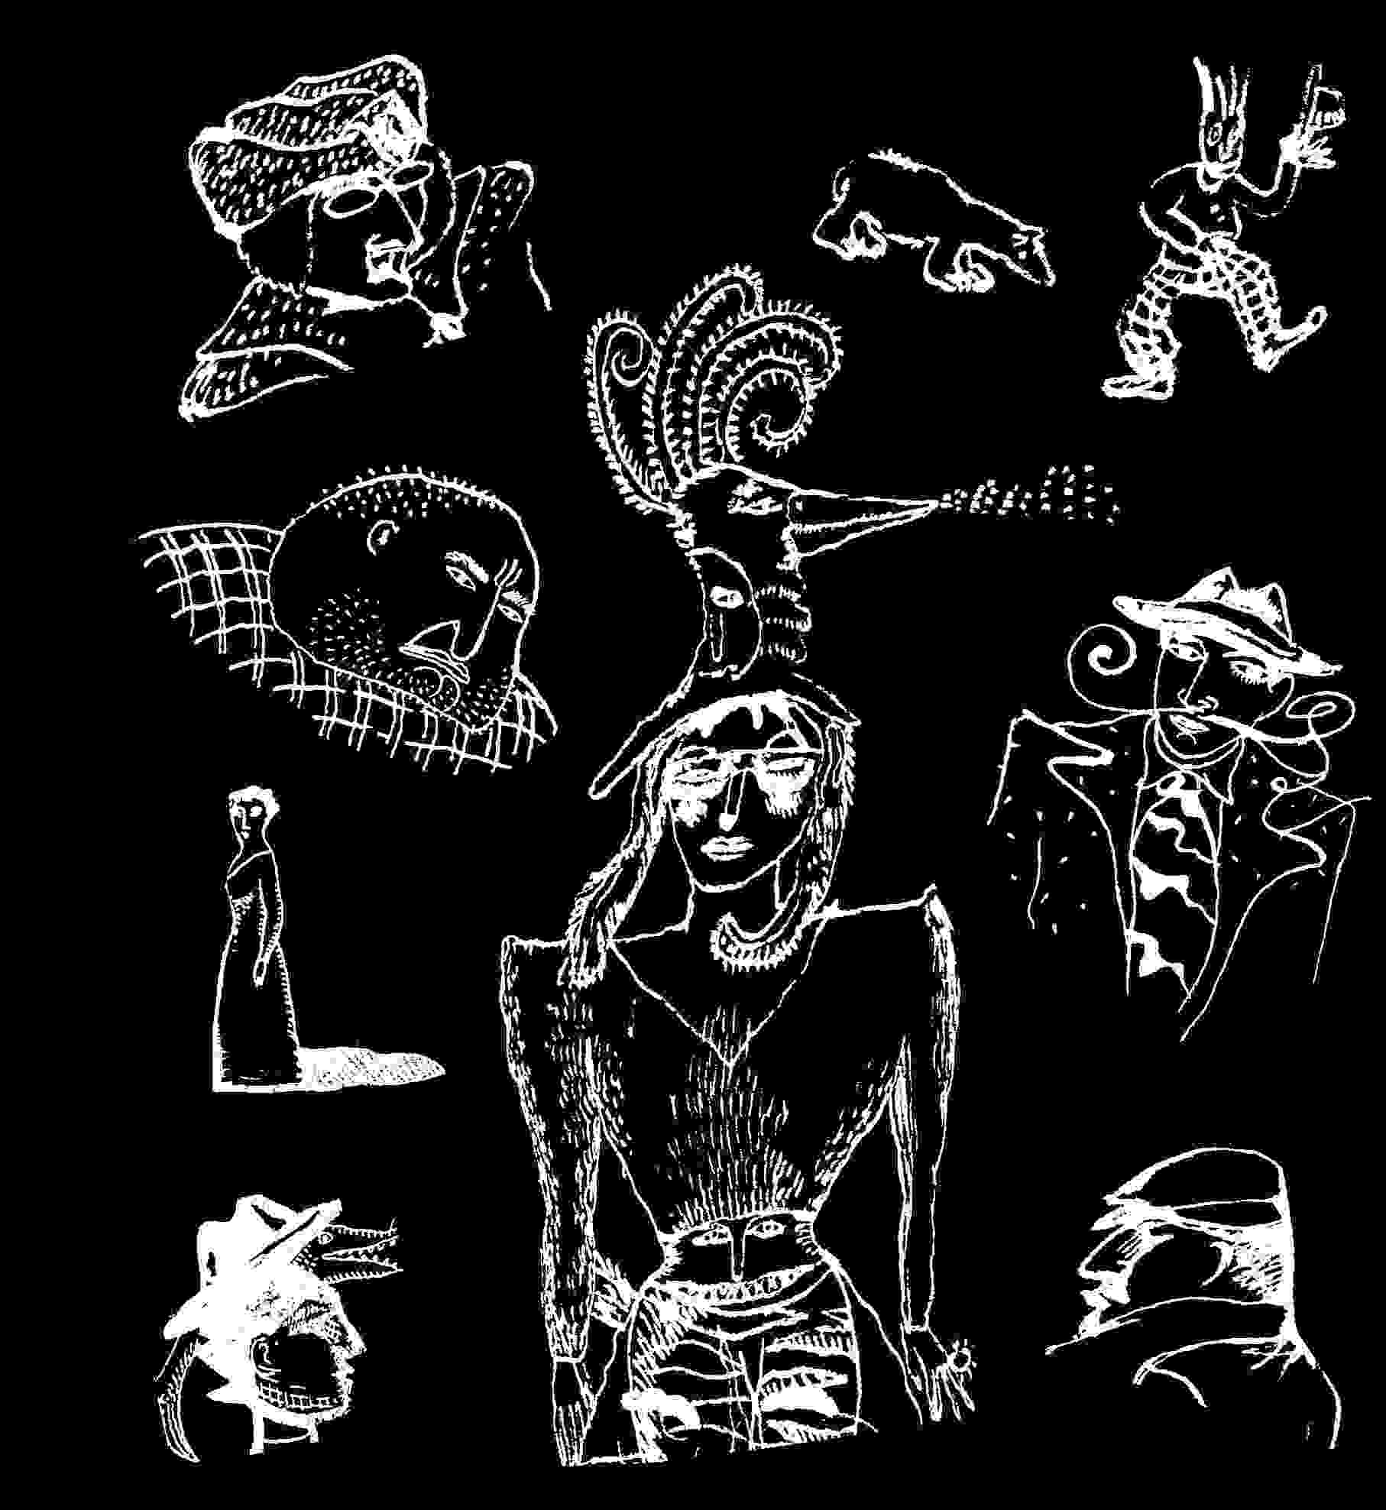
But with all the secrets necessary to the US National Defence, as well as US history and the future, what area of secrets could cross so many professional areas to bind its participants in silence ? So we arrive at the military, scientific, academic, and intelligence communities massive hiring of Nazi war criminals at the end of World War II.⁽⁵⁰⁾ This was accomplished in direct violation of Present Truman's orders, and knowledge, thereby creating an American fascist cadre in opposition to the office of the President.
To scratch this surface lightly, what in fact the victorious Army and Intelligence networks of World War II were doing under US command, was selecting the most talented among the war criminals of the Third Reich to serve the agenda of the victors. The morality or criminality of the human being was rendered inconsequential, compared to his or her usefulness to agendas of further control. From war criminals, the doctors were hired, who had already learned so much from their subjects in the concentration camps. The rocket scientists were hired, simply switching their allegiance from the swastika to the American flag, and their work force from slave labour to government union wages. The atomic scientists were hired, melding easily with the assortment of Manhattan Project nuclear scientists assembled by Vannover Bush. Though Vannover Bush remains a hero to M.I.T. he would probably not be welcome among remaining first peoples around Great Bear Lake in Canada. They were used as porters and loaders of uranium for the first Atomic bombs, and after work found the showers were for Europeans. The new Americans became luminaries of the academic and scientific communities, as if the distinct strain of Nazism, racism, fascism, anti-Semitism, predominant on American soil in the late Thirties, was weakened by the war effort and needed refreshment.
Among so many names of another generation⁽⁵¹⁾ the North American Nazis were frightening in the depth of their ignorance and their choices when presented with that question each of us faces when we try to form our lives: where do we draw the line ? At what point do we refuse to accept inhumanity? We know surely they were there, at the "Third International Congress in Eugenics," (Museum of Natural History, NYC, August 21-23,1932), operating under the "International Federation of Eugenics Societies." To directly quote Tarpley and Chaitkin (the earliest source I know on this): "Averell Harriman personally arranged with the Walker/Bush Hamburg-Amerika Line, to transport Nazi idealogues from Germany to New York for this meeting. The most famous among those transported was Dr. Ernst Rudin, psychiatrist at the Kaiser Wilhemlm Institute for Genealogy and Demography in Berlin, where the Rockefeller family paid for Dr. Rudin to occupy an entire floor with his eugenics 'research.' .....At Harriman's 1932 New York Eugenics Congress, Ernst Rudin was unanimously elected president of the International Federation of Eugenics Societies...." Also, "..on a commission by Frick, Dr. Ernst Rudin wrote The Law for the Prevention of Hereditary Diseases in Posterity, the sterilization law modeled on previous US statutes in Virginia and other states....Special courts were soon established for the sterilization of German mental patients, the blind, the deaf and alcoholics. A quarter million people in these categories were sterilized..."⁽⁵²⁾ American intellectual life in New York City was closer to being Nazi than the future was led to believe.
Starting school in 1945, I was taught everything in the light of a US victory over the Nazis, as though the people of North America were of one mind and one persuasion. In fact, those forming and controlling society were very interested in the uses of the inhumanities which the Nazis taught to the world. They were interested in profit. They were interested in some forms of freedom as an encouragement to their own power. They were interested in their enemy which was not fascism but communism. So they were pleased to turn fascism against communism domestically, as they had in Germany, then internationally and particularly against the Soviet Union. It was as if the West's capitalists had hurled Germany against the Soviet Union in their first strike of open war against Communism.
If you consider the Third Reich's railway stations, each, and each death camp, relied on IBM punch card machines which required monthly maintenance by IBM employees through its German subsidiary.⁽⁵³⁾ IBM maintained expanding operations, and actual control until war was officially declared, which was a relief to its management/owners since under German corporate law the company could be held in Nazi trusteeship during actual war years. US IBM's concern throughout the rise of the Nazis was not the policies of the Third Reich but whether IBM's share of the profits would reach the parent company in New York.⁽⁵⁴⁾ IBM's role as unearthed by the courageous work of so many working with and in cooperation with Edwin Black, is so outrageous that it should change our awareness of who we are, and of the truth and wisdom of our elders, or its absence. Read Edwin Black. Read of Ford Motor company's production lines for the Third Reich. Of General Motors. Read of Standard Oil of New Jersey playing both sides of World War II for profit. Read Chaitkin⁽⁵⁵⁾ whose father prosecuted Prescott Bush, George Bush Sr.'s father, as a traitor to his country for profits aiding the Third Reich. Read of the Dulles brothers who set up both the CIA and the post WWII American foreign policy, and how they primed the Nazi war machine for war, and afterwards poured in millions of recovery aid to protect American investments.
While a generation born during World War II was being inculcated in how victoriously destroyed Nazism was, the machinery of the future was proceeding ruthlessly ⁽⁵⁶⁾, harvesting the fruits of Nazism stripped from the victims in death camps: advances in management techniques, life triage, medicine, aerospace medicine, information, available to those who would set aside their responsibility to common humanity.
The power structure taught and trained me in one perspective while operating within its opposite, and I was just one among millions.
What this did was allow a fairly thorough mind control of one generation by its predecessor. Our parents' generation knew what it refused to yield or tell us. There are still those of my generation who will insist our parents didn't know, couldn't have known and say this because they loved their parents. But surely mid-Century New Yorkers knew of the Harrimans. The political, academic and economic strength of America's home-grown Nazis was never mentioned after World War II, nor taught the children. The difficulty was not in the little mysteries where honest men and women lost their lives in ongoing objection to fascism, but that the Nazi ethic was so deeply embedded in the American system that the price of power, inclusion, of gaining wealth, of being happy, was silence about how it worked. It was a silence more virulent than racism, and rationalized and supported by anti-communism, but in its partial hold on truth, a criminal silence. Its matrix was the cement of racism. The US Armed Services were largely segregated in World War II, and this was particularly true of the officer class, and therefore the OSS, OWI and other intelligence and special operations services which formed the postwar controls, had little understanding to be anything but racist.
What they knew was the strength of Nazi control mechanisms in the States, which survived World War II. There is no way they couldn't have known. They didn't tell others. It is likely that John Fitzgerald Kennedy was dead the instant he was elected to office.
Information management as terrorism
What became clear in each of the successive assassinations of the Sixties, was the importance of the information that reached the public. As a writer in the early Sixties, I was aware of "controls" on what could be published, but ascribed this to simple codes of anti-communism, class to some degree, and the racism of the day. Aside from the Black community, amid the professional classes there was little objection to strident racism until 1960.
Then the push for civil rights for American Blacks, mild compared to independences in what was once colonial Africa, became a public education in the States. But it was an education parcelled out by the press. Because we lived and grew up under the myth of a free press, I never considered the possibility of serious overriding controls of the media, until the Nineties. When I was excluded from publication myself, I thought I was personally at fault. Eventually, I began to realize that some areas which were necessary for the people to consider, were banned from discussion.
An interest in the first Kennedy assassination reveals one clear point - information which should have been verified and shared with the people, wasn't. The areas of this breakdown in communications, are consistently points of background involving government agencies and particularly mention of CIA programs. By what goes unsaid in the media you can begin to formulate by default, what was being hidden. There would be no certainty that something was intentionally hidden if it weren't for recurring similarities in the four assassinations of leaders. The first was that the assassin of each was either not found and verified as the assassin, or found and convicted by ignoring large areas of information and evidence. Aware at the time of the assassinations, and intensely concerned, over thirty years later I am still not sure who the specific assassins were.
Because in fact the people don't believe the assassins were correctly identified by law enforcement, the assassinations became a threat as a control of the people. The threat says most simply, we can kill and get away with it - look what happened to those much more popular and powerful and better loved than you: JFK, RFK, Martin, Malcolm.
It is classic terrorism.
The information controls rested in the hands of groups created at the end of World War II to manage public thinking by psychological warfare operations. They were in league with the CIA and Defence Department but apparently separate and not responsible to either. Their primary mission at the time was supposed to be anti-communism, which increasingly meant defence of covert fascism. There was so much to reveal of democracy's glory, but there was so much to hide of capitalism's necessities. How could an army of German war criminals respected in their fields by those who would bring us the crimes of our future, have hidden in the US atomic program, space program, rocket sciences, space medicine, computer sciences, and all attendant university programs and government funded laboratories - without fairly absolute codes and rules requiring silence about them ? Certainly in other areas of academia which employed the Nazi intelligence operatives, the manifestation of Nazi thinking must have been evident. It was possibly most easily covered by a left wing liberal - as far left as one could go without actually being a communist, a political stance which was the keyed in position selected by the CIA for its arts and humanities funding.⁽⁵⁷⁾ It was the preferred position of the university professors funded, boasted of as half the US academic community, but funded by an organization prohibited from operating in the United States itself. How great would the percentage be then, for professors beyond its borders ? It was also the preferred mind set for the journalists, bought outright or kept in the CIA pockets by other means. Because these "other means" are the most effective ones they aren't respected by innocents or the young. They become known through participation in crime, or group bonding, or deep consideration over long periods of time. It's probable that Nazi war criminals once in the States, adopted left wing profiles, so the left wing became a treacherous place for Americans who genuinely cared about humanity.
So it was as though our elders - for those of us born American during the years of World War II - were waiting for us to show ourselves as anti-fascists to be manipulated leader after leader and friend after friend, into positions of political declaration which would assure our deaths when the fascists took off their masks. It is as if the machinery of society was itself a steel trap at the sole service of the corporate rich which would kill off their opposition for asserting simple decencies.
Which is why one returns to thoughts of Operation Phoenix, ICEX, or however the offending agency wished to label the programs which were conceptually an extension of Nazi insistence on identifying each and every Jewish person as a prelude to labelling and attempted extermination. It was an extension of the driving force behind the FBI under Hoover with its need to identify all communists when the file numbers went far beyond any membership of the US Communist Party to include people listed for thinking with any freedom.
The entire program of training death squads for intelligence gathering and extermination duties in South and Central America was also Nazi. These were programs within a normal expectable progression of Third Reich military tactics against civilian zones and occupied territories. They were not acceptable under any common US ethic, and particularly when the US wasn't under attack. So knowledge of such operations and the US role instigating them, was withheld from the public, hidden from the people exactly because it was Nazi.
Colby places the inception of extended intelligence gathering to identify communist leaders - the purpose could only have been from the start, for execution, as early as 1962, when the first Australian and US Seal teams moved into the Cambodian Laos Vietnam regions with their "black operations."⁽⁵⁸⁾ I've pointed out that the covert programs' inception coincides in force with the Kennedy assassination, while its official phase in Vietnam coincides with the other assassinations. What can't be ruled out is killer team tactics in the four assassinations - particularly JFK's, and probably King's. This would explain why four assassinations of leaders of import, have remained essentially unsolved, and clarifies their intention as a psychological warfare control of the American people.
What the Nazis agreed on
Aside from the long list of murdered witnesses who might have testified about aspects of JFK's death, the basic terrorization of the people by the government relied on law enforcement cooperation and civilian media cooperation as well as upper level State Department and military planning. The only pre-assassination common element of those in opposition to the fallen leaders, may have been their secrecy about Nazi inclusion in US military and covert programs, and the scientific, academic, intelligence and medical communities. The common need to hide the extent and depth of Nazi involvement is the one facet of American life large enough to assure the establishment's cooperation in hiding the truth. The conspiracy already existed for another purpose. All four leaders threatened fascism's hold on an unwitting public and so they were killed.
Entire portions of the people they represented were also killed. If the previous generation accepted and welcomed Nazis into its power while teaching its children of Nazism's horrors, those children became the Vietnam generation and were purposefully placed in a criminal war which destroyed the fighters, tried to break its moral purpose, isolated it from international law, murdered its leaders, and selecting out a power group of those who would cooperate, a group of collaborators who would assure continued profits.
Long range planning to avoid revenge
Why would anyone want to cancel out a generation ? It helps to examine the patterns of controls in actions of those trained by the School of the Americas. Throughout South and Central America merciless policies
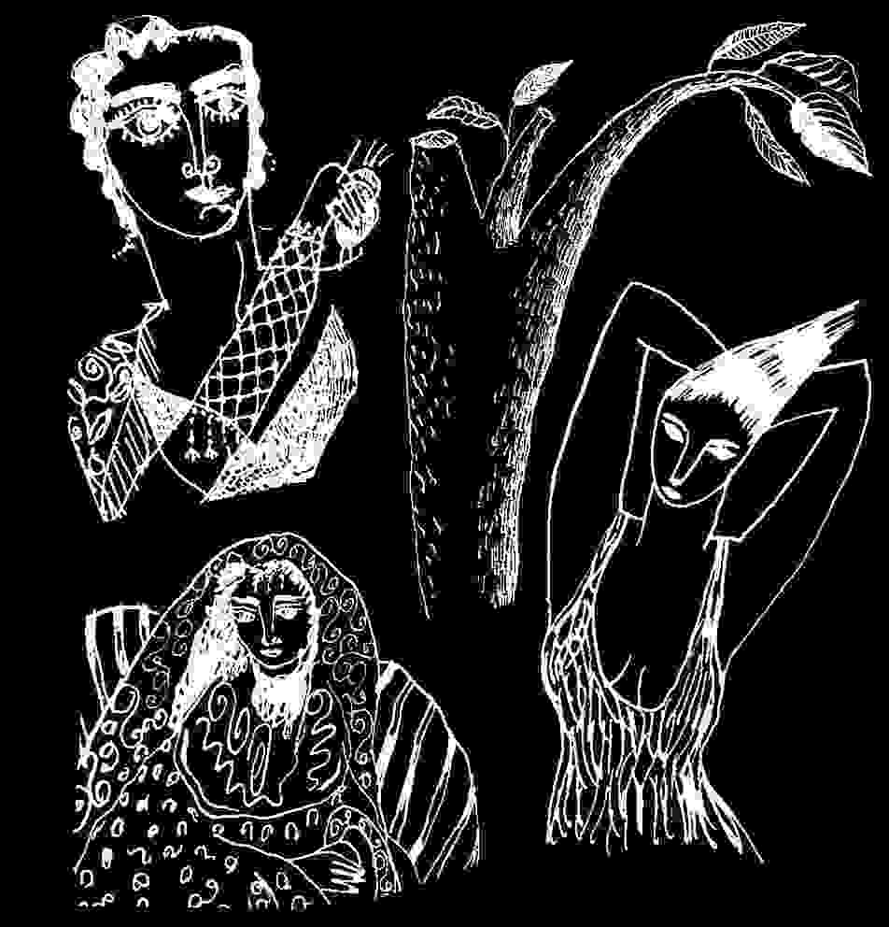
toward children were viewed as a preventative culling out of future guerillas - when the children were of poor or radical families. The School of the Americas policy might be put most baldly as "preventive murder", to assure there would be no communist challenge in the future, or terrorist challenge, or people's challenge. In tactics of omerta or other Western vengeance, the children are at points killed so they cannot avenge deaths or terminal insults to their parents. Was the war baby generation knocked out then, in fear that they would avenge some terrible wrong to their parents ?
In America, these parents were spared invasion, and spared the bombings and deaths of their families. Less fortunate were those in Europe, the Soviet Union, Nazi occupied countries, Germany and England; these lost millions and millions of men, women and children. Those who died weren't simply the six million Jews in the Holocaust, nor the millions of communists and others caught in the Nazi's death machines - but millions of civilian casualties and soldiers of both sides. And what of Japan and China, Vietnam, Burma, civilians and military as well ? The amount of pure death was substantial.
For the Americans who survived there were the benefits of victory. For most this was translated into economic benefits. For North Americans it was a trial of only some of the men, but what if, as the overwhelming victor of World War II, the US power group was responsible (this is, I think, an essential suggestion of Joseph Heller's Catch 22) ? What if World War II was a US elite's attempt to crush communism ? What if World War II were encouraged so Germany could be used as a defence against Communism internationally ? Would a generation raised in anti-fascism, get in the way of the campaign against communism? If those who fought against Nazi Germany were betrayed by the inclusion of the most criminal Nazis within the US institutions - would the next generation have been crippled to be sure there was no vengeance for the double cross ?
One double cross was from the US controllers of big companies who profited from both the German and US Allied war machines. For example if the management of IBM ⁽⁵⁹⁾, Ford, General Motors, Standard Oil - the directors of those companies double crossed the US, and its Allies, they double crossed the Axis powers as well, and all of humanity. Yet their efforts were a strong part of the US economic machinery. In one sense the post war double cross by the US military and State Department in hiring upper level Nazi's and known war criminals, covered a primary crime of capitalism. It is an entry level crime. It is precisely because it is not a crime under capitalist code to profit by selling to both sides of a war, that the system shows itself to be criminal. The benefactors of this crime which encouraged the murder of both Europeans and North American men were the ruling groups of North America.
Anti fascism was apparently a threat to be wiped out, on par with communism. By keeping this secret, capitalism encouraged a generation in lessons of anti-fascism - instructing us in the horrors of the Holocaust's six million, to make us overlook the murders of thirty million others who died in the war, to serve the profits of corporations owned by the very rich. Black among others suggests that the German war machine was financed by US investment funnelled by Dulles into Germany to help it recover from ruin in World War I.
Hitler the criminal then, was simply the standard criminal, of a type that has proliferated with the US School of Americas (with its recently changed name). He was a basic trainer for the world. With the entire Nazi machinery he served the profits of others, without understanding fully his own evil, his human failure, which was hidden from him by a philosophy and code formed and defined in service to a single empowered privileged group which would try to gradually gather the world's wealth. It varied from the policies of pure capitalism in that Hitler's concept of an elite was a racist elite, while capitalism forgives racial difference if it pays enough. Neither understands its own selfishness, nor the finality in its self severance from humanity.
Can you imagine how North America's veterans of World War II would have reacted to the deaths of so many millions more than the death camps, if they learned that singular American power elites were profiting from both sides of the carnage ? What if they learned that US owned German corporations were financing the takeover of countries and ultimately the slaughter of US soldiers, among others. There was a secret there, compounded by the outright hiring and protection of the most criminally insane of the losing side, so they and their expertise might be used against yet more peoples.
The elite's game plan was unacceptable, so it was hidden.
In writing of Nixon's rise to political power, the brave Mae Brussell, finds a connection between his work for the Navy Bureau of Aeronautics which was said to be concerned with aircraft firm contracts, and another Navy project: "That year was 1945, when importation proceedings began for the 642 nazi rocket and aerospace experts and scientists from Germany to the US Through the generosity of the Guggenheim Foundation they obtained a suitable site - a huge medieval castle built by financier Jay Gould on a 160-acre estate at Sands Point, Long Island. Here the Germans began work on a secret project for the Navy's Office of Research and Inventions."⁽⁶⁰⁾
My generation couldn't have accepted such deep compromises with nazis. Its fighters were thrown into a useless and self debilitating war in South East Asia. A portion was purposefully wasted by drugs. Another portion was extinguished through poverty and its often blinding anger. Some tried to work within the establishment. Some accepted the privilege of power and have only taught silence. But if everything were as clear as this, remedies would be simple. The difficulty is that many of the rich are innocent of capitalism's ruthless decisions, and only accede through lack of alternative. Alternatives have been extinguished for this reason. Choice is removed so that succeeding generations will believe that the capitalist reality is the only reality - shifting an entire spectrum of political thinking to the right, simply to protect the crimes of a very few.
Operation Phoenix as just another tactical genocide
The central lesson which emerges from the US War Crimes Hearings that Congressman Dellums conducted in 1971,⁽⁶¹⁾ was the corruption at the officer level in the field during Vietnam. Their obsession with body counts was a practical attention to their means of rank and advancement. But because of it they bartered humanity for the deaths of civilians to augment their "kill." They did this knowingly, and their work was directed by policy, enforced by the demand for body count, and buttressed by the training of troops, propaganda, dehumanization of the Vietnamese people, lack of respect for Vietnamese lives, compounded by the lack of respect for US troops, their lives. The avarice for body count, could be converted fairly simply to pay raises but more than that it seems the affirmation of an ethic which may be unique to capitalist structures where responsibility to the group, to the people under one's care, to morals which sustain long term survival, are coined for self advancement as if that is the nature of the game.
What this suggests is that the military created a war machine in Vietnam which would have little resistance to committing atrocities. The need for "body count" encouraged the murder of civilians. So "black operations" and the continuing terrorization of civilians by the US military, could be sustained in the field by a norm that supported inhumanities.
Operation Phoenix then, although it was a program applied specifically to South East Asia, in its manner of operating, in identifying and murdering civilian leaders and civilians, there was a familiar terror. We saw it before in Nazi Germany, in Poland, Austria, France, wherever the Nazis took over (and as recent excavations in Poland show⁽⁶²⁾ , sometimes to the joy of the local populations). We've seen it since throughout South and Central America, this phenomenon of military or vigilante round up at night or arrests where the victims are tortured, killed, judicially killed or extra-judicially killed, never seen again. We've seen it wherever the School of the Americas extended its trainees' reach. We've seen it in Indonesia, in East Timor, throughout former Yugoslavia as the World Bank asserted its control. It is terror and it is the key to capitalism's expansion. It is an evolved, tuned, relatively evil piece of work. It requires academic dissociation - the break between thought and feeling - so that morally painful things can be rationalized; it manipulates the spiritual need and impulse of humankind into controls for acquisition of capital; it requires Western civilization's codes of loyalty and order, subservience, duty, honour, be manipulated with the tools of modern science. Above all it requires the ignorance of the people.
These reflections present problems I haven't been able to answer for at least thirty years. My interest is what made us this way. If you consider Operation Phoenix an illegal reign of terror, murder, assassination against a third world people, and then consider it within contexts of ongoing CIA policies, and know the lists are still being made and are always made, and consider it within the contexts of the Third Reich, the Holocaust, how is the murder of peoples who are unpopular, or idealistically committed, any different ? How do you differentiate the brutalities of capitalism's Operation Phoenix from other kinds of tribal massacres which we recognize as primitive and criminal, or the Holocaust, or previously the Turkish massacres of Armenians, or King Leopold's decimation of the Congolese peoples which continued with the 20th century's refinements, or the Hutu Tutsi civilian warfare in Rwanda?
There is a longstanding political crime occurring - a genocide against people with a singular view of humanity and social responsibility which we've called communism. In South and Central America, in Operation Condor, in Pinochet's Chile - crimes against humanity which found their inception in the think tanks and controls of our language group - one did not have to be a communist to qualify for the death list. It was enough to be anti-capitalist or anti-fascist, or in the case of the Chilean Allende's supporters, believers in and proponents of democracy. Whether Operation Phoenix occurs in Vietnam , Malaysia , East Timor or South and Central America, or in masked and Balkanized forms in Central Europe, or conceivably Dealey Plaza, it is all basically Operation Phoenix: a list of known and suspected Communists or other anti-capitalist group with some resistance to international banking. A rounding up of the listed people; their murder; sometimes this is accomplished without rounding up condemned suspects - as shown by former Senator Bob Kerrey's Seal team raid in Vietnam;⁽⁶³⁾ sometimes the victims are simply confined to ghettos, like Palestinians, where it's easier for death squads to enter and assassinate the political cadre; the entire State of Israel presents its own parallel.
It is a durable program: 1, identifying suspects and putting their names on a list; 2, providing the military with the lists; 3, rounding up the listed or assuring military access to them; 4, the murder. Each of these steps along the way is a crime as part of a larger crime. It is the standard pattern of extra-judicial murder, sanctioned, put in place, and activated. Because these steps are part of a program, the outcome is always the same; the outcome is always criminal; it is always a crime against humanity; it is sometimes a genocide; we must realize that any step along the way is part of that process and is implication in a crime, and complicity in a crime, collaboration with a crime, and whether or not it seems possible for justice to ever be restored - eventually it must be understood as a crime. To maintain our humanity we have to commit ourselves to interrupting the crime at its early stages.
Emergency management planning
Different incomes isolate people within specific information groups. US working people and the middle class were not aware of Operation Phoenix until it was discussed by the Church Commission.⁽⁶⁴⁾ Informed groups of US civilians, ie. university professors, and some were moral people - WWII officers, serious anti-fascists, humanists, if confronted with history's records of Operation Phoenix would have condemned it. But if errors of policy, the sometimes terrible mistakes of a political system, become institutionalized as an operative crime, then life cannot be business as usual. Once you foresee and expect the crime, you can't simply hope for change. You have to decide your relationship to the ongoing crime.
What we know in 2001 about emergency planning under the US FEMA (Federal Emergency Management Act) and the Civil Disturbances Acts, are A. that if we reveal anything about them we become liable to being put on the list. Under emergency procedures we could conceivably be shot according to the discretion of the local Army commander.⁽⁶⁵⁾ Bits and pieces of procedural guidelines are emerging from Freedom of Information Act Requests. As US society has moved surely to the right which I believe was the intention of the assassinations in the Sixties, and as power was more surely transferred to the elites, preparations were made which parallel this stripping of power from the people, with ways to control objections and make claims on what belongs to the people. So the Federal Emergency Management Act and Civil Disturbances Acts provide all means necessary to suppress mass protest by the people. These outlaw Constitutional rights. The acts provide whoever is in charge of the machinery of government, absolute authority, denying all citizens human rights. The Acts permit extra-judicial killing, separation of families, group incarceration, concentration camps, and suspension of habeas corpus. The tools are there for a ruthless suppression of dissent or any attempt to balance unjust authority. The language of the documents as revealed shows a familiar bias against "non -conformists" who can be specifically targeted for arrest and internment, as well as "dissidents," dissenters, and those who question authority. None of these targeted categories suggest that criminal acts are required for arrest or death.
The recent "USA Patriot Act" as part of an ongoing program to strip powers from the judicial system, is possibly providing a way to implement the next stage of what is basically military control.
My understanding of available material on FEMA is that the targeting of emergency management victims is specifically aimed at anti-fascists. It favours right wing forces of law and order. In other words it is a political rather than non-partisan public service. So it suggests a takeover of a democracy by direct threat against necessary positions of opposition within a democracy. It removes "freedom of expression" from the US Constitution, providing the State with a means of retribution against an individual's political beliefs. So the people are afraid to speak out against the Civil Disturbances Acts. They are afraid of being placed on the lists for internment. 2. They are afraid of being murdered outright, as their leaders were. 3. They are conditioned by the US media to be more frightened of dissenting groups or legal political protest, than they are of a total suspension of civil liberties.
Historically what happens is, violent dissent is created and orchestrated by government agents, so the majority of the citizens will say all troublemakers should be arrested. As everyone's normal rights are gradually suspended, the government's power increases to award wealth to its friends.
Under Emergency Management and Civil Disturbances Acts are any legal limits at all placed on those who suspend the peoples' rights? Why do governments need the right to entirely suspend a civilian population's human rights ? These are rights which were not given by the government.
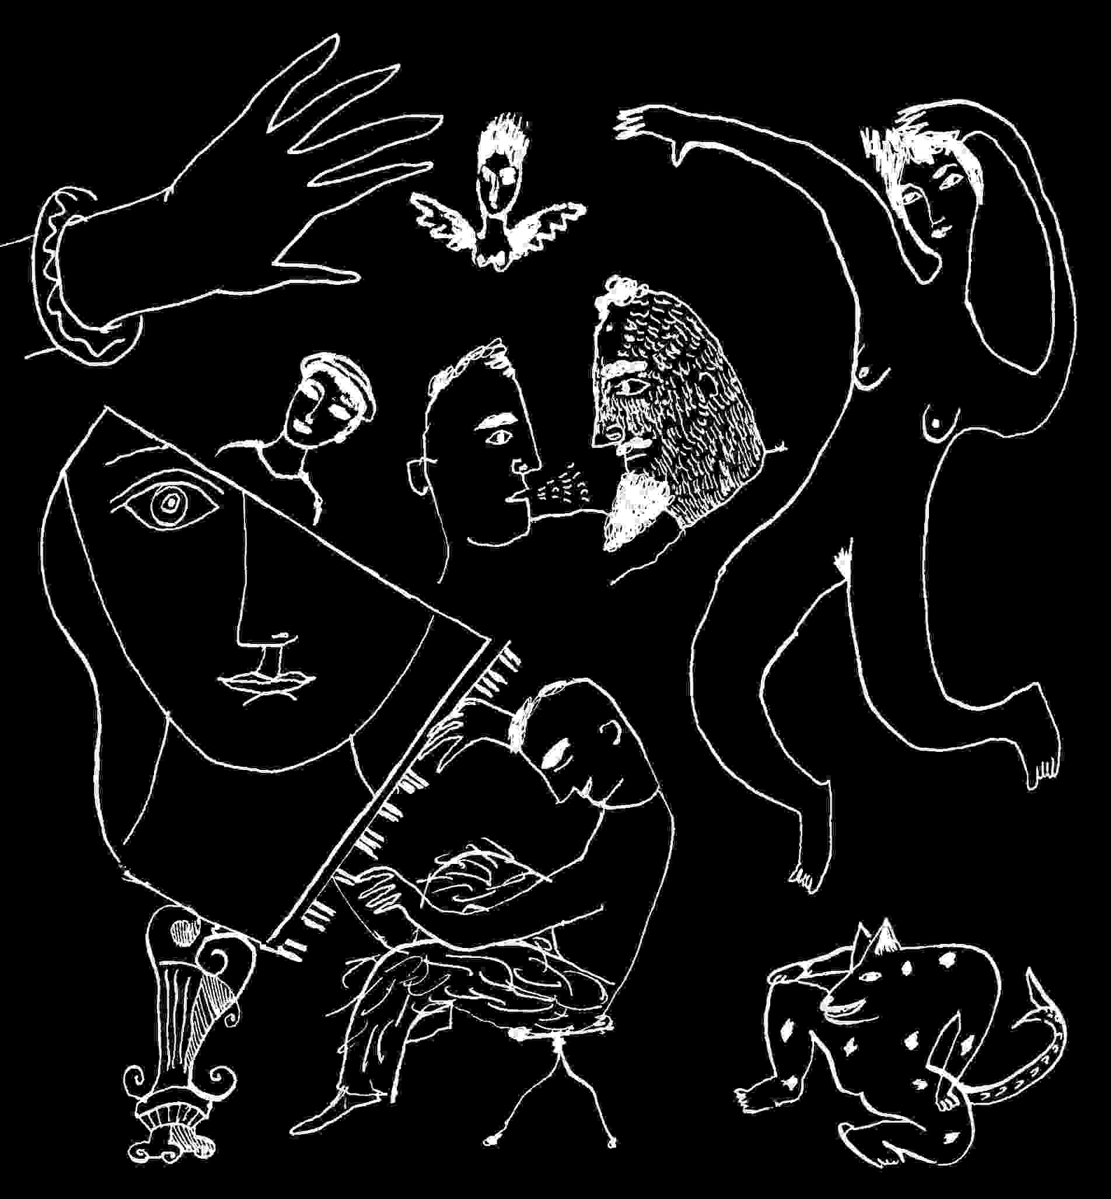
Emergency management acts are unnecessary for people respond-ing to a natural catastrophe. In a natural disaster people look to their elected government and its authorities, for help. Even in New York City, everyone volunteers to help. If emergency acts are meant to mobilize a population under attack, they would first assure the population of its rights and of the government's first responsibility to its people. But US emergency management and civil disturbances acts seem to have as their sole concern, an imposition of rule by force on a civilian population; in a democracy that is a crime. So no wonder so much of the emergency management materials are kept secret.
Human rights exist whether any particular government tries to strip them away or not. They exist because we are all human beings.
The United Nations compromised itself when government representatives agreed to include provisions in a number of the basic human rights texts, allowing abrogation of some rights which leads to the abrogation of others - in times of a country's national emergency⁽⁶⁶⁾ . One mistake was in insisting that power is imposed from the top down - rather than rising from the people. Another was in supposing that a government would not create a national emergency in order to effect illegal policies.
Take the issue of forced labour. The United Nations allows this option in civil emergencies. The US FEMA/ Civil Disturbances Acts allow this in declared civil emergencies when these acts come in to play. Yet there is no excuse for it. Any nation which has forced its citizens by law to work as slave labourers, has done something wrong, and by this act would commit a crime against humanity. Most simply if there is a need in an emergency and the people refuse to help or volunteer, it means they are oppressed. If forced, then they are made slaves.
What is conspicuously absent then from US emergency acts is any mention of the rights of the people - the civilians, from whom the power to make such acts was taken. The powerful have the means to pass or interpret some law to say that this power was taken away quite legally, but it is nevertheless a robbery and without reasonable need, except the obvious need of a small elite to oppress. No government in this new century can protect its land and society by forcing its population to slave labour. Or interning its minorities or dissidents because of the way they/we think. In other words the Acts are a purposeful and conscious threat to all the people. I think it is unwise to threaten a people with all the ultimate injustices known to humanity, simply for better business advantage. Particularly when the people founded the government to assure them freedom.
As I understand it, it is a threat that offers no quarter and imposes no limits on the military's actions. It offers no recourse. So it is clearly fascist. I do not know of any system of political power which claims the right to absolute power over its people, that isn't totalitarian. Every other political system has had to factor in the possibility however remote, of revolution - the people's final refusal of unjust rule or policy.
So those who have drawn up emergency acts and placed them into law are mistaken, possibly guilty of taking over the people's power without mandate, and possibly guilty of hiding this from the people. It is hard for us to believe that they intend to harm or frighten the people to the point of terror.
The difficulty is history. And the difficulty is "Operation Phoenix." It is the history of Colby's agents collecting the names of Communist cadre throughout South East Asia so these could be turned in to Army units. What innate racism makes us think that as North Americans we are immune to these terrors? To repeat, within the US, J. Edgar Hoover began the same procedure of identifying and collecting the names of suspected communists in 1948 and the lists were expanded to include databanks of all people who were outside a fairly strict right wing if not Nazi parameter during Vietnam. Under Nixon, Army units were permitted to spy on civilian citizens within the States. So in fact the same preparedness for identifications, location, internment or covert apprehension and death - which we found in Chile, Operation Phoenix, East Timor, were and are set up within the United States itself and on a path that is currently chosen, would be allowed application under law.
The weakening and possible abrogation of the "United Nations Convention on the Prevention and Punishment of the Crime of Genocide," coincided with the development of the US Emergency Management and/or Civil Disturbances Acts.
The "Reservations" - "Declarations" and "Understandings" made by the US at its ratification of the UN treaty, make legal loopholes by which a nation which wished to commit genocide might be spared the Convention's punishment. Or deflect it. The US has offered the same ambivalence on partnership in the Rome Treaty for the International Criminal Court, and by signing may simply have signalled its commitment to maintaining control of mechanisms of international justice.
What I'm suggesting is that the US State Department has developed a threat against the American people among others, a way for the government to find a portion of its people "missing", and escape repercussions at international law. Why would it want to do that ? Because of its history for forty years of instigating genocides against other countries with minorities, and specifically against people suspected of communism, and because the US has compiled its own lists of its own suspected communists, dissidents, and nonconformists, the possibility of a domestic genocide is there, suggesting the intention of genocide on the part of the political leadership which put it in place. So there it is. I didn't ask to be aware of this. I see no personal gain writing this. Simply it would be wrong to understand what I understand, and not share that, so we all as people might find a way to deal with what threatens us.
The threat of genocide under US emergency management
If society moves ahead as it is, without radically reforming corporate capitalism, without distribution of wealth, without jobs with rights, then the result will be a continued genocide of the poor. That is happening now. It is a continuum, a corollary of capitalism, yet always disguised in other perspectives. Capitalism is simply legalized abuse of humanity at its best, and mass murder/genocide at its worst. As wealth becomes increasingly isolated in a smaller percent of the population, the means of protecting this wealth will become brutal and more and more criminal. If its acquisition is criminal, its maintenance will not suddenly go to church.
Since most people would privately agree that arms sales to both sides of the same war is a crime against humanity, profiteers wouldn't show profit if modern democracies represented the people. So criminally acquired wealth is inherently criminal to protect itself, which might clarify our thinking about the Third Reich. A people's government requires neither storm troopers nor concentration camps. Nor wars nor accumulation of foreign wealth. The Third Reich required heavy machinery of protection - from its own people, it was protecting invest-ments of American wealth - extra-legally in terms of World War I treaties forbidding Germany's rearmament. It was protecting as well its own industrialists' wealth, and portions of Europe's.
What historical example suggests for the future is that the distillation of extreme wealth will be accomplished - 1. by diminishing the actual numbers of people, particularly in the Third World countries; historically that has been accomplished by war, plague, deprival of local production of food; 2. by driving more people into poverty as a prelude to existence without human rights; 3. by increasingly isolating people from each other so they/we can't work toward or protect common interests; 4. by increasingly isolating government from the people; this is done partly by high government salaries, "buying" elected officials into representing the interests of the wealthy rather than constituent poor, and encouraging control of the people for the benefit of trade; 5. by increasing control of information so the sensibilities of the wealthy don't suffer from the effects of their policies.
Within this perspective, race or minority specific diseases such as AIDS or Ebola in Africa, appear to be warfare agents rather than sudden coincidence. Similarly the uses of genetically altered materials in foods without knowing their long-term effect, the exposure to electromagnetic radiation fields, as well as to various kinds of radioactivity, all lessen the number of people which wealth might have to contend with. Where these are knowingly applied against a grouping of humanity - there may be some recourse for humanity in the Convention on Genocide.
The lessons of Operation Phoenix and its fellow CIA programs throughout the past century are that the US can no longer make serious claim to care for anti-fascism. All aspects of the society, as well as the literary, art, cultural, and entertainment worlds are subject to the threats of terminal incarceration without rights - at the discretion of a President who might declare a National Emergency that gives local military commanders absolute authority. You might understand why US Senators and Representatives would vote repressive legislation as an alternative to losing any legal authority.
An immediate difficulty is that current US policies against third world countries weaken domestic defences against genocide. The defences have always been in question or the sterilization of so many First Nations women would never have been accomplished in the Seventies and Eighties. There is and would be at least moral resistance to identifiable genocide, but the ways to legally counter genocide are in doubt. There is technically a law against genocide on the books, but my experience is that it is impossible for individual citizens to bring any laws against genocide to bear on the policies of the United States. It isn't only that you are up against the full force of capitalism but against the fabric of a society formed in part throughout all the Americas by the genocide of its First Peoples.
Individual lawyers can't stand against corrupt police interests, much less government conspiracies to deal arms or drugs, mount covert operations, or commit genocide, which is why international application of the Convention on Genocide is necessary, and why the US has blocked its direct application domestically, except where the US government permits. And even if someone tried to use the US domestic genocide law to limit FEMA procedures, the Army would probably use the legal defence that domestic laws are specifically suspended and replaced with military authority when emergency management procedures are in effect.
Domestic laws against genocide in both the US and Canada, prove to be something of a puzzle, since they are there but everyone pretends they aren't. Under the US Code the law defines the crimes as the United Nations does.⁽⁶⁷⁾ As far as I know, Canadian extant law on genocide is currently confined to advocating and incitement⁽⁶⁸⁾ . However I am not a lawyer. Canada has accepted, signed and ratified the Convention on Genocide without reservation, and I would hope that any direct breach of the Convention, domestically, would be dealt with under domestic law which has a keen sense of international law. Yet in both countries, in practice, the individual's moral defence against genocide finds no representation that I know of.
Domestic laws against genocide, and international law against genocide, have had no effect at all on the United States or Canada's involvement in the documentable offences of genocide, mutually attended in Iraq, or Serbia. The current bombing of Afghanistan at a point when its people need massive humanitarian assistance to survive, may suggest that the Convention on Genocide is being ignored.
Since the machinery for domestic genocide is in place, since information gathering aspects of Operation Phoenix have taken place in the US, since there is some likelihood that the assassinations of the Sixties and betrayal of democracy were accomplished by Operation Phoenix directives, since US military and CIA policy (despite President Truman's direct orders) purposefully recruited Nazi war criminals to serve their own interests in numbers more vast than anyone previously imagined, and since covert war programs throughout the Americas can be provably traced to CIA direction and School of the Americas training, and since these would be declared deeply criminal under international law, the perpetrators will try to find non-legal, non-judicial protections which are likely to involve more war crimes.
Since all these conditions pre-exist, and with a machinery for genocide constructed and enforceable within the US by its Civil Disturbances and Emergency Management Acts, and since application of these is eased by new "anti-terrorist" legislation, and since the minds of the people are increasingly subject to techniques of information warfare which hide the truth and bend democracies to corporate rulers' needs, we should recognize that there is a threat to the entire people, consciously created so that there is no recourse to law, so the threat is specifically the US government's threat of genocide against its own people, if there is overly strong dissent. Acute parallels to this are forming in several NATO countries.
Precedent suggests that it is more than a mechanism of psychological warfare attempting to terrorize dissent in democracy. I think the United States should be internationally challenged with a Genocide warning, since the first steps of a conspiracy to commit genocide have already occurred. Those who have effected the first steps of emergency management regulations that suspend human rights of any ethnically defined group of civilians, should be prosecuted. Any portions of the laws should be struck down when they permit any military or law enforcement action which deprives people of basic human rights. Every country's defence is its people.
Or to approach this from another angle: North American universities have in a sense ceded the academic field of "History," to the CIA, and its funders at the Ford Foundation, the Rockefeller Foundation as well as all the foundations funnelling covert intelligence funding into academia that we don't know about. When one thinks of the takeover of Indonesia in 1965, and the murder of either a half or full million Indonesians who were loyal to the people or actual Communists...as an act of madness it would have thrown the country into economic turmoil. But an economic elite to take over in just such an event, had been specifically trained at MIT, Cornell, and Berkeley, through funding of the Ford and Rockefeller foundations at the disposal of the CIA.⁽⁶⁹⁾ In other words the genocide was the direct result of a US corporate program, orchestrated with US government funding. To give some idea of the scope of this program I quote directly from David Ransom's definitive essay: "Other institutions joined the Ford economists in preparing the military. High-ranking Indonesian officers had begun US training programs in the mid-'50s. By 1965 some four thousand officers had learned big-scale army command at Fort Leavenworth and counterinsurgency at Fort Bragg. Beginning in 1962, hundreds of visiting officers at Harvard and Syracuse gained the skills for maintaining a huge economic, as well as military, establishment, with training in everything from business administration and personnel management to air photography and shipping."⁽⁷⁰⁾
There is no moral, ethical, or legal check on corporate planning by the powerful. The terrorization by psychological warfare techniques which Scott has discussed has become an economic weapon, to be used for the profit of the few. The militaries are in service to the corporate ethic. It would be unwise not to recognize the threat of all emergency management acts and openly discuss them, and subject them as well to the laws of human rights.
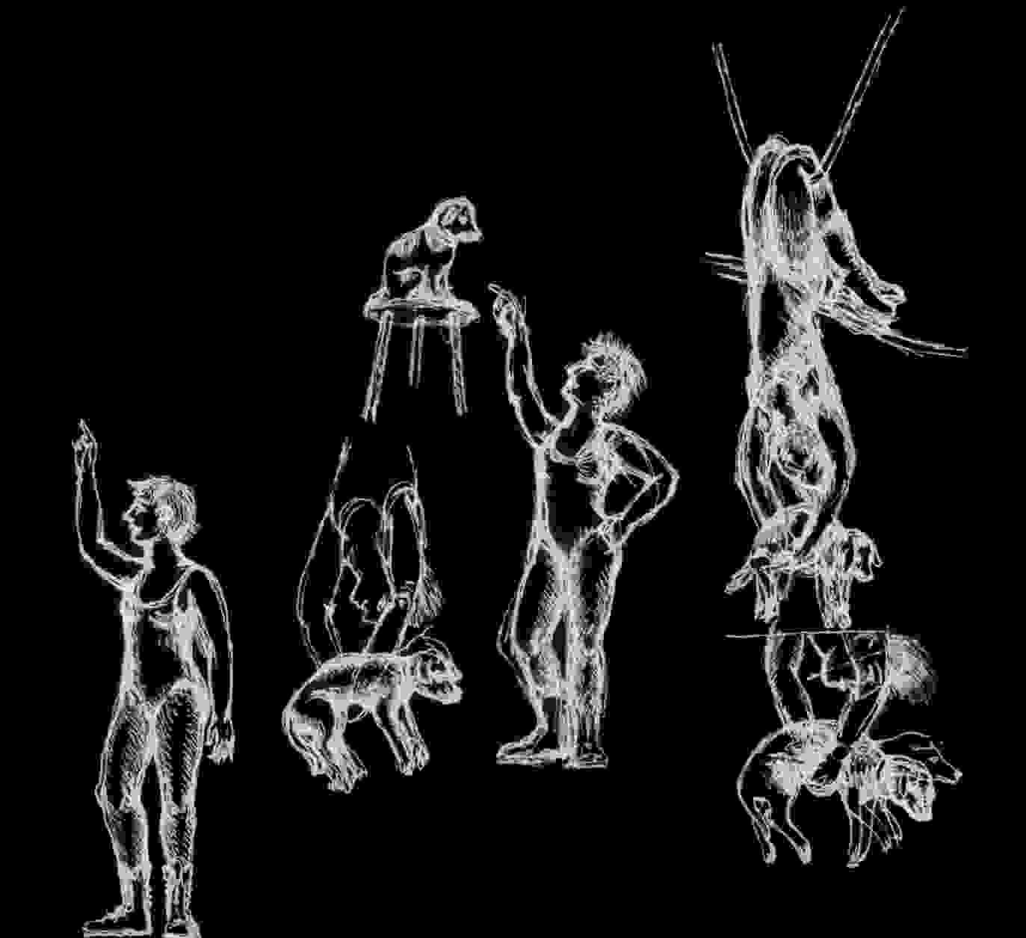

Footnotes
1. The first two sections of this were published under this title by Confrontation magazine: Thirtieth anniversary Issue, No.66/67 (New York, Long Island University, 1998).
2. Hired when a professor died of AIDS, mid-term. I withhold the name of this Eastern college because its policies presented no exception to a prevailing academic norm. The college requested Faculty input during its restructuring. I was never asked to teach again.
3. For the complete United Nations Text, see the Convention on the Prevention and Punishment of the Crime of Genocide, United Nations, December 1991 (DPI/1055), or at Common Rights & Expectations, http://www.nightslantern.ca/community.htm .
4. According to Multilateral Treaties deposited with the Secretary-General. Status as at 31 December 1992. United Nations, New York.
5. The "Understandings" are:
1.That the term 'intent to destroy, in whole or in part, a national, ethnical, racial, or religious group as such' appearing in article II means, the specific intent to destroy, in whole or in substantial part, a national, ethnical, racial or religious group as such by the acts specified in article II.
2. That the term 'mental harm' in article II(b) means permanent impairment of mental faculties through drugs, torture, or similar techniques.
3. That the pledge to grant extradition in accordance with a state's laws and treaties in force found in article VII extends only to acts which are criminal under the laws both of the requesting and the requested state and nothing in article VI affects the right of any state to bring to trial before its own tribunals any of its nationals for acts committed outside a state.
4. That acts in the course of armed conflicts committed without the specific intent required by article II are not sufficient to constitute genocide as defined by this Convention.
5. That with regard to the reference to an international penal tribunal in article VI or the Convention, the United States declares that it reserves the right to effect its participation in any such tribunal only by a treaty entered into specifically for that purpose with the advice and consent of the Senate. Ibid..
6. International Covenant on Civil and Political Rights. United States "Reservations" at ratification on 8 June 1992, to Article 6 and Article 10, among numerous others.
7. The Boston Globe, "The real Iraqi targets," June 6, 1991.
8. This is a fictional construct. There is no Franz Boergy, who presents a human truth from my own lessons in life and human nature.
9. Initially author published at http://www.achilles.net/~jbgerald, July 13,1999, this appeared August 1, 1999, on Serendipity in Switzerland.
10. See: Michel Chossudovsky, "NATO's War of Aggression against Yugoslavia: an Overview," Michel Chossudovsky, June 1999.
11. See: NewsMax (ref. a John Whitley quote in The Global Watch Bulletin (April 2, 1999); and "KLA Croatian Connection Resurfaces," 2357 (April 2, 1999); GMT,990503, Stratfor.Com, 1998.
12. See: Michael Parenti,"The Destruction of Yugoslavia," Michael Parenti Political Archives, 1996.
13. This point noted by a number of journalists, as well as the inception of various NAT0 countries' involvement with Croatia, was definitively explored in "The Fate of the Wartime Ustasha Treasury," US and Allied Wartime and Postwar Relations and negotiations With Argentina, Portugal, Spain, Sweden and Turkey on Looted Gold and German External Assets and US Concerns About the Fate of the Wartime Ustasha Treasury, USIA online site, or US Government Printing Office, #044-000-02494-2.
14. ibid..
15. Michael Chossudovsky, "Dismantling Yugoslavia; Colonizing Bosnia," Covert Action Quarterly, No.56, Spring 1996.
16. John B. Roberts II, "Roots of Allied Farce," The American Spectator, 6/4/99.
17. Richard Poe, "The Big Lie about Kosovo." NewsMax, April 14, 1999.
18. Binder, New York Times, Late City Final edition, Nov. 1, 1987.
19. Projected figure. "Cohen: U.S. Casualties Could Be High," Laura Myers. AP-NY 04/15/99. The Federal Republic of Yugoslavia's "Request for the Indication of Provisional Measures," of April 28th, about half way through the bombardment, states: "From the onset of the bombing of the Federal Republic of Yugoslavia, over 10000 attacks were made against the territory of the Federal Republic of Yugoslavia. In air strikes were used: 806 warplanes (of which over 530 combat planes) and 206 helicopters stationed in 30 air-bases (situated in 5 states) and aboard 6 warships in the Adriatic Sea. More than 2,500 cruise missiles were launched and over 7,000 tons of explosives were dropped."
20. Daniel Williams, "After Sanctions and War, Yugoslavia Is in Pieces" The Washington Post Foreign Service, June 5, 1999.
21. Canada's public response to this is negligible. On June 2nd in Parliament, the Secretary of Foreign Affairs, Lloyd Axworthy was asked to report on the International court's proceedings of this day. Mr. Axworthy stated that the Commons would be glad to hear the case was dismissed; any qualification of this he made, was unclear. Press discussion of the ICJ decision was minimal, and any mention of the open status of the case was accompanied by the implication that its resolution would take a long long time.
22. "Chomsky Replies Re. Kosovo from the ZNet Forum System," ZNet, June 1999.
23. The Federal Republic of Yugoslavia's "Request for the Indication of Provisional Measures," of April 28th, about half way through NATO's air campaign protests a thousand civilian casualties, listing many by name as well as location of targeted civilian facilities, the jobs of 500,000 workers through targeted industry, a million citizens short of water, two million citizens without means of sustenance, specific roads and bus stations, railways stations, track and line, 32 bridges destroyed or damaged and all with specific name and location. Similarly airports, housing blocks, fifty specific industrial factories ("Over 250 commercial and crafts shops in Djakovica were destroyed"); 18 refineries and warehouses were destroyed "causing large contamination of soil and the air;" fertile land and forests, 17 hospitals and health care facilities; over 200 schools from day care centres to elementary schools to secondary schools, to universities: "public and housing facilities" - refugee camps, theatres; infrastructure - power plants and lines, water plants; telecommunications, 18 monasteries and churches, 9 historical monuments and museums, each specifically noted. A partial listing.
24. Judge Louise Arbour of Canada, was then appointed to Canada's Supreme Court. Canada's leadership remained accused of war crimes at the International Court of Justice.
25. Aside from the sequence of Associated Press releases in March 1999: "Internal Documents from German's Foreign Office Regarding Pre-Bombardment Genocide in Kosovo," International Lawyers Against Nuclear Arms," junge welt, April 24, 1999. Trans. Canepa, Brecht Forum.
26. David McReynolds points this out in "Reflections on the Indictment of Milosevic," The Nonviolence Web, May 28th, 1999.
27. News management has tried to remove this area of concern from the public's attention. Use of Depleted Uranium weapons in air attacks is confirmed by Alex Kirby, BBC Online and Radio 4 Environment Correspondent, "Depleted Uranium: the Lingering Poison," BBC Online, June 6, 1999. It is specifically referred to in the Federal Republic of Yugoslavia's "Request for the Indication of Provisional Measures," of April 28th, 1999, presented to the International Court of Justice.
28. This is substantiated by the work of Peter Dale Scott,"Using Atrocities: U.S. Responsibility for the Slaughters in Indonesia and East Timor." 1998. <http://www.copi.com/deepbook.html> (June 2001), who states: "By the time of the 1965 coup, over 4000 Indonesian officers had been trained in the United States; and almost half of the officer corps had received some kind of training from the Americans." Citing footnote #52. Peter Dale Scott, "The United States and the Overthrow of Sukarno, 1965-1967," Pacific Affairs, 58 (Summer 1985), 248.
29. According to an article of May 19, 1990, Spartanburg South Carolina Herald-Journal reprinted May 20, 1990, San Francisco Examiner, and May 21, 1990, Washington Post, and May 23, 1990, Boston Globe.
30. To note here then, exceptional people in uniform: helicopter pilot Hugh Thompson,with Larry Colburn and Glenn Andreotta, who landed to stop Lt. Calley's massacre of villagers at My Lai (Nat Hentoff "The Americans Who Stopped My Lai," Village Voice, posting of May 25, 2001, citing CBS Sixty Minutes, Mike Wallace, May 6, 2001 rebroadcast of March 1998). Also, worthy of note,"The Dellums Committee Hearings on War Crimes in Vietnam, April 25-29, 1971, and the veterans and few Congressmen who appeared during the course of the hearings: Capt Fred Laughlin, Dr.Gordon Livingston, Captain Robert B. Johnson, Capt Greg Hayward, Capt Ron Bartek, Capt. Michael O'Mera, Daniel Barnes, Gary Battles, Daniel Notley, John Beitzel, Guadalupe G Villarreal, Kenneth Campbell, Thomas Cole, Randy Floyd, Charles Locke, Elliot L Meyrowitz, Terry Mullen, Steve Padoris, William Toffling, a non-veteran writer-John Sack, Congressman Reuss, Congressman Donald W.Riegle from Michigan, Congressman Don Edwards from California, Congressman Herman Badillo from New York, Congressman Frank Ryan of New York; Congresswoman Bella S.Abzug of New York, Congressman Parren Mitchell from Baltimore, Congressman John Conyers, Jr. from Michigan, Congressman Seiberling from Ohio, Congresswoman Mink from Hawaii, Congressman Ed Koch of New York, Congressman James Abourezk, Congressman Phillip Burton, Jr, Congressman Benjamin S. Rosenthal. Congressman Jonathan B. Bingham from NY, Congresswoman Shirley Chisholm, Congressman Robert W. Kastenmeier of Wisconsin, Congressman Abner J.Mikva, Congresman Don Edwards, Congressman Ronald V. Dellums, ( "Vietnam War History files, AOL "http://members.aol.com/warlibrary/vwch1.htm June 2001).
31. Scott. Ibid. and ref. Footnote #131, noting the role of the American Embassy, Jakarta, officials during the massacres, supplying lists of Communist party members marked for death.
32. Peter Dale Scott's essay (ibid.) points out that the CIA's Lansdale instituted a "Civic Action" program in 1955 in Vietnam, to provide cover for Special Forces black operations, citing endnote #145 Valentine, The Phoenix Program, 27.
33. Date: 19 Feb 1996 11:58:48 -0500, "CIA and Operation Phoenix in Vietnam," Ralph McGehee. 34. Ref. Edwin Black. IBM and the Holocaust. (Crown, 2001). passim., notes the transfer of Dehomag, a CTR licensee in Germany, to the American company CTR in 1922. German interests retained only 10%..CTR became IBM in 1924, and Dehomag was its German subsidiary. It became the tool of German statisticians serving the Nazis. Pp.43-44.
35. Jim Huck, "FBI Book 3 Chapter 10" <http://www.angelfire.com/ca3/jphuck/BOOK3Ch10.html.> As of June, 2001, this material has been reformulated to "Book 3 Chapter 14" at <http://www.angelfire.com/ca3/jphuck/rightframe.html>
36. Ibid..
37. Edwin Black. IBM and the Holocaust. Crown, 2001. Ibid.. 38. Date: 19 Feb 1996 11:58:48 -0500, "CIA and Operation Phoenix in Vietnam" Ralph McGehee's bibliography noting " Toohey, B., & Pinwill, W. (1990). Oyster: The Story of the Australian Secret Intelligence Service 87-88."
39. Recent evidence in French court suggests the role of French military officers in the training of Argentine Army and officials in torture and psywar operations. Susan Bell, "French Taught Torture to Argentines." TheScotsman.co.ukm June 15,2001.
40. "Did Science Create a Genetic Genocide Machine ?" New Dawn Magazine. <http://aidsbiowar.com/printpage.htm.> Noting in particular the DOD Appropriations Hearings for 1969, Dr. MacArthur's request for development of a virus to destroy the human immune system, Dr. Campbell's report on Africa, considerable other updated evidence on AIDS as an engineered biological warfare disease.
41. "Africa Panel Probes Science Horrors," by Paul Harris, AP-NY-06-11-98 1553EDT.
42. Leonard G. Horowitz, Capitol Mall, Washington D.C., Labor Day Weekend, 1996, "Kissinger and Rockefeller Connections to American Central Intelligence and the Origins of AIDS and Ebola." Available through <http://www.tetrahedron.org,/> in 1998.
43. US PATENT 4,877,027--HEARING SYSTEM. See Rense.com, "Actual Patents Of Mind Control And Behavior Modification Technology," Compiled by Theresa de Veto, SURFING THE APOCALYPSE, at "http://www.surfingtheapocalypse.com" and "http://www.surfingtheapocalypse .com/intelligence2.html#patentscontrol," 8-25-00.
44. De Veto, ibid.. ie. US PATENT 4,858,612 - HEARING DEVICE.
45. "The Depraved Spies and Moguls of the CIA's Operation MOCKINGBIRD," by Alex Constantine. Constantine was on this early and well. An internet classic this work remains currently available through most search engines. (June 2001).
46. J.B.Gerald, Dissident Accounts, New York, author published, 1980, "The Dove" p.7.
47. See C.D.Stelzer's, "Reasonable Doubt." Riverfront Times, April 2, 1997; http://home.stlnet.com/~cdstelzer/mlk6.html
48. According to Huck in "FBI Book 3 Chapter 10," ASA teams were used illegally and extensively to monitor civilian radio waves during Dr. King's "Poor People's Crusade" and "Resurrection City" actions in Washington, of May, 1968.
49. Huck, "FBI Book 3 Chapter 19".
50. One of the best early descriptions of this process is "Population Control, Nazis, and the UN!"-- by Anton Chaitkin, in "The Omega File." The Omega file, carries a heavy cover of extravagant UFO information which may impede some researchers' consideration. On checking, facts of Chaitkin's observations are continually verified by other sources. Or try current search engine information on "Operation Paperclip."
51. Chaitkin, ibid..
52. Webster G. Tarpley & Anton Chaitkin, George Bush: The Unauthorized Biography. "Chapter III - Race Hygiene: Three Bush Family Alliances."
53. Edwin Black, IBM and the Holocaust. Ibid. The thesis succinctly presented on page 22, is established with authority in subsequent pages.
54. Edwin Black. Ibid.
55. Anton Chaitkin, ibid.. Many of his works remain online.
56. Edwin Black. Ibid. p.47. "The government of our Fuhrer and Reichschancellor Adolph Hitler is statistics-friendly," Friedrich Zahn, President, Bavarian Statistical Office, 1939.
57. F.S. Saunders. Who Paid the Piper, London, Granta, 1999. Pp 62-63. ("Indeed for the CIA, the strategy of promoting the Non-Communist Left was to become 'the theoretical foundation of the Agency's political operations against Communism over the next two decades.'" c. 1948. Saunders footnotes Michael Warner, "Origins of the Congress for Cultural Freedom," Studies in Intelligence vol.38/5, Summer, 1995.)
58. Spartanburg, ibid; others.
59. Edwin Black. Ibid. p.423-425 notes IBM's reclaiming of inventory and the New York HQ's eventual reclamation of its German affiliate.
60. Mae Brussell, "How Nixon Actually Got Into Power, The Realist, August, 1972.
61. "Dellums Committee Hearings on War Crimes in Vietnam." April 25-29, 1971 Caucus Room, Cannon House Office Bdlg, http://members.aol.com/warlibrary/vwch1.htm; passim.
62. Warsaw Poland, Associated Press. "Mass Polish Grave Probe Continues," by Monika Scislowska,AP-NY-06-04-01 1549EDT.
63. CBS News "Sixty Minutes." May 1, 2001.
64. "Results of the Hearings on CIA misdeeds, 1973 Church Committee." NCOIC. (http://pw2.netcom.com/~ncoic/cia_info.htm).
65. See complete and online version 5 August 2000: http://cryptome.org/garden-plot.htm; Frank Morales, "US Military Civil Disturbance Planning: the War at Home." Covert Action Quarterly #68, Spring/Summer 2000.
66. For example, "The International Covenant on Civil and Political Rights," Part III, Article 12, #3 : "The above-mentioned rights shall not be subject to any restrictions except those which are provided by law, are necessary to protect national security, public order (ordre public), public health or morals or the rights and freedoms of others, and are consistent with the other rights recognized in the present Covenant." United Nations Texts: Common Rights and Expectations (Ottawa: Gerald and Maas, 1996). Currently available online at www.nightslantern.ca/01.htm.
67. "The Proxmire Act of 1987." US Code, Title 18, Part 1, Chapter 50A, Section 1091.
68. Department of Justice. Canada - Criminal Code 318 & 319
69. David Ransom, "Ford Country: Building an Elite for Indonesia." Steve Weissman, ed.,w. Pacific Studies Center and the North American Congress on Latin America, The Trojan Horse: A Radical Look at Foreign Aid. Palo Alto, Ramparts Press, 1975, rev.). Pp. 93-116 (http://www.cia-on-campus.org)
70. Ransom, Ibid. With footnote to Michael Max Ehrmann, The Indonesian Military in the Politics of Guided Democracy, 1957-1965, unpublished Masters thesis (Cornell University,Ithaca, New York, September 1967), p. 296, citing Col. George Benson (US Army), US military attache‚ in Indonesia 1956-1960.

END

