**Evil Ltd**

It is also in Piccadilly a very exclusive area.

Had a bit of a pallava finding it.

It is down a back street with an eat shop on the corner - funnily enough

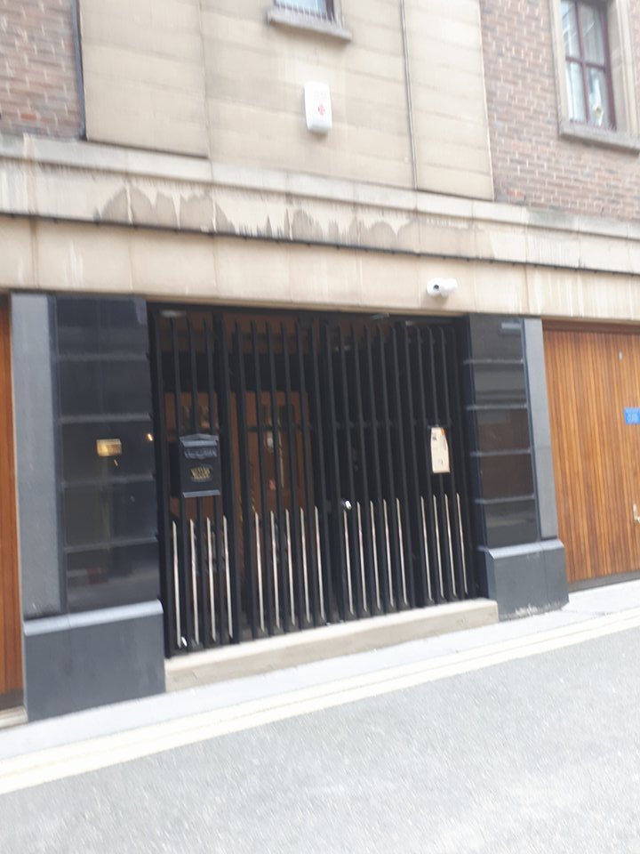

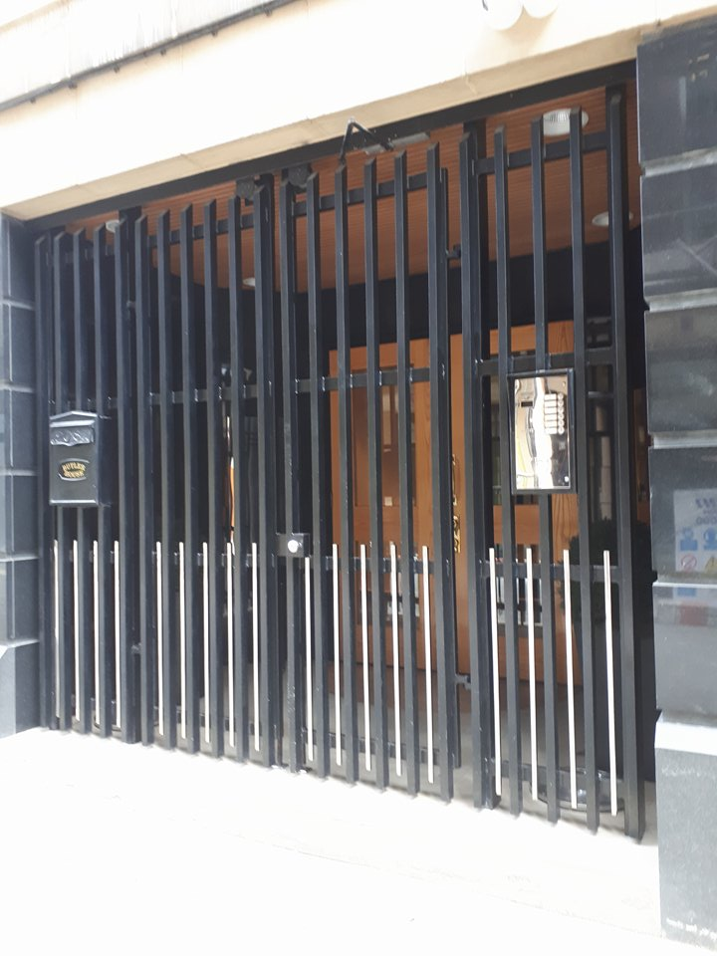

A bit scary black bars and a CCTV camera above the door. So i didn't hang about.

No number on the door, but a key code pad

But next door says 12 so it must be 11

Next door is

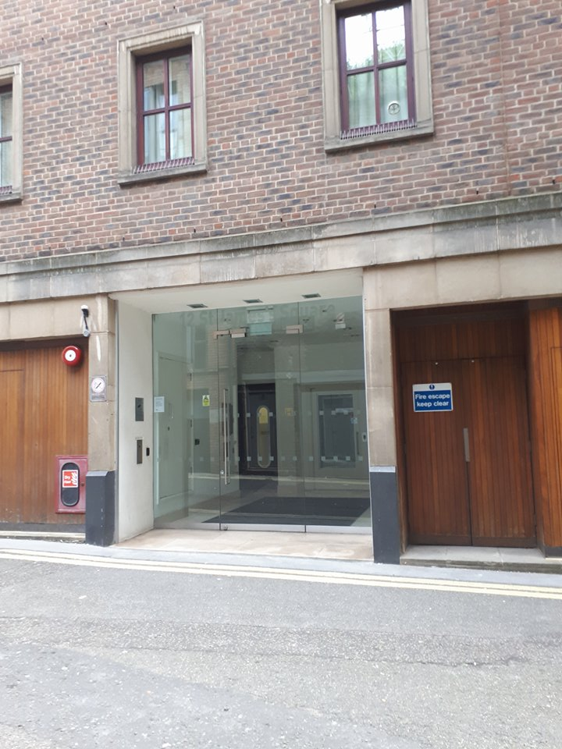

This is the street

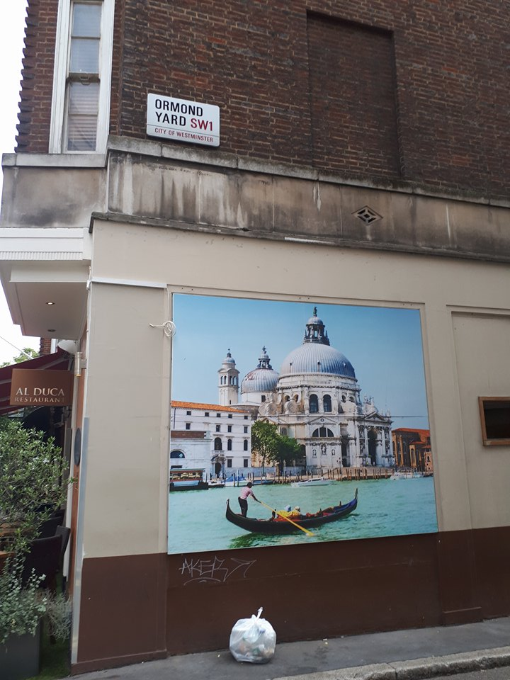

This is looking down the street

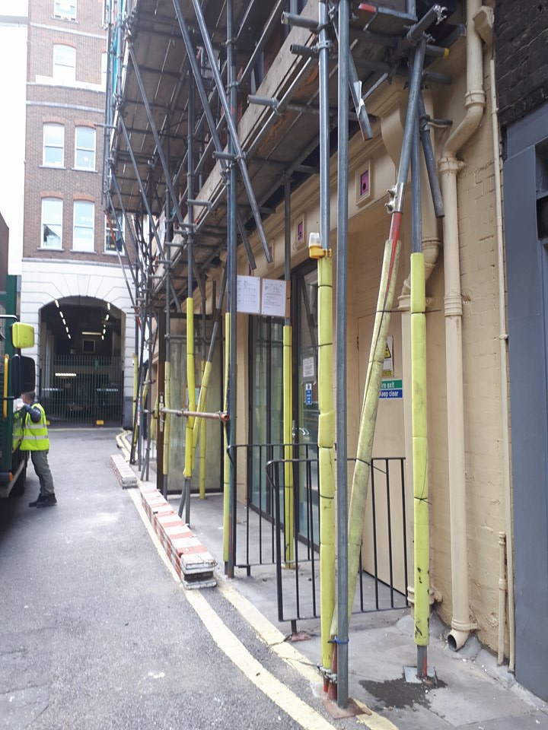

These workmen came down wirh there lorry and they are renovating the building opposite. I wander if it is connected to them?

You can't really see anything through the window as there are some doors behind the msin doors.

It is about a 5 minute walk from Dover Street. A bit odd Evil Ltd down a back street, albeit in an exclusive area - with black iron gates. I just checked the address and it says 11, 12. So the picture with the glass doors is no 12. And maybe they are in two buildings?

Look at what is also nearby

**Permal Investment Management Services Ltd**

The address for Permal Investment Management Services Ltd is 12 St James's Square - that means it is based in the same building. On its website it has a global clientele. Interesting because state of the art IT is one way to secure future markets. It clients includes banks

inShare The Hedgeweek Interview: Omar Kodmani, senior executive officer, Permal Investment Management Services: "Many of the funds that are closed to new money are open to us" Fri, 24/08/2007 - 06:58 Tags : Fund of Hedge Funds Senior executive officer Omar Kodmani highlights the investment process and thinking behind the Permal FX, Financials and Futures Fund, to which the London-listed fund of hedge funds fund Dexion Trading is proposing to become a feeder.

HW: What is the background to Permal? OK: Permal was set up in the early 1970s to manage hedge fund investments for Worms & Cie, a European holding company, although the business was headquartered in New York. Over the years the business has increasingly focused the business on funds of hedge funds and in 2005 was sold to Legg Mason. Today Permal has USD35bn under management and is one of the world's largest fund of hedge funds managers

HW: What are the characteristics of the Permal FX, Financials and Futures Fund? This is a global fund, which was launched in 1992 and is the largest in the world, with USD8.7bn under management. The fund invests with some of the world's most recognised macro traders, focusing on discretionary, systematic, natural resources and relative value strategies

What about this...

[http://dl.acm.org/citation.cfm?id=561015](https://l.facebook.com/l.php?u=http%3A%2F%2Fdl.acm.org%2Fcitation.cfm%3Fid%3D561015&h=ATNX4kdYfShEknb-_aPGvwfg2yj8izi0EMZTBI_Fl8Kc9kBY-YC1UTneCVq7ahhvyxs6JkJwL-m6odtkLFhEUmzlbBy4_hrsunnXnKhDDNX9K8nA_Wn8BeZT3LZDsn7QI-QgoqR5Mh7GLg)

**[Artificial Intelligence in the Capital Markets](https://l.facebook.com/l.php?u=http%3A%2F%2Fdl.acm.org%2Fcitation.cfm%3Fid%3D561015&h=ATNEJfWUVhRCrTtmax99h7uJamexwlnRGj18zb4jSdmpE1vrHG5dT2uv_7rkZA6YdBG_48hL2allnss9wAEz6GUXAUEzwC9RvedBmorfESc1y-l65jHgnc4Hs3JMCOEbYPxvHRSWALNo&s=1&enc=AZMpchvo5gD1xUhRM74bIP-13q-zqdC7eyWyB3GrjBc4nemni90uiCg8xb54w-ATLT_FyVredcL-ItXVdTHrPGW6xIsBPYpq37XyXZrRhXW96A" \t "_blank)**

[dl.acm.org](https://l.facebook.com/l.php?u=http%3A%2F%2Fdl.acm.org%2Fcitation.cfm%3Fid%3D561015&h=ATNEJfWUVhRCrTtmax99h7uJamexwlnRGj18zb4jSdmpE1vrHG5dT2uv_7rkZA6YdBG_48hL2allnss9wAEz6GUXAUEzwC9RvedBmorfESc1y-l65jHgnc4Hs3JMCOEbYPxvHRSWALNo&s=1&enc=AZMpchvo5gD1xUhRM74bIP-13q-zqdC7eyWyB3GrjBc4nemni90uiCg8xb54w-ATLT_FyVredcL-ItXVdTHrPGW6xIsBPYpq37XyXZrRhXW96A" \t "_blank)

Using AI to predict/control financial markets.

I realise now that what Max Igan missed was that Evil Ltd is in the same building or next door to it - not clear which - that it provides 'neural networks' for the hedge funds globally.

You know what is also nearby?

[https://en.m.wikipedia.org/wiki/Dubai\_International\_Financial\_Centre](https://l.facebook.com/l.php?u=https%3A%2F%2Fen.m.wikipedia.org%2Fwiki%2FDubai_International_Financial_Centre&h=ATNX4kdYfShEknb-_aPGvwfg2yj8izi0EMZTBI_Fl8Kc9kBY-YC1UTneCVq7ahhvyxs6JkJwL-m6odtkLFhEUmzlbBy4_hrsunnXnKhDDNX9K8nA_Wn8BeZT3LZDsn7QI-QgoqR5Mh7GLg)

**[Dubai International Financial Centre - Wikipedia](https://l.facebook.com/l.php?u=https%3A%2F%2Fen.m.wikipedia.org%2Fwiki%2FDubai_International_Financial_Centre&h=ATNBfsSJLcTeRdNBC3dPFHWYZb3QPa2q0kVJ19EdyygNdRMg31YYm-Nnx8Hlth4QV4LHa9qbIezV62bewdJpOJ7Bkp6EIhVahoB2ZsGpP440ZcoZ0FAFZenszC-2grq6rD-sxQ1UL9Pl&s=1&enc=AZMVigJnxEWFgRMU5RuIlGaKVv1PNb6wDuEX6EYcugvJxXSKG5JeolWXeR_V5aRBGT9EFC9SDjToQ9v8bwgFaZC-RAC19ByGGzR39-ADLXZttA" \t "_blank)**

[The Dubai International Financial Centre (DIFC) is a special economic zone in Dubai covering 110 ha, established in 2004 and major global financial hub for the Middle East, Africa and South Asia (MEASA) markets. DIFC has its own independent, internationally regulated regulator and judicial system, c...](https://l.facebook.com/l.php?u=https%3A%2F%2Fen.m.wikipedia.org%2Fwiki%2FDubai_International_Financial_Centre&h=ATNBfsSJLcTeRdNBC3dPFHWYZb3QPa2q0kVJ19EdyygNdRMg31YYm-Nnx8Hlth4QV4LHa9qbIezV62bewdJpOJ7Bkp6EIhVahoB2ZsGpP440ZcoZ0FAFZenszC-2grq6rD-sxQ1UL9Pl&s=1&enc=AZMVigJnxEWFgRMU5RuIlGaKVv1PNb6wDuEX6EYcugvJxXSKG5JeolWXeR_V5aRBGT9EFC9SDjToQ9v8bwgFaZC-RAC19ByGGzR39-ADLXZttA" \t "_blank)

[en.wikipedia.org](https://l.facebook.com/l.php?u=https%3A%2F%2Fen.m.wikipedia.org%2Fwiki%2FDubai_International_Financial_Centre&h=ATNBfsSJLcTeRdNBC3dPFHWYZb3QPa2q0kVJ19EdyygNdRMg31YYm-Nnx8Hlth4QV4LHa9qbIezV62bewdJpOJ7Bkp6EIhVahoB2ZsGpP440ZcoZ0FAFZenszC-2grq6rD-sxQ1UL9Pl&s=1&enc=AZMVigJnxEWFgRMU5RuIlGaKVv1PNb6wDuEX6EYcugvJxXSKG5JeolWXeR_V5aRBGT9EFC9SDjToQ9v8bwgFaZC-RAC19ByGGzR39-ADLXZttA" \t "_blank)

The Dubai International Financial Centre(DIFC) is a special economic zone in Dubaicovering 110 ha, established in 2004 and major global financial hub for the Middle East, Africa and South Asia (MEASA) markets. DIFC has its own independent, internationally regulated regulator and judicial system, common law framework, global financial exchange, tax-friendly regime, and a large, cosmopolitan business community. The district houses hundreds of financial institutions, including wealth funds and private investors, but it also hosts multinationals, retail outlets, cafés, restaurants, residential space, public green spaces, hotels and art galleries

Interesting!!!!!

Now you have an interesting network of stakeholders

In a small geographical area.

Picadilly/St James's Park

Crisis Solutions - crisis/terrorism, Evil Ltd technological know how, and the globzl financial sector. Anything is possible - anywhere.