79-year-old retired CIA agent, Malcom Howard, has made a series of astonishing claims since being released from hospital in New Jersey on Friday and told he has weeks to live. Mr. Howard claims he was involved in the “controlled demolition” of World Trade Center 7, the third building that was destroyed on 9/11.
Mr. Howard, who worked for the CIA for 36 years as an operative, claims he was tapped by senior CIA agents to work on the project due to his engineering background, and early career in the demolition business.
Trained as a civil engineer, Mr. Howard became an explosives expert after being headhunted by the CIA in early 1980s. Mr. Howard says has extensive experience in planting explosives in items as small as cigarette lighters and as large as “80 floor buildings.”
The 79-year-old New Jersey native says he worked on the CIA operation they dubbed “New Century” between May 1997 and September 2001, during a time he says the CIA “was still taking orders from the top.” Mr. Howard says he was part of a cell of 4 operatives tasked with ensuring the demolition was successful.
Mr. Howard says the World Trade Center 7 operation is unique among his demolitions, as it is the only demolition that “we had to pretend wasn’t a demolition job”. He claims he had no problem going through with the deception at the time, because “when you are a patriot, you don’t question the motivation of the CIA or the White House. You assume the bigger purpose is for a greater good. They pick good, loyal people like me, and it breaks my heart to hear the shit talk.”
But even he admits that now, looking back, “Something wasn’t right.”
“No good has come from this. This isn’t the America we envisioned.”
Explaining how the building was bought down, Mr. Howard says, “It was a classic controlled demolition with explosives. We used super-fine military grade nanothermite composite materials as explosives. The hard part was getting thousands of pounds of explosives, fuses and ignition mechanisms into the building without causing too much concern. But almost every single office in the Building 7 was rented by the CIA, the Secret Service, or the military, which made it easier.”
Mr. Howard explains that WTC 7 was “loaded with explosives in strategic places” in the month leading up to the day that changed the course of American history. On September 11th, while the North and South towers burned, fuses were ignited in World Trade Center 7, and nanothermite explosions hollowed out the building, destroying the steel structure, removing the reinforcements, and allowing the office fires to tear through the rest of the building, hollowing it out like a shell.
World Trade Center 7 collapsed into its own footprint at 5:20pm, seven hours after the destruction of WTC 1 and 2. The building shocked witnesses by coming down at the speed of freefall, indicating that it encountered zero resistance on the way down.
Mr. Howard and his colleagues had done their job.
“When the building came down, it was such a rush. Everything went exactly to plan. It was so smooth. Everybody was evacuated. Nobody was hurt in WTC 7. We were celebrating. We kept watching replays of the demolition, we had the whiskey and cigars out, and then all of a sudden the strangest thing happened. We all started to worry that it looked a bit too smooth. We watched the tape again and again and again and we started to get paranoid. It looked like a controlled demolition. We thought shit, people are going to question this. And then we heard that people from the street were reporting that they heard the explosions during the afternoon. When we were told that the BBC botched their report and announced to the world that the building collapsed 20 minutes before it actually did… At that point we really thought the gig was up.”
According to the official 9/11 report issued by the government, WTC 7 collapsed due to “uncontrolled fires” that were caused by debris that floated over from WTC 1 and 2, which had been hit by passenger planes. If the official narrative was true, WTC 7 would be the first tall building in the world to ever collapse due to uncontrolled fires, and the only steel skyscraper in the world to have collapsed into itself, due to “office fires.”
Mr. Howard and his colleagues feared the public would see through the official narrative and rise up against the government, demanding to be told the truth.
“There were so many loose ends, so much evidence left behind. We thought the public would be all over it. We thought there would be a public uprising that the media couldn’t ignore. They’d be funding investigations and demanding to know why they were being lied to. We thought they’d find chemical composites in the area that would prove Building 7 was blown up.
“We thought there would be a revolution. It would go all the way to the top, to President Bush. He’d be dragged out of the White House.
“But none of that happened. Almost nobody questioned anything. The media shot down anyone who dared question anything they were told.”
Follow the money
Mr. Howard claims he has “no direct knowledge” about the destruction of North and South Towers of the World Trade Center, explaining that “CIA operations are very specific” and that it is common to be working on a larger project while only understanding a small piece of the puzzle.
[9/11: Larry Silverstein Designed New WTC-7 One Year Before Attacks]
But he has advice for investigators seeking to understand the entire puzzle and work out who was behind the most devastating attack on American soil in history.
“Follow the money.”
“When you want to find out who is behind something, just follow the money. Look at the trades made just before 9/11. These are the guys that knew what was coming. The sons of CIA agents, government officials. Close relatives of the most powerful men in America. Cheney, Rumsfeld. They all got rich. It wasn’t just the contracts awarded to their friends in the construction business and the wars and the kickbacks.”
“It was insider trading.”
Many countries including Britain, France, Germany, Italy, Japan and Monaco launched insider trading investigations in the wake of the 9/11 attacks, believing that if they could prove Al-Qaeda operatives profited on the stock market then they could prove the terror organization was behind the attacks.
And all the evidence pointed to heavy insider trading around 9/11.
Italy’s foreign minister, Antonio Martino, said: “I think that there are terrorist states and organizations behind speculation on the international markets.” German central bank president, Ernst Welteke, said his researchers had found “almost irrefutable proof of insider trading.”
Even CNN reported that regulators were seeing “ever-clearer signs” that someone “manipulated financial markets ahead of the terror attack in the hope of profiting from it.”
Mr. Howard says that a serious study of who profited on the stock market from 9/11 would “tear the heart out of the oligarchy in America.”
“There is only one organization that spans the entire world, and let me tell you now, it isn’t and it never was al-Qaeda.”
It’s the CIA.
“There could never be a real investigation. The entire shadow government, as you call them now, are implicated.”
The 79-year-old, spending his final weeks at home, said he doesn’t expect to be taken into custody following his confession because “then they’d have to go after everyone else. They will just use the media to attack me. They are all on the payroll to suppress everything around 9/11.”

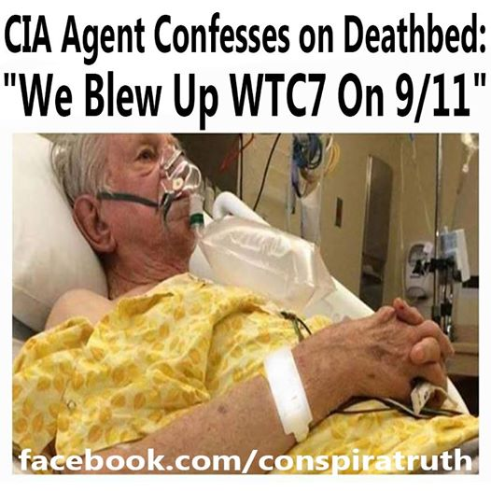

149149
71 comments628 shares
Ole Dammegard
Like
CommentShare

Comments
Most relevant

Write a comment...

- 
Mykel Greene Its was quite obvious to me that 911 was a inside job. This gentleman just confirmed it for his own personal reasons to the public..
13
Hide or report this
  - Like
  - · Reply
  - · 11w

2 replies

- 
Tim Searle I am certainly not surprised. I always thought that it was an inside job!
2
Hide or report this
  - Like
  - · Reply
  - · 4h
- 
Eric Christian Olsen Good God! Am I so naive that I (want to) believe my government does what's best for its citizens?
Hide or report this
  - Like
  - · Reply
  - · 17h
- 
Michelle Toweel 😂 yeah right. Is this the right post to be wearing my Tim foiled hat?
Hide or report this
  - Like
  - · Reply
  - · 35m
- 
Shaun Cunningham If it looks like a bomb sounds like a bomb tests find bomb residue and brings 3 building's down with extreme prosecution
that only very comprehensive demolition plans could hope to pull off I would be silly not to believe that 2 planes brought down 3 buildings wouldn't I? and it's just luck the insurance wos updated to cover sutch a event weeks prior
10
Hide or report this
  - Like
  - · Reply
  - · 11w
- 
Duke Eng Wow our United States did this I hope it’s true an get who ever in the government in jail am strip of everything thet own
2
Hide or report this
  - Like
  - · Reply
  - · 1d
- 
William Granados He is a coward in my eyes for waiting so long he should have told the truth at the time and now he want simpathy go to hell it does matter anymore you domestic trader enjoy hell
1
Hide or report this
  - Like
  - · Reply
  - · 1d
- 
Iron William Cia or not
If their reasoning is about getting rich isn’t it a bit elementary at that just to get all that explosives up there, destroy a building that tall, go thru all that just to manipulates the stock market to get rich, couldn’t they find a better conspiracy theory ??
3
Hide or report this
  - Like
  - · Reply
  - · 1d

3 replies

- 
Pat Roche Thank you Sean, it's what your Dad been saying for years!!🤔
1
Hide or report this
  - Like
  - · Reply
  - · 10w
- 
Neil 'Papa' Johns Here's a jar of sun dried tomatoes
Hide or report this

1
  - Like
  - · Reply
  - · 11w

1 reply

Pat Roche our own goverment, unreal but so true??
Hide or report this
  - Like
  - · Reply
  - · 10w
- 
Mohammad F Bashir Sad how we are controlled and we follow the minority who are always milking us in one way or another
1
Hide or report this
  - Like
  - · Reply
  - · 1d
- 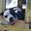
Scott Washington If you have ever watched one you can see the Similarities
Hide or report this
  - Like
  - · Reply
  - · 5h
Pat Roche Abe Lincoln, founder of the internet, duh???
Hide or report this
  - Like
  - · Reply
  - · 10w
  - · Edited
- 
Dennis Kiruai It's too late to apologize... it's too late.
3
Hide or report this
  - Like
  - · Reply
  - · 1d
- 
Cindy Houle That's what I always said that's trump but no one listened
Hide or report this
  - Like
  - · Reply
  - · 11w

1 reply

- 
Ner Escuadro The truth cannot be hidden forever.
1
Hide or report this
  - Like
  - · Reply
  - · 11w

1 reply

- 
Mark Cullup Yeah, we know.
Hide or report this
  - Like
  - · Reply
  - · 1d
- 
Mikey Maj Interesting how everyone seems to have known about 9/11 being an inside job but somehow there was no uprising or revolution. The American ppl were fed shit and they just ate it.
11
Hide or report this
  - Like
  - · Reply
  - · 11w

1 reply

- 
Dominique Ess Where is this info coming from
Hide or report this
  - Like
  - · Reply
  - · 1d
Pat Roche CIA at it again my friends???🤔
Hide or report this
  - Like
  - · Reply
  - · 10w

1 reply

- 
Frank Bonito Wouldnt surprise me
Hide or report this
  - Like
  - · Reply
  - · 3h
- 
Rocky Tillman Reference to support this?
3
Hide or report this
  - Like
  - · Reply
  - · 11w
- 
Thomas Paul Duh
Hide or report this
  - Like
  - · Reply
  - · 10w
- 
Toh Yew Beng The more you learn, the more you know.
The more you know, the more you don't know..
3
Hide or report this
  - Like
  - · Reply
  - · 11w
- 
Gary Yudin It figured
Hide or report this
  - Like
  - · Reply
  - · 21h
- 
Sean Roche Pat Roche check this out.
Hide or report this
  - Like
  - · Reply
  - · 10w
- 
Freddy Mesot
Hide or report this
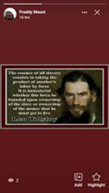
2
  - Like
  - · Reply
  - · 11w
- 
William Morrison Richie. Off your meds
Hide or report this
  - Like
  - · Reply
  - · 1d
- 
Larry Sears Allum https://www.facebook.com/FollowTheWhiteRabbit1776/videos/689876911754765/?d=null&vh=e
Hide or report this
  - Like
  - · Reply
  - · 10h
- 
John Brawley No surprise news here. Inteligent American People knew it was an inside job and that the buildings came down in a
controlled manor.
14
Hide or report this
  - Like
  - · Reply
  - · 14w
  - · Edited
- 
Graham Milne Surprise. Surprise. Only the good old US of A would ever believe that 911 was done by terrorists. They are Unbelievabley gullible. Nothing like Australia. Look at who the fuck we voted in. !
5
Hide or report this
  - Like
  - · Reply
  - · 10w
- 
Keith Hickman
Hide or report this
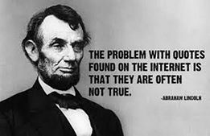
1
  - Like
  - · Reply
  - · 11w
"Most relevant" is selected, so some comments may have been filtered out.

Create post



Photo/Video
Tag friends
Get messages



Conspiratruth
49 mins ·
Nice idea! 👇👇👇
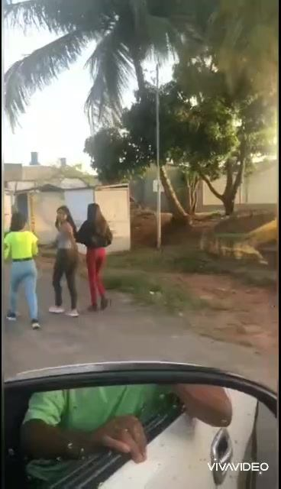
Play
-0:43
Additional visual settings
Enter Watch and ScrollClick to enlarge
Mute

1010
1 comment9 shares
Ole Dammegard
Like
Comment
Share

Comments
Most relevant

