HOW 'PULLING' THE TOWERS WAS PULLED OFF
I will hereby submit my best take as to how the WTC demolitions in Lower Manhattan were achieved - without awakening undue suspicions among that early morning's bystanders / eyewitnesses (no wonder the whole thing was staged in the early morning hours - so as to minimize the amount of onlookers). However hypothetical my reasoning may seem, I trust that readers will appreciate the logical processes which I have applied in order to formulate this tentative, 'final reckoning' of how the magic trick / sleight of hand of 9/11 was concocted - and how the Twin Towers were demolished in bright daylight without any onlooking New Yorkers being able to understand what exactly they saw - and much less PROVE that what they saw was different from what was aired on TV.
Here's a brief summary of my conclusions - in three short paragraphs :
1: - A miltary-grade smokescreen was raised before the supposed 9:59 collapse of WTC2. The possibility that any odd bystanders (in what by then was a fully evacuated area) would have noticed / or captured on film any smoke billowing from the ground up BEFORE 9:59AM - was extremely slim. However, this slim possibility was anticipated by the 9/11 planners, with their Willy "BOOM" Rodriguez actor and his tales of "basement explosions prior to the plane crashes". Thus, any ground-level smoke witnessed BEFORE 9:59AM would have had the plausible-deniability-alibi of these mysterious, pre-collapse "basement explosions".
2: - On Live TV, these "basement explosions" were in fact reported on the FOX channel - within 40 seconds of the (purported) WTC2 collapse at 9:59AM. It is clear, therefore, that these 'WTC basement explosions' were MEANT (according to the 9/11 psyop script) to have occurred way before the first, WTC2 collapse. Again, this was likely meant to provide the alibi for any smoke seen around the towers - or even recorded on film by onlookers - BEFORE their collapse (any lucky filmmakers wishing to expose the scam would then have to PROVE that their camera's time-stamp clock was set at the correct time...)
3: - Once the smokescreen was deemed dense enough - and enveloped the entire WTC complex - the controlled demolition of the Twin Towers were "go". When exactly this took place is nothing that we can ever know - yet anytime between 9:59 and 10:28 is a good guess. (please note that 29 minutes [2+9=11] separate the two alleged WTC collapse timelines - just another joke). The two towers were likely 'pulled' simultaneously.
Let me now back up this brief summary - with what was aired on TV. I hope you will stay with me throughout this reasoning process.
WHAT WAS AIRED ON CNN:
The way the first WTC2 collapse was (NOT) shown on CNN is a quite hilarious / pathetic thing to watch again today - and an extremely revealing sequence/timeline of purported "historical Live TV images". Firstly, just pay attention at the words uttered by CNN's Aaron Brown (apparently standing on the CNN building's rooftop - with a SPECTACULAR view of the Towers) - starting at about 29:20 of this CNN archive clip:
https://archive.org/details/cnn200109110929-1011
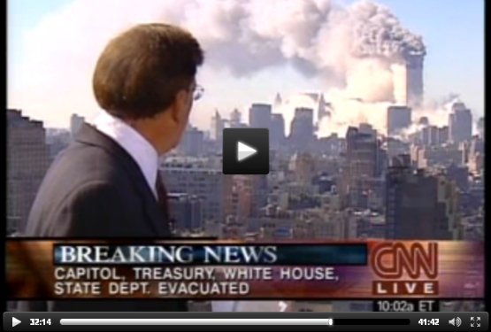
So, in fact, the actual WTC2 collapse was NOT shown "live" on CNN (their TV feed at the time being busy 'covering' the Pentagon event)- and Aaron Brown, appears to be totally clueless as to what is (supposed to be) going on at the WTC. We just see the WTC area completely enveloped in smoke (as it probably was IN REALITY - yet not as a result of the WTC2 collapse - but more likely due to a military-grade smokescreen being raised ).
At 32:20(a full 3 minutes later), Aaron still talks about 'another possible explosion' and that "we are getting reports that parts of the 2nd tower appears to have collapsed, we are checking on that..." NO ONE has yet informed Aaron that the WTC2 has fully collapsed... Amazing, huh? The thing is, if only Aaron had been watching NBC or FOX, he would have seen the WTC2 collapsing 'in real time'. Yet there he is, still wondering what happened - for three minutes and more - and MORE THAN 5 MINUTES will pass before his CNN colleagues in the studio finally run a replay of the actual (CGI animation of the) WTC2 collapse imagery! Why on Earth would the CNN producer WAIT for over 5 long minutes to air the WTC2 collapse - which their cameraman had supposedly captured?
At 34:40 (more than 5 full minutes after WTC2 supposedly collapsed) Aaron FINALLY announces: "We can show you NOW, what happened just a few minutes ago at the World Trade center..." - and CNN viewers are FINALLY treated with this most momentous, 'world-defining news imagery'. Yet, their main anchorman was supposedly standing on the CNN building's rooftop, with a direct, birds-eye view of the WTC! Oh well, so we're asked to believe that he was turning his back on the spectacular (greenscreen) view- and unfortunately just missed witnessing the collapse itself at 9:59AM... Yeah, rrright.
WHAT WAS SHOWN ON NBC AND FOX:
So much for CNN reporting the WTC2 collapse 'live'.
Now, was the WTC2 collapse aired on other networks, purportedly just as it happened at 9:59AM ?
Yes, believe it or not, but it was shown on NBC - in THIS way (check out the NBC archives if you think that I'm kidding you):
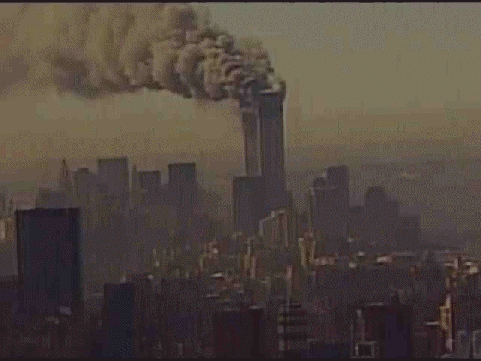
(If you cannot see how fake this imagery is - now in 2013 - there is no way I can help you. Keep buying it - if you so wish.)
And on FOX TV, the WTC2 collapse was also shown (in one half of a split-screen shot) - yet NO ONE in the TV studio seemed to notice. Instead, the imagery quickly switched to some dramatic (gory, yellow-green) imagery of the WTC area enveloped in smoke (initially 'mistaken' by FOX anchor Jim Ryan to be images from the Pentagon):
"FOX FLOP" (link to exact "WTC2 collapse" timeline) : http://www.youtube.com/watch?v=Ls0CRXEV ... page#t=444
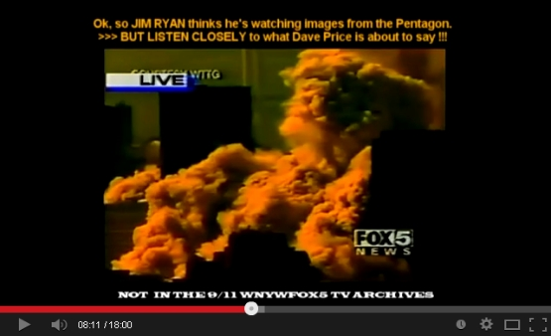
Here we have FOX's Dave Price reporting about some "basement explosions in the WTC" - only 40 seconds after its collapse - as seen on TV. So wait a minute: are we to believe that Dave Price was informed (by whom?) about these "basement explosions" within 40 seconds - while Aaron Brown of CNN remained uninformed for over 5 minutes about the collapse of the entire WTC2 building? The "basement explosions" were obviously part of the original 9/11 psyop script - so as to 'justify' why smoke emerged around the WTC area BEFORE they collapsed.
It is all up to reader to draw his/her conclusions, but I believe this all goes to support my (quite simple) smokescreen thesis, which goes like this:
A: The entire WTC complex was engulfed in military-grade smoke obscurants BEFORE they were demolished - with conventional explosives. No one saw them collapsing - and no imagery or footage exists of their demise - since no conventional cameras can film through thick smoke.
B: What we were shown on TV was a prefabricated movie which, in fact, was rather smartly made - since it showed Lower Manhattan enveloped in an enormous, lingering cloud of smoke for most of that fateful morning. However, we know that NO controlled demolition produces as much smoke as seen on TV on 9/11. Please watch ANY videos of building demolitions and realize that the dust of any large building being demolished settles in the matter of minutes. That enormous amount of smoke on 9/11 enveloping Manhattan for hours was produced by military-grade smoke machines - and the prefabricated TV images were made to simulate this predictable scenery.
To sum it up: the WTC was demolished behind a smokescreen which was raised sometime before the alleged 9:59AM collapse of WTC2.
simonshack
Administrator

Posts: 6745
Joined: Sun Oct 18, 2009 8:09 pm
Location: italy

Top

Re: CGI collapse footage
by Houdini on Mon Dec 02, 2013 11:58 pm
That's an excellent analysis, Simon.
Say, I wonder what would have happened had it been raining that morning? Do you think they had a backup set of CGI footage showing the entire episode happening in the rain, just in case?
Houdini
Member

Posts: 88
Joined: Thu Mar 31, 2011 12:26 am
Top

Re: CGI collapse footage
by hoi.polloi on Tue Dec 03, 2013 2:06 am
Who the fuck knows? Who can tell what their plan was? They don't seem to be phased very much by blatant problems. Certainly, average viewers at home haven't been, have they? How many people have pointed out that the footage of that day was anything but clear and perfect and bright?
I can guess that one of the backups they had, besides anything obvious or practical we would come up with, was simply the variable quality of footage; the screens don't look remotely like a bright sunny day in New York. They look like muddy, filtered, deliberately inconsistent, compressed, poorly received, blurry messes. If they added a 'rain' backdrop and overlay to it, it would hardly even make a difference. Not the clear blue day recorded by "amateur videos" only released much later.
Plus, there is the simple, time and tested methods of weather prediction and cloud seeding to influence predictions. As you can see, not a drop of rain either on the 11th or 12th for all of New York. http://www1.ncdc.noaa.gov/pub/orders/IP ... 310B71.pdf
But some on the 10th. Could it have been seeded to get all the moisture out of the air the night before?
Last edited by hoi.polloi on Tue Dec 03, 2013 12:42 pm, edited 1 time in total.
Reason: seeding question
hoi.polloi
Administrator

Posts: 5061
Joined: Sun Nov 14, 2010 7:24 pm
Top

Re: CGI collapse footage
by Brutal Metal on Tue Dec 03, 2013 9:28 am
Houdini wrote:That's an excellent analysis, Simon.
Say, I wonder what would have happened had it been raining that morning? Do you think they had a backup set of CGI footage showing the entire episode happening in the rain, just in case?
CRAZY if it did go down just like that, if so TV anchors are either really STUPID or part of it
Brutal Metal
Member

Posts: 401
Joined: Thu Jul 22, 2010 3:58 am
Top

Re: CGI collapse footage
by lux on Tue Dec 03, 2013 3:23 pm
Houdini wrote:
Say, I wonder what would have happened had it been raining that morning?
Postponed until 9/22?
lux
Member

Posts: 1914
Joined: Sat Oct 01, 2011 10:46 pm
Top

Re: CGI collapse footage
by simonshack on Wed Dec 11, 2013 2:52 pm
*
THE VANISHING "PAT" (just rehashing this PAT for newcomers to the forum)
Most people are not aware that what TV showed on 9/11 was a prefabricated movie - so here we go again. Our forum is, admittedly, a rather tough place for newcomers to navigate - what with all its info spread over many different threads - and I will try to sort this out in the near future. Until then, I think no harm is done to remind everyone - from time to time - of selected 'nuggets' of the absurd 9/11 imagery...
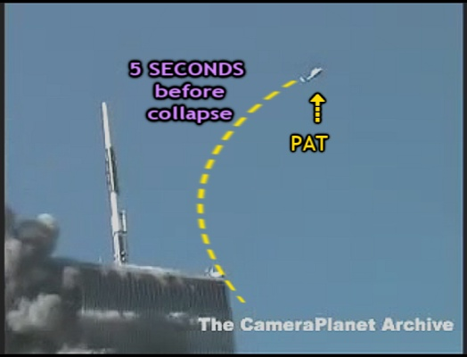
I have named "Pat" a white police chopper which is seen - in a few alleged 'amateur videos' from Steven Rosenbaum's CAMERA PLANET archive - flying away from the towers in a Northwest direction, JUST as we see WTC2 initiating its collapse (officially at 9:59AM). Below are two animated gifs showing (what is meant to be) this particular moment in time (in reality, the WTC area was likely already engulfed by military-grade smoke obscurants ):
NOTE: The above is yet another "MIRACLE ZOOM" shot - a 'trademark' of the 9/11 imagery...http://www.septemberclues.info/miracle_zooms.htm
It stands to reason that this white police chopper should have been captured by ALL decent cameras filming this same moment in time. Keep in mind that this white police chopper (bigger than a large car) is lit by direct sunlight and should be clearly visible against the sky - as captured by any professional, top end broadcasting camera. So let's try and see if we can find "PAT" in the official TV broadcasts of 9/11.
Now, whatever the reasons for NBC's 9/11 imagery to feature a bizarre, 'brownish' sky, "PAT" should have been even more distinguishable and contrasted against this darker sky. Yet, on NBC, "Pat" is nowhere to be seen - (for the whole duration of the WTC2 collapse):
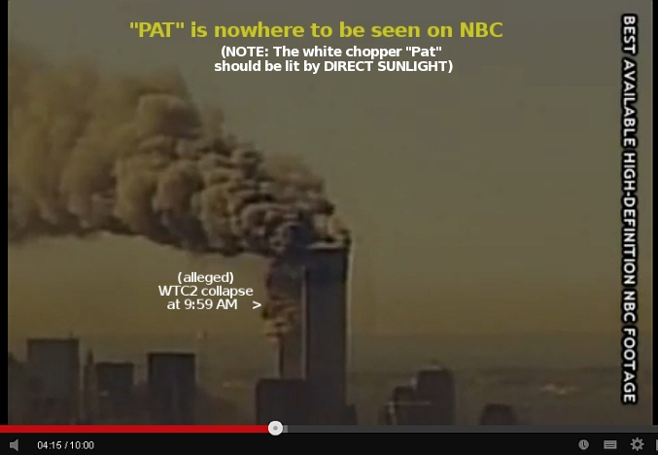
On MSNBC, the sky is more realistically blueish (as we've come to expect the sky's hue to be) - yet once again, "PAT" is nowhere to be seen:
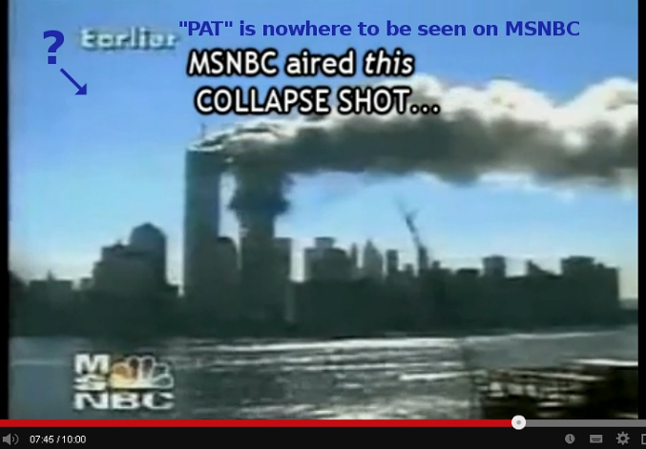
Another shot aired on NBC - "LIVE on 9/11" (from what's meant to be from a 'different NBC camera location' ).
Please enlarge it at will - and see if you can see a single pixel of PAT... You can? Tell me WHERE, I can't see it!
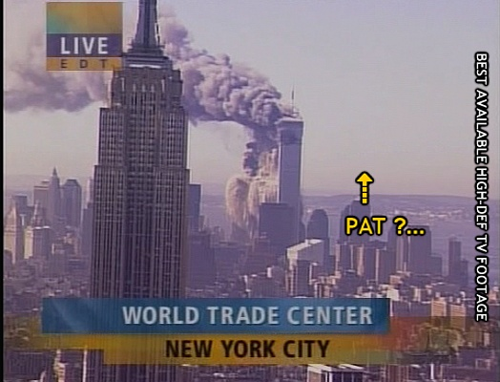
CBS seems to be the only network which caught "PAT" flying away as WTC2 collapsed. The problem is, CBS's alleged Camera Chopper ("CHOPPER2") appears here to be hovering directly South of the towers... yet the "CBS CHOPPER2" itself is nowhere to be seen in ANY of the countless shots of this moment in time ("collapse of WTC2 at 9:59AM") purportedly shot from North (or East or West) of the towers.
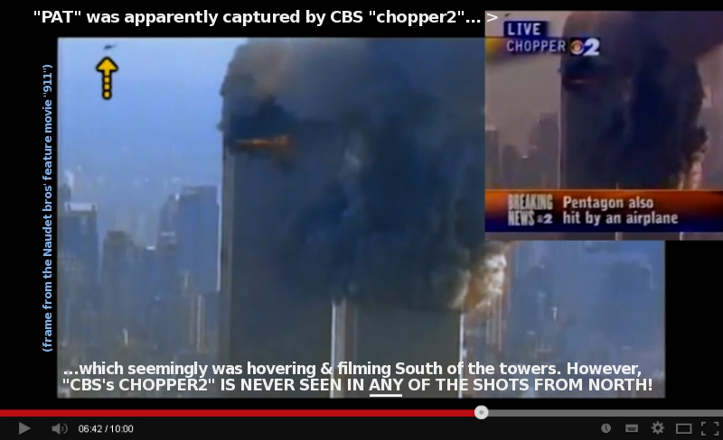
As a matter of fact, NONE of the alleged four TV CAMERA CHOPPERS (CBS's chopper2, NBC's chopper 4, FOX's Chopper5, ABC's chopper7) are EVER seen capturing each other hovering in the Manhattan airspace for the full duration of the 102min 9/11 multi-channel broadcasts !
(An exception to the rule - although more of a military copter: "CHOPPED OUT"): http://www.youtube.com/watch?v=PZ3SQbK2Zfg )
Oh well... we DO actually get to see a great many "chameleon choppers" aimlessly flying by the towers at steady speed - always from one side to the screen to the other - while mutating hue (black <-> white) depending on the backdrop they're set against...
A classic 9/11 "CHAMELEON CHOPPER" in a hurry to get home for lunch:
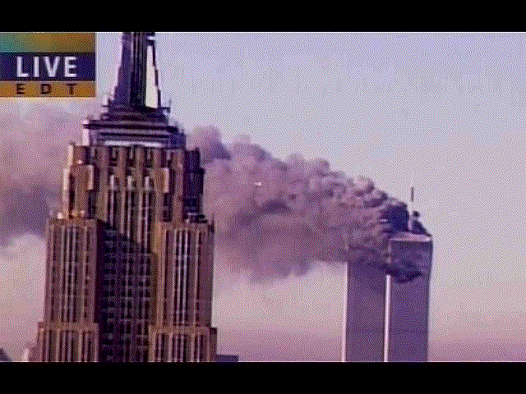
If you reckon that the above observations are flawed / fallacious / disputable - let me know and let's discuss.
I say that there's something horribly wrong with all this 9/11 imagery. What about you? To be sure, MOST people still believe that these are real and authentic videos depicting what actually happened in Manhattan on September 11, 2001. So beware, folks: if your mind concludes that these images are totally fake - most people will say that you are totally out of your mind !
For the full "PAT" analysis - and more, please watch my September Clues Addendum: http://www.youtube.com/watch?v=UGyW-0MeBOU
simonshack
Administrator

Posts: 6745
Joined: Sun Oct 18, 2009 8:09 pm
Location: italy

Top

Re: CGI collapse footage
by mnew9 on Thu Dec 12, 2013 1:56 pm
Simon, your excellent September Clues Addendum on You Tube has certainly brought out the usual weirdo comments.
A certain John Mather has recently let his inane attacks on you become very personal. Is he some kind of friend of yours?
mnew9
Member

Posts: 103
Joined: Sat Sep 11, 2010 5:57 am
Top

Re: CGI collapse footage
by simonshack on Thu Dec 12, 2013 5:25 pm
mnew9 wrote:Simon, your excellent September Clues Addendum on You Tube has certainly brought out the usual weirdo comments.
A certain John Mather has recently let his inane attacks on you become very personal. Is he some kind of friend of yours?
Uh, no - but it would seem that this John Mather guy is a keen Cluesforum reader - so we might call him 'a friend of ours' - even though he calls us "sociopaths"...
viewtopic.php?p=2388355#p2388355
simonshack
Administrator

Posts: 6745
Joined: Sun Oct 18, 2009 8:09 pm
Location: italy

Top

Re: CGI collapse footage
by antipodean on Fri Dec 13, 2013 4:56 am
Uh, no - but it would seem that this John Mather guy is a keen Cluesforum reader - so we might call him 'a friend of ours' - even though he calls us "sociopaths"...
Am I missing something here , are we talking about John Mather Father of 7/7 vicsim Shelley Mather ?
viewtopic.php?f=24&t=478&p=2350034&hilit=shelley+mather#p2350034
Never knew he was mentioned on the Dale Cregan thread.
viewtopic.php?f=33&t=1432&p=2375894&hilit=John+Mather#p2375894
antipodean
Member

Posts: 622
Joined: Tue Oct 20, 2009 1:53 am
Top

Re: CGI collapse footage
by brianv on Fri Dec 13, 2013 2:13 pm
antipodean wrote:
Uh, no - but it would seem that this John Mather guy is a keen Cluesforum reader - so we might call him 'a friend of ours' - even though he calls us "sociopaths"...
Am I missing something here , are we talking about John Mather Father of 7/7 vicsim Shelley Mather ?
viewtopic.php?f=24&t=478&p=2350034&hilit=shelley+mather#p2350034
Never knew he was mentioned on the Dale Cregan thread.
viewtopic.php?f=33&t=1432&p=2375894&hilit=John+Mather#p2375894
I knew I heard the name before but Brits don't use american tvisms like "small time offender" and "controlled substances".
Complete sub-illiterate comment.
" If anyone is interested message me for details Simon Shack is a know drug addict and small time offender in Italy,he has police file for taking of controlled substances"
brianv
Member

Posts: 3959
Joined: Sun Oct 18, 2009 10:19 pm
Top

Re: CGI collapse footage
by anonjedi2 on Wed Jan 08, 2014 7:41 am
Simon and all,
Fortunately, the video that contains the cloned horses is still available so that anyone can verify for themselves. You can see the still photo just before the 4 minute mark.
http://www.911memorial.org/images-video ... and-loss-0
anonjedi2
Member

Posts: 726
Joined: Mon Dec 31, 2012 5:50 am
Top

Re: CGI collapse footage
by Flabbergasted on Thu Jan 09, 2014 2:41 am
Gosh, the still pictures in that video are some of the silliest fakes I have ever seen. They look like 3D fold-outs in children's books. And then, of course, there's the dirt-brown textured Rosenbaumish background and the oh-so-credible eyewitnesses!
Flabbergasted
Member

Posts: 778
Joined: Mon Nov 12, 2012 12:19 am
Top

Re: CGI collapse footage
by simonshack on Thu Feb 06, 2014 11:37 pm
*
SIX OF A KIND / the WTC1-collapse assembly line
Dear forum readers,
As you all know, the debate is still raging (uh well - at least outside of this forum!) regarding the question of JUST HOW MUCH of the 9/11 imagery was faked / staged / fabricated. I know full well just how hard it can be (and how much time must be spent) for anyone to formulate his / her personal opinion about what is (in my personal opinion) the foremost / crucial issue of the 9/11 psyop (along with the phony victims, of course). I also know that there are scores of well-intentioned, genuinely interested people out there only wishing to get a better understanding of it all. Therefore I try - from time to time and as best I can - to submit lines of reasoning and logic which may, hopefully, transcend the purely technical aspects of the available 9/11 imagery. So here we go.
The 6 below shots are meant to have been captured by six different cameramen standing along Manhattan's West Side Highway. They are extracted from the NIST-FOIA image pool released in 2010 - and are all sourced to the NIST-FOIA clips they belong to. Please spend a little time observing these six short image loops - one by one. Once you've done that, I'll propose a little thought exercise to all Cluesforum readers - new and old alike:
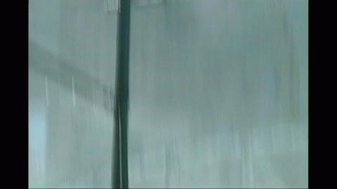<1: Note ZOOM OUT motion - just as collapse starts
source: http://www.youtube.com/watch?v=oW18Pj-3gHc (at start of clip)
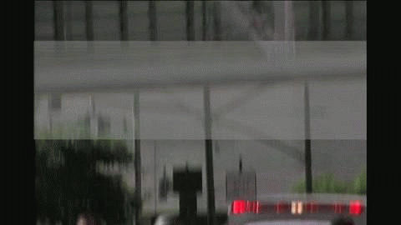< 2: Note ZOOM OUT motion - just as collapse starts (yet different vantage point)
source: http://www.youtube.com/watch?v=-2KVQI_CG8M (at start of clip)
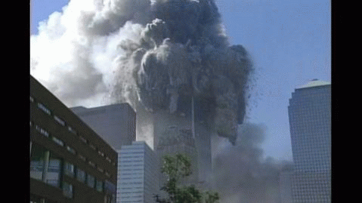< 3: Note rapid ZOOM OUT - a few seconds after collapse initiation
source: https://www.youtube.com/watch?v=dJI3E7gIvrE
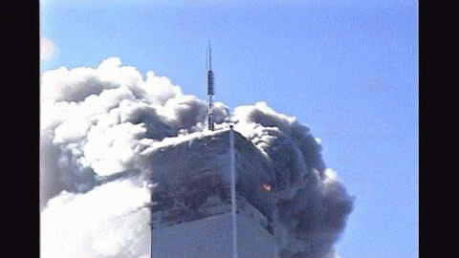< 4: Note smooth / gradual ZOOM OUT - as tower collapses
source: http://www.youtube.com/watch?v=81FVslXmIow (at 1:10)
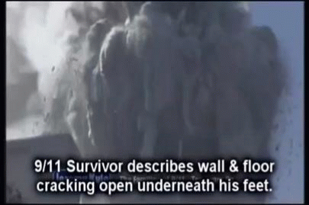< 5: Note ZOOM OUT motion - about halfway through collapse
source: https://www.youtube.com/watch?v=x9NYAFZPq0I
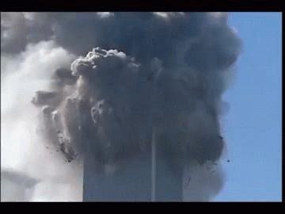< 6: Note ZOOM OUT motion towards end of collapse
source: https://www.youtube.com/watch?v=6fg1jmr3n6w (at 5:07)
In order to believe that these six shots are what they are CLAIMED TO BE (i.e. REAL clips shot by REAL cameramen of the REAL WTC1 collapse), you would have to accept that - for these six "sister-clips" to exist - ALL of the following 'real-world conditions' were fulfilled (whether by matter of chance, happenstance or karmic serendipity...):
1 - ALL SIX cameramen were - for whatever reason - still roaming in the vicinity of the WTC complex at 10:28am (a full 29 minutes after the earlier WTC2 collapse at 9:59am). This, in spite of the officially reported 'total evacuation' of Lower Manhattan - which, reportedly, was kicked off soon after the alleged "plane crashes" - one hour or so earlier.
2 - ALL SIX cameramen, no matter how far they were standing from each other / and from the WTC, were pretty much LATERALLY aligned with each other. The LATERAL perspectives of the six shots - although not perfectly identical - are quite remarkably similar.
3 - ALL SIX cameramen had their six camera-lenses coincidentally trained on the top floors of WTC1 - at a high zoom level (close-up view) - JUST as WTC1 started to fall. This, in spite of having no possible foreknowledge of the WTC1's sudden collapse - and in spite of WTC2 having collapsed (as seen on TV) 29 minutes earlier. For some reason, they all just hung around there for another half-hour, a few hundred yards away from the WTC complex, filming away (undisturbed by the ongoing evacuation)...
4 - ALL SIX cameramen (quite coincidentally / by pure happenstance) decided to perform a manual or motorized zoom-out motion - immediately / or within seconds of the WTC1 collapse initiation - and quite successfully so (all six zoom out motions being remarkably progressive and smooth - with minimal amounts of camera shake or motion blur).
5 - ALL SIX cameramen had nerves of steel - and remained calm and composed while all around them, screaming people were running away from the scene in dire panic.
°°°°°°°°°°°
Our collective work here at Cluesforum submits a more plausible and logical explanation (and I hope no one minds me "speaking for all" on this occasion). What we are looking at is digitally fabricated imagery or, if you will, (fairly)'realistic-looking' computer animations. There is certainly no question that such technology exists, since Hollywood movie productions use it everyday - and have been doing so way before 2001. To simulate a crumbling building - in reasonably realistic-looking manner - and to produce various "camera angles" of its collapse (from a main template crafted in a 3D environment) is well within the reach of ANY high-end movie studio.
THE MIRACLE ZOOMS: http://www.septemberclues.info/miracle_zooms.shtml
As a former sports photographer / cameraman, I know from experience that the very last thing I would want to do - while in the midst of capturing a sudden and dramatic split-second event - is to perform a zoom-in or zoom-out motion. This, for a number of reasons which I trust anyone (who has ever handled a camera) can intuitively fathom. Instead, the 9/11 imagery is replete with such zoom ins/ zoom outs - almost to the point of being an absurd, pervasive "trademark" of the crucial 9/11 'money shots' ("plane approaches" / "tower collapses"). Several other such "MIRACLE ZOOM" examples can be viewed in the above link to my website.
NIST'S NONSENSICAL "11 SECOND" CLAIM
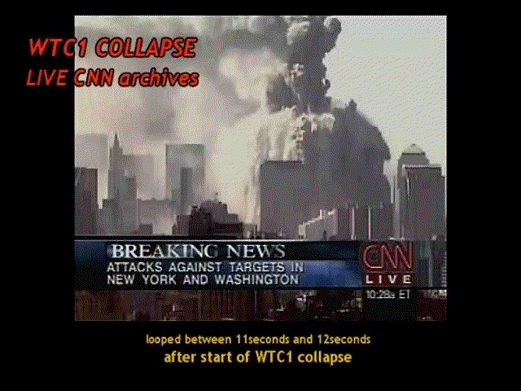
Another empirical / incontrovertible fact that requires NO special photographic/ camera experience to appreciate is the following: ALL of the above clips show a building collapse which clearly appears to last for well over 11 seconds. In fact, if we just time these collapses, we may estimate the 11-second mark to occur at / or around the video (animation) frame illustrated below. For easy comparison with other WTC1 collapse animations, I have put an "x" on that massive 'chunk of debris' which is seen tumbling mid-air, still about halfway on its journey down to the ground (and almost level with the 47-story WTC7) :
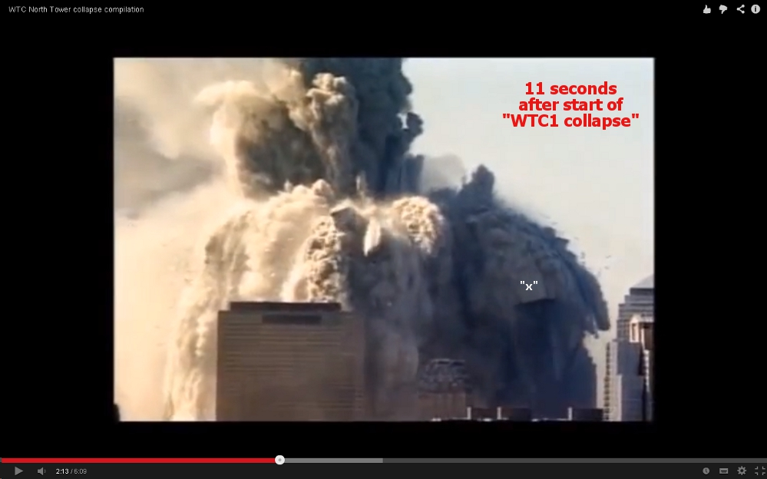
source: https://www.youtube.com/watch?v=6fg1jmr3n6w (at 2:13)
So what about those 11 seconds - you ask me? Well, here's the problem. The official NIST report states:
"WTC2 collapsed in 9 seconds."_______ "WTC1 collapsed in 11 seconds".
I kid you not, dear reader: that is actually what NIST (the National Institute of Standards and Technology - no less!) officially claims in its million-dollar report which (taxpayers are told) is the result of a most accurate, painstaking and long-lasting scientific investigation. So what exactly - you may ask - does this mean? Has NIST never taken a look at the available 9/11 "footage"? Can Americans not even trust their own government-appointed agencies? Could NIST possibly be outright lying to the American people and even - Heavens forbid - taking them all for a ride ? How callously offensive would this be for the 9/11 victims' families!... Oh wait, are there any victim's families? We still haven't heard from any of them, have we? Hmm - perhaps we should just be a little more patient. After all, only 5 years have passed since we first postulated that no one perished on 9/11... (***crickets***crickets***)
Well, folks. This is all very sad for the American people. And the rest of the world of course. If US government agencies can get away with such crude 'in-your-face' mockery - like that "9 and 11 seconds" claim for the alleged collapse times of WTC2 and WTC1 - they can get away with absolutely anything. For now, it seems they are doing just that. We all need to stop buying into their dodgy data.
Some will go ahead and buy it - yet others will simply refuse to sell out their brain cells
***************************************************************************************
The Collapse Animations page at my SEPTEMBER CLUES info website: http://www.septemberclues.info/wtc_collapses.shtml
simonshack
Administrator

Posts: 6745
Joined: Sun Oct 18, 2009 8:09 pm
Location: italy

Top

Re: CGI collapse footage
by simonshack on Sun Feb 16, 2014 7:34 pm
*
DUST BUST
As you know, there are multiple methods of exposing a video fraud. Some may be more - and some may be less - compelling, but perhaps the most 'elegant' and irrefutable is when we can prove a chronological impossibility. Well, if you wonder what I'm on about - here's one such perfect, "chrono-logic" case.
Some of you may remember my previous post in this thread called "DUST IN THE WIND". In that little study, I compared different "WTC2 collapse videos" credited to various purported amateur cameramen - all of which featured very similar camera angles - with the Millenium Hotel in the foreground. I noted how the dust seen on top of the blue hotel always looked oddly different in the various shots.
We also saw exactly HOW and WHEN that dust (or 'soot') was meant to have got there - thanks to this clip credited to one "BARRY WEISS". The dust was clearly MEANT to originate from the WTC2 - soon after it started collapsing:
source: http://www.youtube.com/watch?v=qZUcom0hUxk
To be sure, as the collapse initiates in the BARRY WEISS clip, there is NO DUST whatsoever to be seen on the top of the Millenium hotel. Let us verify this fact: here is a frame from the WEISS clip - moments before that grayish dust starts trickling down:
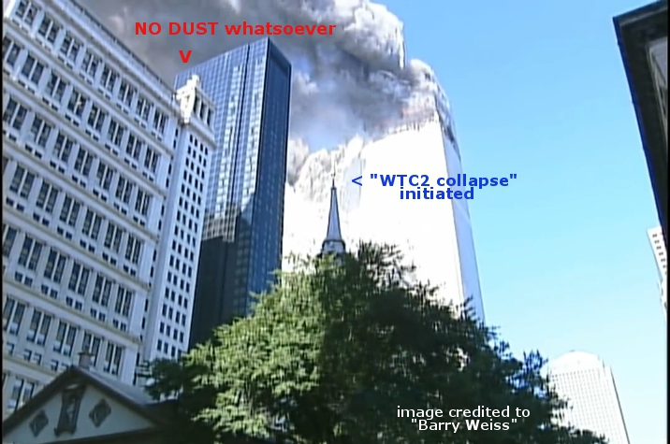
source: http://www.youtube.com/watch?v=qZUcom0hUxk
Today, I took a fresh look at this other NIST-FOIA video credited to one "KEVIN SEGALLA". Now, "Kevin's" clip doesn't actually feature the WTC2 collapse (or, more correctly - the animation thereof). Apparently, our Kevin only briefly walks by the Millenium Hotel and aims his camera at it - sometime before 9:59am. Well, according to "Kevin's video" the dust was already there BEFORE the WTC2 collapse! Here's a frame from the "KEVIN SEGALLA" video - showing the top of the Millenium hotel:
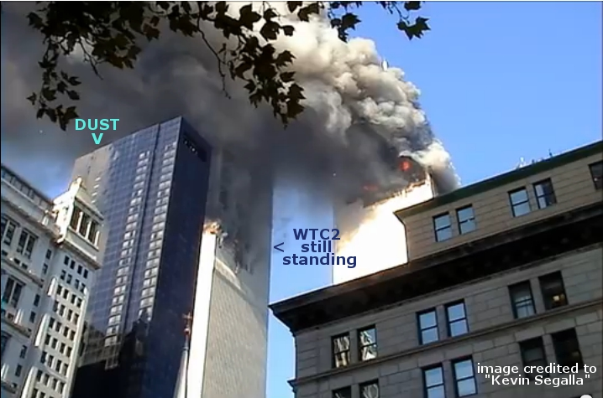
source: http://www.youtube.com/watch?v=odWiVUcwN48
I often say that "the 9/11 videos DISQUALIFY EACH OTHER" - and some may wonder what I mean by that. Hopefully, this example is self-explanatory.
I should probably add it to my collection of "Utterly Undebunkable September Clues". Objections, anyone? Uncle Fetzer, perhaps?
simonshack
Administrator

Posts: 6745
Joined: Sun Oct 18, 2009 8:09 pm
Location: italy

Top

Re: CGI collapse footage
by simonshack on Fri Feb 21, 2014 4:13 pm
*
WTC2 ROOFTOP TILT ANGLE(S)
Judy Wood has these two images (allegedly depicting the initial moments of the WTC 2 collapse) on her website:
IMAGE A
IMAGE B
If you understand the geographical vantage points that these images are supposed to be captured from, you will easily notice that:
- IMAGE A shows the WTC2 rooftop tilting steeply 'due' SOUTH.
- IMAGE B shows the WTC2 rooftop tilting steeply 'due' EAST.
You just can't have it both ways. Is Judy Wood incapable of understanding such a simple fact?

