Remote Controlled Terrorism
By Michael Treis

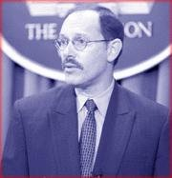
Until President George W. Bush appointed him Undersecretary of Defense and Comptroller of the Pentagon, Rabbi Dov Zakheim was Chief Executive Officer of System Planning Corporation's International Division. He co-authored an article entitled "Rebuilding America's Defenses: Strategy, Forces and Resources for a New Century" which was published by The Project for a New American Century in September 2000, a year before 9/11; on page 51, it is stated that "the process of transformation, even if it brings revolutionary change, is likely to be a long one, absent some catastrophic and catalyzing event - like a new Pearl Harbor"! Could he by physic? Might he have been issuing a warning or giving a public coded message of his intent?
System Planning Corporation main claim to fame is the Flight Termination System (FTS) which allows the takeover of an aircraft prior to flight or in flight. It allows the remote control of up to eight planes by one controller. Rather than my explanation, I give you System Planning Corp. own website.


Flight Termination System
System Planning Corporation's is proud to offer the Flight Termination System (FTS), a fully redundant turnkey range safety and test system for remote control and flight termination of airborne test vehicles. The FTS consists of SPC's Command Transmitter System (CTS) and custom control, interface, and monitoring subsystems. The system is fully programmable and is flexible enough to meet the changing and challenging requirements of today's modern test ranges.
The FTS is generally deployed in one of two configurations:  - Multi-Site System: a network of multple CTS units spread over a large geographic area  - Multi-Control System: multiple operator consoles sharing control of a single CTS unit  Multi-Site System  Because many installations require several remote CTS units that can be controlled from either the remote site or a centralized site, the FTS has been developed to control a fully redundant automated network of transmitters. The system can be configured to operate as a single local site or with up to eight remote sights over an extended range. Each CTS unit may be controlled locally (manually), or as part of the larger FTS system. The fully redundant central control unit also supports either manual or automated modes of operation.  Mission logging is performed by the Range Monitor, an independent subsystem which monitors commands to the CTS as well as transmitted RF tones. All activity is recorded for post-mission analysis.  One of FTS's major strengths is its flexibility. A fully programmable command library provides a variety of mission-specific command tones in addition to the required Command Destruct sequence.  Multi-Control System  FTS also allows multiple missions to be run simultaneously with a single CTS unit. In this mode, multiple operator stations share control of the transmitter unit. The FTS control software ensures that the multitasking of the CTS unit is performed seamlessly and is completely transparent to the operators. | 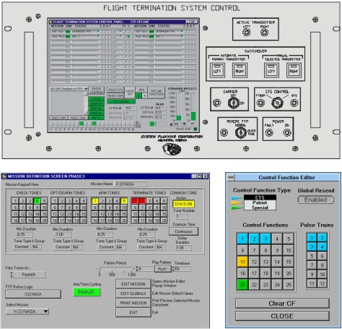

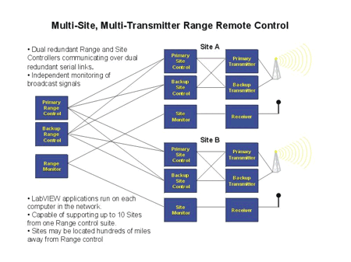 | 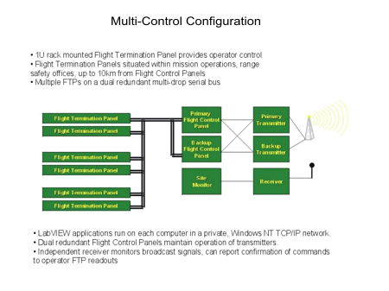
Control Software
FTS Control Systems feature a LabVIEW-based graphical user interface (GUI) that can be easily customized to suit specific requriements. FTS software automatically coordinates communication and control among range-control subsystems, site-control subsystems, and CTS units. The user-friendly interface is simple and straightforward, yet provides considerable power and flexibility.
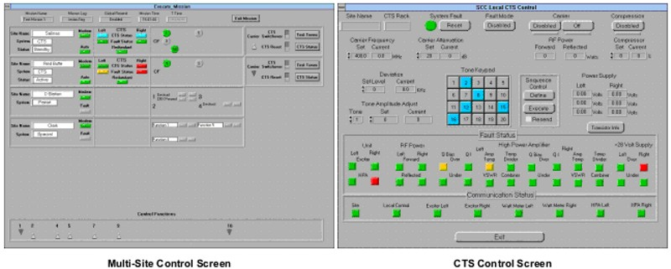

Features and Specifications
Mission Programmability | - Select active components for each mission profile*  - Select mission control location
Command Programmability | - Support for multiple receiver formats:  - Individual tone  - Continuous tone  - Pattern  - Synchronization of programs to all participating controllers via inter-unit communications  - Support for future upgrades and increased capability though software enhancement
Command Response Time | - Button push to ON-AIR < 40 milliseconds*
Redundancy | - Dual controller system with seamless manual or automatic switchover on fault detection  - Automatic recovery of restored communication paths  - Dual paths for operator commands and carrier controls
Fault Detection/Indication | - Visual & audible alarms  - Controller communication link fault detection  - Detection of CTS internal faults  - Communication between subsystems uses packetized messages with error detection (16-bit CRC)
System Monitoring | - Display and recording of OFF-AIR or closed loop carrier and tone decode activity  - Monitoring of carrier power (dBm) and modulation deviation (kHz) at 67 Hz rate  - Recording of all operator inputs  - Log of communications with each participating controller identified  - Records include all message interchanges with corrupted data packets highlighted**
User Interface | - User-friendly GUI  - Ability to save and recall setups  - Visual system interconnection diagram with real-time monitored data (at transistor level):**  - Amplifier temperature and current draw**  - Power, voltage**
Security | - Three levels of password protection on all control and monitor computers
* Multi-site configuration
** Multi-control configuration
Download brochure for complete system or RF subsystem.

*** An ISO 9001:2000 Certified Company ***

*** Over 30 Years of Excellence ***
Copyright © 2004 System Planning Corporation | Site Search | Jobs
For more information on radar products and services, contact radar@sysplan.com

Command Transmitter System
System Planning Corproation's Command Transmitter Systems (CTS) provide remote control and flight termination functions through a fully-redundant self-contained solid-state system.
Exciter  The exciter incorporates state-of-the-art Direct-Digital-Synthesis technology to simultaneously generate an RF carrier and up to 6 of 20 available standard IRIG-B tones. It has 20 watts of output power and an internal ferrite isolator. The exciter may also be used as a standalone unit.  High-Power Amplifier  The high-power amplifier (HPA) is solid-state, dependable, and cool running, allowing continuous 1-kW output power at temperatures from 0º to 50ºC, and from sea level to 30,000 feet AMSL. The Command Transmitter System is MIL-STD-461C qualified and designed to military standards for high MTBF and continuous 24-hour-per-day operation.  State-of-the-art CMOS micro-controllers provide full fault detection and reporting. High-power ferrite isolators allow full-power operation with antenna VSWRs up to 2:1. The HPA is designed for graceful degradation, which allows high-output power operation even with several amplifier modules inoperative. As an optional feature, each HPA sub-system is provided with an RF switch matrix that allows real-time replacement of HPA units.  External modulation inputs may be used to modulate the transmitters with externally-generated tones from 10 Hz to 100 kHz.  The system can be switched automatically or manually between transmitters. Automatic switching to the redudant system is completed in less than 5ms upon detection of an internal fault or at preset RF power thresholds. The system is mounted in two standard 60"-high racks for easy installation in mobile platforms. The roller-bearing, tiltable rack slides allow easy access within the chassis for low MTTR. CTS generally ships with front panel button operation for broadcast frequency and tones. Add-on options are available from SPC for remote control features. For more information on an integrated control system, see SPC's Flight Termination System | 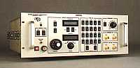  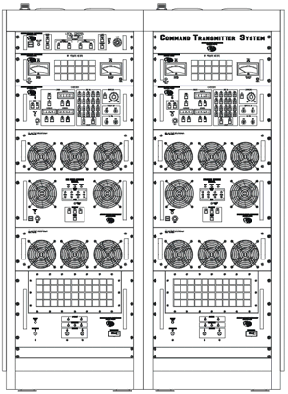
Download a CTS brochure.
CTS Specifications
Performance Feature | FTS Specification
Frequency Range: | 400-550 MHz in 100-kHz steps
RF Output Power: | Exciter: 20 Watts; HPA: 1 kW
RF Power Control: | 1-dB steps, 60-dB total range
Permissible Antenna VSWR: | > 2:1 continuously, 50 ohms nom.
Harmonics: | < -50 dBc at 1 kW
Spurious: | < -80 dBc at 1 kW
Modulation: | FM
Deviation: | ± 300 kHz
Modulation Range: | Internal: 7.5-73.95 kHz (IRIG-B tone frequencies)
Prime Power: | 180-228 VAC 3-phase Wye connection, 47-63 Hz; 5 kVA maximum per rack, two connectors required (supplied); entrance at bottom center of each rack  Local Control, RF Power Monitor, and Exciter are supplied 120 VAC nom. single-phase by the HPA power supply
Cooling: | Forced air; all exhausts through rear panels
Controls and Indicators
Local Control: | - Automatic or manual  - Either transmitter as primary or secondary Local/Remote  - Alarm reset and audio alarm disable  - System fault  - Overtemperature fault  - Power on/off
RF Power Monitor: | - Forward and reflected RF output power level  - Forward and reflected RF output power fault  - Overtemperature
Exciter: | - Local/Remote  - Carrier enable, carrier on  - RF output power attenuator  - RF carrier frequency  - Selected audio tone (up to 6 of 20)  - Deviation  - Deviation monitor  - Compressor on/off and limit set  - Overtemperature fault  - Power on/off
HPA: | Overtemperature
HPA Power Supply: | - Line power (indicators)  - System power (circuit breaker/switch)  - HPA 28-volt power (circuit breakers/switches,Indicators)  - Overtemperature
Dimensions: | 2 standard 19" racks, 32" deep and 60" high
Antenna Connectors: | Female type LC, mounted on left-rear upper rack surfaces
Weight: | Approx. 800 lb/rack

These two web pages are proof that this technology in here now, in fact in place almost two years prior to 9-11! People want to say your nuts to think such a thing is possible, but here you have proof of what I’ve been saying.
To deal with a couple of other facts that support what happened on 9-11. We are told that flight 175 screaming at over 500 miles per hour made three final turns two that generated forces between six and seven G’s and the third in excess of eight G’s. The first thing wrong is, if it had been on autopilot this plane could not have done this, second if under pilot control the pilot would have blacked out, these turns were remotely done. Most damming of all is this photo taken seconds before impact:

This plane has NO windows it is a military tanker, not flight 175

There are other problems with “Flight 175” in the picture below there are the clear marked explosive device and a missile that was fired and caught on video just before impact with the building.
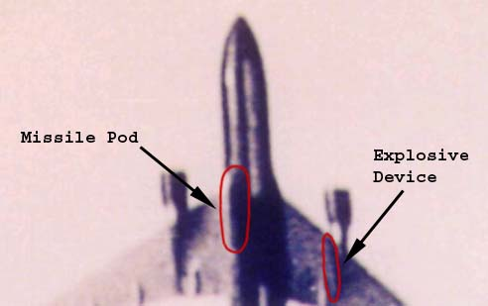

Below is the original this came from:


Below is an earlier shot of the same thing different angle
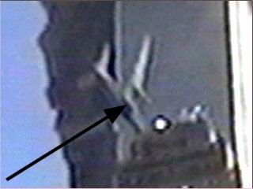

Many have wondered about this, but it is made clearer in the video that should be attached to this article (if it loads). This in the video appears to be a missile launched just before the plane impact with the building, you can see an orange flash of it as it penetrates the building.
Former Pentagon arms salesman Donn de Grand-Pre, author of three books that allege 9/11 was an inside job, “There were no hijackers on the 9/11 killer jets. And he said the chairman of the Joint Chiefs of Staff (Richard Myers) agrees with him.
de Grand-Pre noted: "... the Chairman of the Joint Chiefs himself has agreed, there were no hijackers. There were no cell phone calls. Everybody aboard that aircraft, pilots and crew, were unconscious within 8 to 18 minutes after take-off. And you can take it from there. “These planes were being piloted by remote control, probably an AWACs aircraft taking over that airplane or airplanes or drones, unmanned drones. And flying them at 5 and 8 G-force that no pilot could withstand.”
“Flight 93, the jetliner that supposedly crashed in Pennsylvania after courageous passengers struggled with armed hijackers, was shot down by the North Dakota Air Guard. I know the pilot who fired those two missiles to take down 93," de Grand-Pre insisted, adding that the order to shoot down the plane came from the Adjutant General of North Dakota.”
I have proven through my reports on 9-11 that there were explosives in all three buildings BEFORE 9-11 that brought them down. Now we have Donn de Grand-Pre insistence that these were remote controlled aircraft, which goes along with facts I have reported in previous articles that the US had designed and had in place such technology as much as 2 years before 9-11.
We must not be lulled to sleep by such things as the 9-11 Commission Report and we must continue seek to bring the individual with prior knowledge of the events of 9-11 and did nothing as well as those in high places that participated in the events of that day to justice.
People say why would people in our government do such a thing? One reason the US planned to put an oil pipeline from SE Asia to Russia through Afghanistan but the Taliban refused to allow it. In fact in a meeting two years prior to 9-11 Mr. Cheney sat on the Afghanistan Oil Reserve Control Board and offered “ a carpet of gold” if they allowed the pipline put through or a “ carpet of bombs if they didn’t.” The last negotiations were held two month prior to 9-11 with the Taliban in Washington DC, they still refused. Here is a BBC article proving Colin Powell laid plans for the war in Afghanistan MONTHS prior to 9-11. The order for war was on President Bush’s desk two days prior to 9-11!
Top of Form

 | CATEGORIES | TV | RADIO | COMMUNICATE | WHERE I LIVE | INDEX |  | SEARCH
Bottom of Form

 |  | You are in: World: South Asia
Daily E-mail  News Ticker  Mobiles/PDAs  Feedback  Help  Low Graphics |  | Tuesday, 18 September, 2001, 11:27 GMT 12:27 UK  US 'planned attack on Taleban'  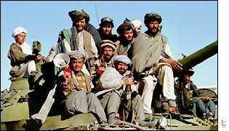  The wider objective was to oust the Taleban  By the BBC's George Arney  A former Pakistani diplomat has told the BBC that the US was planning military action against Osama Bin Laden and the Taleban even before last week's attacks.  Niaz Naik, a former Pakistani Foreign Secretary, was told by senior American officials in mid-July that military action against Afghanistan would go ahead by the middle of October.  Mr Naik said US officials told him of the plan at a UN-sponsored international contact group on Afghanistan which took place in Berlin.  Mr Naik told the BBC that at the meeting the US representatives told him that unless Bin Laden was handed over swiftly America would take military action to kill or capture both Bin Laden and the Taleban leader, Mullah Omar.  The wider objective, according to Mr Naik, would be to topple the Taleban regime and install a transitional government of moderate Afghans in its place - possibly under the leadership of the former Afghan King Zahir Shah.  Mr Naik was told that Washington would launch its operation from bases in Tajikistan, where American advisers were already in place.  He was told that Uzbekistan would also participate in the operation and that 17,000 Russian troops were on standby.  Mr Naik was told that if the military action went ahead it would take place before the snows started falling in Afghanistan, by the middle of October at the latest.  He said that he was in no doubt that after the World Trade Center bombings this pre-existing US plan had been built upon and would be implemented within two or three weeks.  And he said it was doubtful that Washington would drop its plan even if Bin Laden were to be surrendered immediately by the Taleban. |  | See also:  17 Sep 01 | South Asia  Analysis: Pakistan's tough choice  18 Sep 01 | Sci/Tech  Spy satellites retasked  12 Sep 01 | South Asia  Taleban tense as US seeks targets  14 Sep 01 | Americas  Bin Laden's command structure  11 Sep 01 | South Asia  Who is Osama Bin Laden?  17 Sep 01 | South Asia  On edge: Afghanistan's neighbours  18 Sep 01 | South Asia  The Taleban military machine  Internet links:  Afghanistan Online  US State Department  The BBC is not responsible for the content of external internet sites  Top South Asia stories now:  Karachi bomb suspects arrested  Pentagon team to examine bomb error  Bangladesh floods maroon thousands  Sri Lanka truce violations recorded  Al-Qaeda 'may have killed minister'  Regional media views Afghan killing  More arrests in Pakistan gang rape  England crash to defeat  Links to more South Asia stories are at the foot of the page.
  Front Page
  World
  
  Africa
  Americas
  Asia-Pacific
  Europe
  Middle East
  South Asia
  -------------
  From Our Own Correspondent
  -------------
  Letter From America
  UK
  UK Politics
  Business
  Sci/Tech
  Health
  Education
  Entertainment
  Talking Point
  In Depth
  AudioVideo
  SERVICES
  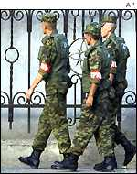
  Russian troops were on standby
  
  Bin Laden would have been "killed or captured"
  WATCH/LISTEN
  ON THIS STORY
  The BBC's George Arney
  says the US had made plans for a major assault on Afghanistan before the WTC attacks
  Former British soldier Mike Yardley
  "From a military perspective Afghanistan is a really tough nut to crack"
  
  The loya jirga
  Political healing
  What is a loya jirga?
  Profiles
  Hamid Karzai
  Zahir Shah
  Unfinished conflict
  Guarding Gardez
  Violence halts refugees
  'Bounty' threat
  Last stand or long war?
  Warlords re-emerge
  Rebuilding the country
  Spending the billions
  Children's bravery
  FACT FILES
  Afghan powerbrokers
  War: Where next?
  AUDIO VIDEO
  TV and Radio reports
  TALKING POINT
  You asked Hamid Karzai

E-mail this story to a friend
Links to more South Asia stories
Top of Form

Bottom of Form

So we have motive for the attacks. The oil pipeline. There was also motive to take Saddam and Iraq, the control of the oilfield there is quite the prize in MILLION of dollars a day in oil.
I could write a hundred more such articles with different proof of the motive , means and opportunity for the attack on 9-11, all of which boil down to money, control & power. Power over this country as well, power that is destroying our Constitutional Republic, FOREVER with police state laws invoked since 9-11. Our Heavenly Father allows this destruction of our country because; we have turned our backs on HIM. In the 1930’s WE allowed the Common Law based on HIS law to be taken away without so much raising a hand or our voice to stop it. In 1960’s WE allowed prayer, His Word the Bible, to be taken from our schools without a whimper. Now we have allowed over 40 MILLION children to be sacrificed on the alters of Baal in the aborticide clinics and a million plus a year added to the figure. That’s twice the population of North Dakota, or Ft.Worth, Texas being murdered each year and WE allow it.
Our Heavenly Father, Yahweh, allows the chastisement of his people in hopes the will turn from their wickedness of sin, and return to obeying HIS law, before the soon final destruction comes to this planet.
It is YOUR choice, choose well.

Pastor Michael Treis

