Battle of Los Angeles
By Paul T. Collins
http://www.oregonuforeview.com/battle.html

On Wednesday, February 25, 1942, as war raged in Europe and Asia, at least a million Southern Californians awoke to the scream of air-raid sirens as Los Angeles County cities blacked out at 2:25 AM. Many dozed off again while 12,000 air raid wardens reported faithfully to their posts, most of them expecting nothing more than a dress rehearsal for a possible future event - an invasion of the United States by Japan. At 3:36, however, they were shocked and their slumbering families rudely roused again, this time by sounds unfamiliar to most Americans outside the military services.
The roar of the 37th Coast Artillery Brigade's anti-aircraft batteries jolted them out of bed and before they could get to the windows the flashing 12.8 pound shells were detonating with a heavy, ominous boomp - boomp - boomp and the steel was already raining down. All radio stations had been ordered off the air at 3:08. But the news was being written with fingers of light three miles high on a clear star-studded blackboard 30 miles long.
The firing continued intermittently until 4:14.
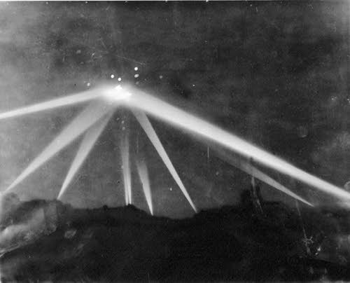
This is an actual photograph of the event as it unfolded.
Unexploded shells destroyed pavement, homes and public buildings, three persons were killed and three died of heart attacks directly attributable to the one hour barrage. Several persons were injured by shrapnel. A dairy herd was hit but only a few cows were casualties. The blackout was lifted and sirens screamed all clear at 7:21. The shooting stopped but the shouting had hardly begun. Military men who never flinched at the roar of rifles now shook at the prospect of facing the press. While they probably could not be blamed for what had happened, they did have some reason for distress. The thing they had been shooting at could not be identified.
Caught by the searchlights and captured in photographs, was an object big enough to dwarf an apartment house. Experienced lighter-than-air (dirigible) specialists doubted it could be a Japanese blimp because the Japanese had no known source of helium, and hydrogen was much too dangerous to use under combat conditions. Whatever it was, it was a sitting duck for the guns of the 37th. Photographs showed shells bursting all around it. A Los Angeles Herald Express staffer said he was sure many shells hit it directly. He was amazed it had not been shot down.

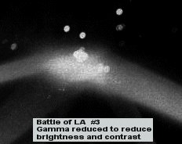

The object that triggered the air raid alarm had drawn 1430 rounds of ammunition from the coast artillery, to no effect. When it moved at all, the object had proceeded at a leisurely pace over the coastal cities between Santa Monica and Long Beach, taking about 30 minutes of actual flight time to move 20 miles; then it disappeared from view.
You can well imagine with what chagrin public information officers answered press queries. The Pasadena Office of the Southern California Sector of the Army Western Defense Command simply announced that no enemy aircraft had been identified; no craft was shot down; no bombs were dropped; none of our interceptors left the ground to pursue the intruder.
Soon thereafter US Navy Secretary Frank Knox announced that no planes had been sighted. The coastal firing had been triggered, he said, by a false alarm and jittery nerves. He also suggested that some war industries along the coast might have to be moved inland to points invulnerable to attacks from enemy submarines and carrier-based planes.

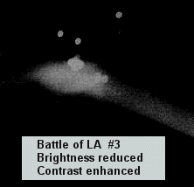

The press responded with scathing editorials, many on page one, calling attention to the loss of life and denouncing the use of the coast artillery to fire at phantoms. The Los Angeles Times demanded a full explanation from Washington. The Long Beach Telegram complained that government officials who all along had wanted to move the industries were manipulating the affair for propaganda purposes. And the Long Beach Independent charged: "There is a mysterious reticence about the whole affair and it appears some form of censorship is trying to halt discussion of the matter. Although it was red-hot news not one national radio commentator gave it more than passing mention. This is the kind of reticence that is making the American people gravely suspect the motives and the competence of those whom they have charged with the conduct of the war."
The Independent had good reason to question the competence of some of the personnel responsible for our coastal defense operations as well as the integrity and motives of our highest government officials. Only 36 hours before the Long Beach air raid, a gigantic Japanese submarine had surfaced close to shore 12 miles north of Santa Barbara and in 25 minutes of unchallenged firing lobbed 25 five-inch shells at the petroleum refinery in the Ellwood oil field. The Fourth Interceptor Command, although aware of the sub's attack, ordered a blackout from Ventura to Goleta but sent no planes out to sink it. Not one shot was fired at the sub.
Against this background of embarrassing indecision and confusion, Army Western Defense Command obviously had to say something fast. Spokesmen told reporters that from one to 50 planes had been sighted, thus giving themselves ample latitude in which to adjust future stories to fit whatever propaganda requirements might arise in the next few days.
When eyewitness reports from thousands searching the skies with binoculars under the bright lights of the coast artillery verified the presence of one enormous, unidentifiable, indestructible object - but not the presence of large numbers of planes - the press releases were gradually scaled downward. A week later Gen. Mark Clark acknowledged that army listening posts had detected what they thought were five light planes approaching the coast on the night of the air raid. No interceptors, he said, had been sent out to engage them because there had been no mass attack.
Photo Analysis by Bruce Maccabee.

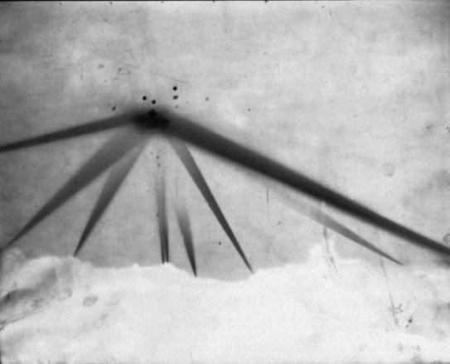

To get the true relative image brightnesses it is necessary to scan the original negative and then adjust the "gamma" (relation between film image density and the about of light which made the image) to match the gamma at development. This is typically 1, but they may have pushed the film to a higher gamma to get faint images. There may well be information on the shape of the "object" which is not discernible from the print because apparently the exsposure level of the "object" is quite high and so the image may be well into the range of brightness saturation of the print. IF this is so, i.e., if the print image is well saturated, no amount of analysis will "dig out" the totality of brightness information (variations in the high brightness levels)contained within the negative.
I don't know the film speed or the f stop of the camera. However, I would guess that this is a time exposure because (a) the light beams show up and (b) there are quite a few "explosions" (I presume) which probably did not happen all at once. The exposure could have been several seconds.
The fact that the beams basically do not get past the "object" (there is some faint evidence of beams above the object), whatever was at the beam convergence must have been optically quite dense. If there was a lot of smoke swirling around the volume of air illuminated by the beams, I would expect to see variations in bream brightness (brighter where there was smoke). There are variations, but they are uniform and agree with the distance (from the searchlight) and width of the beam. That is, the variations are consistent with each beam getting dimmer as it travels away from the searchlight. IF there were smoke within any beam it should cause an increase in scattered light where there is smoke (which is how we see the beams anyway... light bounced or scattered from dust or smoke particles in the air). The beams are quite bright before they reach the "object" and zero or nearly zero afterward. Just how much optical density of smoke this requires I do not know. However, certainly a solid metallic object would be sufficient to block the beams.

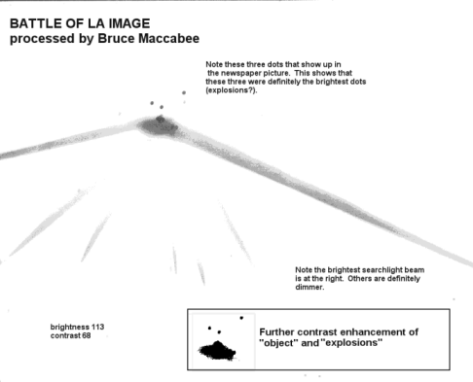

How large is the "object"? If we knew the distance of the camera from the beam convergence and the focal length of the camera we could calculate the approximate size. This requires knowing what portion of the city the object was over, where the cameraman was, and the altitude of the "object." An alternative method is to estimate the diameter of a spotlight beam at some distance from the spotlight and use that width as a reference size. I found a research article by Dr. Louis Eltermann that reports research in the latter 1940's in which he used an army searchlight to probe the upper atmosphere in order to determine the vertical distribution of dust in the atmosphere.
Eltermann described the searchlight as being 5 ft in diameter and with a divergence of about 1.25 degrees or about 20 milliradians. This means that the diameter at a distance d from the mirror would be about D = 5'+0.02d. Thus at 1000 ft the diameter would be about 25 ft. Of course, the beam is not uniformly bright across its diameter, so the effective diameter might be a foot or so less than this. Consider the beam at the right side of the photo. It protrudes upward at some angle, probably not the angle in the photo. Suppose the elevation angle were 30 degrees. The "object" width is oriented horizontally (parallel to the ground) whereas the beam is assumed to be tilted at about 30 degrees. Hence the horizontal width of the beam, W, (not perpendicular to the beam axis) would be W = D/cos(angle of elevation) = D/sin(30) = 2D. Hence if the object were 1000 ft from the projection lens it was about 40 ft wide. If at 2000 ft the calculation yields D = 45 ft and W = 90 ft.
Based on the above estimate, and realizing that a much better estimate could be made if we had more accurate information on the spotlights, camera, etc., I would hazard a guess that the width of the illuminated "object" is on the order of 50 ft - 100 ft in size. Without more solid information to go on this has to be no more than a WAG (wild...rear-end... guess) (but I bet its close to right!)
Special thanks to OUFOR consultant and photo analyst Dr. Bruce Maccabee and to Paul T. Collins for his outstanding investigative work as it appeared in Fate Magazine July, 1987.

The Battle of Los Angeles
Part 1
B J Booth
http://ufocasebook.com/battleoflosangeles.html

Case and point: A UFO event of mass proportion: a giant Alien spaceship hovering over one of our major cities, threatening our very existence. A scenario from "War of the Worlds," "Independence Day," or "The Day the Earth Stood Still"? NO! it is NOT science fiction, it has ALREADY happened. When? February 25th, 1942 in the Los Angeles area.
Many believe that the "beginning" of the UFO era was in 1947, when Kenneth Arnold sighted flying disc-like objects over Mt. Rainier, coining the phrase "flying saucers." This term was already common military jargon by the time of the Roswell event of the same year. Preceding these landmark UFO events was the mass sighting of a large flying disc in the Los Angeles area in February 25th, 1942. Coming at a time of heightened security and anxiety following the Japanese invasion of Pearl Harbor only a few months before, this invasion would become a major UFO event, and possibly an omen of things to come. In Ufology, this is commonly referred to as:
The Battle of Los Angeles
The early morning hours of 2-25-42 would bring the first alerts of an invasion. Naturally, the first thought in the minds of everyone was that another wave of Japanese planes was attacking America on its own soil. Citizens of Culver City and Santa Monica would be the first to witness the surreal sight of a giant unknown object hovering over the suburban areas of Los Angeles.
Immediately, an air raid siren shattered the peaceful sleep of the residents, and volunteer Air Raid Wardens grabbed their gear, and headed to the streets, affecting a total blackout. Army's 37th Coast Artillery Brigade swung into action, lighting up the clear, black skies with their massive spotlights. What they saw was beyond belief. With the Japanese planes still flying in their nightmares, another menacing flying machine was now right on top of them.
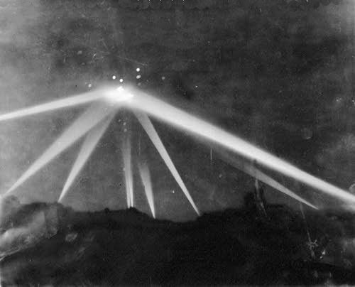
Actual photograph of object under attack
In a matter of a few short minutes, the entire southern area of California was looking to the skies, watching the intense spotlight beams converging on the giant invading UFO. The 37th's anti-aircraft guns helped light up the night, firing volley after volley at the large craft. Many eyewitness reports would state that the large object took many direct hits, but appeared undamaged. The 30+ minute barrage would send fragmented shells over homes, businesses, and citizens. In the aftermath six individuals were found dead from the spent and fragmented artillery shells.
It was reported that hundreds upon hundreds of rounds were fired at the giant UFO, yet it appeared unaffected. Eyewitness accounts described the object as a "surreal, hanging, magic lantern." The object was especially visible as it hovered over the MGM studios in Culver City. There are a number of newspaper articles of this event, and an astonishingly clear picture of the object as it was under its heaviest attack. The object eventually made its way over Long Beach, before it silently disappeared from view. The cannons were now silent.
Some of the most intriguing testimony of the UFO comes from a woman who was a volunteer Air Raid Warden. She lived like many others, in fear of another Japanese attack. Nothing, however, could prepare her for what she so clearly witnessed the night of the giant UFO. Shaken awake by a call from her supervisor, she was briefed on the situation. Living not far from Santa Monica, she was told the object was close enough for her to see from her window. Peeking out of her window, she was shocked at the sight of the massive UFO above. She described the sight as follows:
"It was huge! It was just enormous! And it was practically right over my house. I had never seen anything like it in my life!" she said. "It was just hovering there in the sky and hardly moving at all."
"It was a lovely pale orange and about the most beautiful thing you've ever seen. I could see it perfectly because it was very close. It was big!"
"They sent fighter planes up and I watched them in groups approach it and then turn away. There were shooting at it but it didn't seem to matter."
"It was like the Fourth of July but much louder. They were firing like crazy but they couldn't touch it."
"I'll never forget what a magnificent sight it was. Just marvelous. And what a gorgeous color!", she said
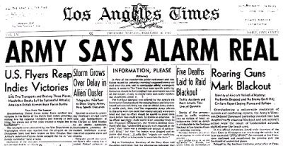
Los Angeles Times Headlines of the event
As the giant UFO moved away, things began to get back to normal, as normal as things could get, considering the times. The military clampdown on Japanese citizens, and security restrictions on its native populace made this an unusual time. Had it not been for America being at war, news of this event would have gained more momentum. The lesson to be learned from this is simply that we must be ready at all times to defend our country, and our globe from any invading force that would take our freedom as we know it from us.

The Battle of Los Angeles, Part 2
Newspaper Excerpts
Chilly Throng Watches Shells Bursting In Sky
By Marvin Miles
Explosions stabbing the darkness like tiny bursting stars... Searchlight beams poking long crisscross fingers across the night sky...Yells of wardens and the whistles of police and deputy sheriffs...The brief on-and-off flick of lights, telephone calls, snatches of conversation: 'Get the dirty...' That was Los Angeles under the rumble of gunfire yesterday.
RESIDENTS AWAKENED
Sleepy householders awoke to the dull thud of explosions... "Thunder? Can't be!" Then: "Air Raid! Come here quick! Look over there...those searchlights. They've got something...they are blasting in with anti-aircraft!" Father, mother, children all gathered on the front porch, congregated in small clusters in the blacked out streets -- against orders. Babies cried, dogs barked, doors slammed. But the object in the sky slowly moved on, caught in the center of the lights like the hub of a bicycle wheel surrounded by gleaming spokes.
SPECULATION RIFE
Speculation fell like rain. "It's a whole squadron." "No, it's a blimp. It must be because it's moving so slowly." "I hear planes." "No you don't. That's a truck up the street." "Where are the planes then?" "Dunno. They must be up there though." "Wonder why they picked such a clear night for a raid?" "They're probably from a carrier." "Naw, I'll bet they are from a secret air base down south somewhere." Still the firing continued. Like lethal firecrackers, the anti-aircraft rounds blasted above, below, seemingly right on the target fixed in the tenacious beams. Other shots fell short, exploding halfway up the long climb. Tracers sparked upward like roman candles. Metal fell. It fell in chunks, large and small; not enemy metal, but the whistling fragments of bursting ack-ack shells. The menacing thud and clank on streets and roof tops drove many spectators to shelter.
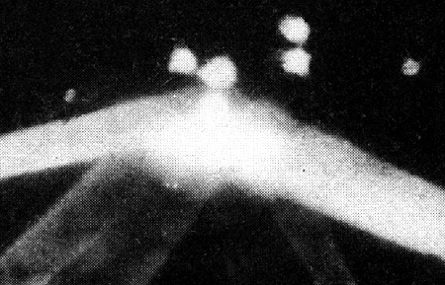
Close up view of large UFO
WARDENS DO GOOD JOB
Wardens were on the job, doing a good job of it. "Turn off your lights, please. Pull over to the curb and stop. Don't use your telephone. Take shelter. Take shelter." On every street brief glares of hooded flashlights cut the darkness, warning creeping drivers to stop. Police watched at main intersections. Sirens wailed enroute to and from blackout accidents. There came lulls in the firing. The search lights went out. (To allow the fighter planes to attack?). Angelinos breathed deeply and said, "I guess it's all over." But before they could tell their neighbors good night, the guns were blasting again, sighting up the long blue beams of the lights.
WATCHERS SHIVER
The fire seemed to burst in rings all around the target. But the eager watchers, shivering in the early morning cold, weren't rewarded by the sight of a falling plane. Nor were there any bombs dropped. "Maybe it's just a test," someone remarked. "Test, hell!" was the answer. "You don't throw that much metal in the air unless you're fixing on knocking something down." Still the firing continued, muttering angrily off toward the west like a distant thunderstorm. The targeted object inched along high, flanked by the cherry red explosions. And the householders shivered in their robes, their faces set, watching the awesome scene.
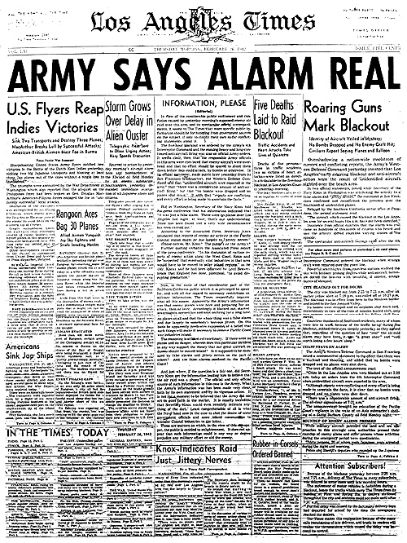
Newspaper Archives
Army Says Alarm Real Roaring Guns Mark Blackout
By Marvin Miles
Identity of Aircraft Veiled in Mystery; No Bombs Dropped and No Enemy Craft Hit; Civilians Reports Seeing Planes and Balloon
Overshadowing a nation-wide maelstrom of rumors and conflicting reports, the Army's Western Defense Command insisted that Los Angeles' early morning blackout and anti-aircraft action were the result of unidentified aircraft sighted over the beach area. In two official statements, issued while Secretary of the Navy Knox in Washington was attributing the activity to a false alarm and "jittery nerves," the command in San Francisco confirmed and reconfirmed the presence over the Southland of unidentified planes. Relayed by the Southern California sector office in Pasadena, the second statement read: "The aircraft which caused the blackout in the Los Angeles area for several hours this a.m. have not been identified." Insistence from official quarters that the alarm was real came as hundreds of thousands of citizens who heard and saw the activity spread countless varying stories of the episode. The spectacular anti-aircraft barrage came after the 14th Interceptor Command ordered the blackout when strange craft were reported over the coastline. Powerful searchlights from countless stations stabbed the sky with brilliant probing fingers while anti-aircraft batteries dotted the heavens with beautiful, if sinister, orange bursts of shrapnel.
City Blacked Out For Hours
The city was blacked out from 2:25 to 7:21 am after an earlier yellow alert at 7:18 pm was called off at 10:23 pm. The blackout was in effect from here to the Mexican border and inland to the San Joaquin Valley. No bombs were dropped and no airplanes shot down and, miraculously in terms of the tons of missiles hurled aloft, only two persons were reported wounded by falling shell fragments. Countless thousands of Southland residents, many of whom were late to work because of the traffic tie-up during the blackout, rubbed their eyes sleepily yesterday and agreed that regardless of the question of how "real" the air raid alarm may have been, it was "a great show" and "well worth losing a few hours' sleep." The blackout was not without its casualties, however. A State Guardsman died of a heart attack while driving an ammunition truck, heart failure also accounted for the death of an air raid warden on duty, a woman was killed in a car-truck collision in Arcadia, and a Long Beach policeman was killed in a traffic crash enroute to duty. Much of the firing appeared to come from the vicinity of aircraft plants along the coastal area of Santa Monica, Inglewood, Southwest Los Angeles, and Long Beach.

The Battle of Los Angeles, 1942
by Temnz Sword
From: "UFO Universe", Winter 1993, 9-14
http://www.ufo.it/testi/1942.htm

The controversy over what really happened over Los Angeles is still very much alive. Today, 50 years later, what happened is still unexplained. It has been largely forgotten, or reduced to a few pages in several books and magazines, including official histories of W.W.II, in which it is still considered a mystery.

The Story
On December 7th, 1941, the Japanese attacked Pearl Harbor and the United States of America entered a state of war. During the following weeks, the WestCoast experience several "blackouts."The Army issued statements insisting that the threat of an air-raid was real.There were reports of unidentified planes being seen, and signals were picked up on a new, top-secret device called radar, from Alaska to the Mexican border. None of these reports were ever explained. On December 8, 1941 at 6:00 PM, the first air-raid warning of the night was sounded when air invaders were first detected 100 miles due west of the Golden Gate. First reparts stated that there were 50 planes but later reports gave a smaller number. They were thought tobe planes from a carriet Some of them were thought to have entered the Bay Area and headed southwest.The next night San Francisco underwent two alarms, the first at 1:45 AM,and then again at 2:02 AM. A Uackout was called for and almost immediately planes were heard in the sky all roundthe Bay Area. Another alert came at4:05 AM. Lt. General John L. DeWitt warned that there was a real attack by enemy planes and that California should be prepared. Wednesday December 10, 1941, allof Southern California and the area from Las Vegas to Boulder Coloradowere blacked out shortly after 8 PM. Anti-aircraft gunners were put on alert. Invading planes were reported in the Los Angeles area and south ofthe city. One of the longest blackouts of the war came on December 12th, at 7:20PM. Invading planes were first detected offshore; the first reports came from San Mateo. Invisible, they could be heard as they roared low over the tall buildings inSan Francisco' business district. Many reports during the blackouts were from people who heard planes overhead and assumed they were either Japanese planes or our own planes inpursuit. We know they were not ourplanes. If they were not Japanese planes, Wednesday December 10,1941, all of Southern California and the area from Las Vegas to Boulder Colorado were blacked outshortly after 8 PM. Anti-aircraft gunners were put on alert. Invading planes were reported in the Los Angeles area and south of the city.

What did these people hear? Several of the raids in the Bay areawere accompanied by reports of flaresbeing dropped from the sky or seenflashing from the ground. It was thought that either they had been dropped by the airplanes from above, or by "enemy agents" attempting to direct an attack. The Army issued reports that all theair raids were real and that there were verified reports of planes flying around and over the West Coast area. There hadbeen no test blackouts. The reports gaveno indication as to where the enemy planes had come from, made no men-tion of airplanes carriers, nor suggested whether the invading planes were landor sea planes, heavy bombers, light bombers, or reconnaissance craft.There were many submarine attacksoff our Pacific Coast during this same period. On Monday night, February 23,1942, while President Roosevelt was speaking to the nation on the radio, alarge Japanese submarine surfaced and shelled an oil refinery in Santa Barbara.Timed to have a great political significance, the submarine fired 15-25 shell sat the Bankline Oil Co. in Goleta, Ca. just north of Santa Barbara. The attack did little damage, but it did shake up the locals and increase the cries for removal of the Japanese from coastal areas.
There was also a rumor spread that Los Angeles would be attacked in some &shion the next night.That Tuesday night, the planes returned. At 2 AM Wednesday morningFebruary 25, a blackout was ordered. Searchlights scanned the skies and anti-aircraft guns, protecting the vital air-craR and ship-building factories, wentinto action. In the next few hours, they would fire over 1,400 three-by-twelve inch shells, at an unidentified, slow-moving, object in the sky over Los Angeles, that looked like a blimp, or a balloon. Strange crafl were seen to fly into the area from offthe coast near theSanta Monica mountains and then turnto fly south. Radar was a Top-Secret invention at the beginning of the war, so there could be no discussion of how the Army would be aware of planes approaching our western coast line with out actually seeing them. As a rule, a blackout was called for if radar picked up planes within 60 miles or 15 minutes flying time of the shore. Radar first picked up unidentified craft about 120 miles west of Los Angeles, and at 2:15 AM anti-aircrafl batteries were alerted.
By 2:21AM radar tracked the approaching tar-gets to within a few miles of the coast. Then the radar blips mysteriously vanished. Later there would be reports of planes near Long Beach. After the firing started, careful observation was difficult because of drifting smoke from shell bursts; yet it was a clear weather night. The acting commander of the anti-aircraft artillery brigade in the area testified that he had first been convinced that he had seen fifteen planes in the air, but had quickly decided that he was seeing smoke. The streets, sidewalks, housetops, lawns and rose gardens were litte red with little pieces of metal, particularly in the Long Beach and Santa Monica areas. Most of the anti-aircrafl firing was done by the 65th Coast Artillery (Anti-Aircraft) Regiment in Inglewood, and the 205th A.A. regiment in Santa Monica. By Thursday, the incident became clouded in mystery. Were there planes in the sky? Where did they come from? Why were none shot down? Why were no bombs dropped? Was it just a balloon? Was it a case of jittery nerves? Or was it something we could not shoot down? Of the reports made by various individuals:"I could clearly see the "V" formation of about 25 silvery planes overhead moving slowly across the sky toward Long Beach," said Peter Jenkins ofthe editorial staff of the Los Angeles Evening Herald Examiner. Bill Henry of the L.A. Times reported that "I was far enough away to see an object without being able to identify it....I would be willing to bet what shekels I have that there were a number of direct hits scored on the object."Long Beach Police Chief J. H. Mc-Clelland said "I watched what was de-scribed as the second wave of planes from atop the seven-story Long Beach City Hall. I did not see any planes, butyounger men with me said they could. An experienced Naval observer with me using powerful Carl Zeiss binoculars said he counted nine planes in the cone of the searchlight. He said they were silver in color. This group passed along from one battery of searchlights to another, and under fire from anti-aircraft guns, flew from the direction of Redondo Beach and Inglewood on the landside of Fort MacArthur, and continued toward Santa Ana and Huntington Beach. Anti-aircrafl fire was so heavy, we could not hear the motors of the planes. "The Secretary of the Navy, Frank Knox, issued a statement, "that as far as I know the whole raid was a false alarm and could be attributed to jittery nerves," and he admitted that it was probably a good thing everyone was so alert. He was blasted by critics who felt that if this was true it was a terrible waste of effort and that it hurt the credibility of the many air raid wardens who worked so hard at getting all the lights of the city turned out and helped to keep the citizens calm.
Secretary of War, Henry Stimson, issued what is still the official record of the event which concluded that theraid was caused by as many as 15 planesflying at various speeds and altitudes and that it was reasonable to assume that these planes were flown from commercial sources by enemy agents to spread alarm. No planes were shot down and no bombs were dropped. He would later add his "personal disclaimer" to that statement and simply state that was the report he was given from the West Coast. Congress demanded an explanation. Considerable damage had been done by the antiaircraft fire. Several unexploded shells fell to earth and in some cases into homes of local residents. Several people died as a result of automobile accidents. The attack did little damage, but it did shake up the locals and increase the cries for removal of the Japanese from coastal areas. There was also arumor spread that Los Angeles would be attacked in some fashion the next night.
Some heart attacks, and other injuries were recorded. There was a massive trafflc jam that lasted into the morning rush hour paralyzing the city of Los Angeles. Representative Leyland M. Ford of Santa Monica, was quoted as saying, "The morale of California is extremely highand our people can take the truth, but they do resent this program of misrepresentation and wonder what it is all about. "Records show that 1,440 rounds of anti-aircraft ammunition were shot sky-ward Feb. 25th.
But at what? A Japanese Bomber? No bombs were dropped. A Japanese reconnaissance piane? In 194S, after the war had ended, Lt.Gen. John L. DeWin still held to the belief thd planes had indeed been over Los Angeles and that they probably had come from lapanese submarines. The Japanese submarine I-17, which shelled Goleta, Ca. the night before the raid, had a GLEN light aircraft disassembled on board, but according to Nobukiyo Nambu, First Officer of the I-17, the plane made no flights on that cruise. Was it an American military plane? The Army Air Force (AAF) kept its pursuit planes on the ground, preferring to await indications of the scale and direction of any attack before committing its limited fighter force.
Was it an American commercial plane? A plane from one of the nearby aircraft plants being tested? If so, where did it come from? Where did it go? There is some evidence to suggest that meteorologicai balloons, known to have been released over Los Angeles, may have caused the initial alarm. At3:06 AM, a balloon, reported to be carrying a red flare, was seen over Santa Monica. It was supposedly released by the 205th Anti-Aircraft unit in Santa Monica. This theory is supported by the fact that anti-aircraft artillery units were officially criticized for having wasted ammunition on targets which moved too slowly to have been airplanes. Associated Press ran a photo that with its accompanying caption, tells a different story. It clearly shows "an object" caught in the searchlight beams,with anti-aircraft shells bursting overhead. I have been told by veterans that if they caught something in those beams, they were certain to hit it. If it was a meteorological balloon, of course it would have collapsed immediately and parts of it would have been found the next day. Halbert P. Gillette of San Marinos aid, "The photo in Thursday's L.A.Times shows the alleged balloon clearly, illuminated by nine converging searchlight beams, and with half a dozen blobs of light from bursting anti-aircraft shells near it. This balloon has a nearly hemi-spherical top and possibly a similar base. That it was not a balloon seems probable because the escape of no balloon has been reported as well as because it failed to collapse under intense and apparently accurate shell-fire. "The signal flares, reportedly set off by"enemy agents ' were most likely tracer bullets from anti-aircraft guns. Yet this explanation does not satisfy the reports of flares when there was no anti-aircraft fire. They could have been attempts by our armed forces on the ground to see and identify the planes circling above. A blackout not only makes the ground targets impossible to see, but it also makesidentification of aerial targets difficult. Once searchlights are turned on they must be accompanied by anti-aircraft fire as they become targets themselves. In 1974, a request for information from eyewitnesses was made by Bert Webber, author of Retaliation, and Silent Siege II, following a broadcast from radio station KGO in San Francisco. Over two hundred letters and telephone calls were received. A Community Air Raid Warden from the time says he saw a group of planes, about ten, directly over-head, "forming a perfect V, like a flightof wild geese flying very high. "In 1979, Universal Pictures, through M.C.A., released one of the few embarrassments in the career of Steven Spielberg. Two of his most successful films had extraterrestrial themes. But this one, 1941, a $40 million dollar, star-studded, action packed comedy, without rageous special effects, may have had another purpose. It makes fun of the incidents which transpired in Santa Barbara and in Los Angeles, and offers the excuse, carried in the L.A. Times in 1962, that the raid was caused by civilians who were later too embarrassed to admit they caused the air raid; or as in the movie, were two young people trying to have sex in an airplane on auto-pilot, flying unauthorized, over LosAngebs. Apparently no one thought the joke was funny and the movie bombed. This event was a blow to the prestige of the U.S. military defenses against attack. It was also a dramatic illustration of what could be expected if any of our cities came under actual enemy attack. Of course, no bombs were dropped! However, it may represent somethingeven more sinister. Perhaps there is a power greater than the U.S. military is willing to admit to. A technological presence that they can not control may have been demonstrating that fact. Perhaps we were visited by an unknown power elite that chose the middle of one of our planet's most devastating wars, to demonstrate their mastery of the skies. The arrival of extraterrestrial craft from anothe rsolar system flying over a large populous area. We responded by giving them the searchlights that revel the opening of a major event and saluted with 1400 guns. But did we know this was a mere beginning of similar events to come?

The Most Incredible Mass Sighting Of All?
1942 'Battle Of Los Angeles'
Biggest Mass Sighting In History?
New Photo Analysis!
Wednesday, February 25, 1942
By Jeff Rense
Including Stunning New Photo Analysis!
http://www.rense.com/ufo/battleofla.htm

Five years before Roswell, five years before pilot Kenneth Arnold's landmark sightings of "flying saucers" in the Pacific Northwest, 3 years before the Battle of the Bulge, two years before D-Day, and years before the so-called "modern UFO era" had officially begun, there was the Battle of Los Angeles, arguably the most sensational, dramatic UFO mass encounter on record.

Have you ever heard of the Battle of Los Angeles? Few have. Imagine a visiting spacecraft from another world, or dimension, hovering over a panicked and blacked-out LA in the middle of the night just weeks after Pearl Harbor at the height of WWII fear and paranoia. Imagine how this huge ship, assumed to be some unknown Japanese aircraft, was then attacked as it hung, nearly stationary, over Culver City and Santa Monica by dozens of Army anti-aircraft batteries firing nearly 2,000 rounds of 12 pound, high explosive shells in full view of hundreds of thousands of residents. Imagine all of that and you have an idea of what was the Battle of Los Angeles.

The sudden appearance of the enormous round object triggered all of LA and most of Southern California into an immediate wartime blackout with thousands of Air Raid Wardens scurrying all over the darkened city while the drama unfolded in the skies above... a drama which would result in the deaths of six people and the raining of shell fragments on homes, streets, and buildings for miles around.

Dozens of gun crews and searchlights of the Army's 37th Coast Artillery Brigade easily targeted the huge ship which hung like a surreal magic lantern in the clear, dark winter sky over the City of the Angels. Few in the city were left asleep after the Coastal Defense gunners commenced firing hundreds and hundreds of rounds up toward the glowing ship which was apparently first sighted as it hovered above such west side landmarks as the MGM studios in Culver City. The thump of the batteries and the ignition of the aerial shells reverberated from one end of LA to the other as the gun crews easily landed scores of what many termed "direct hits"....all to no avail. Here now, is what the night skies of LA looked like at the height of the firing....

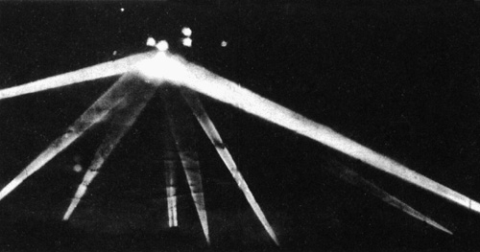

New 7-24-00 photo enhancements and anaylsis
shows the huge craft caught in the converging spotlights!

Pay close attention to the convergence of the searchlights and you will clearly see the shape of the visitor within the illuminated target area. It's a BIG item and seemed completely oblivious to the hundreds of AA shells bursting on and adjacent to it which caused it no evident dismay. There were casualties, however...on the ground. At least 6 people died as a direct result of the Army's attack on the UFO which slowly and leisurely made its way down to and then over Long Beach before finally moving off and disappearing.

In February, 1942, Katie was a young, beautiful, and highly-successful interior decorator and artist who worked with many of Hollywood's most glamorous celebrities and film industry luminaries. She lived on the west side of Los Angeles, not far from Santa Monica. With the outbreak of the war with Japan and the rising fear of a Japanese air attack, or even invasion of the West Coast, thousands of residents volunteered for wartime duties on the home front. Katie volunteered to become an Air Raid Warden as did 12,000 other residents in the sprawling city of Los Angeles and surrounding communities.

In the early morning hours of February 25th, Katie's phone rang. It was the Air Raid supervisor in her district notifying her of an alert and asking if she had seen the object in the sky very close to her home. She immediately walked to a window and looked up. "It was huge! It was just enormous! And it was practically right over my house. I had never seen anything like it in my life!" she said. "It was just hovering there in the sky and hardly moving at all." With the city blacked out, Katie, and hundreds of thousands of others, were able to see the eerie visitor with spectacular clarity. "It was a lovely pale orange and about the most beautiful thing you've ever seen. I could see it perfectly because it was very close. It was big!"

The U.S. Army anti-aircraft searchlights by this time had the object completely covered. "They sent fighter planes up (the Army denied any of its fighters were in action) and I watched them in groups approach it and then turn away. There were shooting at it but it didn't seem to matter." Katie is insistent about the use of planes in the attack on the object. The planes were apparently called off after several minutes and then the ground cannon opened up. "It was like the Fourth of July but much louder. They were firing like crazy but they couldn't touch it." The attack on the object lasted over half an hour before the visitor eventually disappeared from sight. Many eyewitnesses talked of numerous "direct hits" on the big craft but no damage was seen done to it. "I'll never forget what a magnificent sight it was. Just marvelous. And what a georgeous color!", said Katie.

"The object...caught in the center of the lights like the hub of a bicycle wheel surrounded by gleaming spokes. The fire seemed to burst in rings all around the object."

The ONLY description in the LA Times of the UFO, and a sense of the energy and emotion of that night, was found in this small sidebar article written by Times staff writer the day after the event:

Chilly Throng Watches
Shells Bursting In Sky
By Marvin Miles

Explosions stabbing the darkness like tiny bursting stars... Searchlight beams poking long crisscross fingers across the night sky...Yells of wardens and the whistles of police and deputy sheriffs...The brief on-and-off flick of lights, telephone calls, snatches of conversation: 'Get the dirty...' That was Los Angeles under the rumble of gunfire yesterday.

RESIDENTS AWAKENED

Sleepy householders awoke to the dull thud of explosions... "Thunder? Can't be!" Then: "Air Raid! Come here quick! Look over there...those searchlights. They've got something...they are blasting in with anti-aircraft!" Father, mother, children all gathered on the front porch, congregated in small clusters in the blacked out streets -- against orders. Babies cried, dogs barked, doors slammed. But the object in the sky slowly moved on, caught in the center of the lights like the hub of a bicycle wheel surrounded by gleaming spokes.

SPECULATION RIFE

Speculation fell like rain. "It's a whole squadron." "No, it's a blimp. It must be because it's moving so slowly." "I hear planes." "No you don't. That's a truck up the street." "Where are the planes then?" "Dunno. They must be up there though." "Wonder why they picked such a clear night for a raid?" "They're probably from a carrier." "Naw, I'll bet they are from a secret air base down south somewhere." Still the firing continued. Like lethal firecrackers, the anti-aircraft rounds blasted above, below, seemingly right on the target fixed in the tenacious beams. Other shots fell short, exploding halfway up the long climb. Tracers sparked upward like roman candles. Metal fell. It fell in chunks, large and small; not enemy metal, but the whistling fragments of bursting ack-ack shells. The menacing thud and clank on streets and roof tops drove many spectators to shelter.

WARDENS DO GOOD JOB

Wardens were on the job, doing a good job of it. "Turn off your lights, please. Pull over to the curb and stop. Don't use your telephone. Take shelter. Take shelter." On every street brief glares of hooded flashlights cut the darkness, warning creeping drivers to stop. Police watched at main intersections. Sirens wailed enroute to and from blackout accidents. There came lulls in the firing. The search lights went out. (To allow the fighter planes to attack?). Angelinos breathed deeply and said, "I guess it's all over." But before they could tell their neighbors good night, the guns were blasting again, sighting up the long blue beams of the lights.

WATCHERS SHIVER

The fire seemed to burst in rings all around the target. But the eager watchers, shivering in the early morning cold, weren't rewarded by the sight of a falling plane. Nor were there any bombs dropped. "Maybe it's just a test," someone remarked. "Test, hell!" was the answer. "You don't throw that much metal in the air unless you're fixing on knocking something down." Still the firing continued, muttering angrily off toward the west like a distant thunderstorm. The targeted object inched along high, flanked by the cherry red explosions. And the householders shivered in their robes, their faces set, watching the awesome scene.

The following are excerpts from the primary front page story of the LA Times on February 26th. Note that there is not a SINGLE description of the object even though is was clearly locked in the focus of dozens of searchlights for well over half an hour and seen by hundreds of thousands of people:

Army Says Alarm Real
Roaring Guns Mark Blackout
Identity of Aircraft Veiled in Mystery; No Bombs Dropped and
No Enemy Craft Hit; Civilians Reports Seeing Planes and Balloon

Overshadowing a nation-wide maelstrom of rumors and conflicting reports, the Army's Western Defense Command insisted that Los Angeles' early morning blackout and anti-aircraft action were the result of unidentified aircraft sighted over the beach area. In two official statements, issued while Secretary of the Navy Knox in Washington was attributing the activity to a false alarm and "jittery nerves," the command in San Francisco confirmed and reconfirmed the presence over the Southland of unidentified planes. Relayed by the Southern California sector office in Pasadena, the second statement read: "The aircraft which caused the blackout in the Los Angeles area for several hours this a.m. have not been identified." Insistence from official quarters that the alarm was real came as hundreds of thousands of citizens who heard and saw the activity spread countless varying stories of the episode. The spectacular anti-aircraft barrage came after the 14th Interceptor Command ordered the blackout when strange craft were reported over the coastline. Powerful searchlights from countless stations stabbed the sky with brilliant probing fingers while anti-aircraft batteries dotted the heavens with beautiful, if sinister, orange bursts of shrapnel.

City Blacked Out For Hours

The city was blacked out from 2:25 to 7:21 am after an earlier yellow alert at 7:18 pm was called off at 10:23 pm. The blackout was in effect from here to the Mexican border and inland to the San Joaquin Valley. No bombs were dropped and no airplanes shot down and, miraculously in terms of the tons of missiles hurled aloft, only two persons were reported wounded by falling shell fragments. Countless thousands of Southland residents, many of whom were late to work because of the traffic tie-up during the blackout, rubbed their eyes sleepily yesterday and agreed that regardless of the question of how "real" the air raid alarm may have been, it was "a great show" and "well worth losing a few hours' sleep." The blackout was not without its casualties, however. A State Guardsman died of a heart attack while driving an ammunition truck, heart failure also accounted for the death of an air raid warden on duty, a woman was killed in a car-truck collision in Arcadia, and a Long Beach policeman was killed in a traffic crash enroute to duty. Much of the firing appeared to come from the vicinity of aircraft plants along the coastal area of Santa Monica, Inglewood, Southwest Los Angeles, and Long Beach.

In its front page editorial, the Times said: "In view of the considerable public excitement and confusion caused by yesterday morning's supposed enemy air raid over this area and its spectacular official accompaniments, it seems to The Times that more specific public information should be forthcoming from government sources on the subject, if only to clarify their own conflicting statements about it."
"According to the Associated Press, Secretary Knox intimated that reports of enemy air activity in the Pacific Coastal Region might be due largely to 'jittery nerves.' Whose nerves, Mr. Knox? The public's or the Army's?"

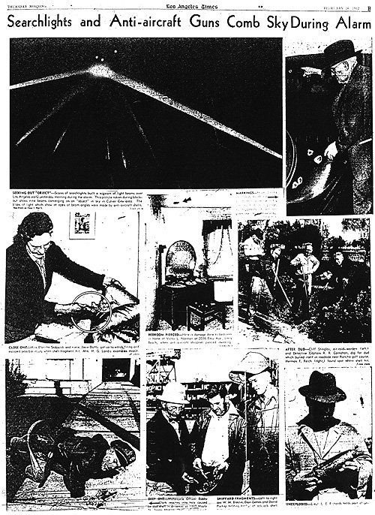

The following is an excerpt of an article appearing in Fate Magazine. Our special thanks to Bill Oliver of UFO*BC for transcribing and bringing it to our attention.

WORLD WAR II UFO SCARE
By Paul T. Collins
Fate Magazine July, 1987

On Wednesday, February 25, 1942, as war raged in Europe and Asia, at least a million Southern Californians awoke to the scream of air-raid sirens as Los Angeles County cities blacked out at 2:25 AM. Many dozed off again while 12,000 air raid wardens reported faithfully to their posts, most of them expecting nothing more than a dress rehearsal for a possible future event - an invasion of the United States by Japan. At 3:36, however, they were shocked and their slumbering families rudely roused again, this time by sounds unfamiliar to most Americans outside the military services.

The roar of the 37th Coast Artillery Brigade's antiaircraft batteries jolted them out of bed and before they could get to the windows the flashing 12.8 pound shells were detonating with a heavy, ominous boomp - boomp - boomp and the steel was already raining down. All radio stations had been ordered off the air at 3:08. But the news was being written with fingers of light three miles high on a clear star-studded blackboard 30 miles long.

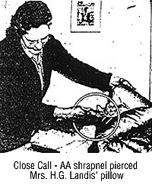
The firing continued intermittently until 4:14. Unexploded shells destroyed pavement, homes and public buildings, three persons were killed and three died of heart attacks directly attributable to the one hour barrage. Several persons were injured by shrapnel. A dairy herd was hit but only a few cows were casualties.

The blackout was lifted and sirens screamed all clear at 7:21. The shooting stopped but the shouting had hardly begun. Military men who never flinched at the roar of rifles now shook at the prospect of facing the press. While they probably could not be blamed for what had happened, they did have some reason for distress. The thing they had been shooting at could not be identified.

Caught by the searchlights and captured in photographs, was an object big enough to dwarf an apartment house. Experienced lighter-than-air (dirigible) specialists doubted it could be a Japanese blimp because the Japanese had no known source of helium, and hydrogen was much too dangerous to use under combat conditions.

Whatever it was, it was a sitting duck for the guns of the 37th. Photographs showed shells bursting all around it. A Los Angeles Herald Express staffer said he was sure many shells hit it directly. He was amazed it had not been shot down.

The object that triggered the air raid alarm had drawn 1430 rounds of ammunition from the coast artillery, to no effect. When it moved at all, the object had proceeded at a leisurely pace over the coastal cities between Santa Monica and Long Beach, taking about 30 minutes of actual flight time to move 20 miles; then it disappeared from view.

You can well imagine with what chagrin public information officers answered press queries. The Pasadena Office of the Southern California Sector of the Army Western Defense Command simply announced that no enemy aircraft had been identified; no craft was shot down; no bombs were dropped; none of our interceptors left the ground to pursue the intruder.

Soon thereafter US Navy Secretary Frank Knox announced that no planes had been sighted. The coastal firing had been triggered, he said, by a false alarm and jittery nerves. He also suggested that some war industries along the coast might have to be moved inland to points invulnerable to attacks from enemy submarines and carrier-based planes.

The press responded with scathing editorials, many on page one, calling attention to the loss of life and denouncing the use of the coast artillery to fire at phantoms. The Los Angeles Times demanded a full explanation from Washington. The Long Beach Telegram complained that government officials who all along had wanted to move the industries were manipulating the affair for propaganda purposes. And the Long Beach Independent charged: "There is a mysterious reticence about the whole affair and it appears some form of censorship is trying to halt discussion of the matter. Although it was red-hot news not one national radio commentator gave it more than passing mention. This is the kind of reticence that is making the American people gravely suspect the motives and the competence of those whom they have charged with the conduct of the war."

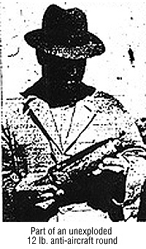
The Independent had good reason to question the competence of some of the personnel responsible for our coastal defense operations as well as the integrity and motives of our highest government officials. Only 36 hours before the Long Beach air raid, a gigantic Japanese submarine had surfaced close to shore 12 miles north of Santa Barbara and in 25 minutes of unchallenged firing lobbed 25 five-inch shells at the petroleum refinery in the Ellwood oil field. The Fourth Interceptor Command, although aware of the sub's attack, ordered a blackout from Ventura to Goleta but sent no planes out to sink it. Not one shot was fired at the sub.

After the Ellwood incident had alerted all the West Coast defense posts to possible repeat attacks, these units were sensitive to anticipated invasion attempts. By Wednesday morning in the Los Angeles area they were ready to open fire on a boy's kite if it in any way resembled a plane or a balloon. Secretary of War Henry Stimson praised the 37th Cost Artillery for this attitude. It is better to be a little too alert than not alert enough, he said. At the same time he delicately suggested that it might have been a good idea to send some of our planes up to identify the invading aircraft before shooting at them.

Planes of the Fourth Interceptor Command were, in fact, warming up on the runways waiting for orders to go up and interview the unknown intruders. Why, everybody was asking, were they not ordered to go into action during the 51-minute period between the first air-raid alert at 2:25 AM and the first artillery firing at 3:16?

Against this background of embarrassing indecision and confusion, Army Western Defense Command obviously had to say something fast. Spokesmen told reporters that from one to 50 planes had been sighted, thus giving themselves ample latitude in which to adjust future stories to fit whatever propaganda requirements might arise in the next few days.

When eyewitness reports from thousands searching the skies with binoculars under the bright lights of the coast artillery verified the presence of one enormous, unidentifiable, indestructible object - but not the presence of large numbers of planes - the press releases were gradually scaled downward. A week later Gen. Mark Clark acknowledged that army listening posts had detected what they thought were five light planes approaching the coast on the night of the air raid. No interceptors, he said, had been sent out to engage them because there had been no mass attack.

Believing an aerial bombardment was in progress, some people thought they saw formations of warplanes, dogfights between enemy craft and our fighter planes and other things that they assumed were evidence of such an attack. Obviously there were no dogfights because none of our interceptors were in the air. Tracer bullets were fired from military ground stations and some people mistook the fire pattern made by these projectiles for aerial combat. Other observers reported lighted objects which were variously described as red-and-white flares in groups of three red and three white, fired alternately, or chainlike strings of red lights looking something like an illuminated kite.

People suggested that some of these lights were caused by Japanese-Americans signaling approaching Japanese aircraft with flares to guide them to selected targets, but because no bombs were dropped, the theory was quickly abandoned. In any case, such charges fitted in perfectly with a hysterical press campaign to round up all citizens of Japanese descent and put them in concentration camps.

During the week of the Japanese submarine attack on the Ellwood oil field and the air raid on Los Angeles County, the press took full advantage of the made-to-order situation. Arrests of suspects were quickly made and the FBI was called in, but the Long Beach Press Telegram stated all investigations indicated nobody was signaling the enemy from the ground.

Santa Barbara's Ellwood
Oil Field Submarine Attack

Just a few days before the "Battle of LA" a Japanese submarine had surfaced at night and fired its deck gun into the Ellwood oil field located 12 miles northwest of Santa Barbara. The LA Times:

"From Santa Barbara, area of the submarine attack Monday night, District Attorney Percy Heckendorf said he would appeal to Lt. Gen. John L. DeWitt, commanding officer of the Western Defense Command, to make Santa Barbara County a restricted area for enemy nationals and American-born Japanese as well. "There is convincing proof," Heckendorf asserted, "that there were shore signals flashed to the enemy." Heckendorf said the people will hold Gen. DeWitt responsible if he failed to act. Army ordinance officers, meanwhile, were studying more than 200 pounds of shell fragments from missiles fired by the submarine, which caused only $500 damage in the Ellwood oil field near Santa Barbara."

It is said by some locals that the skipper or one of the officers on the Japanese sub had worked in the Ellwood oil field some years prior to the outbreak of the war. The story claims that the man had been mistreated by some of his co-workers during that time, had returned to Japan before the war began, and had then subsequently helped lead the submarine back to the area to make it's attack.

Army Gunners Fire
At UFOs Over Los Angeles
Courtesy UFO ROUNDUP
Volume 3, Number 8
February 22, 1998
Editor Joseph Trainor
On Wednesday, February 25, 1942, at precisely 2 a.m., diners at the trendy Trocadero club in Hollywood were startled when the lights winked out and air raid sirens began to sound throughout greater Los Angeles.

"Searchlights scanned the skies and anti-aircraft guns protecting the vital aircraft and ship-building factories went into action. In the next few hours they would fire over 1,400 shells at an unidentified, slow- moving object in the sky over Los Angeles that looked like a blimp, or a balloon."

Author Ralph Blum, who was a nine-year-old boy at the time, wrote that he thought "the Japanese were bombing Beverly Hills."

"There were sirens, searchlights, even antiaircraft guns blamming away into the skies over Los Angeles. My father had been a balloon observation man (in the AEF) in World War One, and he knew big guns when he heard them. He ordered my mother to take my baby sisters to the underground projection room--our house was heavily supplied with Hollywood paraphernalia--while he and I went out onto the upstairs balcony."

"What a scene! It was after three in the morning. Searchlights probed the western sky. Tracers streamed upward. The racket was terrific." Shooting at the aerial intruders were gunners of the 65th Coast Artillery (Anti-Aircraft) Regiment in Inglewood and the 205th Anti-Aircraft Regiment based in Santa Monica. The "white cigar-shaped object" took several direct hits but continued on its eastward flight.

Up to 25 silvery UFOs were also seen by observers on the ground.

Editor Peter Jenkins of the Los Angeles Herald Examiner reported, "I could clearly see the V formation of about 25 silvery planes overhead moving slowly across the sky toward Long Beach." Long Beach Police Chief J.H. McClelland said, "I watched what was described as the second wave of planes from atop the seven-story Long Beach City Hall. I did not see any planes but the younger men with me said they could. An experienced Navy observer with powerful Carl Zeiss binoculars said he counted nine planes in the cone of the searchlight. He said they were silver in color. The (UFO) group passed along from one battery of searchlights to another, and under fire from the anti-aircraft guns, flew from the direction of Redondo Beach and Inglewood on the land side of Fort MacArthur, and continued toward Santa Ana and Huntington Beach. Anti-aircraft fire was so heavy we could not hear the motors of the planes."

Reporter Bill Henry of the Los Angeles Times wrote, "I was far enough away to see an object without being able to identify it...I would be willing to bet what shekels I have that there were a number of direct hits scored on the object."

At 2:21 a.m., Lt. Gen. John L. DeWitt issued the cease-fire order, and the twenty-minute "battle of Los Angeles" was over. (See BEYOND EARTH: MAN'S CONTACT WITH UFOs by Ralph Blum, Bantam Books, New York, April 1974, page 68. See also the Los Angeles Times, the Los Angeles Herald-Examiner and the Long Beach Press-Telegram for February 25, 1942. All newspaper quotes taken from "The Battle of Los Angeles, 1942" by Terrenz Sword, which appeared in Unsolved UFO Sightings, Spring 1996 issue, pages 57 through 62.)

60th Anniversary Of The Battle Of Los Angeles

From Frank Altomonte
alto@earthlink.net
2-18-2

Excerpt from 'UFOs and the National Security State'
By Richard M. Dolan Keyhole Publishing, 2000

"At least a million residents awoke to air raid sirens at 2:25am., and U.S. Army personnel fired 1,430 rounds of antiaircraft shells to bring down what they assumed were Japanese planes. But these were not Japanese planes. George Marshall wrote a memorandum to President Roosevelt about the incident, which remained classified until 1974. Marshall concluded that conventional aircraft were involved, probably "commercial sources, operated by enemy agents for purposes of spreading alarm, disclosing location of antiaircraft positions, and slowing production through blackout."

Despite the barrage of American antiaircraft fire, none of these "commercial" planes were brought down, although several homes and buildings were destroyed, and six civilian deaths were attributed to the barrage. Considering the carnage, the military's explanation was meager. U.S. Navy Secretary Knox even denied that any aircraft had been over the city; he called the incident a false alarm due to war nerves.

The local press, needless to say, did not take this very well. The Long Beach Independent noted that: "There is a mysterious reticence about the whole affair and it appears some form of censorship is trying to halt discussion of the matter." It is noteworthy that for thirty years until the release of the Marshall memorandum, the Department of Defense claimed to have no record of the event. Five years before Roswell, them military was already learning to clamp down on UFOs."

Historic UFOs
Anti-Aircraft Guns Blast LA
Mystery Invader
From Frank Warren
frank-warren@pacbell.net
8-21-2

http://www.rense.com/general28/histla.htm

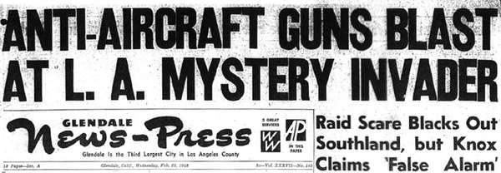

ANTI-AIRCRAFT GUNS BLAST AT L.A. MYSTERY INVADER  Raid Scare Blacks Out Southland, but Knox Claims 'False Alarm'  Washington(AP)-Secretary of the Navy Frank Knox said today that there were no planes over Los Angeles last night. "That's our understanding," he said. He added that " none have been found and a very wide reconnaissance has been carried on." He added, "it was just a false alarm."  Anti-aircraft guns thundered over the metropolitan area early today for the first time in the war, but hours later what they were shooting at remained a military secret. An unidentified object moving slowly down the coast from Santa Monica was variously reported as a balloon and an airplane.  No bombs were dropped and no planes were shot down during the anti-aircraft firing in the Los Angeles area, the western defense command said in San Francisco.  "Cities in the Los Angeles area were blacked out at 2:25 a.m. today on orders from the fourth interceptor command when unidentified aircraft were reported in the area," the western defense command said.  "Although reports are conflicting and every effort is being made to ascertain the facts, it is clear that no bombs were dropped and no planes were shot down." | 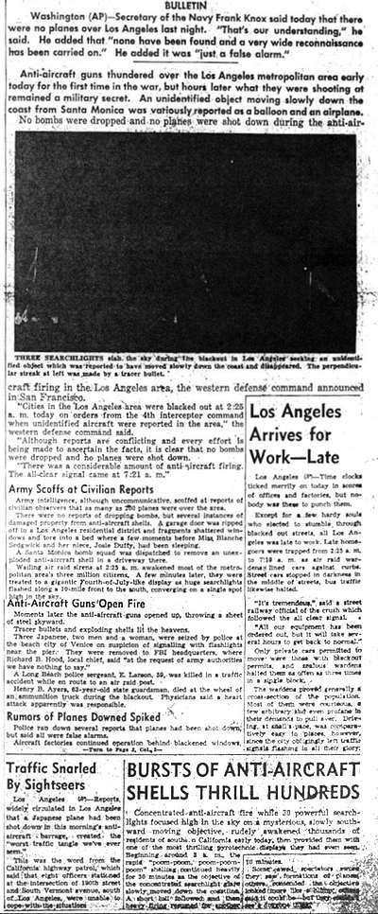

"There was a considerable amount of anti-aircraft firing. The all-clear signal came at 7:25 a.m."

Army Scofts at Civilian Reports

Army intelligence, although uncommunicative, scoffed at reports of civilian observers that as many as 200 planes were over the area.

There were no reports of dropping bombs, but several instances of damaged property from anti-aircraft shells. A garage door was ripped off in a Los Angeles residential district and fragments shattered windows and tore into a bed where a few moments before Miss Blanch Sedgewick and her niece, Josie Duffy had been sleeping.

A santa Monica bomb squad was dispatched to remove an unexploded anti-aircraft shell in a driveway there.

Wailing air raid sirens at 2:25 a.m. awakened most of the metropolitan's three million citizens. A few minutes later they were treated to a gigantic Fourth-of-July-like display as huge searchlights flashed along a 10-mile front to the south, converging on a single spot high in the sky.

Anti-Aircraft Guns Open Fire

Moments later the anti-aircraft guns opened up, throwing a sheet of steel skyward.

Tracer bullets and exploding shells lit the heavens.

Three Japanese, two men and a woman, were seized at the beach city of Venice on suspicion of signaling with flashlights near the pier. They were removed to FBI headquarters, where Richard B. Hood, local chief, said, "at the request of Army authorities we have nothing to say."

A Long Beach police sergeant, E. Larsen 59, was killed in a traffic accident while in route to an air raid post.

Henry B. Ayers, 63-year-old state guardsman, died at the wheel of an ammunition truck during the black-out. Physicians said a heart attack was apparently responsible.

Rumors of Planes Downed Spiked

Police ran down several reports that planes had been shot down, but said all were false alarms.

Aircraft factories continued operation behind blackened windows, while ack-ack guns rattled from batteries stationed near-by.

A Japanese vegetable man, John Y. Harada, 25, was one of three persons arrested on charges of violating a county black ordinance. Sheriff's Capt. Ernest Sichler said Harada, driving to the market with a load of cauliflower, refused to extinguish his truck lights.

Others held on similar charges were Walter E. Van Der Linden, Norwalk dairy man, accused of failing to darken his milking barns, and Giovouni Ghigo, 57, nabbed while driving to market with a truckload of flowers.

Traffic Snarl Follows All Clear Signal

Soon traffic was snarled. Thousand of southern Californians were an hour or more late to their jobs.

There were isolated incidences of failure to comply with black-out regulations. Neon signs were glowing inside stores. Traffic signals continued to flash in some areas.

Radio stations went off the air with the first alert, and were not permitted to resume broadcasting until 8:23 a.m.

There was speculation, that the unidentified object, might have been a blimp-although veteran lighter-then-air-experts in Akron, O., the nations center of such construction, said Japan was believed to have lost interest in such craft following experiments in World War I. These sources said inability to obtain fire proof helium caused discarding of such plans.

Observers lent some credence to the blimp theory by pointing out that the object required nearly thirty minutes to travel 20 or 25 miles-far slower then an airplane.

Unidentified Planes Pass Over Harbor

AN official source which declined to be quoted directly told The Associated Press in Los Angeles that United States Army Planes quickly went into action. Later however, another official said no United States craft had taken off because of possible danger from the army's own anti-aircraft fire.

A newspaper man at San Pedro said airplanes passed over the Los Angeles-Long Beach harbor area. The craft were not identified.

There were no reports of any attempt to bomb southern California from the air although many war-vital factories, shipyards and other defense industries were on the route the object followed.

Although some watchers said they saw airplanes in the air, semi-official sources said they probably were the United States Army's pursuits.

All the action, clearly spotlighted for ground observers by 20 or so searchlights, was just a few miles west of Los Angeles proper.

Object Disappears Over Signal Hill

Observers said the object appeared to be 8000 ft ot higher.

Firing, first heard at 3 a.m., ceased suddenly at 3:30 a.m., after the object disappeared south of Signal Hill, at the east edge of Long Beach. Anti-aircraft guns fired steadily for two minute periods, were silent for about 45 seconds, and continued that routine for nearly a half an hour.

All of southern California from the San Juaquin valley to the Mexican border was blacked out. Los Angeles doused its lights first, at 2:25 a.m.. San Diego, just 17 miles from the border did not receive its lights out order until 3:05 a.m.

When daylight and the all-clear signal came, Long Beach took on the appearance of a huge easter egg-hunt. Kiddies and even grown-ups scrambled through the streets and vacant lots, picking up and proudly comparing chunks of shrapnel fragments as if they were the most prized possession they owned.

END

