Robert Anton Wilson 1932-
http://en.wikipedia.org/wiki/Robert_Anton_Wilson
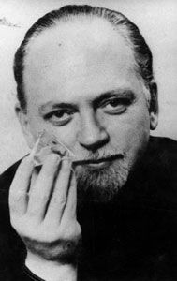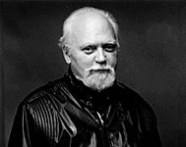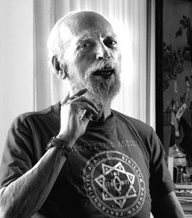
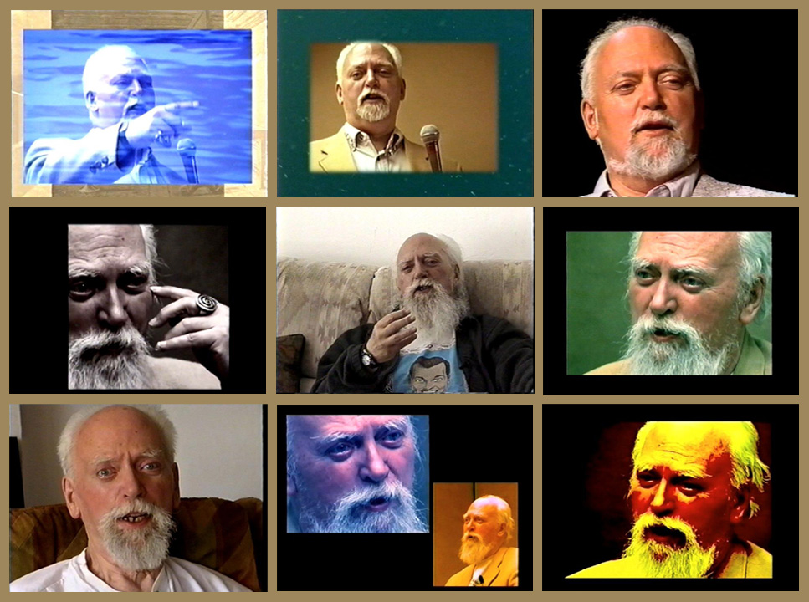
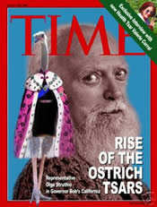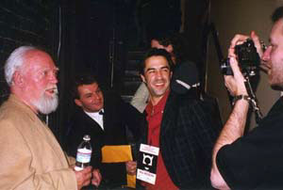
Robert Anton Wilson or RAW (b. January 18, 1932) is an American novelist, essayist, philosopher, psychologist, futurologist, anarchist, and conspiracy theory researcher.
Wilson was born in Methodist Hospital, downtown Brooklyn, New York, and spent his first years in Flatbush, moving with his family to Gerritsen Beach around the age of 4 or 5, where they stayed until he turned 13.
On June 22, 2006, Huffington Post blogger Paul Krassner reported that Robert A. Wilson is currently under hospice care at home with friends and family. [1] On 2 October 2006 Douglas Rushkoff reported that Wilson was in severe financial trouble.[2] As of 3 October the front page of rawilson.com contains an appeal for funds. Slashdot, Boing Boing, and the Church of the Subgenius also picked up on the story, linking to Rushkoff's appeal. [3] [4] As his homepage reports on 10 October these efforts succeeded beyond expectation and raised a sum which will support him for at least 6 months.

Contents
[hide]
- 1 Writings
- 2 Bibliography
- 3 Partial Discography
- 4 See also
- 5 References
- 6 External links

[edit] Writings
His best-known work, The Illuminatus! Trilogy (1975), co-authored with Robert Shea and advertised as "a fairy tale for paranoids," humorously examined American paranoia about conspiracies. Much of the odder material derived from letters sent to Playboy magazine while Shea and Wilson worked as editors of the Playboy Forum.^{[1]} The books mixed true information with imaginative fiction to engage the reader in what Wilson called "Operation Mindfuck"; the trilogy also outlined a set of libertarian and anarchist axioms known as Celine's Laws, concepts Wilson has revisited several times in other writings. Although Shea and Wilson never partnered on such a scale again, Wilson has continued to expand upon the themes of the Illuminatus! books throughout his writing career.
In Cosmic Trigger I: Final Secret of the Illuminati (1977) and other works, he examined Discordianism, Sufism, Futurology, Zen Buddhism, Dennis and Terence McKenna, the occult practices of Aleister Crowley and G.I. Gurdjieff, the Illuminati and Freemasons, Yoga, and other esoteric or counterculture philosophies. He advocates Timothy Leary's eight circuit model of consciousness and neurosomatic/linguistic engineering, which he writes about in Prometheus Rising (1983, revised 1997) and Quantum Psychology (1990), books containing practical techniques for breaking free of one's "reality tunnels".^{[citation needed]} With Leary, he helped promote the futurist ideas of space migration, intelligence increase, and life extension (SMI²LE).
Wilson also supports many of the utopian theories of Buckminster Fuller, as well as those of media theorist Marshall McLuhan and Neuro Linguistic Programming co-founder Richard Bandler, with whom he has taught workshops. He also admires James Joyce, and has written commentary on Finnegans Wake and Ulysses.^{[citation needed]}
Ironically, considering Wilson has long lampooned and criticized new age beliefs, his books can often be found in bookstores specializing in new age material. He has claimed to have perceived encounters with magical "entities," and when asked whether these entities were "real," he answered they were "real enough," although "not as real as the IRS" since they were "easier to get rid of." He warned against beginners using occult practice, since to rush into such practices and the resulting "energies" they unleash can lead people to go "quite nuts." Instead, he recommends beginners start with NLP, Zen Buddhism, basic meditation, etc., before progressing to more potentially disturbing activities.^{[citation needed]}
Wilson had a long-standing relationship with the Association for Consciousness Exploration, beginning in 1982. He was the keynote speaker for their center's open house in 1984, and appeared at many Starwood Festivals[5]. Both Illuminatus! co-author Robert Shea[6][7] and Wilson's wife Arlen Riley Wilson[8] have appeared with him at the WinterStar Symposium. They served as his American lecture agency while he lived in Ireland, and hosted his first on-stage dialog with his life-long friend Timothy Leary in 1989 in Cleveland, OH, entitled The Inner Frontier.
In a 2003 interview with High Times magazine, RAW described himself as a "Model Agnostic" which he says "consists of never regarding any model or map of the universe with total 100% belief or total 100% denial. Following Korzybski, I put things in probabilities, not absolutes... My only originality lies in applying this zetetic attitude outside the hardest of the hard sciences, physics, to softer sciences and then to non-sciences like politics, ideology, jury verdicts and, of course, conspiracy theory."^{[2]} More simply, he claims "not to believe anything," since "belief is the death of thought."^{[citation needed]} He has described his approach as "Maybe Logic." Wilson wrote articles for seminal cyberpunk magazine Mondo 2000.^{[3]}
While he has primarily published material under the name Robert Anton Wilson, he has also used the pen names Mordecai Malignatus, Mordecai the Foul, Reverend Loveshade ^{[citation needed]}, and other names associated with the Bavarian Illuminati, which he allegedly revived in the 1960s.
RAW holds the post of American director of the Committee for Surrealist Investigation of Claims of the Normal (CSICON) and has appeared at Disinformation events.^{[citation needed]} He has summed up his attitude towards life as one of optimism, cheerfulness, love, and good humor.
Maybe Logic: The Lives and Loves of Robert Anton Wilson, a documentary featuring selections from over twenty-five years of Wilson footage, was released on DVD in North America on May 30, 2006.^{[4]}
Wilson's writings connect to the madcap satirical fiction of Flann O'Brien in a several ways, including his free use of O'Brien's character De Selby. The views of De Selby, a would-be obscure intellectual, are the subject of long pseudo-scholarly footnotes in Wilson's novels as well as O'Brien's. This is entirely fitting, because O'Brien himself made free use of characters invented by other writers, allegedly because there are already too many fictional characters as is. O'Brien was also known for pulling the reader's leg by concocting elaborate conspiracy theories, and for publishing under several pen names.^{[citation needed]}

[edit] Bibliography
- Playboy's Book of Forbidden Words (1972)
- Sex and Drugs: A Journey Beyond Limits (1973)
- The Sex Magicians (1973)
- The Book of the Breast (1974)
- The Illuminatus! Trilogy (1975) (with Robert Shea)
  - The Eye in the Pyramid
  - The Golden Apple
  - Leviathan
- Cosmic Trigger I: Final Secret of the Illuminati (1977)
- Neuropolitics (1978) (with Timothy Leary and George Koopman)
- The Game of Life (1979) (with Timothy Leary)
- The Illuminati Papers (1980)
- Schrödinger's Cat trilogy (1980-1981)
  - The Universe Next Door
  - The Trick Top Hat
  - The Homing Pigeon
- Masks of the Illuminati (1981)
- The Historical Illuminatus Chronicles
  - The Earth Will Shake (1982)
  - The Widow's Son (1985)
  - Nature's God (1991)
- Right Where You Are Sitting Now (1983)
- Prometheus Rising (1983)
- The New Inquisition (1986)
- Wilhelm Reich in Hell (1987)
- Natural Law, or Don't Put a Rubber on Your Willy (1987)
- Coincidance (1988)
- Neuropolitique (1988) (with Leary & Koopman) [revision of Neuropolitics]
- Ishtar Rising (1989) [revision of The Book of the Breast]
- Semiotext(e) SF (1989) (editor, with Rudy Rucker and Peter Lamborn Wilson)
- Quantum Psychology (1990)
- Cosmic Trigger II: Down to Earth (1991)
- Reality Is What You Can Get Away With: An Illustrated Screenplay (1992)
- Chaos and Beyond (1994) (editor and primary author)
- Cosmic Trigger III: My Life After Death (1995)
- The Walls Came Tumbling Down (1997)
- Everything Is Under Control (1998)
- TSOG: The Thing That Ate the Constitution (2002)
- Email to the Universe (2005)

[edit] Partial Discography
- A Meeting with Robert Anton Wilson
- Religion for the Hell of It
- H.O.M.E.s on LaGrange
- The New Inquisition
- The H.E.A.D. Revolution
- Prometheus Rising
- The Inner Frontier (with Timothy Leary)
- The Magickal Movement: Present & Future (with Margot Adler, Isaac Bonewits & Selena Fox)
- Magick Changing the World, the World Changing Magick (with AmyLee, Isaac Bonewits, Selena Fox & Jeff Rosenbaum)
- The Once & Future Legend (with Ariana Lightningstorm, Patricia Monaghan, Jeff Rosenbaum, Rev. Ivan Stang & Robert Shea)
- What IS the Conspiracy, Anyway? (with Anodea Judith, Jeff Rosenbaum, Rev. Ivan Stang & Robert Shea)
- The Chocolate-Biscuit Conspiracy with The Golden Horde (1984)
- Twelve Eggs in a Basket

[edit] See also
- Illuminatus
- Patapsychology
- Discordianism
- Chaos magic
- Fnord
- Guerrilla ontology
- Max Stirner
- Tanstagi
- 23 (film)
- 23 (number)
- smart drugs
- Hakim Bey

[edit] References
- ^ "The Illuminatus saga stumbles along" by Robert Anton Wilson
- ^ Krassner, Paul. A Paul Krassner Interview With R. A. W - High Times, March 2003 issue.
- ^ "CybeRevolution Montage", Mondo 2000 no. 7, 1989
- ^ Maybe Logic

[edit] External links
Wikiquote has a collection of quotations related to:
Robert Anton Wilson
- Wilson maintains his own website, which includes thoughts of the month, jokes, and many links to obscure and informative Internet sites.
- Maybe Logic - The Lives and Ideas of Robert Anton Wilson
- Maybe Logic Academy offers online courses and a forum with regular posts from Wilson
- Robert Anton Wilson fan site has a bio, comprehensive bibliography, interviews, writing, a forum, book cover galeries, and mp3s of his punk rock record, comedy record, and more.
- Guns and Dope Party
- Robert Anton Wilson Online Library - has several RAW interview and texts on the web. The library also includes material from people who influenced RAW.
- BlackCrayon.com: People: Robert Anton Wilson
- Wilson, Robert Anton booklist from New Falcon Publications
- Robert Anton Wilson Multimedia, Video & Audio Hundreds of media files including interviews and links.
- 8-Circuit Model of Timothy Leary and Robert Anton Wilson
- 23 Questions With Robert Anton Wilson
- Man Bites Dogma An interview with RAW by Michael Dare
- Robert Anton Wilson at deoxy.org
- Wilson's teenage daughter, Patricia Luna Wilson, was murdered on October 2, 1976. Her parents had her brain placed into cryonic suspension [9].
Persondata
NAME | Wilson, Robert Anton
ALTERNATIVE NAMES | RAW
SHORT DESCRIPTION | American writer
DATE OF BIRTH | January 18, 1932
PLACE OF BIRTH
DATE OF DEATH
PLACE OF DEATH
Retrieved from "http://en.wikipedia.org/wiki/Robert_Anton_Wilson"
Categories: Articles to be merged since September 2006 | Articles with unsourced statements | American science fiction writers | American novelists | American non-fiction writers | American memoirists | American anarchists | Psychedelic advocates and proponents | Chaos magicians | Discordianism | Occultists | American agnostics | Libertarians | SubGenii | 1932 births | Living people | Futurists
========================================================================================================

