Those Revolting Retirees
Reclaiming their self-worth, dignity and happiness

by
Garry Greenwood

Please note that no experts, academics, financial advisers, bank managers, legal experts or other do-gooders were involved or injured in the authorship or publication of this guidebook.
This humble tome is totally free from all those usual constraints associated with publishing. It’s not a book to help you make even more money. It hopes to open you to a wider and much richer world of endless opportunities through its revolutionary and well-tested, step by step plan to free those approaching their senior years from the many constraints and challenges often associated with those ever-restrictive years. It hopes to make you wealthier in spirit and in other ways, by encouraging you to stare down adversity and seek its inherent opportunities.
This is solely the work, writings and photographs of author, Garry Greenwood, based upon his real and continuing experiences as an adventurous senior.
Greenwood still travels widely, toils as an artist, photographer and sculptor and is a travel blogger for Australia’s largest seniors’ online magazines – startsat60.com and travelat60.com
This author has no financial or other interests with any of the valuable services, references or website links contained herein.

Text and photographs Copyright 2019, Garry Greenwood
All Rights Reserved
January 2019 Edition

Table of Contents

Introduction
Chapter 1 Why I’m Out Of Here
Chapter 2 Where Is Out Of Here?
Chapter 3 Tidying Up Affairs At Home
Chapter 4 Let’s Go!
Chapter 5 Moving On
Chapter 6 How to Find Work Overseas
Chapter 7 Thailand, Laos – And The Buddha
Chapter 8 The Lament Of The Volcano Gods
Chapter 9 Back In The Saddle
Chapter 10 Vietnam
Chapter 11 Let’s Wrap It Up
References
About The Author

Introduction

At the age of 65 I’d had enough of the daily humdrum which had invaded my life and I was ready to throw in the towel. My prevailing mind-set, was leading me into a very dark place of depression, boredom, purposelessness and poverty. To say my future looked bleak as I entered my senior years would be an understatement - all the while the Call of the Wild was gnawing away at my soul or spirit. Finally, and in desperation, I answered that rebellious Call.
I had tried to simply accept my situation or to simply suck it up, but this had proven futile.
I eventually came to realize I needed a revolution, not so much in a global sense, but on a personal level. I needed to turn my current way of thinking upside down. The old formulas and thought patterns we are encouraged to practice, were not working for me.
I needed to think outside the box. I also began to question exactly who the makers of these boxes are, and why we are so eager to enter them?
Then the revolutionary thought slowly dawned upon me – do we need these boxes at all?
That was five years ago.
Today my life is exactly how I wish it to be. And so I invite you to come with me and step out of our not-so-comfortable comfort zones and create new lives full of adventure, new friends, travel, work and so much more. In the process we will reclaim our self-worth, dignity and happiness that many of us have had stripped away by ageism, miss-information, cruel Government austerity policies, thuggery, cultural indifference and the ever-increasing us-versus-them mind set found in most Western nations nowadays.
They – those who rule, reign, govern, dictate, bully and preside over us now tell us seniors “we are not economically viable!”
For those of us in, or approaching, our senior years and fed up with this steady drip of elitists’ propaganda; this book presents a personal antidote to this dark and degenerate mind-set by turning personal adversity into opportunities.
This book is also a distillation of my many years of extensive research, travel, re-training, work and play often in various exotic locations, some of which I found to be more accommodating and suitable for my needs at this particular point in my life.
It’s actually fun. I’m now a very happy and fulfilled senior as a result and maybe this book might speak to you also and help turn your adversities into opportunities too, if given a chance.
Discover how I gradually came to see retirement not as a time or mind-set for slowing down or opting out, but as an opportunity to fashion a completely new and purposeful existence.
It’s not written in the style of your common everyday seniors’ self-help book but rather a revolution complete with true real-life adventures calling out for you to follow; in ways that resonate with you personally, and within your means and capabilities.
When I boarded that flight out of Australia, stepping out into the great unknown, I had very limited means indeed. I really didn’t know where, exactly, I was going but the alternative of remaining within my current mind-set and circumstances was not an option.
I have included dozens of valuable resource links to make it so much easier for you to do your own research as well as including around 70 or more photos to further encourage you to turn adversity into boundless opportunities.
If the ‘Call Of The Wild’ is constantly gnawing away at your soul or spirit, then this book is for you to help launch you into an exciting new world full of purpose, new friends and experiences. It’s a true real-life work in progress. If necessary you can even do it all on a shoestring budget by simply following in my well-trodden footsteps.
Let’s distance ourselves from all prevailing mind-sets which don’t serve us anymore.
Let’s regain control of our own destinies.
Be a rebel and let’s get out of here.

Chapter 1. Why I’m Out Of Here

I lost my beloved wife of some 47 years to the ravages of Alzheimer’s disease a few years ago. I had home-nursed her for several years and to say that I was at a low point in my life would be an understatement. Such a long, drawn out and painful event leaves its toll in many ways. Firstly, it’s the exhaustion in tandem with the emotions – grief, guilt, and helplessness. Then there’s the family and friends to consider - how must they be suffering also. Then thoughts begin to turn to finances and future prospects or plans. When you’re 65 it’s not easy.
This book is not about dealing with a loved one suffering from Alzheimer’s disease: it’s about rebuilding a shattered life in a world itself rapidly dividing along countless fault lines. But it’s a good story – a story of triumph.
After losing my wife it took me a year or two to finally pull myself together enough and grant myself permission to plan a future. What would I do? How will I deal with loneliness? How will I fill my empty days? Would I find a sense of purpose? How will I survive financially? Is it even possible to start all over again at my age?
As my grief subsided I began to slowly imagine how I would like my new life to be, out there in the big wide world I hadn’t participated in for so long. After being almost totally house-bound and cut off from the world during those long years I nursed my wife, I bravely stepped out to embrace my new challenges.
But it somehow looked different. Things had changed. People had changed.
Had things really changed or was I viewing the world through some kind of filter, created by my emotional state?
I assumed the latter was the case and set about making my new life.
For the past several years my life had been restricted to more or less one or two quick visits to a nearby shopping centre to buy food and other necessities. I was now been forced to live outside the box, so to speak, and was now attempting to again enter that same big box just like everyone else. But I also began to sense or hear an inner voice whispering to me that maybe boxes were not now the best options for this 65 year old.
As the months rolled by and as my thoughts were no longer consumed by the daily care and nursing of my wife, I also began to experience how a different culture was slowly taking root in western civilisation. I now saw a culture often pre-occupied with dividing itself into opposing factions – left versus right, Liberal versus Labour, Democrats versus Republicans, the haves and have-nots, leaners and lifters, those in the blue corner and those in the red corner, men versus women and the young verses the not-so-young. What corner do you find yourself in? No response required.
The ever-growing schisms, the indifference and disrespect often shown to the not-so-young, understandably resonated more so with me. My research shows how the creation of these schisms and the indifference comes firstly from the top - corporations, politicians, government departments and many of our special interest, religious and minority groups – in more or less the aforementioned order. The top ten percent of our Western civilisations have all the good jobs, opportunities and all the money, leaving the ninety percent of us with very little. The wealth distribution gap is forever increasing. When you reach your senior years this is particularly noticeable and its impact is sorely felt: as you may be very well aware. This book is not meant for that ten percent but rather the other ninety percent, and more particularly seniors within that ninety percent.
I see myself as a patriot of my beloved country, and probably so do you: so what should I do? Here I am torn between my allegiance to my country: wanting to help right this untenable situation by either patiently hoping and waiting for better, fairer times to dawn; all the while hoping our esteemed leaders would finally exercise common sense, see reason and show some compassion; or conversely should I temporarily jump ship, so to speak.
At my age I suspected I would be long gone from this world before any noticeable cultural shift or change in conditions occurred; therefore serious activism, waiting and hoping for better conditions were out of the question for me.
Another alternative was to simply suck it up and live as a second class citizen accepting whatever society allowed to come my way. Judging by the level of today’s ageism within my country, I suspected that as time passed less and less would come this way and our relevance and worth, as seniors, would diminish even further. It’s undeniable that western societies are seeing less and less value in their senior citizens and scant regard is paid to our accumulated wisdom, knowledge, reliability and talents. I’m now hearing seniors saying they don’t deserve us, with all our aforementioned age-acquired qualities.
By and large we are now seen as a burden, particularly those living partly or fully on welfare – except of course, the top ten percent who won’t be reading this. No longer was I prepared to put up with the relentless and one-way flow of bullying of our most vulnerable citizens, myself included; perpetrated by the self-entitled elitists who reign, rule, preside, govern, administer, bully, cheat and lie to us.
“Australians can forget about relying on the age pension when they retire, the age pension should no longer be seen as an entitlement but a welfare payment.”
Says Scott Morrison – Australian Federal Treasurer, September 2015 - August 2018, Australian Prime Minister, August 2018 - ??/??/????.
Yet all our lives we have been led to understand the aged or retirement pension was a reward for our 40 years of hard work and paying taxes.
Little recognition is given to the fact we seniors built our nations and paid our taxes all our working lives. Unlike the younger generations, we didn’t receive maternity allowances, single mum pensions, child support, unemployment allowances and more. We did it all by ourselves mostly with only one wage-earner in the family and with the promise that in retirement we would receive our hard-earned pensions, and health care. Today the nation is being told we are welfare recipients and a burden on society. Many of us even fought for our countries in ill-conceived elitists’ wars. Sadly our younger generations are not being told this and many are now beginning to see us also as welfare recipients who have passed their age of usefulness. This has given rise to a new tier of ageism.
So how did I deal with the subject of allegiance to the country I love and helped build with little or no government assistance? To help overcome this nagging conundrum I reminded myself how, in 1950, just after the Second World War, when my father was finally discharged from the U.K. military wherein he fought against the fascist German military, my family and I migrated to Australia seeking a better life. This was a common practice at this time as, much of Europe was in ruins and countries such as Canada, Australia, New Zealand, South Africa and the U.S. were encouraging mass migration to their welcoming and needy shores. Within this mass exodus from Europe another driving force was at play. It was a primordial and fundamental quest for self-preservation. Allegiance was way down on any list of priorities. Just try debating allegiances, to anyone on an empty stomach or with no roof over their head.
In spite of the difficult times they experienced in their homelands these migrants, including my family, had little or no resentment towards their homelands – they were just wanting a better life. Many of these migrants would regularly return to their homelands to see family and friends, for holidays and some even returned permanently and most speak lovingly of their former country. My parents returned to the UK once and would have returned regularly if money would have permitted.
Nowadays many seniors are once again finding themselves in self-preservation mode counting their pennies, as it were, just to keep the power on or to put food on the table. This situation is particularly serious for senior single women on retirement pensions since most of them stayed out of the work force by choice, to raise their children – as was the custom in those days, since childrearing was seen as a noble and valued occupation. They did this without any form of Government assistance; nor did they expect any. This also means many women paid little or nothing into retirement funds and must now rely solely for their survival on a meagre single government pension – something now impossible to do.
Today hundreds of thousands of men and women, particularly seniors, in affluent western countries are living in vehicles or tents moving from place to place; many disguised as Grey Nomads or Baby Boomers camping out and faking enjoyment in the good life in the great outdoors. The reality for many within this massive grey army and the many not-so-grey vulnerable, is more a case of: it’s the end of the road.
Here in Australia statistics reveal how the number of women over 50 living in vehicles has doubled in the past four years. Australia was once known as the Lucky Country but nowadays we see ads on TV appealing for us to sponsor our own Australian children so they can eat three meals a day! Such ads were once only appealing for sponsorship of children in third world countries. Will it ever eventuate that one day similar ads will appear on TV’s in those third world countries appealing for sponsors for our Australian children?
In the U.S., and in particular Los Angeles, you will see videos posted online of tens of thousands of homeless people living in tents or just sleeping bags on the streets. The once land of opportunity is beginning to look more like a third world country. You won’t see those scenes in their Hollywood productions.
Now that I’ve got you all depressed, please don’t be, I’m just venting and presenting a view of reality confronting many seniors in western society. It gets better soon as I’ll show you how my personal revolution turned adversity into an opportunity for growth, fulfilment and more; and maybe you can too.
Eventually I discarded that outdated and restrictive box concept and called upon my atrophied creative forces and thought-ability for help. I decided to file my national allegiance conundrum in its proper place – after all, my country was saying, in differing tongues, it didn’t need me anymore, although I still live with the hope that one day it will. At times it felt as if my country had deserted me. Don’t get me wrong I’m a true Australian patriot just seeking opportunities, in adversity.
I resolved I wouldn’t wait around for things to change to suit me as I’ve come to realise, they won’t. No one was coming to save me and I’m not prepared to simply suck it up anymore. I won’t put up with elitist, governmental or cultural bullying anymore. The situation many seniors and other vulnerable groups throughout western civilisation find themselves in has been brought about by deliberate design. I’m not a second class citizen. I’m a senior citizen who helped build this nation and I paid my taxes – unlike many of our corporate bullies, politicians and others who are continually stripping away our dignity, self-esteem and relevance.
Yes, western nations are great places for the young, healthy, energetic and aspirational ones, and of course, for the top ten percenters. But alas this is not the case for many of their senior citizens.
Confuses once said “In a country well governed poverty is something to be ashamed of. In a country badly governed wealth is something to be ashamed of.”
No matter how deep into denial one chooses to plunge, the western dystopian nightmare as portrayed by George Orwell in his classic apocalyptic novel, 1984, has surely arrived on the doorsteps of the most vulnerable in many of our western societies - that is, for the vulnerable who actually still have a dwelling with doorsteps.
Based upon our current socio-political trajectory, as surely as the sun rises in the east, the great God of Dystopia will eventually be knocking on every ninety percenters’ door if that trajectory is not corrected.
“The proletarians will never revolt, not in a thousand years or a million. There’s no way the Party can be overthrown. The rule of the party is forever.” Orwell – 1948.
I’ve come to realise that this ever-increasing poverty in western societies exists not because we cannot feed the poor, but because we cannot satisfy the rich.
This book can also be used as a seniors’ survival guide in a world gone mad with political correctness by helping us all reset our proprieties.
I, therefore, resolved to change whatever was in my power to change.
And so I did, starting with: no more whingeing, no more complaining, no more anger, no more disappointment, no more guilt, no more waiting and no more daily doses of radio, TV and newspaper lies and propaganda – with the exception of some quality, mainly educational productions.
I freed myself from debt, destroyed my credit cards, worked on my health and fitness, sold up and, in my late sixties, proclaimed to all and sundry:
“Stuff This! - I’m Out of Here!”

Chapter 2 Where Is Out Of Here?

“So what do you mean: out of here?” I hear some readers say.
No! I’m not talking about euthanasia. I’m talking about life – building a better life – just somewhere else.
And I’m not advocating anyone should renounce or permanently exit their country. I’m proposing that some seniors and others experiencing similar plights or sentiments should consider spending varying lengths of time in other countries (which I will outline in detail later), to see which countries, if any, might be more accommodating to their needs and aspirations. Yes, we are now allowed to have aspirations although there is a price to pay, and that is: we will need to find our way past our excuses, our fears, our preconceptions, and our “What Ifs”. But this book is here to take you on a new journey – a journey I have often taken and still tread today. Don’t be afraid…come with me.
I do realise this may seem revolutionary and is going to require a leap of faith, but by taking the leap you will be able to see for yourself if this is worthy of your consideration, versus the other familiar alternative of staying where you are in an ever-deteriorating situation. It’s your call.
“What qualifies me to make such suggestions? Have I ever visited any foreign countries?” you ask.
When I was 54 my late wife and I spent over five years living and working in several countries. These countries were Japan – six months, Indonesia – six months, Malaysia – twelve months, China – three years, Slovakia - six months, Greece –six months, Italy – six months.
I have also holidayed and travelled extensively in Vietnam, Thailand, Laos, India, Papua New Guinea, Philippines, Singapore, Fiji, Vanuatu, New Zealand, Austria, Germany, England, Wales and Scotland.
Please don’t think I’m showing off here, I’m simply giving you a glimpse of my previous life activities and endeavouring to present my qualifications as a reasonably seasoned traveller and travel writer. I still write for two on-line travel sites including Australia’s largest online senior’s magazines – startsat60.com and travelat60.com
During my many years of international travel and work and my continuing travels in some of the aforementioned countries, I had ample opportunities to get close up and gain personal insights into the everyday conditions there. Most of the time I worked as an English language teacher in private schools wherein my students were mostly young adults and professionals such as airline pilots, doctors and company directors. I know those countries and their people very well.
Whilst working in China, for two years, I was the English editor of China’s first all-English weekly newspaper – Common Talk, published by the Xiamen Daily in Xiamen, Fujian Province. I was often dispatched to cover a wide variety of assignments from restaurant reviews, art exhibitions, tourist hot spots, crimes committed by foreigners and visa compliance issues. Once I was dispatched to view and write a film review of “Independence Day” - a major Hollywood production in which the world is saved from an alien invasion singlehandedly by the President of the US. Not surprisingly both the film and my review were not well received by the Chinese.
You are welcome to read my 2017 book, Stuff For Seniors – a secret plan to live not retire: a book which describes in detail the many years my late wife and I travelled, worked and played throughout much of Asia, Europe and the UK.
Later in this book I will be sharing some of my experiences and insights with you including places to stay, how to get there, how much you should expect to pay a taxi driver, and even how much a bottle of beer costs and so much more. I think you are in for some pleasant surprises.
Let’s now take a broad overview of exactly what I am about to propose here.
With over 30% of Australian pensioners now living below the poverty line and at least a similar number doing it just as tough with absolutely no possibility of any improvement whatsoever in their lifetimes, I am laying out a plan which could/should interest some.
Whatever your country of residence, the above statistics and the situation your seniors now find themselves in is probably very similar, and everything you will read herein is applicable to you.
If at all possible take a trip to Asia with the view of spending several months of each year, living there. Just go for a few weeks or a month and have a look. Nowadays, and on into the foreseeable future, I spend around 4 – 5 months in total in various locations in Asia before returning to Australia for a month or so in order to catch up with family, and to take care of other personal matters such as renewing drivers licenses, car registration and banking matters. When I have fulfilled all my responsibilities I then return to Asia for a further 4 -5 months.
Shortly, I will share with you all the great locations I frequent – and there are many. I am sure some will appeal to you too.
Yes, I do realise Asia often gets a bad rap in the mainstream media, social media and from people you may know, but believe me most of this comes from people who have never been there or from the media who I know, from personal experience, will do anyone’s bidding – for a price. Remember, I was the editor of China’s Common Talk weekly English newspaper.
Most of the bad publicity and negative comments come from a place of ignorance, fear, jealousy and anger. There are a lot of angry and disappointed people out there nowadays. You only need to check out some the comments on any Facebook post to see them. Ignore them. Make up your own mind based upon your actual experiences and forget about what you may have heard about Asia.
I’m not going to make Asia out to be a utopian paradise as it’s not. But realise there are both the good and the bad in all civilisations as most of us have experienced this in our own country. By staying or living in Asia (except for Japan and Singapore where living expenses are similar to most western countries) you will be instantly elevated into Asia’s middle class even if your sole income is just an aged pension or something similar. Being middle class in Asia has enormous benefits which I can attest to, and which will vary somewhat depending upon the country you might be staying in. I will outline these benefits later as we examine several countries one by one based upon my personal on-the-ground experiences.
During my long, or short, 4-5 month’s fun filled stays I usually enjoy the benefits and delights of two or three countries. Sometimes I might stay one month in one country then three or four months in another. This will depend upon the time of year, weather and visa conditions, or simply upon a whim to linger longer. I’m now in a position to make choices.
To make it even more economical I usually stay put for at least one month in any location, but when I say “stay put” I’m talking about staying in a pleasant, sometimes four or five star hotel; usually with pool and often breakfast delivered onto my scenic balcony included. Could you see yourself here? The choices are unlimited. I wonder what kind of choices, if any, you are offered daily in your current situation.
As weird as it may sound, at first, I had to get used to the idea that I actually had choices at all. Nowadays, I get to choose which country to visit, when, which hotel or resort to stay in, which restaurant to dine in and what to choose from the menu. Such is the life of this recently-promoted-to-middle class retiree. Stay with me and I’ll soon go into more detail country by country and hopefully this may begin to open you to a whole new mind set, and as this occurs a whole new world of choices, opportunities, friends and activities will gradually unfold just for you. This is the revolution I am alluding to and I hope you will consider joining in.
If you have no income stream whatsoever don’t feel excluded as you can always do what I did many years ago, and that is teach English. No qualifications, other than being a native English speaker, are required. If you teach for around 15-20 hours a week you will also be elevated into Asia’s middle class with all its benefits. Later in Chapter 6, I will go into great detail about work opportunities for those who still need to work, but in the meantime check out this English teaching vacancies website. Click on Jobs Board, then the Country of your choice: http://www.eslcafe.com This site is just one of many offering thousands of paid English teaching jobs.
As I mentioned earlier Asia is no Utopia. It does have its fair share of problems too. But those problems need not be your problems. Remember you’re now living a middle class lifestyle immune to the mundane and stressful things of daily life.
I soon learnt to live like one of those elites I mentioned earlier - but a good one. I have even thought through what I would do in the event of the country I was in suddenly going all dictatorial or radical and imploding upon itself as they sometimes do these days. The answer is simple: I would simply move camp to a neighbouring country where I was still welcome. Most, if not all Asian countries, want your money and you. I never involve myself in any political activities by way of writing, idle criticism or otherwise. It’s none of my business nor responsibility. Just like our elites in western counties, they never endanger themselves or their money, with such issues and they never send their children to war. We can learn much from our elites.
You will be living in a hotel or a villa or a resort or perhaps renting your own apartment all with no responsibilities attached such as maintenance, lawn mowing, electricity bills, and more. There are no bills to pay. If you don’t like your neighbours you are free to simply move away. If your hotel pool is not big enough simply move and go the hotel or villa or resort down the street. Most will be equipped with cable TV, movie channels, free Wi-Fi, air-con - where necessary, heating, restaurants, staff to do your washing, clean your room and to make your bed.
I usually pay around A$10 – A$40 a night for a villa or hotel room with pool, free breakfast, free Wi-Fi and occasional I will treat myself to five star accommodation for little more, as I am always on the lookout for online specials via the online hotel booking site booking.com This is my favourite international hotel booking site since I find it easiest to navigate, but you might know of a better one. You can also rent short term spacious and fully kitted out apartments throughout Asia for much less. This means that for the price you will pay for a tent or caravan site back home you will get a quality hotel room or self-contained villa in Asia. Get used to making choices.
This then begs the question: what do you do to fill in your day? This will depend upon where you are, but some of the things I do to fill my day include, but are not limited to: sightseeing, dining out two or three times daily, socialising, river cruises, visiting art galleries and learning how to cook Asian food, to name just a few. Later as I share each country with you I will discuss what I often do to fill my day. This book that I hope you are still reading - was written partly in Indonesia, Vietnam, China and Laos.
Socialising might take up much of your day and night since, to your surprise, you will meet many other foreigners from across the globe doing exactly what you are doing, and for the same reasons. You will be in like-minded company - and often. After my many years of semi hibernation caring for my ailing wife, I had to re-learn the art or skill of socialising once again.
To my amazement I discovered how in most places, even the most remote places, they have faster internet than back home. Expect to pay one tenth of the price. Excellent and inexpensive mobile phone coverage is everywhere. All you need do is bring your existing mobile phone and for just a few dollars they will install your new Sim card for you, and with a big smile.
I have found most Asians smile much more than we do even though most of them are doing it tough – just as we did it tough back home. They are not as uptight as we are, and with all the new choices you will be confronted with you might even begin to smile more too.
Most media coverage of Asia only shows the down side – traffic congestion, dilapidated buildings and sometimes poverty. Yes these do exist and there’s not much you can do on an individual level to help, but you will not be living in that world, you will be amongst the privileged. Depending upon where you are you might even be one of those top ten percenters.
If the downside worries you, realise your presence there does help a little by buying and eating locally. If this doesn’t satisfy your philanthropic leanings there are plenty of opportunities everywhere to get involved in, as all kinds of volunteer activities are available and you would be greatly appreciated. I still teach English as a volunteer in many place and this also leads to lasting friendships amongst the locals. There is no need to sign up to a foreign or local NGO as this can often be burdensome, time consuming, complicated and expensive. I find my volunteer activities here http://helpx.net Here you will be dealing directly with the school, orphanage or family. Click on international, then click on country – it’s your choice. You will be overwhelmed by the number of opportunities available. Choices, choices.
I’ve recently returned from China’s Gobi Desert wherein I taught English and Art as a volunteer in return for local sightseeing excursions far out into the surrounding mysterious desert, and numerous restaurant visits. You can read more about this adventure in a later chapter.
Everywhere I will take you, even the most remote places, there will be ATMs which accept international ATM cards and dispense local currency. Just make sure you notify your bank before leaving so they don’t block your card whilst trying to withdraw cash at an ATM in foreign countries.
Let’s talk briefly about food. As you must expect, the food will vary from country to country, so it’s not unreasonable to expect curries (my favourite) in India and dumplings in China. But it’s more than that, as in all Asian countries you have the choice of all styles of cuisine from many countries, for example Indian food is to be found in great abundance in Malaysia whilst Vietnamese food is easily obtained in Indonesia. Popular French patisseries are springing up everywhere wherein you can get your regular carb fix anytime you choose. If it’s junk food you’re after then KFCs, Macca’s and Pizza Huts are also everywhere. So too are Starbucks, Subways, juice bars and coffee shops. You will never go hungry and you will never have to cook and clean up after yourself. You are now one of the elites I vented about in the previous chapter. How good is that!
They do good restaurants in Asia. Some are lavishly decorated with huge chandeliers, massive aquariums and grand pianos complete with pianists to serenade you whilst you eat. I go to these lavish establishments sometimes simply because I can, and to train or remind myself to act like an elite - and the food is great too, and so affordable. There’s now no need to choose the specials of the day or the most inexpensive dish – as all the dishes are affordable. It’s also healthy for your self-esteem.
Some tough choices eh?
Now that I’m one of those self-appointed elites, I need to live like one, but I also eat street food too. This can be a very casual affair sitting outside on plastic chairs with the locals or expat friends. Here, a meal will cost you around A$1.50 throughout the Asia I will be showing you.
You will find most locals everywhere in Asia to be friendly but often curious at the same time. I’ll take you to places where many locals have never seen a westerner and they may stop and stare in bemusement. I have been taken home by taxi drivers in Bali to see their newly installed shrines and meet their families; taken to many grand meals by students and their families, taken home for Christmas celebrations by my hotel owner in Vietnam and so much more; so be likewise prepared.
Don’t worry about how you will get around as taxis, mini buses, motorbike taxis and Tuk Tuks are in great abundance and very inexpensive. Sometimes I hire a taxi for half a day to go sightseeing – it’s that inexpensive. This also means you won’t need your own car and will be spared from all vehicle maintenance and running costs. Let others drive you around.
Once I am in Asia I mostly fly to my next destination using Airasia. This Malaysian- based airline company has a huge network covering all of Asia, from Kathmandu Nepal to Auckland in New Zealand. I prefer them because I find their online booking site easy to navigate and their flights so inexpensive – once you are in Asia. I buy tickets to my next destination whilst in Asia as this gives me the flexibility to decide exactly when and where I want to go. Their main or central hub, which is used solely by Airasia is at the Kuala Lumpur International Airport Terminal Two, Malaysia (KLIA2). For around A$150, most often less, you can fly to just about anywhere in Asia. You can also fly with Airasia to Kuala Lumpur and other Asian locations from most Australian capital cities for often under A$200 one way.
Another very affordable option to fly from Australia to several major S. E. Asian cities is by Jetstar Australia. I’ve used them often. But be warned – these Australian based budget airlines will ask to see your return or onward ticket before letting you board, but not so the Asian based ones. Most Asian countries no not require return or onward tickets in order to enter.
I have grown up children with families in Bendigo, Victoria and Cairns, Queensland, so I will usually depart for Asia via Cairns on Jetstar to Bali, Indonesia, wherein I can either stay in Bali for some time or simply transit to any number of Asian cities. When my four or five months in Asia are up I usually fly with Airasia or Jetstar from Kuala Lumpur or Bali back to Melbourne and spend a week or so with my daughter and family in nearby Bendigo, before flying on to Cairns for a few weeks to be with family there; then on to Bali once again. I like to catch up with my family twice a year and now my grown-up children are planning on coming to see me in Asia.
A few times I have stored my much-loved campervan at my daughter’s place in Bendigo, Victoria and slowly driven the 4,000 kilometres to Cairns in far north Queensland. I have also done this trip in reverse order - Cairns to Bendigo. I take my time, about a month, camping and enjoying Australia’s beautiful nature and tranquillity along the way.
The money I save by living in Asia for several months covers my return airfares and some. Recently I saved so much that I treated myself to a month in Scotland. I bought my return ticket in Kuala Lumpur and flew into Edinburgh, such a beautiful city. I even ventured as far north as the Orkney Isles, and spent two glorious weeks on the remote Island of Shapinsey undertaking a Helpx volunteer assignment for free accommodation and food. In return I undertook a few hours a day mowing the lawns and some simple gardening.
My children are happy with my Asian arrangement as now they see a much happier and fulfilled father as compared to how I once was. They also have the added bonus and option of coming to see me. Wouldn’t you prefer to see your parents doing what makes them happy and active rather than toughing it out at home? It’s a rhetorical question. No need to answer.
“What about health or medical issues?” someone asks.
I will go into more detail later but as an overview, medical treatment varies greatly depending upon where you happen to be. Other than a few Asian countries medical facilities are generally almost on a par with most western countries whilst Thailand is said to have perhaps the best in the world. China and Malaysia have excellent medical facilities also. Don’t listen to negative western propaganda. Yes, in some poorly underdeveloped places it’s bad, but you won’t be going there. This negative propaganda intentionally tars the whole region with the same brush to discourage foreigners from taking advantage of the lower costs involved and the efficient service. Nowadays people from many western countries are heading there just for this reason. In some Asian countries they now offer special medical visas to further assist foreigners.
I’ve have visited friends hospitalised in China, India and Thailand and was amazed at the treatment they received and the low costs involved. In the above cases my friends were attended to within minutes, not hours. In Thailand they will offer you a specialist within thirty minutes. Depending upon the medical problem you can choose whether to go to a Government run hospital or a private clinic. The choice is yours.
Since I travel back to Australia regularly I still claim Australia to be my country of residence thereby entitling me to take out travel and health insurance which I strongly urge others to do. I have never made a claim. I used an online company World Nomads as my insurer as I could edit, change and renew my policy online from overseas, as I travel; but be warned: as soon as you turn 70 they will not insure you. I now use Tick Travel Insurance and 1Cover. Perhaps you can suggest even better travel insurance companies.
I’ve had dental work done in China, India, Thailand, Vietnam and Malaysia and was extremely happy with the results. The reason why I’ve visited so many dentists in Asia is because I could never afford the rip-off prices Australian dentists charge, and having to wait months for Government dental clinic appointments simply added to my long-neglected dental woes.
In Asia there is no need to make dental appointments. You simply walk in off the street and at worst they might ask you to come back in thirty minutes or so. Some will offer you a cup of coffee and free internet whilst you wait. Dental clinics are everywhere and in Thailand most dentists are women, which I like as it’s somehow less stressful for me having a woman sticking things down my throat. Expect to pay around A$5 – A$25 per filling depending on the country you are in, e.g., India was A$5, Thailand was A$25 per filling, whilst a large filling in Vietnam cost me A$9 in December 2018.
Surprisingly, I’ve met some expats who say they feel guilty taking advantage of such low costs for dental work, but I say to them with a touch of satire: think of all the money we are saving the Australian (insert your country here) government, taxpayers and insurance companies by having our dental and medical issues paid out of our own pockets.
Perhaps one of most enjoyable aspects of spending time in Asia is the way they treat and respect their senior citizens. This is profoundly noticeable in all Asian countries where the elderly are revered for their perceived wisdom and life experiences. Whether they have such wisdom and knowledge or not is a secondary issue. This respect and reverence will also be afforded to you too, so accept it graciously. If they offer you a seat on a crowded bus, and they will, accept the offer.
In some of the Asian airports I have used recently I was singled out by a special attendant whose job was to fast track seniors through security and immigration. This has happened to me twice now, once in Medan, Indonesia and the other in Bangkok, Thailand; whilst Bali’s International Airport now has signs directing over 60s to ‘special seniors only’ immigration counters. Look out for them when you arrive. Wherever you go you will always be offered the best seat, served first and listened to attentively.
But before we go anywhere we have to tidy up our affairs at home…
Chapter 3 Tidying Up Affairs At Home

So by now I’m hoping that some of my readers are doing their own research into a few of the topics covered so far. Others might be considering to at least take a trip and check it out for themselves. Both are wise decisions.
Having reached my biblically allotted three score and ten years the one most important thing I have learnt from life and which is most precious to me now is that investment in oneself by way of experiences involving travel, different cultures, personal relationships, community service, re-education, good entertainment and the like are the most rewarding investments. I am too old to wait for the cultural change or revolution required to place seniors in their proper and rightful position in our society. I don’t want to while away what time I have left hoping for a shift in policy or attitudes which may never come. I have long ago realised no one is coming to save me. I have to save myself and for me, travel plays an important role. It has also made me realise what an absolutely amazing planet we inhabit. This is real education, real investment and true personal revolution and I urge you to get out there and experience it. I still feel my sense of gratitude growing and as my gratitude for life increases somehow I feel wealthy in spirit too.
The dividends I now receive from investing in myself are instantaneous. The investments I made in time and resources necessary to live how I now live are producing dividends exceeding my expectations, and this is the motivating power that has driven me to write this book. I urge you to consider your current position, whatever or wherever you may be, particularly as a senior citizen, and to see if you might be in a position to make a similar investment.
But before we go anywhere there are some things we might have to attend to, so I’ll now go through a few matters that I think may need to be addressed.
Chances are you might need to improve your level of fitness and health. You don’t need to be an athlete or super fit, but you need to be able to walk, carrying your own hand luggage, for at least one kilometre. This is mainly because some of the new international airports in Asia are so huge that sometimes the distance you will have to walk between your aircraft and the arrival hall could be a kilometre or more. Assistance by way of electric ride-on buggies is usually available but this could take time to arrange depending upon how busy it is. Everywhere else you may need to walk to will usually be close by, e.g., restaurants, taxis, etc. Sounds a little petty, but I’ve seen some foreigners really struggling and doing it tough simply getting from A to B. Plus you will want to get out and about exploring your new-found world which will require some walking at times. You will also need to be reasonably sure-footed as often footpaths and walkways can be uneven, have sections completely missing or have objects protruding waiting to trip you up. Asian society is not yet a nanny state so you are expected to take responsibility for your own decisions and actions. Here if you stumble over a protruding object they have this crazy belief or notion that it’s your fault for not looking where you were going , not the fault of the city council.
Regarding personal health issues: it might be a good idea to start changing a few bad habits which are making so many of us ill in western society, namely consuming too much sugar, meat, alcohol and processed food. To put it simply: if your heath is not up to it you will really struggle. Asians eat a diet with a high concentration of fruit and vegetable with little meat, little processed food and little sugar. Many drink much less alcohol and in some places it’s either banned or difficult to source. But don’t worry, most places I will take you alcohol is available and much less expensive.
It’s permissible to take any pills and potions you may need with you but some countries may require that you declare them. I’ve never seen any customs officials take any interest in such matters and it’s assumed we all know of the deadly consequences of smuggling illegal drugs anywhere in Asia.
There are also well-stocked chemists everywhere. Many drugs which require a doctor’s prescription back home are available over the counter in Asia – including Viagra. Pharmacists in Asia have a different skill level and many locals firstly visit them for health issues, before visiting a doctor - as it’s also free and quick. Again, please don’t forget to take out travel insurance. I never leave home without it.
As your self-esteem begins to elevate and your sense of purpose intensifies it’s natural to become more active, happy and sociable. This also leads to the gradual disappearance of depression and a reduction in the amount of any necessary medications. How do I know this? Well, I’m a living example – I’m totally un-medicated, plus I’ve met so many other long-term visitors to Asia who also claim similar experiences.
Again, think of the great savings your country’s health budget will make when we all reduce or cease our reliance on their medical assistance. You are actually doing them a great favour – although they probably won’t see it that way, particularly the big drug and health insurance companies who make their fortunes from our illnesses, particularly in our senior years. Think how healthy you will become. Think how happy and impressed your family and friends will be when you return home a few times each year a new person and full of wonderful stories to tell.
Naturally you will have to ensure you have your income stream locked in, whether it’s a government aged pension or otherwise. Most western countries allow their citizens to access their retirement pensions from overseas countries and this applies to the Australian aged pension – although many people dispute this. But if these naysayers were to fact check for themselves instead of listening to those who know no better, they would indeed discover that I am correct. Beware, Governments being what they are could easily change this arrangement as nowadays Governments are prone to shifting the goal posts to suit their budgets, with no concern for those who will be effected. All that matters to them are the votes.
You must take personal responsibility for fact checking your Government’s requirements and conditions regarding pension eligibility whilst overseas. If you are self-funded all the better. If you have neither, perhaps because you are too young (lucky you) then there are countless opportunities for well-paid English teaching jobs throughout Asia and elsewhere. Again I refer you to http://www.eslcafe.com
I spent the last seven years of my working life teaching English and doing other interesting jobs whilst traveling Asia, Europe and the UK, and so can you.
You will need a passport with at least six months validity remaining and for some countries you will need to apply for a visa in advance, either through an agent or online. Whilst some will give you a visa on arrival at the airport all will have varying lengths of permitted stay. Again, I’ll outline what is currently required country by country as we visit them, but be aware these conditions can easily change. Australians can get the latest and reliable visa requirements from http://smartraveller.gov.au
After I had visited Asia several times I took the bold step of terminating my house rental lease and put my most treasured belongings into storage. But in order to do this I had to unburden myself of a lifetime of stuff – furniture, children’s belongings, memorabilia and so much more. When I had completed this task I was amazed and happy at how light and stress free I felt. I would recommend everyone should carry out this type of spring clean-out every now and then. In ways that I don’t fully understand, possessing and holding onto all that useless stuff generated a kind of stress or sense of burden – and something I no longer feel. I think it has something to do with the various stages of our lives. One phase drives us to accumulate stuff at all cost, whilst a later phase reveals to many of us the futility of all the consumerism we once engaged in. It never really made anyone happier – just broke. I guess you could say it’s just part of growing up – not growing old. It’s funny how one’s priorities change with the passing of time and the onset of more senior years as now I feel perfectly content with very little - not even a permanent place to call home. I think it was Bob Dylan who once said “freedom is just another word for nothing left to lose” and nowadays all I have left to lose is my valuable freedom – my most prized possession.
I wouldn’t recommend that you sell up and move out just on the strength of this book, but I do recommend you go to Asia with an open mind. Have a good look to see if living there several months at a time in one or more different locations or countries, might be something you could find doable. I soon realised having less stuff created a greater appreciation for the things I do have.
You will also have to consider where you will stay in your home country upon your frequent returns. I usually stay with one or more of my children for a week or so each, and depending upon the time of year I will treat myself to a few weeks traveling in my campervan somewhere or other, enjoying Australia’s great outdoors. Nowadays I no longer need a permanent home to feel happy and secure.
It’s during these campervan travels that I often get to see Australia’s hidden-from-view underbelly – the homeless and destitute often attempting to camouflage themselves by passing themselves off as freedom campers and pretending to love living in the great outdoors, out of sight and out of mind from ordinary Australians. Many of them are senior single women and nowadays many of them are traveling in groups for safety reasons. This is also probably the case in your country too. So I say to those unfortunate women, Asia is a far better and safer option than living rough as you are. This book is equally aimed at you too. I have met many senior single women and women traveling in small groups, throughout my Asian travels. They are there for those same reasons - as touched on earlier. Later in the book you will read how I came across one of these Australian solo senior women volunteering in a Thai orphanage teaching English and music. We now travel together. If you put yourself out here, whether you are male or female, you will come across like-minded solo travellers. Perhaps you might find someone happy to team up with you if you are on your own.
There are obvious advantages of traveling as a pair as immediately, accommodation costs are halved and this then allows you to choose even higher quality accommodation if you wish. It’s also comforting from a safety perspective particularly if one of you falls ill.
You will read in the mainstream media stories of tourists coming to grief or being robbed in Asia and this paints a scary scenario, but in my experience, grounded in many years of travel and work there, I see a completely different picture. Yes there is petty crime and yes it’s not uncommon for foreign drunken louts to get into fights or accidents, but all western counties suffer similar activities also. Most of these incidents are usually the fault of the foreigners involved. I’ve seen foreign travel advice websites warning their citizens of the high danger of robbery, assaults and murder in Australia.
In Bali there is the nagging problem of tourists having their bank accounts raided after using an ATM there. It’s called skimming here in Australia. The local police have been having great success in catching the skimmers who are mostly turning out to be foreign tourists.
Now that I’m an almost-perpetual global traveller I still need to take care of my mail – snail mail that is. Where possible I get bank statements and other reminders sent via email and for matters such as driver’s license renewal, I use one of my daughter’s addresses. I probably only get three or four letters a year, most of which is junk mail. I get her to open my mail in case it’s something important – which it rarely is, and if need be she will photograph it and email it to me.
I think it’s essential to be fairly computer savvy as you probably will want to do your banking online, buy airline tickets, book hotels in advance as well as communicating with family and friends via Facebook Messenger, WeChat or Skype. I also use my laptop to view movies and video clips on YouTube. Most hotels or resorts you will be living in will have cable TV, movies and free high-speed Wi-Fi included. I also check out places I am planning on going to in advance, by going to Google Images and looking at the hundreds of photos others have posted there. This way it minimises the chances of any unpleasant surprises.
I also take my smartphone everywhere. Make sure it’s unlocked before leaving home. Some brands are already unlocked anyway but you will need to check at your local phone dealer. Once you have arrived it’s a very simple procedure to buy a local sim card with phone and data allowance. In most Asian countries it’s just a matter of going to your local 711 store and they will do it all for you. I have the Australian ABC Listen app on my smartphone which allows me to listen to Australian radio – news, music and more. There are also apps which allow you live stream sports and more. By using these apps it might lessen any symptoms of homesickness you might experience from time to time.
Don’t take too much baggage with you as whatever you take you will have to carry at times. I have stayed in Asia for four months with only carry-on luggage on several occasions. If I need anything, I will buy it there – particularly clothing, and it’s a great way to continually upgrade your wardrobe at little expense. Asia is generally not a good place to buy electronic equipment including computers, as they’re about the same price as here in Australia, plus the programs already installed might be unfamiliar or not available in English. Get all your gadgets and devices back home; is my advice.
The people that you will be dealing with in most countries that you are likely to visit will speak varying levels of English. This means, on the ground communications won’t normally be a problem except for China where I plan to take you. To overcome this problem I have downloaded the Google Translator app. It’s available for iPhones and Androids and it’s free. It will translate text to text, text to voice and voice to voice, in all languages.
Stepping out into the great unknown in our senior years can be a daunting prospect and something only you can overcome or deal with. This will be, perhaps, your greatest challenge to overcome. This is something I am fully aware of as I’ve done this a few times now. But I’ve come to the realisation that security is not only overrated but is an illusion.
“Security is mostly a superstition. It does not exist in nature, nor do the children of men as a whole experience it. Avoiding nature is no safer in the long run than outright exposure. Life is either a daring adventure, or nothing.” Helen Keller.
Let me introduce you to an old friend of mine whom I regularly meet up with in Chiang Mai, Thailand. Leo will share his take on security, retirement and life as a senior in Thailand. He is in his 90s.
My friendship with Leo Ellis, of Chiang Mai Thailand, began a few years ago. It was a hot April afternoon. I was alone sheltering from the heat in a small well-air-conditioned restaurant in Chiang Mai’s old town, when I noticed an elderly gentleman dismount his bicycle and enter the café.

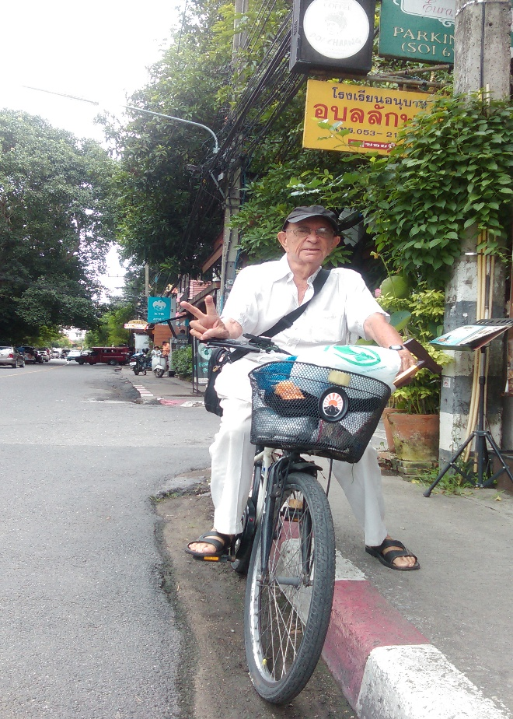
Leo Ellis, Chiang Mai, Thailand
I invited him to join me and he graciously accepted. Wiping the sweat from his forehead he introduced himself and we began chatting. I was curious to know why an elderly foreigner was out cycling alone on such a hot afternoon. “I love to be out and about as there are so many interesting places to visit” Leo explained, and continued “When it’s very hot I bring my laptop and a book and come to places like this, with good air-con and spend an hour or two over a few drinks.”
Leo must have noticed my look of growing curiosity and concern. “I’m 92, so I guess I need to slow down a bit nowadays.”
I was amazed. Leo’s demeanour gave me the impression he was in his early 70s – the way he walked, talked and looked. As our conversation progressed he began to happily divulge more about himself including his reason for being in Thailand. Firstly, Leo is no tourist. He lives here. He migrated from Vancouver, Canada aged 88 – alone, seeking an even better life. “I’ve worked and travelled in many countries – England, South Africa, Australia, Central America and several Asian countries. My favourite is Japan, but it’s too expensive for me. I holidayed here in Thailand for six months testing it out to see if I might like to stay here,” he explained.
Leo commented on his dislike for the nanny state and the political correctness paralysing much of western societies, “I don’t want to buy into all that nonsense. The frustration would probably drive me crazy,” he continued “here the elderly are treated with respect. Respect for the elderly is a cornerstone of Asian culture.”
As we sipped our cold drinks under the coolness of the air-con, I learnt how Leo’s aged pension’s purchasing power has increased four or five fold, which means he is able to rent a very comfortable apartment in the charming old town section of Chiang Mai, he eats out whenever he wants including regularly at higher end restaurants. He also travels – yes, at 92, to neighbouring Asian countries for holidays. He stopped counting the many times he’s visited Japan. He admits that in the last few years he has ceased returning to Canada; instead he encourages family and friends to visit him – and they do. He’s either planning for their visits or entertaining them. They stay in nearby guesthouses or hotels, inexpensive by Canadian standards.
“How do you fill in your days?’ I ask. “I fill them however I choose. I love visiting the numerous cafes and restaurants where I will often meet friends or sit quietly with a book. I know many of their owners and staff. I couldn’t afford to do this in Canada. Here, I don’t even have to consider whether I can afford to or not. I also enjoy reading, visiting the library, planning my next holiday or entertaining my overseas guests. My life is as busy or as quiet as I want it to be.”
Observing Leo more closely my mind was beginning to wonder if he had wittingly or unwittingly stumbled upon that elusive ‘elixir of life’ so many of us dream of. Is his youthful attitude and demeanour attributable to his strong sense of place and meaning within his new-found community; one that generously bestows rightful respect? Surely this must be a contributing factor to his healthy longevity.
Putting ‘life elixirs’ aside, Leo further explains how he’s only had one major brush with the medical profession since being here. That was when he had a kidney stone, but after an MRI scan, some CAT scans, x-rays and seven consultations with specialists his total bill was around A$700 – which he paid out of his own private health insurance fund – of which he is the sole member, contributor and benefactor. “It pays me to take good care of my health.”
“Isn’t it a little dangerous to be riding a bicycle around town at your age?” I ask. “No more dangerous than most places. But I have fallen off a few times. Who hasn’t? I just get back on – a bit like life, although my last fall has left me with a nagging pain in my hip. I’ve learnt to live with it and I’ll be more careful in future” he said.
“What other advantages of living here would you like to share?” I ask. “I think many people have negative or misleading ideas of Asia, but perhaps they’re focussing too much on the wrong things. Most places in Asia have excellent, inexpensive public transport. This means I don’t need to own a car. The internet is usually much faster with Wi-Fi access just about everywhere. New airlines and modern airports are opening up everywhere, too. I find most people here are less stressed. I ride my bicycle all over town - slowly, but have never experienced road rage. Showing such anger, would have them losing face – something to be avoided at all costs.”
“What about your future? You’re 92; we all have to expect that one day we won’t be able to care for ourselves properly. What will you do?” “I’ve already planned for that. I’ve found two local retirement homes with beautiful gardens, one on 100 acres of woodlands with walking paths and a stream. Both have comfortable rooms and excellent nursing and medical facilities. My pension will more than cover the total expenses. I feel I will be looked after better here than back “home”. Since my pension will more than cover my expenses I won’t be a burden on the Canadian public health system’s purse.’’
Ever since our first chance encounter on that hot April afternoon Leo and I have met for breakfast and coffees a few times a week – when he’s available, and when I’m in town, whereupon we would share our tales of travel all the while, unknowingly perhaps, fine tuning our very own ‘life elixirs’.
Leo - a true friend of the same revolution.
I’m now continuing on with my travels firmly of the belief that ‘if possible, life is not meant to be lived in just one place.’

Chapter 4 Let’s Go!

Consider this: perhaps we’ve been committed to certain patterns of behaviour and beliefs because they’ve helped us in the past. Now for some of us, those behaviours and beliefs have become more harmful or, at best, useless. Perhaps the reasons why some of us can’t move forward as we would wish, is because we keep applying old formulae and beliefs to the new level in our lives which we are striving to create. We must change the formulae and outdated or false notions, in order to get a different result.
We must also consider the possibility no, the probability, that in some aspects of our beliefs we have been brainwashed by those who reign supreme, rule supreme, govern supreme, dictate supreme and control us. This is why we need a revolution in the way we think - a retirees’ revolution wherein we refuse to follow those same old formulae and construct our own according to our values and aspirations, not theirs.
Here I ask you to suspend some of those beliefs which do not serve you anymore and come with me; as we travel throughout parts of Asia having left behind those preconceived ideas – usually other peoples’ ideas, and open yourselves to a whole new world of possibilities as a mature citizen.
Since my country of citizenship is Australia we are going to visit Bali, Indonesia firstly as it’s only a few hours away and easily accessible from all Australian main cities, daily.
Bali suffers from much criticism and misinformation in the mainstream media - nowadays labelled Fake News, particularly emanating from Australian commercial TV stations who often promote domestic Australian holidays. This is because in Bali our Australian dollar has around four or five times the purchasing power, and since Australia has now earnt the title of being the most expensive country in the world is it no wonder our elites are unhappy about so many of “their” countrymen and others flocking to Bali for holidays and long-term stays rather than spending what little they have, at home.
There is so much ignorance about Bali that many still think it’s a separate country. No, Bali is a small island, one amongst the several thousand which make up the Indonesian archipelago. Whilst Indonesia is the most Muslim populated country in the world, Bali is a Hindu enclave.
As I mention earlier, nowhere is that Utopia to be found. There are both the good and the not-so-good side of everywhere. We’ve most likely come to this conclusion ourselves and this is probably one of the reasons some of us are reading this book, searching for places or situations more suited to our monetary, social and maybe other reasons mentioned earlier. But remember; now our purchasing power has suddenly increased four or five fold so we are in a position to make choices, perhaps something very foreign to many of us.
Nowadays Bali seems more like an Australian colony as there are Australians everywhere as are their home creature comforts such as Australian beer, TV programs, clubs and expat social and activity groups.
I spend a few months of each year up in Bali’s cool mountainous interior far from the madding crowd, and I want to share this with you. Strange as it may sound, I’m over very hot tropical weather for long term stays, so I usually seek out those rarely-talked-about cool tropical locations found at higher altitudes and in great abundance throughout Asia.
Upon arrival at Bali’s International Airport, Denpasar, look for the designated Over 60s and Disabled immigration queue and be fast-tracked through. Remember, they want you here. Then simply catch a taxi to wherever you have planned to go. There’s no need to book tours or pre-plan anything. Citizens of most countries will be given a one month permit to stay upon arrival, or alternatively for US$25 you will be given a one month renewable visa, for an extra one month – giving you two months in total. Other types of visas for longer stays are also obtainable from the Indonesian Embassy in your home country. I know of many long-stay seniors who exit the country every two months for a day or so then simply re-enter.
I base myself in the town of Ubud up in foothills of Bali’s cool mountainous interior wherein I have an unlimited choice in hotels or guesthouses. Here, occupancy rates usually hover around 60% so no need to book in advance. Just turn up and any taxi driver will help you select accommodation according to your budget or other preferences; or conversely book online at your favourite hotel booking site. Being a retiree, I usually go for A$30 a night place with pool, free breakfast - delivered to my balcony, free Wi-Fi, over-sized room with balcony views over the terraced rice fields and surrounded by cafes and restaurants.
To get out and about to explore the region, simply ask the hotel staff to arrange a taxi. I have found Balinese taxis to be clean and reliable with friendly English-speaking drivers who will also double as your guide, helper, philosopher, photographer and maybe your life-long friend. Recently one such driver insisted I visit his family home in a nearby village – at no extra cost. I thoroughly recommend checking out Bali’s mountainous interior – a cool climate region of crater lakes, volcanoes and UNESCO World Heritage listed terraced rice paddies – not much to see here?

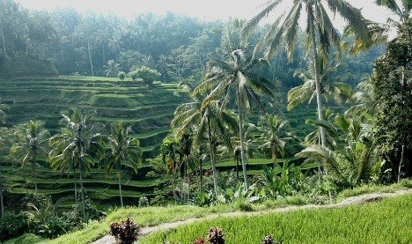
Bali’s World Heritage-listed rice paddies

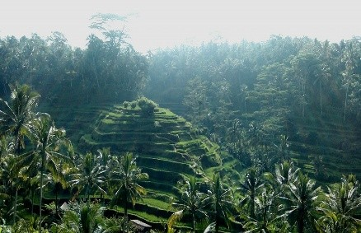

Check out Lake Bratan (1,300 meters above sea level) in the village of Candikuning where I sometimes stay. Here stands the stunning Hindu Water Temple which juts out into the lake. This is a must-see place of immense beauty. It also features on the 50,000 (A$5) Indonesian Rupiah bank note which you will probably have several in your pocket.

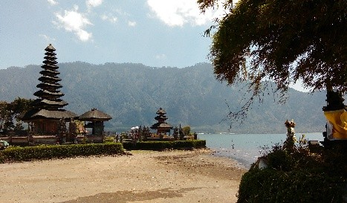
Lake Bratan – 1,300 metres above sea level
Just a further two kilometres up the mountain side are the beautiful local Botanical Gardens. Be prepared. They’re gobsmacking. The Garden is so huge that it’s best to drive through it stopping for walks and photos along the way. Remember to bring a sweater as on some days you will need to wear it.
Greeting you at the Garden’s entrance us is a gigantic and scary statue of Rahwana, an evil Hindu Deity who is always present in the continuous battles between the forces of good and evil, found in much Balinese mythology. Fortunately, Rahwana is always defeated, but I can never find an explanation why this evil one gets to have centre stage at the Garden’s entrance.
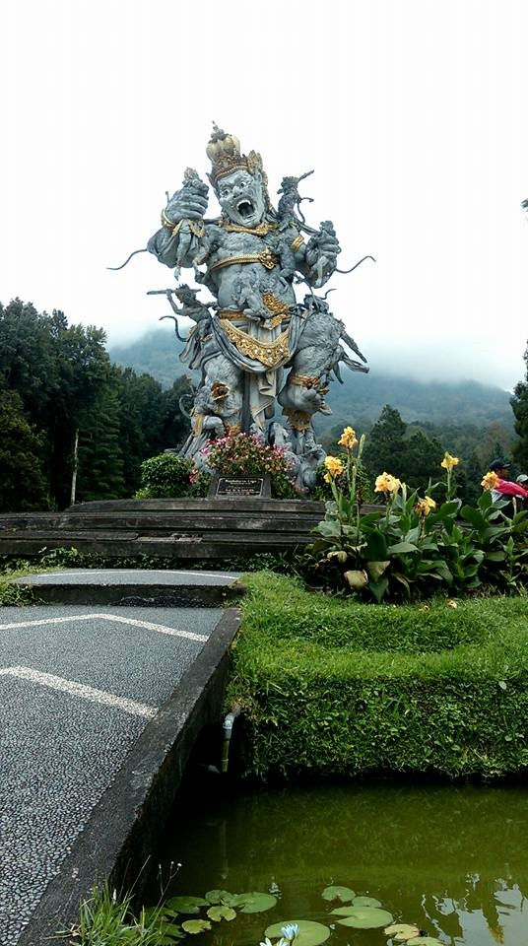
A scary Rahwana greeting
The road continues to climb ever higher and I always get my driver to stop at one of the many cliff-hugging coffee shops/restaurants along the way. I love having coffee or a meal at around 2,000 meters on the edge. You may have difficulty choosing which one to stop at. Live dangerously and select a place many would consider too close to the edge and discover that you are the only patron there. It’s usually like this, which explains why they are so pleased to serve us.
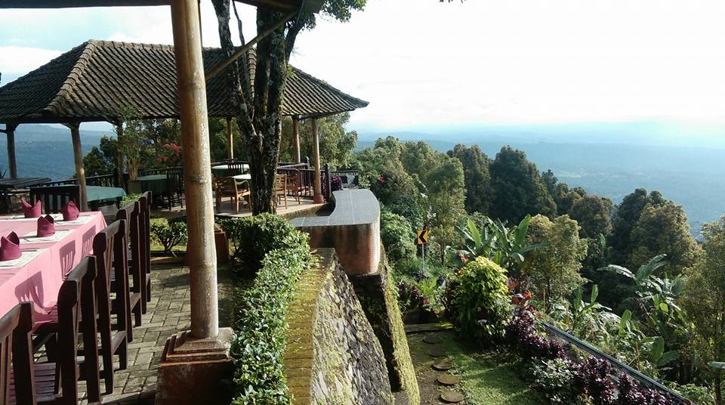
Coffee at 2,000 metres – on the edge
Whilst you are in the area visit the largest of all the high-altitude lakes via the township of Kintamani. It’s obligatory you stop here and visit one or more of their many cliff-edge cafes too, all of which offer stunning views of towering Mt. Batur (1720 metres) with Lake Batur in its shadow.
Lake Batur is a huge volcanic caldera with Mt Batur placed within the centre. This is a dormant volcano which last erupted in 1963 together with nearby, and barely visible, Mt Agung (3112 meters). They say well over 1,000 people were killed as a result of this twin eruption. Mt Agung has recently re-awoken and on occasions when the wind is blowing in the wrong direction the Denpasar Airport closes until the wind direction changes.

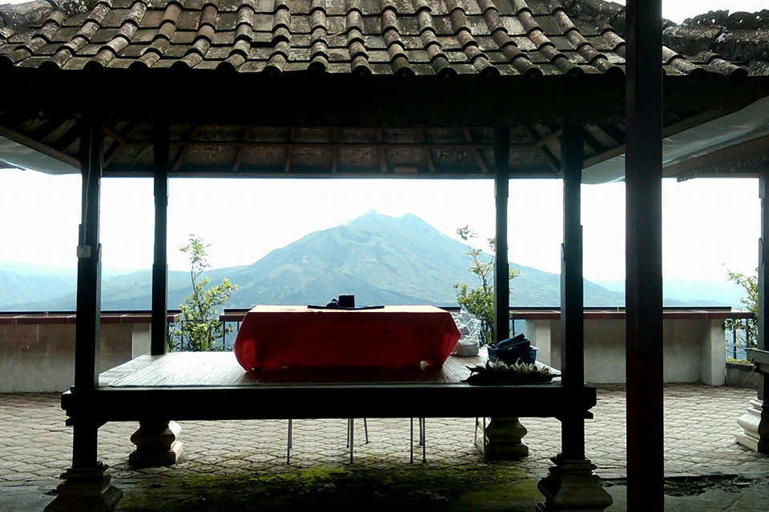
Lake Batur central Bali
It’s possible to drive down to Lake Batur’s picturesque foreshore where there are holiday villas, guesthouses and hot springs. It’s a rarely-visited area and you may be surprised to notice that you are the only visitor at one of the hot springs: this is because most visitors to Bali are to be found at the coastal resorts, beaches and in bars. But this is the way we want it – right?
For many mature readers, travellers and would be travellers this is truly an easy to do and comfortable adventure into the deep heart of Bali. I have done it often and on occasions for weeks at a time. Other villages in the area that I’ve stayed in and can recommend are: Sideman, Kintamani, Munduk and Ahmed which is located within the shadow of the now-active volcano - Mt Agung.

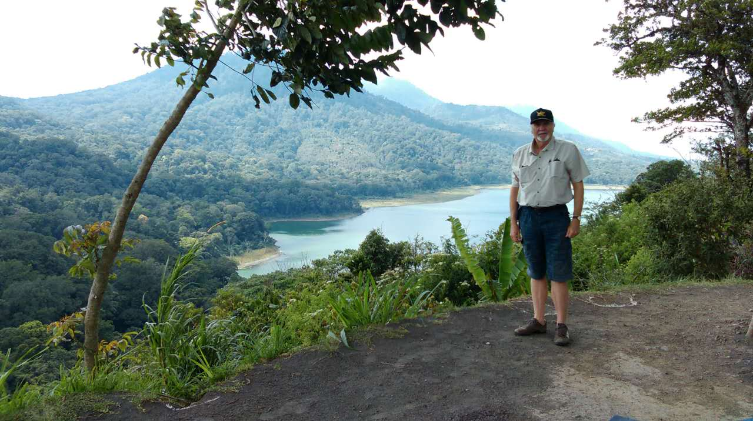
On the high road to Munduk central Bali
You can get an idea of the natural beauty of the above places by simply going to Google Images. When it’s time to book accommodation I usually book online via http://booking.com or http://trivago.com. I book for three or four nights in order to check the place out and if it’s satisfactory, I then extend my stay.
I hope you get to enjoy this magical area one day too. Maybe I will even see you up there!
It may take you some time to get used to being suddenly released from survival mode and into a more middle class existence. Think what it must be like for a prisoner, who has served his sentence, being once again set free into his new world on the outside; except you didn’t do anything wrong to lose your freedom – it was those who claim governance over you that are at fault.
Bali is great place to familiarise yourself with your newfound existence as here, and in particular the artistic and cultural environment of Ubud, is a great place to start. Here are exquisite and affordable restaurants and cafes many of which are often frequented by newly released souls such as yourself. You will be in good company in Ubud and I have met some wonderful new friends and acquaintances from all corners of this wonderful planet.
I’ve been patronising the Lotus Café in central Ubud, my favourite café, nigh on ten years. I love the way it surrounds the most beautiful Lotus pond imaginable. An ancient Hindu Temple towers sentinel over both the Lotus flowers and patrons. It’s humbling. It’s surreal. It’s a sanctuary – these are some of the many things that keep drawing me back here. I have to pinch myself as I’m just here for coffee!
Ubud in Balinese means medicine, not Western medicine, but more a sense of being here – to allow nature to rejuvenate body and soul. Artists and other creative types have been coming to Ubud over many decades and their presence has surely had a creative influence in the shaping of this most unique town and its inhabitants. They tell me some of them include Rudolf Bonnet, Charlie Chaplin, Noel Coward, Barbara Hutton, H. G. Wells, Vicki Baum and more. I’m in good company.

Nowadays there’s a much more cosmopolitan vibe inside the Lotus Café. As I glance around I observe most patrons are young/ish U.S. or European-looking women in groups of twos or threes... Sigh! The absence of similar groups of young men is noticeable. I ponder, why is this so? And then I remember: Eat, Love, Pray – that popular 2010 romance movie partly set in Ubud explains the over-abundance of young and more mature women, many of whom have a certain Julia Roberts aura about them. Beautiful! So if it’s romance on an exotic tropical island you are seeking then perhaps a visit to the Lotus Café might be a good place to start.

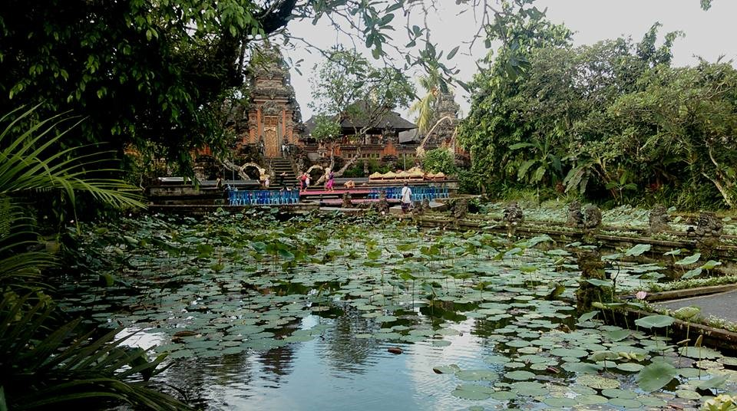
Lotus Café, Ubud
The coffee is local – maybe organic, and inexpensive too. The ambience is unbeatable and I just love how the gigantic tropical Magnolia trees frame the whole scene perfectly.
One evening as I exited the Cafe a ceremonial Hindu street procession was passing by and occupying the whole street. It was so colourful, noisy and invigorating. The vitality there is palpable.

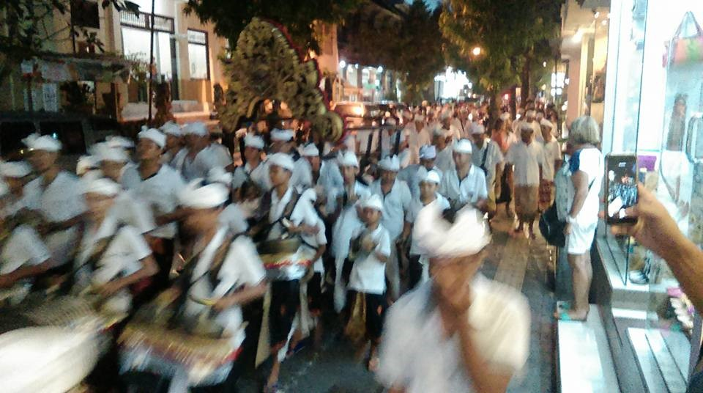
Hindu ceremonial procession Ubud
Believe me – it’s not just the caffeine that makes you feel so good at The Café Lotus.
By now some readers may be wondering how will you fill your day or find any kind of purpose in life in such foreign environments. Here I can only share with you what I do to keep myself active and fulfilled. Firstly, I usually select a hotel or guesthouse which has a decent size pool. As of the time of writing this humble tome I’m 70 years of age. I need to keep active so I’m big on swimming. I like to swim every day when possible. Not only does this keep me reasonably fit but often hotel swimming pools are a centre of social interaction. You would be surprised at some of the interesting people I’ve met and befriended poolside, whilst getting my fair dose of vitamin D.
Social interaction in itself is a worthy pastime and you will find in these foreign environments these interactions occur frequently and in a very relaxed and informal way. I’ve met a European celebrity, an ex-Harvard professor, writers, artists, activists, an Asian royal and countless mature aged adventurous singles and couples from many countries all seeking a more fulfilling existence.
I read and write. This book was written in various locations throughout Asia as I travelled. I read e-books which I download as I travel.
As regard to fulfilment, it depends upon where I am. For example I’ve taught English to Buddhist monks in remote temples in Laos, taught art and English to children in China’s remote Gobi Desert, I’ve attended art classes in Thailand, meditated with monks in Thai temples. I’ve even taught English for money. These are just a few of the life fulfilling activities I have participated in. I will go into more detail about these and similar activities country by country, as we come to them, but be assured you can be actively involved as little or as much as you wish, anywhere. The opportunities and boundless and borderless.
If you need to work because you are too young to retire (lucky you) I will outline my experiences and how and where to find the best opportunities later in Chapter 6.
When my one month visa for Bali, Indonesia is about to expire I am usually not done with Indonesia since there is far more to this diverse, beautiful and welcoming island nation than Bali. Hereupon I fly to Kuala Lumpur, Malaysia’s capital city where I board another very short flight to Medan Sumatra, Indonesia. Since I have officially departed Indonesia for another country, Malaysia, I am now able to have another month in Sumatra, Indonesia – my second favourite place in Indonesia. I’m heading for the magnificent Lake Toba in northern Sumatra. Allow me to describe and explain a little.
It’s a special place high up in central Sumatra Indonesia where 70,000 years ago, a huge mountain exploded. The explosion was so enormous, planet Earth suddenly entered a severe volcanic winter.
Depending upon the location upon Earth, temperatures dropped 5-20 degrees Celsius below average as ash circled the planet for years. The whole of S.E. Asia was smothered in 10-15 metres of volcanic ash. The ash, combined with the sudden drop in temperature caused most forms of life, including most humans, to perish. It was the largest known explosion for the past 25 million years.
The explosion created a huge crater or volcanic caldera and some of the debris blown high into the atmosphere fell back into the caldera forming a large mound. When the caldera eventually filled with water, Lake Toba came into existence and the large mound – 50 x 15 kilometres in size, became known as Samosir Island. The lake is around 90 kilometres long and 30 kilometres at its widest point. It’s over 500 metres deep and over 1,000 metres above sea level, making it the largest Crater Lake in the world.
I’ve had the great fortune to visit Samosir Island twice in the past few years, staying a month on each occasion.

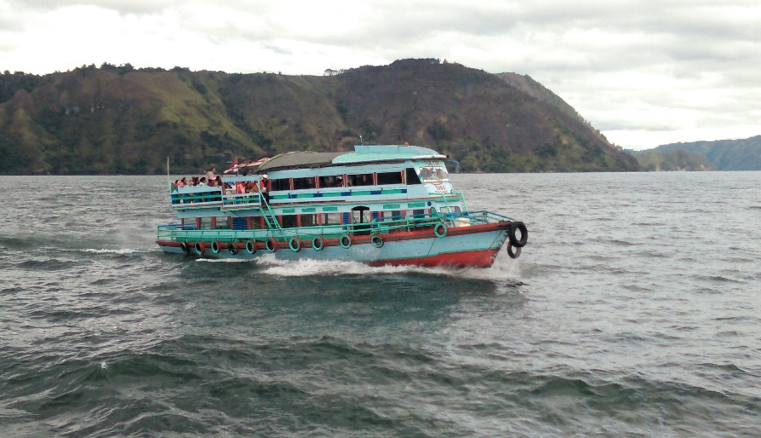
Lake Toba – Sumatra, Indonesia

I’ve found Lake Toba to be special as its climate is always pleasantly mild – I even had to wear a sweater some evenings, even though it’s only three degrees from the Equator – no air-con or fans required here. It’s a sparsely populated area with few foreign tourists and very little traffic, and when you consider its origins and location it’s surprising to see such a wide variety of pleasant and four star guest houses, hotels and restaurants. My hotel, which I cannot name for fear of it being overrun with tourists, was perhaps, the best hotel of its type I have ever stayed in. Its rooms and villas are styled upon the local Batak houses peculiar to this region, with their roofs extending upwards at their ends. Their exteriors are all intricately carved in the Batak style and constructed mainly of local timber. My room was large with a balcony overlooking the lake. The food was excellent in the traditionally constructed dining room, and the free Wi-Fi was strong. Not bad for A$27 a night.

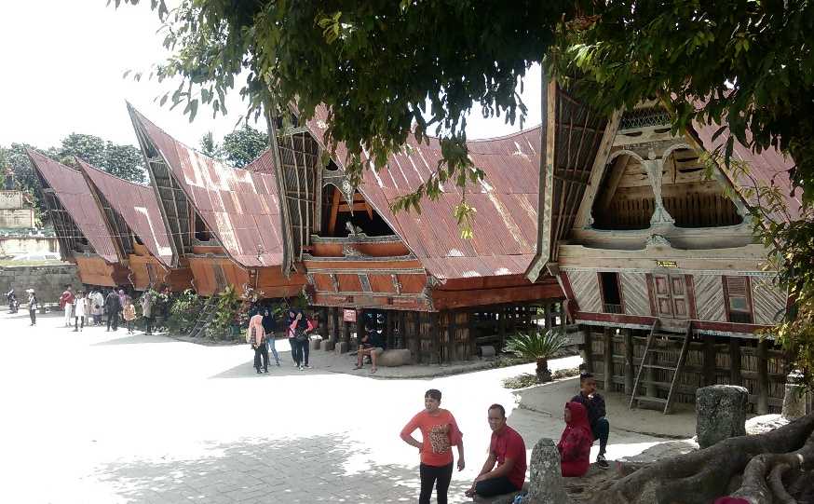
Traditional Batak houses Lake Toba
But it’s the beautiful lake which is the main attraction here. All the major hotels and guest houses are located on the lakeside with many having diving boards and access steps immediately in front of some rooms, inviting you to enter the clear, warm fresh water.
The lake, with all its hotels and lake-side villages, are serviced several times daily by an over-abundance of colourful ferries and cruise boats. It works out about A$1.50 an hour on board a ferry. I never did pay the much higher fare for a Cruise Boat as the ferries go just about everywhere and you get to mingle with the locals more. Here, locals would always want to chat with me and on one occasion insisted I share a large bag of passion fruit with them. They nearly always ask: where do you come from? If you are lucky, on some ferries and just before departure, a few children might scamper aboard and sing songs, hoping for tips.
I rode the ferries to wherever they might be going every three or four days, and on some days when the wind was up and the waves were forming white caps, the ferries would bounce around a little. Things became even more exciting when all the seats, which are never bolted down, would begin to slide about. You never quite knew where you and your seat might end up; so a flexible attitude or sense of humour comes in handy on those days.
Unfortunately, wheelchairs and walking frames might be out of the question since you have to board and alight via a plank over the bow (pointy end) and you need to be fairly sure-footed, but the crew are always there to give you a helping hand.
All the hotels and many other establishments will hire out motor scooters for A$10 a day including petrol and you can circumnavigate the Island and explore the unique Batak villages which are scattered around the Island. No special license is required and upon returning my scooter I noticed it didn’t even have number plates. Traffic is very light – just watch out for the potholes.
When you stop along the way it’s common for locals to approach wanting to greet and talk with you. You’ll be surprised to discover many will speak at least some English and again, many will ask: where do you come from?

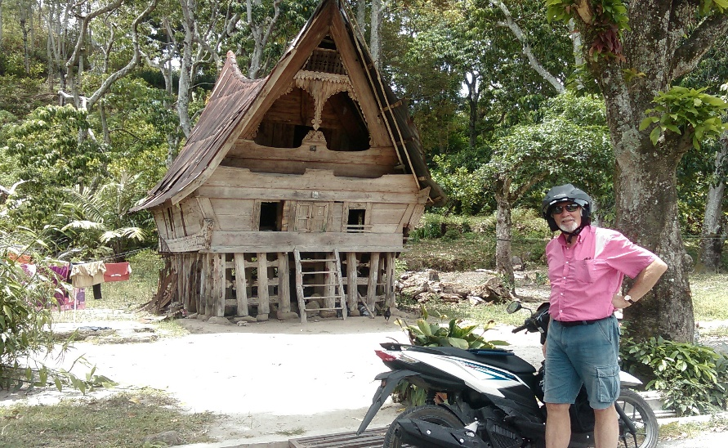
Sumatra Indonesia
Here’s how I got there - there are two ways – an easy way and a hard way. I took the hard way…I flew Air Asia from Kuala Lumpur to Medan, Sumatra Indonesia. At the new and under-utilised Kuala Namu airport (Medan) there are ATMs, money changers, restaurants and taxis waiting for you. I caught a taxi for around A$55 to the township of Parapat, located on the shores of Lake Toba, from where I caught a ferry. The taxi ride takes 4-5 hours and can be a little gruelling, but it’s a very scenic trip and the driver will stop along the way for food and rest stops. Once at Parapat your driver will direct you to your ferry which departs every hour. Just get on, tell them the name of your hotel and eventually someone will take your A$1.50. Next time I’ll fly from Kuala Lumpur on Air Asia to the recently-reopened Silangit airport which is only an hour and a half drive to the ferry terminal at Parapat on Lake Toba.
To book hotels on Samosir Island – most use the internet nowadays, just use your favourite hotel booking site. Most good hotels are in the lakeside township of Tuk Tuk. The hotel I stayed in, whose name I refuse to divulge is the Hotel Carolina. Check it out.
This part of Indonesia is completely different to Bali. Firstly Lake Toba is a Christian enclave and each Sunday you will be awoken by the sounds of church bells and hymn singing. The cost of living for your newfound middle class existence is at least half that of Bali. This will allow you to save money which you might like to use to somehow contribute to the local community. Here I always tip everyone generously and have even helped sponsor a local student through University. She recently graduated with a BA in English Literature and is now fruitfully employed as a local English teacher.
Heavens! You might now want to sponsor one of those impoverished children back in Australia, the U.K. or the U.S. – the ones that charities there are appealing for sponsors.
Well, we are now done with Indonesia and we are free to move on to our next country. An appeal of this lifestyle is that you are released from the ever-present pull of nationalism. When my family migrated to Australia in 1950 seeking a better life we never gave up our ties and love for England. I’ve returned there four times since for study, work and play. Now I love both countries.
Having spent many months in Indonesia and several other Asian countries I now love them all. This openness, respect and love for all these countries leaves no room for nationalism, racism and their associated and dangerous narrow thinking to take root.
We shouldn’t let nationalism, in all its different stripes, hold us hostage in situations that don’t serve us at a particular point in our continuous personal development. Perhaps we should consider concentrating more on our loyalty or allegiance to Planet Earth, its wellbeing and the Family of Man.
Yes, I too have often said Australia is the best country and as I travel it seems just about everyone I meet is saying the same thing about their countries, just like every religious person says theirs is the best religion. Till proven otherwise!
As we grow and our wants, needs and aspirations change so too does our understanding and acceptance of the criteria by which we might gauge a country. For example Australia is a great place for bringing up a young family and for carving out a career, but alas once we arrive in our senior years as we all will, except of course those who have already passed away whilst still young, then those same criteria do not always apply. This then drives some of us to strive for better acceptance elsewhere. This can also be seen as just another opportunity to take full responsibility for all aspects of our lives. This is just being human.
Don’t fall for Government, or otherwise, sponsored nationalistic propaganda such as “ours is the best country”. History has repeatedly demonstrated that leaders who have used the nationalism card are the ones more likely to have taken their countries to war.
We need to understand the difference between patriotism and nationalism, and that is: a patriot is proud of his country for what it has achieved and does, whilst a nationalist is proud of his country no matter what it does. Patriotism creates a feeling of respect whilst nationalism creates a feeling of blind arrogance no matter what the country does and that’s how wars are started. In my opinion international travel is the best antidote.
Australia is a great country, and probably yours is too. Up till recently it has served me well just as I served it well by paying my taxes and raising a family, but as I mentioned earlier there has been a dangerous cultural shift or mood swing with its seniors and underprivileged, being its main victims. For a new cultural shift to occur and for the pendulum to swing back to a more humane and compassionate balance it will take years, and when you are a senior, time is of the essence.
Recently starting in France and slowly spreading throughout much of the western world the popular but much-maligned Yellow Vest Movement is steadfastly gaining momentum in spite of mainstream media blackouts, miss-reporting, Government distain and, in Europe’s case, outright elitists’ horror. This global citizen uprising is the result of decades of Governance by Corporations and the cold, cruel bureaucratic governance in general. The hard-working tax paying public have had enough.
Fortunately for retirees and others this book provides a personal antidote for those brave enough and willing to apply the new formula presented within this book. It also means, depending upon your degree of frustration, you are free to join the Yellow Vests or similar revolutionary groups when and where it may suit your circumstances – something I am considering as my circumstances and locations might permit.
After viewing several YouTube videos of the Yellow Vests protests in France and elsewhere I was amazed and encouraged by the large proportion of mature-aged protesters I saw taking to the streets and endangering themselves. In contrast, the mainstream media images show only young thugs destroying whatever was in their paths. I believe we are witnessing the early days of a growing global revolution aimed at taking the decision making powers away from our corrupt and incompetent politicians and placing that power with the people. How can any thinking person disagree with stripping those who have failed us so miserably of their powers?
“The world will not be destroyed by those who do evil, but by those who watch them without doing anything” Albert Einstein
But this book is not about global revolutions as for many of us time is already an enemy. It’s about our very own personal revolution within the context of a crazy, confused and cruel world.

Chapter 5 Moving On

So, we’ve finished with Indonesia this time around and to help keep travel costs down I’m off to nearby Kuala Lumpur (KL), Malaysia for some big city life. Flights from Medan, Sumatra to KL are very inexpensive and take around 40 minutes.
As with most of my flights I firstly go to the Skyscanner internet site to see what’s on offer at the times and dates I am interested in. Skyscanner has become an indispensable tool for my lifestyle. Check it out.
Upon arrival at the KL international airport you will be given a three months visa stamp in your passport and I understand this is also renewable, but I have never done this. Once through immigration catch a bus or train into the city centre. Both buses and trains are very inexpensive, frequent and comfortable. The bus takes about an hour. From the KL airport you also have multiple choices of destinations such as, Penang, Malacca and the cool Cameron Highlands directly – all by bus. I’ve caught buses from here to both Malacca and Penang as well as KL. I hope you are getting used to choices by now .
I usually find that 10-14 days in the big, but beautiful city of KL is usually enough for me: I’m not too big on crowds nowadays. KL still retains much of its oriental charm and British colonial architecture. It really is a beautiful city with so much to offer, and everyone speaks English.
I usually head for the Maytower Hotel because of its location, affordable tariff and because of its great shaded swimming pool. I can swim all day without getting sunburnt. Diagonally across the road is one of my favourite Indian restaurants. Indian food is my favourite.
A great way to explore this former British Colony of Malaysia, is to take a ride on Kuala Lumpur’s Hop-On Hop-Off double decker bus. Starting at around A$15 for a 24 or 48 hour time limit, the round trip takes approximately two and a half hours in which time you get to see so much of what this vibrant, modern city has to offer. I’ve done this trip twice now and I’ll probably do it again next time I’m in KL.
The bus stops at twenty three well-chosen points of interest, some of which include the world famous Petronas Twin Towers, the National Palace, National Museum, Bird Park and Chinatown, plus so much more. You simply alight at whatever location appeals to you most, knowing another bus will shortly follow every 20-30 minutes. You can do this all day or even up to 48 hours depending upon your ticket.

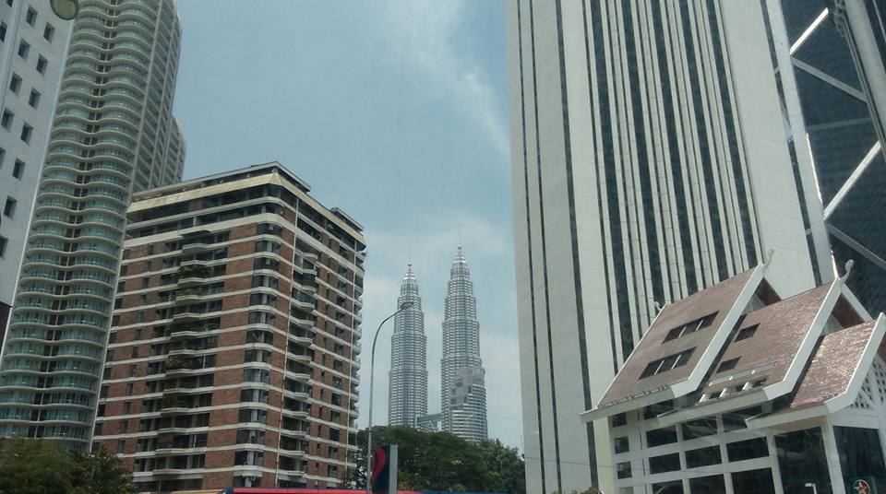
Petronas Twin-Towers downtown Kuala Lumpur
So, if walking endlessly in the torrid tropical sun isn’t your thing – it’s not mine - this might suit many you as everything of interest is so close and when you are through looking, or the sun becomes too much, you can simply retreat into the air-conditioned comfort of the next bus.
I alighted in Chinatown on my first trip, for an hour or so seeking food – and what a culinary delight that turned out to be, inexpensive too at around $2.50 a course. On my second trip I alighted in Little India. Both choices are excellent.

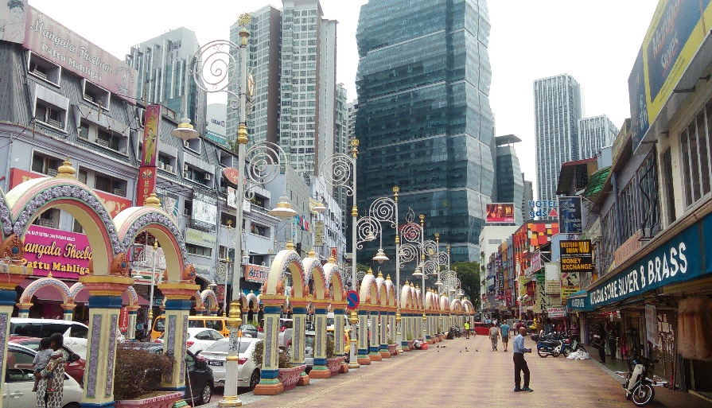
Little India – Kuala Lumpur
Tickets are available online at www.myhoponhopoff.com or just hop on at any stop without a ticket and eventually a smiling conductor will sell you one. Most hotels and tourist information kiosks, etc have information brochures and route maps.

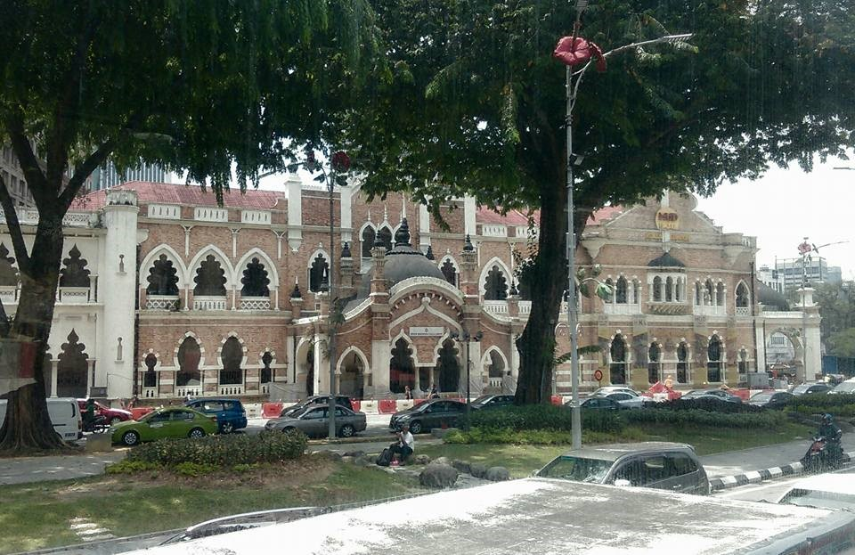

You will probably need at least one full day to experience just two or three city attractions.
No, I have no financial or other interests in this venture. I just think this is the type of excursion which could appeal to some of my readers. I also want to share my wonderful, comfortable and easy to do day out of the tropical midday sun.
Malaysia is a real foodies delight as all major ethnic groups are represented here – Malay, Chinese, Indian and Western styles of cooking.
By now you are probably not even bothering to read through the menus looking for the day’s specials or the most inexpensive dishes. Those days are over as you can simply order whatever you want.
Hopefully by now you are also beginning to stop being afraid of what could go wrong and are becoming more excited about all the things that are going right for you. Your newfound heightened sense of self-worth and self-esteem will be helping you forget about all that is wrong with the state of the world; its politics, its corruption and more. Yes, it’s good to be aware wherever you are, but in our current stages of life and locations we need not bother about such eternal things. We have left all that behind for others to try and resolve. By our being positive, happy and healthy; these are already a far greater force for good than we could have ever been back home. Concentrate on your own personal revolution. Don’t concern yourself with the politics of wherever you are. If the country goes belly up due to war or some other kind of civil disturbance, all you need do is catch the next plane or bus out, to the country next door. Yes, some Asian countries may eventually fall apart due to the aforementioned reasons, and so too could many Western ones, but in our lifetimes it’s hardly likely they all will. And don’t forget you can always return home whenever it suits you.
If there is any one place in the whole of Asia where you can experience such a diverse array of cultures, languages, food, architectural wonders and history it is the Malaysian island of Penang, just off Malaysia’s west coast.
This easily accessible island has it all and more, and for the budget-conscious over 60s person, it’s very affordable.
Getting there is easy as it has its own international airport or you can catch a bus from downtown KL or the KL airport. I stayed in the old UNESCO World Heritage listed city of Georgetown – so named after King George III. The British East India Company occupied the Island in 1786, originally naming it Prince of Wales Island.
Here, you will be surrounded by street after street of mainly old traditional Chinese shop houses – shop downstairs, house upstairs all in differing stages of decay, restoration and colours. It’s an area lost somewhere in time. I love it, and around almost every corner a surprise awaits – an ornate Chinese Temple, a street full of Indian restaurants, a crumbling old colonial mansion, a row of awaiting rickshaws: don’t feel embarrassed if you have to awaken the driver as it’s hot in the tropical sun, and a midday nap is just part of the culture here – I do it too.

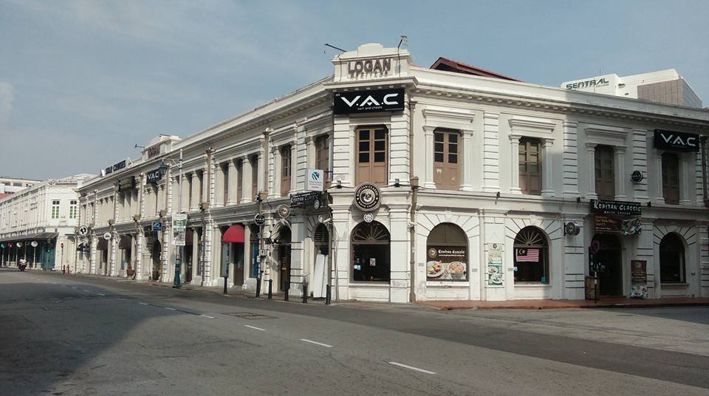
Georgetown, Penang Malaysia

There’s no need to travel to India or China as they’re both here. Little India and Chinatown, both are in the middle of town. You will know when you are approaching Little India because you will hear it first and then suddenly you will find yourself fully immersed in it. Oh boy, you asked for it! And without realising it, you will find your surroundings morphing into Chinatown. How did that happen? - you will be wondering.
It’s also a foodie’s paradise and I noticed most locals don’t bother cooking so often, instead they make for their local inexpensive eateries which are never far away. I mostly eat at the pop-up food courts which pop up everywhere always on que, and to the delight of my budget, rarely do I pay more than A$2 a meal. Going for seconds is not uncommon. I am not exaggerating when I say, Penang is the food capital of my world.
I’m not really into religion, but I do love religious architecture and religious art. Here, there are striking religious buildings everywhere – centuries old and very charming Christian Churches, ancient Mosques, both large and small Chinese and Hindu Temples. But my favourite is the Chaiya Mangalaram Buddhist Temple which is home to the third largest statue of Buddha in the world – the 108 foot long reclining Buddha, created in 1845. Seeing Buddha, all 108 feet of him, reclining in such a relaxed manner now makes me feel so much better about my afternoon naps. This Temple is also adorned with a further 30,000 images of Buddha. The whole complex is set in a large garden which also features ornate dragons glittered with tiny mirrors and other striking Buddhist statues.

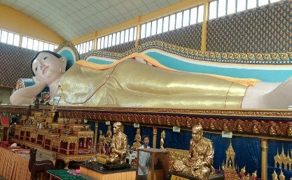
108 foot reclining Buddha – Penang, Malaysia
And if this Temple doesn’t do it for you, immediately across the street there is another one – a Burmese Buddhist Temple, just as spectacular, complete with a gigantic standing Buddha. How convenient is that as both temples are on the Hop-On-Hop-Off bus route.
For any Brits reading this: centuries-old British artefacts, statues and stately buildings abound, including a 300 years old fort, Queen Victoria’s Clock Tower, Botanical Gardens and a modern Horse Racetrack. Most have been restored to their original splendour and they’re guaranteed to bring a smile to your face.

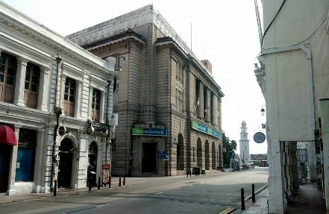
Georgetown Penang

I stayed at the grand old Heritage Hotel, built by the British almost 100 years ago and sometimes during the nights I swear I could hear King George addressing his subjects as he wandered its long regal corridors. With all the splendour and creativity this city offers it really gets my creative juices flowing – and my imagination too.
Language is no problem here as English is almost everyone’s second or first language and unlike most places in Asia everyone obeys the traffic rules and drives properly – a big plus. About 40% of the population of 700,000 is Chinese, another 40% is local Malay, and the remainder are mainly Indian and other minorities, including Europeans. This all adds up to a truly cosmopolitan and vibrant place indeed.
If you are into beaches and tropical mountain scenery, once you leave the built up areas there are easy-accessible large and small sandy beaches along the coastline all with mountains behind.
Believe me, the water is warm, clear and safe and you don’t have to travel far, and many high-end hotels are located right on the beach frontage.
I’ve met several over 60s on Penang Island and many of them have exclaimed how they are feeling somewhat overfed, but they all definitely looked very happy – and relaxed.
It’s now time for little reality check: I often hear people say how they couldn’t afford to travel as I do – after all many of us are retired and on modest fixed incomes. Here I would like to point out, based upon my many years of travel throughout Asia and other regions, that it is more expensive to sit on your couch back in Australia, or the U.S. or the U.K. than it is to travel and live according to the locations and lifestyle presented in this book.
For the cost of a measly cup of coffee back home you can buy two meals in these low cost countries. I always try to stay in hotels which offer a free buffet breakfast, free coffee and tea making facilities in the room, free unlimited Wi-Fi, cable TV and swimming pool. There are no extras to pay. You have no bills to pay. You don’t need a car as all manner of inexpensive transport options are easily available. You are freed from all these stressful and costly annoyances.
A good hotel with all the aforementioned will set you back around A$40 a day. If you are traveling as a couple that’s only A$20 each. Some types of accommodation will even have facilities to do some basic cooking and you can always take snacks and more, back to your room. In the previous chapter I mentioned how my favourite four star hotel by Lake Toba in Sumatra, Indonesia cost me only A$27 a day, and I didn’t mention how a further kilometre along the Lake’s shoreline I also sometimes stay in a self-contained lakeside villa for A$20 a day.
This also means that the money you save on your day to day living expenses can be used to cover your airfares back home and further afield. In 2016 I spent a month travelling Scotland, with two of those weeks on the Orkney Islands off Scotland’s north east coast.
I love remote islands as they invoke within me a sense of calmness and escapism from this world going crazy with political correctness, and more. Read more about my Highland adventures in Chapter 11.
Malaysia has its remote tropical islands also, so after a month in Penang I caught the high-speed ferry from Penang harbour to the idyllic and nearby Langkawi Islands, Malaysia. The journey takes about two hours.
I knew I was going to love Langkawi Island as soon as my high-speed ferry got closer. Firstly, you see the tall mountains rising from the aqua Andaman Sea, and then as you get even closer you begin to realise this land mass looming ahead is actually a seemingly endless sea of small islands. It’s an archipelago consisting of around one hundred islands.
The ferry graciously winds its way amongst them finally arriving at Langkawi’s ferry terminal on the outskirts of Kuah – the main town. What an entrance. My positive first impressions were further upheld as I disembark into perhaps the best, most functional and new ferry terminal ever. Here, there are ATMs, money changers, restaurants, shops – it’s all here.
Within minutes I head for a popular beachside community, Pantai Cenang, about 20 minutes by taxi on the west side of the island. Driving out of Kuah Township I am still struck by what a modern, tree-lined township it is. The streets are wide, traffic is light, I see two or was it three modern shopping malls - one with a cinema complex. Everything looks new here. My talkative Indian taxi driver asks me where do I come from? “Australia!” I reply.
“Oh, very nice country Sir. I was born here, my grandfather came here from India.” He then proceeds to give me a short history lesson on Langkawi: Population 90,000, the Island is bigger than Singapore, it’s located 50 kilometres off the coast of Malaysia, only three of the 100 islands have residents, it was once home base for many pirates who hid amongst the maze of islands, their coves and caves. 17th century European traders would journey here in search of pepper which grew in great abundance, and it was once part of the Kingdom of Siam (Thailand), but somehow the British ended up occupying the archipelago around 1909, and I am just one of the 3,000,000 tourists who visit each year.
Soon we leave the modernity of Kuah and are quickly surrounded by mountains and jungle with regular vistas out over the island peppered sea. The road gets even wider and the traffic thins. This is Malaysia and everyone here drives according to the rules.
Finally we arrive at my destination and after booking into my hotel I make for the beach a few hundred meters away, and for a cold beer - the tropical midday sun is beginning to take its toll.
The Pantai Cenang beach is long and sandy, Andaman Sea on one side, luxury resorts on the other side with a purpose built public walkway well located in between. It’s beautiful – and I’ve seen a few beaches in my time, and I can’t help notice this is a hot spot for all those sun seeking jet-setting types who demand the luxury of an almost deserted island, but also with tastefully developed tropical hideaways.

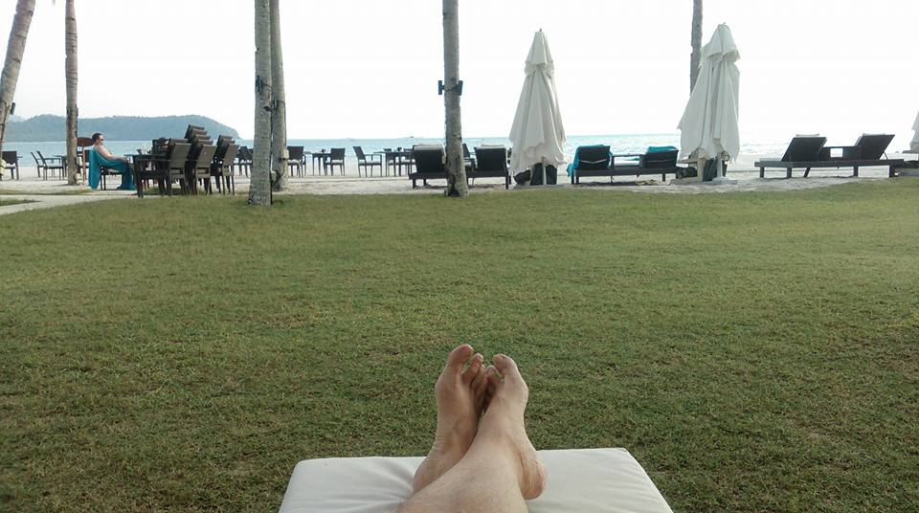

Being an over 60s traveller I initially thought I might have landed in the wrong kind of place, but no, I soon discovered there is plenty of room for us seniors here, and it’s not too long before I’m raising a glass with a few of them in one of those luxury, out of my price range resorts; relaxing in their shade on their comfortable recliner chairs complete with uniformed waiters hovering about. One thing I love about Asia is that they respect – or is it fear, us over 60s types and will tolerate almost anything we do, for example they wouldn’t dare ask what my room number was.

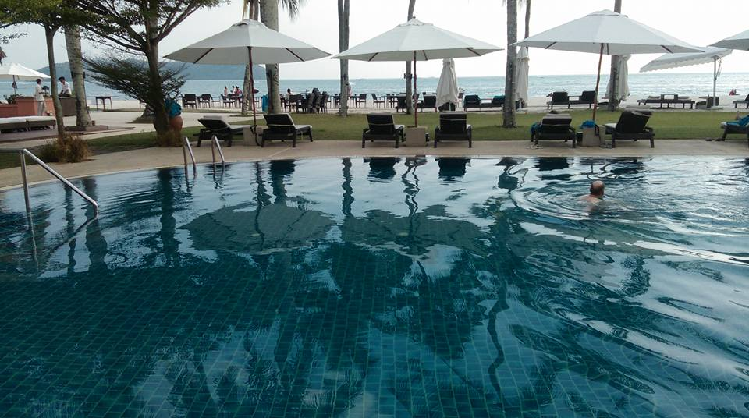

My talkative Indian taxi driver later took me on a pre-arranged 3-4 hour tour of the Island. Much of the time we followed the coastal route stopping at beautiful coves, deserted beaches and some not so deserted. Here and there I caught glimpses of very upmarket resorts; some perched perilously atop headlands and with others barely visible in the jungle.

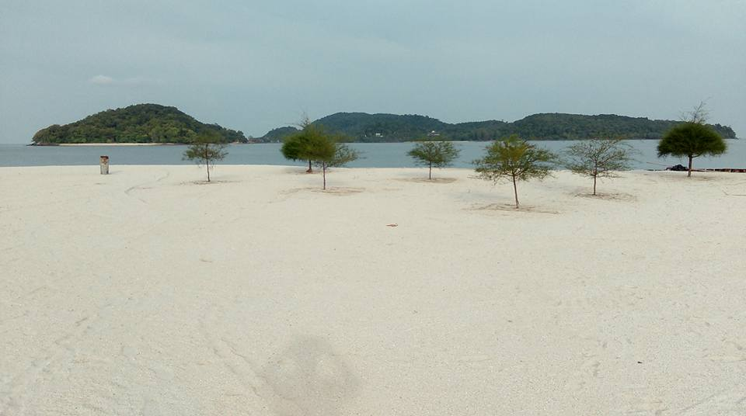
Pantai Cenang beach – Lankawi Islands, Malaysia
There are three UNESCO World heritage listed Geoparks here – whatever they are? – wildlife park, crocodile park, gold courses, water parks and all manner of water sports activities including a wide variety of cruises amongst the once pirate infested islets. It’s all here, even an international airport and perhaps the best free Wi-Fi I have come across in Asia so far.
On the downside I found all this modern development – all the newness, has taken away much from the old Asian charm with its unique, often antiquated architecture, and quaintness. But this is the new way of the world almost everywhere nowadays. But at least here it’s done in style and in a well-preserved and beautiful environment.
Don’t worry, the food, the relative low cost of everything and the lack of crowds still makes Langkawi Island a very attractive and easy accessible place for any seniors and others looking for that something different, whatever your budget.
The locals are friendly and it was here on a beautiful sunny day as I was wistfully gazing out over the azure sea, pondering life’s imponderables, that I happened to see a group of women fully draped in their black burqas swimming, fully burqared, alongside others in a more familiar-to-me swimming attire – bikinis and so on.
I discretely reached for my camera and took a few photos of this most peculiar-to- me scene. Alas, the women in the burqas spotted me with camera pointed menacingly at them and came running towards me. My heart began beating harder “what should I do? Should I run with six dripping wet burqa-clad women chasing me along the beach, or should I stand my ground and face up to them? What would you do?”
I opted to stand my ground whereupon they surrounded me all the while talking wildly in a foreign tongue. Finally one of them began to speak in English and politely asked if I wouldn’t mind posing with them for a group photo on the beach. This I found an offer too good to refuse and enthusiastically agreed. After they were done with the photography they proceeded to ask all manner of questions about where I came from, what was my religion (I don’t have one), how long I am staying, where is my family and more.
We finally parted as friends whereupon they informed me how the photo will be shared on Facebook to show everyone their newfound Australian beach-boy friend.

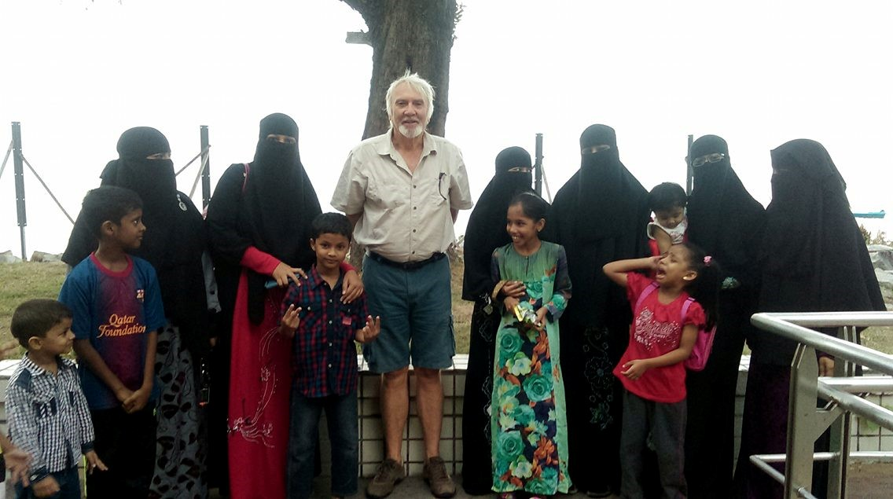
The burqa-clad swimmers, Langkawi
Malaysia’s largest State, Sabah, is located almost 2,000 kilometres to the east of peninsular Malaysia on the large Island of Borneo which it also shares with Indonesia.
Recently whilst travelling in Asia I made the wise decision to pay a visit to the Kundasang War Memorial also known as the Australian War Memorial Garden in Sabah, Malaysia. It’s located high up in the rugged mountains a few hours drive from Sabah’s provincial capital city, Kota Kinabalu. The scenery on the drive up is gobsmacking and holds no clue as to what transpired here around 1945 – the Sandakan Death Marches. The road gently winds its way up some two or more thousand meters all the while in the shadow of towering Mt Kinabalu, which rises even further to a height of 4,095 meters to the small village of Kundasang. It is here you will find the Kundasang War Memorial Garden dedicated to the lives of the 1,787 Australian and 641 British POWs systematically murdered by their Japanese captors.
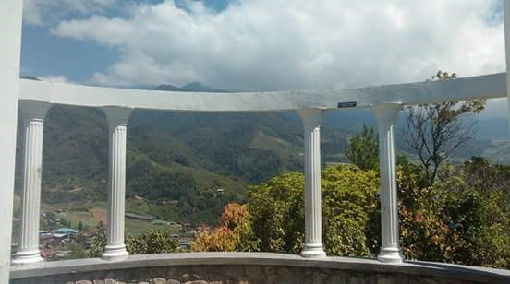
Kundasang War Memorial Garden, Sabah, Malaysia
Here, it is recorded how 2,434 captured Allied soldiers were sent on three Death Marches through the dense jungle from Sandakan to the small mountain top village of Ranau located nearby. Only six soldiers survived. They were the “lucky” ones who had managed to escape into the jungle and were hidden by brave local Malay villagers. It was a deliberate and successful means employed by the Japanese military in disposing of their captives, as none ever made it to their final destination, Ranau.
The Memorial Garden was established in 1962 upon a small knoll in the village of Kundasang, a few hundred meters from the main road with majestic Mt Kinabalu standing permanent sentinel over it.

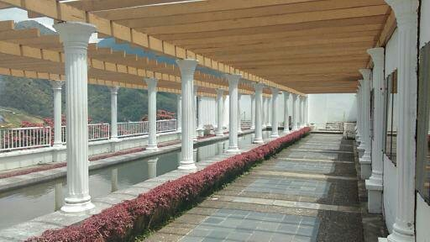

I spent a most solemn day here wandering amongst the rose garden and other well-kept gardens, which are a feature here. One garden is dedicated to the Australian soldiers and another to the British soldiers. It was also a solitary day. Most of the time I was the only one there except for a few gardeners.

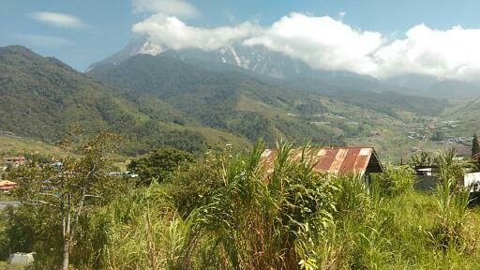
Mt Kinabalu, Kundasang War Memorial Garden
Within the Australian Garden there is a memorial stone inscribed with a poem by one of the six survivors – Nelson Short:

I’m dreaming of Australia,
The land we left behind.
Dreaming of the loved ones
We could always bear in mind
Although it’s only fancy
Our hearts within us yearn.
But we’ll make up for lost moments
When to Australia we return.
There’d be sailing on the harbour,
The Showboat our first choice.
Or maybe we’d be dancing
Listening to our sweetheart’s voice.
Although it’s only fancy
Our hearts within us yearn.
Gee we’ll make up for lost moments
When to Aussie we return.
Nelson Short – Kundasang
My visit to the lonely Garden was an experience I will never forget and I hope more and more Australians and others get to know the dark history behind this most beautiful and tranquil of resting places, too.

Chapter 6 How To Find Work Overseas
This Chapter is totally dedicated to those hiding amongst us who are secretly reading these pages - still needing or wishing to work, and wanting to experience the transformative power of travel. The following information is based upon my personal experiences and research carried out over a period of 15 years or more, whilst working in several Asian countries as well as Europe and the U.K.
This information is really useful for any able-bodied person disillusioned with the daily humdrum of work, paying endless bills and more; including those retirees looking for some extra cash and a more fulfilling retirement. In other words for those seeking to revolutionise their lives. Wow, that could just about include everyone.
Starting in 2003 together with my late-wife we undertook a giant leap of faith and began a new life firstly in China as English Teachers. We spent a total of three years teaching English in various locations throughout China, and based upon our experiences gained there we later taught English in Slovakia, the Greek Island of Cephalonia and the Italian Island of Sardinia. Later I also taught English as a volunteer in Vietnam, Thailand, Indonesia and Japan. I also taught as a volunteer to Buddhist Monks in remote Temples in Laos. You are welcome to read more of our English teaching experiences in some of those exotic locations in my prequel to this book – Stuff For Seniors – a secret plan to live not retire.
Let’s start in Asia. Throughout much of Asia there is an overwhelming demand for native English speakers to teach conversational English, to students of all ages. You don’t need any qualifications to do this except in Government or certain exclusive schools. I found it best to teach in one of the thousands of small private English schools most of which have probably never had a native English teacher, ever. In these schools there’s usually no red tape or governmental bureaucracy. They are simply happy to just have you on board. There is no need to apply online from afar. Just go to the country of your choice and visit a few of these private schools. They are easy to find.
Recently I was in China’s Gobi Desert in the city of Yinchuan and as I was walking down the street I happened to pass one of the aforementioned private schools. As I walked past I was approached by the school principal who earnestly began asking if I would teach a few hours a week in her school. If I agreed she could easily fill up my working week with her associates, from other nearby schools. She offered to pay me A$40 an hour - cash. Unfortunately I was due to depart in a few days so I had to decline the offer. This is not the first time I have been approached in such a manner in China. But if China seems too daunting then Vietnam, Laos, Cambodia, Sri Lanka and Taiwan to name a few, will welcome you.
Check out this website ( http://eslcafe.com ) offering thousands of English Teaching jobs throughout the world. Many of the jobs listed are Government or University teaching positions asking for degrees, but in my experience degrees and other qualifications are simply on their wish list only. Another easy way to find suitable teaching or volunteer teaching jobs is to simply tell your hotel receptionist, you are looking for teaching opportunities. I’ve done this successfully a few times. If you want to volunteer teaching in orphanages, refuges or Temples just turn up. I’ve done this too. I enjoyed volunteering in Buddhist temples in Laos as there they are very accommodating and happy to share their life experiences as Buddhist Monks.
Other fruitful methods of finding volunteer opportunities globally or locally is via the Helpx website. Here you simply click on your preferred country and hundreds of opportunities will appear. This site covers just about every available opportunity imaginable. I have used this site to obtain volunteer positions with free accommodation in Australia, China and Scotland. If you lack confidence and experience in teaching English you could consider volunteering for a few weeks firstly, then in the eyes of most employers you qualify as experienced.
My Scottish Helpx assignment was on the remote Orkney Islands off the North East coast of Scotland. Here, I had to mow some lawns and do other odd jobs a few hours a day for a few memorable weeks.
Another equally useful site for volunteering and with some paid work can be found here ( https://www.workaway.info ).
Not all work opportunities need be confined to teaching English. In the 15 or so years that I have been living this lifestyle I also worked as the English Editor on the Xiamen Daily Newspaper in China plus on two separate visits to the U.K. I worked as a live-in caretaker in posh country manor houses. Both these positions came with a modest salary, beautiful accommodation and the use of a car.
Depending upon the seriousness of your desire and financial needs to work teaching English, you would be advised to consider going through the proper channels of obtaining correct work visas and perhaps even sign contracts that Universities and other Governmental organisations might require. The school will organise these red tape issues but the benefits of doing so means you will receive an excellent salary, free accommodation, work security, holiday pay, other bonuses and more.
I must confess I never did any of the above as I preferred to choose my own accommodation and terms and conditions, for example: hours of work, age of students and salary. Yes, you only need work around 15 hours a week to live very well and I chose to teach only young adults, or business people who were all prepared to pay a reasonable sum for the rare opportunity to learn from a native English speaker. I taught airline pilots, business executives, medicos, police officers and an assortment of politicians. In my experience it was not uncommon for some of my students listed above to become friends and invite me to their homes, work places or to fancy restaurants. This is also an important factor in creating a new life in a new environment – having local friends, as this also provides opportunities to immerse yourself in the local culture; something most tourists and short-stay visitors rarely experience. We shouldn’t underestimate the empowering benefits of making new friends.
Visa conditions vary from country to country and are also prone to constant change and, at times, confusion; but don’t be put off as your prospective employer will advise and probably arrange everything accordingly.
If you visit the websites via the links I have placed above, you will find not only thousands of teaching jobs but also much more useful information; including forums and other social media platforms sharing all kinds of experiences and opportunities too voluminous to include herein.
Allow me to turn back the clock to 2003 and share with you our first ever English teaching job in China.
Within a few days of our seamless arrival in China we were dispatched by our new Chinese employer to a large island off the southern coast of mainland China. It’s called Hainan Island.
Our new employer, who called himself Charlie, had just started the first and only English language school in the town and we were his first ever teachers – in fact we learnt that we were the only foreigners ever to have visited the town. This also meant the inhabitants of Ding An had never before seen a westerner.
At this time Ding An was just how I had imagined the old China would be: few cars, traditional old buildings, motorized rickshaws, lots of commotion and lots of people on foot. As we drove into town, for a moment, I thought we were in a foreign movie – but we weren’t. Once the locals spotted us in the car they would all stop in their tracks and stare, wide-eyed.
In case you might be wondering how non-Chinese speaking people like ourselves could ever possibly teach English to non-English speaking people, let me explain. In many non-English speaking countries all students learn English as part of the standard school curriculum often throughout their entire schooling years. Their grasp of English grammar is usually far more advanced than, say here in Australia, where English grammar is often not taught. This grammar is also taught by non-English speaking teachers from textbooks. This is where folk like us enter into the picture. We teach them how to use it on a practical speaking level versus the theoretical level that they have learnt up till now. We are really conversational English teachers. We just speak with them, all the while encouraging them to overcome their shyness and reluctance to speak English.
Later in our China travels we were to meet so many other older westerners doing exactly what we were doing and for the same reasons. In fact I might even go so far to say that us older, grey and wrinkled ones were much more sought after than the younger versions of us; since they were all too often late for classes - because of drunkenness or hangovers, not to mention their often disrespect for their Asian peers and womanizing. This also explains why you need little or no previous experience in teaching. You just need to be able to speak English as a native English speaker would, and the courage to try.
Our somewhat basic and dilapidated Ding An apartment overlooked a beautiful river with rice paddies all about, on the opposite side. Often children could be seen swimming in the river, and large water buffalos grazed its grassy banks.
Our school was about a kilometre away and our employer, Charlie, accompanied us on our first day. Firstly, he summonsed a motorized rickshaw, of which there seemed an oversupply. We all boarded, much to the obvious glee of its driver who had just raised himself a notch in the one-upmanship stakes amongst his fellow rickshaw drivers. Off we set amongst the madding crowd dodging other rickshaws, piles of rubbish, potholes, occasional cars and people standing wide-eyed and staring. “The foreigners are here” well no, I didn’t actually hear anyone proclaiming those words; it was just my over active imagination at work.
Everyone who spotted us would stop and stare as if aliens from outer space had just landed. Cars would even come to a complete standstill as we passed. Children would scream and run to their mothers’ bosoms for safety… well no, not really; they just stared like everyone else. I was becoming a little overwhelmed at the spectacle and the prospects of beginning my new life as an English teacher, never having taught anyone anything.
Our first ever classes consisted of approximately eight students each around twelve years of age. As they gingerly took their seats we, just as gingerly, opened our text books and tried to look confident, experienced and professional. Firstly, we introduced ourselves in the most simplest of English that we could manage and they, in turn, responded by introducing themselves. It was a bit tense, I must confess, but as we got to know each other the atmosphere gradually became more relaxed – convivial even. And before we had reached the end of the ninety minute lesson we were all laughing and joking with each other. I was amazed at how fast we all settled in. They didn’t care for the text books. They wanted to know all about us and Australia. What kind of animals we had? What kind of food we ate? What was our favourite fruit and so on? We were talking English and they were responding well; and I was confident that they saw us as experienced and professional teachers. The ice had been broken and we were sailing.
Most evenings we took Charlie up on his offer for a free restaurant meal and to make ourselves available for any students who wanted, or could afford, to join us. One particular young adult student asked if he could sing a song for us during our meal. Well why not; we had all consumed a few bottles of beer and jumped at the chance for a bit of home-grown and spontaneous entertainment. Showing no signs of nervousness or embarrassment he immediately burst into a strong operatic voice singing arias that only Pavarotti could do justice to. In fact he sounded just like Pavarotti himself minus all the fat and ego. How delightful. How special. We were so taken aback and enjoyed his singing so much that we asked him to accompany us as often as he could on our evening dinners out. “I’ll pay”.
This was the beginning of a special and beautiful relationship between our very own Pavarotti and ourselves, as he would appear often at our table and sing for us all.
The favourite dish of this region consisted of a pot of boiling water over a small flame into which you gradually placed all manner of animal offal and vegetables. We had to exercise great care and diplomacy when it was our turn to scoop out our share as often we would find a whole chicken head or chicken claw caught between our quivering chop sticks. Once you scoop it out you must eat it.
To break the monotony of chicken claws, too much white rice and plain boiled vegetables we would feel compelled on occasions to visit a new Mc Donald’s look-alike restaurant which had recently open nearby. Instead of having the large and familiar big M sign outside the restaurant, our newly discovered look-alike had a big yellow W instead. Upon seeing us eating at his new establishment the proud new owner approached us and explained, through Pavarotti, that we could eat here as often as we liked, for free, since our mere presence in the restaurant was the best advertising or endorsement available. So we did.
Life in Ding An soon took on a comfortable routine for us. We gradually became accustomed to all the constant staring and pointing. Our rickshaw drivers were faithfully and diligently adhering to Charlie’s travel plan: our dilapidated old apartment began to look not so dilapidated and crouching low under our almost-useless shower began to seem almost normal; whilst our nightly dinners and sing-alongs with Charlie, Pavarotti and other students never seemed to lose their appeal. Our lessons now seemed to roll by with both of us able to somehow switch into a cruise control, or automatic pilot mode. We were also able to save almost every Yuan (the Chinese currency) we earned which was a bit of a change for us, as back home we constantly struggled to make ends meet and never considered eating out. We also had something very worthwhile to do, which in our eyes held a great value in itself.
In order to recruit more students for his school, Charlie decided that all three of us should attend a local high school and give a kind of English language demonstration to the students for a few hours. We happily agreed and upon our arrival at the school we found all the students were waiting, standing silently to attention in the parade ground. We were directed to mount a podium and address them, which we did by saying a few words of greetings and encouragement. We also spoke a little about our home country, etc. After the official side was over it was explained that shortly we would separately visit a few selected class rooms and participate in a more informal and relaxed fashion; so, everyone was temporarily dismissed.
Once dismissed, and without any warning we were rushed by a student stampede - actually the whole school. We were all forced into a very tight and sweaty scrum formation unable to retreat or escape. It seemed they all wanted our autographs and which we were obliged to give thereof for well over an hour. During this hectic, sweaty and slightly dangerous period many asked in their broken English what films were we in. “None” I declared. This didn’t seem to dampen their enthusiasm for our autographs as they kept on repeating this same question, “What films are you in?”
It turns out, since the only westerners they had ever seen were in American movies and by a weird sense of association they were all thinking that somehow, we were film stars too. How weird was that?

Chapter 7 Thailand, Laos – And The Buddha

Moving on from Malaysia; it’s a very short and inexpensive flight to Thailand. Personally I don’t bother with Bangkok anymore. I find it simply too busy for the likes of me, plus the traffic is so congested, you will most likely find yourself spending more time at a standstill in chaotic traffic than in any other pastime there. I do realise some folk love it but it’s definitely not for me anymore; although I do use the Bangkok International airports as transit places on occasions.
I always fly directly into the Chiang Mai International airport in the north of Thailand. Irrespective of your entry point into Thailand you will be given a one month renewable visa upon arrival. I have renewed my visa on a few occasions for a further one month by simply visiting the local Immigration office, filling in a few forms and paying a small cash fee. There are several longer and permanent stay visas available, too numerous to mention here, but most of these options must be done before you leave at the Thai Embassy in your home country.
Once you are cleared though the Chiang Mai immigration it’s just a short taxi or bus trip into town. The best time to visit this region is between November and March as it can get quite hot during the other months. Head for the old city area which is mostly enclosed by an ancient wall and a moat. Within the old city precinct you will find plenty of inexpensive and quaint hotels; restaurants and more, plus there is little or no vehicular traffic - making walking so much easier. For a good middle-range affordable hotel well located within the old city, check out The Top North Hotel on your favourite online booking site.
Outside the old city wall you will find all the modern city attractions and more that you might expect; including five star hotels, modern shopping malls and more. Personally I would suggest the old city area is the best place to set up camp as it has a friendly and relaxed vibe. Both within the old city and outside you will find all manner of restaurants, clubs and drinking venues catering for foreigners including big screen TVs showing foreign sporting events and news. Your hotel room TV will most likely have all these channels too.
To take much of the stress out of my Asian travels I often return to the same hotels, guesthouses or villas time and time again. I even request the same room, as by doing so, you know in advance exactly what to expect when you arrive.
English is widely spoken and money changers and ATMs are everywhere to be found. All of Thailand can be inexpensive even for those on a retirement budget; and you will encounter senior foreigners everywhere. You will not get lonely in Thailand.
Thailand offers big city delights, rustic hill-top getaways and numerous tropical island hideaways for those of us on the run from the constant onslaught of western B.S. All the aforementioned locations are affordable as Thailand is a very low cost and a tourist friendly country.

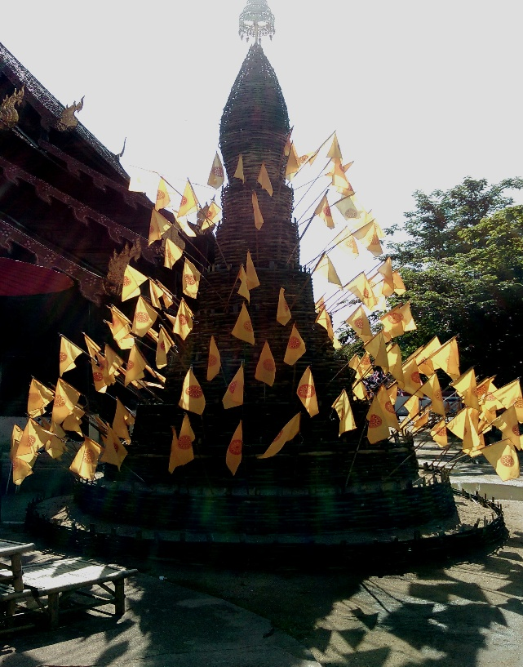
Temple prayer flags in honour of the just-deceased Thai King
There is plenty to fill your days here in Chiang Mai and other parts of the country. Check out the numerous and magnificent Buddhist Temples. Some welcome English speaking foreigners to teach English to the monks, whilst others offer holistic live-in retreats for those male and female souls damaged by the stresses and strains of a lifetime of modern living. To find these opportunities a good place to start is by asking your hotel receptionists or a local tourist or information centre. They’re all easy to find.

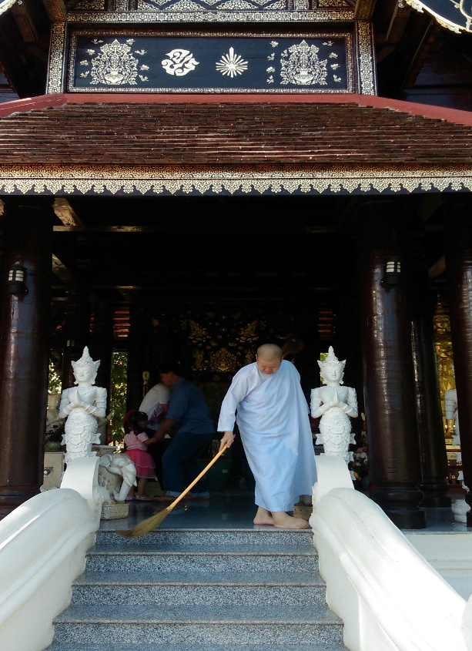
Buddhist Nun, Chiang Mai
I also write regular travel blogs or articles accompanied by some of my photos and email them to Australia’s largest seniors’ online magazine – Starts at Sixty for publication. Check it out. There are some good stories to be found there.
I undertook a watercolour painting course at a nearby art gallery in Chiang Mai. I’m so glad I did as I now carry my painting materials with me as I travel and paint, when I get the urge. On a recent four month trip to Asia I returned to Australia with 30 of my watercolour paintings; many of which I later sold on EBay. You are welcome to visit my art website ( http://ministryofsculpture.com ) where many of my artworks are to be found.
As in most Asian countries you will be offered various Asian cooking lessons, local tours, yoga lessons, herbal remedy courses and more.
During one stay in Chiang Mai I hired a small motor bike and headed north to the Mekong River, which acts as the border between Thailand and Laos, and followed the mighty river as it meanders between the mountains and valleys, for three days. I’m usually reluctant to ride motor bikes in Asia at it requires a certain temperament and skill to deal with the non-existent Asian road rules, plus my travel insurance doesn’t cover me for motor bike accidents. Anyway I survived intact, although a little sunburnt.
About an hour north of Chiang Mai I came across the gob smacking White Temple of Wat Rong Khun. It’s set amongst several acres of beautiful gardens. Much of the Temple and its surrounding buildings and other structures, are covered with millions of minute mirrors. This is meant to reflect the holy teachings of the Buddha far and wide.

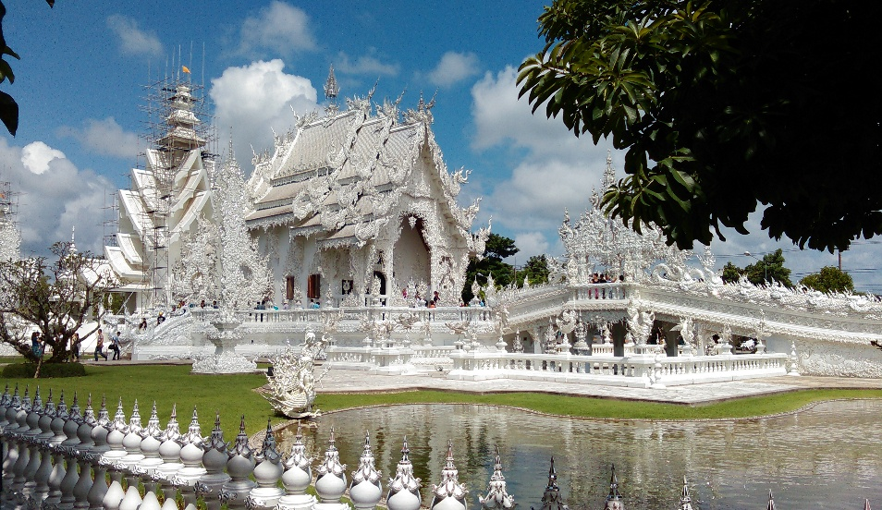
White Temple of Wat Rong Khun
Inside, the walls are adorned with beautiful contemporary murals and other striking works of art, depicting the state of the world today. I even saw a mural depicting the 911 Twin Towers terrorist attack in New York. It’s a privately owned and funded project by a very successful local artist whose works are also on display in the Temple’s gallery. Construction on the temple began in 1997 and won't be complete till 2070. It was closed briefly in 2014 due to damage caused by an earthquake.
It’s located about ten kilometers south of Chiang Rai on the main highway between Chiang Mai and Chiang Rai. It’s a few hundred meters off the highway. Adjacent to the temple there are cafes, toilets and waiting buses to take you home. Both cities have airports and other excellent transport options.
It really is an impressive structure and a wonderful example of philanthropy in action. I hope you get a chance to see it for yourself one day.
I must confess (again) on occasions I still get the urge to play out my Indiana Jones fantasies and go seeking long-lost temples of ancient and mysterious civilizations.
Have you ever fancied yourself as an Indiana Jones type character? Fearlessly forging your way through endless jungles in search of exotic lost kingdoms somewhere or other?
If you have, then come with me as I introduce you to Ayutthaya, Thailand’s ancient and once capital city.
Fear not, as there’s no need to hack your way through any jungle, as nowadays you can simply catch a taxi or train from central Bangkok. It only takes about one hour.
Once there you will easily find hotels and guesthouses to suit any budget, and the same applies to restaurants - it’s all here and more. I spent four very comfortable days in Ayutthaya and during this time I rode in Tuk Tuks (a six-seater converted and covered motorbike) everyday as I set out to re-discover just some of the ancient World Heritage Listed palaces, pagodas, temples and waterways of this very remarkable ancient Kingdom.

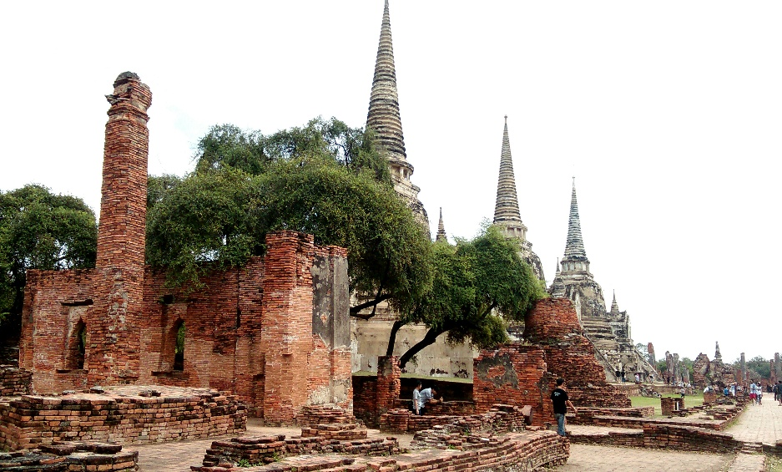
Temple ruins Ayutthaya
Your Tuk Tuk driver will also act as your guide for around A$8 an hour in total, taking you to the most spectacular or culturally significant places firstly, then to the sites of lesser importance. It’s totally up to you how long you wish to stay at any particular site and how long you wish to keep exploring. It’s so inexpensive and easy to do as your Tuk Tuk will park very close to the ruins and generally the ground is flat and free of major obstructions.
The ancient city of Ayutthaya was founded about 700 years ago and named after the sacred Indian city of Ayodhaya. Within about 200 years of its founding, the Kingdom of Ayutthaya covered most of Thailand. Ayutthaya was a vast amphibious city with over 140 kilometres of waterways and was known as the Venice of the East. Only a few of the waterways remain today, and for a small fee you can hire a boat, with crew, to explore the ruins via the waterways and canals.
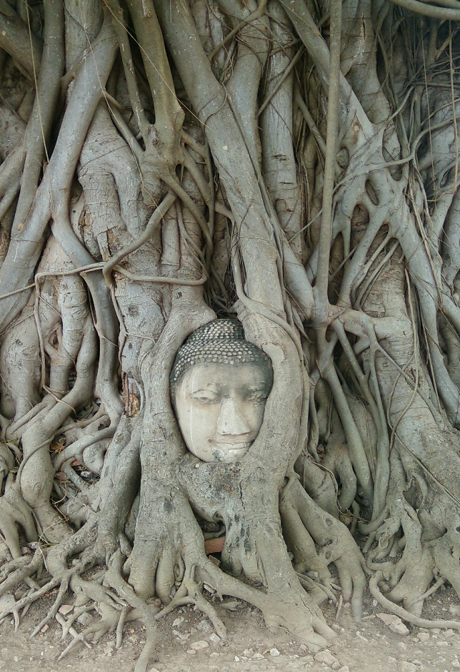

By the 17th century Ayutthaya had a population of well over a million and attracted foreign traders, adventurers and missionaries, becoming a centre of great wealth, spiritual pilgrimage and worship.
The inner part of the ancient city is located upon a man-made island around four kilometres square, and it is within this area that the main temples, shrines and pagodas are to be found, all in their various stages of decay or otherwise.
Buddha was, and still is, the focal point of all spiritual activities here and you will see Buddha statues in their hundreds. One temple houses a seated Buddha statue over 12 metres high, whilst another nearby temple hosts a reclining Buddha 42 metres in length. Some of the partly ruined temples have functioning monasteries attached and you will see saffron-robed monks walking amongst the visitors and ruins. This really adds both colour and authenticity to the scene.
Elephants are also part of the living kaleidoscope here too, and you will see tourists having short rides on them. I am assured these elephants only work a few hours daily and are treated very well. The tourists I saw riding them seemed only interested in taking selfies rather than actually riding them and, I assume, much to the relief of the elephants; so in this context I believe selfies have finally found a good purpose.

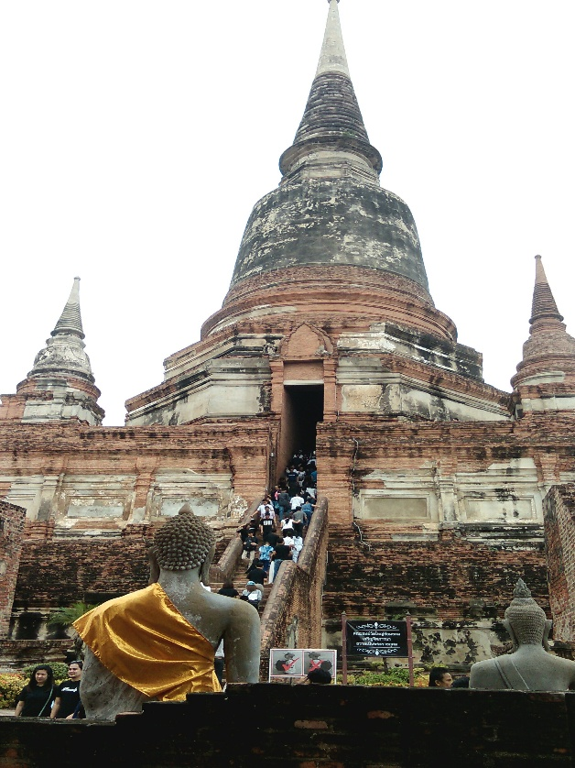

I did enjoy seeing the elephants crossing nearby busy streets stepping boldly amongst the retreating traffic and seemingly oblivious to the other lesser road users. Who in their right mind would stand in the way of an elephant intent on crossing in front of them?
For me, Ayutthaya was more a visual spectacle rather than a deep history lesson, but for my more right-brain thinking readers, the whole place is soaked in history waiting for you. Seeing so many beautiful temples all in their natural and un-natural states of decay and restoration is truly an incredible sight. It’s a photographer’s heaven and a historian’s one too.
Experiencing all the delights, sights and adventures of my new life in Asia, has been, and still is a never ending education and more for me, but there has always been that nagging sense of something still missing. One day I unexpectedly received an email from an old friend who had recently read one of my travel blogs of some of my adventures in Thailand, and took the trouble of contacting me. We hadn’t seen each other for over 30 years and we had been good friends in the past. SHE was volunteering her time as an English and Music Teacher in a nearby orphanage here in Thailand. We suggested we meet up when she had finished her commitment at the orphanage.
To cut a short story even shorter we now travel together and that nagging sense of something missing no longer follows me. Believe me, it’s even better when you have someone to share your adventures and those special moments with, not to mention the hotel bills and the added sense of security should something go wrong.
Anne hails from Southern Queensland, Australia and loves a good challenge, loves being useful and loves traveling with me.
It just goes to show: put yourself out there and all kinds of wonderful or unexpected things can happen, or as some prefer to say: fortune follows the brave.
If you are still up for more travel adventures before returning home; for those family and other commitments come with us to Laos – the land of smiles.
You would be surprised at the number of people who don’t even know where Laos is or know very little about this sparsely populated, rarely-visited land-locked nation. My advice is to fly into the holy Buddhist town of Luang Prabang in the north of the country. You can get flights into Luang Prabang via several major Asian cities.
You can also arrive or depart from Luang Prabang via a two-day slow boat journey on the Mekong River from neighbouring Thailand. Tourists I spoke to who undertook this journey highly recommend this way of arrival, and I will enter Laos this way next time.
Upon arrival at the airport you will be given a one month renewable visa. You will need two passport size photos; around US$30 in local currency; and a simple form to fill in. I made the mistake of only having $30 Australian cash on me - which they wouldn’t accept. I was then politely advised to leave my passport and application with them and step outside into the public concourse area of the airport; either use an ATM or change some cash into the local currency at a money exchange. This meant I simply walked past the immigration officials in their booths who paid no attention to me and out into the public area minus my passport, whereupon I changed some cash and walked back into the immigration area once again, without anyone noticing me. It was a nerve-racking experience to say the least – in a public airport area, in a foreign country and, with no passport.
Laos is a small land-locked country sandwiched between Vietnam, Thailand, China, Cambodia and Myanmar. It’s perhaps one of the least visited places in South East Asia and it’s perhaps again – another favourite place for me, in Asia.
If you are looking for some peace or an escape from all the ever-worsening global turmoil and B.S. – consider Laos P.D.R - Please Don’t Rush: as the locals constantly reminded me.
With only six million inhabitants and relatively few tourists, Laos is all about beautiful nature, organic farming, mountains, countless rivers, streams and spectacular waterfalls. A truly “road less travelled” destination.
A Laotian wise man once said: “why are you the one with the watch yet I am the one who has all the time?” Things are definitely not the same here in Laos as back home so you will have no choice but to embrace the gentle pace of life here, so be prepared. Laotians are a stress-free and patient people. They have little comprehension of road rage and other manifestations of the impatience raging in western societies. Here you could walk down the middle of a street and the traffic would politely and slowly go around you, without a passing thought.
This collective peaceful mind set could have something to do with the strong Buddhist traditions and beliefs that are taken seriously in Laos and in neighbouring Thailand.
We based ourselves in Luang Prabang in the north of the country. Luang Prabang has a population of around 50,000 and is home to over 30 magnificent Buddhist temples and hundreds of saffron-robed monks.

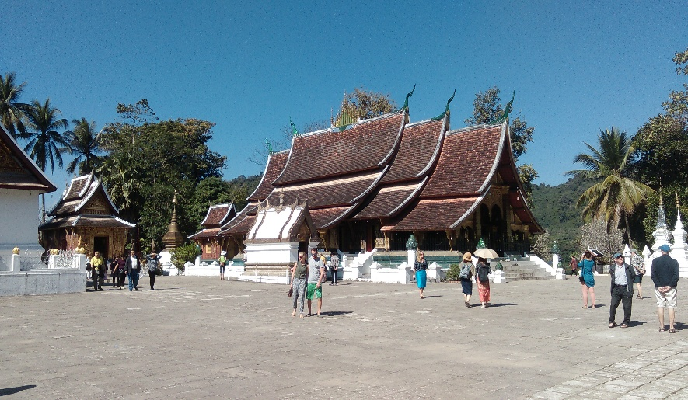

Every morning at dawn, hundreds of these monks parade through the town’s main streets collecting their daily Alms (food offerings) from devotees and curious tourists. This ageless custom is truly a remarkable and uplifting event.
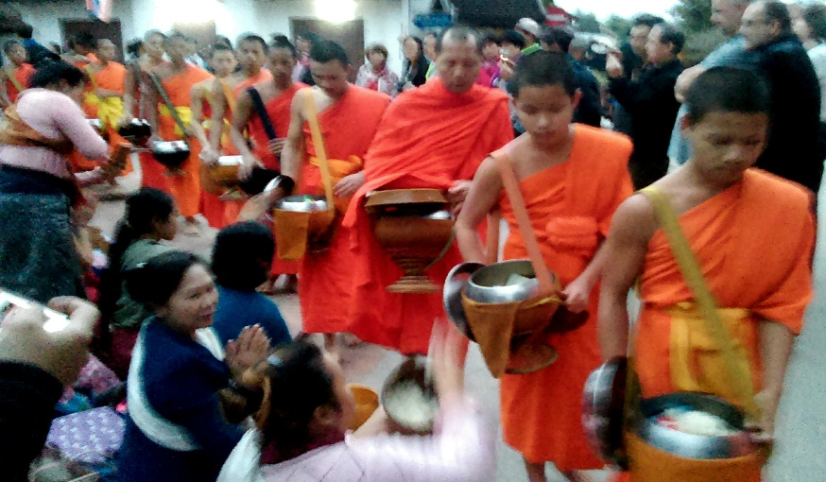
Laos was not always a peaceful place as between 1964 – 73, at the height of Laos’ Secret War – a proxy war between the US and the Soviet Empire, in which two million tonnes of ordnance was dropped on this tiny nation. That equates to 580,000 bombing mission, or one plane-load every eight minutes 24 hours a day for nine years – making Laos the most heavily bombed country per capita, in history.

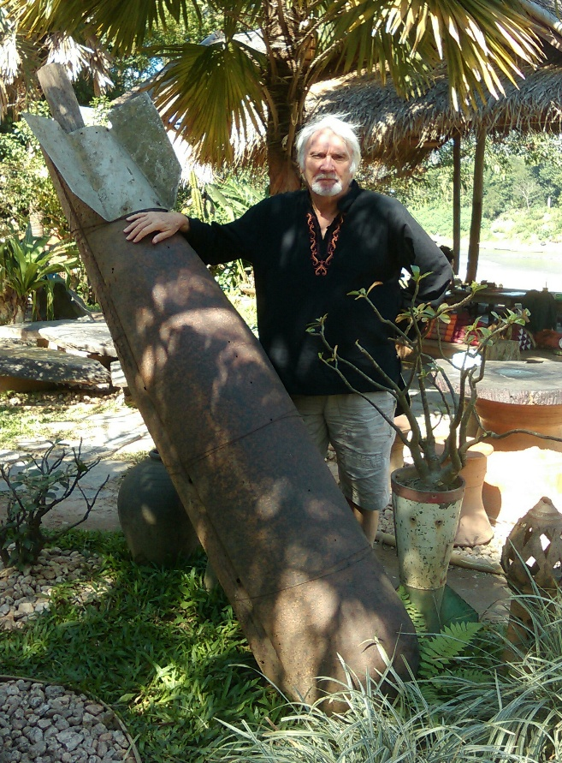
Laos, the most heavily bombed country per capita in history
Luang Prabang is sited on a small slither of land around three kilometres long and less than a kilometre wide at the confluence of two rivers – the Mekong and the Khan. It is encircled by mountains. Luang Prabang is also a World Heritage Listed Town because of all the wonderfully preserved local and French-style buildings and the extraordinary Buddhist Temples – some over 500 years old. It looks like a 19th century exotic oriental movie set. The traffic is light and it’s a real delight to walk in the shade of the huge Tamarind and Poinciana trees, which line many streets.
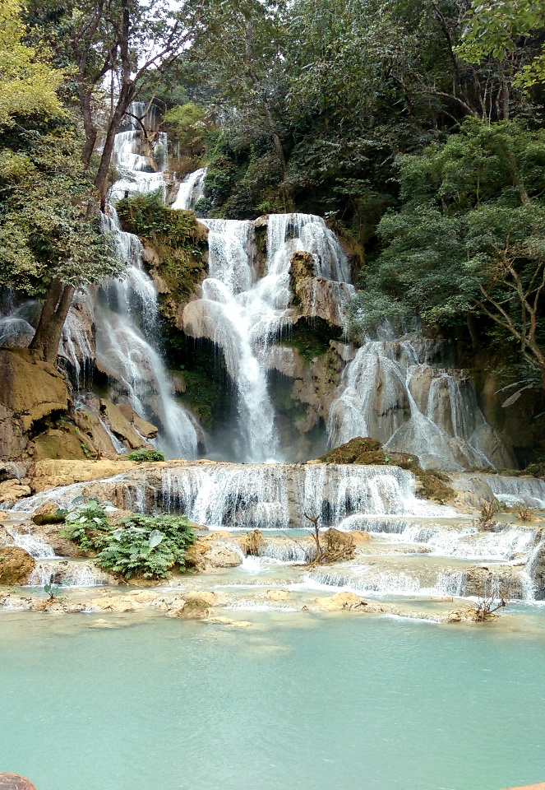
Magnificent waterfall Luang Prabang
The mighty Mekong River is a wonderful feature in Luang Prabang and you can stroll for a few kilometres along the shaded promenade which hugs the river bank. It’s here that some of the largest trees I have ever seen are to be enjoyed. On one side of the promenade there are dozens of beautiful guest houses and restaurants overlooking the mighty river and on the other side of the promenade you will see dozens and dozens of river craft of all types, plying the water.
All the conveniences you might expect are here: ATMs, money changers, pharmacies, hospital, Tuk Tuks, taxis and excellent mobile phone coverage and fast Wi-Fi – everywhere.
I took two river cruises up the Mekong calling into local villages and other places of interest. Expect to pay around A$15 for a day, in one of their unusually-shaped cruise-boats. Along the way I saw villages hugging the river bank, majestic mountains, Buddhist Temples complete with saffron-robed monks waving as we cruised by. I saw elephants, water buffaloes, Buddhist statues, fisherman casting their nets, canoes full of saffron monks and groups of children playing on the sandy shores and swimming in the shallows – and more. A highlight of one of my cruises was a visit to a secret cave housing around 4,000 Buddhist statues, placed there by religious pilgrims over the past 500 years.

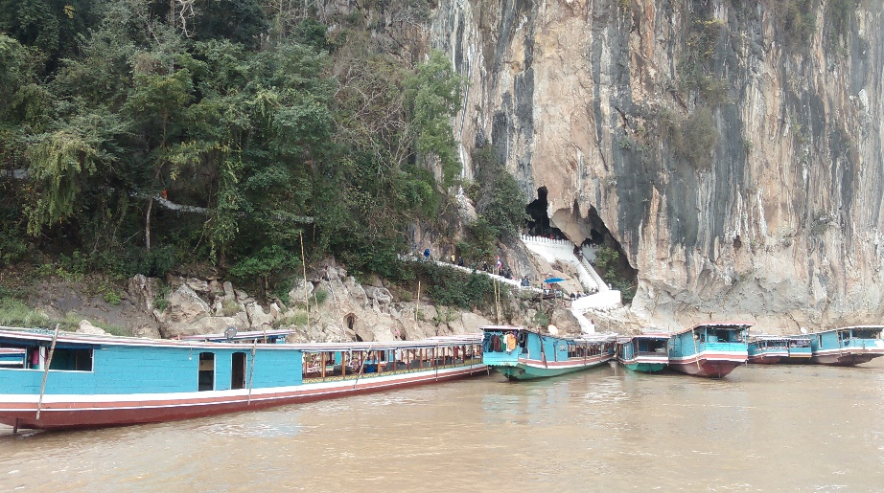
Entrance to secret cave housing thousands of Buddhist statues
I plan on returning to Luang Prabang again soon as I am constantly reminded of that old Scottish folk story – Brigadoon – a story about the fabled village of Brigadoon wherein its happy residents never grow old as it’s so peaceful there, and no one has any desire to leave - to leave means that you once again begin to age.

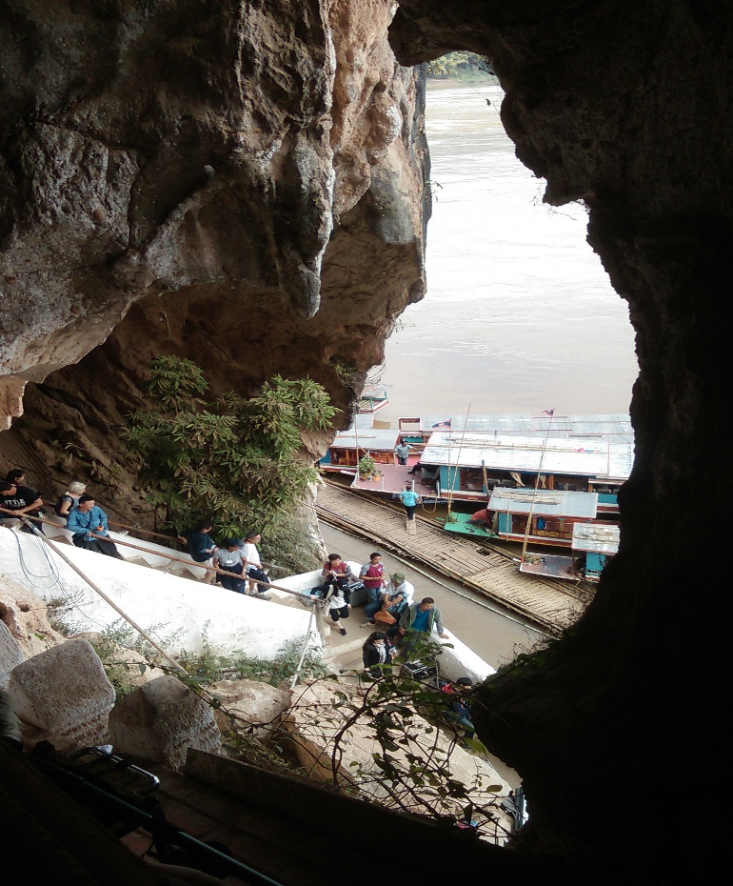

I might even retire there.
You will find plenty to do: volunteering in Buddhist Temples teaching English to monks, river cruises and more. On many occasions we would visit a nearby Temple and sit quietly at the back at around 5:30 pm as the monks began their evening prayer chanting. It’s an amazing experience and you will be made very welcome. At other times of the day everyone is welcome to come inside and sit peacefully and reflect upon their lives and more, or meditate. You should try it.
To the Laos Buddhist community, Luang Prabang is a Holy City, and often during the day you will hear the peaceful chanting of the monks permeating the whole town. This serves to remind everyone of the words of the Buddha.

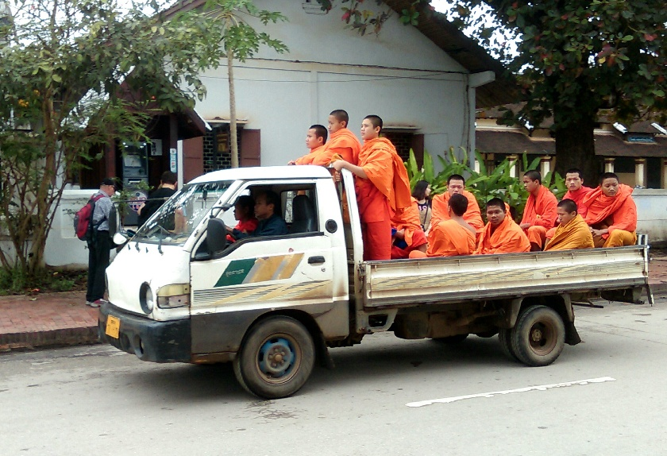

I am not a religious person but I have read many of the words of the Buddha and find them very helpful in trying to navigate and make sense of our troubled world minus all the judgement, fear, guilt, and the, us-versus-them mentality.
Listed below are The Fourteen Teachings of the Buddha some readers might find useful and pertinent to the state of the world we now find ourselves in.
- The greatest enemy in life is the self.
- The greatest ignorance in life is deceit.
- The greatest failure in life is vanity.
- The greatest tragedy in life is jealousy.
- The greatest error in life is to lose oneself.
- The greatest crime in life is disloyalty to parents.
- The greatest pity in life is self-belittlement.
- The greatest pride in life is recovery from failures.
- The greatest bankruptcy in life is hopelessness.
- The greatest wealth in life is health and wisdom.
- The greatest debt in life is affection and love.
- The greatest gift in life is acceptance and forgiveness.
- The greatest weakness in life is lack of awareness.
- The greatest consolation in life is charity.
I can see a few points there that I need to brush up on. How about you?

Chapter 8 The Lament Of The Volcano Gods

Let’s take a short rest from our travels as some readers might now be ready to return home. I hope I haven’t exhausted anyone. Our travels will resume in the next chapter. But now let me share with you some of my reflections and observations of the natural world I inhabit as I’ve travel Asia thus far - in particular the sudden and dramatic increase in seismic and volcanic activity in the Asian and Pacific region; much of which lies within the Pacific Ring of Fire.
For some readers this might appear a little off-topic, but I believe a healthy sensitivity or awareness and my related observations; to be interesting and useful aspects of the lifestyle that I wish to share with you.
In case you are unaware the Pacific Ring of Fire, particularly in the South East Asian region, has had a sudden increases in all kinds of seismic activities, from earthquakes, volcanic eruptions and tsunamis.
I have experienced numerous moderate earthquakes in Bali and elsewhere in Indonesia and was witness to the unspeakable loss of life and destruction immediately after the world’s most severe earthquake ever recorded - Japan’s March 2011 earthquake and tsunami. I also witnessed a once-in-a-lifetime event when a once-deadly volcano that had been dormant for over 400 years suddenly erupted in front of my very eyes. For some travellers such events might send them packing, but for me, these often-deadly events serve as timely reminders to reflect upon my life, my humanity, mortality and my place within this wonderful ever-changing world. It also strengthens or reinforces my sense of awe, mystery and wonder; something that I hold very dear to my heart. I believe once we lose our sense of awe; I believe, we lose our sense of purpose which in turn often leads to depression, hopelessness, drug addiction and so much more. It’s vital that we maintain our sense of curiosity, awe and wonder. This is where travel can find its true and useful purpose - if allowed, as opposed to those countless poor souls enslaved by their minds and masters. This is also why we need a revolution whereby we all begin to take personal responsibility for own wellbeing, health, thoughts and happiness. Our silence is compliance, thus each and everyone one of us much take action by firstly changing our thought patterns, which will then change our actions and ways of living.
I’ve experienced all of the aforementioned – the depression, the hopelessness, the masters and more and I never intend to return to those dark manmade realms. Freedom and Wonderment is now my catch cry!

What’s up with the volcano Gods lately?
At first light the Balinese shaman begins his dangerous ascent of Mt Agung. His mission is to offer prayers of atonement to the angry Gods who reign over Bali and its people. By the time he reaches its summit, some 3,000 meters later, Agung is grumbling loudly. The sound is deafening. Sensing their great displeasure, and an imminent eruption; the elderly shaman performs the customary and ageless rites then beats a hasty retreat. He’s very wary of these Gods and well remembers how in 1963 over 1,500 local inhabitants perished by their fiery wrath. Such shamans are not uncommon hereabout and there are currently 129 active volcanoes in Indonesia.
Meanwhile, some 3,000 kilometres to the west I am holidaying – enjoying the peace and tranquillity by Lake Toba in northern Sumatra, Indonesia. It’s my second long-term visit to this magnificent fresh water lake in as many years. The Lake is 100 kilometres long by 30 kilometres wide and around 900 meters above sea-level. Indonesia, and more particularly Bali, has become my second home these past several years.
This day at sunrise I am gazing out over the Lake’s peaceful waters, as I would do most mornings. I eventually cast my gaze to the north whereupon I see, to my surprise, an unusual column of cloud, some 20 kilometres across the other side of the lake and rising upwards. I’m astonished and it takes me several minutes to realise this is not just a fluffy white cloud but an erupting volcano. Sitting there, in the half-light, on my lake-side balcony I feel blessed to bear witness to this magnificent and rare spectacle: a darker side of me questions whether this could also be a curse as I soon learn I am witnessing the re-awakening of Mt Sinabung after 400 years of slumber.
Both Agung and Sinabung lay within the Pacific Ring of Fire: a deadly ring of volcanic and seismic activity which stretches for over 40,000 kilometres starting at the bottom of New Zealand; then heads north through Vanuatu, New Guinea, across the Indonesian archipelago, north through Japan, all the way to Alaska then turns south along the west coast of Canada, the US and all the way to southern Chile. It is enormous. It’s active, hot and is the home to 452 volcanoes (90% of Earth’s volcanoes). Herein I am only referring to the Western regions of the Ring since I’ve had the great fortune to travel, work and play within these regions over a period of more than five years. It has become my second home.
Lake Toba’s Mt Sinabung has now caused the evacuation of 30,000 people and on occasions closed the busy international airport near Medan – a city of over 2,000,000 and only 50 kilometres from Mt Sinabung. Newspaper reports are describing bouts of panic amongst some city dwellers. When passing through Medan I was advised that the city was on high earthquake alert. Sinabung is not a large volcano by Indonesian standards but some fear it could be the portent of something more sinister as Lake Toba, adjacent to where the volcano is located, is the world’s largest volcanic caldera. It was here 75,000 years ago, when a series of volcanoes exploded creating the massive now-water-filled crater – Lake Tobe. Scientists refer to this event as the Toba Catastrophe as it caused a global volcanic winter lasting 6-10 years; whereupon Earth’s temperatures dropped 15 C, and affected global temperatures for a further 1,000 years. Many scientists also believe Earth’s population was reduced to around 30,000 people as a result. Google it.
During the remainder of my three weeks by the Lake, Mt Sinabung was in an ever-growing state of anger and constant eruption, and for those who love a magnificent red sunset, this is the place to be.

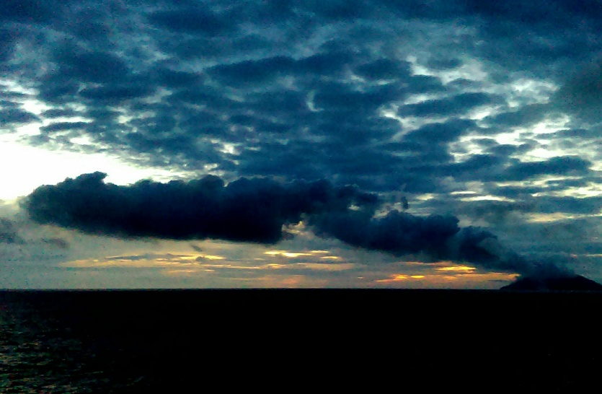
Mt Sinabung, Lake Toba
I used to think, 75,000 years ago is ancient history in the overall scheme of things and similar big volcanic events belonged to that ancient era.
Off the southern end of Sumatra and wedged between it and Java lies a small disfigured island growing in stature at around a meter a month. It’s called Anak Krakatoa – Son of Krakatoa. This island was the home of Mt Krakatoa, a super volcano which exploded in 1883 in which 36,000 local people perished. The explosion was equivalent to over 10,000 Hiroshimas and displaced 45 cubic kilometres of debris. The region was cast into total darkness for three days up to 500 kilometres away, and the sound of the explosion was heard in Perth, Western Australia, 3,000 kilometres away. Again global temperatures dropped 1-2 degrees C for five years. The ever-growing Son of Krakatoa is still active and its last major eruption was in December 2018 which also resulted in a deadly tsunami that killed hundreds of local inhabitants. Let’s hope it’s not a case of Like Father Like Son, or that the Gods of Krakatoa have yet to be appeased.
Around 200 kilometres east of Bali’s angry Mt Agung lies the Indonesian island of Sumbawa, as yet undiscovered by mass tourism. This beautiful island is the home of Mt Tombora - the world’s deadliest volcano. When Tombora exploded in 1815 global temperatures decreased by 5 C and the world experienced a year without summer. Crops failed all over the northern hemisphere resulting in a famine causing the death of well over 100,000 people, as well as the deaths of tens of thousands of local inhabitants. Its eruption is the biggest in recorded history with 150 cubic kilometres of debris being expelled into the atmosphere and surrounding area. Mt Tombora, an active volcano recently upgraded to Code Yellow alert, lies upon the same fault line as all the preceding volcanoes mentioned herein, and commencing in 2011 increasing levels of seismic activity are still being recorded on this mountain.
Scientists are exclaiming that the Ring of Fire is now exploding with 32 volcanoes currently erupting with many dozens more showing unrest or minor activity, and several strong earthquakes. In the western regions of the Ring Of Fire (my region) seismologists and volcanologists are openly voicing their concerns at the sudden increase and severity of eruptions and earthquake activity along much of the Ring; from earthquakes in New Zealand, Tonga, Fiji, Samoa and Taiwan, and volcanic eruptions in Vanuatu, New Guinea, Japan and throughout Indonesia.
The devastating March 2011 earthquake just off the east coast of Fukushima Prefecture, Japan – the strongest earthquake ever recorded on our planet, caused a deadly tsunami to smash into the east coast of Japan killing around 25,000 people. My son and his family were living and working in far north east Japan, on the edge of the tsunami ravaged area, when it struck - and I was there shortly afterwards to assist them with various needy matters. I visited the tsunami coast and the images of the devastation I witnessed first-hand will remain with me forever. Consequently, I have a deep respect for the awesome power of the forces of nature.
Japan is home to 110 active volcanoes which is extraordinary since it’s such a small country. Since their deadly 2011 earthquake and tsunami, 47 of those 110 active volcanoes have unexpectedly and dramatically increased their volcanic activity and most alarmingly Mt Fuji, Japan’s most sacred mountain and home of their highest level Gods, is rumbling so loudly - its status has been upgraded to critical, after 300 years of slumber – It’s primed to spew – say scientists. It’s a mere 50 kilometres from Tokyo’s suburbs. Some are saying the Gods here are angry because Japan, being at the juncture of four major tectonic plates has the highest ratio of nuclear power plants for such a small-sized nation anywhere on our planet. The nation is also crisscrossed with uncountable minor fault lines. Japan has 54 nuclear power plants with 6 of them sited upon the tsunami coast, mostly centring Fukushima: what could possible go wrong?
A simple Google search will reveal this information plus the concerns and recordings of scientists.
So, what’s up with the Gods lately?
I do not claim to be able to read Godly minds and know what the Gods are up to lately, so I will leave that doubtful task to those with a more heightened sense of importance; or arrogance. But my recent experiences and research have certainly given me much to ponder. Because of these experiences and my extensive travels through various regions within the Fiery Ring, I have come to realise it is these very same forces of nature – call them Gods if you must, that both create and influence much of life here on planet Earth. But just as those Gods giveth life so too those Gods can taketh it away.
Let’s time travel back to 2011: location Northern Japan.
My son and his wife have a small English school in the far north of Japan well within the devastating March 2011 earthquake zone but fortunately on the outer edge of the tsunami devastated zone.
Their small school in the city of Aomori was badly shaken but there was no significant damage. The whole region lost power and temperatures quickly dropped below freezing. They were forced to spend the next three days and nights huddled with their two young children in their car. They kept warm by repeatedly running the car’s motor; turning it off and on to keep themselves warm.
Soon thereafter my late wife and I were not-so-unexpectedly asked by our son and daughter-in–law if we would spend some months helping out at their private English language school, as most of the foreign English teachers had returned home because of the destruction and the continuing earthquakes. The family needed help.
And so it was that we found ourselves once again at the coalface of English teaching, something we thought we had left behind long ago. It was a delightful school in downtown Aomori only meters from the waterfront. I would sometimes catch myself thinking what would have happened if the sea, so close to everything, had rushed in here.
We volunteered our time and almost-lost skills of teaching as required plus we took some of the load of the rest of the family by preparing meals and more. It felt wonderful to be useful again and when I reflect back over the past decade or so of our retirement, or life after work, I realized how I had now become a firm believer in the truth that: too much leisure time will lead to boredom.
One day we were invited to participate in a regular ‘children happy day party’ in the town of Minamisanriku a few hours’ drive from Aomori. Minamisanriku was totally swept away by the March 2011 tsunami and the child survivors still somehow living in the area would be treated to special parties consisting of singing, fun games and party food to help distract them from the terrible tragedy. These were regular events held every few weeks or so wherein any foreigners in the area were invited to attend to talk about their home countries, customs, food, and to sing their traditional songs, etc. Today however, my late wife and I plus several US military personnel from the nearby US military base at Misawa had been invited.
As we drove through the rubble of what once was Minamisanriku we were shocked at what we encountered. It was as if an atomic explosion had only just occurred. Everything had been swept away by waves over ten meters high. Nothing remained. I think what shocked me most was the hospital with a very large fishing boat resting upon the roof. The hospital and all its patients and staff had been sucked out through its doors and windows never to be seen again. All that remained of the City Hall was a skeleton of twisted rusting metal. I could go on but we have all seen the graphic and disturbing footage on our TVs.
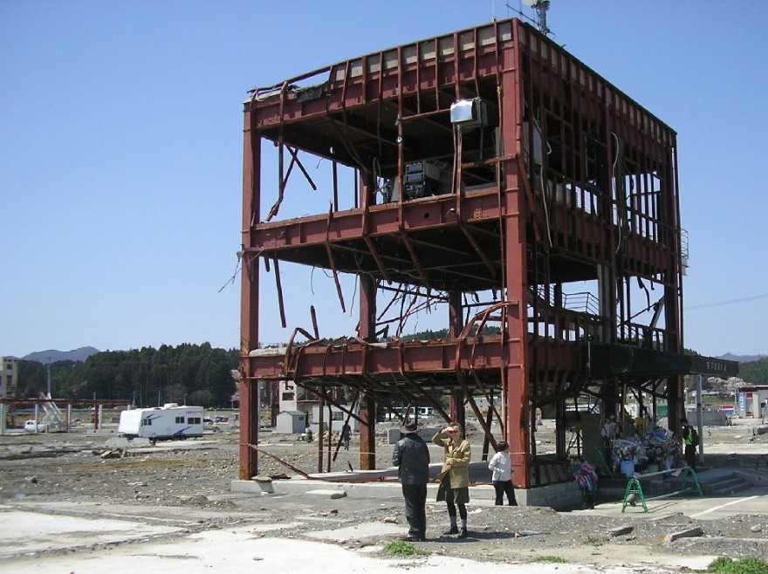
All that remains of the Minamisanriku City Hall
The party was a delightful event with much singing, tomfoolery, talking and of course, eating. There were around one hundred locals most of whom were young children all keen to talk with us all. For most of the day my heart had been in my mouth as I was struggling to fight back the tears; as I sat and talked and joked and ate and cried with them.
An elderly woman of around eighty years or so came and sat by me. Through a translator she recounted how, as a young girl, she had survived the Hiroshima atomic bomb and how, at the time, she raised her fists in the air and cursed the Americans who had wrought such destruction upon her world. After a pause for a deep breath she then recounted the day of the tsunami whereupon she had lost everything once again and had given up any hope of survival when suddenly out of the sky a US military helicopter from the nearby Misawa military base appeared and, unable to secure a safe landing site, began dropping emergency food rations all about.
Now back to the present:
In our western societies we often see death as some kind of human failing – as if we have somehow failed by not staying alive. We deny the fact that death and its accompanying uncertainties are normal and important functions of our total existence. I believe it’s irrelevant whether we believe in a God or not or understand the forces at work determining our destiny – if such forces even exist. It’s clear to me that possibilities play a great role in our life yet nothing is more guaranteed other than death. These two opposing factors present an unfathomable conundrum to me.
But I now firmly believe we can multiply, work with, bend, or submit to our possibilities depending upon the limitless, large and small, choices that we are free to make on a daily basis. For example if we choose to stay rooted to our couch, club, TV or smartphones our possibilities are to be found only within them. Conversely there is an amazing multifaceted world out there full of limitless possibilities for us to choose; yet on the other hand no one gets out of here alive.
The above experiences have taught me - there is no such thing as certainty no matter who you are, how rich or poor or where you live: and here again I wish to draw upon the words of that prolific American author, activist, philosopher, and global traveler - Helen Keller:

“Security is mostly a superstition. It does not exist in nature, nor do the children of men as a whole experience it. Avoiding nature is no safer in the long run than outright exposure. Life is either a daring adventure, or nothing.”

Chapter 9 Back In The Saddle

Sunset is steadfastly approaching so let’s saddle-up and ride bravely off into our setting sun whilst we still have time.
We’ve off to China’s Gobi Desert in North West China.
As I’ve previous mention I worked in several locations in China for around three years several years ago. In early 2018 I decided to return, this time not to work, but to visit an area which has always held a certain mystique for me. I didn’t want to join an organised tour and I also wanted to do a little volunteer work and hang out with some of the locals hoping they might take me to places far from the well-worn tourist trails.
A big downside of staying long term in many Asian countries is the large number of tourists, both international and local, who swarm to many of the more well-known locations and landmarks. For this reason I try to select places as yet unknown to the mass tourist market. Similar swarming is most likely happening in your home country too. I also avoid China’s mega cities for the same reason: they are simply too crowded and inconvenient for me, although I have used their airports for transit purposes.
Nowadays it’s a little more complicated to obtain a tourist or work visa for China – but well worth the effort. If you are over 60 you cannot get a work visa and for citizens of most countries, you can only stay in China for one month at a time as a tourist.
After much research I finally decided to use the services of a well-known Australian Travel agent – Flight Centre, to both purchase our tickets and to obtain the necessary visas. Anne was coming with me. For reasons I don’t fully understand the travel agent managed to obtain tickets much less than the best online deals I could find – saving us around A$100 each. This extra cash would then cover the costs of the visas which they would arrange. Too easy. I had vowed never to use travel agents for my travels but now I am forced to eat my words. Never say never.
My next challenge was to connect with someone in the Gobi Desert who might like to help show us around in exchange for some free English teaching lessons. To the uninitiated this might sound a little too optimistic but this proved to be easy. I trolled through the Helpx.net site as mentioned in earlier chapters. If you use the appropriate filters on this website it won’t take you long to find exactly what you are looking for. And so within a very short time I had found a few possibilities and sent them messages.
Be warned – there is no Facebook or Twitter and other social media platforms are probably also banned in China. China has its own government-approved (censored) social media platforms with almost everyone using the WeChat application. I suggest you download it as well as Google’s Translator application. They are simple to use and will spare you from a lot of frustration.
Be forewarned regarding exchanging your money into Chinese currency. In my experience the rules regarding foreigners wishing to exchange foreign currencies vary from region to region. The only bank that I have ever had success with is the Bank of China who sometimes will and sometimes won’t exchange your cash. Some will require you to use a third party local Chinese person also. The best option is to use ATMs for withdrawing Chinese cash, but in my experience only the Bank of China’s ATMs will allow this.
Within a day or so I had managed to secure exactly what we were looking for: an English speaking woman who runs a small English School in the city of Yinchuan, Ningxia Province in the Gobi Desert. The deal was we would each teach English around five hours a week and a further two hours a week teaching art to her students. In return she would take us to a restaurant most days and show us around town plus every weekend take us to some of the mysterious archaeological sites and more, out in the desert - places rarely visited by tourists.

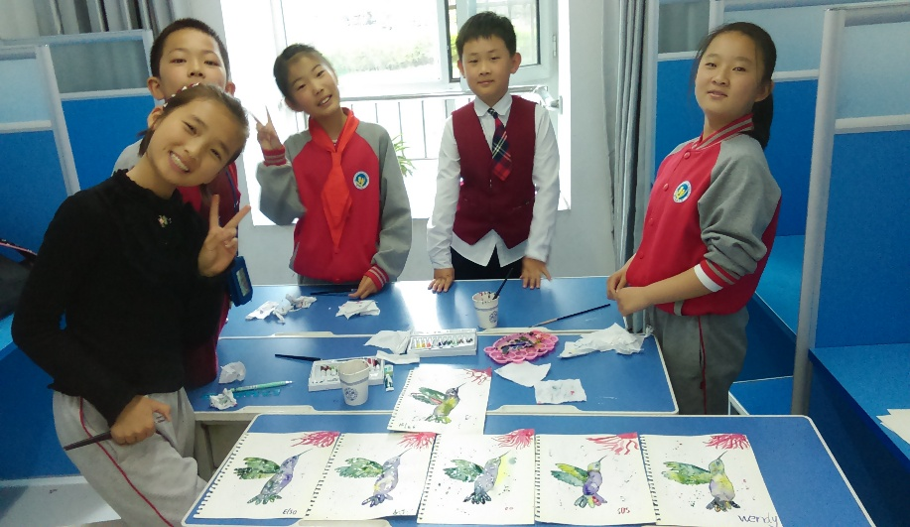
Art Class students
She also helped us secure a well-priced and very comfortable hotel within walking distance to her home and school, and as promised, more than fulfilled her part of the bargain and so too did we.
To my surprise I discovered the Gobi Desert was more than just sand and camels.
This mostly-cold desert, is perhaps the largest desert on Earth with much of it being over 1,000 metres above sea level.
We stayed in the medium-sized city of Yinchuan, Ningxia province. Yinchuan has a population of around 2,000,000 and growing rapidly. We were looked after by our Chinese family - they showed us around town and took us sightseeing out into the surrounding desert. I love deserts. It was a very good arrangement as far as we were concerned as we got to see and learn things that few tourists may ever experience. We think we were the only foreigner in town judging by the way the locals often approached us asking “where do you come from?” They also liked to photograph us; took selfies with us, welcomed us to China, offered us free food in restaurants as well as asking if they could be of any assistance. We felt like celebrities.
But that’s not why we’re here. I’d read about China’s Smart City Program, and by using Yinchuan as a base we could experience both the desert and a smart city.
Yinchuan is just one of several Chinese cities selected to be a part of this revolutionary program. Medium-size cities known to be struggling or in decline for various reasons were chosen, which means huge Government funds were provided to basically re-construct them. Here in Yinchuan this program commenced in earnest about 15 years ago starting with massive infrastructure construction in conjunction with the construction of millions of apartments, many office block complexes, super malls, and magnificent Government office buildings. Everything here is new.
There are tree-lined six and eight lane city streets and arterial roads; city parks with lakes, sculptures and rubbish bins every 100 or so metres. It’s the cleanest city I have ever visited. The infrastructure, the apartments, office buildings and roads are all built to service 15 million people for the next 60-100 years, yet only two million people live here.
Grand buildings stand idle waiting for their new occupants.
Next to our hotel stands the magnificent Yinchuan Centre for Performing Arts silently awaiting its first performers. There are art galleries awaiting artists, multi-storey shopping malls awaiting customers, and so on. It’s a case of “if you build it they will come” - and coming they are, from the overcrowded and over-polluted cities to the east.
There is little focus on the central business area as everything is thoughtfully integrated so that work, housing and shopping can all be done locally, often by simply walking. Here they wish to banish the daily commute wherever possible.
Even though the city is surrounded by endless desert it’s located by the Yellow River – China’s second largest river. This means there is an abundant supply of water for the massive agricultural projects springing up around the region and which now supplies food to the much bigger cities to the east.
The infamous Mongol warlord Genghis Khan was killed here in 1227 - but not before he destroyed the city which had a population of 150,000 at the time - many of whom he slaughtered.
Yinchuan – is now a truly smart new city risen from the ashes and decades of war, want and neglect.
To get here we flew by China Southern Airlines from Cairns, North Queensland to Guangzhou, then again by China Southern Airlines direct to Yinchuan’s brilliant new and under-utilised airport, located a 25 kilometre taxi ride upon a six lane highway to town.
There’s plenty of affordable accommodation ranging from luxury five star to budget, and there are plenty of restaurants all within walking distance. All taxis are metered and the drivers will all be bemused to have you aboard.
As promised, our host Helen, took us far out into the desert to a section of China’s Great Wall together with a few of her students the first weekend we were there.
So let me take you on a walk back through the pages of history, into an ancient China most have forgotten and fewer have ever witnessed.
I felt so fortunate as I walked along its silent ramparts and I want to share this experience with you.
Just an hour’s drive out of Yinchuan in China’s sparsely populated North Western region sleeps a crumbling and forgotten Wall stretching snake-like off into the endless Gobi Desert. If only Walls could talk; then I feel this Wall would have us all spellbound with its story.
Image this: we’re on a ridge atop a section of the Great Wall of China in the desolate but stunningly beautiful Helan Mountains. There’s no one about, and as we look to the North we see the crumbling mud-brick and rammed earth Wall clinging precariously to the ridge tops, striking off into the distance. Some sections are reasonably intact whilst other sections have melted away creating ghostly shapes against a stark mountainous backdrop.
Walking is relatively easy as the Wall is several metres wide but with steep and sometimes sheer drops either side. We wouldn’t want to be here on a very windy day. There’s no hint of anyone being here except for a faint worn path in the middle. You can walk for miles.
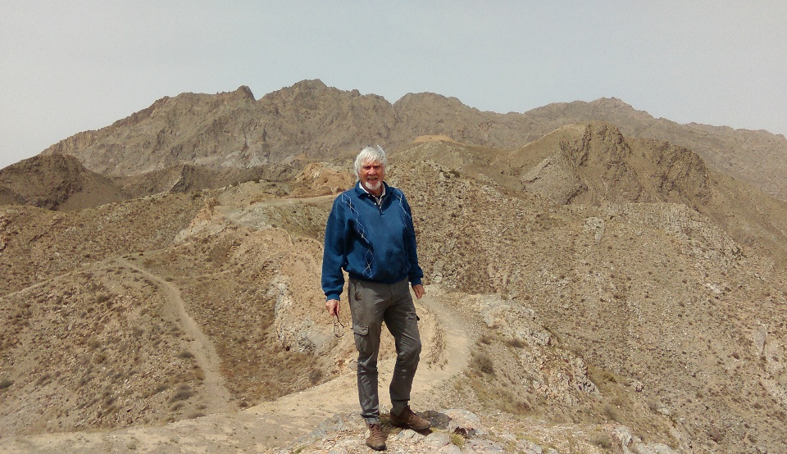
Taking a walk atop The Great Wall
Facing South and far off into the distance we can see the flat desert terrain; its only discernible feature being an ochre-coloured Wall snaking off into infinity.
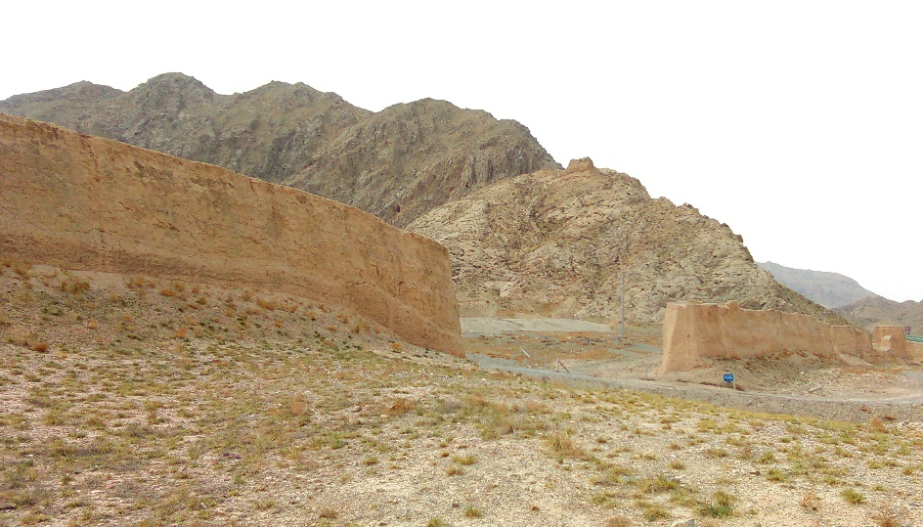
Hole cut into The Wall for a roadway
We’re told this section of the wall is probably around six hundred years old and made of mostly mud bricks, rammed earth, rocks and, surprisingly bound together in places with sticky rice.
This peaceful section of the Wall is dripping with a history of bloody battles long fought and all but forgotten. The narrow pass below us, and where we have just set out from, is where the infamous Mongol warlord, Genghis Khan, first led his 150,000 mounted cavalrymen into China from Mongolia in 1209. It’s said it took them days to negotiate the narrow pass. From here they commenced their decades-long invasion of China starting with the destruction of nearby Yinchuan and the slaughter of over 100,000 of its inhabitants.
It was during this horrific massacre and destruction that Genghis Khan was also killed.
The cries of battle have long ago faded and the only sounds to be heard now are our heavy breathing, having just climbed up from the pass, and the breath of the restless desert winds.
Construction of the Great Wall commenced around 2,700 years ago whilst the last sections were completed about 600 years ago. The Wall is in fact a series of Walls mostly running roughly in parallel with each other, but at times some sections branch off at right angles for hundreds of kilometres. Its combined total length is over 21,000 kilometres, some of which is walkable, but it is shorter and probably easier to walk from the South Pole to the North Pole which is a mere 20,000 kilometres.
The Wall’s main function was to keep out the marauding Mongol hoards, but it was also used to control immigration and to collect duties on goods at certain control points; since the famous Silk Road passed through several of the Walls.
The Wall is now seen as a Museum in its own right, with sections of it being constantly restored to its former glory. Some sections receive various degrees of maintenance whilst other sections are totally neglected due to its location and other factors. You can visit sections using cable cars or you can simply drive out into the remote desert away from the crowds and be absorbed by the stunning scenery and the silence; and its history.
This was our experience of The Great Wall.
On the following weekend’s sojourn Helen took us to see the pyramids of China’s lost civilisation, also far out in the Western regions of the Gobi desert - where the remnants of the lost civilisation lay. This once thriving and artistic civilisation – the Kingdom of Western Xia, was abruptly and permanently destroyed by the invading forces of Genghis Khan in 1227 AD.
All that remains of this lost Kingdom are a series of Xia Imperial Tombs of its Emperors and lessor priests, scattered over an 80 square kilometre area. These beehive-shaped pyramids dot the valleys under the shadow of the nearby and magnificent Helan Mountains.
This large area also contains the burial tombs of 253 lesser Royals. Scattered throughout this burial area ongoing archaeological excavations are continually unearthing large numbers of exquisite statues, carvings and other artefacts. In some areas shattered pottery fragments can be found lying abandoned and exposed on the ground as if calling to be picked up; so the stories of their lost owners may be finally told.
As we walked amongst the ochre-coloured rammed-earth pyramids, I’m sure I felt them beckoning me to come closer to hear their stories too. The layout of the tombs is patterned after celestial bodies we are told. It’s truly a mystical place also at the end of a road less travelled. You should come here and see and feel this wonderment for yourself.
These are the best-preserved Imperial Burial mounds in China due to the extremely dry weather conditions and their remote location.

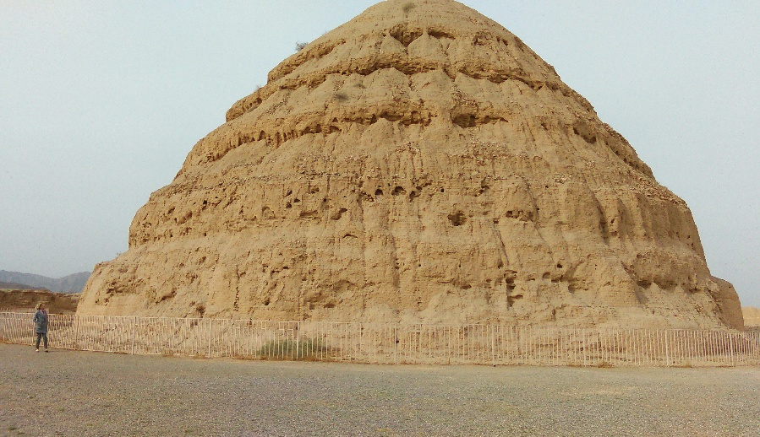
Royal Burial Mounds of the Kingdom of Western Xia
Grave robbers have, long ago, looted the main Imperial mounds of their caches of gold and other precious metals, gems and other valuables; but left untouched many of the statues, hieroglyphics and other works of art. Many of these items have now found safe haven in the nearby and new Yinchuan Museum where we visited earlier.
Helen, proudly tells us how she is a descendant of these Xia Emperors. She explains that when Genghis Khan ordered the slaughter of every man, woman and child of the Xia Kingdom, several of the Xia escaped into the desert and found refuge in small villages. Here, they changed their family names in order to dissociate themselves with the Xia people. These Xia escapees and their descendants were gradually absorbed into the dominant ethnic group thereby erasing any further trace of the Xia Kingdom.
This part of China is dripping with history, both ancient and not-so-ancient. It was also here that Mao’s famous Long March, which started in southern China with 300,000 followers came to the end of its road too, as only 30,000 of its original participants reached its final destination. Exhausted due to lack of food, and sickness, it was here in the land of the lost Kingdom of Xia that China’s still-ruling Communist Party firstly consolidated itself amongst the locals to become the powerhouse it is today.
China is such a huge and diverse country and our recent visit and experiences there cannot possibly portray a complete picture. You would have to visit China yourself in order to understand what I am trying to convey here.
We also spent a few days in Nanjing, China’s ancient capital, staying with an old Japanese friend of mine who now lives there. For the purpose of anonymity I will call him Peter. Peter is a retired and outspoken journalist living in self-imposed exile in Nanjing where he still writes as a freelancer. He was once an editor of Japan’s largest English language newspaper. As an editor he invoked the ire of the Japanese Government for some of his essays criticising their handling of the crippled Fukushima nuclear power plant which, according to Peter, continues to pour lethal levels of radioactive nuclear particles into our atmosphere and oceans – totally un-contained and totally out of control still - after seven years.
Since I was once the English editor of a large Chinese newspaper we had much in common, therefore our stay with Peter was also a good opportunity to compare notes and first-hand experiences about other misleading, biased or fake mainstream media reports about China, Japan and more. Such discussions included the reporting of the Chinese invasion of Tibet and the incarceration of perhaps a million Muslims in internment camps for the purpose of assimilating them into the greater Chinese population, in the western Gobi Desert regions of China, where we had just spent several weeks.
Having taught well over 100 Tibetan students in the past and heard their first-hand accounts of what life was like there, including what the Chinese occupation mean to them is at odds with our mainstream media’s view. There again, after experiencing several weeks in the Gobi Desert rubbing shoulders with the locals, both Hun Chinese and Muslims who make up 30% of the population there, my on-the-ground observations are also at odds with the mainstream viewpoint. But these at-odds-with-mainstream-media views are the subject of another book which I will probably never write.
This book was not meant to include political opinions or propaganda of any persuasion but suffice to say here - question everything – question who gains by the propaganda – make up your own mind based upon your own first hand experiences as anything else is most likely simply another’s opinion, and possible agenda. Say’s this ex-newspaper editor.
Peter proved an excellent guide showing us around the wonderful and historic city of Nanjing taking us to places rarely visited by tourists. We learnt of the massive ship building yards located upon the banks of the nearby Yangtze River. Here hundreds of years ago the locals built massive timber sailing crafts, reported to be over two hundred metres in length. These massive wooden vessels would then sail in large armadas to distance places for the purpose of trade and to gain knowledge of the greater world.
We also visited the Nanjing Massacre Museum in downtown Nanjing. This was a very sombre occasion for us as we learnt much from the graphic photos and other artefacts of the terrible World War Two massacre of over 300,000 civilians and military personnel, by the Japanese military. It is also known as the Rape of Nanjing wherein a further 30,000 women were systematically raped by the invading Japanese military.
In spite of the horrors of the massacre presented in the Museum it was refreshing to see that the main theme or purpose of the Museum is not to instil hate or revenge in its visitors - but rather to educate through the use of history as a means of prevention so that such things must never be allowed to occur again.
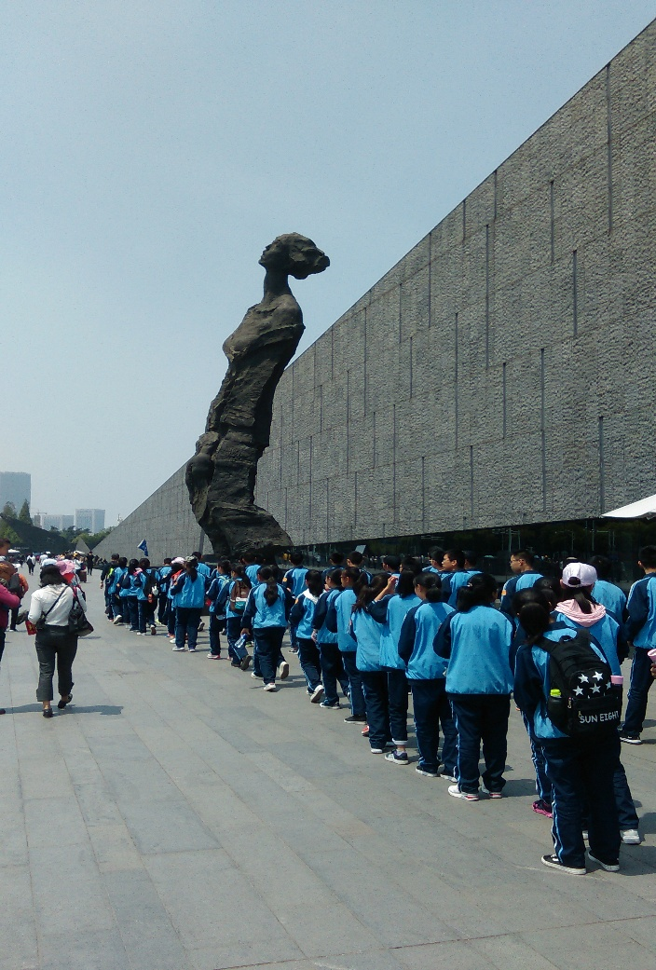
Entrance to the Nanjing Massacre Museum

Those who cannot remember the past are condemned to repeat it: George Santayana

Chapter 10 Vietnam

Vietnam is perhaps the most foreigner-friendly long-stay country of them all, as here you will be made most welcome indeed.
Having been fortunate enough to visit and work in several Asian countries, I was so pleasantly surprised to discover how modern and well developed Vietnam has become. Considering how this small peace-loving country was, not so long ago, devastated by the combined might of the U.S. and its allies; Vietnam now appears more advanced than most.
Foreigners must firstly enter Vietnam via one of their three International airports – Ho Chi Minh City (Saigon), Hanoi and Da Nang in order to collect their e-visa on arrival.
I have successfully used the following website twice to obtain a three month visa. It’s a simply procedure. Just follow the instructions to obtain either a one month or three month visa. https://vietnamvisa.govt.vn/
You are also welcome to apply for a variety of visas by attending the Vietnamese Embassy in your home country, but this can often prove inconvenient and time consuming. I have done two long-stays in Vietnam and from now on we will always fly into the modern Da Nang International Airport. This is because the airport is only four kilometres from the city centre, it functions very smoothly and the awaiting taxi drivers show more mercy when negotiating a reasonable fare to our hotel. Expect to pay less than A$5 to almost anywhere in town. As I have mentioned earlier, big cities anywhere simply don’t do it for me and Ho Chi Minh City and Hanoi definitely fall within that category, but of course this may not be the case for you.
From Da Nang you can fly to many places within Vietnam and to other major Asian cities. On our most recent visit we flew with Jetstar from Bali via Singapore, to Da Nang.
As I have mentioned earlier I’m also a bit over hot tropical weather, yet Vietnam offers cool mountain cities and a mild coastal winter. Da Nang is a great place to stay during their winter months – December to March whilst the cool mountain city of Da Lat offers a cool summer climate as it’s over 1,500 metres above sea level.
My advice is to start with Da Nang in their winter and if you still need more Vietnam fly up to Da Lat when the weather heats up. Da Nang is home to thousands of expats from all corners of the globe so you will never get lonely or bored here. Join one or more of the Da Nang expat Facebook forums as there you will find a whole community of like-minded souls all happy to help you with all manner of advice, information, social events and accommodation options. There is plenty to do here.
Da Nang straddles a large river and on both sides there are wonderful riverside promenades with funky cafes, excellent hotels and the occasional patisserie. Since Vietnam was once a French colony certain sections of the promenade are also adorned with sculptures – think Paris – West bank. On both sides of the river there are dozens of hotels with plenty offering river views, balconies, free breakfast, free Wi-Fi and cable TV for less than A$40 a night. It’s only a short drive to the nearby beaches where there are also heaps of hotels, restaurants and a beach stretching for over 30 kilometres.

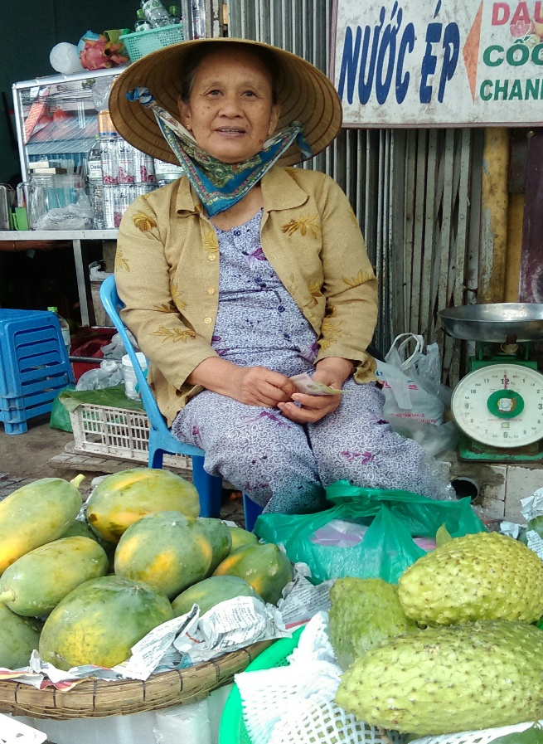
Da Nang Central Market
When I book on-line via booking.com I have discovered that if you simply input for requiring only one night’s accommodation, in order to gauge the nightly tariff, it will offer you a much higher rate per night than if you input say, for several nights. Check this out for yourself.
Another reason why Da Nang is a great place to start is because the historic UNECSO World Heritage listed city of Hoi An is only a 30 minute taxi drive away. This means you get two great cities for the price of only one airfare.
Da Nang was also the site a major U.S. Military base and associated activities during the Vietnam War with the U.S. and Australia. But other than a few military museums in town little evidence of this dark era remains. I did stumble across a fascinating café, the Cong Café, by the riverside which was established by a former Viet Cong soldier and which houses some of his works of art, writings and other memorabilia relating to his time as a soldier. The interior of the café resembles the inside of a military bunker of that period and all the staff wear Viet Cong military uniforms. Here I learnt how this city was finally liberated from the U.S. backed South Vietnamese military forces. The U.S. forces had withdrawn but the city was still controlled and occupied by the South Vietnamese forces who were finally driven out by several truckloads of mainly women Viet Cong Guerrillas. I guess a lesson we can learn from this is: don’t mess with the women there…
When you’re done with the bright fluorescent lights of Da Nang take the short taxi drive to the neighbouring UNESCO Heritage Listed city of Hoi An – the city of Night Lanterns.
Hoi An also straddles a river complete with wide promenades on both banks as well as having several inhabited islands in the river and which are all connected by vehicular and walking bridges. There are hotels and guest houses on these islands and on the adjacent beaches.

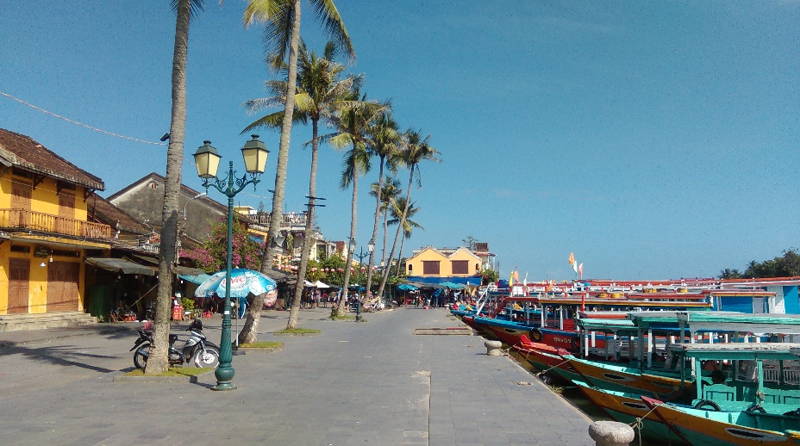
Riverfront Hoi An
This is a very ancient city with a population of around 100,000. It has around 800 buildings all of historical importance and many are around 400-500 years old. Most are found within the touristy Old City precinct and many have been turned into delightful cafes and restaurants whilst museums, historical family houses, tailors, gift shops, pagodas and assembly halls abound. It’s a stunning place steeped in history going back at least 2,000 years. It’s also a photographer’s heaven. If you can’t take a good photo here then you never will.
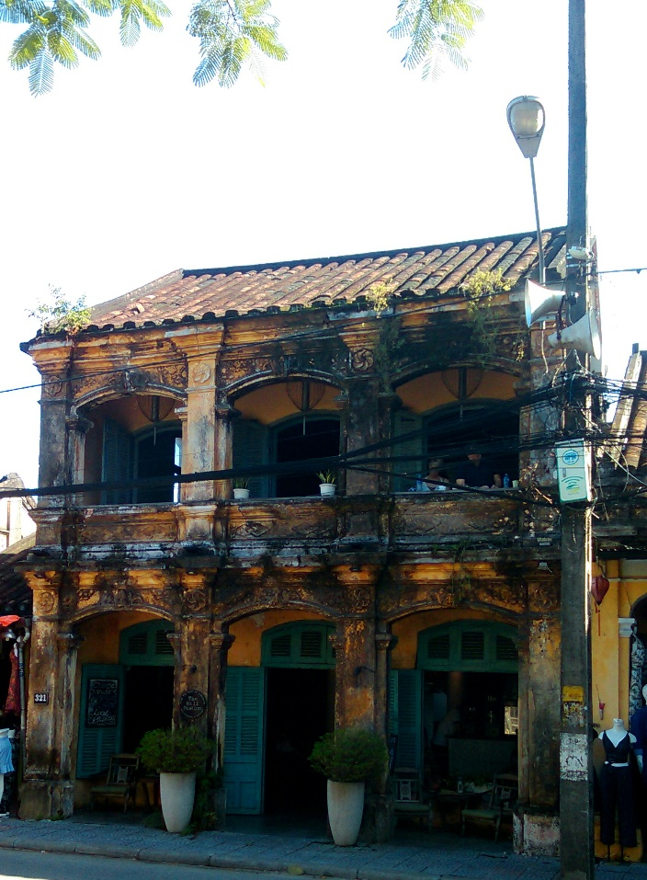
Hill Station Restaurant Hoi An
The earlier generations here were mainly made up of Chinese and Japanese traders as Hoi An was once the major coastal trading city of Vietnam. They traded fabrics, paper, silk, ceramics and Chinese medicines with many European nations.
It’s also claimed it was here around 1,600 years ago that the Buddhist sage, Bodhidharma, first arrived to spread Buddhism throughout East Asia.
Vehicular traffic is banned from the Old City precinct and at night the whole city is illuminated with thousands of colourful lanterns.
Along the waterfront hundreds of traditional-styled water crafts will offer to take you cruising amongst the adjacent islands and waterways for as long or as short as you wish. There are no set routes, timetables and prices. Everything is negotiable – so negotiate. These watercraft do a roaring trade at night as they too are illuminated with colourful lanterns creating a very spectacular sight as sometimes hundreds of them all weave amongst each other in the dark. No need to book in advance – just turn up and choose what you want.
There are a lot of foreign expats living or spending long stays here. We stayed In Hoi An for a month. We chose a hotel just outside of the Old City precinct to avoid the hordes of evening tourists. It’s only the Old City that suffers from this over-supply of tourists as fortunately the rest of this charming city doesn’t suffer such a fate.
We stayed at the Lotus Hoi An Boutique Hotel and Spar in our A$35 a night room complete with balcony, free buffet breakfast, pool, free Wi-Fi, cable TV, and free shuttle bus into town. It’s what we have come to expect living this lifestyle and so can you too. These are just some of the fruits of our revolution.

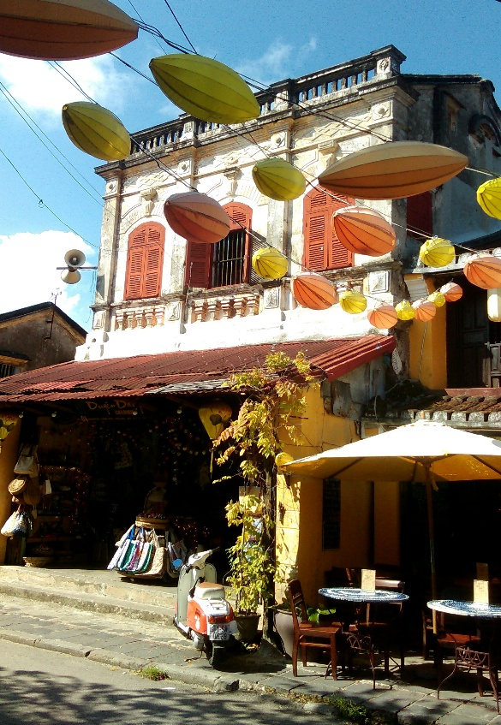
Old City Precinct Hoi An
As to be expected there are ATMs, money changers, convenience stores, taxis, information offices, medical clinics and a hospital, travel agents, mobile phone providers and more. Most people you will need to do business with will speak at least enough, if not good English.
Located behind both Hoi An and Da Nang are the jungle-clad Ba Na Hills which are easy accessible firstly by bus and then cable cars. I recommend these cool-climate Hills as an excellent one-day, or even longer, getaway or escape from the heat and humidity of the coast.
To get to the Hills I would strongly recommend you take one of the many tours that depart from both Hoi An and Da Nang daily. You will need your tour guide to firstly help you negotiate the Cable Car stations – there is in fact a network of Cable Cars, and once you have arrived high up in the Hills your guide will lead you to the best spots, and believe me, there’s so much happening up here. It also means you will be following one of those flag-bearing guides – something I have always avoided. Here I was simply forced to swallow my pride and follow my flag.
Upon arriving at the main Cable Car Station you will be confronted by a huge magnificent military fort-like building with a large welcoming entrance. Before entering you walk over a traditional Chinese-style bridge spanning a large pond full of goldfish. Once inside the magnificent Cable Car Station I got the impression I was in a five star hotel as it’s highly decorated with beautiful works of art and exquisite furnishings. You are then ushered by attractively-dressed uniformed ushers towards your awaiting Cable Car, using a series of escalators.
For a moment I thought I was having one of those near-death or out of body experiences as I entered my Cable Car in such beautiful and peaceful surrounds and was silently whisked away at high speed towards the mountain tops and a bright light, shining directly overhead.
It takes about 15 minutes to get to the first stop – The Golden Bridge. This is gobsmacking (see photos). This gold-coloured walking bridge is several hundred meters long and is supported by two gigantic hands, all of which is perched precariously over a deep valley hundreds of meters below. Much of the time everything, including the high-altitude valley, is shrouded by swirling mists. The views are magnificent.

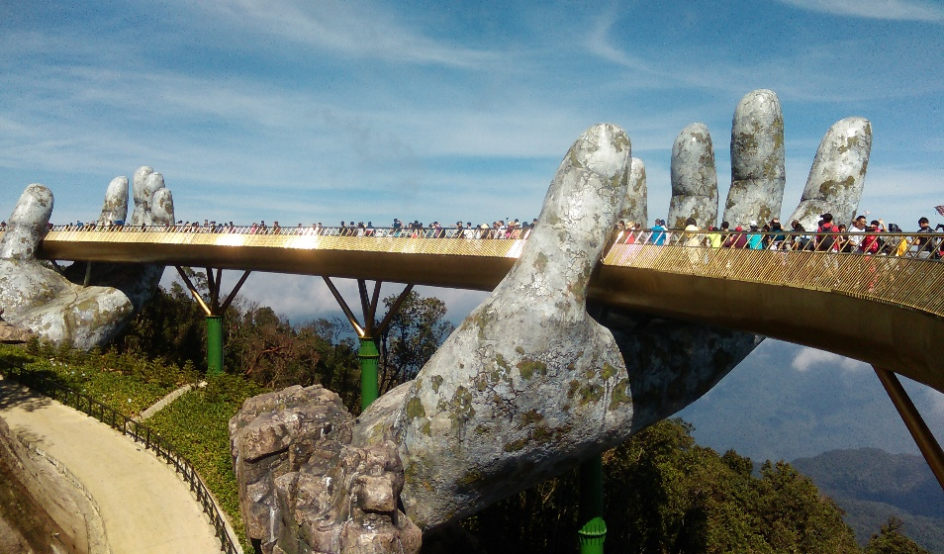
The Hands of the Mountain Gods
The outreaching Hands are those of the Mountain Gods willing and welcoming anyone and everyone who cares to visit. It also represents a glimpse of heaven 2,000 metres above sea level and with everyone in the safe embrace of the Gods whilst eternally united by a Golden Bridge. All are welcome.

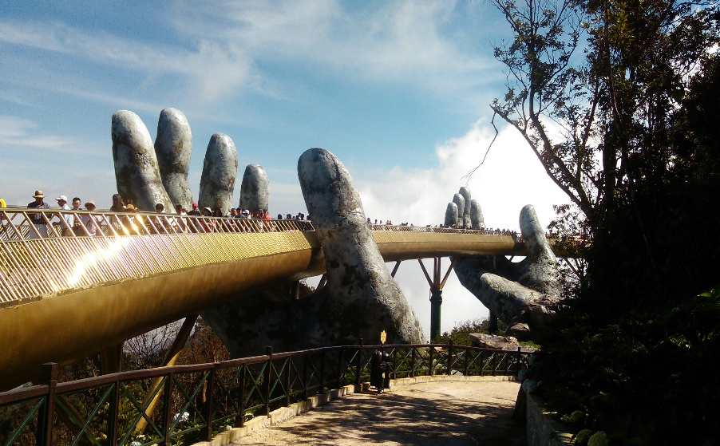

I was surprised and happy to see so many people here from all over the world accepting this special invitation from these Gods.
This is a true place of pilgrimage in my book.

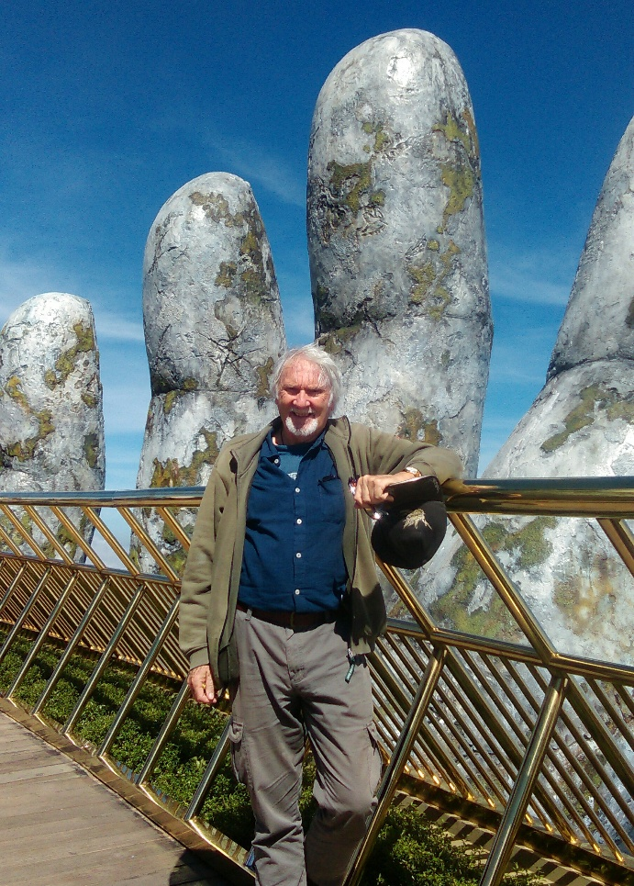

When you’re done with Heaven you will then catch another cable car and ascend a further 1,000 meters up to the very top of the mountain. Here, barely visible most of the time due to the swirling mist, stands a once-fabled and mysteries village - the 19th century French village of Ba Na Hills (see photos below).
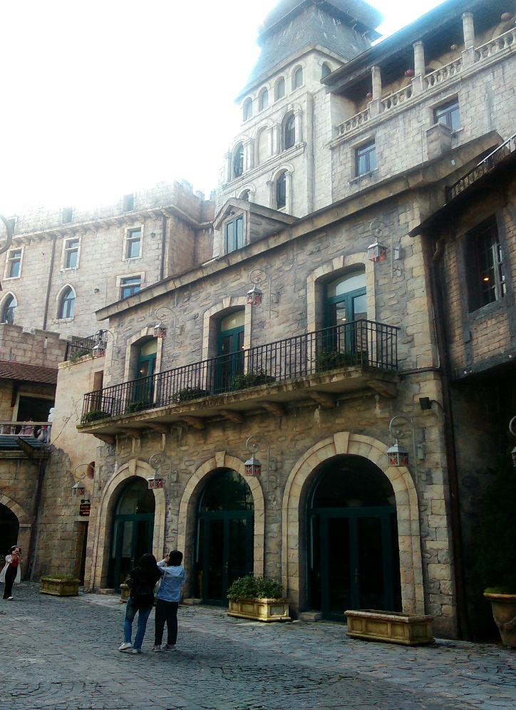

This mist-shrouded French village was constructed by French colonialists around 1920 as their summer retreat from the coastal heat and humidity. Here they constructed luxury hotels, a grand castle, French-styled gardens, villas, cafes, restaurants and shops all in the French style. I spent the afternoon here walking its cobbled streets and alleys thinking I was somewhere in the French countryside. At first I suspected it was all some kind of fake movie set or cheap amusement centre constructed of wood or other synthetic materials. But after diligently tapping many of the buildings and their accoutrements I discovered everything was in fact, constructed of bricks and cement. It is in fact the real deal. I entered many of the hotels, concert halls and more and was delighted to see their 1930’s period décor and furnishings. There are even old Peugeots, Renaults and other strange-looking French cars of that period parked in the streets.
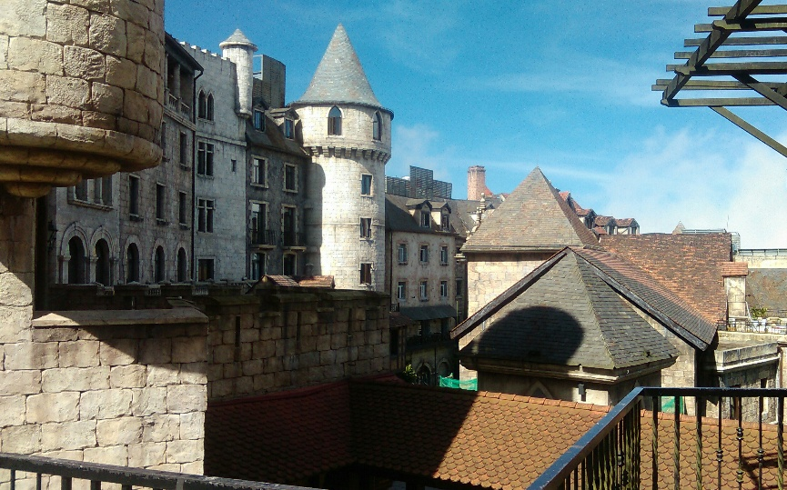

When the French were finally ousted from Vietnam the Village was abandoned and gradually fell into dis-repair until the 1990s when it was gradually restored to its former glory. Nowadays you can even stay overnight in one of the Village’s luxury boutique hotels.
As the sun approaches the horizon, the mist further intensifies and the Village once again gradually fades from view. The weather begins to turn cold and your tour guide, with flag, with finally guide you back to your awaiting bus and hotel.
If you’re planning on visiting Vietnam during the summer months and if you’re like me and wish to avoid the heat and humidity, then consider Da Lat as here yet another side of Vietnam awaits you.
Da Lat is a city of around 200,000 inhabitants; located 1,500 metres above sea level in Vietnam’s Central Highlands.
Here the air is clean, the traffic is manageable – mostly motorbikes, the services are first class, the price is right and the welcoming boutique hotels and guest houses are excellent. For example, we booked into the Tulip 3 Hotel in the centre of town for three days and ended up staying there for almost three weeks for around A$30 a night, in our 35 square metres room.
We spent most of December in Da Lat – their winter; whereupon the daytime temperatures hovered around 20-23C, and I’m told summer temperatures rarely rise above 25C. I would recommend summer as the best time to visit though. This means over 60s travellers can get out and walk and explore in comfort. Air-con is not necessary here and the city surrounds a beautiful man-made lake complete with walking paths, eateries and more.
This part of Asia was also once occupied by the French and here you will see their lasting legacy of countless stylish French villas and wide tree-lined avenues. Many of these villas have been lovingly restored as guest houses, hotels and government offices. Almost next door to our hotel proudly stands a huge French patisserie. It’s a local landmark and it’s easy to find as it’s permanently surrounded by dozens of parked motorbikes, belonging to its customers. We went there almost every day and sometimes had to almost fight our way in. The locals take their pastries very seriously here.
If delicious French pastries aren’t for you then there are numerous cafes, restaurants and food courts offering all manner of cuisines, both Asian and Western at very affordable prices. We ate out, as usual, at least twice a day – something few Australians can afford back home.

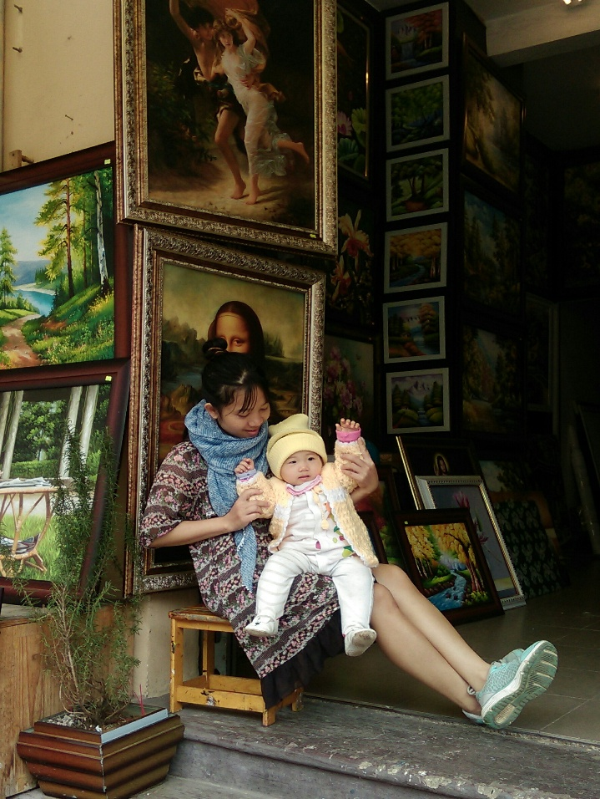
Artist’s Studio Da Lat
When your legs get tired from all the walking a modern taxi will take you back to your hotel or almost anywhere in town for around A$2, or you can travel by motorbike taxi for even less.
The French, more or less enlarged the original village of Da Lat in the 1800s as a place to escape the tropical heat. It also became a retreat and summer residence of the Vietnamese Royal Family till the 1940s when the monarchy was abolished. We visited their summer palace - a large French designed villa in the middle of town. Here, everything has been left in place or preserved exactly as it was on the day that the Royal Family vacated the premises.
Da Lat appears as a very prosperous city since it’s the epicentre of a large and very important fruit and vegetable growing region due to its mild climate and rich soil. Hundreds of trucks carrying farm produce depart this region daily for Ho Chi Minh City (Saigon), Hanoi and for export overseas.
It’s also the centre of a large flower growing industry. In the nearby hills a large Dutch company has over 2,000 hectares of flowers under cultivation mainly for export to Europe. This company employs over 1,000 local people.
For the senior traveller, this part of Vietnam, and particularly Da Lat, would make an ideal location for an extended stay as it has all the modern conveniences we have come to expect, and more.
Da Lat has a beautiful new airport and Jetstar also flies here daily, so if you are looking for an exotic and affordable home away from home for a few months or even longer, I would also highly recommend Da Lat.
Our stay was made so much more enjoyable by the kind and helpful staff of the new and beautiful Tulip 3 Hotel. We stayed here over the festive season and on Christmas Eve the owner invited some staff members and ourselves to his house for a lavish Christmas dinner. As often happens on our travels, the staff at many of the hotels we stay in become almost like family members and we sometimes exchange emails or Facebook posts long after we have left.
Don’t forget to bring a sweater, as you will need it most evenings.

Chapter 11 Let’s Wrap It Up

Well we certainly have covered a lot of ground; perhaps enough for many readers, so here our journey together is about to end. If you’ve made it this far consider yourself qualified to step out into that brave new world we have been studying together. From here on - you are on your own.
I have now taken you to several countries all the while offering all manner of advice and tips based upon my real-life experiences, accumulated over many years. I haven’t taken you everywhere that I could have as there are other counties I’ve visited long term which didn’t get a mention – Papua New Guinea, the Philippines, and the islands of the Pacific Ocean.
But before we get out our passports; let me say a few words about India – yet another very low cost country; and my experience there. I have squeezed India in here at the last minute as we have just been invited to create one of my sculptures for an artist group – The Palette People, located in Kerala, India. They are also wanting me to teach some of their artists how to create the bird wire sculptures that I have had much success with recently. You can see some of my bird wire sculptures at my website: http://ministryofsculpture.com
Nowadays most travellers are able to apply online for a two month stay via: https://indianvisaonline.gov.in/visa/index.html and I would suggest this is probably the easiest method. Many major cities in India are now serviced by Airasia from Kuala Lumpur and I used Airasia to arrive in Kochi (also known as Cochin) the main city of Kerala in far South West India. As I have mentioned several times herein, I prefer to avoid the hot tropics where possible, so I made haste for the old British colonial hill-station city of Kodaikanal located over 2,500 metres above sea level, in the Western Ghats Mountains.

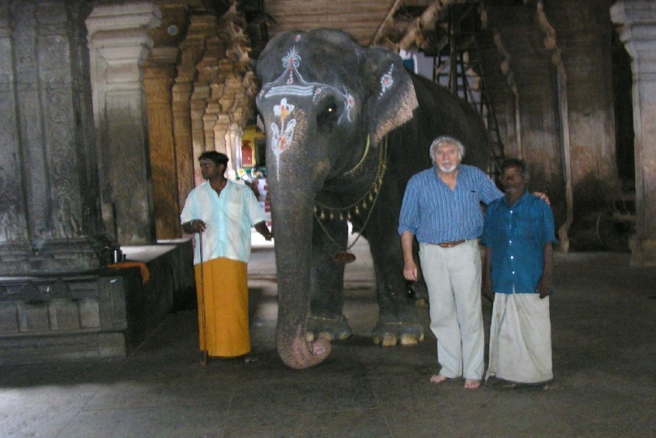
The Elephant in the room - Kerala
Kodaikanal looks, in many respects, like an aged British suburb as most houses were constructed in the British tradition and most are stand-alone bungalows. During Britain’s rule the well-heeled Brits would retreat to hilltop locations such as this, to escape the torrid summer heat.
Here, my hotel was a recently renovated posh old English manor house perched right on the edge of what appeared to be a thousand or more meters drop. It was delightful and a great relief from the heat below. For much of the time I was living above the clouds as I experienced blue skies above and clouds below.
The Western Ghats is a mountainous region noted for its wildlife and biodiversity and here I visited national parks and private gardens wherein I was fortunate to get glimpses of tigers and elephants in the wild. It also has an extremely rich bird life which pleased me no end since one of my hobbies, is painting birds.
Tea plantations are also a feature of this region and wherever I went it seemed as if every hillside was terraced with them. But what pleased me most was the terraced garden of my hilltop retreat hotel which I used as my base. Even though it was a small garden it was situated right on the edge of an escarpment which fell almost vertically for over one thousand meters. I would sit in this celestial garden every day for hours as if I was British royalty or a bard of a remote Scottish castle, and read my daily newspapers whilst sipping tea of the highest quality. Just like one of those selfish elites, except I don’t see myself as selfish. The kind staff would always be on hand to offer whatever assistance I might need. I even had my meals in this garden. Such is my new-found existence and we are planning on returning to India in the very near future.

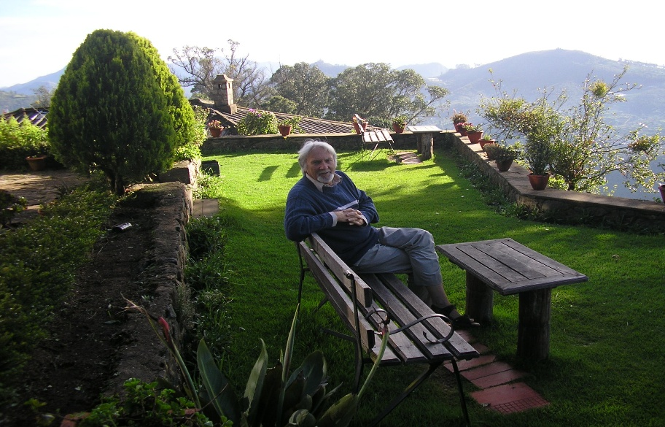
Life as a new Elite – Terraced Garden - Kodaikanal
It is not my intention to overburden you with too much information regarding all the countries I have visited, but rather just some of the ones I feel are suitable or long-term stays for folk like you and me. It is also my intent to focus holistically on new ideas or possibilities for a more fulfilling life as you approach retirement, or that new life after work.
Here I do not wish to offer which is my favourite country either. Your favourite country will be for you to decide. My only wish is that you consider experiencing long-term stays in your favourite low cost countries as a means of opening up to the wonderful possibilities and choices which will be offered to you. By all means select a starting or reference point from amongst the several countries I have presented herein but you need not confine yourself to these; the world is an amazing place.
The world can also be a dangerous, crazy and restrictive place. There are also a lot of bad things being done by bad people out there, many of whom are in power and some of whom are most likely active in your country too. Use this book to help you find and focus upon the good things to help you weave your unique journey – wherever that may lead you. Always remember travel is not all about the destination; it’s also about the journey.
I realise I haven’t covered every conceivable detail regarding best hotels, the price of a cold beer in Chiang Mai or whether you can renew your visa whilst still in Vietnam as this would weigh the book down with minor details too numerous and mind-numbing. It’s suffice to say, in low-cost countries everything is low cost and here you are encouraged to use the internet to obtain those precise up-to-the-minute details. Every time I plan on going somewhere new I always go to Google Images and look at all the photos of the place before-hand, to minimise the risk of any unpleasant surprises.
I must confess – again, that I’ve always been a bit of an adventurer. I think this is because I was brought up in rural central Queensland, Australia. As I’ve mentioned earlier; my family migrated from England when I was only two years old and was dispatched to a migrant camp located on the banks of the Brisbane River, Brisbane. We spent a month or so there living in disused army huts before being dispatched further afield to the cattle town of Rockhampton, some 600 kilometres further north on the Tropic of Capricorn.
In those days – 1950s, Rockhampton was a Wild West type outpost servicing the inhabitants and cattle stations of much of outback Queensland. Horse-drawn carts still graced the streets and outside many of the drinking hotels horses would be tethered to hitching rails, whist their owners were inside drinking copious amounts of beer and sheltering from the intense tropical heat.
I am told we were the first migrants in town and thus we became an instant curiosity. In spite of the isolation and harsh environment the locals were a very friendly bunch and we settled in relatively easy – much to our surprise. As a child I loved my life there. At the age of ten I was the proud owner of .22 rifle, a horse and prided myself on being able to crack my stock-whip whilst riding my horse at full gallop. I saw myself as a bit of a legend – think John Wayne.
We had no TV, no phone, and one radio station, but we were blessed with several movie houses we attended regularly to watch mainly American cowboy and western movies. Since I was already living in my own lookalike Western movie my life as a child there was filled with adventure, gun smoke, curiosity, frequent hard knocks, spills and near misses: the perfect upbringing for any budding adventurer.
In my early twenties, after I had barely dodged the military draft for active service in the phony war in Vietnam, I found myself as the deckhand on a two-crew member Tug boat, servicing the isolated and just-established bauxite mine at Weipa on the far north west tip of Australia’s Cape Your Peninsula. The only way in or out was by weekly cargo freighter from Cairns or twice weekly flights – weather permitting, from Cairns. I spent almost a year here as the sole deckhand assisting my Thursday Islander skipper who was intoxicated much of the time. This meant I was frequently called upon the take over the wheel, towing massive bulk ore carriers in and out of the Weipa harbour, then bringing them alongside as well as transporting the port’s marine pilot to and fro from arriving or departing vessels. I am a quick learner and handled the challenge without incidents. I’m not sure if the Department of Workplace Health and Safety would approve of this nowadays.
Not only did I undergo fast track training to handle the Tug boat but my skipper – a former Pearling Lugger skipper, also taught me all manner of seamanship skills such as navigation, marine maintenance and weather forecasting. These skills and the hands on experience had now whet my appetite for more adventure and which resulted in my late wife and I building a 38 foot yacht in our backyard, a few years later. Its construction took us two years. When complete we lived aboard in Elizabeth Bay, Sydney Harbour. Much to the angst of the owners of the nearby exclusive homes it was, in those days, permissible to live abroad on the Harbour.
Life aboard was one great big adventure. We explored Sydney Harbour as if we were exploring a just-discovered land. We cruised up and down the East Coast of New South Wales as far as our days off from work would allow. We both worked on the Sydney buses, I as a driver and my wife as a ticket seller (clippie). Our ultimate plan was to save enough to fully equip the yacht in order for us to sail off into the setting sun, probably never to be seen again.
We never did get to sail off into the setting sun as somehow we came to lose that vision; but this also means I am able share my dreams and adventures with you.
As I briefly mentioned in an earlier chapter, I love islands as they invoke, within me, a sense of escapism from this crazy world. I also mentioned how I spent four weeks in Scotland in 2016, with two of those weeks spent exploring the Orkney Islands. During my visit I returned to the exact same spot, by Loch Ness where, 50 years earlier, I had the most exciting adventure imaginable.
Let me explain: It was in the late summer of 1966 and the cool winds had already begun to blow. This is how it is in Lancashire, North West England. I had just graduated from Art School, near Liverpool. The cool air reverberated with the ever-increasing sounds of the Beatles. I prided myself for being able to sing every song that they had released up till then. My life was full of excitement, anticipation and song.
Back then it was customary, each year, for graduating students to conjure up and then participate in all manner of mischievous public pranks. The more outrageous and attention grabbing the better. It was seen and tolerated as our rite of passage, and in many instances would even bring a wry smile to the faces of many of the hardened and struggling locals. The local authorities disliked this practice immensely and would even warn us in advance to not over-step our marks. Naturally we ignored their warnings.
Picture a group of students with Beatle-style haircuts packed tightly into a delivery van together with all manner of hardware materials – wood, wire, rolls of black plastic, nails, hammers, etc, heading north out of Blackpool towards the wilds of Scotland singing our hearts out…she loves you yeah, yeah, yeah…she loves you… I was in that van. Loch Ness was our destination.
Upon arriving on the southern shore of the mysterious Loch, we encountered a group of photographers and others gazing out over its frigid waters. I asked them what were they doing and was told this was a permanent camp set up for Loch Ness monster adherents, photographers and researchers. They told us they had had a recent sighting on the other side of the Loch. Upon bidding them farewell we set out for the northern, other side, of the Loch.
When we arrived at our final destination on the other side we feverishly began to assemble our bits of wood, wire, black plastic and more into a very large, black, slimy and somewhat familiar-looking monster shape – a large head with three smaller separate humps all attached together with ropes and floating devices (watertight tin cans). We launched it. It floated. It was Nessie!
Next we had to decide who would tow Nessie far out onto the Loch in the dead of night in our small rubber inflatable. It was a dark cold night. To cut a long story short it was I who was chosen, since I was from Australia and the only one amongst us who could swim – I was now regretting the times I used to boast to my fellow English students about my recently-acquired Australian Bronze Medallion Lifesaving medal.
Not surprisingly, as I rowed, alone, far out onto that dark cold Loch towing a large, black, slimy and ghastly looking monster, all manner of thoughts passed through my mind: but I won’t go into them here. Suffice to say that I was terrified and I wouldn’t recommend it.
Morning finally yawned and dawned early and we all rushed to the water’s edge.
Alas, to our great disappointment our Nessie was nowhere to be seen. What ever happened to her during that dark night, we will never know.
During my recent 2016 visit to Scotland, I was delighted to learn that the Nessie mystery still lives on. It’s my belief that our world needs its mysteries more than ever nowadays. It’s not of paramount importance whether Nessie exists or not. What’s more important is that such mysteries can help cultivate or nurture our sense of awe and wonderment; something sorely lacking in today’s world.
I hope to return once again to Scotland in the near future, and maybe, just maybe, Nessie will reappear from the depths.
I am only sharing the aforementioned information with you simply to give you an insight into my early life experiences; this may help you understand why I think and do as I do.
People often ask, where do we stay when we are back in Australia.
As mentioned earlier I visit my grown up children and their families both in Cairns, north Queensland and Bendigo near Melbourne, Victoria for as long as I/they wish. It’s wonderful catching up with everyone, hearing their stories and sharing mine. It’s also a good time to take care of those other humdrum duties such as banking, licence renewals and similar eternal matters. Anne does likewise with her family and any personal matters.
Depending upon the time of year we then take to my campervan and head off into yet another glorious setting sunset; usually into Australia’s almost-deserted great outback; camping at some of our favourite locations - simply soaking in the wonderful great nature which is so abundant in that part of Australia.

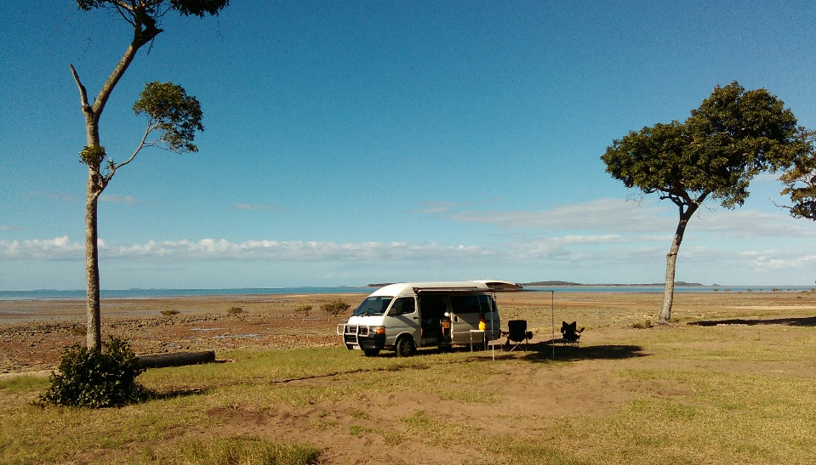
At home somewhere in Australia
Australia is a wonderful safe country to spend time camping since it’s so inexpensive with easily accessible and quiet camping locations. We sometimes forget how fortunate we are in this regard and if anyone from overseas is looking for an inexpensive camping holiday: Australia is the place to come. Many foreign visitors to Australia buy old vehicles at one end of Australia, fill them up with inexpensive camping gear and spend several months driving and camping all the way to the other end of our vast continent; whereupon they will sell the car with all its camping equipment to another such adventurer who does likewise but in the reverse direction. Cairns in North Queensland is one such end or beginning of the road destinations as there are always dozens of cars and vans, etc, for sale by about-to-depart foreign campers. Check them out on the Gumtree site by looking firstly for the Cairns site then ‘cars for sale.’
There are dozens of fine Camping in Australia books available online, so mate: come on down sometime. One such camping publication which is referred to as the Camping Bible is titled Camps 9 with Camps 10 just released. This publication is available at most Australian newsagents and bookstores. Another great source of camping locations, etc, is the new mobile phone app
Wikicamps. This interactive app is available at http://www.wikicamps.com.au We use it all the time.

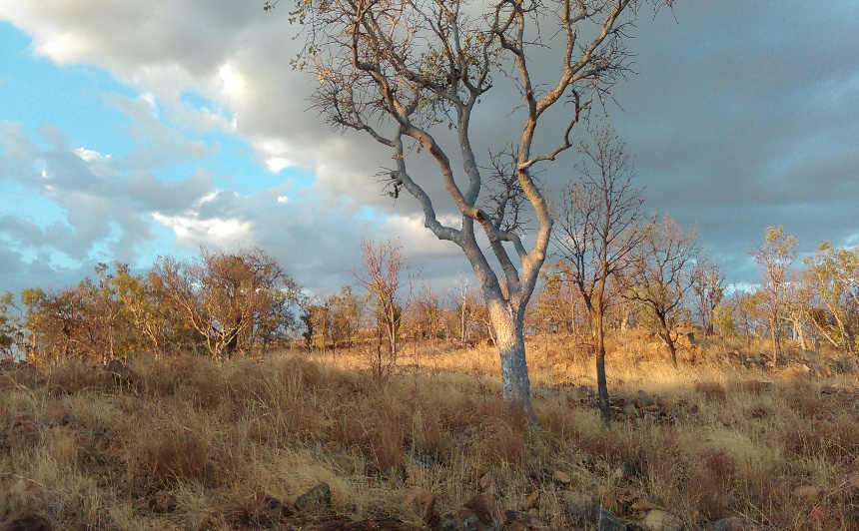
Waiting for an outback Australian sunset
Other options for finding that special campsite or caravan site are listed immediate below. These new websites are packed with an ever-growing number of campsites wherein land owners, farmers and the like offer a place, to you. The websites come complete with photos, maps, relevant information and prices (very inexpensive – often free) etc. Check them out here: http://www.campsight.com.au https://parkmyvan.com.au https://www.youcamp.com
Here’s a good website which lists many cattle stations and other farms inviting you to come and camp or even stay in cabins, etc. http://www.farmstaycampingaustralia.com.au
Sometimes I’ve visited distant places within Australia by doing house-sits. This is perhaps the most economical method of traveling within any “developed” country. It’s free and all you usually have to do is live in someone’s house and look after the place, and perhaps some pets whilst the owners go on holidays. I’ve done several of these house-sits in the past. I belong to just one of the many Australian house-sit website and I found it extremely useful. Check it out here: http://www.aussiehousesitters.com.au Most homeowners wanting a sitter will usually sift amongst the available sitters and contact them directly and don’t bother placing sitter wanted adverts on the website.
If you want to travel the world for next to nothing, house-sitting, as many people do, then this is a good site to check out: http://www.mindmyhouse.com Simply choose the country of your choice and apply.
As you can now see from the aforementioned internet links there is something for every budget and every taste, whether in a foreign land or nearer to home. No one with good or reasonable health is excluded from opportunities to either, travel, work, volunteer, re-train or play anywhere anytime. There are thousands upon thousands of mature aged and not so mature aged people of all persuasions out there living life with such passion and purpose. We met so many of them on our travels and we were just two amongst the many. I’m no longer a retiree – I’m a person living life according to my terms and conditions.
I do suspect some readers might be thinking all my traveling and everything that went with it was a bit extreme, over the top or even radical. Well....maybe, yes and no.
Yes, I did do a lot in this time, but so did everyone, and probably you did too: except that mine was a period filled with great experiences, variety, adventure, danger, work, play, volunteering, fulfillment, passion, learning, growth, freedom and new peoples. And nowadays we do it all mostly on our terms. We don’t travel every day or move locations so often. Usually we stay put for weeks on end. It’s not particularly tiresome and we have even experienced far more and visited more countries than I have chosen to include here in this book. I sometimes wonder how others can maintain their daily humdrum for such long periods when it’s so easy and affordable to live in a parallel universe, such as the one we are experiencing.
One of the most valuable lessons life has taught me is the value of freedom and how so easily we often sell ourselves short in the futureless pursuit of materialism. I now see materialism as the enemy of this freedom; with freedom being the antidote to materialism. Investing in freedom will bring far greater happiness than any other form of investment. But perhaps this is not something you ought to be discussing with your bank manager or financial adviser.
Having lived both in the world of humdrum and the world of freedom I know which one I would choose any day and it’s my sincere wish readers might use this book as inspiration, to look at the world differently and choose that which is relevant or doable to them.
By no means do I expect, or advise, any reader to drop everything and step out into the big void unprepared. A degree of planning, good health, common sense, a positive attitude and courage must be cultivated firstly if not already present. I set out with a small cash safety net and this increases steadfastly the longer I travel. You will need a modest safety net, too.
I do realise everyone has their unique story to tell, and how your story has shaped you into the type of person you are today. I hope my story somehow speaks to you in such a way that in your senior years you see yourself as a valuable member of society, with much to contribute; as opposed to the ever-growing schisms of ageism, oppression and worthlessness now bearing down upon many of us.
Do not fall for their ageism propaganda. You are entitled to a good life irrespective of your age. You have earnt it by your years of toil, bringing up a family and paying your taxes. Pursue your happiness and your liberty. These are your unalienable rights as laid out for us all by Thomas Jefferson in the American Declaration of Independence.
“We hold these truths to be self-evident, that all men are created equal, that they are endowed by their Creator with certain unalienable Rights that amongst these are Life, Liberty, and the pursuit of Happiness”.
Your personal antidote is to show all those who create the schisms, cloud your horizons or engage in ageism, how you turned those adversities into opportunities; by creating a new life full of possibilities, new friends and better heath.
These then, will silence them, whilst for some readers it might be their sweet revenge.
Now that your self-worth and energy levels have dramatically increased, it’s only natural that you might begin to seek ways to somehow utilise your new worth or value in our troubled world. Perhaps you could consider becoming a self-appointed goodwill Ambassador for humanity tasked with destroying those schisms, barriers, false beliefs and memes as you live, travel and interact with the different cultures, races and beliefs. The only qualifications necessary for this special seniors’ role are: to be a graduate of the University of Life; the ability to embrace new cultures and acceptance of their ways of doing things, and a desire to live outside those confounded Boxes.
What better life-fulfilling activity is there out there for us new graduates? The world today needs an army of such Ambassadors so qualified, with their self-gained wisdom and seniority, who are answerable to no master other than their own conscious. The pay might be lousy but the rewards are incalculable and everlasting.
For those amongst us with a more in-your-face type attitude might like to occasionally, when appropriate, shapeshift into the fabled St George the Dragon Slayer character. St George is a character of the Roman Legends who, during his travels, came across a defeated people forced to sacrifice their children to an evil Dragon in order to appease it. St George came up with the revolutionary idea that it was better to kill the Dragon than to continually feed it with children. So one day, mounted upon his horse, he slayed the Dragon with his sword. For his revolutionary stance he became the patron Saint of England and several other European countries, and his legacy lives on. This legend represents the eternal battle between the forces of good over the forces of evil.
The world needs you now more than ever.

References

startsat60.com and travelat60.com Australia’s largest online seniors’ Magazine
Stuff For Seniors – a secret plan to live not retire Author’s prequel to this publication
http://www.eslcafe.com Useful site featuring thousands of English Teaching jobs
booking.com Author’s favorite online Hotel booking site
http://helpx.net Site featuring thousands of volunteer opportunities worldwide
Airasia Asia’s largest budget airline company
Jetstar A popular Australian budget airline also servicing much of Asia and Pacific
World Nomads An online travel insurance company for the under 70s
Tick Travel Insurance An online travel insurance company
1Cover Online travel insurance company that allows you to extend from overseas
http://smartraveller.gov.au Australia’s Government travel warning site
http://trivago.com A popular online hotel booking site
Skyscanner Perhaps the best online flight comparison search engine
www.myhoponhopoff.com Booking site for Kuala Lumpur’s Hop On Hop Off Bus
my art website Visit the author’s art website
Brigadoon Information about the fabled Scottish village where time stands still
https://vietnamvisa.govt.vn/ Apply for your online e-visa for Vietnam here
Hoi An Boutique Hotel and Spar Lotus Hoi An Boutique Hotel
http://www.wikicamps.com.au An essential app for finding those great camping spots
http://www.campsight.com.au Online site for locating camping spots
https://parkmyvan.com.au Online site for locating camping spots
https://www.youcamp.com Online site for locating camping spots
http://www.farmstaycampingaustralia.com.au Farm Sitting opportunities in Australia
http://www.aussiehousesitters.com.au House sitting opportunities in Australia
http://www.mindmyhouse.com Global House sitting opportunities
https://indianvisaonline.gov.in/visa/index.html Apply online for a visa to India

About The Author

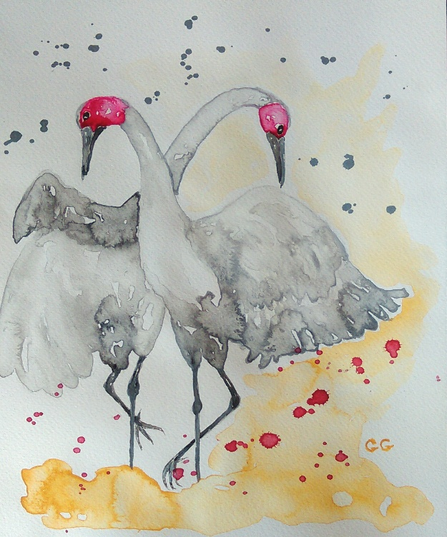

Amongst other things, Garry is a talented and successful artist, sculptor, scriptwriter, traveler and author. Unsuitable for big city life he finds fulfillment, excitement and wonder in his extensive travels, writing and art.
In the early 70s he built a 38 foot yacht and lived aboard, on Sydney Harbor for months as well as sailing extensively in the local area. Immediately prior to that endeavor he worked and lived aboard a tiny tugboat in the vast emptiness of the Gulf of Carpentaria in North Queensland, Australia, for almost a year. It was here he acquired not only his seamanship skills and a deep appreciation of nature, but a wondrous sense of awe for the brilliant celestial night sky which, in those days, was an integral component of his navigational aids. He acquired all of this from his indigenous Torres Straits Islander skipper who was his constant companion, during all of this time.
Garry’s last real job in Australia was as the caretaker of a large outback Queensland native flora botanical garden for 18 months. This outback experience was preceded by several years of international work and travel throughout Asia, Central and Western Europe mainly teaching English as a second language.
These experiences afforded him abundant ground-level opportunities to study the many and diverse local arts, crafts, religions, cultures and spiritual practices of the above regions: something Garry says everyone should strive to do at some stage of their lives, “and become a true graduate of the University of Life.”
Not shy of tertiary study, Garry also studied journalism at the Southern Cross University of New South Wales, Australia. He also has a Diploma of Photography from the Blackpool School of Art in the UK, and for a number of years was a News cameraman at Channel Seven, Canberra, Australia. He was born in the UK in 1948 and in 1950 migrated to Queensland with his family.
Garry calls tropical north Queensland home.





