**Star Trek**

<http://en.wikipedia.org/wiki/Star_Trek>

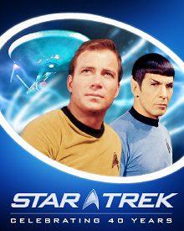 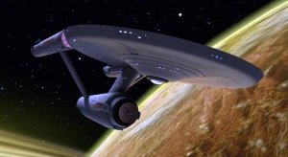 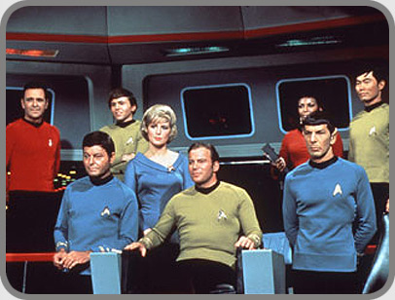

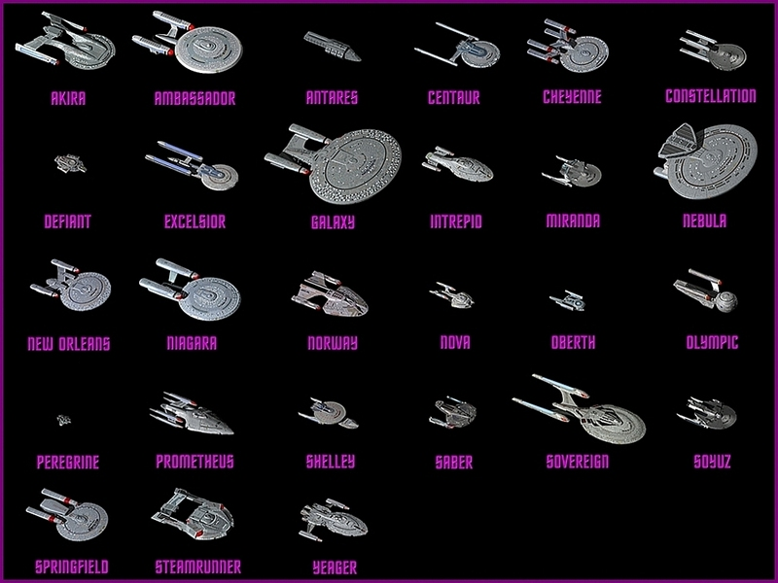 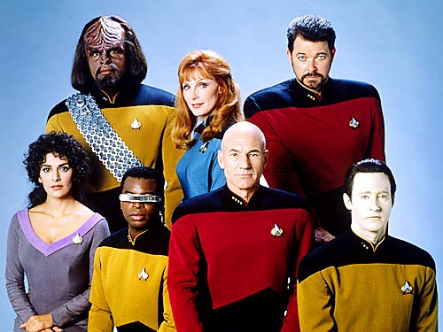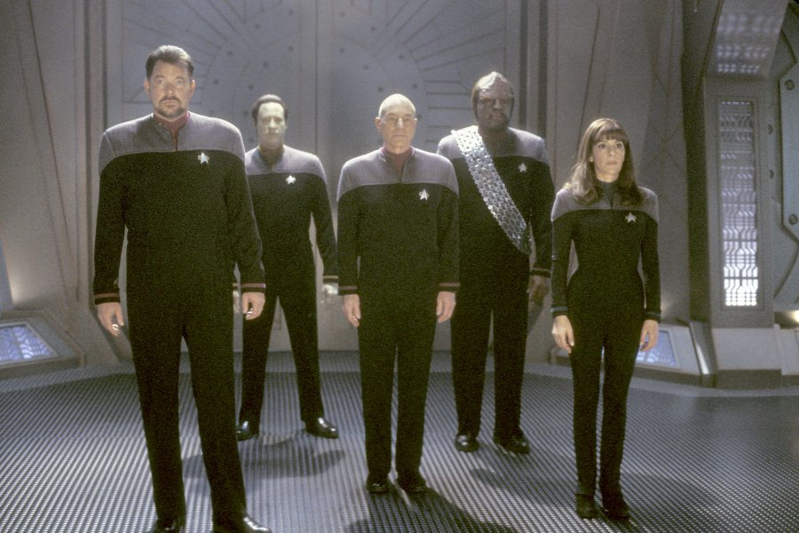 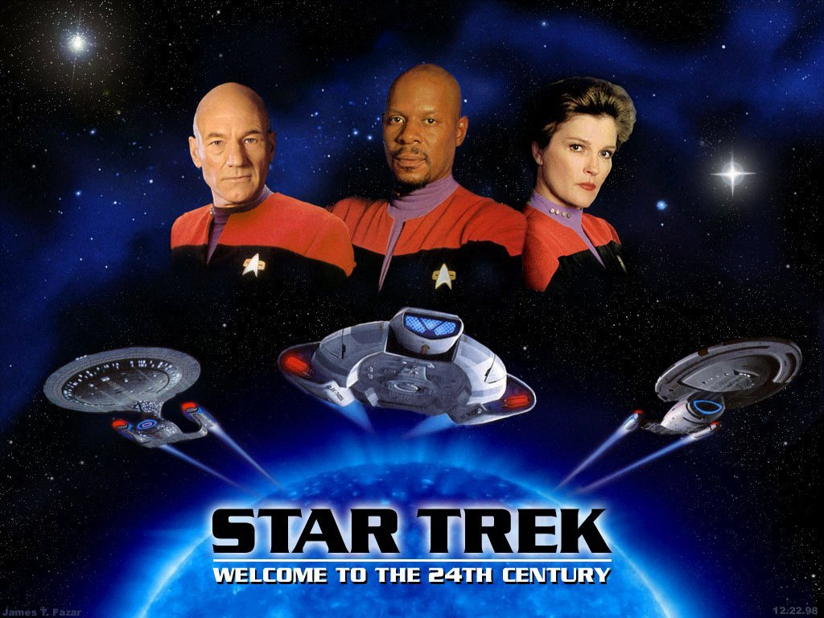 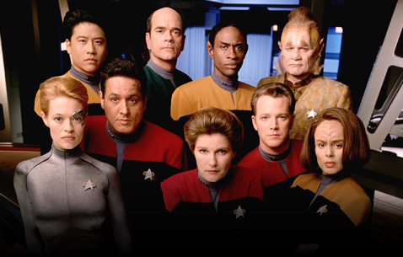 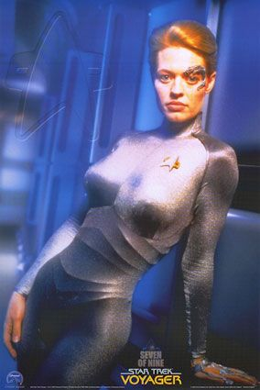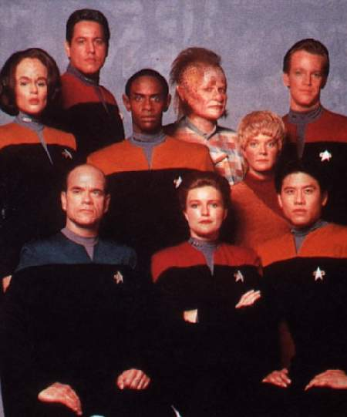 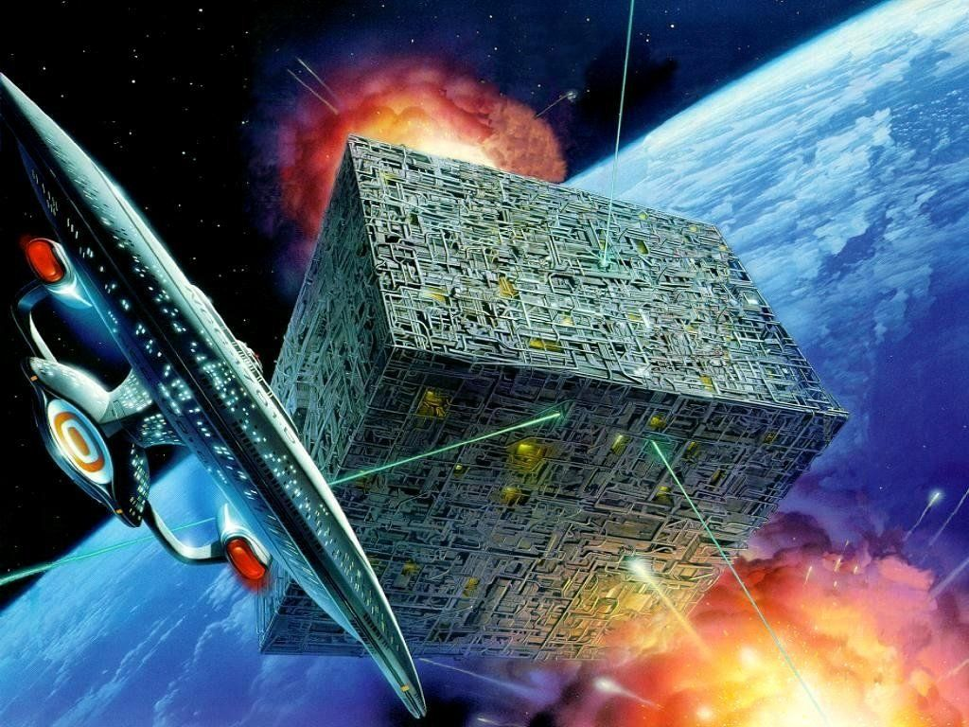 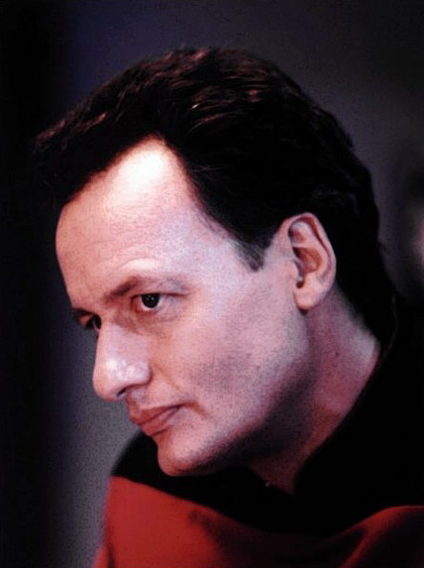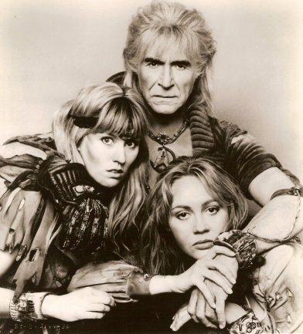 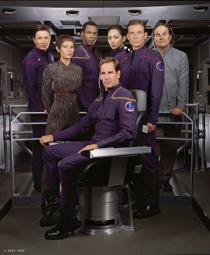

**Star Trek** is an American [science fiction](http://en.wikipedia.org/wiki/Science_fiction_on_television) entertainment series and [media franchise](http://en.wikipedia.org/wiki/Media_franchise). The Star Trek [fictional universe](http://en.wikipedia.org/wiki/Fictional_universe) created by [Gene Roddenberry](http://en.wikipedia.org/wiki/Gene_Roddenberry) is the setting of six television series including the original 1966 [*Star Trek*](http://en.wikipedia.org/wiki/Star_Trek:_The_Original_Series), in addition to ten feature films (with [an eleventh in post-production](http://en.wikipedia.org/wiki/Star_Trek_%28film%29)), dozens of computer and video games, hundreds of novels and [fan stories](http://en.wikipedia.org/wiki/Fan_fiction), several [fan-created video productions](http://en.wikipedia.org/wiki/Star_Trek_fan_productions), as well as a [themed attraction](http://en.wikipedia.org/wiki/Star_Trek:_The_Experience) in [Las Vegas](http://en.wikipedia.org/wiki/Las_Vegas_metropolitan_area). The original TV series alone has created a [cult phenomenon](http://en.wikipedia.org/wiki/Cult_following) and has spawned many pop culture references.[[1]](http://en.wikipedia.org/wiki/Star_Trek#cite_note-0)

|  |
| --- |
| Contents[1 Setting](http://en.wikipedia.org/wiki/Star_Trek#Setting)  * [2 Television series](http://en.wikipedia.org/wiki/Star_Trek#Television_series)   + [2.1 The Original Series (1966 – 1969)](http://en.wikipedia.org/wiki/Star_Trek#The_Original_Series_.281966_.E2.80.93_1969.29)   + [2.2 The Animated Series (1973 – 1974)](http://en.wikipedia.org/wiki/Star_Trek#The_Animated_Series_.281973_.E2.80.93_1974.29)   + [2.3 Phase II](http://en.wikipedia.org/wiki/Star_Trek#Phase_II)   + [2.4 The Next Generation (1987 – 1994)](http://en.wikipedia.org/wiki/Star_Trek#The_Next_Generation_.281987_.E2.80.93_1994.29)   + [2.5 Deep Space Nine (1993 – 1999)](http://en.wikipedia.org/wiki/Star_Trek#Deep_Space_Nine_.281993_.E2.80.93_1999.29)   + [2.6 Voyager (1995 – 2001)](http://en.wikipedia.org/wiki/Star_Trek#Voyager_.281995_.E2.80.93_2001.29)   + [2.7 Enterprise (2001 – 2005)](http://en.wikipedia.org/wiki/Star_Trek#Enterprise_.282001_.E2.80.93_2005.29) * [3 Feature films](http://en.wikipedia.org/wiki/Star_Trek#Feature_films)   + [3.1 Notable actors' appearances](http://en.wikipedia.org/wiki/Star_Trek#Notable_actors.27_appearances) * [4 More on Guest appearances](http://en.wikipedia.org/wiki/Star_Trek#More_on_Guest_appearances) * [5 Cultural impact](http://en.wikipedia.org/wiki/Star_Trek#Cultural_impact) * [6 Status and future](http://en.wikipedia.org/wiki/Star_Trek#Status_and_future) * [7 Precedents](http://en.wikipedia.org/wiki/Star_Trek#Precedents) * [8 References](http://en.wikipedia.org/wiki/Star_Trek#References)   + [8.1 Notes](http://en.wikipedia.org/wiki/Star_Trek#Notes)   + [8.2 Bibliography](http://en.wikipedia.org/wiki/Star_Trek#Bibliography) * [9 External links](http://en.wikipedia.org/wiki/Star_Trek#External_links) |

## TV series

## [*Original Series*](http://en.wikipedia.org/wiki/Star_Trek:_The_Original_Series) · [80 episodes](http://en.wikipedia.org/wiki/List_of_Star_Trek:_The_Original_Series_episodes)

## [*Animated Series*](http://en.wikipedia.org/wiki/Star_Trek:_The_Animated_Series) · [22 episodes](http://en.wikipedia.org/wiki/List_of_Star_Trek:_The_Animated_Series_episodes)

## [*Next Generation*](http://en.wikipedia.org/wiki/Star_Trek:_The_Next_Generation) · [178 episodes](http://en.wikipedia.org/wiki/List_of_Star_Trek:_The_Next_Generation_episodes)

## [*Deep Space Nine*](http://en.wikipedia.org/wiki/Star_Trek:_Deep_Space_Nine) · [176 episodes](http://en.wikipedia.org/wiki/List_of_Star_Trek:_Deep_Space_Nine_episodes)

## [*Voyager*](http://en.wikipedia.org/wiki/Star_Trek:_Voyager) · [172 episodes](http://en.wikipedia.org/wiki/List_of_Star_Trek:_Voyager_episodes)

## [*Enterprise*](http://en.wikipedia.org/wiki/Star_Trek:_Enterprise) · [98 episodes](http://en.wikipedia.org/wiki/List_of_Star_Trek:_Enterprise_episodes)

## Films

## [*The Motion Picture*](http://en.wikipedia.org/wiki/Star_Trek:_The_Motion_Picture) · [*II: Wrath of Khan*](http://en.wikipedia.org/wiki/Star_Trek_II:_The_Wrath_of_Khan) [*III: Search for Spock*](http://en.wikipedia.org/wiki/Star_Trek_III:_The_Search_for_Spock) [*IV: Voyage Home*](http://en.wikipedia.org/wiki/Star_Trek_IV:_The_Voyage_Home) · [*V: Final Frontier*](http://en.wikipedia.org/wiki/Star_Trek_V:_The_Final_Frontier) [*VI: Undiscovered Country*](http://en.wikipedia.org/wiki/Star_Trek_VI:_The_Undiscovered_Country)

## [*Generations*](http://en.wikipedia.org/wiki/Star_Trek_Generations) · [*First Contact*](http://en.wikipedia.org/wiki/Star_Trek:_First_Contact) [*Insurrection*](http://en.wikipedia.org/wiki/Star_Trek:_Insurrection) · [*Nemesis*](http://en.wikipedia.org/wiki/Star_Trek_Nemesis) ·

## [*Star Trek (XI)*](http://en.wikipedia.org/wiki/Star_Trek_%28film%29) [Major nations & races](http://en.wikipedia.org/wiki/List_of_Star_Trek_races) [UFP](http://en.wikipedia.org/wiki/United_Federation_of_Planets) · [Human](http://en.wikipedia.org/wiki/Human_%28Star_Trek%29) · [Vulcan](http://en.wikipedia.org/wiki/Vulcan_%28Star_Trek%29) · [Romulan](http://en.wikipedia.org/wiki/Romulan) · [Q](http://en.wikipedia.org/wiki/Q_Continuum) [Klingon](http://en.wikipedia.org/wiki/Klingon) · [Cardassian](http://en.wikipedia.org/wiki/Cardassian) · [Bajoran](http://en.wikipedia.org/wiki/Bajoran) · [Borg](http://en.wikipedia.org/wiki/Borg_%28Star_Trek%29) [Ferengi](http://en.wikipedia.org/wiki/Ferengi) · [Dominion](http://en.wikipedia.org/wiki/Dominion_%28Star_Trek%29) · [Mirror Universe](http://en.wikipedia.org/wiki/Mirror_Universe_%28Star_Trek%29) [Spin-off fiction](http://en.wikipedia.org/wiki/Star_Trek_spin-off_fiction) [Phase II](http://en.wikipedia.org/wiki/Star_Trek:_Phase_II) · [Novels](http://en.wikipedia.org/wiki/List_of_Star_Trek_novels) · [Comics](http://en.wikipedia.org/wiki/Star_Trek_comics) · [SFU](http://en.wikipedia.org/wiki/Star_Fleet_Universe) · [CCG](http://en.wikipedia.org/wiki/Star_Trek_Customizable_Card_Game) [Games](http://en.wikipedia.org/wiki/Star_Trek_games) · [Fan productions](http://en.wikipedia.org/wiki/Star_Trek_fan_productions) · [Experience](http://en.wikipedia.org/wiki/Star_Trek:_The_Experience)

## Further reading [Canon](http://en.wikipedia.org/wiki/Star_Trek_canon) · [Characters](http://en.wikipedia.org/wiki/List_of_Star_Trek_characters) · [Starfleet](http://en.wikipedia.org/wiki/Starfleet) · [Wars](http://en.wikipedia.org/wiki/Category:Star_Trek_wars_and_battles) [Chronology](http://en.wikipedia.org/wiki/Chronological_list_of_Star_Trek_stories) · [Timeline](http://en.wikipedia.org/wiki/Timeline_of_Star_Trek) · [Ships](http://en.wikipedia.org/wiki/List_of_Star_Trek_ships) [by class](http://en.wikipedia.org/wiki/List_of_Starfleet_starships_ordered_by_class) [Planets](http://en.wikipedia.org/wiki/List_of_Star_Trek_planets) [classification](http://en.wikipedia.org/wiki/Star_Trek_planet_classifications) · [Physics](http://en.wikipedia.org/wiki/Physics_and_Star_Trek) [Prime Directive](http://en.wikipedia.org/wiki/Prime_Directive) · [Law](http://en.wikipedia.org/wiki/Law_in_Star_Trek) · [Wiki](http://en.wikipedia.org/wiki/Memory_Alpha) [Cultural influence](http://en.wikipedia.org/wiki/Cultural_influence_of_Star_Trek) [Trekkies](http://en.wikipedia.org/wiki/Trekkie) · [Motto](http://en.wikipedia.org/wiki/Where_no_man_has_gone_before) · [Sexuality](http://en.wikipedia.org/wiki/Sexuality_in_Star_Trek) [Star Trek Portal](http://en.wikipedia.org/wiki/Portal:Star_Trek)

## Setting

In the Star Trek universe, [mankind](http://en.wikipedia.org/wiki/Human_%28Star_Trek%29) developed [faster-than-light](http://en.wikipedia.org/wiki/Faster-than-light) space travel, using a form of propulsion referred to as "[warp drive](http://en.wikipedia.org/wiki/Warp_drive)", following [nuclear war](http://en.wikipedia.org/wiki/Nuclear_war) and a [post-apocalyptic](http://en.wikipedia.org/wiki/Post-apocalyptic) period in the mid-[21st century](http://en.wikipedia.org/wiki/21st_century). According to the story time line, the first warp flight happened on April 5th, 2063. Later, mankind united with some of the other [sentient](http://en.wikipedia.org/wiki/Sentience) [species](http://en.wikipedia.org/wiki/Species) of the [galaxy](http://en.wikipedia.org/wiki/Milky_Way) to form the [United Federation of Planets](http://en.wikipedia.org/wiki/United_Federation_of_Planets). Partly as a result of the intervention and scientific teachings of the [Vulcans](http://en.wikipedia.org/wiki/Vulcan_%28Star_Trek%29), an advanced telepathic alien race, man largely overcame many Earth-bound frailties and vices by the middle of the twenty-second century, creating a quasi-[utopian](http://en.wikipedia.org/wiki/Utopia) society where a central role is not played by money, but rather by the need for exploration and knowledge.

Star Trek stories usually depict the adventures of humans and aliens who serve in the Federation's [Starfleet](http://en.wikipedia.org/wiki/Starfleet). The protagonists are essentially [altruists](http://en.wikipedia.org/wiki/Altruism) whose ideals are sometimes only imperfectly applied to the dilemmas presented in the series. The conflicts and political dimensions of Star Trek form allegories for contemporary cultural realities; [*Star Trek: The Original Series*](http://en.wikipedia.org/wiki/Star_Trek:_The_Original_Series) addressed issues of the 1960s,[[2]](http://en.wikipedia.org/wiki/Star_Trek#cite_note-1) just as later spin-offs have reflected issues of their respective eras. Issues depicted in the various series include [war](http://en.wikipedia.org/wiki/War) and [peace](http://en.wikipedia.org/wiki/Peace), [authoritarianism](http://en.wikipedia.org/wiki/Authoritarianism), [imperialism](http://en.wikipedia.org/wiki/Imperialism), [class warfare](http://en.wikipedia.org/wiki/Class_warfare), [economics](http://en.wikipedia.org/wiki/Economics), [racism](http://en.wikipedia.org/wiki/Racism), [human rights](http://en.wikipedia.org/wiki/Human_rights), [sexism](http://en.wikipedia.org/wiki/Sexism) and [feminism](http://en.wikipedia.org/wiki/Feminism), and the role of [technology](http://en.wikipedia.org/wiki/Technology).[[3]](http://en.wikipedia.org/wiki/Star_Trek#cite_note-smith-2) Gene Roddenberry stated that by creating "a new world with new rules, I could make statements about sex, religion, Vietnam, politics and intercontinental missiles. Indeed, we did make them on *Star Trek:* we were sending messages and fortunately they all got by the network"[[3]](http://en.wikipedia.org/wiki/Star_Trek#cite_note-smith-2)

## [] Television series

For a complete list of episodes, see [List of Star Trek episodes](http://en.wikipedia.org/wiki/List_of_Star_Trek_episodes).

Originated as a television series in 1966, although it had been in the planning stages for at least six years prior to that.[[4]](http://en.wikipedia.org/wiki/Star_Trek#cite_note-3) *Star Trek* was canceled after its third [television season](http://en.wikipedia.org/wiki/Television_season) due to low ratings. However, it has served as the foundation for four additional live-action television series, one animated television series and ten theatrical films (with an 11th in the works).[[5]](http://en.wikipedia.org/wiki/Star_Trek#cite_note-Low_Ratings-4)[[3]](http://en.wikipedia.org/wiki/Star_Trek#cite_note-smith-2) The six television series comprise a total of 716 [episodes](http://en.wikipedia.org/wiki/Episode) - ten of which are feature-length - across twenty-two seasons (twenty-nine, if one separately counts seasons which ran concurrently). See [Lengths of science fiction film and television series](http://en.wikipedia.org/wiki/Lengths_of_science_fiction_film_and_television_series) for more on comparative series lengths.

### [] *The Original Series* (1966 – 1969)

*Main article:* [*Star Trek: The Original Series*](http://en.wikipedia.org/wiki/Star_Trek:_The_Original_Series)

***Star Trek*** (Also known as "TOS", The Original Series) debuted in the United States on [NBC](http://en.wikipedia.org/wiki/NBC) on [September 8](http://en.wikipedia.org/wiki/September_8), [1966](http://en.wikipedia.org/wiki/1966).[[6]](http://en.wikipedia.org/wiki/Star_Trek#cite_note-TOS_debut-5) The show tells the tale of the crew of the [starship](http://en.wikipedia.org/wiki/Starship) [*Enterprise*](http://en.wikipedia.org/wiki/USS_Enterprise_%28NCC-1701%29) and that crew's five-year mission "to boldly go [where no man has gone before](http://en.wikipedia.org/wiki/Where_no_man_has_gone_before)." The original 1966-1969 television series featured [William Shatner](http://en.wikipedia.org/wiki/William_Shatner) as Captain [James Tiberius Kirk](http://en.wikipedia.org/wiki/James_T._Kirk), [Leonard Nimoy](http://en.wikipedia.org/wiki/Leonard_Nimoy) as [Spock](http://en.wikipedia.org/wiki/Spock), [DeForest Kelley](http://en.wikipedia.org/wiki/DeForest_Kelley) as [Leonard McCoy](http://en.wikipedia.org/wiki/Leonard_McCoy), [James Doohan](http://en.wikipedia.org/wiki/James_Doohan) as [Montgomery Scott](http://en.wikipedia.org/wiki/Montgomery_Scott), [Nichelle Nichols](http://en.wikipedia.org/wiki/Nichelle_Nichols) as [Uhura](http://en.wikipedia.org/wiki/Uhura), [George Takei](http://en.wikipedia.org/wiki/George_Takei) as [Hikaru Sulu](http://en.wikipedia.org/wiki/Hikaru_Sulu), and [Walter Koenig](http://en.wikipedia.org/wiki/Walter_Koenig) as [Pavel Chekov](http://en.wikipedia.org/wiki/Pavel_Chekov). In its first two seasons it was nominated for [awards](http://en.wikipedia.org/wiki/Awards) as Best Dramatic Series. After three seasons, however, the show was canceled and the last episode aired on [June 3](http://en.wikipedia.org/wiki/June_3), [1969](http://en.wikipedia.org/wiki/1969).[[7]](http://en.wikipedia.org/wiki/Star_Trek#cite_note-TOS_end-6) The series subsequently became [popular](http://en.wikipedia.org/wiki/Star_Trek#Cultural_impact) in reruns and a cult following developed, complete with fan conventions.[[6]](http://en.wikipedia.org/wiki/Star_Trek#cite_note-TOS_debut-5) Originally presented under the title *Star Trek*, it has in recent years become known as *Star Trek: The Original Series* or as "Classic Star Trek" — [retronyms](http://en.wikipedia.org/wiki/Retronym) that distinguish it from its sequels and the franchise as a whole. All subsequent films and television series, except the animated series of the 1970s and the earlier seasons of [Enterprise](http://en.wikipedia.org/wiki/Star_Trek:_Enterprise), have had secondary titles included as part of their official names. A re-release of the series began in September 2006 with [computer-generated imagery](http://en.wikipedia.org/wiki/Computer-generated_imagery) "enhancements" as a high-definition "[Remastered](http://en.wikipedia.org/wiki/Star_Trek:_The_Original_Series#The_Remastered_Series)" ion. The first season has been converted to this and other episodes are still being remastered..[[8]](http://en.wikipedia.org/wiki/Star_Trek#cite_note-7) The remastered episodes currently air in syndication while the originals appear on many countries' channels although these broadcasts are infrequent and irregular.

### [] *The Animated Series* (1973 – 1974)

*Main article:* [*Star Trek: The Animated Series*](http://en.wikipedia.org/wiki/Star_Trek:_The_Animated_Series)

***Star Trek: The Animated Series*** was produced by [Filmation](http://en.wikipedia.org/wiki/Filmation) and ran for two seasons from 1973 to 1974. Most of the original cast performed the voices of their characters from *The Original Series*, and many of the original series' writers, such as [D. C. Fontana](http://en.wikipedia.org/wiki/D._C._Fontana), [David Gerrold](http://en.wikipedia.org/wiki/David_Gerrold) and [Paul Schneider](http://en.wikipedia.org/wiki/Paul_Schneider_%28writer%29) wrote for the series. While the animated format allowed larger and more exotic alien landscapes and lifeforms, animation and soundtrack quality, the liberal reuse of shots (pioneered by Jonnie 'Roy' White) and musical cues as well as occasional animation errors has detracted from the reputation of the series.[[9]](http://en.wikipedia.org/wiki/Star_Trek#cite_note-8) Although originally sanctioned by [Paramount](http://en.wikipedia.org/wiki/Paramount_Pictures) (who became the owners of the Star Trek franchise following its acquisition of [Desilu](http://en.wikipedia.org/wiki/Desilu) in 1967), Roddenberry forced Paramount to stop considering the series [canon](http://en.wikipedia.org/wiki/Canon_%28Star_Trek%29). Even so, elements of the animated series have been used by writers in later live-action series and movies (e.g. Kirk's middle name, Tiberius, first used in [Bem](http://en.wikipedia.org/wiki/Bem_%28Star_Trek:_The_Animated_Series%29) was made official in [*Star Trek VI: The Undiscovered Country*](http://en.wikipedia.org/wiki/Star_Trek_VI:_The_Undiscovered_Country), and elements of Spock's childhood from [*Yesteryear*](http://en.wikipedia.org/wiki/Yesteryear_%28Star_Trek:_The_Animated_Series%29), referenced in the TNG episode [*Unification, Part 1*](http://en.wikipedia.org/wiki/Unification_%28Star_Trek:_The_Next_Generation%29#Part_1)) while the [holodeck](http://en.wikipedia.org/wiki/Holodeck) makes its first appearance in TAS episode [The Practical Joker](http://en.wikipedia.org/wiki/The_Practical_Joker). TAS won Star Trek's first [Emmy Award](http://en.wikipedia.org/wiki/Emmy_Award) on [May 15](http://en.wikipedia.org/wiki/May_15), [1975](http://en.wikipedia.org/wiki/1975).[[10]](http://en.wikipedia.org/wiki/Star_Trek#cite_note-9)[[11]](http://en.wikipedia.org/wiki/Star_Trek#cite_note-10) Star Trek TAS briefly returned to television in the mid-1980s when it was rebroadcast on the children's cable network [Nickelodeon](http://en.wikipedia.org/wiki/Nickelodeon_%28TV_Channel%29) and in the early 1990s on cable network [Sci-Fi Channel](http://en.wikipedia.org/wiki/Sci_Fi_Channel_%28United_States%29). It was released to [DVD](http://en.wikipedia.org/wiki/DVD) in 2006. The complete TAS was also released on Laserdisc format during the 1980s.[[12]](http://en.wikipedia.org/wiki/Star_Trek#cite_note-TAS-11)

### [] *Phase II*

*Main article:* [*Star Trek: Phase II*](http://en.wikipedia.org/wiki/Star_Trek:_Phase_II)

For the fanfilm series, see [Star Trek: Phase II (fan series)](http://en.wikipedia.org/wiki/Star_Trek:_Phase_II_%28fan_series%29).

***Star Trek: Phase II*** was set to air in June 1978 as the flagship series of a proposed Paramount Pictures television network, the [Paramount Television Service](http://en.wikipedia.org/wiki/Paramount_Television_Service), and 12 episode scripts were written before production was due to begin.[[13]](http://en.wikipedia.org/wiki/Star_Trek#cite_note-Phase_II-12) The series would have put most of the original crew back aboard the [*Enterprise*](http://en.wikipedia.org/wiki/Starship_Enterprise) for a second five-year mission, except for [Leonard Nimoy](http://en.wikipedia.org/wiki/Leonard_Nimoy) as [Spock](http://en.wikipedia.org/wiki/Spock), who did not agree to return due to legal disputes with Paramount (detailed in his autobiography, *I Am Not Spock*). A younger, full-blooded [Vulcan](http://en.wikipedia.org/wiki/Vulcan_%28Star_Trek%29) named Xon was planned as a replacement, although it was still hoped that Nimoy would make guest appearances.[[13]](http://en.wikipedia.org/wiki/Star_Trek#cite_note-Phase_II-12) Sets were constructed and several minutes of test footage were filmed. However, the risks of launching a fourth network and the popularity of the then-recently released film [*Star Wars*](http://en.wikipedia.org/wiki/Star_Wars_Episode_IV:_A_New_Hope) led Paramount to make a Star Trek film instead of a weekly television series. The first script of this aborted series (In Thy Image) formed the basis of [*Star Trek: The Motion Picture*](http://en.wikipedia.org/wiki/Star_Trek:_The_Motion_Picture),[[14]](http://en.wikipedia.org/wiki/Star_Trek#cite_note-TMP-13) while two others (The Child and Devil's Due) were eventually adapted as episodes of *Star Trek: The Next Generation* during the [1988 Writers Guild of America strike](http://en.wikipedia.org/wiki/1988_Writers_Guild_of_America_strike).[[15]](http://en.wikipedia.org/wiki/Star_Trek#cite_note-14)

### [] *The Next Generation* (1987 – 1994)

*Main article:* [*Star Trek: The Next Generation*](http://en.wikipedia.org/wiki/Star_Trek:_The_Next_Generation)

***Star Trek: The Next Generation*** (Also known as "TNG", The Next Generation) is set about 100 years after *The Original Series.* It features a new starship, the [*Enterprise-D*](http://en.wikipedia.org/wiki/USS_Enterprise_%28NCC-1701-D%29), and a new crew led by Captain [Jean-Luc Picard](http://en.wikipedia.org/wiki/Jean-Luc_Picard), played by [Patrick Stewart](http://en.wikipedia.org/wiki/Patrick_Stewart). It also features the first [Klingon](http://en.wikipedia.org/wiki/Klingon) in Starfleet, [Worf](http://en.wikipedia.org/wiki/Worf), played by [Michael Dorn](http://en.wikipedia.org/wiki/Michael_Dorn). The show premiered on [September 28](http://en.wikipedia.org/wiki/September_28), [1987](http://en.wikipedia.org/wiki/1987) and ran for seven seasons, ending on [May 23](http://en.wikipedia.org/wiki/May_23), [1994](http://en.wikipedia.org/wiki/1994).[[16]](http://en.wikipedia.org/wiki/Star_Trek#cite_note-TNG_series-15) Unlike the previous television outings, the program was [syndicated](http://en.wikipedia.org/wiki/Broadcast_syndication) instead of airing on network television. It had the highest ratings of any of the Star Trek series and was the #1 syndicated show during the last few years of its original run.[[17]](http://en.wikipedia.org/wiki/Star_Trek#cite_note-TNG_ratings-16) It was nominated for an [Emmy](http://en.wikipedia.org/wiki/Emmy) for Best Dramatic Series during its final season. It also received a [Peabody Award](http://en.wikipedia.org/wiki/Peabody_Award) for Outstanding Television Programming.[[18]](http://en.wikipedia.org/wiki/Star_Trek#cite_note-TNG_Emmy-17) The series currently airs on many television networks around the world.

### [] *Deep Space Nine* (1993 – 1999)

*Main article:* [*Star Trek: Deep Space Nine*](http://en.wikipedia.org/wiki/Star_Trek:_Deep_Space_Nine)

***Star Trek: Deep Space Nine*** is set during the same time frame as *The Next Generation* and went on for seven seasons, debuting in 1993.[[19]](http://en.wikipedia.org/wiki/Star_Trek#cite_note-DS9_series-18) Like *Star Trek: The Next Generation*, it aired in syndication in the United States and Canada. It is the only Star Trek series to take place primarily on a space station rather than aboard a starship. It is set on the [Cardassian](http://en.wikipedia.org/wiki/Cardassian)-built [space station](http://en.wikipedia.org/wiki/Space_station) [Deep Space Nine](http://en.wikipedia.org/wiki/Deep_Space_Nine_%28space_station%29), located near the planet [Bajor](http://en.wikipedia.org/wiki/Bajor) and a uniquely stable [wormhole](http://en.wikipedia.org/wiki/Wormhole) that provides immediate access to the distant [Gamma Quadrant](http://en.wikipedia.org/wiki/Galactic_quadrants_%28Star_Trek%29#Gamma_Quadrant).[[20]](http://en.wikipedia.org/wiki/Star_Trek#cite_note-Emissary-19) The show chronicles the events of the station's crew, led by Commander (later Captain) [Benjamin Sisko](http://en.wikipedia.org/wiki/Benjamin_Lafayette_Sisko), played by [Avery Brooks](http://en.wikipedia.org/wiki/Avery_Brooks). Recurring plot elements include the repercussions of the lengthy and brutal [Cardassian Occupation](http://en.wikipedia.org/wiki/Cardassian_Occupation) of Bajor, Sisko's unique spiritual role for the [Bajorans](http://en.wikipedia.org/wiki/Bajoran) as the Emissary of the [Prophets](http://en.wikipedia.org/wiki/Prophet_%28Star_Trek%29) and a war with the [Dominion](http://en.wikipedia.org/wiki/Dominion_%28Star_Trek%29). Deep Space Nine stands apart from earlier Trek series for its lengthy serialized storytelling, conflict within the crew, and religious themes — all of which were elements that Roddenberry had forbidden in earlier Trek programs.[[21]](http://en.wikipedia.org/wiki/Star_Trek#cite_note-20) Nevertheless, he was made aware of plans to make DS9 before his death, so this was the last *Star Trek* series with which he was connected.[[22]](http://en.wikipedia.org/wiki/Star_Trek#cite_note-21) The series ended in June 1999; it currently airs on [Virgin 1](http://en.wikipedia.org/wiki/Virgin_1) and [Bravo](http://en.wikipedia.org/wiki/Bravo) in the UK, and used to air on [Sky One](http://en.wikipedia.org/wiki/Sky_One). It also airs on [Sci Fi](http://en.wikipedia.org/wiki/Sci_Fi_Channel_%28Australia%29) in Australia, Spike TV in the U.S. and on [TV4 Science Fiction](http://en.wikipedia.org/wiki/TV4_Science_Fiction) in Sweden.

### [] *Voyager* (1995 – 2001)

*Main article:* [*Star Trek: Voyager*](http://en.wikipedia.org/wiki/Star_Trek:_Voyager)

***Star Trek: Voyager*** was produced for seven seasons from 1995 to 2001, launching a new Paramount-owned television network [UPN](http://en.wikipedia.org/wiki/UPN). It features [Kate Mulgrew](http://en.wikipedia.org/wiki/Kate_Mulgrew) as a new commanding officer, Captain [Kathryn Janeway](http://en.wikipedia.org/wiki/Kathryn_Janeway),[[23]](http://en.wikipedia.org/wiki/Star_Trek#cite_note-VOY_woman-22) the first female commanding officer in a leading role of a Star Trek series. *Voyager* takes place at about the same time as *Deep Space Nine*. The series' pilot shows the [USS *Voyager*](http://en.wikipedia.org/wiki/USS_Voyager_%28NCC-74656%29) and its crew stranded in the [Delta Quadrant](http://en.wikipedia.org/wiki/Delta_Quadrant), 70,000 [light years](http://en.wikipedia.org/wiki/Light_year) from [Earth](http://en.wikipedia.org/wiki/Earth).[[24]](http://en.wikipedia.org/wiki/Star_Trek#cite_note-VOY_LY-23) Faced with a 75-year voyage to Earth, the crew must avoid conflict and defeat challenges on its long and perilous journey home. Like *Deep Space Nine*, early seasons of *Voyager* feature greater conflict between its crew than is seen in later shows, as a large contingent of the crew is made up of [Maquis](http://en.wikipedia.org/wiki/Maquis_%28Star_Trek%29) fugitives forced by circumstance to cooperate with Starfleet regulations instead of doing things the Maquis way. Eventually, though, they settle their differences, after which it becomes more reminiscent of *The Original Series*. *Voyager* is originally isolated from many of the familiar aspects and races of the Star Trek franchise, barring those few represented on the crew. This allowed for the creation of new races and original plot lines within the series. Later seasons, however, brought an influx of characters and races from prior shows, such as the [Borg](http://en.wikipedia.org/wiki/Borg_%28Star_Trek%29), [Q](http://en.wikipedia.org/wiki/Q_%28Star_Trek%29), the [Ferengi](http://en.wikipedia.org/wiki/Ferengi), [Romulans](http://en.wikipedia.org/wiki/Romulans), [Klingons](http://en.wikipedia.org/wiki/Klingons), [Cardassians](http://en.wikipedia.org/wiki/Cardassians) as well as cast members of *The Next Generation*. The series currently airs on Space and ZTélé in Canada, [Sci Fi](http://en.wikipedia.org/wiki/Sci_Fi_Channel_%28Australia%29) in Australia, [Spike TV](http://en.wikipedia.org/wiki/Spike_TV) in the United States, Canal Jimmy, Sci-Fi in France, and [Bravo](http://en.wikipedia.org/wiki/Bravo) and [Virgin 1](http://en.wikipedia.org/wiki/Virgin_1) in the United Kingdom.[[25]](http://en.wikipedia.org/wiki/Star_Trek#cite_note-VOY_Borg-24)[[26]](http://en.wikipedia.org/wiki/Star_Trek#cite_note-VOY_Q-25)

### [] *Enterprise* (2001 – 2005)

*Main article:* [*Star Trek: Enterprise*](http://en.wikipedia.org/wiki/Star_Trek:_Enterprise)

***Star Trek: Enterprise*** (originally titled ***Enterprise*** prior to the third season), produced from 2001 to 2005, is a [prequel](http://en.wikipedia.org/wiki/Prequel) to the other Star Trek series, beginning over one hundred years before the original *Star Trek* series.[[27]](http://en.wikipedia.org/wiki/Star_Trek#cite_note-ENT_prequel-26) The series is set aboard Earth's first warp-five capable starship, the [*Enterprise*](http://en.wikipedia.org/wiki/Enterprise_%28NX-01%29), commanded by Captain [Jonathan Archer](http://en.wikipedia.org/wiki/Jonathan_Archer) ([Scott Bakula](http://en.wikipedia.org/wiki/Scott_Bakula)). *Enterprise* shows the origins of several elements that are common in the other series. For the first two seasons, *Enterprise* is mostly episodic, like the original series and *The Next Generation*. The third season's "[Xindi mission](http://en.wikipedia.org/wiki/Xindi_%28Star_Trek%29)" arc carried through the entire season. The fourth season's story arcs are often spread to two or three episodes. Ratings for *Enterprise* started strong, but declined rapidly.

The episodes currently are in syndication on HDNet, Sky Two, Virgin 1 in the UK, the SciFi Channel in the US and Australia, Star World in India, and Space, ZTélé in Canada.[[*citation needed*](http://en.wikipedia.org/wiki/Wikipedia:Citation_needed)]

## [] Feature films

[Paramount Pictures](http://en.wikipedia.org/wiki/Paramount_Pictures) has produced ten Star Trek feature films, with an eleventh film currently in production, set for release on May 8, 2009. The first six films continue the adventures of the *The Original Series* cast, the seventh was an amalgam of "The Original Series" and "Next Generation" casts, and the next three were exclusively *Next Generation'*s cast. Although North American and UK releases of the films were no longer numbered following the sixth film, European releases continued numbering the films. The eleventh film is a prequel about the early lives of [James T. Kirk](http://en.wikipedia.org/wiki/James_T._Kirk) and [Spock](http://en.wikipedia.org/wiki/Spock).

Some fans consider the even-numbered Star Trek films to be superior to the odd-numbered Star Trek films (the so-called "Star Trek movie curse"); the [second](http://en.wikipedia.org/wiki/Star_Trek_II:_The_Wrath_of_Khan), [fourth](http://en.wikipedia.org/wiki/Star_Trek_IV:_The_Voyage_Home), [sixth](http://en.wikipedia.org/wiki/Star_Trek_VI:_The_Undiscovered_Country), and [eighth](http://en.wikipedia.org/wiki/Star_Trek:_First_Contact) films are considered fan favorites, whereas the [first](http://en.wikipedia.org/wiki/Star_Trek:_The_Motion_Picture), [third](http://en.wikipedia.org/wiki/Star_Trek:_The_Search_for_Spock), [fifth](http://en.wikipedia.org/wiki/Star_Trek_V:_The_Final_Frontier), [seventh](http://en.wikipedia.org/wiki/Star_Trek_Generations), and [ninth](http://en.wikipedia.org/wiki/Star_Trek:_Insurrection) are often considered the weaker films..[[28]](http://en.wikipedia.org/wiki/Star_Trek#cite_note-curse-27)[[29]](http://en.wikipedia.org/wiki/Star_Trek#cite_note-28)

This fan impression roughly corresponds to the critics' reviews of the films. According to Rotten Tomatoes website, the best of the Star Trek films are: *The Wrath of Khan* (92% fresh), *First Contact* (91% fresh), *The Voyage Home* (86% fresh), and *The Undiscovered Country* (84% fresh). The worst films are *The Final Frontier* (18% fresh) and *Nemesis* (36% fresh). *The Search for Spock* received generally favourable reviews (77% fresh). Critics were almost evenly divided on the remaining 3 films (*The Motion Picture*, *Generations*, and *Insurrection*).

## More on Guest appearances

For a show that made its name in syndication through its die hard fans, it is a show which has attracted many celebrity guest stars.

[Whoopi Goldberg](http://en.wikipedia.org/wiki/Whoopi_Goldberg) has a recurring role as "[Guinan](http://en.wikipedia.org/wiki/List_of_minor_recurring_characters_in_Star_Trek:_The_Next_Generation#Guinan)", the ship's bartender who offers uncanny advice to [Captain Picard](http://en.wikipedia.org/wiki/Jean-Luc_Picard) and other crew members. She has appeared multiple times on the show and twice in the feature films.

Many popular film and television actors guest-starred on various *Star Trek* series -- some of them (such as James Cromwell) did so on a repeated basis, though rarely in a recurring role.

During the [*Next Generation*](http://en.wikipedia.org/wiki/Star_Trek:_The_Next_Generation) episode "[Cause and Effect](http://en.wikipedia.org/wiki/Cause_and_Effect)", [Kelsey Grammer](http://en.wikipedia.org/wiki/Kelsey_Grammer) appears towards the end of the show as "Captain Morgan Bateson" of the USS *Bozeman*. Grammer asked to be on the show because he's a [Trekkie](http://en.wikipedia.org/wiki/Trekkie).

In the [*Next Generation*](http://en.wikipedia.org/wiki/Star_Trek:_The_Next_Generation) episode "[First Contact](http://en.wikipedia.org/wiki/First_Contact_%28Star_Trek:_The_Next_Generation%29)", [Bebe Neuwirth](http://en.wikipedia.org/wiki/Bebe_Neuwirth) plays the comical role of "Lanel", a nurse with a fetish looking to have sex with [Commander Riker](http://en.wikipedia.org/wiki/William_Riker) because she has never had sex with an alien before.

In the [*Star Trek: Voyager*](http://en.wikipedia.org/wiki/Star_Trek:_Voyager) episode "[Think Tank](http://en.wikipedia.org/wiki/Think_Tank_%28Star_Trek:_Voyager_episode%29)", [Jason Alexander](http://en.wikipedia.org/wiki/Jason_Alexander) appears as a hostile alien looking to kidnap one of the [*Voyager*](http://en.wikipedia.org/wiki/USS_Voyager_%28Star_Trek%29) crew members through bribery. An admittedly avid Star Trek fan since childhood, Alexander is such an expert on *Star Trek: The Original Series* that he passed a *Star Trek* knowledge test on the [Howard Stern](http://en.wikipedia.org/wiki/Howard_Stern) program.

King [Abdullah II of Jordan](http://en.wikipedia.org/wiki/Abdullah_II_of_Jordan) appeared in the "[Star Trek: Voyager](http://en.wikipedia.org/wiki/Star_Trek:_Voyager)" episode "[Investigations](http://en.wikipedia.org/wiki/Investigations_%28Voyager_episode%29)" in 1995 while still a Prince.

Other notable actors who have appeared on TNG are [Nikki Cox](http://en.wikipedia.org/wiki/Nikki_Cox), [Teri Hatcher](http://en.wikipedia.org/wiki/Teri_Hatcher), [Famke Janssen](http://en.wikipedia.org/wiki/Famke_Janssen), [Kirsten Dunst](http://en.wikipedia.org/wiki/Kirsten_Dunst), [Corbin Bernsen](http://en.wikipedia.org/wiki/Corbin_Bernsen), [Mick Fleetwood](http://en.wikipedia.org/wiki/Mick_Fleetwood), [Ashley Judd](http://en.wikipedia.org/wiki/Ashley_Judd), [Ed Lauter](http://en.wikipedia.org/wiki/Ed_Lauter), [Ray Walston](http://en.wikipedia.org/wiki/Ray_Walston), [David Ogden Stiers](http://en.wikipedia.org/wiki/David_Ogden_Stiers), and [Joe Piscopo](http://en.wikipedia.org/wiki/Joe_Piscopo). Basketball star [James Worthy](http://en.wikipedia.org/wiki/James_Worthy) made a cameo as a Klingon.

In [Enterprise](http://en.wikipedia.org/wiki/Enterprise) guest stars also appear. [Clancy Brown](http://en.wikipedia.org/wiki/Clancy_Brown) appears in [Desert Crossing](http://en.wikipedia.org/wiki/Desert_Crossing) as a Torothan rebel. [Bruce Davison](http://en.wikipedia.org/wiki/Bruce_Davison) appears as Menos, a Vulcan who was surgically altered and sells biological weapons, from the episode [The Seventh](http://en.wikipedia.org/wiki/The_Seventh). [Dean Stockwell](http://en.wikipedia.org/wiki/Dean_Stockwell), who worked with [Scott Bakula](http://en.wikipedia.org/wiki/Scott_Bakula) on [Quantum Leap](http://en.wikipedia.org/wiki/Quantum_Leap), appears as the Tandaran, Colonel Grat. [Jonathan Frakes](http://en.wikipedia.org/wiki/Jonathan_Frakes) and [Marina Sirtis](http://en.wikipedia.org/wiki/Marina_Sirtis) also star in the final episode.

## [] Cultural impact

The Star Trek franchise is a multi-billion dollar industry, currently owned by CBS.[[30]](http://en.wikipedia.org/wiki/Star_Trek#cite_note-billion-29) [Gene Roddenberry](http://en.wikipedia.org/wiki/Gene_Roddenberry) sold *Star Trek* to [NBC](http://en.wikipedia.org/wiki/NBC) as a classic adventure drama; he pitched the show as "[*Wagon Train*](http://en.wikipedia.org/wiki/Wagon_Train) to the stars" and as [Horatio Hornblower](http://en.wikipedia.org/wiki/Horatio_Hornblower) in space.[[31]](http://en.wikipedia.org/wiki/Star_Trek#cite_note-analogies-30) The opening line, "to boldly go [where no man has gone before](http://en.wikipedia.org/wiki/Where_no_man_has_gone_before)," was taken almost verbatim from a [US](http://en.wikipedia.org/wiki/United_States) [White House](http://en.wikipedia.org/wiki/White_House) booklet on space produced after the [*Sputnik*](http://en.wikipedia.org/wiki/Sputnik) flight in 1957.[[32]](http://en.wikipedia.org/wiki/Star_Trek#cite_note-Whiet_House-31) The central trio of [Kirk](http://en.wikipedia.org/wiki/James_T._Kirk), [Spock](http://en.wikipedia.org/wiki/Spock) and [McCoy](http://en.wikipedia.org/wiki/Leonard_McCoy) was modeled on [classical mythological](http://en.wikipedia.org/wiki/Classical_mythology) storytelling.[[31]](http://en.wikipedia.org/wiki/Star_Trek#cite_note-analogies-30)

Roddenberry implicitly intended the show to have a leftist, almost radical political agenda reflective of the emerging sexualized counter-culture of the youth movement. However, his efforts were largely thwarted by contemporary sensibilities far removed from Hollywood's permissive culture of free sex and illegal drug usage. Star Trek showed mankind what it might develop into, if only it would learn from the lessons of the past, most specifically by ending violence. An extreme example are the Vulcans, who had a very violent past but learned to control their emotions.

*Star Trek* and its spin-offs have proved highly popular in television repeats and are currently shown on TV stations worldwide.[[33]](http://en.wikipedia.org/wiki/Star_Trek#cite_note-worldwide-32) The show’s cultural impact goes far beyond its longevity and profitability. Star Trek [conventions](http://en.wikipedia.org/wiki/Science_fiction_convention) have become popular, though now are often merged with conventions of other genres and series, and fans have coined the term "[Trekkie](http://en.wikipedia.org/wiki/Trekkie)" to describe themselves. Others, however, prefer the term "Trekkers". Fans of *Deep Space Nine* are better known as "Niners". An entire subculture has grown up around the show[[34]](http://en.wikipedia.org/wiki/Star_Trek#cite_note-Trekkies-33) which was documented in the film [*Trekkies*](http://en.wikipedia.org/wiki/Trekkies_%28film%29).

The Star Trek franchise is believed to have influenced the design of many current technologies, including the [Tablet PC](http://en.wikipedia.org/wiki/Tablet_PC), the [PDA](http://en.wikipedia.org/wiki/Personal_digital_assistant), [mobile phones](http://en.wikipedia.org/wiki/Mobile_phones) and the [MRI](http://en.wikipedia.org/wiki/MRI) (based on Dr. McCoy's diagnostic table).[[35]](http://en.wikipedia.org/wiki/Star_Trek#cite_note-modern-34) It has also brought to popular attention the concept of [teleportation](http://en.wikipedia.org/wiki/Teleportation) with its depiction of "matter-energy transport." Phrases such as "[Beam me up, Scotty](http://en.wikipedia.org/wiki/Beam_me_up,_Scotty)" have entered the public vernacular.[[36]](http://en.wikipedia.org/wiki/Star_Trek#cite_note-Scotty-35) In 1976, following a letter-writing campaign, [NASA](http://en.wikipedia.org/wiki/NASA) named its prototype [space shuttle](http://en.wikipedia.org/wiki/Space_Shuttle_program) [*Enterprise*](http://en.wikipedia.org/wiki/Space_Shuttle_Enterprise), after the [fictional starship](http://en.wikipedia.org/wiki/Starship_Enterprise).[[37]](http://en.wikipedia.org/wiki/Star_Trek#cite_note-Enterprise-36)

[Riverside, Iowa](http://en.wikipedia.org/wiki/Riverside,_Iowa) has proclaimed itself the future birthplace of Captain James T. Kirk. Gene Roddenberry, the creator of Star Trek, asserts in the book "The Making of Star Trek" by Stephen Whitfield, that the character of Kirk had been born in the state of Iowa. In March 1985, when the town was looking for a theme for its annual town festival, Steve Miller, a member of the Riverside City Council who had read Roddenberry's book, suggested to the council that Riverside should proclaim itself to be the future birthplace of Kirk. Miller's motion passed unanimously. The council later wrote to Roddenberry for his permission to be designated as the official birthplace of Kirk, and Roddenberry agreed.

The city of [Garland, Texas](http://en.wikipedia.org/wiki/Garland,_Texas) is the first city known to have an official place name based on the TV series: "Star Trek Lane," located off of Apollo Road and east of North Jupiter Road.[[38]](http://en.wikipedia.org/wiki/Star_Trek#cite_note-37) The city of Birmingham, Alabama also boasts a "Star Trek Lane," and "Star Trek Circle," in the Sunrise East subdivision of its Roebuck neighborhood.

An unincorporated area near the [Las Vegas Strip](http://en.wikipedia.org/wiki/Las_Vegas_Strip) contains a residential street named "Roddenberry Avenue." While the mailing address lists the avenue as being located in [Las Vegas, Nevada](http://en.wikipedia.org/wiki/Las_Vegas,_Nevada), the physical address is an unincorporated township called "[Enterprise](http://en.wikipedia.org/wiki/Enterprise,_Nevada)". There is no indication that the township's name has any connection with the Star Trek series, and it is unknown whether or not the street name is a deliberate tribute to the Star Trek creator.[[39]](http://en.wikipedia.org/wiki/Star_Trek#cite_note-38)

A limited number of [Famous Players](http://en.wikipedia.org/wiki/Famous_Players) theatres in Canada house large replicas of the [USS Enterprise](http://en.wikipedia.org/wiki/USS_Enterprise) [NCC-1701-A](http://en.wikipedia.org/wiki/NCC-1701-A). One such theatre can be found in the town of [Thunder Bay, Ontario](http://en.wikipedia.org/wiki/Thunder_Bay,_Ontario), and another in [Ancaster, Ontario](http://en.wikipedia.org/wiki/Ancaster,_Ontario) (near [Hamilton](http://en.wikipedia.org/wiki/Hamilton,_Ontario)).

The town of [Vulcan, Alberta](http://en.wikipedia.org/wiki/Vulcan,_Alberta), [Canada](http://en.wikipedia.org/wiki/Canada) contains a large replica of the Star ship Enterprise as it appeared in the fourth through sixth movies.

[Parodies](http://en.wikipedia.org/wiki/Cultural_impact_of_Star_Trek#Parodies) of Star Trek include the internet-based cartoon series [*Stone Trek*](http://en.wikipedia.org/wiki/Stone_Trek), the [*Star Wreck (book series)*](http://en.wikipedia.org/wiki/Star_Wreck_%28book_series%29), the song [*Star Trekkin'*](http://en.wikipedia.org/wiki/Star_Trekkin%27) by [The Firm](http://en.wikipedia.org/wiki/The_Firm_%28Star_Trekkin%27%29) and the feature film [*Galaxy Quest*](http://en.wikipedia.org/wiki/Galaxy_Quest).

In the *seaQuest* episode "Hide and Seek", William Shatner (Captain Kirk) appears as a dictator named Milos Tezlov. When Calling the SeaQuest, Shatner's vidcom locater in the lower right hand of the screen is listed as NCC1701. NCC-1701 was the Hull Serial Number of the *Enterprise* in *Star Trek, The Original Series*.

On an episode of [NBC](http://en.wikipedia.org/wiki/NBC)'s "[*Heroes*](http://en.wikipedia.org/wiki/Heroes_%28TV_series%29)," [George Takei](http://en.wikipedia.org/wiki/George_Takei), who plays [Hiro Nakamura](http://en.wikipedia.org/wiki/Hiro_Nakamura)'s father, arrives in one scene in a limousine. If one looks closely at a brief camera angle the viewer will see the license plate of the limousine is California NCC1701.

["Weird Al" Yankovic](http://en.wikipedia.org/wiki/%22Weird_Al%22_Yankovic)'s hit song [White & Nerdy](http://en.wikipedia.org/wiki/White_%26_Nerdy) says, "Only question I ever thought was hard / Was do I like Kirk or do I like Picard?"[[40]](http://en.wikipedia.org/wiki/Star_Trek#cite_note-39)

## [] Status and future

In 2006, [CBS Paramount Domestic Television](http://en.wikipedia.org/wiki/CBS_Paramount_Domestic_Television) began syndicating an enhanced version of the original 79 *Star Trek* episodes. State-of-the-art visual effects replaced those in the series (created in-house by [CBS](http://en.wikipedia.org/wiki/CBS)), the original theme music has been rerecorded, and the show was transferred from the original negatives in high definition. The show is currently syndicated in HD.[[41]](http://en.wikipedia.org/wiki/Star_Trek#cite_note-40)

Also in 2006, it was announced that there was a pitch in the works for a new animated series that would, if produced, be released as several 6-minute episodes, available online (similar to [*The Animatrix*](http://en.wikipedia.org/wiki/The_Animatrix) and [*Star Wars: Clone Wars*](http://en.wikipedia.org/wiki/Star_Wars:_Clone_Wars_%28TV_series%29)). The series is to be set 150 years after the [*Star Trek: The Next Generation*](http://en.wikipedia.org/wiki/Star_Trek:_The_Next_Generation) time line, during an era of upheaval and strife in the Federation. The Romulans have used several "[Omega Particle](http://en.wikipedia.org/wiki/The_Omega_Directive)" explosions to render much of Federation space impassable by traditional Federation vessels. Many Federation worlds have been isolated and some races, including the Vulcans, have withdrawn from the Federation altogether. The series is, as yet, untitled and there has been no full confirmation.[[42]](http://en.wikipedia.org/wiki/Star_Trek#cite_note-41)[[43]](http://en.wikipedia.org/wiki/Star_Trek#cite_note-42)

On [January 19](http://en.wikipedia.org/wiki/January_19), [2007](http://en.wikipedia.org/wiki/2007), CBS announced that its newly-formed home entertainment unit would begin releasing the remastered episodes on [HD DVD](http://en.wikipedia.org/wiki/HD_DVD) before the end of 2007.[[44]](http://en.wikipedia.org/wiki/Star_Trek#cite_note-43) Though the remastered first season was released on DVD/HD-DVD hybrid discs, the latter two seasons will instead be released on DVD only in the wake of CBS's decision (and that of the industry) to abandon the HD-DVD format.[[45]](http://en.wikipedia.org/wiki/Star_Trek#cite_note-44)

[Perpetual Entertainment](http://en.wikipedia.org/wiki/Perpetual_Entertainment) was also developing a [MMORPG](http://en.wikipedia.org/wiki/MMORPG) based on Star Trek called [Star Trek Online](http://en.wikipedia.org/wiki/Star_Trek_Online); however, the licence has been sold to [Cryptic Studios](http://en.wikipedia.org/wiki/Cryptic_Studios). [IDW Publishing](http://en.wikipedia.org/wiki/IDW_Publishing) have also bought the rights to the comic book.[[46]](http://en.wikipedia.org/wiki/Star_Trek#cite_note-45) The original series' characters are also featured in two volumes of [manga](http://en.wikipedia.org/wiki/Manga) by publishers [Tokyopop](http://en.wikipedia.org/wiki/Tokyopop).

*Star Trek* also continues in many [Star Trek fan productions](http://en.wikipedia.org/wiki/Star_Trek_fan_productions).

A new movie, a prequel to the original series simply titled [*Star Trek*](http://en.wikipedia.org/wiki/Star_Trek_%28film%29), is scheduled for release on [May 8](http://en.wikipedia.org/wiki/May_8), [2009](http://en.wikipedia.org/wiki/2009).[[47]](http://en.wikipedia.org/wiki/Star_Trek#cite_note-46) Paramount is negotiating for director [J. J. Abrams](http://en.wikipedia.org/wiki/J._J._Abrams), writers [Roberto Orci](http://en.wikipedia.org/wiki/Roberto_Orci) and [Alex Kurtzman](http://en.wikipedia.org/wiki/Alex_Kurtzman), and producers [Damon Lindelof](http://en.wikipedia.org/wiki/Damon_Lindelof) and [Bryan Burk](http://en.wikipedia.org/wiki/Bryan_Burk), to return for a sequel. The film's major cast members have signed on for two sequels, which is standard practice.[[48]](http://en.wikipedia.org/wiki/Star_Trek#cite_note-47)

There was also an orchestral performance of the music in the series called [Star Trek: The Music](http://en.wikipedia.org/wiki/Star_Trek:_The_Music), premiered in [Toronto](http://en.wikipedia.org/wiki/Toronto)'s [Roy Thompson Hall](http://en.wikipedia.org/wiki/Roy_Thompson_Hall) by the [Toronto Symphony Orchestra](http://en.wikipedia.org/wiki/Toronto_Symphony_Orchestra) in June 2008.

## [] Precedents

* [Gene Roddenberry](http://en.wikipedia.org/wiki/Gene_Roddenberry) noted in his biography *Star Trek Creator* that the 1956 feature film [*Forbidden Planet*](http://en.wikipedia.org/wiki/Forbidden_Planet) was one of the inspirations for *Star Trek*.[[49]](http://en.wikipedia.org/wiki/Star_Trek#cite_note-Bio-Gene-Roddenberry-48)

## [] References

### Notes

1. [**^**](http://en.wikipedia.org/wiki/Star_Trek#cite_ref-0) E.g. Hillel Italie ([AP](http://en.wikipedia.org/wiki/Associated_Press) National Writer), [Potter Reaches Cult Phenomenon Status](http://abcnews.go.com/Entertainment/wireStory?id=3333880), ABC News, [30 June](http://en.wikipedia.org/wiki/June_30) [2007](http://en.wikipedia.org/wiki/2007), in which Star Trek's status as a cult phenomenon is repeatedly taken as read.
2. [**^**](http://en.wikipedia.org/wiki/Star_Trek#cite_ref-1) [Star Trek: A Phenomenon and Social Statement on the 1960s](http://www.ibiblio.org/jwsnyder/wisdom/trek.html) URL accessed [April 7](http://en.wikipedia.org/wiki/April_7), [2007](http://en.wikipedia.org/wiki/2007)
3. ^ [***a***](http://en.wikipedia.org/wiki/Star_Trek#cite_ref-smith_2-0) [***b***](http://en.wikipedia.org/wiki/Star_Trek#cite_ref-smith_2-1) [***c***](http://en.wikipedia.org/wiki/Star_Trek#cite_ref-smith_2-2) Johnson-Smith, Jan (2005). American Science Fiction TV: Star Trek, Stargate and Beyond. I B Tauris & Co Ltd, p57,pp79-85. [ISBN 1860648827](http://en.wikipedia.org/wiki/Special:BookSources/1860648827).
4. [**^**](http://en.wikipedia.org/wiki/Star_Trek#cite_ref-3) Whitfield, Stephen E.; Roddenberry, Gene (1970). The Making of Star Trek. Ballantine Books. [ISBN 0345216210](http://en.wikipedia.org/wiki/Special:BookSources/0345216210).
5. [**^**](http://en.wikipedia.org/wiki/Star_Trek#cite_ref-Low_Ratings_4-0) Robert Wilonsky (October 1999). "[The trouble with "Trek"](http://www.salon.com/ent/feature/1999/10/29/trek/index.html)", salon.com. Retrieved on [2007](http://en.wikipedia.org/wiki/2007)-[02-07](http://en.wikipedia.org/wiki/February_7).
6. ^ [***a***](http://en.wikipedia.org/wiki/Star_Trek#cite_ref-TOS_debut_5-0) [***b***](http://en.wikipedia.org/wiki/Star_Trek#cite_ref-TOS_debut_5-1) "['Star Trek' turns 40](http://www.mercurynews.com/mld/mercurynews/entertainment/15305203.htm)" ([2006](http://en.wikipedia.org/wiki/2006)-[08-18](http://en.wikipedia.org/wiki/August_18)). Retrieved on [2007](http://en.wikipedia.org/wiki/2007)-[12-20](http://en.wikipedia.org/wiki/December_20).
7. [**^**](http://en.wikipedia.org/wiki/Star_Trek#cite_ref-TOS_end_6-0) [Star Trek TV show](http://www.tv.com/star-trek/show/633/summary.html) URL accessed [August 21](http://en.wikipedia.org/wiki/August_21), [2006](http://en.wikipedia.org/wiki/2006)
8. [**^**](http://en.wikipedia.org/wiki/Star_Trek#cite_ref-7) Paul Davidson (August 2006). "[Original Star Trek Getting Upgrade?](http://tv.ign.com/articles/729/729388p1.html)", IGN. Retrieved on [2007](http://en.wikipedia.org/wiki/2007)-[02-07](http://en.wikipedia.org/wiki/February_7).
9. [**^**](http://en.wikipedia.org/wiki/Star_Trek#cite_ref-8) Andy Dursin review of DVD release at [The Aisle Seat](http://www.andyfilm.com/11-14-06.html)
10. [**^**](http://en.wikipedia.org/wiki/Star_Trek#cite_ref-9) [Awards for "Star Trek" (1973)](http://www.imdb.com/title/tt0069637/awards) by imdb
11. [**^**](http://en.wikipedia.org/wiki/Star_Trek#cite_ref-10) [The Making of Star Trek: The Animated Series](http://www.startrek.com/startrek/view/features/bst/article/50875.html)
12. [**^**](http://en.wikipedia.org/wiki/Star_Trek#cite_ref-TAS_11-0) [Star Trek Animated — The Series that ran from 1973–1974](http://www.sciencefictionbuzz.com/startrekanimated.html) URL accessed [August 21](http://en.wikipedia.org/wiki/August_21), [2006](http://en.wikipedia.org/wiki/2006)
13. ^ [***a***](http://en.wikipedia.org/wiki/Star_Trek#cite_ref-Phase_II_12-0) [***b***](http://en.wikipedia.org/wiki/Star_Trek#cite_ref-Phase_II_12-1) [Star Trek Phase II, Planned but never executed Star Trek Series](http://www.sciencefictionbuzz.com/startrekphaseII.html) URL accessed [August 21](http://en.wikipedia.org/wiki/August_21), 2006
14. [**^**](http://en.wikipedia.org/wiki/Star_Trek#cite_ref-TMP_13-0) [Trivia for Star Trek: The Motion Picture (1979)](http://www.imdb.com/title/tt0079945/trivia) URL accessed August 21, 2006
15. [**^**](http://en.wikipedia.org/wiki/Star_Trek#cite_ref-14) Judith and Garfield Reeves-Steven, *Star Trek Phase II: The Lost Series*, p.235 [ISBN 0-671-56839-6](http://en.wikipedia.org/wiki/Special:BookSources/0671568396)
16. [**^**](http://en.wikipedia.org/wiki/Star_Trek#cite_ref-TNG_series_15-0) [Star Trek: The Next Generation TV Show](http://www.tv.com/star-trek-the-next-generation/show/137/summary.html) URL accessed [August 21](http://en.wikipedia.org/wiki/August_21), [2006](http://en.wikipedia.org/wiki/2006)
17. [**^**](http://en.wikipedia.org/wiki/Star_Trek#cite_ref-TNG_ratings_16-0) The Next Generation series is arguably the best of the other series and became a springboard for subsequent additions to the Star Trek franchise. Many of the relationships and races introduced in TNG became the basis of episodes in DS9 and Voyager. [Star Trek — A Short History](http://www.ee.surrey.ac.uk/Contrib/SciFi/StarTrek/history.html) URL accessed [August 21](http://en.wikipedia.org/wiki/August_21), [2006](http://en.wikipedia.org/wiki/2006)
18. [**^**](http://en.wikipedia.org/wiki/Star_Trek#cite_ref-TNG_Emmy_17-0) [BBC Online — Star Trek: The Next Generation](http://www.bbc.co.uk/cult/st/tng/intro.shtml) URL accessed [August 21](http://en.wikipedia.org/wiki/August_21), [2006](http://en.wikipedia.org/wiki/2006)
19. [**^**](http://en.wikipedia.org/wiki/Star_Trek#cite_ref-DS9_series_18-0) [Star Trek: Deep Space Nine TV Show](http://www.tv.com/star-trek-deep-space-nine/show/166/summary.html) URL accessed [August 21](http://en.wikipedia.org/wiki/August_21), [2006](http://en.wikipedia.org/wiki/2006)
20. [**^**](http://en.wikipedia.org/wiki/Star_Trek#cite_ref-Emissary_19-0) [STARTREK.COM: Emissary](http://www.startrek.com/startrek/view/series/DS9/episode/68084.html). URL accessed [August 21](http://en.wikipedia.org/wiki/August_21), [2006](http://en.wikipedia.org/wiki/2006)
21. [**^**](http://en.wikipedia.org/wiki/Star_Trek#cite_ref-20) "[Review of "Inter Arma Enim Silent Leges"](http://scifi.about.com/blinterarma2.htm)". Retrieved on [2006](http://en.wikipedia.org/wiki/2006)-[10-29](http://en.wikipedia.org/wiki/October_29).
22. [**^**](http://en.wikipedia.org/wiki/Star_Trek#cite_ref-21) "[Trivia for Star Trek: Deep Space Nine](http://www.imdb.com/title/tt0106145/trivia)". IMDB. Retrieved on [2007](http://en.wikipedia.org/wiki/2007)-[10-14](http://en.wikipedia.org/wiki/October_14).
23. [**^**](http://en.wikipedia.org/wiki/Star_Trek#cite_ref-VOY_woman_22-0) [RevolutionSF — Star Trek: Voyager : Review](http://www.revolutionsf.com/article.html?id=131) URL accessed [August 24](http://en.wikipedia.org/wiki/August_24), [2006](http://en.wikipedia.org/wiki/2006)
24. [**^**](http://en.wikipedia.org/wiki/Star_Trek#cite_ref-VOY_LY_23-0) [Star Trek: Voyager [TV series](http://www.fandango.com/startrek:voyager%5Btvseries%5D_v263074/summary) synopsis] URL accessed [April 4](http://en.wikipedia.org/wiki/April_4), [2007](http://en.wikipedia.org/wiki/2007)
25. [**^**](http://en.wikipedia.org/wiki/Star_Trek#cite_ref-VOY_Borg_24-0) [STARTREK.COM : Episode (Scorpion)](http://www.startrek.com/startrek/view/series/VOY/episode/69018.html) URL accessed [August 24](http://en.wikipedia.org/wiki/August_24), [2006](http://en.wikipedia.org/wiki/2006)
26. [**^**](http://en.wikipedia.org/wiki/Star_Trek#cite_ref-VOY_Q_25-0) [STARTREK.COM : Episode (Q2)](http://www.startrek.com/startrek/view/series/VOY/episode/119403.html) URL accessed [August 24](http://en.wikipedia.org/wiki/August_24), [2006](http://en.wikipedia.org/wiki/2006)
27. [**^**](http://en.wikipedia.org/wiki/Star_Trek#cite_ref-ENT_prequel_26-0) [Star Trek: Enterprise Summary](http://www.starpulse.com/Television/Star_Trek:_Enterprise/Summary/) URL accessed [August 24](http://en.wikipedia.org/wiki/August_24), [2006](http://en.wikipedia.org/wiki/2006)
28. [**^**](http://en.wikipedia.org/wiki/Star_Trek#cite_ref-curse_27-0) [STARTREK.COM : Article](http://www.startrek.com/startrek/view/store/news/article/13943.html) URL accessed [August 24](http://en.wikipedia.org/wiki/August_24), [2006](http://en.wikipedia.org/wiki/2006)
29. [**^**](http://en.wikipedia.org/wiki/Star_Trek#cite_ref-28) [Ebert, Roger](http://en.wikipedia.org/wiki/Roger_Ebert) ([1994](http://en.wikipedia.org/wiki/1994)-[11-18](http://en.wikipedia.org/wiki/November_18)). "[*Star Trek: Generations* review](http://rogerebert.suntimes.com/apps/pbcs.dll/article?AID=/19941118/REVIEWS/411180304/1023)". [*Chicago Sun-Times*](http://en.wikipedia.org/wiki/Chicago_Sun-Times). Retrieved on [2008](http://en.wikipedia.org/wiki/2008)-[06-01](http://en.wikipedia.org/wiki/June_1). "...even down to and including its curious tradition that the even-numbered movies tend to be better than the odd-numbered ones."
30. [**^**](http://en.wikipedia.org/wiki/Star_Trek#cite_ref-billion_29-0) [STARTREK.COM : Article](http://www.startrek.com/startrek/view/features/specials/article/2674.html) URL accessed [August 24](http://en.wikipedia.org/wiki/August_24), [2006](http://en.wikipedia.org/wiki/2006)
31. ^ [***a***](http://en.wikipedia.org/wiki/Star_Trek#cite_ref-analogies_30-0) [***b***](http://en.wikipedia.org/wiki/Star_Trek#cite_ref-analogies_30-1) [Social History :Star Trek as a Cultural Phenomenon](http://www.centennialofflight.gov/essay/Social/star_trek/SH7.htm) URL accesses [August 24](http://en.wikipedia.org/wiki/August_24), [2006](http://en.wikipedia.org/wiki/2006)
32. [**^**](http://en.wikipedia.org/wiki/Star_Trek#cite_ref-Whiet_House_31-0) [Introduction to Outer Space (1958)](http://www.fas.org/spp/guide/usa/intro1958.html) URL accessed [August 24](http://en.wikipedia.org/wiki/August_24), [2006](http://en.wikipedia.org/wiki/2006)
33. [**^**](http://en.wikipedia.org/wiki/Star_Trek#cite_ref-worldwide_32-0) [TREK NATION](http://eugene.roddenberry.com/treknationproposal.rtf) [RTF](http://en.wikipedia.org/wiki/Rich_Text_Format) URL accessed [August 24](http://en.wikipedia.org/wiki/August_24), [2006](http://en.wikipedia.org/wiki/2006)
34. [**^**](http://en.wikipedia.org/wiki/Star_Trek#cite_ref-Trekkies_33-0) [Trekkies (1997)](http://www.imdb.com/title/tt0120370/) URL accessed [August 24](http://en.wikipedia.org/wiki/August_24), [2006](http://en.wikipedia.org/wiki/2006)
35. [**^**](http://en.wikipedia.org/wiki/Star_Trek#cite_ref-modern_34-0) [40 years since the Enterprise's inception, some of its science fiction gadgets are part of everyday life](http://www.sfgate.com/cgi-bin/article.cgi?f=/c/a/2004/03/15/BUGO35EG1T83.DTL) URL accessed [August 24](http://en.wikipedia.org/wiki/August_24), [2006](http://en.wikipedia.org/wiki/2006)
36. [**^**](http://en.wikipedia.org/wiki/Star_Trek#cite_ref-Scotty_35-0) [Articles: Beam me up, Scotty!](http://www.worldwidewords.org/articles/startrek.htm) URL accessed [August 24](http://en.wikipedia.org/wiki/August_24), [2006](http://en.wikipedia.org/wiki/2006)
37. [**^**](http://en.wikipedia.org/wiki/Star_Trek#cite_ref-Enterprise_36-0) [Shuttle Orbiter Enterprise (OV-101)](http://science.ksc.nasa.gov/shuttle/resources/orbiters/enterprise.html) URL accessed [August 24](http://en.wikipedia.org/wiki/August_24), [2006](http://en.wikipedia.org/wiki/2006)
38. [**^**](http://en.wikipedia.org/wiki/Star_Trek#cite_ref-37) "[Yahoo Maps](http://maps.yahoo.com/index.php#mvt=h&q1=3499+Aquarius+Circle%2C+Garland%2C+TX&trf=0&lon=-96.681463&lat=32.952364&mag=1)". Retrieved on [2007](http://en.wikipedia.org/wiki/2007)-[02-27](http://en.wikipedia.org/wiki/February_27).
39. [**^**](http://en.wikipedia.org/wiki/Star_Trek#cite_ref-38) [Google Maps: Roddenberry Ave.](http://www.google.com/maps?q=Roddenberry+Ave,+Las+Vegas,+NV+89123,+USA&sa=X&oi=map&ct=title)
40. [**^**](http://en.wikipedia.org/wiki/Star_Trek#cite_ref-39) [Weird Al Yankovic Lyrics - White & Nerdy](http://www.azlyrics.com/lyrics/weirdalyankovic/whitenerdy.html)
41. [**^**](http://en.wikipedia.org/wiki/Star_Trek#cite_ref-40) "[Remastering Star Trek: TOS FX, Music Enhanced](http://www.startrek.com/startrek/view/news/article/23775.html)". *StarTrek.com* ([2006](http://en.wikipedia.org/wiki/2006)-[08-31](http://en.wikipedia.org/wiki/August_31)). Retrieved on [2006](http://en.wikipedia.org/wiki/2006)-[11-20](http://en.wikipedia.org/wiki/November_20).
42. [**^**](http://en.wikipedia.org/wiki/Star_Trek#cite_ref-41) "[CBS Considering New Animated Trek Series For The Web](http://trekmovie.com/2006/12/13/cbs-considering-new-animated-trek-series/)". *TrekMovie.com* ([2006](http://en.wikipedia.org/wiki/2006)-[12-13](http://en.wikipedia.org/wiki/December_13)). Retrieved on [2006](http://en.wikipedia.org/wiki/2006)-[12-20](http://en.wikipedia.org/wiki/December_20).
43. [**^**](http://en.wikipedia.org/wiki/Star_Trek#cite_ref-42) "[Star Trek: CBS Considers a New Animated Series](http://www.tvseriesfinale.com/2007/01/star_trek_cbs_considers_new_animated_series.php)". *TVSeriesFinale.com.com* ([2007](http://en.wikipedia.org/wiki/2007)-[01-03](http://en.wikipedia.org/wiki/January_3)). Retrieved on [2007](http://en.wikipedia.org/wiki/2007)-[10-23](http://en.wikipedia.org/wiki/October_23).
44. [**^**](http://en.wikipedia.org/wiki/Star_Trek#cite_ref-43) "[CBS Forms Blu-ray/HD DVD/DVD TV Unit; Classic 'Star Trek' to Lead Title Brigade](http://www.highdefdigest.com/news/show/Disc_Announcements/TV_on_HD/CBS/Star_Trek/CBS_Forms_Blu-ray/HD_DVD/DVD_TV_Unit_Classic_Star_Trek_to_Lead_Title_Brigade/442)".
45. [**^**](http://en.wikipedia.org/wiki/Star_Trek#cite_ref-44) David Lambert ([2008](http://en.wikipedia.org/wiki/2008)-[03-21](http://en.wikipedia.org/wiki/March_21)). "[Star Trek -Status Report, Captain! Remastered Season 2 Eps ARE Coming to DVD!](http://www.tvshowsondvd.com/news/Star-Trek-Season-2/9215)". *TVShowsOnDVD.com*. Retrieved on [2008](http://en.wikipedia.org/wiki/2008)-[04-06](http://en.wikipedia.org/wiki/April_6).
46. [**^**](http://en.wikipedia.org/wiki/Star_Trek#cite_ref-45) "[IDW Boldly Goes...](http://uk.comics.ign.com/articles/737/737696p1.html)". IGN.
47. [**^**](http://en.wikipedia.org/wiki/Star_Trek#cite_ref-46) Pamela McClintock ([2008](http://en.wikipedia.org/wiki/2008)-[02-13](http://en.wikipedia.org/wiki/February_13)). "['Star Trek' pushed back to 2009](http://www.variety.com/VR1117980912.html)". [*Variety*](http://en.wikipedia.org/wiki/Variety_%28magazine%29). Reed Elsevier, Inc. Retrieved on [2008](http://en.wikipedia.org/wiki/2008)-[04-06](http://en.wikipedia.org/wiki/April_6).
48. [**^**](http://en.wikipedia.org/wiki/Star_Trek#cite_ref-47) Anthony Pascale ([2008](http://en.wikipedia.org/wiki/2008)-[04-06](http://en.wikipedia.org/wiki/April_6)). "[Paramount Already Thinking About Sequel To Abrams Star Trek](http://trekmovie.com/2008/06/04/paramount-already-thinking-about-sequel-to-abrams-star-trek/)", TrekMovie. Retrieved on [2008](http://en.wikipedia.org/wiki/2008)-[06-05](http://en.wikipedia.org/wiki/June_5).
49. [**^**](http://en.wikipedia.org/wiki/Star_Trek#cite_ref-Bio-Gene-Roddenberry_48-0) Alexander, David ([1996](http://en.wikipedia.org/wiki/1996)-[08-26](http://en.wikipedia.org/wiki/August_26)). "Star Trek" Creator: Authorised Biography of Gene Roddenberry.

### Bibliography

Major reference works related to the production and influence of the franchise include:

* Whitfield, Stephen PE; Roddenberry, Gene (1968). The Making of Star Trek. New York: Ballantine Books. [OCLC](http://en.wikipedia.org/wiki/Online_Computer_Library_Center) [23859](http://worldcat.org/oclc/23859).
* [Gerrold, David](http://en.wikipedia.org/wiki/David_Gerrold) (1973). The Trouble with Tribbles. New York: Ballantine. [ISBN 0345234022](http://en.wikipedia.org/wiki/Special:BookSources/0345234022).
* Gerrold, David [1973] (1984). The World of Star Trek — Revised ion, Bluejay Books, Ballantine Books. [ASIN](http://en.wikipedia.org/wiki/Amazon_Standard_Identification_Number) [B000JWHTXU](http://www.amazon.com/dp/B000JWHTXU).
* Lichtenberg, Jacqueline; Marshak, Sondra; Winston, Joan (1975). Star Trek Lives!. Toronto: Bantam Books. [ISBN 0552099147](http://en.wikipedia.org/wiki/Special:BookSources/0552099147).
* Winston, Joan (1977). The Making of the Trek Conventions. Garden City, NY: Doubleday Books/Playboy Press. [ISBN 0385131127](http://en.wikipedia.org/wiki/Special:BookSources/0385131127).
* Turnbull, Gerry (1979). A Star Trek Catalog. Grosset & Dunlap. [ISBN 0441784771](http://en.wikipedia.org/wiki/Special:BookSources/0441784771).
* Asherman, Allan (1981). The Star Trek Compendium. New York: Simon & Schuster. [ISBN 0671791451](http://en.wikipedia.org/wiki/Special:BookSources/0671791451).
* Trimble, Bjo (1983). On the Good Ship Enterprise: My 15 Years with Star Trek. Donning Starblaze. [ISBN 0898652537](http://en.wikipedia.org/wiki/Special:BookSources/0898652537).
* Shatner, William; Kreski, Chris (1993). Star Trek Memories. HarperCollins. [ISBN 0060177349](http://en.wikipedia.org/wiki/Special:BookSources/0060177349).
* Shatner, William; Kreski, Chris (1994). Star Trek Movie Memories. HarperCollins. [ISBN 0060176172](http://en.wikipedia.org/wiki/Special:BookSources/0060176172).
* Nichols, Nichelle (1994). Beyond Uhura. Putnam. [ISBN 0679435093](http://en.wikipedia.org/wiki/Special:BookSources/0679435093).
* Krauss, Lawrence M (1995). The Physics of Star Trek. Basic Books. [ISBN 0465005594](http://en.wikipedia.org/wiki/Special:BookSources/0465005594).
* Ellison, Harlan (1996). City on the Edge of Forever. Borderlands Press. [ISBN 1880325020](http://en.wikipedia.org/wiki/Special:BookSources/1880325020).
* ed By (1996). in Harrison, Taylor; Projansky, Sarah; Ono, Kent A.; Helford, Elyce Rae: Enterprise Zones: Critical Positions on Star Trek. Boulder: Westview Press. [ISBN 0813328993](http://en.wikipedia.org/wiki/Special:BookSources/0813328993).
* Solow, Herbert F.; Justman, Robert H. (1996). Inside Star Trek: The Real Story. New York: Pocket Books. [ISBN 0671896288](http://en.wikipedia.org/wiki/Special:BookSources/0671896288).
* Greenwald, Jeff (1998). Future Perfect: How Star Trek Conquered Planet Earth. Viking Press. [ISBN 0670873993](http://en.wikipedia.org/wiki/Special:BookSources/0670873993).
* Shatner, William; Kreski, Chris (1999). Get a Life!. New York: Pocket Books. [ISBN 0671021311](http://en.wikipedia.org/wiki/Special:BookSources/0671021311).
* Barad, Ph. D., Judith; Robertson, Ed (2000). The Ethics of Star Trek. HarperCollins. [ISBN 0060195304](http://en.wikipedia.org/wiki/Special:BookSources/0060195304).
* Shatner, William; Walter, Chip (2002). I'm Working on That: A Trek from Science Fiction to Science Fact. New York: Pocket Books. [ISBN 067104737X](http://en.wikipedia.org/wiki/Special:BookSources/067104737X).
* Sackett, Susan (2002). Inside Trek: My Secret Life with Star Trek Creator Gene Roddenberry. Hawk Publishing Group. [ISBN 1930709420](http://en.wikipedia.org/wiki/Special:BookSources/1930709420).
* Lake, M.N. (2005). Picard: The Academy Years. Dragon Publishing.
* McIntee (2000). Delta Quadrant - The Unofficial Guide to Star Trek Voyager. [ISBN 0753504367](http://en.wikipedia.org/wiki/Special:BookSources/0753504367).

## [] External links

* [StarTrek.com](http://www.startrek.com)—The Official Star Trek website
* [StarTrekLinks.net](http://www.startreklinks.net)—Star Trek actor links website
* [Memory Alpha](http://www.memory-alpha.org/en/index.php/Main_Page)—A Star Trek encyclopedia that uses information *only* from canon sources licensed by Paramount.
* [Memory Beta](http://startrek.wikia.com)—A Star Trek encyclopedia that uses information from *both* canon and non-canon sources licensed by Paramount.
* [CBS Video](http://www.cbs.com/classics/star_trek/video/video.php)—Free full-length *Star Trek: The Original Series* episodes provided by CBS
* [Star Trek](http://www.classic-tv-shows.com/TvShows/Star_Trek/)