# **10 Life Quotes from Dr. Seuss**

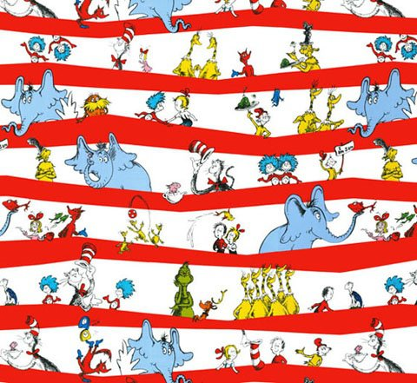

**Dr. Seuss on…**

[**http://www.elephantjournal.com/2012/08/10-life-quotes-from-dr-seuss/**](http://www.elephantjournal.com/2012/08/10-life-quotes-from-dr-seuss/)

1. being yourself:

**“Be who you are and say what you feel, because those who mind don’t matter and those who matter don’t mind.”**

2. freedom and choice:

**“You have brains in your head. You have feet in your shoes. You can steer yourself, any direction you choose.”**

3. no regrets:

**“Don’t cry because it’s over, smile because it happened.”**

4. clarity:

**“Sometimes the questions are complicated and the answers are simple.”**

5. creativity:

**“I like nonsense, it wakes up the brain cells. Fantasy is a necessary ingredient in living, it’s a way of looking at life through the wrong end of a telescope. Which is what I do, and that enables you to laugh at life’s realities.”**

[6. love:](http://www.elephantjournal.com/2011/08/dr-seuss-defines-love/)

**“You know you’re in love when you can’t fall asleep because reality is finally better than your dreams. “**

7. activism:

**“Unless someone like you cares a whole awful lot, nothing is going to get better. It’s not.”**

8. brain power:

**“Think left and think right and think low and think high. Oh, the thinks you can think up if only you try!”**

9. looking after Earth:

**“I speak for the trees, for the trees have no tongues.”**

10. process and patience:

**“If things start happening, don’t worry, don’t stew, just go right along and you’ll start happening too.”**

=========================================================================================================